HPAN6006-1602399-portfolio

Component 1: Gobbet
Somethin' Else. 2018. ‘When will we stop stereotyping people?’ BBC. [online] Available at: https://www.bbc.com/ideas/videos/when-will-we-stop-stereotyping-people/p06p97cr?playlist=the-a-z-of-isms accessed 14.2.19

This film can be found at the BBC under the title of ‘BBC Ideas: Short films and videos for curious minds. These short films are made by ‘Somethin’ Else’, a London content agency, who specialise in content strategy and production through television, radio, audio and social media platforms (Somethinelse, 2019). The American voice over is that of Professor Evelyn Alsultany, who is an Associate Professor in the Department of American Culture at the University of Michigan where she specialises in Arab and Muslim American studies. She is also an author. This short film was made in 2018 as part of a set of information/educational films under the title of ‘the A-Z of isms’.
Orientalism is a book written by the late Edward Said in the 70’s that questions and critiques the ways in which the East is viewed from a Western viewpoint (Said, 1978) (Teo, 2013). This short film inspired by the works of Said, explains simplistically how the West views the East but from a Western perspective, therefore not a true representation of the East. It is another way of ‘othering’, separating ‘us’ from ‘them’ and tarring all others with the same brush, also known as ‘stereo-typing’. Generalising peoples of different geographical locations and/or different skin tones is problematic as each individual is just that, individual, unique and therefore cannot be pigeon holed or categorised.
This inaccurate view point, an exaggerated perception is a damaging distortion of the reality.
The knowledge that has been acquired has been deeply embedded into Western cultures and is seen by many as fact, when indeed it is not (Gupta and Ferguson,1997:24). Western media platforms, such as newspapers and television have exasperated the issue by projecting more negative narratives surrounding the East. Although since the 9/11 incident, more positive views on the East have been publicised to offset the imbalance (Alsultany, 2013).
Historically anthropologists wrote of faraway lands and exotic and/or savage others, this was during the era of colonialization. Studying others as though they were another species. In doing so, information and data was collected and amassed in order to understand how other peoples lived their lives. With this information, knowledge and [miss]understanding, enabled control and power that could then be asserted over ‘others’ by Westerners.
The BBC are presenting this short film in order to illuminate the problems of stereo-typing and bring awareness to the Western public that not all Eastern peoples are exotic, extremists or terrorists. Bringing light to our misunderstanding of ‘others’ is currently significant as mass migration and global culture flows blur the boundaries of East and West. The movement of many different people from all over the world now exist not only in the ‘West’ but everywhere and the bottom line must now be, how to find a way to coexist in harmony.
Orientalism is presented in the video as being an imposed action from the Western people onto those from the East, which underpins a form of stereotyping in a negative manner- emphasis upon the concept of ‘danger’ in relationship to those individuals from the West and how political blanket manipulation endorses this perspective.
The social and political attitudes of the author are expressed as such, that she hardly alluded to the ‘exotic’, or ‘romantic’ potential of the ‘other’, and where she did it was equally presented as a negative action. She is clearly American from her accent but presents the argument as opposed to the Western viewpoint. The author, Professor Evelyn Alsultany is an American living in New York, her parents are from Iraq and Columbia. As a child she would often hear her parents, when asked where they are from, lie and say they were from Spain and Turkey. They did this to avoid the negative responses such as ‘are you a terrorist? Or are you a drug dealer?’ As a child, Evelyn soon became aware of the politics of culture, seeing herself as no different to other Americans and definitely not seeing herself as a harem girl or one that rode camels (Alsultany, 2013).
The source highlights the need for a better understanding of why we see, think and act the way we do in relation to people who are considered different because of dress code, skin tones, religion and geography. What it also highlights is how knowledge produced from the West about the East would be better illustrated if the East would produce knowledge about the East.
At a time when it has become commonplace to hear how so many people are ‘offended’, that recognising that this othering, stereo-typing, orientalism, creates negativity. The negative stereotyping that continues today is not so dissimilar to that of racism and segregation that was around last century.
As a global community that is so diverse, how is it possible to speak of others without generalising? If knowing that your perspective is from a Western point of view and that all you have learnt is also from a Western view point that stems from a colonial past, it would appear that nothing much has changed except the wording.

References
Alsultany, E. (2013). Tedx Talks, 2013. Untapped Stereotypes. TEDxUofM [online] Available at: https://www.youtube.com/watch?v=r4J1Gaz3ByU&t=625s [accessed: 24. 02. 2019].

Gupta, A. and Ferguson, J. (1997). Culture, Power, Place: Explorations in Critical Anthropology. Durham: Duke University Press.

Said, E. (1978). Orientalism. New York: Random House Inc.
Somethinelse. (2019). We are an audience business. [online] Available at: https://www.somethinelse.com/ [accessed 03.03.2019]
Somethin' Else. 2018. ‘When will we stop stereotyping people?’ BBC. [online] Available at: https://www.bbc.com/ideas/videos/when-will-we-stop-stereotyping-people/p06p97cr?playlist=the-a-z-of-isms [accessed 14.2.19]

Teo, Hsu-Ming. (2013). Orientalism: An Overview. Australian Humanities Review 54, 2013: 1-25. [online] Available at:
https://www.academia.edu/5804743/Orientalism_An_Overview [accessed 21.02.2019].

.

Component 2: Blog post

Surveillance: Who is Watching Who?

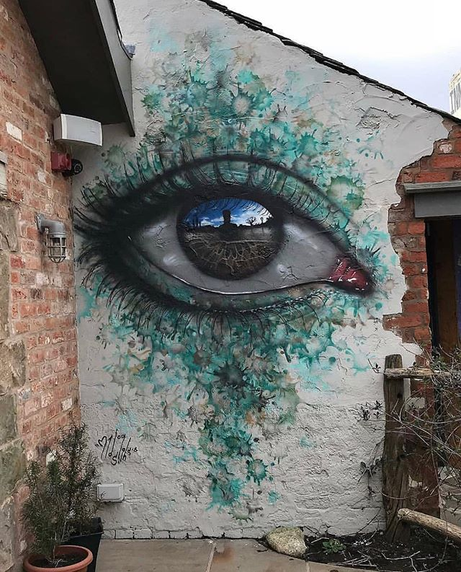
Figure 1 My Dog Sighs (2019).

One morning, I noticed a camera had appeared in our sleepy quiet village that is nestled in rural Wales. Positioned high up next to a street light and some trees. Why here? Surveillance serves four main purposes: safety of self and others, as a deterrent, to create levels of power and authority and to collect data.
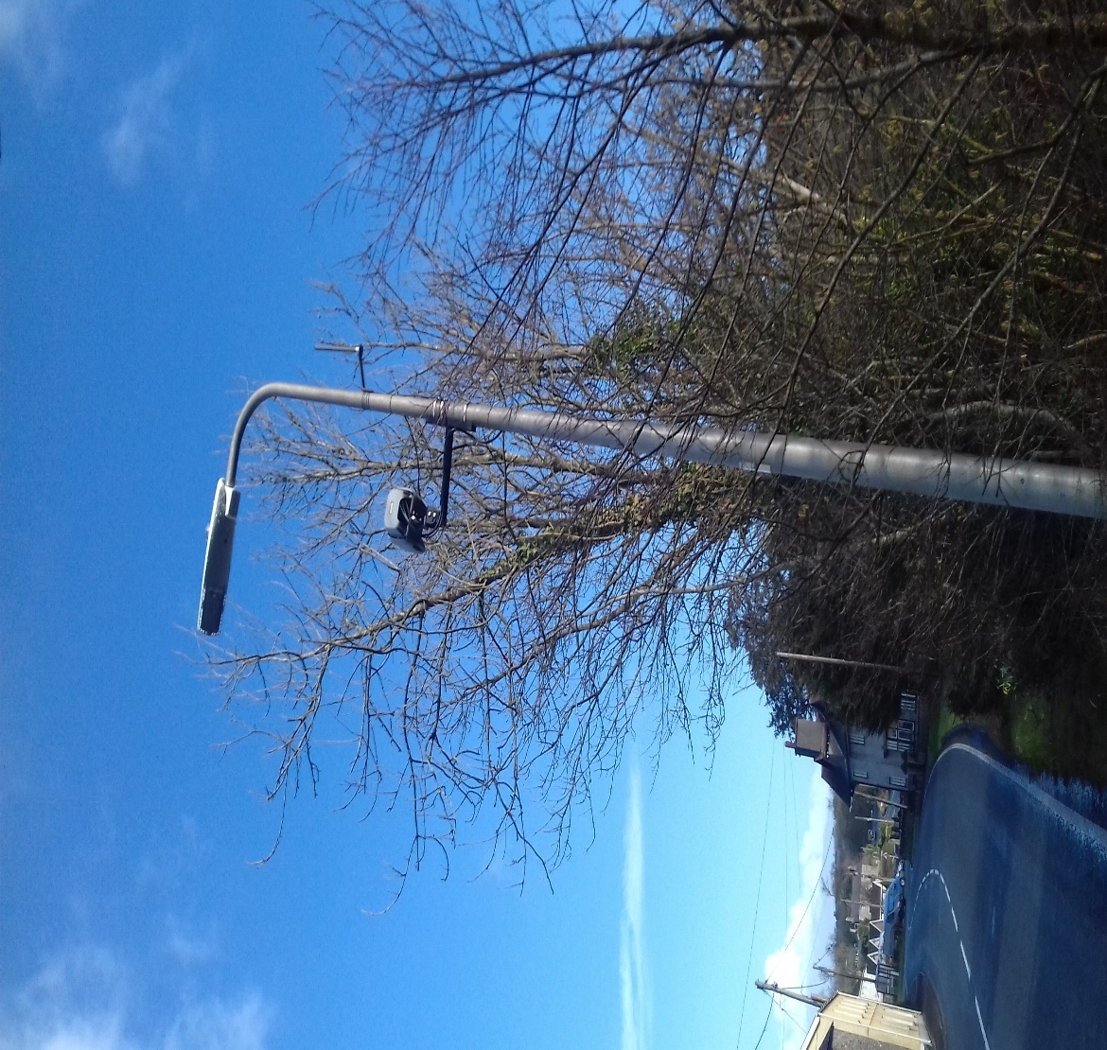
Figure 2. Tracey McGillvray (2019)
Today surveillance in the form of cameras, is operated almost everywhere, on the streets, in carparks, shops, educational facilities, doctors’ surgeries, factories, offices, in the home and even in our children’s playgrounds. Systems of surveillance still operate in prisons and psychiatric hospitals but now surveillance and cameras have become common place in areas that are considered safe spaces. It is not just criminal intent or activity that is being observed today, but everyday activity by people who are neither criminal or ‘insane’.
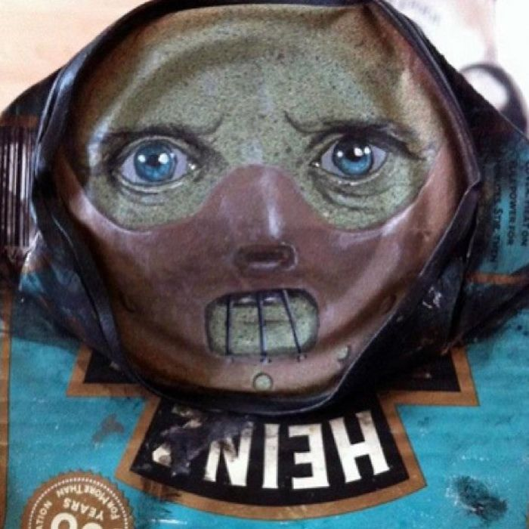
Figure 3. My Dog Sighs. (2019)
Surveillance is defined as the practice of watching and observing people and places and until recent years, these observations were directed at criminals, criminal activity, psychiatric patients and potential threats to the general public. Historically, surveillance was developed and formally used in institutions such as prisons and psychiatric hospitals, known as ‘the mad house’. Surveillance systems installed in institutions enabled less man power on the floor within these spaces, where the safety of the staff was a high-risk factor. Observation using surveillance equipment therefore served two purposes, the monitoring of prisoners and patients and the safe guarding of the staff employed in these institutions.
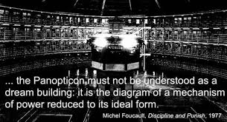
Figure 4: https://www.google.co.uk/search?tbm=isch&source=hp&biw=1366&bih=657&ei=H3h-XMmtGY7eav3Qn5gF&q=panoticon&oq=panoticon&gs_l=img.3..0i1

The architectural design of these institutions was created by Jeremey Bentham in the mid19th century which saw the shift from dark, obscured visionary places, where punishment was given in the form of torture, to the panopticon, a tool to which all could be viewed, monitored and regulated. Foucault, a French philosopher, whilst studying the history of institutions and societies, noticed that the panopticon is also a reflexion of the societies in which they were insitu. The panopticon creates power through knowledge that is gained from observation (Foucault, 1980).



Figure 5: (google images)
Surveillance also comes in the form of data collection from electronic devices, which a variety of agencies use for a number of reasons. Police surveillance is used to create profiles of people and places in order to apprehend or deter criminal activity. Online surveillance of search behaviour for sales and marketing purposes, and the criminal activity of internet hackers that steal identities and empty your bank accounts.
Although it may be assumed that we would change our actions due to being watched, we have become so normalised to the cameras that we rarely notice unless we are acting illegally. All this knowledge acquired through surveillance can be useful to monitor and maintain the infrastructures in place that allow populations to go about their business with a sense of safety.
Though some see surveillance as a tool that is used to control the masses and as such creates levels of paranoia and regards surveillance as an impingement on their right to privacy, thus creating groups of people who are anti-establishment. If data was to fall into the hands of unsavoury characters or organisations, we would then be at risk and unsafe.

References
Foucault, M. (1980). Power/Knowledge: Selected Interviews and Other Writings 1972-1977. Edited by Colin Gordon. New York: Vintage Books.

Figure 1: My Dog Sighs (2019) [online image] Available at:
https://scontent.cdninstagram.com/vp/f3a6e9b8017bdf0c82f0ef9575be4a87/5D05578B/t51.2885-15/sh0.08/e35/p640x640/52331994_169012177418400_7623338804826403970_n.jpg?_nc_ht=scontent.cdninstagram.com [accessed 05.03.2019].

Figure 3: My Dog Sighs #14 [online image] Available at: https://www.boredpanda.com/street-art-paintings-on-cans-my-dog-sighs/?utm_source=ecosia&utm_medium=referral&utm_campaign=organic [accessed 05.03.2019].
Figure 4: google images [online images] Available at: https://www.google.co.uk/search?tbm=isch&source=hp&biw=1366&bih=657&ei=H3h-XMmtGY7eav3Qn5gF&q=panoticon&oq=panoticon&gs_l=img.3..0i1 [accessed 05.03.2019].
Figure 5: google images. [online images] Available at: https://www.google.co.uk/search?biw=1366&bih=608&tbm=isch&sa=1&ei=Qnx-XIHjBKKtgweOi4iYDg&q=the+problem+isnt+just+cambridge&oq=the+problem+isnt+just+cambridge&gs_l=img.3...542806.558774..559570...0.0..3.77.2497.40......2....1..gws-wiz-img.....0..35i39j0i10i24j0j0i10j0i67j0i24.kRvylSHA7RQ [accessed 05.03.2019].

