

Planning For Innovative Customer Service
Report

Danielle Baskerville
1806101

Table of Contents

Executive Smarmy 3
Introduction 4
A SOSTAC planning framework prescribed by Smith (2012) will be employed in detailing the intended marketing plan: 4
2.0 Main Findings 4
2.1 Situation Analysis 5
Objectives 6
Strategy 7
3.0 Tactics 9
3.1Guerrilla Marketing 9
3.2 Word- of- Mouth (WOM) 11
3.3 Collaborative Marketing 12
3.4 Search engine optimisation & Paid search marketing – search engine marketing techniques 14
3.5 Buzz marketing 15
Actions & Control 18
Conclusion 21
References 22
Appendix 1 - PESTLE 24
Appendix 2 – SWOT Analysis 26
Appendix 3 – Porter’s Value Chain Analysis 28

Executive Summary

The customer journey is a fundamental strategic approach, in helping brands develop an understanding of their customer’s expectations, this being a crucial factor in optimising the overall customer experience (Johnston, 2017). This report provides the formulation for ASOS to enhance their customer journey through reacting to the sustainability mega trend dominating the fashion industry.

Following on from an initial presentation addressing the macro and microenvironment of ASOS, marketing strategies have been tactically outlined to augment ASOS customer journey, through value creating activities. ASOS’ CEO, Nick Beighton, states technology innovation is a top of his priority, as this being what the core ASOS customer resonates with the most. In light of this, digital marketing approaches have been designed to strengthen the customer journey through focusing on sustainability, which findings from the presentation show as integral to the consumer. The following initiatives are propsed:

- Drive brand awareness of ASOS recent acquisition of Arcadia Brand
- Drive sales supporting sustainably made fashion, through employing tactics aimed at ASOS core customer.
- Test a new technological market, with integrating CLO 3D Design technology to create garments, to overall reduce waste, and ASOS carbon footprint.
- Engage with customers in a more in-depth way though hosting collaborative pop-up stores with university students promoting the use of CLO technology.

Introduction

This report will formulate a marketing plan for ASOS, of which will aid the brand in communicating the message of sustainability, in view of enhancing ASOS’s market perception. Sustainability being a key factor when analysing the external environment of ASOS, and therefore a key concept at the core of this marketing plan. Novel marketing strategies have been put forward, with the ASOS consumer needs and interests considered. Living in a customer-centric society, the methods in which we communicate with our audience should reflect the customers attributes, moving away from traditional marketing norms (Ritz, 2017).

A SOSTAC planning framework prescribed by Smith (2012) will be employed in detailing the intended marketing plan:

- Situation Analysis - An environmental audit
- Objectives - Desired objectives
- Strategy - A review of the strategic options to achieve these goals
- Tactics - Details of how the chosen strategies will be implemented
- Actions - Recommended resources
- Control - Recommendations for monitored performance

2.0 Main Findings

A detailed marketing audit delivered by Baskerville, et al., (2021), acts as a framework designed to enhance the customer journey for the fashion brand ASOS. The marketing audit considered the political, economic, social, technological, environmental and legal (PESTEL) factors outlined in Appendix 1, as well as summarising the strengths, weaknesses (internal), opportunities and threats (external) as a SWOT analysis (Appendix 2). Through analysing the microenvironment of which ASOS operates, allows for the development of relevant key marketing strategies to be considered when planning for innovative customer service. Jobber & Ellis-Chadwick (2016) reaffirms this, by stating the environment in an organisation impacts operational capabilities, market segmentation and distribution channels. All key factors that can impact on delivering an effective customer journey.

2.1 Situation Analysis

The key findings of the marketing audit have been outlined in Porter’s Value Chain Analysis (Appendix 3). A key theme taken from the audit revealed that from the perceptual map centred around ASOS current market position (Figure 1), the recent acquisition of the Arcadia brand has been successful. This is largely due to similar target demographic to Topshop share with ASOS, which signifies that any future planned strategies ASOS have for Topshop to reinvent itself as a brand has great scope for being successful. Global data, 2020 stating that ASOS’s purchase of the Topshop shows great credential and would not dilute Topshop brand in any way, and instead offer a more innovative approach to fashion of the 20 something

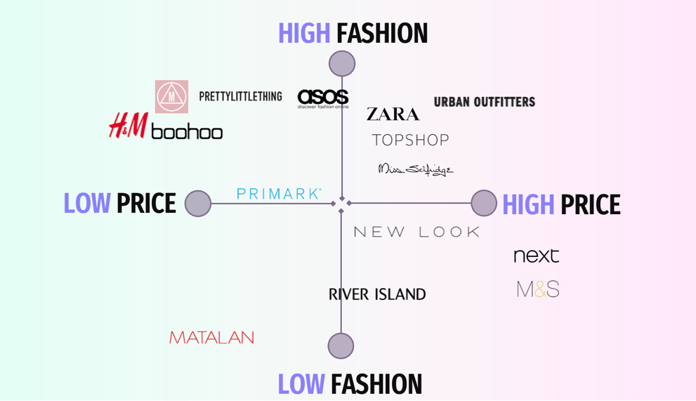

Figure 1: ASOS Perceptual Map

Another key theme identified shows ASOS encompasses fierce online competition coming from fellow online retailers including Missguided, and Boohoo. High fashion brands such as these, are at the forefront of the sustainability mega-trend which is dominating the industry. Corporate Social Responsibility (CSR), has expanded as role where consumers are now placing expectations on brands to share the same ideals and values as them, failing to do so can have a damaging effect on the customer journey (Chen,et al,. 2019). This highlighting scope for ASOS to realign its sustainable marketing strategy and practices.

Objectives

- Increase consumer base by 15% through a collaborative process
- Increase consumers perception of ASOS, and the brands approach to sustainability by using pop-up store initiatives
- By 2023 fully integrate the CLO 3D software platform within all ASOS design process, offering a fully streamlined design process, using circular fashion principles to guide approach.
- Promote employment amongst Fashion Design students by collaborating with them at pop-up events across the next 12-month period.

Strategy

Building on the internal competencies outlined within the presentation (Baskerville et al, 2021), offers ASOS opportunity to capitalise on the brands successful trend-led ecommerce strategy. ASOS have developed authentic ways in delivering their core message to the consumer, in particular the ASOS Insiders Community initiative. This approach moves away from generic marketing approaches and is recognised as a novel communication strategy. In a disrupted retail environment this approach is imperative in seizing opportunity from other market players (McCunines, 2017. Therefore, to achieve the desired objectives set out ASOS would continue to employ this strategy, whereby a focus is on introducing a new clothing line, designed and manufactured in a sustainable manner.

This focus upon sustainable fashion would align itself with the new paradigm of ‘green marketing and would strengthen ASOS market presence within the ethical fashion apparel market. However according to REF, to communicate such a key message the attention of the target audience must be captured in an engaging and innovation manner from the offset.

Therefore, a more automated marketing platform in this instance the integration of a retail pop up store will be implemented to re-engage the current consumer. Pop up or ‘temporary, retailing’ is namely an ephemeral retail strategy, and designed to facilitate direct consumer-brand interaction as part of a new promotional launch strategy (Warnaby & Shi, 2018). This strategy will be employed to compliment ASOS mainstream business activities, transitioning from product-centric marketing, whereby ASOS current market success can be attributed, towards a more consumer-centric approach. To compliment this method, entrepreneurial marketing a combined approach, intended to conceptualise the role of marketing would be applied. Morris et al. (2002) defines as:
“an opportunistic perspective wherein the marketer proactively seeks novel ways to
create value for desired customers and build customer equity.”

Whilst each of these techniques vary in regard to their emphasis on promotion, versus entire marketing mix, they do share commonality through the form of creativity. Overdiek & Warnaby, (2020) affirm this by stating alternative approaches deliver innovation, in particular when managing and marketing products or processes with a deeper meaning. The segmentation of markets is presented below:
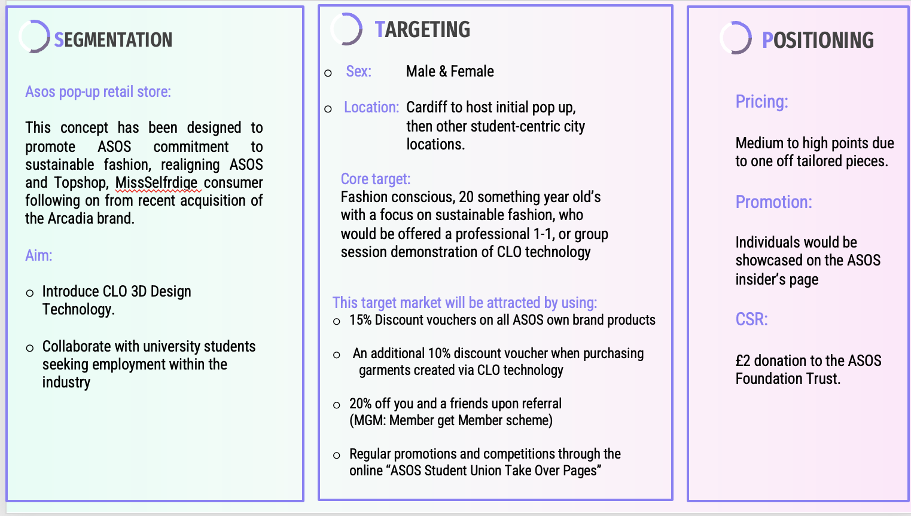

3.0 Tactics

3.1Guerrilla Marketing

Guerrilla marketing, an ambient tactic when integrated within marketing communication (Khare, 2017), would be implemented through the use of collaborative pop-up stores across various UK locations. In light of ASOS’s recent acquisition of the Arcadia brand, the concept would be centred upon fashion design students at the forefront of creating garments, as part of a promotional launch amalgamating the two brands.

The stimulus behind the new product launch is supported by ASOS’s commitment to re-invent the Topshop brand with a heavy focus on sustainability across the two brands. Saunders & Dong (2019) affirms that consumer’s loyalty towards a brand has now shifted, with a focus now upon a brand’s sustainable attributes. The design process an increasingly important credential, especially amongst the millennial generation. The pop-up stores would be utilised as an offline platform, to capture both ASOS’s already established online consumer, with the acquired Topshop and Miss Selfridge consumer, to drive maximum impact in communicating the message surrounding sustainability.

The main aim would be to acquire the pop-up events in the environment of which the typical ASOS consumer would be identified, thus being student-centric, city locations.
The rationale behind this is to generate relationships with the consumer and indorse the message of sustainable fashion as a mega-trend dominating the fashion industry. (Mckinsey, 2021) states that:
“in order to maximise impact amid a rapidly changing channel mix, fashion players
must find new ways to excite customers and encourage them to engage”.

At a tactical level, Boustani (2019), defines guerrilla marketing to be a low-cost, effective approach, employing unorthodox marketing practices to evoke connections between a brand and consumer. Such method differentiates itself from traditional marketing norms, as the aim is to achieve a “surprise effect” from the consumer and evoke an emotive reaction. When emotions are charged, it leads to individuals taking action particularly when the surprise factor has been aroused by social, ethical or environmental concerns. This therefore motivating the audience to take action (Durson,2019). When the surprise element has been established, this then initiates the diffusion effect, whereby the desired message can be delivered to a wider audience, both directly and indirectly.

To achieve this, the pop-up stores would be focused on promoting the benefits of integrating CLO Virtual Fashion Technology within garment construction. The technology visualises users’ creations with the ability to create unlimited graphic placements, colourways and engineered print layouts, reducing production times and design inaccuracies. The software acts as a change agent in the fashion industry’s transformation, demonstrating garment design process would be executed in a dynamic and sustainable manner (Kim & Choi, 2020). To date this technology has not yet been introduced within high-street fashion, and therefore would be intended to act as a market disruptor for the brand, generating conversation.

3.2 Word- of- Mouth (WOM)

Word- of- Mouth (WOM) is a crucial factor leading on from guerrilla marketing. If as a tactical tool, a guerrilla campaign is executed well, then that can begin to stimulate effective WOM communication. In today’s hyper-connected world, a single recommendation can be pivotal in companies sustaining a positive relationship with the consumer (Ferguson, 2019). Amplified WOM can be achieved within new and or existing communities, when a campaign has been designed to generate conversation in a positive manner. Through the creation of carefully considered, emotive and thought-provoking content WOM can prove advantageous, as it targets the emotions of its audience. This igniting a response, increasing WOM publicity over other conventional means (Clow and Baack, 2017).

Through utilising ASOS already established online social media platforms, such as YouTube and TikTok a promotional campaign can be developed to promote the importance of sustainability through a short promotional video, encouraging users to visit the proposed pop-up stores. This reinforcing the brands commitment to a more sustainable practice, and in doing so could lead to increasing the amount of positive conversation surrounding the brand both on and off-line.
This approach can be highly valuable to a brand building a community, rather than commodity as it seeks to engage a consumer base, in doing so budling strong loyalty between the brand and consumer (Taube & Warnaby, 2017).

3.3 Collaborative Marketing

Collaborative marketing merges two or more established brand names together, as a part of a promotional alliance (Crick and Crick, 2020). The purpose of this is to combine the market strength, and brand awareness of both parties involved, in order to capture the consumer’s interest in an idea, product or service. Aligning reputable like-minded brands together and consolidating resources can increase brand exposure, increasing sales leads (Sheth, Parvatiyar and Sisodia, 2019).
This approach will be implemented through the use of having University of South Wales (USW) fashion design students being present at the initial pop-up event showcasing the CLO technology. Moore (2021), notes that in order for collaborative marketing to be successful, each brand involved must share a common purpose, goal or mission. Both USW and ASOS have actively displayed their commitment to sustainable fashion, through adopting a holistic approach, taking part in various initiatives, to support this concept. In particular ASOS signed up to the ‘2020 Circular Fashion System Commitment’ launching a circular fashion pilot training programme in partnership with London College of Fashion. 100% of ASOS design team have now undertaken training programmes, broadening their knowledge on the concept of circular fashion, and how this can be implemented within their designs (ASOS PLC, 2021). In addition, ASOS have also joined “The Textile 2030 Roadmap”, whereby ASOS made a voluntary pledge to the programme indicating their commitment to a more sustainable fashion industry.
Conversely, USW have become the first UK university to embed CLO technology software within their fashion design courses, this creating a “fashion revelation”, (USW, 2021). To date such technology has only be implemented by leading luxury fashion houses such as Balenciaga, so only emphasises the university’s commitment to both creating sustainable fashion, but also educating their students on the topic. Therefore, combing both ASOS and USW satisfies the assertion by forward by Moore, (2021), as both brands evidently share the same goal, and ASOS have previously shown it can successfully partner with higher education institutions. Through merging the two companies together would successfully integrate the desired target consumer, of which the pop-up events would intend to address: the young, fashion and environmental conscious consumer.
Furthermore, (Hackley & Hackley, 2018) indicates that through two companies blending their resources, skillset and ideology together, to create a campaign that resonates with the desired consumer, it can open up more opportunities than each of them could achieve independently. In this instance not only would ASOS benefit from greater publicity, but it would also provide a positive platform for USW students to showcase their work and abilities, and in turn potentially generate employment opportunity with ASOS. This could also reach out to Marketing and Event Management students as a means of offering internship placements promoting the events. Indorsing employment in creative way is vital for Gen Z to acquire employment. Especially during the challenging times experienced as a result of the recent pandemic, where un-employment and redundancy were at an all-time high (CIM, 2021).

3.4 Search engine optimisation & Paid search marketing – search engine marketing techniques

Search Engine Optimisation (SEO) is an integral from of inbound marketing, whereby marketing is elevated through the use of search engine listings to deliver content that is relevant to the consumer, based on their search preferences (Woodriff, 2018). The integration of carefully considered key words, and content creation within a search engine field, is intended to encourage potential consumers to continue on and click-through to a website, and or event submission. This approach enhances the customer’s buying journey, as it is designed to engage consumers in buying activity, through only offering content that is meaningful and of purpose. This, strengthening the relationship between the retailer and consumer (Deepak,2018).

This tactical response to boosting traffic, is cost affective, and differs greatly to traditional outbound marketing, whereby the intention is to attract the consumer through the use of promotional material usually through the form of costly TV advertisements. Fahy (2019) recognises the latter approach to be of no relevance when marketing to the GEN Z consumer, thus being ASOS core customer, for it is disruptive and fails to target the consumer direct, therefore holding little value.
User-centric marketing can be achieved from the implementation of SEO, whilst driving traffic to a website, accelerating conversion rates, and as a result market opportunity is generated. Adopting the concept of SEO within the proposed pop-up event, would entail utilising the buyer’s persona, in order to maintain optimised listings. Through analysing the buyers wants and needs, key words and phrases that are of relevance can be identified. outlines that to successfully convert potential consumers, the choice of phrases needs to be specific, and avoid being too broad in order to achieve high search volume.

Therefore, in order to communicate the message effectively regarding the pop-up phrases such “CLO Sustainable Fashion Retail Concept”, and “USW Fashion Design Event”, would need to be integrated to gain awareness around the event. Consequently, features such as Dynamic Locator, should also be implemented as means of promoting the times and location of such pop-up event. Such features are highly responsive and can be customised if needed to (Jobber, 2016) . It is important to note, to generate engagement and placement surrounding the event, content should be listed 90 days prior, in order to achieve maximum success and maintain the relationship with the consumer.

3.5 Buzz marketing
Buzz marketing, a viral technique is focused upon maximising word-of-mouth potential, and heavily relies upon positive associations made with the brand. According to Tabeck (2018), in order for a brand to capitalise from a pop-up store, a “buzz” concept must be executed, as this hold’s greater value than the innovation of the pop-up itself.
These associations coming from other consumers of the brand, in particular friends or family, avid users of the brand, or conversations held online through social media platforms. Ramírez (2018), asserts that recommendations coming from a person of trust, is far more effective than any other promotional tactic.
Online buzz marketing is highly driven through the use of ‘influencers’ or ‘early adopter’s’, who proactively share their experiences across their social media platforms. These individuals benefit from having a large following, enabling their ideas around a product or campaign to be noticed on a larger scale. This in turn creates greater exposure and creditability of a product (Suttherman,2020). As identified earlier with the SWOT analysis, ASOS upholds a strong social media presence, therefore utilising this will be pivotal in communicating buzz around the pop-up events.
To aid communication, the ‘New Marketing Mix’ will be adopted with promotional content driven by various social media platforms. Tik Tok and Instagram in particular will be at the forefront of developing promotional campaigns, as these platforms are more aligned to the Gen Z consumer. Behind the scenes content of the pop-up stores, as well competitions amongst the universities to design a sustainable collection would be implemented. The winner of the competition would then have the opportunity to showcase their collection at the pop-up event, advertised as a limited time, one-off piece. According to Pennington (2016), in order for a brand to capitalise from a pop-up store, a “buzz” concept must be executed, as this hold’s greater value than the innovation of the pop-up itself.
In conjunction, forming close working relationships with universities, would allow for content to be shared across student union pages, with tactics such as ‘ASOS Student Union Take-over page’ being employed.
Combing influencers and content creators to take over ASOS main social media platforms, and hosting giveaways would also strengthen promotional activity and create that ‘buzz’ around the events. In fulfilling an enhanced customer journey, the consumer must be met at their highest place of interaction, and should be presented with a personalised, and contextualised experience (Chen & Lee, 2018). Through integrating these approaches, it would strengthen the message that ASOS are committed to sustainable fashion and not just ‘green-washing’ its consumers.
Similarly, Buting (2018) states, in order for a brand to capitalise from a pop-up store, a “buzz” concept must be executed, as this hold’s greater value than the innovation of the pop-up itself.
This focus upon sustainable fashion would align itself with the new paradigm of ‘green marketing and would strengthen ASOS market presence within the ethical fashion apparel market. However according to Ritz (2019) to communicate such a key message the attention of the target audience must be captured in an engaging and innovation manner from the offset. Therefore, a more automated marketing platform in this instance the integration of a retail pop up store will be implemented to re-engage the current consumer.

Pop up or ‘temporary, retailing’ is namely an ephemeral retail strategy, and designed to facilitate direct consumer-brand interaction as part of a new promotional launch strategy (Warnaby & Shi, 2018). This strategy will be employed to compliment ASOS mainstream business activities, transitioning from product-centric marketing, whereby ASOS current market success can be attributed, towards a more consumer-centric approach. To compliment this method, entrepreneurial marketing a combined approach, intended to conceptualise the role of marketing would be applied. Morris et al. (2002) defines as:
“an opportunistic perspective wherein the marketer proactively seeks novel ways to
create value for desired customers and build customer equity.”

Whilst each of these techniques vary in regard to their emphasis on promotion, versus entire marketing mix, they do share commonality through the form of creativity. Overdiek & Warnaby, (2020) affirm this by stating alternative approaches deliver innovation, in particular when managing and marketing products or processes with a deeper meaning.

Finally, content marketing, a digital inbound marketing strategy Opreana and Vinerean, 2015), would be employed as an advocate in promoting sustainability. This would offer consumer- to-consumer interaction both within online and offline environments. This approach can have an effect on an individual’s attitudes and preference towards a brand and can work both in a negative and positive way (Berger and Milkman, 2018). Therefore, content must be strategically though out and relevant in order to drive consumer action.

Actions & Control

In order to executive the strategics and tactical approaches drawn upon within this marketing plan, a scheduler of activity would need to be implemented. What actions are needed to be taken and when, the level of labour required, and the cost involved would all need to be addressed before implanting any promotional activity.
Bressolles & Lang (2020) notes through identifying a set of relevant key performance indicators (KPI’s), enables areas most relevant to a brands infrastructure to be analysed. Moreover, Nepal (2017) affirms that in order to for an analysis to be of value, recognising key metrics that can be specifiable measured is critical for understanding consumer satisfaction rates. ASOS control metrics, shown in figure 2 below, highlights how the brand would monitor the reaction of the pop-up events in terms of sales conversion, and the level of engagement received across social media platforms.

Control would be achieved through the internal marketing and e-commerce departments present within ASOS. Integrating packages such as ‘Salesforce’ which is an online dashboard would allow for consistent monitoring, and statistical summary reports to be distributed in real-time. As Jim (2019) maintains that analysing data organically, is both a labour intensive and timely process, that fails to deliver data that can be actioned upon immediately.

In addition, an E-Marketing programme would also need to be implemented in accordance with data protection procedures and policies in place. This would enable a time-time to be created outlining relevant content, and social media platforms for this to be integrated with. In doing so this limits the risk of cross-posting across two platforms, ensuring that the desired content remains engaging increasing the prospects of conversion (Trotter, 2017).

KPI Indicators for Analysis | How Often (Daily, Weekly, Monthly, Quarterly | Who Is Responsible (Internal or External) | Cost to Measure KPI’s
Sales  - Units  - Revenue  - Market Share | Evaluate sales daily and report monthly to merchandising and buying department | Internal, with the use of external software. | Sales metric’s outlining sales units from pop-up events, can be accessed for free on a web-based platform.
Succession Rate  - Attrition rate  - Conversion rate | Daily during pop-up events. Once this have completed, evaluate conversion rates on a weekly basis | Internal, supported by the finance department | Online sales data is integrated within the ASOS website and is free. This can determine sales supported through CLO technology.
Affection Level  - Online Analysis ‘Shares, Likes’  - Sentiment Analysis  - Customer satisfaction rate | Social media statistics report to be generated weekly | Internal an assessed on social media platforms and presented to the marketing team | This can be analysed through social media analytics software, as a low-cost detailed approach.  Customer satisfaction survey at pop-up event to benchmark satisfaction rates.
Engagement Levels  - Sum Of Shares, Likes & Comments to content marketing  - Number of attendees to pop up | Analyse customer satisfaction feedback weekly and generate a detailed report monthly. | Internal Marketing team | Performance management systems to be integrated within the pop-up events to accurately control footfall.

Figure 2: ASOS Control Matrix

Conclusion

From conducting the market audit, is evidential to see that ASOS is a key market player within the high-street fashion sector. ASOS has successfully broken-down barriers within the ecommerce fashion industry, through its all-inclusive approach, which was formulated from the listening to what it is exactly its consumer wants.
ASOS has already began to establish themselves as a more sustainability focused retailer, and therefore this marketing plan acts as a growth strategy alongside the efforts already achieved. Strategic planning has been incorporated within this document, in particular proposing a pop-up store versus a bricks and motor store. With the latter being far more costly than maintaining a store on a temporary basis.

Reacting to systematic change within the fashion industry requires a holistic approach (Fletcher, 2012), encompassing all relevant associates and stakeholders. To achieve sustainable practice a fundamental shift must take place involving how we consume and how we produce. This being the premise of what this marketing plan has been centred upon, and capitalising on ASOS already proven successful alternative approach to strengthen the customer journey.

References

Agarwal, S., 2018. Different ideas for textile fashion market and sustainability – environmental & economical costs of fashion products. Journal of Textile Engineering & Fashion Technology, 4(6), pp.55-56.
ASOS PLC. (Unknown). ASOS Mission Statement. Available: https://www.asosplc.com/. Last accessed 19th June 2021.

ASOS PLC. (Unknown). ASOS Mission Statement. Available: https://www.asosplc.com/. Last accessed 19th June 2021.
Asosplc.com. 2021. Latest Results. [online] Available at: <https://www.asosplc.com/investors/latest-results> [Accessed 18 June 2021].

Asosplc.com. 2021. Latest Results. [online] Available at: <https://www.asosplc.com/investors/latest-results> [Accessed 14 June 2021].
Berkhout, C. (2015). <i>Retail Marketing Strategy: Delivering Shopper Delight. [ebook] Kogan Page. Available at: https://www.perlego.com/book/1015396/
Boustani, G., 2019. Pop-up retail. 1st ed. London: Routledge, pp.34-36.
Clow, K. and Baack, D., 2017. Integrated advertising, promotion, and marketing communications. 8th ed. London: Pearson, pp.118-120.
Crick, J. and Crick, D., 2020. Coopetition and COVID-19: Collaborative business-to-business marketing strategies in a pandemic crisis. Industrial Marketing Management, [online] 88, pp.206-213. Available at: <http://doi.org/10.1016/j.indmarman.2020.05.016> [Accessed 17 June 2021].
Crowther, Phil, 2011. Marketing event outcomes: from tactical to strategic. International journal of event and festival management, 2(1), pp.68–82.
D. & Ellis-Chadwick, F., 2016. Principles and Practice of Marketing. Eighth ed. London: McGraw-Hill Education.
Dursun, 2019. Psychological Barriers to Environmentally Responsible Consumption. Ethics, Social Responsibility and Sustainability in Marketing, [online] pp.103-128. Available at: <https://link.springer.com/chapter/10.1007/978-981-13-7924-6_6> [Accessed 14 June 2021].
Ferreira, C., Lord Ferguson, S. and Pitt, L., 2019. Entrepreneurial marketing and hybrid entrepreneurship: the case of JM Reid Bamboo Rods. Journal of Marketing Management, [online] 35(9-10), pp.867-885. Available at: <https://doi.org/10.1080/0267257X.2019.1637921> [Accessed 18 June 2021].
GlobalData. 2021. Agile ASOS continues to shine bright throughout COVID-19 - GlobalData. [online] Available at: <https://www.globaldata.com/agile-asos-continues-shine-bright-throughout-covid-19/> [Accessed 14 June 2021].
Hackley, C. and Hackley, R., 2018. Advertising and promotion. Los Angeles: SAGE, pp.80-82.
Herz, M. and Rauschnabel, P., 2019. Understanding the diffusion of virtual reality glasses: The role of media, fashion and technology. Technological Forecasting and Social Change, 138, pp.228-242.
Hooley, G., Piercy, N., Nicoulaud, B. and Rudd, J. (2017). Marketing Strategy and Competitive Positioning. 6th ed.
Khare, D., 2017. Guerrilla Marketing - Innovative and Futuristic Approach towards Marketing. International Journal of Advanced engineering, Management and Science, [online] 3(5), pp.421-426. Available at: <https://dx.doi.org/10.24001/ijaems.3.5.3> [Accessed 12 June 2021].
Kim, J. and Choi, K., 2020. A Collaborative Study on 3D Dynamic Fashion Design Development, Using Digital Technology. Pivoting for the Pandemic, [online] Available at: <https://www.iastatedigitalpress.com/itaa/article/id/12028/> [Accessed 16 June 2021].
Mckinsey and Company. (2021). The State of Fashion 2021. Available: https://www.mckinsey.com/~/media/McKinsey/Industries/Retail/Our%20Insights/State%20of%20fashion/2021/The-State-of-Fashion-2021-vF.pdf. Last accessed 19th June 2021.
Moore, G., 2021. Fashion Promotion: Building a Brand Through Marketing and Communication. 2nd ed. London: Bloomsbury, pp.108-109.
Overdiek, A. and Warnaby, G., 2020. Co‐creation and co‐design in pop‐up stores: The intersection of marketing and design research?. Creativity and Innovation Management, 29(S1), pp.63-74.
Pennington, A., 2016. the Customer Experience Book. London: Pearson.
Pottier, A. & Muinos, C. A., n.d. Calameo. [Online]
Available at: https://en.calameo.com/read/005312124af55bbd57332
[Accessed 16 June 2021].
Ritz, N., 2017. The CMO Show marketing podcast Ep 66 - The organic growth of Lush cosmetics [Interview] 2017.
Sheth, J., Parvatiyar, A. and Sisodia, R., 2019. Handbook of advances in marketing in an era of disruptions. 1st ed. London: Sage, pp.12-13.
Taube, J. and Warnaby, G., 2017. How brand interaction in pop-up shops influences consumers’ perceptions of luxury fashion retailers. Journal of Fashion Marketing and Management: An International Journal, [online] 21(3), pp.385-399. Available at: <http://doi.org/10.1108/JFMM-08-2016-0074> [Accessed 16 June 2021].
Taylor, C. and Carlson, L., 2021. The future of advertising research: new directions and research needs. Journal of Marketing Theory and Practice, 29(1), pp.51-62.
Truong, V., Saunders, S. and Dong, X., 2019. Systems social marketing: a critical appraisal. Journal of Social Marketing, [online] 9(2), pp.180-203. Available at: <https://doi.org/10.1108/JSOCM-06-2018-0062> [Accessed 12 June 2021].

Appendix 1 - PESTLE
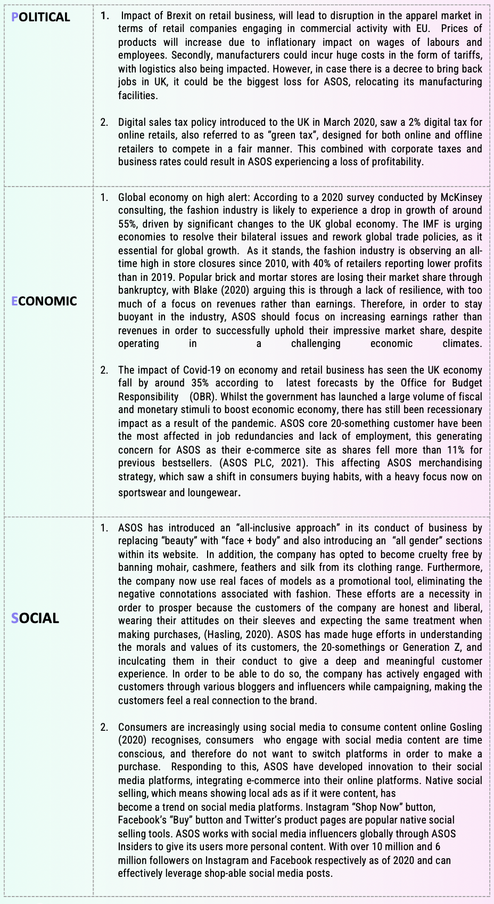

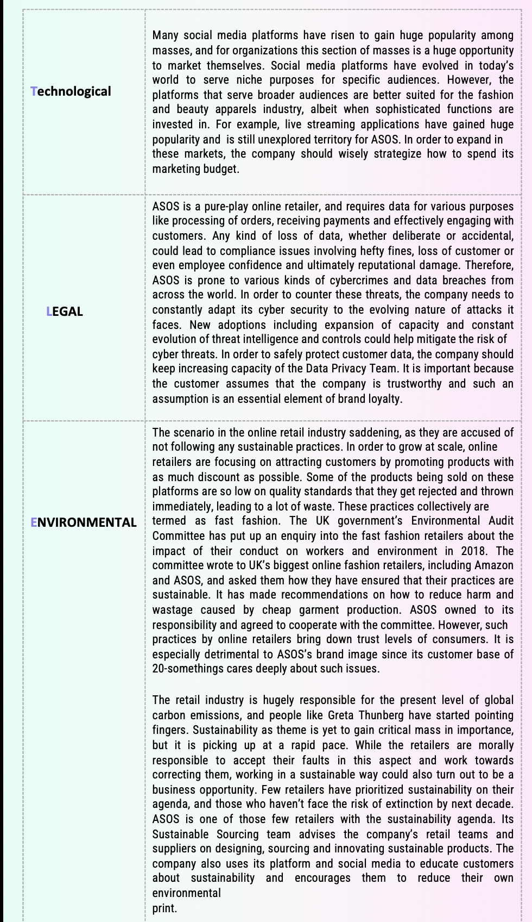

Appendix 2 – SWOT Analysis
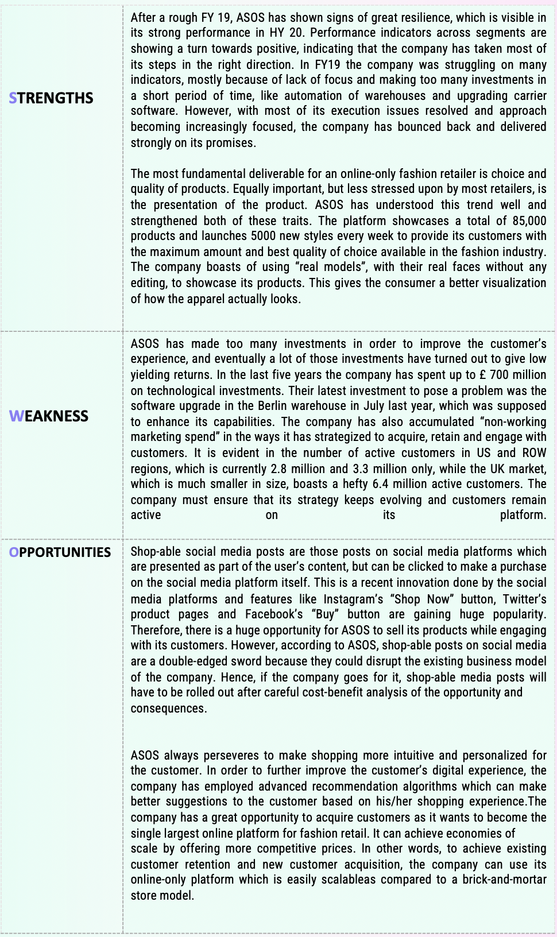

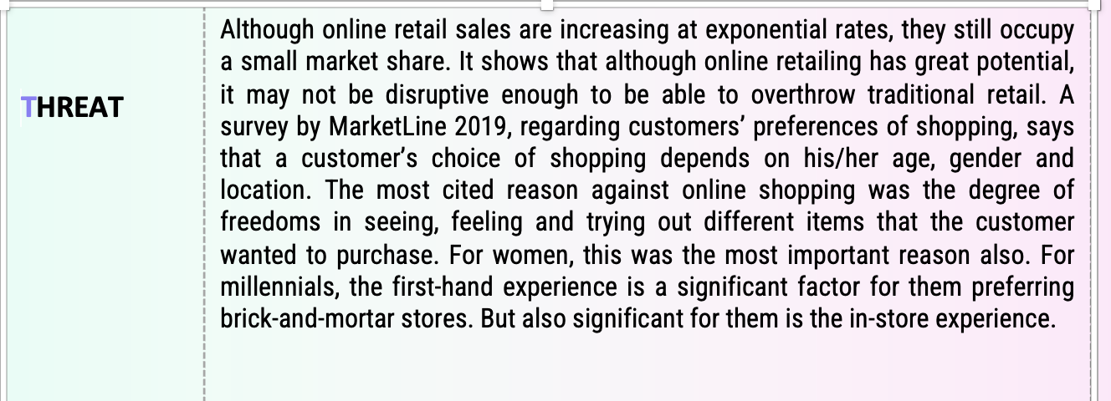

Appendix 3 – Porter’s Value Chain Analysis


