

Programme: BA Business Management

Marketing Fundamentals
LCBB4004

Assessment 1
Blogging to communicate

Lecturer: Tushara Balendran
Student: Miroslava Todorova Velkova
Student number: 2125655
BACKGROUND OF TESLA
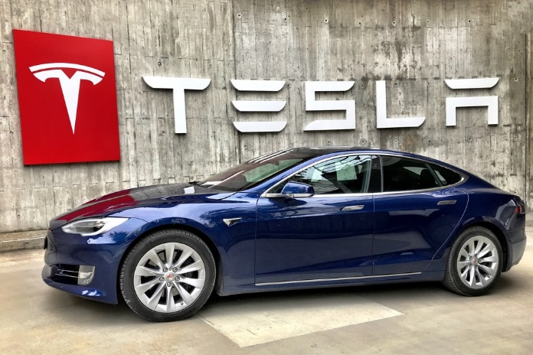
Tesla Motors was formed in 2003, and the company changed its name to Tesla in 2008. Tesla was not founded by Elon Musk, despite common perception. Tesla was created by Martin Eberhard and Marc Tarpenning, with the help of early investors including Elon Musk (About Tesla | Tesla, 2022).
For the most part, Tesla is recognized for its competence in electric vehicles. Currently, buyers may choose between a Model S, Model 3, X, or Y, each of which has its own distinct advantages and disadvantages. Tesla is also engaged in the production and storage of electricity.
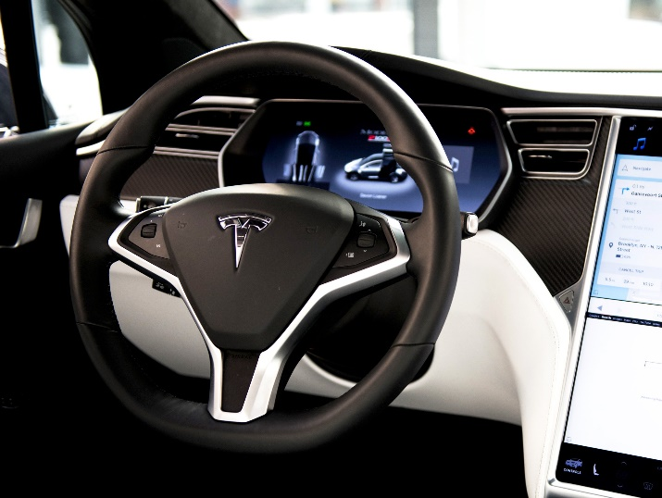
Electric vehicles were introduced in 2008 with the launch of Tesla's Roadster model. In the immediate aftermath of it, Tesla began constructing the world's first premium all-electric vehicle from scratch: The Model S. When it comes to automobiles today, the Model S sets a new standard for safety, performance, and fuel efficiency. It features the greatest range of any electric car, as well as over-the-air software upgrades that make it better over time. It also holds the Motor Trend record for the fastest 0-60 mph acceleration time at 2.28 seconds.
There are now production plants in China and the United States, as well as 438 retail locations and 100 service centers in several nations, making Tesla more global in scope.
Tesla's "face" and "creator," Elon Musk, has become a household name. An engineer by trade, Elon Musk is a South African-born Canadian-American who founded SpaceX. He graduated from the University of Pennsylvania with a physics and economics double major.
Focusing on electric vehicle (EV) powertrain systems and components is a key element of Tesla's secret to success. By 2021, the business plans to have 438 retail shops, 100 service centers, and more than 30,000 Superchargers (electric vehicle charging stations) spread over 3,100 different points of sale and points of distribution.
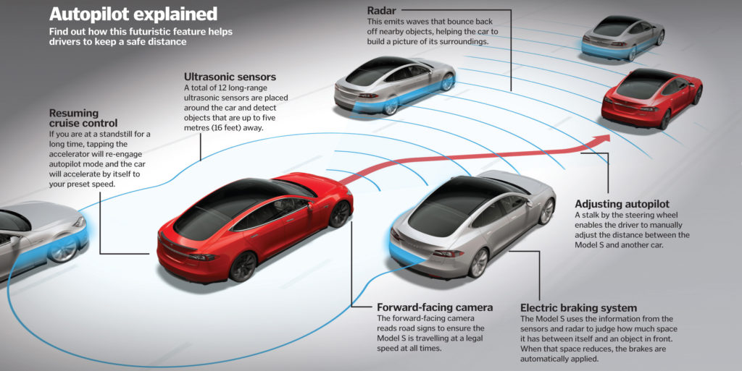
New goods that appeal to a broader range of customers is Tesla's strategy for keeping up with the times. In order to remain competitive in this specialized business, Tesla Motors has created additional offices in the United States and China. There are several reasons why Tesla and its strategic partners like as Panasonic developed the Gigafactory in Nevada in order to keep the cost of lithium-ion battery packs low. Mercedes Benz and BMW are among the premium automakers entering the electric car market. More than two-thirds of all new auto sales in 2030 are expected to be made up of electric vehicles, according to industry experts.
When it comes to promoting its products and services, the company has always relied on this phrase to do so. A safe and secure marketing campaign is another benefit. As a result of these activities, the organization has grown and achieved its goals. The brand has also taken use of the potential of social media since the emergence of the Internet. This makes it easier for Tesla to make an effect in its target demographic on social media sites like Facebook, Instagram, and Twitter. In addition, the brand has always attracted people and groups by encouraging them to improve their performance. As a result of this research, goods and services have been developed specifically for them. Rather than focusing on growth, profitability, and success, the firm has focused on what is best for its consumers in order to establish a growth and success-oriented communication. Because of this, the company's brand has grown and its consumers have a particular place in their hearts for the company.

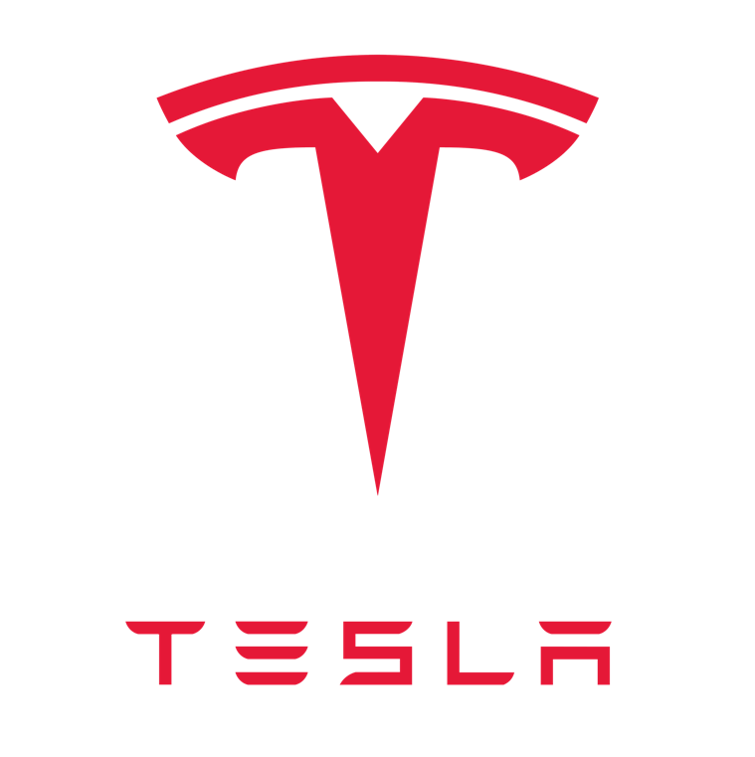
TESLA PRODUCTS
Tesla, Inc. was created in California in 2003 as a manufacturer of electric cars, solar panels, and batteries for both automobiles and residences. The sooner the world abandons its need on fossil fuels, the closer Tesla is to a zero-emission future. All production workers must complete a multi-day training course before they can set foot on the factory floor, as part of Tesla's proactive commitment to workplace safety. While Tesla's manufacturing continues to rise, the company's safety record is steadily improving.
PRODUCTS RANGE OF TESLA
1. Electric Cars
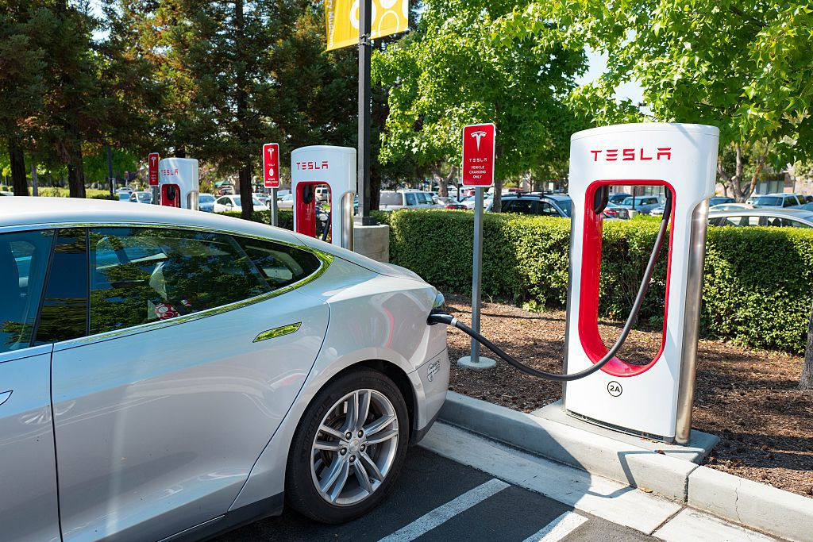
Electric vehicles have been shown attractive almost solely by Tesla, which combines exceptional performance and high-tech interiors with a usable driving range. Cargo space in the Model X crossover is generous, with accommodation for up to seven adults and two children. With its Falcon Wing doors, it's also Tesla's most costly model. You may choose from two sedans: the more costly Model S is a high-performance vehicle. A less expensive version of the Model 3 Performance isn't far away. The Cybertruck, a bizarrely designed pickup truck, was also unveiled by the business.

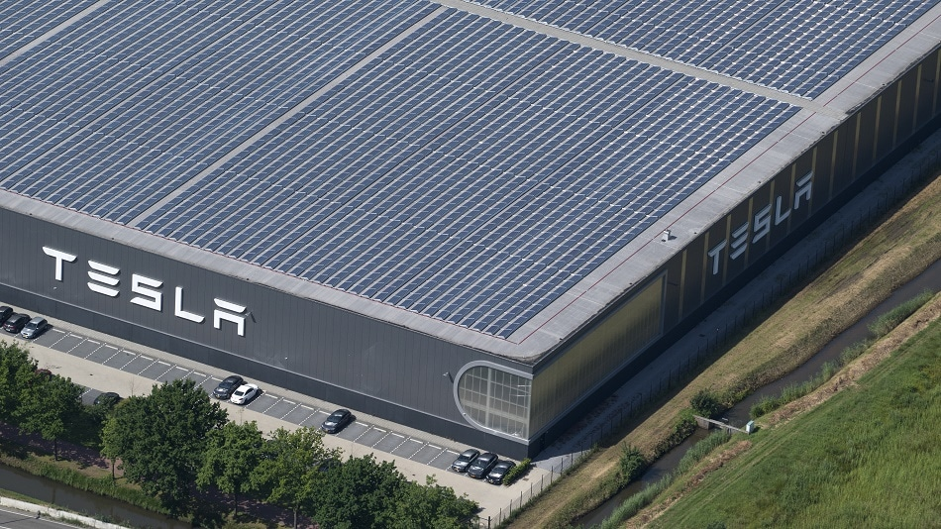
2. Solar
A key feature of Tesla solar panels is their efficiency, which allows them to produce as much solar energy as possible even on rooftops with complex angles. The Tesla Solar Inverter ensures the safety and reliability of your fully integrated system. For decades to come, our solar panels will silently transform sunshine into electricity. The panels are kept close to your roof and to one another for a basic appeal thanks to integrated hardware and a simple design. Get in touch with a Tesla solar panel expert if you have any queries.
3. Clean Energy
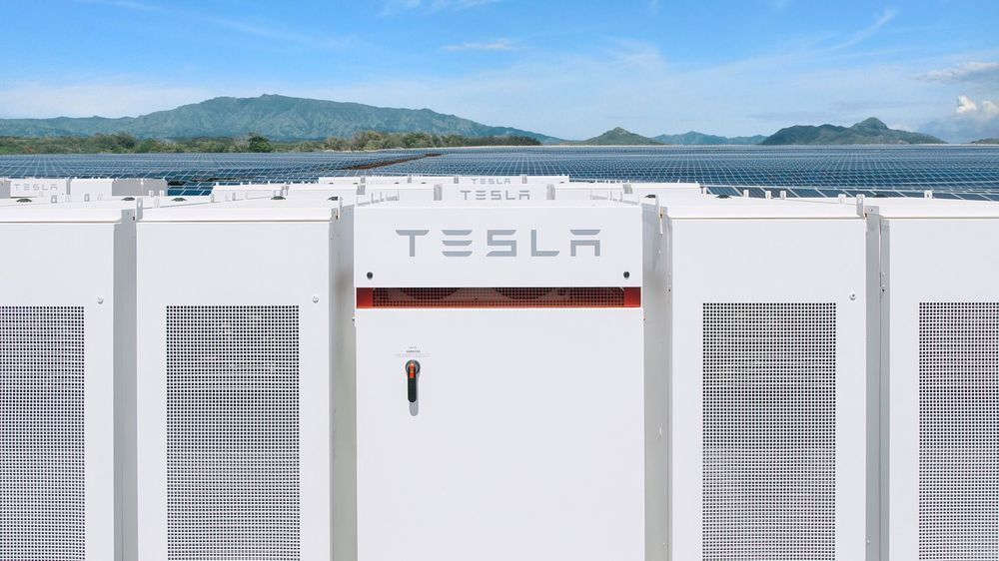
Solar City was purchased by Tesla in 2016 for $2.6 billion. SolarCity's solar energy services are available to anyone, anywhere in the globe. One of the most prominent solar energy companies in the United States, SolarCity was founded in 2006. Clean energy services may be provided from residential installations all the way up to Tesla's latest automobile models thanks to a partnership with SolarCity. Your house has the potential to lessen the dependency on fossil fuels in your neighborhood.

FEATURES OF TESLA PRODUCT
- Autopilot: A driving assistance system called autopilot is included on all Tesla vehicles.
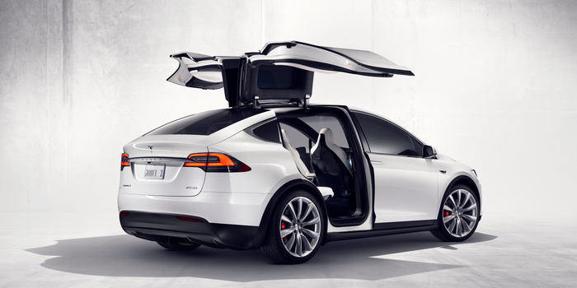
- Caraoke: Caraoke has been included to Tesla's 10.0 software update, allowing owners to pick from a wide selection of songs and music lyrics.
- Bioweapon defence mode: The HEPA filtration system in Tesla's Model X and Model Y prevents hazardous substances from entering the car's interior.
An air purification system that can remove pollen and germs from the air has been created in the wake of similar systems in hospitals, living quarters, and the space industry.
- Touchscreen: Models from Tesla come standard with a unique touchscreen that includes video games and real-time traffic information.
YOU CAN LEARN MORE ABOUT THE FEATURES, YOU CAN CLICK ON LINK BELOW:
HTTPS://WWW.TESLA.COM/SAFETY

BANDING STRATEGY
Tesla's branding approach is more "human," relatable, and entertaining — something you can mimic for your own branding. Tesla's branding is more "human," relatable, and enjoyable. People who own a Tesla have a rationale for purchasing the vehicle that goes beyond simply getting behind the wheel.
It's mind-blowing how much attention Tesla's car line-up receives for a firm that doesn't spend any money on advertising (Zhao, 2021).
Tesla Inc. takes great pleasure in its vehicles' ability to challenge conventional wisdom. There have been advancements in both solar technology and how a car company offers itself since then. A 700% increase in Tesla's stock price in 2020 will raise the brand's worth to over $800 billion, according to analysts. The value of the Tesla brand has risen to the point that CEO Elon Musk momentarily became the world's richest man.
MASS CUSTOMIZATION
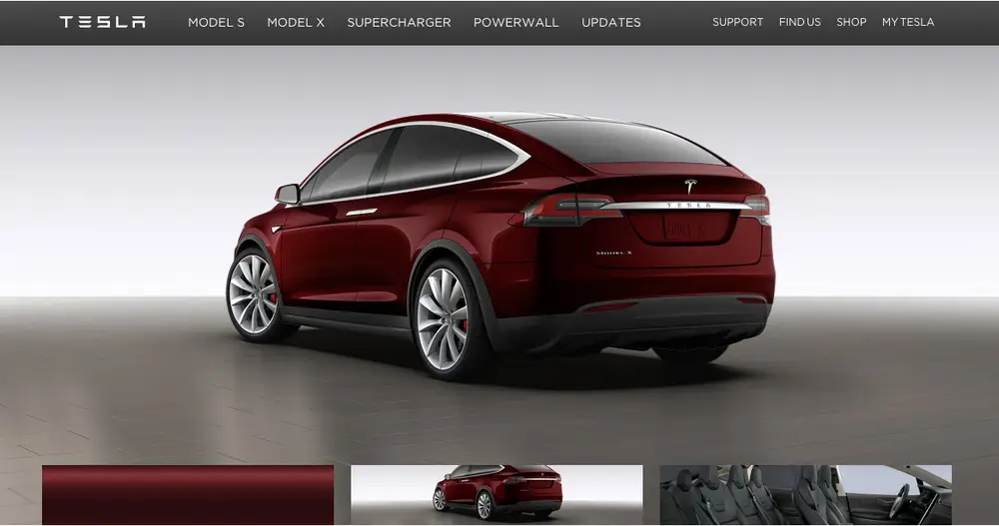
Mass customization enables small- and medium-sized businesses to provide a wider variety of unique alternatives to their customers by allowing them to design their own goods (for example, using a 3D configurator). Digital technologies are being used to replace traditional automobile sales by replacing carless with a virtual, personalized approach. Customers may use a touch screen display at a store with only two automobiles on the sales floor to customize their own vehicle. When you're ready to buy, you may do it in-store or online through Tesla's official web site.

TESLA PRICES
1. Electric Cars
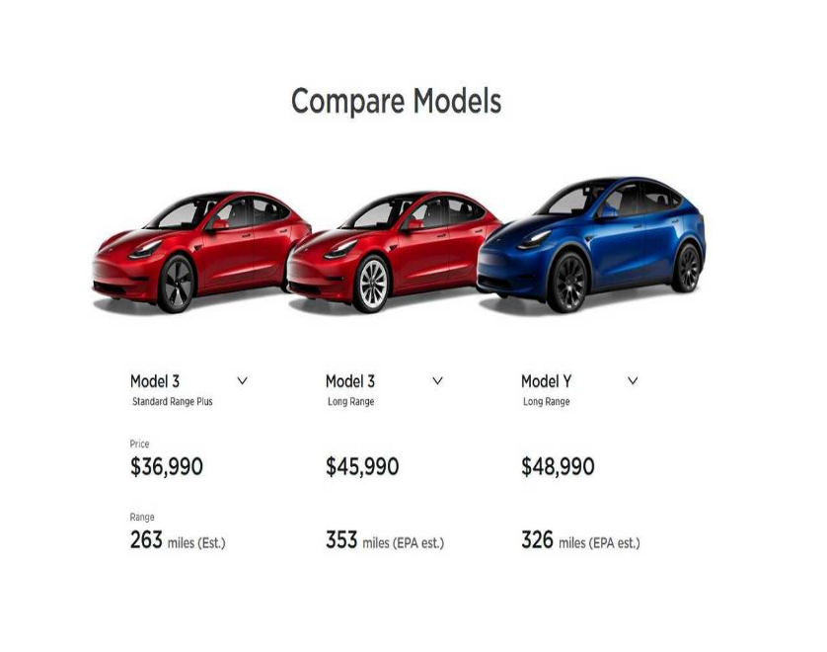
In just thirteen years, Tesla has become one of the most prominent American carmakers. Tesla is clearly the most popular electric vehicle brand, regardless of whether you're looking for a tiny sedan or an SUV.
While other automakers focused on making electric vehicles, Tesla created an iconic brand that included an entire ecosystem and a way of life. Despite the fact that its ecology has grown stronger than ever in 2022, its costs have risen steadily upward. Currently, Tesla's lowest model is the Model 3 RWD. Whether it's about the Model 3's performance, range or driving characteristics, it's been a benchmark for the industry since it debuted in 2017.
2. Solar
Reduce your reliance on the electricity grid by using solar energy to power your house. With Tesla's price match promise, you can save money on your monthly power bill by purchasing solar at the lowest price of any national supplier.
3. Clean Energy
Tesla Powerwalls are pre-installed for $8,500 and installed for between $12,000 and $16,500. (before incentives and taxes). Electricity can be generated by the Tesla Powerwall's 14 kilowatt-hour lithium-ion battery, which can power a home on its own.

Tesla Promotion
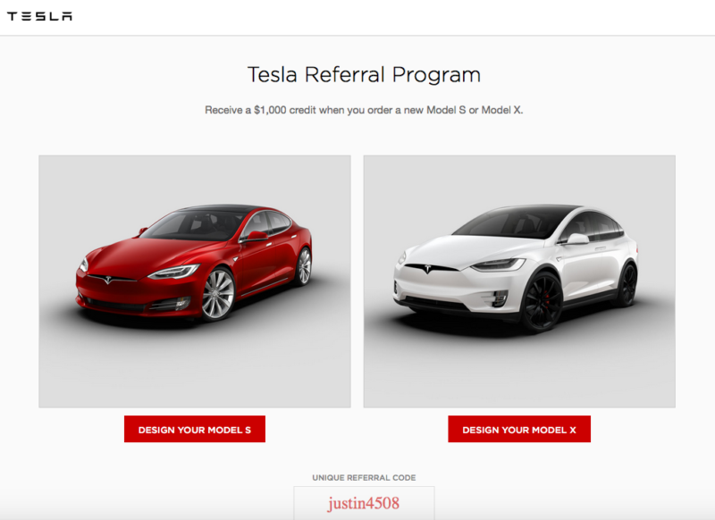
Word-of-mouth marketing is one of the most successful ways to sell a product or service which is main driving force for Tesla. Customers who spread the word about their positive experiences are rewarded through the brand's referral program. Customers rely on recommendations from people they know and trust, such as coworkers, family members, and friends, more than they do on channels controlled by brands.
There are things you can do to increase the amount of positive word-of-mouth about your business. You should begin by providing the finest possible service and products to your customers, both directly and indirectly. With a family and friends referral program and a newsletter approach that encourages supporters to spread the word about your firm, Tesla is on the road to gaining customers' confidence.

REFERENCES:
Shao, X., Wang, Q. and Yang, H., (2021) Business Analysis and Future Development of an Electric Vehicle Company--Tesla.
Tesla. (2022) Safety | Tesla. [online] Available at: <HTTPS://WWW.TESLA.COM/SAFETY> [Accessed 9 April 2022].
Tesla.com. (2022). About Tesla | Tesla. [online] Available at: <https://www.tesla.com/about> [Accessed 8 April 2022].
Zhao, T., (2021) June. Analysis of New Energy Vehicle Pricing from the Perspective of Management Economics——Taking Tesla as an Example. In 2021 2nd International Conference on Internet and E-Business (pp. 134-138).

