
BMSK4013 – Management Communication
Independent Study Workbook



This workbook is not your assignment.
The workbook does not replace the assignment brief

It is designed to support your learning and help you prepare evidence for your BMSK4013 Management Communication assignment.
Complete each section carefully and refer to the Appendices for practical activities and self-assessment tools.

Your Assignment must cover the following areas:

Communication cycle and communication models
Barriers to communication and how they can be reduced
Verbal, non-verbal, written and digital communication in the workplace
Tone, language and levels of formality in management communication
Trust, workplace conflict and conflict resolution
Motivation theories
Factors affecting workplace motivation and performance
Evaluation of your own communication skills
Feedback collected and analysed on your communication
Gap analysis and a Personal Development Plan (PDP)

Session-by-Session Content Map
Session | Core Theme | Assignment Link
1 | What is Communication? | Introduction; barriers; listening
2 | Communication Models | Communication cycle and models
3 | Verbal and Non-verbal Communication | Verbal and Non-verbal Communication, Para-linguistics, Feedback, Tactful Communication, Tone, Language and Formality. Verbal and non-verbal communication; tone, language and formality; audience awareness
4 | Trust and Conflict | Conflict and conflict resolution
5 | Difficult Communication and Communication Methods | Verbal and written methods; communication style
6 | What is Motivation? | Motivation, performance, key factors
7 | Maslow and McClelland | Motivation theories
8 | Herzberg and McGregor | Motivation theories and workplace application
9 | Communication, Self-Evaluation and PDP | Feedback, gap analysis, PDP

Introduction, Assignment and Independent Study
Effective communication is essential for effective management. It enables managers to share ideas, align goals, and motivate people toward collective success.
Duck & McMahan (2015) describe communication as a transactional process, meaning that both the sender and receiver shape its meaning through their responses and interpretations (a transaction).
This illustrates that management communication is more than issuing instructions, it is about ensuring shared understanding and commitment to get things done effectively.
In practice, clear communication improves decision-making, builds trust, and strengthens relationships. Poor communication, however, can lead to confusion, frustration, and reduced productivity. I am sure many of you have experienced this in your everyday lives.
The theories explored throughout this workbook, such as Shannon and Weaver’s (1949) Model of communication, Covey’s (2013) levels of listening, and Maslow’s (1943) Hierarchy of needs will help you recognise how theory supports good managerial practice.
Example:
A team leader explaining a new safety procedure asks colleagues to repeat the key steps back. This ‘check of understanding’ ensures that the message has been received accurately, a communication action drawn directly from communication theory.

Independent Study Expectations
You are expected to:
- Engage with credible academic sources such as textbooks, peer-reviewed journals, and professional publications. Avoid sites like Mindtools or Wikipedia in your assignment.
- Apply learning to your real or simulated workplace. This is important.
- Use APA 7th edition referencing.
Note: Completing the tasks in this workbook will generate most of the material for your final 3000-word assignment.
The workbook is not your assignment; it helps you complete your assignment.

Reflective Question
Think about a time when communication failed in your workplace.

Example: A manager sent an unclear message about shift changes, leading to confusion. How could better two-way communication have prevented this?
Answer:

Summary
Communication is a two-way process central to management effectiveness. You learned that meaning is created jointly (Duck & McMahan, 2015) and that managers must communicate
clearly, listen actively, and seek feedback (Covey, 2013) to be effective as managers or leaders.
In short, good communication does not come from just speaking. What good communication
is and how it can be used follows a set of rules, rules we can all learn and use to become more effective managers and future leaders.
The table below summarises the key learning points and their relevance to management communication.
Concept  CONCEPT WHAT IT MEANS WHY IT MATTERS | What It Means | Why It Matters in Management Communication
Transactional communication  (Duck & McMahan, 2015) | Communication is an exchange shaped by both the sender and receiver. | Reminds managers that understanding, not just delivery, defines success.
Feedback loop | Checking that messages are understood. | Ensures clarity, prevents costly mistakes.
Theory–practice link | Using theory to explain workplace behaviour. | Builds credibility in your assignment analysis. Not just expressing an unsubstantiated opinion

In your assignment:
This understanding forms the basis of your Introduction section where you define communication, explain why it matters to managers, and outline its link to motivation and performance.

Session 1: What Is Communication?
Learning focus
- Define communication and explain its importance in management.
- Explore verbal and non-verbal communication.
- Recognise common barriers to effective communication.
- Practise active and empathic listening.
1.1 Introduction
Communication is the process of creating shared meaning between people (Duck & McMahan, 2015). In management, it determines whether goals are understood, relationships are positive, and teams remain motivated.
Communication in management is about the exchange of information, ideas, and understanding between people to achieve organisational goals. It involves both verbal (spoken and written) and non-verbal (body language, gestures, tone) elements.
1.2 The Elements of Communication
Element | Example | Description
Vocal | Rate, pitch, tone | How something is said
Visual | Eye contact, posture, gestures | What is seen
Verbal | Actual words used | What is said

Mehrabian (1971) found that in situations when words, tone, and body language gave conflicting messages about feelings (for example, saying “I’m fine” with an angry tone) words account for only 7% of meaning, tone 38%, and body language 55%, showing why how we speak often matters more than what we say.
In short, people tend to trust nonverbal cues (tone 38%, body language 55%) more than the literal words (7%).

1.3 Barriers to Communication
Common barriers include:
- Environmental (noise, poor lighting)
- Linguistic (jargon, unclear vocabulary)
- Psychological (stress, emotion)
- Physiological (hearing/sight difficulties)
- Perceptual (bias, assumptions)
- Content (irrelevant or excessive information)
- Personal (attitude, confidence)

Activity 1 Barrier Analysis
List as many barriers as you can and give real examples from your own workplace.
Barrier | Example | Strategy to Overcome
Environmental | Team meetings in a noisy open office | Book quiet meeting room

1.4 Listening Levels – Covey (2013)
Covey (2013) described five levels of listening, from ignoring to empathic. Managers who listen empathically build trust and reduce conflict because they demonstrate genuine understanding.
Level | Description | Example | How to Improve
Ignoring | Not listening at all | Checking your phone while someone speaks | Remove distractions; maintain eye contact
Pretend Listening | Nods but mentally elsewhere | Saying “yeah” while thinking of something else | Summarise what was said
Selective Listening | Hearing only what interests you | Responding to one small point | Repeat key ideas before replying
Active Listening | Paying full attention | Taking notes; asking clarifying questions | Use paraphrasing  (“So what you’re saying is…”)
Empathic Listening | Understanding words and feelings | “That sounds tough – do you want to talk more?” | Reflect both content and emotion

Key Points for Better Listening
Pause before responding. Replay what has been said. Concentrate on meaning. Test understanding. Encourage flow. Avoid interrupting
Theory in Practice
During a performance meeting, a manager listens carefully to an employee’s concerns about workload, repeats the key points back, and agrees priorities. This shows active engagement and empathy, improving motivation and clarity.

Remember
Definition
“Communication is the transactional use of symbols, influenced, guided, and understood in the context of relationships.” (Duck & McMahan, 2015, p. 5)
Three Elements (Mehrabian, 1971)
(applies when feelings and being expressed and verbal and non verbal signals are in conflict)
Words – 7 % Tone – 38 % Body Language – 55 %
Listening Levels (Covey, 2013)
Ignoring → Pretend → Selective → Active → Empathic
Complete these 2 activities:

Activity 1. Define Communication
In one sentence, in your own words, describe what communication means in management.
Example: “Communication in management is the process of exchanging information clearly and respectfully to achieve shared goals.”

Answer:

Activity 2. Listening Reflection
Think of a recent conversation. Which Covey listening level did you use?
Ignoring → Pretend → Selective → Active → Empathic.
Answer:

How did it affect the outcome?
Example: “I used selective listening and missed an important detail. Practising empathic listening would have improved understanding.”
Answer:

Reflective Question
Why is listening often harder than speaking in management communication?
Example: Listening requires focus and patience.
Answer:

Summary
This section showed that communication is more than words; tone and non-verbal behaviour can carry most meaning (Mehrabian, 1971).
You also looked at Covey’s (2013) levels of listening and common barriers that affect understanding.
These can prepare you for your assignment introduction and early discussion, where you will define communication, identify barriers, and explain how good communication enhances leadership and motivation
The table below summarises the key learning points and their relevance to management communication.
CONCEPT WHAT IT MEANS WHY IT MATTERS
Mehrabian’s 7–38–55 Rule  (1971) | Most meaning is conveyed through tone and body language. | Encourages managers to match words with non-verbal cues.
Covey’s Listening Levels  (2013) | Empathic listening builds understanding and trust. | Improves feedback and reduces conflict.
Communication Barriers | Factors that block clear messaging. | Recognising barriers helps prevent errors and misunderstandings.

In your assignment: Use this section for Assignment Sections 1 & 2
Include
- definition of communication
- identify barriers
- explain how listening enhances motivation and performance.

Session 2: Communication Models
Learning focus
- Understand key communication models and how they explain workplace communication.
- Identify similarities and differences between models.
- Apply the models to management contexts.
- Reflect on which model best fits your own communication style.

2.1 Introduction
Communication models illustrate how messages are created, sent, received, and understood. They help managers recognise where meaning can be lost or distorted and how to improve clarity.
Communication models help managers understand how messages are transmitted, interpreted, and sometimes distorted.
They also show the importance of feedback, clarity, and context in ensuring messages are received as intended.
Shannon and Weaver (1949) focused on the technical transmission of messages and the effects of “noise.”
Schramm (1954) highlighted shared understanding and feedback.
Berlo (1960) explained how skills and culture affect interpretation. The Communication Cycle shows how feedback closes the loop.
Together, these models show that effective management communication combines accuracy, feedback, and adaptability.

Assignment Tip
In your assignment, for each model you use you should include:
1. What the model shows
Explain the stages or components of the model.

Key concepts
Explain important terms such as:
• encoding
• decoding
• noise
• feedback

2. Strengths
What does the model explain well?

3. Weaknesses
What does the model fail to explain?

4. Workplace example
Explain how the model relates to communication in your workplace.

2.2 The Basic Communication Cycle
Description:
A circular model in which a sender creates a message, delivers it through a channel, and receives feedback from the receiver. Communication is complete only when the receiver has understood and responded.
The Basic Communication Cycle shows how a message moves between sender and receiver through key stages:
Idea Formation | The sender develops an idea or information they want to communicate.
Encoding | The sender converts the idea into words, symbols, or gestures.
Transmission | The message is delivered through a communication channel such as speech, email, or written report.
Reception | The receiver receives the message.
Decoding | The receiver interprets the message and tries to understand its meaning.
Idea Formation | The receiver decides on what they want to reply
Feedback | The receiver responds, confirming whether the message has been understood

Reflective Questions
Think about a situation at work where communication went wrong.

Which stage of the communication cycle failed?
Idea / Encoding / Transmission / Decoding / Feedback

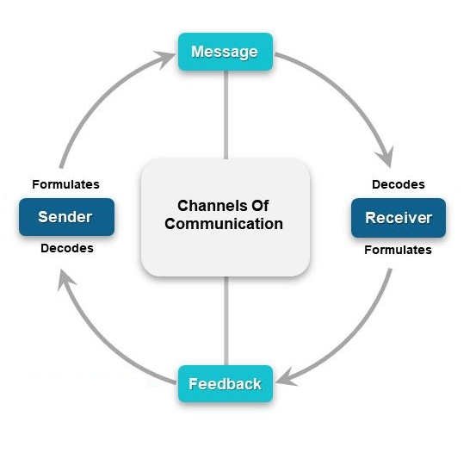
Workplace Example:
A manager explains a new procedure in a meeting.
Team members summarise key points back to the manager to confirm understanding.
Sender formulates the message: The process begins with the sender, the person who creates the message. They formulate their ideas or intentions into a clear communication.
Sender encodes the message: The sender encodes the message using language, tone, or symbols so that it can be understood by the receiver.
Message is transmitted through a channel: The encoded message is sent through a communication channel (such as speech, email, or written report). The channel is the route or medium the message travels through.
Receiver decodes the message: The receiver interprets (or decodes) the message, translating it into meaning based on their own knowledge, experience, and perception.
Receiver formulates feedback: After understanding the message, the receiver formulates feedback, a verbal or nonverbal response that shows how the message was interpreted.
Feedback is sent back through the channel: The feedback travels back to the sender using the same or a different channel, allowing two-way communication.
Sender decodes the feedback: The sender then decodes the feedback to confirm whether the original message was understood correctly.
Continuous cycle: This loop continues as both parties alternate roles as sender and receiver, ensuring that communication remains clear, effective, and complete.

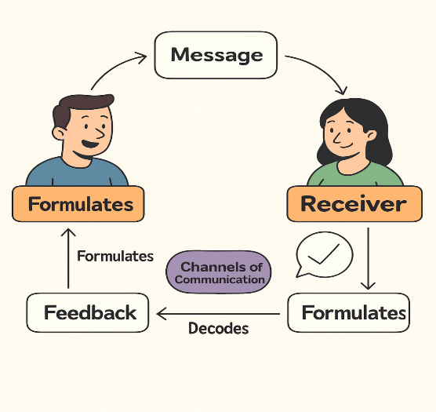

Key Term: Channel:
The medium through which the message travels for example, spoken words (in a meeting or call), written text (in an email or report), digital tools (Teams, WhatsApp, etc.), or nonverbal cues (gestures, tone, posture).

Relevance to Management Communication:
Managers could use this model when delegating tasks or checking understanding. It reminds them that communication is not finished until feedback confirms understanding.

In your assignment: Use this model when explaining the relevance of the communication cycle for effective management.

2.3 Shannon and Weaver (1949) – The Transmission Model
Description:
This model introduced the idea of noise anything that distorts the message between sender and receiver.
It includes:
- Information Source (sender)
- Transmitter (encoder)
- Channel
- Receiver (decoder)
- Destination (recipient)
- Noise Source (distraction/interference)
The model explains communication as information transmitted through a channel from a source to a receiver but emphasises the importance of noise, which interferes with the message, causing distortion or loss.
Examples:
In a virtual team meeting, poor internet connection (noise) may cause miscommunication and frustration.
Manager sends a policy update by email. Some staff miss the message because the subject line is unclear and the timing poor. The noise (preoccupied recipients and vague wording) blocks understanding.

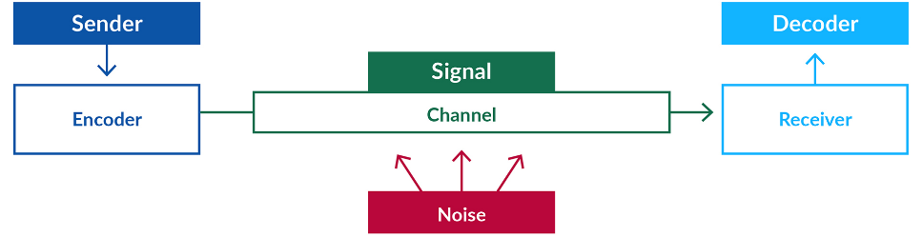
Figure 1: Shannon Weaver (1949)
Relevance to Management Communication:
Reminds managers to consider clarity, timing, and channel choice.
Removing noise ensures messages reach everyone accurately and on time.
In your assignment, Consider this model to plan clear, well-timed messages and check for understanding to see if noise has impacted understanding.

2.4. Berlo (1960) – SMCR Model (Source, Message, Channel, Receiver)
Description:
Berlo expanded the Shannon Weaver model into distinct parts. It adds human factors to communication.
The model emphasises how the sender’s and receiver’s skills, attitudes, knowledge, social system, and culture influence meaning.
Example:
A manager working with an international team avoids ‘idioms’ (terms like ‘over the moon’ ‘raining cats and dogs’
under the weather’) and uses simple language to ensure shared meaning.
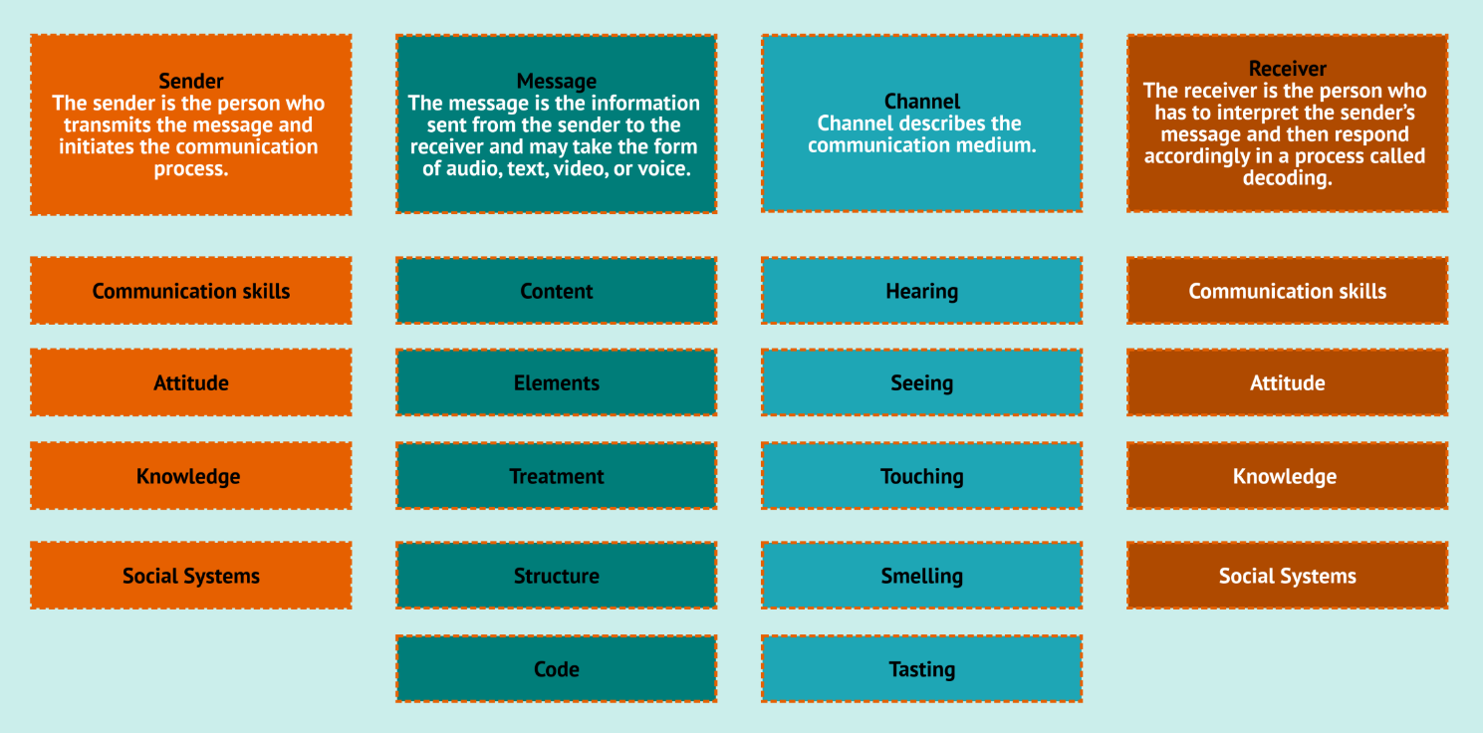
Figure 2. Berlo - SMCR Model (Source, Message, Channel, Receiver)

Relevance to Management Communication:
Shows that effective managers adapt their tone and language to different audiences to avoid misinterpretation and build inclusive teams.
In your assignment: Consider this model to encourage inclusive, audience-aware communication that takes into account the skills, attitudes, knowledge, social system and culture of the environment to create effective management communication.

2.5. Schramm (1954) – The Interactive Model
Description:
Schramm (1954) modified the Shannon-Weaver model to create a circular, more comprehensive model. The sender sends the message to a receiver, and the receiver returns feedback to the sender. The experiences of both the sender and the receiver are taken into consideration.
Schram (1954) took an earlier update to the Shannon-Weaver model (Osgood & Schramm, 1954) and expanded it to include the Field of Experience Model, stressing that successful communication occurs only when the sender’s and receiver’s experiences overlap, for example, shared background, culture, or understanding.
Views communication as a two-way process where both sender and receiver encode and decode messages within their shared field of experience.
Feedback and context are vital.
Example:
During a 1-to-1 meeting, an employee asks for clarification, and the manager rephrases until both agree. Understanding emerges through dialogue.

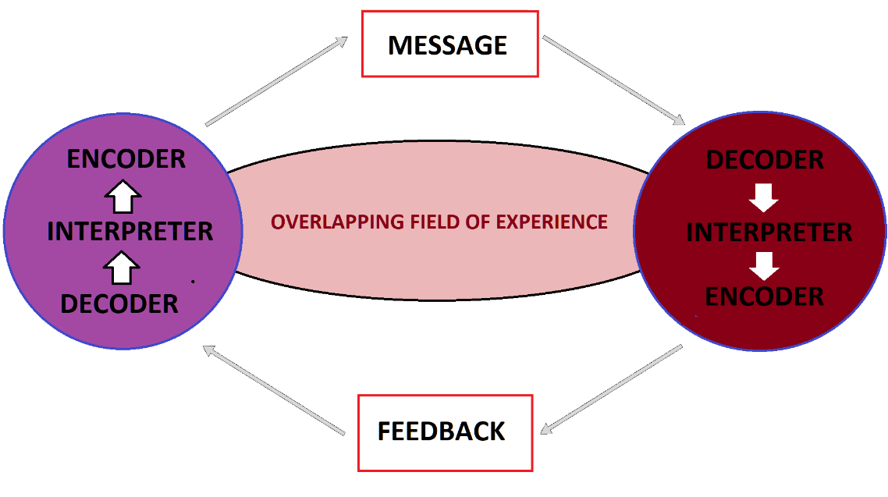
Figure 3. Schramm (1954); Interactive Model

Relevance to Management Communication:
Encourages two-way dialogue and active feedback in meetings and reviews, building trust and engagement. Encourages managers to consider the ‘overlapping knowledge or experience’ of those they are communicating with.
In your assignment: Consider this model in promoting effective two-way communication through mutual understanding of the context.

Comparative Table
Model | Main Idea | Example in Practice | Strengths | Limitations
Communication Cycle | Circular process with feedback loop | Manager delegates a task and checks understanding. | Simple and practical for instructions. | Ignores cultural and emotional factors.
Shannon & Weaver (1949) | Message transmission with potential noise. | Email lost due to vague wording or timing. | Highlights clarity and noise control. | One-way; misses feedback.
Berlo (1960) SMCR | Focus on skills, attitudes, knowledge, culture. | Multicultural team adapts language. | Considers human factors. | Lacks formal feedback stage.
Schramm (1954) | Shared understanding through feedback. | Performance review discussion. | Emphasises interaction and context and shared understanding | Complex for large teams.

Complete these 2 Activities

Activity 1. Compare and Contrast
Which two models best represent communication in your workplace?
Example: “Shannon and Weaver for our weekly newsletter (one-way). Schramm fits team meetings (two-way).”
Answer:

Activity 2.
Do any of these models fully cover how communication works in all situations?

Answer:
Explain your answer:
Answer:

Section Summary
This section explored four key models of communication and how each explains different aspects of managing messages and feedback. Understanding these models helps you analyse how communication occurs in your organisation and identify ways to improve it.
Use these models in your assignment to demonstrate your knowledge and apply the most suitable model to your workplace examples.

The table below summarises the key learning points and their relevance to management communication.
Concept | What It Means | Why It Matters  CONCEPT WHAT IT MEANS WHY IT MATTERS
Basic Communication Cycle | Communication is complete only when feedback confirms understanding. | Encourages managers to check for understanding after giving instructions.
Shannon and Weaver (1949) | Identifies how noise interferes with messages. | Helps managers plan clear, well-timed communication.
Berlo (1960) SMCR | Highlights skills, attitudes, knowledge, and culture in message delivery. | Promotes inclusive, audience-aware communication.
Schramm (1954) | Communication is two-way and based on shared understanding. | Supports feedback and dialogue in leadership communication.

.
Reflective Questions
How does understanding communication theory help you be a more effective manager?
Consider one specific change you could make to improve your workplace communication.

In your assignment: Include at least two communication models in your assignment and evaluate their relevance to your workplace.
Cite each model in APA 7th style.

Session 3:

Verbal and Non-verbal Communication, Para-linguistics, Feedback, Tactful Communication, Tone, Language and Formality

Learning Focus
In this session you will explore how verbal and non-verbal communication influence meaning in the workplace.
You will consider the importance of para-linguistics, feedback, tactful communication, tone, language and formality, and how communication should be adapted for different audiences and situations.

Link to Your Assignment
In your assignment you will need to:
• explain verbal and non-verbal communication
• discuss tone, language and levels of formality
• explain how communication should be adapted to audience and situation
• apply examples from your workplace

3.1 Para-linguistics
Para-linguistics refers to:
vocal features that add meaning to spoken communication.
This includes:
• tone of voice
• speed of speech
• volume
• pitch and intonation
• pauses and emphasis
These features can affect how a message is interpreted. For example, a manager may say the right words, but a sharp tone or impatient delivery may still create tension or confusion.
In management communication, para-linguistics matters because people often respond not only to what is said, but to how it is said.

3.2 What is Tone in Communication?
Tone refers to the attitude or emotional quality of a message.
Two messages can contain the same information but produce very different reactions depending on the tone used.
For example:
Poor tone
“You need to redo this report.”
Constructive tone
“Could you revise this report so we can improve the final version?”
Managers who communicate with a respectful and supportive tone are more likely to maintain motivation and cooperation within teams.

3.3 Language and Clarity: Formal and Informal Communication
Effective communication depends on using language that is:
• clear
• appropriate for the audience
• easy to understand
Managers should avoid:
• jargon
• overly complex language
• unclear instructions
Clear communication reduces mistakes and improves efficiency.
Example:
Unclear instruction
“Send the information later.”
Clear instruction
“Please send the information by 3pm today.”

Activity
Read this message:
“Please can you send the report by 3pm today?”
1. What is the tone of this message?
A. Aggressive
B. Polite and professional
C. Rude
D. Emotional
2. Why is this message effective?
A. It is vague
B. It uses slang
C. It is clear and gives a deadline
D. It is very informal
3. What level of formality does this message use?
A. Too informal for work
B. Fully casual
C. Appropriate workplace formality
D. Overly emotional
Assignment sentence starter
In my workplace, tone, language and formality are important because …

Reflective Question
Does tone and language need to change in different situations?
Why?
Examples?

Communication can be either formal or informal depending on the context.
Formal communication may include:
• reports
• official emails
• policies
• performance reviews
Informal communication may include:
• conversations
• team discussions
• instant messaging
Effective managers choose the correct level of formality for the situation.

Activity
Think about two communication situations in your workplace.
Situation | Formal or Informal | Why was this approach appropriate

Reflection Question
How might using the wrong tone or level of formality affect communication in your workplace?

3.4 Non-Verbal Communication
Learning Focus
Understand the importance of non-verbal communication in the workplace.

What is Non-Verbal Communication?
Non-verbal communication refers to communication without spoken words.
Examples include:
• facial expressions
• body language
• eye contact
• posture
• tone of voice
Research suggests that non-verbal signals can significantly influence how messages are interpreted.
For example, a manager who says “good work” but appears uninterested may unintentionally communicate criticism rather than praise.

Why Non-Verbal Communication Matters
In workplaces, non-verbal communication can influence:
• trust
• motivation
• relationships between colleagues
Managers must be aware of how their body language and tone affect others.

Activity
Think about a situation where body language affected communication.
Describe what happened.

What message do you think the body language communicated?

Reflection Question
How aware are you of your own body language when communicating with colleagues?

Feedback
Feedback is communication that gives someone information about their behaviour, actions, or performance.
Effective feedback should be:
• specific
• respectful
• clear
• focused on behaviour
• timed appropriately
• linked to improvement
For example, a manager is more likely to help a colleague improve by saying, “The report was clear, but the final section needs more detail,” than by saying, “This is not good enough.”
Good feedback helps improve performance, build understanding, and maintain professional relationships.

3.5 Communicating Tactfully
Managers sometimes need to communicate clearly in situations that may be sensitive or difficult.
Tactful communication means being honest and direct while still showing respect.
This may involve:
• checking assumptions before responding
• using clear and professional language
• focusing on the issue rather than the person
• avoiding unnecessary emotion
• listening carefully
• explaining consequences clearly where needed
• ending the conversation professionally
Tactful communication is important because it helps managers deal with sensitive issues without creating unnecessary conflict or defensiveness.

Link to Your Assignment
• explain verbal and non-verbal communication
• explain how tone, language and formality affect meaning
• show how communication should be adapted to different audiences and situations
• provide examples from your workplace

Session 4
Trust and Conflict in the Workplace

Learning Focus
In this session you will explore how trust influences workplace relationships and how conflict can develop when communication breaks down.
You will consider the difference between personal and professional conflict and look at practical steps managers can use to resolve conflict in a fair and professional way.

Link to Your Assignment
In your assignment you will need to:
• explain workplace conflict
• analyse its impact on performance
• describe a professional conflict resolution strategy
• apply examples from your workplace

4.1 What is Trust?
Trust is the confidence that another person will act honestly, reliably, and with respect.
In management communication, trust matters because people are more likely to listen, share concerns, accept feedback, and work together when they believe others are being truthful and fair.
Without trust, communication often becomes guarded, defensive, or unclear. This can damage relationships, reduce motivation, and make conflict harder to resolve.

4.2 Relationship Trust
Trust in working relationships does not usually appear by accident. It is built through repeated behaviours over time.

Reflection Question
What behaviours help to build trust?

Here are some examples
speaking honestly
showing respect
being transparent
correcting mistakes
showing loyalty
delivering results
taking responsibility
listening first
keeping commitments
giving trust to others where appropriate

Reflection Question
Which do you do?
Which could you improve on?

Managers who behave consistently in these ways are more likely to build strong working relationships and positive team communication.

4.3 What Can Affect Trust and Relationship Building?
A number of factors can affect how trust develops in the workplace, including:
• organisational culture
• personal values and background
• confidentiality
• social skills
• communication style
• levels of formality and informality
For example, if a manager does not keep information confidential or regularly fails to do what they said they would do, trust may quickly weaken. By contrast, clear communication and consistent behaviour can strengthen professional relationships over time.

4.4 Personal and Professional Conflict
Conflict in the workplace is not always the same. Some conflict is personal, while some is professional.
Personal conflict is conflict between people that often develops because of dislike, personality differences, or personal pressures.
Examples may include tension caused by different working styles, family stress, or emotional reactions.
Professional conflict is conflict linked to work itself.
This may happen because of:
• different goals
• shared resources
• unclear responsibilities
• dependence on other teams or colleagues
• differences in authority
• competing priorities
Understanding the difference matters because the cause of the conflict often shapes the best way to respond to it.

4.5 The Effects of Workplace Conflict
Unresolved conflict can have serious effects on individuals, teams, and organisational performance.
It can lead to:
• frustration, anger, and stress
• poor communication
• lack of teamwork
• reduced motivation
• weaker decision-making
• lower productivity
• poor quality of work
• absenteeism or lateness
Conflict can sometimes lead to useful discussion and improvement, but this is more likely when it is handled early and professionally.

4.6 Conflict Resolution
Managers should not ignore conflict and hope it disappears. A structured and fair approach is usually more effective.
A practical conflict resolution process may include the following steps:
1. Show impartial respect to all parties
Deal with the issue privately and fairly. Make it clear that the purpose is resolution, not blame.
2. Listen to both sides
Allow each person to explain the issue from their point of view. Encourage them to stay focused on the current problem.
3. Keep the focus on facts
Avoid insults, blame, or unrelated past issues. Focus on what has happened and what needs to change.
4. Agree a plan
Work towards a realistic solution that both sides understand and accept.
5. Set up a review
Arrange a follow-up conversation to check whether the solution is working and whether any further action is needed.
This approach helps keep communication professional and makes it more likely that conflict will be resolved rather than repeated.

Activity
Think about a situation in your workplace where trust was either strengthened or damaged.
Describe what happened.
Answer:

What behaviours helped to build trust, or what behaviours weakened it?

Answer:

Now think about a conflict in your workplace.
Was it mainly:
A. Personal conflict
B. Professional conflict
C. A mixture of both
What makes you say that?

Answer:

Reflective Question
How can managers use communication to build trust and reduce conflict in the workplace?

Link to assignment:
• what trust means in workplace communication
• the difference between personal and professional conflict
• the effects of conflict on performance
• a professional conflict resolution strategy
• an example from your workplace

Session 5
Difficult Communication, Personal Communication Styles and Communication Methods

Learning Focus
In this session you will explore how managers deal with difficult communication in a professional way.
You will consider how communication style affects relationships at work and examine the strengths and limitations of different communication methods used in organisations.

Link to Your Assignment
Link to assignment
• assess the effectiveness of a range of verbal and written communication methods in your workplace
• explain how communication style affects workplace interactions
• apply examples from your workplace
• evaluate what works well, what does not, and why

5.1 Difficult Communication
Managers do not always communicate in easy situations. Sometimes they have to respond to aggression, manage difficult face-to-face discussions, speak on the phone when emotions are high, or deliver bad news professionally.
Difficult communication requires clarity, control, and professionalism. If a manager reacts emotionally, becomes defensive, or avoids the issue, communication can quickly become less effective.
A more effective approach is to stay calm, focus on the issue, and respond with purpose.

5.2 Dealing with Aggression
When communication becomes aggressive, it is important to remain assertive rather than passive or aggressive in return.
Helpful approaches include:
• getting to the point clearly
• being honest about what is relevant
• responding rather than reacting
• keeping emotions under control
• listening carefully
• holding clear boundaries
Assertive communication helps managers stay professional without escalating the situation.

5.3 Face-to-Face Difficult Conversations
Some conversations are best handled in person, especially where misunderstanding, emotion, or conflict may be involved.
In face-to-face situations it can help to:
• explain the purpose of the meeting clearly
• set a professional and respectful tone
• explain the facts and the impact of the issue
• ask open questions
• break the discussion into clear stages
This gives the conversation structure and makes it easier for both sides to focus on resolution.

Reflective Question

How well (or not) do you do these?

What areas would you like to improve?

Why?

5.4 Difficult Communication by Phone
Phone communication can be effective when a quick response is needed, but it also removes visual cues such as facial expression and body language.
A useful structure for difficult phone conversations is:
• pause and listen
• clarify the issue
• reassure where appropriate
• summarise key points
• offer a solution or next step
• confirm what has been agreed
This helps reduce confusion and creates a clear record of understanding.

5.5 Delivering Bad News
Delivering bad news is part of management communication. This may involve saying no to a request, explaining a change, or giving disappointing information.
Good practice includes:
• pausing between points
• explaining clearly what can and cannot be done
• giving a brief reason
• using respectful and professional language
• offering cooperation where possible
• leaving the conversation as positively as the situation allows
Bad news should be clear, honest, and respectful. Managers should avoid vague wording, harsh language, or false reassurance.

Reflective Question

How well (or not) do you do these?

What areas would you like to improve?

Why?

5.6 Personal Communication Styles
People do not all communicate in the same way. Communication style influences how others experience us and how we respond under pressure.
Some people communicate in an assertive way, while others may lean towards passive, passive-aggressive, or aggressive behaviour.
An assertive style is usually the most effective in professional settings because it combines honesty, respect, and clarity.
Communication style can affect:
• teamwork
• trust
• conflict
• confidence in leadership
• how willing others are to speak openly
Understanding your preferred communication style can help you recognise your strengths and identify areas for improvement.

Reflective Question

How would you describe you communication style?

5.7 Communication Methods in the Workplace
Communication in organisations happens through a range of methods. These may include verbal, written, and digital forms of communication.
Examples include:
Verbal communication
• meetings
• one-to-one conversations
• briefings
• phone calls
• presentations
Written communication
• emails
• reports
• policies
• notes
• letters
Digital communication
• video meetings
• messaging systems
• collaborative platforms
Managers need to choose the right method for the situation. The most effective method depends on the purpose, urgency, complexity, and audience.
For example, a complex issue may be better discussed in a meeting, while a simple update may be more effective by email.

5.8 Choosing the Right Communication Method
No communication method is always best. Each has advantages and disadvantages.
A meeting may allow discussion and immediate feedback, but it can take time and may not create a permanent record.
An email creates documentation and can be shared easily, but tone may be misread and questions may not be answered immediately.
A phone call can deal with urgent issues quickly, but there is less visual information and no automatic written record.
Effective managers think carefully about:
• urgency
• need for detail
• sensitivity of the issue
• number of people involved
• whether a record is needed
• whether questions or discussion are likely

Activity
Think about a difficult communication situation in your workplace.
What type of situation was it?
A. Aggression
B. Face-to-face discussion
C. Phone conversation
D. Delivering bad news
E. Other

Answer:

How was the situation handled?

Answer:

What was done well, and what could have been improved?

Answer:

Now list four communication methods used in your workplace.
Method | Advantages | Disadvantages | When it is most appropriate

Reflective Question
Which communication method works most effectively in your workplace, and why?

Link to assignment
Use this section when discussing communication methods and professional communication in the workplace.
Include:
• examples of difficult communication in management
• how communication style can affect workplace relationships
• a range of verbal and written communication methods in your organisation
• the advantages and disadvantages of different methods
• examples of when each method is most appropriate

Session 6
What is Motivation? Intrinsic and Extrinsic Motivation, Factors Affecting Motivation and Performance

Learning Focus
In this session you will explore what motivation means and why it matters in the workplace.
You will consider the difference between intrinsic and extrinsic motivation and examine the factors that can influence employee motivation and performance.

Link to Your Assignment
• explain what motivation is
• explain the difference between intrinsic and extrinsic motivation
• evaluate factors that affect motivation and performance in the workplace
• apply examples from your workplace

6.1 What is Motivation?
Motivation is the driving force behind behaviour. It helps explain why people act, persist, and put effort into tasks.
In the workplace, motivation affects how employees approach their work, how much effort they put in, and how likely they are to stay engaged when tasks become difficult.
Motivated employees are often more likely to:
• put effort into their work
• communicate positively with others
• cooperate with colleagues
• stay focused on goals
• perform more effectively
Managers need to understand motivation because communication, leadership, and performance are all influenced by what drives people to act.

6.2 Intrinsic and Extrinsic Motivation
Intrinsic motivation comes from within the individual. A person is motivated because they enjoy the task, find it meaningful, or gain satisfaction from doing it well.
Examples may include:
• enjoying solving problems
• taking pride in doing a job well
• wanting to improve personal skills
• feeling satisfied by helping others
Extrinsic motivation comes from outside the individual. A person is motivated by external rewards, pressure, or consequences.
Examples may include:
• salary
• bonuses
• deadlines
• praise from a manager
• promotion opportunities
• fear of negative consequences
Both forms of motivation can influence behaviour. In many workplaces, people are motivated by a mixture of both.

6.3 Why the Difference Matters
Understanding the difference between intrinsic and extrinsic motivation is important because the type of motivation may affect the quality and consistency of performance.
For example, an employee who is intrinsically motivated may continue to perform well because they value the work itself. An employee who is mainly extrinsically motivated may work hard when rewards, deadlines, or supervision are present, but may lose momentum without them.
Neither type is automatically better in every situation. However, managers often need to think carefully about balance. Over-reliance on external pressure may create compliance, but it may not always create commitment.

6.4 Needs, Values and Goals
Motivation is also influenced by a person’s needs, values, and goals.
Needs are basic psychological or practical drivers such as security, belonging, achievement, or recognition.
Values are the things people believe matter, such as fairness, responsibility, family, independence, or professionalism.
Goals are the outcomes people are working towards, such as promotion, stability, qualifications, development, or improved performance.
Two employees may appear to be working towards the same goal, but for different reasons. One person may want promotion because they value achievement. Another may want it for financial security. This is why motivation should not be treated as the same for everyone. This reflects the Session 6 slide material on needs, values, and goals as key dimensions of motivation.

6.5 Factors Affecting Motivation and Performance
A number of workplace factors can influence motivation and performance. These may vary between organisations, teams, and individuals.
Common factors include:
• job satisfaction
• recognition and reward
• leadership and management style
• opportunities for development
• work environment
• autonomy
• relationships at work
• work-life balance
• clear goals and expectations
• organisational culture and values
For example, employees may feel more motivated when they are recognised for good work, trusted to use initiative, and supported by managers who communicate clearly. By contrast, poor communication, unclear expectations, lack of recognition, or a negative working environment may reduce both motivation and performance.
This fits the assignment requirement to evaluate the principal factors that may affect workplace motivation and performance.

6.6 Motivation and Performance
Motivation and performance are linked, but they are not exactly the same thing.
A motivated employee is often more willing to put effort into their work, but performance can still be affected by other issues such as:
• lack of training
• poor communication
• unclear systems
• inadequate resources
• conflict
• weak management support
This means managers should avoid assuming that poor performance is always caused by a lack of motivation. Sometimes performance problems are caused by barriers in the workplace rather than unwillingness.

Workplace Example
In one workplace, an employee may be motivated by the satisfaction of helping customers and doing the job well. This would reflect intrinsic motivation.
In another example, an employee may focus strongly on meeting targets because their performance is linked to bonus payments or promotion. This would reflect extrinsic motivation.
In practice, many employees experience both at the same time. A manager who understands this is better able to communicate effectively, encourage performance, and support staff in different ways.

Activity
Think about your own workplace.
Identify four things that ‘motivate’ people in your organisation.
Example | Intrinsic or Extrinsic? | How might it affect performance?
Now think about one factor that appears to ‘reduce motivation’ in your workplace.
Answer:

How does it affect communication or performance?

Answer:

Reflective Question
Do people in your workplace seem to be motivated more by internal satisfaction or by external rewards?

Link to assignment
Include:
• a clear explanation of motivation
• the difference between intrinsic and extrinsic motivation
• examples from your workplace
• factors that affect motivation and performance
• links between motivation, communication, and workplace effectiveness
Session 7
Motivation Theories: Maslow and McClelland
Learning Focus
Explore key theories that explain what motivates people at work.

7.1 Maslow’s Hierarchy of Needs

Overview
Maslow (1943) proposed that human behaviour is motivated by a series of needs arranged in a hierarchy. According to this theory, individuals must satisfy lower-level needs before they become motivated by higher-level needs.
Maslow suggested five levels of needs that influence motivation.

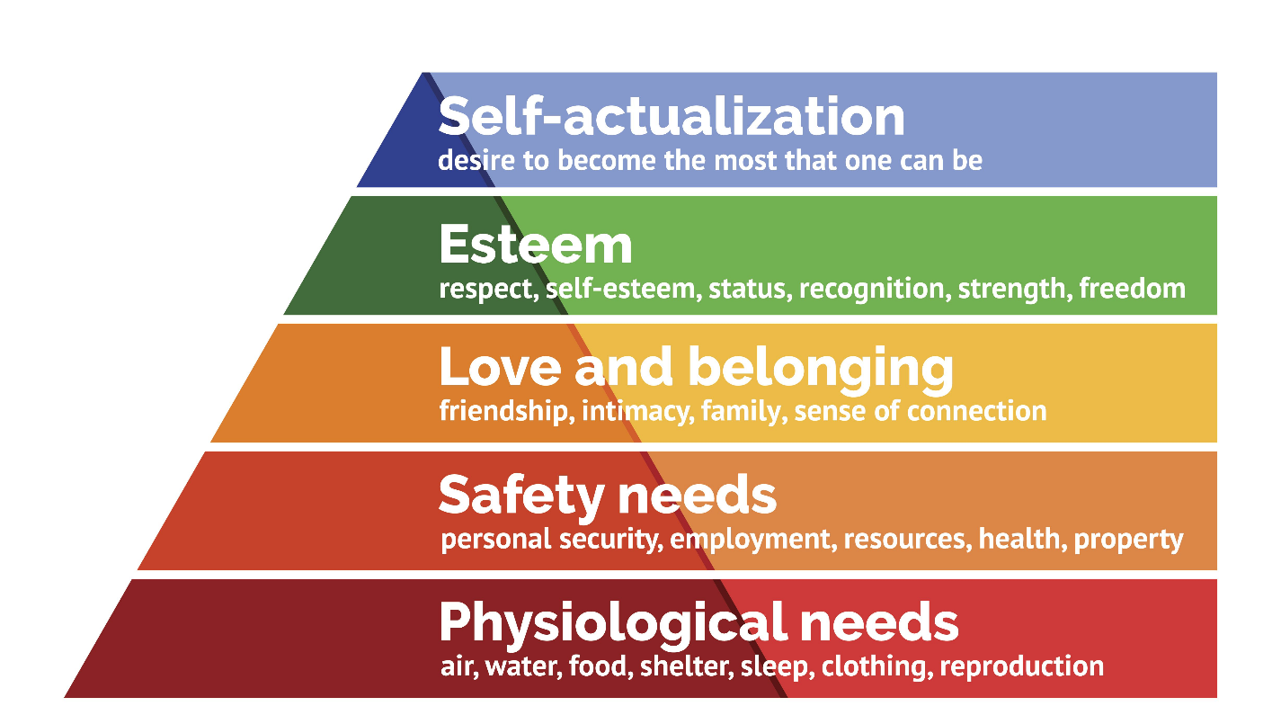

Maslow’s Five Levels of Needs

Physiological Needs
These are the most basic needs required for survival.
Examples include:
• food
• rest
• income to support basic living
In the workplace this often relates to salary and working conditions.

Safety Needs
Once basic needs are met, individuals seek security and stability.
Examples include:
• job security
• safe working environments
• stable employment

Social Needs
Individuals want to feel part of a group and develop relationships.
Examples include:
• teamwork
• positive relationships with colleagues
• belonging within an organisation

Esteem Needs
Individuals seek recognition and respect from others.
Examples include:
• praise
• promotion
• professional recognition

Self-Actualisation
This is the desire to achieve personal potential and growth.
Examples include:
• career development
• learning opportunities
• challenging work

Workplace Example
In organisations employees may be motivated by different needs.
For example, new employees may initially focus on job security and financial stability.

Once these needs are satisfied, they may become more motivated by recognition, responsibility and career development opportunities.
Managers who understand these needs can communicate more effectively and support employee motivation.

Activity

Think about employees in your workplace.

Which level of Maslow’s hierarchy do you think motivates them most?

Level of Need | Example from Workplace

Reflection Question

Giving examples, how could managers support employees at different levels of Maslow’s hierarchy? (example / level)

Link to Your Assignment

If you include Maslow’s theory in your assignment you should:
• explain the hierarchy of needs
• describe the five levels
• apply the theory to your workplace
• explain how motivation influences performance

7.2 McClelland’s Theory of Needs

Overview
McClelland (1961) proposed that individuals are motivated by three main psychological needs.

These needs influence behaviour and motivation in the workplace.

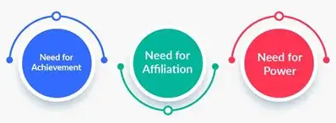

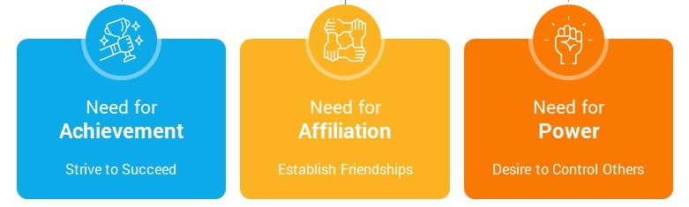

Need for Achievement

Individuals with a strong need for achievement are motivated by success and accomplishment.

They often:

• set challenging goals
• seek feedback on performance
• enjoy solving problems

Need for Affiliation

Individuals with a strong need for affiliation value relationships and cooperation.

They often:

• prefer teamwork
• enjoy social interaction
• seek positive relationships with colleagues

Need for Power

Individuals with a strong need for power want to influence others and control outcomes.
This need can be positive when used to guide teams and support organisational goals.

They often:

• take the lead in group situations
• enjoy influencing decisions
• want responsibility and authority

Workplace Example

In organisations employees often display different motivational needs.

For example, one employee may be motivated by achieving targets, another may value teamwork and relationships, while another may be motivated by leadership and influence.

Understanding these needs can help managers communicate more effectively and allocate roles that suit individual motivations.

Activity

Think about three colleagues in your workplace.

Which motivational need best describes each person?

Person 1 | Achievement Affiliation Power
Person 2 | Achievement Affiliation Power
Person 3 | Achievement Affiliation Power

Reflection Question

How could managers adapt communication and leadership styles to motivate people with different needs?

Link to Your Assignment

If you use McClelland’s theory you should:

• explain the three motivational needs
• apply the theory to employees in your workplace
• explain how these needs influence performance

Session 8
Herzberg and McGregor

Learning Focus
In this session you will explore two further theories of motivation and consider how they help explain employee behaviour in the workplace.
You will examine Herzberg’s Two-Factor Theory and McGregor’s Theory X and Theory Y, and apply both ideas to workplace practice.

Link to Your Assignment
In your assignment you will need to:
• explain motivation theories relevant to your workplace
• evaluate how motivation affects performance
• apply theory to workplace examples
• select and apply a theory of motivation to your workplace
8.1 Herzberg’s Two-Factor Theory

Overview
Herzberg (1959) developed the Two-Factor Theory to explain what causes job satisfaction and dissatisfaction in the workplace.

He suggested that two different types of factors influence motivation.

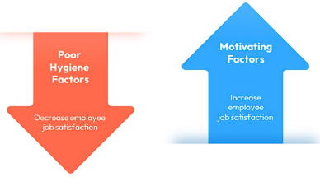

Hygiene Factors

Hygiene factors are conditions that prevent dissatisfaction but do not necessarily motivate employees.
Examples include:
• salary
• working conditions
• company policies
• job security
• supervision
If these factors are poor, employees may feel dissatisfied.
However, improving these factors does not automatically increase motivation.

Motivators

Motivators are factors that encourage employees to perform well and feel satisfied with their work.
Examples include:
• achievement
• recognition
• responsibility
• opportunities for development
• meaningful work
These factors can increase engagement and performance.

Workplace Example

An employee may receive a competitive salary and good working conditions, which prevents dissatisfaction. However, if the job lacks opportunities for development or recognition, motivation may still remain low.

Managers can increase motivation by recognising achievements and providing opportunities for responsibility and growth.

Activity

Identify examples of hygiene factors and motivators in your organisation.

Hygiene Factors

Motivators

Reflection Question

Which factors appear to influence motivation the most in your workplace?

Link to Your Assignment

If you use Herzberg’s theory you should:

• explain hygiene factors and motivators
• apply the theory to your workplace
• explain how these factors influence employee performance

8.2 McGregor’s Theory X and Theory Y

Overview

Douglas McGregor (1960) proposed that managers’ assumptions about employees influence how they manage and communicate with staff.
He suggested two contrasting management perspectives known as Theory X and Theory Y.

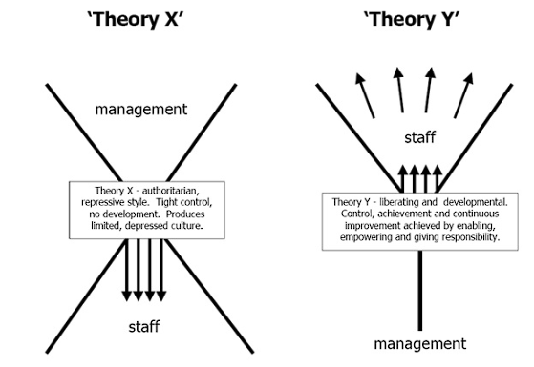

Theory X

Theory X assumes that employees:

• dislike work
• avoid responsibility
• require supervision
• must be directed to complete tasks

Managers who follow Theory X often use strict supervision and detailed instructions.
Communication in these environments is typically top-down, where managers give instructions and employees follow them.

Theory Y

Theory Y assumes that employees:

• are capable of self-direction
• enjoy responsibility
• are motivated to contribute to organisational goals
• can be creative and innovative

Managers who follow Theory Y encourage participation, teamwork and open communication.

Workplace Example

In some organisations managers closely monitor employees and make most decisions themselves. This reflects Theory X assumptions.

In other organisations employees are encouraged to contribute ideas and take responsibility for tasks. This reflects Theory Y thinking.

These different approaches influence communication, motivation and workplace culture.

Activity

Which management approach best describes your workplace?

Management Style | Evidence from Workplace
Theory X
Theory Y

Reflection Question

How might management beliefs about employees influence communication and motivation?

Link to Your Assignment

If you include McGregor’s theory in your assignment you should:

• explain Theory X and Theory Y
• apply the theory to your workplace
• explain how management style affects motivation and performance

8.3 Comparing Motivation Theories

Different motivation theories explain employee behaviour in different ways.
Some focus on human needs, while others focus on management style or workplace fairness.

Understanding these differences helps managers decide how to motivate employees effectively.

Theory | Key Idea | What Motivates Employees | Strengths | Limitations
Maslow (1943) | People are motivated by a hierarchy of needs. | Progression through five levels of needs (physiological, safety, social, esteem, self-actualisation). | Easy to understand and widely recognised. Helps managers consider different employee needs. | People do not always move through needs in order. Different individuals may value needs differently.
Herzberg (1959) | Job satisfaction and dissatisfaction come from different factors. | Motivators (achievement, recognition, responsibility) increase satisfaction. Hygiene factors (salary, conditions) prevent dissatisfaction. | Helps managers focus on job design and meaningful work. | Some factors may act as both motivators and hygiene factors depending on the individual.
McGregor (1960) | Managers’ beliefs about employees influence leadership style. | Theory X assumes employees need control. Theory Y assumes employees are self-motivated. | Highlights the impact of leadership style on motivation and communication. | May oversimplify management behaviour, as most organisations use a mix of both styles.
McClelland (1961) | People are motivated by different psychological needs. | Need for achievement, affiliation, and power influence behaviour. | Recognises individual differences in motivation. Useful for leadership and management development. | Difficult to measure these needs accurately in practice.

Activity:

Comparing Motivation Theories

Review the four motivational theories detailed.

Answer the following questions.

- Which motivation theory best explains behaviour in your workplace?

- Which theory do you think managers use most often?

- Which theory do you think is the most effective for motivating employees?

Write a short paragraph explaining your answers.

Reflection Question
How might different employees respond differently to these motivational approaches?

Link to Your Assignment

In your assignment you should:

• explain at least one or two motivation theories
• apply them to your workplace
• explain how motivation affects performance

You may also compare theories to show deeper understanding.

Example sentence starter:
“Maslow’s theory focuses on … whereas Herzberg’s theory …

Session 9
Communication and Motivation, Self-Evaluation, Gap Analysis and Personal Development Plan

Learning Focus
In this session you will explore how communication can influence motivation in the workplace.
You will also evaluate your own communication skills, identify strengths and areas for improvement, and begin to develop a Personal Development Plan based on feedback and gap analysis.

Link to Your Assignment
• explain how communication affects motivation in the workplace
• develop criteria to evaluate your own communication skills
• collect and analyse feedback on your communication
• identify strengths and areas for improvement
• complete a gap analysis
• produce a SMART Personal Development Plan (PDP)

9.1 Communication and Motivation
Communication plays an important role in motivation. The way managers speak, listen, explain expectations, and involve employees in decision-making can influence how motivated people feel at work.
Clear and effective communication can help to:
• build trust
• improve relationships
• reduce uncertainty
• increase involvement
• support employee development
• improve performance
Poor communication can have the opposite effect. If employees are unclear about expectations, feel ignored, or do not receive useful feedback, motivation may begin to fall.

9.2 How Communication Can Improve Motivation
In the workplace, communication can support motivation in several ways.
Information
Employees are more likely to feel secure and involved when they receive important information clearly and at the right time.
Relationships
Open and honest communication helps build stronger relationships between managers, employees, and teams.
Decision-making
Employees are often more motivated when they feel their views are listened to and when they can contribute ideas.
Improvement
Constructive communication between managers and staff can support learning, training, and development.
This means communication is not separate from motivation. In many workplaces, it is one of the main ways motivation is shaped and maintained. This follows the Session 9 slide content directly.

Reflection Question

How do others motivate you or demotivate you through their communication at work?

9.3 Evaluating Your Own Communication Skills
Managers need to evaluate their own communication skills, not just the communication of others.
Self-evaluation involves identifying what you do well, where communication problems occur, and what needs to improve. This should be based on evidence rather than guesswork.
To do this, you first need suitable criteria.
Examples of criteria for effective communication may include:
• clarity
• listening skills
• professionalism
• confidence
• tone
• respect for others
• ability to adapt to the audience
• written accuracy
• handling difficult conversations
• giving and receiving feedback
These criteria can then be used to design a questionnaire or feedback tool.

9.4 Collecting Feedback
One way to evaluate your communication is to ask other people for feedback.
This may involve asking colleagues, managers, peers, or others who know your communication style to respond to a short questionnaire.
Example of areas they may consider:
• Does this person communicate clearly?
• Do they listen effectively?
• Are instructions easy to understand?
• Do they remain professional in difficult situations?
• Do they adapt their communication to different people and situations?
Collecting feedback helps you compare your own view of your communication with how others experience it.
This is important because communication is not just about intention. It is also about how messages are received and understood.

9.5 Analysing Feedback
Once feedback is collected, it needs to be analysed.
You should look for:
• repeated strengths
• repeated weaknesses
• any surprises
• differences between your self-view and others’ views
• patterns across verbal and written communication
For example, feedback may show that you are seen as approachable and clear in conversation, but that your written communication lacks detail or structure. This would help identify where improvement is needed.
The assignment materials expect students not just to collect feedback, but to analyse it and use it to evaluate their own communication.

9.6 Gap Analysis
A gap analysis helps identify the difference between your current communication ability and the level of communication needed for your role or future development.
This can be useful because it turns general reflection into a more practical form of self-assessment.
A simple gap analysis may look at:
• what you do well now
• what needs to improve
• what effective communication in your role requires
• what actions are needed to close the gap
For example, you may currently communicate well in informal discussions, but need to improve confidence in difficult conversations or improve clarity in written reports.

9.7 Personal Development Plan (PDP)
A Personal Development Plan is used to turn self-evaluation into action.
It should focus on realistic goals linked to your feedback and gap analysis.
A good PDP should use the SMART framework.
Specific
The goal should clearly state what you want to improve.
Measurable
You should be able to see whether progress is being made.
Achievable
The goal should be realistic.
Relevant
The goal should connect to your communication needs or role.
Time-bound
The goal should include a review point or deadline.

Example of a SMART Communication Goal
Goal: Improve clarity when giving verbal instructions in team meetings.
Specific: I will prepare key points before each meeting and summarise instructions clearly at the end.
Measurable: I will ask colleagues to confirm their understanding and review whether fewer follow-up questions are needed.
Achievable: This is realistic because it only requires a short period of preparation before meetings.
Relevant: This is relevant because unclear instructions can lead to mistakes and confusion.
Time-bound: I will review my progress after six weeks.

Activity
Think about your own communication skills.
Write down three strengths in your communication.

Answer:

Write down three areas that may need improvement.

Answer:

Now think about what feedback from other people might reveal.
What do you think they would say are your main strengths?

Answer:

What do you think they might identify as areas to improve?

Answer:

Complete the gap analysis table below.
Activity -Complete a Gap Analysis for 3 communication skills you want to improve

Skill | Current Ability | Gap  (What needs to happen) | Required Ability

Now identify three possible PDP goals

Reflective Question
How could improving your communication skills benefit your current or future role?

Link to assignment

• how communication affects motivation in the workplace
• criteria used to evaluate your communication
• summary of feedback collected
• strengths and areas for improvement
• a gap analysis
• a SMART Personal Development Plan

Check
Before submitting, check that you have included:
Introduction
Communication models
Communication barriers
Communication methods
Motivation theory
Conflict discussion
Communication evaluation
Feedback analysis
Gap analysis
SMART PDP
At least 10 references

How the Workbook Supports Your Assignment

BMSK4013 Assignment Structure
This workbook is designed to support the teaching of the module and help you prepare for your assignment.
Each session links to a different part of the report. By completing the activities, reflections, and examples in each section, you are already beginning to develop ideas, workplace examples, and evidence that can be used later in your written assignment.
The workbook does not replace the assignment brief. It is a learning and preparation tool that helps you build the content, understanding, and examples needed for your final report.

Workbook Session | Topic | What You Will Write
Session 1 | What is Communication? | Define communication, explain why it matters in management, and identify barriers and listening issues that affect workplace communication.
Session 2 | Communication Models | Explain the communication cycle and key communication models, compare them, and apply them to your workplace.
Session 3 | Verbal and Non-verbal Communication, Para-linguistics, Feedback, Tactful Communication, Tone, Language and Formality | Explain verbal and non-verbal communication, discuss tone, language and formality, and show how communication should be adapted for different audiences and situations.
Session 4 | Trust and Conflict | Explain trust in workplace communication, discuss personal and professional conflict, analyse the effects of conflict, and describe conflict resolution in practice.
Session 5 | Difficult Communication, Personal Communication Styles and Communication Methods | Assess different verbal and written communication methods used in your organisation, explain your communication style, and discuss how difficult communication situations should be handled.
Session 6 | What is Motivation? Intrinsic and Extrinsic Motivation, Factors Affecting Motivation and Performance | Define motivation, explain intrinsic and extrinsic motivation, and evaluate the main factors that affect motivation and performance in the workplace.
Session 7 | Maslow and McClelland | Explain key motivation theories and apply them to examples from your workplace.
Session 8 | Herzberg and McGregor | Continue evaluating motivation theories, compare their strengths and weaknesses, and apply a selected theory to your workplace.
Session 9 | Communication and Motivation, Self-Evaluation, Gap Analysis and PDP | Explain how communication affects motivation, evaluate your own communication skills, analyse feedback, complete a gap analysis, and produce your Personal Development Plan (PDP).

Important
The workbook follows the taught session order and is designed to help you prepare material for your assignment. However, you should still use the assignment brief and checklist when planning and reviewing your final report to make sure that all required sections are fully covered.

BMSK4013 Final Assignment Checklist
Before you submit your assignment, check that you have included all of the following.

Report Structure
□ Title page
□ Name, student ID, module code
□ Automatic table of contents
□ Clear headings and page numbers
□ Introduction
□ Conclusion
□ Reference list
□ Appendices
□ Professional report format

Communication
□ Communication defined
□ Importance of communication in management explained
□ Communication cycle explained
□ At least two communication models explained and compared
□ Key communication barriers identified and discussed
□ Verbal and non-verbal communication explained
□ Tone, language, and formality discussed
□ Range of verbal and written communication methods assessed, including advantages, disadvantages, appropriateness, and workplace use
□ Workplace examples used throughout

Trust, Conflict and Motivation
□ Trust in workplace communication explained
□ Workplace conflict explained
□ Effects of conflict on performance discussed
□ Conflict resolution approach described
□ Motivation defined
□ Intrinsic and extrinsic motivation explained
□ Factors affecting motivation and performance discussed
□ Motivation theories explained and applied to the workplace

Self-Evaluation and Development
□ Criteria for effective communication identified
□ Own communication strengths identified
□ Own communication areas for improvement identified
□ Feedback collected and analysed
□ Gap analysis completed
□ SMART Personal Development Plan included

Referencing and Final Checks
□ Credible sources used
□ APA 7 in-text citations used correctly
□ APA 7 reference list included
□ Theory linked to workplace throughout
□ Discussion is analytical, not only descriptive
□ Spelling, grammar, and punctuation checked
The workbook does not replace the assignment brief

