LCBB4005
The Global Business Environment
Assessment 02: Environmental analysis of an industry
Student name: Raul Trif
Student number: 2030167

Table of Contents
Introduction 3
Overview of the company 4
Analysing the impact of the pandemic on automobile industry 4
The development of the survival and success factors of the automobile industry 6
Exploring timely information and relevant newsletters from Aston Martin 8
Conclusion 10
References 11

Introduction
A spectrum of organisations of manufacturing and selling self-powered vehicles, including cars, trucks, passengers cars, firm equipment, and other commercial vehicles is known as the automobile industry that also includes the development, design, producing, promoting, and selling of motor vehicles. The major aim of the report is to analyse the pandemic impact of a pandemic on the automobile industry, develop the survival and success factors of the automobile industry and explore different information regarding this industry. For this report, the chosen company is named “Aston Martin” which is is an independent producer of luxury sports cars and grand tourers in the United Kingdom. Firstly, the impact of the pandemic on the automobile industry has been analysed in the report. There are different factors that have been considered as the survival and success factors of the automobile industry. Then, the development of the survival and success factors have been demonstrated in the report. At the least, the timely information and newsletters from Aston Martin have been explored in the report.

Overview of the company
Aston Martin is an iconic luxury car manufacturer in the United Kingdom that has been chosen for the report. It is an independent producer of luxury sports cars and grand tourers in the United Kingdom. The company's predecessor has been founded by Lionel Martin and Robert Bamford on 15th January 2015 and the headquarters of the company has been situated at Gaydon in the United Kingdom. According to Statista (2020), the annual revenue of Aston Martin is £ 611.8 million GPB. The company was founded at the beginning of world war one and fought against financial difficulties and the pressures of producing hand-crafted cars in an industry powered by mass production and it is fully owned by Ford in 1993 (Chang, 2017).
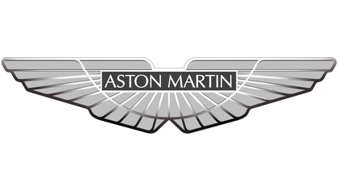
Figure-01: Aston Martin (Astonmartin.com. 2021)

Analysing the impact of the pandemic on the automobile industry
A spectrum of organisations of manufacturing and selling self-powered vehicles, including cars, trucks, passenger’s buses, firm equipment, and other commercial vehicles is known as the automobile industry that also includes the development, design, producing, promoting, and selling of motor vehicles (Eilert, 2017). The industry plays a crucial role in the economy and industrial development of the United Kingdom and the company also supports some industries like steel, metal, plastic, petrochemicals, rubber, glass, and so on by purchasing them. The entire earth has faced a challenge that is named the “COVID-19” pandemic that has impacted all the sectors of a country (Chang, 2017). The industry has been affected swiftly and severely by the COVID-19 pandemic. The impact of the COVID-19 pandemic on the automobile industry has been demonstrated below:
- Disrupting in importing raw materials: Due to the pandemic, the lockdown situation has appeared in the world for a long time. That’s the reason, many popular organisations like Aston martin have failed to import raw materials that have been badly affected their production activities and operational activities (Kumar, 2016). The main exporter of raw materials of the automobile industry in China has been under the lockdown situation for a long time. That’s the reason, many countries like the United Kingdom couldn’t able to export raw materials from China. Aston Martin also fails to import raw materials from China due to the pandemic.
- Facing financial difficulties: Another brutal impact on the automobile industry of the pandemic situation is that many popular organisations have been faced a financial crisis. Due to the pandemic situation, business operations have been stopped for a long time (Smys, 2019). That’s the reason, the organisations of automobile industries have to face unexpected losses and financial crises. Aston Martin has to face unexpected losses.
- Reducing demands: The demand for luxury cars has been reduced rapidly due to the pandemic situation. The entire earth has faced a challenge that is named the “COVID-19” pandemic that has impacted all the sectors of a country (Guajardo, 2016). The financial capability of all people has been affected by the pandemic. In this crisis moment, people are not willing to spend a lump sum of money that is another pessimistic effect of the pandemic on the automobile industry. The demand for the Aston Martin has been decreased to due to the pandemic.
- Firing employees: One of the adverse impacts of the pandemic situation is firing employees. Due to the pandemic situation, business operations have been stopped for a long time (Chang, 2017). That’s the reason, the organisations of automobile industries have to face unexpected losses and financial crises. To cut the losses, few automobile organsiation has to fire their employees.
- Impacting adversely on the overall economy of the United Kingdom: The automobile industry plays a crucial role in the economy and industrial development of the United Kingdom and the company also supports some industries like steel, metal, plastic, petrochemicals, rubber, glass, and so on by purchasing them. “In April 2020, the first full month of lockdown in the UK, new vehicle registrations nearly disappeared, dropping 97% year-on-year”.

The development of the survival and success factors of the automobile industry
There are different factors that have been considered as the survival and success factors of the automobile industry. A spectrum of organisations of manufacturing and selling self-powered vehicles, including cars, trucks, passengers cars, firm equipment, and other commercial vehicles is known as the automobile industry that also includes the development, design, producing, promoting, and selling of motor vehicles (Eilert, 2017). The industry plays a crucial role in the economy and industrial development of the United Kingdom and Aston Martin is an iconic luxury car manufacturer in the United Kingdom that has been chosen for the report. It is an independent producer of luxury sports cars and grand tourers in the United Kingdom. The survival and success factors of the automobile industry that needs to be developed have been discussed below:
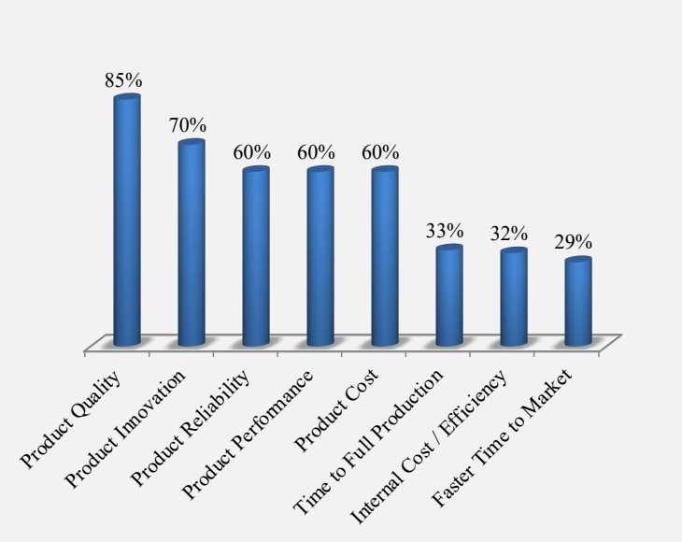
Figure-02: Survival and success factors (Ortiz-Villajos, 2018)
- Quality of the product: Product quality in the automobile industry can be defined as the ability of the vehicle to fulfill its desired functions and behaviour like engine efficiency, product features, and environmental exhaust standards. To survive and succeed in the automobile industry, an organisation needs to ensure the quality of the product like Aston Martin.
- Innovativeness of the product: Product innovation in the automobile industry can be defined as the acquaintance of a product or service which is new or significantly improved concerning its features or intended uses (Guajardo, 2016). The innovativeness of the product attract consumers. To survive and succeed in the automobile industry, an organisation needs to ensure the innovativeness of the product like Aston Martin.
- Reliability of the product: “Product reliability refers to the estimation that a good, method or service will perform its intended function adequately for a specified period, or will operate in a defined environment without failure” (Smys, 2019). The reliability of the product is another survival factor for an organisation. Aston Martin ensures the reliability of the product (Astonmartin.com. 2021).
- Product Performance: “The performance of the vehicles exhibits above-average abilities in one or more of the following areas like acceleration, top speed, cornering, and braking. It is debated how much performance is required to move classification from standard to high performance”. Another survival factor for the automobile industry is the performance of the product.
- Expenditure of the product: The cost of the product needs to be maintained and controlled by an organisation to survive in the automobile industry. Ensuring efficiency is another vital factor to survive and succeed in the market (Eilert, 2017). By using fewer resources, an organisation needs to produce a high-quality product in less time that will help an organisation to survive.
- Others: The trend of the world is changing every moment. An organisation needs to follow some megatrends to survive in the automobile industry. That includes-
- “Connected vehicles and connected people”.
- “Consolidation of industry”.
- “New business models proliferate”.
- “Next wave emerging markets”.
- “The digital retail revolution”.
- “The drive for greener cars”.
These are the megatrends of the automobile industry at present time.

Exploring timely information and relevant newsletters from Aston Martin
Timely information can be defined as the distribution of information sufficiently far in advance in order to the interested public has enough time to review related materials, decide to become focused, and make a plan for the focus (Ortiz-Villajos, 2018). Besides, a tool that has been utilised by organisations and businesses to provide valuable and relevant information with their network of customers, prospects, and subscribers.
A range of organisations of manufacturing and selling self-powered vehicles, including cars, trucks, passenger’s buses, firms equipment, and other commercial vehicles is known as automobile industry that also includes the development, design, producing, promoting, and selling of motor vehicles (Eilert, 2017). The industry plays a crucial role in the economy and industrial development of the United Kingdom and the company also supports some industries like steel, metal, plastic, petrochemicals, rubber, glass, and so on by purchasing them (Guajardo, 2016). Aston Martin is an iconic luxury car manufacturer in the United Kingdom that has been chosen for the report. It is an independent producer of luxury sports cars and grand tourers in the United Kingdom.

Figure-03: An iconic luxury car of Aston Martin (Astonmartin.com. 2021.)
For persuading potential customers, timely information is very important for an organisation. The timely information and newsletters help the organisation and its stakeholders to take correct decisions. Timely information that helps Aston Martin to take the right decisions are the consolidation of the automobile industry, the importance of connecting vehicles and people, and so on. Another timely information of Aston Martin is the digital revolution of the retailers (Shao, 2016). It helps the company to take appropriate distribution decisions that help the company become one of the most popular car manufacturing companies. “New business models proliferate” is another crucial piece of information for Aston Martin that helps the company to design an attractive car to gripe the attraction of the consumers. “Next wave emerging markets” is one of the most important timely information for an automobile company. Aston Martin is independent producer of luxury sports cars and grand tourers in the United Kingdom that have understood that a new wave emerges in the market (Smys, 2019). Aston Martin is fully owned by Ford in 1993 that is the consolidation of the automobile industry is a piece of timely information for Aston Martin. The choices and preferences of the consumers are changing which is another timely information for Aston Martin. According to consumers' information, the company has modified its design of the car and made it more attractive that is one of the reasons of its success (Astonmartin.com. 2021).
The newsletters play an important role to maintain the relationship of Aston Martin and its consumers that is a tool that has been utilised by Aston Martin to share valuable and relevant information with their network of customers, prospects, and subscribers (Shao, 2016). To make conscious customers about the new vehicles and their advantages, the company uses newsletters. The newsletters of Living Legend 40 is shown below:
“Dear Living Legend Reader”,
“As we are deep into the summer months, Aston Workshop and the whole classic car industry are ready to unleash their roaring V6, V8, V10, and V12 engines into the world. In this Living Legend we are exploring our brand new 'The Aston Workshop' newspaper, if you would like a copy please get in touch. We have our DB4/5/6 Electric Conversion, our 'month in pictures', news from the Aston Martin world, and much more”.
“We hope you enjoy it”.
“Aston Workshop”
Figure-04: Newsletters of Aston Martin (Astonmartin.com. 2021.)
In this newsletter, the company has demonstrated the advantages of the Living Legend 40. By using newsletters, the company shares valuable information with consumers.

Conclusion
The automobile industry is the main concern matter of the report and. The pandemic has affected this industry harshly. Disrupting in importing raw materials, financial crisis, reducing demands of luxury cars are the pessimistic impact of COVID-19 on the pandemic. The success and survival factors of the automobile industry are product quality, product performance, reliability, innovativeness and needs to be involved. Different timely information and newsletters help the company to become a successful company in the automobile industry that has been explored in the report.

References
Astonmartin.com. 2021. Aston Martin | Iconic Luxury British Sports Cars (United Kingdom). [online] Available at: <https://www.astonmartin.com/> [Accessed 9 November 2021].
Chang, W.J., Liao, S.H. and Wu, T.T., 2017. Relationships among organizational culture, knowledge sharing, and innovation capability: a case of the automobile industry in Taiwan. Knowledge Management Research & Practice, 15(3), pp.471-490.
Eilert, M., Jayachandran, S., Kalaignanam, K. and Swartz, T.A., 2017. Does it pay to recall your product early? An empirical investigation in the automobile industry. Journal of Marketing, 81(3), pp.111-129.
Guajardo, J.A., Cohen, M.A. and Netessine, S., 2016. Service competition and product quality in the US automobile industry. Management Science, 62(7), pp.1860-1877.
Kumar, M., Nanavati, R., Modi, T.G. and Dobariya, C., 2016. Oral cancer: Etiology and risk factors: A review. Journal of cancer research and therapeutics, 12(2), p.458.
Kumar, M., Nanavati, R., Modi, T.G. and Dobariya, C., 2016. Oral cancer: Etiology and risk factors: A review. Journal of cancer research and therapeutics, 12(2), p.458.
Kushwaha, G.S. and Sharma, N.K., 2016. Green initiatives: a step towards sustainable development and firm's performance in the automobile industry. Journal of cleaner production, 121, pp.116-129.
Ortiz-Villajos, J.M. and Sotoca, S., 2018. Innovation and business survival: A long-term approach. Research policy, 47(8), pp.1418-1436.
Shao, J., Taisch, M. and Ortega-Mier, M., 2016. A grey-DEcision-MAking Trial and Evaluation Laboratory (DEMATEL) analysis on the barriers between environmentally friendly products and consumers: practitioners' viewpoints on the European automobile industry. Journal of Cleaner Production, 112, pp.3185-3194.
Smys, S. and Ranganathan, G., 2019. Robot assisted sensing control and manufacture in automobile industry. Journal of ISMAC, 1(03), pp.180-187.

