Introduction
ACDB 4011: Flame Test Report
Daani Nayyar, QinetiQ
UWTSD

Table of Contents
Introduction ACDB 4011: Flame Test Report 3
Results 3
Discussion 4
Conclusion 5
References 6
Appendix 7
SAFETY NOTES 9

Introduction
ACDB 4011: Flame Test Report
This experiment is done to identify what metal ions are in given chemical compounds. The hypothesis is that different solutions with differing metal ions in will give off a different colour when proceeding with a flame test. The variables in this experiment are the colours the flame gives off being the dependant varaiable, the diluted solutions -with different metal ions in- being the independent variable and the control variable being the height of the flame and the cleaning process of the metal wire rod. [1] The equations used in this experiment are: Energy difference = Planck Constant x Frequency of light in Hz; Constant speed of light = Frequency x Wavelength. Frequency and Wavelength are inversely proportional meaning as one increases in value, the other decreases. [2]

Results
The results found where that, once conducted the experiment, the presence of certain metal ions when executing a flame test are: Yellow-green for Barium; Red-orange for Calcium; Red-pink for Lithium; Red for Strontium; Lavender for Potassium; Blue-green for Copper and Yellow-orange for Sodium as well as disappearing whilst looking through blue cobalt glass. By being given the colours, a rough estimate of what the wavelength is can be given. As shown in Fig.1. 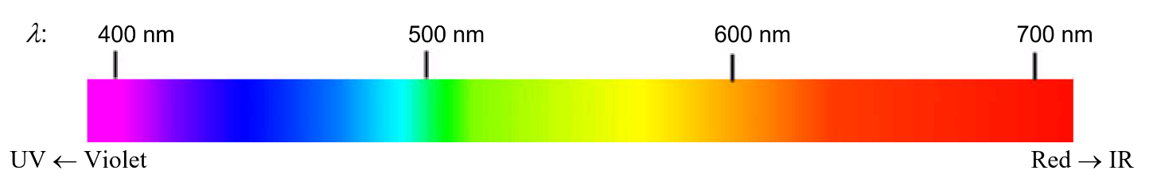

Fig.1 [3]
Mixture | Metal Ions | Colour | Estimated Wavelength
DI | None | Orange | None
HCL | None | No colour | None
A | Sodium | Yellow-orange. Nothing through Cobalt glass | 600nm
B | Potassium | Lavender | 400nm
C | Calcium | Red-orange | 620nm
D | Strontium | Red | 700nm
E | Copper | Blue-green | 490nm
F | Lithium | Red-pink | 780nm
G | Barium | Yellow-green | 560nm
H | Sodium + Potassium | Orange. Purple through Cobalt glass | 390nm, 620nm

Fig.2
Fig.2 is a table showing the results of the experiment. By looking at the colour of the flame, an estimated wavelength was given by cross-checking the colour with Fig.1.

Discussion
The results in Fig.2 show that metals can give off the wavelength of UV and of Infrared, Potassium has UV and Strontium has IR. Potassium has a rough wavelength of 400nm. This can be proven using the equations given before, E = h x f = h x c/wavelength. Shown below is Fig.3 proving the wavelength to be 405.67nm.
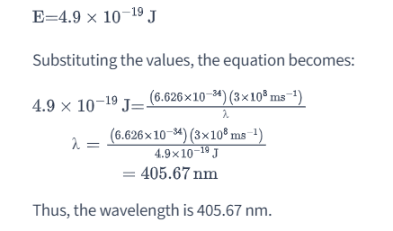 [4]

Jumping to the other end of the scale towards IR, we have Strontium with a rough wavelength of 700nm. The energy (E) of the light emitted during the flame test is 3.01 x 10^-19 J and the frequency (v) is 4.55 x 10^14 Hz. The energy (E) of light can be calculated using the equation E = h * v, where h is Planck's constant (6.626 x 10^-34 J·s) and v is the frequency of the light. To calculate the frequency (v), we can use the equation v = c / λ, where c is the speed of light (3.00 x 10^8 m/s) and λ is the wavelength of the light. Given that the wavelength (λ) of the light emitted during the flame test is 660 nm, we first need to convert it to meters by dividing it by 10^9, since there are 10^9 nm in 1 meter. Therefore, the wavelength (λ) is 660 nm. [5]
There are many uses for flame tests and identifying metal ions and what colours they give off in the OME industry such as detecting what metal ions are in foreign or unknown explosives when disposing of them, detecting what hazards are there after an explosion and to make sure there are no traces of other metal ions when there shouldn’t be. [6] Linking this back to OME, these metal ions can be used in tracer rounds, flares and even counter-measures. Outside of OME, this phenomenon can be used for things such as cinematic special effects as well as airport emergency comms.
In this experiment particularly, there were limitations and problems in particular, the contamination of Sodium on the wire affected most of the other results. This caused the almost every flame to be looked at through the blue cobalt glass to check. Sodium is extremely sticky and that is why the contamination occurs. [7]

Conclusion
The experiments’ results do in fact support the hypothesis and confirm that different metail ions, give off different colour flames due to the wavelength, energy and frequency. In future experiments, a new metal rod should be used to control and stop the cross contamination as it was automatically put down to that in the experiment but if conducting on explosives, an orange flame appeared slightly and the assumption was made it was cross-contamination, it could lead to serious injury in other experiments, disposal or even firing.

References

[1] | R. H. School, "flame test.docx," 2 June 2019. [Online]. Available: https://www.coursehero.com/file/37567393/flame-testdocx/#:~:text=page%20of%208-,Flame%20Test%20Lab%20The%20Independent%20Variable%20is%20compounds%20used%20to,colors%20of%20some%20metal%20ions.. [Accessed 20 June 2024].
[2] | UWTSD, "ACDB 4011: FLAME TEST," UWTSD, Swansea, n/a.
[3] | S. M. College, "8: Flame Tests of Metal Cations (Experiment)," LibreTexts Chemistry, [Online]. Available: https://chem.libretexts.org/Ancillary_Materials/Laboratory_Experiments/Wet_Lab_Experiments/General_Chemistry_Labs/Online_Chemistry_Lab_Manual/Chem_10_Experiments/08%3A_Flame_Tests_of_Metal_Cations_(Experiment). [Accessed 20 June 2024].
[4] | D. W. O. L. J. B. H Pat Gillis, "Potassium atoms in a flame emit light as they undergo transitions from one energy level to another that is," Vaia, [Online]. Available: https://www.vaia.com/en-us/textbooks/chemistry/principles-of-modern-chemistry-8th-edition/introduction-to-qyantum-mechanics/q14p-potassium-atoms-in-a-flame-emit-light-as-they-undergo-t/. [Accessed 20 June 2024].
[5] | B. Fatmi, "question/34716771," Brainly, 7 November 2023. [Online]. Available: https://brainly.com/question/34716771. [Accessed 20 June 2024].
[6] | M. R. S. Dr Vimal Rarh, "PAPER No.5: Forensic Chemistry and Explosives," Pathshala, [Online]. Available: https://epgp.inflibnet.ac.in/epgpdata/uploads/epgp_content/S000016FS/P000692/M011473/ET/1453184303FSC_P5_M33_e-text.pdf. [Accessed 21 June 2024].
[7] | T. e. O. E. Britannica, "sodium," Britannica, 2 June 2024. [Online]. Available: https://www.britannica.com/science/sodium. [Accessed 21 June 2024].

Appendix
Materials used:
- Bunsen burner
- Heat-resistant mat
- Matches
- Metal wire rod
- 1 M solutions of unknown metal salts labelled A-H
- Beaker with 1 M HCL
- Beaker with deionised water (DI water)
- Blue cobalt glass
Procedure:
- Put the Bunsen burner on the heat-resistant mat and connect it to the gas tap. Light and open vent to create the blue flame with two cones.
- As a control, dip the metal wire rod into the DI water and look at the effect and record it. After, dip into 1 M HCL and log the effects of that too. Dip back into DI water several times and heat it to clean the metal wire rod before proceeding.
- Once clean, dip the metal wire into either solution from A-H, ONLY ONE, and heat and log the results, if needed dip and heat again.
- To clean, dip the metal wire into 1 M HCL and heat it in the hottest part of the blue flame and repeat it until no colour is shown other than the blue flame. Once achieved, dip into DI water and heat to get rid of any HCL residue.
- Let the wire cool down and then repeat the previous two steps, making sure to clean the metal wire rod before dipping into the next solution, until all results have been logged.
- Once done, turn the vent to closed, turn off the gas to the Bunsen burner, place lids back on each solution and the experiment is finished.

SAFETY NOTES
- Turn the flame into the safety flame, closed vent, whenever not using the apparatus
- Clean off the metal wire rod before or after each new solution
- Wear correct PPE: lab coat, glasses, gloves and trousers.

