ADAM WILLSTEAD
ACMA6011 2309258
Advanced thermofluid mechanics
DESIGN & ANALYSIS OF EXTENDED SURFACES

Abstract:
Extended surfaces known as fins are used in thermal engineering to improve convective heat transfer by increasing the effective surface area available for heat dissipation. Their use is important in items where efficient thermal management is needed to maintain performance and limit overheating. Throughout this report the historical development and application of fins within automotive engineering is studied. The report will examine how fin geometries, materials and configurations have changed through time to improve performance in automotive parts (engines) and associated components. Early automotive cooling systems leaned towards air-cooled engine blocks with fins. Later designs included radiator fins and improved heat exchangers.
The report also looks at integration of extended surfaces in modern electronic systems, for example within microprocessors. Within microprocessors high heat flux densities demand efficient thermal management solutions. The development of integrated heat sinks, better materials and more advanced fin geometries has helped grow improvements in heat dissipation of electronic devices. Innovations such as micro pin fins, vapour chamber heat spreaders and additive-manufactured heat sinks are discussed in this section. This helps to highlight advantages linked to thermal performance, compactness and manufacturability.
This report demonstrates how design of extended surfaces continues to improve in response to increasing thermal loads and technological advancements, emphasising their importance in both automotive and electronic cooling systems.

Contents
Abstract: 1
List of figures: 3
Introduction: 4
Task 1: 5
Historical Development of Fins in Automotive Design: 5
Early Automotive Cooling Systems (1900s–1930s): 5
Transition to Liquid Cooling (1930s–1960s): 5
Material and Design Optimization (1960s–1990s): 6
Modern Automotive Applications (2000s–Present): 6
Early Designs (1970s–1990s): 6
Modern Designs: 7
Recent Advances in Extended Surface Design: 8
Micro/Nano-Structured Fins: 8
Additive Manufacturing (3D Printing): 8
Topology Optimization: 8
Advantages of Modern Fin Designs: 8
Conclusion: 9
Task 2: 10
Task 3: 13
Part 1: 13
Part 2: 15
Part 3: 17
Part 4: 19
Part 5: 21
Part 5 Conclusion: 22
Suggested optimized lengths: 22
Assignment Conclusion: 24
References 25

List of figures:
Figure 1: Early Aircooled Volkswagen Engine (House, 2019)
Figure 2: 1923 BMW R23 With Early Aircooled Engine (Hooshmand, 2021)
Figure 3: Early Liquid Cooled Automotive Engine Components (Sachar, 2023)
Figure 4: Microprocessor aluminium heat sink (Kang, 2017)
Figure 5: Modern Microprocessor Cooling System (Kang, 2017)
Figure 6: Values from excel showing the ratio of heat transfer for a fin with an adiabatic tip Q finite with the heat transfer rate for an infinitely long fin Q ̇∞ against a function of mL
Figure 7: Graph showing Fin Performance vs mL (Adiabatic Tip)
Figure 8: Values for each material
Figure 9: Temperature distribution values
Figure 10: Temperature distribution graph
Figure 11: Relationship between thermal conductivity and linear mass density
Figure 12: steady-state heat conduction (fin) analysis

Figure 13: Material heat loss values

Figure 14: Material values

Figure 15: Heat loss optimum length

Figure 16: Part 3 comparison table

Figure 17: Optimum length of each material
Figure 18: Suggested optimized lengths

Introduction:
Efficient thermal management is important in many engineering systems where high temperatures can lead to reduced performance, degradation and sometimes failure. A method for improving heat dissipation is use of extended surfaces, which are fins. Fins increase surface area available for convective heat transfer between a solid surface and its surrounding fluid. This helps enhance the rate that heat is removed from a component. Performance of fins can depend on certain parameters including its geometry, material, surface area and boundary conditions at the fin tip.
Fins have always played a key role in the thermal management of automotive systems. Internal combustion engines frequently rely on air-cooling mechanisms where fins are integrated directly onto engine cylinders and heads to maximise heat rejection to air. Throughout automotive technology progression, cooling requirements became more demanding. This led to the development of liquid-cooled systems with radiators and complex fin geometries designed to maximise heat transfer effectiveness. As manufacturing techniques advanced and materials have enabled complex fin configurations that improve performance of modern heat exchangers.
In other applications, extended surfaces are also important to the thermal management of electronic devices. Microprocessors with high heat fluxes within very small areas require highly efficient cooling solutions to maintain operation. Heat sinks which have layers of fins are used to dissipate heat from processor surfaces. Recently improvements in electronics have driven research into new fin designs and advanced materials.
This report studies the historical development of fins within the automotive sector and looks at how extended surfaces have evolved over time. The report also studies the fins in microprocessor cooling systems and recent innovations in extended surface design. This will highlight the advantages offered by modern thermal management technologies.

Task 1:

Historical Development of Fins in Automotive Design:
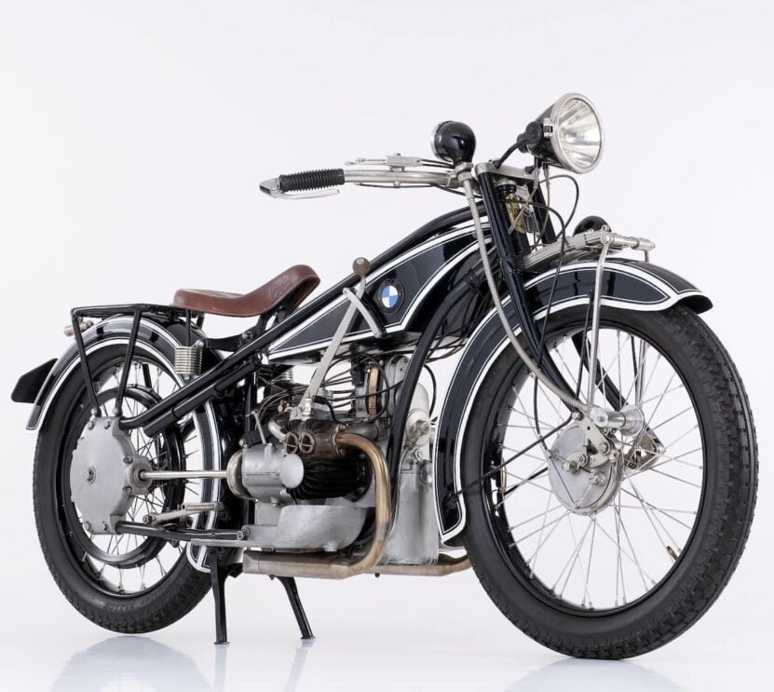
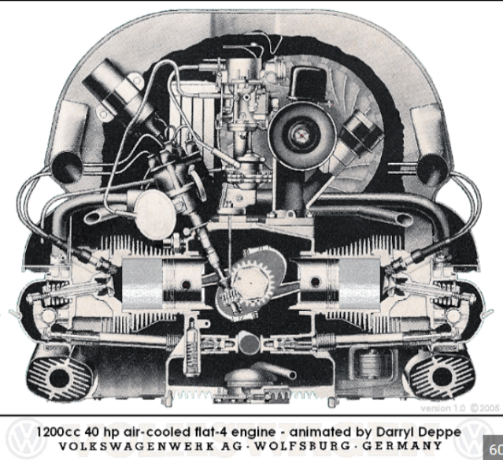
Early Automotive Cooling Systems (1900s–1930s):
Figure 2 - 1923 BMW R23 With Early Aircooled Engine
Figure 1 - Early Aircooled Volkswagen Engine

Early combustion engines relied on air-cooled engines and fins as cooling systems to remove heat from engine blocks. Fins were cast as part of engine blocks and cylinder heads to help remove heat. Early designs were simple and most had straight thick fins with large spacing to increase effective cooling. Heat transfer relied on natural convection, as vehicle speeds were relatively low. An example is early motorcycles and aircraft engines, where air-cooled fin systems were ubiquitous due to their simplicity and reliability as stated by (Sachar, 2023).

Transition to Liquid Cooling (1930s–1960s):
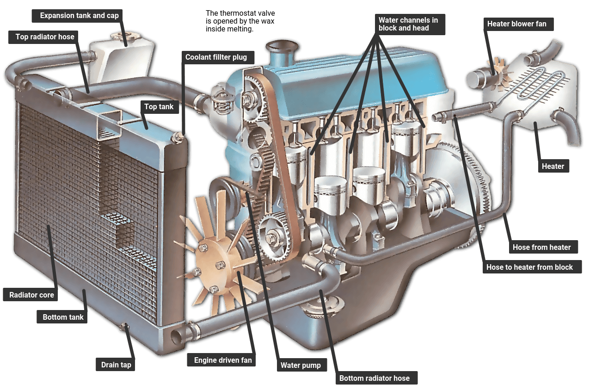
Figure 3 - Early Liquid Cooled Automotive Engine Components
As engine power and, in turn, heat issues increased, air cooling became insufficient for some automobiles. Due to this, liquid-cooled systems with radiators were introduced. “Radiators of liquid-cooled systems used thin metal fins made of copper or brass and were linked to pipelines with flowing coolant” (Sachar, 2023). The design of thinner fins meant more surface area was exposed to cold airflow. Later, forced convection was introduced using engine-driven fans for increased cooling efficiency.

Material and Design Optimization (1960s–1990s):
During this period, following the introduction of liquid-cooled systems, materials were improved to advance fin design and increase overall efficiency. This included replacing copper in many applications with “aluminium, lowering weight and cost while improving thermal conductivity” states (Sachar, 2023). Throughout this period fin shapes evolved from flat fins to louvered and corrugated forms, which increased turbulence to enhance convective heat transfer. In later years, cooling systems became even more efficient by integrating thermostats, controlled airflow systems and better radiator designs. Although liquid-cooling systems were dominant, some applications stayed with the air-cooled design, where air-cooled engines also gained advancements with finer closely spaced fins and better airflow channelling.

Modern Automotive Applications (2000s–Present):
Due to the introduction of turbocharged engines and hybrid/electric vehicles, modern vehicles use more optimized cooling systems. “Developments in modern cooling system designs include compact heat exchangers and microchannel radiators with small flow passages/thin fins” (Darbari, 2026). (Bacellar, 2017) explains the use of CFD has increased optimization within fin geometry for enhanced thermal performance.

Early Designs (1970s–1990s):
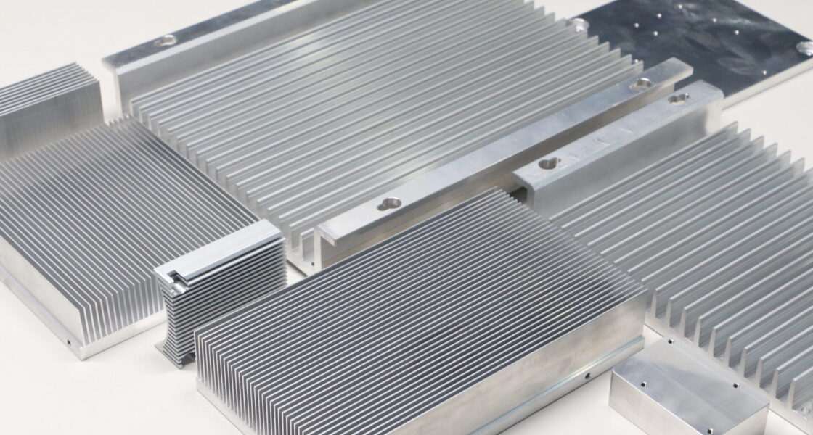
Figure 4 - Microprocessor aluminium heat sink
Throughout the early years of microprocessor development, heat generation was adequate, allowing simple cooling solutions. (Nair, 2024)states that Microprocessors were mostly cooled by aluminium heat sinks with straight fins, as natural convection alone was sufficient to dissipate heat. As transistor density increased in line with Moore’s Law, thermal output increased, necessitating improvements in cooling designs. This led to the introduction of forced convection using fans and more complex fin arrangements. “Designs focused on extended surfaces to increase surface area and improve heat transfer, with geometries including straight plate, cylindrical or square fins, and early skived or folded fins” (Singh, 2020).

Modern Designs:
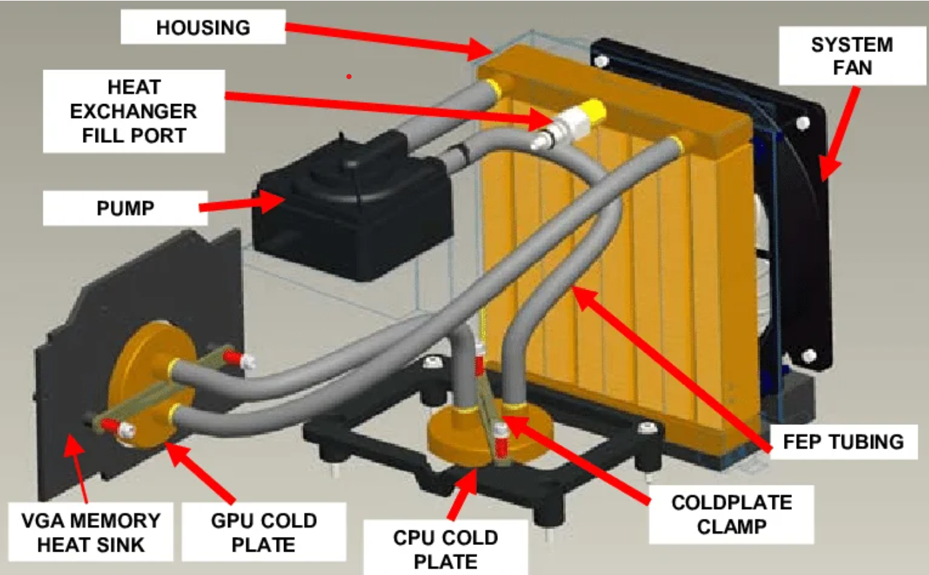
Figure 5 - Modern Microprocessor Cooling System
Modern microprocessors (CPUs/GPUs) produce high heat fluxes, requiring efficient cooling designs. “Air-cooled heat sinks are characterized by high fin density and thin fins which maximize surface area; spacing is optimized to improve airflow efficiency” stated by (El-Sebaey, 2026). Systems use forced convection (fans) to improve heat transfer. Advanced thermal technologies such as heat pipes and vapor chambers are used to improve heat transport from processor to the fins. Heat pipes exploit phase change mechanisms to move heat rapidly, and vapor chambers distribute heat evenly before dissipation by fins. For greater thermal demands, liquid cooling systems with cold plates incorporating microfins or microchannels are used, where coolant absorbs heat and carries it to a radiator equipped with fins for dissipation (Darbari, 2026).

Recent Advances in Extended Surface Design:
Micro/Nano-Structured Fins: Recent research focuses on micro scale and nano scale surface enhancements. Micro fins increase surface area dramatically. Nano coatings improve thermal conductivity and wettability.
Advantages:
- Higher heat transfer coefficients
- Improved performance in compact systems

Additive Manufacturing (3D Printing):
Additive manufacturing can now be used to manufacture complex fin geometries. For example, lattice structures, biomimetic designs and internal cooling channels.
Advantages:
- More optimized heat transfer and airflow
- Reduced waste
- Scope for customization

Topology Optimization:
Through use of computational methods fins can now be designed with optimal shapes. Designs maximize heat transfer and minimizing weight.
Advantages:
- More proven efficient structures
- Better performance to weight ratio

Advantages of Modern Fin Designs:
Advanced Heat Transfer:
- Larger surface area leads to higher heat dissipation
- More turbulence enhances convective heat transfer
More Compact:
- More efficient cooling in smaller volumes
- Critical for electronics and EV systems
Reduction in Weight:
- Use of lightweight materials (Aluminum/Copper)
- Optimized geometries/reduced material usage
Improved Energy Efficiency:
- Improved cooling reduces energy consumption (smaller fans)
Better Reliability:
- Advanced thermal management reduces stress on the component
- Greater lifespan of engines and electronic devices.

Conclusion:
Air cooling fins have been a key part thermal management since the early days of automotive engineering. Varying from cast iron fins in early air cooled engines to efficient microchannel structures in up to date systems. Fin designs has evolved/advanced over time.
Within the automotive sector, fins have moved from basic air cooled structures to complex components like radiators and EV thermal systems. In microprocessors, increasing heat flux has driven the development of heat sinks, pipes, and liquid cooling systems.
Modern updates such as additive manufacturing, micro/nano structured surfaces, and topology optimization are pushing the boundaries of fin design. Innovations such as these offer great improvements in efficiency, compactness, and performance, proving that extended surfaces remain central to modern thermal engineering solutions.

Task 2:

Straight fin (uniform cross section) with an adiabatic tip, the heat transfer rate:
$${\dot{Q}}_{finite}=\sqrt{hPkA_{c}} (T_{b}-T_{∞}) tanh⁡(mL)$$
Infinitely long fin,
$${\dot{Q}}_{∞}=\sqrt{hPkA_{c}} (T_{b}-T_{∞})$$
Ratio:
$$\frac{{\dot{Q}}_{finite}}{{\dot{Q}}_{∞}}=tanh⁡(mL)$$
Plot:
$$y=tanh⁡(mL)$$

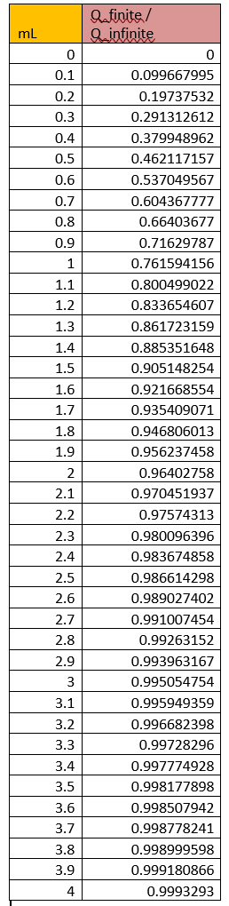
Figure 6 - Values from excel showing the ratio of heat transfer for a fin with an adiabatic tip Q finite with the heat transfer rate for an infinitely long fin Q ̇∞ against a function of mL

Figure 7 - Graph showing Fin Performance vs mL (Adiabatic Tip)
Figure 7 shows:
- Rise in heat transfer for small $mL$
- Flattening after $mL≈2.5$
- $mL=2.65$, the ratio ≈ 0.99
Figure 7 confirms that for an adiabatic tip fin ($mL≥2.65)$ the fin provides at least 99% of the heat transfer of an infinitely long fin. Increased fin length after 2.65 results in minimal improvement. This validates the design guideline that optimal fin length is $mL≈2.65$.

Task 3:

Part 1:
Fin parameter and equation:

Rectangular fin parameter is:
$$m=\sqrt{\frac{hP}{kA_{c}}}$$
$P$= perimeter of the fin cross-section exposed to air
$A_{c}$= cross-sectional area

Area:
$$A_{c}=w⋅t=0.03⋅0.005=1.5×{10}^{-4}\text{ m²}$$
Perimeter: Rectangular handle (exposed surfaces top, bottom, and sides)

$$P=2(w+t)=2(0.03+0.005)=0.07\text{ m}$$
Fin parameter:
$$m=\sqrt{\frac{hP}{kA_{c}}}=\sqrt{\frac{7.5⋅0.07}{k⋅1.5⋅{10}^{-4}}} \\ m=\sqrt{\frac{0.525}{k⋅1.5⋅{10}^{-4}}}=\sqrt{\frac{0.525}{0.00015k}}=\sqrt{\frac{3500}{k}}$$
$$m=\sqrt{\frac{3500}{k}} {\text{m}}^{-1}$$

Temperature at the adiabatic tip

$$\frac{T_{L}-T_{∞}}{T_{b}-T_{∞}}=\frac{cosh⁡(m(L-L))}{cosh⁡(mL)}\text{but }L_{\text{tip}}=L$$
$mL$ for materials below:
$$mL=L\sqrt{\frac{3500}{k}}=0.2⋅\sqrt{\frac{3500}{k}}$$
Copper (k = 385):
$$mL=0.2⋅\sqrt{\frac{3500}{385}}=0.2⋅\sqrt{9.09}=0.2⋅3.016≈0.603$$
Aluminium (k = 205):
$$mL=0.2⋅\sqrt{\frac{3500}{205}}=0.2⋅\sqrt{17.073}=0.2⋅4.132≈0.826$$
Brass (k = 99):
$$mL=0.2⋅\sqrt{\frac{3500}{99}}=0.2⋅\sqrt{35.354}=0.2⋅5.945≈1.189$$

Stainless Steel (k = 15):
$$mL=0.2⋅\sqrt{\frac{3500}{15}}=0.2⋅\sqrt{233.33}=0.2⋅15.27≈3.054$$

Step 4: tip temperature
$$T_{L}=T_{∞}+\frac{T_{b}-T_{∞}}{cosh⁡(mL)} \\ T_{b}-T_{∞}=100-22=78 °\text{C}$$

Copper:
$$cosh⁡(0.603)≈1.185 \\ T_{L}=22+\frac{78}{1.185}=22+65.8≈87.8 °\text{C}$$
Aluminium:
$$cosh⁡(0.826)≈1.354 \\ T_{L}=22+\frac{78}{1.354}=22+57.6≈79.6 °\text{C}$$
Brass:
$$cosh⁡(1.189)≈1.778 \\ T_{L}=22+\frac{78}{1.778}=22+43.9≈65.9 °\text{C}$$
Stainless Steel:
$$cosh⁡(3.054)≈10.69 \\ T_{L}=22+\frac{78}{10.69}=22+7.3≈29.3 °\text{C}$$

Safety assessment:

“Medical science gives us a cruel "magic number." That number is 49°C (120°F). As soon as the surface temperature of your skin crosses this line, the protein structure breaks down. This is the start of a burn.” As stated by (BullSafety, 2026).

44°C = Safe for short periods
49°C = “the magic number” tissue damage begins
60°C = 3rd degree burns in 5 seconds
70°C instant burns

Conclusion:

Material |  | Tip Temp (°C) | Safe to Touch? Yes/No
Copper |  | 87.8 | No
Aluminium 2024 |  | 79.6 | No
Brass |  | 65.9 | Marginal/No
Stainless Steel |  | 29.3 | Yes

Copper conducts heat best and will make the handle hot. Using a bad conductor like stainless steel keeps the handle cooler than copper. This is why modern cookware use copper/aluminium bodies but stainless steel handles. Cookware may also have stainless steel bodies with copper/aluminium cores for durability and easier maintenance. Handles are often stainless steel, sometimes with silicone or plastic coatings for extra insulation.

Part 2:

Temperature distribution formula (adiabatic tip)

$$T(x)=T_{∞}+(T_{b}-T_{∞})\frac{cosh⁡[m(L-x)]}{cosh⁡(mL)}$$

$x$= distance from the base (0 ≤ x ≤ L)

$$L=0.2\text{m}$$
$$m=\sqrt{\frac{hP}{kA_{c}}}$$
$$T_{b}=100 °\text{C}=22 °\text{C}$$

values for each material:
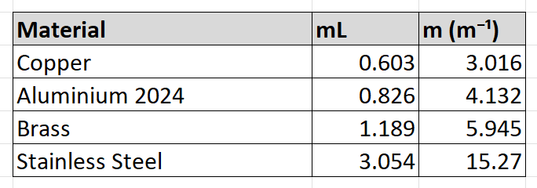
Figure 8 - Values for each material
Compute temperature at each x

$$T(x)=22+78⋅\frac{cosh⁡[m(L-x)]}{cosh⁡(mL)}$$
Plot:
X-axis: Distance along the handle (mm, 0–200)
Y-axis: Temperature (°C, 20–100)

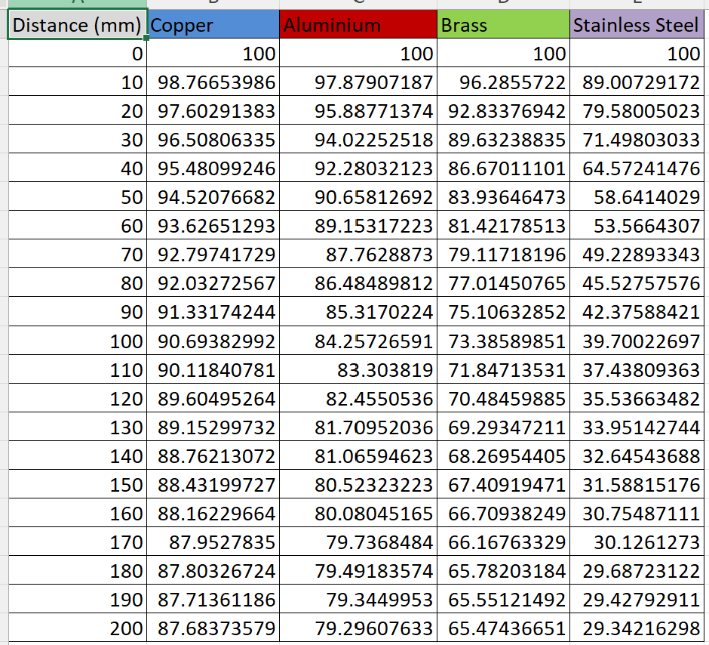
Figure 9 – Temperature distribution values
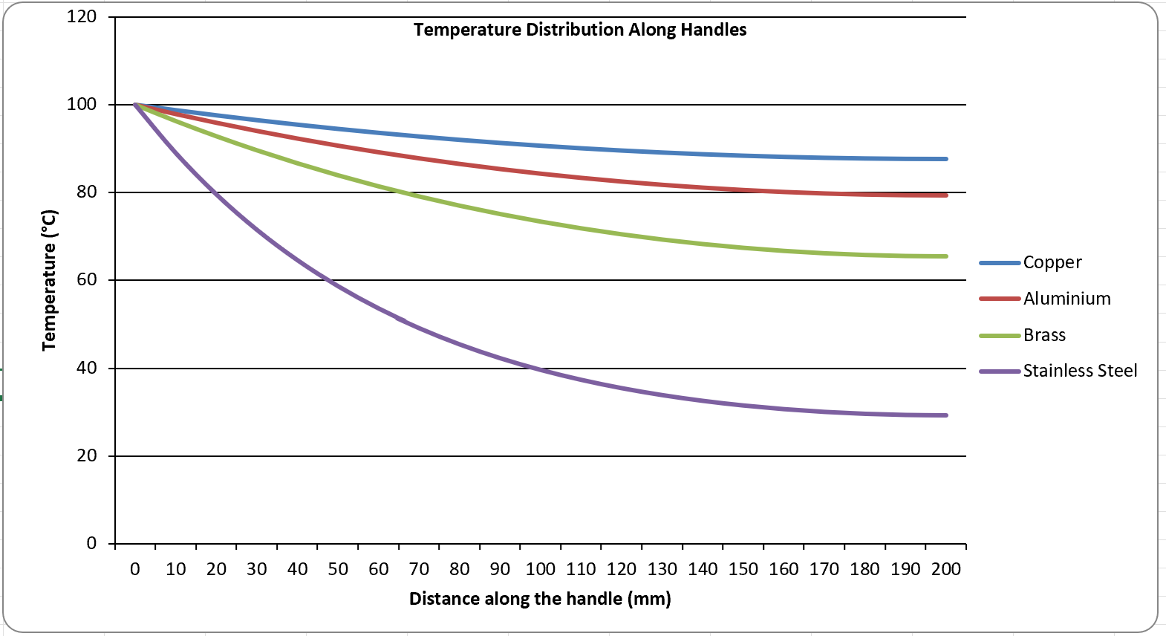
Figure 10 – Temperature distribution graph
Analysis/Summary:

Copper & Aluminium = highest temperatures at the tip
Brass = moderate
Stainless Steel = stays cool along the handle

Part 3:
Heat loss formula for a fin with adiabatic tip
$$Q=\sqrt{hPkA_{c}} (T_{b}-T_{∞}) tanh⁡(mL)$$
Where:
- $h=7.5\text{ W/m²\backslash cdotpK}$

(surface heat transfer coefficient)

- $P=2(w+t)=0.07\text{ m}$ (perimeter)
- $A_{c}=wt=1.5×{10}^{-4}\text{ m²}$ (cross-sectional area)
- $T_{b}-T_{∞}=78 °\text{C}$
- $m=\sqrt{\frac{hP}{kA_{c}}}=\sqrt{\frac{3500}{k}} {\text{m}}^{-1}$
- $L=0.2\text{ m}$

m for each material:
$$m=\sqrt{\frac{3500}{k}}$$
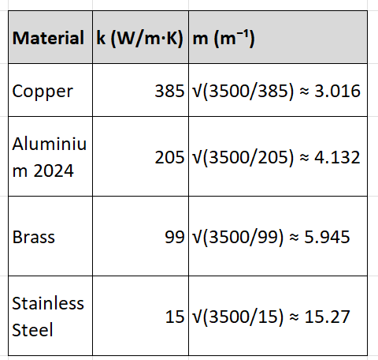
Figure 11: relationship between thermal conductivity and linear mass density

Calculate: $\sqrt{hPkA_{c}}$ (Each material)

$$\sqrt{hPkA_{c}}=\sqrt{7.5⋅0.07⋅k⋅1.5⋅{10}^{-4}}=\sqrt{7.875⋅{10}^{-5}⋅k}$$
Copper: $\sqrt{7.875⋅{10}^{-5}⋅385}=\sqrt{0.0303}=0.174\text{ W/°C}$

Aluminium: $\sqrt{7.875⋅{10}^{-5}⋅205}=\sqrt{0.01614}=0.127\text{ W/°C}$

Brass: $\sqrt{7.875⋅{10}^{-5}⋅99}=\sqrt{0.00779}=0.0883\text{ W/°C}$

Stainless Steel: $\sqrt{7.875⋅{10}^{-5}⋅15}=\sqrt{0.00118}=0.0343\text{ W/°C}$

Calculate heat loss using $Q=\sqrt{hPkA_{c}}(T_{b}-T_{∞})tanh⁡(mL)$
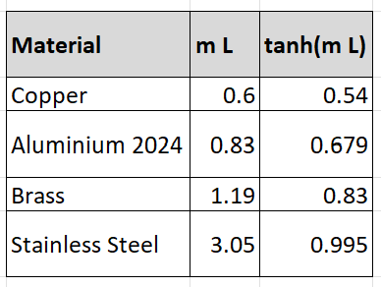
Figure 12: steady-state heat conduction (fin) analysis
$$Q=factor⋅(T_{b}-T_{∞})⋅tanh⁡(mL)$$

Copper: $0.174⋅78⋅0.540=7.34\text{ W}$

Aluminium: $0.127⋅78⋅0.679=6.73\text{ W}$

Brass: $0.0883⋅78⋅0.830=5.72\text{ W}$

Stainless Steel: $0.0343⋅78⋅0.995=2.66\text{ W}$
Summary:

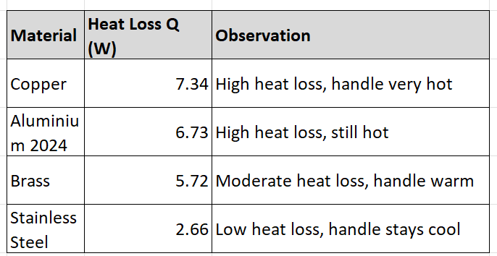
Figure 13: Material heat loss values
Copper conducts heat better than other materials but this then aids heat transfer making the handle hot.
Stainless steel handles are much safer, as they limit heat from the pan.

Part 4:
Optimum fin length:
Adiabatic tip fin:
$$θ_{L}=\frac{T_{L}-T_{∞}}{T_{b}-T_{∞}}=\frac{1}{cosh⁡(mL)}$$
Finding optimum length, (set the tip temperature close to ambient).

$$T_{L}-T_{∞}=0.01(T_{b}-T_{∞})⇒θ_{L}=0.01 \\ \frac{1}{cosh⁡(mL_{\text{opt}})}=0.01=cosh⁡(mL_{\text{opt}})=100 \\ mL_{\text{opt}}={cosh⁡}^{-1}(100)$$
Solve for $L_{\text{opt}}$:
$${cosh⁡}^{-1}(100)=ln⁡(100+\sqrt{{100}^{2}-1})≈ln⁡(100+99.995)=ln⁡(199.995)≈5.3$$
$$L_{\text{opt}}=\frac{5.3}{m}$$

Calculate $m$for each material:

From part 3:
$$m=\sqrt{\frac{hP}{kA_{c}}}=\sqrt{\frac{3500}{k}}$$
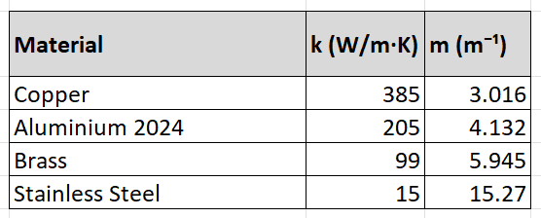
Figure 14: Material values

Calculate $L_{\text{opt}}=5.3/m$

Copper: $L_{\text{opt}}=5.3/3.016≈1.76\text{ m}$
Aluminium: $L_{\text{opt}}=5.3/4.132≈1.28\text{ m}$
Brass: $L_{\text{opt}}=5.3/5.945≈0.89\text{ m}$
Stainless Steel: $L_{\text{opt}}=5.3/15.27≈0.347\text{ m}$

Heat loss for optimum length:

For an adiabatic-tip fin, the total heat loss for very long fins approaches:

$$Q_{\text{max}}=\sqrt{hPkA_{c}}(T_{b}-T_{∞})$$
- This is the maximum possible heat loss; $\tanh\left(mL\right)= 1$ for long fins.

Compute for each material (using values from part 3: $\sqrt{hPkA_{c}}$):

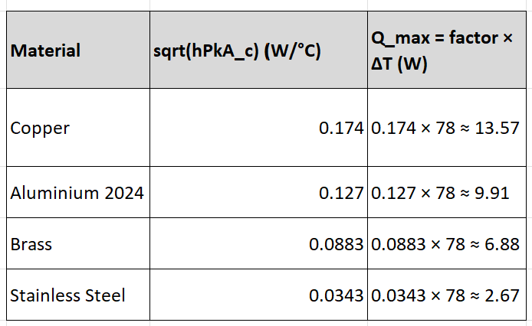
Figure 15: Heat loss optimum length
Comparison with part 3:

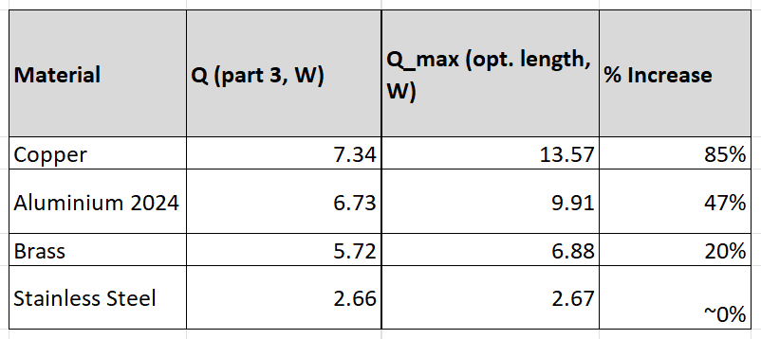
Figure 16: Part 3 comparison table

Summary:

Copper/aluminium handles are not close to the the optimized length. These handles could transfer more heat if they were manufactured longer.

Brass is closer to the optimized length, so its heat loss is below max.

Stainless steel is nearly at maximum heat loss even with a short handle. This is due to poor conductivity.

Part 5:
Temperature distribution formula for optimum-length fin:
For a fin with adiabatic tip, the temperature along the fin is:
$$T(x)=T_{∞}+(T_{b}-T_{∞})\frac{cosh⁡[m(L-x)]}{cosh⁡(mL)}$$
- $x$= distance from the pan base (0 ≤ x ≤ L)
- $L$= optimum length (from part 4)
- $m=\sqrt{\frac{hP}{kA_{c}}}$

Use optimum lengths from part 4:
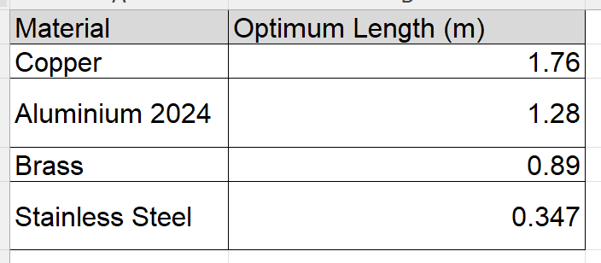
Figure 17: Optimum length of each material
Calculate temperature distribution along x:
Copper (1.76 m):
Tip temperature ~22 °C
Entire handle now cooler than original 0.2 m handle (~88 °C tip before)
Aluminium (1.28 m):
Tip temperature ~22 °C
Original 0.2 m handle had ~80 °C tip
Brass (0.89 m):
Tip temperature ~22 °C
Original tip ~66 °C
Stainless Steel (0.347 m):
Tip temperature ~22 °C
Original tip ~29 °C

Part 5 Conclusion:
Temperature difference is dramatic for high-conductivity metals like copper and aluminium for long handles, the tip is essentially at ambient. Stainless steel, being a poor conductor, doesn’t change much.

Suggested optimized lengths:
Even though the mathematical optimized length is very long, practical considerations (safety, ergonomics, handle size) make such lengths unrealistic. A suitable practical optimized length would balance heat transfer and usability:
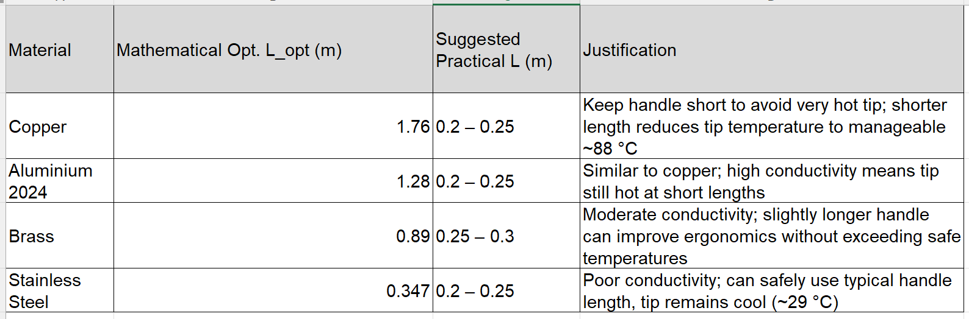
Figure 18: Suggested optimized lengths

Assignment Conclusion:
This study has shown the role of extended surfaces (fins) in improving convective heat transfer of automotive/electronic applications. Historically, fins moved from simple cast air cooled engines in the early days to complex radiator and microchannel designs later, with advancements in geometry, materials and improved thermal efficiency. Microprocessor cooling moved from simple heat sinks relying on natural convection to efficient designs with forced airflow, heat pipes, vapor chambers and better fin shapes. Micro/nano structures, topology optimization, and additive manufacturing have advanced the capability to manage high heat fluxes efficiently and also help reduce weight and improve compactness.
Later in this report the analysis of saucepan handles has shown how material properties influence heat conduction/safety. High conductivity metals like copper and aluminium give high tip temperatures and heat loss. Moderate/low conductivity materials such as brass and stainless steel limit heat transfer. This means the handle is cooler and safer to touch than the other materials. Optimized fin length calculations confirmed that while maximum heat dissipation can be achieved with longer fins, realistic design must balance safety and manufacturing.
Overall, the report proves that extended surfaces remain a key part of thermal engineering. Optimized geometry, material, and configuration will allow engineers/designers meet performance, safety and efficiency targets. Despite recent advancements, the concept of fins as tools for enhancing heat transfer continues to be relevant.

References
Bacellar, D. (2017). Design optimization and validation of high-performance heat exchangers using approximation assisted optimization and additive manufacturing. In D. Bacellar, Science and Technology for the Built Environment (pp. 896-911).
BullSafety. (2026, January 21). What Temperature Can Your Hands Really Handle The Science of Heat Protection? Retrieved from BullSafety: https://bullsafety.com/what-temperature-can-your-hands-really-handle-the-science-of-heat-protection/#:~:text=no%20email%20required!-,What%20Temperature%20Can%20Your%20Hands%20Really%20Handle%20The%20Science%20of,Heat%20Safety%20Limits.
Darbari, B. (2026). Application of micro-channel heat sinks for thermal management of electric vehicle components: A comprehensive review. Energy Conversion and Management, 1-30.
Dhumal, A. R. (2024). Investigation of the Effect of Different Fins Configurations on the Thermal Performance of the Radiator. Journal of Advanced Research in Fluid Mechanics and Thermal Sciences , 1-13.
El-Sebaey, M. S. (2026). Exploring design configurations of micro heat sink for thermal performance management and heat transfer augmentation. Results in Engineering, 1-22.
He, Y.-L. (2016). Advances and Outlooks of Heat Transfer Enhancement by Longitudinal Vortex Generators. Advances in Heat Transfer, 1-10.
Hooshmand, D. (2021, January 12). Airhead, Hexhead, Oilhead… What are the BMW motorcycle engines? Retrieved from Motofomo: https://motofomo.com/bmw-motorcycle-engines-airhead-hexhead-oilhead/
House, D. (2019, April 10). Understanding your volkswagen aircooled engine. Retrieved from Medium: https://iknowdavehouse.medium.com/understanding-your-aircooled-volkswagen-engine-7d01688e799e
Kang, S. (2017, January 01). Liquid Cooling System for a PC . Retrieved from ResearchGate: https://www.researchgate.net/figure/Liquid-Cooling-System-for-a-PC_fig1_267621341
Karwa, R. (2020). Extended Surfaces (Fins). Heat and Mass Transfer, 113-194.
Kumar, R. R. (2024). Enhancing automotive cooling systems: composite fins and nanoparticles analysis in radiators. Scientific Reports.
Muir, A. (2024, March 2). How an engine cooling system works. Retrieved from How a car works: https://www.howacarworks.com/basics/how-an-engine-cooling-system-works
N.Nagarani. (2014). Review of utilization of extended surfaces in heat transfer problems. Renewable and Sustainable Energy Reviews, 1-10.
Nair, V. (2024). A comprehensive review of air-cooled heat sinks for thermal management of electronic devices. International Communications in Heat and Mass Transfer, 10.
Rastan, H. (2020). Heat transfer study of enhanced additively manufactured minichannel heat exchangers. International Journal of Heat and Mass Transfer, 1-24.
Sachar, S. (2023). Heat transfer enhancement of the air-cooled engine fins through. Materials Today: Proceedings, 1-18.
Singh, M. K. (2020). A Review on Internal Combustion Engine Fins . International Journal of Engineering Research & Technology , 1-3.
Thole, K. A. (2021). Chapter Five - Review of advances in convective heat transfer developed through additive manufacturing. In K. A. Thole, Advances in Heat Transfer (pp. 249-235). Department of Mechanical Engineering, Pennsylvania State University, University Park, PA, United States.
Wikipedia. (2026, January 10). Air-cooled engine. Retrieved from Wikipedia: https://en.wikipedia.org/wiki/Air-cooled_engine?utm_source=chatgpt.com
Yang, T. (2024). A Review on Application of Pin-Fins in Enhancing Heat Transfer. Energies, 1-17.
Yuan, K. (2026, January 29). Aluminum heat sinks explained . Retrieved from Total power solutions: https://tps-elektronik.com/en/aluminum-heat-sink-efficiency-cooling-scenarios-analysis/

