

HTML & CSS Web Development
Introduction to Web and Database Concepts

January 10, 2025
Naod habtom(2306565)
University of Wales Trinity Saint David

Table of Contents
Introduction 3
Requirements 3
Purpose 3
Subject Matter 3
Target Audience 3
Key Features 4
Implementation 4
Screen Grabs 5
Validation Results 11
Summary of Validation: 13
Evaluation 14
Usability 14
Accessibility 14
Search Engine Optimization 15
Conclusion 15
Appendices 17
Appendix 1: Index Page 17
Appendix 2: Services Page 18
Appendix 3: Achievements Page 18
Appendix 4: About Us Page 19
Appendix 5: Career Page 19
Appendix 6: Contact Page 20
Appendix 7: HTML Validator (W3C Validator) 20
Appendix 8: CSS Validator (W3C Validator) 21
Appendix 9: Index Code 22
Appendix 10: Services Code 24
Appendix 11: Achievements Code 26
Appendix 12: About Us Code 28
Appendix 13: Career Code 30
Appendix 14: Contact Code 33
References 35

Introduction
The VitaConnect website is an example of an information technology and sustainability health-tech project. This report documents the research, design, and implementation of the website, which consists of six interconnected pages: Just to name a few, Home, Services, Our Achievements, Our Career, Contact Us, and About Us. Therefore, the functions of this site shall be to act as a presentation of VitaConnect efforts towards enhancing people’s lives and the environment through the advancement of health-based solutions.
From the first glance, the design of the site meets modern web standards, and reflects basic principles of usability, accessibility, and SEO⁽⁾. The other pages of the website were coded manually employing HTML and CSS and this made the pages to have nice professional look. The goal of this report is to explain the need of the website, the steps taken to construct it and the validation of the website.

Requirements
The VitaConnect website was designed with the following requirements in mind:

Purpose
The role of the website is to market VitaConnect as a modern institution that contributes to the practice of providing sustainable health technologies. It is expected to attract the users by offering them various links with information on mission and services offered by the company, its accomplishments, and recruiting opportunities and offering them an opportunity to interact using a contact us link.

Subject Matter
The website covers a variety of topics related to health-tech innovations, including:
- Health monitoring tools
- Digital wellness programs
- Eco-friendly practices integrated into technology
- Career opportunities in the health-tech industry

Target Audience
Health-conscious individuals: These users are attracted by matters concerning their health along with technology in health industry⁽⁾. They demand equipment and applications that offer recommendations for an improved quality of life and mechanisms, including health indicators, and volunteer wellness projects.
Businesses and organizations: Employers seeking fresh, evidence-informed health strategies for their workforce or who want to incorporate health technology products into their business make up an important part of the audience.
Job seekers: job seekers in the health-tech space may use these job listings to search for jobs that best fit their knowledge and, in the process, get a company that will be interested in them.
Environmental advocates: Energy enthusiasts, environmentally conscious, and those interested in sustainable health-tech development will find VitaConnect’s message of combining technology and sustainability to promote environmentally viable health technology appropriate⁽⁾.

Key Features
Home Page: A home-like page with the main site slogan and a big VitaConnect logo, blocks stating the company’s purpose, and the principles of environmental friendliness.
Services Page: On this page, there are descriptions about the health service solutions that VitaConnect offers: the health monitoring tools, the digital wellness programs, the data analytics and the layout of the page is divided systematically with icons used frequently throughout the web site.
Achievements Page: VitaConnect’s Achievements section that encompasses Company achievements through bulleting them and adding visuals to highlight specifics about VitaConnect.
Career Page: Contains information on vacancies at VitaConnect including job descriptions and necessary criteria in one section and employment perks in another.
Contact Page: A form providing users with an opportunity to post their questions such as name, email, subject, message, and a submit button.
About Us Page: Gives an idea regarding VitaConnect’s mission, vision and value system; highlights some important facts infographics given side wise for improved understanding.

Implementation
The development of the VitaConnect website has been done in HTML and CSS promoting advanced web design and responsiveness. This section describes several activities in the implementation process, such as the screen grabs and the validation results.

Screen Grabs
Homepage: Its function is to present the face of the website. It possesses a well-designed header where you will find the title of the website and the links to the other section of the website. The hero section is rather unobvious focusing on the large banner image and short line of text here that introduce the company’s mission/vision statement⁽⁾. Furthermore, this page also has the headers of VitaConnect’s focus on enhancing the health technology and its availability though they also need to be sustainable. Content is laid out this way to capture the attention of the target group and urge them to delve deeper. Captured screenshots to depict this page are given in the Appendix 1.
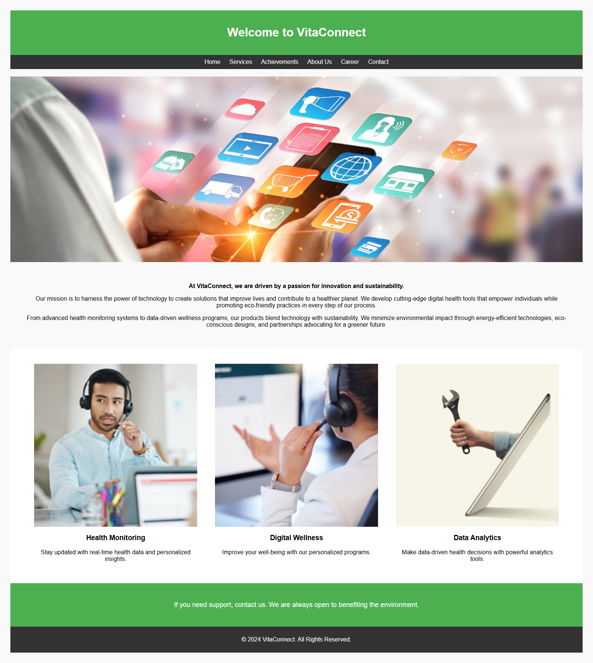

Services Page: Through this page, readers get to learn more about VitaConnect through definitions of services offered such as health monitoring , digital wellness, and data solutions. The content is separated clearly for better comprehend of users on the services being offered. Some more details are provided in Additional services list that can help to navigate and sort the information more efficiently. Other graphical items such as icons, make reading very easy on the page⁽⁾. The sections make it functional as well as good-looking; the information gets across effectively, and they’re easy on the eyes⁽⁾. Additional screenshots are in the appendix 2.
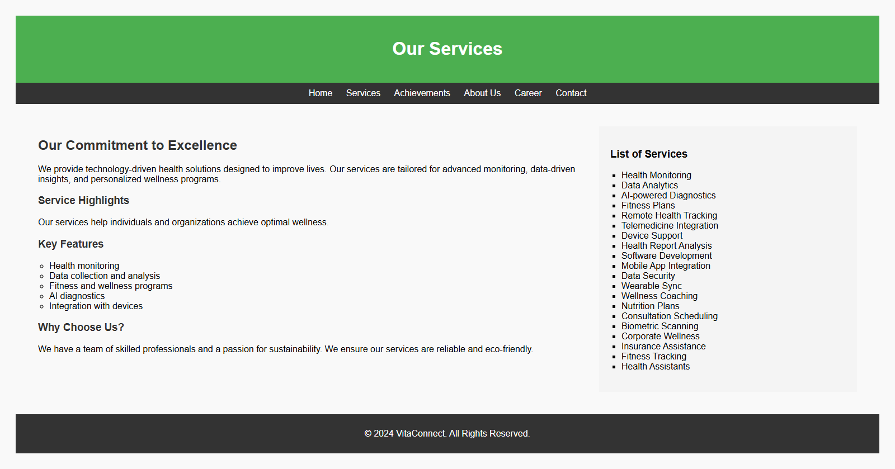
Achievements Page: Intended to draw attention to VitaConnect’s core achievements, this page is dedicated to the organization’s story of triumph. In a way, it structures significant recognitions such as awards and partnerships. Simple lists help to divide information in a handy way; beautiful pictures and unintended layout keep users engaged. The visuals for the achievements page are provided in the Appendix 3 to show that it focuses on the credibility and accomplishment.
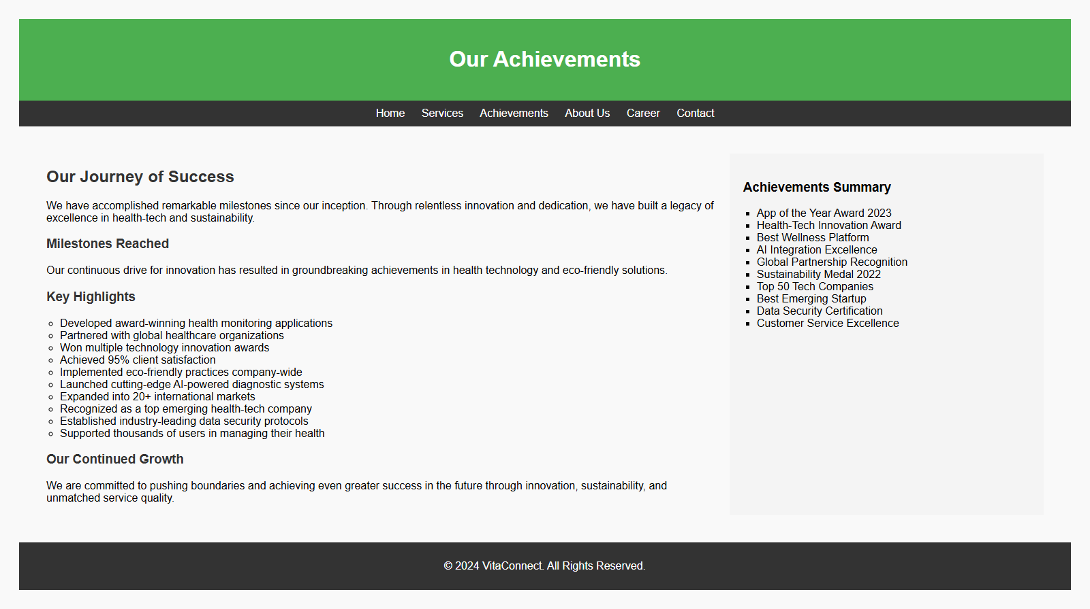
Career Page: This page has the intention of recruiting talent by offering detailed job descriptions and details about vacancies with VitaConnect. Different sections describe the tasks and the needed employee attributes concerning positions like a Software Developer or a Digital Marketing Specialist. Also, there is a recruitment ad which presents VitaConnect company and all the benefits that one can receive by joining the company such as competitive wages and responsive working conditions⁽⁾. The layout makes it easier for any potential applicant to find any piece of information he or she may be looking for in the page. Snapshots offered in Appendix 4 give the viewer an idea of how its interface is organized with the user in mind.
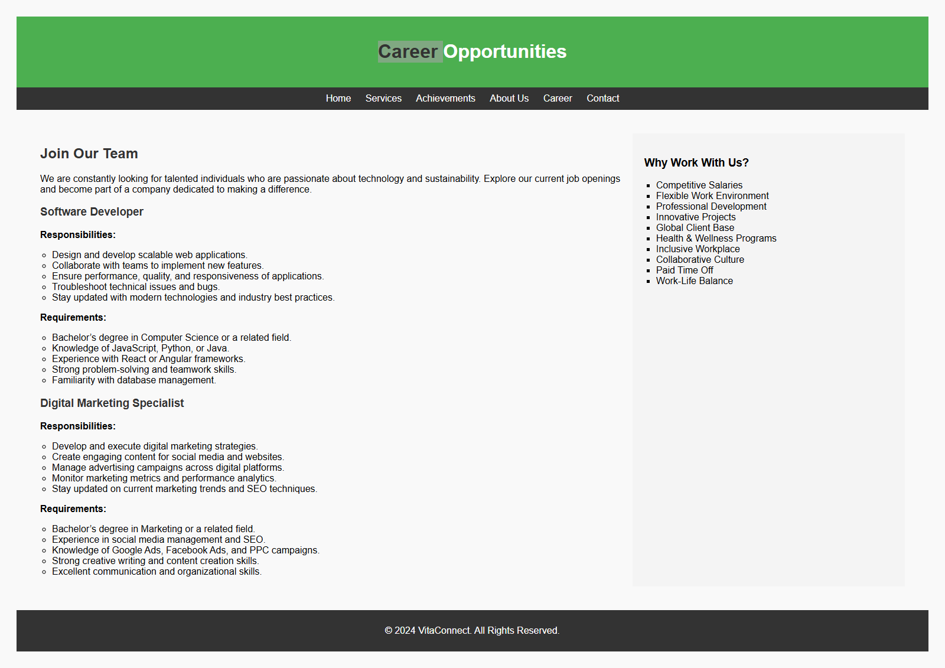
Contact Page: The contact page serves to help individuals and the company to communicate with each other. The design of the website includes an attractive and convenient form with the required fields in which a user can enter his name, e-mail, subject, and message. This basic design makes the equipment accessible and friendly for use. Significantly, a large button for submission leads to improved usefulness⁽⁾. Appendix 5 brings images of the browser with the simple and inciting layout intended for the user.
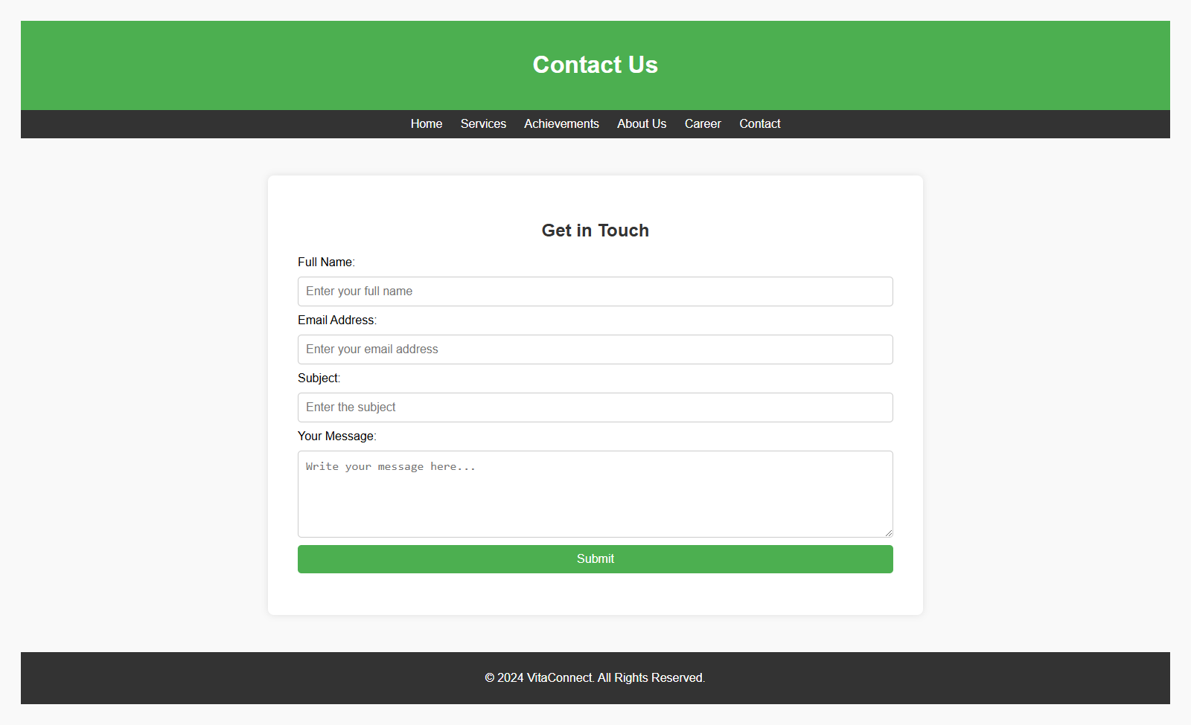
About Us Page: This part informs the visitors the Company’s problems, aims, and goals, and the Company creates the image of a mission-driven Company by portraying VitaConnect as such. In the sidebar, there are bullet-pointed pieces of information that may include the year, the number of users, and environmental policies. It provides much text near each folder yet keeps info bits simple enough that people can grasp them. Printed or electronic copies of the screenshots are shown in appendix 6 to illustrate how the contents are presented well.
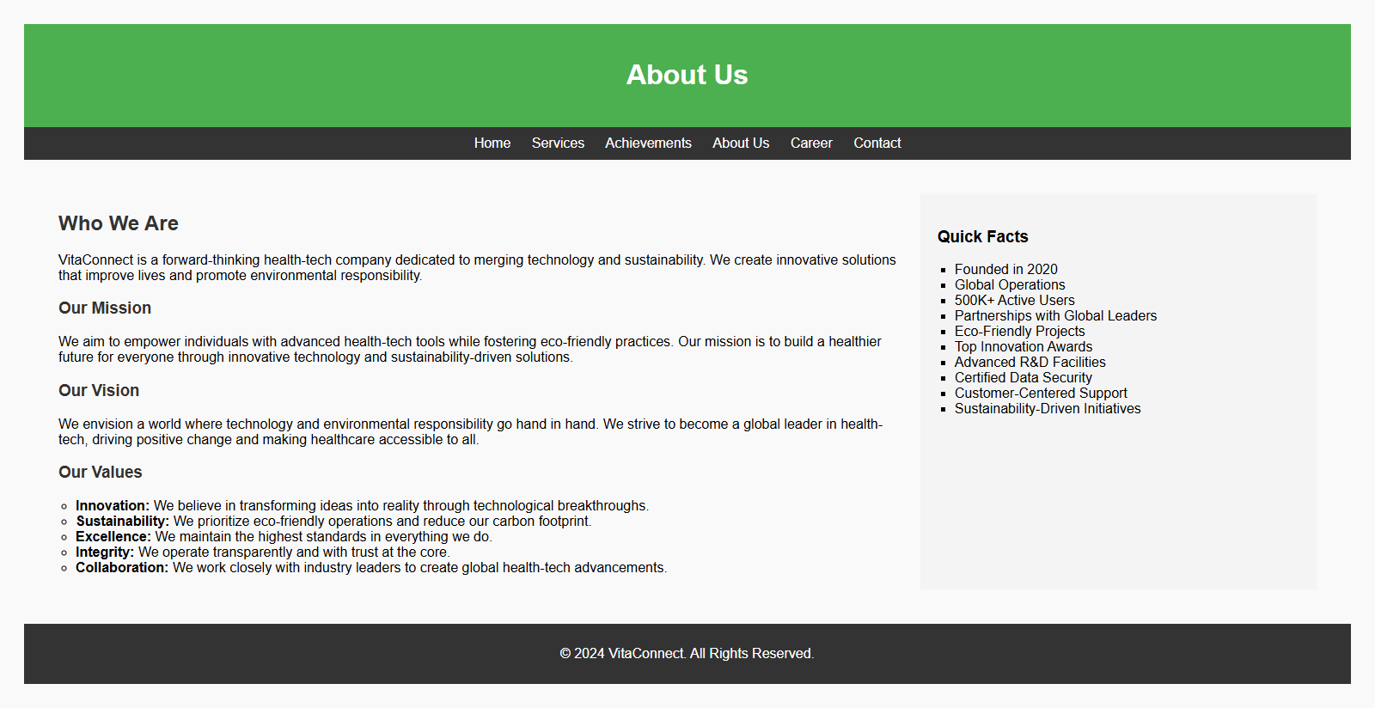

Validation Results
This may be utilized as a way of being certain somewhat that the web site functions correctly on the Web and passes Web Standards across the browsers. Concerns that were made with reference to VitaConnect website concerned issues in the HTML and CSS types of the webpage; these concerns were attended to using validators.
HTML Validation: The HTML code used also underwent check using the W3C HTML Validator⁽⁾. Some problems were identified at first: the lack of alt attributes in img tags and improperly nested elements. It causes alternative properties not to be available because they can be very useful especially to the people using screen readers. With proper descriptions of all images on the website using descriptive alt attributes there is better description of visual content. In addition, non-conforming tags that affected consistency for layout were fixed by adjusting the HTML structure to conform with syntax standards. After these changes the HTML code was validated, which means that it complies with the web standards.
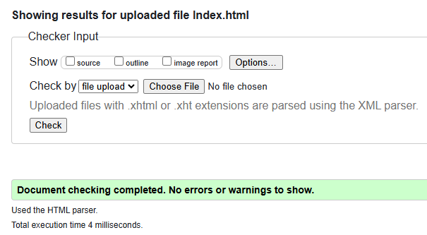
CSS Validation: The validity of the Created Style Sheets was done with the assistance of W3C CSS Validator it is on this first glance one can notice such errors as use of unknown experimental values and having two same rules. Some of the experimentally were removed as the library is written for or compatible with all current browser environments⁽⁾. Several statements were made for increased efficiency, and for reduction in repetitiveness. By tuning of these problems, this validation gives a CSS compliance and proper styling a ‘clean bill of health’.
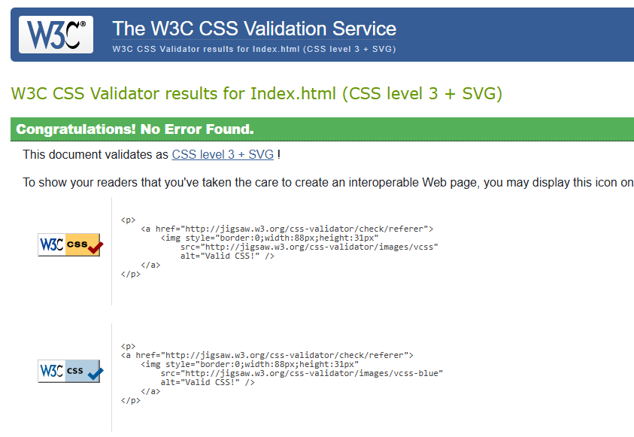

Summary of Validation:
Validation made then made sure that the website complied with web standards increasing the functionality, the usability and the overall feel of the website. Hence, the validation process was able to create the framework for moving forward in refining not only the code and structure, but every aspect of this website.
Enhanced Functionality: Common problems like the lack of alt attributes and incorrect tags used were also addressed by correcting nested HTML tags leading to enhanced site responsiveness and usability⁽⁾. Corrections made during the validation have led to a perfect flow of users’ interactions and screen readers’ ability to understand visual features for other users with sight problems.
Improved Accessibility: Some problems mentioned in HTML and CSS validation include: For all images, text contrast has been ensured, an appropriate size for text has been chosen so that it can be viewed in high contrast mode, and an alt attribute has been set for all images so that they can be audibly described to the users, and the website is fully accessible for the disabled, following all the guidelines of WCAG 2.1. These changes are not only beneficial for the users having physical disabilities but also, they are more suitable for every visitor(⁾.
Code Quality: Removing duplicate CSS rules and experimental property inchoate the styling process and improved BB2bw compatibility. This has also made future maintenance easier and possible to tweak the site to fit any changing web standards as they may be in the future.
SEO Benefits: The proper code structure also helps in better indexing since the validation checks whether the crawlers can understand and access the content of the site. This increases the exposure rate and the chances of achieving first organic traffic.

Evaluation

Usability
Navigation: The website has a neat looking bar which runs along the top of the page and in all subpages; this bar contains links to all the site’s sections. The links are cleared, and their function is well described; it’s common to find a brief description like this in case of first-time visitors⁽⁾.
Design: Organizing information under clean headings, list, and graphics made them easy to understand. For example, on the Services page, representatives of various services are illustrated by icons, making it easier to understand.
Responsiveness: The site’s layout is responsive to support various view-port sizes so that users from devices like desktops, tablets, and Smartphone’s are well accommodated. This is especially considered to welcome a wide client base.
Accessibility to Diverse Users: Therefore, through application of usability principles including consistent layout of the vita-connect pages, clear call-to-action buttons and logical categorization; vita-connect guarantees adequate satisfaction of all targeted users including the novices in technical knowledge.

Accessibility
Perceivable: Descriptive text for images can be also provided so that for instance those employing a screen reader can comprehend images too. For instance, during the validation process the alt attributes were included on all the images⁽⁾. Text and background contrast are at optimum with WCAG to provide a sharp and clear interface for the visually impaired.
Operable: The form areas and navigation links are produced in a manner that makes them accessible for keyboard or assistive device. Features such as clear focus indicators, help people with mobilities impairments find content easily.
Understandable: The content of the website provides simple, clear and jargon-free language that will be easily understood by virtually all its users due to good literacy levels. Hitting a button called Contact, on the top of the page allows for easy navigation through submissions procedures along with clear instructions provided.
Robust: It works well with numerous accessibility tools and contemporary browsers to make it compatible for every person. Some examples of testing included WAVE, used to check for accessibility problems.

Search Engine Optimization
Meta Tags: Every page contains title and meta description tags with brief description of every web page with actual keywords used in the description. For instance, the Home page contains such words as ‘health-tech,’ ‘sustainability.’
Heading Structure: The correct usage of header tags including H1, H2, H3 make the content to be well structured in a way that search engines can comprehend the structure of the page. For example, on the About Us web section, the labelling system separates segments such as “Mission” and “Vision.”
Alt Text: Images contain tags, benefiting the visually impaired and allowing search engines to easily read through visuals.
URL Structure: The URLs of the website do not contain any unnecessary names and are descriptive, for example, services.html correspond with the page content.
Content Optimization: The keywords are used well together with meaningful and interesting information and the problem of using too many keywords is solved. It is quite easy to incorporate such words as “digital wellness” and “innovative solutions” into materials.

Conclusion
From that point of view, the website is incorporated with all the best SEO practices including ideal meta tags, header hierarchy, and proper utilization of the alt text for proper organic traffic and better visibility⁽⁾. Several validation checks made it easy to conform to web standards, reduce the poor-quality code and offer easier to maintain structure to the code.
Some features that could be added in the further development include the ability to support multiple languages other analyses such as social or geographical to enable customers to get extra analyses to suit their preferences. All in all, VitaConnect successfully places itself among leaders of the health-tech industry, thus creating the basis for further development and clients’ constant interest.

Appendices

Appendix 1: Index Page
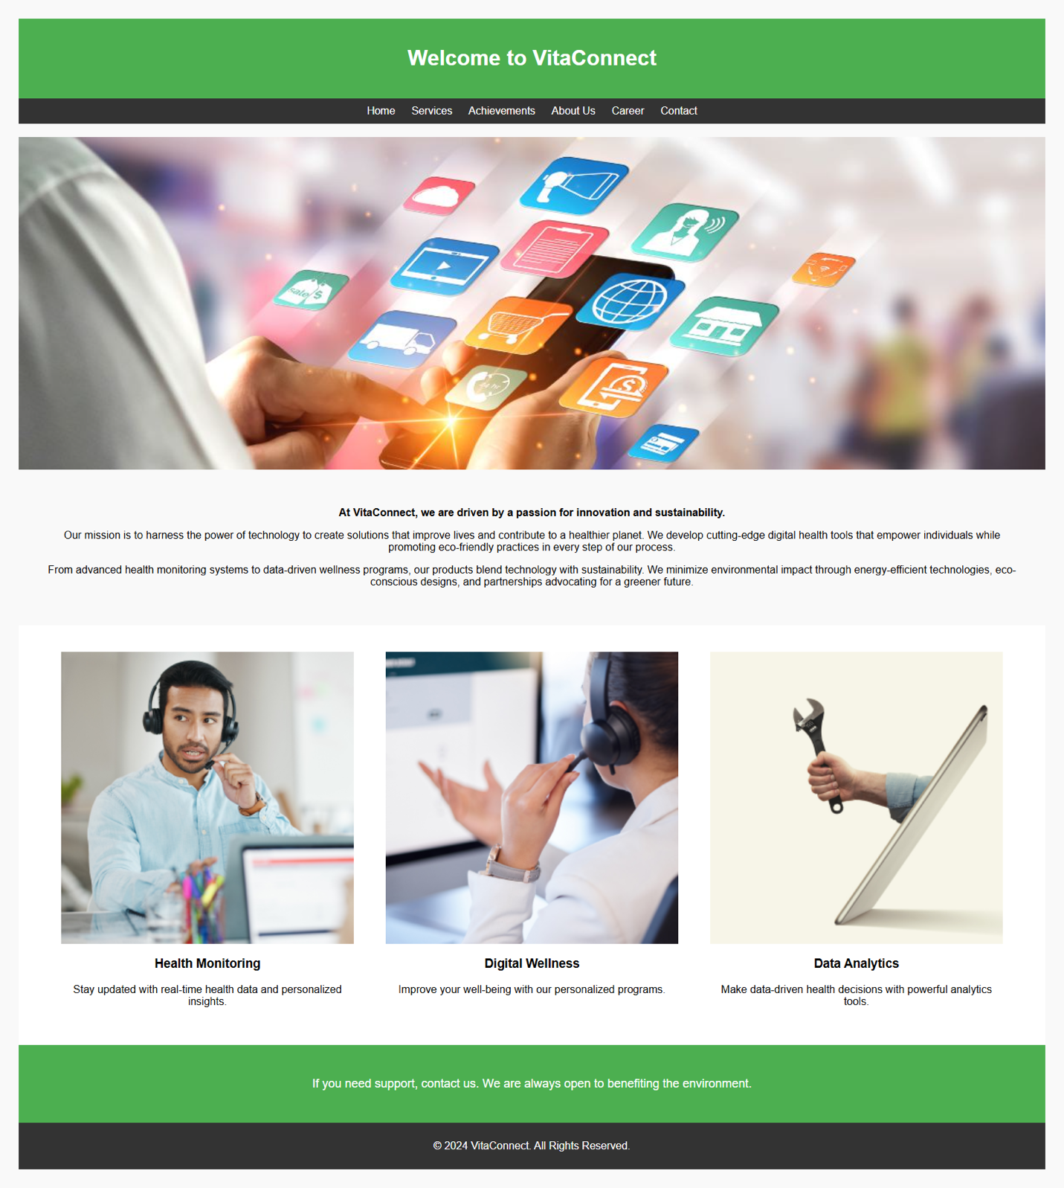

Appendix 2: Services Page

Appendix 3: Achievements Page

Appendix 4: About Us Page

Appendix 5: Career Page

Appendix 6: Contact Page
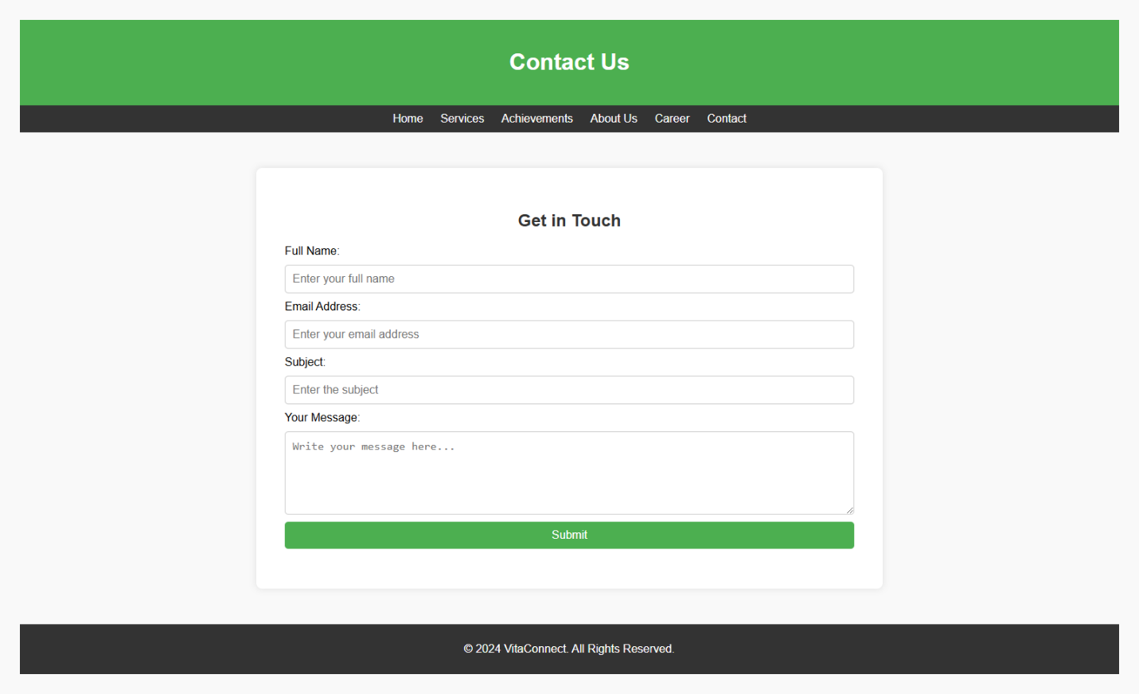

Appendix 7: HTML Validator (W3C Validator)

Appendix 8: CSS Validator (W3C Validator)

Appendix 9: Index Code
<!DOCTYPE html>
<html lang="en">
<head>
<meta charset="UTF-8">
<title>Homepage</title>
</head>
<body style="font-family:Arial;background:#f9f9f9;padding:20px;">
<!-- Header Section -->
<div style="background:#4CAF50;color:white;padding:20px;text-align:center;">
<h1>Welcome to VitaConnect</h1>
</div>
<!-- Navigation Bar -->
<div style="background:#333;padding:10px;text-align:center;">
<a href="index.html" style="color:white;text-decoration:none;padding:10px;">Home</a>
<a href="services.html" style="color:white;text-decoration:none;padding:10px;">Services</a>
<a href="achievements.html" style="color:white;text-decoration:none;padding:10px;">Achievements</a>
<a href="about.html" style="color:white;text-decoration:none;padding:10px;">About Us</a>
<a href="career.html" style="color:white;text-decoration:none;padding:10px;">Career</a>
<a href="contact.html" style="color:white;text-decoration:none;padding:10px;">Contact</a>
</div>
<!-- Hero Section -->
<div style="background:url('image/large.jpg') no-repeat center center/cover;height:500px;margin-top:20px;">
</div>
<!-- About Section -->
<div style="padding:40px;text-align:center;">
<p><b>At VitaConnect, we are driven by a passion for innovation and sustainability.</b></p>
<p>Our mission is to harness the power of technology to create solutions that improve lives and contribute to a healthier planet. We develop cutting-edge digital health tools that empower individuals while promoting eco-friendly practices in every step of our process.</p>
<p>From advanced health monitoring systems to data-driven wellness programs, our products blend technology with sustainability. We minimize environmental impact through energy-efficient technologies, eco-conscious designs, and partnerships advocating for a greener future.</p>
</div>
<!-- Services Section -->
<div style="display:flex;justify-content:space-around;padding:40px;background:white;">
<div style="width:30%;text-align:center;">
<img src="image/1.png" alt="Service 1" style="width:100%;">
<h3>Health Monitoring</h3>
<p>Stay updated with real-time health data and personalized insights.</p>
</div>
<div style="width:30%;text-align:center;">
<img src="image/2.png" alt="Service 2" style="width:100%;">
<h3>Digital Wellness</h3>
<p>Improve your well-being with our personalized programs.</p>
</div>
<div style="width:30%;text-align:center;">
<img src="image/3.png" alt="Service 3" style="width:100%;">
<h3>Data Analytics</h3>
<p>Make data-driven health decisions with powerful analytics tools.</p>
</div>
</div>
<!-- Contact Section -->
<div style="background:#4CAF50;color:white;text-align:center;padding:30px;font-size:18px;">
<p>If you need support, contact us. We are always open to benefiting the environment.</p>
</div>
<!-- Footer -->
<div style="background:#333;color:white;text-align:center;padding:10px;">
<p>&copy; 2024 VitaConnect. All Rights Reserved.</p>
</div>
</body>
</html>

Appendix 10: Services Code
<!DOCTYPE html>
<html lang="en">
<head>
<meta charset="UTF-8">
<title>Services</title>
</head>
<body style="font-family:Arial;background:#f9f9f9;padding:20px;">
<!-- Header Section -->
<div style="background:#4CAF50;color:white;padding:20px;text-align:center;">
<h1>Our Services</h1>
</div>
<!-- Navigation Bar -->
<div style="background:#333;padding:10px;text-align:center;">
<a href="index.html" style="color:white;text-decoration:none;padding:10px;">Home</a>
<a href="services.html" style="color:white;text-decoration:none;padding:10px;">Services</a>
<a href="achievements.html" style="color:white;text-decoration:none;padding:10px;">Achievements</a>
<a href="about.html" style="color:white;text-decoration:none;padding:10px;">About Us</a>
<a href="career.html" style="color:white;text-decoration:none;padding:10px;">Career</a>
<a href="contact.html" style="color:white;text-decoration:none;padding:10px;">Contact</a>
</div>
<!-- Main Content -->
<div style="display:flex;padding:40px;">
<!-- Main Section -->
<div style="width:70%;padding-right:20px;">
<h2 style="color:#333;">Our Commitment to Excellence</h2>
<p>We provide technology-driven health solutions designed to improve lives. Our services are tailored for advanced monitoring, data-driven insights, and personalized wellness programs.</p>
<h3 style="color:#333;">Service Highlights</h3>
<p>Our services help individuals and organizations achieve optimal wellness.</p>
<h3 style="color:#333;">Key Features</h3>
<ul style="list-style-type:circle;padding-left:20px;">
<li>Health monitoring</li>
<li>Data collection and analysis</li>
<li>Fitness and wellness programs</li>
<li>AI diagnostics</li>
<li>Integration with devices</li>
</ul>
<h3 style="color:#333;">Why Choose Us?</h3>
<p>We have a team of skilled professionals and a passion for sustainability. We ensure our services are reliable and eco-friendly.</p>
</div>
<!-- Sidebar -->
<div style="width:30%;background:#f4f4f4;padding:20px;">
<h3>List of Services</h3>
<ul style="list-style-type:square;padding-left:20px;">
<li>Health Monitoring</li>
<li>Data Analytics</li>
<li>AI-powered Diagnostics</li>
<li>Fitness Plans</li>
<li>Remote Health Tracking</li>
<li>Telemedicine Integration</li>
<li>Device Support</li>
<li>Health Report Analysis</li>
<li>Software Development</li>
<li>Mobile App Integration</li>
<li>Data Security</li>
<li>Wearable Sync</li>
<li>Wellness Coaching</li>
<li>Nutrition Plans</li>
<li>Consultation Scheduling</li>
<li>Biometric Scanning</li>
<li>Corporate Wellness</li>
<li>Insurance Assistance</li>
<li>Fitness Tracking</li>
<li>Health Assistants</li>
</ul>
</div>
</div>
<!-- Footer -->
<div style="background:#333;color:white;text-align:center;padding:10px;">
<p>&copy; 2024 VitaConnect. All Rights Reserved.</p>
</div>
</body>
</html>

Appendix 11: Achievements Code
<!DOCTYPE html>
<html lang="en">
<head>
<meta charset="UTF-8">
<title>Achievements</title>
</head>
<body style="font-family:Arial;background:#f9f9f9;padding:20px;">
<!-- Header Section -->
<div style="background:#4CAF50;color:white;padding:20px;text-align:center;">
<h1>Our Achievements</h1>
</div>
<!-- Navigation Bar -->
<div style="background:#333;padding:10px;text-align:center;">
<a href="index.html" style="color:white;text-decoration:none;padding:10px;">Home</a>
<a href="services.html" style="color:white;text-decoration:none;padding:10px;">Services</a>
<a href="achievements.html" style="color:white;text-decoration:none;padding:10px;">Achievements</a>
<a href="about.html" style="color:white;text-decoration:none;padding:10px;">About Us</a>
<a href="career.html" style="color:white;text-decoration:none;padding:10px;">Career</a>
<a href="contact.html" style="color:white;text-decoration:none;padding:10px;">Contact</a>
</div>
<!-- Main Content -->
<div style="display:flex;padding:40px;">
<!-- Main Section -->
<div style="width:70%;padding-right:20px;">
<h2 style="color:#333;">Our Journey of Success</h2>
<p>We have accomplished remarkable milestones since our inception. Through relentless innovation and dedication, we have built a legacy of excellence in health-tech and sustainability.</p>
<h3 style="color:#333;">Milestones Reached</h3>
<p>Our continuous drive for innovation has resulted in groundbreaking achievements in health technology and eco-friendly solutions.</p>
<h3 style="color:#333;">Key Highlights</h3>
<ul style="list-style-type:circle;padding-left:20px;">
<li>Developed award-winning health monitoring applications</li>
<li>Partnered with global healthcare organizations</li>
<li>Won multiple technology innovation awards</li>
<li>Achieved 95% client satisfaction</li>
<li>Implemented eco-friendly practices company-wide</li>
<li>Launched cutting-edge AI-powered diagnostic systems</li>
<li>Expanded into 20+ international markets</li>
<li>Recognized as a top emerging health-tech company</li>
<li>Established industry-leading data security protocols</li>
<li>Supported thousands of users in managing their health</li>
</ul>
<h3 style="color:#333;">Our Continued Growth</h3>
<p>We are committed to pushing boundaries and achieving even greater success in the future through innovation, sustainability, and unmatched service quality.</p>
</div>
<!-- Sidebar -->
<div style="width:30%;background:#f4f4f4;padding:20px;">
<h3>Achievements Summary</h3>
<ul style="list-style-type:square;padding-left:20px;">
<li>App of the Year Award 2023</li>
<li>Health-Tech Innovation Award</li>
<li>Best Wellness Platform</li>
<li>AI Integration Excellence</li>
<li>Global Partnership Recognition</li>
<li>Sustainability Medal 2022</li>
<li>Top 50 Tech Companies</li>
<li>Best Emerging Startup</li>
<li>Data Security Certification</li>
<li>Customer Service Excellence</li>
</ul>
</div>
</div>
<!-- Footer -->
<div style="background:#333;color:white;text-align:center;padding:10px;">
<p>&copy; 2024 VitaConnect. All Rights Reserved.</p>
</div>
</body>
</html>

Appendix 12: About Us Code
<!DOCTYPE html>
<html lang="en">
<head>
<meta charset="UTF-8">
<title>About Us</title>
</head>
<body style="font-family:Arial;background:#f9f9f9;padding:20px;">
<!-- Header Section -->
<div style="background:#4CAF50;color:white;padding:20px;text-align:center;">
<h1>About Us</h1>
</div>
<!-- Navigation Bar -->
<div style="background:#333;padding:10px;text-align:center;">
<a href="index.html" style="color:white;text-decoration:none;padding:10px;">Home</a>
<a href="services.html" style="color:white;text-decoration:none;padding:10px;">Services</a>
<a href="achievements.html" style="color:white;text-decoration:none;padding:10px;">Achievements</a>
<a href="about.html" style="color:white;text-decoration:none;padding:10px;">About Us</a>
<a href="career.html" style="color:white;text-decoration:none;padding:10px;">Career</a>
<a href="contact.html" style="color:white;text-decoration:none;padding:10px;">Contact</a>
</div>
<!-- Main Content -->
<div style="display:flex;padding:40px;">
<!-- Main Section -->
<div style="width:70%;padding-right:20px;">
<h2 style="color:#333;">Who We Are</h2>
<p>VitaConnect is a forward-thinking health-tech company dedicated to merging technology and sustainability. We create innovative solutions that improve lives and promote environmental responsibility.</p>
<h3 style="color:#333;">Our Mission</h3>
<p>We aim to empower individuals with advanced health-tech tools while fostering eco-friendly practices. Our mission is to build a healthier future for everyone through innovative technology and sustainability-driven solutions.</p>
<h3 style="color:#333;">Our Vision</h3>
<p>We envision a world where technology and environmental responsibility go hand in hand. We strive to become a global leader in health-tech, driving positive change and making healthcare accessible to all.</p>
<h3 style="color:#333;">Our Values</h3>
<ul style="list-style-type:circle;padding-left:20px;">
<li><b>Innovation:</b> We believe in transforming ideas into reality through technological breakthroughs.</li>
<li><b>Sustainability:</b> We prioritize eco-friendly operations and reduce our carbon footprint.</li>
<li><b>Excellence:</b> We maintain the highest standards in everything we do.</li>
<li><b>Integrity:</b> We operate transparently and with trust at the core.</li>
<li><b>Collaboration:</b> We work closely with industry leaders to create global health-tech advancements.</li>
</ul>
</div>
<!-- Sidebar -->
<div style="width:30%;background:#f4f4f4;padding:20px;">
<h3>Quick Facts</h3>
<ul style="list-style-type:square;padding-left:20px;">
<li>Founded in 2020</li>
<li>Global Operations</li>
<li>500K+ Active Users</li>
<li>Partnerships with Global Leaders</li>
<li>Eco-Friendly Projects</li>
<li>Top Innovation Awards</li>
<li>Advanced R&D Facilities</li>
<li>Certified Data Security</li>
<li>Customer-Centered Support</li>
<li>Sustainability-Driven Initiatives</li>
</ul>
</div>
</div>
<!-- Footer -->
<div style="background:#333;color:white;text-align:center;padding:10px;">
<p>&copy; 2024 VitaConnect. All Rights Reserved.</p>
</div>
</body>
</html>

Appendix 13: Career Code
<!DOCTYPE html>
<html lang="en">
<head>
<meta charset="UTF-8">
<title>Career</title>
</head>
<body style="font-family:Arial;background:#f9f9f9;padding:20px;">
<!-- Header Section -->
<div style="background:#4CAF50;color:white;padding:20px;text-align:center;">
<h1>Career Opportunities</h1>
</div>
<!-- Navigation Bar -->
<div style="background:#333;padding:10px;text-align:center;">
<a href="index.html" style="color:white;text-decoration:none;padding:10px;">Home</a>
<a href="services.html" style="color:white;text-decoration:none;padding:10px;">Services</a>
<a href="achievements.html" style="color:white;text-decoration:none;padding:10px;">Achievements</a>
<a href="about.html" style="color:white;text-decoration:none;padding:10px;">About Us</a>
<a href="career.html" style="color:white;text-decoration:none;padding:10px;">Career</a>
<a href="contact.html" style="color:white;text-decoration:none;padding:10px;">Contact</a>
</div>
<!-- Main Content -->
<div style="display:flex;padding:40px;">
<!-- Main Section -->
<div style="width:70%;padding-right:20px;">
<h2 style="color:#333;">Join Our Team</h2>
<p>We are constantly looking for talented individuals who are passionate about technology and sustainability. Explore our current job openings and become part of a company dedicated to making a difference.</p>
<!-- Job 1 -->
<h3 style="color:#333;">Software Developer</h3>
<p><b>Responsibilities:</b></p>
<ul style="list-style-type:circle;padding-left:20px;">
<li>Design and develop scalable web applications.</li>
<li>Collaborate with teams to implement new features.</li>
<li>Ensure performance, quality, and responsiveness of applications.</li>
<li>Troubleshoot technical issues and bugs.</li>
<li>Stay updated with modern technologies and industry best practices.</li>
</ul>
<p><b>Requirements:</b></p>
<ul style="list-style-type:circle;padding-left:20px;">
<li>Bachelor’s degree in Computer Science or a related field.</li>
<li>Knowledge of JavaScript, Python, or Java.</li>
<li>Experience with React or Angular frameworks.</li>
<li>Strong problem-solving and teamwork skills.</li>
<li>Familiarity with database management.</li>
</ul>
<!-- Job 2 -->
<h3 style="color:#333;">Digital Marketing Specialist</h3>
<p><b>Responsibilities:</b></p>
<ul style="list-style-type:circle;padding-left:20px;">
<li>Develop and execute digital marketing strategies.</li>
<li>Create engaging content for social media and websites.</li>
<li>Manage advertising campaigns across digital platforms.</li>
<li>Monitor marketing metrics and performance analytics.</li>
<li>Stay updated on current marketing trends and SEO techniques.</li>
</ul>
<p><b>Requirements:</b></p>
<ul style="list-style-type:circle;padding-left:20px;">
<li>Bachelor’s degree in Marketing or a related field.</li>
<li>Experience in social media management and SEO.</li>
<li>Knowledge of Google Ads, Facebook Ads, and PPC campaigns.</li>
<li>Strong creative writing and content creation skills.</li>
<li>Excellent communication and organizational skills.</li>
</ul>
</div>
<!-- Sidebar -->
<div style="width:30%;background:#f4f4f4;padding:20px;">
<h3>Why Work With Us?</h3>
<ul style="list-style-type:square;padding-left:20px;">
<li>Competitive Salaries</li>
<li>Flexible Work Environment</li>
<li>Professional Development</li>
<li>Innovative Projects</li>
<li>Global Client Base</li>
<li>Health & Wellness Programs</li>
<li>Inclusive Workplace</li>
<li>Collaborative Culture</li>
<li>Paid Time Off</li>
<li>Work-Life Balance</li>
</ul>
</div>
</div>
<!-- Footer -->
<div style="background:#333;color:white;text-align:center;padding:10px;">
<p>&copy; 2024 VitaConnect. All Rights Reserved.</p>
</div>
</body>
</html>

Appendix 14: Contact Code
<!DOCTYPE html>
<html lang="en">
<head>
<meta charset="UTF-8">
<title>Contact Us</title>
</head>
<body style="font-family:Arial;background:#f9f9f9;padding:20px;">
<!-- Header Section -->
<div style="background:#4CAF50;color:white;padding:20px;text-align:center;">
<h1>Contact Us</h1>
</div>
<!-- Navigation Bar -->
<div style="background:#333;padding:10px;text-align:center;">
<a href="index.html" style="color:white;text-decoration:none;padding:10px;">Home</a>
<a href="services.html" style="color:white;text-decoration:none;padding:10px;">Services</a>
<a href="achievements.html" style="color:white;text-decoration:none;padding:10px;">Achievements</a>
<a href="about.html" style="color:white;text-decoration:none;padding:10px;">About Us</a>
<a href="career.html" style="color:white;text-decoration:none;padding:10px;">Career</a>
<a href="contact.html" style="color:white;text-decoration:none;padding:10px;">Contact</a>
</div>
<!-- Main Content -->
<div style="max-width:800px;margin:50px auto;background:white;padding:40px;box-shadow:0 0 10px rgba(0,0,0,0.1);border-radius:8px;">
<h2 style="color:#333;text-align:center;">Get in Touch</h2>
<form action="#" method="POST" style="display:flex;flex-direction:column;">
<label for="name" style="text-align:left;">Full Name:</label>
<input type="text" id="name" name="name" placeholder="Enter your full name" required style="padding:10px;margin:10px 0;font-size:16px;border:1px solid #ccc;border-radius:5px;">
<label for="email" style="text-align:left;">Email Address:</label>
<input type="email" id="email" name="email" placeholder="Enter your email address" required style="padding:10px;margin:10px 0;font-size:16px;border:1px solid #ccc;border-radius:5px;">
<label for="subject" style="text-align:left;">Subject:</label>
<input type="text" id="subject" name="subject" placeholder="Enter the subject" required style="padding:10px;margin:10px 0;font-size:16px;border:1px solid #ccc;border-radius:5px;">
<label for="message" style="text-align:left;">Your Message:</label>
<textarea id="message" name="message" rows="5" placeholder="Write your message here..." required style="padding:10px;margin:10px 0;font-size:16px;border:1px solid #ccc;border-radius:5px;"></textarea>
<button type="submit" style="background:#4CAF50;color:white;border:none;padding:10px;font-size:16px;border-radius:5px;cursor:pointer;transition:background-color 0.3s;">Submit</button>
</form>
</div>
<!-- Footer -->
<div style="background:#333;color:white;text-align:center;padding:10px;">
<p>&copy; 2024 VitaConnect. All Rights Reserved.</p>
</div>
</body>
</html>

References

A. Powell, "Web Design: Principles and Practices," Cengage Learning, 2021.
T. L. Tullis and W. Albert, "Measuring the User Experience: Collecting, Analyzing, and Presenting Usability Metrics," Morgan Kaufmann, 2013.
E. Dubois, J. Gray, "Accessibility Design for Individuals with Disabilities," Springer, 2020.
M. Rosenfeld and L. Morville, "Information Architecture for the World Wide Web," O'Reilly Media, 2006.
A. Kalbag, "Accessibility for Everyone," A Book Apart, 2017.
S. Krug, "Don't Make Me Think: A Common Sense Approach to Web Usability," New Riders Publishing, 2013.
C. Turner, "SEO for Dummies," Wiley, 2020.
G. Atkins, "Responsive Web Design: A Beginner's Guide," McGraw-Hill, 2012.
W3C, "Web Content Accessibility Guidelines (WCAG) 2.1," [Online]. Available: https://www.w3.org/TR/WCAG21/.
Google Developers, "Search Engine Optimization (SEO) Starter Guide," [Online]. Available: https://developers.google.com/search/docs/beginner/seo-starter-guide.
A. Robbins, "Learning Web Design: A Beginner's Guide to HTML, CSS, JavaScript, and Web Graphics," O'Reilly Media, 2018.
J. Duckett, "HTML and CSS: Design and Build Websites," Wiley, 2011.
J. Nielsen, "Usability Engineering," Morgan Kaufmann, 1994.
E. Freeman, "Head First HTML and CSS," O'Reilly Media, 2012.
J. Nielsen and R. Molich, "Heuristic evaluation of user interfaces," in Proceedings of the SIGCHI Conference on Human Factors in Computing Systems, ACM, 1990.

