Jayden Brewer

Essential elements of construction contracts.
Legal and contract responsibilities in the Built Environment.
Abstract
Consider the essential elements of a contract and consider a misinterpretation of an element of work contracted for.
Table of contents

Page 1……………. Table of contents
Page 2……………. Introduction and Contracts in Construction
Page 3……………..Construction Contracts Overview
Forms of construction contract
Page 5,6……………. What makes a contract valid
Page 7,8…………. Scenario
Page 9,10…………… Reference list

Introduction
Considering the essential elements of a contract and a misinterpretation of an element of work. Construction contracts are a crucial aspect of any job; however, they are very complicated. Misinterpretations to an element of work can cause issues to the project and parties involved. With construction projects potentially costing millions of pounds a contract may assist you in not losing money. Contracts will give a clear guide as to what is going to happen in the project.

Contracts in construction
Contracts are used within construction as a guide to all parties that will clearly state what is required from each party. It will highlight all important information that a party is required to meet standards with. Cost, time, and resources are among the most crucial elements when buying into a contract.
“A construction contract is a written agreement between a client and a contractor that sets out the services to be provided, the cost of those services, and the delivery schedule. The contract may also include details about the quality of work, who will inspect the work, how the parties will resolve disputes, and how the parties can terminate the agreement.” (Heming, 2022)
Variations need to be considered when forming a contract. A variation is a change to the scope of work and will have an effect on how and when work will be completed. A variation can occur if a change of design or an issue with construction arises.
“A variation (sometimes referred to as a change) is an alteration to the scope of work originally specified in the contract, whether by way of an addition, omission, or substitution to the works, or through a change to the manner in which the works are to be carried out.” (LexisNexis, 2023)
“Extras” are sometimes needed to finish a project. These will not be in the original scope of works therefor not in the original contract. Payments for extras are contractual and if the contractor completes extra work without an instruction/permission then the client will not be obligated to pay for the works and the contractor will have to fund the work completed.
The (Molloy v liebe (1906)) case gives an example of extra works that were not included in the contract. The court stated the employer had knowledge and witnessed the extra works being completed and knowing that they were not part of the contract, knew the builder would expect payment for them.

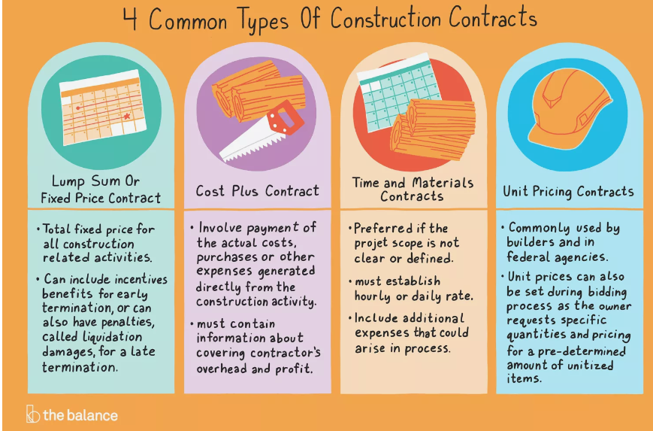
(Miller, 2018) https://www.liveabout.com/common-types-of-construction-contracts-844483

Forms of Construction Contracts
There are multiple types of construction contracts. Different contracts are used for different purposes depending on many factors of the project. These factors can be size of the job, the scope of the job and also how complicated the job is.
For example a smaller project will better suit a lump sum contract, this is where the price is fixed from the start. “A lump sum contract is a construction contract where the contractor or subcontractor agrees to complete a project for a fixed price.” (Hemming, 2023)

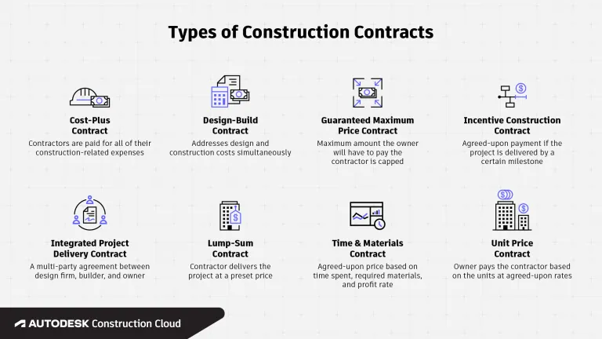
https://constructionblog.autodesk.com/construction-contracts-types/ (Ellis, 2022)

What makes a contract valid?

A contract is an agreement that is legally enforced. An agreement Is made between two or more parties. “A contract is a legally binding promise (written or oral) by one party to fulfil an obligation to another party in return for consideration A basic binding contract must comprise four key elements: offer, acceptance, consideration and intent to create legal relations.” (Reuters,2023)

For a contract to be considered valid, there are many requirements that must be met. When forming a contract in construction, there may be other elements of work that will also need to be accounted for:
∙Project- This can be the time, materials, and scope of works.
∙Tenancy – this is the right to occupancy.
∙Lease- such as machinery, vehicles and tools.
∙Employment- Sub contractors

Offer and acceptance – An offer will be proposed by one party to enter a contract with another. The offer must be clear, definite and certain. All important details must be included in the offer such as price and other things.
Acceptance must mirror the terms of the offer, meaning the acceptance must exactly match the terms of the offer. Acceptance is subject to time, if the offer is not accepted/rejected within the time given then the offer may be withdrawn.
Offers still have the potential to be revoked by the party. (A case example of an offer being revoked (Dickenson v Dodds (1876)) If the offer is negotiated with, then the offer given is rejected. If negotiation of the offer occurs, then the party accepting/rejecting the offer (offeree) will then become the ones making the offer (offeror). (A case example of negotiation has rejected the offer (Hyde V Wrench (1840))
Consideration – When entering a contract both parties must provide something of value as part of the contract. For example, if a contractor is providing you with a service to build a house, then you will provide them with money or other services in return. (A case example of a party failing to provide consideration (Price V Easton (1833))

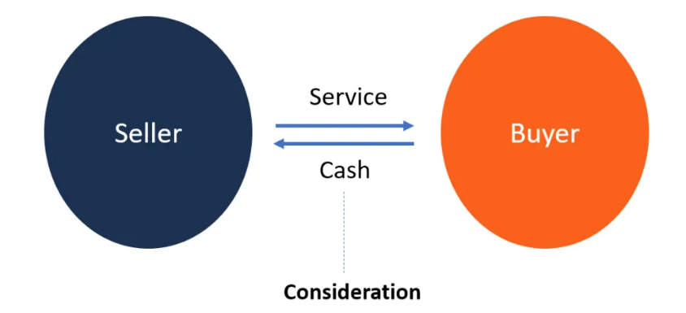

Image used (CFI, 2015)

Legal capacity – Both parties entering the contract must be of legal age and must be mentally sound therefor being able to judge their decisions. “Individuals who enter into a contract must have the legal capacity to enter into a contract, otherwise its voidable” (Laver, n.d.)
Certainty and performance – The contract proposed must be achievable in the time given. If a contract is not deemed as “possible” to complete, then it will not go ahead. “Certainty in contract law refers to the clarity and precision of the terms and conditions within a contractual agreement. All parties involved in a contract need to fully understand and interpret its terms. A contract should be a complete and final agreement, leaving no room for ambiguity or misunderstanding.”
(lawbite.co.uk, 2023)

Consent is needed to assure the validity of a contract. Consent implies that all parties have full understanding and fully agree to the terms and conditions of proposed contract. If any changes have been made to the original contract, then all parties must also consent to these amendments.
Finally, a signature will be needed as an official confirmation of acceptance into the contract.

Scenario
A construction company is hired to renovate a hospital owned by company AZ. The contract proposed highlights that the construction company will be required to install new fire doors throughout the whole building. The contract specifies the fire doors must be of a high quality and durable.
The construction company selects a high quality and durable fire door that they believe will be compliant with what the client has requested from them. During the project, company AZ realise the fire doors that are being installed are not what they were hoping for aesthetically.
Once the project is completed, company AZ express that they are not satisfied with the works completed as the fire doors installed did not meet expectations aesthetically. They claim that there has been a misinterpretation of the contract. They debate that “high quality” means aesthetically pleasing and that they were expecting a better-looking door.
The construction company argued that their choice of a “high quality and durable” fire door met all requirements set by the client. The aesthetics of the fire doors was not mentioned in the contract therefor were not factored in by the construction company. Company AZ has refused to pay the construction company for all aspects of work.

This issue could lead to many other problems.
Company AZ may refuse to pay the construction company for the work they have completed due to dissatisfaction. This should try to be resolved by communicating between parties and clearly outlining issues within the contract and then having the issues solved. The company that is dissatisfied may pay for certain aspects of work but may not give full payment.
The problem may also be taken to court. In this case, the client is in the wrong as they did not specify in the contract how the fire doors should look. If the client refuses to provide full payment, then this is called breach of contract. The construction company may claim for compensation for the lack of payment they have received.
Compensation is the “Money paid to make up for damage or loss caused.” (legalchoices.org.uk, n.d.)
Taking the case to court is also an expensive decision and will cost the client additional money. If the client is judged as being in the wrong, then they could be paying out compensation worth more than the original price of the works completed.

Construction project deficiency is defined as “a characteristic or condition that fails to meet a standard or is not in compliance with a requirement or specification, and is sometimes referred to as defective work. “ (Behner, 2017)
With the fire doors not meeting the clients request in their opinion. Then they may want the work re done. They would require paying a construction company for the works again because there was no issue with the previous works according to the contract. This would double the project time to 4 years and also double the costs. It is crucial that both parties read and fully understand what they are required to do as it can lead to many issues. The issue in the scenario was a loss of money and loss of time.

Summary
With contracts within construction being so complicated, the need for clarity and understanding is key to successfully executing the project in progress. It provides guidance and a clear plan as to when and how different aspects of work will occur. Health and safety is a massive thing in construction, contracts can help minimise risks and hopefully prevent accidents on site. A contract will help settle any disputes between anyone that is contracted to work on the site, money and time are often major aspects of a job and a contract will clearly state a time frame and the price of the work agreed on.

References

(n.d.). Retrieved from legalchoices.org.uk: https://www.legalchoices.org.uk/dictionary/compensation
Behner, P. (2017, March 15). Retrieved from brendaniel.ca: https://brendaniel.ca/deficiencies-the-achilles-heel-of-construction-projects/
CFI. (2015). Retrieved from corporatefinanceinstitute.com: https://corporatefinanceinstitute.com/resources/valuation/consideration/
Ellis, G. (2022, september 1). Retrieved from Constructionblog.autodesk.com: https://constructionblog.autodesk.com/construction-contracts-types/
Heming, P. (2022, December 9th). Retrieved from C-Link.com: https://c-link.com/blog/a-guide-to-construction-contracts-in-the-uk/
Hemming, P. (2023, June 30). Retrieved from c-link.com: https://c-link.com/blog/what-you-need-to-know-about-lump-sum-contracts-in-construction/
jctltd.co.uk. (2023). Retrieved from jctltd.co.uk: https://www.jctltd.co.uk/category/standard-building
Laver, N. (n.d.). Retrieved from Claims.co.uk: https://www.claims.co.uk/knowledge-base/contract-law/capacity-in-contract-law#:~:text=in%20contract%20law-,What%20is%20'capacity'%20in%20Contract%20Law%3F,unless%20they%20are%20illegal%20contracts).
lawbite.co.uk. (2023, October 24). Retrieved from lawbite.co.uk: https://www.lawbite.co.uk/resources/blog/certainty-in-contract-law
LexisNexis. (2023). Retrieved from LexisNexis: https://www.lexisnexis.co.uk/legal/guidance/what-is-a-variation-on-a-construction-project#:~:text=A%20variation%20(sometimes%20referred%20to,are%20to%20be%20carried%20out.
Miller, K. (2018). Retrieved from liveabout.com: https://www.liveabout.com/common-types-of-construction-contracts-844483
Reuters, T. (2023). Retrieved from Thompson Reuters Practical Law: https://uk.practicallaw.thomsonreuters.com/4-107-6271?transitionType=Default&contextData=(sc.Default)

