Self-Assessment and the developing learner portfolio

Self- assessment and self- evaluation are proposed to be powerful learning tools, and have major significance to the development of the effective learner. This is especially important in higher education. This portfolio will include discussion on the development of the individual learner, the role of self-assessment and self-evaluation and it’s relativeness in creating effective learners in higher education. The portfolio will also include reflection on the available evidence on “The student” and how they have developed in higher education.
Success in higher education and life after education is achieved when students are aware of their own thought process and are able to self regulate their own learning (Siegesmund, 2017). Reflection is a major part of self assessment, it’s when students process their learning by evaluating their performance using success criteria and work out ways in which to improve their work (Andrade, 2019). During the self-assessment of ones own learning there are many questions a student asks himself or herself; “‘how am I doing?’ 'Is this enough?’ 'Is this right?’ 'How can I tell?’ 'Should I go further?'” (Boud, 2005, P1)
These questions are the way in which students assess their own learning. By answering these questions students can begin their own self-assessment of their work and how to improve. According to Black and William (2009) self assessment is vital to current and life long learning, it increases student motivation and helps students to regulate their own work and achieve better results. When self-assessment is completed and changes are made students are then able to move on and begin to self evaluate their work.
Self-evaluation is usually summative in the form of tests and essays etc. Formative assessment is usually used for self-assessment this can also be in the form of feedback received from lecturers. Self-evaluation is performed based on results and progress outcomes etc. (Blanchard, 2002). The development of effective learners in higher education happens with the correct support from all staff, however mostly it is the responsibility of academic staff such as the lecturers. Supporting this the EEF (2020) states that specific strategies should be in place in order for pupils to develop individually and effectively, the following strategies are supporting students in planning, monitoring, understanding and managing their own learning, developing an inquisitive mindset and becoming self motivated. Lecturers should ensure that there is opportunity for collaborative learning, peer assessment, feedback and strategies to boost metacognition and self-regulation. When these support strategies are put in place and implemented properly alongside quality teaching of higher education content, student attainment can be raised.

“The student” reflection of starting higher education:

The student at the focus of this study began university at age 21, older than the most common entry age for university. The student suffered from anxiety because they felt unprepared for the leap they were taking starting their higher education journey, feeling that her ‘break’ from education had left her ‘out of practice’. However determined, She left a comfortable full time job in pursuit of the opportunity to better herself. After starting the course she started to assess what she knew in comparison to her peers, she felt worried as they all had recent experience of writing essays and using ‘Turnitin’ to submit essays which the student had never heard of before. It seems the student suffered from imposter syndrome, she felt she didn’t belong and if she expressed her concerns too much to her lecturers or peers they would confirm her fears (Corkindale, 2008).

Barnett (1999) once said that students who had previously worked before entering higher education had already formed their identity to their previous work role and this conflicted with their new role as a student. He suggested students who used to work full time and chose to the attend university faced existential anxiety.
As the student had come from a working background, they were used to working towards targets and having to be responsible for their own workload. However the targets were provided by her team leader and the work she did never changed much, so she did not have to regularly learn new content. At university the student had to consider her own learning and how to become more self regulated.
Nicol and Macfarlane-Dick (2005) believe that to develop individual effective learning in higher education the student must set themselves goals. The definition of a goal in this case is to, “monitor, regulate and control their cognition, motivation, and behaviour, guided and constrained by their goals and the contextual features of the environment” (Nicol and Macfarlane-Dick, 2005).

Through self- assessing, the student felt it was important to learn about their learning style to enhance their development. Hawk and Shah (2007) who stated that students learn in different ways; also said that higher education institutions need to approach lectures in a way where they are understood by all learning styles. The student took a VARK questionnaire during first year to understand how best to take in information from lecture and how to study effectively to develop her learning.

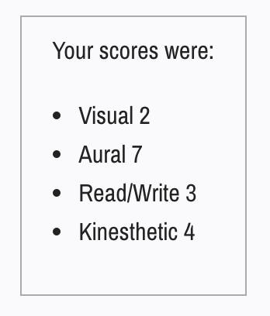
These were the student’s results from the VARK questionnaire. Her results show that she learns more aurally, this means she prefers to listen and discus in order to learn and develop (VARK, 2020). Looking back at lectures the student realised that a lot of the lectures included power points that were visual and as this was her weakest point she often zoned out, however the class often had discussions and debates that the student enjoyed listening and partaking in because that’s how she learnt best. She realised that for her to improve her learning in lecture she needed to be able to take effective notes as well as listening to the lecture. It was important for the student to understand how they learnt best, as they didn’t expect to have so much responsibility for their own learning in university. Previous experience in sixth form suggested they would still be taught in a format so that they could pass tests, they soon found out that university lectures do not teach directly to the assessments. It is the responsibility of the students to decide what they pick up from each lecture and how they use that information to explore and add to their knowledge.

Feedback

One of the most essential parts of becoming an effective learner is receiving feedback. Feedback allows students to understand their work and know what went well and what could be improved. Ferguson (2011) said that feedback is important, as it is crucial for allowing students to develop independently and lets them “feed- up” from their education and degree and into their further careers. Although there is evidence of feedback helping students, however there are also some experts that think that feedback lacks impact in regard to improvement (Perera et al, 2008).
Based on reflection from the student, feedback could be extremely insightful, though depending on how the student reviews the feedback it can be pointless or harmful to development. The student found that in higher education she cares more about her grade than the feedback. The grade is considered feedback enough unless her marks are lower than usual the she will look into the feedback more.
Higgins et al (2001) agrees with the student’s point of view, they believe that a feedback gap exists; students will not make proper use of their feedback or act on it to improve their work. The student example in this portfolio went into higher education already considering her final grade and hoping to ensure she received a 2:1 or above. When she sees that she is getting consistent scores in the 60’s which equals to a 2:1 she assesses her situation as she is doing well enough for her previous set goal and does not need to try and improve her grades. In this case reading the feedback thoroughly is not really important, however it is nice to read about the good aspects of her work. Because she already considers herself to be at the level she wants, considering any difficult improvements to increase her grade may seem uninteresting. Perhaps if there was a more intimate form of feedback the student may have believed that increasing her self-assessment of her final grade a possibility and could have improved her grade to a 1st .
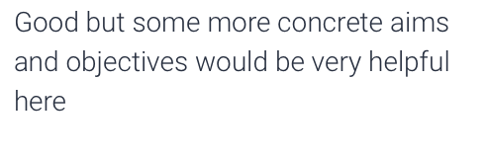
The student’s results, from the current academic year: Her lowest mark is seen in community engagement. The comment seen in the red box was left on the community engagement assignment completed by ‘the student’. The student felt that this comment was okay but could have given an example to improve her understanding, however she feels that she could also have booked to speak to her lecturer in person to discuss the point made.

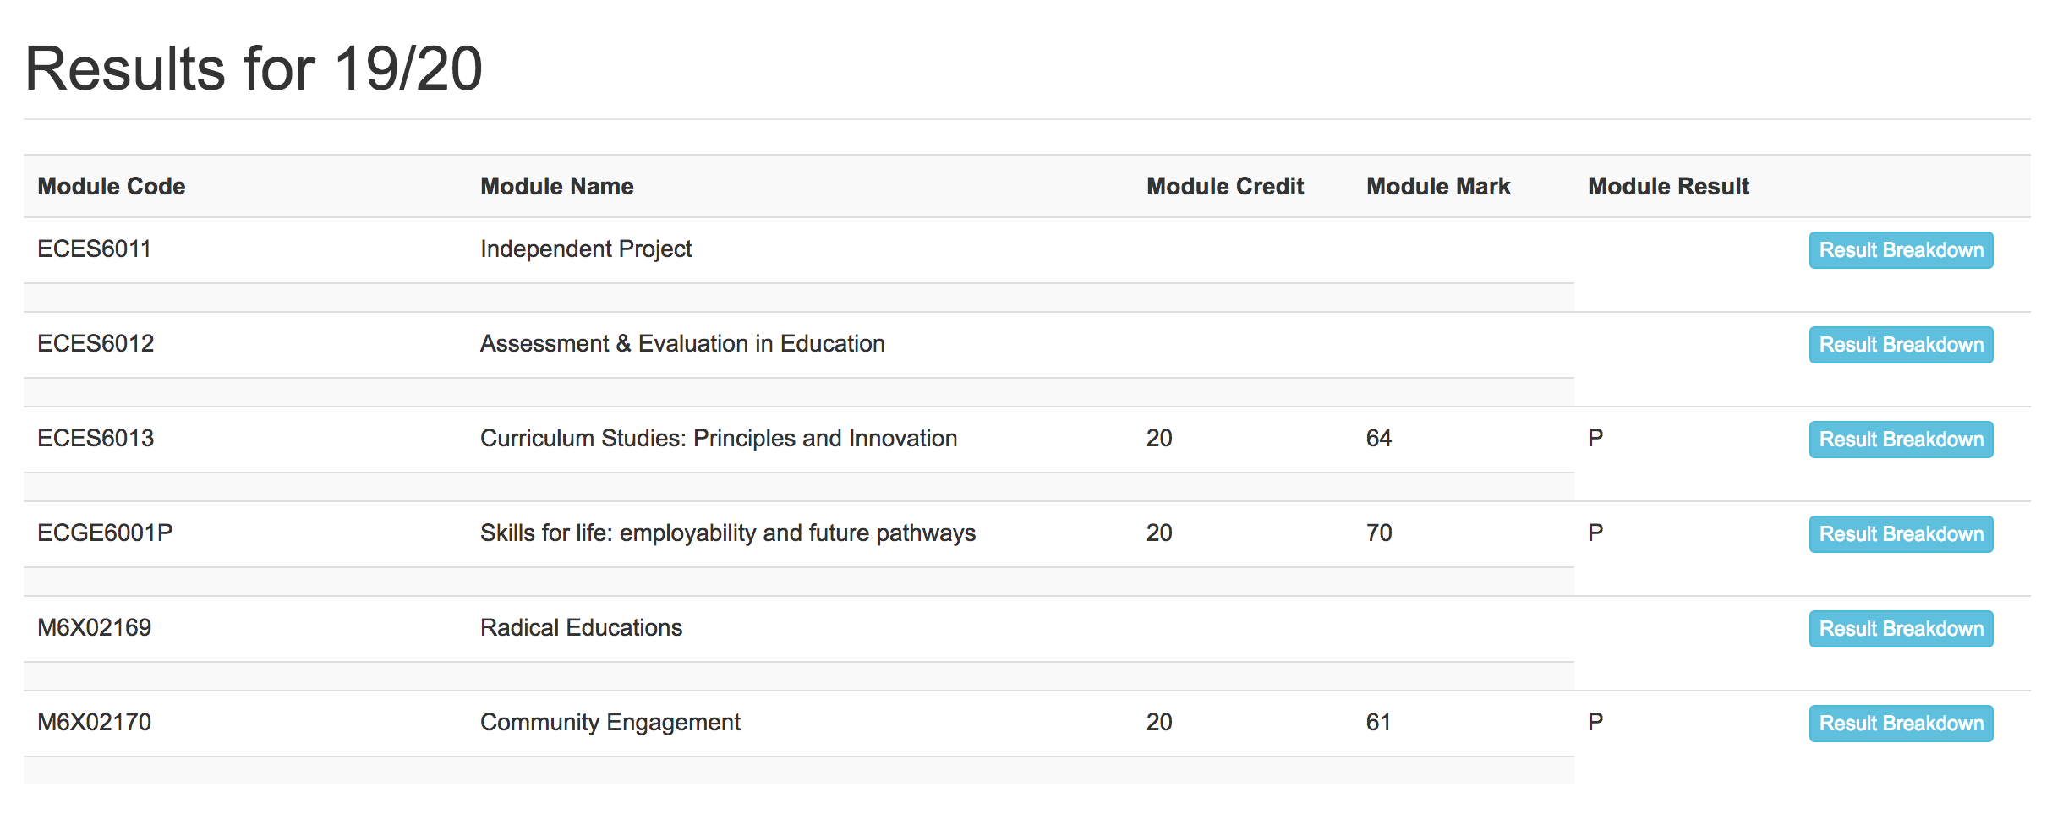
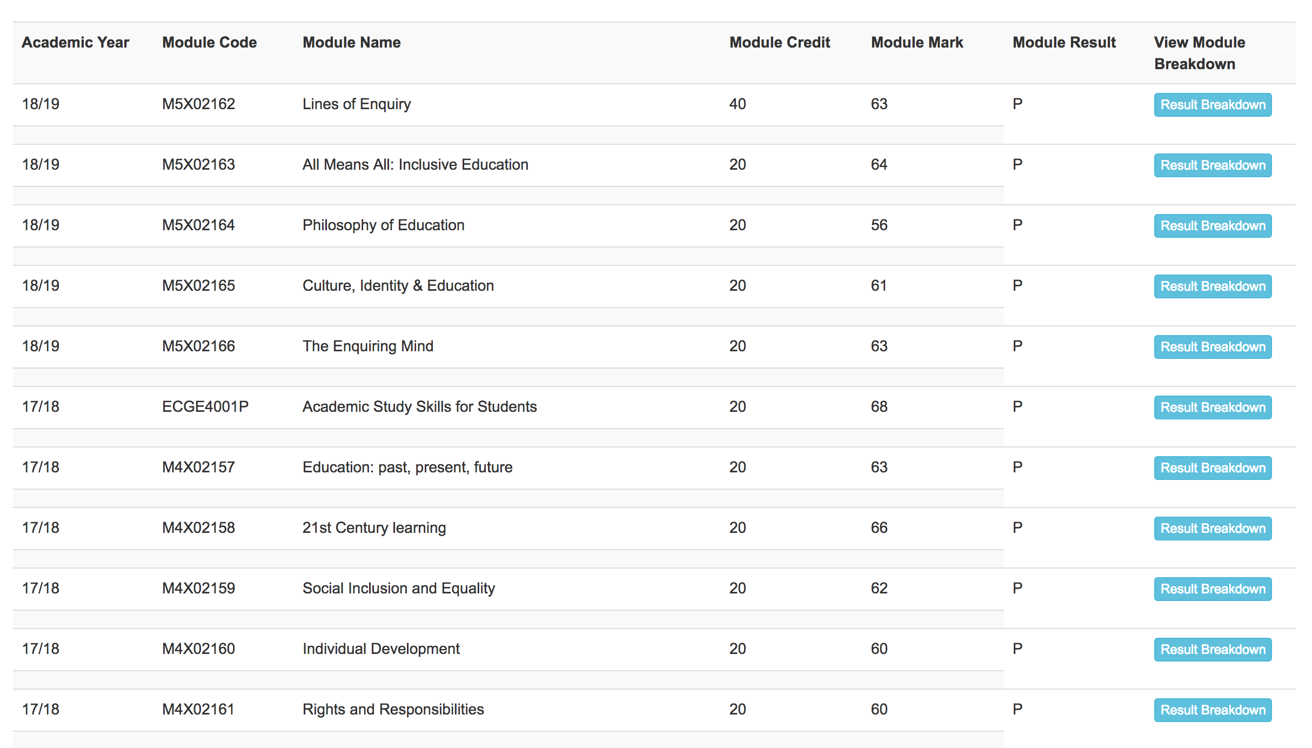
Below are the student’s results from years one and two;
The results are very consistent with only one dropping below 60. The mark below the 60 is the only case where the student said she looked at her feedback to see what went wrong. However as assessments are summative and classed as a pass over 40 the student felt she didn’t take much notice of the feedback as she couldn’t make changes to that particular work and her other marks she was happy with. Had there been opportunity to retake the assessment or had she received feedback from her draft versions of essays then she may have taken more notice of the feedback and used it to improve.

As an aural learner the student feels that feedback would be taken in more if it were delivered verbally face-to-face. In first year the student attended feedback sessions, which she felt helped her improve her work more as the lecturer explained to her whilst also showing her where she went wrong in her assessment and also what she did well. An example she was shown from first year was that her paragraphs were too long, spelling; punctuation and layout are all marked in the success criteria and if she improved this she could gain more marks easily. The student took this feedback in to consideration and since then has only had marks over 60.

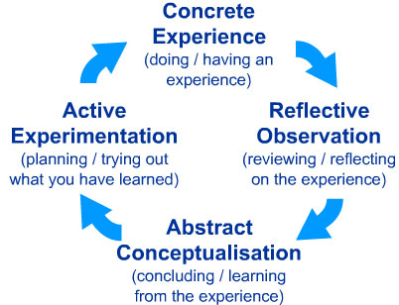

This diagram is Kolb’s experiential learning style theory. This theory is something the student has decided is important for her future career based on what she has learnt at university. The student has experience receiving feedback, self-assessing, self-evaluating and peer assessing. She reflects on all the times she has had experience with the above, she then concludes what she learnt and what she would do different and strategies she could include. When the student becomes a teacher she will then be involved in active experimentation. The accumulation of what she has learnt in higher education can now be used to inform her teaching practice. To pass on knowledge to learners in her care, so that they too can become effective learners (Virginia tech, 2020)

Presentations

Ritchie (2016) states that assessed oral presentations are an important part of higher education; they help individuals to develop vital skills needed for their future profession. Being competent in areas such as planning, organisation, and delivery are just some of the skills Richie believes are inherent to a successful, well-received presentation.
The student aims to be come a teacher, according to Cox (2020) the key skills required for teaching are confidence, communication, engagement, organisation and the ability to inspire. All these skills are skills that the student can improve and/or develop by partaking in assessed oral presentations.

In Richie’s (2016) study students had the opportunity to do a mock presentation before the real thing. Students who had there mock recorded and were able to use it to self-assess their performance had better knowledge of their content. Subsequently their presentation was explained more thoroughly, timing was much more improved and they spoke more clearly. Thus, this self-assessment meant that in their assessed presentation they performed better.
The student evaluated the use of assessed presentations on her course; she feels that it is a great opportunity to build confidence in public speaking. Through self-assessment she has been able to learn to organise the content she wanted to include on her presentation slides, effectively delivery the content she wanted to talk about. The student felt that having to plan how she would give her presentation, what she could add to it to make it more engaging, considering learning aids such as hand-outs (and anything else, videos, visual and diagrams). This has taught her a lot about how to adapt to different scenarios and how to provide for different audiences. These skills will be important to ensuring her future presentations are successful.
In the case of the student, some of her best marks have been in her presentations and she believes this is because she was able to more eloquently explain the topic by expressing herself verbally and through body language. Using a medium of teaching that she better understands because of her aural learning style increases her ability to explain her opinion and get the point across.
The idea that Richie (2016) suggests, is appealing to ‘the student’, allowing pupils to self assess their own presentation is an incredibly useful tool. In this case she thinks that this would have been useful to improve her own presentations. Somewhat implementing this idea her self, she has previously done a practice run at home. However being able to watch a recording of herself would have been useful as she could have pin pointed required improvement using self-assessment, being able to realise what is good and bad about her presentation before it was assessed and graded. This could have lead to more thorough reading of feedback to understand the discrepancies between her own thought process and how things are marked.

Objectives and Success criteria

Knight (2005) suggests, “Assessment is an engine for learning”, assessment for learning in higher education allows students to have more of an idea of what their summative assessments will include and what they need to practice to pass successfully. A success criterion is extremely relevant for understanding what is needed in an assignment. Learners need to be aware of what will be judged in their work, just as much as their lecturer and Knight believes that arguably students need to be more aware than their lecturers when it comes to success criteria.

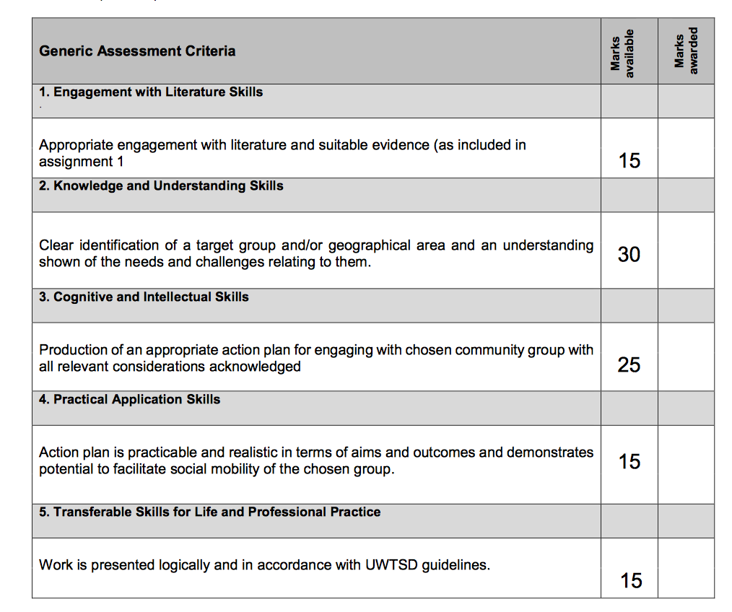

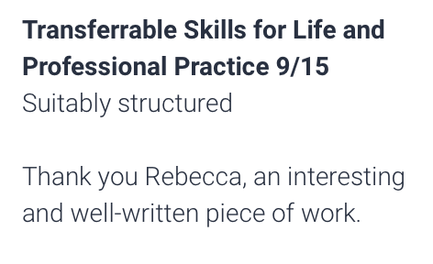
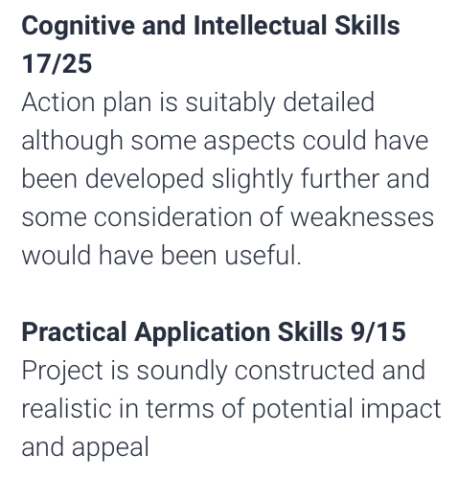
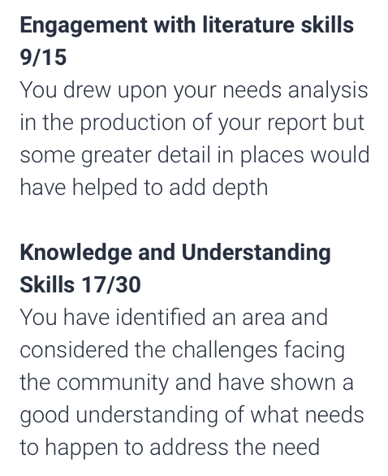

This above is an example of the student’s criteria she received before the assignment on community engagement. Below the criteria sheet is the comments left by the lecturer using the criteria sheet to grade each area of the students work. This is really helpful for the student as she can use this feedback to see the areas that she is doing well at and the areas where she is lacking. The student says that she sometimes gets her friends to peer assess her work using the criteria sheet but she struggles to self assess herself using the sheet. She feels it isn’t detailed enough or written in a simple enough way for her to understand. As Knight (2005) said if the student is aware and able to interpret the criteria properly they are more likely to achieve higher.

Learning intentions/objectives are also seen to be useful in developing learner understanding. Studies suggest that some students find learning objectives to be tokenism and the lecturer just tick boxing what they must include in lectures. However there is evidence to suggest that learning objectives allow students to have a snapshot of what they are expected to learn each lesson and it is also something they can look back on when they need to study or find information for assignments (Crichton and Mcdaid, 2016).
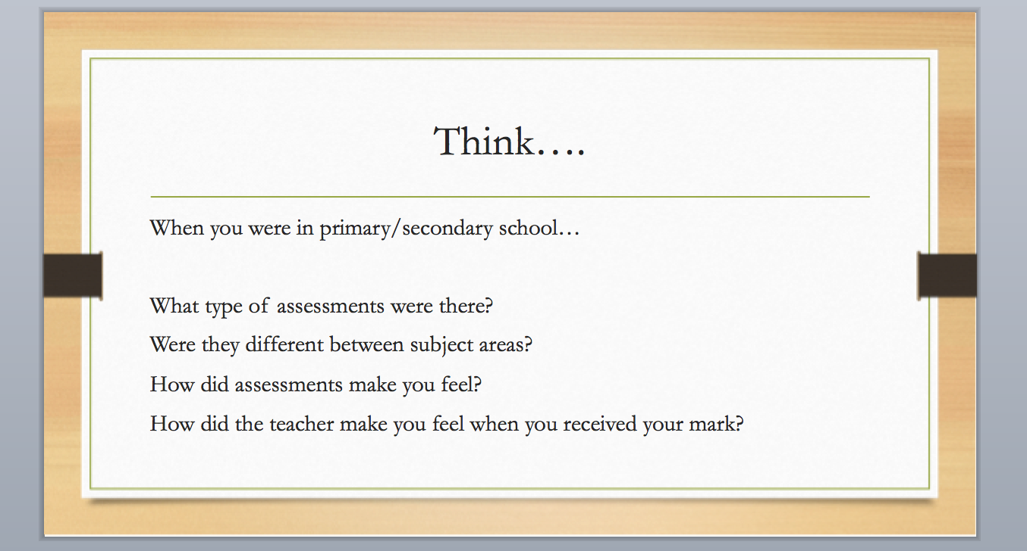

The above is an example of objectives set out at the beginning of one of the student’s lectures. The student said she appreciates the thought put into these objectives. She suggests that the lecturer could ‘tick boxes’ by just saying what the students are expected to learn, instead the lecturer asks questions for the objectives. Asking questions allows the student to think more in-depth about the topic area and allows the student to look back on the questions in order to help her with the assignments.

Conclusion

This portfolio has explored the meaning of self-assessment, self-evaluation, and the individual effective learner and how assessment is used in higher education to improve the work and understanding of the developing learner. The portfolio has included a wide range of appropriate and academic evidence proving the usefulness of self-assessment and self-evaluation in higher education, covering the areas of entry into higher education, feedback, oral presentations and objectives/success criteria. The areas have all been looked at critically as there is always something wrong with assessment for learning approaches but the reflections of the student have given a real life insight in to the use of assessment for learning and the development of the effective learner in higher education and from the reflection has suggested that if self-assessment and self-evaluation is used correctly and understood then this powerful tool will guide learners to becoming more effective and helping them to progress in any future careers.

Reference List

Andrade, H. (2019) “A Critical Review of Research on Student Self-Assessment” University at Albany, NY
Barnett, R. (1999). “Learning to work and working to learn.” In Understanding learning at work, Edited by: Boud, D and Garrick, J. London: Routledge.

Boud, D. (2005). “Enhancing learning through self assessment” London: Routledge Falmer

Black P, William D. (2009) “Developing the theory of formative assessment” Educational assessment, evaluation and accountability

Blanchard, J. (2002) “Teaching and targets – self-evaluation and school improvement” London: Routledge Falmer

Corkindale, G. (2008) “Overcoming Imposter Syndrome” Harvard Business

Cox, J (2020) “15 professional development skills for modern teachers” Teach hub

Crichton, H., and Mcdaid, A. (2016) “Learning intentions and success criteria: learners' and teachers' views” Curriculum Journal, 27

Education Endowment Foundation (2020) “Developing effective learners” https://educationendowmentfoundation.org.uk/school-themes/developing-effective-learners/#closeSignup (Accessed 18/02/2020)

Ferguson, P. (2011) “Student perceptions of quality feedback in teacher education” Assessment & Evaluation in Higher Education
Hawk, T.F and Shah, A, J. (2007) “Using learning style instruments to enhance student learning” Decision sciences journal of innovation education, Vol 5, issues1

Knight, P. (2005) “Assessment for learning in higher education” London: Routledge Falmer

Higgins, R., Hartley, P., Skelton, A. (2001). “Getting the message across: The problem of communicating assessment feedback” Teaching in Higher Education

MYTSD (2020) “Assessment results”
https://mytsd.uwtsd.ac.uk/urd/sits.urd/run/SIW_POD.start_url?1371904AD9D446E193RJPMoD-lQTtiGCkcIp91sUmKbmbc9Gvh9flJ2dLyN7xo-splVBolfkl9byJFECkIV1BBhhTXkZL0SrckUQETZYnBxHcpP_IoIttm6-gX2vgg2NWqX4D3MVb-AIX9L0SrICi3AdFpdMj4aY5QJketkJHzOFaYaSzBQ0kbebwInlLKYkH7SOhjgOu1vdI0wrUka6j_zthdDdAJwnf_lmGafPP_JpOKqkvMIjU9Q5bQhmASdGLCmPd11V5eXWyrjLwaYGjdfIWdmUzBi32yJ4QFrG2a0AkvPeKgxNyswmCsqVuFl0pKl-28KbG6qdjveE
https://career.vt.edu/experience/Internships/reflect.html
https://www.teachhub.com/15-professional-development-skills-modern-teachers
https://journals.sagepub.com/doi/abs/10.1177/1469787416654807?journalCode=alha (Accessed 20/02/2020)

Nicol, J, D and Macfarlane-Dick, D (2005) “Formative assessment and self-regulated learning: A model and seven principles of good feedback practice” Studies in Higher Education

Perera, J., Lee, N., Win, K., Perera, J., Wijesuriya, L. (2008) “Formative feedback to students: The mismatch between faculty perceptions and student expectations” Medical Teacher

Richie, S, M. (2016) “Self-assessment of video-recorded presentations: Does it improve skills?” Sage Journals

Siegesmund, A. (2017) “Using self-assessment to develop metacognition and self –regulated learners” Department of biology, Pacific Lutheran University

VARK (2020) “VARK questionnaire”
https://vark-learn.com/the-vark-questionnaire/?p=results (Accessed on 18/02/2020)

Virginia Tech (2020) “Reflections and learning from an internship experience” https://career.vt.edu/experience/Internships/reflect.html (Accessed 20/02/2020)

