HNCHND Computing Level 4
Computer Architecture and Operating Systems

Computer Architecture

Report

By Rhys Davies
Student Number: 181019

(10/02/2025)

Introduction 2
Key Functions of general Operating Systems 3
Use of Windows OS CLI commands 6
Use of Linux OS CLI commands 9
Use of Windows OS scripts 11
Use of Linux OS scripts 14
Conclusion 16
References 17

Introduction
This report will go into detail about operating systems in general, talking about their purpose as well as commands and scripts (with screenshots) which can be used. The 2 main operating systems which are discussed are Windows and Linux. In this report there will be many screenshots to provide examples of the information. Windows and Linux are the most used operating systems in the world. Both have their own advantages and disadvantages which make them greater for specific uses compared to the other.

Key Functions of general Operating Systems

There are many key functions that general operating systems contain, for example Device management. Device management is defined as “the act and skill of overseeing the installation, operation, and upkeep of a computer or network.” [1]
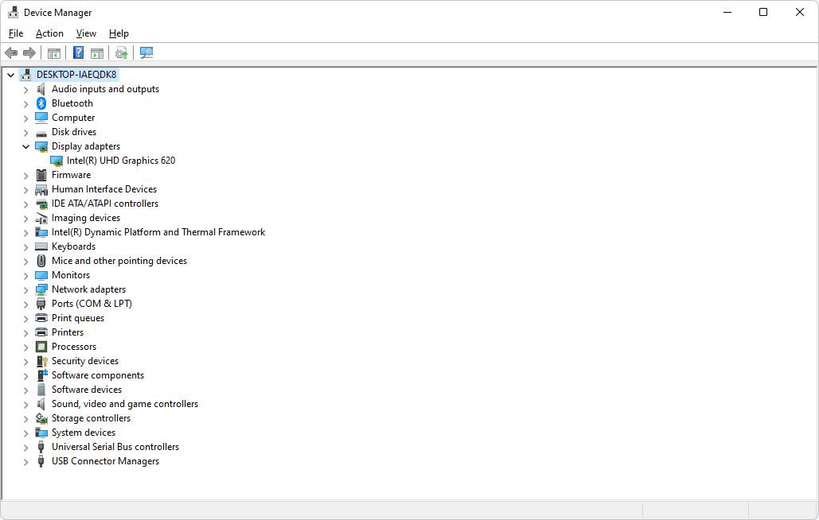
Another key function of operating systems is user interface; this allows the user of the computer to interact with it. The user Interface is known as “the point of human-computer interaction and communication.” [2]
Furthermore, computers contain files which are a key function to operating systems. Operating systems are capable of managing files and folders as well as providing the user interface which allows us to view and navigate through all of our files saved on the device. “Operating systems manage file systems by controlling access, organising data, managing storage space, and ensuring data integrity.” [3] 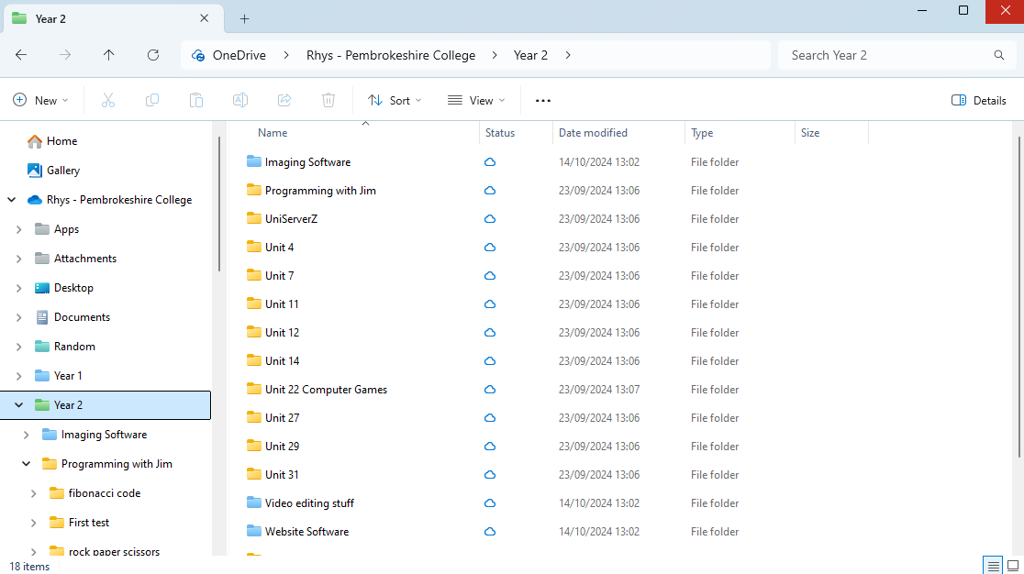
Another key function is the software support, the operating system allows for a large library of software to be downloaded, this can be anything from games to creative tools or productivity apps. Operating systems also support a big range of hardware devices by using drivers to be able to ensure that they are compatible with all of the new and old peripherals. “Compatibility is crucial in ensuring smooth interoperability, reducing potential conflicts and inconsistencies, and enhancing the overall user experience.” [4]

Additionally, another key feature of operating systems is the virtual desktops and task view. Virtual desktops allow us users to have multiple desktops which can improve our organisation and productivity. Having multiple desktops allows us to improve out multitasking as we can have separate tasks on different desktops allowing us to manage a large number of applications more efficiently. Tast view is a feature which allows the user to be able to move windows to other desktops and switch between those different windows.

Finally, another key feature to operating systems is the windows updates and support for the machines. Windows frequently applies updates which help improve the security, sometimes add new features and regularly fix bugs which helps keep the system secure and up to date with all the latest technology. Users are able to manage their updates for example, enabling manual installation allowing the user to choose when they update their device. This allows for more flexibility in how and when the updates are applied to the user's system. Windows will encourage users to upgrade by creating lifecycles which give users support and updates in a specific time period. Once this period has passed, they will no longer update the version of windows and will encourage users to upgrade to the latest version for more support.

Use of Windows OS CLI commands
Copy (COPY) [5]- The COPY command can be useful for making backups of folders and many other things. This command can also allow you to copy the files to a printer or other devices.
Date (DATE) This Batch command will display the current date set on the device. This command can also allow you to enter a new date in case the current date is incorrect, and you need to edit it.
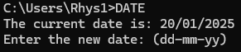
Exit (EXIT) - This command will close the terminal. It causes the terminal to terminate.
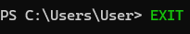
Move files or directories (MOVE) [6]- The MOVE command allows the user to move files or folders. This can be quicker than manually looking for the file to be able to move it to another location.
Echo to display message (ECHO) - The ECHO command will output the message/strings which are entered. This can be used to communicate with the terminal.
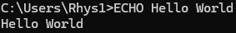
Rename files or directories (REN) - The REN command allows the user to change the name or directory of a files or folder. When the name is changed the file will still be stored on the same path.
Change Directory (cd) - The cd command allows the user to change back and forth between the subdirectory and parent directory, it can also move all to the root directory or to any directory you choose.
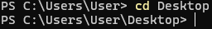
Pause (Pause) - The Pause command allows you to pause your batch files or scripts until you press a key to resume. This is useful if the user is reading a set of instructions and needs to pause to be able to read before continuing.
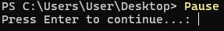
IP Config (ipconfig) - The Ipconfig command will show the user information about your network's configuration as well as the DNS settings. This can be used to troubleshoot your network issues and identify new network adapters.
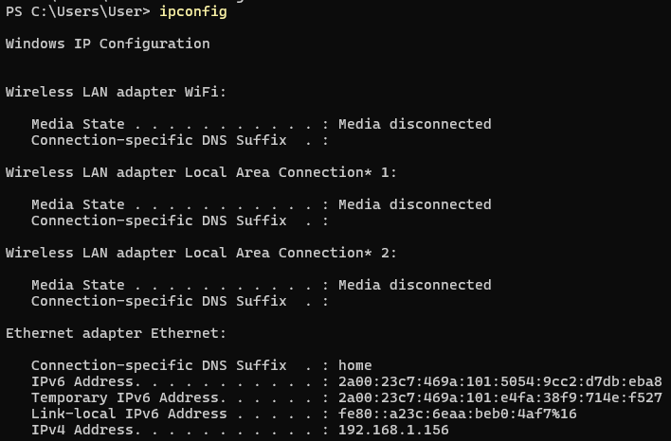
Remove-Item (del) - The del command allows you to delete folders or files easily using the terminal. This allows for multiple files or folder to be deleted at once which can be quicker and easier than locating all the files individually.

Use of Linux OS CLI commands

Creates File (touch) [7]- The touch command will allow the user to create a new file. This file will be empty and contain no content.
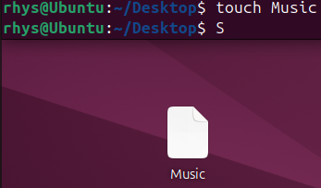
PWD (pwd) - The pwd command allows you to check the full working directory. When used will print the full name/path of the current directory which is being used.
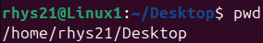
More or Rename Directory (mv) - This command allows you to rename files or folders as well as directories. When the name is changed the file will still be stored on the same path.
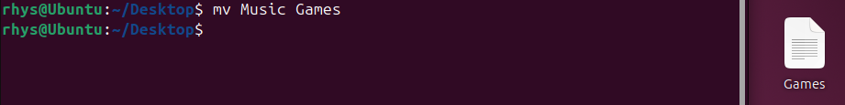
Change Directory (cd) [8]- The cd command allows you to change your directory. When used it will change your current working directory. With this command you are able to choose your directory by simply enter “cd [directory].
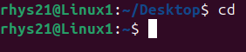
Clear Terminal(clear) - This command will allow you to clear the terminal commands, this is useful if you have been using lots of commands and want to have a clean terminal without closing and opening it.
View text file contents (less) - The less command will allow the user to see the specified files content. This will be shown one screen at a time and can be useful when dealing with large text files as you can split the file into sections.
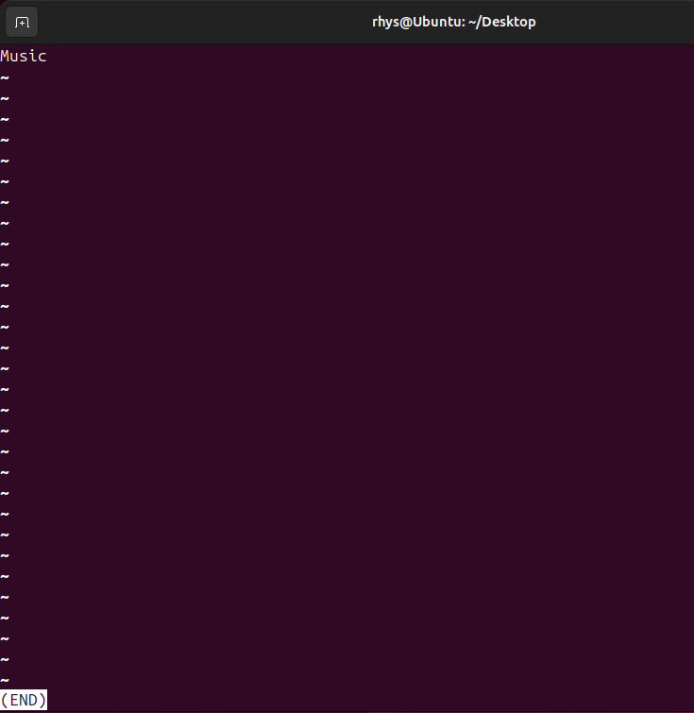
Show all available commands, aliases and functions (compgen) - The compgen command will generate and “display a list of possible completions for commands, aliases, functions, and keywords.”
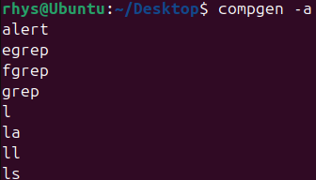
Exit (exit) - The exit command will simply exit the terminal. This command terminates the terminal.
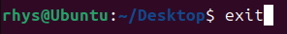
Information about files and directories (-l) - This command will simply list all the files and directories which have been chosen. This can be used to find out where a certain file is located quickly.
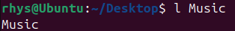
Cat (cat) - The Cat command has many uses, it is primarily used to read, display and concatenate text files. As shown the cat command can show the line number of the text file.
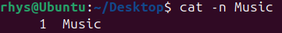

Use of Windows OS scripts

Batch Scripts are multiple commands combined into 1 to create a series of commands which will be triggered when the user chooses too. Shown below is 2 batch scripts, which will demonstrate the uses and will explain how useful they can be.
I have used the command “ipconfig / all” which will display all information about the network interfaces on the computer. Then, the command “ping amazon.com” has been used to test the networks connectivity with the location by sending packets. This will then record the response time taken for the website to receive the packet. Next, the command “tracert amazon.com” this command will track the path and the time it takes to travel between to locations, for example my computer and amazon.com. Finally, the “PAUSE” command will suspend the script until the user presses a key. The use of this script is to find out about your network's diagnostics. This can allow us to see if there are any problems with our network as the packet may take a long time to reach the servers.
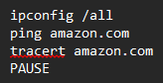
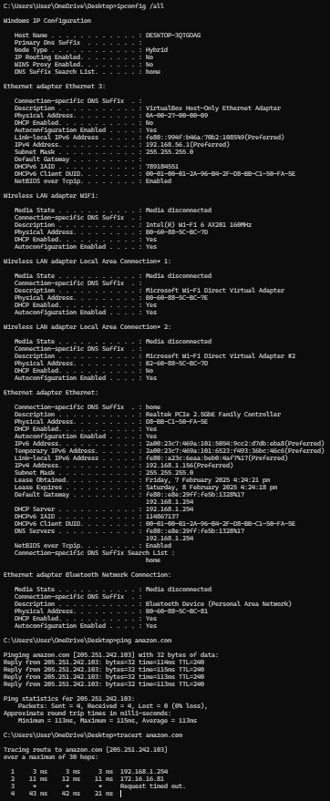

The second script is used for creating backups. The first script will copy the chosen folder of work and will create a identical copy of it with a different name. This is done with the script “Copy CollegeWork CollegeBackup). Then the command “Move CollegeBackup Backups” will move the new backup into a folder which will store all of the backups which have been created. Finally, the “Pause” command to suspend the script until the user interacts. The purpose of this script is to quickly create a backup of the users chosen folder (College Work) and to automatically place that backup into a separate folder which will hold all backups. This is a useful script which is to make sure your files are always safe in case of a corruption or malfunction on the main folder of work.
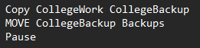
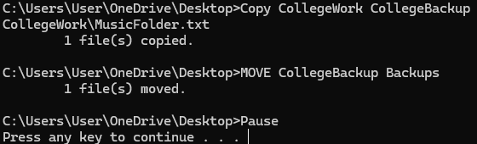

Use of Linux OS scripts

A difference between Linux and Windows is the scripts names. On windows you create scripts which are known as “Batch scripts”, however on Linux these are known as “Bash scripts”. Linux Bash scripts are multiple bash commands combined into 1 in order to create a sequence of actions.
Shown below is a bash script. This script is an “if” script which will check to see if a file containing the users chosen name exists. This script is very useful if you are trying to look for a file, for example, looking for a specific file which may contain information you are looking for. In the script the main line is “ if [ -f “$filename” ]; then”. ‘-f’ option is used in the following script to test the file existence [9]. This command will filter out the name which has been entered by the user which will then be followed with an echo and an else command which will let the user know whether the file was found or was not.
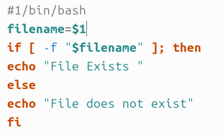
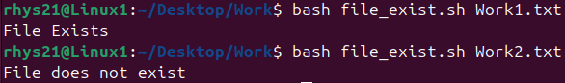
The second script is used to count the number of files in a certain location. This bash script will count the number of files in a directory and display the number to the user. This command is useful for quickly finding where large amounts of files are stored without having to manually search through all of your folders locating them. This can be used to clean out your computer if you are in need of more storage and you have lots of excess files which are no longer being used.
#!/bin/bash
file_count=$(ls | wc -l)
echo "Number of files: $file_count"
[10]

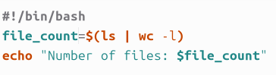

Conclusion
To conclude, both Windows and Linux have many useful commands which can all be combined into 1 to create a script. These scripts are able to automate functions such as creating backups of files. They also allow you find out more detailed statistics about your network and computer statistics which are found much easier through the command terminal. Windows power shell is mainly used to automate tasks however it is possible for users to fully script and make applications using it. It is usually used to automate management tasks. Linux's Bash is also used for automating functions as well as can be used as a scripting language. However, Bash, on the other hand, is more traditionally suited for development environments. [11] . Bash does contain disadvantage and it is that “shell functions is that they’re stored in memory and have to be reparsed every time you start a new shell” [12]

References

[1] | G. Meyer, “What is the role of device management?,” EMTERIA, 4 May 2022. [Online]. Available: https://emteria.com/learn/what-is-device-management#:~:text=Device%20management%20is%20the%20act,PC%20or%20network%20working%20smoothly..
[2] | C. Hashemi-Pour, “user interface,” TechTarget, April 2024. [Online]. Available: https://www.techtarget.com/searchapparchitecture/definition/user-interface-UI#:~:text=The%20user%20interface%20(UI)%20is,the%20appearance%20of%20a%20desktop..
[3] | Alfie, “In what ways do operating systems manage file systems?,” TutorChase, [Online]. Available: https://www.tutorchase.com/answers/ib/computer-science/in-what-ways-do-operating-systems-manage-file-systems.
[4] | Lenovo, “What is compatibility in technology?,” Lenovo, [Online]. Available: https://www.lenovo.com/gb/en/glossary/compatibility/?orgRef=https%253A%252F%252Fwww.google.com%252F&srsltid=AfmBOoo2I1YZ1yoxFb054jmgZobRC_rmLMDdml8mx3Pr4IqRloCFUfFf.
[5] | tutorialspoint, “Batch Script - Commands,” tutorialspoint, [Online]. Available: https://www.tutorialspoint.com/batch_script/batch_script_commands.htm.
[6] | D. Scripto, “Table of Basic PowerShell Commands,” Microsoft, 11 June 2015. [Online]. Available: https://devblogs.microsoft.com/scripting/table-of-basic-powershell-commands/?hide_banner=true.
[7] | eduactive, “Bash cheat sheet: Top 25 commands and creating custom commands,” educative, 27 May 2024. [Online]. Available: https://www.educative.io/blog/bash-shell-command-cheat-sheet.
[8] | B. Marijan, “30 Bash Commands Cheat Sheet,” phoenixNAP, 24 August 2023. [Online]. Available: https://phoenixnap.com/kb/bash-commands.
[9] | F. Yesmin, “30 Bash Script Examples,” Linuxhint, 2018. [Online]. Available: https://linuxhint.com/30_bash_script_examples/#t26.
[10] | W. Maina, “50 cool Bash scripts! and what they do ...,” Medium, 7 October 2023. [Online]. Available: https://medium.com/aimonks/50-cool-bash-scripts-and-what-they-do-b38b4e841ba2.
[11] | A. B. Brien Posey, “PowerShell vs. Bash: Key differences explained,” Techtarget, 17 March 2023. [Online]. Available: https://www.techtarget.com/searchitoperations/tip/On-Windows-PowerShell-vs-Bash-comparison-gets-interesting.
[12] | E. Nemeth, UNIX and Linux System Administration Handbook, Pearson Education, 2017.

Appendices
Fundamentals of Quantum Computing Course





