Max Smith
1810364@student.uwtsd.ac.uk

Digital Signal processing and communication
Simulation of Digital Modulation Techniques

Table of Contents
1 Table of Figures 2
2 Introduction 3
3 Background Information 3
3.1 Additive White Gaussian Noise 3
3.2 Bit Error Rate (BER) 3
3.3 Amplitude Shift Keying (ASK) 3
3.4 Phase Shift Keying (PSK) 4
3.5 Quadrature Phase Shift Keying (QPSK) 4
3.6 Quadrature Amplitude Modulation (QAM) 4
4 Simulation Models 5
4.1 ASK Model 5
4.2 PSK Model 5
4.3 QPSK Model(s) 6
4.3.1 Method 1 6
4.3.2 Method 2 6
4.4 QAM Model 7
5 Results 7
5.1 ASK Results 7
5.2 PSK Results 9
5.3 QPSK Results 11
5.4 QAM Results 14
5.4.1 4-QAM 14
5.4.2 16-QAM 16
5.4.3 32-QAM 18
6 Discussion 20
7 Conclusion 20
7.1 Summary 20
8 Bibliography 21

Table of Figures
Figure 1 - ASK Simulation 5
Figure 2 - PSK Simulation 6
Figure 3 - QPSK Simulation Method 1 6
Figure 4 - QPSK Simulation Method 2 7
Figure 5 - QAM Simulation 7
Figure 6 - ASK Modulated Scope 8
Figure 7 - ASK Demodulated Scope 8
Figure 8 - ASK BER data 8
Figure 9 - ASK graphical BER 9
Figure 10 - PSK Modulated Scope 10
Figure 11 - PSK Demodulated Scope 10
Figure 12 - PSK phase shift 10
Figure 13 - PSK BER data 11
Figure 14 - PSK graphical BER 11
Figure 15 - QPSK Imaginary Scope 12
Figure 16 - QPSK Quadrature Scope 12
Figure 17 - QPSK phase shift 12
Figure 18 - QPSK BER data 13
Figure 19 - QPSK graphical BER 13
Figure 20 - QPSK general Constellation 14
Figure 21 - QPSK @ 10dB 14
Figure 22 - QPSK @ 6dB 14
Figure 23 - QPSK @ -4dB 14
Figure 24 - QPSK @ -40dB 14
Figure 25 - 4QAM BER data 15
Figure 26 - 4QAM graphical BER 15
Figure 27 - 4QAM general Constellation 16
Figure 28 - 4QAM @ 12dB 16
Figure 29 - 4QAM @ 6dB 16
Figure 30 - 4QAM @ -4dB 16
Figure 31 - 4QAM @ -70dB 16
Figure 32 - 16QAM BER data 17
Figure 33 - 16QAM graphical BER 17
Figure 34 - 16QAM general Constellation 18
Figure 35 - 16QAM @ 18dB 18
Figure 36 - 16QAM @ 12dB 18
Figure 37 - 16QAM @ 0dB 18
Figure 38 - 16QAM @ -40dB 18
Figure 39 - 32QAM BER data 19
Figure 40 - 32QAM graphical BER 19
Figure 41 - 32QAM general Constellation 20
Figure 42 - 32QAM @ 20dB 20
Figure 43 - 32QAM @ 16dB 20
Figure 44 - 32QAM @ 4dB 20
Figure 45 - 32QAM @ -30dB 20

Introduction
In Digital Signal Processing (DSP) and Communications, analogue elements of systems are replaced and converted to digital information, which is more efficient when transmitting data. Better modulation techniques increase accuracy and stability, thus reduce environmental impact on components and systems. Noise affecting the system is more easily controlled by it being introduced as part of the system, and with the design packages available, it is easier to simulate the system against various levels of noise disruption. Systems can be easily modified and debugged at reduced costs, and it is possible to surpass the limitations of analogue systems.
DSP systems can easily become complex through the application of digital to analogue converters and analogue to digital converters. They consume higher amounts of power than analogue systems due to the lack of passive components within the system [1]. DSP systems are used for image and speech processing, military use, telecommunications, and seismology are just some.
Data transmission and receival is heavily affected by the sampling rate applied. The frequency sampling $f_{s}$ should as a minimum be double that of the original frequency, this is derived from sampling theorem. The Nyquist Criterion defines frequency sampling as $f_{s}>2W$, where W is the maximum original frequency. If the criterion is not met, aliasing occurs in the system, distorting the transmitted data making it indistinguishable, essentially resulting in data loss. By having a higher sampling rate you avoid aliasing, however it does result in a lengthier data process rate. [2] [3]
Digital data is used to modulate one or more parameters of the carrier signal which is known as shift keying. There are various modulation techniques applied to DSP to ensure high levels of accuracy of information transmitted. In this report the performance of various modulation techniques have been simulated and analysed with the presence of additive white Gaussian noise (AWGN) in the system.

Background Information

Additive White Gaussian Noise
The main drop in performance is generally caused by thermal noise generated in the receiver which usually has a flat power spectral density. AWGN is indicative of the many natural sources of noise including but not limited to environmental and celestial sources. It is a linear and time invariant channel, and its amplitude frequency response is flat, and the phase response is linear across all frequencies. As a result, the modulated signals pass through the channel with no loss of amplitude nor phase distortion. [4]

Bit Error Rate (BER)
BER is the main performance parameter and is determined from the following equation:
$$BER=\frac{Number of bits with error}{Total number of bits sent}$$
When data is transmitted, errors can be introduced into the system. This can be caused by but not limited to noise, the system design and/or filter design.
BER is an ideal method to assess the performance of a system from transmission through to receiver. However, there is discussion as to whether Packet Error Rate is a better evaluation tool. [5]

Amplitude Shift Keying (ASK)
In ASK, the carrier wave amplitude is changed between discrete levels in accordance with the digital data. For ASK modulation a conventional modulator can be used which can be determined by the following equation:
$$A_{c}\cos\left(2πf_{c}t\right)$$
or, simply through the use of a switch. Demodulation of the signal is achieved by multiplying the received signal by a copy of the carrier signal and processing through a low pass filter. In ASK, frequency and phase of the carrier wave remains the same. ASK was one of the earliest modulation techniques and has since been surpassed by alternate methods. [6]
ASK offers a relatively high bandwidth efficiency, the design is simple, and the information can be transmitted over fibre-optic. With the systems simplicity it relatively inexpensive in comparison to the other methods.
ASK is highly susceptible to noise interference, simply because this method relies on amplitude which is easily affected. ASK is restricted in its uses due to its low power efficiency.

Phase Shift Keying (PSK)
PSK uses different phases to represent the binary data, in short, the carrier wave changes phase according to the binary inputs. The phase shifts are offset by 180ᵒ or π which act as the 0’s and 1’s. These are determined through the following equations:
$Binary 0 = y=\cos\left(2πf_{c}t\right)$
$$Binary 1 = y=\cos\left(2πf_{c}t+π\right)$$
In PSK modulation there is a wavelength delay which produces the phase changes.
The signal at any time is $±A_{c}\cos\left(2πf_{c}\right)$, so in demodulation the phase is detected by the sign of the signal. In the demodulation process the reference signal must be in phase with the original carrier signal. [7]
PSK is more power efficient in comparison to ASK and Frequency Shift Keying (FSK) in that data is able to cross over radio frequency signals with greater efficiency. Advanced variants of PSK achieve far greater data transmission rates. PSK is less susceptible to noise than ASK, however the bandwidth efficiency is less than ASK. The detection and recovery of data is carried out by estimation of phase states which can result in quite complex programming algorithms. [8]

Quadrature Phase Shift Keying (QPSK)
QPSK is one of the most widely used modulation technique in digital communications. QPSK has four possible carrier phases allowing for double the amount of information to be transmitted whilst using the same bandwidth as PSK or maintaining the same data rate as PSK but halving the bandwidth requirement [9]. QPSK is used for satellite transmissions, mobile networks, cables modems and more.
In QPSK there are two separate modulated signals, Quadrature, and In-Phase. QPSK is more sensitive to phase variations than PSK, meaning that the transmitter and receiver have to be synchronised frequently.

Quadrature Amplitude Modulation (QAM)
QAM transmits two-bit streams changing the amplitude of the carrier waves that have the same frequency and phase shift. QAM is a combination of ASK and PSK.
For QAM and QPSK the information may be represented in constellation diagrams, which depict Binary code and Gray code. In Gray code two symbols may differ over one bit whereas in Binary code two symbols may differ in two bits. Due to potential noise or errors, it is preferable to plot using Gray code as it will reduce the bit errors. Constellation diagrams show the bit/symbol locations in complex signal space, the x axis represents the amplitude of the cosine portion of the quadrature carrier. The y axis represents the amplitude of the sine portion of the quadrature carrier. The amplitude of the symbol is the distance from the origin and the phase angle of the symbol is the angular displacement from the positive x axis. [10]
Variants of QAM range from 4-QAM up to 256-QAM, enabling greater data transfer, though the higher the number of streams being modulated increases susceptibility to noise. Generally, the use of 256-QAM is done in wired communications. [11]

Simulation Models
For all the below models, a Bernoulli Binary Generator was used as a random data generator. An AWGN channel was used as required to simulate the effect of noise. Scopes and BER calculators were used to analyse the system performance. The sampling rates used were more than double the original frequency satisfying the sampling theorem. Multiple simulations were run with various Signal to Noise Ratio’s (SNR) applied. A digital filter was used to clean the data post AWGN channel. The filter was set as a low pass filter, applying the windowing technique of a finite impulse filter.

ASK Model
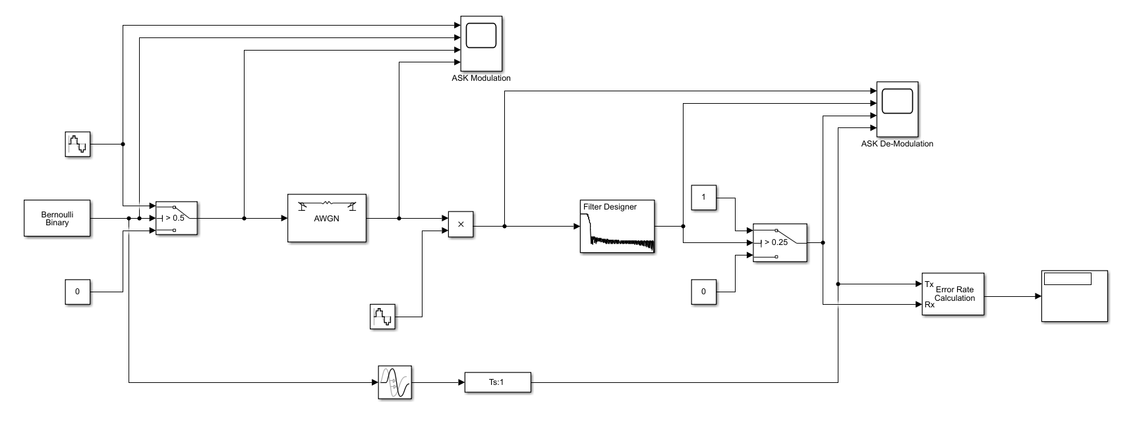
Figure 1 - ASK Simulation
The source/carrier wave had a frequency of 2*pi*10, an amplitude of 1 and a sampling rate of 1/1000. The constant of 0 was put into the system along with the switch to enable modulation of the data. The data received was multiplied by another carrier wave with the same parameters as the source. To further clear the data received it went through another toggle system this time with constants of 1 and 0, with a lower threshold than the modulation. See results in 5.1.

PSK Model
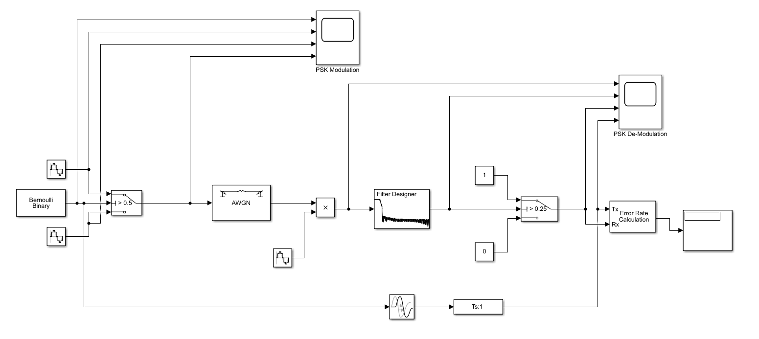
Figure 2 - PSK Simulation
The PSK model was of similar design to the ASK model, though an additional carrier wave with phase shift rather than a constant input into the system. The frequencies were increased to 2*pi*100, amplitude was 1, carrier waves had a phase shift difference of pi. The source used on the receiving end match that of the top source on the modulation side, this was so that it was in phase when received.

QPSK Model(s)

Method 1
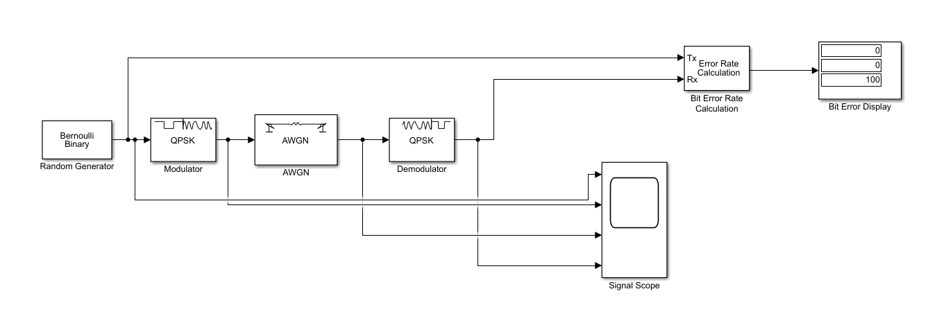
Figure 3 - QPSK Simulation Method 1
A QPSK model was built in Simulink using pre-set blocks from the Simulink Library.

Method 2
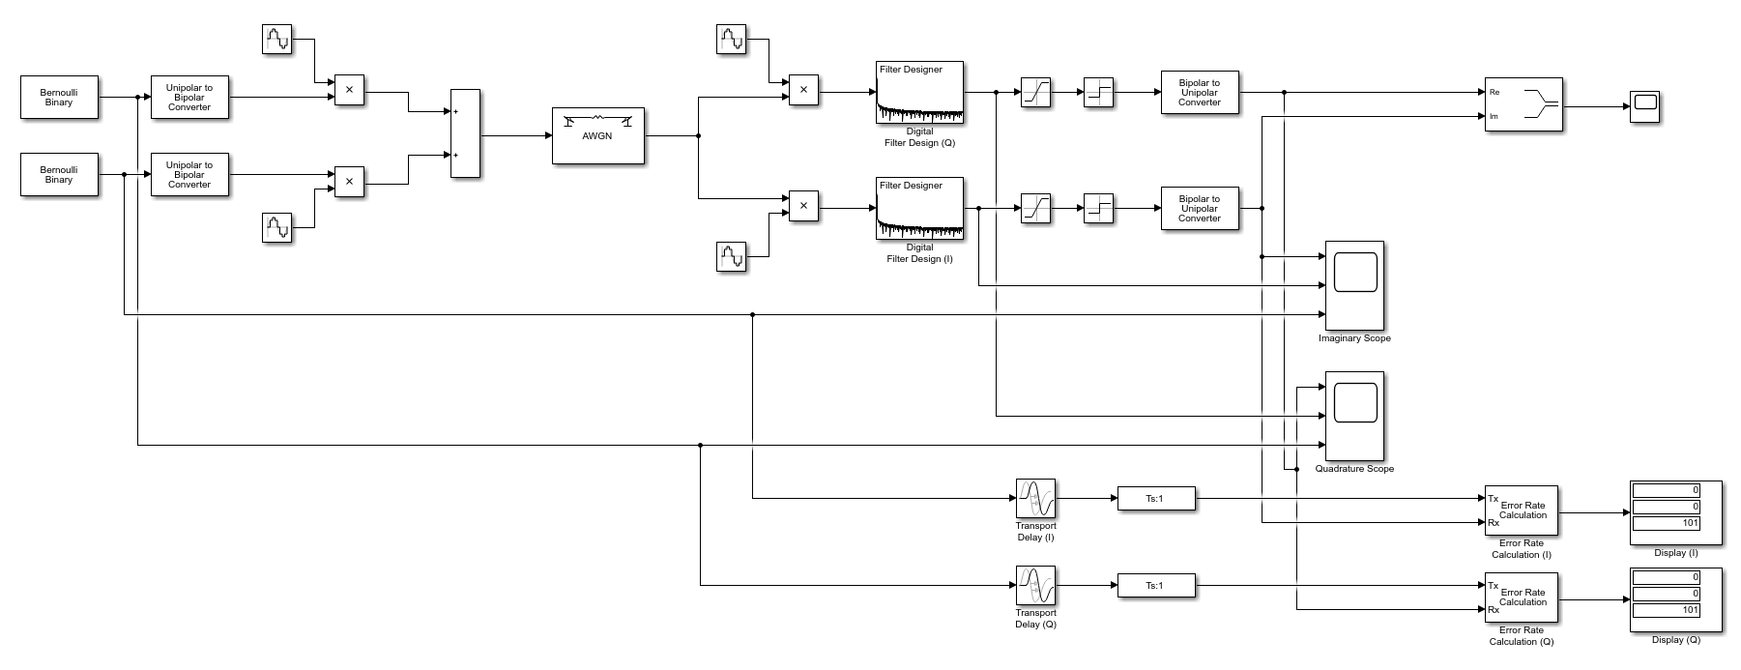
Figure 4 - QPSK Simulation Method 2
The top half of the model acts as the quadrature carrier and the bottom half acts as the in-phase carrier. The Q carrier had a shift of pi/2 and the I carrier had a phase shift of pi. The saturation blocks imposes limitations on the signal allowing only signals between an upper and lower band through. The sign blocks clear up the input, in that when the input is greater than 0 the output is 1, and when the input is 0 the output is 0. The scopes in this model display the carrier signals against the respective outputs enabling ease of comparison. [12] [13]

QAM Model
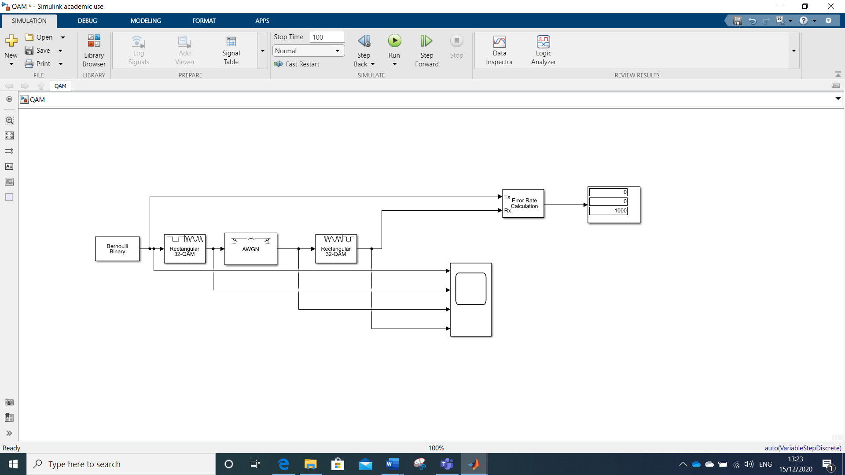
Figure 5 - QAM Simulation
The simulation above was run for 4-QAM, 16-QAM and 32-QAM in order to better understand and determine the differences in the performance of the method.

Results
For the purpose of this experiment the critical failure was selected as 50% or 0.5 BER.

ASK Results
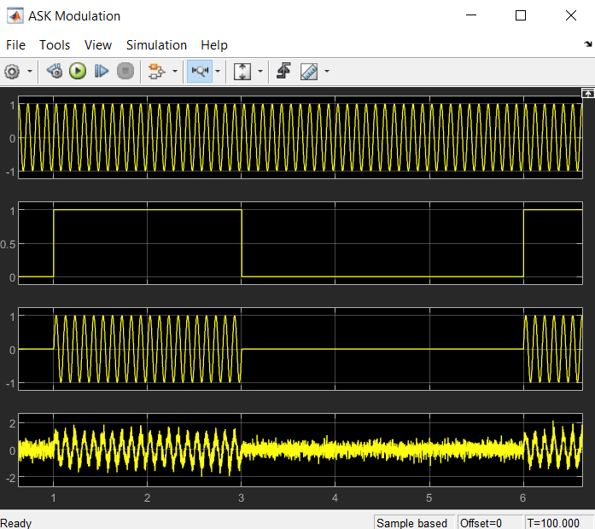  Figure 6 - ASK Modulated Scope | 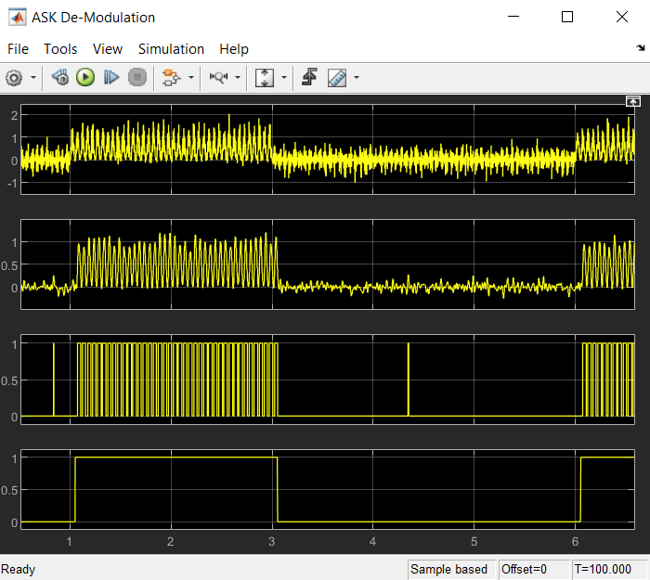  Figure 7 - ASK Demodulated Scope
Input 1 – carrier wave  Input 2 – data transmitted  Input 3 – carrier wave with respect to data  Input 4 - AWGN | Input 1 – AWGN data multiplied by carrier wave  Input 2 – Filtered data  Input 3 – data received  Input 4 – original data

A bulk of the noise generated was removed by the digital filter. The noise however was not fully dissipated as can be seen in the spikes in input 3 (RHS). There was a transmission delay of 0.052s, this can be seen between input 2 (LHS) and input 3 (RHS).
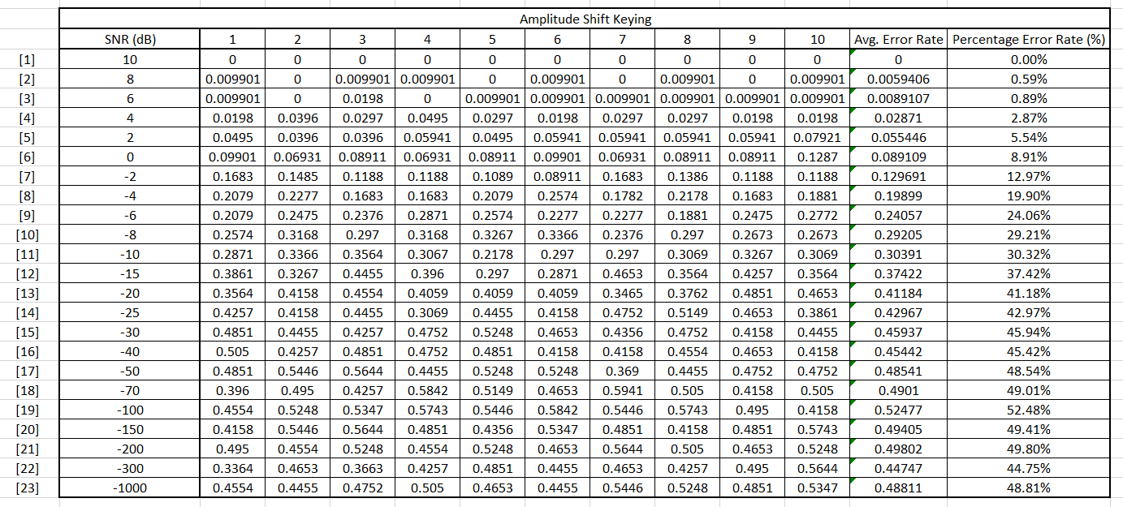
Figure 8 - ASK BER data

Figure 9 - ASK graphical BER
Critical failure at -70dB.

PSK Results
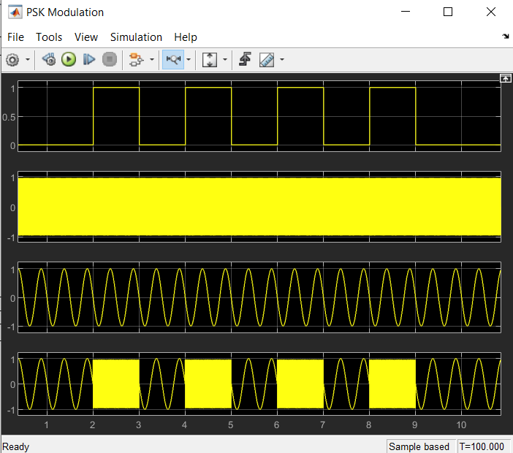  Figure 10 - PSK Modulated Scope | 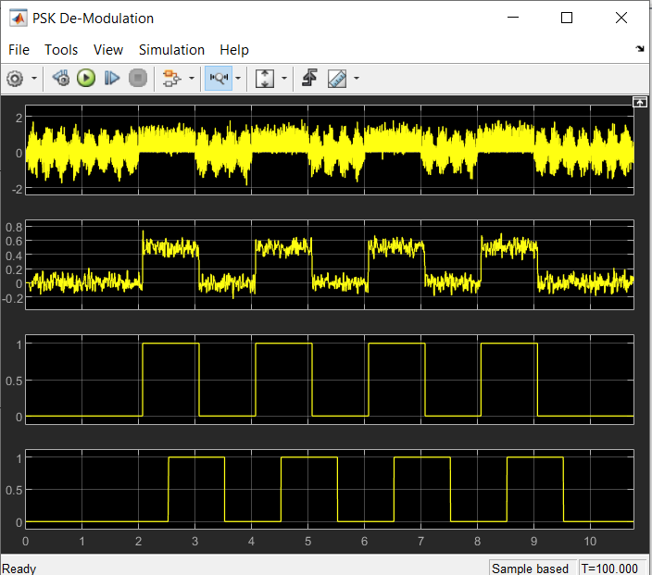  Figure 11 - PSK Demodulated Scope
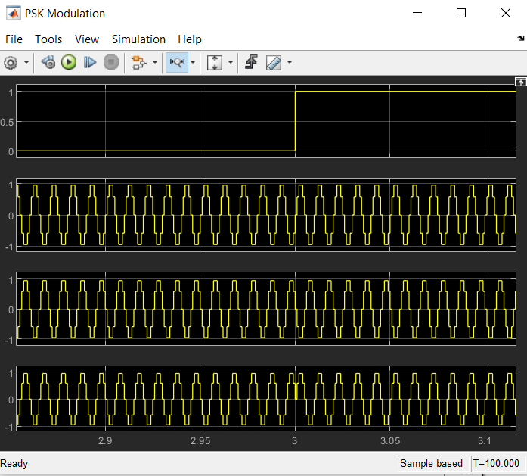  Figure 12 - PSK phase shift | Inputs for modulation and demodulation were the same as ASK, with the exception of the additonal phase source. From figure 12, the phase shift occuring when the data from the binary generator changes from 0 to 1 was clear.  On figure 11, it is clear there was a larger delay between transmission and recieval, which was 0.52s. However, it can be seen that the data transmitted and the data matched were the same.

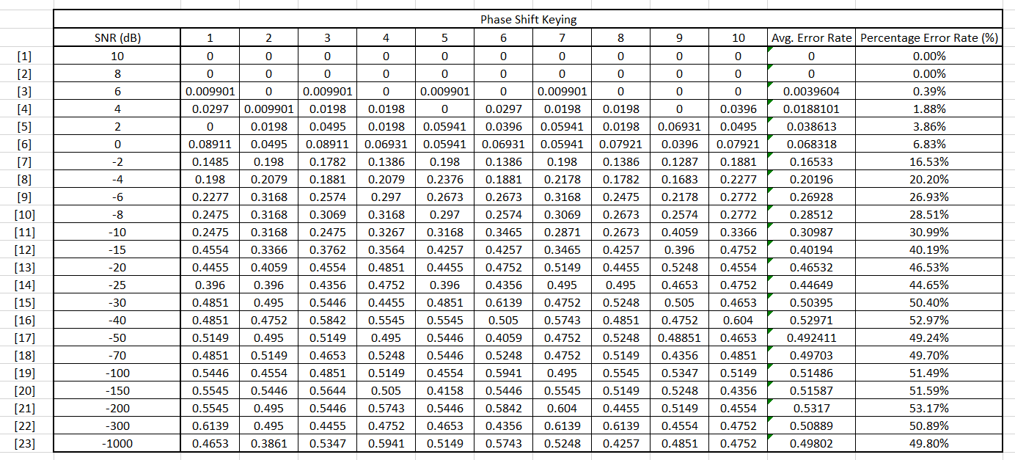
Figure 13 - PSK BER data

Figure 14 - PSK graphical BER
Critical failure at -30dB.

QPSK Results
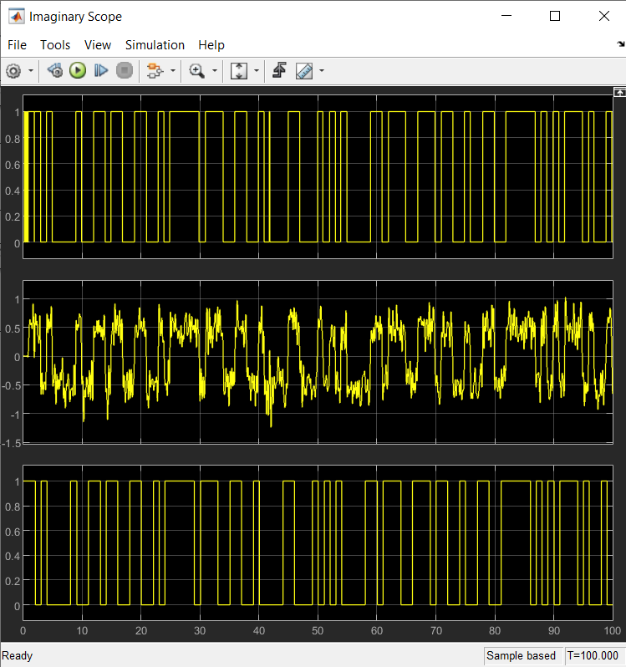  Figure 15 - QPSK Imaginary Scope | 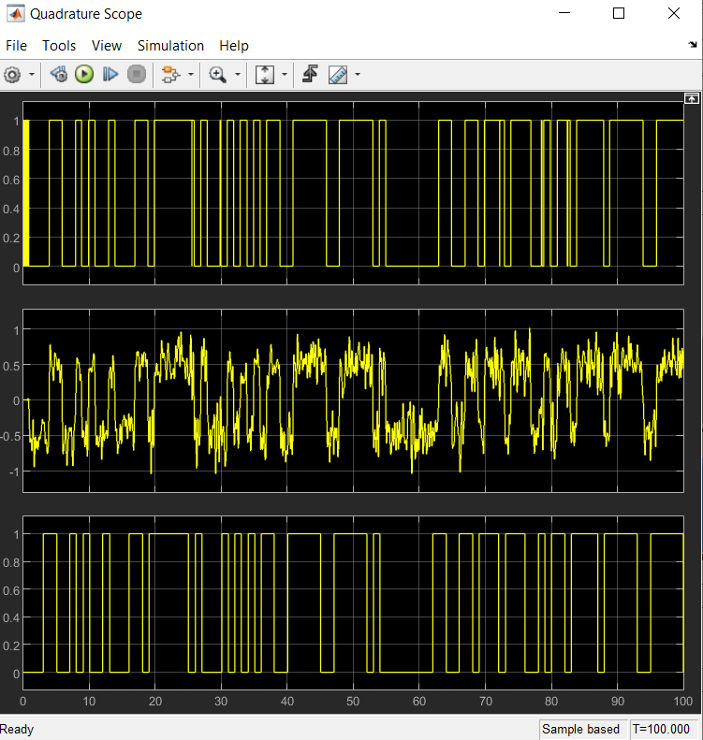  Figure 16 - QPSK Quadrature Scope
Input 1 – data received  Input 2 – data post-filtering/pre-saturation  Input 3 – data transmitted  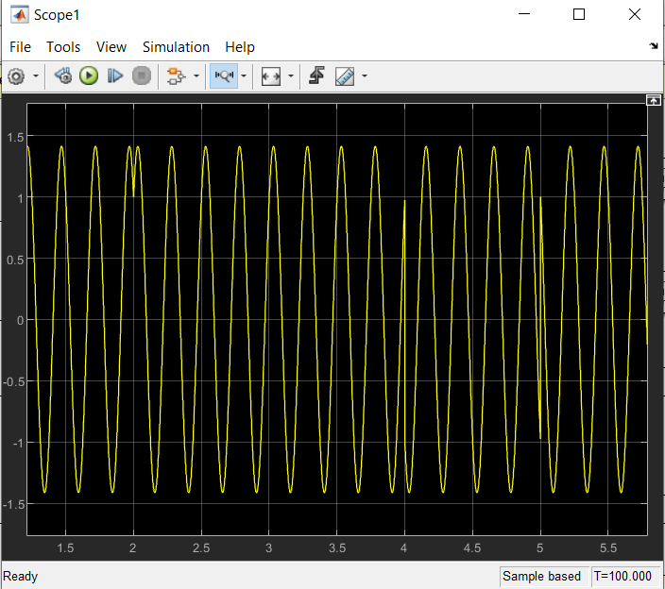  Figure 17 - QPSK phase shift | The above graphs show both the imaginary (LHS) and quadrature (RHS)signals. It was clear to see that there was still noise left in the data. There was a delay in transmission of 0.833s. This is to be expected as the system is processing more data than the previous systems which have been looked at.  Figure 17 shows the signal undergoing the various phase shifts during transmission.

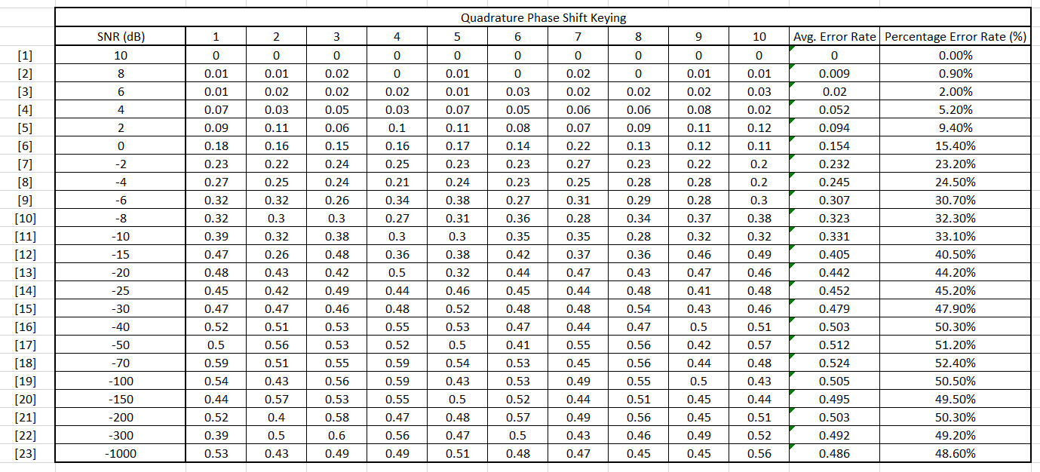
Figure 18 - QPSK BER data

Figure 19 - QPSK graphical BER
Critical failure at -40dB.
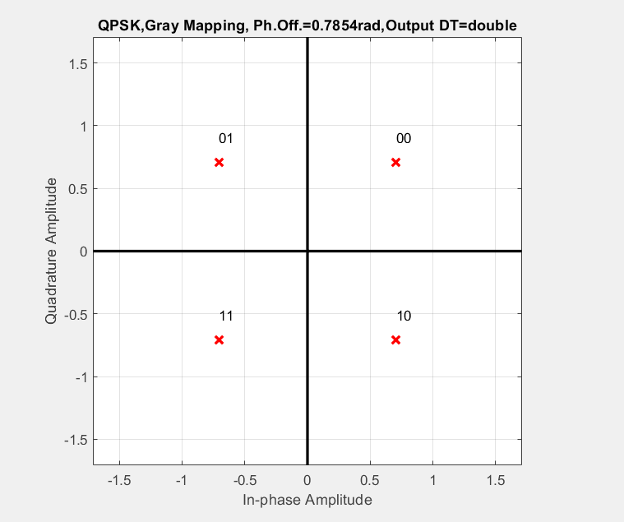
Figure 20 - QPSK general Constellation
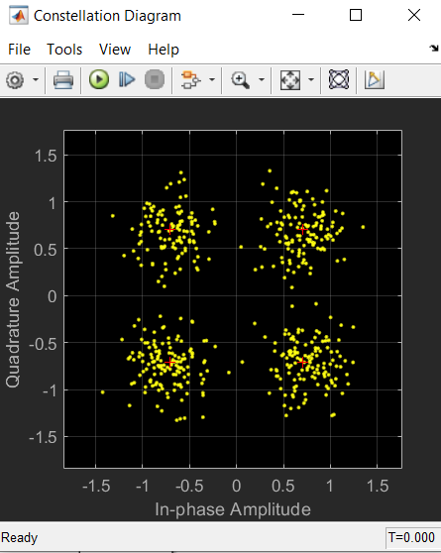  Figure 21 - QPSK @ 10dB | 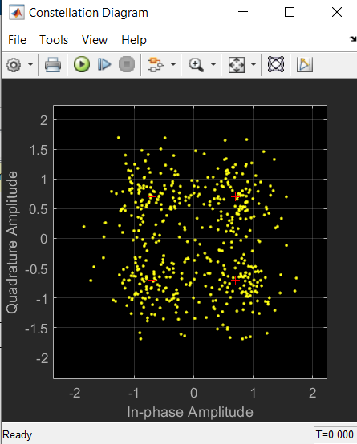  Figure 22 - QPSK @ 6dB
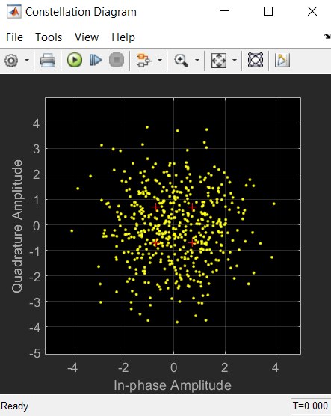  Figure 23 - QPSK @ -4dB | 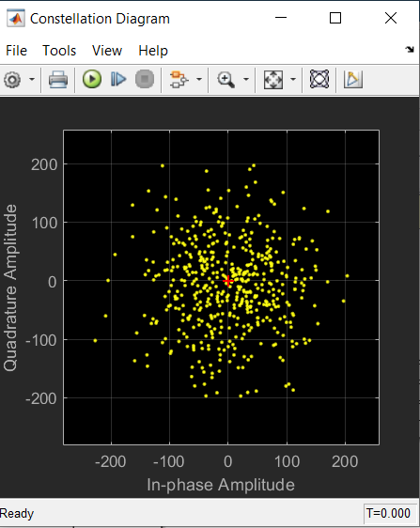  Figure 24 - QPSK @ -40dB

QAM Results

4-QAM
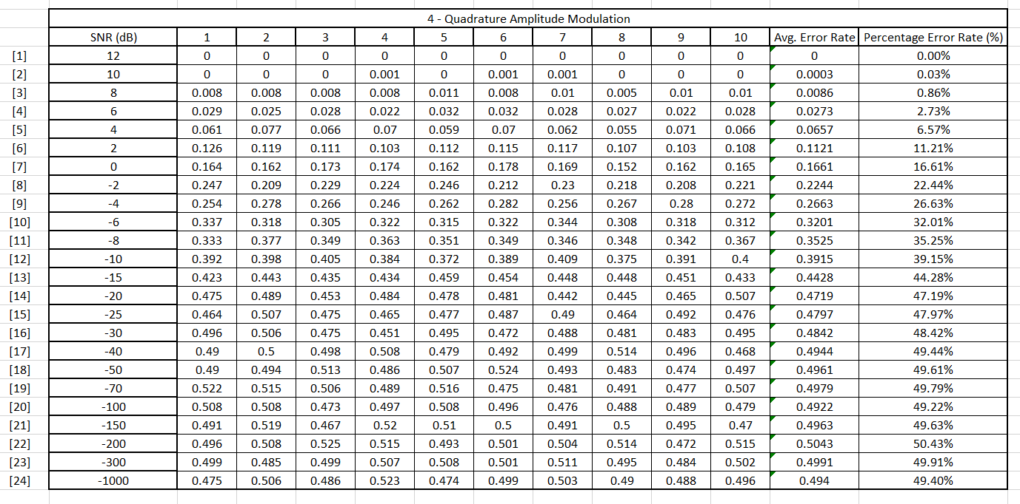
Figure 25 - 4QAM BER data

Figure 26 - 4QAM graphical BER
Critical failure at -70dB.

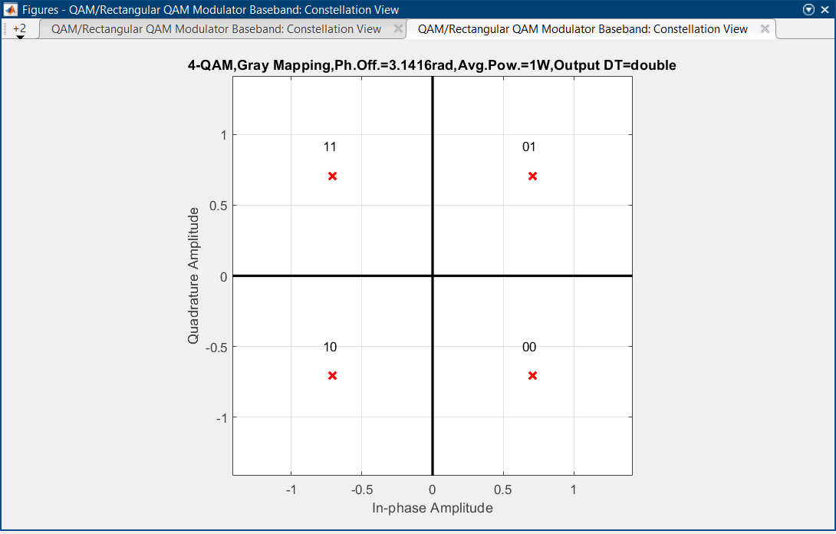
Figure 27 - 4QAM general Constellation
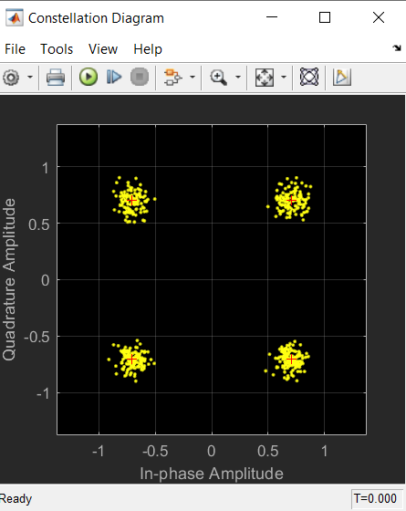  Figure 28 - 4QAM @ 12dB | 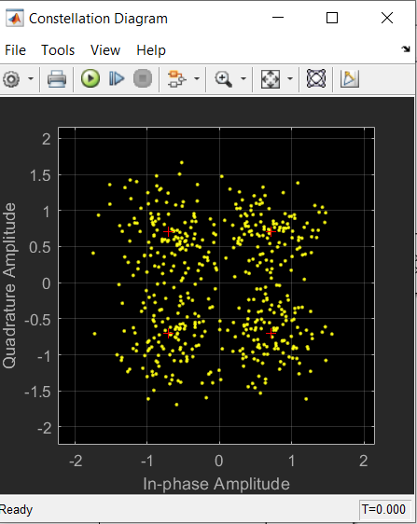  Figure 29 - 4QAM @ 6dB
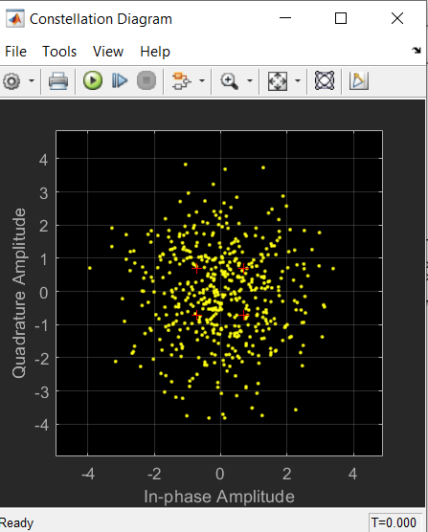  Figure 30 - 4QAM @ -4dB | 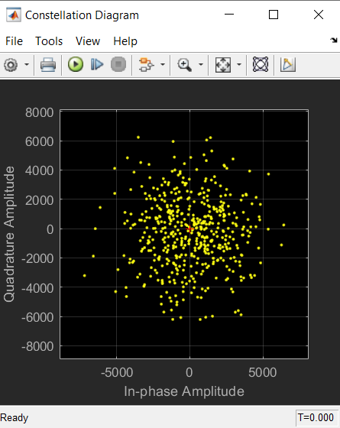  Figure 31 - 4QAM @ -70dB

16-QAM
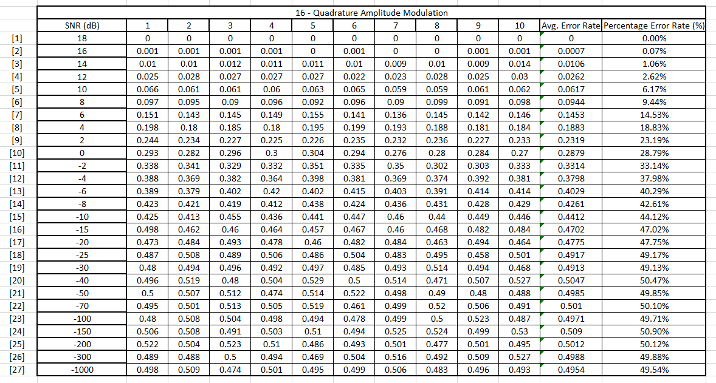
Figure 32 - 16QAM BER data

Figure 33 - 16QAM graphical BER
Critical failure at -40dB.

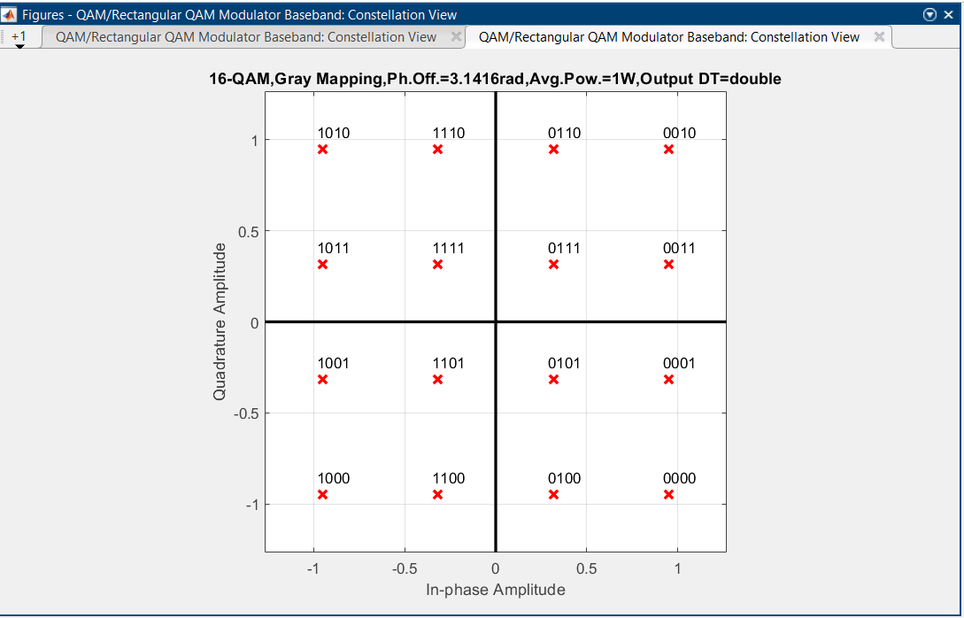
Figure 34 - 16QAM general Constellation
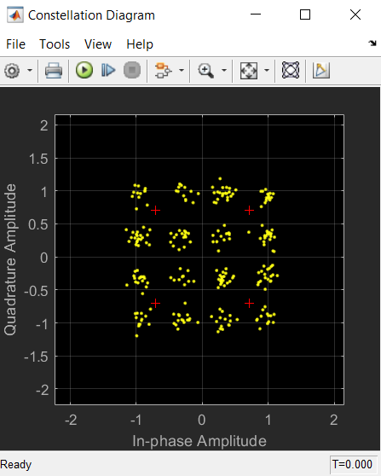  Figure 35 - 16QAM @ 18dB | 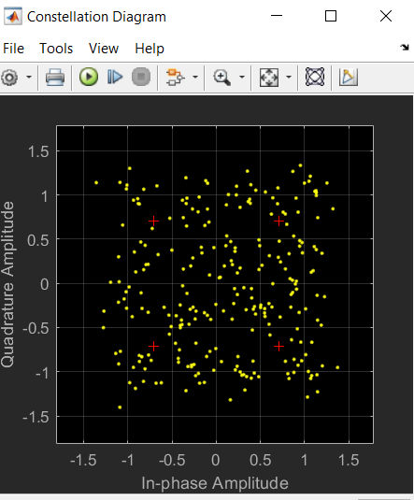  Figure 36 - 16QAM @ 12dB
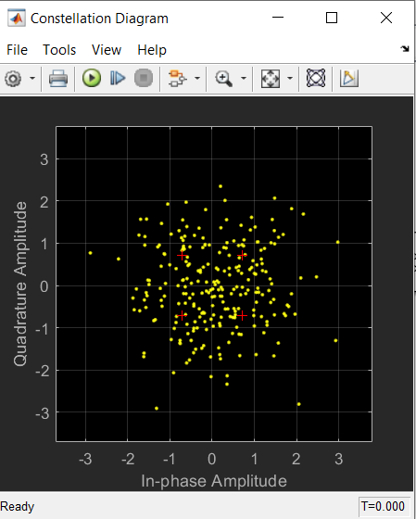  Figure 37 - 16QAM @ 0dB | 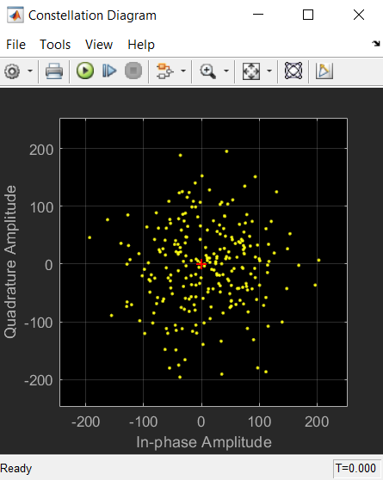  Figure 38 - 16QAM @ -40dB

32-QAM
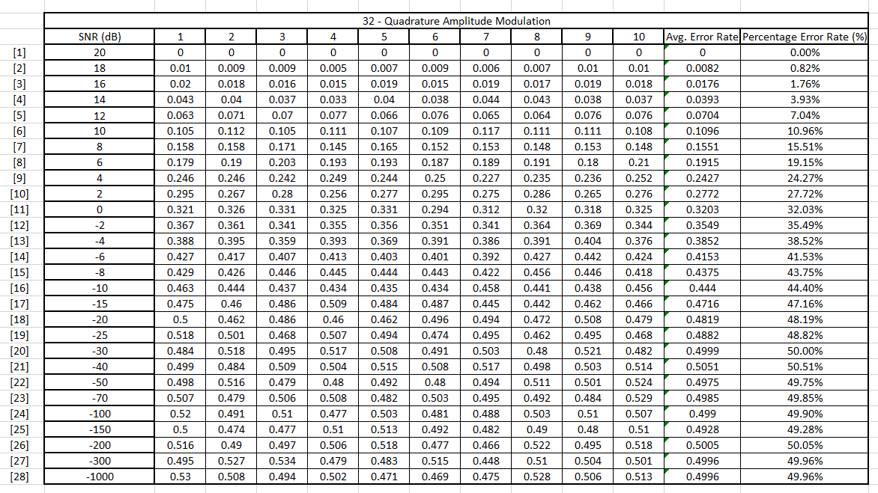
Figure 39 - 32QAM BER data

Figure 40 - 32QAM graphical BER
Critical failure at -30dB.

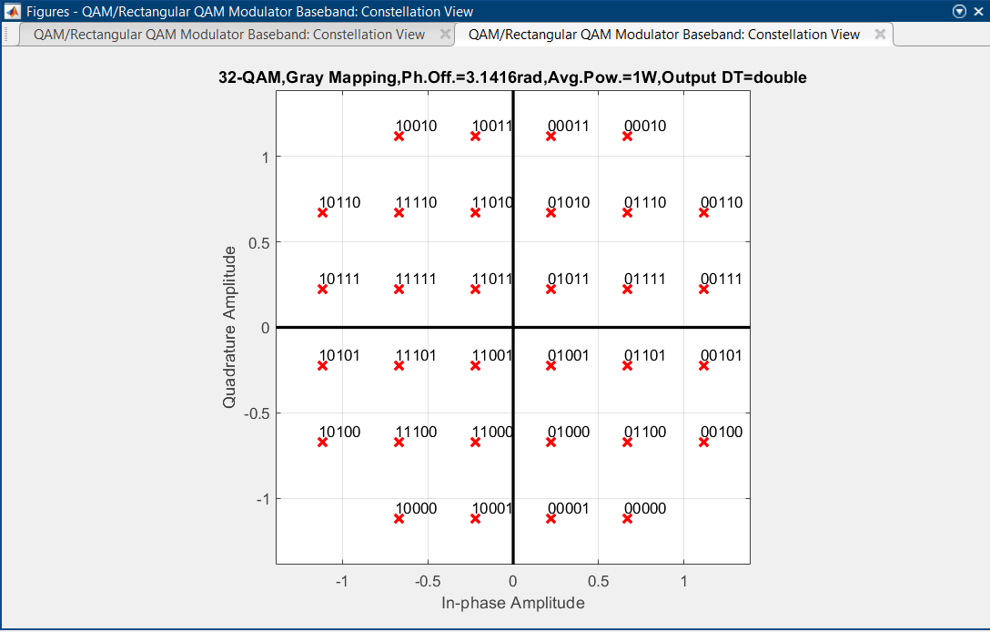
Figure 41 - 32QAM general Constellation
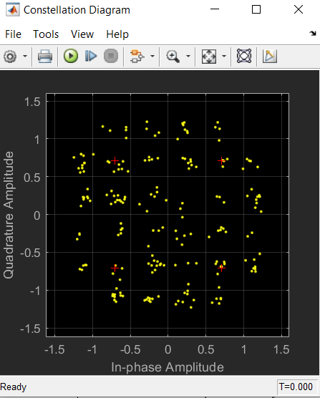  Figure 42 - 32QAM @ 20dB | 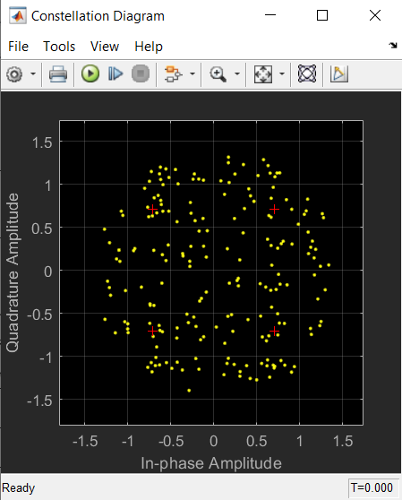  Figure 43 - 32QAM @ 16dB
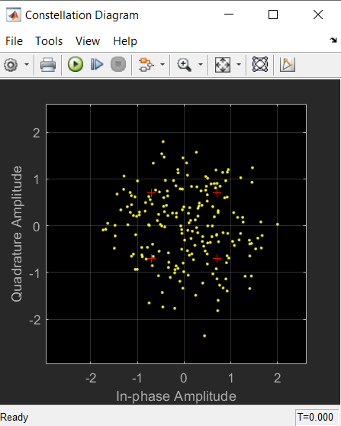  Figure 44 - 32QAM @ 4dB | 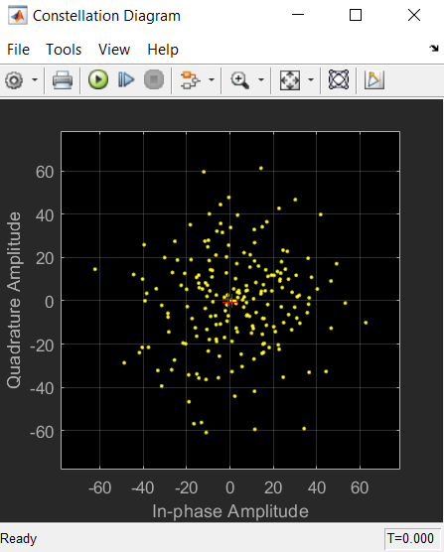  Figure 45 - 32QAM @ -30dB

Discussion
The results suggest that ASK and 4-QAM have the highest reliability due to having the best SNR at critical system failure.
PSK from SNR where system was fully stable and BER was 0, showed the best resilience to initial increase of noise to the system. ASK typically is known for being quite susceptible to noise, which was demonstrable from the rapid increase of BER in comparison to the other systems over the same changes in SNR. All the systems appear to have a similar rate of BER increase with the changes to SNR.
It was however noticed that for the advanced modulations such as QAM, they required an increasingly positive SNR for stability and 0 BER. This was expected as QAM systems are more sensitive to noise due to them using amplitude and phase shift for data transmission.
The higher QAM systems reached critical failure sooner than 4-QAM and ASK, due to the sheer number of variants in the system that could be affected by noise. This can be seen in the constellation diagrams from 16-QAM and 32-QAM, the bit displacement appeared far more erratic than that of 4-QAM and QPSK. Comms that generally use 16-QAM, 32-QAM and higher, have more protection in the system, or are wired as opposed to wireless. These advanced methods of modulation are used to transfer a significant amount more data, thus making them more susceptible to noise.

Conclusion

Summary
Communications systems have a multitude of components and programmes which aren’t present in the simulations. These simulations do not illustrate such effects as time jitter and frequency, phase, or amplitude errors. QAM systems are more sensitive to noise than other systems as the data undergoes amplitude and phase modulation.
In QAM and QPSK, the Quadrature and In-Phase can have synchronous issues due to having two or more signals, which can cause errors throughout transmission. That is why it is crucial that there is one or more matching carrier signals on the receiver, to minimise data transfer error. [14]
The simulations could have gleaned more efficient results with improved filtering design. The design of the filter is critical to the performance in communications. Higher sampling rates could have been implemented showing greater accuracy, however this would increase the delay between transmission and receival.
More simulations could have been done to get a better average i.e. 50 runs as opposed to 10, equally had the run time been shorter for each simulation the BER may have been better but not as accurate.

Bibliography

[1] | S. Hrishikesan, “Digital Signal Processing,” Electronics and Communications, 12th August 2013. [Online]. Available: https://www.electronicsandcommunications.com/2013/08/digital-signal-processing.html. [Accessed 16th December 2020].
[2] | Academia, Aliasing and Nyquist, Youtube, 2016.
[3] | P. I. Wells, “Ian Wells Lecture 1,” University of Wales Trinity Saint David, Swansea, 2020.
[4] | M. G. Sadeque, “Bit Error Rate (BER) Comparison of AWGN Channels for Different Type’s Digital Modulation Using MATLAB Simulink,” American Scientific Research Journal for Engineering, Technology, and Sciences (ASRJETS), vol. 13, no. 1, pp. 61-71, 2015.
[5] | S. Hanatani, T. Akita and I. Murata, “BER Estimation through Packet Error Rate Measurement,” in Aeronautical Communications Panel, Webinar, 2014.
[6] | D. B. Mounir, Advanced Digital Communication Simulation Using Simulink, Skikda: ResearchGate, 2018.
[7] | D. S. Mosey, “3. Digital Modulation,” University of Wales Trinity Saint David, Swansea, 2020.
[8] | D. K. Mynbaev and L. L. Scheiner, “Digital Transmission with Binary Modulation,” in Essentials of Modern Communications, Hoboken, Wiley, 2020, pp. 922-932.
[9] | V. Bandaru, “Advantages of QPSK,” Slideshare, New Delhi, 2014.
[10] | J. E.Gilley, “Digital Phase Modulation: A Review of Basic Concepts,” Chief Scientist Transcript International Inc, 2003.
[11] | T. J. Rouphael, RF and Digital Signal Processing for Software-Defined Radio, Amsterdam: Elsevier Inc, 2009.
[12] | S. N. Abdel-Rezeq, A. S. Al-Azzeh and R. Y. Ayyoub, “Study of QPSK Modulator and Demodulator in Wireless Communication System Using MATLAB,” Al-Balqa' Applied University, Irbid, 2013.
[13] | P. I. Wells, “Ian Wells Lecture 4,” University of Wales Trinity Saint David, Swansea, 2020.
[14] | S. Haykin, Digital Communication Systems, Danvers: John WIley and Sons, 2014, pp. 262-314.

