2317135
SHAUN JAMES DAVIES

ACCA5023
NETWORKING OPERATING SYSTEMS & SERVICES
Contents
Task 1 4
Introduction 4
Research on Type 1 & Type 2 Hypervisors 4
Choice of Hypervisor 4
Research on IP Addressing 5
Research on Routing 8
Research on Network Services 9
Conclusion 10
Task 2 11
Choose your Hypervisor – Type 2 11
Microsoft server 11
Microsoft client 11
Debian Server 11
Debian Client 12
Download and Setup 13
Overview 13
Windows – Server 24
Microsoft – Client 31
Debian – Server 33
Debian – Client 35
Windows Client & Server 36
Debian Server & Client 37
Server 37
Client 39
Microsoft Client Rename 41
Configure IP Addressing 44
Appropriate IP addressing 44
Client 50
Test and Troubleshoot 51
Perform Connectivity tests 52
Outcome 1: Successful Connectivity Within the Same Networks 52
Outcome 2: Unsuccessful Connectivity Within Different Networks 53
Task 3 – Reflection 54
Technical Reflection 54
Personal Reflection 56
References 56
Appendix 1 58
Appendix 2 61
Set Debian server name 61
Debian Client Set up 62

Task 1

Introduction

Research on Type 1 & Type 2 Hypervisors
Hypervisors, also referred to as a “Virtual Machine Manager”, can “create and run multiple virtual machines” [1]. Hypervisors allow for multiple instances of virtualised and isolated operating systems, “into one or more virtual machines” simultaneously and is the foundation of networks within scalable enterprises to run “arbitrary services on demand”. Hypervisors act an abstraction layer for virtualisation separating physical hardware from virtual machines (VMs) [2]. Hypervisors can be replaced by a self-managed server and are not a necessity.

Two types of hypervisor architectures are common:
- Type 1: bare-metal or “native hypervisors” [1] run on a layer of software directly on top of a physical server [3] . See figure 1.
- Type 2: “hosted hypervisors” [1] runs inside the physical host machine and its operating system and not directly on the hardware like type 1 but type 2 has one layer of software in between. See figure 2.
This allows for variation in:
- The hosting environment
- Dependency on host operating system
- Typical structure

Choice of Hypervisor
I will select a type 2 hypervisor as it offers an ease and flexibility of deployment. Although type 1 architectural design improves performance [2] and reduces latency [3] and attack surface [2] and aligns with enterprise best practices. A type 2 hypervisor represents the most applicable choice due to ease of set up for the environment based on the description in Table 1. I will use Microsoft Server and client and Debian server and client.

Research on IP Addressing
Reiterating the discussions held in our group activity regarding how data travels across the internet, encapsulation occurs in a layered manner [4]. Users send data is separated into packets containing source and destination IP addresses. The IP addresses provide logical identification of devices, enabling routers to determine forwarding paths across multiple interconnected networks [4].
Another point that we discussed was that switchers operate at layer two while router operate at layer three. Continuing, this refers to MAC address forwarding within a local network and IP packet forwarding between networks, respectively [5].
Additionally, routers use routing tables to determine the next hop, facilitating scalable internetwork communication and segmentation. Network functionality is enables structured communication and scalability [5].
IPv4 structure and representation is detailed by 32 bit addressing scheme. Typically, represented by a dotted decimal notation for example 192.168.1.1/24. Furthermore, the CIDR notation details how many bits an IP address belong to the network [5] . Limited address space means there is a need for subnetting and efficient allocation [6]. This can be detailed in the below table [7].
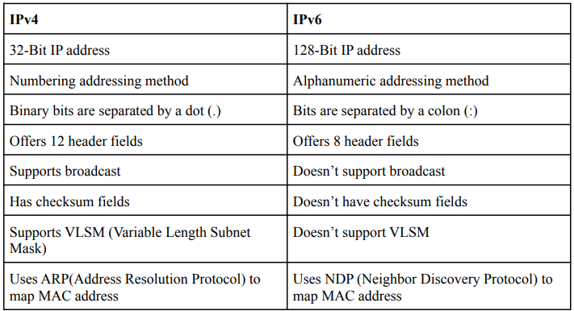 [7]

Subnetting divides larger networks into smaller subnetworks by reallocating host bits to network bits to improve performance “by reducing traffic and minimizing disruption”. For the benefit of larger networks, this makes them more “manageable” for enterprise [8].
IPv6 structure and representation is detailed by “extended from 32 to 128 bits” addressing scheme. Typically represented by hexadecimal format. For example, “2001:DB8:0000:0056:0000:ABCD:EF12:1234”. Vast address space improves scalability and reduces exhaustion issues. Furthermore, this eliminates broadcast traffic which improves efficiency [9].
The table below details classful IPv4 addressing into fixed classes with predefined subnet mask and host capabilities, This demonstrates how the IPv4 allocation has developed over time. The allocation is simple to administer but inefficient in practice. This drove the adoption and more flexible allocation methods.
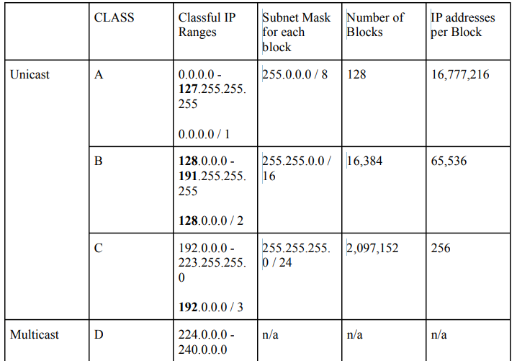
[7]

Packets are transferred over the internet in the fashion detailed with the simplistic diagram below. A message is encapsulated with a header containing the source and destination IP addresses. This is known as a IP packet [10] . This packet is forwarded through routers across the internet to the intended device.
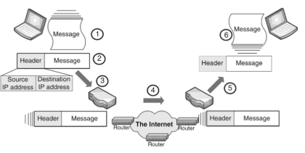 [10]
IP addressing within a network topology as detailed by an educational page by learnisco details a practical use of network management. Each host device has a unique IPv4 address within its subnet. This creates the functionality of devices being able to be identified logically and can communicate across the network. The routers connect multiple subnets which enable packet to be forwarded between different internal and external networks. The switches connect hosts on the same network within the local network based on destination IP addresses. In conclusion, this hierarchical IP addressing allows devices across multiple networks to use routing to communicate effectively and efficiently.
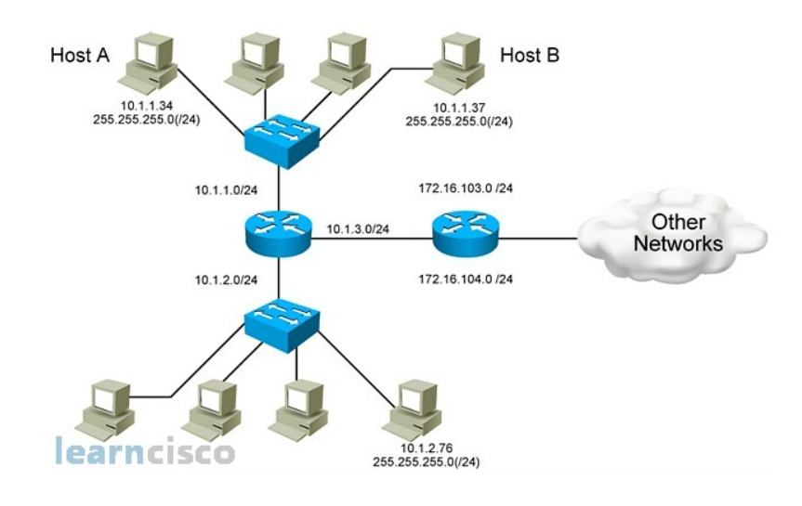 [11]

In summary, effective IP addressing design contributes to performance, scalability, manageability and organisational network effectiveness.

Research on Routing
Routing is defined as “the process of selecting a path for data packets to travel from their source to their destination across the networks” [12]
Routing enables packets to traverse interconnected networks by examining packet headers and determining an appropriate forwarding path. A router uses the “header of each packet to determine the link to be used to output the packet” and “arbitrates between two (or more) packets which must both be output through the same link.”
This reflects the fundamental routing function: inspecting destination information and selecting the correct outbound interface . Additionally, routers may “start to output each packet as early as possible,” demonstrating efficiency techniques such as “wormhole routing” to reduce delay and improve throughput [13].
Static routing is configured through manual commands where admins define the path and routing tables [12]. Dynamic routing automatically exchange routing information between routers. Such dynamic protocols are RIP and OSPF that “share information about the reachability and the status” of network information and “determine the best path to a destination and note them in their routing tables” [14].
For the given topology, which includes a Debian Server acting as a DHCP relay and a Windows Server providing domain connectivity, the network is structured and limited in scale. The topology consists of a small number of subnets with fixed paths, static routing is the most optimal solution and allows a simpler troubleshooting process.

Research on Network Services
The below description includes a focus on VPNs, DHCP, Active Directory Domain Services (AD DS), and Certificate Authorities and their key features and best practices.
Network Services | Key Features | Best Practices
Virtual Private Network (VPN) | An encrypted internet access encapsulating data across public or untrusted networks.  Supports remote access and connectivity across locations and provide “cost savings” and “scalability”. Uses “PPTP; L2TP; GRE; IPsec; SOCKS” protocols for confidentiality and integrity. Users are authenticated before access is granted. Used in industry to protect sensitive enterprise data during sending and receiving between locations [15]. | Enforces strong authentication using “tunnelling, encryption, traffic separation, authentication and access control” to minimise attack surfaces [15].
Dynamic Host Configuration Protocol (DHCP) | Automates IP assignment.  Automates network “configuration parameters” like default gateway and DNS servers. This reduces administration overhead and errors from configuration. Supports centralised IP management and typically works with DHCP relay across subnet [16]. | Effective DHCP implementation requires proper scope design, exclusion ranges, lease time management and redundancy planning to prevent single points of failure. In multi-subnet environments “DHCP relay agents forward DHCP messages between client and servers” that enable centralised IP management without the deployment of DHCP servers [16].
Active Directory Domain Services | A “security service” for authentication and authorization between “domains”. Restricts functionality throughout “users and machines” [17]. | Creates organisational units. Creates “an effective hierarchy” [17].
Certificate authorities (CA) | Manages and issues certificates digitally for “certificate recipients” for “secure connection” and the “security” of the Transport Layer Security relies on CAs [18]. | Secure storage of keys allow for safe protection using strict security controls relating to “private signing” keys which are the cryptographic keys used by CAs to digitally sign certificates. Avoiding storing or managing CA signing keys in a single system as this can have “disastrous consequences” if compromised [18].

Conclusion
The research discusses virtualisation techniques and technologies. This highlights the variety of uses of VMs and hypervisors. Continuing, the deployment of enterprise network environments with multiple clients and servers on one physical machine. Although Type 1 hypervisors are more applicable for enterprise compared to its counterpart, Type 2 hypervisors are suited for small scale environments as described in the topology. IP addressing allows for reliable communication between machines through IPv4 and IPv6 addressing schemes. Subnetting and IP addressing allocated correctly improves network organisation for enterprises whilst improving security. In conclusion, this encapsulates the core infrastructure of networking between locations across virtualised technology.

Task 2

Choose your Hypervisor – Type 2

Microsoft server
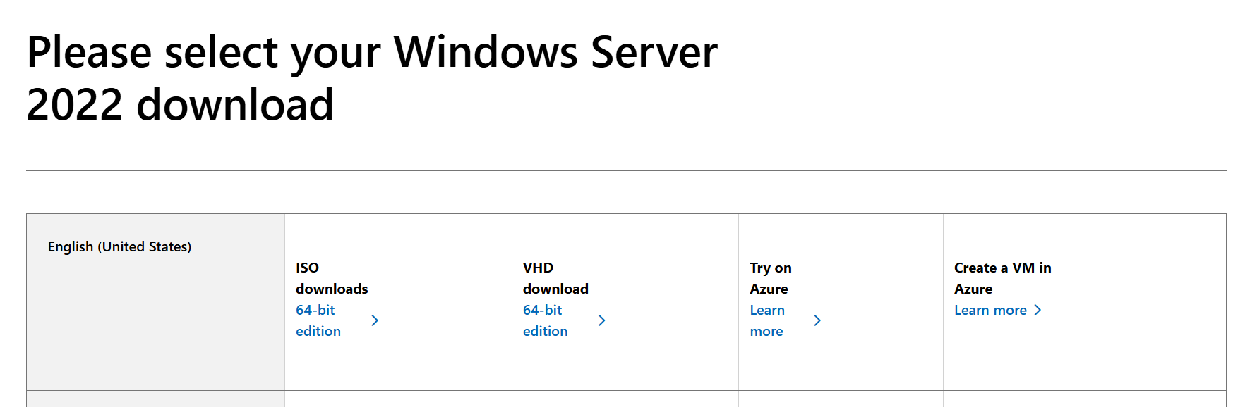

Microsoft client
Whilst trying to install the Microsoft Client, each file downloaded was corrupted. I used a file from my lecturer to install.

Debian Server
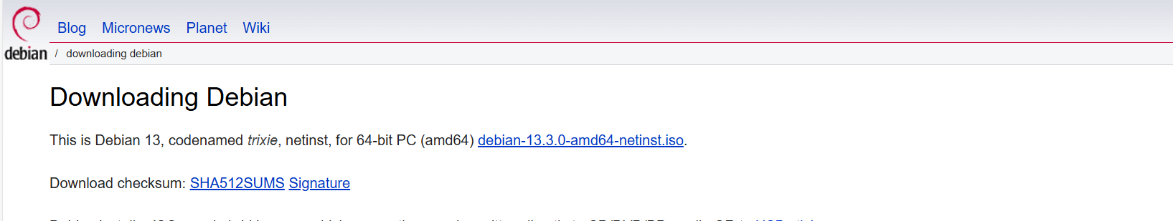

Debian Client
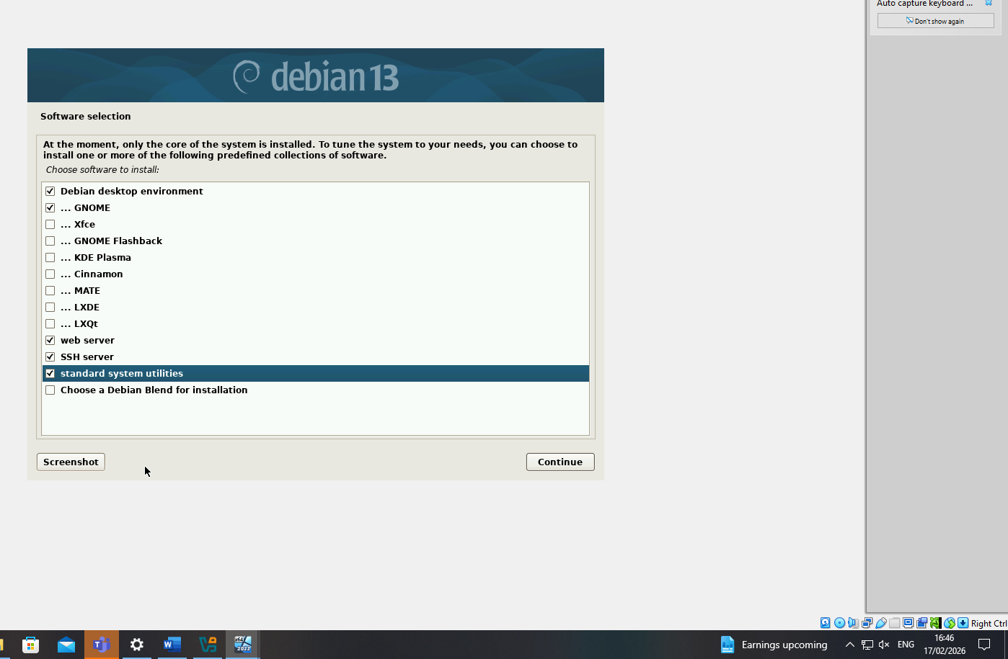

Download and Setup

Overview
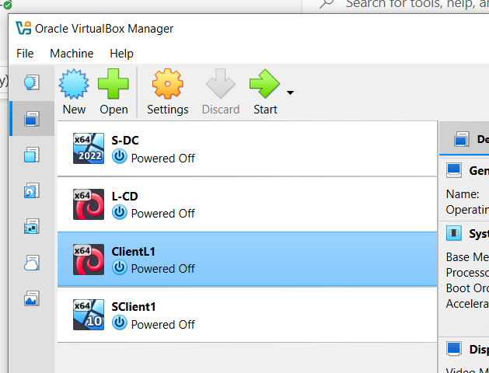
Adapters: S-DC
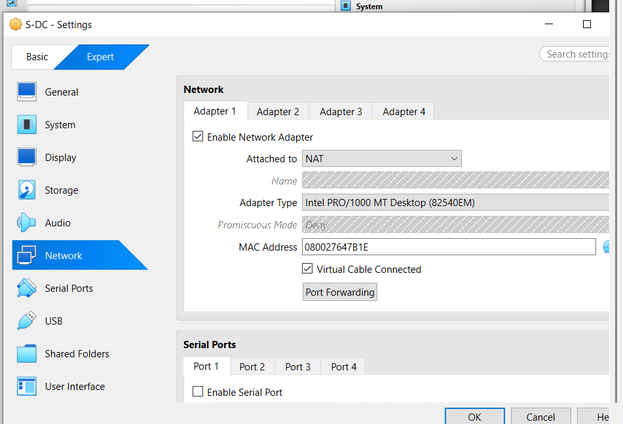
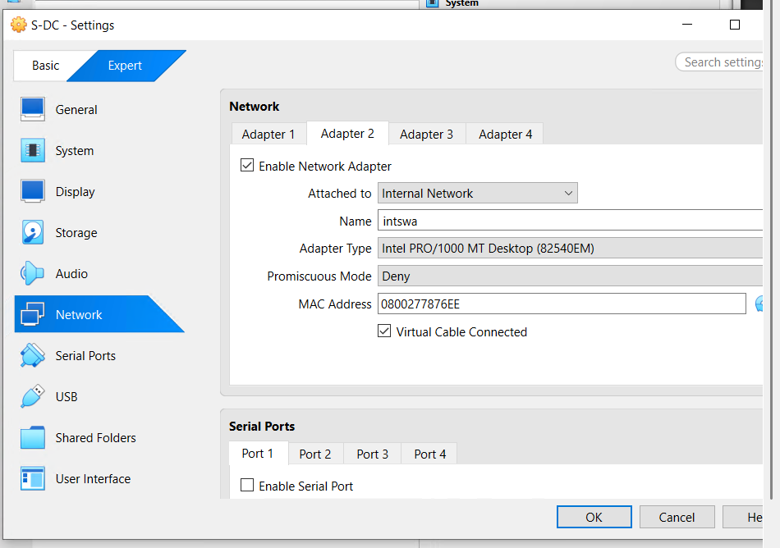
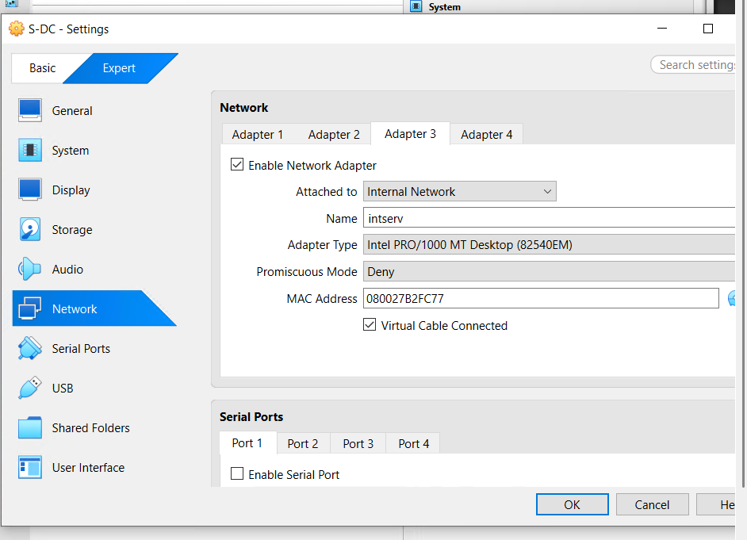
Adapters: L-CD
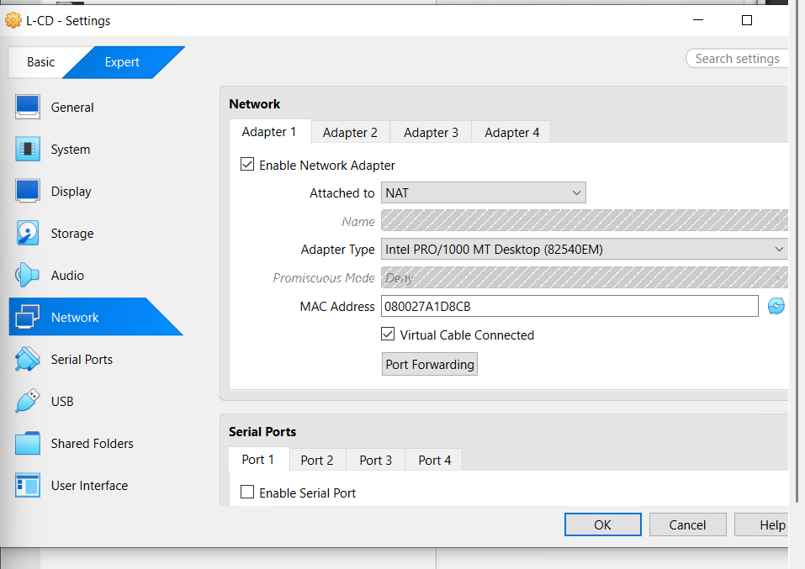
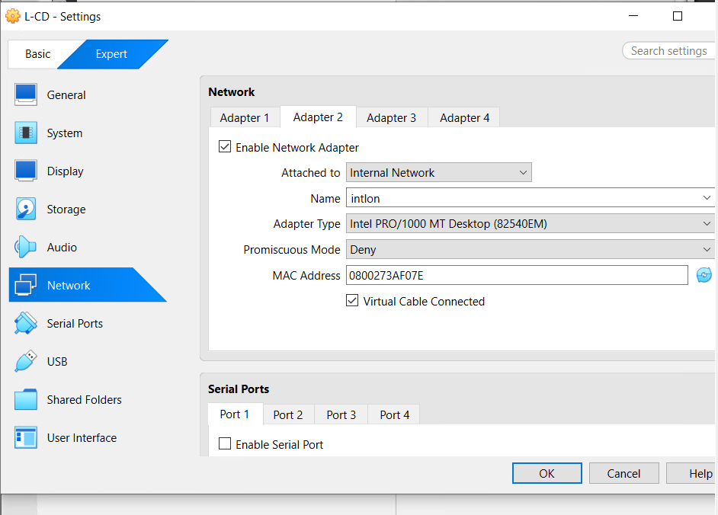
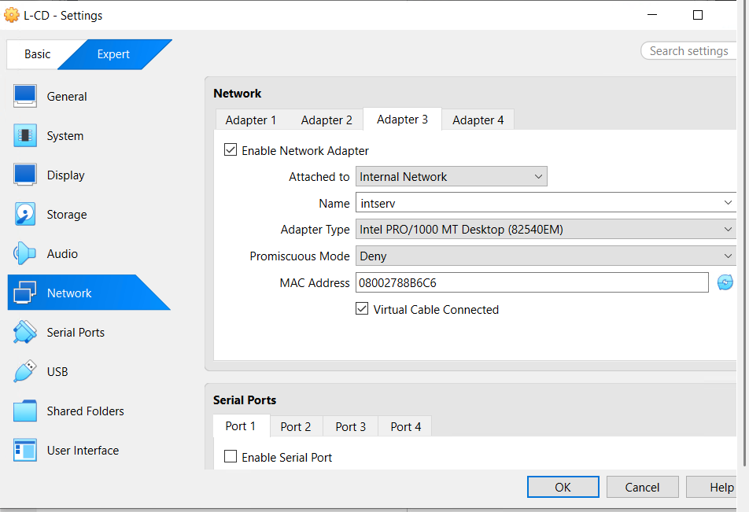
Adapter – ClientL1
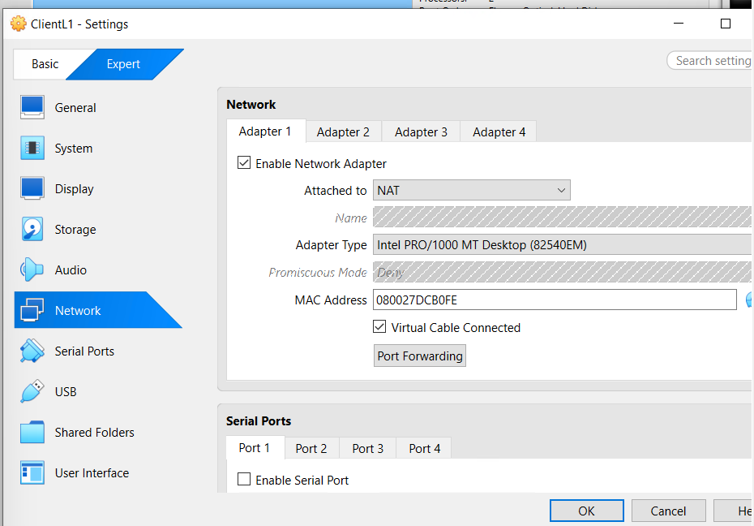
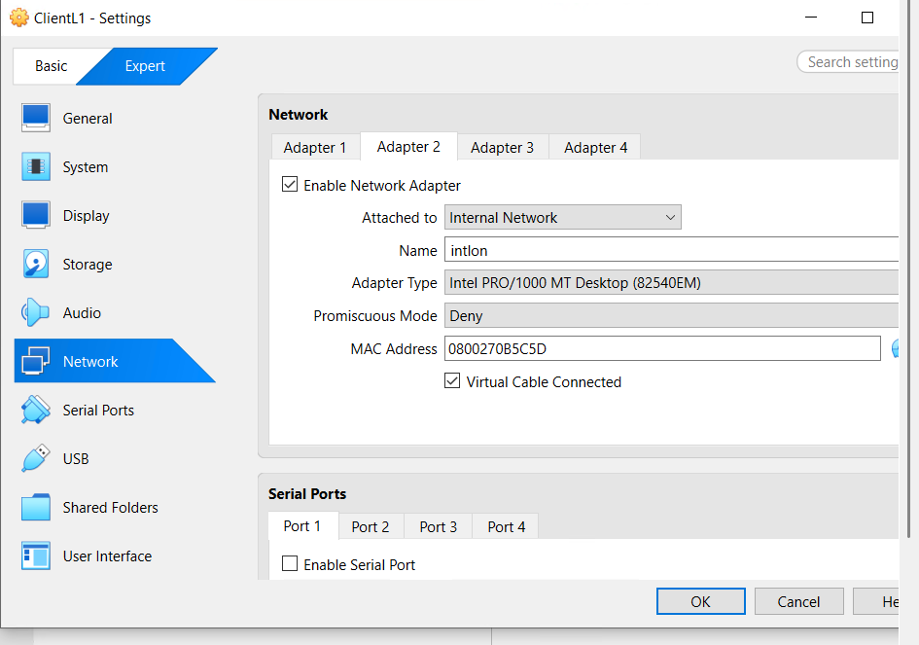
Adapters: ClientS1
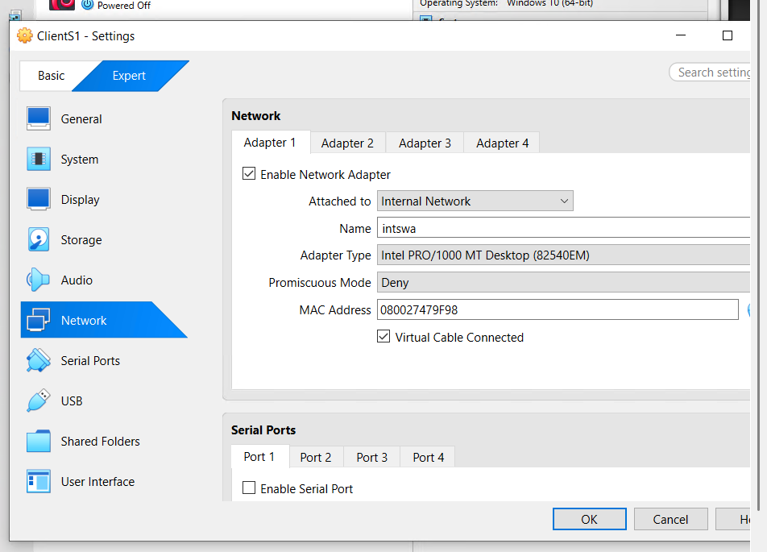
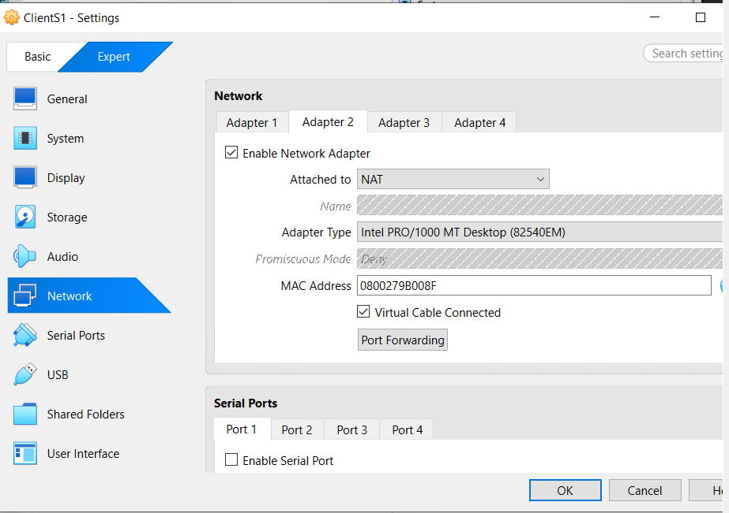

Windows – Server
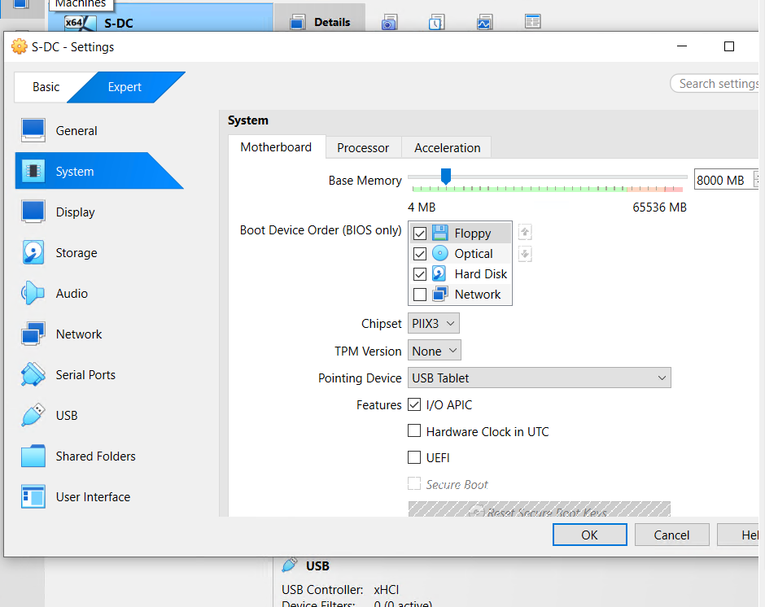
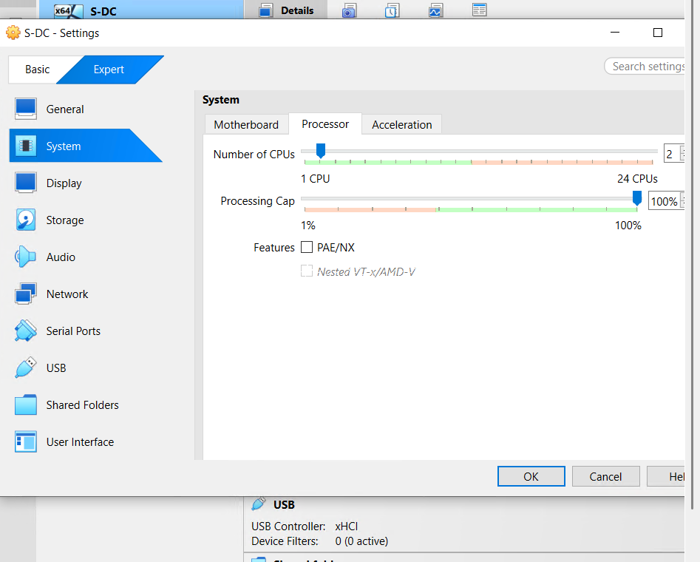

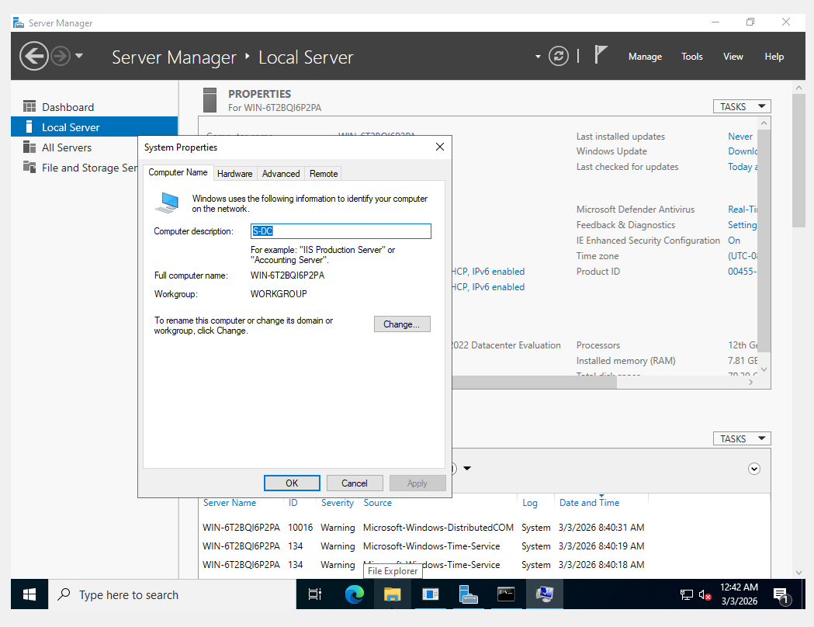
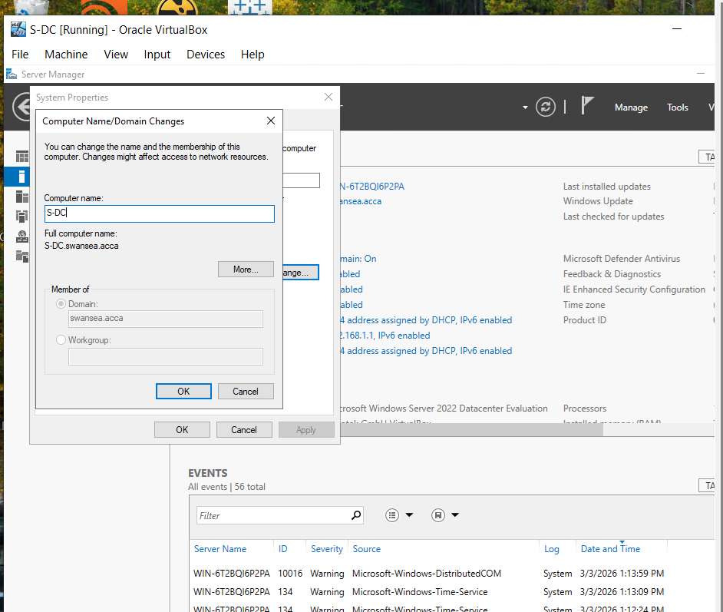
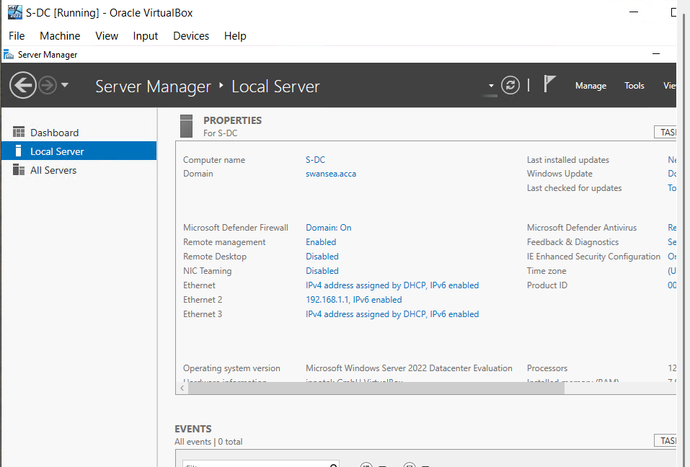
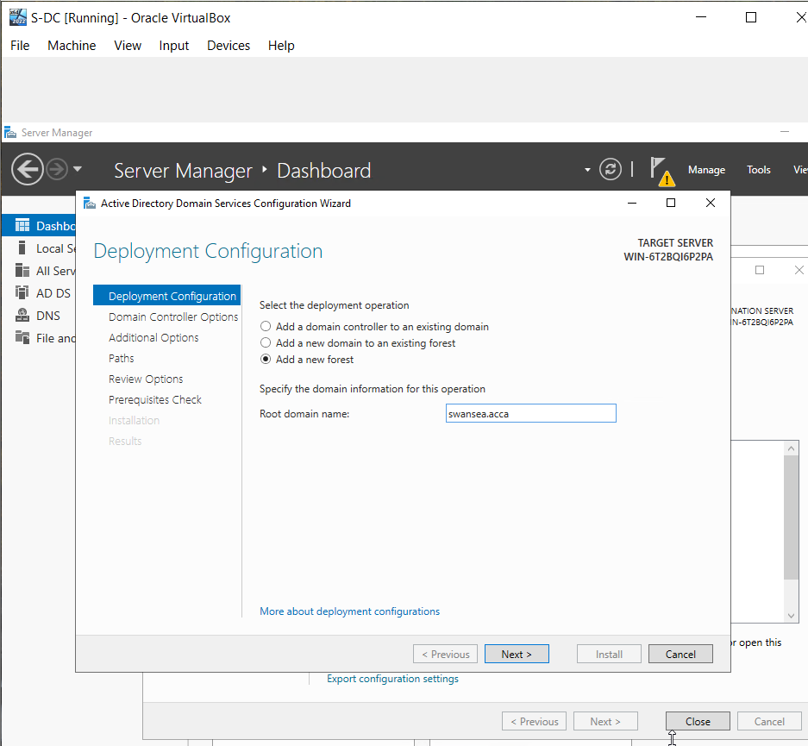
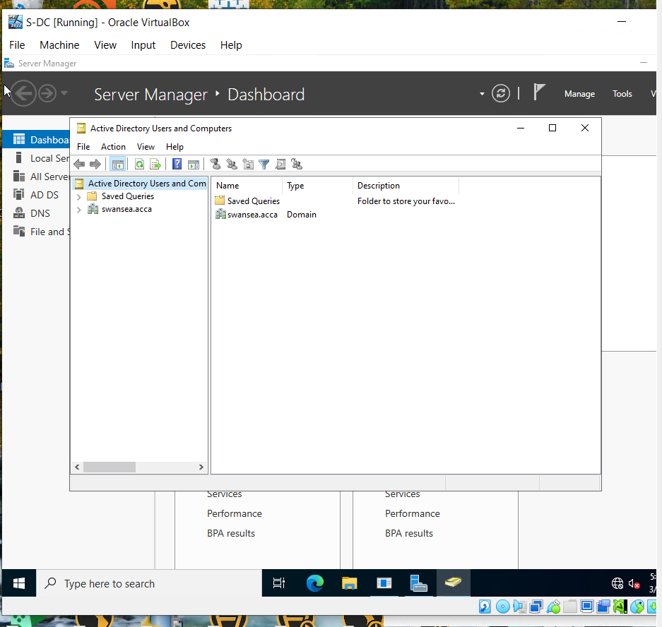

Microsoft – Client
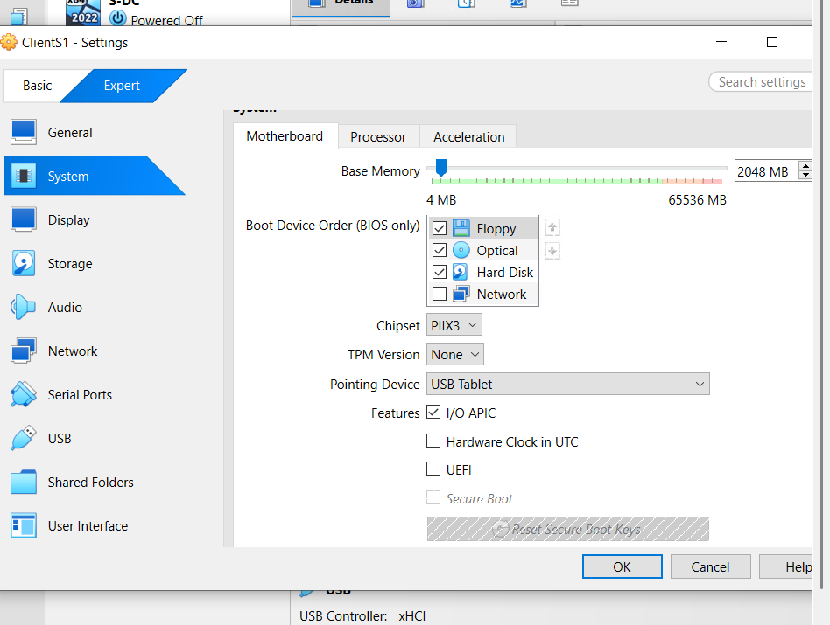
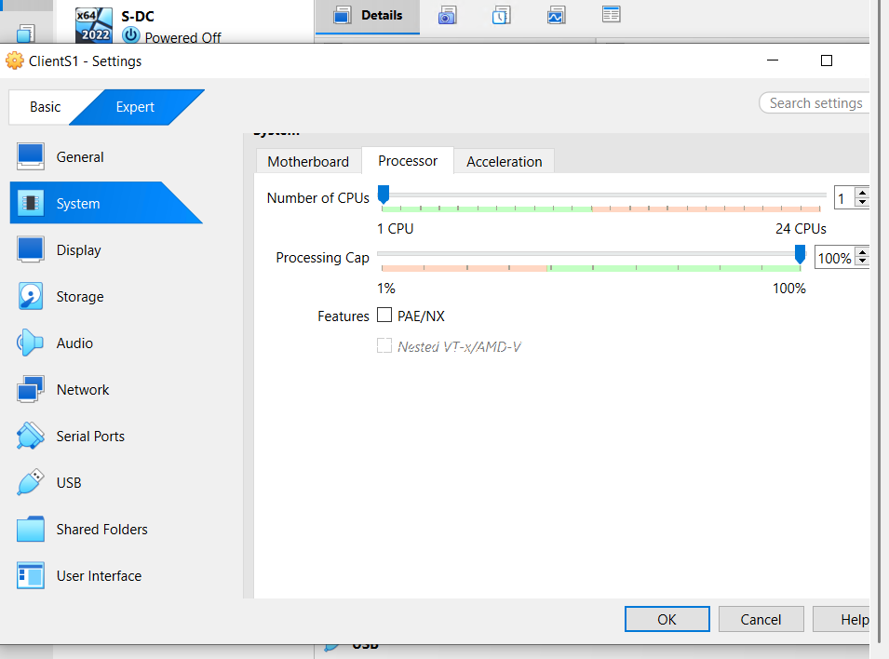

Debian – Server
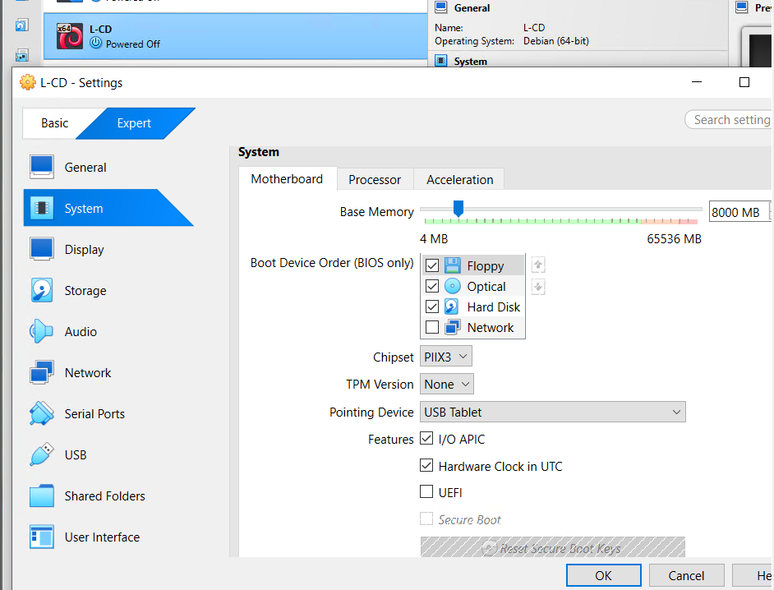
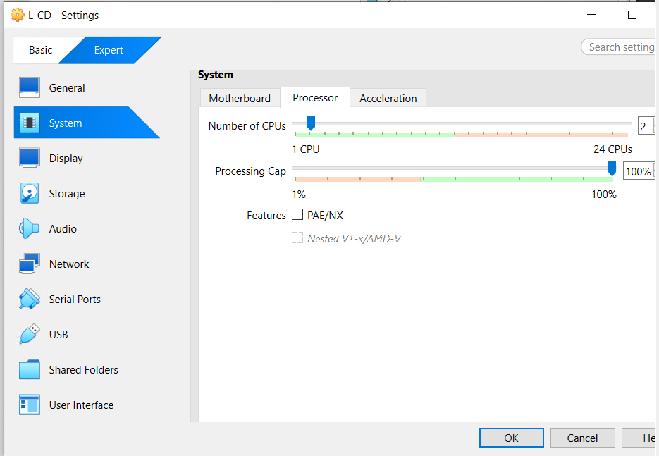

Debian – Client
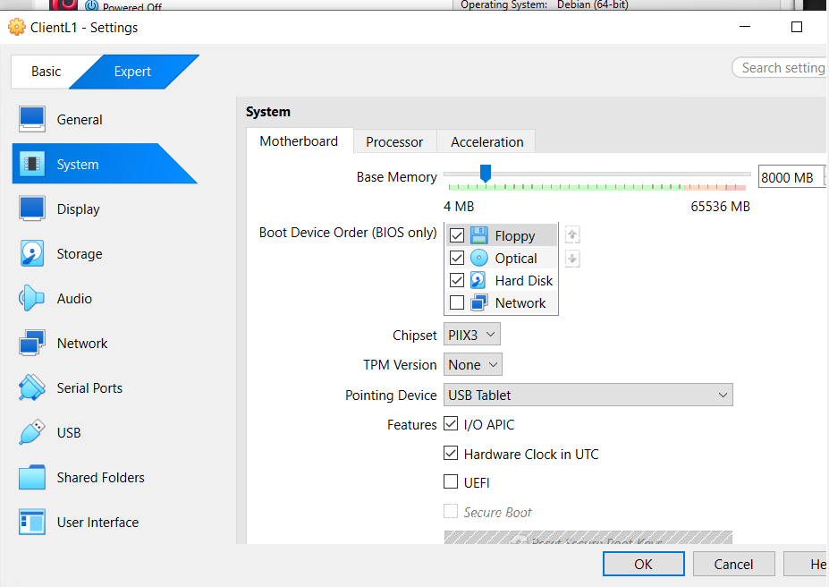
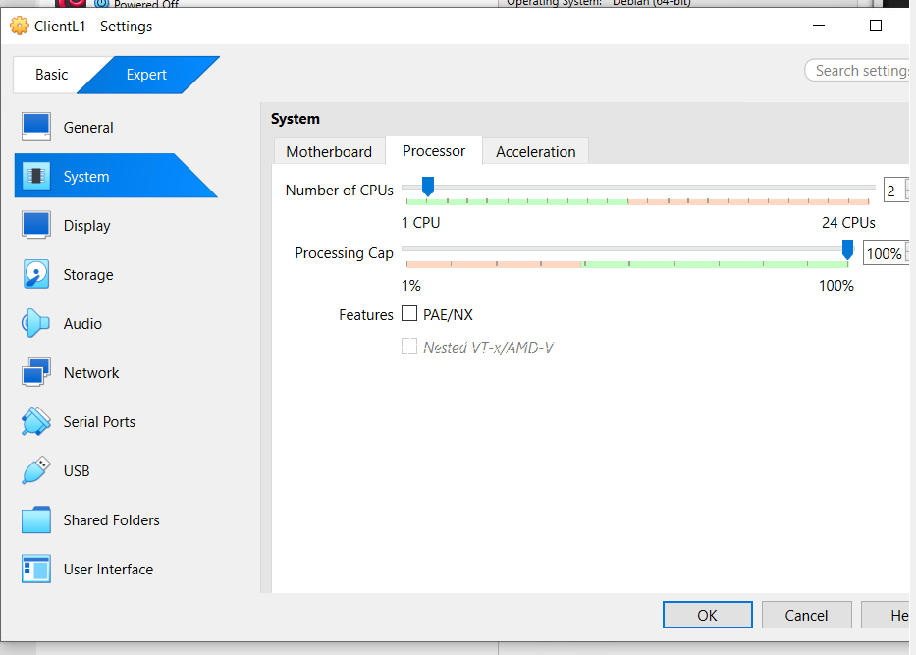

Windows Client & Server
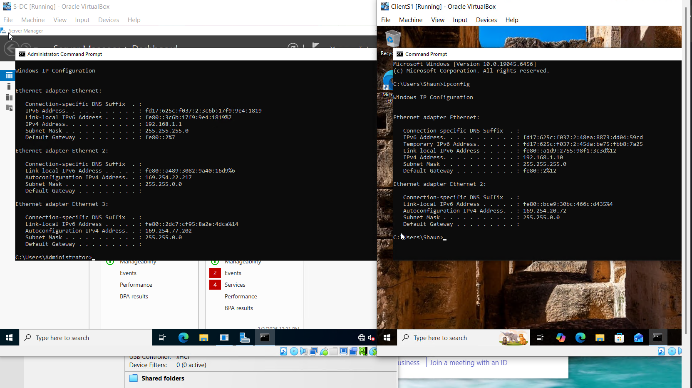

Debian Server & Client

Server
Set up.
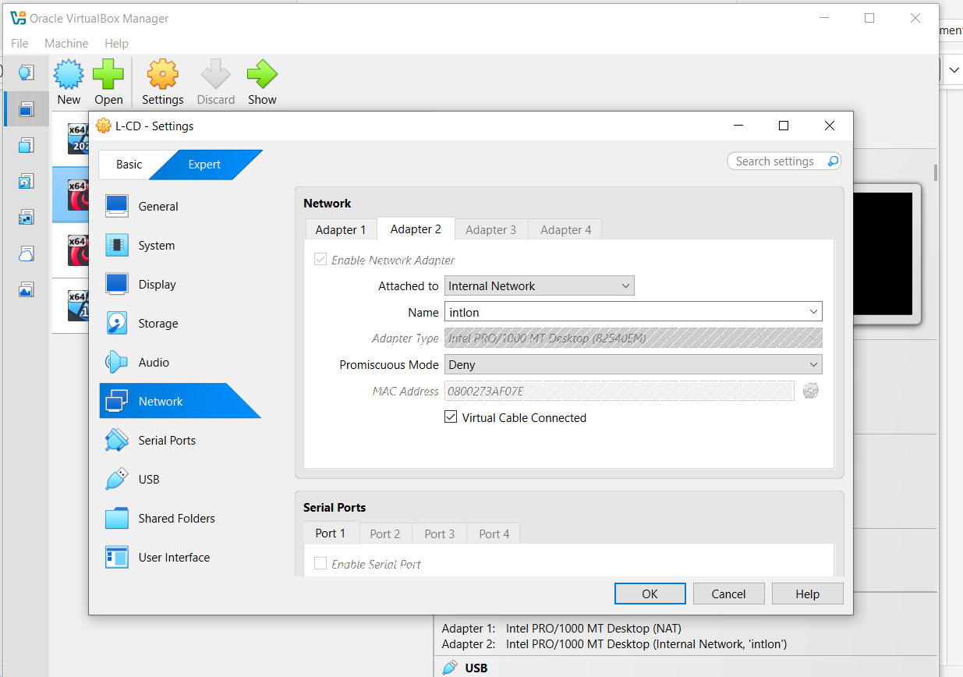
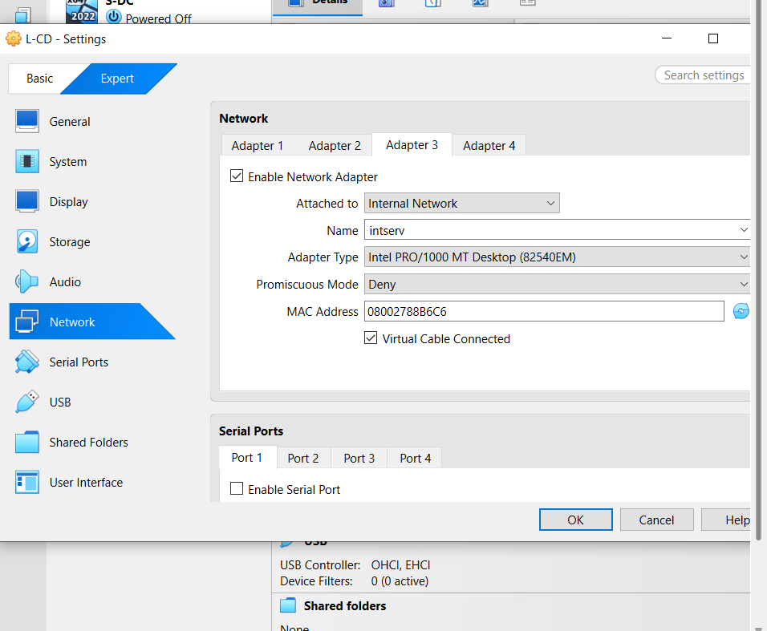

Client
Set up.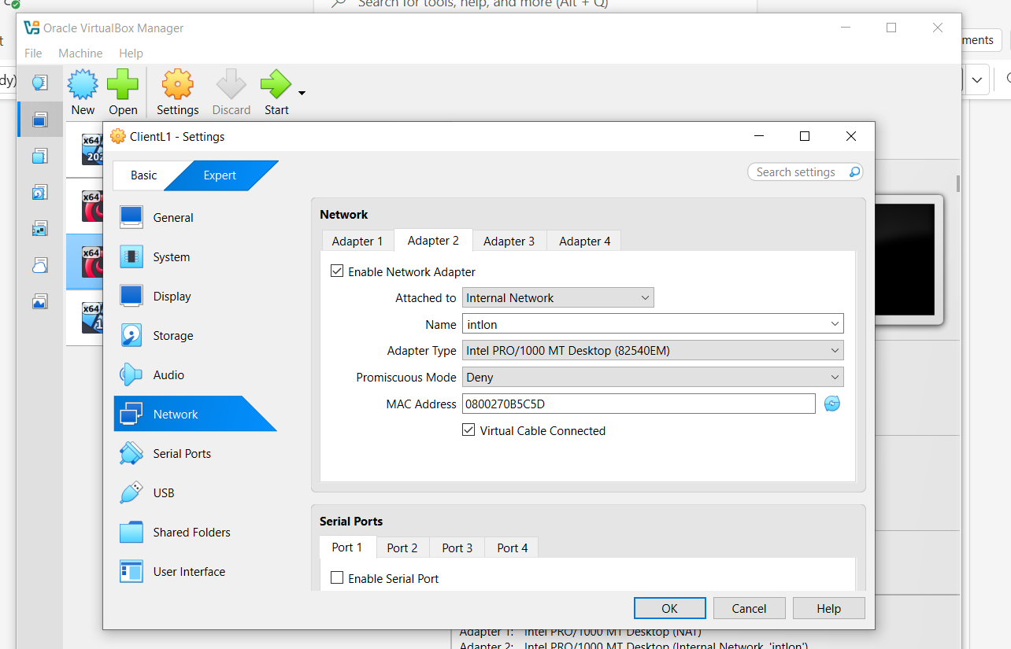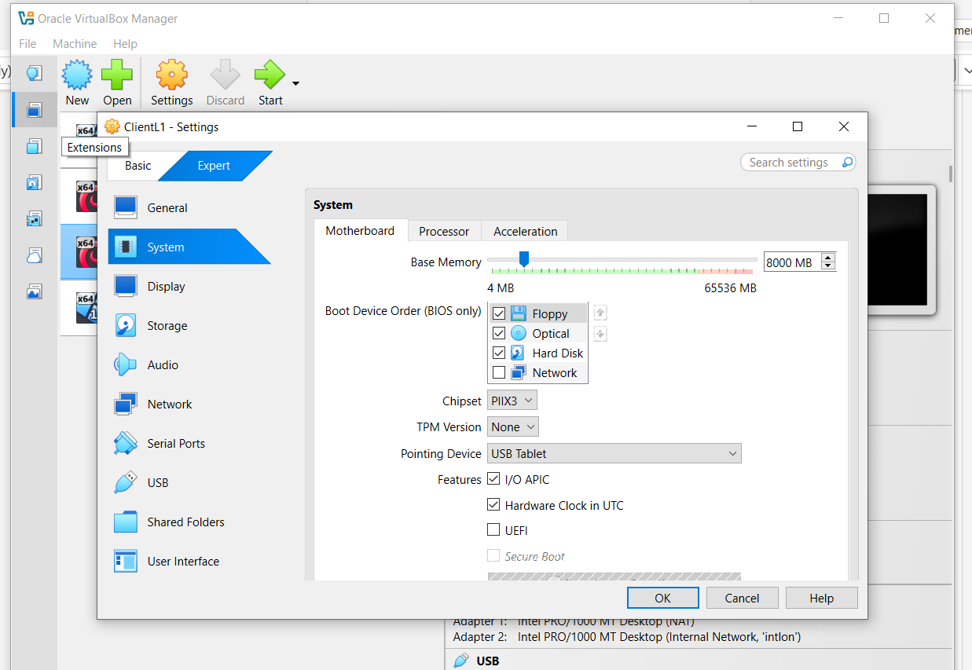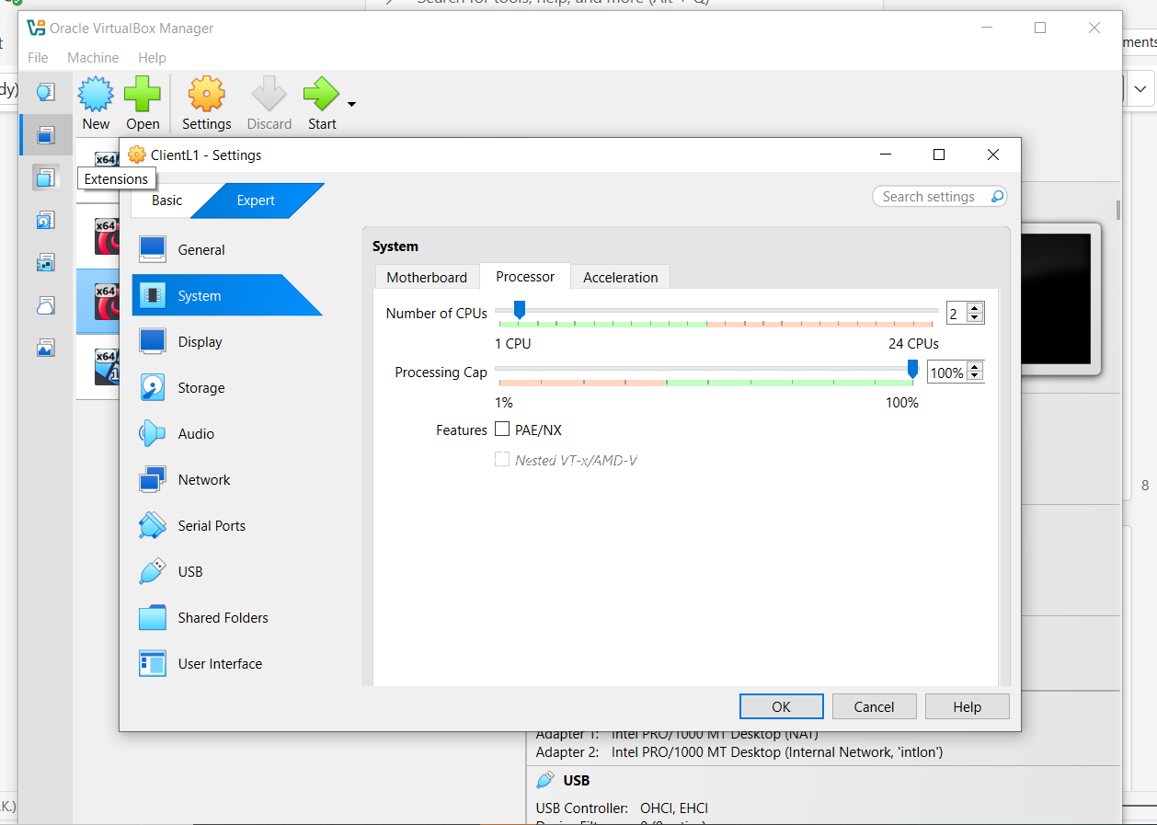

Microsoft Client Rename
Evidence
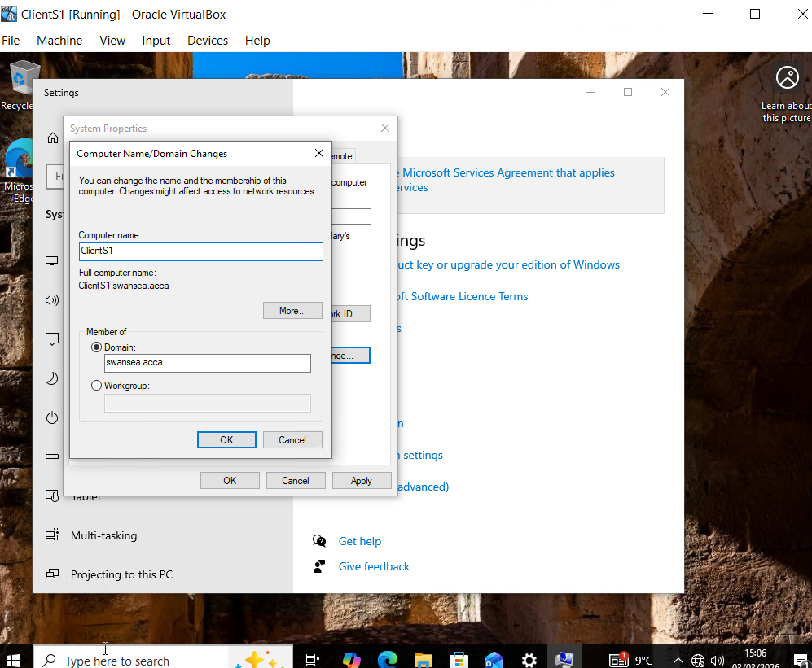
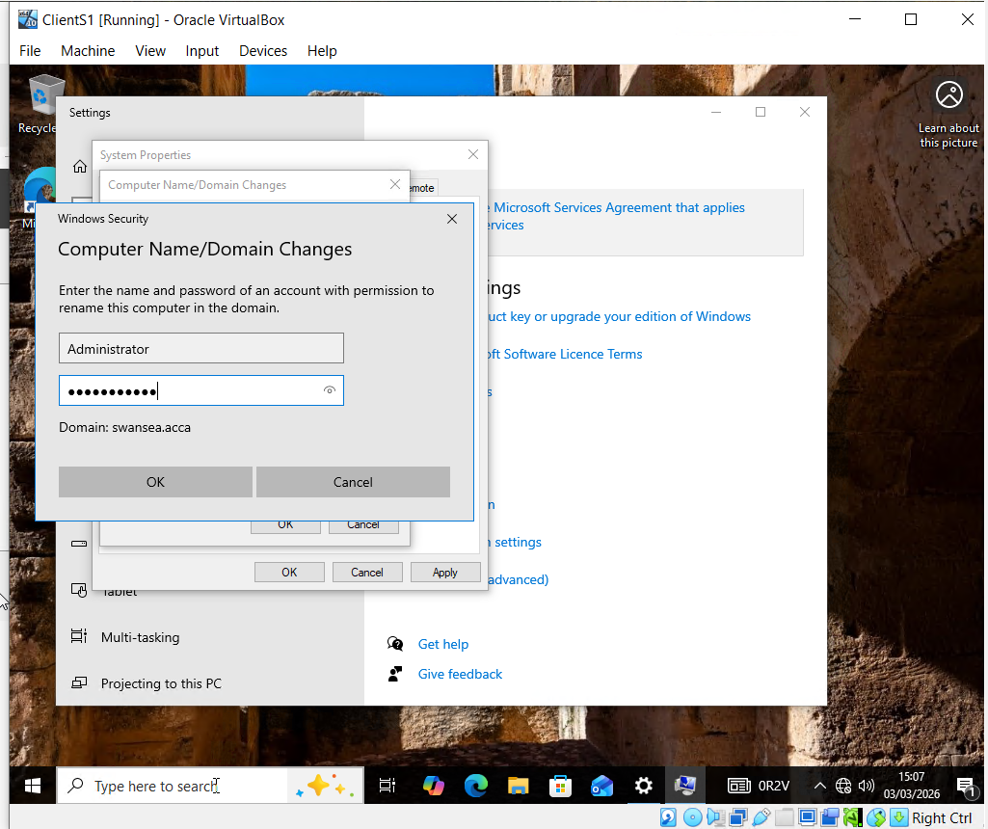
Client renamed

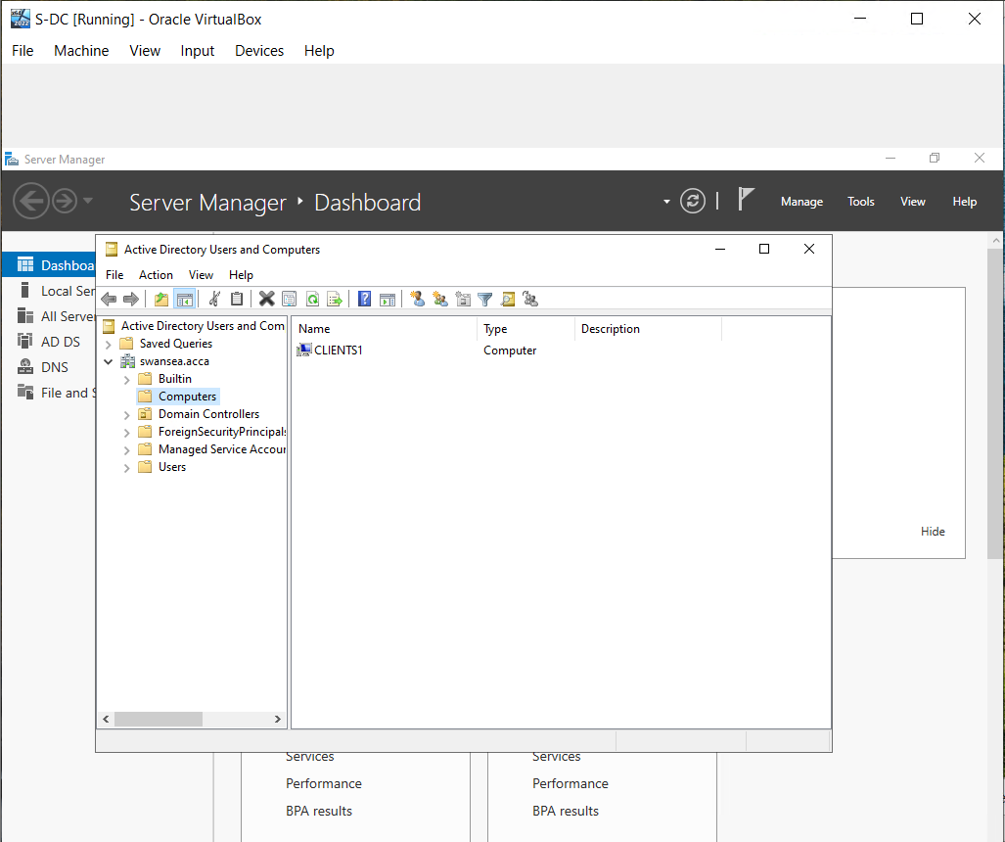
Confirmation on server that client is apart of the active directory.

Configure IP Addressing

Appropriate IP addressing
Debian – Client & Server
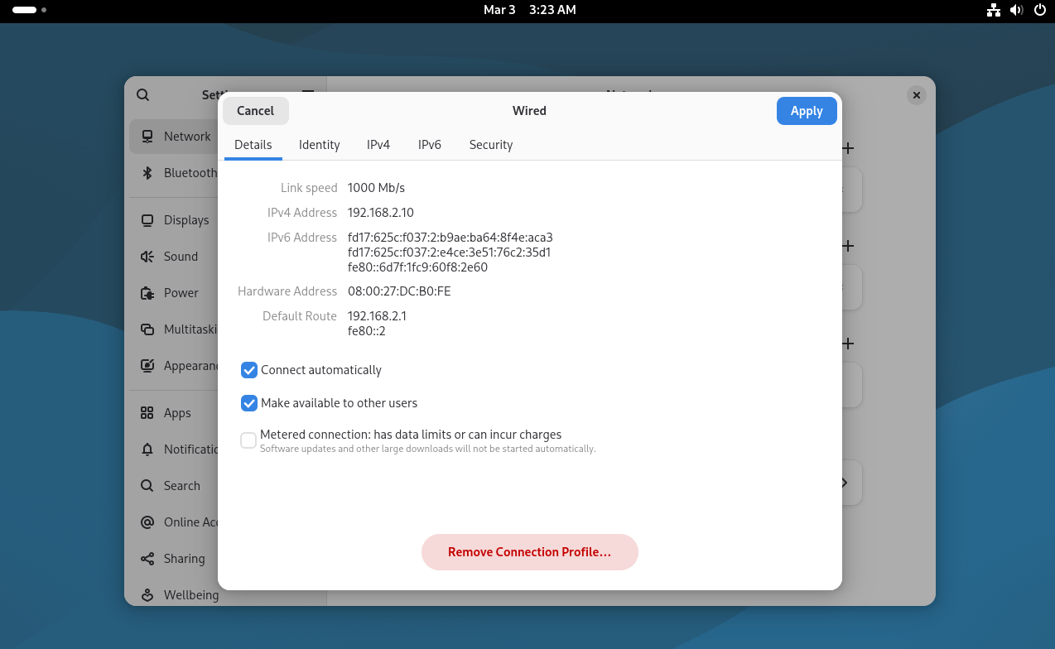 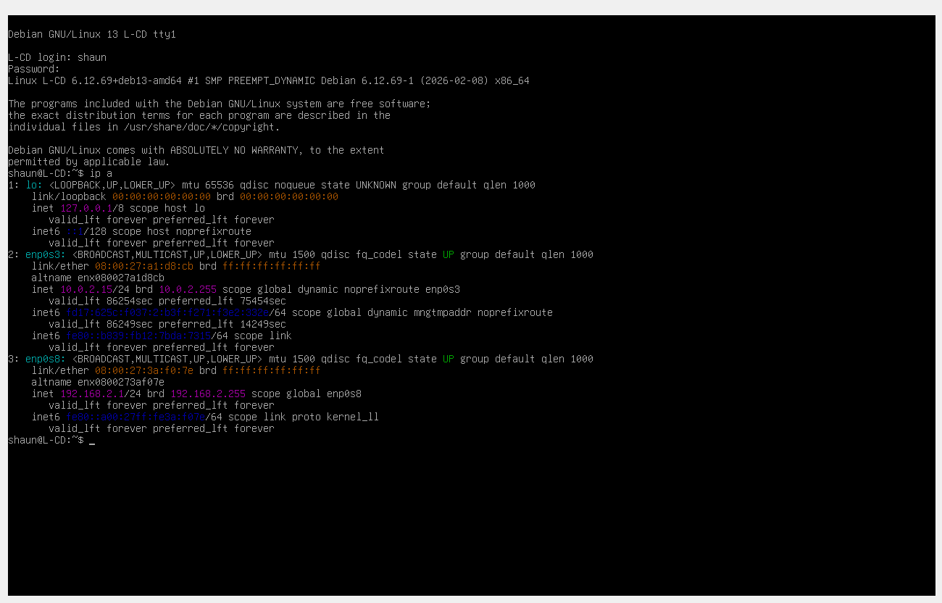Microsoft Server
Server – Adapter 2
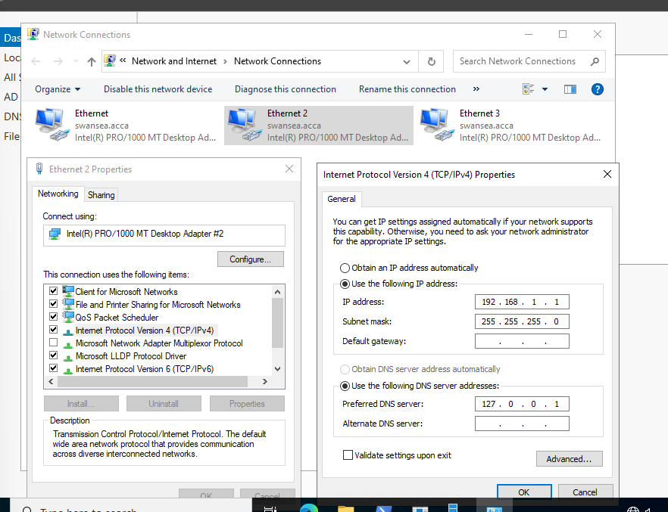
Server – Adapter 3
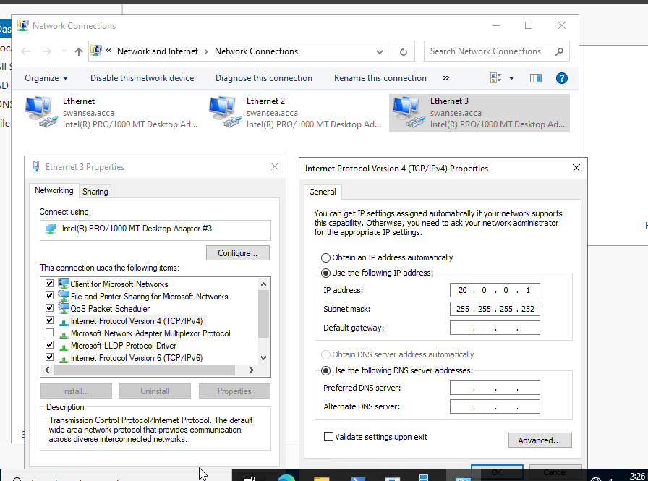
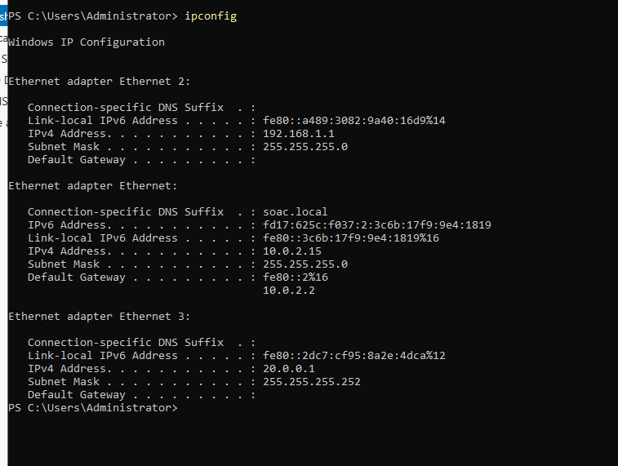
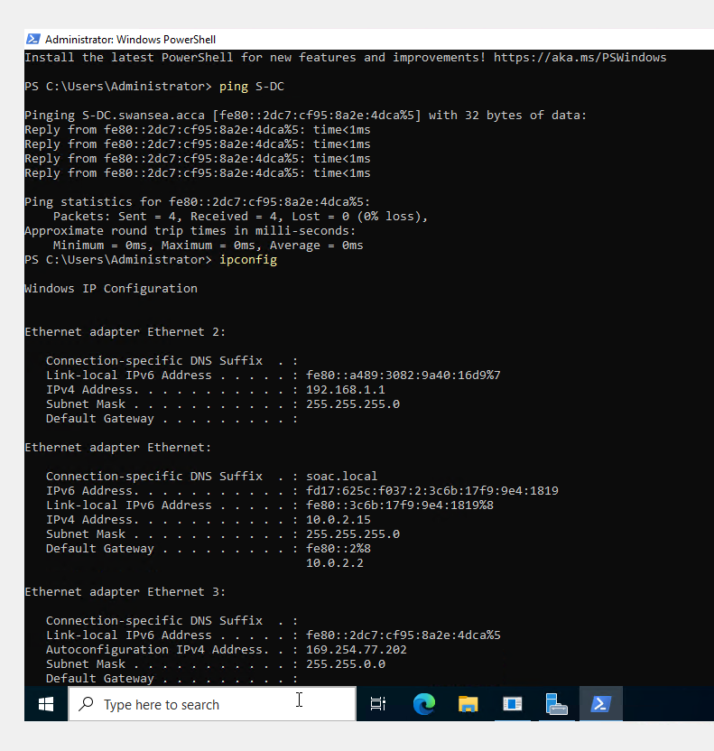

Client
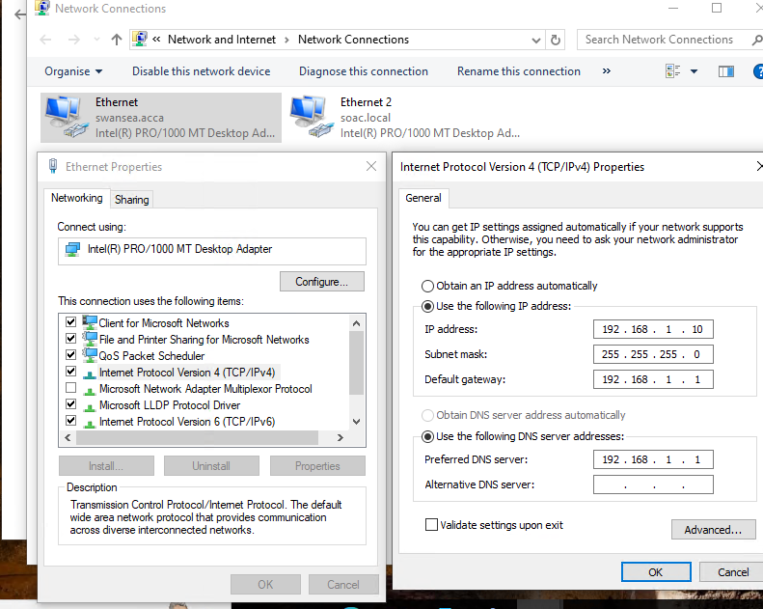
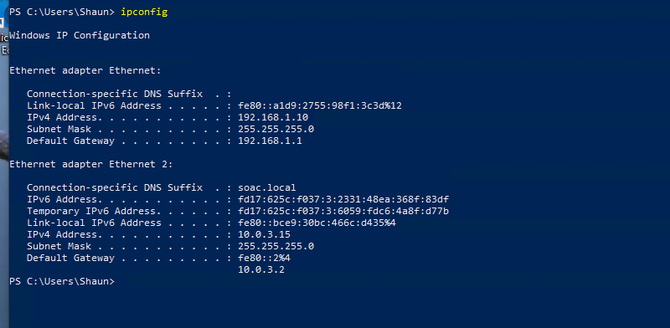

Test and Troubleshoot
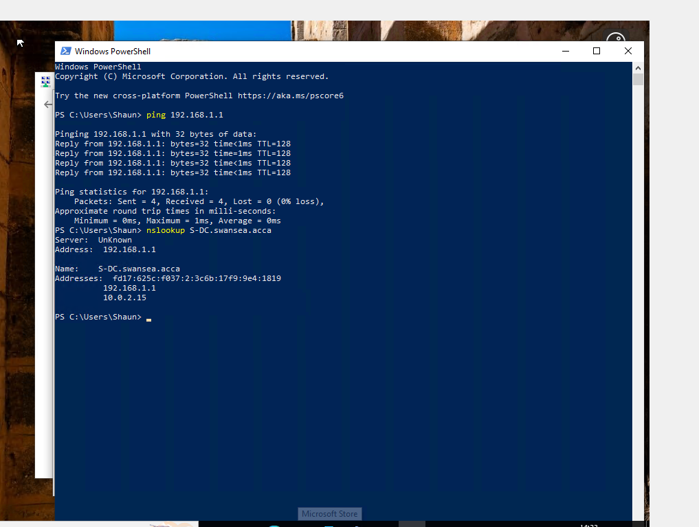
Server pings from client
Still includes NAT IP.
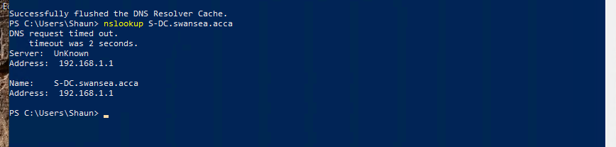
Now corrected by deleting 10.02.15 off swansea.acca domain.

Perform Connectivity tests

Outcome 1: Successful Connectivity Within the Same Networks
Debian – Server & Client (pinging each other)
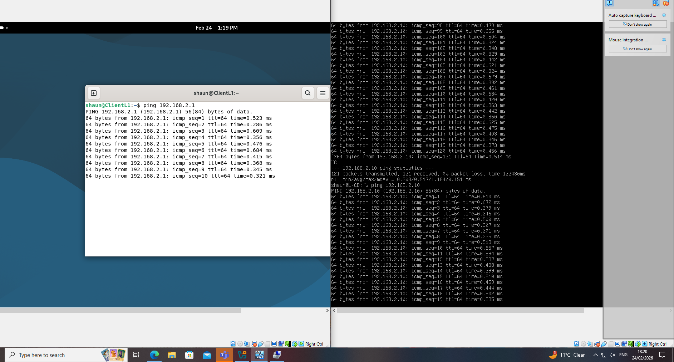
Debian – Client to Client (pinging themselves)
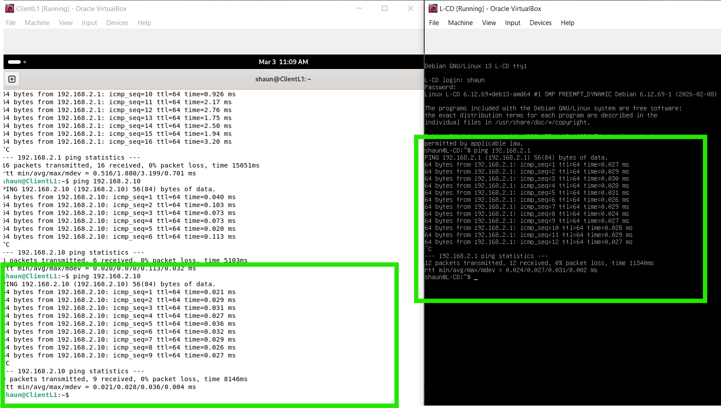
Microsoft – Server & Client (pinging each other)
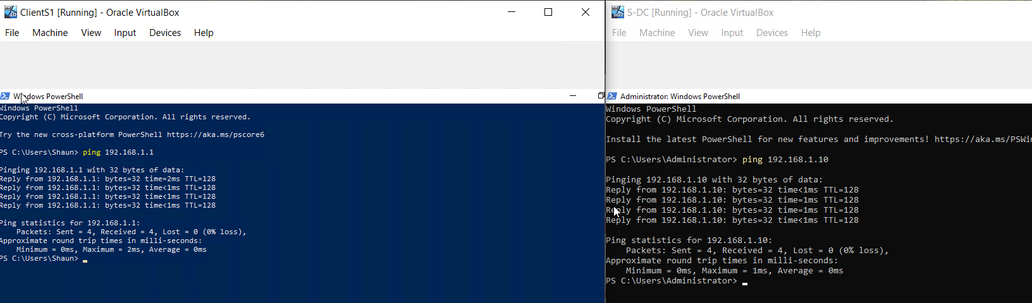
Microsoft – Client to Client (pinging themselves)
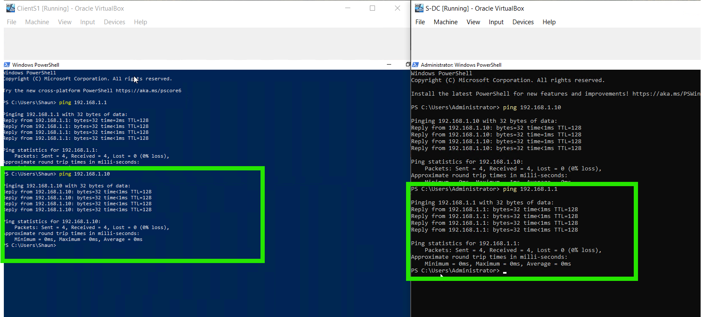

Outcome 2: Unsuccessful Connectivity Within Different Networks
Microsoft Client to Debian Client
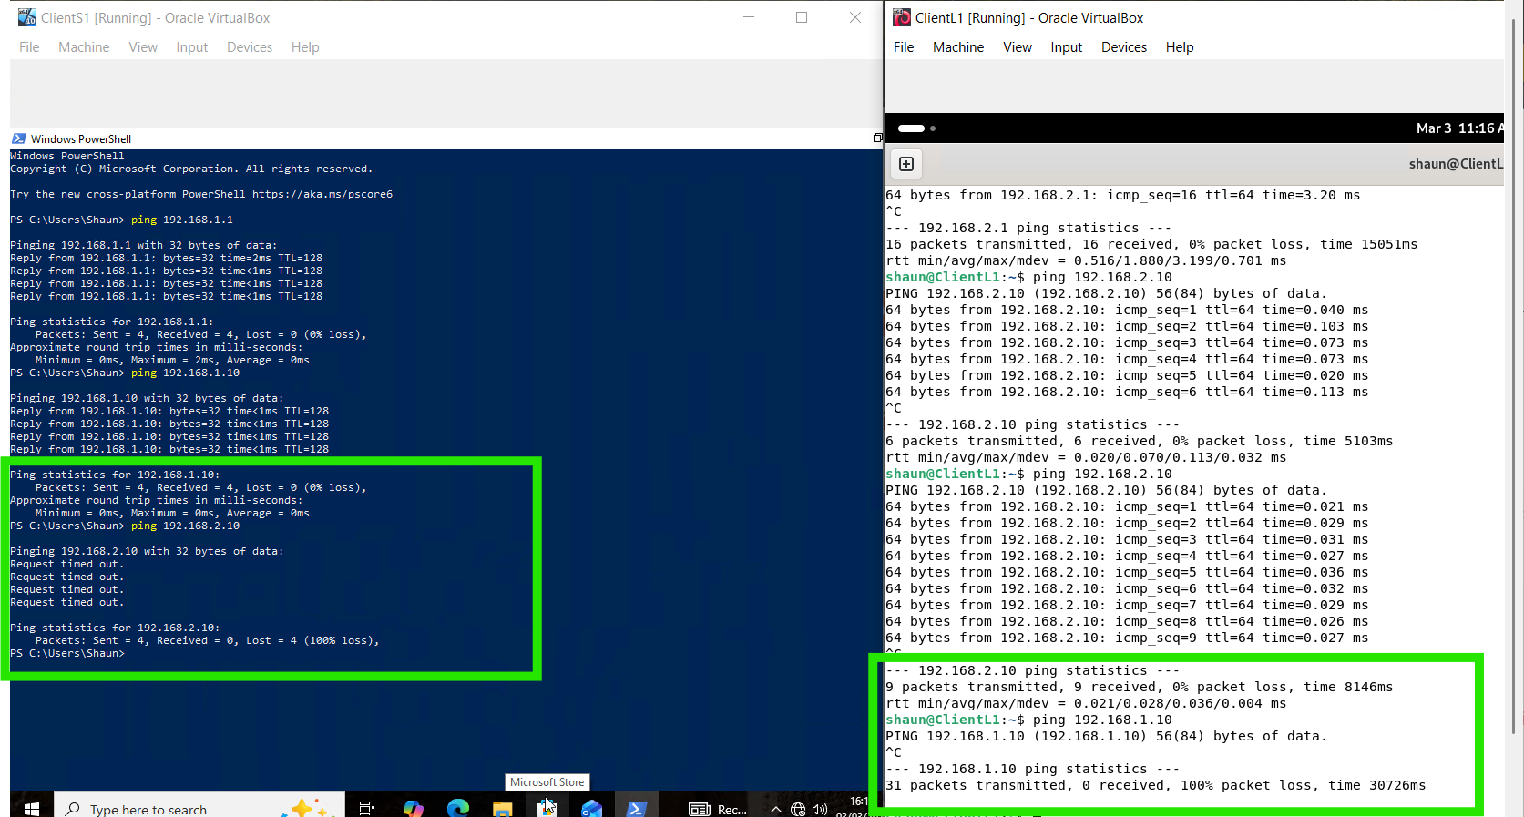
Server to Server
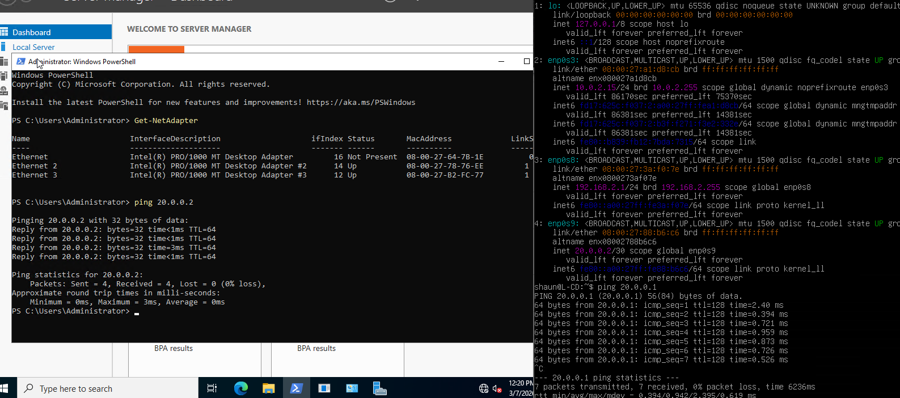

Task 3 – Reflection

Technical Reflection
Throughout this assignment, there was a variety of connectivity tests that failed between S-DC and L-CD. This required checking each IP address, verifying the subnet masks, confirming the adapters were correctly assigned and reviewing routing paths. By assessing these avenues, I eliminated the majority of issues. Despite following these steps, while ensuring that S-DC could ping its’ client, no communication occurred between the two. By restarting both machines, this allowed the pings to be received on both.
An issue I faced was with Windows. With it having multiple network adapters the operating system was choosing the wrong interface to send traffic through. The InterfaceMetric value is used to determine which network adapter has priority. I changed this so that Ethernet 2 had a higher priority to force windows to send traffic through the correct interface. Internal adapter has metric 10. This ensures the correct response from the ping.

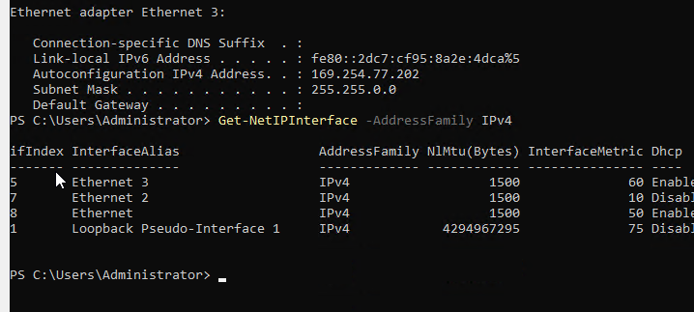
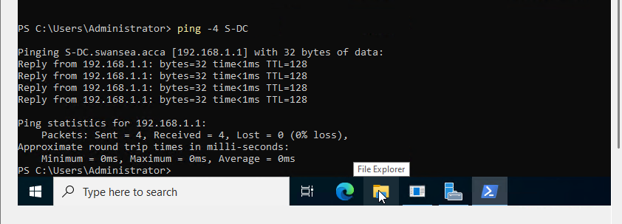

Another issue faced whilst deploying the network was the Debian Server being “DOWN”. With the interface not being active, the Debian server could not communicate with the Windows server.

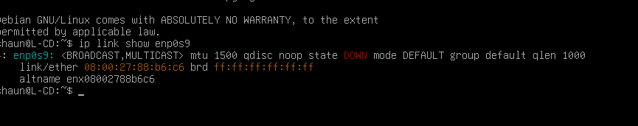
By running the below code, this issue was elevated.
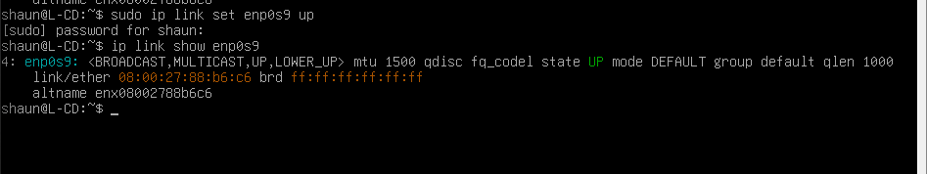

Personal Reflection
Throughout this assignment, I learned a variety of skills. Configuring and deploying networks including clients and servers whilst troubleshooting errors that appeared. I developed an understanding of how to use multiple adapters within virtual machines and how the network priority can effect connectivity.
Using command line tools like ping, ip a, ip link and Get-NetAdapter developed my understanding of network connectivity. Through examining interface states, IP configurations and adapter information this improved my ability to analyse network behaviour.

References

[1] | Z. Aalam, “A review paper on hypervisor and virtual machine security,” Journal of Physics: Conference Series, pp. 1-6, 2021.
[2] | M. a. G. T. Rosenblum, “Virtual Machine Monitors: Current Technology and Future Trends,” Computer, vol. 38, no. 5, pp. 39-47, 2005.
[3] | L. a. B. M. a. D. S. D. Youseff, “Toward a Unified Ontology of Cloud Computing,” 2008 Grid Computing Environments Workshop, pp. 1-10, 2008.
[4] | D. Clark, “The design philosophy of the DARPA internet protocols,” Computer Communication Review, vol. 18, no. 4, pp. 106-114, 1988.
[5] | W. Tenenbaum, Computer Networks, Pearson, 2011.
[6] | G. Thomas, “Limited address space means there is a need for subnetting and efficient allocation [],” The Extension, vol. 1, no. 8, pp. 1-4, 2000.
[7] | J. A. K. B. C. C. D. L. D. D. V. M. H. QUITANEG, “Understanding the Concepts of IP Addressing and Subnetting,” 2022.
[8] | G. Thomas, “Introduction to Subnetting: How to maximize network addresses,” The Extension A Technical Supplement To Control Network, vol. 1, no. 8, pp. 1-4, 2000.
[9] | S. Hagen, IPv6 Essentials, O'Reilly Media, Inc., 2006.
[10] | T. a. D. M. Rooney, “IP address management,” in IP address management, John Wiley & Sons, 2021, p. 5.
[11] | learncisco, “Constructing an IP Network Addressing Scheme,” learncisco, [Online]. Available: https://www.learncisco.net/courses/icnd-1/lan-connections/network-addressing-scheme.html. [Accessed 27 January 2026].
[12] | L. W. Kin, “Basic Networking and Static Routing,” Authorea Preprints, pp. 1-7, 2024.
[13] | P. a. W. P. Thompson, Networks, Routers and Transputers, IOS press, 1993.
[14] | D. V. P. G. P. Sai Kalyan, “Optimal Selection of Dynamic Routing Protocol with Real Time Case Studies,” 2012 International Conference on Recent Advances in Computing and Software Systems, pp. 219-223, 2012.
[15] | Z. a. Z. Y.-Q. a. C. X. a. L. B. Zhang, “An Overview of Virtual Private Network (VPN): IP VPN and Optical VPN,” Photonic network communications, vol. 7, no. 3, pp. 213-225, 2004.
[16] | IEEE, “Automated configuration of TCP/IP with DHCP,” IEEE Internet Computing, vol. 3, no. 4, pp. 45-53, 1999.
[17] | R. a. L.-N. A. Allen, Active directory, O'Reilly Media, Inc., 2003.
[18] | H. L. D. E. Bargav Jayaraman, “Decentralized Certificate Authorities,” Cryptography and Security, pp. 1-12, 2017.
[19] | A. T. a. S. Ngamsuriyaroj, “Assessment of Hypervisor Vulnerabilities,” International Conference on Cloud Computing Research and Innovations, pp. 71-77, 2016.
[20] | S. Giallorenzo, J. Mauro and M. G. Poulsen, “Virtualization Costs: Benchmarking Containers and Virtual Machines Against Bare-Metal,” SN Computer Science, vol. 2, no. 404, pp. 1-20, 2021.

Appendix 1
Comparison Type | Comparison Sub-Type | Type 1 | Type 2 | Type 1 & 2
Architecture | Hosting Environment | Direct hardware execution [19]: Directly “installed and run on the physical layer” of a server.  “Type 1 Hypervisor has direct access and control over Hardware resources” [1]. A type 1 hypervisor runs on hardware in kernal mode | Host OS dependent execution [19]. “Installs on Host operating system of a physical Machine” [1]. It is not the hypervisor that has direct access and control over hardware resources, but the operating system[]. Type 2 runs on host OS which holds higher priveledge (check the privledge thing [1] | Run on physical hardware. Enables virtualisation by “running and managing virtual machines on a computing system” [19].
Architecture | Dependency on Host Operating System | No requirement; Virtual [1]. | Required; installed on host operating system [1]. VMs are created and managed by host OS and “by coordinating g calls for CPU, memory, disk, network and other resources through the physical host’s operating system” [1]
Architecture | Typical structure | Runs directly on the physical server hardware. The hypervisor manages system resources whilst hosting VMs without a host operating system. See figure 1 [1]. | Runs as an application on top of a host operating system. The host OS interacts with the hardware and the type 2 hypervisor manages the VMs. See figure 2 [1].
Use Cases | Typical Use cases | Cloud service provider generally used this type of Hypervisor [1]. | Development, testing and all personal setups [1].
Use Cases | Examples | “Proxmox, VMware ESXI, and Citrix Xenserver, Ovirt, Hyper-V” [1],  “VMWare vSphere”, “Xen Project”, “ESXi” [20]. | “VMware Workstation and Oracle VM VirtualBox” [1],  “VirtualBox, followed by QEMU and VMware Workstation” [20].

Table 1: Type 1 & Type 2 hypervisor comparison.
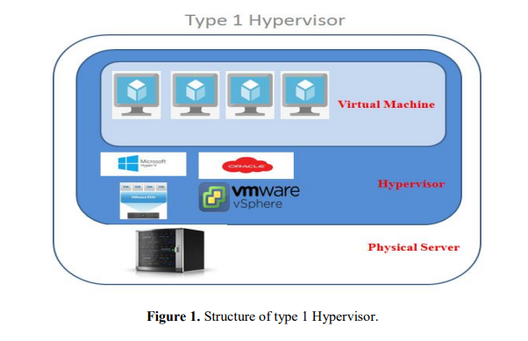
Figure 1. Structure of type 1 Hypervisor

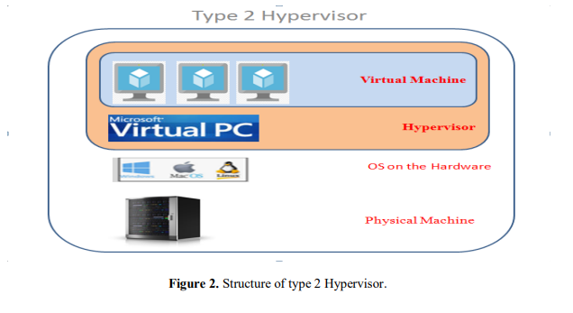
Figure 2. Structure of type 2 Hypervisor.

Appendix 2
Further detail from setting up Microsoft.
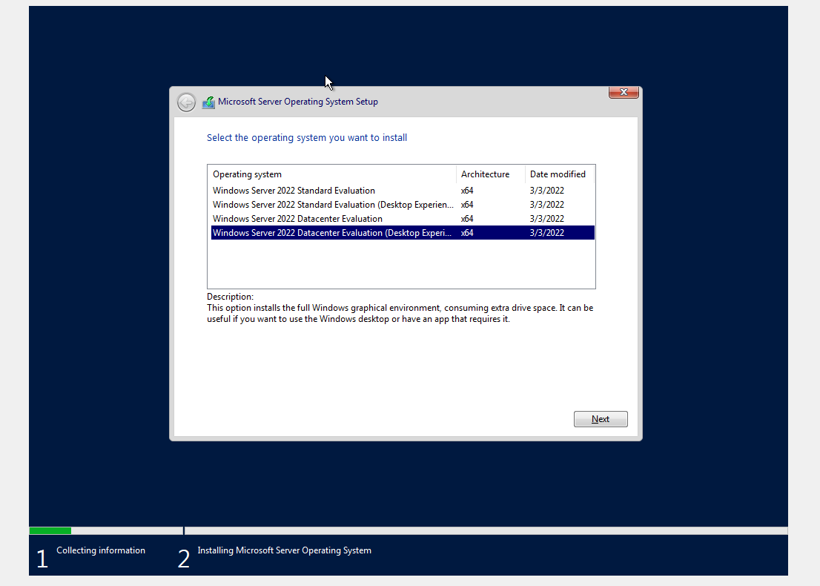

Set Debian server name
Evidence

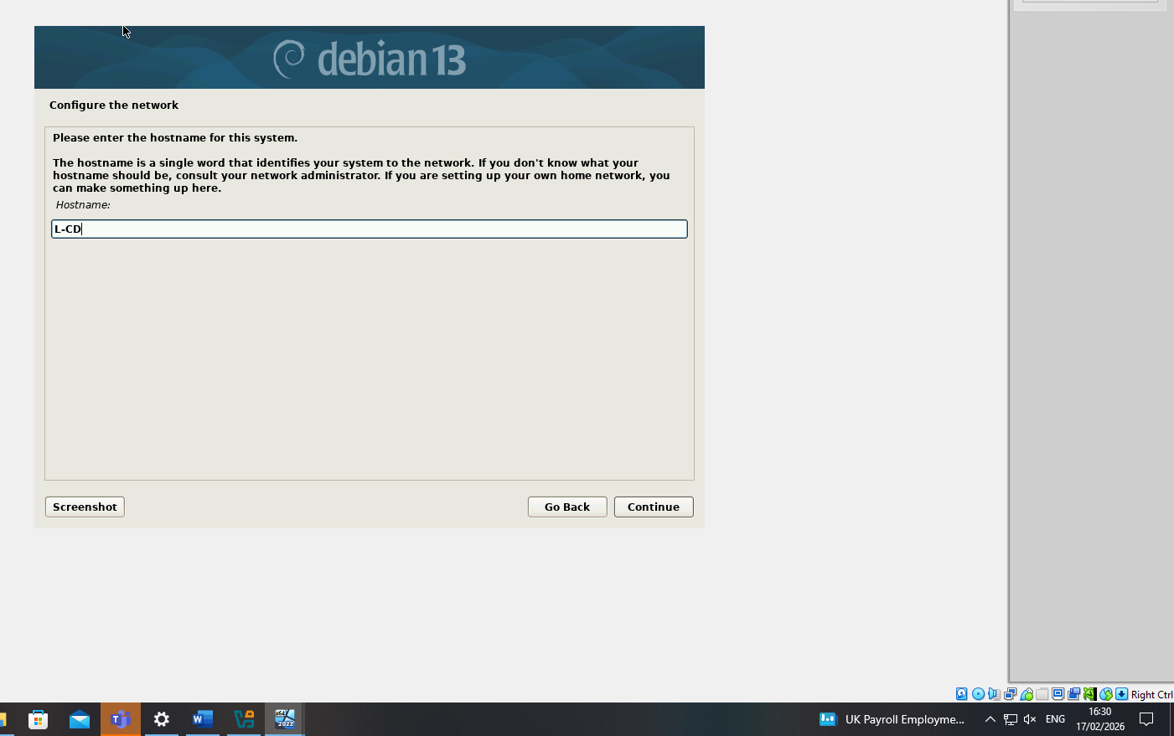

Debian Client Set up
Evidence

