

No

Programme: | MSc Public Health and Social Care in Practice
Module name: | Population Health and Digital Health Promotion
Module code: | LCHS7009
Student Name: | Dhruv Satishbhai Soni
Student ID: | 2521762
Lecturer’s name : | Diola Bijlhout

Table of Contents
Blog 1- Critically discussion on the impact of an existing digital technology currently used for a digital health promotion intervention 3
References: 7
Blog 2- Critically discussion on the impact of a digital technology DESIGNED for a digital health promotion intervention 9
References: 12

Blog 1- Critically discussion on the impact of an existing digital technology currently used for a digital health promotion intervention
Title: Fostering Accessible Mental Healthcare using AI Chatbots

Public health problem and the concerning factor:
Across the UK, one of the critical and common public health problems comprises mental health distress, which develops disparities within the nervous system, personality, behaviour, overall human well-being, and fosters suicidal tendencies with extreme anxiety and depression (Mind, 2026). Specifically, among young adults aged 16 to 24 years olds, one in five, almost 20.2%, experience common mental health conditions (NHS England Digital, 2025).
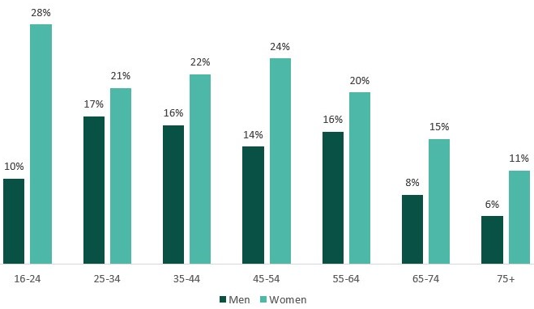
Figure 1: Diagnosed CMD experienced
(Source: Education Policy Institute, 2026)

Chosen Digital technology description and its usage in health promotion:
AI Chatbots track sensual behaviours and deliver technologically empathetic conversations with profound coping strategies, which can be used to control anxiety and complex emotions (Olawade et al., 2024). Under AI chatbots, digital support apps, like Limbic Access, launched by Dr. Ross Harper, and Wysa, launched by Jo Aggarwal and Ramakant Venpati, fulfill the need for therapists and help people gain deep personal insight and awareness through understanding their own behaviours (Medical Device Network, 2026; Wysa, 2026).

Evidence of impact:
The impact of using AI chatbots like Limbic Access and Wysa aligns with Cognitive Behavioural Theory. As a clinical AI solution, Limbic Access has been widely used by over 650,000 patients throughout 66% of the Integrated Care Boards of NHS England (Open Access Government, 2026). Overall a 50% reduction in assessment has been achieved (Limbic, 2026). Alternatively, Wysa has supported 36,000 patients. Based on current research majority of adults within the UK is seeking metal support from an AI chatbot, which increases psychological stability as a virtual therapist (Healthcare Management, 2025).
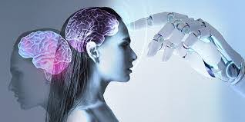
Critical evaluation of advantage and shortfall of the impact of digital technology:
Advantages
AI Chatbots like Limbic Access and Wysa have been used widely, and it provides immediate therapeutic solutions with 24/7 accessibility through which one can process cognitive behavioural therapy exercises and gain control over mind and nervous system (IBM, 2026). These chatbots offer private and comfortable spaces for the users and help them to process emotions freely with a balancing coping mechanism (Mental Health UK, 2026).
Disadvantages
The major disadvantage includes multiple technological disruptions and repetitive outcomes, where sometimes these AI supporters fail to acknowledge users’ severe suicidal tendencies and also often provide improper judgments, triggering harmful decisions that could affect someone’s life (Demir et al., 2026).

Recommendation for mitigating the shortfall:
Developing more prominent inspections, cultivating AI literacy, and mainly raising awareness of where AI chatbots can be used as supporting adjuncts instead of replacing professional assistance. Additionally, ensuring clear transparency and programming hardcoded formation, these AI platforms can produce explicit advice with mentioning limitations (Coghlan et al., 2023). However, AI Chatbots only provide mandated reporting with destigmatised support; they do not process human empathy, and heavily depending on them can cause severe damage and false emotional affection.

References:
Coghlan, S., Leins, K., Sheldrick, S., Cheong, M., Gooding, P. and D'Alfonso, S. (2023) ‘To chat or bot to chat: Ethical issues with using chatbots in mental health’, Digital health, 9, p.20552076231183542. Available at: https://doi.org/10.1177/2055207623118354
Demir, M., Aydoğdu, F., Alabay, M.B., Yaşar, H.K. and Bozkurt, A. (2026) ‘More than an algorithm: mental health professionals confront the promise and ethical perils of artificial intelligence’, Universal Access in the Information Society, 25(1), p.24. Available at: https://doi.org/10.1007/s10209-025-01297-1
Education Policy Institute (2026) Prevalence of mental health issues within the student-aged population. Available at: https://epi.org.uk/publications-and-research/prevalence-of-mental-health-issues-within-the-student-aged-population/
IBM (2026) Unlocking the power of chatbots: Key benefits for businesses and customers. Available at: https://www.ibm.com/think/insights/unlocking-the-power-of-chatbots-key-benefits-for-businesses-and-customers
Limbic (2026) The clinical AI assistant for referral and assessment. Available at: https://limbic.ai/access
Medical Device Network (2026) Talk to the bot: AI assistant marks breakthrough for UK mental health. AVialablet at: https://www.medicaldevice-network.com/interviews/talk-to-the-bot-ai-assistant-certification-marks-breakthrough-for-uk-mental-health/
Mental Health UK (2026) Artificial Intelligence and mental health. Available at: https://mentalhealth-uk.org/help-and-information/health-and-wellbeing/artificial-intelligence-and-mental-health/
Mind (2026) Mental health facts and statistics. Available at: https://www.mind.org.uk/information-support/a-z-mental-health/mental-health-facts-and-statistics/
NHS England Digital (2025) Adult Psychiatric Morbidity Survey: Survey of Mental Health and Wellbeing, England, 2023/4. Available at: https://digital.nhs.uk/data-and-information/publications/statistical/adult-psychiatric-morbidity-survey/survey-of-mental-health-and-wellbeing-england-2023-24/common-mental-health-conditions
Olawade, D.B., Wada, O.Z., Odetayo, A., David-Olawade, A.C., Asaolu, F. and Eberhardt, J., (2024) ‘Enhancing mental health with Artificial Intelligence: Current trends and future prospects’, Journal of medicine, surgery, and public health, 3, p.100099. Available at: https://doi.org/10.1016/j.glmedi.2024.100099
Open Access Government (2026) Limbic: Clinical AI for mental health. Available at: https://www.openaccessgovernment.org/stakeholder/limbic-limited-clinical-ai-for-mental-health/206852/
Wysa (2026) NHS TALKING THERAPIES Digital support across the whole NHS TT pathway. Available at: https://www.wysa.com/nhs-talking-therapies

Blog 2- Critically discussion on the impact of a digital technology DESIGNED for a digital health promotion intervention
Title: Designing AI based solution for the wellness of mental health
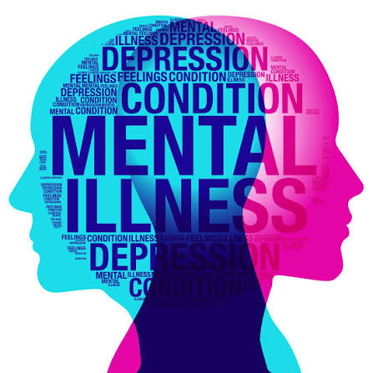
Public health problem and its concerning factors:
In the modern world, recognising mental health alongside emotional disturbance directs the way for survival continuation. Digital reliance, hyperstress, and financial constraints have been escalating conditions like chronic depression, anxiety, and many more (Menefee et al., 2022). Throughout the UK, one in five adults suffers from common mental health disorders. Notably, the rate stays higher for women, at almost 24.2%, and 15.4% include men (Centre for Mental Health, 2025).
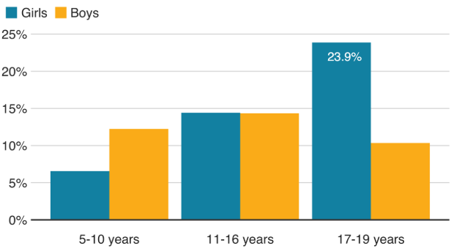
Figure 1: Mental disorders by age
(Source: Guibourg and Jeavans, 2018)
Digital Technology in health promotion:
Following the shortfalls of Limbic Access, like risk of misleading, repetitive outcomes, and technological barriers, a refined version of the AI chatbot has been proposed. This version will launch an in-depth layer of processing with prominent hard-code, voice detection analysis, expression recognition, and immediate backup setups, which will not only provide mental assistance but also secure stages according to the behaviours and detect a way out of it. AI chatbots serve as a supplementary tool against person-centred empathetic support, tracking users by assisting their mental conditions with profound coping strategies that can foster emotional stability (Casu et al, 2024; Denecke et al., 2021).

Evidence of impact:
The Biopsychosocial model, combining Biological, Psychological, and Social elements aligns with the impact of the modified version of Limbic Access (Lumen Learning, 2026). The implementation of prominent hardcode will ensure users’ psychological stability through providing authentic care without any repetition of the outcomes (Feng et al., 2025). With voice detection analysis and expression recognition, this version can detect biological and emotional stress by examining the user's vocal pitch, facial articulation, and brain mechanisms (Sharma et al., 2025). Further, by implementing red alert to indicate severe mental illness with profound suicidal tendency, the societal fulfilment will be done.
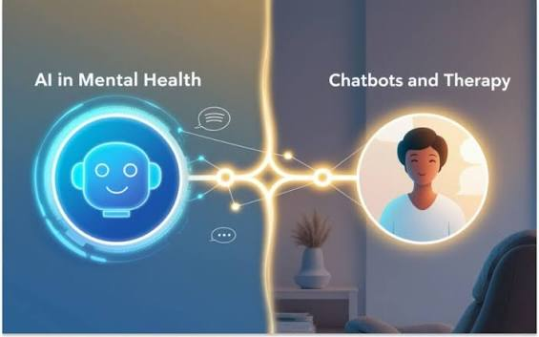
The advantages and disadvantages of the impact of digital technology:
Advantages
The improved version will not duplicate or repeat any results for individuals. It will first gather information through conversing with the users and then suggest details behind their stress alongside profitable solutions (Nyakhar and Wang, 2025). Besides, this version’s immediate backup setup will secure users with severe mental health disorders, especially those that cannot be solved using chatbots, by processing an alarming system that will connect local users to prevent any kind of suicidal attempt.
Disadvantages
The excessive use of the AI chatbot can increase the risk of hampering privacy, where users' confidential information can be retrieved by third parties (Dhaigude and Baishya, 2025). Additionally, as a highly functional AI-assistant conversational chatbot, it could drain mobile batteries faster than usual (Reddi, 2025).
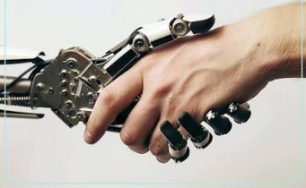
Recommendation for diminishing the shortfall:
AI chatbots with high coding formation can elevate strong technological infrastructure to avoid cyberattacks, where users can feel secure and protected to share their thoughts (Li, 2023). Using digital technology for promoting healthcare intervention can be helpful in certain ways; however, in severe cases, human resources contain major effectiveness to provide personalised care empathetically.

References:
Casu, M., Triscari, S., Battiato, S., Guarnera, L. and Caponnetto, P. (2024) ‘AI chatbots for mental health: A scoping review of effectiveness, feasibility, and applications’, Applied Sciences, 14(13), p.5889. Available at: https://doi.org/10.3390/app14135889
Centre for Mental Health (2025) The Big Mental Health Report 2025. Available at: https://www.centreformentalhealth.org.uk/publications/the-big-mental-health-report-2025/
Denecke, K., Abd-Alrazaq, A. and Househ, M. (2021) ‘Artificial intelligence for chatbots in mental health: opportunities and challenges’, Multiple perspectives on artificial intelligence in healthcare: Opportunities and challenges, pp.115-128. Available at: https://doi.org/10.1007/978-3-030-67303-1_10
Dhaigude, S.A. and Baishya, K. (2025) ‘December. The Dark Side of AI Chatbots: Ethics, Privacy and Responsible Data Usage in Digital Marketing’, In Proceedings of the 1st Engineering Data Analytics and Management Conference (EAMCON 2025), p. 211. Available at: https://books.google.co.in/books?hl=en&lr=&id=ckKlEQAAQBAJ&oi=fnd&pg=PA211&dq=how+ai+chatbots+can+damage+users+privacy&ots=NZsfWBwVwh&sig=iiR1PeRzlZCik2wGiKww7pqbo78&redir_esc=y#v=onepage&q=how%20ai%20chatbots%20can%20damage%20users%20privacy&f=true
Feng, X., Tian, L., Ho, G.W., Yorke, J. and Hui, V. (2025) ‘The effectiveness of AI chatbots in alleviating mental distress and promoting health behaviors among adolescents and young adults: Systematic review and meta-analysis’, Journal of Medical Internet Research, 27, p.e79850. Available at: https://doi.org/10.2196/79850
Guibourg, C. and Christine, J. (2028) In charts: Report into children's mental health. Available at: https://www.bbc.com/news/health-46306241
Li, J. (2023) ‘Security implications of AI chatbots in health care’, Journal of medical Internet research, 25, p.e47551. Available at: https://doi.org/10.2196/47551
Lumen Learning (2026) Biopsychosocial Model. Available at: https://courses.lumenlearning.com/suny-hvcc-healthpsychology/chapter/biopsychosocial-model/
Menefee, D.S., Ledoux, T. and Johnston, C.A. (2022) ‘The importance of emotional regulation in mental health’, American journal of lifestyle medicine, 16(1), pp.28-31. Available at: https://doi.org/10.1177/15598276211049771
Nyakhar, S. and Wang, H. (2025) ‘Effectiveness of artificial intelligence chatbots on mental health & well-being in college students: a rapid systematic review’, Frontiers in Psychiatry, 16, p.1621768. Available at: https://doi.org/10.3389/fpsyt.2025.1621768
Reddi, V.J. (2025) ‘Generative AI at the edge: challenges and opportunities: the next phase in AI deployment’, Queue, 23(2), pp.79-137. Available at: https://spawn-queue.acm.org/doi/pdf/10.1145/3733702
Sharma, S.K., Alutaibi, A.I., Khan, A.R., Tejani, G.G., Ahmad, F. and Mousavirad, S.J. (2025) ‘Early detection of mental health disorders using machine learning models using behavioral and voice data analysis’, Scientific Reports, 15(1), p.16518. Available at: https://doi.org/10.1038/s41598-025-00386-8

