Assignment 1 - Economics of sustainability
BMSP6007
Word count- 2,588
Due- 27th March

Alexandra Olivia Safadi

The steel industry in relation to the economics of sustainability
Introduction
This essay is based on the steel production industry in relation to the economics of sustainability. The essay will discuss the environmental problems that affect the steel industry, the industries successes and failures and the solutions implemented nationally and internationally to rectify the failures within the industry relating to economic models and evidence-based approaches.
The Steel industry
The steel industry is a global institution which creates products and raw materials. Steel contributed massively with the industrial revolution and even today the industry plays a huge role in the economic development of developed and developing regions. According to Greenspec statistics, The United States was once the biggest supplier of steel worldwide (GreenSpec, 2020).
Steel is omnipresent in its uses such as in the construction field, the health of the industry can provide useful information to predict and view overall global economic progress. When the steel industry is thriving with high demand and healthy statistics for its products, this can provide a positive indication for the global economy.
Steel was not originally marketed as a commodity however this changed at the beginning of the 21st century. According to Laukkonen, this affected the steel industry and its prices (Laukkonen, 2020).
The price of steel was predicted to rise due to competitors such as China having the power to affect the price of raw materials. According to professionals, although the price of steel globally had previously been predicted to remain weak for 2010 they began to increase for many specific metals for example, those used to build ships. This is due to Chinas effort to lower output in order to ensure that they meet the governments end-of-year energy saving goals. This is just one case study demonstrating how the steel industry can be affected by competitors and government strategies.
The diagram below illustrates how the steel industry would hypothetically be placed if there were no tendency for the price of steel to fluctuate. This is also described as being the time when market clearing price has been achieved. The market equilibrium can be seen on the diagram below, where the good supply meets the demand curve. In most cases such as the steel industry planned demand does not necessarily equal planned supply due to changing externalities. This is known as a state of disequilibrium as there is a surplus therefore industries have incentive to alter prices (Pettinger, 2020).
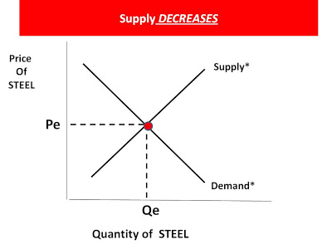 (HaywardeEcon, 2010)
Excess demand
Market equilibrium

The diagram below demonstrates China’s 2010 case studies effect on the supply and demand on the steel industry. The supply curve moves to the left (Supply 1) which demonstrates a decrease in supply due to the result of the Chinese action. At each price there will be less quantity compared to the original supply curve. Whilst the supply curve continues to move left, we move higher and to the left on the demand curve creating a new market equilibrium demonstrated on the graph as P1 and Q1. This will result in the quality being less and the market price increasing in comparison to what they once were, supporting the law of demand theory (Clark, 1917).
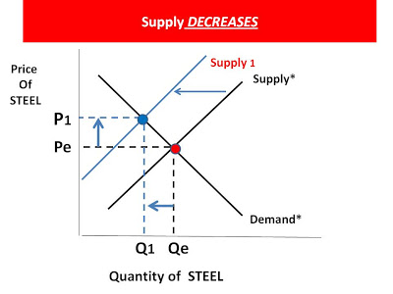
(HaywardeEcon, 2010)

Negative and positive externalities

Externalities can be explained as either negative or positive outcomes of economic activities on independent third parties (Vatn & Bromley, 1997).

Positive Externalities of the steel industry
Steel contributes to make multiple materials for industries worldwide and produces many advantages such as being the main source of material to be used to create climate durable cities, protection to coastal paths and the design contributes to decreasing impacts of natural disasters (Zeder, 2019).
Factors such as increased carbon dioxide emissions, over use of limited resources, and waste disposal issues are continuing to incline. However, steel could potentially contribute to the solution to these issues as steel is a valuable recyclable material as its waste energy and by-products are both valuable assets therefore contributes to the circular economy and therefore aids in contributing to maintaining a sustainable future (Stahel, 2016).
The industry has also contributed to reducing greenhouse gas emissions through adapting to using new technologies which improves energy efficiency. An example of a greener steel producer is a Korean company which developed a steelmaking method that releases 90 percent less toxic fumes (Int J Environ Res Public Health, 2010).
The steel industry creates jobs within society creating economic advantages, ‘360 000 individuals were directly employed in the sector in 2013’ (European Commission, 2020). Below is a diagram hypothetically demonstrating both the steel manufacturer and the construction company benefitting from each other.
This example can be hypothetically drawn on a diagram as seen below through contrasting social benefit and social cost on a supply and demand diagram. The diagram below demonstrates individual demand being equal to the social benefit as there are no externalities on the consumption side. Although, the social cost is lower than the individual supply because there is an external benefit that is not included in the individual supply curve. This results in the market equilibrium differentiating from the optimal market situation meaning that there is an undersupply of both steel and construction.

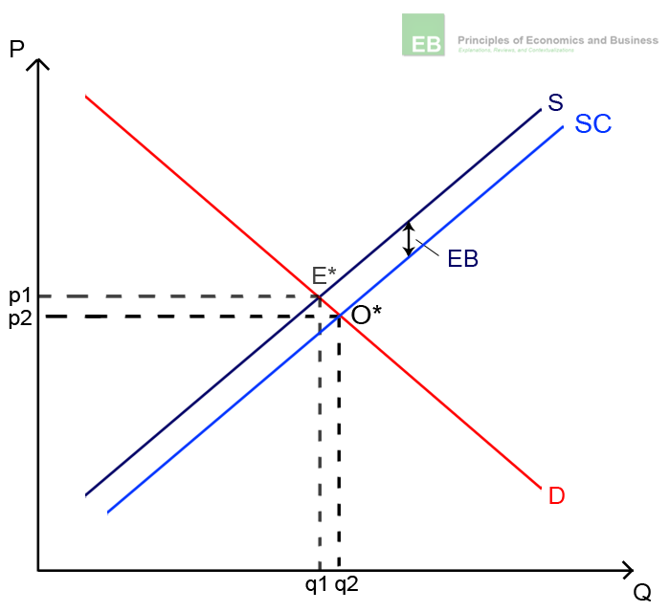
(HaywardeEcon, 2010)

Negative externalities
One of the main examples of a negative externality found within the steel industry involves negative production externalities.
Negative production externalities are negative effects produced during the production of steel. An example of this externality found within the steel industry involves the pollution.
The diagram below demonstrates the comparison between the social benefit and social cost. The social cost curve is situated higher than the supply curve and this can be hypothetically due to external costs that are not included in the steel industries supply decision. This results in the market equilibrium differentiating from the optimal market situation creating an oversupply of harmful behaviour. This diagram hypothetically illustrates that the optimal price of steel is higher than its market price.
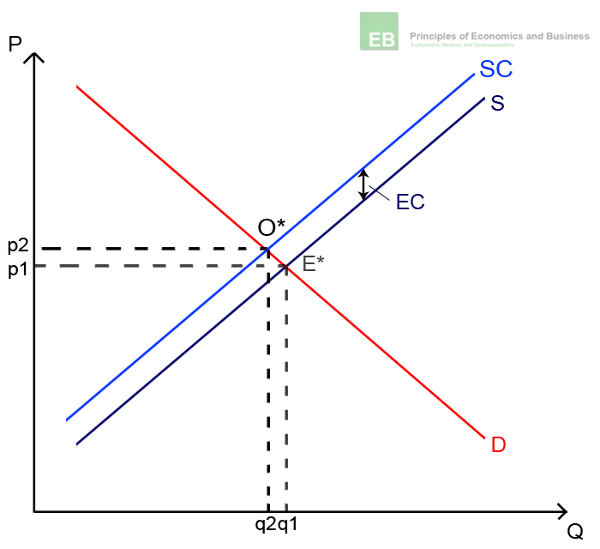
(HaywardeEcon, 2010)
Market failures
In market failure, a company’s behaviour leads to negative results for society (Chappelow, 2019).
The main factors associated with steel which affect the environment are discussed below (Bessemer, 1855).
Firstly, water is used to cool coke after it has finished baking and becomes contaminated with coke breezes and other compounds.
Secondly, climate change, Professionals state, ‘The making of steel from the mined iron ore is also highly energy demanding. Production of steel is the most energy-consuming and CO2 emitting industrial activity in the world’ (Zeder, 2019).
Steel production uses large amounts of coke which is extremely damaging to the environment. On average, 1.83 tons of CO2 is released in each ton of steel created making steel production a huge contributor to global warming adding over 3,3 million tons annually to global emissions (GreenSpec, 2020).
Another market failure of steel production involves Slag, the iron ore and toxins gathered at the top of the molten iron, this creates the biggest number of iron-making by-products.
According to GreenSpec the world produces huge quantities of steel, over 240 kilos of steel are produced for every person in the world annually (GreenSpec, 2020). This provides evidence that there is great demand for steel however as established, there are huge environmental failures caused from the impact of steel.
The world mines over 2,000 million tons of iron ore annually and 95% of that is used in steel production. Mining iron ore is extremely energy extensive and causes a high volume of pollution from equipment (Zeder, 2019).
Regulations and legislation are put in place to target these failing markets. An advantage of Legislation and regulations being implemented are that they provide a social control and a law that industries must follow. This will be more likely to create a change in tackling failures inside specific markets (Schmidt, 1977).

International and national solutions implemented to rectify failures within the market
According to the world steel association, partnership between government and the steel industry is vital in order to create and maintain a sustainable future. This can be done through assessing the market approach. The Market approach refers to incentive-based policy that encourages conservative practices or pollution reduction strategies such as legislations and regulations (World Steel Association, 2020).
To rectify failures within the steel industry stakeholders and the government must work together to overcome economic issues within the sector (Brunke, Johansson, & Thollander, 2014).
The steel industry is extremely energy intensive and CO2 intensive. However, the competitive industry allows large amounts of CO2 reduction. According to the OECD Council, “Attempts to price carbon implicitly or explicitly will have distributional consequences that may be contentious. It requires the determination and creativity of governments to find the right level of arbitrage between the economic efficiency and the political and social sustainability of climate policies” (World Steel Association, 2020). Around 30% of steel is traded internationally therefore it is vital that policies are put in place to ensure that all steel industries worldwide have equal opportunities and are not disadvantaged in relation to competing materials. However, for this movement to be successful in relation to consumer behaviour and the production of steel they need to ensure that steel products are not relocated. To guarantee the industry working fairly in relation to the financial and trade implementations throughout the value chain a consistent application of comprehensive market-based approach must be considered.
Regulations such as the CO2 Tax are placed to calculate emissions based on annual energy however adapting to a life cycle inventory approach may be more effective, an important tool for future environmental policy (HM government, 2020). James Mc Dermott states, ‘managed carbon price act is one of two most effective climate change measures’, the other one being ‘America’s Energy security trust fund act (2009)’ (Carbon Tax Center, 2020). The carbon tax centre estimated that the carbon tax levels mandated under the mcdermott bill would have reduced US CO2 emissions by 1/3 within a decade.
The eight-sector carbon tax model below demonstrates US Carbon emissions reduction using the Carbon Tax. The model captures the demand and supply responses to Carbon taxes and time lags in end-users reaction to the tax implemented higher prices (Carbon Tax Center, 2020).
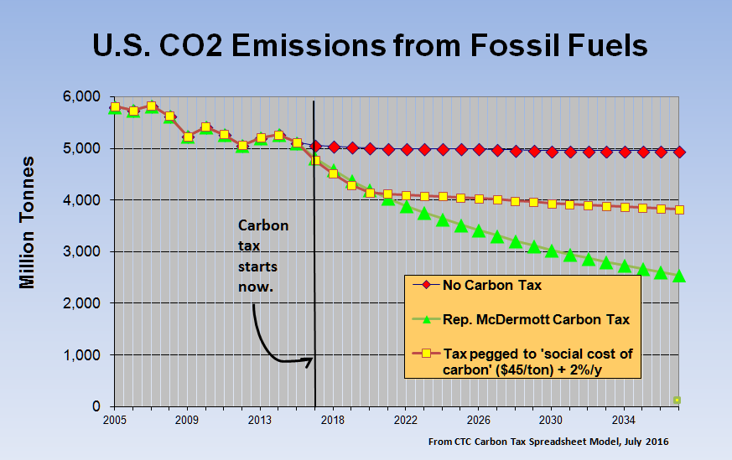 (CTC, 2016)
U.S. CO2 Emissions in relation to industry

It is also necessary for government policies to consider the life cycle of a product when creating regulations as this is the only way to calculate the impact of each stage of a products life to be addressed. Research shows that most regulations address production stages of a product whilst ignoring the full-cycle of an industry which results in less effective action (Milne, 2020).
Americas energy security trust fund act (2009) provides a solution to target climate issues. This strategy has positively attributed to reducing carbon and effects on climate change through viewing an industry in staggered stages which supports the idea of viewing an industries life-cycle approach in stages. The first-year tax rate = 15 dollars per ton of carbon dioxide. This rate increases to 10 dollars per ton per year. After five years this ‘increases further to 15 dollars per ton if US emissions stray from an EPA certified glide path to cut emissions from 80% from 2005 levels in 2050’. Using this act, emissions have been predicted to decrease 25% lower than 2005s statistics by 2022, providing evidence that this strategy could potentially be an effective way of tackling a major market failure (Komanoff, 2009).
An approach which considers a product or services life cycle involves the circular economy approach. Governments encourage this approach as benefits include factors such as encouragement of recycling of all materials and minimising waste. Prioritising the recycling of end of life steel will positively impact the market as well provide alternative to landfill (Stahel, The circular economy, 2016).
An effective way to approach market failures can be through a Pigouvian tax, named after the Cambridge Economist Arthur Cecil Pigou (1877–1959).
Pigou believed that placing a unit tax on harmful products could provide a useful way to establish an efficient equilibrium price that takes into consideration negative aspects on consumption such as through placing a carbon tax (Economics Online, 2020). Alternatively, many environmental regulations focus on banning principles. One case study of a country banning involves Sweden’s banning of solvent Trichloroethylene (TCE). Sweden passed the law in 1991 banning TCE in consumer products. Detailed statistics showed that use of TCE in Sweden reduced from 9000 tons to 3000 tons per year before the ban due to strong policies placed by Swedish authorities. This provides evidence that Pigouvian tax regulations could be a solution to tackle market failure. However, when the ban was placed, TCE was not completely stopped instead it dropped extremely slowly after 1992. Interviews revealed that corporations did not believe authorities could implement such drastic action and instead decided to fight against it (Sterner & Robinson, 2018).
The diagram below demonstrates reported marginal costs of abatement relating to a number of corporations. It is clear that the majority of corporations would have had incentive to voluntarily stop the use of TCE if there were a tax implementation.
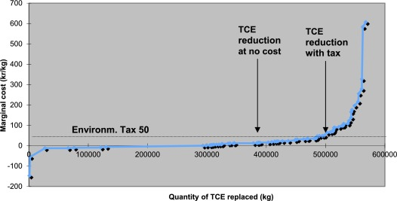 (Sterner & Robinson, 2018)
Through comparing the effectiveness of a ban on US Tax fees it is clear that a ban is not necessarily effective and a tax is easier to place as well as more effective to limit negative externlity and industry market failiure.
The diagram below represents the negative externality. The x-axis measures the output created by the industry and the y-axis represents monetary units. The marginal benefit curve hypothetically demonstrates the marginal advantages of the industry for each level of production which declines as the amount of output increases. The marginal private cost curve shows the marginal cost of the industry as output increases. The more the steel industry produces, the more it pollutes which creates increased negative effects. This is represented using the marginal damage curve. The marginal social cost shows the total marginal cost for society, and is found through adding together the social and private costs.
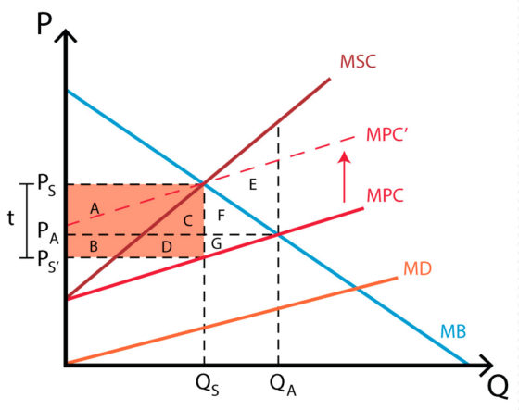
A Pigouvian tax could be placed as mentioned in Sweden’s case study to decrease negative externality as the ban is not affective. This tax would decrease the output produced to Q_{S}, and increase price to P_{S}, creating a socially efficient equilibrium. Consumer surplus decreases A+C+F, while producer surplus decreases by area B+D+G. Government will gain a tax revenue equal to area A+B+C+D as seen on the light red illustration on the diagram. The external factors will gain E+F+G. Therefore, the net effect is E: -(A+C+F)-(B+D+G)+(A+B+C+D)+(E+F+G)=E
Demonstrating that negative impacts of an externality can decrease using this tax supporting findings from the Swedish case study above (Policonomics, 2020).
To conclude
The steel industry creates both positive and negative externalities. The negative externalities often lead to market failures such as the large amount of pollution the industry creates. Market failures can be addressed through solutions however positive movement within the steel industry will be extremely difficult to implement unless strategies are mandatory through government regulations. As the world markets become more complex and our understanding more thorough, solutions are offered to balance inequalities within society. However unfortunately industries aren’t likely to adapt new strategies unless it affects them personally and unless industries are penalised for their harmful behaviour. Evidence suggests that banning is not necessarily effective and setting a Pigouvian tax could potentially be the strategy moving forwards as this tax limits negative impact through penalising bad behaviour with a tax system which may be more effective in creating change by increasing the cost of action such as the carbon tax implementation,which in turn creating a healthier economy and environment (Astriddare, 2012).

References

Astriddare. (2012, February 17). Pigovian Taxation as a Means of Reducing Carbon Emissions . Retrieved from Astriddare: https://astriddare.wordpress.com/2011/04/05/pigovian-taxes/
Bessemer, H. (1855). Bessemer Process. Retrieved from American Histograma: http://www.american-historama.org/1850-1860-secession-era/bessemer-process.htm
Brunke, J.-C., Johansson, M., & Thollander, P. (2014). Empirical investigation of barriers and drivers to the adoption of energy conservation measures, energy management practices and energy services in the Swedish iron and steel industry. Cleaner Production, 509-525.
Carbon Tax Center. (2020). Estimated CO2 Reductions from a Briskly Rising Carbon Tax. Retrieved from Carbon Tax Center: https://www.carbontax.org/carbon-tax-effectiveness/
Chappelow, J. (2019, July 30). Market failure. Retrieved from Investopedia: https://www.investopedia.com/terms/m/marketfailure.asp
Clark, J. M. (1917). Political Economy. Journal of Political Economy, 217- 235.
CTC. (2016, July). Carbon Tax Spreadsheet model. Retrieved from CTC.
Economics Online. (2020). Pigouvian tax. Retrieved from Economics Online: https://www.economicsonline.co.uk/Definitions/Pigouvian_taxes.html
European Commission. (2020). Energy Efficiency and CO2 Reduction in the Iron and Steel Industry. Retrieved from European Commission : https://setis.ec.europa.eu/system/files/Technology_Information_Sheet_Energy_Efficiency_and_CO2_Reduction_in_the_Iron_and_Steel_Industry.pdf
GreenSpec. (2020). Steel production & environmental impact. Retrieved from GreenSpec: http://www.greenspec.co.uk/building-design/steel-products-and-environmental-impact/
HaywardeEcon. (2010, September 21). Price of Steel rises---Can't be China's fault, can it? Dang it! It is...see nifty graphs illustrating this change!! . Retrieved from HaywardeEcon: http://haywardeconblog.blogspot.com/2010/09/price-of-steel-rises-cant-be-chinas.html
HM government. (2020). Sustainable construction legislation, regulation and drivers. Retrieved from SteelConstruction: https://www.steelconstruction.info/Sustainable_construction_legislation,_regulation_and_drivers
Int J Environ Res Public Health. (2010, January 18). Environmental Remediation and Conversion of Carbon Dioxide (CO2) into Useful Green Products by Accelerated Carbonation Technology. Retrieved from PMC: https://www.ncbi.nlm.nih.gov/pmc/articles/PMC2819785/
Komanoff, C. (2009, March 6). New Larson Bill Raises the Bar for Congressional Climate Action. Retrieved from Carbon Tax Center: https://www.carbontax.org/blog/2009/03/06/new-larson-bill-raises-the-bar-for-congressional-climate-action/
Laukkonen, J. (2020, March 7). What is the Steel Industry?
Milne, C. (2020). Ask Full Fact: British steel and EU rules. Retrieved from Full Fact: https://fullfact.org/economy/ask-full-fact-british-steel-and-eu-rules/
Pettinger, T. (2020). Market equilibrium. Retrieved from Economics Help: https://www.economicshelp.org/microessays/equilibrium/market-equilibrium/
Policonomics. (2020). Pigouvian tax. Retrieved from Policonomics: https://policonomics.com/pigouvian-tax/
Schmidt, D. H. (1977). Advantages and disadvantages of an integrated market compared with a fragmented market. Brussels: University of Hamburg .
Stahel, W. R. (2016, March). The circular economy. Retrieved from Nature: https://www.nature.com/news/the-circular-economy-1.19594
Stahel, W. R. (2016, March 23). The circular economy. Retrieved from Nature: https://www.nature.com/news/the-circular-economy-1.19594
Sterner, T., & Robinson, J. E. (2018). Pigouvian Tax. Retrieved from Science Direct: https://www.sciencedirect.com/topics/economics-econometrics-and-finance/pigouvian-tax
Vatn, A., & Bromley, D. W. (1997, March). Externalities — A market model failure. Environmental and Resource Economics, pp. 135-151.
World Steel Association. (2020). Steel's contribution to a low carbon future. Retrieved from World Steel Association : https://www.worldsteel.org/publications/position-papers/steel-s-contribution-to-a-low-carbon-future.h
Zeder, R. (2019, June 14). Positive Externalities vs Negative Externalities. Retrieved from Quickonomics: https://quickonomics.com/positive-externalities-vs-negative-externalities/

