IONELA VLAD- 1905718
FOREIGN LANGUAGES& CULTURAL AWARNESS
INTERCONTINENTAL HOTEL BUCHAREST- INFORMATION BOARD
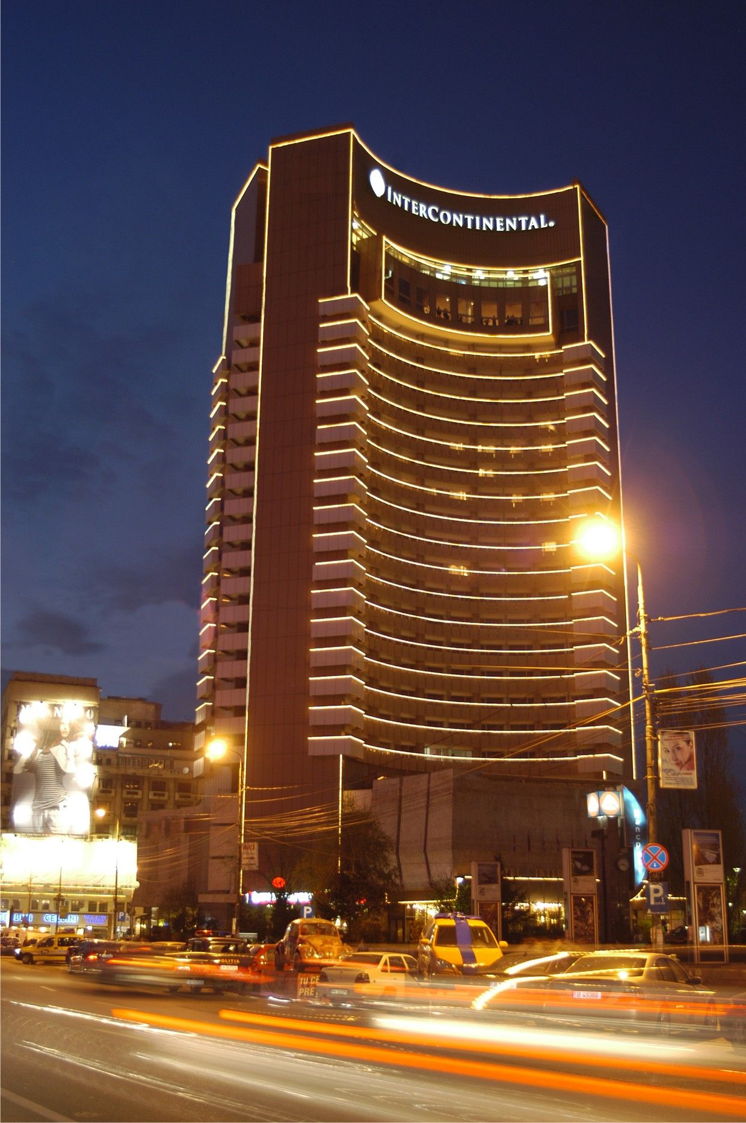

INFORMATION BOARD
-PRCES-
Double room  雙人間 | £120
Superior twin room  高級雙床間 | £125
Double deluxe room  雙人豪華間 | £158
Double room club  雙人房俱樂部 | £180
One-bedroom suite  一臥室套房 | £263

