Samina Sultana
Student No. 1912524

BSc Health and Social Care
Living with Care:
The Older Person
BMHP6009_BIRM

Assignment 1 Part 1: Poster
Lecturer: Joanne Davies

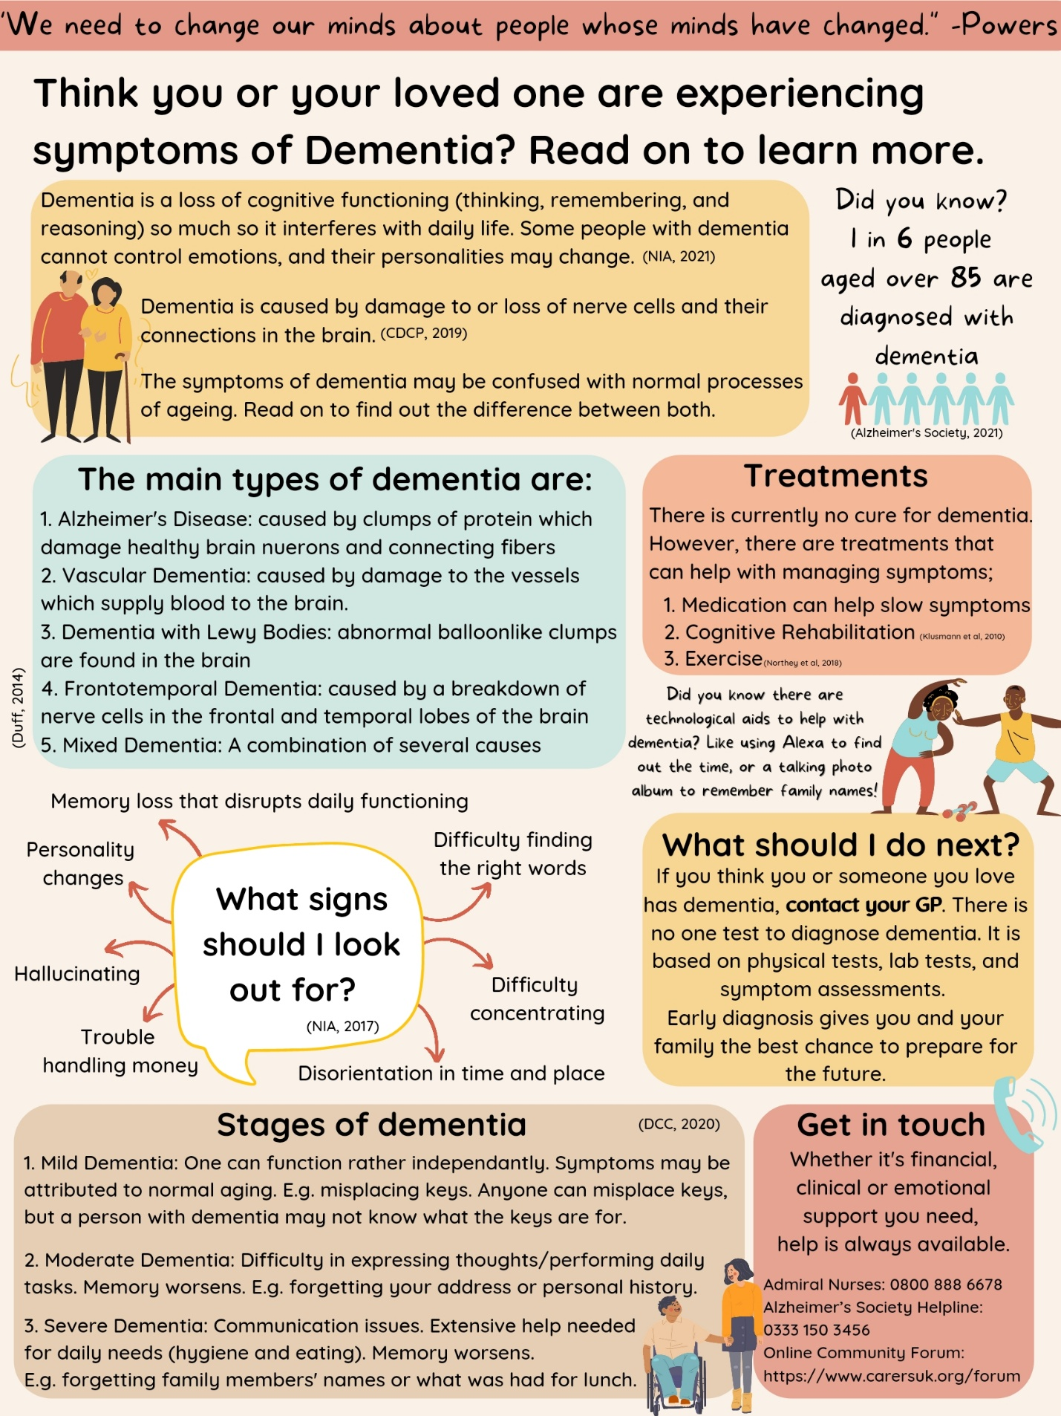

References:
- Alzheimer’s Society. (2020). Alzheimer’s Society’s view on assistive technology. Available at: https://www.alzheimers.org.uk/about-us/policy-and-influencing/what-we-think/assistive-technology (Accessed: 3 February 2022)

- Alzheimer’s Society. (2021). What is Dementia? Available at: https://www.alzheimers.org.uk/about-dementia/types-dementia/what-is-dementia (Accessed: 21 February 2022)

- Baharudin, AD., Din, C., Subramaniam, P., Razali R. (2019). The associations between behavioral-psychological symptoms of dementia (BPSD) and coping strategy, burden of care and personality style among low-income caregivers of patients with dementia. BMC Public Health, 19(4):447.

- Barnett, E. (2000). Including the person with dementia in designing and delivering care. London: Jessica Kingsley Publishers Ltd.

- Birren, J. E., & Schroots, J. J. F. (2001). History of gero-psychology. Handbook of the psychology of aging. San Diego: Academic Press.

- Care Quality Commission. (2018). Mental Health Act: The rise in the use of the MHA to detain people in England. Available at: https://www.cqc.org.uk/sites/default/files/20200206_mhareport1819_report.pdf (Accessed: 6 March 2022)

- Centers for Disease Control and Prevention. (CDCP). (2019). What is Dementia? Available at: https://www.cdc.gov/aging/dementia/index.html (Accessed: 20 February 2022)

- Chertkow, H., Feldman, H., Jacova, C. (2013). Definitions of dementia and predementia states in Alzheimer’s disease and vascular cognitive impairment: consensus from the Canadian conference on diagnosis of dementia. Alzheimers Research Therapy.

- Chiu, M., Chen, Ta-Fu., Yip, Ping-Kueng. (2006). Behavioural and psychological symptoms in different types of dementia. Journal of the Formosan Medical Association, 105(7), pp 556-562.

- Dementia Care Central. (DCC). (2020). Stages of Alzheimer’s & Dementia: Durations & Scales Used to Measure Progression (GDS, FAST &CDR). Available at: https://www.dementiacarecentral.com/aboutdementia/facts/stages/amp/ (Accessed:19 February 2022)

- Department of Health. (2015). Policy paper: 2010 to 2015 Government policy: dementia. Available at: https://www.gov.uk/government/publications/2010-to-2015-government-policy-dementia/2010-to-2015-government-policy-dementia (Accessed:2 March 2022)

- Duff, K. (2014). Mild cognitive impairment and dementia: Definitions, Diagnosis and Treatment. Oxford University Press. Archives of Clinical Neuropsychology, 29(7), pp. 691-692.

- Havighurst, R. J., & Albrecht, R. (1953). Older people. Oxford, England: Longmans, Green.

- Havighurst, R. J., Neugarten, B. L., & Tobin, S. S. (1968). Disengagement and patterns of aging: Middle age and aging. Chicago: University of Chicago Press.

- Feil, DG., MacLean C., Sultzer, D. Quality indicators for the care of dementia in vulnerable elders. J Am Geriatric Society. 55(2), pp. 293–301.

- Kamiya, M., Sakurai, T., Ogama, N., Maki, Y., Toba K. (2014). Factors associated with increased caregivers' burden in several cognitive stages of Alzheimer’s disease. Geriatr Gerontol Int, 14(2), pp. 45–55.

- Karon, S.L., Gould, E., Hughes, S.J., Piersol, C.V., Maier, J., Leopold, J., & Wiener, J.M. (2015). Training family caregivers on skills for behavioral symptoms. Administration on Aging, Administration for Community Living.

- Klusmann, V., Evers, A., Schwarzwald, R. (2010). Complex mental and physical activity in older women and cognitive performance: a 6-month randomised controlled trial. Gerontol A Biology Sci Med Sci. 65(6), pp. 680-8

- Lethin, C., Leino-Kilpi, H., Bleijlevens, MH., Stephan, A., Martin, MS., Nilsson, K. (2020). Predicting caregiver burden in informal caregivers caring for persons with dementia living at home: a follow-up cohort study. Dementia, 19(3), pp. 640–60

- Longino, C. F., & Kart, C. S. (1982). Explicating activity theory: A formal replication. Journal of Gerontology, 35, 713–722.

- Matthews, E., Farrell, G., Blackmore, A. (1996). Effects of an environmental manipulation emphasizing client-centred care on agitation and sleep in dementia sufferers in a nursing home. J Adv Nurs, 24:439-47.

- Mental Health Act. (2007). Available at: https://www.legislation.gov.uk/ukpga/2007/12/contents (Accessed: 6 March 2022)

- Muangpaisan, W. (2007). Clinical differences among four common dementia syndromes. Geriatr Aging, 10(425):9.

- National Institute of Ageing. (NIA). (2021). What is Dementia? Symptoms, Types and Diagnosis. Available at: https://www.nia.nih.gov/health/what-is-dementia (Accessed: 21 February 2022)

- National Institute on Aging (NIA). (2017). About Alzheimer's disease: Symptoms. Available at https://www.nia.nih.gov/alzheimers/topics/symptoms (Accessed:18 February 2022)

- NHS. (2021). Activities for Dementia. Available at: https://www.nhs.uk/conditions/dementia/activities/ (Accessed: 6 March 2022)

- Northey, M., Cherbuin, N., Pumpa, K., Smee DJ. (2018). Exercise interventions for cognitive function in adults older than 50: a systematic review with meta-analysis. Br J Sports Med.

- Powers, A. (2014). Dementia beyond disease: Enhancing Well-being. New York: Health Professional Press.

- Sabat, S., Fath, H., Moghaddam, F. (1999). The maintenance of self-esteem: lessons from the culture of Alzheimer’s sufferers. Culture and Psychology, 5:5-31.

- Schroots, J. J. F. (1996). Theoretical developments in the psychology of aging. Gerontologist, 36, pp. 742–748.

