

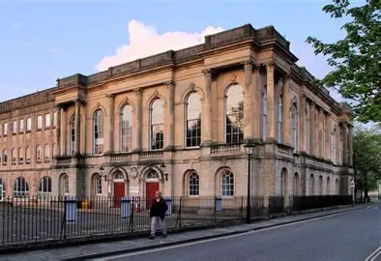
Figure 1: Dylan Thomas Centre, Somerset Place

Research proposal: Condition Survey and Maintenance Strategy
Module code: ACBA 7000
Name: Inderdeep Singh Sidhu
Student number: 2119841
Deadline date: 13/05/2026
Contents
Part 1 4
Summary 4
1. Introduction 5
2. Causes of Deterioration 5
3. Methodology 5
3.1 Desktop Study 5
3.2 Onsite Survey (Visual Only) & Asbestos Considerations 6
3.3 Alignment with Standards 7
4. Survey Conditions 7
5. About the Property 7
5.1 Dating the Building 7
5.2 Construction 7
6. Survey Findings 8
6.1 Roof – Condition Rating: C 8
6.2 Rainwater Goods – Condition Rating: C 8
6.3 External Walls – Condition Rating: C 10
6.4 Windows and Doors – Condition Rating: C 15
6.5 Internal Walls – Condition Rating: C 21
6.6 Services – Condition Rating: B 22
6.7 Courtyard 25
7. Conclusion 27
Part 2 27
Summary 27
1. Asset Management Systems and Frameworks 27
1.1 People – Roles, Responsibilities, Accountability, Competency 28
1.2 Process 29
1.3 Software – CMMS, BMS, CAFM, GIS 30
1.4 Data – Quality, Accuracy, Validity, Completeness, Uniqueness 30
2. SFG20 and CAFM Systems 30
3. Maintenance Strategies – With Critical Justification 30
4. Statutory Compliance Baseline 30
5. PPM Schedule – Based on SFG20 31
6. Operational Management References 31
7. Business Strategy and Asset Management 31
8. Conclusion 32
9. Appendix 32
Appendixes A – Causes of deterioration 32
Appendixes B - Alignment with standards 33
Appendixes C – Survey conditions 33
Appendixes D – Dating the building 34
Appendixes E – Construction 34
Appendixes F - Software – CMMS, BMS, CAFM, GIS 34
Appendixes G – Data – Quality, Accuracy, Validity, Completeness, Uniqueness 35
Appendixes H - SFG20 and CAFM Systems 36
Appendixes I – Operational Management References 36
References 36

Part 1

Summary
This condition survey assesses the Dylan Thomas Centre, a Grade II* listed building located on Somerset Place in Swansea’s Maritime Quarter. Prior to the site visit, I undertook a detailed desktop study, reviewing historic maps, local authority records, and archival photographs. This is not simply good practice, it is the correct and essential starting point for any building survey (RICS, 2019). A surveyor cannot diagnose defects accurately without first understanding the building’s age, original construction, and the changes it has undergone over time. The building’s history, materials, and environmental context all shape the way it behaves today.

The building dates from 1829 and is designed in the neo classical style. Knowing this immediately tells us a great deal: solid masonry walls, lime mortar, timber sash windows, natural ventilation, no cavity, and no insulation. These features are not defects, but they are simply characteristics of traditional construction. However, modern expectations such as warm interiors, airtightness, energy efficiency can often clash with the way historic buildings were originally designed to function. That tension underpins many of the issues observed.

The survey identified typical coastal deterioration such as moisture ingress, masonry decay and timber rot. Yet the more important question is not simply “what is damaged?” but “why was this not prevented?”. The evidence points to a lack of planned preventative maintenance (PPM) and an over reliance on reactive repairs. This is a systemic issue rather than a technical one. The building is fundamentally robust, but the maintenance regime is not.

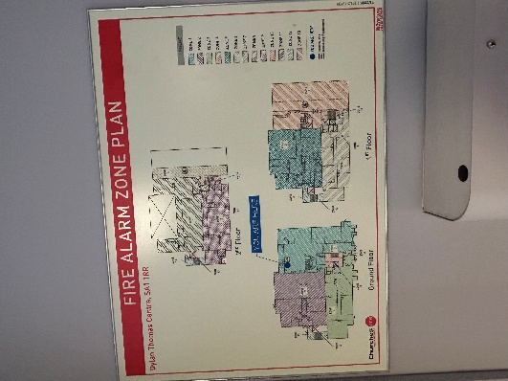
Figure 2: Fire alarm floor plan

1. Introduction
The Dylan Thomas Centre stands prominently on Somerset Place in Swansea’s Maritime Quarter. As a Grade II* listed building, it holds particular architectural and historical significance. Originally completed in 1829 as Swansea’s town hall, it was designed by John Collingwood and constructed by Thomas Bowen. A major remodelling took place in 1852 under Thomas Taylor, who drew inspiration from the Temple of Jupiter Stator in Rome which is a detail that reflects the building’s classical proportions and stylistic influences.

Understanding how we know these facts is important. The desktop study confirmed the construction date and architectural lineage. Knowing the architectural era is essential for correct diagnosis. Although the building predates the Victorian period, the principles of building pathology remain the same. A late Georgian/early Regency building typically features solid masonry walls, slate roofs, cast iron rainwater goods, and timber sash windows. These materials behave differently from modern ones. For example, lime mortar is vapour permeable, allowing moisture to move through the structure, whereas modern cement mortars trap moisture. Understanding these distinctions is fundamental to interpreting defects (Brunskill, 2000; Alford, 2019).

2. Causes of Deterioration
Refer to Appendixes A

3. Methodology

3.1 Desktop Study
In addition to the formal historical research, I carried out a practical desktop study using contemporary digital sources and first hand staff insight. This approach is increasingly common in building pathology, as it allows the surveyor to build an informed picture of the building’s current condition, operational context and maintenance history before arriving on site.

My preparatory work included the following:
- Online Research on the Dylan Thomas Centre Website: The official website provided up to date information on the building’s current use, public access arrangements and recent refurbishment activities. Although not a technical source, it helped establish how the building is occupied on a daily basis, which is relevant when assessing wear patterns, high traffic areas and the likelihood of user related defects.
- Discussions with Current and Former Caretakers: Speaking to caretakers who have worked in the building, both currently and in previous years offered valuable insight into recurring issues, past repairs and areas that have historically required attention. Caretakers often hold practical knowledge that is not recorded in formal documentation, such as which windows regularly leak, which doors swell seasonally or where services have been altered informally over time. This type of anecdotal evidence is widely recognised as a useful supplement to technical data in building pathology practice.
- Google Maps and Street View Review: Satellite imagery and street view were used to examine the building’s external elevations, roofscape and surrounding environment. This helped identify exposure risks, drainage patterns and the condition of external elements that are visible from public viewpoints. It also allowed a preliminary assessment of the western elevation, which is more exposed to prevailing winds and therefore more susceptible to moisture related defects.
- Online Image Searches and Publicly Available Photographs: Reviewing publicly available images helped confirm the appearance of the building over time and identify any visible changes to the façade, windows or roof coverings. These images also provided a reference point for comparing past and present conditions during the onsite survey.
- Swansea Council Planning Portal: A review of the planning portal provided information on past applications, refurbishment works, and any statutory constraints linked to the building’s Grade II listing. This was essential for understanding which elements of the building fabric are original, which have been altered, and where previous interventions may influence current defects.

3.2 Onsite Survey (Visual Only) & Asbestos Considerations
The onsite inspection took place recently. Due to the academic nature of this exercise and the lack of specialist equipment, the survey was visual only. No intrusive investigations were carried out.

Asbestos Considerations: In professional practice, an asbestos management survey is required to identify and assess asbestos containing materials (ACMs). I did not have access to an asbestos register for the Dylan Thomas Centre, nor did I conduct sampling. Given the building’s age and later refurbishments, asbestos is likely in:
- pipe insulation
- textured coatings (e.g. Artex)
- floor tiles
- roofing felts
- gaskets

Because the presence of asbestos could not be confirmed or ruled out, I adopted a strict hands off approach, avoiding disturbance of any suspect materials. This aligns with the Control of Asbestos Regulations (HSE, 2012).

Other Limitations
I did not have access to:
- a damp meter
- thermal imaging equipment
- a borescope
- high level access equipment
As a result, the roof and high level gutters were assessed from ground level only. This is a significant limitation (RICS, 2019).

3.3 Alignment with Standards
Refer to Appendixes B

4. Survey Conditions
Refer to Appendixes C

5. About the Property

5.1 Dating the Building
Refer to Appendixes D

5.2 Construction
Refer to Appendixes E

6. Survey Findings

6.1 Roof – Condition Rating: C
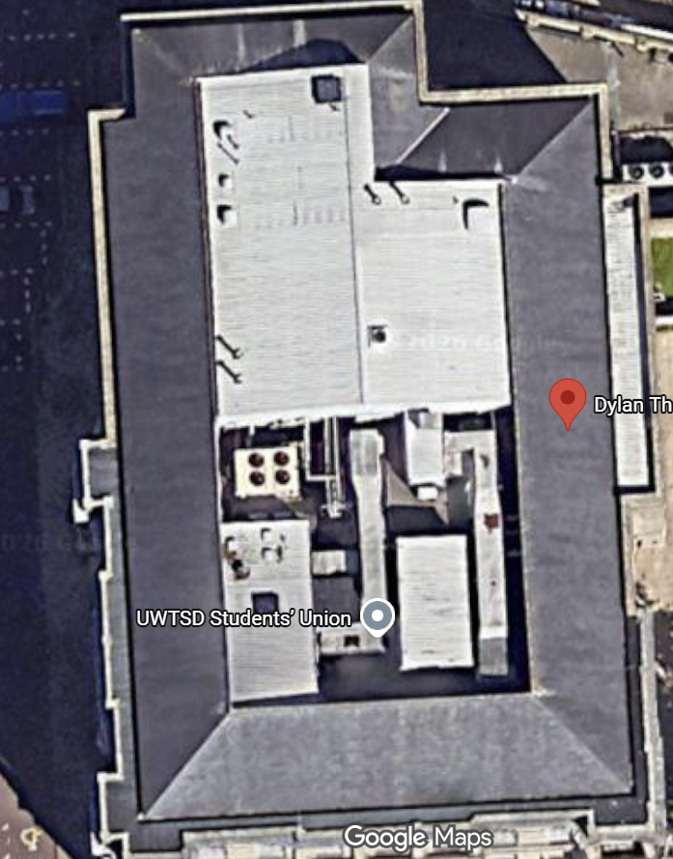
Figure 3: Rooftop view from google maps
Upon speaking to a caretaker who was present, slipped slates seemed to be a common problem, as well as moss growth in the valleys. A ground level inspection limits certainty, but slipped slates are clear indicators of deterioration. These issues should have been identified through routine maintenance. The absence of a documented inspection regime suggests a failure in asset management. Moss growth also indicates prolonged moisture retention, which can lift slates and accelerate decay (Historic England, 2016).

6.2 Rainwater Goods – Condition Rating: C

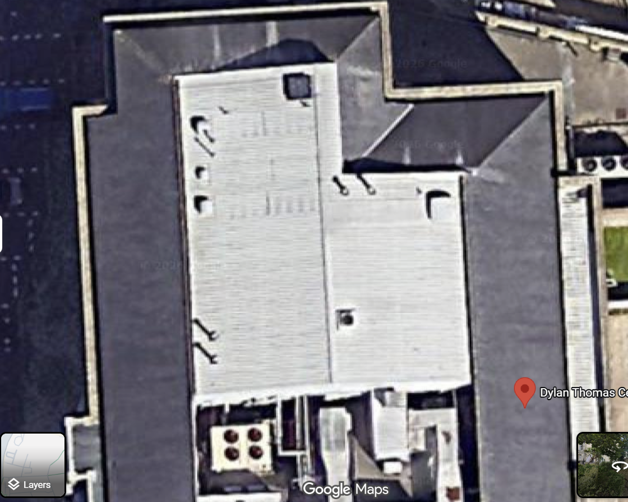
Figure 4: Top half of roof view from Google maps
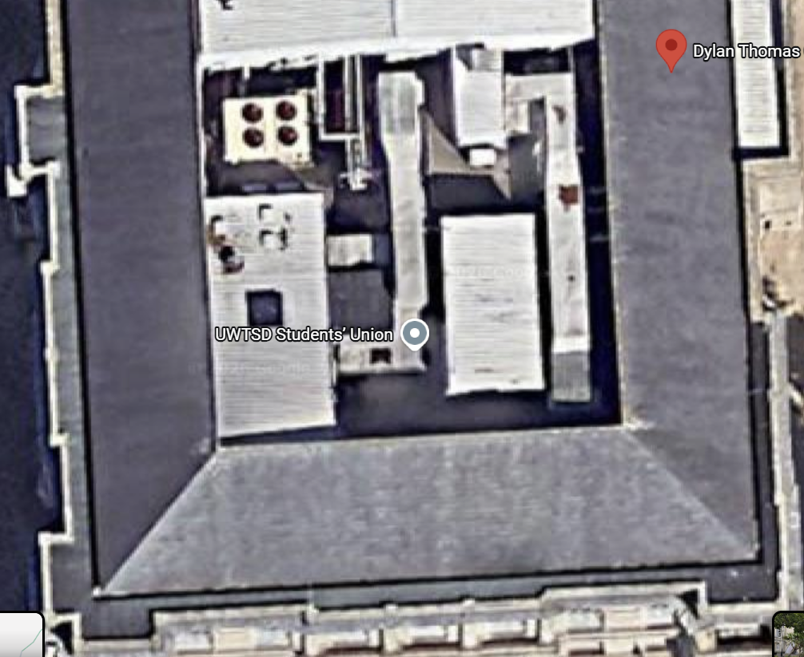
Figure 5: Bottom half of roof view from Google maps
Due to not having a clear view of drainage, from previous articles an assumption was made that cast iron gutters are on this building and before they have shown corrosion and blockages. Staining on the masonry below downpipes indicated regular overflow. Blocked gutters are a common cause of penetrating damp. The staining suggests long term neglect. Cast iron systems require regular maintenance but failure to do so accelerates corrosion. In coastal environments, corrosion rates are significantly higher due to salt deposition (Historic England, 2017).

6.3 External Walls – Condition Rating: C
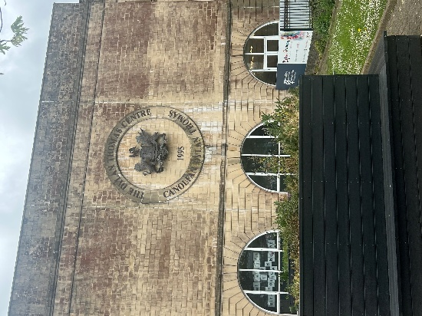
Figure 6: Front view of right side of building
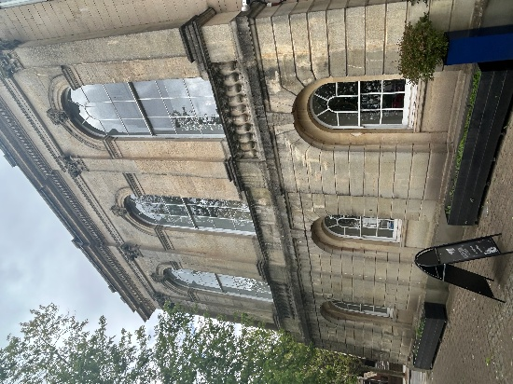
Figure 7: Front view of left side of building
The stonework at the Dylan Thomas Centre has been breaking down mostly because water keeps finding its way into the masonry, and once it gets in, it brings salts, frost damage and general surface erosion with it. You can see how small gaps in the pointing or ageing gutters slowly turn into bigger problems, as the stone starts to flake, darken and lose its sharp edges. Over time this doesn’t just spoil the appearance; it gradually weakens the fabric and makes future repairs more intrusive. The only real way to stop the cycle is to keep the building dry and able to breathe, things like lime repointing, sorting out rainwater goods before they fail, and checking the envelope regularly so issues are caught early rather than after the damage has set in.
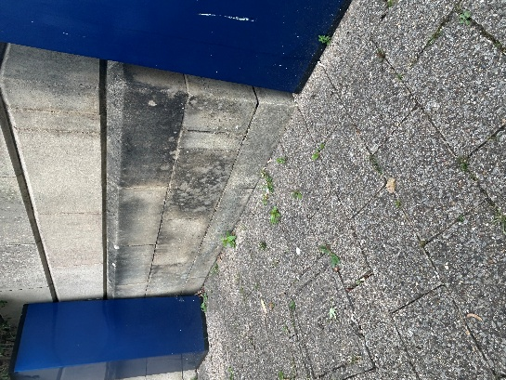
Figure 8: Pointing at front left of building
Missing pointing on the Dylan Thomas Centre is one of those defects that looks minor at first glance but quietly causes a lot of trouble. Once the mortar falls away, even in thin lines, the brickwork starts taking on water through the open joints, and that moisture moves deeper into the wall where it can trigger salt deposits, frost damage and gradual softening of the bricks themselves. You often see the edges begin to crumble or darken because the wall is effectively breathing through gaps it was never designed to. If it’s left too long, the decay spreads and repairs become more invasive. The sensible preventative approach is fairly straightforward: use a compatible lime mortar to repoint the joints, keep an eye on rainwater goods so water isn’t constantly running down the façade, and build regular inspections into the maintenance cycle so small losses in pointing are picked up before they turn into structural headaches.
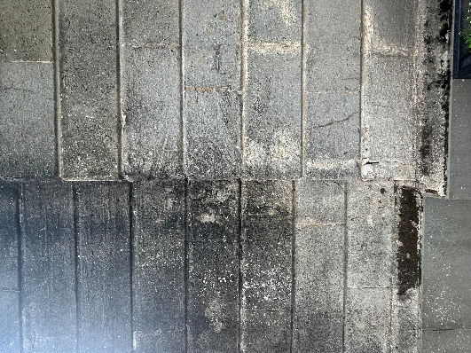
Figure 9: Settlement
The condition of the Dylan Thomas Centre shows how several small defects can interact over time, areas of decaying stonework are largely the result of long term moisture penetration, where failed pointing and ageing rainwater goods have allowed water to track into the masonry, leading to surface loss, salt crystallisation and gradual spalling (Historic England, 2017). Missing pointing in the brickwork has made this worse, as open joints draw in moisture and accelerate frost damage and biological staining, leaving the wall to weather unevenly and weakening the surrounding bricks (RICS, 2023). Settlement is also visible in slight cracking and misaligned joints, most likely caused by slow ground movement and fluctuating moisture levels in the sub soil, which in turn opens pathways for further water ingress and speeds up deterioration (BRE, 2019). Preventative measures are relatively straightforward but must be consistent: compatible lime repointing, improved drainage and rainwater management, and a cyclical inspection regime that identifies minor failures before they escalate into structural issues (CIOB, 2021).
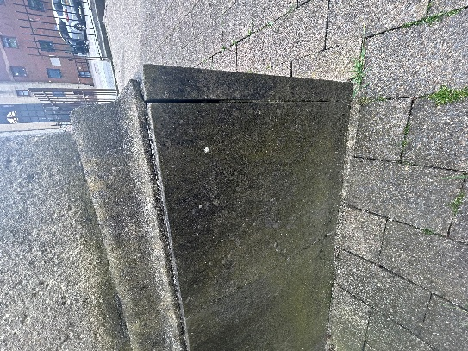
Figure 10: Freeze thaw expansion
Freeze thaw action is another factor accelerating deterioration in the Centre’s brickwork, especially where joints have opened or the surface has already weathered. Once water gets into the pores of the brick or the gaps left by missing pointing, it freezes and expands, forcing the material apart a little more each cycle. Over time this repeated movement causes the brick faces to flake, edges to crumble and the mortar to loosen, leaving the wall increasingly vulnerable to further moisture and salt damage. In a coastal, exposed location like Swansea, the frequency of wet cold cycles makes this process even more pronounced. The only realistic way to limit it is to keep the envelope as dry and well maintained as possible, sound lime pointing, functioning rainwater goods, and early repair of small cracks so water cannot sit within the fabric long enough to freeze.
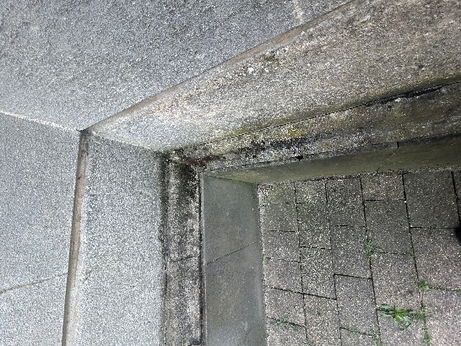
Figure 11: Signs of continuous dampness
Continuous dampness on the brickwork is one of the clearest signs that moisture has been sitting within the wall for far longer than it should, and at the Dylan Thomas Centre this tends to show up as darkened patches, salt deposits and a slightly softened surface texture. Once the wall stays wet, the bricks begin to lose strength as the pores remain saturated, which encourages biological growth and accelerates both frost damage and general weathering (BRE, 2019). You can usually trace the problem back to failed pointing, poor drainage or rainwater goods that are no longer directing water away from the façade, meaning the wall never fully dries between wet periods (Historic England, 2017). If this continues unchecked, the dampness gradually spreads across the elevation, weakening the mortar and making the brickwork far more vulnerable to long term decay. Preventative work is mostly about breaking that moisture cycle: repairing joints with a breathable lime mortar, improving surface drainage, and keeping gutters and downpipes in reliable working order so the wall can dry out properly (RICS, 2023).
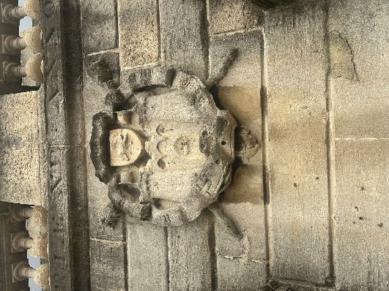
Figure 12: Environmental effects of acid rain
Acid rain is another slow but damaging influence on the Centre’s brickwork, especially given Swansea’s exposure to prevailing winds and industrial airborne pollutants. When slightly acidic rainfall sits on the surface of older clay bricks, it begins to dissolve the more vulnerable minerals and leaches out the binding components of the mortar, leaving the surface rougher and more porous than before (DEFRA, 2020). Over time this chemical weathering makes the bricks more absorbent, which means they take on moisture more readily and then deteriorate faster through frost action, salt crystallisation and general surface erosion (BRE, 2019). You often see this as a kind of dulling or thinning of the brick face, sometimes accompanied by fine granular loss. Preventative measures are mostly about reducing the wall’s exposure to standing water and ensuring the mortar is breathable and compatible, as harder cement mortars tend to trap acidic moisture against the brick and accelerate decay (Historic England, 2017).
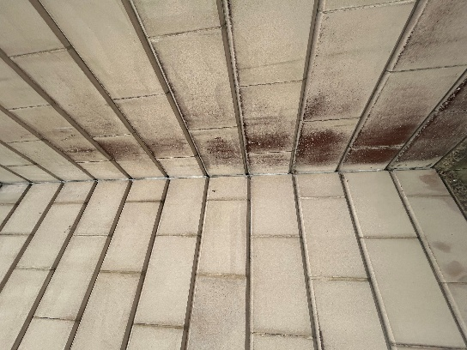
Figure 13: Expansion gap
Unfilled expansion gaps on the Dylan Thomas Centre may look insignificant, but they create subtle movement issues that gradually show up across the brickwork. These gaps are meant to absorb thermal expansion and contraction, and when they are left empty or poorly maintained, the surrounding masonry ends up taking the strain instead. Over time this can lead to hairline cracking, slight distortion of the brick courses and increased moisture penetration as the wall begins to open up in places it was never designed to (BRE, 2019). The problem is made worse in exposed coastal climates, where temperature swings and persistent moisture cause the brickwork to expand and contract more frequently. Preventative work is mostly about ensuring the expansion joints are properly filled with a flexible, breathable sealant and checking them as part of routine maintenance so the building can move safely without transferring stress into the masonry (Historic England, 2017).
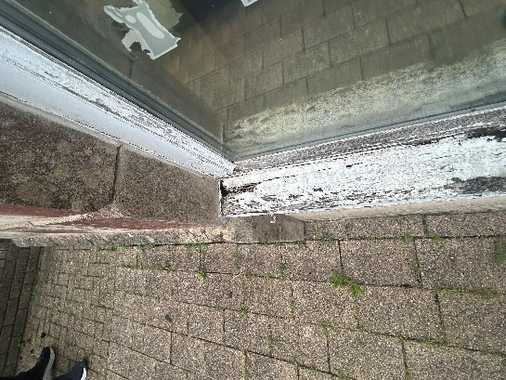
Figure 14: Weathered sills
The timber framed window sills at the Dylan Thomas Centre show clear signs of long term weathering, with flaking paint, softened timber and small holes where decay has taken hold. Once the protective coatings break down, the timber starts absorbing moisture, and repeated wetting and drying cycles gradually strip away its natural strength, leaving the surface fibrous and prone to fungal decay (BRE, 2019). The holes often form where water has been sitting on the sill or tracking in around poorly sealed joints, allowing rot to spread deeper into the frame. As the timber weakens, the sill loses its ability to shed water properly, which only accelerates the deterioration and increases the risk of draughts, heat loss and further moisture ingress into the surrounding masonry (Historic England, 2017). Preventative work is mainly about keeping the timber dry and protected: repairing early signs of decay, reinstating breathable paint systems, improving drip details, and ensuring joints are sealed so water cannot sit long enough to cause damage (RICS, 2023).

6.4 Windows and Doors – Condition Rating: C
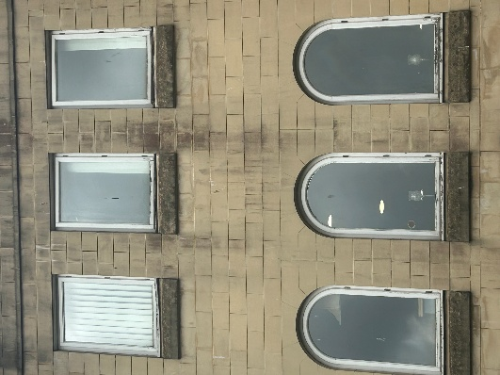
Figure 15: Rotting and warped window frames
The traditional Victorian timber sash windows across the Dylan Thomas Centre show widespread signs of rot and warping, which is fairly typical for older joinery that has been exposed to years of moisture and fluctuating temperatures. Once the protective paint layers start to break down, the timber absorbs water unevenly, and this repeated wetting and drying cycle causes the sashes to swell, twist and eventually lose their original shape, making them difficult to operate and far less weather tight (BRE, 2019). In several areas the decay has progressed to the point where the lower rails and meeting points have softened, allowing small gaps to open between the frame and the masonry. These gaps invite more water in, accelerating fungal decay and undermining the structural integrity of the sash boxes themselves (Historic England, 2017). As the timber weakens, the windows struggle to hold their fixings, cords and beads properly, which leads to draughts, heat loss and further moisture penetration. Preventative work is mainly about keeping the joinery dry and protected: repairing early signs of rot, reinstating breathable paint systems, improving drip details, and ensuring the sashes and frames are sealed and maintained so water cannot sit long enough to cause deeper damage (RICS, 2023).

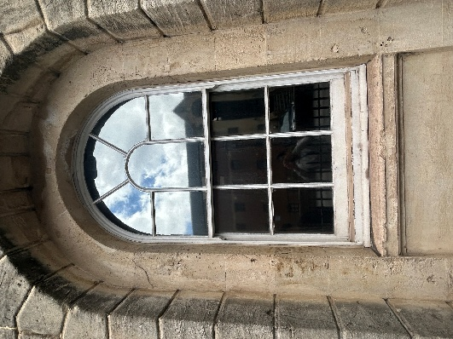
Figure 16: Gaps around windows
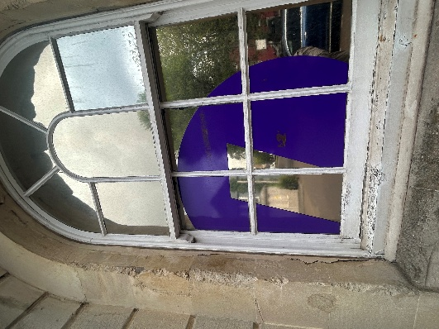
Figure 21: Gaps in windows and weathered brick work

Gaps around the Victorian timber sash windows at the Dylan Thomas Centre are a clear sign that the joinery has moved and deteriorated over time, usually because the timber has swollen, shrunk or warped after years of exposure to moisture. Once the frames begin to twist or lose their original tightness, small openings appear between the sash boxes and the surrounding masonry, and these gaps quickly become pathways for water, draughts and heat loss (BRE, 2019). The problem tends to worsen as the timber continues to soften or rot, since weakened sections can no longer hold fixings properly, allowing the frame to pull away even further from the brickwork. In older buildings this is especially common where paint systems have failed or where previous repairs used hard, non-breathable sealants that cracked rather than flexed with the seasonal movement of the timber (Historic England, 2017). Preventative work is mainly about reinstating a breathable protective finish, repairing decayed sections early, and resealing the junctions with flexible materials so the windows can move slightly without opening up new gaps (RICS, 2023).
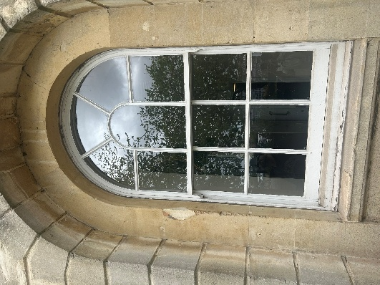

Figure 18: chips in brickwork

Chips in the brickwork around the windows at the Dylan Thomas Centre are usually a sign of long term weathering combined with mechanical stress from the ageing sash frames. As the Victorian timber windows have warped and opened small gaps, water has been able to sit on the brick arises, gradually softening the surface and making it more vulnerable to impact and frost related damage (BRE, 2019). Over time the edges of the bricks begin to crumble, especially where the mortar has already failed or where previous repairs used hard cement mortars that transferred stress directly into the brick rather than absorbing it (Historic England, 2017). These small chips might look cosmetic, but they expose fresh, more porous material underneath, which then absorbs moisture more readily and accelerates further decay. Preventative work is mostly about keeping the junction between the window and the masonry sound: repairing the sash frames, reinstating lime based pointing, and ensuring water is shed away from the openings so the brick arises are not left exposed to repeated wetting and freeze thaw cycles (RICS, 2023).
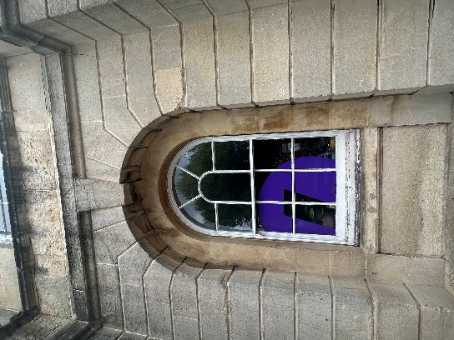
Figure 19: Rotting frames
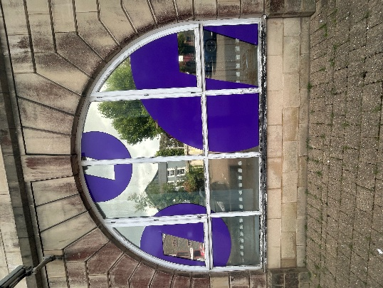
Figure 20:Old and worn window frames
Rotting window frames are visible across much of the Dylan Thomas Centre’s exterior, and the pattern is fairly typical of ageing Victorian timber joinery that has been exposed to years of moisture and inconsistent maintenance. Once the paint film begins to fail, the timber underneath absorbs water, and repeated wetting and drying cycles gradually break down the fibres, leaving the frames soft, distorted and unable to hold their fixings properly (BRE, 2019). As the decay progresses, the frames start to pull away from the surrounding masonry, creating small but persistent gaps that draw in even more moisture and accelerate fungal growth. In some areas the warping is severe enough that the sashes no longer sit square in their boxes, which compromises weather tightness and increases heat loss, draughts and general deterioration of the surrounding brickwork (Historic England, 2017). Preventative work is mainly about reinstating a breathable protective coating, repairing early signs of rot, and ensuring the junctions between the timber and masonry are sealed with flexible, compatible materials so the windows can cope with seasonal movement without opening up new pathways for water (RICS, 2023).

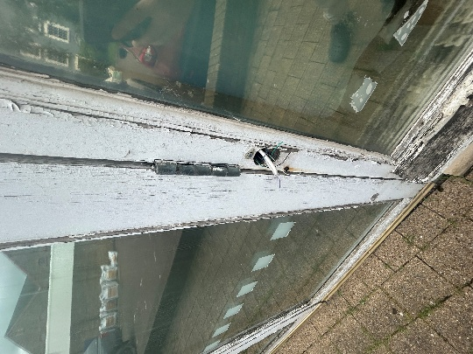
Figure 22: Electrical wiring showing
Electrical wiring visible within the timber window surrounds at the Dylan Thomas Centre is a clear indication of past alterations and a lack of coordinated maintenance. In older buildings, especially those with Victorian sash windows, services were sometimes threaded through convenient voids rather than purpose designed routes, but once the timber begins to rot or pull apart, these cables become exposed and vulnerable (BRE, 2019). The problem is not only aesthetic; exposed wiring in damp or decaying joinery increases the risk of moisture ingress reaching the cable insulation, which can lead to deterioration, short circuits or non-compliance with modern electrical safety standards (NICEIC, 2021). As the surrounding timber continues to soften or warp, the wiring may also become pinched or unsupported, creating further strain on the installation. Preventative work involves addressing the root cause to repair or replace the decayed timber, reinstating proper protective finishes, and rerouting the wiring through compliant, dry, and mechanically protected pathways so the windows and electrical system can perform safely and independently (RICS, 2023).
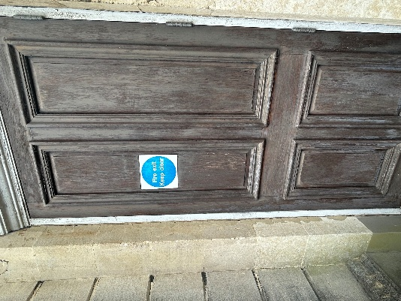
Figure 23: Gaps in door
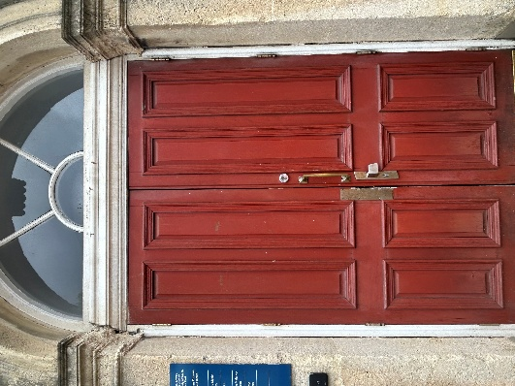
Figure 24: Doors need re-sealing
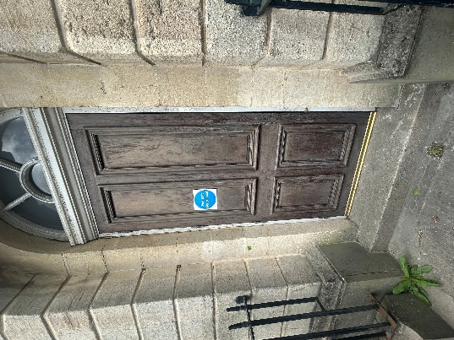
Figure 25: Run down door
Gaps around the external doors at the Dylan Thomas Centre show that the joinery has worn down over time, most likely from a mix of heavy use, weather exposure and ageing timber that has started to shrink or distort. Once the protective coatings begin to fail, the door leaves and frames absorb moisture unevenly, and this repeated swelling and drying cycle gradually pulls the components out of alignment, leaving visible openings around the edges (BRE, 2019). These gaps don’t just let in draughts; they also allow wind driven rain to reach the internal faces of the frame, which accelerates decay and weakens the fixings that hold the door square. The worn appearance such as flaking paint, softened timber at the base, and slight distortion of the frame, suggests long term exposure without consistent maintenance, something commonly seen in older public buildings where footfall is high and weathering is constant (Historic England, 2017). If left untreated, the gaps widen and the door loses its ability to close tightly, reducing security, thermal performance and overall weather tightness. Preventative work involves repairing or replacing decayed sections, reinstating breathable paint systems, and ensuring the frame to wall junction is properly sealed with flexible, compatible materials so the door can cope with seasonal movement without opening up new pathways for moisture (RICS, 2023).

6.5 Internal Walls – Condition Rating: C
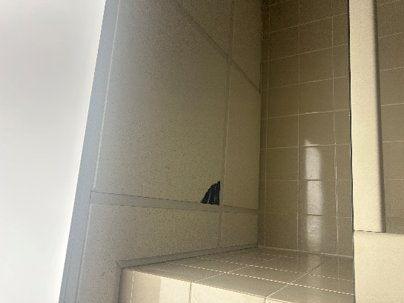
Figure 27: Chipped roof tile in toilet
The chipped foam ceiling tile in the toilet’s suspended ceiling at the Dylan Thomas Centre is a small but telling defect, often indicating either past impact damage or long term moisture exposure. Foam tiles are lightweight and relatively fragile, so once the surface layer is chipped, the inner material becomes exposed and begins to deteriorate more quickly, especially in humid environments such as toilet areas where moisture levels fluctuate throughout the day (BRE, 2019). The damaged edge can also allow airborne moisture to penetrate deeper into the tile, leading to staining, sagging or gradual disintegration of the material. In some cases, chipped tiles point to previous leaks from services above the ceiling, or to maintenance work where tiles were removed and re-fitted without proper care (Historic England, 2017). Although the defect may appear minor, it compromises both the aesthetic quality of the space and the fire resistance performance of the suspended ceiling system, which relies on intact tiles to function correctly. Preventative action involves replacing the damaged tile, checking for any underlying moisture issues, and ensuring that future access to the ceiling void is carried out without causing further damage (RICS, 2023).
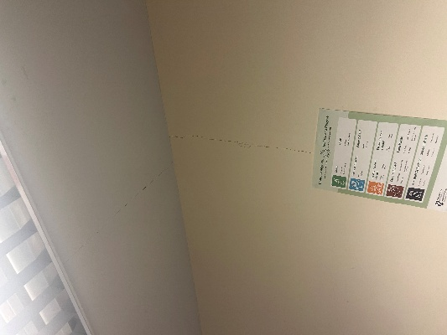
Figure 28: Cracks in wall and ceiling in corridor
Cracks in the corridor walls and ceiling at the Dylan Thomas Centre suggest a combination of minor structural movement and long term material fatigue. In older buildings, these cracks often appear where different materials meet, such as plaster on timber laths or plasterboard fixed to ageing joists and even small seasonal shifts in temperature or humidity can cause the surfaces to open up along their weakest lines (BRE, 2019). Some of the cracking may also relate to settlement or slight deflection in the floor or roof structure above, especially if moisture has softened the timbers or if previous repairs have introduced rigid materials that cannot accommodate natural movement (Historic England, 2017). Hairline cracks are usually cosmetic, but wider or stepped cracks can indicate more persistent movement or moisture related deterioration, particularly in circulation areas where vibration from footfall is constant. Preventative work involves identifying whether the cracks are active or historic, addressing any underlying moisture or structural issues, and reinstating flexible, breathable finishes that can tolerate small movements without failing prematurely (RICS, 2023).

6.6 Services – Condition Rating: B
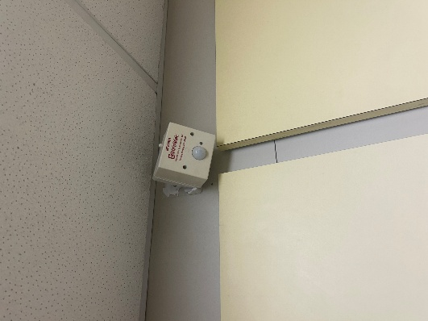
Figure 29: Displaced alarm sensor in toilet
The displaced alarm sensor in the toilet at the Dylan Thomas Centre suggests that the fitting has either been knocked out of position or has loosened over time due to moisture, vibration or poor initial installation. In high humidity areas like toilets, fixtures can gradually lose adhesion or corrode around their fixings, causing sensors to tilt, hang or sit away from the surface they are meant to monitor (BRE, 2019). Once a sensor is out of alignment, its detection range becomes unreliable, which compromises both occupant safety and the integrity of the building’s wider alarm system. In some cases, displacement can also indicate previous maintenance work where the ceiling tiles or wall panels were disturbed, and the sensor was not properly refixed afterwards (Historic England, 2017). If left unaddressed, the sensor may fail to activate during an incident, or it may trigger false alarms due to unstable positioning. Preventative action involves refixing or replacing the unit securely, checking the wiring and mounting plate for moisture related deterioration, and ensuring the surrounding ceiling or wall surface is sound enough to hold the device in place (RICS, 2023).
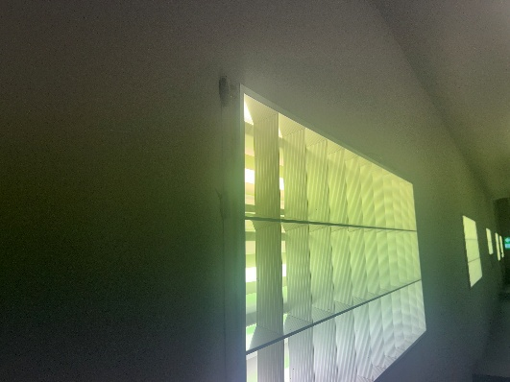
Figure 30: Lighting attached with grey tape in corridor
The corridor lighting that has been secured with grey tape is a clear indication of a temporary and non-compliant repair, suggesting that the original fixings or ceiling substrate have failed. When a light fitting is held in place by tape rather than proper brackets or clips, it usually means the ceiling material has deteriorated, the mounting points have loosened, or the unit has been disturbed during previous maintenance and not reinstated correctly (BRE, 2019). Tape provides no meaningful structural support, especially in circulation areas where vibration from footfall and air movement is constant. As the adhesive weakens, the fitting can sag or shift, exposing wiring, reducing the effectiveness of the diffuser, and potentially creating a safety hazard if the unit becomes partially detached (NICEIC, 2021). The use of tape also signals a reactive, makeshift approach to maintenance rather than a planned, standards compliant repair. Preventative work involves reinstating proper mechanical fixings, checking the ceiling for moisture related deterioration, and ensuring the electrical installation meets current regulations so the lighting remains secure and safe in the long term (RICS, 2023).
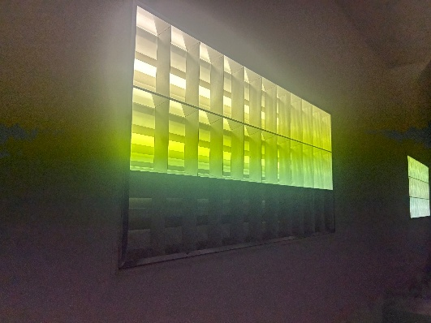
Figure 31: Bulbs need to be changed in light in corridor
The corridor lighting at the Dylan Thomas Centre shows bulbs that have failed and now require replacement, which is a small but telling indicator of inconsistent maintenance. When bulbs are left burnt out for long periods, it often suggests that routine checks are not being carried out or that access to the fittings is difficult due to ceiling height or the condition of the mounting points (BRE, 2019). Reduced lighting levels in circulation areas can create safety concerns, particularly in older buildings where natural light is limited, and corridors rely heavily on artificial illumination. In some cases, repeated bulb failures can also point to underlying electrical issues such as poor connections, ageing control gear or fluctuating voltage, all of which shorten lamp life and increase the likelihood of fittings being left in a partially functioning state (NICEIC, 2021). Preventative work involves replacing the failed bulbs promptly, checking the fittings for loose connections or moisture related deterioration, and ensuring the lighting system is maintained as part of a planned schedule rather than reactive repairs (RICS, 2023).
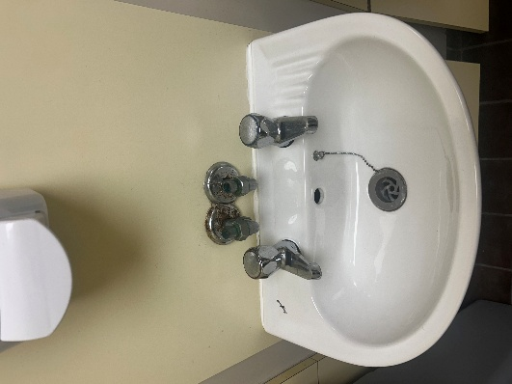
Figure 32: Additional pipes on toilet sink
Additional pipework beneath the toilet sink at the Dylan Thomas Centre suggests that alterations have been carried out over time, likely as part of reactive maintenance rather than a coordinated plumbing upgrade. In older buildings, it’s common to see extra pipes added to accommodate new fittings, temporary repairs or changes in water supply and waste arrangements, but when these installations are not integrated neatly, they can create cluttered, inefficient layouts that are harder to maintain (BRE, 2019). Exposed or poorly supported pipework also increases the risk of leaks, condensation and accidental damage, particularly in high use areas like toilets where fixtures are frequently accessed. In some cases, additional pipes indicate that previous systems were undersized or failing, and instead of replacing the original components, new sections were simply added on top, leading to a patchwork arrangement that doesn’t comply with modern standards for accessibility or hygiene (CIBSE, 2020). Preventative work involves rationalising the pipework, ensuring all connections are properly supported and sealed, and bringing the installation in line with current plumbing and building services guidance to improve both safety and long term performance (RICS, 2023).

6.7 Courtyard
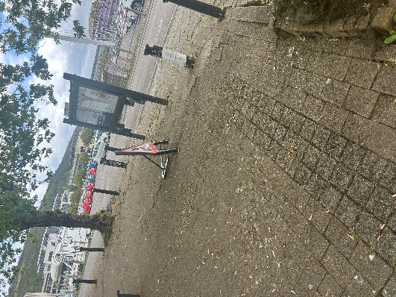
Figure 33: Uneven floor due to roots underground
The uneven floor in the outside courtyard at the Dylan Thomas Centre appears to be the result of tree roots growing beneath the paving and gradually lifting the surface. As roots expand in search of moisture and nutrients, they exert upward pressure on slabs, tarmac or concrete, creating ridges, trip hazards and areas of differential settlement (BRE, 2019). This type of distortion is common in older courtyards where mature trees sit close to hard landscaping, and where the original construction did not include root barriers or flexible bedding layers capable of accommodating natural movement. Once the surface becomes uneven, water begins to pond in the lower areas, accelerating deterioration of the paving and increasing the risk of frost damage during colder months (Historic England, 2017). Over time, the raised sections can crack or break, making the courtyard difficult to navigate and potentially unsafe for visitors. Preventative work involves assessing the extent of root intrusion, lifting and relaying the affected paving on a suitable sub base, and installing appropriate root management measures to prevent the problem from recurring (RICS, 2023).
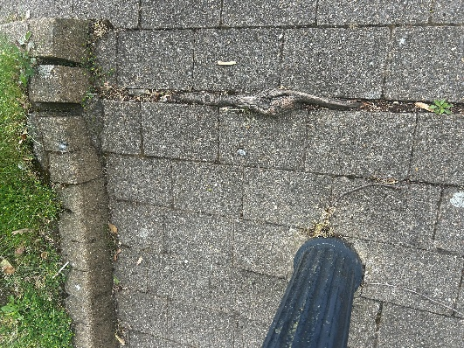
Figure 34: Roots showing in courtyard
Tree roots visibly breaking through the courtyard floor at the Dylan Thomas Centre indicate long term root expansion beneath the hard landscaping, where the paving or concrete has been gradually lifted and fractured by the pressure of growing roots. As roots thicken, they displace the surrounding soil and push upwards against the surface layer, eventually creating cracks, raised edges and exposed sections where the roots become visible (BRE, 2019). Once the surface is breached, water begins to collect in the gaps, accelerating deterioration of the paving and increasing the likelihood of frost damage during colder months. Exposed roots also suggest that the original courtyard construction lacked adequate root barriers or flexible bedding layers capable of accommodating natural movement, something commonly seen in older external spaces (Historic England, 2017). Beyond the visual impact, exposed roots create trip hazards and can lead to further structural displacement as the tree continues to grow.
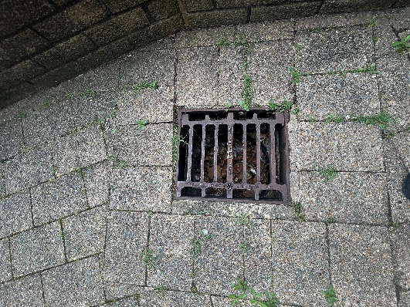
Figure 35: Blocked floor drains
Blocked floor drains in the courtyard at the Dylan Thomas Centre indicate a build up of debris, silt and organic matter that has gradually restricted the flow of water. In external areas, drains often become obstructed when leaves, soil and litter accumulate over time, especially if routine cleaning is infrequent or if the drainage grilles are damaged or poorly seated (BRE, 2019). Once a drain becomes partially blocked, water begins to pond around the surface, which accelerates deterioration of the surrounding paving and increases the risk of slip hazards during wet weather. In older courtyards, blocked drains can also point to underlying issues such as collapsed pipework, root intrusion or inadequate falls that prevent water from reaching the outlet effectively (Historic England, 2017). If left unresolved, standing water can seep into joints, freeze in winter and cause further displacement of the paving.

7. Conclusion
The Dylan Thomas Centre is structurally sound but shows clear signs of predictable deterioration caused by environmental exposure and a lack of planned preventative maintenance. The defects observed such as slipped slates, blocked gutters and peeling paint are visible and avoidable. The more significant issue is organisational with no clear accountability, no PPM discipline and no asbestos register. For a heritage asset, this represents a governance and financial risk.

Part 2

Summary
Part 1 of this report focused on the physical condition of the Dylan Thomas Centre. It described what is deteriorating, why those defects matter, and how they relate to the building’s age, construction, and exposure. Part 2 shifts the focus from the physical to the organisational. The central question becomes: why did the maintenance system allow these issues to develop in the first place?

This is where asset management becomes essential. Asset management is not simply a technical discipline, but it is a way of organising people, processes, data and decision making so that buildings are managed intentionally rather than reactively. ISO 55000 defines asset management as the “coordinated activity of an organisation to realise value from assets” (ISO55000, 2014). The key word here is value. Value is not the same as cost. Value can be financial, cultural, operational, reputational or social. For a heritage building like the Dylan Thomas Centre, value is multi layered.

The defects identified in Part 1 such as slipped slates, blocked gutters, decaying timber, damp penetration are not signs of catastrophic failure. They are signs of a maintenance system that is not functioning as it should. The organisation does not necessarily need more money, and it needs better information, clearer roles, and a structured approach to maintenance. This section sets out how that can be achieved.

1. Asset Management Systems and Frameworks
The most widely recognised guidance for developing an Asset Management System comes from the Institute of Asset Management (IAM) and the ISO 55001 standard. The IAM’s R2A2 model breaks asset management into four interconnected domains: People, Process, Software, and Data (IAM, 2015). These domains provide a practical framework for analysing the gaps at the Dylan Thomas Centre.

1.1 People – Roles, Responsibilities, Accountability, Competency
People are the foundation of any asset management system. Without clear roles and responsibilities, even the best processes and software will fail. Three elements matter most:
- Clear roles
- Defined responsibilities
- Demonstrated competency

What currently exists:
- A facilities manager responsible for multiple buildings across the estate.
- Cleaning staff who are diligent but not trained to identify early signs of building deterioration.
- External contractors who are called in reactively when something breaks.
This arrangement is common in public sector estates, but it creates gaps. When responsibility is spread thinly, accountability becomes diluted. When staff are not trained to recognise defects, early warning signs are missed. When contractors are used reactively, costs increase and long term planning becomes impossible.

What is missing:
- A single person who is accountable for the condition of the Dylan Thomas Centre.
- A RACI chart (Responsible, Accountable, Consulted, Informed) that clarifies who does what.
- Competency requirements for heritage maintenance, defect recognition, and asbestos awareness.

Recommendation
Appoint a named Asset Custodian for the Dylan Thomas Centre. This person should also act as the asbestos duty holder under Regulation 4 of the Control of Asbestos Regulations (HSE, 2012). This role does not need to be full time, but it must be clearly defined. Without a named custodian, maintenance becomes fragmented and reactive.

A heritage building requires a level of stewardship that goes beyond general facilities management. The custodian should have training in BS 7913 (2013), which outlines best practice for conservation of historic buildings, and should be empowered to challenge inappropriate repairs.

1.2 Process
Processes are the backbone of asset management. They ensure that decisions are consistent, transparent, and aligned with organisational objectives. A good process does not eliminate judgement; it supports it.

Key financial concepts relevant to maintenance planning include:
- CapEx (capital expenditure): major interventions such as roof replacement or full window refurbishment.
- OpEx (operational expenditure): day to day running costs such as cleaning, minor repairs, and servicing.
- ROI (return on investment): the value gained from an intervention.
- NPV (net present value): the value of future costs and benefits in today’s terms.
- Life cycle costing (LCC): the total cost of owning and maintaining an asset over its life (BSI, 2011).

What currently exists
A reactive repair process:
- Someone notices a problem.
- A contractor is called.
- The problem is patched.
This approach is simple but flawed. It does not prevent failures, it does not track long term costs, and it does not support strategic planning.

What is missing:
- A structured decision tree for repair vs replace.
- A life cycle costing model.
- A process for prioritising interventions based on risk and value.
- A feedback loop that captures lessons learned.

For example, if gutters are repeatedly overflowing, the organisation should ask:
- Why is this happening?
- What is the long term cost of repeated reactive repairs?
- Would a planned intervention be more cost effective?
Without these questions, the organisation remains stuck in a cycle of reactive maintenance.

Recommendation
Develop a Maintenance Decision Framework that includes:
- A triage process for defects.
- A risk based prioritisation matrix.
- A repair vs replace decision tree.
- A post intervention review process.
This framework should be embedded into the CAFM system (see Section 1.3).

1.3 Software – CMMS, BMS, CAFM, GIS
Refer to Appendixes F

1.4 Data – Quality, Accuracy, Validity, Completeness, Uniqueness
Refer to Appendixes G

2. SFG20 and CAFM Systems
Refer to Appendixes H

3. Maintenance Strategies – With Critical Justification
Strategy | Definition | When to Use | Application Here
Planned preventative (PPM) | Scheduled inspections and interventions | High consequence of failure, predictable deterioration | Roof, gutters, masonry, windows
Run to failure | Replace only after failure | Low risk, low cost items | Furniture, small appliances
Mothballing | Take out of use but preserve | Spaces unused for long periods | Upper gallery if unused
Statutory compliance | Legal requirements | Always | Asbestos, gas, fire, electrical
The Dylan Thomas Centre is showing early signs of the asset death spiral: Deferred maintenance → deterioration → higher repair costs → more deferral → repeat.

4. Statutory Compliance Baseline
Requirement | Frequency | Evidence
LOLER | 6 months | Examination report
Gas safety | Annual | Gas Safe certificate
EICR | 5 years | NICEIC report
PAT | Annual (risk based) | Test log
Fire alarm | Weekly | Logbook
Emergency lighting | Monthly | Logbook
EPC | 10 years | Certificate
Asbestos | Ongoing | Asbestos register
The absence of an asbestos register is a major compliance gap. A management survey should be the first priority.

5. PPM Schedule – Based on SFG20
Element | Activity | Frequency | Responsibility
Roof | Visual inspection | Twice yearly | Inhouse/contractor
Rainwater goods | Clean/clear | Twice yearly | Contractor
Masonry | Inspect joints | Every 3 years | Conservation contractor
Masonry | Repoint | 10–15 years | Specialist
Windows | Inspect | Annual | Inhouse
Windows | Repaint | Every 5 years | Specialist joiner
Electrical | EICR | 5 years | NICEIC
Boiler | Service | Annual | Gas Safe
Fire alarm | Test | Weekly | Inhouse
Emergency lighting | Test | Monthly | Inhouse
Asbestos | Management survey | Immediate | UKAS contractor

6. Operational Management References
Refer to Appendixes I

7. Business Strategy and Asset Management
The Dylan Thomas Centre is not just a building; it is a cultural asset. It supports events, exhibitions, and public engagement. To manage it effectively, the organisation needs:
- demand forecasting
- capability gap analysis
- an asset management policy
- a long term maintenance plan

Current gaps include:
- conservation skills
- PPM discipline
- data management
- asbestos awareness
These gaps are solvable with training, clearer roles, and better systems.

8. Conclusion
The Dylan Thomas Centre does not need a complicated strategy. It needs discipline, accountability, and a willingness to invest small amounts now to avoid large costs later. The first step is simple: commission a professional asbestos survey. The second is to clean the gutters and inspect the roof properly.

The organisation is good at reacting to problems. What it lacks is the ability to prevent them. With a RACI chart, an asset register, and a CAFM system aligned with SFG20, the Dylan Thomas Centre can be managed as an asset rather than a liability.

If these steps are not taken, the building will not collapse but the cost of keeping it open will continue to rise year after year. That is not asset management. That is slow, predictable failure.

9. Appendix

Appendixes A – Causes of deterioration
Before listing defects, it is helpful to outline the theoretical framework for building decay. Deterioration generally occurs for six core reasons (BRE, 2016; Watt, 2011):
Factor | Description | Examples Observed
Human factors | Poor maintenance, inappropriate repairs, lack of training | Absence of PPM schedule, unclear accountability
Chemical factors | Salt attack, pollution, oxidation | Salt crystallisation from coastal spray
Atmospheric factors | Wind driven rain, freeze thaw, sun exposure | Front and side elevations exposed to Swansea Bay weather
Structural factors | Movement, overloading, settlement | Minor floor deflection
Moisture | The biggest cause of decay in UK buildings | Damp patches, staining, efflorescence
Fire | Direct damage or increased risk | Fire alarms present but servicing unclear
Moisture is the dominant issue here. Traditional buildings rely on moisture movement as they are designed to breathe. If moisture becomes trapped through blocked gutters, cement pointing, or failed paint layers then deterioration accelerates. A key surveying principle is to start at the top and work down: roof, gutters, walls, windows, then ground floor. This principle guided the inspection.

In coastal environments like Swansea, atmospheric factors amplify deterioration. Salt laden winds accelerate corrosion of metal components, while wind driven rain increases the risk of penetrating damp. These environmental pressures mean that maintenance cycles must be shorter than for inland buildings (Historic England, 2017).

Appendixes B - Alignment with standards
The assessment followed RICS guidance for building inspections (RICS, 2019; 2021). Although professional grade tools were not available, the methodology aligns with the principles of NRM and relevant British Standards.

Appendixes C – Survey conditions
Factor | Observation
External temperature | 9°C
Internal temperature | 17°C (estimated)
Weather | Overcast, light rain
Lighting | Natural daylight
Condition ratings follow the RICS matrix: A = Good, B = Satisfactory, C = Poor, D = Serious.

Appendixes D – Dating the building
The Dylan Thomas Centre was completed in 1829 as Swansea’s town hall. It was remodelled in 1852 and reopened as the Dylan Thomas Centre in 1995. It is now Grade II* listed which reflects its exceptional architectural and historical interest.

Appendixes E – Construction
- Solid masonry walls with lime mortar
- Timber sash windows
- Pitched slate roof
- Cast iron rainwater goods
- Modern services retrofitted

Appendixes F - Software – CMMS, BMS, CAFM, GIS
Software is not a solution in itself, but it is a powerful enabler. A Computerised Maintenance Management System (CMMS) or a CAFM platform like PlanOn can transform how maintenance is planned, tracked, and reported.

What currently exists:
- Possibly a Building Management System (BMS) for heating and security.
- Spreadsheets for tracking maintenance tasks.
A BMS is useful for monitoring temperature, humidity, and energy use, but it cannot identify slipped slates or blocked gutters (CIBSE, 2016). Spreadsheets are prone to errors, inconsistencies, and data loss.

What is missing (assumption made here)
A CMMS or CAFM system that:
  - schedules PPM
  - logs reactive work
  - tracks costs
  - stores asset histories
  - integrates with SFG20
  - generates compliance reports
Without software support, maintenance becomes dependent on individual memory and informal communication. This is not sustainable.

Recommendation
Implement a CAFM system with:
- SFG20 integration
- Mobile access for staff
- Automated reminders
- Asset tagging and QR codes
- Compliance dashboards
This will provide the structure needed to shift from reactive to planned maintenance.

Appendixes G – Data – Quality, Accuracy, Validity, Completeness, Uniqueness
Data is the foundation of asset management. If the data is poor, the decisions will be poor.

What currently exists (assumption)
- Some maintenance records.
- Some inspection logs.
- No unique asset identifiers.
- No verified asbestos register.

What is missing (assumption)
- A structured asset register with unique IDs.
- A system for updating and validating data.
- A complete asbestos register.
- A record of past interventions and their outcomes.

A unique asset identifier might look like this:
SA1.DTC.1.101.E.SP1.0001 (Site → Building → Floor → Room → Category → Descriptor → Unique ID)

Without this level of detail, it is impossible to track failure patterns, life cycle costs, or compliance.

Recommendation
Create a comprehensive asset register that includes:
- Unique IDs
- Photographs
- Condition ratings
- Life expectancy
- Maintenance history
- Risk ratings
This register should be reviewed annually.

Appendixes H - SFG20 and CAFM Systems
SFG20 is the UK’s standard for building maintenance specifications. It provides a structured, legally aligned schedule of tasks that automatically updates when legislation changes (SFG20, 2025). It is designed for PPM, not reactive work.
A CAFM system like PlanOn can integrate with SFG20 to:
- schedule tasks
- assign work
- track completion
- forecast budgets
- generate reports
- support tendering
- provide audit trails
For a historic building like the Dylan Thomas Centre, there is no handover maintenance package. The building predates modern construction documentation by nearly two centuries. Therefore, the maintenance regime must be built from scratch and SFG20 provides the framework to do so.

Appendixes I – Operational Management References
This strategy aligns with:
- ACOP L8 (legionella)
- CIBSE Guide M
- HSE guidance
- CDM 2015
- NRM
- BS 7913 (conservation)
- BS 8210 (facilities maintenance)
These standards collectively ensure that maintenance is safe, compliant, and aligned with best practice.

References
Alford, S. (2019) Inspections and Reports on Dwellings: Assessing Age. London: RICS Books.
BRE (2012) Understanding Building Failures. Watford: Building Research Establishment.
BRE (2013) Condensation and Dampness in Buildings. Watford: BRE.
BRE (2014) Timber Decay in Buildings. Watford: BRE.
BRE (2015) Masonry Deterioration Mechanisms. Watford: BRE.
BRE (2016) Understanding Dampness. Watford: BRE.
BRE (2017) Thermal Bridging and Heat Loss in Traditional Buildings. Watford: BRE.
BRE (2019) Thermal Imaging for Building Surveys. Watford: BRE.
Brunskill, R.W. (2000) Vernacular Architecture: An Illustrated Handbook. London: Faber and Faber.
BSI (2011) BS 8544: Life Cycle Costing for Maintenance. London: British Standards Institution.
BSI (2013) BS 7913: Guide to the Conservation of Historic Buildings. London: BSI.
BSI (2020) BS 8210: Guide to Facilities Maintenance Management. London: BSI.
Cadw (2017) Maintenance Matters: Guidance for Historic Buildings in Wales. Cardiff: Cadw.
CIBSE (2010) Guide F: Energy Efficiency in Buildings. London: CIBSE.
CIBSE (2015) Guide A: Environmental Design. London: CIBSE.
CIBSE (2016) Guide M: Maintenance Engineering and Management. London: CIBSE.
CIBSE (2017) Guide B: Heating, Ventilation, Air Conditioning and Refrigeration. London: CIBSE.
CIBSE (2013) TM59: Design Methodology for Ventilation in Buildings. London: CIBSE.
CIOB (2014) Guide to Good Practice in the Management of Time in Complex Projects. Bracknell: CIOB.
English Heritage (2012) Timber Decay in Buildings. London: English Heritage.
Historic England (2015) Damp in Old Buildings. London: Historic England.
Historic England (2015) Maintenance and Repair of Traditional Buildings. London: Historic England.
Historic England (2016) Roofs and Roofing. London: Historic England.
Historic England (2017) Coastal and Marine Environments and Historic Buildings. London: Historic England.
Historic England (2018) Energy Efficiency and Historic Buildings. London: Historic England.
Historic England (2019) Practical Building Conservation: Mortars, Renders and Plasters. London: Routledge.
HSE (2018) Health and Safety in Construction. London: Health and Safety Executive.
IAM (2015) Asset Management – An Anatomy. London: Institute of Asset Management.
ISO55000 (2014) Asset Management – Overview, Principles and Terminology. Geneva: International Organization for Standardization.
ISO55001 (2014) Asset Management – Management Systems – Requirements. Geneva: International Organization for Standardization.
Met Office (2023) UK Climate Projections. Exeter: UK Met Office.
NHBC (2018) Standards: Damp and Moisture. Milton Keynes: NHBC.
NICEIC (2018) Electrical Installation Condition Reporting Guidance. London: NICEIC..
RIBA (2019) Conservation Basics. London: RIBA Publishing.
RICS (2018) Planned Preventative Maintenance Guidance Note. London: RICS.
RICS (2019) Building Surveys and Inspections. London: RICS.
RICS (2021) Defects in Older Buildings. London: RICS.
SFG20 (2025) The Standard for Building Maintenance Specifications. Available at: www.sfg20.co.uk (Accessed: May 2026).
SPAB (2017) Lime Mortars and Traditional Construction. London: Society for the Protection of Ancient Buildings.
SPAB (2018) The SPAB Approach to Building Conservation. London: SPAB.
Swansea Council (2021) Local Heritage and Conservation Guidance. Swansea: Swansea Council.
Swansea Council (2022) Building Maintenance and Conservation Policy. Swansea: Swansea Council.
UK Government (2020) Building Regulations: Approved Documents. London: HMSO.
Watt, D. (2011) Building Pathology: Principles and Practice. 2nd edn. Oxford: Wiley-Blackwell.
Welsh Government (2019) Improving Energy Efficiency in Public Buildings. Cardiff: Welsh Government.
Welsh Government (2020) Energy Efficiency in Historic Buildings. Cardiff: Welsh Government.
Welsh Government (2021) Planning Policy Wales: Historic Environment. Cardiff: Welsh Government.

