
APPENDIX GA36c

LEVEL 6 ASSESSMENT SPECIFICATION

Student name: |  | Student ID number: | 1800977
Programme: | Primary
Module: | Principles of Pedagogy
Module code: | M6X01438/C | Contribution to Overall Module Assessment (%): | 100%
Lecturer: | Siân Brooks | Internal Verifier: | Siân Brooks
Assignment Title: | ‘Describe a learning event which has happened during your recent school experience. Reflect upon what took place, connecting events to theories of learning and teaching. Make recommendations about how you could improve your own practice in the light of this. Produce a poster to illustrate how you would develop the elements of an effective learning environment.’ | Word count (or equivalent): | 5,000 or equivalent.  5,486
Submission deadline: | 17/10/18 (23.59) | Return date of provisional marks & written feedback: | 14/11/18
Submission method: | All written assessments, where practical and possible, must be submitted via Turnitin unless otherwise instructed by the Lecturer. (Please DO NOT put this assessment specification into Turnitin or it will match many similarities with other students’ submissions.)  Alternative submission method (if applicable):  Late submission of the assessment will result in a late penalty mark. Penalties for late submission: Up to one week late, maximum mark of 40%. Over one week late, 0%. Only the Extenuating Circumstances Panel may approve a change to submission dates.
Academic honesty / referencing: | Academic honesty is required. In the main body of your submission you must give credit to authors on whose research and ideas your work is based. Append to your submission a reference list that indicates the books, articles, etc. that you have used, cited or quoted in order to complete this assessment.

Module Learning Outcomes
(from module syllabus)
1. understand, synthesise and evaluate the main theories that underpinning learning, behaviour and assessment in the primary school
2. reflect critically on how learning theories inform the planning and provision of high quality learning environments, demonstrating a clear understanding of how theory and practice are interrelated
3. organise knowledge and learning through the use of a range of information sources, and present work appropriately.

‘Describe a learning event which has happened during your recent school experience. Reflect upon what took place, connecting events to theories of learning and teaching. Make recommendations about how you could improve your own practice in the light of this. Produce a poster to illustrate how you would develop the elements of an effective learning environment.’
Word Count: 5,486
Introduction
Jean Piaget believed that the role of an adult within an educational setting was to provide the opportunities for children to explore, understand and develop their cognitive skills through the environment around them. In order to teach pupil’s effectively we first need to understand how children develop cognitively and how learning works for them. There are many key contributors in helping us to understand the theories which underpin how children learn. Lev Vygotsky, Susan Issacs and Ivan Pavlov, along with Piaget, to name a few. Bruner (cited in Alexander, 2010 p.12) argued that “children need to be provided with linguistic opportunities and encounters in order to be able to truly think for themselves.”
I recently visited a large primary school in South Wales, with 626 pupils currently on roll, a three-form entry and a flying start facility. During this visit I spent a small period of time observing in a Year 6 Classroom with 26 pupils, the staff included the class teacher and one Learning Support Assistant. The school is situated in a deprived area of Wales. Their last Estyn inspection took place in 2016 in which they scored good in their current performance and excellent for prospects for improvement. Taking all ethical considerations in to account during my visit and in accordance to BERA (2018) I have chosen to keep the school visited, along with staff and pupil’s names, anonymous throughout this essay to support confidentiality. I also received written consent by the school to take any relevant photo’s during my time in the classroom. (Appendix A) I received the school’s safeguarding policy and ensured I was aware of the relevant members of staff to communicate any issues I may hear over the course of my visit. The school is a pioneer for the new Welsh Curriculum recommended by Professor Graham Donaldson in the Successful Futures report (2015), focusing on the Health and Well-Being purpose. Estyn (2016) also discussed on their website that,
“At (Name removed for anonymity), a number of strategies have been introduced that encourage pupils to be responsible for their own learning and become more capable at assessing their own work.”
They go on to discuss that John Hattie’s (2011) visible learning approach is the basis for the schools teaching and learning strategy. This was in response to the recommendations made by Donaldson (2015). (Estyn, 2016)

Observation
The Learning Event I observed involved the use of an Assessment for Learning (AfL) method which is used across the curriculum and adapted to suit the requirements of the different areas of learning and themes at the time. I also observed this method of AfL during my visits to nursery, year one and year five classrooms. Whilst observing a Literacy session the children were continuing pieces of work they had previously done. As the school is now a pioneer school for the new curriculum in Wales the class teacher explained that they are trying a new approach throughout the school whereby lessons work on rotation. The rotation involves the class teacher working with a group on a focus task, this focuses on developing a particular skill, in this particular lesson it was creating a box plan to write a letter to the local council. The focus task takes place in the classroom. Outside the classroom within the corridor there is a “VIP” area (Very Independent Persons) (Figure 1) here the children work on an independent task set by the teacher where the pupils are able to practise this particular skill, within the same corridor there is also a “Digi Den” in which the pupils are given a choice of exploring apps or given a specific task to complete on iPads and laptops, both these areas are promoting independent learning for the pupil to explore the environment. With the children being given a choice which area they wished to work in, this was the first opportunity at which I was able to view a visible link with the constructivist approach within the classroom. Jean Piaget emphasised the importance of active learning, where the child should be free to question, explore and test the knowledge for themselves. (Grigg, 2010).
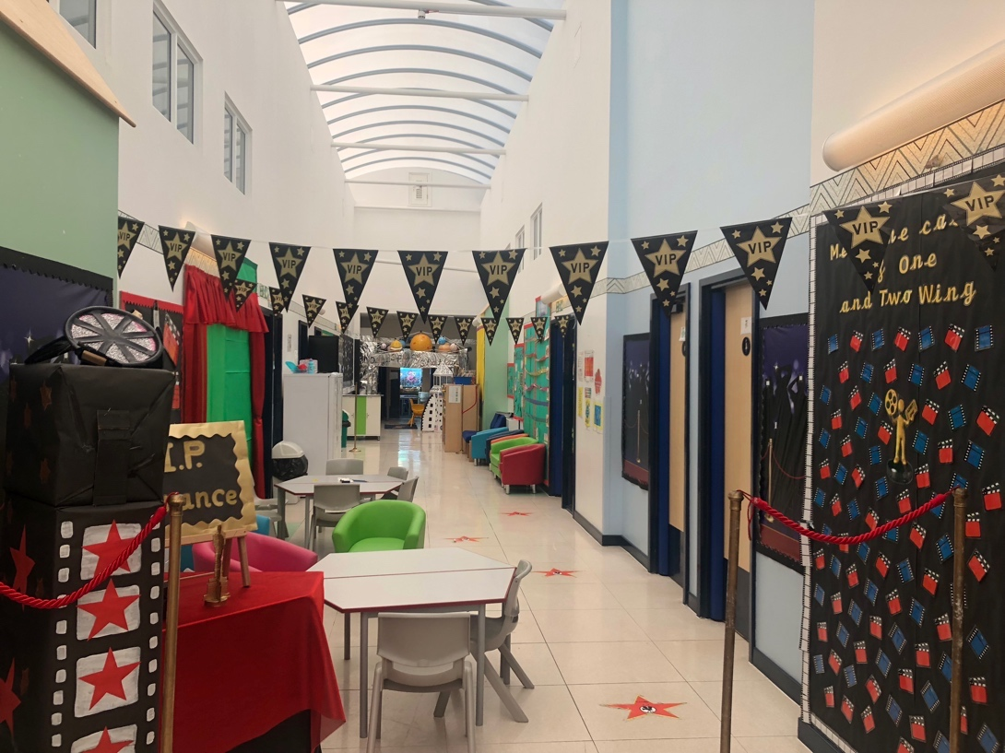
Figure 1 – The VIP area of the corridor. Photographer: Myself.

For the learning event, the pupils were grouped by ability, however the class teacher discussed that due to the recommendations of the Successful Futures (2015), usually the pupils would no longer work in ability groups however for this particular task, due to it being Literacy, it was relevant that they were. Vygotsky believed, “it is better to have learners working alongside someone at a level slightly above their own.” (Grigg, 2010, p.115) Black and Wiliam (1998) say that difficult tasks will tend to be avoided if pupils are given a choice. With such a profound emphasis on the pupil’s assessing and leading their own learning, the children observed during the learning event certainly did not display any apprehension to choosing the more difficult task. Although the pupils were given a great means of independence I had wondered how productive the pupils were when they were able to work away from the classroom setting and without an adult’s presence, I was pleasantly surprised to find how well the pupils use their independence to understand the task.
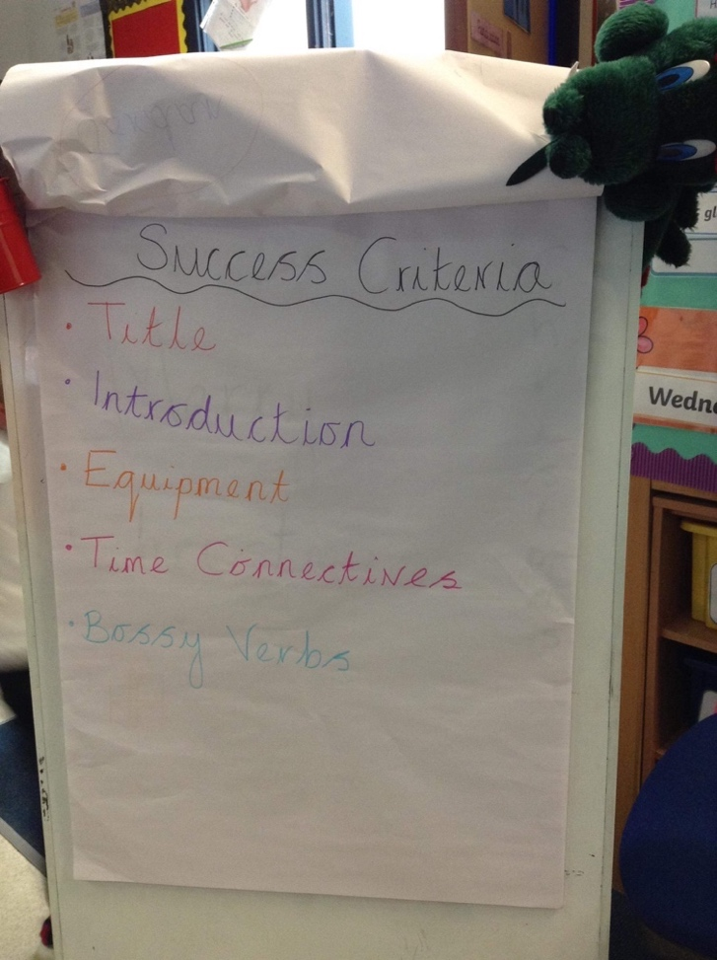
Figure 2 – A success criteria generated by a year one class. Photographer: Myself.

Once the class teacher set the pupil’s their tasks she then gave everybody a skill’s slip which is displayed in figure 3. I became very familiar with these skills slips and found them to be an incredibly beneficial and encouraging form of AfL for the pupils. A recommendation made by Black and Wiliam (1998) was that pupils should have some form of involvement in creating success criteria’s and assessment tasks. During my visit to the year one classroom I observed the pupils creating a success criteria (figure 2) as a class during a Literacy lesson. The class teacher reminded the pupils what they needed to produce showing a WAGOL (what a good one looks like) and the pupils inputted from there what they believed they would need to include to make theirs a good piece of work, the class teacher also referred back to feed forward steps from the previous lesson.
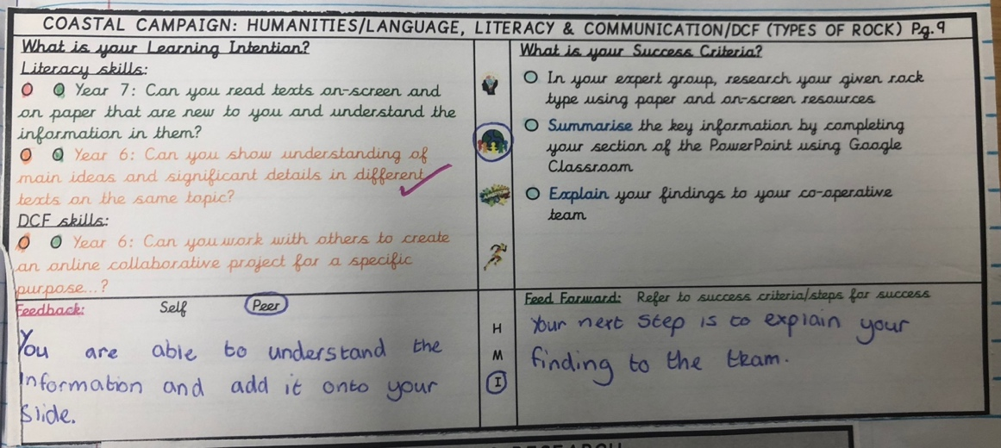
Figure 3 – A skills slip used to evaluate a piece of work. Photographer: Myself.
As shown in Figure 2, each skills slip includes a reference to the outcome that that particular task is focusing on, it is provided by page number. I sat with two pupils who were confidently able to discuss the contents of the skills slip to me. Presented in appendix B I have provided a transcript of the conversation between myself and the two pupils. At the time of the conversation the pupils were working independently in the Digi Den.

Although I had strong intentions to have a conversation myself with some pupils throughout the day, this conversation (Appendix b) was a spur of the moment discussion and I therefore did not feel it was an appropriate time to gather a piece of technology to record the conversation. I therefore used a written method to record the conversation. As it was filled with lots of content, the contents were quickly noted down at the time and once I had finished the conversation I had a couple of minutes to myself to revisit the notes to ensure I had noted everything down correctly and I had not missed any key comments as it was quite a long conversation. There were pauses between some questions as the pupil’s became distracted by other goings on in the room, this gave me a better opportunity to include details in my written method.

I found this conversation with the pupils to be highly engaging. It was enlightening to see forms of assessment and success criteria being understood by the pupils. From my own experiences if the pupil does not understand the reasoning behind using a method of assessment such as a skill’s slip and how it should be correctly used, then they can become an unreliable source of tracking and timewasting. It was clear to see the pupils using the slips throughout and referring to the success criteria during the task. The pupils read the success criteria carefully whilst colouring in the dots and did not seem reluctant at answering honestly.
By using AfL effectively it incorporates collaborative learning through peer and self-assessment. Black and Wiliam, (1998) also discuss that self-assessment can only create effective learners when the learning outcomes are clearly communicated to the pupil. I feel that the skills slips used within my learning event is proving effective on the pupil’s learning due to having clear objectives displayed, as the pupils are given the slips at the beginning of the task they have the objectives outlined. There is a continuity of using the slips throughout the school allowing the pupils to become familiar with the method. This not only develops a more effective assessment at the end of the task but also provides a higher standard of work being produced due the children being knowing what they are supposed to be doing by checking against criteria. As discussed in Appendix B the children have a clear understanding of why the skill’s slips are used and how it can help them personally achieve their goals.
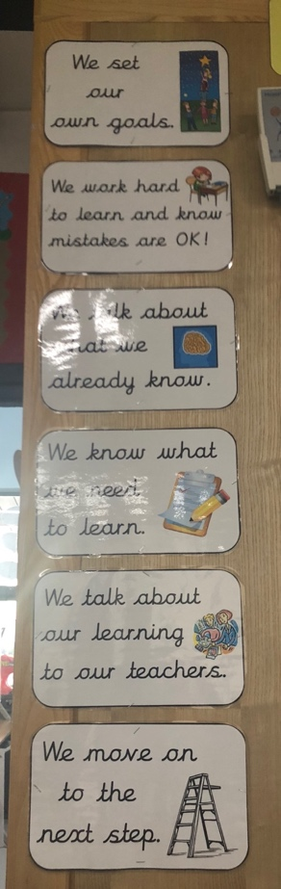
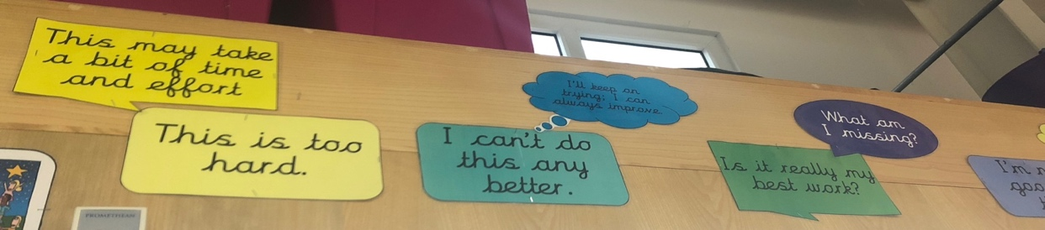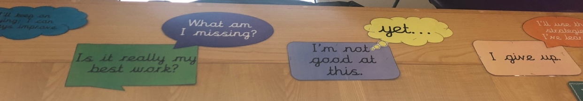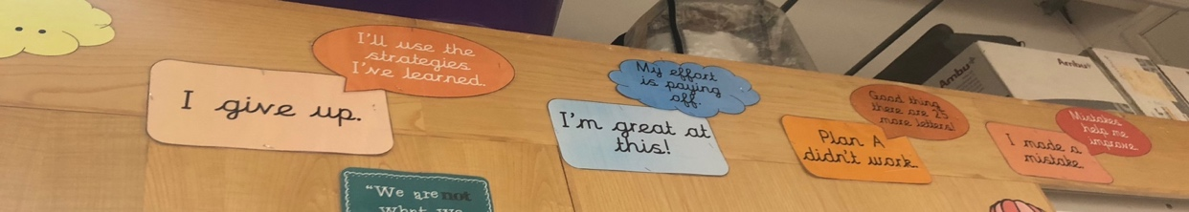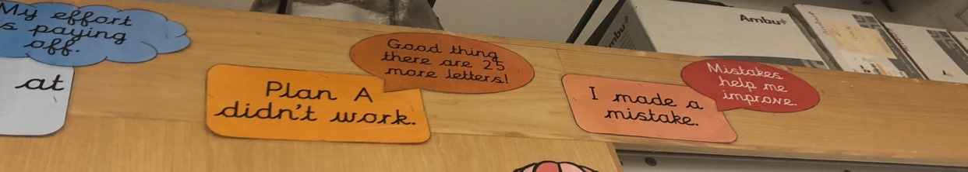
Figure 4 - Visual displays encouraging a growth mindset (Dweck, 2015). Photographer: Myself.
Shown in figure 4 there were numerous visual displays around the classroom encouraging positive attitude from the children. The class teacher has created a strong ethos of growth mindset (Dweck, 2015), in understanding getting something wrong first time is not a failure, what is important is going back and evaluating what they had done to see what they could do differently next time in order to achieve. The growth mindset (Dweck, 2015) approach encourages pupil’s beliefs that they all have room to grow their abilities. Dweck (2015) says that how children perceive their abilities is key in determining motivation and achievement. She also discusses the importance of pupil’s trying new strategies and using their peers when stuck.
Within the learning event I recognised that there were very little disruptive pupil’s in the classroom, even the lower achievers, who perhaps lack confidence, appeared to be enjoying their tasks and had the confidence to work independently. It could be said that this may be due to the high demand that the school places on the pupils holding their own responsibility for their work.
Pressure to emphasize quantity and presentation of work by the primary teacher leads to the learning quality being neglected. (Black and Wiliam, 1998) The class teacher made an interesting comment that she is trying to encourage the children to take ownership for their work, that she does not want to see rushed work or pupils over taking their friend in achieving something, she is more interested in creating lifelong learners and that the focus should be on their journey and how they get there along the way.

Lens – Learning Theories
Black and Wiliam (p.6 1998) say that there are three elements to feedback about the effort of a person trying to learn: “recognition of the desired goal, evidence about present position, and some understanding of a way to close the gap between the two.” Self-assessment helps the pupil grasp what it is they need to do to be able to achieve. Pupil’s need to be able to express that they understand how to develop their learning. (Black and Wiliam, 1998)
Alexander (2010) talks of assessment being used for two purposes, the formative, using the data which assessment provides to help the learning, and summative, a summation of a results of learning at one point in time. The summative can often be displayed in the form of grades or scores. Black and William (1998) discuss AfL as being at the heart of effective teaching. Formative assessment is the process of finding, deepening and furthering a pupil’s learning and not just measuring it. There is less demand for the teacher to be the controller as there is for them to become the co-ordinator within the classroom. (Clarke, 2005) AfL requires the teacher to be flexible with their planning, Alexander (2010) calls it the cyclic process, in which the teacher needs to gain an understanding of the pupil’s current understandings and skills using observation, careful questioning, gathering pupil’s views and studying pupil’s work. The information they gather through doing this needs to be interpreted in relation to the lesson aims and determine the pupil’s next steps in learning. (Alexander, 2010)
Black and William (1998) remind us however that AfL is not new to teaching. They discuss that formative assessment is not an instant quick fix for raising educational standards, therefore consolidating the importance of assessment concepts needs to be adapted throughout the pupil’s whole school experience.
Hattie (2012) talks of the difficulty’s children face in differentiating between the performance related goals of the task and the mastery-related goals. Much like Nottingham (2013) who discusses that it is far better to focus on the learning goals rather than the performance goals, he says that teachers should be focusing on where the individual child needs to go next regardless of where their peers may stand. If teachers attempt to deliver a learning experience in this way, formative assessment can tend to have a large influence on the lower achievers.
Black and Wiliam, (1998) are not against testing, rather there should be more frequent short testing done in the classroom, than long infrequent ones. Testing questions needs to be relevant to the learning information and it is required throughout the topic, when effective feedback can be given, rather than simply a result at the end. Questioning and deep thinking is needed, as pupils learn from discussion, they need to develop the critical evaluation skill and see the environment from the viewpoints of others. (Hattie, 2012) By dispersing the pupil’s into independent zones together, this gives them opportunities to have discussions with one another.
A video created by Estyn in (2017) discusses that successful schools facilitate, demonstrate and collaborate learning. A key skill in teaching is knowing when to intervene in a child’s learning and when to allow them the time to investigate for themselves. Psychologist Lev Vygotsky (1962) developed the Zone of Proximal Development (ZPD), a model referring to the difference between what the learner can do independently, and what the learner can do with guidance and support from a more skilled person. The proximal zone refers to the stage at which the learner is at, where they are close to mastering the skills. (McLeod, 2018) Within this zone the more knowledgeable person is able to use a scaffolding approach to encourage the learner in developing the skill. Scaffolding, a term first devised by Wood, Bruner and Ross (Cited in Alexander, pg. 11, 2004) is the “use of carefully structured interventions to bridge the zone of ZDP.” Estyn (2017) also talk of how it is good for adults to monitor each other as well, to understand the pedagogy behind what one another is doing.
When children first enter schools at early years there is an expectation of what they should be able to do. As time progresses there is a decrease in the number of basic skills children are starting with. Piaget was a Constructivist and viewed knowledge as being constructed by the learner’s response to the environment. (Berkley Graduate Division, 2018) Piaget was one of the first theorists to challenge Pavlov’s Behaviourist approach, he believed that this type of approach did not encourage the understanding of the learning. (Gray and Macblain, 2012) The Behaviourist theory deems the learning by the pupil to come from a conditioned response to external stimuli. (James, 2006) It can focus on formal testing of the pupil. Pavlov’s theory worked on the assumption that a child produces a learned response that, once shaped, is very rarely altered when revisited by the brain. (Nebel, 2018) Through the use of praise and rewards this theory can be argued to achieve only the summative of the learning, this behaviour is made up of a formation of habits, such as children reciting their times tables or the alphabet, they are able to recite a sequence but if questioned of processes within that sequence it’s debated that they wouldn’t be able to show reasoning. The behaviourist approach focuses on the observation of outcome rather than the observation of processes. Only determining success through correct or incorrect answers and positive or negative behaviours. (James, 2006)
However, Piaget was an advocate for observation of processes, stepping back and allowing children the uncontrolled opportunity to explore. The initial observations Piaget undertook were that of the observations of his own children. According to Piaget’s theory of cognitive development (1936) there are four stages to cognitive development all children must pass through, the stages occur at certain ages of a child’s development and they cannot pass through a stage or return to an earlier stage later on in their development.
“Piaget’s four stages of cognitive development;
- Sensorimotor (0-2 years)
- Pre-operational (2-7 years)
- Concrete operational (7-11 years)
- Formal operational (11-15 years)”. (Gray and Macblain, p.46, 2012)
Therefore, it can be said from this study that no matter how high the child’s ability, before that specific age the child will not be able to understand things in certain ways.
Petty (2009) claims that in order to create a deep learning classroom environment then teachers need to follow the Constructivist teaching methods. Petty, (2009) discusses that learning is not simply about remembering and recalling information, but it is about making sense of the learning. The constructivist approach includes encouraging reasoning not simply repeating what they have learnt, time to think and then discuss their knowledge – this develops a high participation rate also and gives feedback on their understanding. (Petty, 2009) This is where we can begin to think about the uses of AfL, success criteria’s and feed forward approaches allow the learner to use their prior knowledge and make connections within the environment. Sadler (cited in Hattie, 2012) discussed that the gap between where the pupil needs to be and where they currently are, can be bridged through feedback. Hattie (2012) discusses three key questions that feedback should address;
- Where am I going? – Children need to understand the learning intentions and the skills aiming to be developed.
- How am I going there? – Providing formative feedback that is relative to the success criteria. Teachers must encourage children to be “instructional resources” to each other.
- Where to next?
Much of the research and discussions on AfL discuss the need to break away from a performance culture and focus the classroom on becoming a learning culture, “effort needs to be recognised rather than ability.” (Clarke, 2005, p.7) A report by the Organisation for Economic Co-operation and Development (2005) also raises the importance of formative assessment developing the emotional competencies of the child, it creates a sense of self-awareness, compassion, self-control, and the ability to reason, to name a few. They go on to say that the child must be able to regulate his or her own learning.
In contrast to Jean Piaget, Black and William (1998) discuss AfL consisting of collaborative learning between pupil’s, their teachers and other fellow pupil’s. At the heart of AfL pupil’s need to discuss and be able to communicate their learning and feedback. Lev Vygotsky (1978) (Berkley Graduate Division, cited 2018) argues that Piaget failed to understand the collaborative process which learning has and has overlooked the social behaviours of language use that pupil’s need to be able to develop their cognitive development. It could be said here that the AfL I observed is not only about observing, there is a social-constructivist approach to the method too. Cambridge (2017) discusses the close link between AfL and the social-constructivist theory, that the quality of feedback and discussion is critical in understanding a pupil’s learning. By allowing the learners to discuss with other pupils and teachers about their work they are developing a rich bank of language and are able to communicate and receive ideas. Children need to be given the challenge to explore and develop their cognitive skills through problem-solving and learn how to share their ideas with one another. Individual thinking can be developed through the considerable role of language. (Grigg, 2010)
Nottingham (2013) says that without knowing how to learn then children cannot become independent or adaptable learners. He discusses thinking skills such as appropriate questioning, reasoning and understanding concepts as being vital in learning how to learn. “Good thinking is flexible, insightful and productive.” (Nottingham, 2013, p.59) Benjamin Bloom (1956) has played an influential role in the study of thinking skills, creating a taxonomy of objectives. (Grigg, 2010) The revised taxonomy consists of a hierarchy of thinking skills that undermines the processes in which children learn. (figure 5) We should be promoting pupils to think creatively and respond to their own learning, using AfL encourages pupils to analyse and evaluate what they have learnt, AfL also creates an opportunity for the pupil to make the connections between their knowledge.

Creating
Remembering
Understanding
Applying
Analysing
Evaluating
Figure 5 – Blooms Revised Taxonomy (Grigg, 2010)
McCallum (2000) argues that in class sizes of today it is usually difficult for teachers to focus on assessment on each individual pupil, recommending that formative assessment be made in small group tasks if a positive effect wants to be seen. By having one focus task going on in the classroom at a time, the teacher I observed was able to do this. Using the rotation method with a focus task the teacher said she felt it gave her much more of an opportunity working with the pupils one to one. She felt she came away from the lesson feeling that she was able to provide honest feedback to other members of staff on how each individual pupil had found the difficulty of the task and reflect back on who required slightly more support than others.

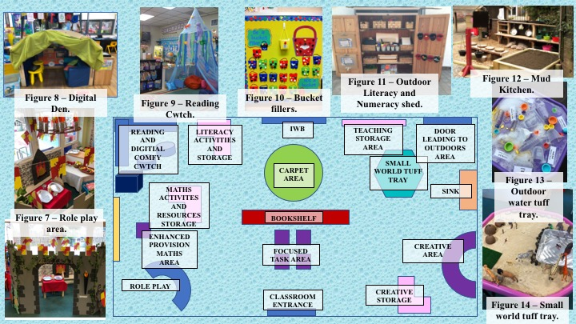
After studying the learning theories discussed, I feel the school I visited takes both a social-constructivist and constructivist approach to its teaching and learning. I feel it works so effectively due to the whole school taking on board the same approach, there is a consistency towards independent and reflective learning throughout each and every pupil’s school journey. I will be using this experience of AfL in my own teaching practice as it promotes pupil independence and ownership of development.

My Ideal Learning Environment.
I have focused my ideal learning environment poster around the Foundation Phase.
As we enter an exciting new step within Education in Wales, Donaldson (2015, p.31) discusses a point within the purpose “Healthy, Confident individuals”, that pupils should “be building their mental and emotional well-being by developing confidence, resilience and empathy.” Michael Lewis (cited in Doherty and Hughes, p.339) writes that “emotions and their development are tied to cognitive development.” Within my ideal learning environment, I felt it was important to include an area of the classroom where the children are able to comfortably present and discuss their feelings. (Figure 6) Doherty and Hughes (2009) discuss the importance of communicating feelings and interpreting other people’s emotions, as being a predominant step in a child’s current wellbeing and emotional development. Having an interactive feelings board within the classroom offers an accessible way for the staff to monitor how pupils are feeling, it bridges the gap between the pupils who are more introvert, who struggle to discuss their anxieties or worries, and their teachers, allowing opportunity for staff to develop relationships with these children. A tool such as this can support the development of the positive relationship which Donaldson (2015, p.31) discusses within the “Healthy, Confident individuals” purpose, which our children will be able to build upon based on mutual trust and respect. Not only do the feelings boards help in generating one-to-one talks between the pupil and teacher but it also helps to develop the pupil’s empathy towards one another in the class and understand how and why others may be feeling the way they do.
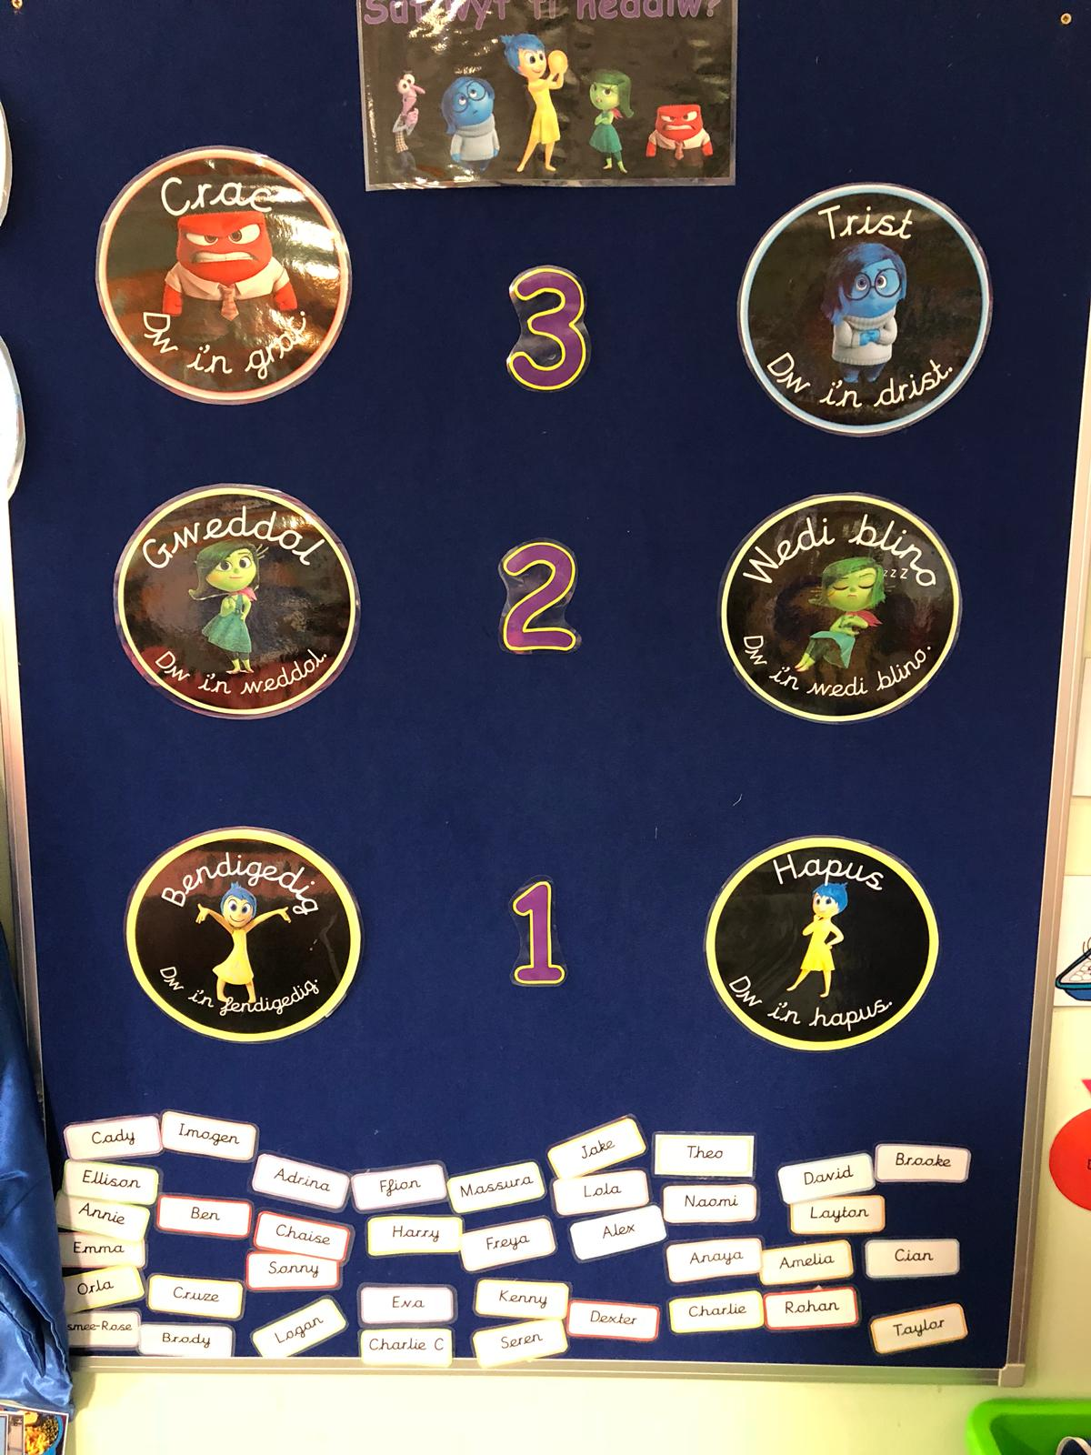
Figure 6 – Visual feelings board. Photographer: Myself.
In light of the “Ethical, informed, citizens” purpose proposed in the report (Donaldson, 2015, p.31) I feel that some behaviourist methods of classroom management would need to be included in the environment. According to Donaldson (2015) children need to understand that the impact of their actions and choices can have consequences. In many of the classrooms I visited, the teachers have taken the “Bucket Fillers” (figure 10) discipline system on board. This system uses the operant conditioning approach (Skinner, 1938) whereby the children behave in a positive manner such as good effort, an act of kindness, to receive a pom pom in their bucket, they also avoid negative behaviour and perhaps think before they do more often, due to worries of losing a pom pom in their bucket. The teacher is adding a stimulus to behaviour as the buckets are then counted at the end of the week and the child with the most pom poms receives a reward. Through operant conditioning, in time the child will make the connection between behaviours and consequences. (Skinner, 1938)
The use of ICT within the classroom has been rapidly increasing over the last 20 years. Many current trainee teachers would have experienced their school years during a period when new technologies were being developed continually, and we are now teaching in a Digital Age. (Alexander, 2010; Levy, 2010; Childwise, 2012) cited by Burnett (2016) discuss how many young children of today now enter educational settings already with an extensive understanding and experience of digital technologies. This however, does not mean that they are equipped with the relevant understanding of the safeties of technologies and how the processes work. A report by Ofcom (2017) stated that 53% of 3-4-year olds and 79% of 5-7-year olds are now online, a growth that has developed due to the use of tablets. If children are using technologies to this extent, then it is important that we use the Digital Competency Framework (2018) to our very best to ensure that children are using the correct technology skills inside and outside of the classroom. Incorporating technology into our lessons will prepare pupils for their future in careers, as the creative uses of Digital Competency Skills are becoming increasingly common in the modern workplace. (Donaldson, 2015) An effective learning environment considers the inequalities associated with technologies such as socio-economic, gender and ethnicity. I would therefore ensure that there was a variety of equipment available to the children such as desktop computers, laptops and iPads, enough so that each child had a fair opportunity to develop their skills. Integrating such forms of technology into the everyday routines of the classroom will encourage the pupil to be able to use technology for shared, social, creative, collaborative and empowering purposes. (Burnett, 2016) As discussed in the former section of this essay we are encouraging learners to explore the environment for themselves, ICT, if used in the correct way, can facilitate the child’s learning providing them with a vast array of knowledge and information to develop their learning. I would create a “Digi Den” area (figure 8) in the classroom where the children can take time out to use the technologies away from distractions, I would place this next to a quiet comfy reading area. (Figure 9)
It can be argued within the Digital Age we are currently in, that pupils are spending too much of their time sitting down, indoors on technology. The outdoors is a vital tool in engaging children with the natural world, experiencing the ever-changing weather and the local environment around such as a local beach and forests. The outdoors is a wonderful resource for learning that can be enjoyed by children of all ages, and also the staff too. It can be said that whilst in the outdoors children often don’t realise that they are learning. As discussed by White (2011) there are a vast amount of benefits for the children from learning in the outdoors, social interaction, exploring the environment and understanding care for living things, and the curiosity and fascination this kind of learning environment brings, to name a few. Outdoor learning connects us to the physical, natural and human world. (White, 2011) It should be important to remember that Outdoor Learning is not just about bringing a classroom lesson to the playground, pupils can build a sense of community through connecting them to the human world, taking visits to the local library or shop and familiarising the pupils with the real world. To provide an effective outdoor learning area, teachers need to develop a well-provided, stimulating area with enticing resources that give the pupil opportunities for productive child-led learning. In doing so we must remember to keep the link between the indoor and outdoor learning. Within my outdoor learning area, I would include a mud kitchen (figure 12) which can be used for a variety of different purposes within the child’s learning experience. Mud kitchens are a useful resource that enables the child to be engaged and exploring outdoors, children are able to bring nature together with real-life situations whilst they could be role-playing. An outdoor station such as this develops the child’s social skills as they communicate with one another and it can also create discussions between the child and teacher as the child becomes eager to talk with the adult about what they have been creating using nature. I would want to keep the connection between the indoors and the outdoors and would place a Literacy and Numeracy shed (figure 11) outside, this would be equipped with classroom resources such as papers, pencils and scissors so that the children have constant access to such resources.

Estyn provides a vast amount of case studies on educational settings who share good practice of outdoor learning. Mrs Tiggywinkles in Blaenau Gwent for instance, uses the outdoors area for focused teaching and child-initiated play. The staff at the nursery ensure they use each season to their advantage, they promote care for the environment and teamwork through using the allotment and grow tent to teach the children about growing vegetables and selling these to shops. (Estyn, 2016) The inspection report states that free flow from the indoors to the outdoors supports children's independent learning choices exceptionally well. (Estyn, 2016)

An exciting role play or small world area (figure 8) within a learning environment can provide a wonderful form of continuous provision for a child through play, developing the use of language, making sense of the world for themselves and communicating with one another. Estyn (2011) describes a role play area as well-resourced, exciting and stimulating. Following the social-constructivist view, Vygotsky believed that social interaction and cognitive development work together. Susan Issacs’ (cited in Mickelburgh, 2018) studies discuss the importance of play, she discussed play as being a means for a child to express their emotions and deal with their feelings in a safe environment. Role play provides the opportunity for imagination and exploration of the world around them to take place. By being given the free-flow to communicate with one another and solve problems together cognitive skills begin to develop as the children are on their own to figure out processes. A role play area not only develops the use of language, but it can also incorporate Literacy and Numeracy, it may be a shop environment where the children are using money, or a restaurant requiring lists to be made.
Conclusion
The observation I made explored a number of techniques showing Assessment for Learning being used within the classroom. Success criteria’s, assessment slips and constructive feed forward inputs all have a great impact on the pupil being able to reflect on and have a better understanding of their learning. Much of the literature published on Assessment for Learning discusses the importance of the pupil mastering the skill rather than competing with their peers. The observation witnessed took on both a Piagetian constructivist and Vygotsky social-constructivist approach towards cognitive development in the pupils. My visit to the school also enabled me to develop a greater understanding of the importance of a well-planned out learning environment. The new curriculum is encouraging learners to be “Ambitious, capable, learners” (Donaldson, 2015, p.31) and providing a rich environment full of resources and language sets the drive for that type of learner.

Reference List
Alexander, R. (2010) Children, their World, their Education. 1st Ed. Oxon: Routledge.

Alexander, R. (2004) Towards Dialogic Teaching; Rethinking classroom talk. 2nd Ed. Dialogos UK Ltd.

Berkley Graduate Division (2018) Graduate Student Instructor: Social Constructivism. Available at: https://gsi.berkeley.edu/gsi-guide-contents/learning-theory-research/social-constructivism/ (Accessed on: 13th October 2018).

Black, P. and Wiliam, D. (1998) Inside the Black Box: Raising Standards Through Classroom Assessment. Phi Delta Kappa International.

British Educational Research Society (BERA). (2018) Ethical Guidelines for Educational
Research. 4th Ed. London: BERA. Available at: https://www.youtube.com/watch?v=lq_v8LLsacQ (Accessed: 10th October 2018).

Burnett, C. (2016) Research Reports: The Digital Age and its Implications for Learning and Teaching in the Primary School. Cambridge Primary Review Trust. Available at: http://cprtrust.org.uk/wp-content/uploads/2016/07/Burnett-report-20160720.pdf (Accessed 14th October 2018).

Cambridge Assessment International Education. (2017) Assessment for learning. Available at: http://www.cambridgeinternational.org/images/271179-assessment-for-learning.pdf (Accessed on: 10th October 2018)
Clarke, S. (2005) Formative Assessment in Action. 1st Ed. Oxon: Bookpoint Ltd.

Doherty, J. and Hughes, M. (2009) Child Development. 1st Ed. England: Pearson Education Limited.

Donaldson, G. (2015) Successful Futures: Independent Review of Curriculum and Assessment Arrangements in Wales. Available at: https://gov.wales/docs/dcells/publications/150225-successful-futures-en.pdf (Accessed: 13th October 2018)

Dweck, C. (2015) Carol Dweck Revisits the “Growth Minset”. Available at: https://www.edweek.org/ew/articles/2015/09/23/carol-dweck-revisits-the-growth-mindset.html (Accessed on: 13th October 2018).

Estyn. (2017) Addysgu ac asesu / Teaching and assessment. Available at: https://www.youtube.com/watch?v=lq_v8LLsacQ (Accessed: 13th October 2018).

Estyn. (2016) A highly effective outdoor learning environment. Available at: https://www.estyn.gov.wales/effective-practice/highly-effective-outdoor-learning-environment (Accessed: 14th October 2018).

Estyn. (2016) Encouraging Independent Learners. Available at: (URL removed for anonymity).

Estyn. (2016) Inspection report (name removed for anonymity) 2017. Estyn, Her Majesty’s Inspectorate for Education and Training in Wales.

Estyn. (2011) Literacy and the Foundation Phase: An evaluation of the Foundation Phase for five to six-year-olds in primary schools, with special reference to literacy. Available at: https://www.estyn.gov.wales/sites/default/files/documents/Literacy%20and%20the%20Foundation%20Phase%20%20-%20September%202011.pdf (Accessed on: 13th October 2018).

Gray, C. and Macblain. S. (2012) Learning Theories in Childhood. 1st Ed. London: SAGE Publications.

Grigg, R. (2010) Becoming an outstanding Primary school teacher. 1st Ed. Oxon: Routledge.

Hattie, J. (2012) Visible Learning for Teachers. 1st Ed. London: Routledge.

James, M. (2006) ‘Assessment, Teaching and Theories of Learning’, in Gardner, J. Assessment and Learning. London: SAGE.

McLeod, S. (2018) The Zone of Proximal Development and Scaffolding. Available at: https://www.simplypsychology.org/Zone-of-Proximal-Development.html (Accessed on: 11th October 2018).

McCallum, B. (2000) Formative assessment – Implications for classroom practice. Available at: http://dera.ioe.ac.uk/4565/1/formative%281%29.pdf (Accessed on: 12th October 2018).
Mickelburgh, J. (2018) Educational Pioneers: Susan Isaacs, 1885-1948. Available at: https://eyfs.info/articles.html/teaching-and-learning/educational-pioneers-susan-isaacs-1885-1948-r40/ (Accessed on: 11th October 2018).

Nebel, C. (2018) Behaviorism in the Classroom. Available at: http://www.learningscientists.org/blog/2017/8/10-1 (Accessed on: 12th October 2018).

Nottingham, J. (2013) Encouraging Learning: How you can help children learn. 1st Ed. Oxon: Routledge.

Ofcom. (2017) Children and Parents: Media Use and Attitude Reports. Available at: https://www.ofcom.org.uk/__data/assets/pdf_file/0020/108182/children-parents-media-use-attitudes-2017.pdf (Accessed on: 7th October 2018).

Organisation for Economic Development (OECD) (2005) Formative Assessment Improving Learning In Secondary Classrooms. OECD Publishing. Available at: https://books.google.co.uk/books?id=4IDVAgAAQBAJ&printsec=frontcover&dq=journal+article+assessment+for+learning&hl=en&sa=X&ved=0ahUKEwiiyLSnp4neAhWKT8AKHSO7BsIQ6AEIMzAC#v=onepage&q&f=false (Accessed on: 13th October 2018)

Petty, G. (2009) Evidence-Based Teaching. 2nd Ed. Oxford: Nelson Thornes Ltd.

Welsh Government. (2018) Digital Competency Framework. Available at: http://learning.gov.wales/resources/browse-all/digital-competence-framework/?lang=en (Accessed on: 3rd October 2018).
White, J. (2011) Outdoor Provision in the Early Years. 1st Ed. London: SAGE Publications.
Figures Reference List
Figure 1 - VIP area of the corridor at (Name of school removed for anonymity). Photographer: Me.
Figure 2 – A success criteria generated by a year one class at (Name of school removed for anonymity). Photographer: Me.
Figure 3 – A skills slip used to evaluate a piece of work. (Name of school removed for anonymity). Photographer: Me.
Figure 4 – Visual displays in the classroom encouraging a growth mindset. (Name of school removed for anonymity). Photographer: Me.
Figure 5 – Blooms Revised Taxonomy. Grigg, R. (2010) Becoming an outstanding Primary school teacher. 1st Ed. Oxon: Routledge.
Figure 6 – Visual feelings board. (Name of school removed for anonymity). Photographer: Me.
Figure 7 – Role play area of the classroom. (Name of school removed for anonymity). Photographer: Me.
Figure 8 – Digital Den in the classroom. (Name of school removed for anonymity). Photographer: Me.
Figure 9 – Reading cwtch. Pinterest. Available at: https://www.pinterest.co.uk/pin/173177548154934643/ (Accessed on: 12th October 2018)
Figure 10 – Bucket Fillers display. Pinterest. Available at: https://www.pinterest.co.uk/pin/450148925228238873/ (Accessed on: 12th October 2018)
Figure 11 – Outdoor Literacy and Numeracy shed. Pinterest. Available at: https://www.pinterest.co.uk/pin/AUhD9X9PMXBlxiMDUwTc2R_2fIi6ViloH8ozP50Zi_i7-EvVmwjHsBY/ (Accessed on: 12th October 2018)
Figure 12 – Mud Kitchen. Pinterest. Available at: https://www.pinterest.co.uk/pin/317433473718764125/ (Accessed on: 12th October 2018)
Figure 13 – Outdoor water tuff tray. (Name of school removed for anonymity). Photographer: Me.
Figure 14 – Small world tuff tray. (Name of school removed for anonymity). Photographer: Me.

Appendix
Appendix A
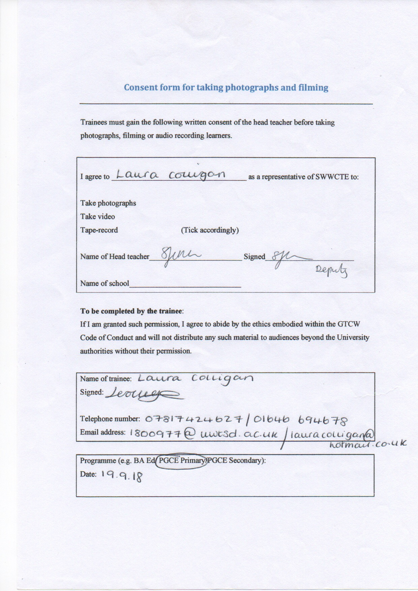

Appendix B
A transcript of a conversation between myself and two pupils.
Me: (Pointing to the left hand half of the slip, Figure 2) What does this tell us?
Child 1: So this side is the Learning Intention and what it means is that the year 6 is what we should be able to now and the year 7 skill is what we are aiming to be able to do for year 7.
Me: I see, and what do these two little dot’s next to the skills mean?
Child 2: So we have to colour the first dot in with either red, orange or green before we start the task, and then we colour the second dots in after we finish the task.
Me: What does red, orange and green stand for?
Child 2: Green means that you really really liked the task, like you found it easy and could do it.
Child 1: It means you were confident.
Child 2: Yeah, and orange means that it was ok but maybe you’d like to have another go. And then red means that you really didn’t like it and you needed help and you didn’t get it.
Me: Thank you, that’s interesting. Now what about this side? (Pointing to the right hand half of the slip, Figure 2)
Child 2: That is our success criteria and you need to fill that in when you do the task.
Me: So would you fill that in before you started the work?
Child 1: No we colour that in when we’ve finished.
Me: Do you use the same colours, red, orange and green?
Child 2: Yeah. So Miss might go through then at the end and we look at our work and decide if we’ve done it or not.
Me: I can see down here you have a box that says feedback, do you peer assess your work sometimes?
Child 1: Yeah, sometimes we will give each other our work and write something and sometimes we will write on our own work.
Me: When somebody else in the class writes feedback for you do you take notice of what they’ve said and read it?
Child 1: Yep.
Child 2: And then in this box (pointing to the box entitled Feed Forward) we write what we are gonna do next lesson.
Me: If you have some oranges and reds coloured in on your success criteria could you put those in as your targets for next time?
Child 1: Yes sometimes Miss will tell us we need to improve something.
Me: Well you have both been very helpful to me! It’s very interesting. Do you find using these slips helpful to you?
Child 1: Yes definitely.
Child 2: Yeah
Me: There’s a lot on here isn’t there, I’ve just noticed these what are they? (Pointing to the Four Purposes images down the centre of the slip)
Child 2: So these are our Successful Futures targets, you can see them over there. (Points to the large display on the wall of Donaldson’s Four Purposes and the corresponding images)
Child 1: So it’s a purpose and you decide which one we’ve learned in this lesson, like today we have learnt..(Looks at the wall for a moment to remind themselves of the titles) being Ethical and Informed Citizens.
Me: Wow I am very impressed, do you use these purposes all the time?
Child 1: Yes most of the time. They are new. And we’ve got it all on the wall over there. (Points to four purposes descriptions)
Me: What does H, M, I stand for? Do you have to circle one of those aswell?
Child 1: You circle H if you found it really hard and needed a lot of help from Miss, couldn’t do it on your own. You circle M if you found it ok, liked it, maybe needed a bit of help. Then I means independent.
Me: How does Mrs (name removed for anonymity) mark and assess your work for you?
Child 1: Miss uses two different coloured pens to mark our work. She uses a pink pen and this is where she has been tickled pink, and is really impressed with what we’ve done.
Child 2: Or she uses a green pen to mark what we’ve done wrong.
Child 1: No it doesn’t mean we’ve done the work wrong but she wants us to change it.
Me: (Looking at previous pieces of work in the exercise book for examples) So I can see a piece of work here where a green and pink pen has been used, the green pen is used to ask you expand on something you’ve written? Explain your answer?
Child 1: Yes we normally have to go back to the work and change it.

