Hilton: Digital Nomads

Name: Mihaela Robutu
Student number: 2245306
Module: Marketing Essentials (BMIH4005)
Lecturer: Scott James

Component 1: Brand for Digital Nomads by Hilton

Introduction
The purpose of creating a new brand that targets the emerging segment of digital nomads is to capture a profitable and growing market, differentiate from competitors, and align with vision and values. The marketing plan for the new brand is being prepared for the senior management team at Hilton who will then review and approve the proposal prior to launching the brand. The plan, which will be developed using SOSTAC, 4Ps, and Ansoff’s matrix to evaluate the current situation, plan, strategise and implement will also be shared with other stakeholders like investors, partners, employees, customers, and suppliers.

Situation Analysis
Company
Hilton is a leading hospitality firm in the world with a million rooms in at least 7,000 properties operating in 113 countries and territories and seventeen brands. Hilton has a strong brand reputation, loyal customer base, diversified portfolio, global presence, and digital capabilities. It faces some challenges such as high dependence on franchising, limited presence in emerging markets, high debt level, and the impact of the COVID-19 pandemic ( Nador and Rašovská 2023). Hilton also faces some threats from competition, regulatory and political uncertainties, and environmental risks and costs.
Customers
The target market for the brand is digital nomads who are different from other travellers and are willing to pay for experiences that meet their expectations. In the United States alone, there were about 10.9 digital nomads, and the global market is expected to reach $1.2 trillion by 2035. Digital nomads will be aged between 25 and 35, be male or female, earn $50k to $100k, have at least a bachelor’s degree, and work as freelancers, entrepreneurs, consultants, and remote workers (Statista Research Department 2023). They are adventurous, flexible, open-minded, experiential, autonomous, and optimistic (Bonneau and Aroles, 2021). They live anywhere in the world but will come from the United States, United Kingdom, Canada, Germany, Thailand, Israel, Netherlands, and Australia, among others, as shown by website analysis on Similar Web. The Similar Web analysis also shows that traffic tends to come from organic sources, direct, social, referral, and display. Digital nomads travel frequently, spend a week to a month, travel for work or leisure, have a moderate to high budget, will book online, and can be Hilton honors members.
Competitors
The main competitors for Hilton’s new brand include other hotel chains and alternative accommodation providers that cater to digital nomads including Selina, Remote Year, and Outside as Gigauri, (2019) outlines. On the perpetual positioning map, Hilton has higher prices and higher quality, Selina is a mid-range option, while Outside and Remote Year are budget friendly with some quality sacrifices.
Collaborators
Hilton has many collaborators that must be involved including franchisees, suppliers, distributors, employees, and customers.
Climate
External factors that have impacted Hilton include technological advancements, cultural diversity, unemployment, inflation, the COVID-19 pandemic, United States-China trade war.
Objectives
As Zia, Younus and Mirza (2021) suggest, the main objective of the marketing plan is to launch and establish Hilton’s new brand for digital nomads in the global market and achieve the following SMART target:
- To increase Hilton’s market share in the digital nomad segment by 10% within one year of launching the new brand
- To generate $100 million in revenue from the new brand within one year of launching
- To achieve an 80% customer satisfaction and retention rate for the new brand within one year of launching
- To create strong brand awareness and recognition for the new brand among digital nomads and potential customers within one year of launching
Strategy
The new brand for digital nomads will have the value proposition of providing a flexible, convenient, and connected coworking and co-living experience for remote workers. The brand will have coworking spaces, social events, different accommodation options, long-stay discounts, and local experiences. Based on Ansoff’s matrix, the firm will use the product development strategy, whereby it will add a new brand to the hospitality industry (Clarissia and Mohamed, 2019). In the marketing mix, the product will be expanded to include high-speed internet for digital nomads. prices will be made dynamic and flexible depending on the season, demand, duration of stay, and destination. Distribution will be primarily online through direct bookings, global distribution systems, and online travel agencies, and locations will include select locations like cultural hubs, urban centres, and scenic spots (Hannonen et al. 2023). Promotion will use digital marketing like influencer marketing, blogs, podcasts, webinars, and magazines among others.
Tactics
The tactics for implementing the proposed marketing strategy will be based on the reach, act, convert and engage elements of the RACE framework, and the communication mix model according to Muhammad et al.(2019). In the reach stage, the objective will be to create awareness and interest in the new brand using channels and tools like online media, offline media, and word-of-mouth (Mahaputra and Saputra, 2021). Relevant and engaging content from the new brand will be shared on blogs, podcasts, videos, and webinars to showcase benefits and features. Magazines, radio, television, and newspapers will be used for advertising and presenting stories that highlight its positioning and market proposition (George, 2021). The new brand will incentivize influencers and existing customers to share positive feedback with their platforms and networks.
The act stage will be aimed at encouraging interaction with the new brand using channel tools like the website, app, and email. The brand will have a website that will provide a comprehensive and user-friendly booking engine and information ( Bhandari and Sin, 2023). Chatbot that will give customers personalized and instant assistance for them to engage on the go, including checking in, checking out, digital keys, and loyalty programs. Email will act as a marketing tool and offer reminders and confirmations.
The convert stage will aim to persuade customers to make a booking using pricing strategy, distribution channels, and sales promotions. the pricing strategy will be value-based, distribution will be multichannel, and sales promotion will be done using giveaways, sweepstakes, and contests as Ibrahim and Wang (2019) elaborate. The convert stage will ensure that customers commit by appealing to their needs and interests.
In the engage stage, the objective will be to achieve customer loyalty and get the customers to be brand advocates using channels and tools like customer service, experiential marketing, and feedback and reviews (Ihtiyar, Barut and Ihtiyar, 2019). Experiential marketing will take the form of tours, events, and workshops that will provide meaningful and memorable experiences for customers during their stay. Feedback will be used to gauge satisfaction, generate word of mouth, and identify areas for improvement.
Action
The point-per-click, social media, email, online discounts, referral points and existing customers elements of marketing communication will be done continuously because it is usually lower cost than other approaches, and digital nomads are always usually online. The radio advertising will be done intermittently whenever the business needs to reach new customers, which means structuring it around the times when the business will need to give offers to customers ( Rubio and Martínez, 2021). Television advertising tends to be highly effective, but it usually costs more, which means it will need to be done continuously at a time when it will be possible to reach more digital nomads, like when they are most likely to be at work and traveling.
Control
KPIs and metrics that will be used to ensure that the business meets its objectives and targets will include market share, revenue, customer satisfaction, customer retention, brand awareness, and brand reception (Matsuoka, 2022). Market share will be the percentage of the digital nomads captured by the brand compared to competitors while the revenue will be the amount of money the new brand makes from customers. Customer satisfaction will use reviews and feedback to determine customer experience with the brand, and customer retention will be measured using referrals and the Hilton loyalty program. Brand awareness will be measured from online and offline media exposure and reach, and brand perception will be based on sentiment and reputation from all media.
Conclusion
The marketing plan for the new brand for digital nomads by Hilton will be comprehensive and strategic so that the new brand is launched and established for the global market. While the marketing plan is based on situation analysis, marketing strategy, and effective marketing tactics, it faces challenges like competition from hospitality providers, uncertainty and volatility in the external environment, and the complexity and diversity of digital nomads. To overcome these challenges, Hilton will need to conduct regular market research and analysis, highlighting the value proposition of the new brand to differentiate it and build strong relationships with customers.

References List
Bhandari, R. and Sin, M.V.A. 2023. Optimizing digital marketing in hospitality industries. Startupreneur Bisnis Digital (SABDA Journal) 2(1).
Bonneau, C. and Aroles, J. 2021. Digital nomads: A new form of leisure class? In: Experiencing the New World of Work. Cambridge University Press, pp. 157–177.
Clarissia, M. and Mohamed, J. 2019. A study on Ansoff Matrix Technique: As a growth strategy and an adaptive learning technique adopted in the leading brand of products. Journal of Composition Theory 12(9), pp. 1494–1506.
George, R. 2021. Digital Marketing in Tourism and Hospitality. In: Marketing Tourism and Hospitality. Springer, pp. 369–415. doi: 10.1007/978-3-030-64111-5_12.
Gigauri, I. 2019. Perceptual mapping as a marketing research tool for brand positioning. International Journal of Economics and Management Studies 6(4), pp. 73–79. doi: 10.14445/23939125/ijems-v6i4p110.
Hannonen, O., Aguiar Quintana, T. and Lehto, X.Y. 2023. A supplier side view of digital nomadism: The case of destination Gran Canaria. Tourism Management 97, p. 104744. doi: 10.1016/j.tourman.2023.104744.
Ibrahim, N.F. and Wang, X. 2019. A text analytics approach for online retailing service improvement: Evidence from Twitter. Decision Support Systems 121, pp. 37–50. doi: 10.1016/j.dss.2019.03.002.
Ihtiyar, A., Barut, M. and Ihtiyar, H.G. 2019. Experiential marketing, social judgements, and customer shopping experience in emerging markets. Asia Pacific Journal of Marketing and Logistics 31(2), pp. 499–515. doi: 10.1108/APJML-02-2018-0081.
Mahaputra, M.R. and Saputra, F. 2021. Relationship word of mouth, advertising and product quality to brand awareness. Dinasti International Journal of Digital Business Management 2(6), pp. 1099–1108.
Matsuoka, K. 2022. Effects of revenue management on perceived value, customer satisfaction, and customer loyalty. Journal of Business Research 148, pp. 131–148. doi: 10.1016/j.jbusres.2022.04.052.
Muhammad, H., Handayani, P.W., Rifki Shihab, M. and Azzahro, F. 2019. The development of digital marketing strategy for tourism startup: A case study of atourin. In: 2019 International Conference on Advanced Computer Science and Information Systems, ICACSIS 2019. IEEE, pp. 337–342. doi: 10.1109/ICACSIS47736.2019.8979797.
Schalk-Nador, S.V. and Rašovská, I. 2023. Opportunities for the United States hotel industry to recover from COVID-19: a multi-period DEA analysis of key efficiency determinants. Journal of Hospitality and Tourism Insights. doi: 10.1108/JHTI-08-2022-0364.
Sellers-Rubio, R. and Calderón-Martínez, A. 2021. Brand strategy scope and advertising spending: The more the better? Tourism Economics 27(1), pp. 70–85. doi: 10.1177/1354816619882135.
Statista Research Department. 2023. Digital nomads - Statistics & facts. Available at: https://www.statista.com/topics/9259/digital-nomads/#topicOverview.
Zia, A., Younus, S. and Mirza, F., 2021. Investigating the impact of brand image and brand loyalty on brand equity: the mediating role of brand awareness. International Journal of Innovation, Creativity and Change, 15(2), pp.1091-1106. https://www.ijicc.net/images/Vol_15/Iss_2/15273_Zia_2021_E1_R.pdf

Appendices

Pestle Table
Factor | Description
Political | The political factors that affect Hilton’s business operations include the stability and security of the countries and regions where it operates, the regulations and policies of the governments and authorities, the trade agreements and tariffs between countries, the political relations, and conflicts between countries.
Economic | The economic factors that affect Hilton’s business operations include the level and growth of income and spending of the customers and markets, the inflation and exchange rates of the currencies, the interest and tax rates of the countries, the availability and cost of capital and credit, the economic cycles, and trends of the industries.
Social | The social factors that affect Hilton’s business operations include the demographics and lifestyles of the customers and markets, the values and attitudes of the customers and societies, the culture and traditions of the countries and regions, the social issues and movements that influence customer behaviour and perception.
Technological | The technological factors that affect Hilton’s business operations include the innovation and development of modern technologies and products that enhance or disrupt the hospitality industry, such as artificial intelligence, blockchain, biometrics, the adoption and diffusion of technologies by customers and competitors, such as online platforms, mobile devices, the availability, and accessibility of technologies in different countries and regions.
Environmental | The environmental factors that affect Hilton’s business operations include the natural resources and conditions that affect travel demand and supply, such as climate change, natural disasters, pollution, the environmental regulations and standards that affect Hilton’s operations and practices, such as carbon emissions, waste management, energy efficiency, the environmental awareness and responsibility of customers and societies that influence their preferences and expectations for sustainable hospitality practices
Legal | The legal factors that affect Hilton’s business operations include the laws and regulations that govern Hilton’s operations and practices in different countries and regions, such as labour laws, consumer protection laws, health and safety laws, intellectual property laws, the legal risks and disputes that Hilton faces or may face from customers, competitors, partners, employees, governments, such as lawsuits, fines, sanctions, the legal compliance and ethics of Hilton’s operations and practices in different countries and regions

Similar Web Graphs
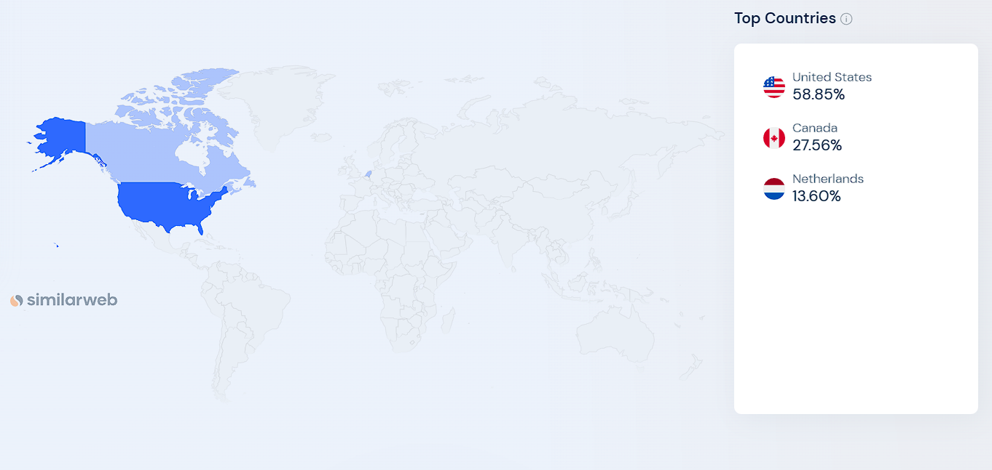
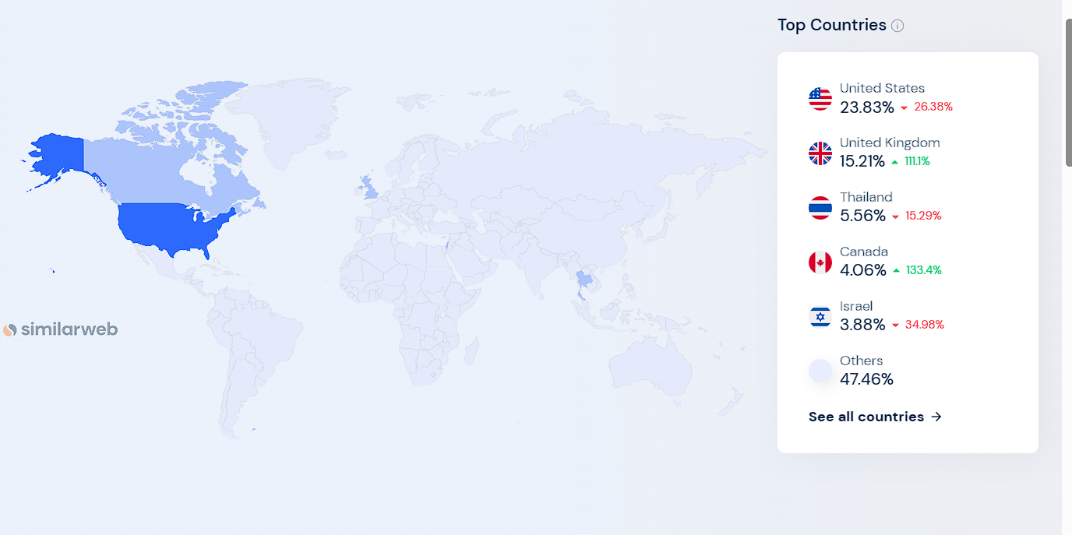

Perpetual Positioning Maps
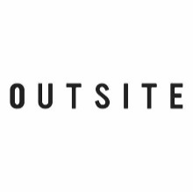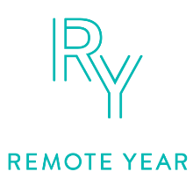
Higher Price
Higher Quality
Lower Quality
Lower Price

Bowmans Strategy Clock
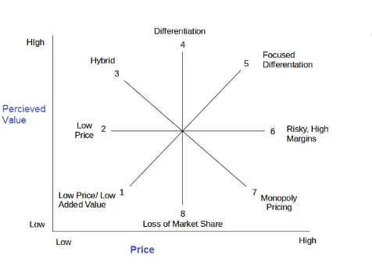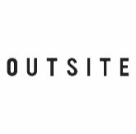

Marketing Plan Gantt Chart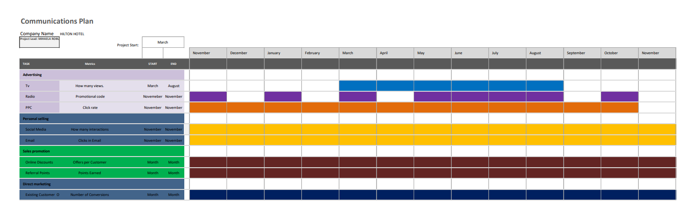

Component B: Presentation


