Robert McIntyre
P149064
Database Management Systems
Kemi Ademoye

Table of Contents
Abstract 3
Performance Tuning 3
When is the database be used most? 3
Distributed Database Solution 5
Region Table 5
Office Table 5
Horizonal Fragmentation 5
City Table Fragmentation 5
Member Table Fragmentation 6
Driver Schedule Table Fragmentation 6
Vertical fragmentation 8
Driver Table Fragmentation 8
Mixed Fragmentation 9
Booking Table Fragmentation 9
Derived Fragmentation 11
Reconstructions of global relations 11
Region Table 11
Office Table 11
City Table 11
Member Table 12
Driver Schedule Table 12
Driver 13
Booking 13

Abstract
This report covers how the database for the book and ride system is utilised using several different techniques that show how to improve the performance and efficiency of the database. Performance tuning of the database is shown by using a cross-reference matrix of CRUD (Create, Read, Update, Delete) to determine which queries are used most often. Database distributed solutions is used to by improve the efficiency of the database by fragmentation. The global relationships are shown to join the fragments together.

Data
The data for the Book and Ride database was generated using Mockaroo random data generator [1]. There was geographic data required which was obtained from various maps[2][3]

Performance Tuning
Looking at the database there are queries that are the most important to the Book and Ride business.
Query 1: For the business the query that is the most important is to check to see if the driver is not working for more than 40 hours in the week. (Cross Matrix CRUD no 2)
Query 2: Another important query for the business is to look at which city is the busiest to see where the business should invest in their money. (Cross Matrix CRUD no 5)
Query 3: Working out the number of journeys that a customer travels. Showing which customers are loyal to the business. (Cross Matrix CRUD no 2)

When is the database be used most?
Customers often call the taxis between 4-6pm and 10-11pm. These times are the times that the customer calls the taxis to take them to a location.
Possible queries that can be executed within the database are as follows.
- Checking to see which the busiest time for the drivers is to pick up passengers.
- Listing the hours that the drivers are doing
- Recording peoples booking into the database
- The Number of Miles done by the driver
- Check to see which the busiest city is
- Check out how many journeys a member has booked.
- If the company decides to add another office
- If the Member want to remove cancel their membership
- Adding a persons’ booking to the table
- Checking how many Passengers there are per driver.
The CRUD table were used to analyse the queries[4]
 | 1 |  |  |  | 2 |  |  |  | 3 |  |  |  | 4 |  |  |  | 5
 | C | R | U | D | C | R | U | D | C | R | U | D | C | R | U | D | C | R | U | D
Booking
City |  |  |  |  |  |  |  |  |  |  |  |  |  |  |  |  |  | ✓
Driver |  | ✓ |  |  |  | ✓ |  |  |  |  |  |  |  | ✓
Driver Schedule |  | ✓ |  |  |  | ✓ |  |  |  |  | ✓ |  | ✓ | ✓
Member |  | ✓ |  |  |  |  |  |  | ✓
Office
Region |  |  |  |  |  |  |  |  |  | ✓
Figure 1: CRUD Diagram part 1

 | 6 |  |  |  | 7 |  |  |  | 8 |  |  |  | 9 |  |  |  | 10
 | C | R | U | D | C | R | U | D | C | R | U | D | C | R | U | D | C | R | U | D
Booking |  | ✓ |  |  |  |  |  |  |  |  |  |  | ✓
City |  |  |  |  | ✓ | ✓ |  |  |  |  |  |  |  |  | ✓
Driver |  |  |  |  |  |  |  |  |  |  |  |  |  |  |  |  |  | ✓
Driver Schedule |  | ✓ |  |  | ✓ |  |  |  |  |  |  |  |  |  | ✓
Member |  | ✓ |  |  |  |  |  |  |  | ✓ |  | ✓ |  |  |  |  |  | ✓
Office |  |  |  |  | ✓ | ✓ | ✓
Region |  |  |  |  |  |  |  |  |  | ✓ |  |  |  | ✓
Figure 2 CRUD Diagram part 2
Looking at these tables above the tables that is the most used are the drivers schedule table, Members table and booking table.

Query 1:
SELECT DriverNo, StartDateTime, EndDateTime, DATEDIFF(HOUR,StartDateTime,EndDateTime) AS 'Hours Worked in a day'
FROM DriverSchedule WITH(INDEX(idxDriverSchedule))
-- Query 1: Calculated the hours the driver has worked within a day using indexes.
This Query has index of idxDriverSchedule to access relevant columns quickly. It reads the DriverSchedule table to retrieve the drivers activities to calculate the hours worked. The cumulation of hours needs to be calculated to ensure that less that 40 hours are worked within a week.
Query 2:
SELECT c.CityName, b.PickupCityId AS City,COUNT(b.MemberNo) AS 'Number of bookings'
FROM Booking b
INNER JOIN City c ON b.PickupCityId = c.CityID
GROUP BY b.PickupCityId,c.CityName
ORDER BY COUNT(b.MemberNo)DESC , b.PickupCityId
--Query 2: Counting the number of times a booking a booked within a city
This is looking at the booking table and city table to determine the busiest city. The tables are joined together using a foreign key. The query is counting the number of members there are.
Query 3:
SELECT MemberNo,COUNT(BookingNo) AS 'Number Of Bookings'
FROM Booking
GROUP BY MemberNo;
--Query 3: Counting the number of times a person has booked the taxi
This is counting the total number of times a member has booked.

Distributed Database Solution

Region Table
The Region table will not be fragmented as it is a small table with few records. It is also not updated very often.
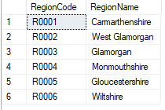

Office Table
The office table does not need to be fragmented as the table is small and not updated often.
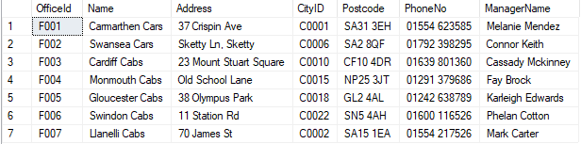

Horizonal Fragmentation
The city table is fragmented horizontally based on the region code because there are several cities within each region.

City Table Fragmentation
SELECT * FROM City where RegionCode = 'R0001'
C1 : σ RegionCode = ‘R0001’ (City)
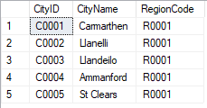
SELECT * FROM City where RegionCode = 'R0002'
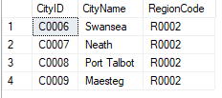
C2 : σ RegionCode = ‘R0002’ (City)
This is repeated with rest of the region codes to give all the city table fragmentations.

Member Table Fragmentation
The member table is fragmented by the address region code as this is the repeated value in the rows. Members are separated into regions as this is where they mainly book their rides.
SELECT * FROM Member WHERE AddressRegionCode = 'R0001'
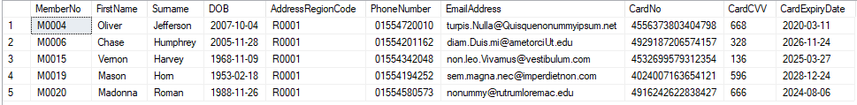
M1 : σ AddressRegionCode = ‘R0001’ (Member)

SELECT * FROM Member WHERE AddressRegionCode = 'R0003'
M3 : σ AddressRegionCode = ‘R0003’ (Member)
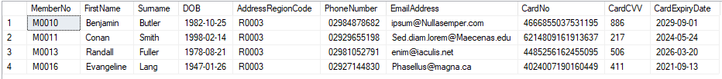

Driver Schedule Table Fragmentation
The Driver Schedule table is fragmented horizontally by Currently available to determine the availability of the drivers. The drivers are separated by availability as these row are updated regularly. There are three different states a driver can be in.
SELECT * FROM DriverSchedule WHERE CurrentlyAvailable = 'Busy'
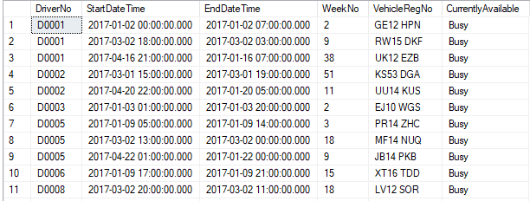
DS1 : σ CurrentlyAvailable = ‘Busy’ (DriverSchedule)

SELECT * FROM DriverSchedule WHERE CurrentlyAvailable = 'Not Working'
DS2 : σ CurrentlyAvailable = ‘Not Working’ (DriverSchedule)
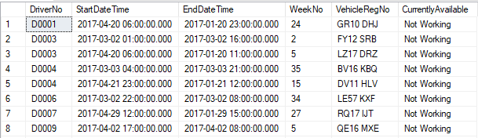

SELECT * FROM DriverSchedule WHERE CurrentlyAvailable = 'Avaliable'
DS3 : σ CurrentlyAvailable = ‘Avaliable’ (DriverSchedule)
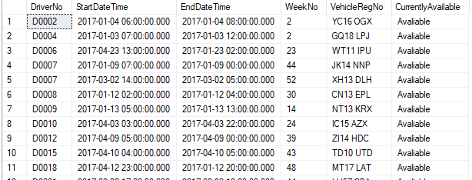

Vertical fragmentation

Driver Table Fragmentation
The Driver table is fragmented vertically into four tables: Personal details, Address details, Banking details and Driving details. These tables group similar information together.
SELECT DriverNo, FirstName, Surname, DOB, NIN FROM Driver;
D1 : π DriverNo, FirstName, Surname, DOB, NIN (Driver)
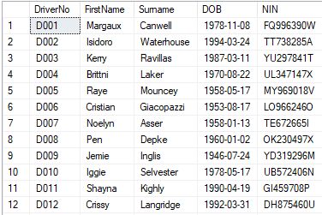
SELECT DriverNo, [Address], Postcode, PhoneNumber, EmailAddress FROM Driver;
D2 : π DriverNo, [Address], Postcode, PhoneNumber, EmailAddress FROM Driver (Driver)
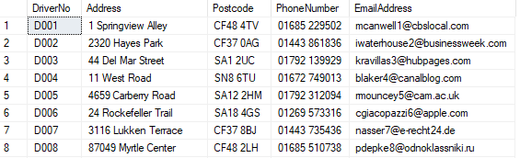
SELECT DriverNo, AccountNo, AccountSortCode FROM Driver;
D3 : π DriverNo, AccountNo, AccountSortCode (Driver)
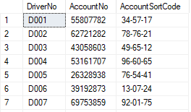

SELECT DriverNo, LicenceNo, LicenceExpiryDate, VehicleRegNo, CarSize, OfficeId, DateRegistered, [Status]
D4 : π DriverNo, LicenceNo, LicenceExpiryDate, VehicleRegNo, CarSize, OfficeId, DateRegistered, [Status] (Driver)
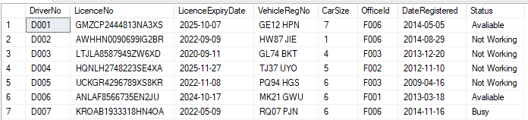

Mixed Fragmentation

Booking Table Fragmentation
The booking table uses the vertical fragmentation and horizontal fragmentation. Therefore, this is a mixed fragmentation.
The Vertical fragmentations are Booking, Pick up, Destination, Journey and Cancellation. The Booking fragment is fragmented horizontally by MemberNo and the Journey fragment is fragmented horizontally by DriverNo. This sorts the information all bookings by one member are together and all journeys per driver are together.
SELECT BookingNo, MemberNo, BookingDateTime, PaymentDetails FROM Frag_Booking1 WHERE MemberNo = 'M0003'
B11 : σ BookingNo, MemberNo, BookingDateTime, PaymentDetails (Frag_Booking1)

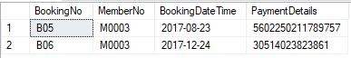

SELECT BookingNo, MemberNo, BookingDateTime, PaymentDetails FROM Frag_Booking1 WHERE MemberNo = 'M0018'
B12: σ BookingNo, MemberNo, BookingDateTime, PaymentDetails (Frag_Booking1)

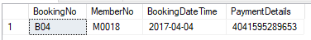
SELECT BookingNo, PickupDateTime, PickupAddress, PickupCityId PickupPostcode FROM Booking;
B2: π BookingNo, PickupDateTime, PickupAddress, PickupCityId PickupPostcode (Booking)

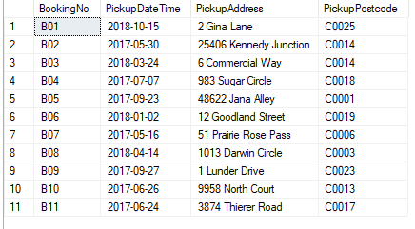
SELECT BookingNo, DestinationAddress, DestinationCityId, DestinationPostcode FROM Booking
B3: π BookingNo, DestinationAddress, DestinationCityId, DestinationPostcode (Booking)

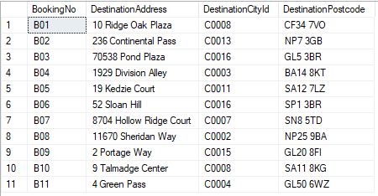

SELECT BookingNo, JourneyMileage, CarSize, AssignedDriverNo, DeliveredDateTime, FareAmount FROM Frag_Booking4 WHERE AssignedDriverNo = 'D015'
B41: σ BookingNo, JourneyMileage, CarSize, AssignedDriverNo, DeliveredDateTime, FareAmount (Frag_Booking4)

SELECT BookingNo, JourneyMileage, CarSize, AssignedDriverNo, DeliveredDateTime, FareAmount FROM Frag_Booking4 WHERE AssignedDriverNo = 'D019'
B42: σ BookingNo, JourneyMileage, CarSize, AssignedDriverNo, DeliveredDateTime, FareAmount (Frag_Booking4)
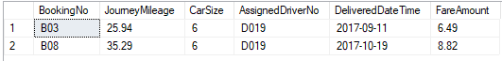

SELECT BookingNo, CancellationDateTime, CancellationCharge FROM Booking;
B5: π BookingNo, CancellationDateTime, CancellationCharge (Booking)
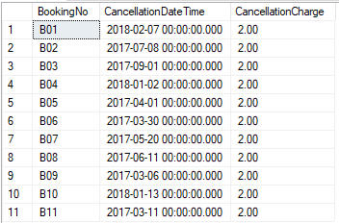

Derived Fragmentation
There is no derived fragmentation used in this database.

Reconstructions of global relations
Below are the tables that are reconstructed from the fragments.

Region Table
This table was not fragmented

Office Table
This table was not fragmented as the table is small

City Table
The City table is joined together by union intersections
SELECT * FROM Frag_City1
UNION
SELECT * FROM Frag_City2;
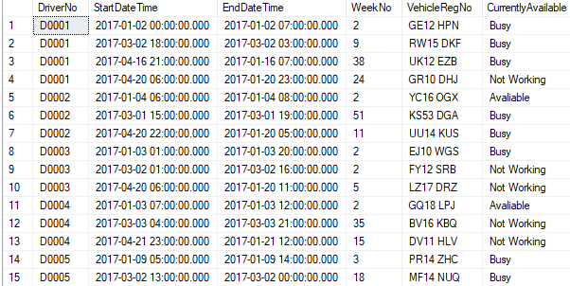

Member Table
The two fragments are joined using a union intersection to reform the table.
SELECT * FROM Frag_Member1
UNION
SELECT * FROM Frag_Member3;
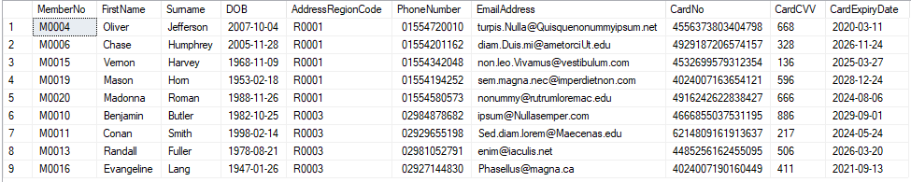

Driver Schedule Table
The driver schedule table is merged together using the union intersection
SELECT * FROM Frag_DS1
UNION
SELECT * FROM Frag_DS2
UNION
SELECT * FROM Frag_DS3;
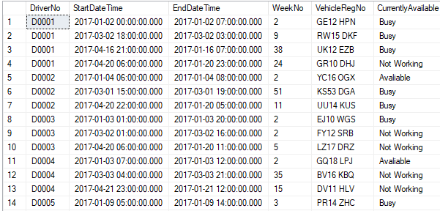

Driver
The driver table is merged using the inner join and ordered by driverNo.
SELECT FD1.DriverNo, FD1.FirstName, FD1.Surname,FD1.NIN,FD2.[Address] ,FD2.Postcode,FD2.PhoneNumber,FD2.EmailAddress,FD3.AccountNo,FD3.AccountSortCode,FD4.LicenceNo,FD4.LicenceExpiryDate,FD4.VehicleRegNo,FD4.CarSize,FD4.OfficeId,FD4.DateRegistered,FD4.[Status]
FROM Frag_Driver1 FD1
JOIN Frag_Driver2 FD2 ON FD1.DriverNo = FD2.DriverNo
JOIN Frag_Driver3 FD3 ON FD2.DriverNo = FD3.DriverNo
JOIN Frag_Driver4 FD4 ON FD3.DriverNo = FD4.DriverNo
ORDER BY FD1.DriverNo;

Booking
The booking table uses both union intersection and natural join to merge the tables together.
SELECT * FROM Frag_Booking11
UNION
SELECT * FROM Frag_Booking12

SELECT * FROM Frag_Booking41
UNION
SELECT * FROM Frag_Booking42;

SELECT FB1.BookingNo,fb1.MemberNo,FB1.PaymentDetails,FB2.PickupDateTime,fb2.PickupAddress,FB2.PickupPostcode,fb3.DestinationAddress,FB3.DestinationCityId,fb3.DestinationPostcode,
FB4.JourneyMileage,FB4.AssignedDriverNo,FB4.DeliveredDateTime,fb4.FareAmount,FB5.CancellationDateTime,FB5.CancellationCharge
FROM Frag_Booking1 FB1
JOIN Frag_Booking2 FB2 ON FB1.BookingNo = FB2.BookingNo
JOIN Frag_Booking3 FB3 ON FB2.BookingNo = FB3.BookingNo
JOIN Frag_Booking4 FB4 ON FB3.BookingNo = FB4.BookingNo
JOIN Frag_Booking5 FB5 ON FB4.BookingNo = FB5.BookingNo
ORDER BY FB1.BookingNo;
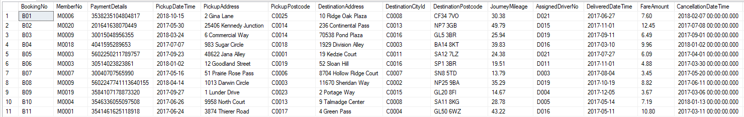

[1] “Mockaroo - Random Data Generator and API Mocking Tool | JSON / CSV / SQL / Excel.” [Online]. Available: https://mockaroo.com/. [Accessed: 28-Mar-2018].
[2] “Current Counties in the UK | BritainVisitor - Travel Guide To Britain.” [Online]. Available: https://www.britain-visitor.com/britain-travel-guide/current-counties-uk. [Accessed: 28-Mar-2018].
[3] “Google Maps.” [Online]. Available: https://www.google.co.uk/maps/@51.62239,-3.950159,15z. [Accessed: 28-Feb-2018].
[4] T. M. Connolly and C. E. Begg, Database systems : a practical approach to design, implementation, and management. Addison-Wesley, 2005.

