5AIOP Contributing to Improving Organisational Performance

Name: Laura Daniel

CIPD Membership Number: 42646234

Date: 20 September 2021

By signing below, I confirm that the work/evidence presented is my own, unaided work. I understand the regulations pertaining to candidate malpractice and the action that may be taken as a result.

Signed: 
Date: 19.09.2021

Contents
Page 1 Front Cover
Page 2 Contents
Page 3 -8 Evidence Matrix
Page 9 Introduction
Page 9-11 LO1 Q 1.1
Page 11-13 LO1 Q 1.2
Page 13 LO1 Q 1.3
Page 14-26 LO1 Evidence
Page 27-28 LO2 Q 2.1
Page 28-29 LO2 Q 2.2
Page 29-30 LO2 Q 2.3
Page 31-40 LO2 Evidence
Page 41-42 LO3 Q 3.1
Page 42-43 LO3 Q 3.2
Page 44-45 LO3 Q 3.3
Page 45 LO3 Evidence
Page 46-47 References

CIPD Candidate Evidence Matrix
Candidate name: Laura Daniel |  |  |  |  | CIPD Membership/registration No.:  42646234
Qualification title: CIPD Level 5 |  |  |  |  | Unique Learner No. (ULN):
Unit code | Unit title |  | Assessment criteria no. | Evidence description | Evidence reference number |  | Assessor  initials | I/V initials if sampled
5AIOP | Contributing to Improving Organisational Performance |  | 1.1 | Organisational Chart | EV1
5AIOP | Contributing to Improving Organisational Performance |  | 1.1 | Mono Directors HR KPI’s | EV2
5AIOP | Contributing to Improving Organisational Performance |  | 1.1 | CEO HR KPI’s | EV3
5AIOP | Contributing to Improving Organisational Performance |  | 1.1 | Absence Control Procedure | EV4
5AIOP | Contributing to Improving Organisational Performance |  | 1.1 | Return to Work form | EV5
5AIOP | Contributing to Improving Organisational Performance |  | 1.1 | Disciplinary Policy | EV6
5AIOP | Contributing to Improving Organisational Performance |  | 1.1 | Performance Improvement Plan | EV7
5AIOP | Contributing to Improving Organisational Performance |  | 1.1 | Job Description | EV8
5AIOP | Contributing to Improving Organisational Performance |  | 1.1 | Job Vacancy | EV9
5AIOP | Contributing to Improving Organisational Performance |  | 1.1 | Recruitment and Selection Policy | EV10
5AIOP | Contributing to Improving Organisational Performance |  | 1.1 | Interview Evaluation Form | EV11
5AIOP | Contributing to Improving Organisational Performance |  | 1.1 | Induction Policy | EV12
5AIOP | Contributing to Improving Organisational Performance |  | 1.1 | HR Induction Form | EV13
5AIOP | Contributing to Improving Organisational Performance |  | 1.1 | Supervisors Induction Form | EV14
5AIOP | Contributing to Improving Organisational Performance |  | 1.1 | Employee Handbook | EV15
5AIOP | Contributing to Improving Organisational Performance |  | 1.1 | Code Of Conduct | EV16
5AIOP | Contributing to Improving Organisational Performance |  | 1.1 | Statement of Core Principles | EV17
5AIOP | Contributing to Improving Organisational Performance |  | 1.1 | Drug and Alcohol Policy | EV18
5AIOP | Contributing to Improving Organisational Performance |  | 1.1 | Smoking Policy | EV19
5AIOP | Contributing to Improving Organisational Performance |  | 1.1 | Training and Development Policy | EV20
5AIOP | Contributing to Improving Organisational Performance |  | 1.1 | Individual Training Plan | EV21
5AIOP | Contributing to Improving Organisational Performance |  | 1.1 | Self-Appraisal Review | EV22
5AIOP | Contributing to Improving Organisational Performance |  | 1.1. | Employer Appraisal Form | EV23
5AIOP | Contributing to Improving Organisational Performance |  | 1.2 | ACAS Code of Practice | EV24
5AIOP | Contributing to Improving Organisational Performance |  | 1.2 | Equality and Diversity Training | EV25
5AIOP | Contributing to Improving Organisational Performance |  | 1.2 | Employment Statutory Code of Practice | EV26
5AIOP | Contributing to Improving Organisational Performance |  | 1.2 | Gov.UK Employment Contract | EV27
5AIOP | Contributing to Improving Organisational Performance |  | 1.3 | Coronavirus Policy | EV28
5AIOP | Contributing to Improving Organisational Performance |  | 1.3 | Coronavirus Employee Notice | EV29
5AIOP | Contributing to Improving Organisational Performance |  | 1.3 | Induction Documentation | EV30
5AIOP | Contributing to Improving Organisational Performance |  | 1.3 | Agenda for Induction | EV31
5AIOP | Contributing to Improving Organisational Performance |  | 1.3 | Probation Letter | EV32
5AIOP | Contributing to Improving Organisational Performance |  | 1.3 | Probation review notes | EV33
5AIOP | Contributing to Improving Organisational Performance |  | 1.3 | E-mail to Warehouse Manager advising on Training | EV34
5AIOP | Contributing to Improving Organisational Performance |  | 2.2 | Disciplinary Meeting notes | EV35
5AIOP | Contributing to Improving Organisational Performance |  | 2.2 | Reminder of Disciplinary process | EV36
5AIOP | Contributing to Improving Organisational Performance |  | 2.2 | Invitation to Disciplinary Meeting | EV37
5AIOP | Contributing to Improving Organisational Performance |  | 2.2 | Warning Letter | EV38
5AIOP | Contributing to Improving Organisational Performance |  | 2.2 | E-mail Arranging Interviews | EV39
5AIOP | Contributing to Improving Organisational Performance |  | 2.2 | E-mail to interview candidate | EV40
5AIOP | Contributing to Improving Organisational Performance |  | 2.2 | E-mail informing of sickness/absence | EV41
5AIOP | Contributing to Improving Organisational Performance |  | 2.2 | Monthly Absence Statistics | EV42
5AIOP | Contributing to Improving Organisational Performance |  | 2.2 | Notes on Managing Unsatisfactory Performance | EV43
5AIOP | Contributing to Improving Organisational Performance |  | 2.2 | HR Induction Form | EV44
5AIOP | Contributing to Improving Organisational Performance |  | 2.2 | E-mail evidence from Manager | EV45
5AIOP | Contributing to Improving Organisational Performance |  | 2.2 | Coaching/Mentoring Training | EV46
5AIOP | Contributing to Improving Organisational Performance |  | 2.2 | Meeting notes HR and Line Manager | EV47
5AIOP | Contributing to Improving Organisational Performance |  | 2.3 | E-mail from MD to start Appraisals | EV48
5AIOP | Contributing to Improving Organisational Performance |  | 2.3 | Probation Review Notes | EV49
5AIOP | Contributing to Improving Organisational Performance |  | 2.3 | Sign Off Probation Letter | EV50
5AIOP | Contributing to Improving Organisational Performance |  | 2.3 | Individual Training Plan | EV51
5AIOP | Contributing to Improving Organisational Performance |  | 2.3 | E-mail regarding Individual Learning Plan | EV52
5AIOP | Contributing to Improving Organisational Performance |  | 2.3 | E-mail for Arranged Training | EV53
5AIOP | Contributing to Improving Organisational Performance |  | 2.3 | E-mail Evidence Engineering Manager | EV54
5AIOP | Contributing to Improving Organisational Performance |  | 3.1 | Employee Feedback on the induction process | EV55
5AIOP | Contributing to Improving Organisational Performance |  | 3.3 | Exit Interview Form to be Circulated | EV56
Candidate declaration:
- I confirm that the work/evidence presented for assessment is my own unaided work.
- I have read the assessment regulations and understand that if I am found to have ‘copied’ from published work without acknowledgement, or from other candidate’s work, this may be regarded as plagiarism which is an offence against the assessment regulations and leads to failure in the relevant unit and formal disciplinary action.
- I agree to this work being subjected to scrutiny by textual analysis software if required.
- I understand that my work may be used for future academic/quality assurance purposes in accordance with the provisions of the Data Protection Act 1998.
- I understand that the work/evidence submitted for assessment may not be returned to me and that I have retained a copy for my records.
- I understand that until such time as the assessment grade has been ratified through internal and external quality assurance processes it is not final.
Signature: |  |  |  |  |  | Date: | 19.09.2021

Introduction – Who are Mono Equipment?
Mono Equipment are a manufacturing company based in Swansea, with 105 employees, 9 of whom work as engineers and sales executives and travel around the UK. There is a flat managerial structure (EV1) with many managers having more than 1 role and a lean workforce within the company. I am the only person working within the HR department.
Mono has a long-standing workforce, with 25% of its employees being employed for over 30 years (this includes half of the management team). There is currently a spike in recruitment as a large proportion of this number have already informed HR of their intentions to retire within the next 2 years and hence leaving a large gap in the workforce. This has prompted senior management to think about current processes and roles and to change some of their historical ways of working. This has proven to be an opportune time to introduce some new performance management activities which haven’t been carried out for several years.

Lo1 Be able to provide information on performance management activities within an organisation.
Question 1.1
Performance Management starts at the beginning of employment from recruitment interviews and continues through the working experience up until an employee exits the company (Valamis 2020). The Performance Management activities currently in circulation and being reviewed by Mono Equipment’s HR department and management are explained below: -
Key Performance Indicators (KPI’s) are not present in office departments. Factory employees have KPI’s based on the number of products produced per day and compared with the maximum number of products that can be produced. These KPI’s are departmental and reviewed and monitored by management and line managers and can alter depending on factors such as customer specifications along with the number of orders for the day/week. HR produce monthly and quarterly KPI’s that are issued to Mono directors and the group CEO. HR KPI’s are based on absence, turnover, off-site training days and include Health and Safety Accidents (EV2 and EV3).
Poor performance at Mono is addressed when a Line manager feels an employee isn’t working effectively or is breaching some of the internal policies. Although line managers have received training on dealing with performance issues, due to the low number of performance issues at Mono, line managers feel more confident when their decisions on how to progress are discussed with HR. HR ensure along with the line manager that the correct process is followed in line with the current polices, best practice and HR Law. The following documentation is used when addressing performance issues:
- Absence Control Procedure (EV4) – This is used when employees have reached the trigger points with absence from work. Mono currently has trigger points of 3 periods of absence within a rolling year. If this is breached, then in line with the absence control procedure, an employee is brought into a disciplinary meeting. HR will inform the line manager of the breach and the line manager will set up a disciplinary meeting. After each period of absence a return-to-work form is completed (EV5) by the line manager and submitted to HR who will decide on whether the sickness is related to other periods of absence or if there are any underlying issues that the company need to be aware of and feed back to the line manager. If there are no underlying issues that need to be addressed, the disciplinary procedure is used.
- Disciplinary policy/procedure (EV6) is used when informal procedures have been exhausted. The reason for the meeting will decide on who chairs the meeting. If it is absence related, line managers and HR will attend, if it is more serious e.g. bullying, a manager and HR will attend. Appeals will always be heard by the Managing Director.
- Performance Improvement Plan (EV7) – These are implemented if there are aspects of an employee’s role that the manager requires improvement on. The area of improvement is identified, what actions are required and review dates are monitored. These are carried out by the line manager with advice from HR.
Interview, recruitment and induction are processes that have been reviewed over the last few months by HR to make them more robust. Job vacancies and descriptions for new roles have been updated to assist with attracting applicants and ensuring they have sufficient information about the role (EV8, EV9). HR create job descriptions based on what the departmental manager requires and the Company Recruitment and Selection Policy is followed (EV10). Interviews are carried out via Line managers/departmental managers. Interview Evaluation forms are completed once the interview has finished and scorings by HR and the line manager are reviewed (EV11). The questions asked ensure that the person selected for the role has the same values as Mono and potential for the future.
When new recruits start within the business, the induction policy is followed (EV12). The induction is the final stage of the recruitment process and the start of the Performance management process (CIPD 2021). The induction has changed over the last months to ensure that performance standards and Mono’s expectations are clearly explained. HR carry out an overview of HR, payroll and H&S processes and discuss the Company Values using a HR induction form (EV13) and supervisors complete a more specific departmental induction form (EV14). The Company handbook is issued (EV15) and discussed which outlines the Companies policies, Code of Conduct and Core Values (EV16, EV17), ensuring new employees know what is expected of them and what they can expect from Mono. Examples of policies discussed are Drug and Alcohol (EV18), bullying and harassment and smoking (EV19).
Informally, during the first number of weeks the employee and line manager have review meetings with their new recruits to monitor their work, give feedback and assist in managing employee expectations of the role. Formal probation reviews are carried out at the end of 3 months between the employee, their line manager and HR. Here, training and development are discussed in-line with the training and development policy (EV20). Individual training and development plans are created and reviewed at an agreed date (EV21).
Appraisals are not currently carried out at Mono, however it has been discussed and agreed that they are to start in January. The meetings will become formalised between the line manager and employee. The employee will complete their own self review form before the meeting (EV22) and the Line manager will complete a review on the employee (EV23). The review will be discussed and HR will keep a copy. Appraisals will not be carried out for monetary purposes, but will be a way of identifying training, offering feedback for the past year and setting objectives for the coming year.

Question 1.2
Performance Management is a vital part of the employer and employee relationship (CIPD 2020). To assist managers, employees, HR and organisations with these activities are key external sources of information to ensure that management activities are in-line with employment law and best practice.
There can be risks associated when employers implement a performance management process; claims can be made by employees if performance related issues are dealt with incorrectly and there is an issue in the way the process was handled (Frettens 2011). Unfair dismissal claims can be brought if internal processes haven’t been followed and an Employment Tribunal will question whether the employer has complied with the ACAS Code of Practice on Disciplinary and Grievance matters (ACAS 2015 EV24). Failure to follow the ACAS Code will be taken into account in determining if the dismissal is fair. Mono Equipment have created their disciplinary policy in-line with the ACAS code of practice to ensure that the process is carried out correctly with the aim that if this policy is followed, any claims brought against the company can be contested (EV6).
ACAS can be referred to for several Performance Management activities and are a key for sources of information such as investigations and dismissal. ACAS can also support and convey advice on information to be included in a contract of employment and inductions and offer advice and assistance such as mediation in the hope that issues can be sorted before the tribunal stage.
Other risks with performance management can include unfair dismissal claims with regards to discrimination under the Equality Act 2010 e.g. an employee stating that they have been involved in the performance management process due to a protected characteristic e.g. sex, age, disability. Or that they were not recruited by the organisation for protected characteristic reasons. Mono ensures that their recruitment policy, disciplinary policy and working practices follow the equality act and managers have received equality and Diversity training in the workplace (EV25) to reflect this.
The Equality Act 2010 have a legislative employment Statutory Code of Practice that goes into further detail on the Equality Act and explains what is expected of employers in line with the Human Rights Commission. This guidance will give individuals, businesses and employers the information required to meet their responsibilities at work (EV26).
Guidance from Gov.uk can be used as step-by-step guidance on how to recruit employees, employment rights and contracts. Breach of contract claims can be avoided if this guidance is followed (EV27). This Government digital service assists companies with any questions they may have with employment guidance and regulations.
CIPD offer guidance on employment and are the professional body for HR and people management (CIPD 2021). They set professional standards to impact organisations, its employees and to influence policy. They offer the tools that can assist and support companies with performance management such as disciplinaries and dismissal.
Employment Advice Bureau are a business advisory service working solely for employers, offering free employment law and HR advice based on the ACAS Code of Practice such as dismissal and contracts of employment. They can be contacted on-line or telephone. Company solicitors can offer the same advice; however organisations will be charged for their service. Mono currently use JCP solicitors for specific HR advice.
Mono Equipment have a union on-site so adhere with Unite union standards when dealing with employment practices and people management. Union representatives are invited to meetings to ensure that their practices are followed for the best interests of its members and Mono employees.
Investors in people provide accreditation to organisations and advise on how to improve on efficiency. They offer advice to improve people systems within business and are a framework which introduces employee recognition (Investors in People 2021). Mono do not currently hold the Investors in People accreditation, however, will look at it in the future.
A publication which offers advice is the Xpert HR website, this website gives assistance and guidance on performance management such as contracts, disciplinaries and poor performance. Members of CIPD get free access to this website.

Question 1.3
The Coronavirus has impacted the workplace over the last 18 months in several ways such as sickness absence and redundancies. To ensure that absence management is controlled and employees are safe, a coronavirus policy was created by HR (EV28). This policy along with numerous informative posters were distributed and explained to employees regularly, this helped ensure employees received the correct information and instruction during the pandemic (EV29). HR have been communicating with the workforce and management on a regular basis informing them of local regulations, this included employee talks where the whole factory came together and smaller departmental talks.
Inductions are carried out by HR when an employee starts on day 1. Company policies, procedures and values are discussed during the induction and signed for by the employee stating that they understand what has been discussed (EV30). HR arrange the first few days of employment for the employee by sending out an agenda to key personnel. Arrangements are made for the employee to spend time with the key individuals to understand their role a little better (EV31).
HR arrange probation review meetings with employees. Letters are produced once completed successfully (EV32) and discussed with employees. During the meeting, training and aspirations for the future are discussed and recorded (EV33) and followed up by HR in a few months.
Training and development of individuals within the company is currently being reviewed. Several employees have asked for advice on what training they can complete to be more effective in their role. The Warehouse Manager is very keen on improvement and asked for advice on the next stage of training for her. HR advised on a course and arranged further training on the Company disciplinary policy and how to mentor her team (EV34).

Evidence LO1
(EV1 – Organisational Chart)
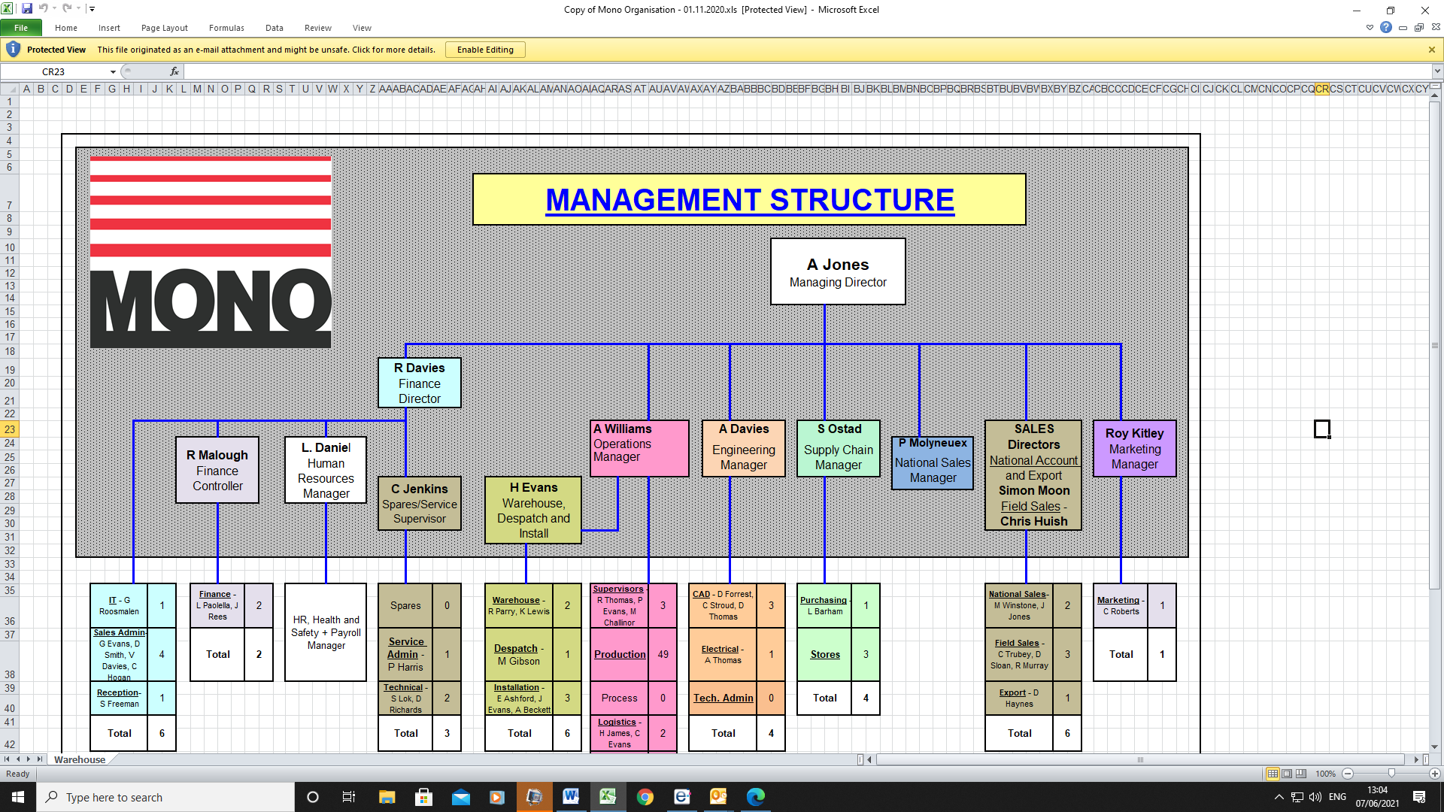
(EV2 Mono Directors HR KPI’s)
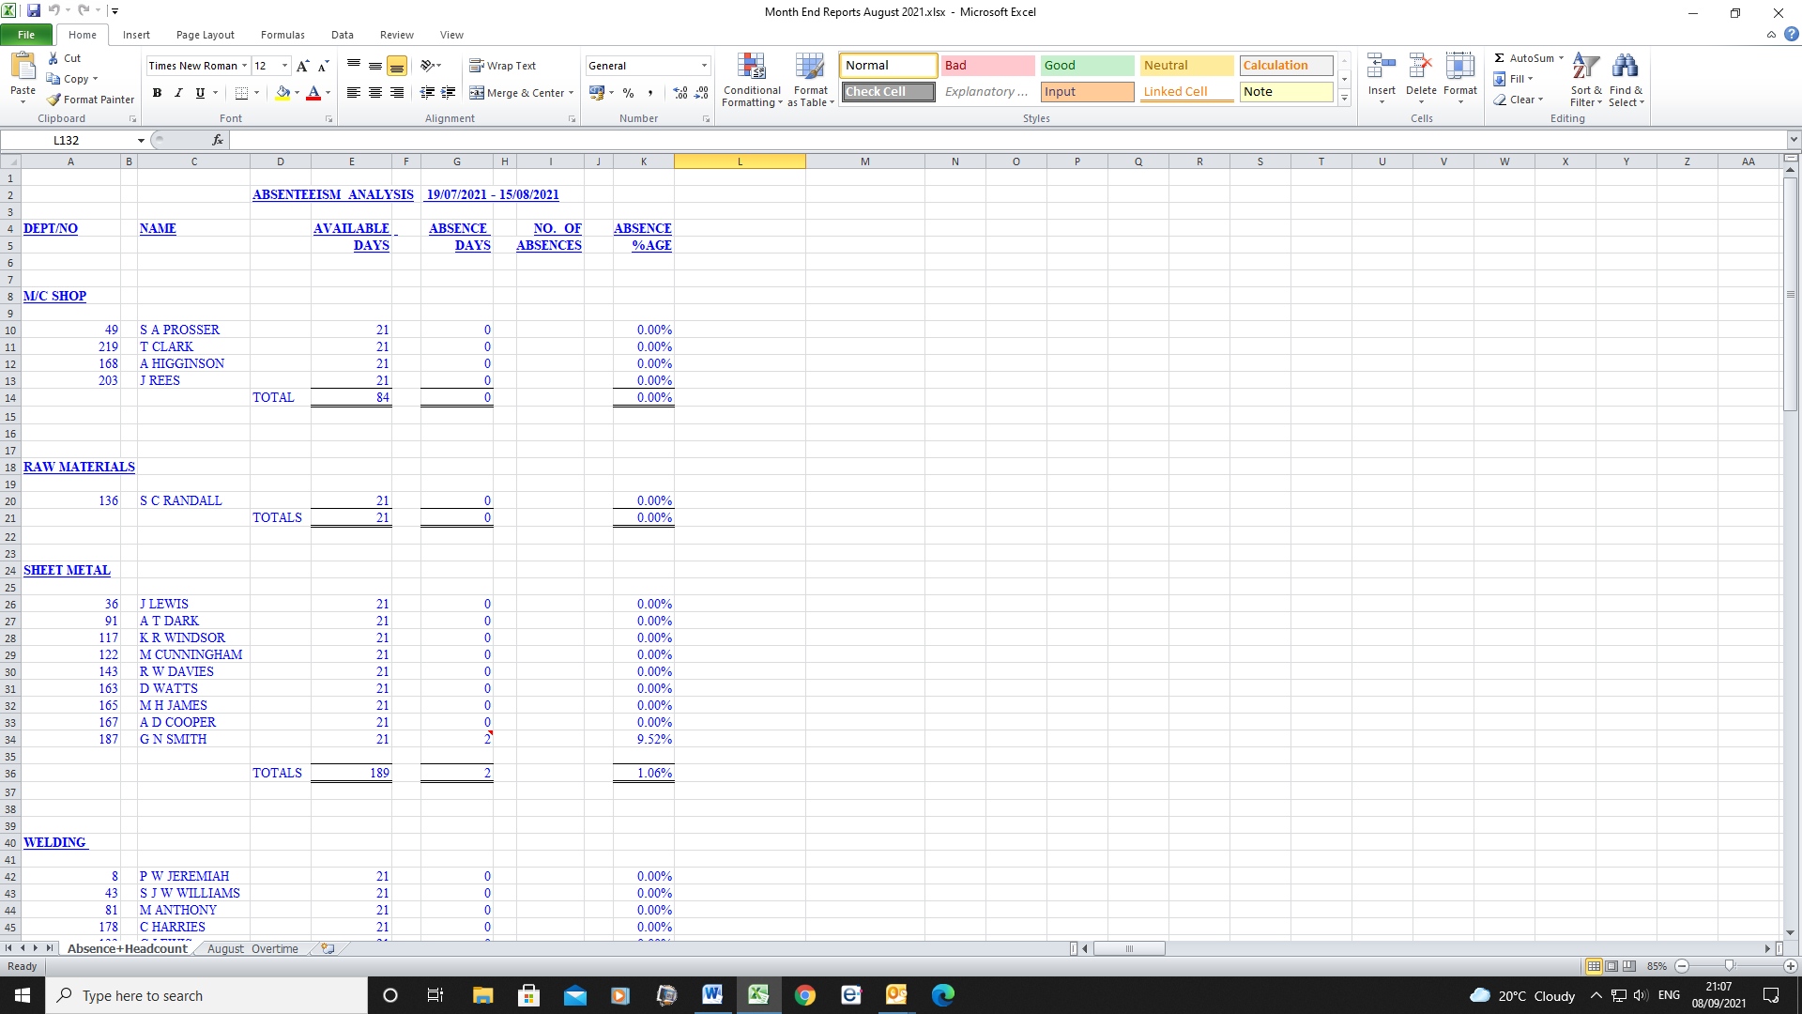
(EV3 CEO HR KPI’s)
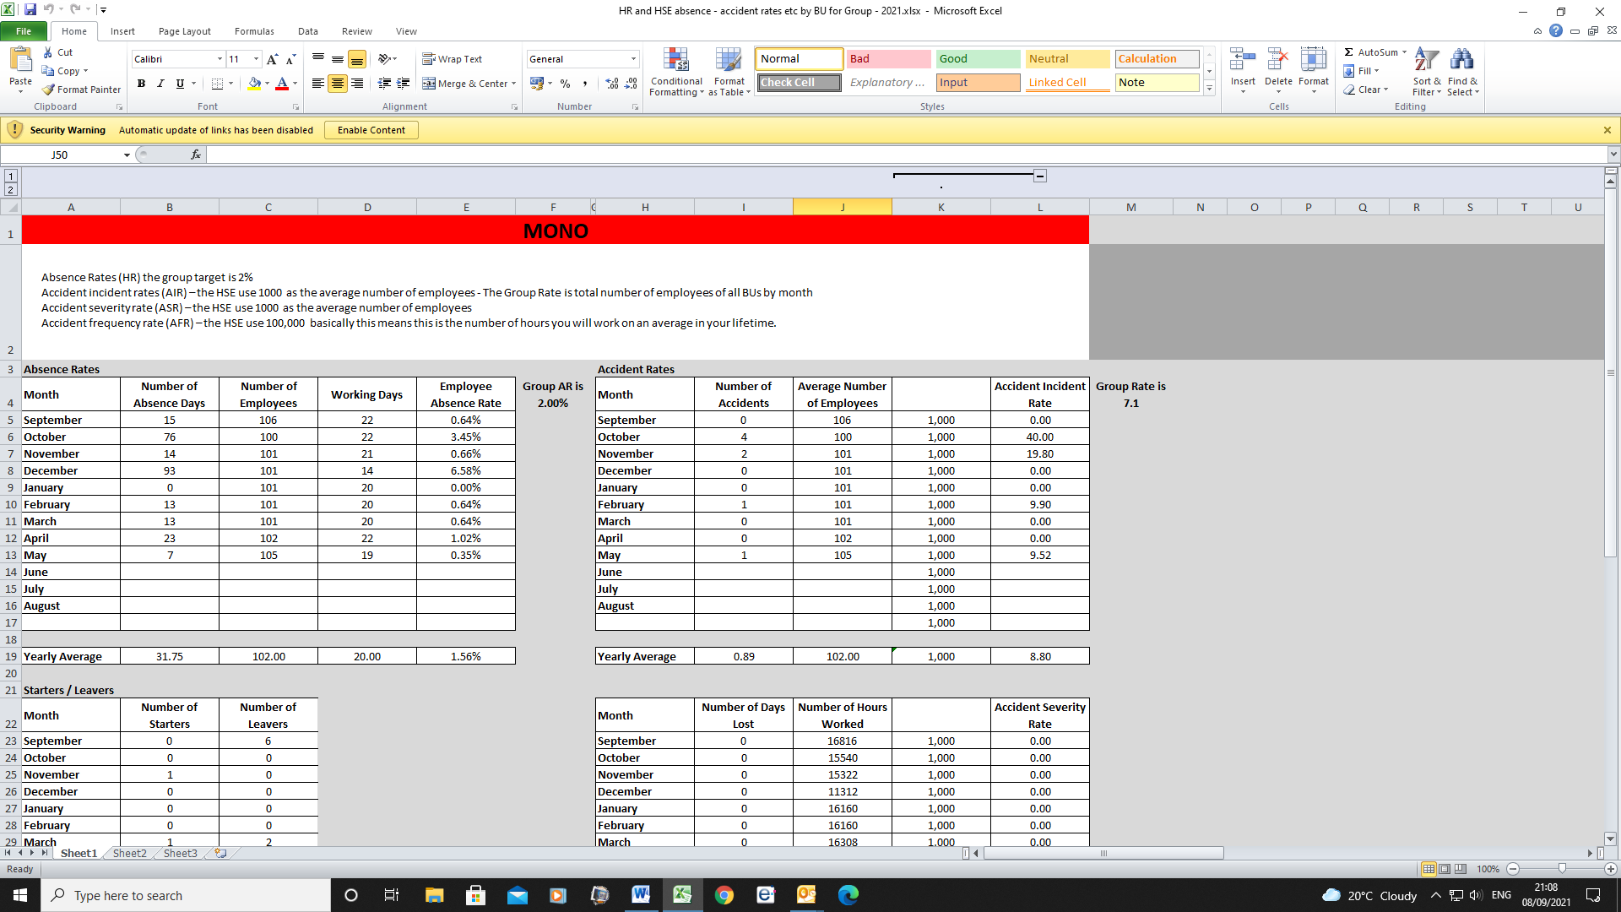
(EV4 – Absence Control Procedure)

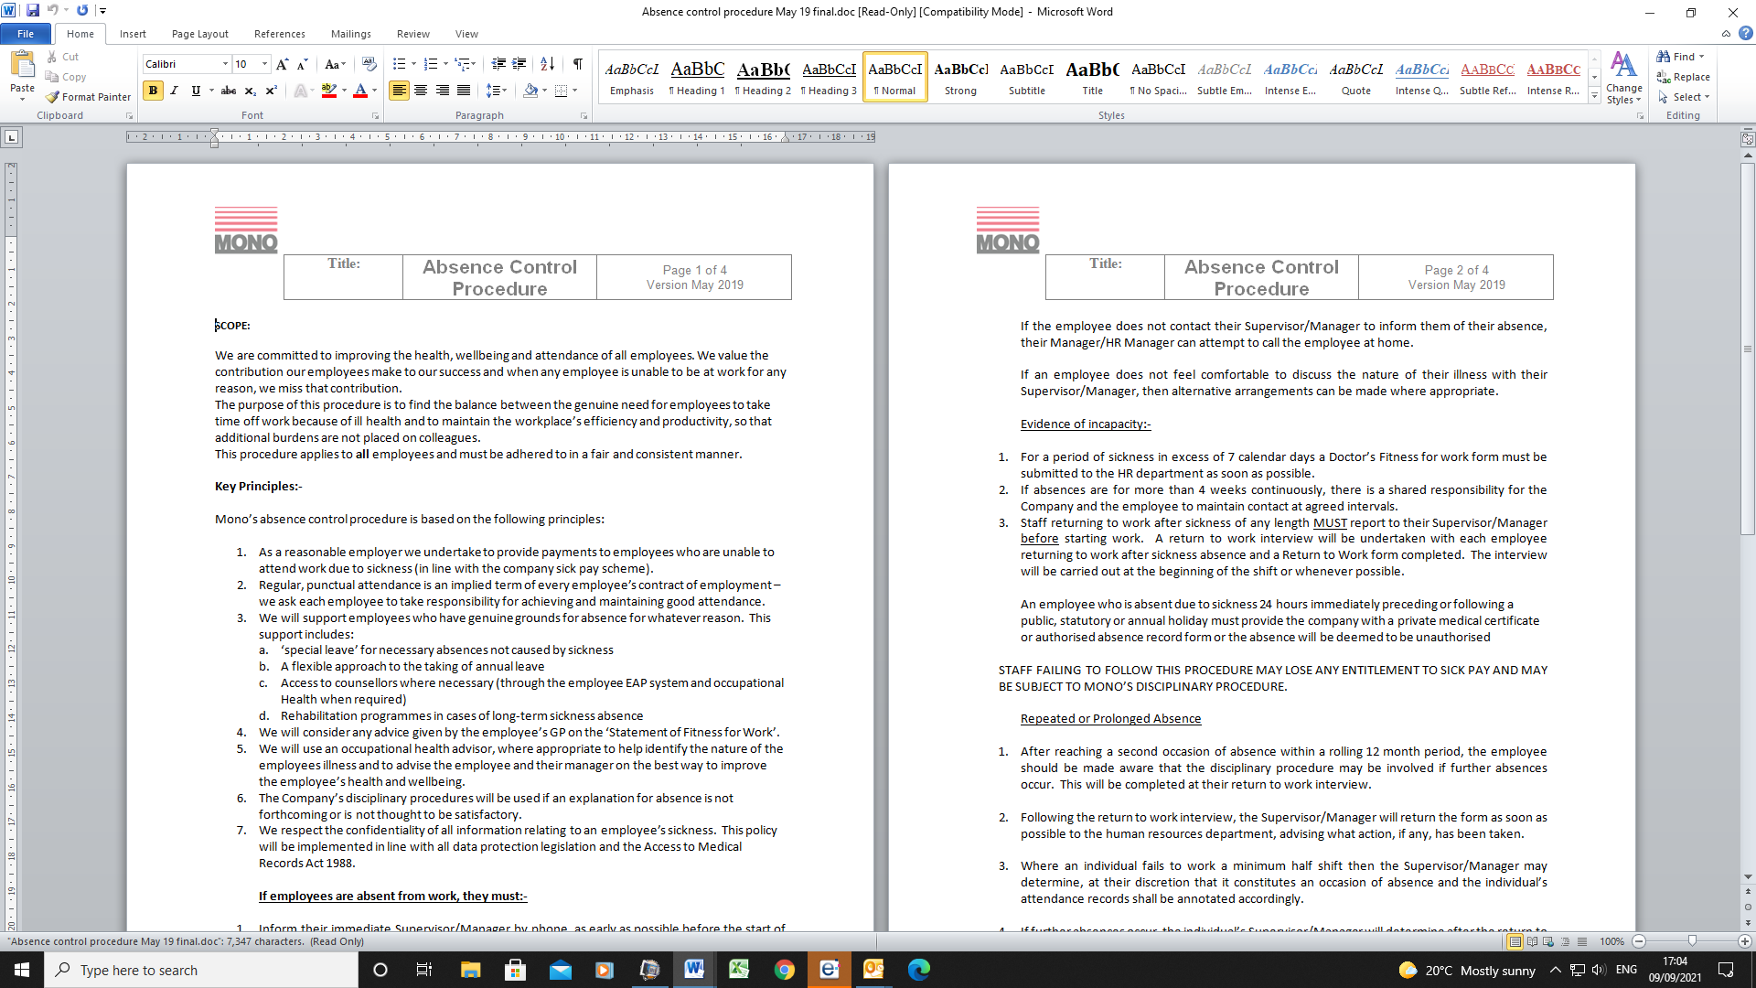
(EV5 Return to work form)
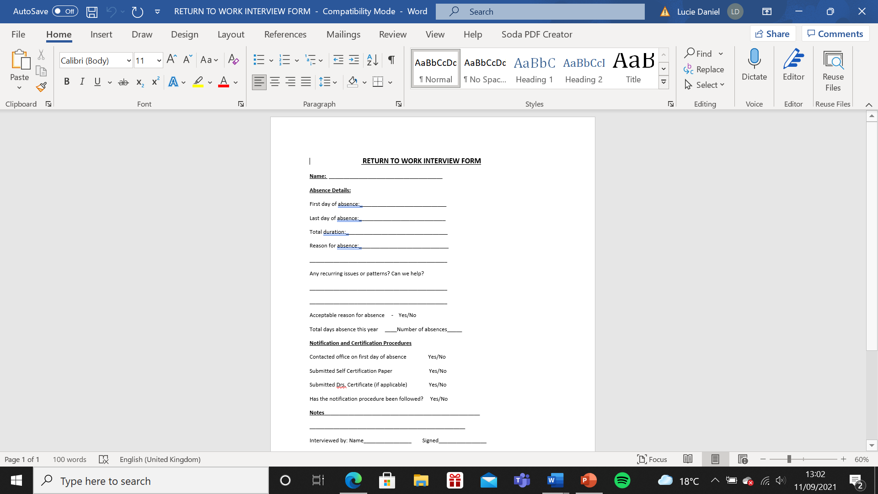
(EV6 – Disciplinary Policy)
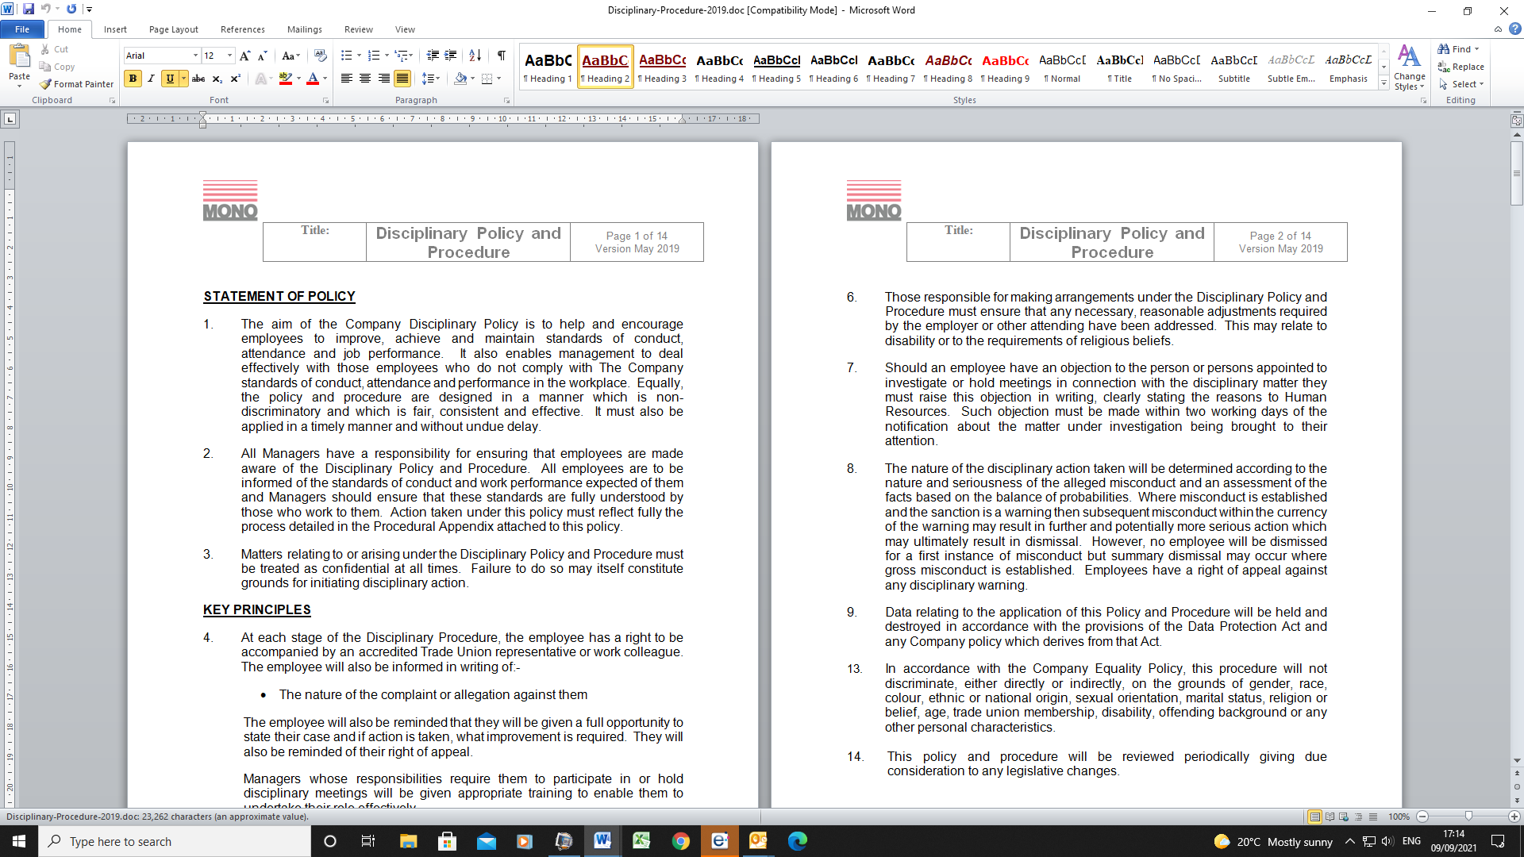
(EV7 Performance Improvement Plan)
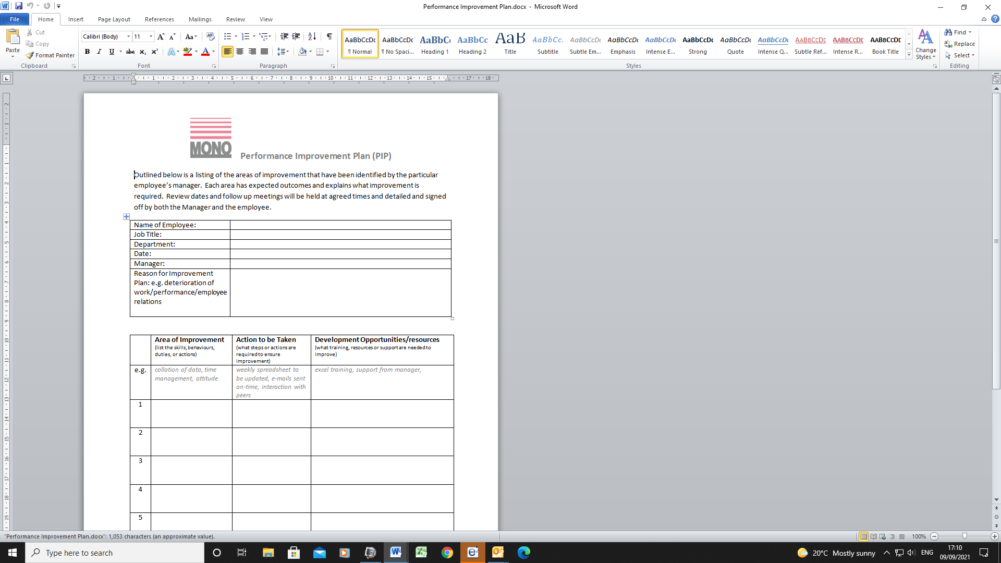
(EV8 – Job Description)
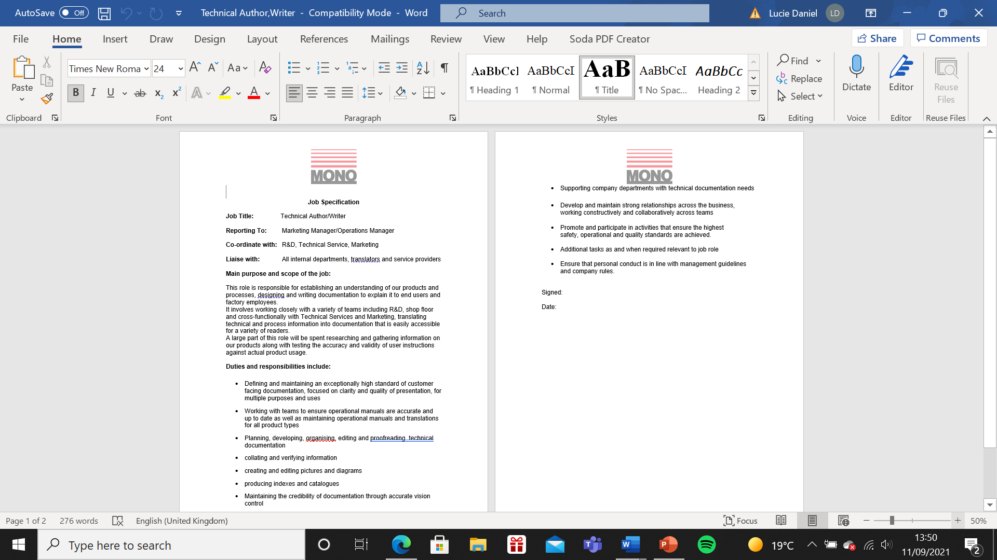

(EV9 – Job vacancies)
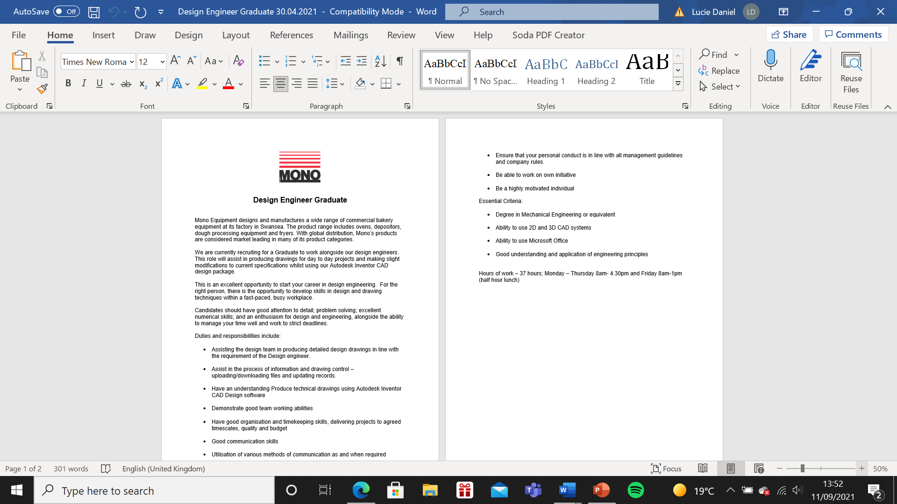
(EV10 – Recruitment and Selection Policy)
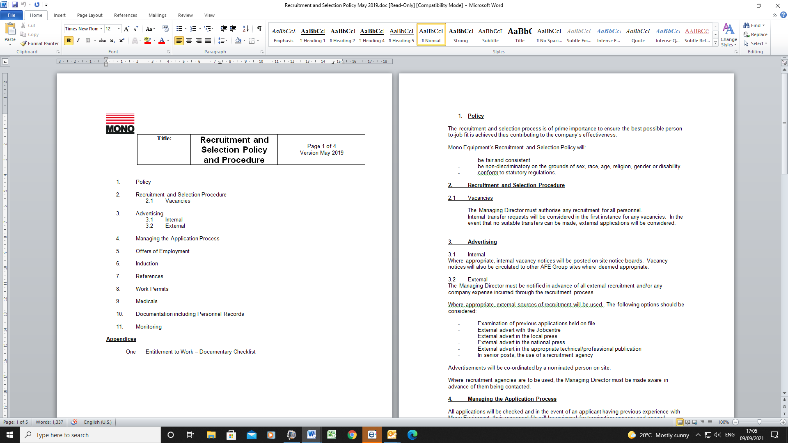
(EV11 - Interview Evaluation Form)
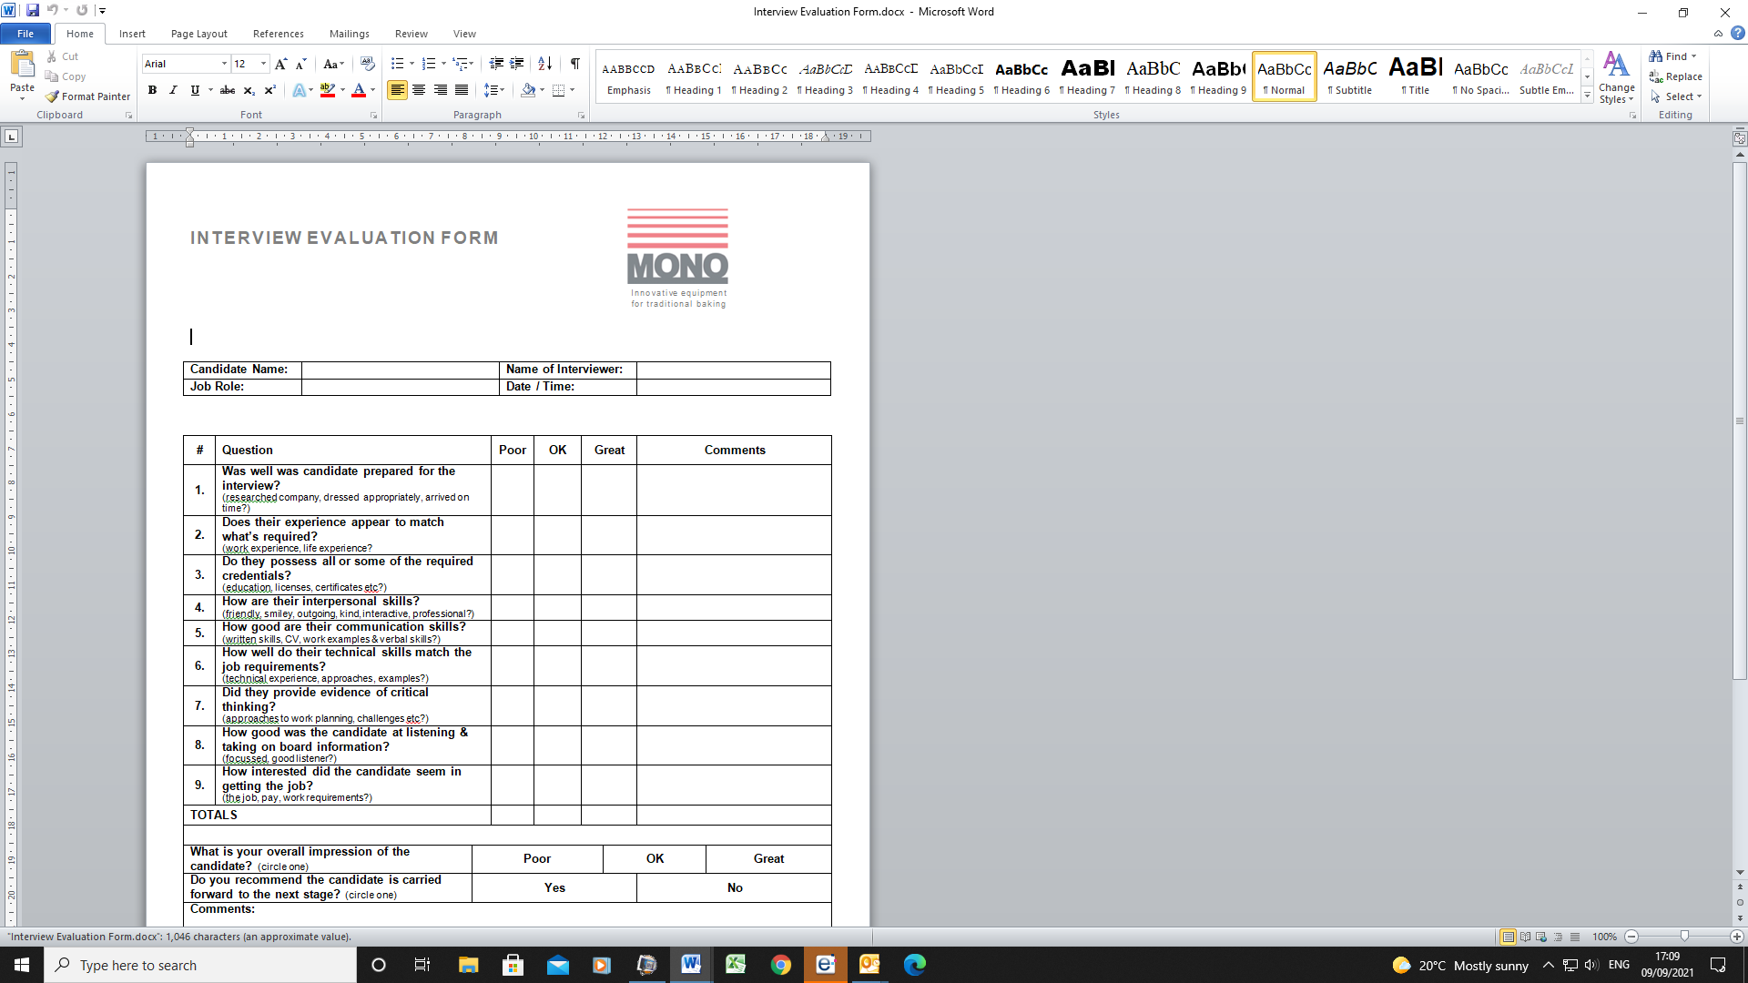
(EV12 – Induction Policy)
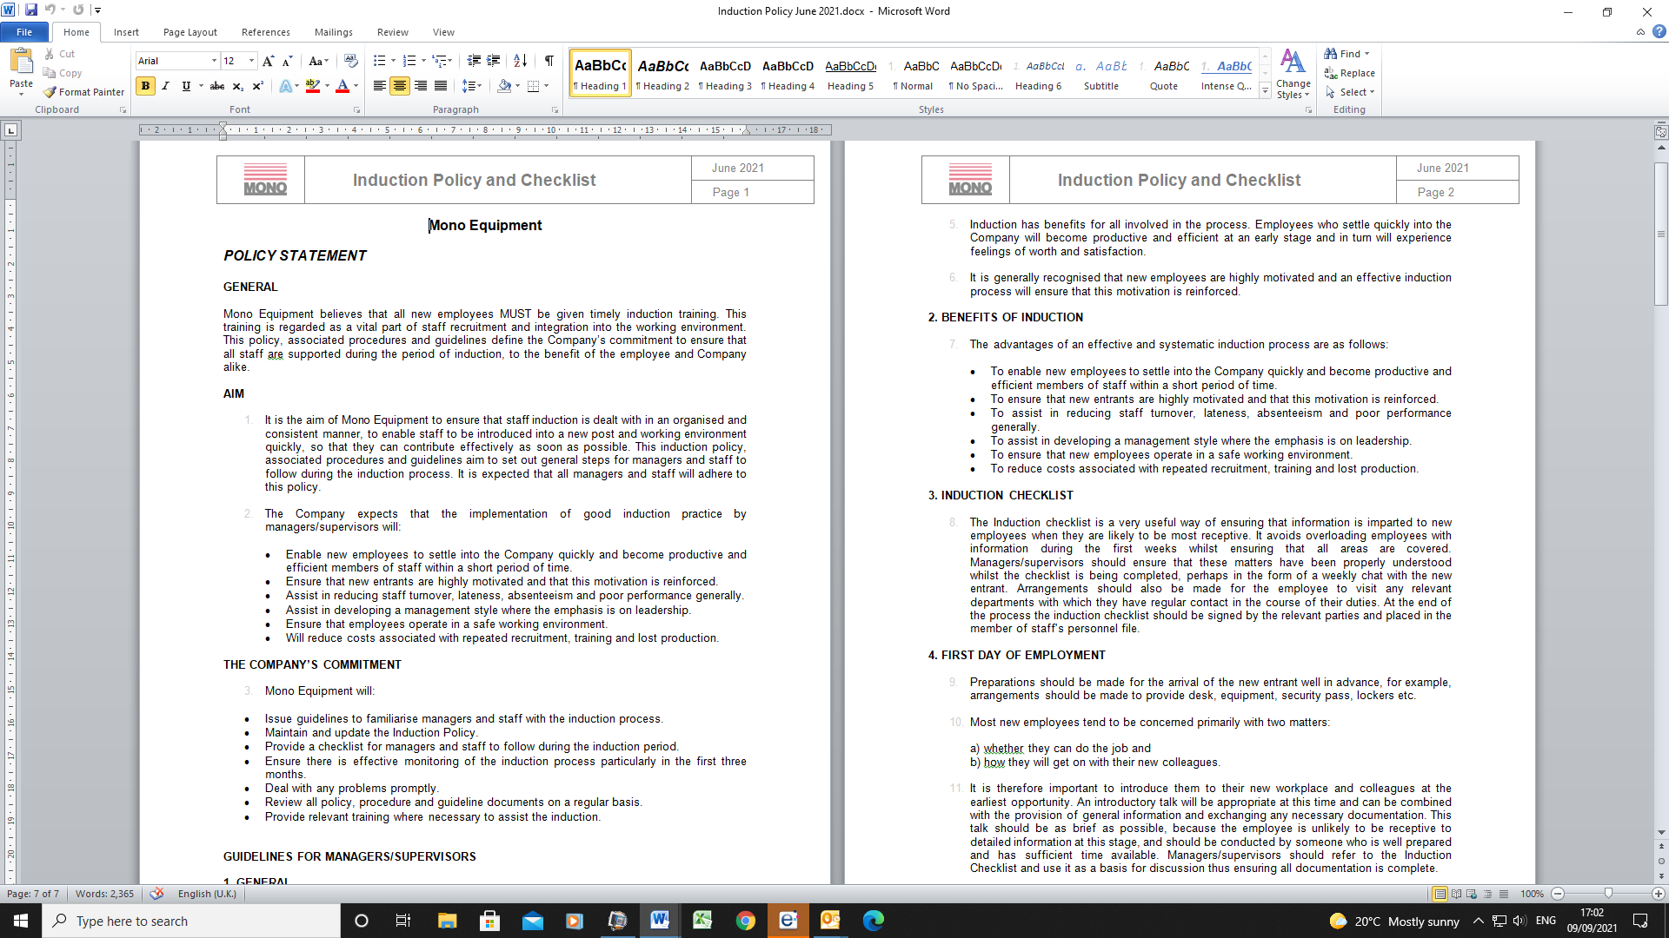
(EV13- HR Induction form)
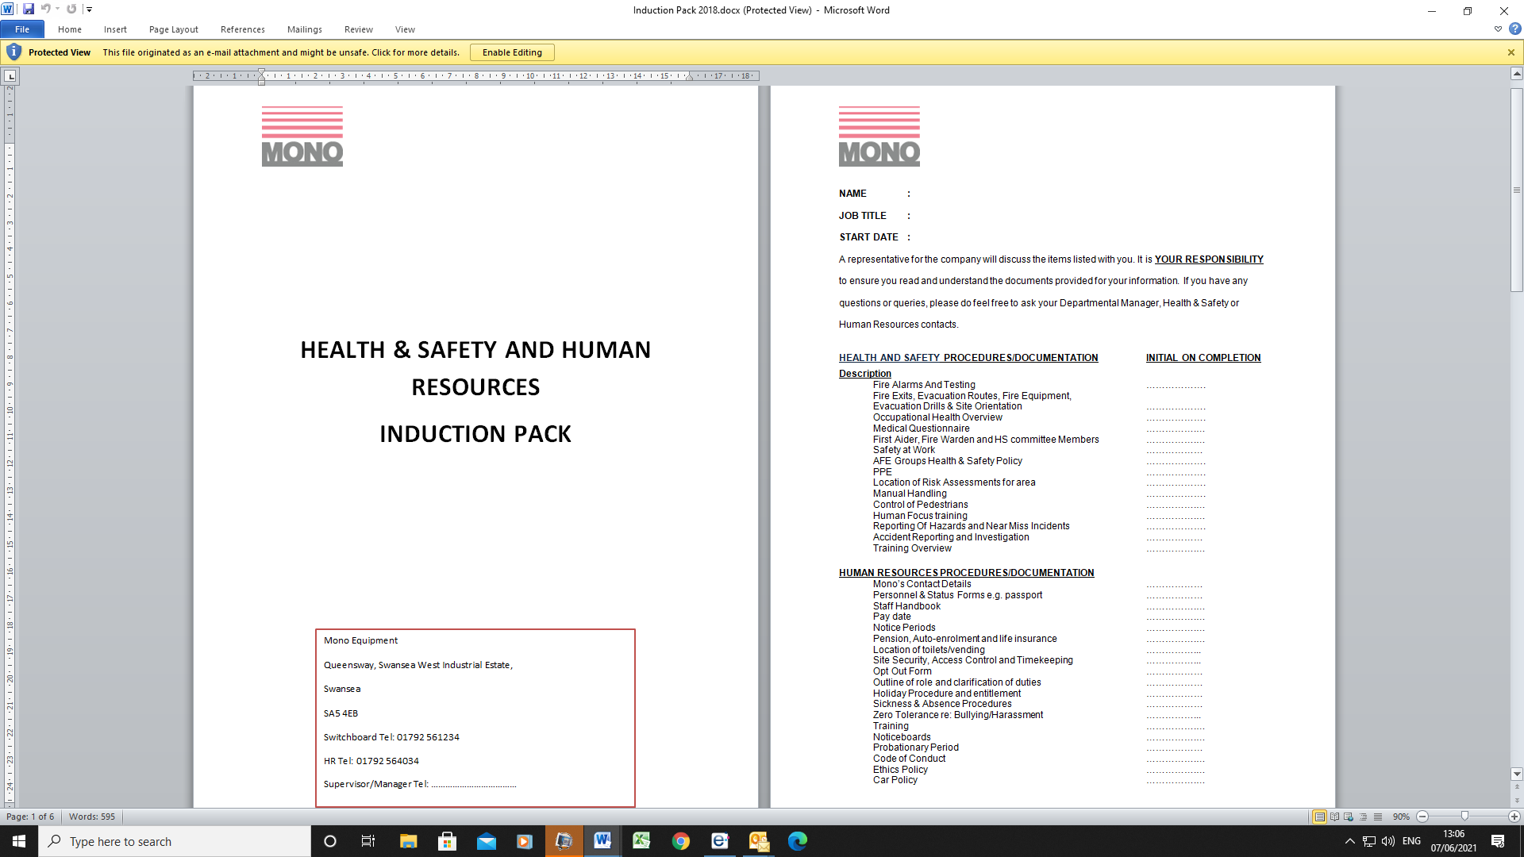
(EV14 – Supervisors Departmental Induction)
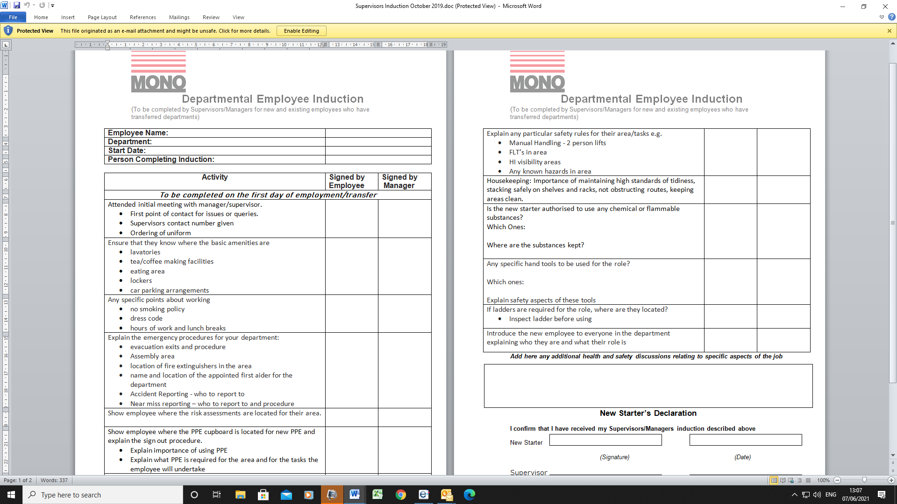
(EV15 – Employee Handbook)
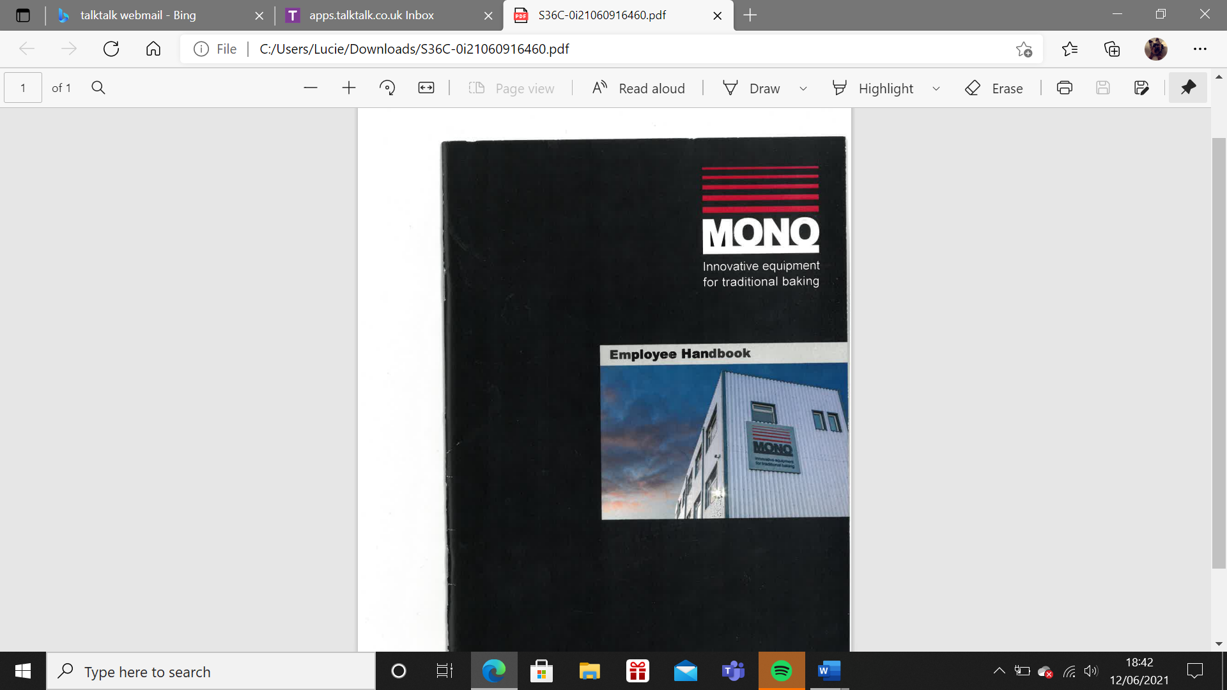
(EV16 – Code of Conduct)
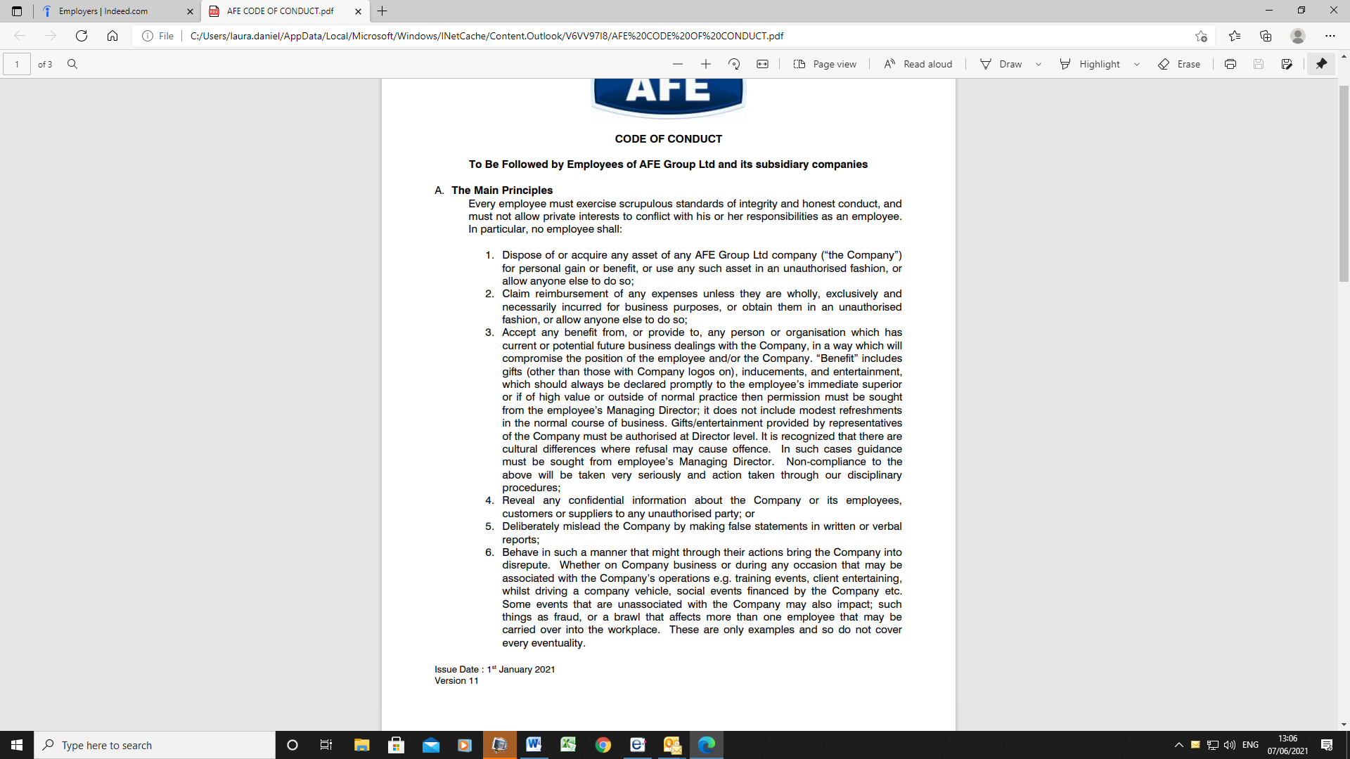
(EV17 – Statement of Core Principles)
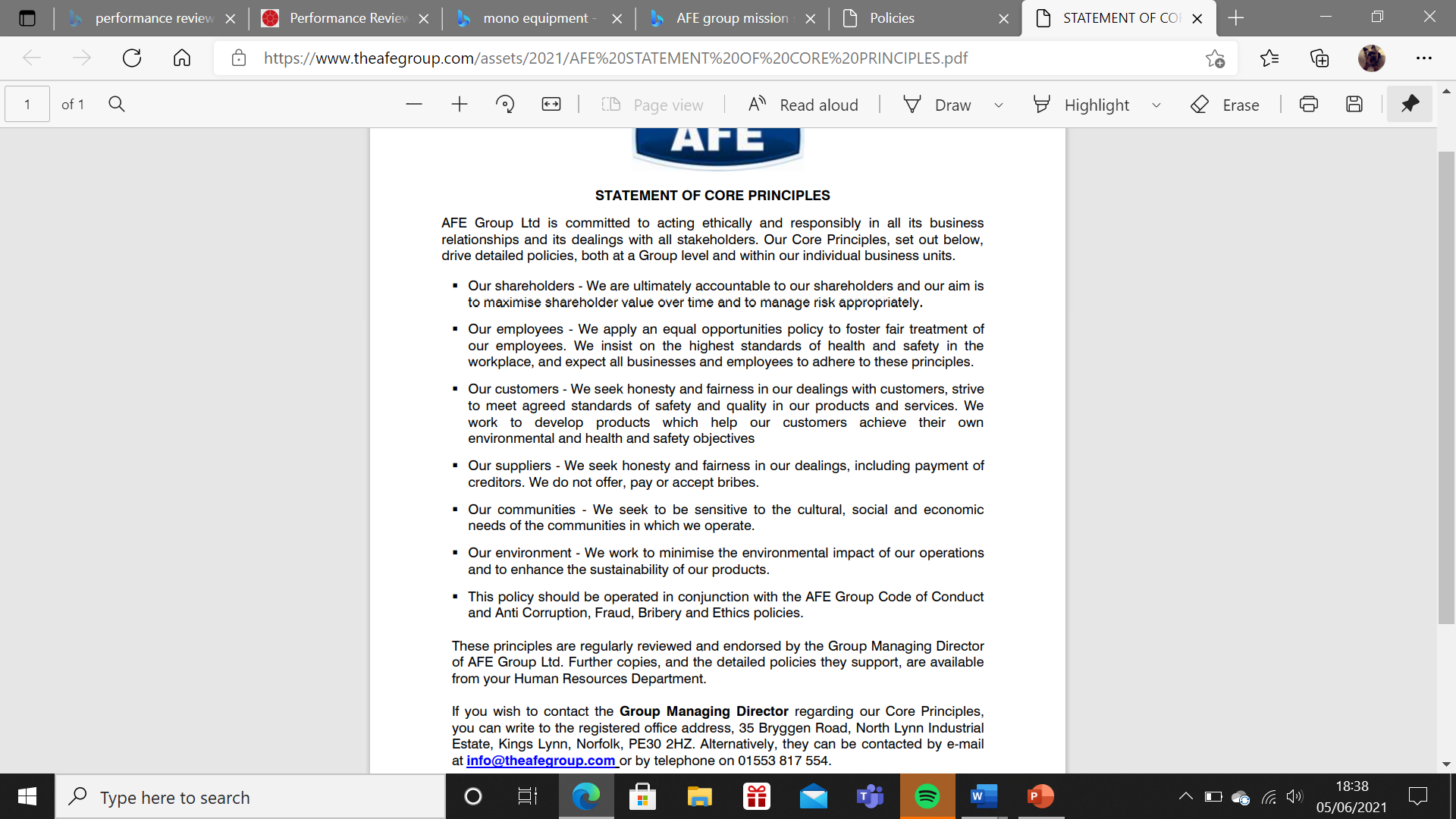
(EV18 – Drug and Alcohol Policy)
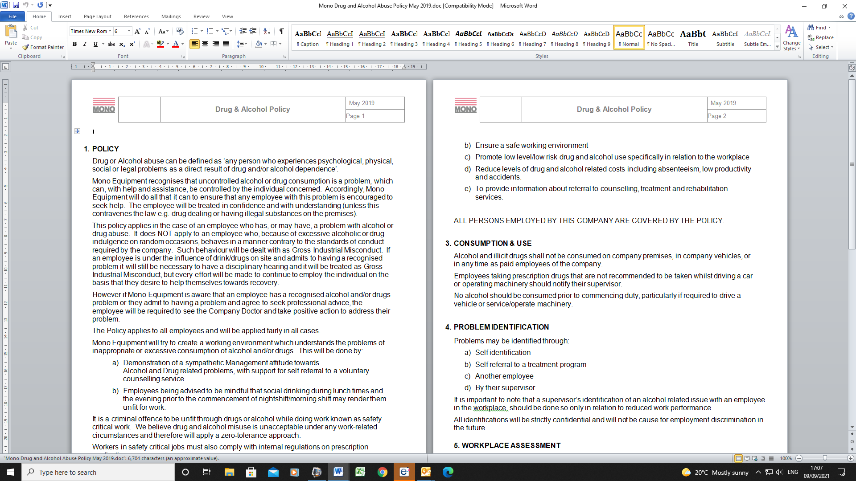
(EV19 – Smoking Policy)
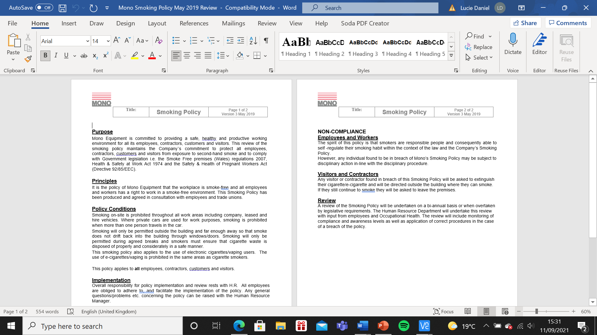
(EV20 – Training and Development Policy)
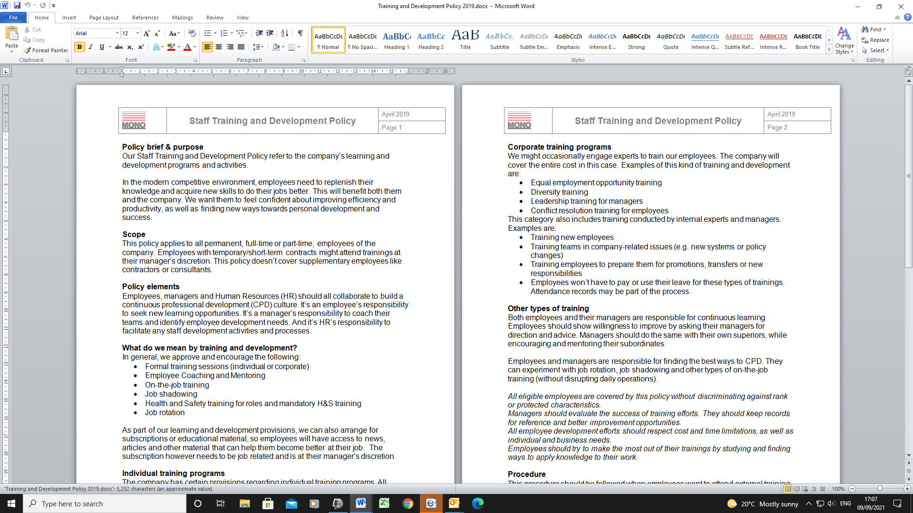
(EV21 – Individual Training Plan)
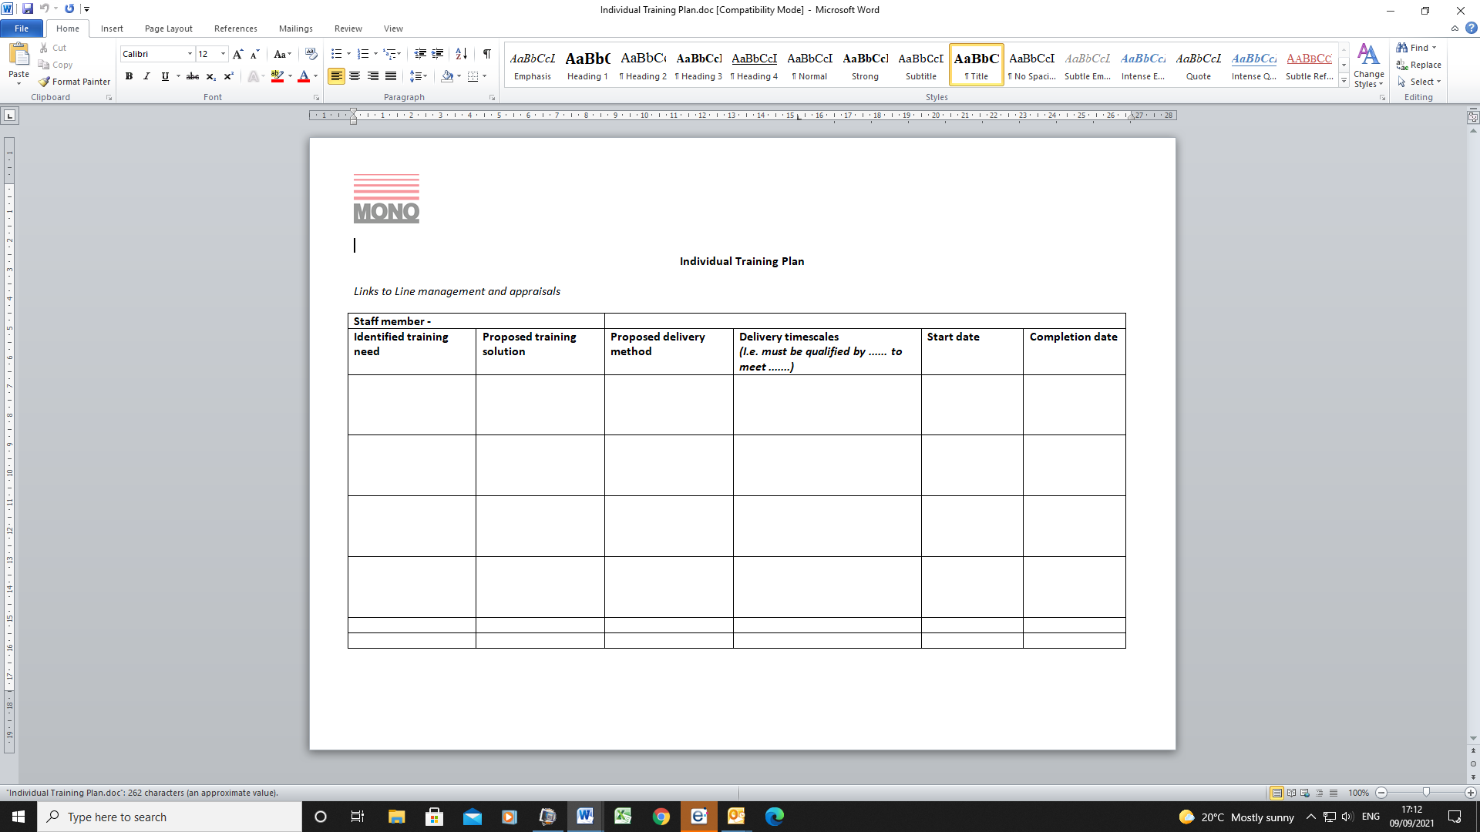
(EV22- Appraisal Self review)
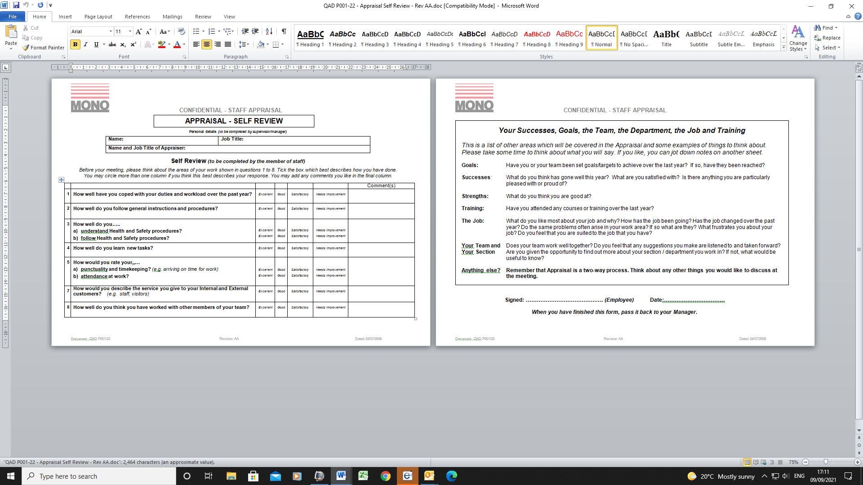
(EV23 – Employer Appraisal Form)
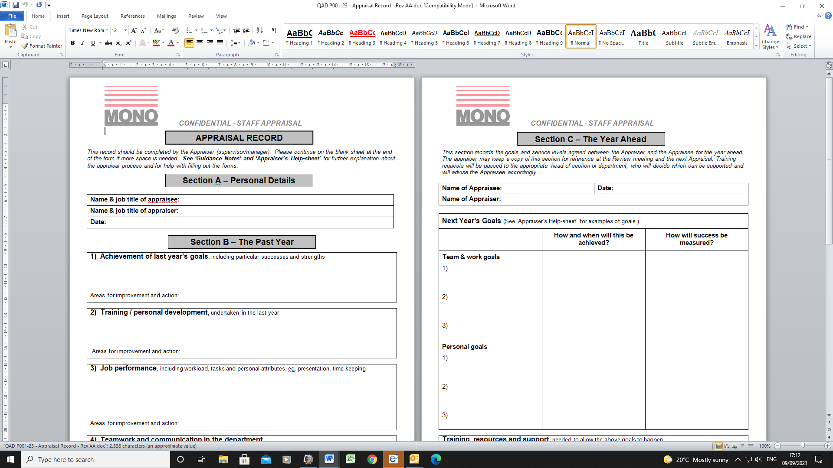
(EV24 – ACAS Code of Practice on Disciplinary and Grievance)
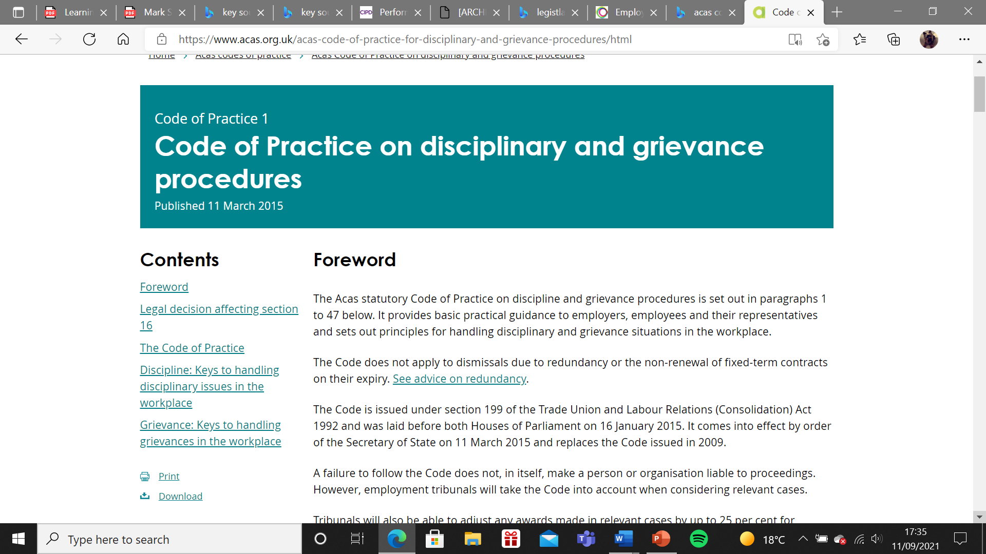
(EV25- Equality and Diversity Training)
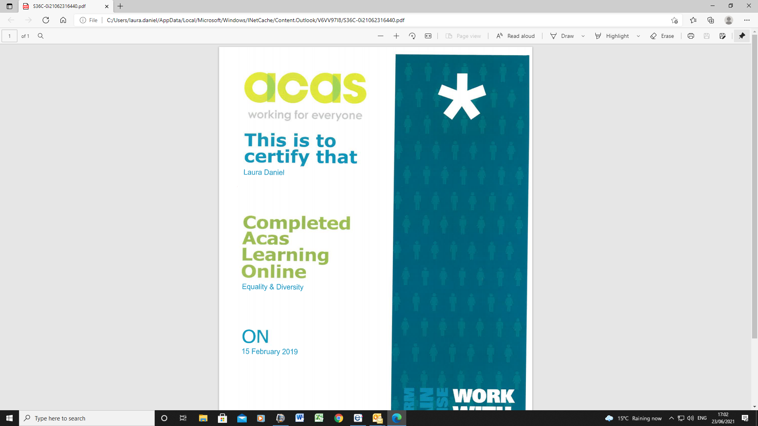
(EV26 – Employment Statutory Code of Practice)
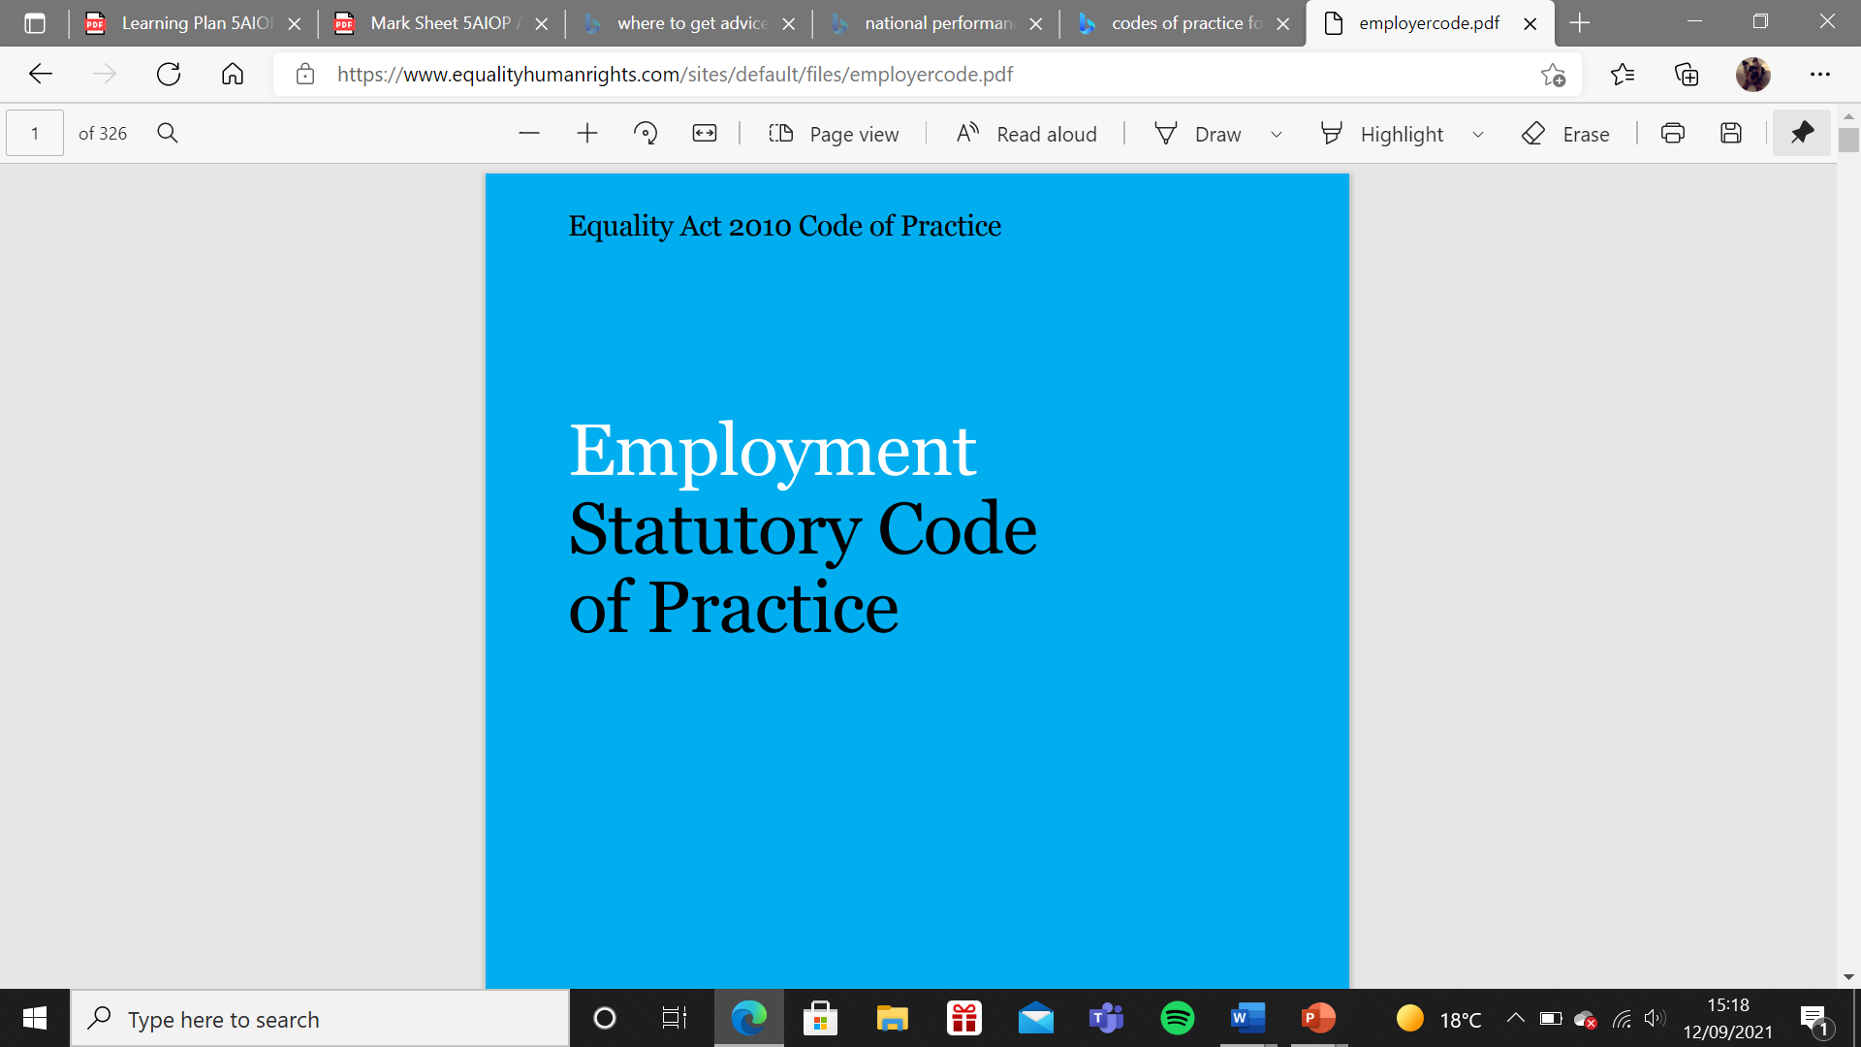
(EV27 – Gov.uk Employment Contracts)
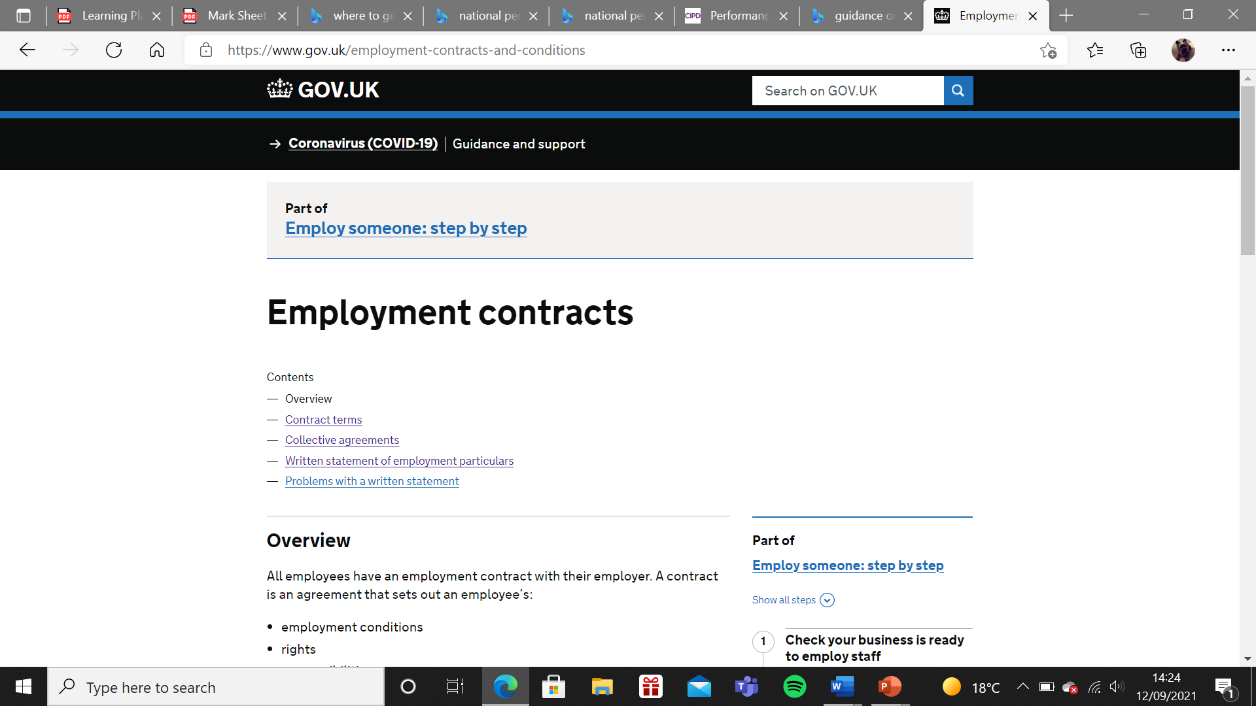
(EV28 Coronavirus policy)
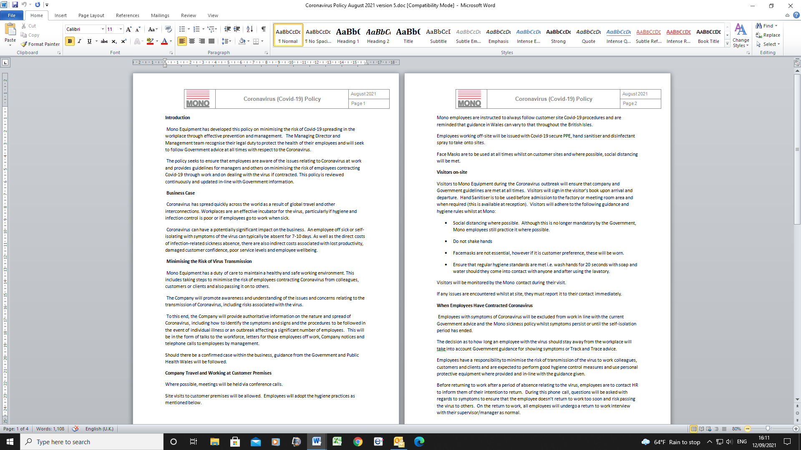
(EV29 Coronavirus employee notice)
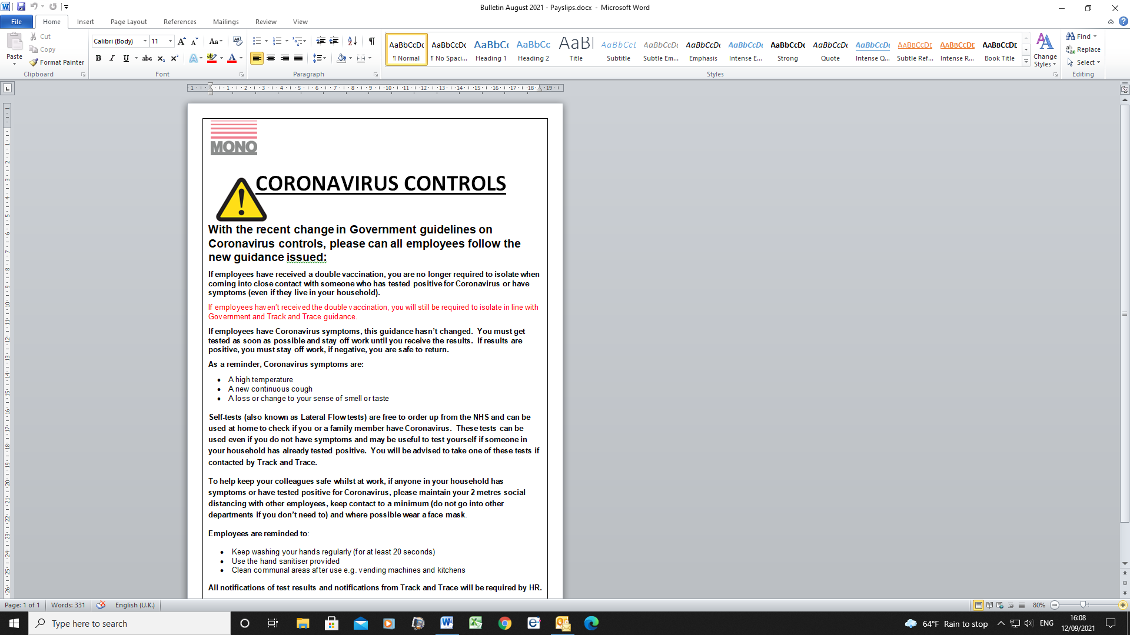
(EV30 induction documentation)
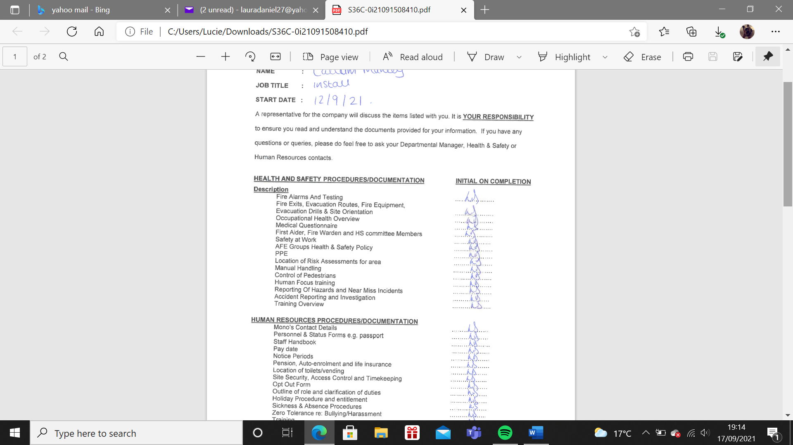

(EV31 Agenda for Induction)
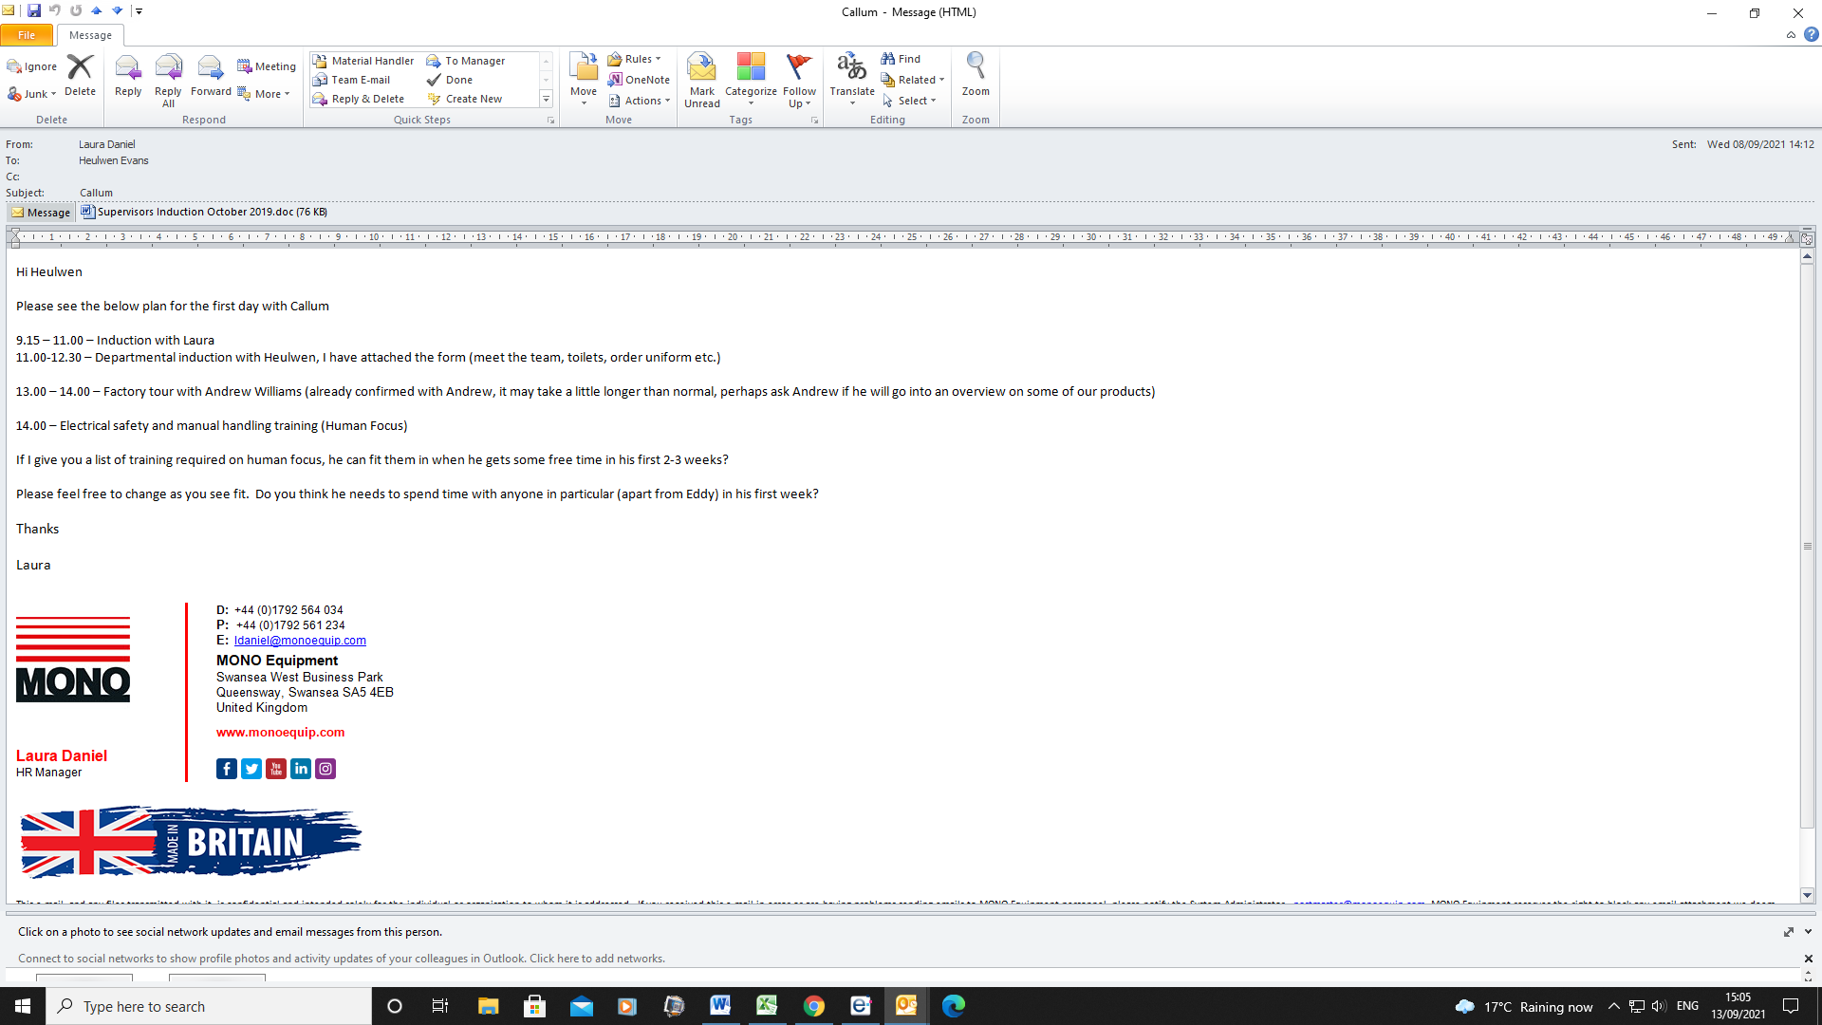
(EV32 Probation letter)
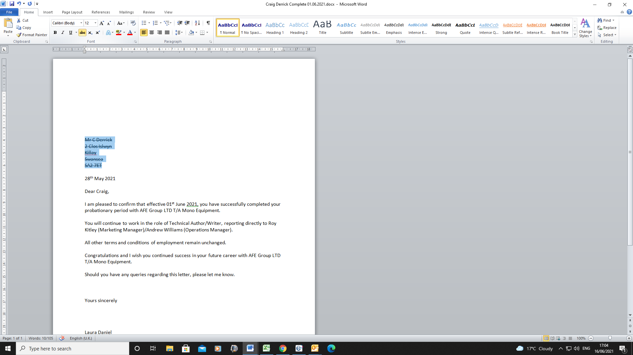
(EV33 probation review notes)
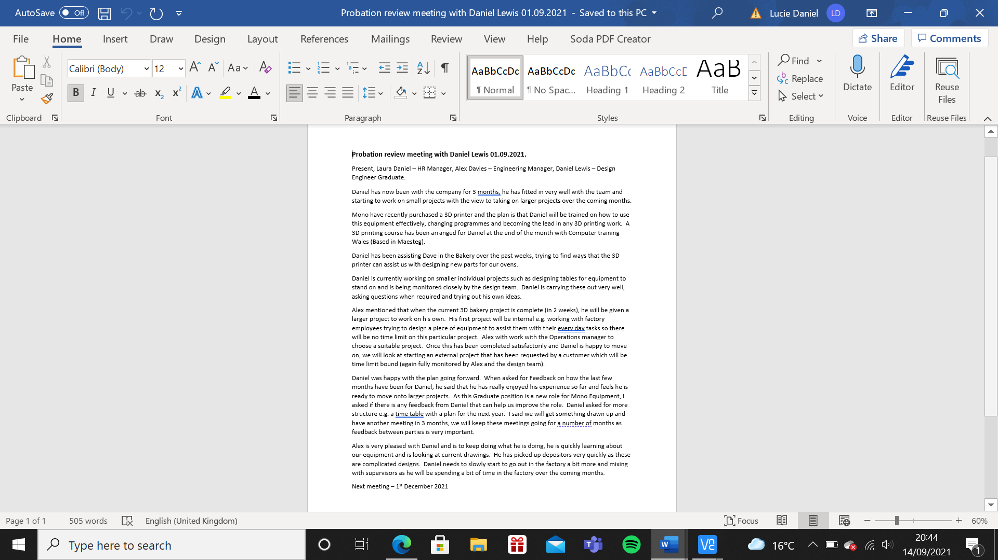
(EV34 e-mail to Warehouse Manager advising on Training requirements and her response)
From: Laura Daniel
Sent: 30 June 2021 10:55
To: Heulwen Evans
Subject: Training
Morning Heulwen,
As mentioned, to assist you with your on-going leaning for your role of Warehouse Manager, I have looked into some courses that will hopefully help you going forward with managing your team. As you have already completed Level 3 in leadership and management, I recommend that you now look at completing level 4.
This will benefit you in so many ways and give you confidence when dealing with more difficult aspects with your team. I will arrange for the tutor to come to site and talk to you in more detail on what is involved. As with your previous learning, I will be available to assist you with the activities and guide you through areas where more experience may be required.
I also include a training plan on further courses I think would benefit your management training.
As already discussed, I will arrange for us to have a training session on our internal disciplinary and grievance policy and on coaching and mentoring the warehouse team.

Please let me know your thoughts.

Kind Regards

Laura

  Laura Daniel  HR Manager
  D: +44 (0)1792 564 034
  P: +44 (0)1792 561 234
  E: ldaniel@monoequip.com
  MONO Equipment
  Swansea West Business Park
  Queensway, Swansea SA5 4EB
  United Kingdom
  www.monoequip.com


This e-mail, and any files transmitted with it, is confidential and intended solely for the individual or organisation to whom it is addressed. If you received this e-mail in error or are having problems sending emails to MONO Equipment personnel, please notify the System Administrator - postmaster@monoequip.com. MONO Equipment reserves the right to block any email attachment we deem inappropriate and to also reject any inbound connections from blacklisted servers. Any email meeting the above criteria will be automatically rejected without notification given to the original sender. Any views or opinions expressed in this email are those of the sender and do not necessarily coincide with those of MONO Equipment or the AFE Group.

From: Heulwen Evans
Sent: 30 June 2021 13:26
To: Laura Daniel
Subject: RE: Training

Thanks very much for the information, the level 4 course is definitely what I am looking for at the moment to help me lead the team. I will have a look at the training plan, can I use this template for my team going forward?
I am available next week for the coaching and mentoring session, Friday suits best as it is quieter for us here if that's ok? Probably the week after would be best for the disciplinary training.
Thanks again for your help on this.
Heulwen

  Heulwen Evans  Installation / Warehouse Manager
  D: +44 (0)1792 564 011
  M: +44 (0)7717 581 902
  P: +44 (0)1792 561 234
  E: hevans@monoequip.com
  MONO Equipment
  Swansea West Business Park
  Queensway, Swansea SA5 4EB
  United Kingdom
  www.monoequip.com
  

LO2 Be able to support line managers to deliver performance management activities within the organisation.
Question 2.1
HR assists Line managers in a variety of ways with performance management at Mono Equipment. Activities are often in line with the Performance Management Process diagram below (CIPD 2021).
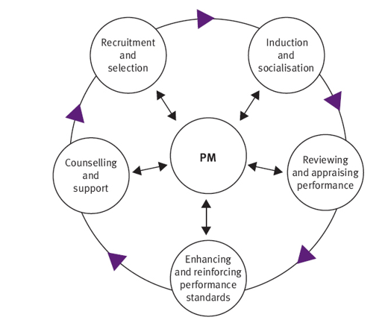
HR enhance and reinforce performance standards by giving advice on Company policies, ensuring that standards are met and employees are treated fairly and consistently. An example of this is when employees are going through the disciplinary procedure. When issues are brought to the attention of HR by the Line Manager, the disciplinary policy is discussed and reminders are given to ensure that the correct procedures are carried out. The Line Manager carries out the disciplinary meeting with HR there as support.
HR occasionally advise on employment law e.g. before and during interviews to ensure that managers are not being discriminatory with any questions asked and reasons for their decisions.
They act as administrative support to prepare letters for disciplinary meetings or probation review meetings and as a record keeper for sickness absence in the form of return-to-work interviews and sickness records. HR also keep record of holidays taken by employees and issue a spreadsheet of remaining holidays each month. They also assist with the induction process of new recruits within their teams, HR give an overview of policies and standards, whilst the Line Manager gives more of an indepth overview of their own departmental workings.
HR keep and review information on training and development by keeping certificates and informing Line Management when training is overdue e.g. first aid training or refresher display screen equipment training. Line Managers identify the training requirements in their departments (sometimes with the help of HR) and inform HR to source and arrange courses. HR also support administratively in meetings e.g. absence meetings, where they give information on previous absences to assist with the decisions made.
HR provide information to Line Managers on a regular basis. From information on Coronavirus Controls in the workplace to information on new policies. Formal meetings are held every six months with HR and Line Managers to talk as a group about any issues and to hold training sessions on new policies.
HR provide coaching to new line managers, assisting them with how to manage some members of their team e.g. those who are disruptive and have recently run a training course on Coaching and Mentoring in the Workplace.
Supervisors review CV’s as they come through the job site Indeed. HR sift through the CV’s picking out the ones who have the skills and experience required for the role. The wording for Job vacancies have been agreed in advance by Line Managers, once agreed, HR will arrange interviews.
HR assist with counselling and support on a regular basis to both line managers and team members. The Line Manager will speak to the individual initially, however for cases where they require additional assistance, they will speak to HR who is a qualified mental health first aider and listen and offer support where possible. However if cases require further help, HR will contact the Occupational Health nurse who will offer her medical assistance.
As mentioned previously, HR will be providing support on Appraisal Systems and filling out the forms when training starts on the new forms in November/December.

Question 2.2
Training on how to conduct a disciplinary meeting has been carried out by HR with the Line Managers to ensure that they have step by step instructions on how to carry it out correctly using best practice (EV35). As there are not many disciplinary meetings within Mono, Line Managers are often sent e-mails from HR before the meeting reminding them of the process (EV36). HR prepare the letters inviting employees into the disciplinary hearing meeting (EV37) and follow up with a letter explaining the outcome of the meeting (EV38). These letters are kept within employee files for either 6 months or a year depending on the outcome.
HR arrange interviews with internal and external candidates once CV’s have been reviewed and agreed with the Line Manager and invite candidates to site and attend the interview with the manager (EV39, EV40).
HR assist with absenteeism and managing teams by informing supervisors of employee absence (EV41) and recording sickness absence statistics for departments. These statistics are sent at the end of each month (EV42).
Line Managers sometimes require assistance with Managing employees who are under performing. EV43 shows notes that have been prepared for such instances as a reminder on the procedure.
Employee Inductions are assisted by HR, there is a HR form that is completed initially to give an overview of Mono’s standards and policies (EV44), then, the Line Manager completes their own Departmental Induction. HR often remind Line Managers of the importance of this induction as it gives employees a good overall picture of what is expected of employees.
HR often Issue advice and support on performance issues and offer counselling advice for the Line Managers to assist with any problems within their teams. Rob Davies who is the Finance Director manages the HR department and gave feedback on a recent issue where an employee became violent at work, HR assisted the Line Manager in taking the employee out of the situation, calming him down, investigating the issue and seeking advice of the employee’s doctor (EV45).
Coaching and mentoring training has recently been carried out to Line Managers in the form of a power point presentation. Mono didn’t have a lot of coaching and mentoring within the business and with the number of employees due to leave in the next few years, this training was prudent on getting current employees trained on other areas of the company. When new recruits come on board, Line managers, who would usually carry out coaching/mentoring in their own departments now have the skills and information required for them to carry this out effectively (EV46).
HR support Line Managers by holding a formal meeting every few months to discuss as a team any issues and offer training and advice. New policies are also discussed in the meetings and ideas shared around the table (EV47).

Question 2.3
HR can assist Line managers with the skills and support to manage their teams, whether it is arranging training courses for line managers or through mentoring/coaching, probation reviews, organising training or identifying training needs through appraisals. Performance management is a way to continuously improve the skill of employees, to improve business performance and improve behaviours of employees (CIPD 2021).
As Mono Equipment do not currently use the appraisal system or any formal system to allow for employee feedback, Line Managers often say it is difficult to set/find time to give feedback or information to their teams. Meetings are currently carried out first thing in the morning between teams or a few minutes are snatched in the corridor throughout the day. It was identified by HR that there needs to be a formalised system and Line Managers need to set time aside for these meetings so they can concentrate fully on their employees.
As mentioned, appraisal forms have already been authorised by the Managing Director Andrew Jones and signed off to start using them in January (EV48). The MD is to inform his managers that HR will be arranging training on the forms during November/December. The Appraisal form consists of one form for the employee to indicate how their past year has been and if they have any training requirements for the coming year, it was decided for them to complete their own form so that they are involved and have a say in their role which can help with employee ownership. The second form is for the Line Manager to complete and discuss with their employee what they see as the requirements for the coming year (EV22, EV23).
Going forward, these forms will allow Mono to set formal employee objectives for the coming year, review objectives set from previous years, identify any training requirements or opportunities and to arrange any assistance to complete these objectives e.g. courses or new equipment.
HR and the Line Manager currently hold probation review meetings with employees, this is usually at 3 months from when the employee started their employment. Review meetings have started becoming more formalised and documented (EV49) and a completion letter issued after the meeting (EV50). These review meetings will aid with the appraisal system in identifying training opportunities at an early stage of employment, hence ensuring that the employee feels a valued member of the team and hopefully remain motivated throughout the year. The probation meetings are currently used to plan employment of employees.
Once a probation review meeting has been held, an Individual Training Plan is discussed, should the employee wish to progress (EV51). An e-mail from the manager agreeing is shown in EV52. This training is agreed by the employee, Line Manager and HR and will be reviewed every few months. HR will arrange the training with a training provider (EV53).
A recent training plan was created for a Graduate Design Engineer who has already attended a training course. Some feedback from the course and his manager is below EV54.
All review information from Probation meetings and Appraisals (when they commence) will be kept with HR in employee personal files. They will be reviewed by HR before being filed away.

Evidence LO2
(EV35 – How to conduct a disciplinary meeting notes)
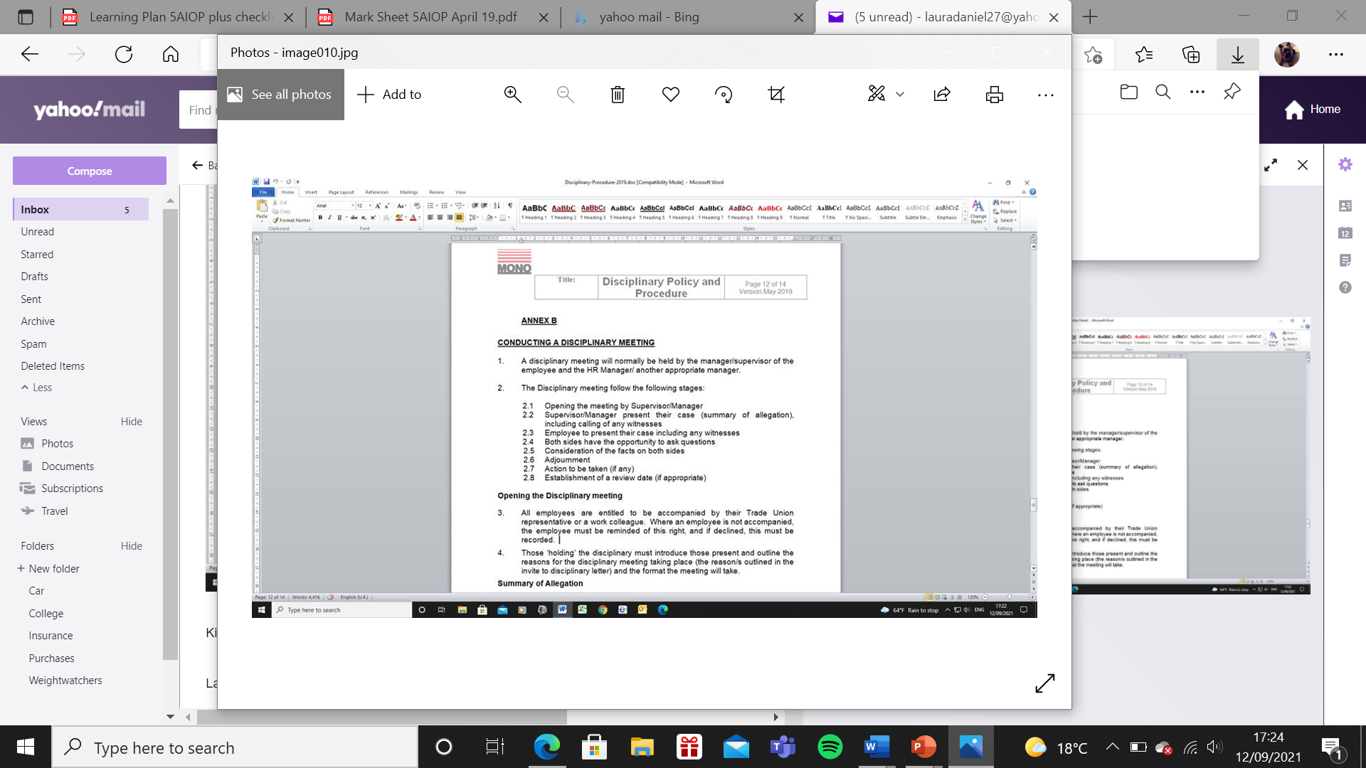
(EV36 – Disciplinary format reminder e-mail)
From: Laura Daniel
Sent: 15 July 2021 10:55
To: Mark Challinor
Subject: Disciplinary Meeting
Morning Mark,
I know you are chairing a disciplinary meeting next week and it has been some time since you have taken part in one. I thought I would give you a few reminders on best practice on how to carry them out. Please see the below. In the mean-time, just give me a call if you need any further help.
The Disciplinary meeting should follow the following stages:
- Opening the meeting by Supervisor/Manager
- Supervisor/Manager present their case (summary of allegation), including calling of any witnesses
- Employee to present their case including any witnesses
- Both sides have the opportunity to ask questions
- Consideration of the facts on both sides
- Adjournment
- Action to be taken (if any)
- Establishment of a review date (if appropriate)

Kind Regards

Laura

Laura Daniel  HR Manager
  D: +44 (0)1792 564 034
  P: +44 (0)1792 561 234
  E: ldaniel@monoequip.com
  MONO Equipment
  Swansea West Business Park
  Queensway, Swansea SA5 4EB
  United Kingdom
  www.monoequip.com

From: Mark Challinor
Sent: 16 July 2021 11:05
To: Laura Daniel
Subject: Re: Disciplinary Meeting

Laura
Thankyou for this reminder. It has been quite some time so much appreciated for the info.
I will probably speak to you before the meeting just to run some things past you if that’s ok.
Cheers..
Mark

(EV37 – Invitation letter to a disciplinary meeting)
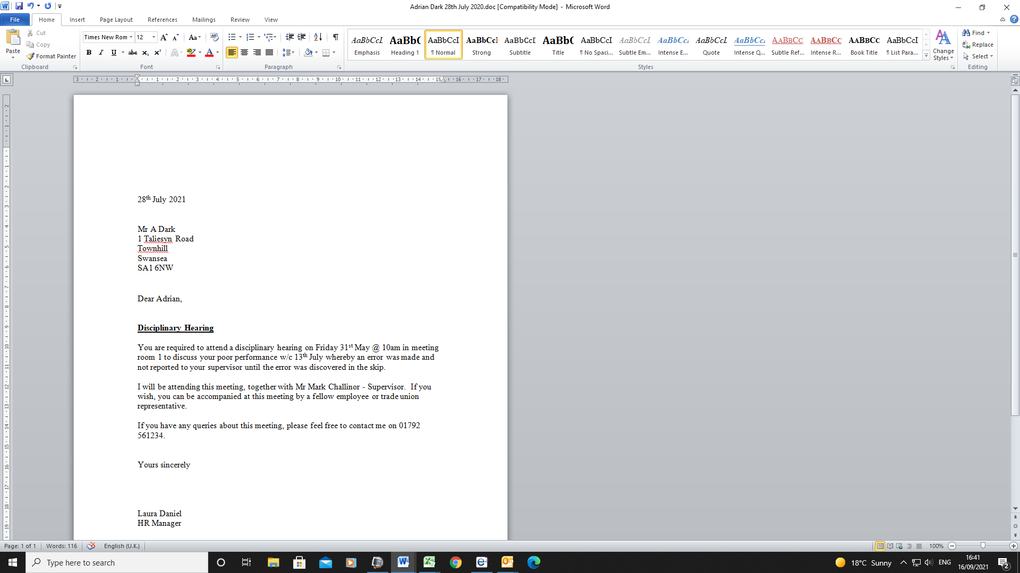
(EV38 – Warning letter from disciplinary)

(EV39 - e-mail showing arranged interviews by HR)
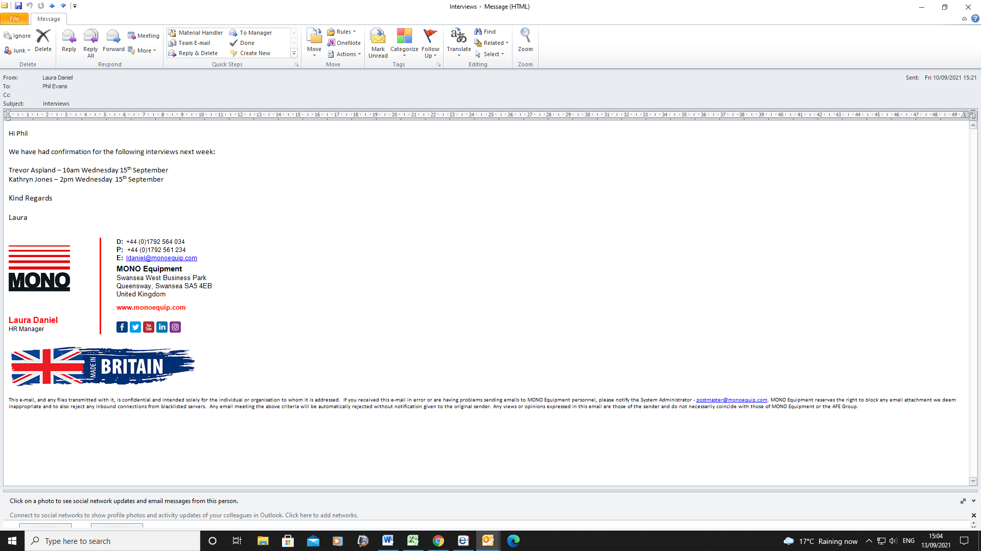
(EV40 – e-mail showing interview request to candidate)
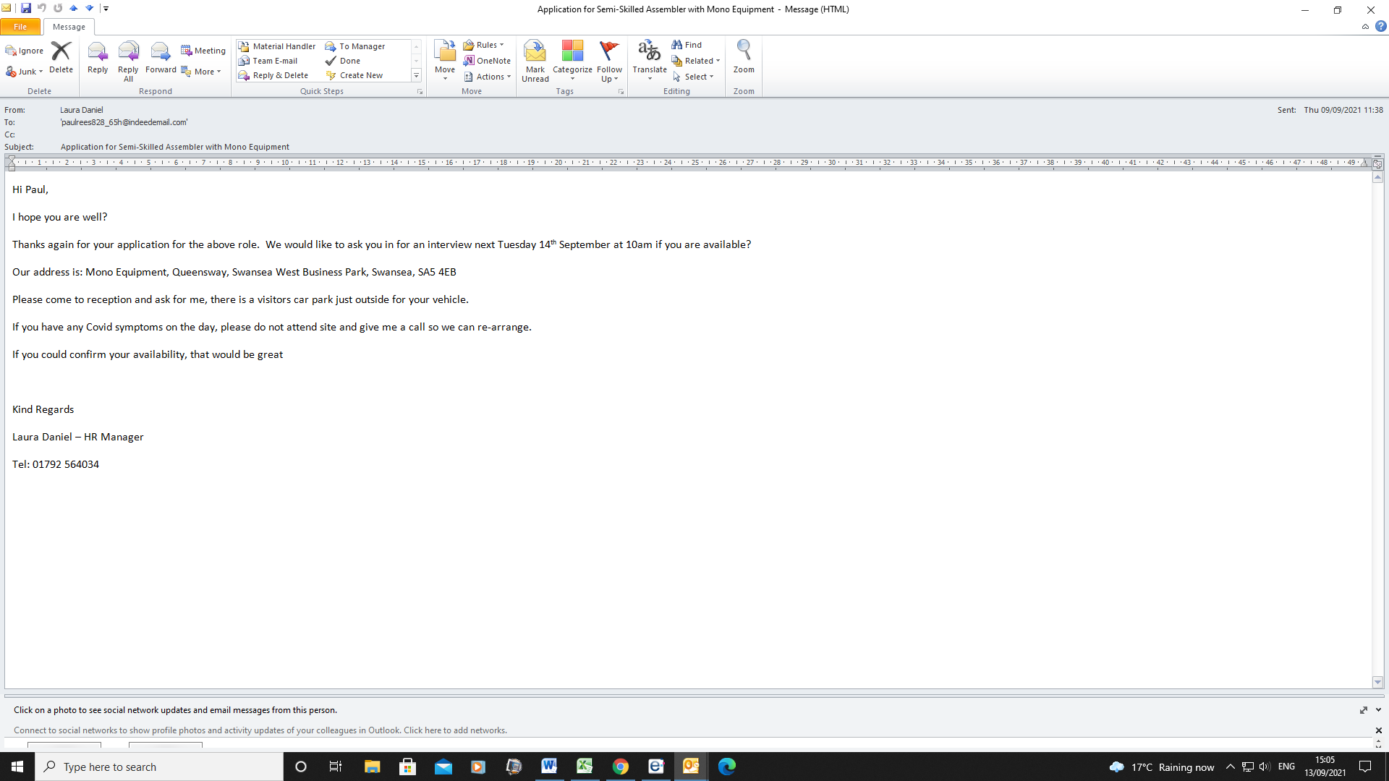
(EV41 – e-mail informing management of employee absence/sickness)
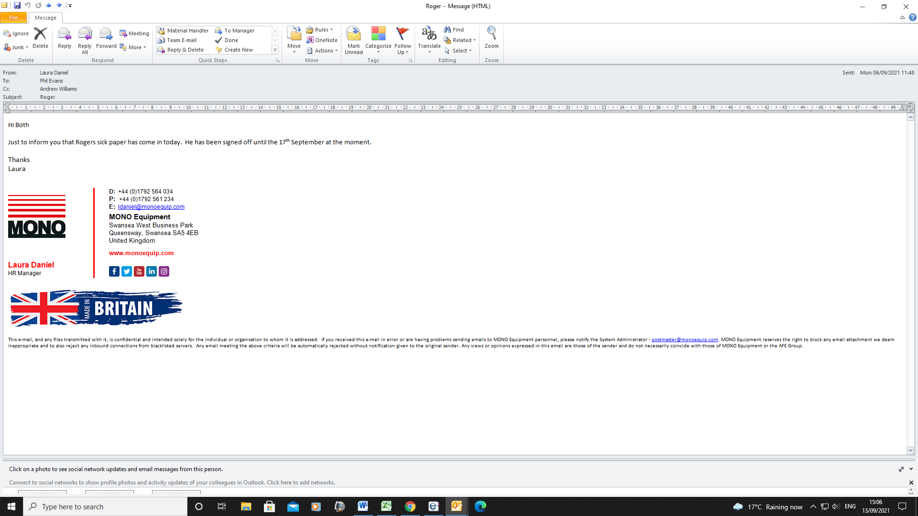
(EV42 – Monthly absence statistics)
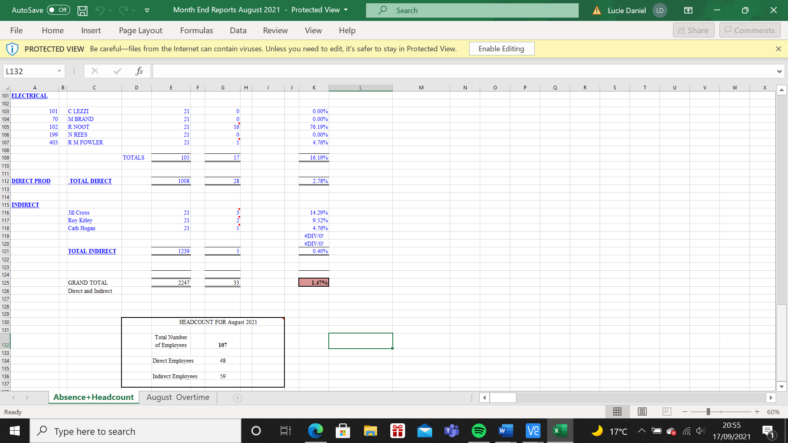
(EV43 – Notes on how to manage unsatisfactory work performance)
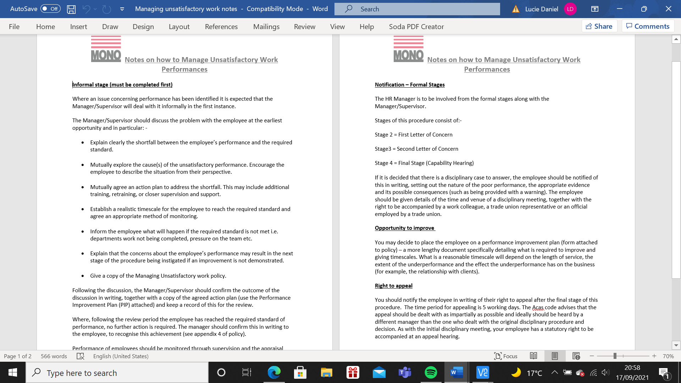
(EV44 – HR Induction form)
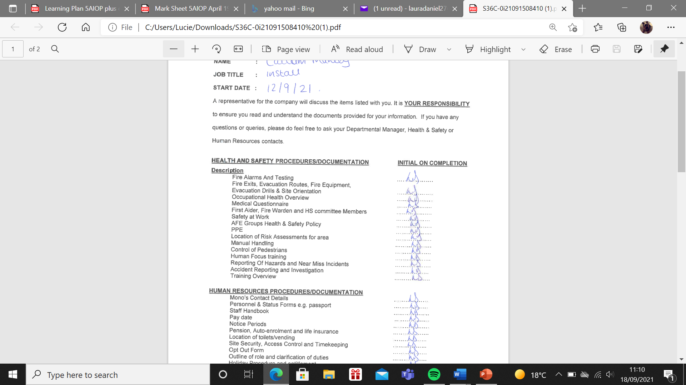
(EV45 – e-mail from Rob Davies ref employee incident)
From: Rob Davies
Sent: 17 August 2021 10:55
To: Laura Daniel; Andrew Jones
Subject: Situation this morning
Laura,
I would like to say well done for the way that you handled the situation this morning when Chris became violent at work. You kept a level head and ensured that employees nearby were safe and kept well away from the situation. You ensured that the supervisor was on hand to help when he had to be taken out of the environment. The issue could have become much worse, you diffused it as quickly as possible. I know that yourself and Chris have regular conversations and you have supported him in the past with his brain injury from a few years ago, however as discussed, I now think that the support of his own doctor and mental health practitioner is the only way forward, can you please see if you can get some information from Chris on who his contacts are, perhaps Shan can help from an occupational health side?
I have copied Andrew in this e-mail for him to know what is happening and how this has been dealt with.
Once again, well done.
Rob.

(EV46 – Coaching and Mentoring Training)
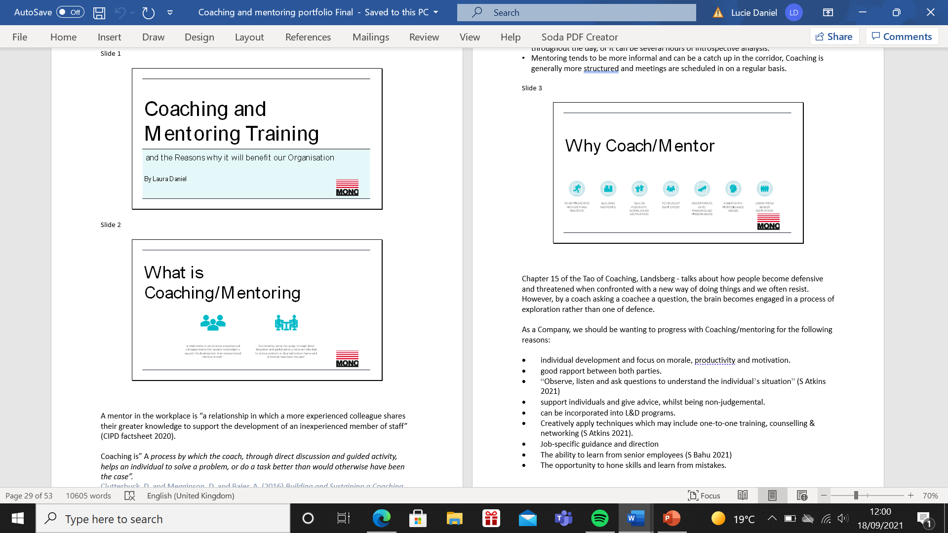
(EV47 – Meeting minutes for HR and Line Manager meeting)
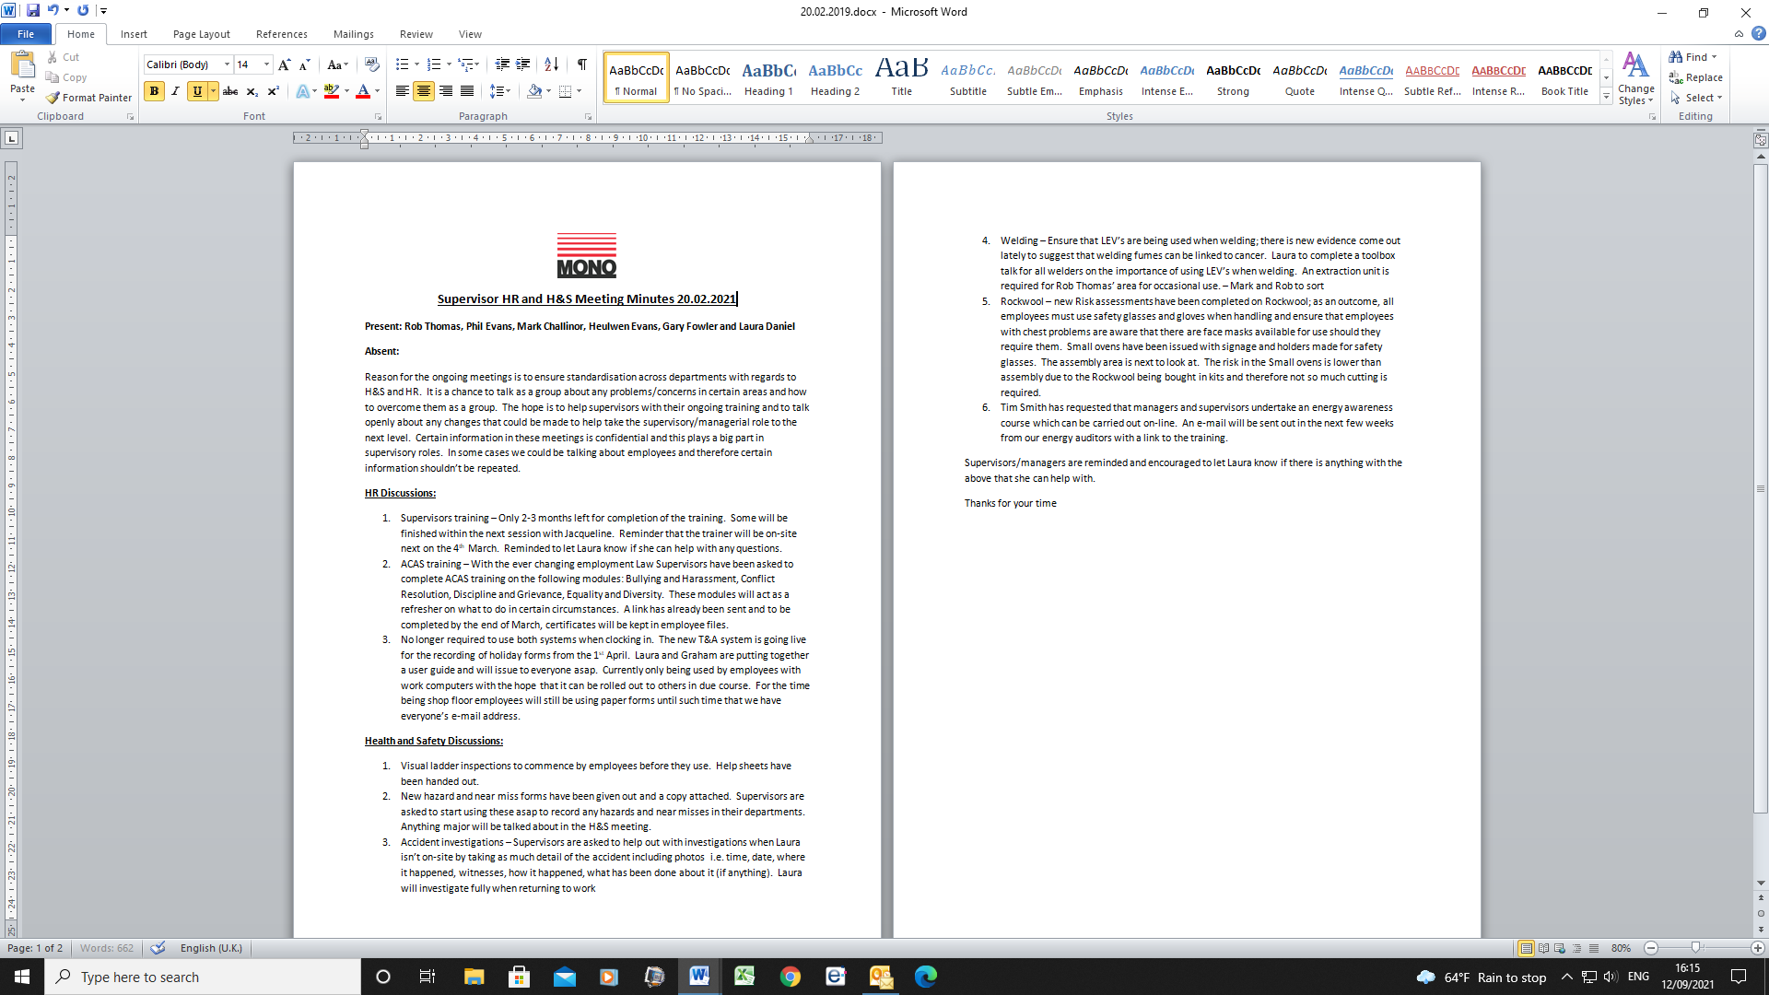
(EV48 – E-mail from MD to start using Appraisal forms in January)
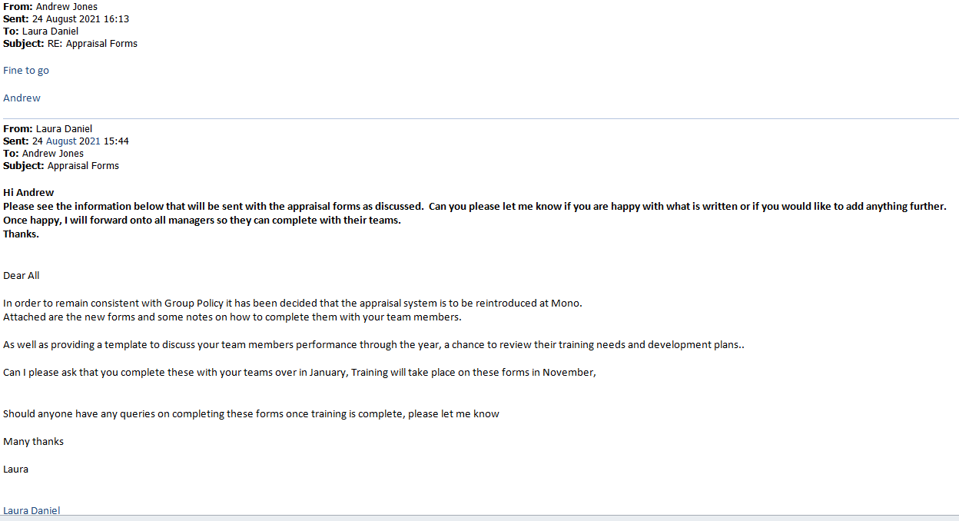
(EV49 – Probation review notes)
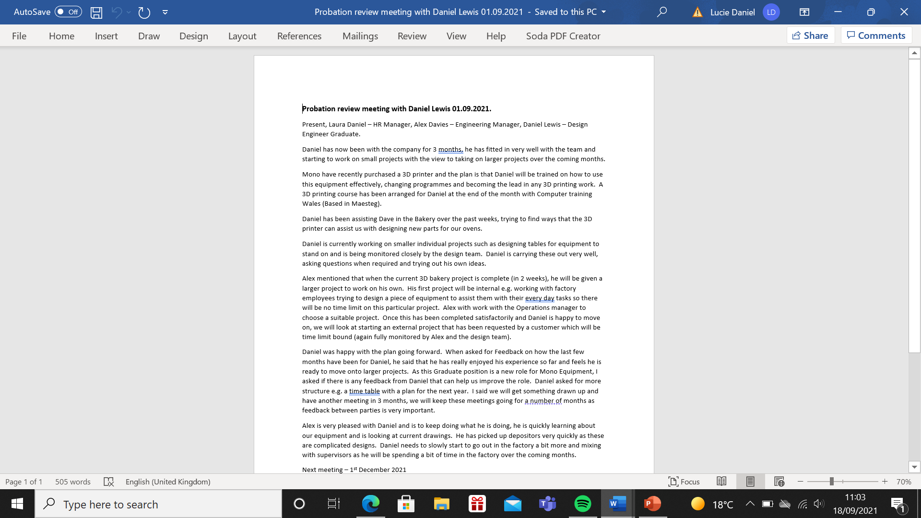
(EV50 sign off probation letter from HR)
(EV51 – Individual Training Plan)
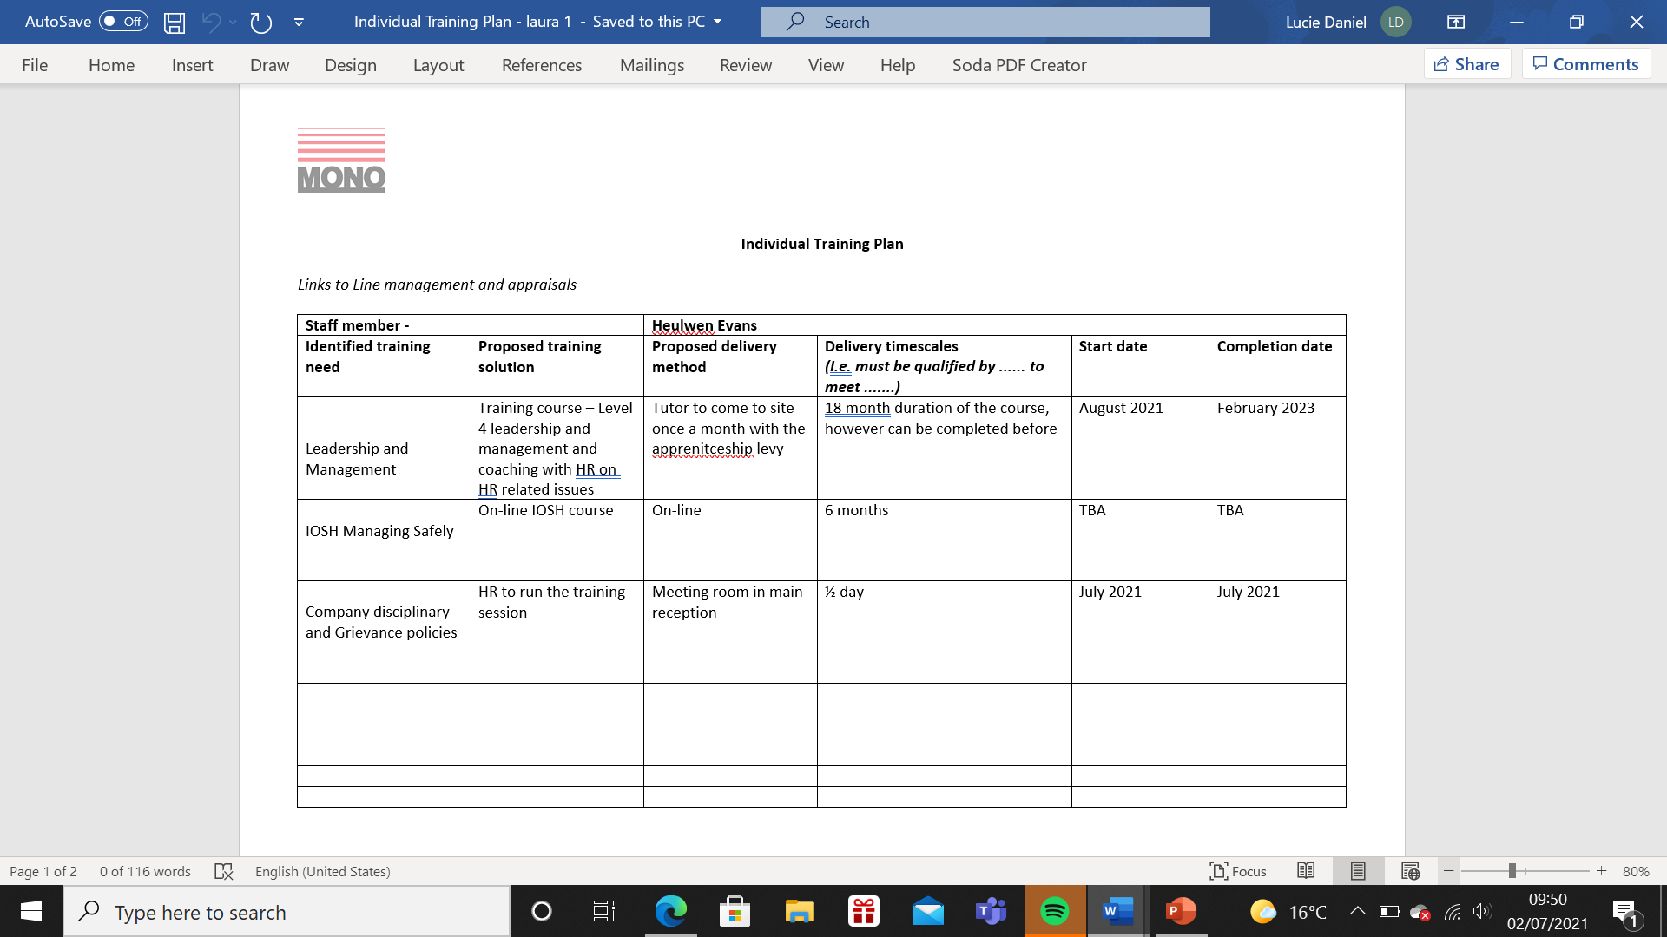

(EV52 – Email from manager for Individual Learning Plan)
From: Laura Daniel
Sent: 30 June 2021 12:21
To: Alex Davies
Subject: Training Plan for Daniel

Hi Alex
I know we have had a few conversations lately regarding Daniel and his Graduate training, coaching and mentoring him etc.
I have put together a quick template that we can use for his future training. This hopefully will help us with planning for his future and for him to see that we do want to invest in him long term.
It would be worth sitting down with Daniel over the next few weeks to discuss this with him, I can join in the meeting if you want and get some input from him, where does he see the role going as well as us? (He isn’t always going to be a graduate, we don’t want him to leave after a year when he has his experience, so really need to focus on some structure for him).
We can also use this template for his internal training? Please let me know your thoughts and if you think this is a good idea to move forward with.

Kind Regards

Laura

Laura Daniel  HR Manager
  D: +44 (0)1792 564 034
  P: +44 (0)1792 561 234
  E: ldaniel@monoequip.com
  MONO Equipment
  Swansea West Business Park
  Queensway, Swansea SA5 4EB
  United Kingdom
  www.monoequip.com

This e-mail, and any files transmitted with it, is confidential and intended solely for the individual or organisation to whom it is addressed. If you received this e-mail in error or are having problems sending emails to MONO Equipment personnel, please notify the System Administrator - postmaster@monoequip.com. MONO Equipment reserves the right to block any email attachment we deem inappropriate and to also reject any inbound connections from blacklisted servers. Any email meeting the above criteria will be automatically rejected without notification given to the original sender. Any views or opinions expressed in this email are those of the sender and do not necessarily coincide with those of MONO Equipment or the AFE Group.

From: Alex Davies
Sent: 30 June 2021 12:27
To: Laura Daniel
Subject: RE: Training Plan for Daniel

Ye, good idea

I would rather if you were present during the sit-down discussions regarding his future etc, and whether enrolling him on courses allows us to tie him down for a certain amount of time after.

Alex

(EV53 – E-mail from training provider for arranged training)
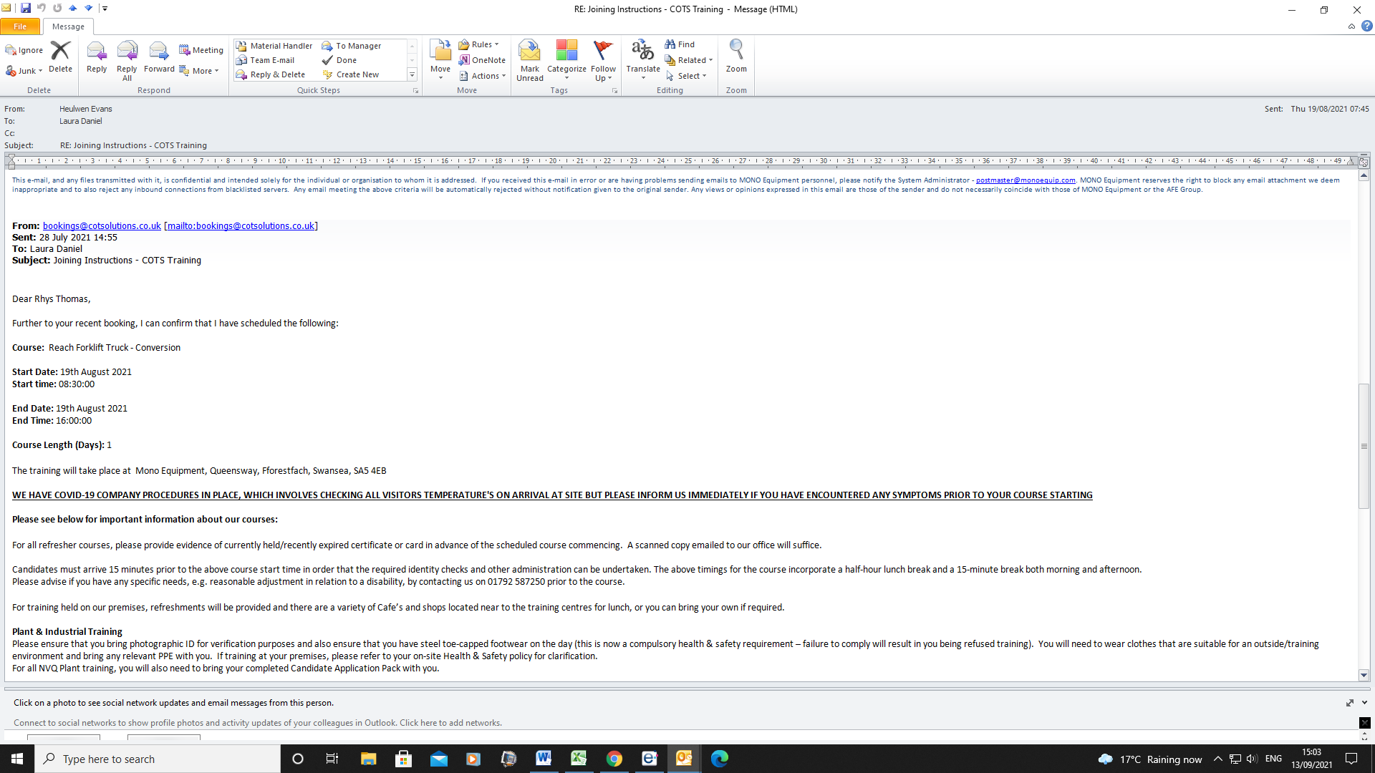

(EV54 – Email from Engineering Manager regarding recent training for employee)
From: Alex Davies
Sent: 30 August 2021 12:27
To: Laura Daniel
Subject: RE: Training Plan for Daniel
Hi Laura
I would like to say thank you for organizing Daniels’s 3D printing course, he really enjoyed it and has come back with some really good ideas for us to use. I know we haven’t used this provider before so the feedback for the is really positive, we can definitely use them again for other courses so please keep them on file.
Daniel seems to be settling in well after his 3 months, I think the training plan we put together has worked for him, I think reviewing it every 3-6 months with him as we spoke about will keep him engaged.
I want to personally thank you for your support since I have become manager, you have given me an insight into what the role entails and helped me with the personnel issues I have encountered. The coaching and mentoring course was an eye opener, I suppose I had never had to think about this in my previous role so hopefully I can take some tips from the course an put them in place. I think that a management training course would be useful for me as discussed previously, so please can you let me know what you think would be best.
Thankyou for your support
Alex

LO3 Be able to assess the impact of performance management activities on organisational performance and make recommendations for enhancement.
Question 3.1
Mono used to do very little with regards to performance management, there are some archaic systems in place and some old school managers. However, progressions are slowly being made and certain managers are buying into any processes being implemented.
There are some good approaches to performance management and some are currently being worked on. Upon examining some internal policies, it is found that some require updating as they haven’t been reviewed for the past 2 years, it is up to HR to implement any changes that are found and the MD to sign them off.
The employee induction process is working well from management point of view, it has recently been updated to give more detail with specific departmental activities and Mono Equipment have retained all staff taken on since the change. A good induction is vital for employees to understand their role within the business and in turn decreases turnover and increases commitment (Taylor 2016). It also assists in understanding the culture of the organisation and helps employees settle in, this can also mean that disciplinary meetings are reduced as employees understand what is expected of them. Upon reviewing disciplinary meetings over the past year, they seem to have decreased, I am not sure now if this is down to the changes that have been made, it is too early to tell at this stage. Feedback from employees is that the induction is very informative, however can be too much information on day 1 and overwhelming (EV55). This will be reviewed and recommendations made.
Mono is not very effective on mentoring employees, there are historical reasons of it not working previously and managers not recognising the importance it brings to departments. Most Line Managers have undergone Coaching/mentoring training with HR a few months ago, however I feel that the issue lies further up the ladder with senior managers not seeing the importance of it. It was discussed with my manager and will be mentioned in the next management review meeting. A request that coaching/mentoring training being given to senior managers will be made. CIPD (2020) mention “before coaching starts, organisations need to assess an individual’s ‘readiness’ for this approach” for this reason, everyone will be asked beforehand to ensure that they are happy to partake in the sessions.
As mentioned, appraisals were going to be implemented in January. According to Bloom et al (2012), there are strong indications that organisations were nearly 25% more productive when employees had formal performance management systems in place which were based on targets, incentives and monitoring. The appraisal system is going to be top down and self-appraisal and will be performance based only (not reward based). Performance appraisals/reviews are to be implemented as they are intended be positive; they raise employee morale along with performance levels, discuss company expectations and the duties of employees, improve communication between both parties, identify training and development opportunities and requirements, reinforce the goals and objectives of the organisation and strengthens the control of management (CIPD 2021). There are however issues with appraisals such as an “unfair bias” in the way that management deal with the process (Taylor 2016 p208). CIPD (2021) state that there is no evidence that appraisals improve employee performance. They say it is often a tick box exercise, SMART objectives can often be unreasonable and the appraiser sometimes isn’t trained to carry them out correctly.
After speaking to most managers about implementing appraisals, their feedback is initially negative, with most stating that they have no time to complete reviews especially with large teams. When these forms are circulated in January, HR will have to ensure that training is issued to managers to ensure that this doesn’t become a tick box exercise and both employees and the managers understand the benefits of appraisals and that both parties get some positive outcomes from it.
Development reviews are currently only carried out after 3 months during the probationary period review. There is positive feedback from new starters on the development review and training plans that are put in place at this stage. According to EV54, feedback from the review is positive, employees are happy with the feedback and future structure, training and goals. A negative point I picked up however is that these reviews need to be completed more regularly. HR will look further into this and make recommendations.

Question 3.2
The Performance Management processes currently in place at Mono Equipment seem basic compared to some of those found through research and other organisations. Mono is starting performance appraisals with employees in January, however trends on performance management now state that annual appraisals are to lose their importance due to a clear positive correlation between higher level of motivation and timely accurate feedback, more managers will seek ways to give effective continuous feedback (Kalja 2021). Although Appraisals are becoming outdated, it is positive that Mono is starting to offer feedback in this form and is a positive step to changing its current culture. Appraisals/feedback on performance contribute to HPW; it informs employees how well they are performing and if there are any improvements required. Feedback also lets employees know that they are valued which can increase commitment and performance and is effective because it defines and identifies expectations (Fernandez 2017). Some organisations are already taking on this different approach to performance management and along with continuous feedback are completing 360 feedback reviews where the managers and employees are being reviewed. Such companies are Millers Vanguard (a sister company to Mono Equipment).
Current practices within Mono do not allow for collection and analysing of performance data or identifying trends and patterns. KPI’s are currently completed in the factory environment, however by informal methods and hence employees are not always aware of what their targets are. Figures are based on customer orders and how many products can be produced. To assist with HPW, these should become more formal so employees can understand what is required and have more vision and ownership going forward.
Other key components of HPW that encourage the commitment and participation of employees include:
- High level of involvement by employees in making decisions on policies and practices. The more employees are involved, the more engaged they become (Marchington and Wilkinson 2012). Currently Mono Equipment do not involve employees in creating policies, however the Union and Line Managers do have input. I don’t think currently Mono will change its stance, however there are benefits in employee involvement which will be researched further.
- Job/employment security attracts and retains high performing employees, ensuring employees stay engaged and committed (Marchington and Wilkinson 2012). Mono Equipment offers job security, with 25% of its current workforce having 30+ years’ service. However, current systems such as induction and training plans are to be reviewed and worked on to retain high performing employees. The current old school culture will need to be worked on to ensure that employees stay engaged.
- Well thought out recruitment and selection systems. Choosing the candidate most likely to excel in the role, based on the evidence given before them (Rees and French 2016). Mono Equipment have a good recruitment and selection system with both HR and Line Managers involved in job descriptions, interviewing and selection, so the correct person can be chosen for the role.
- A broad/high level of training and development. Ensuring investment to help employees develop and improve their skills. Currently Mono are investing in training certain individuals, the appraisals will assist with this in identifying training required for everyone.
- Clear Company strategy encourages commitment of employees and promotes successful leadership. There are discussions currently underway to update our company handbook which includes the organisations principles which will help with promoting the company strategy. The Company intranet will also be a good way for employees can access this information.

Question 3.3
There are many recommendations that can be made for Mono Equipment to develop their performance management processes.
Senior Managers must have training on why coaching/mentoring is important to employees and the organisation. Hardingham (2004) states “a culture where people coach each other all the time as a natural part of meetings, reviews, and one-to-one discussions” has a positive effect on the workforce and organisation. By empowering employees and assisting them in becoming successful, provides them with the tools to help increase skills and knowledge. By making this recommendation could fill some of the gaps that we will be seeing in the workforce in a few year’s time.
To assist with developing the Performance Management processes, employee Inductions should take place over a longer period. Currently they cover the first few days of employment, however it takes longer to sometimes feel settled within an organisation. HR currently meet employees formally during the first few days and at their 3-month review, however it is best practice to meet at 3months, 6 months and a year (CIPD 2021) to ensure that employees get the best information in their early employment.
New Recruits within the business should be consulted on improving the Induction process to get a fuller picture of the process. We have already been informed that it is too much information on day 1, HR will review to see it this should be changed and spread over the week. I will speak with IT to see if some of the policies can be put onto the Intranet so employees can access them at any time or even before they start with Mono. ACAS (2015) say that all employees have different needs so each induction should be different, specific information for their role should be conveyed instead of generic information. I will get in touch with Mono’s sister companies to see how they conduct inductions and speak to managers on why a good induction will benefit their departments in the long term. CIPD (2021) state that some managers feel that an employee induction should be carried out by HR and therefore is not important. A training session on Inductions will be issued to managers over the next few months for them to understand how important they are.
Exit interviews are to commence and to be carried out by HR to determine the reasons why employees leave the company. These are to be documented and will help to find out where/if Mono can make improvements (EV56). This will help current employees in their roles so that Management has a clear indication if anything is going wrong in their departments.
Feedback is not issued very regularly to employees. Managers must understand why both positive and negative feedback is important. According to Matthews (2021), feedback is one of the most effective tools we have for harnessing and promoting change, so it is to everyone’s benefit for improvement. HR will speak to the MD about promoting feedback within the business to help with change and for employees to know how they are performing.
Development reviews are to be revised and completed more regularly (with senior managers agreements). Meetings with employees and Line Managers to increase to every 6 months. It is hoped that the new appraisal system will also assist with this feedback and get managers into the culture of issuing feedback to their teams.

Evidence LO3
(EV55 – Employee feedback from induction process)
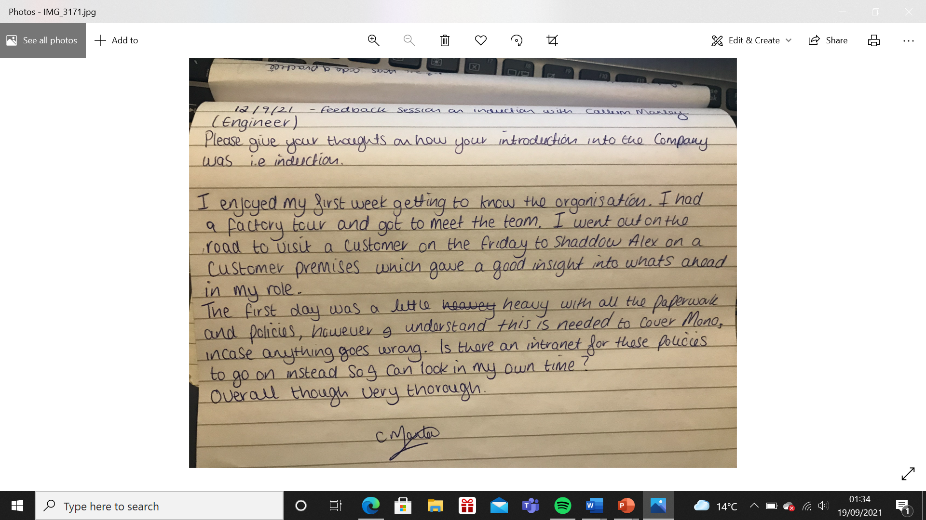
(EV56 Exit Interview Form to be circulated)
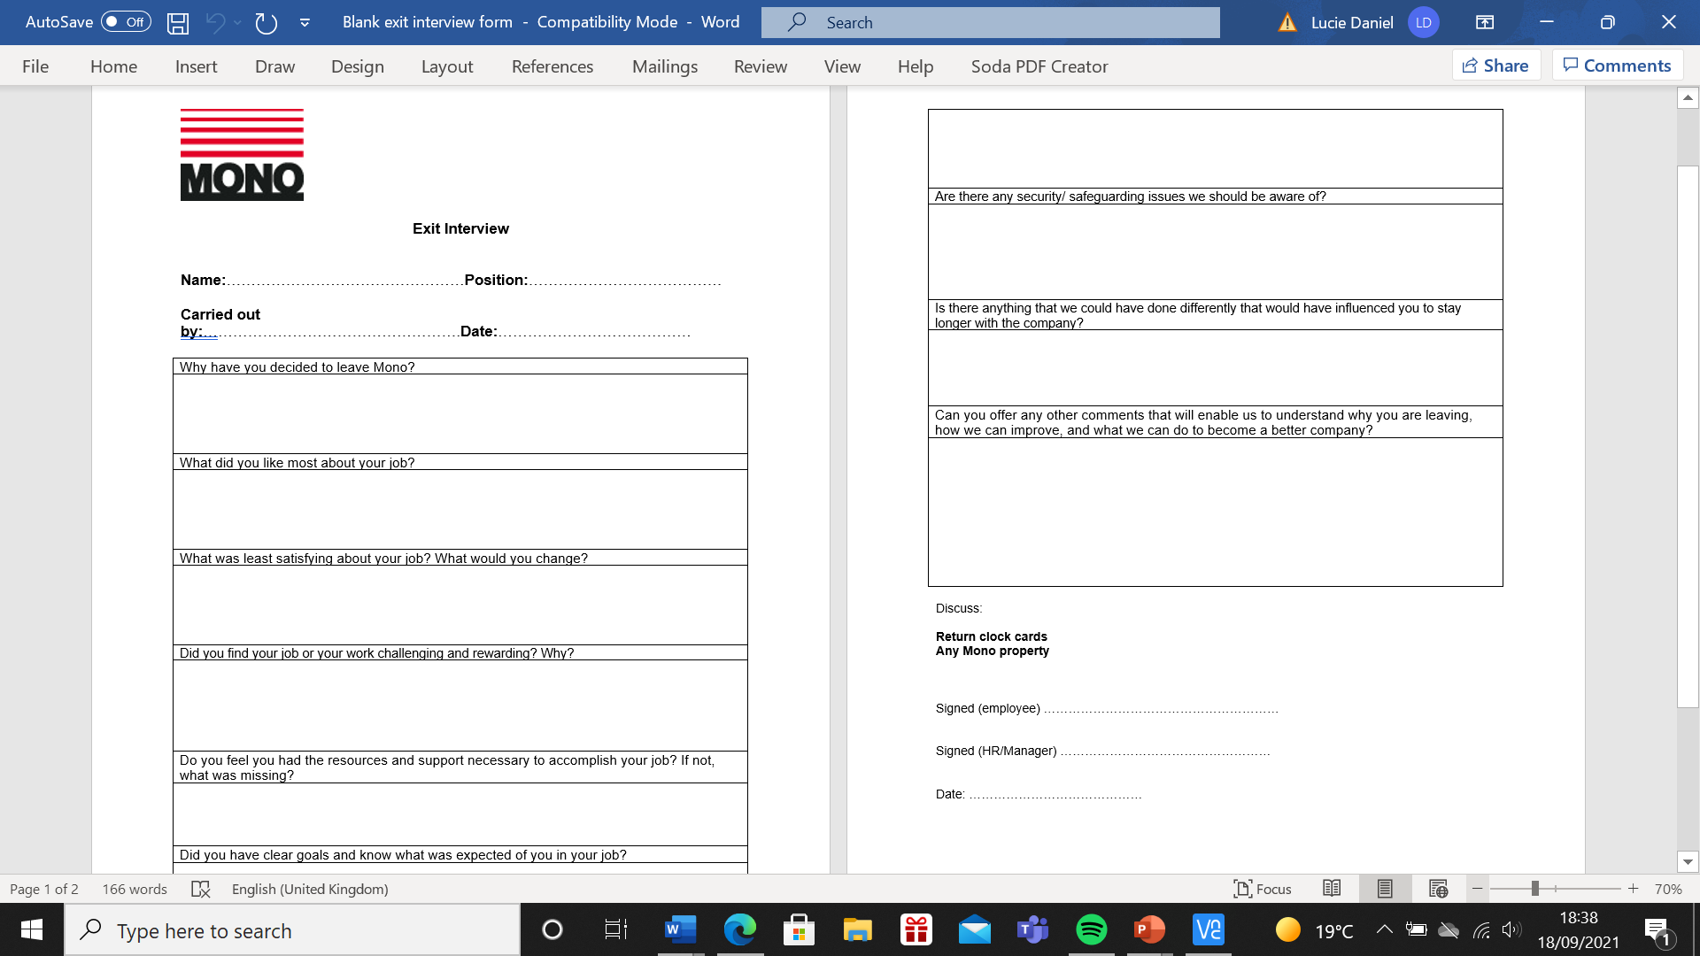
References
ACAS (2015) Code of Practice on Disciplinary and Grievance Procedures. Found at https://www.acas.org.uk/acas-code-of-practice-for-disciplinary-and-grievance-procedures/html Accessed (11.09.2021)
ACAS (2015) Starting Staff: Induction. Found at: https://www.acas.org.uk/sites/default/files/2021-03/Starting-staff-induction.pdf (Accessed 18.09.2021)
Bloom N, Sadun R and Reenen JV (2012) How three essential practices can address even the most complex global problems. Harvard Business Review, November.
CIPD (August 2020) Coaching and Mentoring. Available at: https://www.cipd.co.uk/knowledge/fundamentals/people/development/coaching-mentoring-factsheet Accessed 17/08/2021
CIPD (2020) Performance Management. Found at https://www.cipd.co.uk/knowledge/fundamentals/people/performance. Accessed (11.09.2021)
CIPD (2021) Contributing to Improving Organsiation Performance. Julie Thomas Workshop Slides.
CIPD (2021) Understanding the Link Between Individual and Organisational Performance PowerPoint slides
CIPD (2021) Who are we? Found at: https://www.cipd.co.uk/about/who-we-are Accessed 12.09.2021)
Fernandez (2017) The Benefit of Performance Management for Employees. Found at: https://rmi-solutions.com/performance-management-employees/#:~:text=Together%20with%20goal%20setting%2C%20frequent%20feedback%20lets%20employees,It%E2%80%99s%20effective%20because%20it%3A%20Identifies%20and%20defines%20expectations. Accessed (28.08.2021)
Frettens (2011) Employment Law Q&A- Managing Poor Performance. Found at Employment law Q&A - Managing poor performance - Frettens Solicitors in Christchurch, Ringwood, Bournemouth. Accessed (11.09.2021)
Hardingham (2004) International Journal of Evidence Based Coaching and Mentoring 2021, Reflections from the Field. The Chronological Development of Coaching and Mentoring: Side by Side Disciplines. Found at: https://radar.brookes.ac.uk/radar/items/08eafd72-fbee-462f-8c21-5ddbe3421904/1/ (Accessed 12.05.2021)
Investors in People (2021) Make Work Better. Found at: https://www.investorsinpeople.com/ Accessed (12.09.2021)
Kalja (2021) 10 Performance Management Trends of 2021. Found at: https://blog.weekdone.com/trends-shape-team-management-2020/ Accessed (18.09.2021)
Marchington M and Wilkinson A (2012) Human Resource Management at work: People Management and development. 5th ed. London: CIPD
Matthews (2021) Why Feedback is Important. Found at: https://www.alchemyassistant.com/topics/ULAu7UpjmhK9bPu6.html#:~:text=Uses%20of%20feedback%201%20Influence%20someone%20to%20do,or%20the%20work%20of%20teams%20More%20items...%20 (Accessed 18.09.2021)
Rees and French (2016) Leading, Managing and Developing People. Chapter 12. CIPD. Power point slides
Taylor S and Woodhams C (2016) Studying Human Resource Management, 2nd Edition: London: CIPD
Valamis (2020) Performance Management Process. Found at: https://www.valamis.com/hub/performance-management-process Accessed (14.09.2021)

