Student Name: [Mihaela Caradan ]  Student ID: [2218469]  Module Title: Foreign languages and cultural awareness  Module Code: [BMIH5003]  Lecturer: [Heidi Prosser ]  Date: [09/02/2024] | 
ASSIGNMENT 1: PORTFOLIO
(4 Components)

Component 1: Professional Reflection (500 words +/- 10%)

Weighting: 25%
During my time at Novotel, I saw a cultural misunderstanding that showed how hard it can be to communicate with people from other cultures in the hotel industry. The event took place in the hotel kitchen during breakfast service. Someone from a different culture asked for a meatless meal and made sure to specify "no meat." But the F&B worker didn't understand how strict the guest's dietary rules were, so they served a dish made with animal stock without thinking of it as "meat." This situation shows how language and cultural hurdles can make it hard to understand each other. Hofstede's cultural dimensions theory says that the symbols, rituals, and values of different societies are different (Hofstede, Hofstede, and Minkov, 2010). The employee's idea of "vegetarian" was based on their own culture, which was different from what the guest expected. Such events show how important it is to be able to speak different languages and understand other cultures in the hospitality business, as Deresky (2017) states. He talks about how important it is to communicate across cultures to avoid misunderstandings.
After thinking about what happened, it is clear that F&B workers like me need to improve not only our language skills but also our understanding of cultural nuances in order to avoid future mistakes. This means being aware of how different people eat and their preferences, which are often based on religious and cultural views. Maheshkar and Sharma, (2018) states that giving staff training in intercultural communication can help them deal with cultural differences better, making sure that guests' needs are known and met correctly.
Using a guest-centred method, where employees ask clarifying questions to make sure they understand, can also help avoid misunderstandings. Active listening and noticing nonverbal cues are also important skills that can help you talk to guests from different cultures better. At the same time, cultural intelligence means being able to work well in a range of cultural settings, such as national, racial, and organisational ones (Christiansen, Branch, and Karmowska, 2020). Using this idea to explain what happened at the Novotel, it is clear that if staff had higher CQ, similar mistakes would not happen. This includes not only knowing about different cultures but also changing your mindset and actions so they can interact with people from different backgrounds in a polite and useful way. In the hospitality industry, training programmes that focus on empathy, cultural knowledge, and adaptability can help people become more culturally intelligent. Stressing empathy can help workers see things from guests' points of view and meet their needs better, and being adaptable lets them deal with strange cultural norms in a flexible way. When these skills are used in daily operations, problems can be turned into chances to make guests happier and more loyal.
In the end, what happened at Novotel was a lesson that showed how important it is for individuals working in the hospitality business to keep improving their language skills and cultural awareness. Accepting cultural differences, training employees, and creating an open conversation space are all important ways to reduce cultural misunderstandings and improve the experiences of guests.
References:
Christiansen, B., Branch, J.D. and Karmowska, J. (2020) Cultural Factors and Performance in 21st Century Businesses. Hershey : IGI Global
Deresky, H. (2017) International Management: Managing Across Borders and Cultures: Text and Cases. 9th Ed. Harlow: Pearson Education Ltd
Hofstede, G., Hofstede, G.J. and Minkov, M. (2010) Cultures and organizations: software of the mind. 3rd Ed. New York: McGraw-Hill.
Maheshkar, C. and Sharma, V. (2018) Handbook of Research on Cross-Cultural Business Education. Hershey: IGI Global
Component 2: Training Plan (500 words +/- 10%)

Weighting: 25%

Identified cultural misunderstanding (in a few words) :
During breakfast service at the Novotel, a Food & Beverage worker served a dish with animal stock to a guest who had asked for a vegetarian meal. This showed that staff and guests did not fully understand each other's cultures and languages.
Training plan (Why/What//Who/Where/When):
The event at Novotel shows how important it is for hotel staff to learn more about different cultures and improve their communication skills. Misunderstandings like the one that was seen can make guests' experiences and levels of happiness worse. Therefore, a full staff training programme is being suggested to give workers the skills they need to deal with cultural differences and stop future mistakes of the same kind.
The training programme is meant to help staff develop cultural understanding, which is seen as important for getting along with individuals from other cultures (Maheshkar and Sharma, 2018 ). It will have modules on learning how people dine in different cultures, which is very important because guests have a wide range of dietary needs. The staff will be introduced to Hofstede's cultural dimensions theory so they can better understand how cultural ideals affect how people talk and act.
The training will take place at Novotel and is intended for all levels of food and beverage staff, including front desk and cleaning staff who work directly with guests. This method makes sure that what staff members learn can be used right away in their daily work and is directly related to what they are doing. The programme will last for six weeks, with two-hour lessons every week. These sessions will happen outside of busy times at the hotel in this way not to interfere with normal operations.
Emotional intelligence is the skill of recognising, understanding, and controlling our own state of mind as well as the skill of recognising, understanding, and changing the feelings of others (Vrontis et al., 2021). In the hospitality industry, training workers in EI can make a big difference in how they meet the needs and preferences of guests, especially when there are chances of cultural misunderstandings. By understanding and sharing the feelings of guests, staff can handle sensitive situations better. Including emotional intelligence along with cultural intelligence and intercultural communication strategies in the training programme will give staff all the skills they need to make all guests feel welcome and understood, which will improve the quality of service at Novotel even more (Christiansen, Branch and Karmowska, 2020).
By putting theory into practice, this training scheme not only aims to fix instant problems caused by cultural misunderstandings, but it also wants to make it a habit for Novotel staff to keep learning and changing. This project is meant to make guests content by making sure that all staff members are better prepared to meet the different needs of guests in a respectful and understanding way.
References:
Christiansen, B., Branch, J.D. and Karmowska, J. (2020) Cultural Factors and Performance in 21st Century Businesses. Hershey : IGI Global
Maheshkar, C. and Sharma, V. (2018) Handbook of Research on Cross-Cultural Business Education. Hershey: IGI Global.
Vrontis, D., Chaarani, H.E., Nemar, S.E. and Dib, H. (2021). The relationship between managers’ emotional intelligence and employees’ performance. J. for International Business and Entrepreneurship Development, 13(2), p.177. doi:https://doi.org/10.1504/jibed.2021.118270.
‌
Component 3: Student Self-Reflection (500 words +/- 10%)

Weighting: 25%
Gibbs' Reflective Cycle has six steps that I will use for this reflection: Description, Feelings, Evaluation, Analysis, Conclusion, and Action Plan. To help individuals learn and grow, this model encourages them to think deeply about their experiences (Adeani, Febriani and Syafryadin, 2020).
Description:
When I first started to become more culturally aware, my main goal was to avoid mistakes and make sure I followed basic rules of behaviour. A guest's request to be served as a vegetarian was disrespected at Novotel because of misunderstandings in language and culture. This was a very important lesson for me to learn. This event made me realise how little I know about cultural differences that go beyond language obstacles.
Feelings:
Being able to see for myself that the guest was unhappy made me feel ashamed and responsible. I realised that what I knew did not include enough to keep such types of mistakes from happening. This experience made me feel a lot of different things, including a strong desire to improve my cultural skills.
Evaluation:
After contemplating it, I saw the event not only as a bad example of customer service, but also as a sign of an even greater issue with the manner in which individuals in the hotel industry understand other cultures. In order to fill these gaps, it became clear that language training alone would not be enough. A comprehensive approach to cultural understanding was needed.
Analysis:
Theories like Hofstede's cultural dimensions help us understand how complicated it is for individuals from different cultures to connect with each other. To use the Novotel incident as an example, knowing the Individualism vs. Collectivism dimension could help show why people have different eating habits and talk to each other in different ways. Collectivism means that people put a lot of value on society and family. This may affect what people consume and how they communicate their food preferences (Hoftede, Hoftede and Minkov, 2010). On the other hand, in societies that value individualism, people may be more open about their personal preferences. When hospitality workers use Hofstede's dimensions, they can better predict and understand what guests will want and how they will act, which leads to better and more sensitive communication. Knowing about a guest's cultural background, for example, could explain menu choices or better understand their dietary needs, which would help avoid confusion.
Conlusion:
Going through this process of reflection has helped me learn a lot more about cultural knowledge. I now understand that real cultural competence is a mix of knowing things, being good at things, and being emotionally smart. People with emotional intelligence can recognise, understand, and control their own feelings. They can also recognise, understand, and change the emotions of others. It means being aware of your own feelings and the emotions of others, being able to use emotions to think and solve problems and being able to control your emotions to improve your emotional and intellectual growth. (Vrontis et al., 2021). This realisation has changed how I deal with guests, putting a higher value on empathy, flexibility, and continuing education.
Action Plan:
In order to keep growing, I plan to participate in a wide range of educational and artistic activities. This means going through training programmes to improve my cultural competence, immersing myself in languages and countries other than my own, and using every interaction with a guest as a chance to learn something new. By working on myself in a positive and thoughtful way, I hope to help make the hospitality industry more welcoming and sensitive to different cultures.

References:
- Adeani, I.S., Febriani, R.B. and Syafryadin, S. (2020). Using Gibbs’ Reflective Cycle In Making Reflections Of Literary Analysis. Indonesian EFL Journal, [online] 6(2). Available at: https://journal.uniku.ac.id/index.php/IEFLJ/article/view/3382.
- ‌ Hofstede, G., Hofstede, G.J. and Minkov, M. (2010) Cultures and organizations: software of the mind. 3rd Ed. New York: McGraw-Hill.
- Vrontis, D., Chaarani, H.E., Nemar, S.E. and Dib, H. (2021). The relationship between managers’ emotional intelligence and employees’ performance. J. for International Business and Entrepreneurship Development, 13(2), p.177. doi:https://doi.org/10.1504/jibed.2021.118270.

Component 4: Training Presentation (6 Slides)

Weighting: 25%
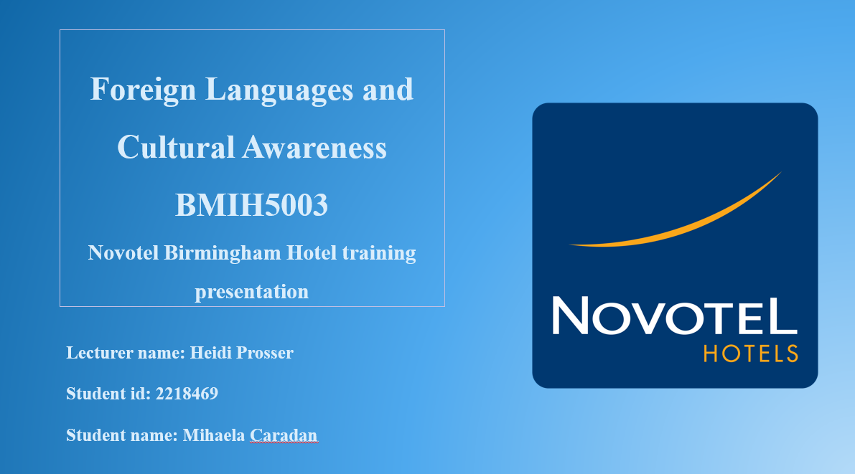
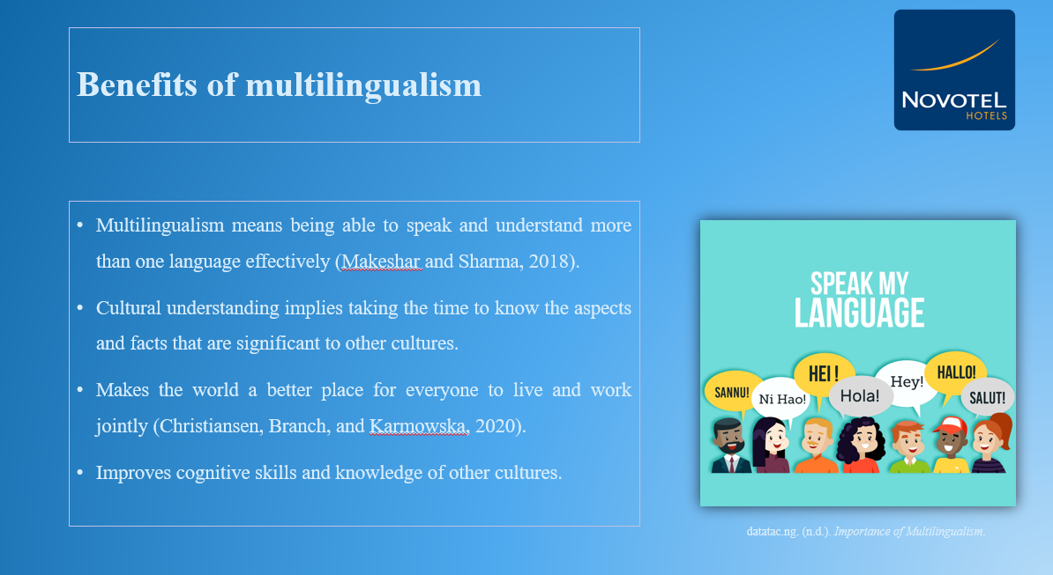
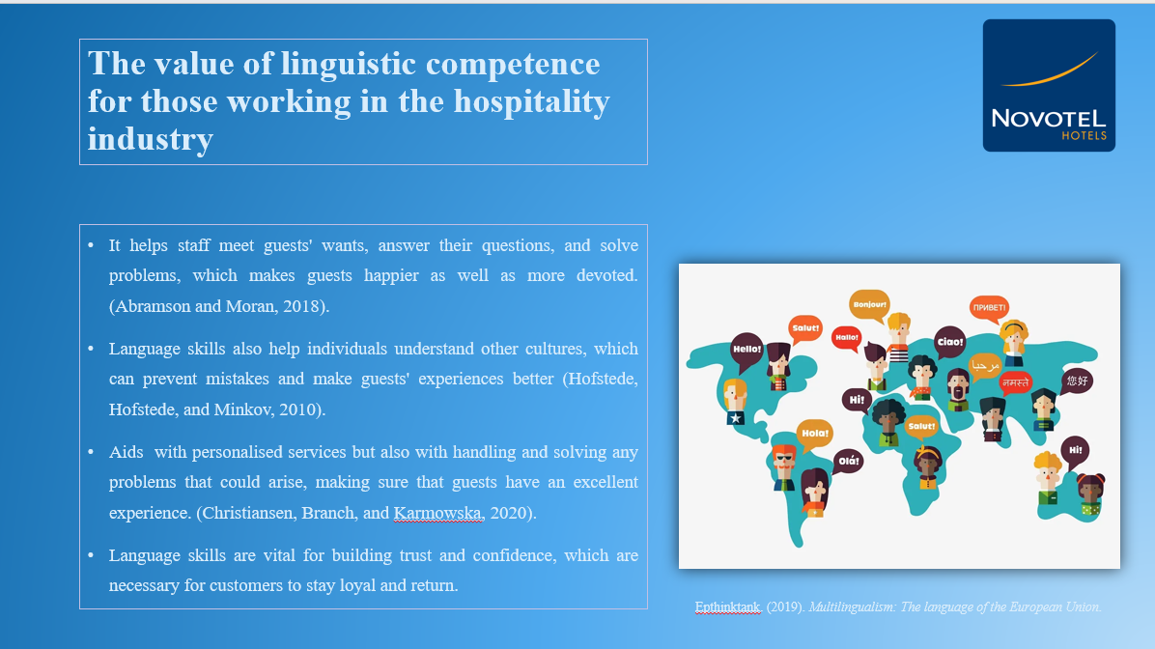
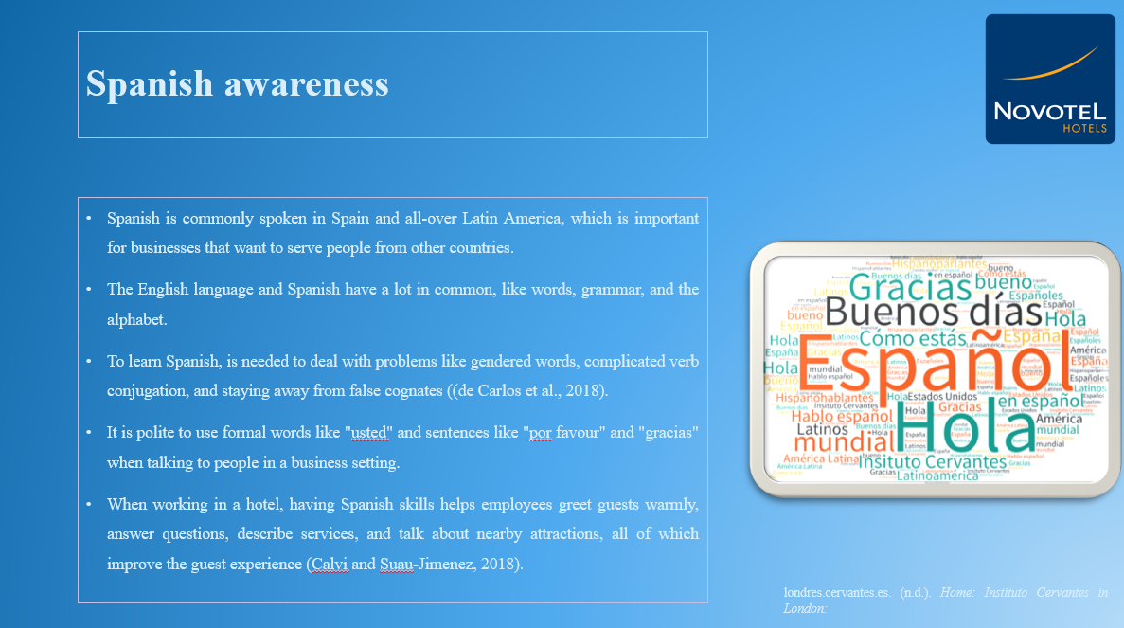
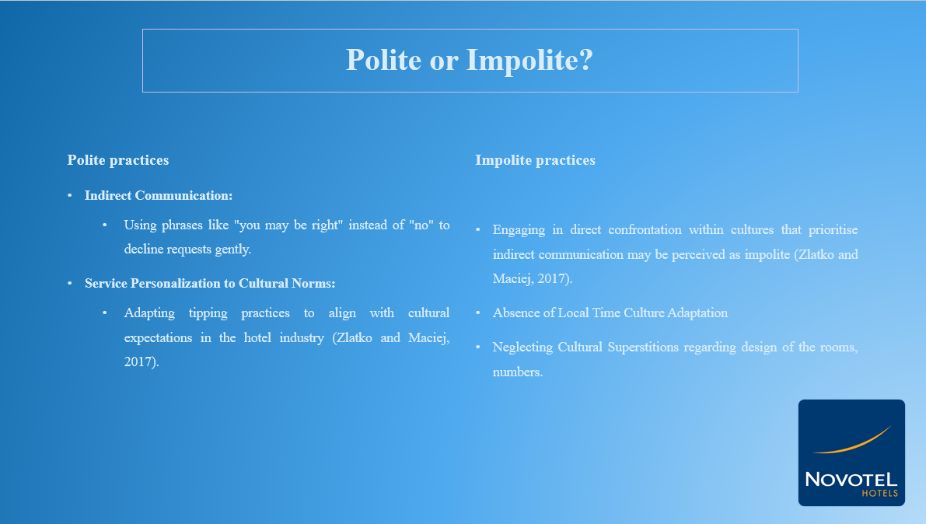
References (no screenshots):
Abramson, N.R. and Moran, R. (2018) Managing Cultural Differences: Global Leadership for the 21st Century. 10th Ed. Abingdon: Routledge.
Calvi, M.V. and Suau-Jiménez, F., 2018. International Languages in Tourism in Europe: Spanish. Sociolinguistica, 32(1), pp.79-90.
Christiansen, B., Branch, J.D. and Karmowska, J. (2020) Cultural Factors and Performance in 21st Century Businesses. Hershey : IGI Global.
de Carlos, P., Alén, E., Pérez-González, A. and Figueroa, B. (2018). Cultural differences, language attitudes and tourist satisfaction: a study in the Barcelona hotel sector. Journal of Multilingual and Multicultural Development, 40(2), pp.133–147. doi:https://doi.org/10.1080/01434632.2018.1493114.
Hofstede, G., Hofstede, G.J. and Minkov, M. (2010) Cultures and organizations: software of the mind. 3rd Ed. New York: McGraw-Hill.
Maheshkar, C. and Sharma, V. (2018) Handbook of Research on Cross-Cultural Business Education. Hershey: IGI Global.
Zlatko, N. and Maciej, B. (2017). Exploring the Influence of Personal Values and Cultures in the Workplace. [online] Google Books. IGI Global. Available at: https://www.google.co.uk/books/edition/Exploring_the_Influence_of_Personal_Valu/oZBADgAAQBAJ?hl=en&gbpv=1&dq=Exploring+the+Influence+of+Personal+Values+and+Cultures+in+the+Workplace+Zlatko+Nedelko+University+of+Maribor

