INTRODUCTION TO PUBLIC HEALTH
Assignment 2
Communicable and non-communicable diseases
BMHP4004
Becca Morris
2105225
Felicity Peacock

INTRODUCTION TO PUBLIC HEALTH Assignment 2

Introduction…………………………………………………………..…………………………………3
Communicable disease ……………………………………………..………………………………..4
Non communicable disease ………………………………………………………………………….6
Conclusion ……………………………………………………..………………………………………..8
References ……………………………………………………………………………………………….9
Appendix………………………………………………………………………………………………...13

In the following I am going to talk about what public health is, what is herd immunity and what the public health organisations do for communicable and non-communicable diseases, mainly influenza and cardiovascular disease. I will also explain the signs and symptoms of influenza and cardiovascular disease and discuss the past and current campaigns used to promote these diseases and if they have been successful or not.

Acheson (1988) defines public health as "the art and science of preventing disease, prolonging life and promoting health through the organized efforts of society”. By giving the public activities to strengthen the public health capacity and services that aim to provide opportunities in which people can maintain healthy, improve their health, or prevent deterioration of their health. The public health services use many activities in the form of health campaigns to target the population as a whole.

Valanis (1999, Pg-106) states herd immunity is when "a high degree of resistance by a group to invasions and spread of an infectious agent may be reached if a high proportion of individuals are immune". Herd immunity is, quite simply, a form of indirect protection from infectious disease. Herd immunity is obtained when a large enough portion of the population is vaccinated, preventing germs from circulating and thereby rendering an infectious disease very unlikely to spread (Fine, Eames and Heymann, 2011).

Using just one of the health organisations here in the UK, The World Health organisation (WHO,2021) collects many different data on their database such as, demographics, genetics, social and family history, lifestyle, socioeconomics’, and environment. All this data can help to reveal patterns in health issues and can open up health campaigns aimed at them specifically. WHO use many different forms of data collection such as administrative date, patient medical records, patient surveys, comments from individual patients and standardised clinical date (AHRQ,2015).
O'Brien (2013) describes a communicable or infectious disease as "an illness due to the transmission of a specific infectious agent (or its toxic products) from an infected person, animal or inanimate source to a susceptible host, either directly or indirectly".

Influenza most commonly known as the flu, is a disease caused by influenza A or B viruses and is spread by coughing or sneezing (County Public Health Department 2021). Influenza is said to reproduce at a different rate in schools compared to in a community setting. In a school environment the reproduction number (R°) is said to be between 2.8 and 16.9 but in a community setting it is said be much less around 1.2 and 2.4 according to the public health research agenda for influenza (2010).

The flu shows many different signs and symptoms. Symptoms for adults tend to appear very quickly from the onset of flu and symptoms may include a high temperature of 38° or above, which will appear and raise fairly rapidly. You may get achy body and feel tired or exhausted. A headache may begin with a dry cough and sore throat. Difficulty sleeping, diarrhoea or abdominal pain, vomiting or a sick feeling may also be part of the symptoms of influenza. Children will also get these same symptoms but may also get pain in their ears and may appear less active (NHS). People who suffer with respiratory diseases such as asthma or chronic obstructive pulmonary disease (COPD) may get increased symptoms if they contract flu. They may also take much longer to recover from the flu than people who are normally healthy (Kato, Saisho, Tanaka, Bando, 2021, page 651-660).

Flu is said to be most transmittable in the first 5 days of having symptoms. The Flu virus can live on hands and surface for up to 24 hours and is spread via coughing and sneezing (NHS, 2021). To reduce the risk of catching flu or passing it on you should wash your hands often with warm water and soap to wash the virus particles away. When sneezing and coughing you should always use a tissue to trap the germs and dispose of the tissue as soon as possible (NHS, 2021).
In the 1930’s the influenza vaccine began to be rolled out, but it was not until 1945 the UK began to role the vaccine out to the people most at risk. The UK run a national influenza immunisation program each year to help tackle the influx of patients needing medical assistance due to influenza. The main aim is to vaccinate as many people that are eligible as possible. The eligibility for the vaccine covers a wide range of people including children aged two to fifteen, carers and the over fifty (Department of Health and Social Care, 2021). Over 76% of people in Wales aged 65 and over received the flu vaccine in 2020/2021 (See appendix 1)

In early 2009 Mexico showed a deadly strain of swine flu, this prompted The World Health Organization to begin a catch it, bin it, kill it campaign (see appendix 2) in April 2009 to encourage people to catch the sneeze or cough, bin the tissue and wash your hands to attempt to reduce the spread of the flu. The government raise alert level 5 in Britain as cases began to appear in the UK. The campaign was spread in newspapers, posters and a tv advert to spread awareness of the campaign. Still to this day the campaign is used to remind people coming in to the flu season (British society for immunology, 2009).

If I was to make recommendations as to reduce the transmission, I would recommend more school-based education around the transmission of the flu virus and how it can be prevented. By teaching young children good hygiene practise at a young age, it would benefit in years to come. I would recommend wearing a face covering if you have flu symptoms as this could reduce the transmission. Education on how severe the flu can be to the nation as to the amount of death it causes each year and spur the ‘catch it bin it kill it’ campaign.

The World Health Organisation (WHO, 2021) says a "Noncommunicable disease (NCDs), also known as chronic diseases, tend to be of long duration and are the result of a combination of genetic, physiological, environmental and behavioural factors".

The heart together with the systematic circulation and pulmonary circulation, the two networks of blood vessels from the heart create the cardiovascular system (see appendix 3). When there is an issue in the cardiovascular system this is then known as cardiovascular disease. Cardiovascular disease "is a general term for conditions affecting the heart or blood vessels" (NHS, 2021) (see appendix 4). 1 in 4 deaths in England are caused by CVD this equates to one CVD death every four minutes (Public health England 2019).

There are four types of CVD. Coronary heart disease is when the oxygen blood flow to the heart muscle is reduced or blocked causing a strain on the heart. This could lead to chest pain known as angina, a heart attack or heart failure. Stroke or a mini stroke known as TIA is when the blood flow to the brain I cut off, this could result in damage to the brain or possibly death. Peripheral arterial disease occurs when the arteries to the limbs are blocked usually the legs. The fourth type of CVD is aortic disease, there are a group of conditions that fall under this which all effect the aorta. This is the largest blood vessel in the body and could, if damaged, cause severe bleeding.

With 7.7 million people living in the UK with heart and circulatory disease causing 450 deaths every day (British Hearth Foundation 2021). Cardiovascular disease does not have an exact cause but there are many known factors that can increase a person’s risk of getting CVD. According to Valanis (1999, page 221) some of the factors recognised to increase your chances of suffering from CVD include smoking, hypertension, high blood cholesterol, and diabetes (see appendix 4)

The signs and symptoms for cardiovascular disease may vary depending on the cause, but most people will experience a pressure sensation on the chest or tightness, difficulty catching their breath, heart palpitations, dizziness or fainting.

Living a heathy fit lifestyle will improve the chances of developing cardiovascular disease. Lifestyle changes to help reduce your chances of CVD would include the introduction of a healthy and balanced diet. Reducing the salt in foods consumed, reduce the saturated fats in foods, reduce sugar intake, introduce a variety of fruit and vegetables and introduce plenty of fibres to your diet (NHS). Smoking causes the oxygen in the blood to reduce causing the heart to work harder to circulate the oxygen around the body and increases the chances of having cardiovascular disease, so by quitting it will reduce your chances and the heart will with time benefit. Exercise can improve your whole-body fitness, as the heart is a muscle, exercising to strengthen the heart to keep your blood pumping. This may include walking, running, swimming or cycling (Dr.handicap, 2021).

When stroke strikes act FAST (see appendix 6), is just one of the government campaigns to raise awareness of stroke. This campaign highlighted the signs people needed to look out for and the process of what to do in the case of a stoke FACE is the face dropped on one side , ARMS can they lift both arms, SPEECH has the speech gone slurred , TIME to call 999 (NHS). In April 2018 the government introduced a sugar tax levy. This made many companies reduce the amount of sugar in soft drinks meaning they wouldn’t have to pay the sugar tax. The tax accumulated via this process would boost the funding for healthy school breakfast clubs across the UK (HM Treasury).

As of January first, 2021, any tobacco products sold in the UK had to include one of the warnings listed in schedule A1 to the tobacco and related product regulations 2016, this meant that all tobacco products had to include either a text warning or a picture and had to be made using the same-coloured packaging (Department of Health and Social). The department of health and social also introduced a ban for anyone to smoke in a vehicle with anyone under the age of 18 present in the vehicle (see appendix 7). This meant that you could no longer smoke in any private vehicle like taxis of buses, in your own vehicle if you had a person under 18 present.

Whilst thinking of recommendations to prevent and spread awareness of CVD I would begin by educate children more in healthy eating by teaching children to cook homecooked healthy meals in schools rather that cakes and bakes. Instead of introducing the ban of smoking in cars with under 18’s I would have banned spoking in front of under 18’s all together if that be on the streets or at home, make it illegal for a child to see any forms of cigarettes. I think it is important to educate people on how to check their blood pressure and blood sugars instead of having to depend on doctors to do this for them, and also how to improve and maintain healthy blood pressure and blood sugars.

Whilst conducting the research for this assignment it has become clear that health promotion surrounding these diseases need improvement. I say this because the number of people suffering each year is on the rise. Healthy eating and exercise needs to become more accessible to all and people in poverty should not be discriminated by the health issues that may arise because of where the home is based (National research council). It is important to practice good personal hygiene from a young age to encourage people of all ages to protect themselves and help prevent the transmission of diseases such as influenzas. The research has also highlighted the causes of CVD and had created awareness of the signs and symptoms.

References
AHRQ, (2015), Types of health care qualities measures, Available at https://www.ahrq.gov/talkingquality/measures/types.html. (Accessed on 22/11/2021)

British heart foundation, (2021), Heart Statistics, Available at https://www.bhf.org.uk/what-we-do/our-research/heart-statistics, (Accessed on 27/12/21).

British Society for Immunology, (2009), catch it, bin it, kill it poster, Available at https://www.immunology.org/catch-it-bin-it-kill-it-poster-2009, (Accessed on 28/11/21).

County Public Health Department, (2021) Communicable Disease control & prevention; Flue season 2021-22, Available at https://acphd.org/flu/, (Accessed on 22/11/2021).

Department of Health and social Care, (2021), national flu immunisation program 2021 to 2022 letter, Available at https://www.gov.uk/government/publications/national-flu-immunisation-programme-plan/national-flu-immunisation-programme-2021-to-2022-letter, (Accessed on 16/12/2021)

Department of Health and Social, 2021, Changed to packaging requirements for tobacco products, Available at https://www.gov.uk/government/publications/packaging-of-tobacco-products/packaging-requirements-for-tobacco-products, (Accessed on 20/12/2021)

Department of health, (2000), National service framework coronary heart disease, Available at https://assets.publishing.service.gov.uk/government/uploads/system/uploads/attachment_data/file/198931/National_Service_Framework_for_Coronary_Heart_Disease.pdf, (Accessed on 13/12/2021).

Dr.Handicap, (2021), 6 lifestyle choices than can lead to heart disease, Dr.Handicap blog, Available at https://drhandicap.com/insights/6-lifestyle-choices-can-lead-heart-disease/, (Accessed on 20/12/2021).

Fine, P., Eames, K. and Heymann, D.L. (2011). “Herd Immunity”: A Rough Guide. Clinical Infectious Diseases, [online] 52(7), pp.911–916. Available at: https://academic.oup.com/cid/article/52/7/911/299077.

Gov.uk, (2021), Sources of UK flu data: influenza surveillance in the UK, Available at https://www.gov.uk/guidance/sources-of-uk-flu-data-influenza-surveillance-in-the-uk, (Accessed on 16/12/21)

HM Treasury, (2018), Soft Drinks Industry Levy comes into effect, Available at https://www.gov.uk/government/news/soft-drinks-industry-levy-comes-into-effect, (Accessed on 20/12/21).

Law J, Martin E, (2020), Concise medical dictionary, cardiovascular system, 10th edition.

Mayoclinic, (2021), Heart disease, Available at https://www.mayoclinic.org/diseases-conditions/heart-disease/symptoms-causes/syc-20353118, (Accessed on 18/12/21)
Motokazu K,Yutaka S, Hiroshi T,Takuma B, (2021), Improvement of respiratory symptoms and health-related quality of life with peramivir in influenza patients with chronic respiratory disease: Additional outcomes of a randomized, open-label study, Volume 15, Issue 5.

National Research Council, Understanding the changing planet: strategic directions for the geographical science, page 67, National academies press, Washington.

NHS, (2021), Act fast, Available at https://www.nhs.uk/actfast/Documents/Act-FAST-A5-leaflet-white-man.pdf, (Accessed on 18/12/21).

NHS, (2021), Flu, Available at https://www.nhs.uk/conditions/flu/, (Accessed on 16/12/21).

NHS, (2021),Cardiovascular disease, Available at https://www.nhs.uk/conditions/cardiovascular-disease/, (Accessed on 07/12/2021)

Public health England, (2019), Health matters: preventing cardiovascular disease, Available at https://www.gov.uk/government/publications/health-matters-preventing-cardiovascular-disease/health-matters-preventing-cardiovascular-disease, (Accessed on 18/12/21)

Public Health Wales, (2011), Welsh health survey – cardiovascular disease, Available at https://phw.nhs.wales/services-and-teams/observatory/data-and-analysis/cardiovascular-disease/, (Accessed on 17/11/2021)
Sarah O'Brien, (2013), Oxford Medicine Online; Communicable disease epidemics, 3rd edition, Available at DOI: 10.1093/med/9780199586301.001.0001, (Accessed on 22/11/2021).

Valanis,B, (1999), Epidemiology in health care, third edition, Appleton & Lange.

WHO, (2010), Limiting the spread of pandemic, zoonotic and seasonal epidemic influenza, page 3-4, Available at https://www.who.int/influenza/resources/research/research_agenda_influenza_stream_2_limiting_spread.pdf, (Accessed on 2/12/21).

WHO, (2021), More Data and Evidence, Available at https://www.euro.who.int/en/data-and-evidence/more-on-data-and-evidence. (Accessed on 22/11/2021).

WHO, (2021), Public Health Services, Available at https://www.euro.who.int/en/health-topics/Health-systems/public-health-services/public-health-services (Accessed on 22/11/2021).

World Health Organisation, (2021), Non communicable diseases, Available at https://www.who.int/news-room/fact-sheets/detail/noncommunicable-diseases, (Accessed on 22/11/21).

apendix
- % of people in Wales who received the flu vaccine in 2020/2021
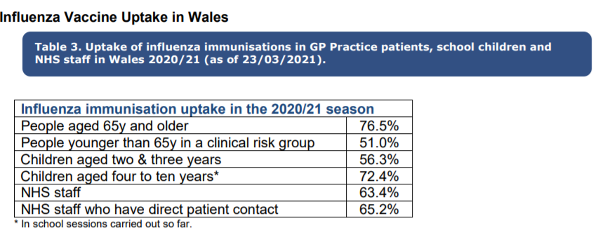

- Catch it, Bin it, Kill it campaign poster from 2009

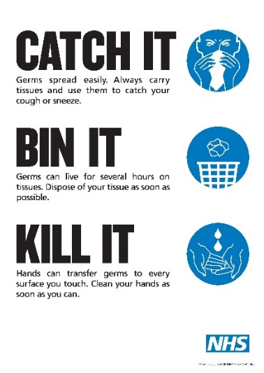

- The cardiovascular system.
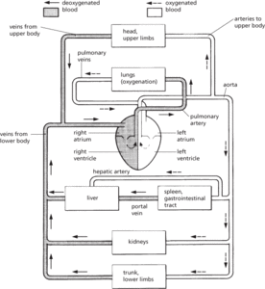

- Image of how CVD is formed
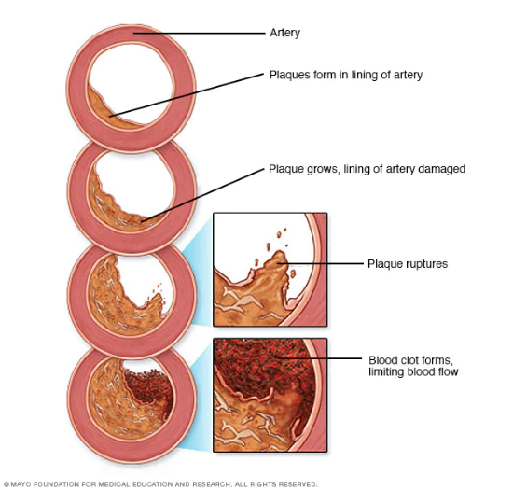

- Things that may increase risk of CVD according to Valanis (1999)
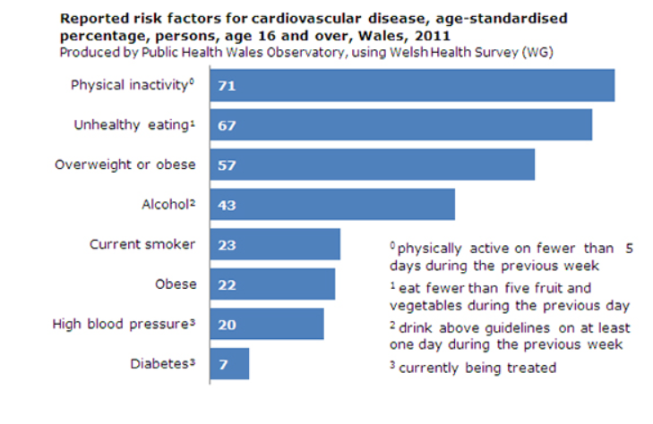

- Think FAST stroke campaign
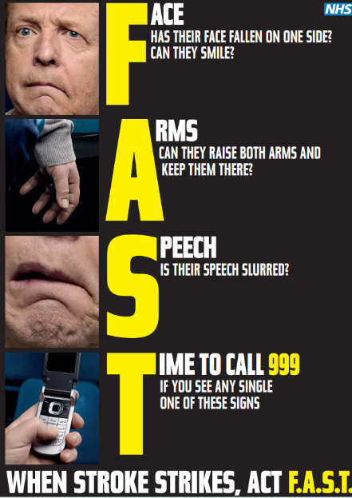

- Smoking ban poster for vehicles.


