Jac Thomas (2204038)

Bmbm6015 – The Strategic Posistioning oF GOogle and How Google Can alter Strategy for greater SUstainability

Table of Contents
Contents
Table of Contents 1
Table of Figures 2
Executive Summary 3
1.1 SWOT Analysis 4
2.0 External Analysis 4
2.1 PESTLE 5
2.2 Porters 5 Forces 7
3.0 Internal Analysis 9
3.1 VRIN Analysis 9
9
3.2 Porters Value Chain 12
3.2.1 Primary Activities 13
3.2.2 Secondary Activities 14
4.0 Strategy Formulation 16
4.1 Ansoff Matrix 16
5.0 Sustainability and Strategic Recommendations 18
5.1 Evaluation of Googles Current Sustainable Strategies 18
5.2 Strategic Recommendations 19
5.2.1 Horizon 1 - Maintaining and strengthening core business activities 19
5.2.2 Horizon 2 – Explore and discover new expansions 19
5.2.3 Horizon 3 – Create entirely new possibilities and competencies 20
6.0 Conclusion 21
References 22

Table of Figures

Figure 1 – VRIN Analysis (Niloshini, 2024)
Figure 2 – Porters Value Chain (Ruan, 2020)
Figure 3 - Ansoff Matrix (Quaranta and Hui, 2024)
Figure 4 - The 3 Horizons model (Van Balen, N.D.)

Executive Summary

This report will conduct an internal and external analysis of Googles, this will be done using models such as PESTLE, Porters 5 Forces, VRIN and Porters Value Chain. Potential Growth Strategies for Google will be highlighted using the Ansoff Matrix. Also, there will has an evaluation of Googles sustainability aims before making suggestions on how they can improve their strategy using the model of McKinsey’s Three horizons for growth. The findings of the report are that Google need to be aware of competitor threat, consider strengthening resources/capabilities that only provide parity with competitors, should Google pursue growth, market penetration is their best option, they should consider implementation of Green AI, they could partner with an organisation like Peace Direct to help resolve Global Conflicts and should reimplement a policy that prevents the use of Google AI in weapon development.

- Introduction

The aim of this report is to analyse the strategic positioning and sustainability of Google. Google are cited by Manela (2024) as a leading tech company, one who have entered the AI industry with Gemini (Pichai and Hassabis, 2023) The report will look at Googles current external and Internal strategic positions, challenges they may face and ways Google could grow their company. The report will also provide recommendations on how Google can alter their strategy to be more sustainable. According to Spiliakos (2018) it also involves the impact a company can have on society, In this report sustainability refers to Googles environmental and societal impacts.

SWOT Analysis

SWOT Analysis is a beneficial tool for businesses, as noted by Wang and Wang (2020) it provides a comprehensive overview of an organisations situation and provide guidance for strategy by analysing Strengths, (S), Weaknesses (W), Opportunities (O) and Threats (T). A SWOT analysis will be carried out throughout the entirety of the report. for example, the PESTLE model below is shown to analyse threats and opportunities to Google.

2.0 External Analysis

2.1 PESTLE

According to Achinas et al. (2019), The PESTLE Analysis is a tool used to assess how external factors can influence an industry. Washington State University (2025) identifies the stages as follows. Political, Economic, Social, Technological, Environmental and Legal. PESTLE will be used here to analyse the external environments effect on Google.

Political | Hall (2025) finds that AI is being used to spread conspiracy and lies that could threaten democracies. Google (N.D.) have measure in place to prevent Gemini AI from being used for such purposes.
Economic | Malik (2025) believes large tech companies can help grow the economy by passing their knowledge on to smaller companies. Google could be of service to these smaller companies and could charge a price for their knowledge allowing them to benefit
Social | Fletcher and Nielsen (2024) find that generative AI is far more popular in use with those aged 18-24 and that it is used for media creation and information deciphering. This information gives Google a specific demographic to target.
Technological | AI is a developing market, Thormundsson (2024) states that “The market for artificial intelligence grew beyond 184 billion U.S. dollars in 2024” Google are already within the market so will be able to reap any advantages of this growing market.
Legal | Ministry of Justice and The Rt Hon Shabana Mahmood MP (2024) says that a new agreement will focus on human rights, data protection and safe use of AI. Google will have to abide by this legislation.
Environmental | BBC News (2025) found that AI will require a great supply of water and land. Google themselves were said to have to retreat from establishing a date centre in Chile because of a drought.

Pathak (2020) notes that PESTLE allows companies to spot opportunities and act on them. However, Pathak (2020) also notes that PESTLE oversimplifies data, so decisions could be made of insufficient data, but arguably the most important external development to Google is the competitive environment within the AI industry. Elliott (2025) writes about the AI arms race, mentioning the arrival of the DeepSeek, could prove to be a cheap and quality AI alternatives, which can threaten Googles Gemini. This is not analysed within PESTLE, but Porters 5 forces is a model that will help Google assess its competitive landscape.

2.2 Porters 5 Forces

Mahat (2019) lists the 5 forces that influence the competitive organisation of a business as “bargaining power of buyers; bargaining power of suppliers; threat of new entrants; threat of substitute products; and rivalry among existing companies” (N.P)
Force | Analysis | Threat Level
New Entrants | Howarth (2025) reports that Perplexity AI is a recently established and accurate AI tool with 10 million users, so they have gained popularity in short time. Google need to be aware of the growth of this company as they could become a threat to Google in future. | Medium
Competitive Rivals | Guardian Staff and Agencies (2025) reports that Elon Musk has launched Grok 3 AI system to compete with Google, DeepSeek and Open AI. Mauran (2025) mentions Google Gemini could appear on iPhones, infiltrating competitor software. Google must keep up with competition but could also spread onto competitor software, allowing Gemini to attain widespread use. | Medium
Industry Substitutes | There are not really substitutes to AI. However different AI models may have different competencies. McKenzie (2025) found ChatGPT was a better alternative to Gemini when it came to research and text-based activity. Google may want to focus on giving Gemini these strengths so it can compete with ChatGPT. | Medium
Buyer Power | Umashankar (2024) states that Google services are typically cheaper on android, but other subscriptions vary in terms of price. If price is the determining factor for the choice of service than Google could see themselves in a more favourable position in some circumstances. | Low
Supplier Power | Richard (2024) reports that Google have purchased output from an Apex Clean Energy wind farm. This will aid Google in becoming more sustainable, Escaler (2020) explains an advantage can be gained by incorporating sustainability into core areas of a business. | Low

Porters 5 Forces highlights New Entrants, Substitute products and Competition as the most threatening factors to Google, Google can use this information to rearrange their strategy. However, Adelakun (2020) raises the point that now, businesses should be focused on maintaining innovation, due to the increased power of the internet, as well as protecting against the 5 forces, this implies that innovative factors are of great importance in business strategy, which the VRIN model focuses on below, noting that Google have a creative culture that fosters innovation, as well as assessing the competitive implications of other resources and capabilities.

3.0 Internal Analysis

3.1 VRIN Analysis

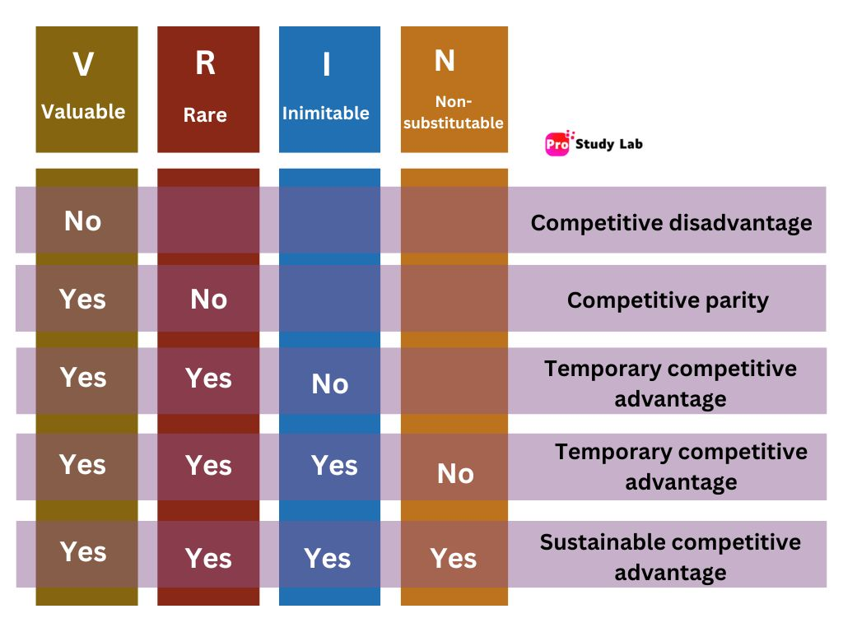

Figure 1 – VRIN Model (Niloshini, 2024)

Florea et al. (2020) explains the VRIN Framework aims to demonstrate how a business can obtain a sustained competitive advantage and that it analyses resources/capabilities in the following way:
Value – does it capitalise on opportunities and/or reduce threats
Rarity – Is this strength exclusive to your business
Inimitable – can your strength be substituted by another company or is it difficult to replicate
Non-Substitutable- If non-substitutable- it cannot be replicated by another resource
The level of competitive advantage is highlighted in the above table by Niloshini (2024).

Resource/Capability | Value | Rarity | Inimitable | Non-Substitutable | Competitive Implication
Gemini System | Yes – Social analysis shows AI is very popular | No – Savage (2025) references ChatGPT as an AI Tool |  |  | Parity
New Technology – Sharif (2025) lists new features the pixel will feature such as translation systems, AI powered summaries and AI Weather reports. | Yes – these new features, like Gemini, act on the social popularity of AI | No, other AI has similar capabilities– Apple (2025) explains that Apple Intelligence will help create emails. |  |  | Parity
Creative Culture – Gopalan (2023) – Google foster creativity, offering learning programmes for their employees and look for talent, fit for adaptation to change | Yes – will help google come up with more innovative ideas like the pixel | Podonly and Hansen (2020) talk about Apples change to an innovative culture by removing conventional management. However, this culture is not the same as Googles | Yes – the exact culture of google cannot be replicated | Yes | Sustainable Competitive Advantage
Customer Loyalty - Jackson (2023) reported that in a YouGov Survey, Alphabet (Google) were seen to have the highest customer loyalty, above both Apple and Microsoft, | Yes- Woolnough-Rai (2025) states “Loyal customers are more likely to make repeat purchases” | No – Samsung (2025) offer rewards to incentivise customer loyalty. |  |  | Parity
Value to other Businesses. – Google (2025) offer a loyalty scheme to merchants that provide benefits such as free delivery. | Yes – greater appeal to merchants could generate further potential for profit | No Samsung (2025) have their own programme for businesses which seems Samsung aid the businesses |  |  | Parity

The VRIN model shows that Googles most advantageous strength is their unique culture, however other resources such as their Gemini system and other new technological features only provide them parity with their competitors, this information could be used to argue that the model is useful in providing strategic direction to Google resources in need of improvement are highlighted. However, this model does not look so closely at areas for improvement in operational areas, Porters Value Chain will be used below to see if any can be identified.

3.2 Porters Value Chain

Stobierski (2020) explains that the value chain looks at operations tha contribute to product creation/service performance. There are Primary Activities such as inbound logistics, that go directly into creating the product/performing service and secondary activities such as HR, which make primary activities more efficient. The model aims to highlight potential areas of improvement by considering how each activity may provide or subtract value.
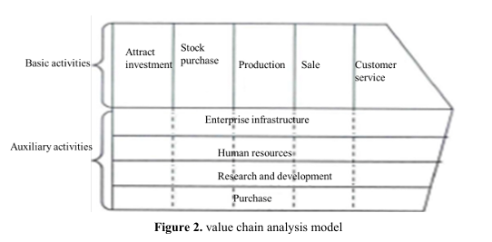

Figure 2– Porters Value Chain (Ruan, 2020)

3.2.1 Primary Activities

Inbound Logistics | Operations | Outbound Logistics | Marketing and Sales | Service
Cerf (2020) explains Google have spent a great deal of time establishing an innovative and forward-looking culture. Valuable in the time of AI, where Google will need to be reactive | Johnston (2025) – Google makes money through sale of advertising and service fees from browsers and mobile operation. | Alphabet Investor Relations (2024) report shows that Google are operating at a gain from their Services and Cloud, which indicates a good performance | Alphabet Investor Relations (2024) shows there is a slight fall in the cost of sales and marketing in 2024, this means money can be used on other areas in need of improvement | Orosz (2022) explains Google have self-service tools that replace customer service. Value is created as money is not spent on hiring people for these roles

3.2.2 Secondary Activities

Infrastructure | Google Cloud (N.D.) explains centres are energy efficient and reliable. Which implies there is satisfactory service for the customer and cost effectiveness for Google as energy is not wasted
HRM | Bhandari (2024) AI is involved in making screening processes more efficient, the removed need for employees will save google money in their operations
Technology Development | Lee and Jung (2024) talk of Googles various innovative technologies through business model innovation .and how between 2011 and 2020 their sales figure has grown by 4.8x that of what It was. This will greatly influence the inbound logistics at Google.
Procurement | Perry (2024) reports that Google, have in recent years invested more into procuring goods from diverse suppliers, this could create value for Google as it aids in achieving social sustainability.

Although highlighting the strengths within Googles operations, the model has not highlighted as many areas for improvement as VRIN before it which makes it less useful to Google in identify strengths and weaknesses. However, neither of these models highlight potential strategies of growth for Google, which is where models like the Ansoff matrix could be used.

4.0 Strategy Formulation

4.1 Ansoff Matrix

Timbrell et al. (2019) explains that the Ansoff Matrix is “A tool that helps a publishing business visualize its current product offering and market, and consider strategy for future growth”
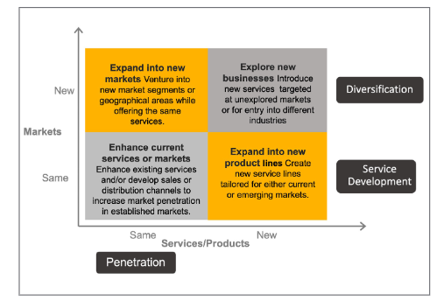
Figure 3– Ansoff Matrix (Quaranta and Hui, 2024)

In Quaranta and Hui’s article, four potential growth strategies are outlined.
- Market Penetration – Enhancing the sales of a current item in a current market
- Service development - Existing markets are offered new items.
- Diversification - New Products for a new target
- Market development – Entering a new market with an existing product or service
The strategy that would be best to pursue for Google is Market Penetration, as the current market google are targeting with their Gemini service is growing, as seen in Curry’s (2025) article, Gemini gained 19 million users between February 2024 and October 2024. Kenton (2024) provides some methods of penetration that Google could use, such as creating new products, as established in this report, creativity is a focal point of Google’s culture so it should be easy for them to further penetrate their current market.
It can be argued however that this model is not too useful to Google currently, as they are arguably in a position where they need not focus on growth. Bianchi (2025) reported that Googles annual revenue for 2024 was $348.16 billion, up from $305.63 billion in 2023 which indicates impressive progress in the space of a year alone. The model is however still useful in providing methods of growth, a more important focus for Google now may be their Sustainability Strategy, as seen below.

5.0 Sustainability and Strategic Recommendations

The aim of this report is to provide strategic recommendations for Google so they can be more sustainable as a company, before providing any recommendations, Googles current sustainability initiatives need to be evaluated.

5.1 Evaluation of Googles Current Sustainable Strategies

Google (2024) reported that:
- 64% of carbon free energy across their centres in recent years, getting them closer to their 2030 goal of being carbon free
- Google hit 99% plastic fee packaging, very close to their 100% goal
- AI is being used by Google to deal with climate action, for example the nest thermostat system helped sabe 29 billion kWh of energy from being wasted.
However:
- Kerr (2024) finds that Googles heavy usage of AI generates a lot of Co2 and there has been a 48% increase in googles greenhouse gas emissions between 2019 and the time of Kerr’s report. This shows that Google are undoing their own progress in environmental sustainability through the heavy use of AI
- Googles current strategy for sustainability focuses more on the environmental aspect and not on social aspects. Rabbitt and Altman (2024) lay out some global issues they find worthy of focus in 2025, such as: Catastrophic conflict, Hassanova (2025) reports that google have removed their principle of banning AI for being used in weapon development, which seems counteractive to solving the issue of conflict.

5.2 Strategic Recommendations

McKinsey’s Three horizon model could be used to implement a new strategy for google:
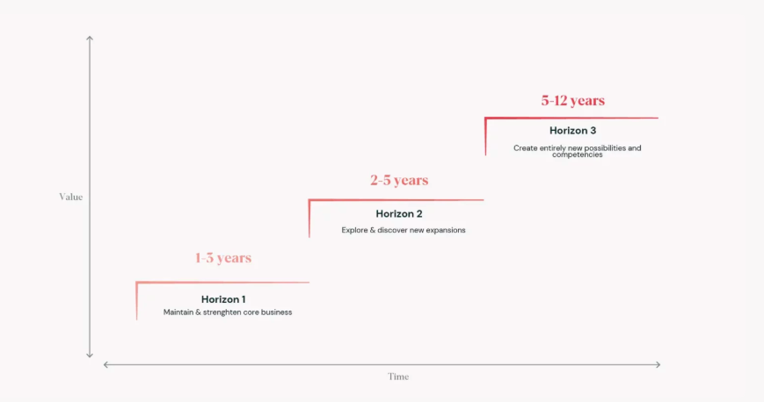
Figure 4: The 3 Horizons model (Van Balen, N.D.)

5.2.1 Horizon 1 - Maintaining and strengthening core business activities

As it stands, Googles current sustainability aims are acceptable and they are shown to be making good progress, these activities can be strengthened by dealing with the counterproductive nature of AI.

5.2.2 Horizon 2 – Explore and discover new expansions

Bolon-Canedo et al. (2024) explains that Green AI is better for the environment and enables research to be carried out without costly servers. Adopting this model of AI will strengthen the development of Googles sustainability efforts. Google should retract their decision to lift restrictions on using AI for weapon development as this could worsen the state of some societies.

5.2.3 Horizon 3 – Create entirely new possibilities and competencies

Google themselves may make further discoveries within the field of Green AI and could optimise its usage, which is reasonable to say given the innovative nature and experience with AI they are shown to have in this report. Google could develop a partnership with an organisation such as Peace Direct (2025) who aim to stop violence across the globe.

6.0 Conclusion

To conclude:
- Google need to be aware of external factors such as the threats posed by competitors, new entrants and substitutable products
- In terms of Internal Strengths, Googles culture will help sustain an advantage but, other resources only provide parity with their competitors, They should look at ways to strengthen their other resources/capabilities.
- Google could achieve growth using market penetration
- Google should incorporate Green AI into their practices, consider partnering up with an organisation focused on resolving conflict like Peace Direct and reimplement a policy against using AI for weapon development

References

Achinas, S. et al. (2019) ‘A PESTLE Analysis of Biofuels Energy Industry in Europe’, Sustainability, 11(21), pp. 5981-.
Adelakun, A., 2020. ‘Should Porters Five Forces have value in businesses today.’ Computing for Business (BSC).
Alphabet Investor Relations (2024) “GOOG Exhibit 99.1 Q4 2024” Available at: https://abc.xyz/assets/a3/91/6d1950c148fa84c7d699abe05284/2024q4-alphabet-earnings-release.pdf Accessed: 9th March 2025
Apple (2025) “Apple Intelligence” Available at: https://www.apple.com/uk/apple-intelligence/ Accessed: 7th March 2025
BBC News (2025) “What is AI, and how do programmes like ChatGPT and DeepSeek work?” Available at: https://www.bbc.co.uk/news/technology-65855333 Accessed: 23rd February 2025
Berne P. (2025) “Apple Intelligence explained: The new Apple AI for your iPhone, iPad and Mac explained” Available at: https://www.techradar.com/computing/artificial-intelligence/apple-intelligence-explained Accessed: 15th March 2025
Bhandari R. (2024) “Ethics And Compliance Are Vital When Applying AI Tools In HR” Available at: https://www.forbes.com/councils/forbeshumanresourcescouncil/2024/11/06/ethics-and-compliance-are-vital-when-applying-ai-tools-in-hr/ Accessed: 15th March 2025
Bianchi T. (2025) “Annual revenue of Google from 2002 to 2024” Available at: https://www.statista.com/statistics/266206/googles-annual-global-revenue/ Accessed: 7th March 2025
Bolón-Canedo, V. et al. (2024) ‘A review of green artificial intelligence: Towards a more sustainable future’, Neurocomputing (Amsterdam), 599, pp. 128096-. Available at: https://doi.org/10.1016/j.neucom.2024.128096.
Cerf V. G. (2020) “Growing A Culture Of Innovation: 5 Lessons From Google” Available at: https://www.forbes.com/sites/googlecloud/2020/09/16/growing-a-culture-of-innovation-5-lessons-from-google/ Accessed: 15th March 2025
Curry R. C. (2025) “Market Penetration: What It Is and Strategies to Increase It” Available at: https://www.investopedia.com/terms/m/market-penetration.asp#:~:text=Key%20Takeaways-,Market%20penetration%20is%20a%20measure%20of%20how%20much%20a%20product,instead%20of%20a%20competitor's%20product. Accessed: 15th March 2025
Elliott L. (2025) “The west is already losing the AI arms race” Available at: https://www.theguardian.com/commentisfree/2025/jan/30/ai-arms-race-china-deepseek Accessed: 13th March 2025
Escaler G. (2020) “Transforming Sustainability Into A Competitive Advantage” Available at: https://www.forbes.com/councils/forbescommunicationscouncil/2020/09/09/transforming-sustainability-into-a-competitive-advantage/ Accessed: 13th March 2025
Fletcher R. and Nielsen R. K. (2024) “What does the public in six countries think of generative AI in news?” Available at: What does the public in six countries think of generative AI in news? | Reuters Institute for the Study of Journalism
Florea, N.V., Mihai, D.C., Duica, A. and Pahome, D., 2020. ‘Analyzing and measuring the value of human resources using VRIN architecture and exponential integral function.’ Journal of Science and Arts, 20(2), pp.381-394.
Google (2024) “Environmental Report 2024” Available at: Google 2024 Environmental Report - Google Sustainability Accessed: 8th March 2025
Google (2025) “About merchant loyalty programme” Available at: About merchant loyalty programme - Google Merchant Center Help Accessed: 8th March 2025
Google (N.D.) “Policy guidelines for the Gemini app” Available at: https://gemini.google/policy-guidelines/?hl=en#:~:text=Harassment%2C%20Incitement%20and%20Discrimination%3A%20Gemini,kill%20individuals%20or%20a%20group. Accessed: 7th March 2025
Google Cloud (N.D.) “Google Cloud infrastructure” Available at: https://cloud.google.com/infrastructure Accessed: 16th March 2025
Gopalan, K. (2023) Why Google India is one of the best companies to work for in the country: Google has created a culture that ensures that its people are engaged in work that is critical, satisfying and creative, Business today (New Delhi, India). New Delhi: Living Media India, Limited.
Guardian Staff and Agencies (2025) “Elon Musk’s startup rolls out new Grok-3 chatbot as AI competition intensifies” Available at: Elon Musk’s startup rolls out new Grok-3 chatbot as AI competition intensifies | Elon Musk | The Guardian Accessed: 25th February 2025
Hall R. (2025) “‘Trump Gaza’ AI video intended as political satire, says creator” Available at: ‘Trump Gaza’ AI video intended as political satire, says creator | Artificial intelligence (AI) | The Guardian Accessed: 7th March 2025
Hassanova T. (2025) “Google’s policy shift on military AI sparks fears of global conflict escalation” Available at: https://caliber.az/en/post/google-s-policy-shift-on-military-ai-sparks-fears-of-global-conflict-escalation Accessed: 16th March 2025
Howarth J. (2025) “25 Fastest Growing Companies & Startups (2025)” Available at: 25 Fastest Growing Companies & Startups (2025) Accessed: 26th February 2025
Jackson A. (2023) “These 10 brands have the highest customer loyalty—Apple isn’t in the top 3” Available at: Brands with top customer loyalty, says report: Alphabet, Lowe's, Intel Accessed: 8th March 2025
Johnston M. (2025) “How Google (Alphabet) Makes Money: Advertising and Cloud” Available at: https://www.investopedia.com/articles/investing/020515/business-google.asp#:~:text=The%20company%20leverages%20its%20search,Cloud%20revenues%20are%20growing%20rapidly. Accessed: 9th March 2025
Kenton W. (2024) “Market Penetration: What It Is and Strategies to Increase It” Available at: https://www.investopedia.com/terms/m/market-penetration.asp#:~:text=Key%20Takeaways-,Market%20penetration%20is%20a%20measure%20of%20how%20much%20a%20product,instead%20of%20a%20competitor's%20product. Accessed: 19th March 2025
Kerr D. (2024) “AI brings soaring emissions for Google and Microsoft, a major contributor to climate change” Available at: Google and Microsoft report growing emissions as they double-down on AI : NPR Accessed: 11th March 2025
Lee, H. and Jung, J. (2024) ‘Customer–Resource Relationships in the Continuous Business Model Innovation of Technology Companies: Google Cases’, Sustainability, 16(1), pp. 257-.
Mahat, M. (2019) ‘The Competitive Forces That Shape Australian Medical Education: An Industry Analysis Using Porter’s Five Forces Framework’, International journal of educational management, 33(5), pp. 1082–1093.
Malik S. (2025) “AI adoption key to economic growth, says BT Business chief” Available at: AI adoption key to economic growth, says BT Business chief | Capacity Media Accessed: 17th February 2025
Manela M. (2024) “How to land a job at Google, Apple, and Amazon: Insights from top CEOs” Available at: https://www.calcalistech.com/ctechnews/article/h1nysk11l1l Accessed: 17th March 2025
Mauran C. (2025) “Apple Intelligence with Google Gemini integration looks to be coming soon” Available at: Apple Intelligence with Google Gemini integration looks to be coming soon | Mashable Accessed: 25th February 2025
McKenzie L. (2025) “Google Gemini vs ChatGPT: Which AI Chatbot Is Better in 2025?” Available at: Google Gemini vs ChatGPT: Which AI Assistant Wins in 2025? Accessed: 26th February 2025
Minister of Justice and The Rt Hon Shabana Mahmood MP (2024) “UK signs first international treaty addressing risks of artificial intelligence” Available at: https://www.gov.uk/government/news/uk-signs-first-international-treaty-addressing-risks-of-artificial-intelligence Accessed: 23rd February 2025
Niloshini M. (2024) “Resource-Based View and VRIO Framework (VRIN Framework)” Available at: https://prostudylab.com/resource-based-view-and-vrio-framework-vrin-framework/ Accessed: 13th March 2025
Orosz G. (2022) “Big Tech and the reality of scaling customer support” Available at: https://blog.pragmaticengineer.com/scaling-customer-support/ Accessed: 15th March 2025
Pathak R. (2020) “What is PESTLE Analysis? Everything you need to know about it” Available at: https://www.analyticssteps.com/blogs/what-pestle-analysis Accessed: 13th March 2025
Peace Direct (2025) “Together, we can build peace that lasts” Available at: https://www.peacedirect.org/ Accessed: 16th March 2025
Perry N. (2024) “How Google Procurement works with Diverse Suppliers” Available at: https://procurementmag.com/articles/how-google-works-with-diverse-suppliers Accessed: 9th March 2025
Pichai S. and Hassabis D. (2023) “Introducing Gemini: our largest and most capable AI model” Available at: https://blog.google/technology/ai/google-gemini-ai/ Accessed: 17th March 2025
Podolny J.M. and Hansen M. T. (2020) “How Apple Is Organized for Innovation” Available at: How Apple Is Organized for Innovation Accessed: 8th March 2025
Quaranta A. and Hui W. L. (2024) ‘The Application of the Ansoff Matrix in Dental Business Management’, Annali di stomatologia, 15(3), pp. 175–178.
Rabbitt M. and Altman M. (2024) “5 Global Issues to Watch in 2025” Available at: 5 GLOBAL ISSUES TO WATCH IN 2025 | unfoundation.org Accessed: 9th March 2025
Richard C. (2024) “Virginia’s first onshore wind farm to power Google’s data centres” Available at: https://www.windpowermonthly.com/article/1900391/virginias-first-onshore-wind-farm-power-googles-data-centres Accessed: 25th February 2025
Ruan, S. (2020) ‘Research on Strategic Cost Management of Enterprises Based on Porter’s Value Chain Model’, Journal of physics. Conference series, 1533(2), pp. 22056-.
Samsung (2025) “Samsung One” Available at: https://www.samsung.com/uk/business/samsung-one/ Accessed: 19th March 2025
Samsung (2025) “What is Samsung Rewards?” Available at: https://www.samsung.com/uk/shop-faq/samsung-rewards/what-is-samsung-rewards/#:~:text=Samsung%20Rewards%20is%20our%20loyalty,accumulated%20points%20on%20Samsung.com. Accessed: 15th March 2025
Savage M. (2025) “Release of technology secretary’s use of ChatGPT will have Whitehall sweating” Available at: https://www.theguardian.com/politics/2025/mar/13/peter-kyle-technology-secretary-freedom-of-information-chatgpt Accessed: 15th March 2025
Sharif A. (2025) “March Pixel Drop: Updates for Gemini Live, Scam Detection and more” Available at: Pixel Drop March 2025: All the latest features for Pixel devices Accessed: 8th March 2025
Stobierski T. (2020) “What Is a Value Chain Analysis? 3 Steps” Available at: https://online.hbs.edu/blog/post/what-is-value-chain-analysis#:~:text=What%20Is%20Value%20Chain%20Analysis,your%20final%20product%20or%20service. Accessed: 14th March 2025
Thormundsson B. (2024) “Artificial intelligence (AI) market size worldwide from 2020 to 2030” Available at: https://www.statista.com/forecasts/1474143/global-ai-market-size Accessed: 14th March 2025
Timbrell N., Jennings C. and Bullock A. (2019) ‘Ansoff Matrix’, A Dictionary of Publishing. 1st edn. Oxford University Press.
Umashankar V. (2024) “Are app subscriptions on iPhones more expensive than on Android devices?” Available at: https://indianexpress.com/article/technology/techook/app-subscriptions-prices-iphone-android-compared-9667686/ Accessed: 13th March 2025
Van Balen A. (N.D.) “What is the 3 horizons model & how can you use it?” Available at: https://www.boardofinnovation.com/blog/what-is-the-3-horizons-model-how-can-you-use-it/ Accessed: 16th March 2025
Wang, J. and Wang, Z. (2020) ‘Strengths, Weaknesses, Opportunities and Threats (SWOT) Analysis of China’s Prevention and Control Strategy for the COVID-19 Epidemic’, International journal of environmental research and public health, 17(7), pp. 2235-.
Washington State University (2025) “What is a PESTEL Analysis?” Available at: https://libguides.libraries.wsu.edu/c.php?g=294263&p=4358409 Accessed: 17th February 2025
Woolnough-Rai M. (2025) “The importance of customer loyalty: a guide for ecommerce brands” Available at: https://loyaltylion.com/blog/the-importance-of-customer-loyalty#:~:text=Loyal%20customers%20are%20more%20likely,than%20that%20of%20new%20customers. Accessed: 15th March 2025

