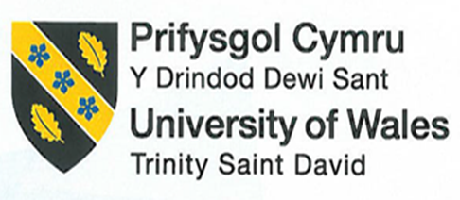

Module Title: Foreign Languages & Cultural Awareness
Programme: BA International Hotel Management
Assignment Title: Intercultural Competence Report
Name: Vasile Puscuta
ID number: 2233417
Module code: BMIH5003
Lecturer: Giulia Chifari, Antoinette Milne

Introduction
Top management of the Inclusivity Hotel and Spa in London, England, requested that the Assistant General Manager travel to the hotel's headquarters in Switzerland. The purpose of this tour is to gain knowledge of the brand standards and operations of the hotel chain, for which the assistant manager must write a report. The main cultural distinctions between Holland and England will be outlined in the paper and to see Holland’s hotel personnel may be used to being managed differently compared to the staff at home.

Main body

Differences among England’s and Holland’s culture and customs
The English prefer understatement and civility in conversation, whereas the Dutch are often more forthright. Due to the Dutch looking direct and the English being ambiguous, this might cause misunderstandings. In Dutch culture, reaching an agreement and promoting equality are valued. English culture is more focused on individual accomplishment and has a more established hierarchy (Miedema, 2018). When conversing, the Dutch are more likely than the English to be physically closer to one another. English greetings tend to be more official (Mr., Ms., etc.), while Dutch greetings are more informal (first names). Whereas the English might be more outspoken and independent, the Dutch are recognized for taking a more somber and subdued approach. Dutch people are more straightforward and may sometimes err on the side of rudeness, while British people are often courteous and indirect. Dutch individuals tend to be more forthright, whereas British people can attempt to be diplomatic or bite their tongue. Most Dutch people are gregarious, kind, and open. Only parents and kids share a home in the Netherlands. They don't typically live with their grandparents, aunts, or uncles. Dutch families often talk about their day's activities over dinner. The British are more traditional and sentimental, cherishing their past and culture, while the Dutch are more focused on the present and money (Kalaycioglu, 2015; Fleischmann and Phalet, 2018).

Analysis
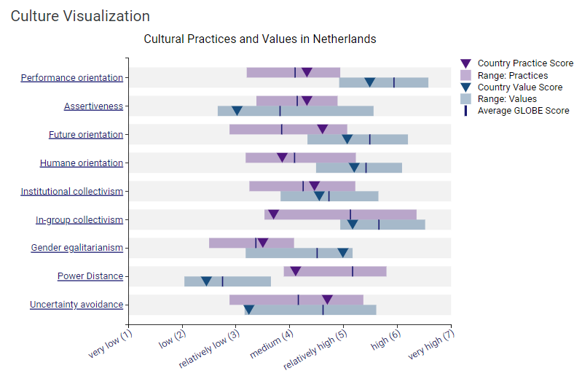
Figure 1: Culture visualisation of Holland
Source: Globe Project, 2024
Regarding a visualization of cultural practices and values in the Netherlands according to the GLOBE project, Holland or Netherlands is performance-oriented that is high with assertiveness in their culture a future orientation to high as well. Therefore, collectivism is normal with in-group collectivism is on the low side. As a result, gender egalitarian for this country is also low with uncertainty avoidance by the people is regarded as relatively low as well. Furthermore, Dutch culture prioritizes equality, with a preference for consensus-based decision making and less emphasis on rigid hierarchies. The project might reveal how Dutch society values fairness, helping others, and environmental sustainability. The Dutch tend to be direct and comfortable expressing opinions. This can be seen in their communication style and decision-making processes (Javidan et al., 2016).

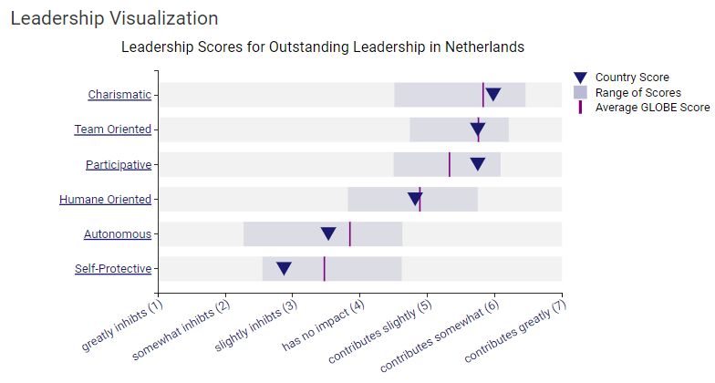
Figure 2: Leadership visualisation of Holland
Source: Globe Project, 2024
Regarding leadership visualization of Holland, the leaders are charismatic that contributes somewhat to the country. This suggests leaders in the Netherlands tend to exhibit strong charisma, inspirational qualities, and visionary behaviors. The participative and humane oriented dimensions are close to the global average. This indicates Dutch leaders focus on building cohesive teams and emphasize collaboration. The autonomous and self-protective dimensions have the lowest scores, falling below the global average, suggesting Dutch leaders are less inclined to delegate authority and allow followers independence. Managers always involve all team members, seek consensus among them and convince everyone of the meaningfulness of a planned project. Dutch are generally pragmatic. The manager oversees fostering a productive team environment and regards himself as primus inter pares, meaning that he is just another team member. Formality, title, and status are seen superfluous. Citing a person's position inside a Dutch firm carries a direct risk of negative reaction from staff members and does little more than showcasing one's authority to make decisions (Wesseling et al., 2020).

Importance cultural intelligence and sensitivity for hotel personnel
A hotel with a diverse staff benefits from a wider range of perspectives and experiences. When staff are culturally intelligent, they can collaborate more effectively and create a more inclusive work environment. This fosters teamwork and can lead to a happier and more productive workforce. By catering to a wider range of guests, hotels with culturally intelligent staff open themselves up to new markets and revenue streams. They can tailor their services and marketing to specific cultural preferences, attracting a broader clientele. In essence, cultural intelligence and sensitivity are investments in the future of the hospitality business. They help hotels create a welcoming environment, build guest loyalty, and achieve sustainable growth. People appreciate feeling valued and understood. Culturally sensitive staff can anticipate guests' needs and avoid misunderstandings. This leads to higher satisfaction, positive reviews, and guests who are more likely to return. In today's competitive market, loyalty is key, and cultural intelligence is a major differentiator (Yurur et al., 2016; Cheung et al., 2022).

Recommendations
The recommendations to overcome culture incompetency is as follows:

- The first solution is to provide comprehensive cultural awareness training for all staff, from front-line employees to management. This helps them understand different cultural norms, customs, and communication styles.
- The hotel should hire staff that are proficient in multiple languages, including the languages of the hotel's key international markets. This facilitates better communication with guests. Diverse employees in the hotel can effectively address the challenges of the diverse hotel guests.
- Another recommendation for hotels is to collaborate with local cultural organizations to learn about the customs and preferences of the hotel's key demographic groups. This can inform product and service offerings (Chenyang, 2022).

Conclusion
Each country has its own culture, especially Holland and England as they are in the same region. However, the culture and customs of both countries are poles apart. Therefore, the main difference can be seen regarding communication, leadership, time and family. About culture visualization, Holland is considered to be prioritize equality, with a preference for consensus-based decision making and less emphasis on rigid hierarchies. Hence, regarding leadership, Holland managers and leaders are open and collaborative with the team.

References
Chenyang, L., 2022. Meta-analysis of the impact of cross-cultural training on adjustment, cultural intelligence, and job performance. Career Development International, 27(2), pp.185-200.
Cheung, C., Tung, V. and Goopio, J., 2022. Maximizing study abroad learning outcomes through cultural intelligence and emotional intelligence development. Journal of Hospitality, Leisure, Sport & Tourism Education, 30, p.100359.
Fleischmann, F. and Phalet, K., 2018. Religion and national identification in Europe: comparing muslim youth in Belgium, England, Germany, the Netherlands, and Sweden. Journal of Cross-Cultural Psychology, 49(1), pp.44-61.
Globe Project. 2024. Globe 2020 [Online]. Available at: https://globeproject.com/results/countries/NLD%3Fmenu=list.html#list [Accessed on May 22, 2024].
Javidan, M., Dorfman, P.W., De Luque, M.S. and House, R.J., 2016. In the eye of the beholder: Cross-cultural lessons in leadership from Project GLOBE. In Readings and cases in international human resource management (pp. 119-154). Routledge.
Kalaycioglu, D.B., 2015. The influence of socioeconomic status, self-efficacy, and anxiety on Mathematics achievement in England, Greece, Hong Kong, the Netherlands, Turkey, and the USA. Educational Sciences: Theory and Practice, 15(5), pp.1391-1401.
Miedema, S., 2018. Organizational models of Islamic religious education at schools in Europe: the Netherlands and France. Transnationale Dimensionen Religioser Bildung in der Moderne, pp.413-427.
Wesseling, J.H., Bidmon, C. and Bohnsack, R., 2020. Business model design spaces in socio-technical transitions: The case of electric driving in the Netherlands. Technological Forecasting and Social Change, 154, p.119950.
Yurur, S., Koc, E., Taskin, C. and Boz, H., 2021. Factors influencing intercultural sensitivity of hospitality employees. International journal of hospitality & tourism administration, 22(1), pp.26-44.

