- Digit Recognition
Among the many uses for digital recognition include automatic sorting by post offices, bank verification reading, license plate recognition, and other kinds of numerical identification. Digit recognition seeks to categorize zero through nine using automated techniques. As a subset of more general handwriting recognition problems such as identifying that the very same character can be written in thousands of different ways and attempting to gather a set of data representative of the countless ways in which people can write that character, it has many of the same challenges as that larger problem. In order to do digit recognition, an image must first be processed and cleaned up before being produced into a picture that can be classed, and this is where image preprocessing comes in. Classifiers that can withstand the inherent variances in the way individuals write numbers are needed for this project, which will then be applied to a collection that must first be analyzed and then categorized.
- Dataset
The MNIST collection of handwritten digits, which was released by Yann LeCun at the Courant Institute of New York University and Corinna Cortes at Google, serves as our primary dataset. This database, which is a subset of a bigger collection from the National Institute of Standards and Technology (NIST), has a training set of 60,000 samples and a test set of 10,000 cases. The numerals are all of the same scale and are centred in the picture, which is a nice touch. Each picture in a 28x28 image is centralized by calculating the centroid of the pixels and then translating the image such that the pivot point is at the center of the picture (see figure). In total, there are approximately 250 different writers represented in the images, which are each a binary image of a handwritten digit and consist of 30,000 motifs drawn from two databases, one containing patterns from Census Bureau employees and the other containing patterns from high-school students. The test set comprises of 5,000 motifs from each of the two databases under consideration. The datasets have been labeled in order to facilitate simple verification.
- Data Preprocess
I used two basic feature extraction methods. The first one is to binarize the image and then flatten it into a one-dimensional vector, since the image is 28*28 in size, the length of the flattened one-dimensional vector is 784. Using a for loop for each image in the training and test sets, the final feature vector is 60,000*784 for the training set and 10,000*684 for the test set. The second method is based on the first binarization process with the addition of HOG feature extraction, and after extraction each image becomes a one-dimensional feature vector with length 1164. The for-loop procedure is similar with the first one.
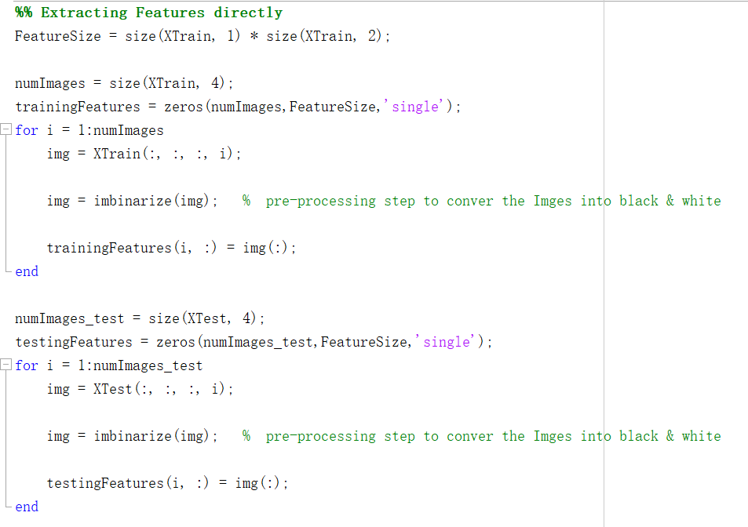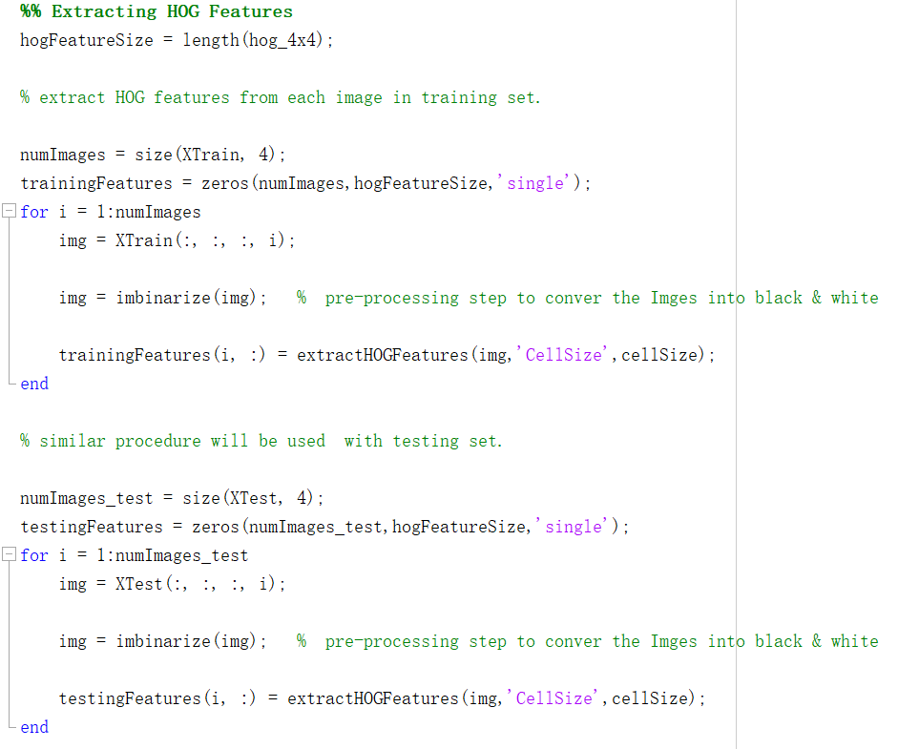
Image Binarization is the procedure that separate image pixels into dual collection of pixels, i.e., black, and white. In the MINST dataset, the given image contains grayscale, i.e., it contains 255 gray levels from white to black. But this grayscale information is not helpful for the recognition of numbers. By image binarization, the pixels can be transformed into only hundred and black, which are expressed by 0 and 1. In this way it is possible to reduce the storage and computational requirements and to better distinguish between foreground and background.
HOG, or Histogram of Oriented Gradients, is a commonly used feature descriptor for extracting features from picture data. It is commonly utilized in tasks involving computer vision. The HOG descriptor is concerned with an object's structure or form. HOG has some similarities with edge characteristics but also has significant distinctions. With edge features, we simply determine if a pixel is an edge or not. HOG is also capable of providing edge direction. This is accomplished by extracting the gradient and orientation of the edges (or their magnitude and direction). Furthermore, these orientations are computed in 'localized' segments. This implies that the whole picture is divided into smaller sections, and the gradients and orientation of each region are determined. Finally, the HOG would create a distinct histogram for each of these sections. Histograms are constructed utilizing the gradients and orientations of the pixel values, hence the term 'Histogram of Oriented Gradients'.
In MATLAB, Image Binarization and HOG feature extraction can be done in a simple way.
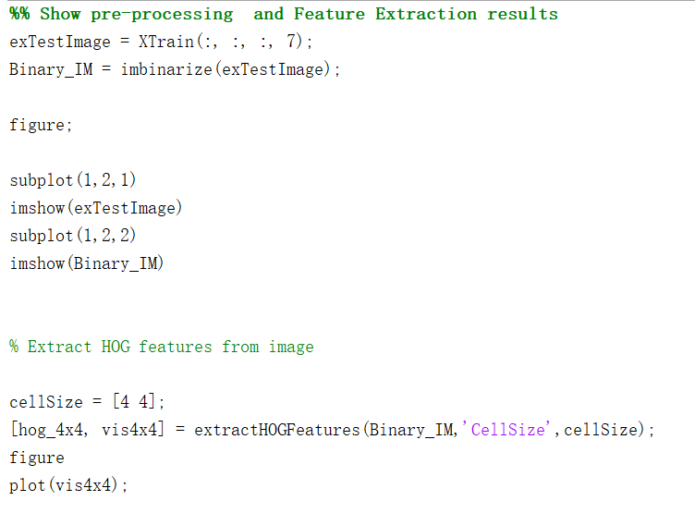
After running the code above, we get a visualization of processing results:
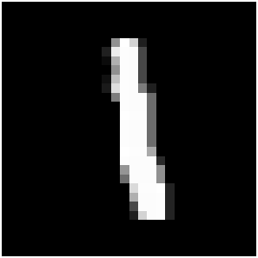 | 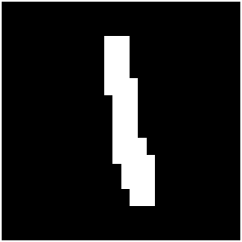 | 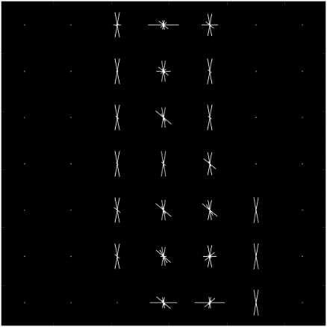
Original image | Image after binarization | Image after HOG

- Algorithm and Results
I tested four basic machine learning methods, namely KNN, Decision Tree, Bagging Decision Trees and SVM. Here is the basic introduction of these methods and the results on two different data preprocess methods.
  - K-Nearest Neighbors (KNN)
The K-Nearest Neighbors (KNN) algorithm is a non-parametric approach used in both classification and regression. In all circumstances, KNN first calculates the distance between the input vectors and all the vectors in the training set (generally using Euclidean distance), and then goes to find the K nearest vectors to the input vectors according to the set K values. Then different methods are used to get the results depending on the task.
In KNN classification, the output is a class membership. A percentage of its neighbors vote to classify an item, with the object being allocated to the class that is most prevalent among its k closest neighbors. If k equals one, the object is simply assigned to the class of the item's closest neighbor.
Here are a few generally accepted advantages and disadvantages of KNN:
Advantages | Disadvantages
- The algorithm is basic and straightforward to implement.  - There is no need to construct a model, fine tune numerous hyperparameters, or make extra presumptions. | - As the number of instances or predictors increases, the process becomes much slower.  - The selection of K is insufficiently adaptable and efficient.
The KNN algorithm can be summarized in the following steps:
- Initialize K to the appropriate number of neighbors.
- For each vector in the test data,
- Calculate the distance between the test vector and the vector from the training data.
- Add the distance and the index of the object to an ordered collection.
- Sort the ordered set of distances and indices by distances from lowest to greatest (in ascending order).
- Pick the first K vectors from the sorted set.
- Get the labels of the selected K vectors and return the majority of the K labels.
The primary challenge of the KNN algorithm is to choose the appropriate value for K. In general, to find the optimal K for data, researchers have to rerun the KNN algorithm numerous times with various K values and find the K that minimizes mistakes while keeping the system's capacity to generate correct predictions when given new data. Additionally, certain common experiences may assist in decrease the quantity of experiments k.
When K is small, the algorithm is particularly adept at capturing fine-grained patterns. However, it is susceptible to noise in the training data, which is difficult to eliminate throughout the data preprocessing phase. As K approaches 1, the predictions become less reliable. In this situation, regardless of the neighborhood, a particular vector will select the closest vector as its label. Consider a question point surrounded by many reds and a single green, with the green being the closest neighbor. We might reasonably believe that the query point is red, but since K=1, KNN wrongly predicts that it is green.
Inversely, as the amount of K increases, the forecast models become more stable owing to plurality voting / averaging, and hence more likely to be correct (up to a certain point). However, it may overlook significant patterns which lead to an increase in the amount of error. This is the moment at which we have exceeded the value of K.
When a majority vote is required among labels, such as when selecting the mode in a classification issue, we normally make K an odd number to provide a tiebreaker.
From general experience, the optimal choice of K depends on the number of data points n and number of features d:
$$K=n^{\frac{2}{2+d}}$$
In the MINST dataset, according to the above formula, the optimal choice of K is 1. But according to the results of our discussion above, this is not an ideal choice.
In general, the choice of k cannot be too small (especially 1) or too large, and an odd number should be chosen for classification problems. In this experiment, I choose k = 3, 5, 7 for testing. Here are the results:

Preprocess Method: Image Binarization
K=3 | 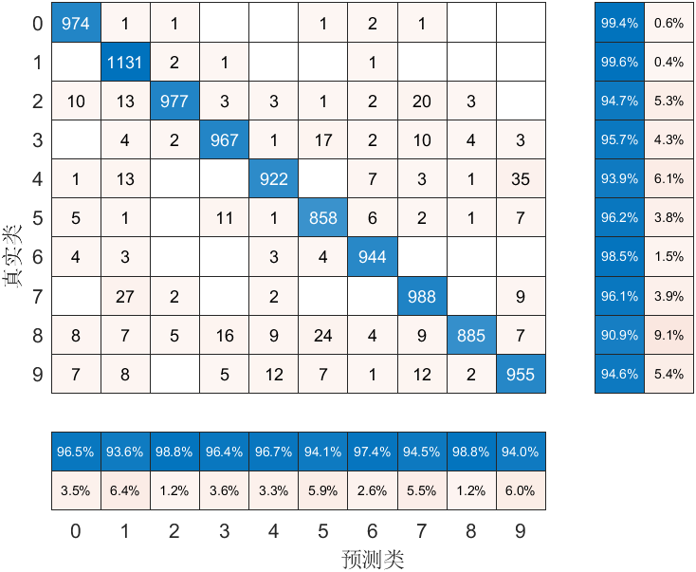
K=5 | 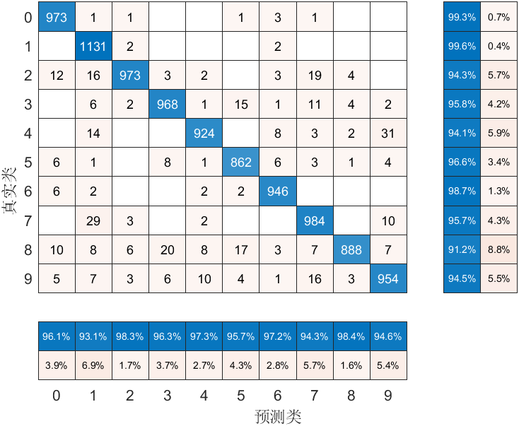
K=7 | 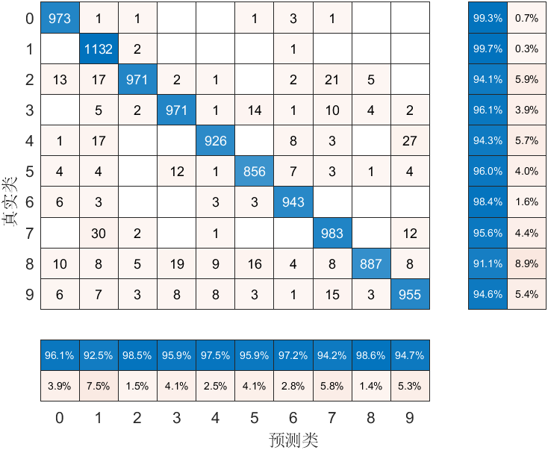

Preprocess Method: Image Binarization + HOG
K=3 | 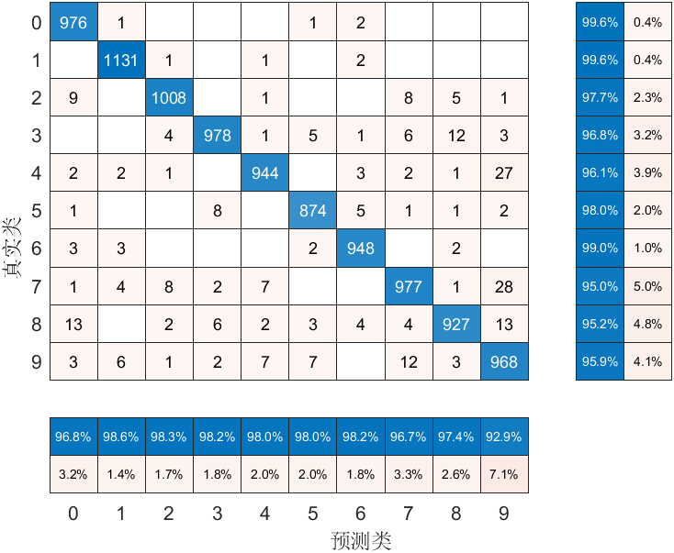
K=5 | 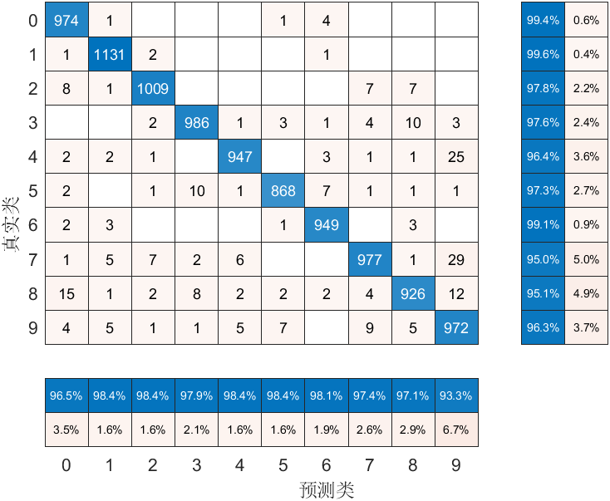
K=7 | 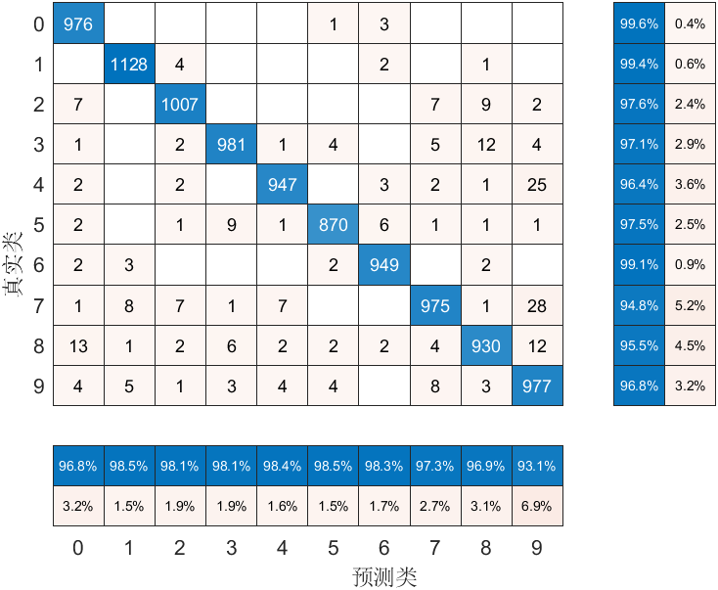

From the Confusion Matrix, we can easily calculate accuracy:
K value Preprocess | Image Binarization | Image Binarization + HOG
K=3 | 96.01% | 97.31%
K=5 | 96.03% | 97.39%
K=7 | 95.97% | 97.40%
From the above accuracy results, the HOG feature extraction method is helpful for the improvement of the algorithm accuracy. However, the improvement of K-value is not helpful for the accuracy improvement, and it may even be counterproductive.
  - Decision Tree
A decision tree is a kind of data flow diagram in which each internal node denotes a "check" on an attribute, each branch indicates the result of the “check”, and each leaf node represents a class label (results after all the “checks”). Classification rules are represented by the pathways from root to leaf.
Here are a few generally accepted advantages and disadvantages of Decision Tree:
Advantages | Disadvantages
- Easy to comprehend, analyze, and envision.  - Capable of dealing with both numeric and categorical data. Additionally, it is capable of resolving issues involving several outputs.  - Users may prepare data for decision trees with comparatively minimal effort.  - Tree performance is unaffected by nonlinear interactions between parameters. | - Decision-tree models have the potential to generate too complicated trees that may not adequately generalize the input.  - Decision trees may be unstable since slight changes in the data could lead to the generation of an entirely new tree.  - Algorithms that are greedy cannot ensure that they will yield the globally optimum decision tree. If certain classes predominate, decision tree classifiers build biased model.
Developing a decision tree entail determining which characteristics to employ and under what circumstances to split, as well as understanding when to quit. Due to the fact that trees develop at their own pace, they must also be trimmed to maintain their beauty.
Recursive Binary Splitting is the first and most critical technique in constructing a decision tree from original data. All characteristics are analyzed in this approach, and several split spots are explored and assessed using a cost function. The division that incurs the least cost is chosen.
Here is a brief step-by-step summary of this procedure:
In the initial split or the root, all attributes/features are examined, and the training data is separated into groups depending on this split. Then, using cost functions (such as Gini and Entropy), the value of accuracy for each split is calculated, and the split with the highest accuracy is selected. For example, the most popular one is Gini score, the function is represented as:
$$G = \sum{(p_{k} * (1 — p_{k}))}$$
A Gini score indicates the quality of a split by indicating how diverse the answer classes are within the categories formed by the split. $p_{k}$ denotes the percentage of inputs of the same class that are present in a certain group. A group with complete class purity has all inputs within the same class, in which case $p_{k}$ is either 1 or 0 and $G=0$, while a node with a 50–50 distribution of categories in a collective has the lowest purity, in which case $p_{k}=0.5$ and $G=0.5$.
Using the same technique recursively, the groups generated is being further subdivided. It is also characterized as a "greedy algorithm" because of this procedure's overwhelming desire to minimize the cost. This means that the root node is the best classification.
Due to a problem's likely vast number of features, many splits are produced, resulting in a massive tree. Overfitting is a problem with complicated trees like this. As a result, knowing when to cease splitting is essential. The smallest amount of training inputs per leaf may be one approach to do this. Another option is to provide the model's maximum depth (length between the root node and the bottommost node).
Pruning can then be used to improve the decision tree's performance even further. It entails deleting branches that contribute to insignificant traits. This reduces the complexity of the tree, hence enhancing its predictive power via less overfitting.
MATLAB has a offered a simple way to implement decision tree, here is the results on both two data preprocesses:
Preprocess Method: Image Binarization
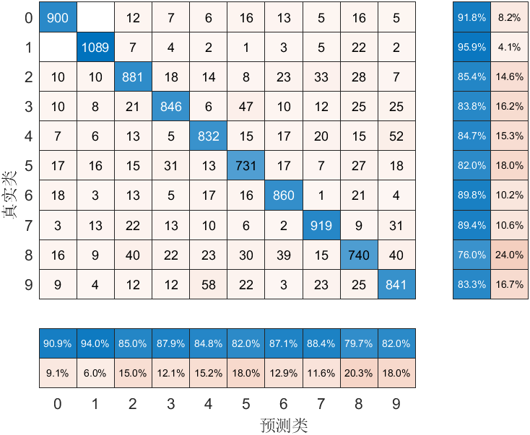
Preprocess Method: Image Binarization + HOG
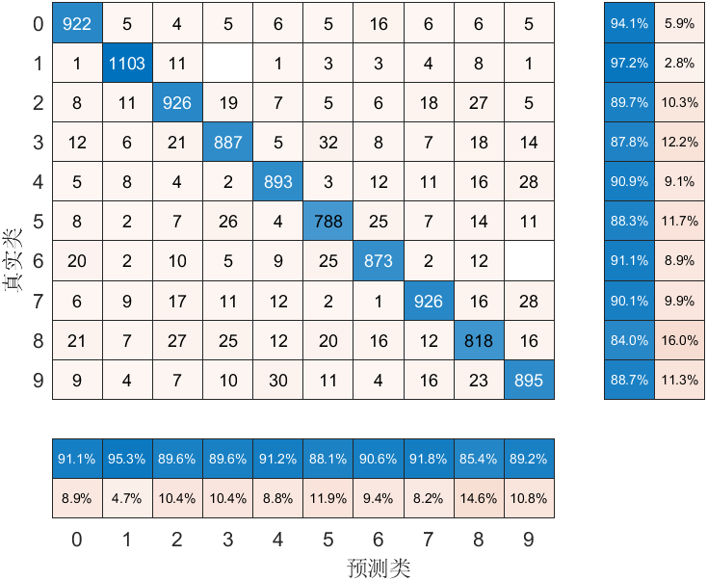
From the Confusion Matrix, we can calculate accuracy:
Algorithm Preprocess | Image Binarization | Image Binarization + HOG
Decision Tree | 86.39% | 90.31%
Comparing the accuracy results of the decision tree with other algorithms, we can find that it has the lowest accuracy among all algorithms, indicating that the decision tree has a significant tendency of overfitting. The accuracy of the HOG feature extraction has increased significantly (about 4%), indicating that good input features can moderate the tendency of overfitting. I did not prune the decision tree in this experiment and believe that the accuracy will be further improved after pruning.

  - Bagging Decision Trees
Overfitting is a recognized problem with decision trees that has existed for a long time. Stopping the growth of the tree when additional splitting does not increase performance and developing a complete tree before pruning the tree, by removing nodes, are two of the most frequent methods. The overfitting issue may be successfully mitigated by ensemble approaches, which combine numerous decision trees to generate higher prediction performance than a single predictor using ensembles of decision trees. When a collection of weak learners comes together, they become stronger, and this is the basic premise of the ensemble model.
There are a few techniques to perform ensemble decision trees, the first and most direct way is bagging. Bagging, also known as Bootstrap aggregation, is the ensemble learning approach that is commonly used to minimize variance within a noisy dataset. Bagging generates multiple training data samples by randomly picking a subset of data from a training data set with replacement—meaning that individual data points may be picked many times. Following the generation of many training data samples, decision trees are trained separately. The forecasts of separate trees are combined via majority voting.
Note that one of the primary benefits of decision trees is their interpretability. Unfortunately, the resultant bagging tree model might be difficult to comprehend. When a significant number of trees are bagged, the resultant statistical learning technique cannot be represented by a single tree, and it becomes unclear which factors are most relevant to the operation. As a result, bagging enhances prediction performance at the cost of interpretability.
MATLAB has offered a simple way to implement bagging decision tree. I chose a different number of bags (10, 50, 100) and here are the results:

Preprocess Method: Image Binarization
B=10 | 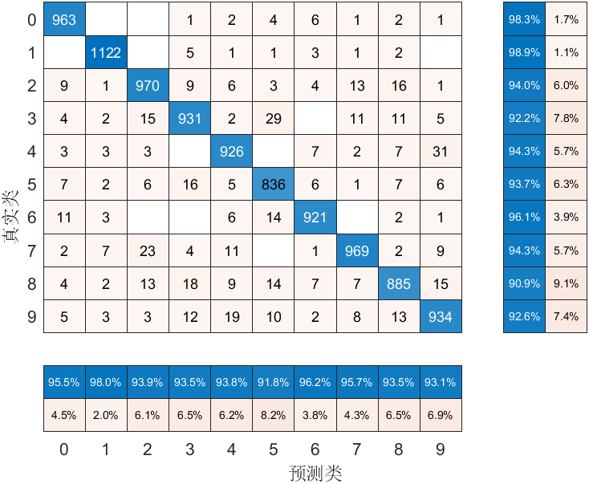
B=50 | 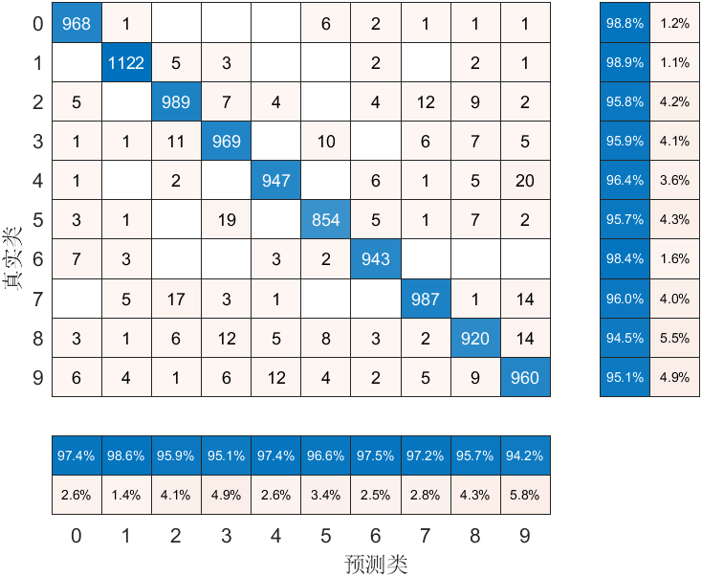
B=100 | 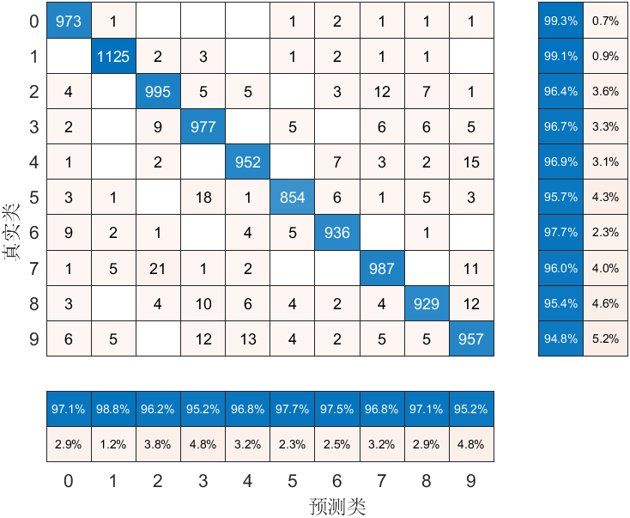

Preprocess Method: Image Binarization+HOG
B=10 | 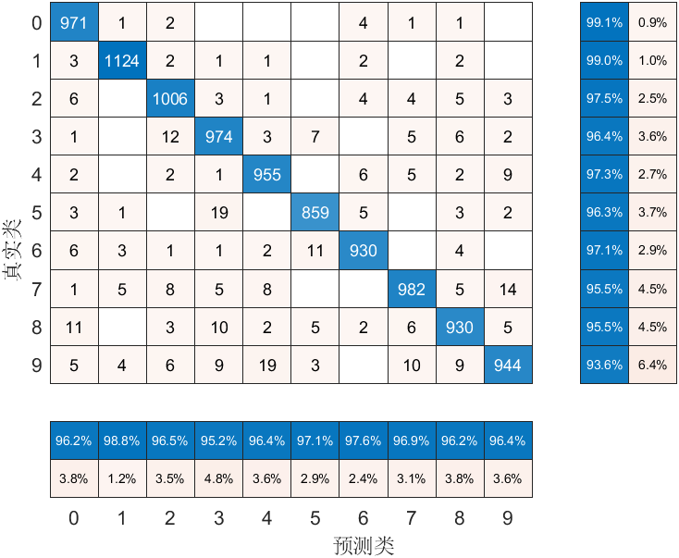
B=50 | 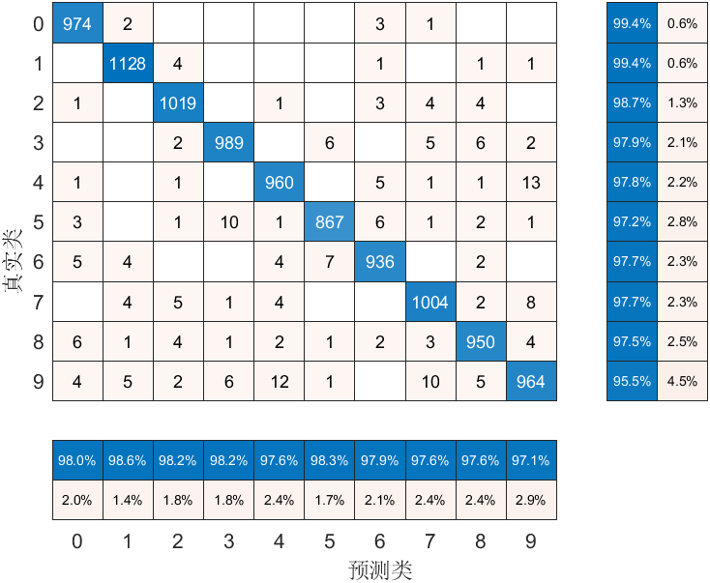
B=100 | 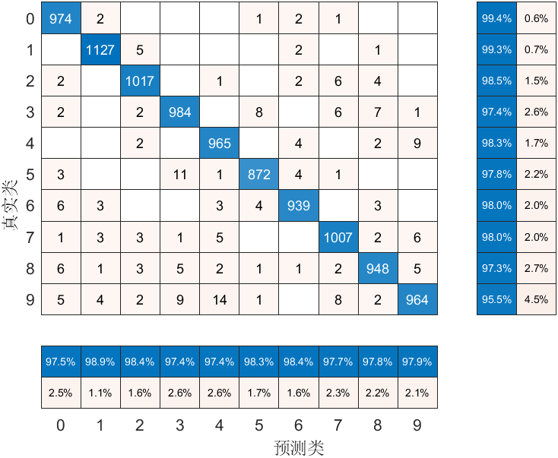
From the Confusion Matrix, we can easily calculate accuracy:

Bag Preprocess | Image Binarization | Image Binarization + HOG
B=10 | 94.70% | 96.52%
B=50 | 96.59% | 97.91%
B=100 | 95.85% | 97.97%
From the above results, increasing the number of bags is helpful for the accuracy improvement, but the magnitude of the help decreases as the number of bags increases. the addition of HOG feature extraction method can further improve the accuracy.

  - Support-vector machine (SVM)
The support vector machine algorithm's purpose is to find a hyperplane in an N-dimensional space (N is the number of features) that classifies the data points differently.
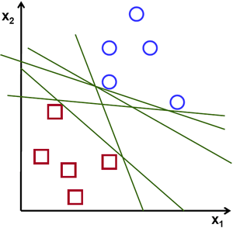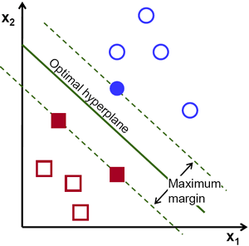
There are several potential hyperplanes for separating the two groups of data points. Our goal is to discover a plane with the greatest margin, that is, the largest gap between data points from both classes. Maximizing the marginal separation reinforces the classification of subsequent data points.
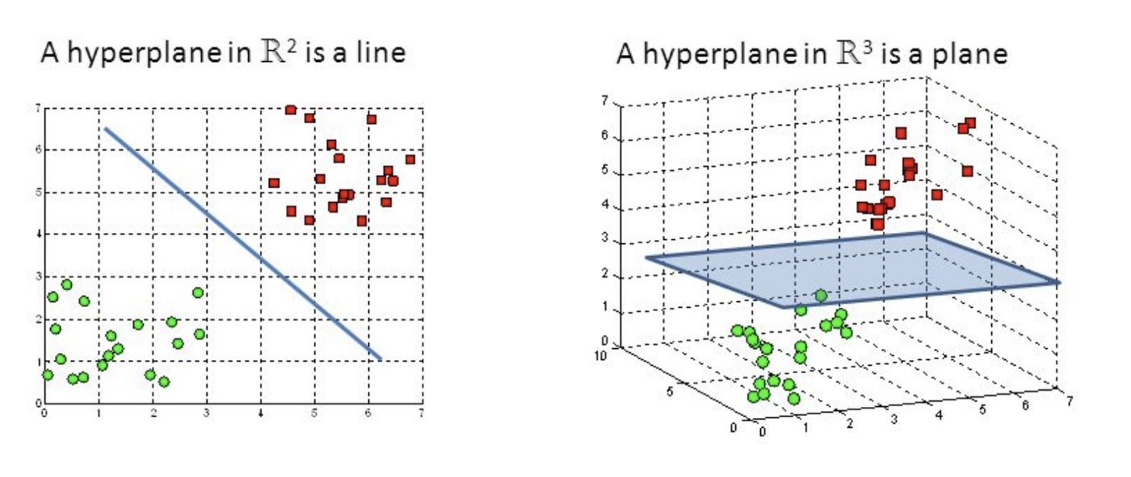
Hyperplanes are classification boundaries that aid in the classification of data points. The data points on each side of the hyperplane are either classified differently. Additionally, the hyperplane's size is related to the number of features. If there are just two input characteristics, the hyperplane is simply a line. When the number of input characteristics is increased to three, the hyperplane transforms into a two-dimensional plane.
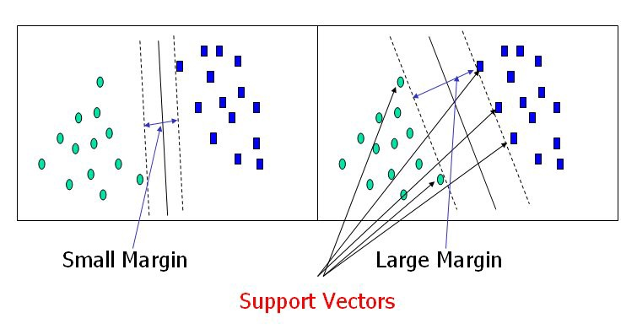
Support vectors are reference points that are closer to the hyperplane and have an effect on the hyperplane's location and orientation. SVM maximize the classifier's margin by using these support vectors. By deleting the support vectors, the hyperplane's location will be altered. These are the aspects that contribute to the development of SVM.
In Linear-SVM, what has to be done is to discover the OPTIMAL HYPERPLANE that results in the greatest distance between the support hyperplanes. This technique is referred to as the Maximum Margin Hyperplane. The Margin is the distance between the support hyperplanes.
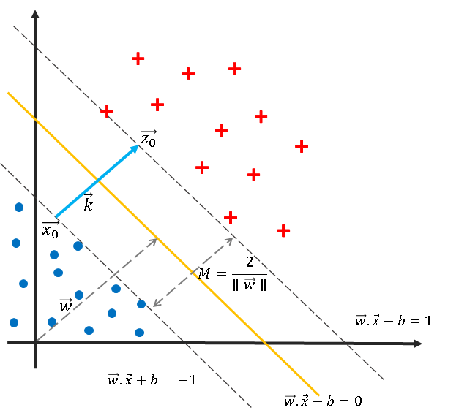
According to the above diagram and the calculation of the vector, we can find that (given the OPTIMAL HYPERPLANE ($w.x+b=0$)), the Margin is equal to:
$$M=\frac{2}{\left\|\vec{w}\right\|}$$
Therefore, the Maximum Margin M:
$$\max\left(M\right)=min⁡(\frac{\left\|\vec{w}\right\|}{2})$$
This, meanwhile, imposes the restriction that the points in a class cannot be contained inside the two support hyperplanes. This may be expressed numerically as:
$$y_{i}\left(\vec{w}∙{\vec{x}}_{i}+b\right)≥1,∀Points i=1,…,to…,n$$
Apply the Lagrangian multipliers, we can create the Loss function:
$$L\left(\vec{w},b,a\right)=\frac{{\vec{w}}^{2}}{2}-\sum_{i=1}^{n}{α_{i}∙\left[y_{i}\left(\vec{w}∙{\vec{x}}_{i}+b\right)-1\right] ,α_{i}≥0}$$
To find the optima, we take the first-order derivative and equate it to 0:
$$\frac{∂L}{∂w}=0$$
$$∴w=\sum_{i=1}^{n}{α_{i}∙y_{i}∙x_{i}}$$
After resubstituting the value of w in the above equation, we can get:
$$W=\sum_{i=1}^{n}{α_{i}-\frac{1}{2}\sum_{i=1}^{n}{\sum_{j=1}^{n}{α_{i}α_{j}y_{i}y_{j}(x_{i}∙x_{j})}}}$$
This is referred to as the DUAL FORMULATION due to the modification of the original Objective function. While the initial equation was reduced, the final equation must maximize W. Due to the fact that W is a quadratic equation, it is a Quadratic Programming (QP) issue that can be solved using the Sequential Minimal Optimization procedure (SMO).
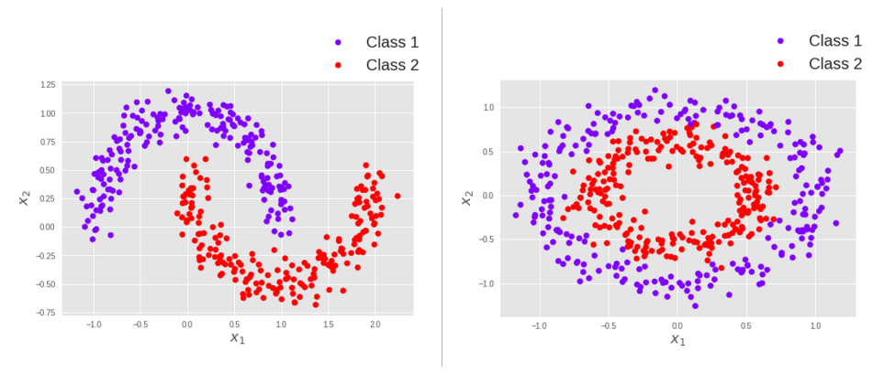
As for non-Linear classification problem, SVM firstly has to map the original input space (X) to some higher dimensional feature space (φ(X)) where the training set is separable. Therefore, the new line equation would be:
$$w∙φ\left(x\right)+b=0$$
However, because to the great dimensionality, it may result in a large computational load and make it difficult to provide a reliable approximation. SVMs make use of a kernel approach to do computations efficiently:
$$K\left(x_{i},x_{j}\right)={φ\left(x_{i}\right)}^{T}φ\left(x_{j}\right)$$
In certain feature space, a kernel function is a function that is identical to an inner product. Thus, a kernel function automatically transfers data to a high-dimensional space, eliminating the need to calculate each dimension individually φ(x).
With kernel function, the DUAL FORMULATION is modified as:
$$W=\sum_{i=1}^{n}{α_{i}-\frac{1}{2}\sum_{i=1}^{n}{\sum_{j=1}^{n}{α_{i}α_{j}y_{i}y_{j}K(x_{i},x_{j})}}}$$
Although the SVM is fundamentally a binary classifier, there are a few techniques to get around this:
Extend to output arity N, learn N SVM’s
- SVM 1 learns “Output equals 1” and “Output does not equal 1”
- SVM 2 learns “Output equals 2” and “Output does not equal 2”
- :
- SVM N learns “Output equals N” and “Output does not equal N”
Here are a few generally accepted advantages and disadvantages of SVM:
advantages | disadvantages
- Training is quite straightforward.  - SVM is not afflicted by the "curse of dimension".  - Reduced susceptibility to overfitting.  - There are no huge networks to tamper with. | - Training is gradual in comparison to other forms of learning.  - In a nutshell, SVM is a binary classifier.  - Extremely susceptible to noise.  - There is no "set-in-stone" theory for selecting a kernel function for each situation, which makes the task of selecting a kernel function rather challenging.

MATLAB provides not only simple methods to accomplish the SVM task for binary classification, but also provides the SVM function fitcecoc() for multi-classification. Here are the results:
Preprocess Method: Image Binarization
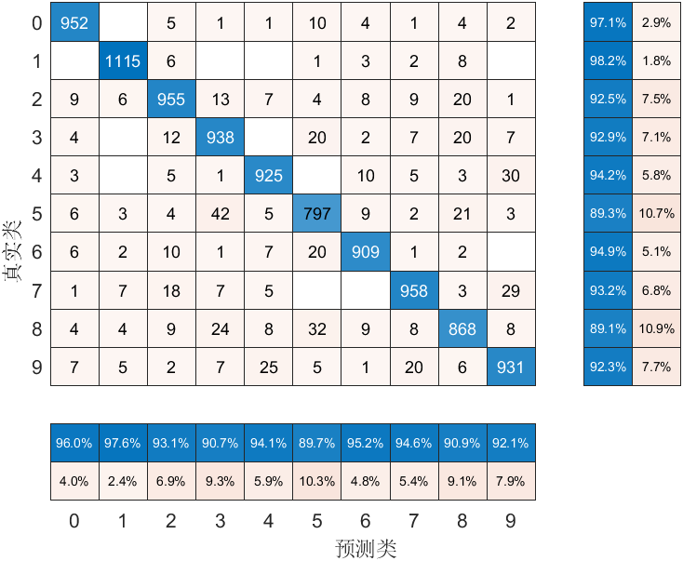
Preprocess Method: Image Binarization + HOG
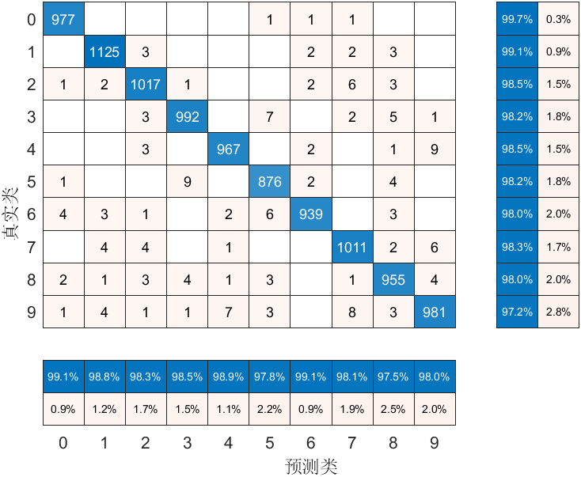
From the Confusion Matrix, we can calculate accuracy:
Algorithm Preprocess | Image Binarization | Image Binarization + HOG
SVM | 93.48% | 98.40%
I did not select the kernel in the SVM and did not adjust the hyperparameters, the default results are already very good. After using HOG feature extraction, the accuracy reached 98%, which is the best result among all the algorithms tested so far. However, the training time of SVM is significantly longer than the other algorithms during training.

