

BA International Hotel Management

Entrepreneurship (BMIH5001)

Assignment 1- Essay of a Individual Business Model Canvas with entrepreneurial reflection using appropriate academic models.

By Nasima Akter
Student ID: 2210268
Lecturer: Ka Po Chong (Ben)
Word Count: 2103
(Part 1 = 1587 words + Part 2 = 516 words)

In this first part of the essay the Business Model Canvas (BMC) visualises, defines, and assesses company concepts which help to ensure the effectiveness of the entrepreneurship process (Burns, 2022). To design and assess their business model, the BMC helps entrepreneurs establish client groups, value propositions, channels, customer interactions, income streams, important resources, activities, partnerships, and cost structure. Giving stakeholders a holistic view of the business, stimulating strategic thinking, recognising challenges, and explaining the business model helps decision-making and sustainable growth. SoulSculpt Spa is the name of the hospitality venture which will offer several services. At the spa, enjoy Swedish, deep tissue, and hot stone massages. Body wraps and washes rejuvenate skin, while tailored facials treat concerns (Barringer and Ireland, 2018). Hydrotherapy and spa baths at SoulSculpt Spa promote wellness. Pedicures, manicures, and nail art pamper. Saunas and steam tubs increase relaxation. Skincare professionals consult and treat spa guests. SoulSculpt Spa offers mind-body-soul health via yoga and meditation. SoulSculpt Spa offers different therapies for relaxation and wellness.
Local vendors and eco-friendly manufacturers supply SoulSculpt Spa's sustainability. To meet the demand for eco-friendly therapies, the spa works with a local organic skincare company. Example: "Green Glow Organics," a local sustainable cosmetics business (Choudhary and Qadir, 2021). This partnership boosts the local economy and SoulSculpt Spa's sustainability. Strategic collaborations with adjacent hotels and restaurants boost the spa's market position. Special spa packages with accommodation or dining boost client value. Collaborations like "Harmony Haven Spa" with a local hotel improve customer experience and audience reach.
SoulSculpt Spa provides excellent spa and health services. Partnering with "Zen Mastery Institute." emphasises staff training. This collaboration gives spa therapists the newest techniques and industry knowledge, improving services (Blackwell, 2011). Wellness experts improve spa offerings. This vital discipline includes trained yoga instructors teaching regular lessons. This diversifies products and provides holistic well-being expertise, attracting customers seeking a whole experience. SoulSculpt Spa must follow industry trends to be relevant. Global wellness conference "International Spa & Wellness Summit," consider attending (Yalcin, 2022). The spa pioneers sustainable and digital wellness to boost client happiness and competitiveness.
SoulSculpt Spa needs essentials for service and sustainability. Expert therapists, aestheticians, and wellness professionals make the spa great. Partners with the "Wellness Academy" provide a steady flow of qualified professionals, increasing the spa's workforce and maintaining top-notch services. Strategic local vendor partnerships boost spa resources (Williams, 2021). Working with local organic cosmetics and eco-friendly Materials Company "Eco Harmony Suppliers" showcases this resource. Sustainable materials help SoulSculpt Spa surpass consumer quality and environmental responsibility requirements. The spa's value proposition and hospitality market advantage are enhanced by ethical sourcing agreements.
SoulSculpt Spa offers unique holistic health benefits. Traditional spa services are enhanced with holistic therapies and customised consultations. Massage aromatherapy improves health. Unlike other spas, SoulSculpt Spa treats mind, body, and spirit. This unique value offer meets consumer needs for comprehensive well-being solutions (Mariotti and Glackin, 2012). After incorporating holistic concepts, "Harmony Haven Wellness Centre," a comparable company, garnered client loyalty and great ratings. SoulSculpt Spa meets the growing need for holistic well-being with its revolutionary wellness approach.
SoulSculpt Spa targets diverse wellness enthusiasts. Spa guests enjoy skincare, spa therapy, and wellness. This client segmentation strategy is presented using "Wellness Explorers Club," a local wellness group. SoulSculpt Spa attracts traditional and holistic spa guests from this locality (Pruñonosa et al., 2022). These methods worked for "Tranquil Bliss Spa," which targeted varied clients. Tranquil Bliss Spa increased visitors and ratings with skincare, massage, and holistic wellness packages. SoulSculpt Spa's diversified customer base supports its hospitality industry performance by catering to wellness interests.
SoulSculpt Spa uses many methods to attract customers. With "Book Well" and Instagram and Facebook, this method establishes a strong presence. The spa gains online prominence by partnering with a local health and lifestyle blogger. Spa "Zen Living Wellness," which used wellness bloggers to increase client inquiries and bookings, supported this cooperation (Michopoulou and Hilton, 2021). Multi-channel services meet modern consumer demands for accessibility and convenience. It also promotes SoulSculpt Spa's unique value proposition and services. Similar companies have grown brand awareness and customer loyalty by using digital marketing and consumer engagement tools.
Guest relations are important at SoulSculpt Spa. Company-specific wellness advisors demonstrate customisation. Customers get customised services with a hands-on approach. SoulSculpt Spa was inspired by "Harmony Retreat Spa," which encourages one-on-one encounters to establish relationships. Post-service questionnaires and online reviews show the spa's customer focus (Thorne, 2021). Adapting massage techniques to consumer feedback produces responsive service. Inspired by landmark spas like "Tranquil Serenity Spa," a reward programme promotes customer retention. SoulSculpt Spa distinguishes apart in the hotel market since it personalises services per industry trends.
SoulSculpt Spa carefully manages costs for a high-quality, sustainable experience. Staff compensation is important to retain experienced therapists and wellness professionals. Inspired by "Serene Sanctuary Spa," SoulSculpt Spa priced itself on employee happiness to retain top talent through competitive compensation (Buxton and Michopoulou, 2021). Wellness schools like "Holistic Mastery Institute," offer spa workers industry upgrades. Training is costly but improves service and satisfaction. Local "Pure Harmony Organics," organic skincare, costs more. Sustainability satisfies social ethical business standards despite higher expenses. These actions show SoulSculpt Spa's long-term vision and socially responsible hospitality brand responsiveness to consumer values.
For financial stability and growth, SoulSculpt Spa diversifies revenue. The main revenue source is spa treatment fees, especially luxury packages. The spa sells personalised cosmetics and health products to boost revenue. Local eco-boutique "EcoEssence Boutique," is a significant partner (Aluculesei et al., 2021). This partnership increases product possibilities for sustainability and wellness-focused customers. SoulSculpt Spa offers boutique packages with local businesses like "Tranquil Escape Spa" with a gym. Collaboration increases revenue, pleasure, and acquisition. This revenue diversity gives SoulSculpt Spa financial resilience and development possibilities in a competitive hotel industry.
Deep hospitality industry understanding, and client trends inspired SoulSculpt Spa. Critical investigation reveals the aspects that may boost spa concept success. Global wellness inspired SoulSculpt Spa. The spa offers holistic and traditional spa therapies to rejuvenate the mind and body (Permatasari, Purwanto and Triyono, 2023). Holistic well-being alternatives outside spas are in demand, according to research. Present industrial examples support this choice. Wellness getaways like "Tranquil Zen Haven," boost client happiness and retention. SoulSculpt Spa may offer a rising market segment seeking deeper wellness experiences by following this industry trend. Second, sustainability informs spa design. SoulSculpt Spa works with local organic skincare and eco-friendly material providers to represent the growing eco-consciousness and ethical business. This meets consumer demand for eco-friendly corporate practices.
Industry successes like "Green Harmony Spa" show how sustainability influences consumer choices. Local sourcing and eco-friendly products have earned Green Harmony Spa positive client ratings and solidified its environmental credentials (Saveleva et al., 2020). By replicating this devotion, SoulSculpt Spa hopes to meet consumer expectations and encourage hospitality sector best practices. Third, the strategy's emphasis on personalised client interactions mirrors the hotel industry's tailored experiences. SoulSculpt Spa provides personalised treatment with wellness advisors and feedback tools. Tailoring services boost client satisfaction and loyalty, according to Frost, Ooi and Dijk (2021). The popular "Harmony Retreat Wellness Centre," personalises consumer interactions. Harmony Retreat sends wellness specialists for personalised service and connection. SoulSculpt Spa addresses consumer needs for tailored health and hospitality.
Digital changes impact multi-channel consumer outreach and engagement. SoulSculpt Spa uses online booking, social media, and wellness influencer collaborations to leverage internet platforms. This ruling recognises that consumers increasingly use the internet for information, bookings, and suggestions (Patterson and Balderas-Cejudo, 2022). Industry examples prove this method works. For "Digital Serenity Spa," influencers and internet marketing helped. Strategic internet marketing increased Digital Serenity Spa's popularity. SoulSculpt Spa increases its internet presence and reach with multi-channel marketing.
Financial stability and growth potential justify broadening income streams to include service fees, product sales, and local business packages. This decision shows that the competitive hospitality industry requires a flexible company strategy (Similarweb.com, 2022). Successful examples include "Tranquil Escape Spa," which sold products and built local ties. Multiple revenue streams helped Tranquil Escape Spa grow. SoulSculpt Spa diversifies to weather market volatility and expands beyond service payments. Last, SoulSculpt Spa drivers understand hospitality market dynamics. Spas adapts and innovates by aligning with global trends like holistic health, sustainability, tailored client interactions, and digital engagement. Industry precedents and sources support SoulSculpt Spa's effectiveness in satisfying changing consumer needs in the dynamic hotel market.
In conclusion, SoulSculpt Spa fulfils wellness fans' changing requirements with holistic hospitality. Customised facials and Swedish and hot stone massages are available at the spa. Hydrotherapy and spa baths relax, while wraps and washes give velvety skin (Williams, 2021). A deep understanding of industry dynamics informed SoulSculpt Spa, according to the BMC. Spas offering holistic treatments reflect the global movement towards transformative wellness. Similar companies, including "Tranquil Zen Haven," show a growing need for wellness items beyond relaxation.
Sustainable partnerships with local organic skincare producers demonstrate the increased focus on eco-friendly approaches. Inspired by "Green Harmony Spa," SoulSculpt Spa promotes sustainability and social responsibility. Engaging customers with online booking platforms and local influencers show awareness. In the digital age of hospitality, "Digital Serenity Spa" shows how this method can boost visibility and client engagement (Thorne, 2021). Specialised wellness consultants and feedback channels help customise the industry. This strategy was inspired by "Harmony Retreat Wellness Centre," which has strong client relationships due to customised services. A pragmatic approach to financial stability and growth involves diversifying revenue streams from service fees to product sales and local business alliances. Like "Tranquil Escape Spa," the plan ensures stability and growth through many revenue sources.

My reflective part of the essay is based on my business and managerial goals, I evaluate my questionnaire and GET2 Test results using the Gibbs Reflective Cycle (Taylor, 2020). This reflection reveals my goals, choices, and entrepreneurial potential. The entrepreneurship questionnaire shows my score as 43. The score suggests entrepreneurship. GET2 Test results show high need for accomplishment (83%), measured risk-taking (75%), and internal locus of control (67%). An entrepreneurial personality encourages drive, measured risk-taking, and outcome control. This holistic assessment demonstrates proactive and resilient problem-solving and a desire to seize entrepreneurial possibilities.
My high entrepreneurship questionnaire and GET2 Test results boost my entrepreneurial confidence. My need for achievement, disciplined risk-taking, and internal control gives me the confidence to undertake challenging tasks (Murnieks, Klotz and Shepherd, 2019). I am confident because I want to achieve great goals, take reasonable risks, and take responsibility for results. I can overcome obstacles, make strategic decisions, and start my firm because this emotional response boosts my entrepreneurial confidence.
My questionnaire answers imply entrepreneurship. Choices are entrepreneurial. Performance and calculated risk-taking are stressed in critical evaluations. Entrepreneurs must accept uncertainty, but conservatism lowers risks (Cunha, Kastenholz and Carneiro, 2020). The appropriate balance is needed to avoid extreme conservatism that hinders entrepreneurship. This review promotes risk management and an ambitious plan that considers potential concerns.
GET2 Test results show a smart, risk-taking entrepreneur. Considerable accomplishment demand (83%) indicates a strong drive for success, but cautious risk-taking (75%) indicates a willingness to handle uncertainty. The moderate creative disposition (58%) balances uniqueness and practicality (Kulikowski, Przytuła and Sułkowski, 2021). This detailed investigation shows my entrepreneurial ambition, risk management, and pragmatic ingenuity. Recognising these traits helps me understand my entrepreneurial impulses and make strategic decisions in a changing workplace.
Introspective study suggests a strong entrepreneurial inclination fuelled by success and prudent risk-taking. Being proactive and problem-solving promotes entrepreneurship. The questionnaire's caution was important. Risk-taking and prudent decision-making must coexist. Entrepreneurs must strategically handle risks (Porfírio, Felício and Carrilho, 2019). This conclusion recognises strengths and suggests areas for careful consideration in the quest for entrepreneurial success, establishing the framework for a sensible and well-informed entrepreneurial path.
A concentrated action plan is needed to maximise my entrepreneurial potential. Creative development boosts innovation and gives entrepreneurs an edge. A balanced risk-taking mind-set is necessary (Taylor, 2020). Careful risks can lead to progress and new opportunities. Entrepreneurship that matches my internal control and high achievement needs is more gratifying. This action plan balances innovation and risk with strategic entrepreneurship. I want to create a purposeful, successful entrepreneurial route with innovation, savvy risk-taking, and a great sense of achievement.
As illustrated in this reflection, entrepreneurship is complicated. Entrepreneurs are ambitious but must balance risk-taking and innovation with reality. My enterprise will reflect my talents and caution. Continuous learning and experience will improve my entrepreneurial and decision-making skills (Permatasari, Purwanto and Triyono, 2023). The reflective analysis shows entrepreneurial potential, high achievement needs, measured risk-taking, and internal locus of control. Understanding the complexity revealed by this reflection allows sensible entrepreneurial efforts, ensuring a balanced and successful journey in the changing corporate environment.

References
Aluculesei, A.-C., Nistoreanu, P., Avram, D. and Nistoreanu, B.G. (2021). Past and Future Trends in Medical Spas: A Co-Word Analysis. Sustainability, 13(17), p.9646. doi:https://doi.org/10.3390/su13179646 [Accessed 1 Feb. 2024].

Barringer, B.R. and Ireland, R.D. (2018). Entrepreneurship: Successfully Launching New Ventures. 4th ed. New York, Ny: Pearson.

Blackwell, E. (2011). How to Prepare a Business Plan. Kogan Page Publishers.

Burns, P. (2022). Entrepreneurship and Small Business: start-up, Growth and Maturity. 5th ed. Basingstoke (Gb): Palgrave Macmillan Education, Cop.

Buxton, L. and Michopoulou, E. (2021). Value Co-Creation and Co-Destruction: Considerations of Spa Servicescapes. Tourism Planning & Development, 18(2), pp.210–225. doi:https://doi.org/10.1080/21568316.2021.1873837 [Accessed 1 Feb. 2024].

Choudhary, B. and Qadir, A. (2021). Impact of COVID-19 on wellness and spa industry. International Journal of Spa and Wellness, pp.1–11. doi:https://doi.org/10.1080/24721735.2021.1986970 [Accessed 30 Jan. 2024].

Cunha, C., Kastenholz, E. and Carneiro, M.J. (2020). Entrepreneurs in rural tourism: Do lifestyle motivations contribute to management practices that enhance sustainable entrepreneurial ecosystems? Journal of Hospitality and Tourism Management, 44, pp.215–226. doi:https://doi.org/10.1016/j.jhtm.2020.06.007 [Accessed 31 Jan. 2024].

Frost, J.H., Ooi, N. and Dijk, P.A. (2021). ‘Is he going to be sleazy?’ Women’s experiences of emotional labour connected to sexual harassment in the spa tourism industry. Journal of Sustainable Tourism, pp.1–20. doi:https://doi.org/10.1080/09669582.2021.1942892 [Accessed 1 Feb. 2024].

Kulikowski, K., Przytuła, S. and Sułkowski, Ł. (2021). E‐learning? Never again! On the unintended consequences of COVID‐19 forced e‐learning on academic teacher motivational job characteristics. Higher Education Quarterly, 76(1). doi:https://doi.org/10.1111/hequ.12314 [Accessed 30 Jan. 2024].

Mariotti, S. and Glackin, C. (2012). Entrepreneurship: Starting and Operating a Small Business + Business Plan Pro. 3rd ed. Prentice Hall.

Michopoulou, E. and Hilton, S.J. (2021). Accessibility to Spa Experiences. [online] www.igi-global.com. Available at: https://www.igi-global.com/chapter/accessibility-to-spa-experiences/271072 [Accessed 1 Feb. 2024].

Murnieks, C.Y., Klotz, A.C. and Shepherd, D.A. (2019). Entrepreneurial Motivation: A Review of the Literature and Agenda for Future Research. Journal of Organizational Behavior, 41(2). doi:https://doi.org/10.1002/job.2374 [Accessed 30 Jan.. 2024].

Patterson, I. and Balderas-Cejudo, A. (2022). Baby boomers and their growing interest in spa and wellness tourism. International Journal of Spa and Wellness, pp.1–13. doi:https://doi.org/10.1080/24721735.2022.2107801 [Accessed 1 Feb. 2024].

Permatasari, H., Purwanto, E. and Triyono (2023). ANALYSIS OF THE ROLE OF RESERVATION SYSTEMS IN IMPROVING CUSTOMER EXPERIENCE IN THE SALON AND SPA INDUSTRY: LITERATURE REVIEW. Proceeding of International Conference on Science, Health, And Technology, [online] 4(1), pp.220–228. doi:https://doi.org/10.47701/icohetech.v4i1.3395 [Accessed 29 Jan. 2024].

Porfírio, J.A., Felício, J.A. and Carrilho, T. (2019). Family business succession: Analysis of the drivers of success based on entrepreneurship theory. Journal of Business Research, 115, pp.250–257. doi:https://doi.org/10.1016/j.jbusres.2019.11.054 [Accessed 1 Feb. 2024].

Pruñonosa, J., Raya, J.M., Crespo-Sogas, P. and Mur-Gimeno, E. (2022). The economic and social value of spa tourism: The case of balneotherapy in Maresme, Spain. PLOS ONE, 17(1), p.e0262428. doi:https://doi.org/10.1371/journal.pone.0262428 [Accessed 30 Jan. 2024].

Saveleva, N., Yudina, T., Kovalenkova, O., Verbin, U. and Rokotyanskaya, V. (2020). Supply Chain Management in Competitive Structure of Sochi Health Resort and Spa Industry: Strategic Groups Analysis. International Journal of Supply Chain Management IJSCM, [online] 9(1), pp.2051–3771. Available at: https://core.ac.uk/download/pdf/288291243.pdf [Accessed 1 Feb. 2024].

Similarweb.com (2022). Spa Business in the UK. [online] Available at: https://www.similarweb.com/website/ukspa.org.uk/vs/ebn.eu/ [Accessed 31 Jan. 2024].

Taylor, B.J. (2020). Reflective practice. 3rd ed. Maidenhead: Open University Press.

Thorne, S. (2021). Are spas and wellness still considered luxurious in today’s world? Research in Hospitality Management, [online] 11(1), pp.9–149–14. Available at: https://www.ajol.info/index.php/rhm/article/view/209539 [Accessed 1 Feb. 2024].

Williams, S. (2021). The financial times guide to business start up 2010 [the only annually updated guide for entrepreneurs]. 32nd ed. Harlow Ft.

Yalcin, B. (2022). Worldwide trends in online searches for the term SPA. Studia Periegetica, 37(1), pp.151–166. doi:https://doi.org/10.5604/01.3001.0015.9048 [Accessed 30 Jan. 2024].

Appendix
Business Model Canvas
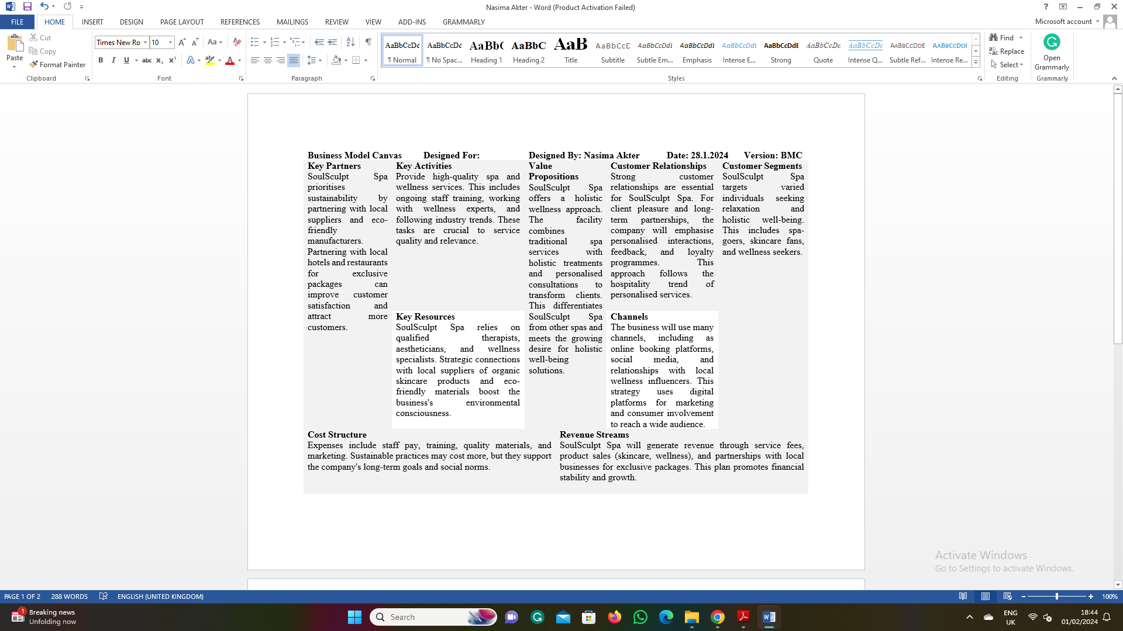
GET2 Test Result
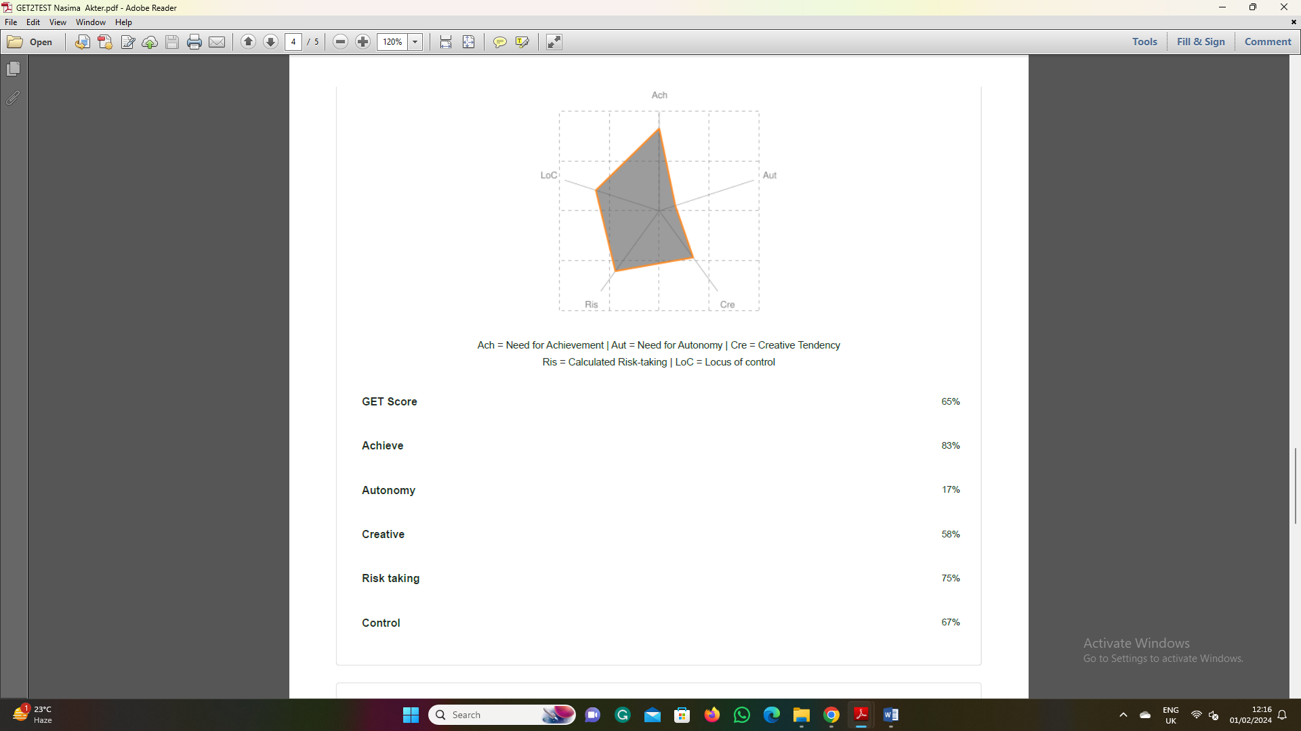
Entrepreneur questionnaire


