
BA (Hons) Leadership and Management Skills
in the Workplace
Reconstruction of local infrastructures that have been damaged in West Midlands (Worcester Shrewsbury and Kidderminster)

Module name: Project management
Module code: LCLM5003
Lecture name: Xavier Mateine
Student name: Rahmia Sulay Kamil
Student ID: 2335591

Part A-Project Proposal Poster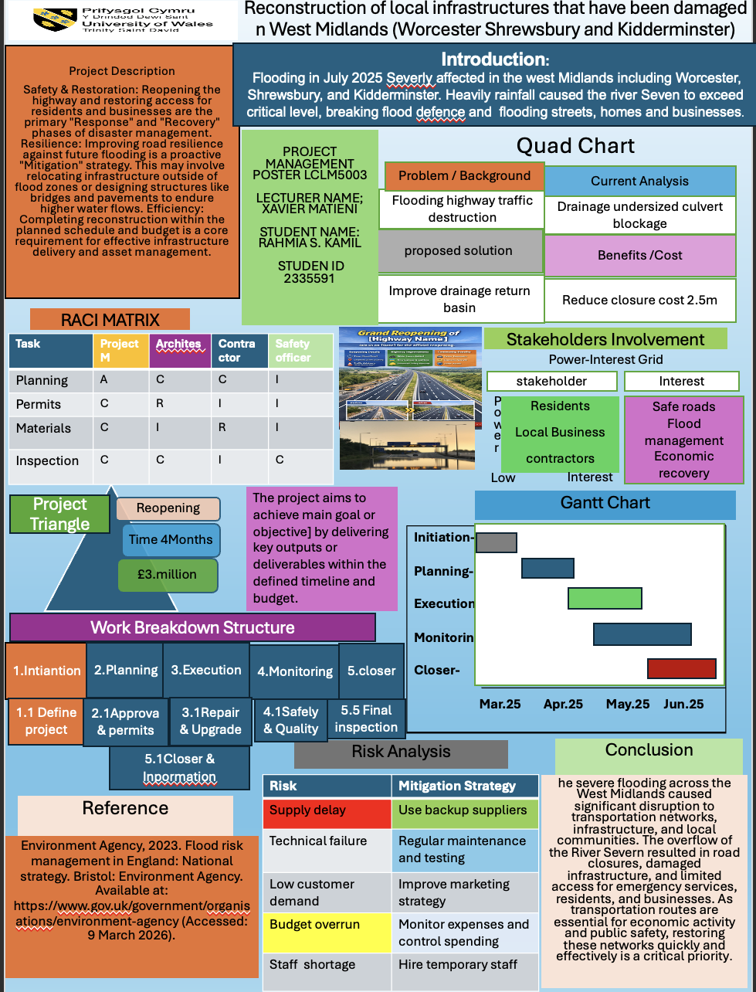

Introduction
The increasing intensity of climate-related events has exposed significant vulnerabilities within the United Kingdom’s infrastructure systems, particularly in regions prone to flooding. In July 2025, the West Midlands faced a major environmental crisis as prolonged rainfall led to extensive flooding across key urban and rural areas. The rapid overflow of the River Severn resulted in severe damage to transport networks, utilities, and public infrastructure, leaving communities such as Worcester, Shrewsbury, and Kidderminster heavily disrupted. Transport infrastructure plays a critical role in maintaining economic stability and enabling emergency response; therefore, its failure can have far-reaching consequences. The A44 corridor, a vital regional route, was among the assets significantly affected, with sections rendered unsafe or unusable. The closure of this route not only restricted mobility but also delayed recovery efforts and increased pressure on alternative transport links. In response to these challenges, this project proposes a structured and strategic approach to restoring the A44 corridor through the application of formal project management principles. The plan focuses on delivering a time-bound recovery programme that integrates risk management, stakeholder coordination, and resource optimisation. Additionally, the project emphasises the incorporation of flood-resilient design measures to reduce vulnerability to future events. This report outlines the development of the project management plan, including the definition of scope, scheduling through a Gantt chart, task structuring via a Work Breakdown Structure, and identification of key stakeholders. Through this approach, the project aims to ensure not only the efficient restoration of the transport corridor but also the long-term sustainability and resilience of the infrastructure.

PART B – REFLECTION
Reflection on Feedback and Improvements

Feeling Emotional
During my creating my project proposal poster, I experienced a range of stressed and emotions that developed throughout the process. At the beginning, I felt uncertain and slightly overwhelmed, as I was not completely confident about how to present my ideas clearly and professionally. The task required me to summarise complex project management concepts into a visually appealing format, which I initially found challenging. There were also moments of frustration, particularly when trying to balance the amount of information included without overcrowding the poster. I found it difficult to decide what to keep and what to remove, as I wanted to ensure that all important aspects were covered while still maintaining clarity and simplicity. But I’m very happy when I receive for my lecture, I’m Pass for my poster Presentation

Evaluation
Overall, this evaluation has helped me understand both my strengths and areas for development, and it will guide me in producing a higher-quality final project management plan, and however, there were some weaknesses in my work, to improve in the future, I will focus on planning my poster more effectively before starting the design. I will also ensure that all key project management tools are fully developed and clearly presented. Furthermore, I will pay more attention to visual design by using diagrams and ensuring a balanced layout. Finally, I will manage my time more efficiently to allow for reviewing and improving my work before submission.

Analysis
This experience during the development of the poster, I also analysed how to present information effectively. I had to decide which content was essential and how to organise it in a logical structure. This involved breaking down the project into key components such as scope, timeline, and stakeholders. Through this, I developed a better understanding of tools like the work breakdown structure and Gantt chart, although I recognised that my application of these tools needed further improvement and communication skill and practising and more performed better than in the future, however, as I worked through the process, I became more confident in organising and presenting my ideas.

Conclusion
Overall, creating my poster was a valuable experience that helped me grow both emotionally and academically. I moved from feeling unsure at the beginning to becoming more confident in my work. By evaluating my poster, I was able to understand my strengths, such as clear ideas, and identify areas that need improvement, like detail and design. Through analysis, I learned how to apply project management concepts and present information more effectively. This experience has helped me improve my skills and will support me in producing a better final project.

Action plan
In the future I will start my work earlier to manage many times better and avoid rushing. I will practise using tools like Excel in power point to improve my technical skills for presentation I will rehearse regularly on focus understanding the content instead of memorising it I will also practice speaking clearly and confidently, passively in front of friends or classmate. Additionally, I will attend classes regularly to avoid missing important information and insure complete all required elements in my work.

References
1.⁠ ⁠Project Management Institute. (2021). A Guide to the Project Management Body of Knowledge (PMBOK®️ Guide) – 7th Edition. PMI.
2. AXELOS. (2023). PRINCE2®️ 7 Managing Successful Projects. PeopleSoft AXELOS.
3. Kerzner, H. (2022). Project Management: A Systems Approach to Planning, Scheduling, and Controlling (13th ed.). Wiley.
4. International Organization for Standardization. (2020). ISO 21502:2020 Project, programme and portfolio management — Guidance on project management. ISO.
5. Harvard Business Review. (2022–2025). Articles on project management, leadership, and effective team communication. Harvard Business Publishing.
6. McKinsey & Company. (2023–2025). Insights on project delivery, performance improvement, and organisational effectiveness. McKinsey Global Institute.
7. Association for Project Management (APM). (2023–2025). APM Body of Knowledge and project management guidance updates. APM.
8. Schwalbe, K. (2022). Information Technology Project Management (10th ed.). Cengage Learning.

Table of content

Introduction………………………………………………………………………………….1
Project description………………………………………………………………………….2
Scope……………………………………………………………………………………………3
Work breakdown structure……………………………………………………………….4
Quad Chart…………………………………………………………………………………….5
Gant Chart………………………………………………………………………………………6
Stakeholder involvement………………………………………………………………….7
Allocation of resources…………………………………………………………………….8
Risk Analysis…………………………………………………………………………………...9
Conclusion…………………………………………………………………………………….10
References……………………………………………………………………………………...11

Part C: Project Management Plan
1.Introduction
Project management is a structured approach used to plan, execute, monitor, and successfully complete projects within defined constraints such as scope, time, cost, and quality. This project management plan outlines the strategy, processes, and tools that will be used to deliver a Smart Campus Mobile Application designed to enhance student and staff experience within a university environment. The plan follows established project management methodologies, incorporating elements from both predictive (Waterfall) and adaptive (Agile) approaches. A hybrid approach is adopted due to the need for structured planning alongside flexibility in software development. The purpose of this document is to provide stakeholders with a clear understanding of how the project will be managed, including its scope, deliverables, timelines, resource allocation, and stakeholder engagement strategies.

2. Project Description
The key objectives of the project are:
•⁠ To implement a fully functional CRM system within 6 months
•⁠ To centralise customer data for improved accessibility and decision-making
•⁠ To increase customer retention by 20% within the first year
•⁠ To streamline internal processes and reduce manual workload
•⁠ To ensure system adoption across all departments
3.⁠ ⁠Project Scope Management
3.1 In-Scope
•⁠ CRM software selection and procurement
•⁠ system configuration and customisation
•⁠ Data migration from legacy systems
•⁠ User training and onboarding
•⁠ Testing and deployment

3.2 Out-of-Scope
•⁠ Development of unrelated IT systems
•⁠ Long-term system maintenance beyond initial support phase
•⁠ Major organisational restructuring

3. Scope
Project Scope Overview
This project focuses on the design and development of an IoT-based smart waste management system that enables real-time monitoring of waste levels in bins. The system aims to improve waste collection efficiency by providing accurate data and reducing unnecessary collection trips.
In Scope
The following elements are not included in this project:
- Large-scale deployment across cities or regions
- Integration with government or municipal systems
- Advanced artificial intelligence or predictive analytics
- Automated waste segregation or recycling systems
- Mobile application development for end users
- Long-term maintenance and operational management
Project Boundaries
- The system will be tested only on a prototype or small-scale setup
- Data handling will be limited to basic monitoring functions
- The project will be completed within a fixed timeline and budget

4.Work Breakdown Structure (WBS)
hierarchical way of breaking down a project into smaller, manageable components. It helps organize work so that every task needed to complete the project is clearly
defined.
The project is divided into key phases:
1.Initiation. 2.Planning 3. Execution 4. Monitoring 5. Closure
1.1Define 2.1Approve 3.1Repair 4.1Safely. 5.1Final
Project & permit. & upgrade. & quality. infection

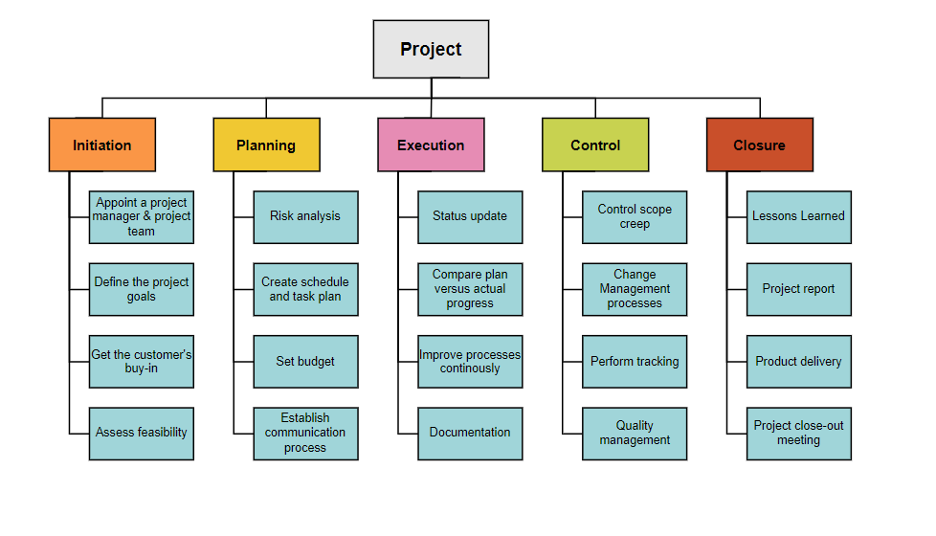
5

5.Quad Chart
A Quad Chart provides a concise overview of the project:
Top Right – Deliverables: | Bottom Left – Timeline:
- Functional web/mobile system | - Month 1–2: Planning & Design
- User documentation | - Month 3–4: Development
- Training materials | - Month 5: Testing
 | - Month 6: Deployment

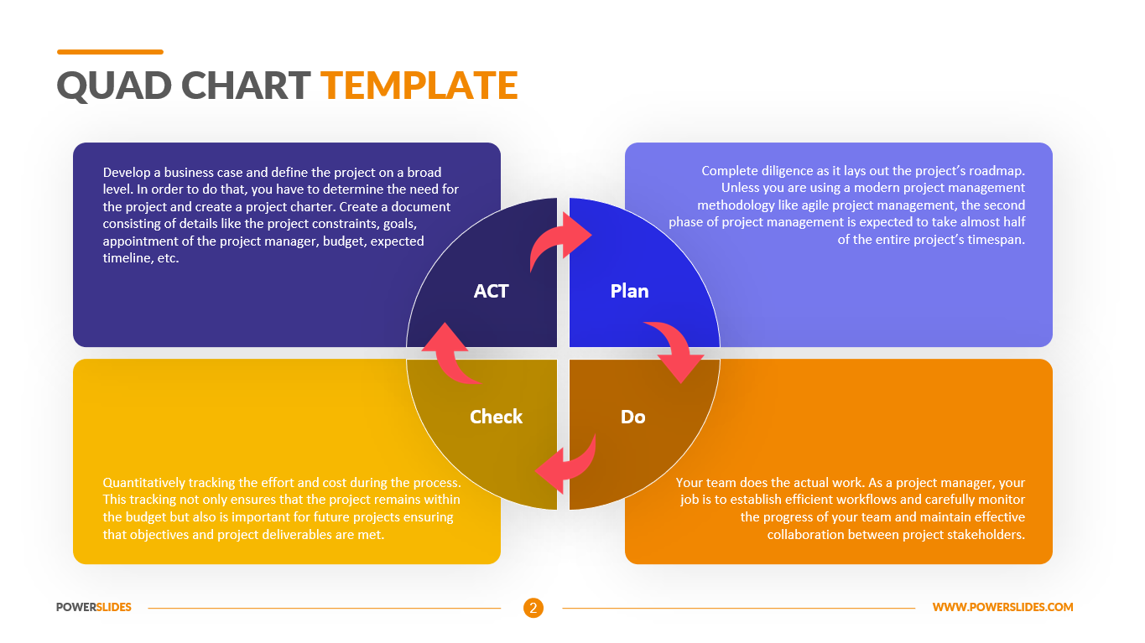 communication
Top Right – Deliverables:
- Functional web/mobile system
- User documentation
- Training materials
Bottom Left – Timeline:
- Month 1–2: Planning & Design
- Month 3–4:
- De teams
- Stakeholder Roles

6. Gantt Chart

Gantt Chart for Smart Campus Management System (6-Month Plan)
Task | Month 1 | Month 2 | Month 3 | Month 4 | Month 5 | Month 6
Project Initiation | ██████
Planning | ██████ | ███
System Design |  | ██████
Design |  | ██████
Development |  |  | ██████ | ██████
Development |  |  | ██████ | ██████
Integration |  |  |  | ██████
Testing |  |  |  |  | ██████
User Training |  |  |  |  |  | ███
Deployment |  |  |  |  |  | ██████
Maintenance |  |  |  |  |  | ███

LOS.
3. 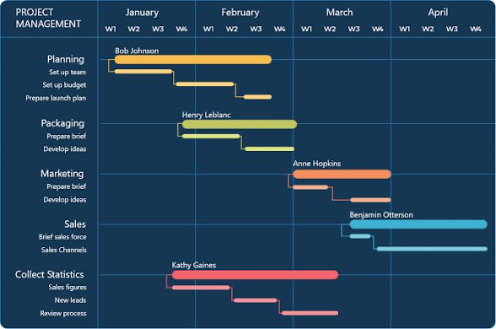 Kerzner, H. (2022). Project Management: A Systems Approach to Planning, Scheduling, and Controlling (13th ed.). Wiley.
4. International Organization for Standardization. (2020). ISO 21502:2020 Project, programme and portfolio management — Guidance on project Angharad Business Review. (2022–2025). Articles on project management, leadership, and effective team communication McKinsey & Company. (2023–2025). Insights on project delivery, performant, and organisational effectiveness. McKinsey Global
guidance updates. AP

7. Stakeholders' involvement,

Stakeholders’ involvement refers to the participation of all individuals and groups who have an interest in the Smart Waste Management System project or are affected by it. Key stakeholders include the project team, municipal authorities, citizens, technology providers, and maintenance teams. Their involvement is important throughout the project lifecycle—from planning and development to testing and implementation. The project team handles design and execution, municipal authorities provide requirements and oversee operations, while citizens benefit from improved waste services and may offer feedback. Supporting stakeholders ensure the system runs effectively and sustainably.

Stakeholder | Interest
Resident | Safe roads
Local Business | Flied management
Contractors | Economic
Employees | recovery

8. Allocation of Resources
Allocation of resources is a crucial aspect of the Smart Waste Management System project, as it ensures that all necessary resources are effectively distributed to achieve project objectives within the given time and budget. Proper resource allocation helps improve efficiency, reduce waste, and ensure the successful completion of the project.
1. Human Resources
Human resources refer to the people involved in the project. Each team member is assigned specific roles and responsibilities to ensure smooth project execution.
- Project Manager: Oversees the entire project, manages timelines, and coordinates team activities
- Hardware Engineer: Responsible for sensor integration and device setup
- Software Developer: Develops the dashboard and manages data processing
- Data Analyst: Analysis collected data and supports optimization
- Tester: Conducts system testing and identifies errors
Effective teamwork and clear role distribution are essential for productivity and project success.
2. Technical Resources
Technical resources include the tools, equipment, and technologies required for the project.
- Microcontrollers (e.g., Arduino, ESP32)
- Ultrasonic sensors for waste level detection
- Communication modules (Wi-Fi/GSM)
- Cloud platforms for data storage
- Software tools for programming and interface design
These resources enable the system to function properly and support both hardware and software development.
3. Financial Resources
Financial resources involve the budget required to complete the project.
- Cost of hardware components
- Software tools and licenses
- Testing and prototype development costs
- Miscellaneous expenses
Proper budgeting ensures that the project remains cost-effective and avoids financial overruns.
4. Time Resources
Time is an important resource that must be carefully managed.
- The project is scheduled over a defined timeline (e.g., 10–12 weeks)
- Tasks are allocated specific durations based on complexity
- Regular progress monitoring ensures deadlines are met
Efficient time management helps in completing the project on schedule.
Resource Management Strategy
To ensure optimal use of resources, the following strategies are applied:
- Clear planning and scheduling of tasks
- Regular team meetings and progress reviews
- Monitoring resource usage and adjusting when necessary
- Avoiding resource wastage through efficient allocation

9.Risk Analysis. Schwalbe, K. (2022). Information Technology Project
.). Risk analysis identifies potential threats and mitigation strategies.

1. Technical Risks
Sensor malfunction
Connectivity issues
Software bugs
Mitigation:
Use reliable components
Conduct thorough testing
Implement backup systems

2. Operational Risks
Lack of user adoption
Improper maintenance
Mitigation:
Provide training
Design user-friendly interfaces

3. Financial Risks
Budget overruns
Unexpected costs
Mitigation:
Proper budgeting
Contingency funds

4. Environmental Risks
Harsh weather affecting sensors
Mitigation:
Use weather-resistant materials

5. Data Security Risks
Unauthorized access
Data breaches
Mitigation:
Secure communication protocol

10.Conclusion
The Smart Waste Management System using IoT provides an effective and innovative solution to the growing challenges of urban waste management. Traditional waste collection methods are often inefficient, leading to unnecessary operational costs, environmental pollution, and poor sanitation. This project demonstrates how the integration of IoT technologies can significantly improve the efficiency, reliability, and sustainability of waste management systems. By implementing smart bins equipped with sensors, the system enables real-time monitoring of waste levels, ensuring that collection occurs only when necessary. This not only prevents overflow and associated health risks but also optimizes collection routes, reducing fuel consumption and operational expenses. The use of a centralized monitoring dashboard further enhances decision-making by providing accurate and timely data to waste management authorities. Throughout the project, key objectives were successfully achieved, including the design of a functional prototype, development of a monitoring system, and demonstration of improved waste collection efficiency. The Work Breakdown Structure and Gantt Chart ensured that the project was completed in an organized and systematic manner, while effective resource allocation and stakeholder involvement contributed to its overall success.

11.References
Ahmed, M. M., Hassanein, E., & Hassanein, A. E. (2023). IoT-based intelligent waste management system. Neural Computing and Applications, 35, 23551–23579. Ishaq, A., Mohammad, S. J., Bello, A. D., Wada, S. A., & Jagan, Z. T. (2023). Smart waste bin monitoring using IoT for sustainable biomedical waste management. Environmental Science and Pollution Research. Farjana, M., Fahad, A. B., Alam, S. E., & Islam, M. M. (2023). An IoT- and cloud-based e-waste management system for resource reclamation. IoT Journal (MDPI), 4(3), 202–220. Vasgersian, D., & Ishaq, I. (2023). Smart e-waste management system utilizing IoT and deep learning approaches. Sustainable Computing Systems. Divya, Y., Achi Ammal, B., & Sahoo, S. K. (2023). Industrial wastewater treatment using IoT. Journal of ISMAC, 5(2), 113–118. Patil, S. C., & Gedde, M. R. (2023). An IoT-based waste management approach for environmental sustainability. Journal of Integrated Science and Technology, 12(3). Raja, N. S. M., Kumar, T. S., Rangarajan, A., & Rao, G. N. (2023). Evaluation of garbage management based on IoT. International Journal on Recent and Innovation Trends in Computing and Communication. Khan, R., Kumar, S., Srivastava, A. K., et al. (2020). Machine learning and IoT-based waste management model. Computational Intelligence and Neuroscience. Sharma, H., Garg, R., Sawani, H., & Kashif, R. (2022). IoT solutions for sustainable and ethical supply chain management. arrive / Research publication. Towa, E., Zeller, V., & Achen, W. M. (2020). Input-output models and waste management analysis: A critical review. Journal of Cleaner Production.

4. International Organization for Standardization. (2020). ISO 21502:2020 Project, programme and portfolio management — Guidance on project management. ISO.
5. Harvard Business Review. (2022–2025). Articles on project management,
6. McKinsey & Company. (2023–2025). Insights on project delivery, 555555performance improvement, and organisational effectiveness. McKinsey Global Institute.
7. Association for Project Management (APM). (2023–2025). APM Body of Knowledge and project management guidance updates. APM.
8. Part C: Project Management K. (2022). Information
Jhhhhy556ttyhgygthyghghmygyhgyhghmbghy

