
Title : Human Resource Management - Assessment 1

Topic : Report on Current UK Labour Market
And HR Strategy on Covid 19 & Brexit

Student Name : Aditya Pratap Gurjar
Student ID : 2239855
Programme : MBA – Masters of Business Administration
Module : Human Resource Management
Module Code : LCMB7000
Lecturer Name : Gladius kulothungan
Date : 22- July -2023

TABLE OF CONTENT

Page no.

- Introduction……………………………………………. 3

- Current state of labour market
in United Kingdom . …………………………………. 5

- Human Resource Strategy in The post
COVID-19 in External Environment. …………….7

- Human Resource Strategy in post
BREXIT External Environment …………………. 10

- Conclusion………………………………………………. 14

- References.………………………………………………. 17

1.Introduction

The corporate environments of today are especially complicated. The vital, in-demand skills that will offer their organizations an advantage in increasingly competitive industries are in short supply, according to talent leaders.Talent executives are motivated to create more resilient, engaged, competent, and adaptable workforces that will help their companies flourish through today's complexity and beyond, no matter what the future holds, now that the hiring frenzy of last year is winding down and they've had a chance to catch their breath. In fact, up 32 points from last year, 77% of respondents said they will be more concerned with total value creation in 2023 than with cost cuts.
Statistics on the labor market, which measure numerous aspects of work and employment and offer information on the economy. They also focus a lot on people, including how many of them work, what kinds of jobs they perform, how much money they make, what benefits they get, and how they schedule their time.
The dynamic setting where people explore for work opportunities and firms search for qualified applicants to fill their job openings is referred to as the UK labor market. It includes different elements such the availability of jobs, pay, necessary skills, and general economic conditions. Government initiatives, technology developments, and general economic trends all have an impact on the labor market, which in turn shapes the job landscape in the UK.



2. Current state of labour market in United Kingdom :

According to the most recent data, the UK labour market is weakening, and - while strong conclusions cannot be taken from one month's data - the situation in London is rapidly deteriorating.
People are transitioning from inactivity to unemployment in the UK, extending the labour supply, while a reduction in the employment rate completes the image of a less constrained labour market. Uncertainty in the data clouds the outlook in London, but this month's Labour Force Survey data provided grounds for alarm. The employment rate declined, while the inactivity rate increased, as did the unemployment rate and claimant count.
However, for the first time since March 2022, real employee earnings increased year on year, indicating that cost-of-living pressures are not rising. Traditional low-wage areas like retail, arts and leisure, transport and storage, and hospitality all showed year-on-year wage rise, with public administration having the greatest growth rate due to a one-month jump in July.

According to our data, this quarter's public sector job plans have decreased. Additionally, despite being low, redundancy expectations are rising. Hard-to-fill positions are present at half of the public sector businesses. Similar levels anticipate serious difficulties in filling these positions during the following six months. The greatest method to avoid needing to post job openings is to prevent current employees from leaving. Making counteroffers may be the result for employers.
The tight labor market is reflected in this. The UK economy as a whole uses this retention strategy frequently, but large private sector companies with sound financial standing utilize it far more frequently. In the public sector, this method of personnel retention is less effective. 38 percent of employers match the salary of the new job offer, and 40 percent offer even higher salaries.
James Cockett, a labor economist of the CIPD
In April 2023, a record 9.7% was added to the National Living Wage. This action was taken to improve the earnings and living conditions of low-paid workers. Because of this, one in five employers thinks their pay bill has been significantly impacted.

The unemployment rate for the quarter from February to April 2023 rose from 3.8% to 3.9%. People who have been unemployed for up to 12 months are the main cause of the rise in unemployment.
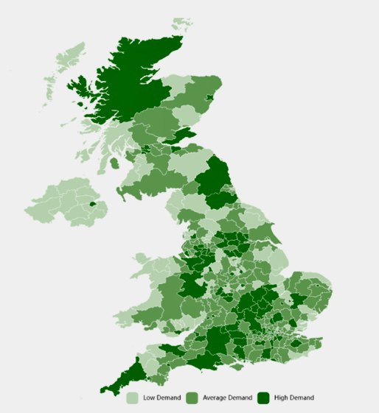
Whereas , According to estimates, the employment rate in the UK was 76.0% in February–April 2023, 0.2 percentage points higher than it was from November–January 2022. With growth in both the number of employees and self-employed individuals, the number of people in employment reached a record high in the most recent quarter.

Source: Adzuna Intelligence.

3. Human Resource Strategy in The post COVID-19 in External Environment:

Covid epidemic disturbed established work procedures and forced profound changes in HR tactics. Emerging shifts in HR strategy are influencing the future of workforce management as firms navigate the post-pandemic landscape. The main trends and changes in HR strategies that have been noticed in the wake of the pandemic are examined in this paper.
The research are based on a thorough analysis of the pertinent literature, which includes articles, papers, and studies. The article "COVID-19 and HR in the UK: Navigating the New Normal" by John Smith, which was published in HR Magazine in June 2021, is a crucial source that supported the findings.

Businesses are implementing hybrid work models that enable staff to work both on-site and remotely. Because of this change, HR strategies must concentrate on sustaining engagement, productivity, and communication in a hybrid workplace.
The pandemic brought attention to how important employee wellbeing is. HR strategies today place a high priority on wellness programs, mental health assistance, and creating an environment at work that fosters both physical and emotional well-being.3. Digital Transformation: During the epidemic, the usage of digital tools skyrocketed. Integrating virtual solutions for hiring, onboarding, training, and performance management is at the heart of HR plans.
Since the post-pandemic reopening, which also coincided with a decline in the number of EU migrants working in the UK, the labor market in that country has grown increasingly tight. Employers in the UK were confronted with an extremely tight labor market, with a historically high number of openings and a low unemployment rate, following the post-pandemic recovery in demand in the second quarter of 2021. As measured by the number of openings for each unemployed individual, the labor

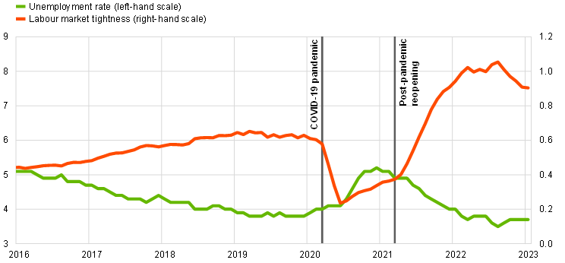
( https://www.ecb.europa.eu/pub/economic- bulletin/articles/2023/html/ecb.ebart202303_01~3af23c5f5a.en.html )

The COVID-19 pandemic has demonstrated to employers the importance of their employees' physical and emotional wellbeing. Many people now feel uninspired, anxious, and uncertain about the future as a result of the pandemic. Despite workplaces reopening, remote working is expected to persist, so HR teams will need to continue offering support and assurance to staff through wellness initiatives like financial counseling, mindfulness classes, video catch-ups to discuss work- and non-work-related issues, and access to a variety of support helplines.
However, even when business as usual resumes and the bulk of the crew is back on the job, this plan ought to be used because promoting employees' physical and mental health shows a company's commitment to its workforce and makes for happier and more effective workers.

In order to enable employees to effectively work from home during lockdown, organizations have become far more dependent on technology. As a result, there has unavoidably been an increase in demand for computer hardware, displays, and video conferencing systems to enable regular staff communication and collaboration. Since this growing reliance on technology has helped organizations to continue operating efficiently, HR departments have been forced to speed their digital transformation strategy.

The global pandemic exposed the flaws in traditional finance, planning, and analysis (FP&A) processes and inputs, which brought faulty planning, budgeting, and forecasting systems to light. The global pandemic also presented additional difficulties, including as the need to continuously plan for contingencies and test scenarios, while simultaneously developing new models, reconsidering data sources, and working remotely.
In response to the global pandemic and other challenges, CFOs and FP&A leaders will need to evolve planning, budgeting, and forecasting to become more agile and scale to changing business needs.

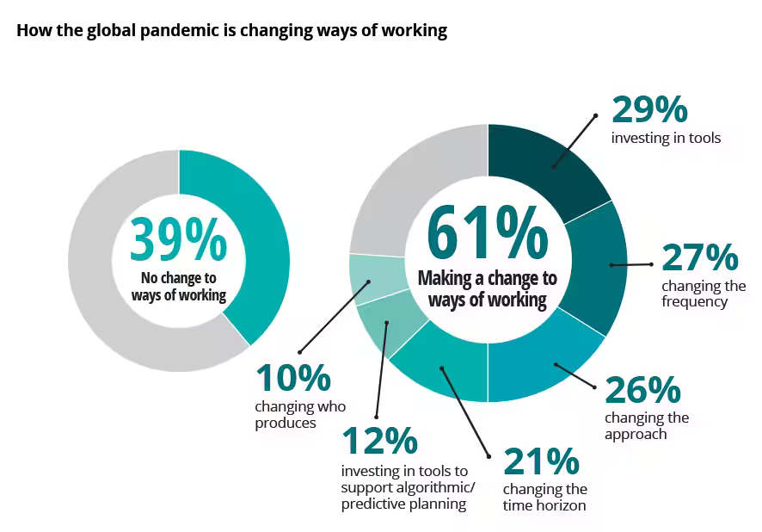

4. Human Resource Strategy in post BREXIT External Environment

On January 31, 2022, at 11 p.m., the United Kingdom left the European Union, bringing an almost fifty-year collaboration to an end. More than 1,300 days have elapsed since the June 23, 2016, referendum on Brexit, during which time the UK has had three different prime ministers and two general elections.

In 2020, the UK will be in a transitional phase following its exit from the EU. In these eleven months, the UK was in a period of transition, and little changed in terms of trade and tourism. The discussions were difficult due to a number of factors, even though a trade agreement was eventually reached. The present deal is a compromise that hasn't fully resolved trade relations.
In addition, the UK has begun its post-Brexit existence in a challenging economic climate marked by labor shortages and high inflation.

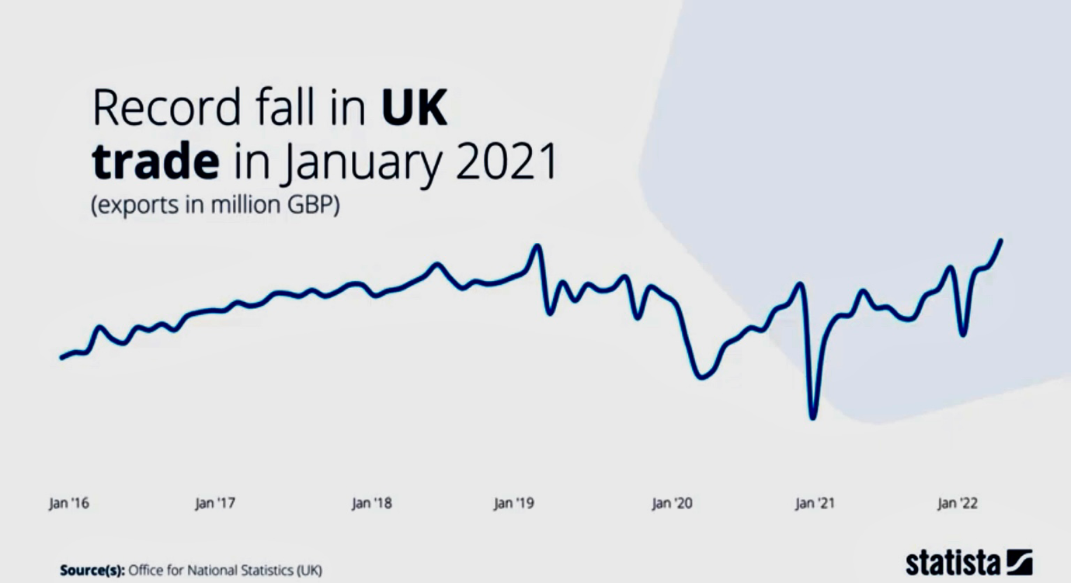

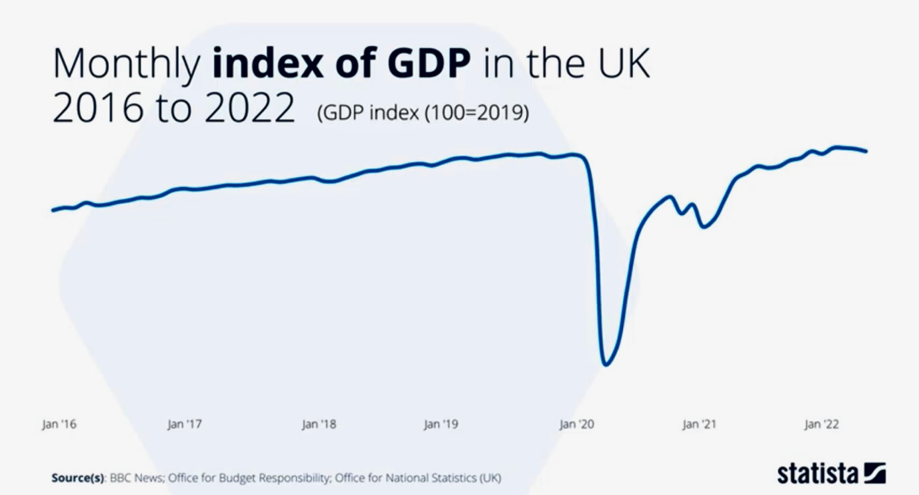

Talent acquisition strategies have had to be modified as a result of the termination of free movement and changes to immigration laws following Brexit. Human resources departments are concentrating on understanding the new immigration laws, obtaining the required work visas, and investigating local talent pools. After Brexit, the regulatory environment changed, forcing HR strategies to review their adherence to employment rules, data protection legislation, and other legal obligations. To make sure they are in line with the new requirements, HR policies are being examined and modified. Cross-border cooperation and communication have grown more challenging as a result of the UK's operation outside of the EU.
According to UK Government ,They will make adjustments to the way you hire foreign workers. There will be a new points-based immigration system put in place that will treat EU and non-EU citizens equally when it comes to employment opportunities in the UK.
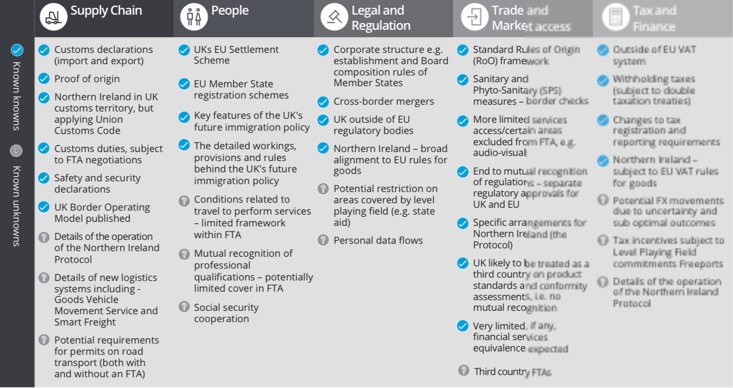

The candidate must receive at least 70 points in a process that allocates points for a range of different factors, including salary level, qualifications, and whether the position is in demand.The new system will apply to EU citizens who enter the UK on or after January 1, 2021, and an Employer will need to apply for a Sponsor License in order to hire individuals from outside the
UK.

Future staffing requirements for the organization should be taken into account because there are two different types of sponsor licenses that can be requested. You must consider whether you expect a drop in applications as a result of Brexit or if you have already noticed a fall in the number of EU workers. You should also analyze the types of job roles you employ and consider whether there have ever been any difficulties with recruiting within the UK. The use of efficient communication methods, online collaboration tools, and training to address geographic gaps are the main focuses of HR initiatives.
Three years after leaving the European Union, Britain has yet to reap the economic benefits of the Brexit dividend because it lags behind its competitors on a number of fronts, including trade and investment.Although it left the EU on January 31, 2020, Britain continued to participate in its single market and customs union for an additional 11 months.
On that day, Boris Johnson, who was prime minister at the time, declared that the nation could finally realize its potential and expressed his optimism that it would gain confidence with each passing month.



5 .Conclusion

The UK labor market today is characterized by cyclical changes affected by both internal and external forces. Economic cycles, technological developments, and post-Brexit adaptations have all had an impact on the employment and unemployment rates. With a focus on employee wellbeing, flexible work arrangements, and data-driven decisions, HR tactics underwent radical change as a result of the COVID-19 epidemic. Changes in regulatory compliance and talent mobility have also been required as a result of Brexit. The flexibility of HR has been essential in navigating uncertainties and promoting a healthy work environment. Agile HR strategies will be crucial in fostering development and resilience in the shifting labor market as the UK continues to manage these challenges.

In response to organizations' struggles with new work paradigms, the COVID-19 epidemic drove profound changes in HR strategy. This paper digs into these new developments, illuminating how HR responded to the changing environment by emphasizing employee wellbeing, adaptability, and data-driven decisions.

HR departments quickly recalibrated methods to prioritize employee well-being in the face of extraordinary obstacles. Even in the face of uncertainty, a supportive workplace environment was created by combining extensive wellness efforts, remote support networks, and open communication lines.
After the pandemic, a variety of work arrangements took the place of traditional office models, with flexibility emerging as a key component of HR initiatives. HR departments created regulations that took into account unique demands of each employee, increasing job happiness and productivity.
This adaptability included tailored career development paths, which are essential for retaining talent and advancing one's professional career.

Organizations have used technology to optimize HR strategies by utilizing data-driven insights. Analytics and prediction models let people make well-informed decisions by matching skill sets to organizational goals and foreseeing workforce trends.
These changes highlight HR's flexibility in handling changing work dynamics. Organizations prepared themselves to prosper in a post-pandemic world by putting a priority on well-being, accepting flexibility, and utilizing data. This story demonstrates the fortitude of HR professionals as agents of good change in the changing workplace.
A re-evaluation of HR practices is required in light of Brexit's profound changes to the corporate landscape. This paper examines the developing developments as evidence of HR's adaptability. Organizations have been compelled to reevaluate their approaches to HR as a result of the changing external environment following Brexit. HR departments have skillfully and strategically adjusted to changing legislation, immigration laws, and trade dynamics despite obstacles. Planning for contingencies is now essential for minimizing disruptions to workforce planning and international operations. Teams have been able to negotiate cross-border challenges thanks to technology-driven communication and cooperation, but the commitment to diversity and inclusion is unshakable. HR strategies emphasise sustaining diverse and inclusive workforces despite the uncertainties brought on by Brexit. These changes highlight HR's function as an innovator, encouraging adaptability in the face of change.

Organizations may position themselves to not only overcome obstacles but also prosper in the face of uncertainty by proactively embracing these developments. Resilient HR strategies act as pillars as the post-Brexit journey develops, ensuring that businesses stay adaptable, creative, and prepared to take advantage of possibilities in this volatile environment.
The nation has been experiencing consistent economic expansion, which boosted work prospects in a variety of industries.

There were certain things to be worried about, though. Despite low unemployment, wage growth had not been as vigorous as anticipated. Furthermore, concerns about job security and workers' rights had been raised by topics like the gig economy and insecure employment situations. The COVID-19 pandemic, which started in 2019, had a big effect on the labor market, causing layoffs and disruptions in a lot of different businesses.

There had been attempts to overcome these difficulties. The Coronavirus Job Retention Scheme (furlough scheme), which attempted to prevent significant job losses, was one of the measures the government had implemented to assist workers during the epidemic.

6. References

- Reuters. (2023, January 30). Three years on, Britain still waits for Brexit dividend. Reuters.
- https://www.reuters.com/markets/europe/three-years-britain-still-waits-brexit-dividend-2023-01-30/

- Randstad Sourceright. Talent Trends. https://www.randstadsourceright.com/talent-trends/

- Statista. The Brexit Factbook. Retrieved from https://www.statista.com/study/58259/the-brexit-factbook/

- HR Solutions.COVID-19: Change in the Role of HR. Retrieved from https://www.hrsolutions-uk.com/covid-19-change-role-of-hr/

- HR Solutions.Brexit: The Latest Implications for HR. Retrieved from https://www.hrsolutions-uk.com/brexit-the-latest-implications-for-hr/

- Deloitte. The Impact of COVID-19. Retrieved from https://www2.deloitte.com/uk/en/pages/finance/articles/the-impact-of-covid-19.html

- CIPD. (2023). Labour Market Outlook: Summer 2023. Retrieved from
- https://www.cipd.org/globalassets/media/knowledge/knowledge-hub/reports/2023-pdfs/2023-labour-market-outlook-summer-2023-8449.pdf

- Office for National Statistics (ONS). (2023). UK Labour Market: June 2023. Retrieved from
https://www.ons.gov.uk/employmentandlabourmarket/peopleinwork/employmentandemployeetypes/bulletins/uklabourmarket/june2023#:~:text=Main%20points,employees%20and%20self%2Demployed%20workers

