
BMIH6007
International Meetings Management for the Hotel Industry
LEVEL 6
Assignment 1: Feasibility Plan for an International Meeting

Individual Presentation

Transcript

2000 words

Student Name: Maria Mihaela Hirs
Student ID: 2226556
Module Lead: Kathryn Flynn
Table of Contents
Slide 3: Introduction 2
Slide 4: Background of the event 3
Slide 5: Market Factors: “Target Market, Demand and Supply” 4
Slide 6: Market Factors: “Competition and Marketing Activity” 5
Slide 7: Operational factors: “Venue, and Resource Allocation” 6
Slide 8: Operational factors: Skills required and Staffing 8
Slide 9: Financial Factors: Costs and Predicted revenues and funding sources 8
Slide 10: Conclusion 10

Slide 1: Cover Page

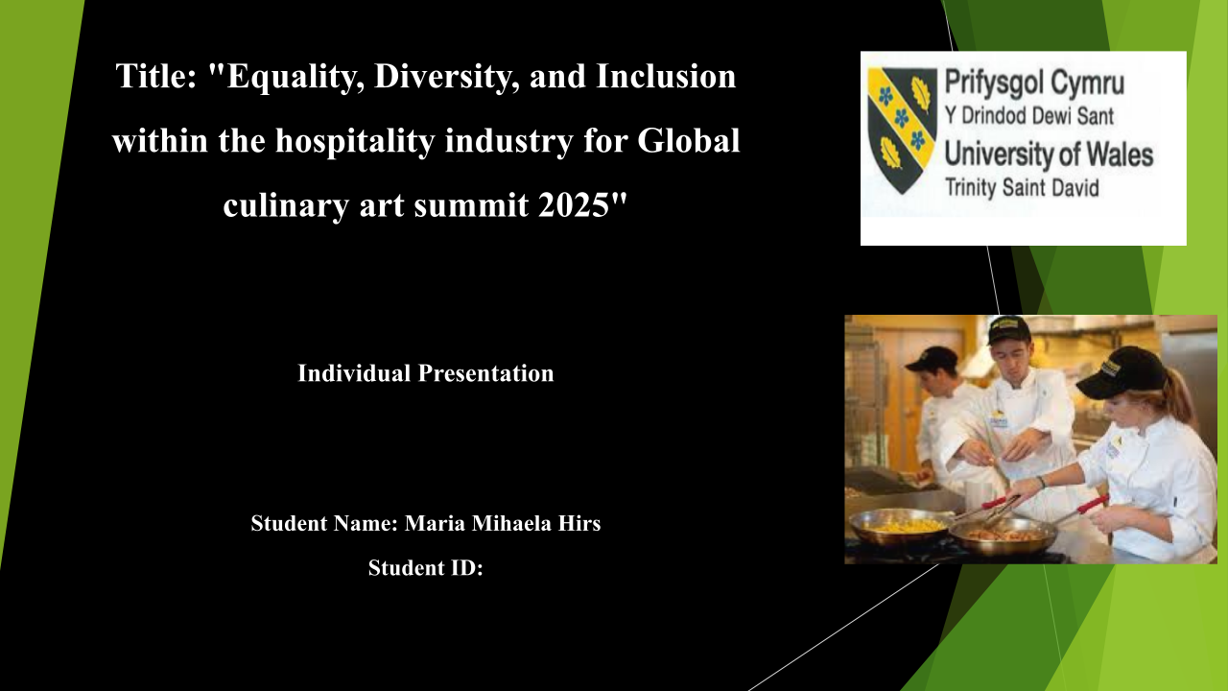

Slide 2: Table of content
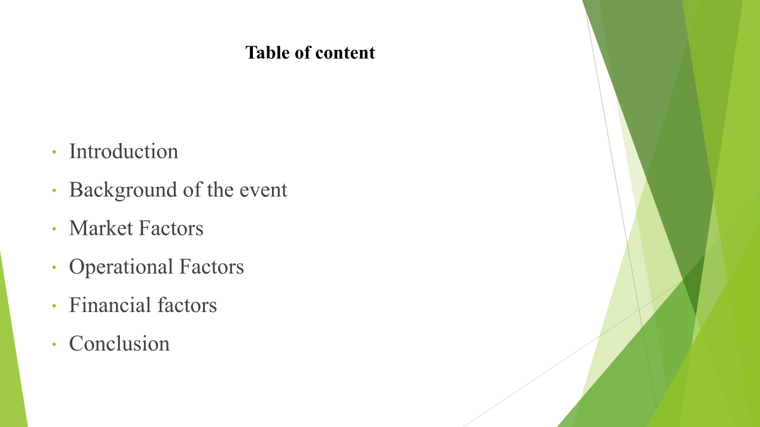

Slide 3: Introduction
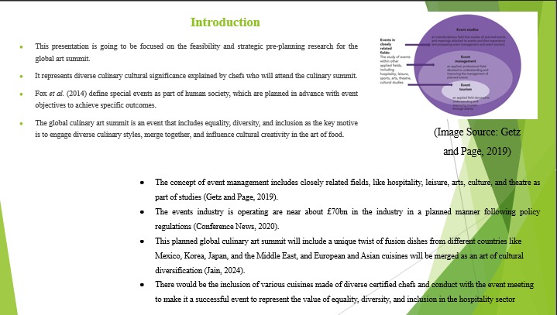

Slide 4: Background of the event
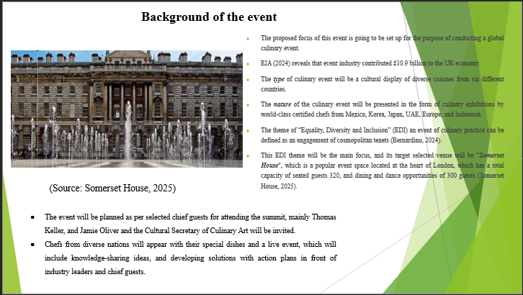

Slide 5: Market Factors: “Target Market, Demand and Supply”
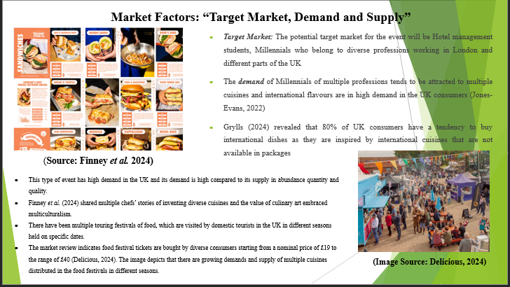

Slide 6: Market Factors: “Competition and Marketing Activity”
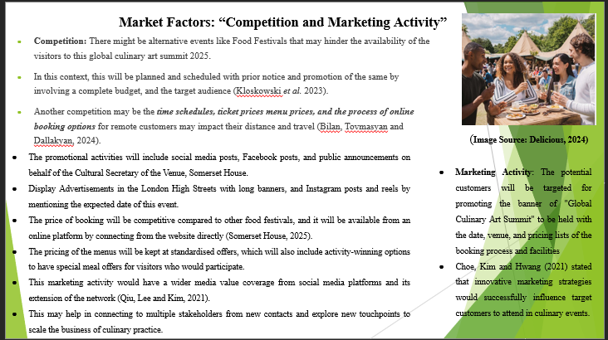

Slide 7: Operational factors: “Venue, and Resource Allocation”
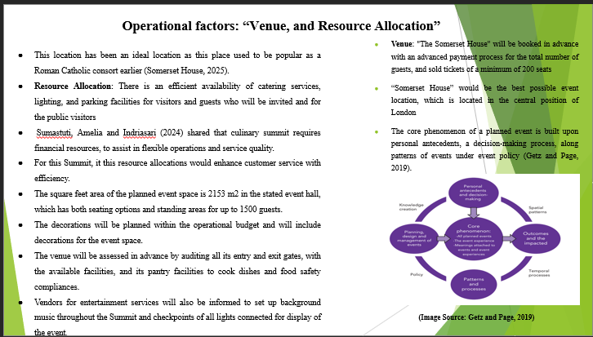

Slide 8: Operational factors: Skills required and Staffing
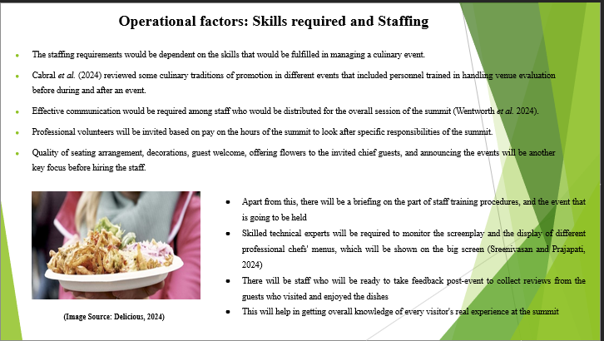

Slide 9: Financial Factors: Costs and Predicted revenues and funding sources

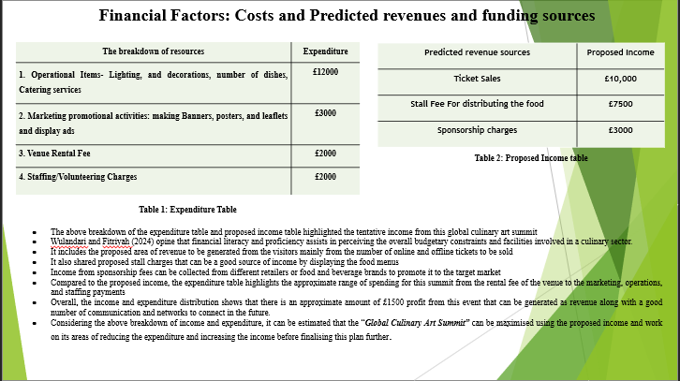

Slide 10: Conclusion
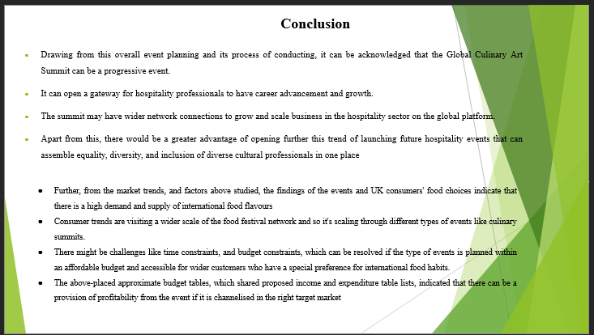
Slide 11: References



