Production and safety improvements to high explosive machining
George Goddard

Contents
Table of figures 2
Table of tables 2
Introduction 3
Background 4
Turning 4
Milling 4
Machining basics 6
Feed rate 6
Spindle speed 6
Depth of cut 6
Explosive machining 6
Cutting forces 8
Literature review 9
Research idea 10
Research objectives 10
Research method 11
Expected outcome 11
Resources 11
Gannt chart 12
References 13
Bibliography 14

Table of figures

Figure 1 - Shows a CNC lathe [2] 4
Figure 2 - Shows a component being manufactured on a five axis mill [3] 5
Figure 3- Shows the five axis available on a five axis mill [4] 5
Figure 4 - Shows a lathe that has been modified for machining explosives [5] 7
Figure 5 - Shows the cutting forces applied while turning. 8
Figure 6 - Shows the approximate timeline for the project. 12

Table of tables

Table 1 - Shows some of the resources required for this project. 11

Introduction

CNC (Computer numerical control) machining is used across the world in the manufacturing industry to produce millions of components each week. Components produced are used within the automotive, electrical, aerospace, and medical industries with the machine market predicted to be worth $117 billion by 2027 [1].
Turning and milling are the two main types of CNC machining. Turning on a lathe involves the workpiece rotating at high speed while a tool is brought into contact with the workpiece to cut material. Milling machines work by fixing the workpiece and using a rotating cutting tool to remove material. As the name suggests CNC machines are computer based. Computer software controls the motors driving the axis. Specialist software is used to program the machine moving the tool in the desired path to cut the material.
CNC machines are used in thousands of conventional applications, they can also be used to machine unconventional materials such as explosives and radioactive materials. The basic principles of the machine are the same however the machines are highly modified so they can be operated in a glove box or remotely.
High explosives are used around the world for civilian and commercial uses, including munitions, rock blasting, mining, demolition, and entertainment. Explosives come in many different formats depending on use, they can be powders, solids and in a slurry. Casting, pressing, and machining are used to manufacture the geometry of explosives.
Machining high explosives is conducted in a similar way to the machining of other materials however the material is held differently, and the machines are heavily modified to reduce the risks associated with explosives. The biggest difference is that the machining is carried out remotely, the explosives are set on the machine and the machinist will then vacate the process area and operate the machine from a safe location. This is generally behind blast walls and doors, or a safe distance from the process area.
As the cutting tool moves through the explosive heat is generated and cutting forces are applied to the material. These forces and temperatures must be within safe working parameters to ensure that the explosive does not initiate. These working parameters are set to ensure the safety of the machinists, other process workers and the explosive processing facility.
Current explosive safety standards are old and outdated and have not been changed since explosives were first machined back in the 1950’s. These standards limit the spindle speed, feed rate and depth of cut. The current maximum lathe spindle speed is 500 RPM, these outdated feeds and speeds mean that the time taken to machine components can take hours. For safety reasons the time spent machining explosives is kept to a minimum and only done when necessary.
This report will investigate the speeds, feeds and depth of cut used while machining high explosives. If these values can be increased without the cutting forces or temperatures generated exceeding safety parameters this will increase production and reduce machining times.

Background

Turning

Turning is a machining process carried out on a lathe, a CNC lathe is shown in Figure 1. Lathes come in a variety of shapes and sizes from small watch makers machines up to large industrial machines that can accommodate the size of a small car.

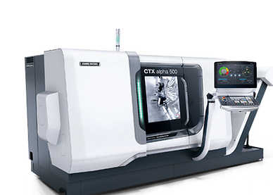
Figure 1 - Shows a CNC lathe [2]

Milling

Milling machines come in all shapes and sizes and can produce a wide range of components from basic blocks to intricate components utilizing all five axis of the machine as shown in Figure 2. Figure 3 shows the axis of a full five axis mill, these are the X, Y and Z of any standard machine, but also A (or B) and a C axis, these extra axes enable the machine to create complex shapes. Certain 5 axis mill’s incorporate a spindle into the C axis, enabling the machine to act as a machining center and perform vertical turning.

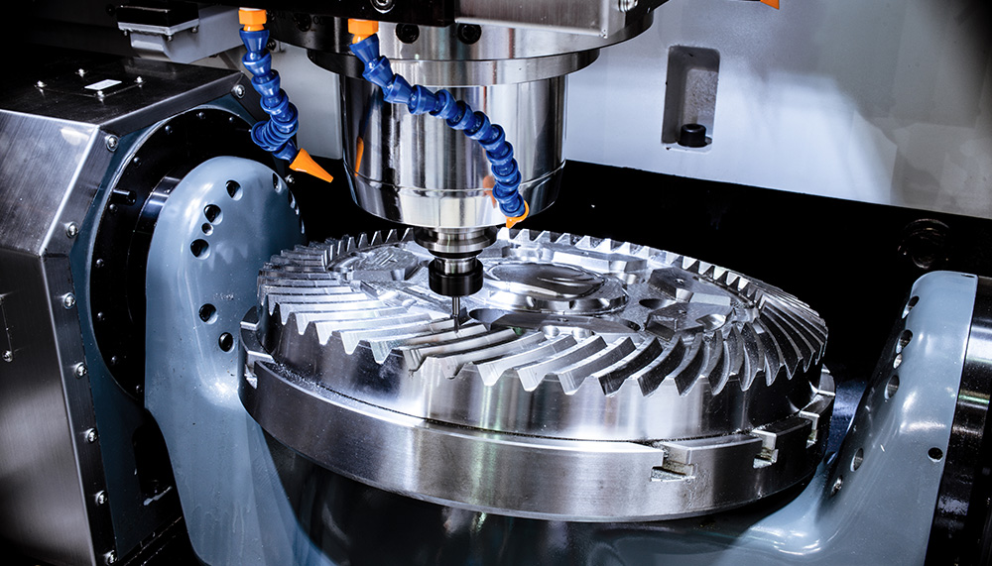

Figure 2 - Shows a component being manufactured on a five axis mill [3]

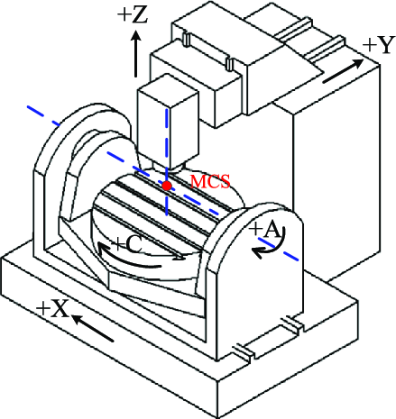
Figure 3- Shows the five axis available on a five axis mill [4]

Machining basics

There are several generic machining terms that will be discussed later in this project, these are: feed rate, spindle speed and depth of cut. All these parameters are defined withing the CNC part program which can be easily adjusted.

Feed rate

Feed rate is defined as how fast the tool moves through the component, it can be set to vary with the spindle speed or measured as a distance per minute. For tuning operations, the tool can be set to move a specific amount per revolution of the spindle given as mm per revolution (mm/rev). For turning and milling operations mm per minute can be used to dictate how fast the tool moves. Milling operations can also use distance per tooth, this moves the tool or work piece a set distance per cutting tooth. Each of these feed rates are calculated using data given by the tool manufacturer, material type, spindle speed, number of teeth and other factors such as type of work holding.

Spindle speed

The spindle speed of the machine is given as RPM (revolutions per minute). With turning the spindle speed is the speed that the chuck and work piece rotate. Five axis milling machines can have two spindles, the main spindle rotates the tool and some spindles can reach speeds in excess of 25,000 RPM. The second spindle being the C axis that can be used as a spindle enabling the mill to perform vertical turning operations.

Depth of cut

Each time the tool makes a pass it removes a set amount of material, the amount of material that is removed is defined by the depth of cut. For turning operations, the diameter of material being removed will be twice the depth of cut. Milling operations remove the full depth of cut with the rotating cutting tool.

Explosive machining

Components manufactured in the explosive industry are generally small and can fit on a standard lathe, however the way the component are held is different. On a conventional lathe the work piece is clamped in a chuck, the chuck clamps and crushes the material and this is not suitable for explosives. Metal components can withstand the clamping forces however an explosive component would be crushed or damaged. This produces a safety risk of the explosive initiating and a quality problem of the material being damaged, marked and out of tolerance. Figure 4 shows a lathe that has been modified for explosive machining. Some of the modifications that have been made to this lathe are positive pressure air purge system, vacuum holding system and a castell interlock system.
To solve this problem explosives are held using vacuum or a measured applied pressure. Vacuum work holding using specially designed tooling is commonly used in machining operations. These fixtures support the material while holding it in place. The amount of vacuum pulled is controlled and adjusted to ensure the component is held securely. The application of pressure must be done in a controlled way, so the component isn’t crushed or distorted. For turning operations, the component is held between pressure pads where pressure is applied from the tailstock. The tailstock of the lathe houses a load cell that measures the force being applied, this force is calculated for each component and depends on the size of the pressure pad and the diameter of the material. This force is constantly measured during the remote machining and if it drops under the specified limit the machine will be stopped and the machinist will need to enter the process cell and increase the pressure. Milling operations use special fixtures that hold smaller components under compression using foam to hold the component securely. As the fixture is tightened around the explosives the foam compresses at a known rate to ensure the component is held tightly without the risk of crushing.
The materials removed while machining is called swarf or chips, this material is sucked up using a swarf and dust extract system. The material is stored in a bin, which is emptied when required and sent for burning.

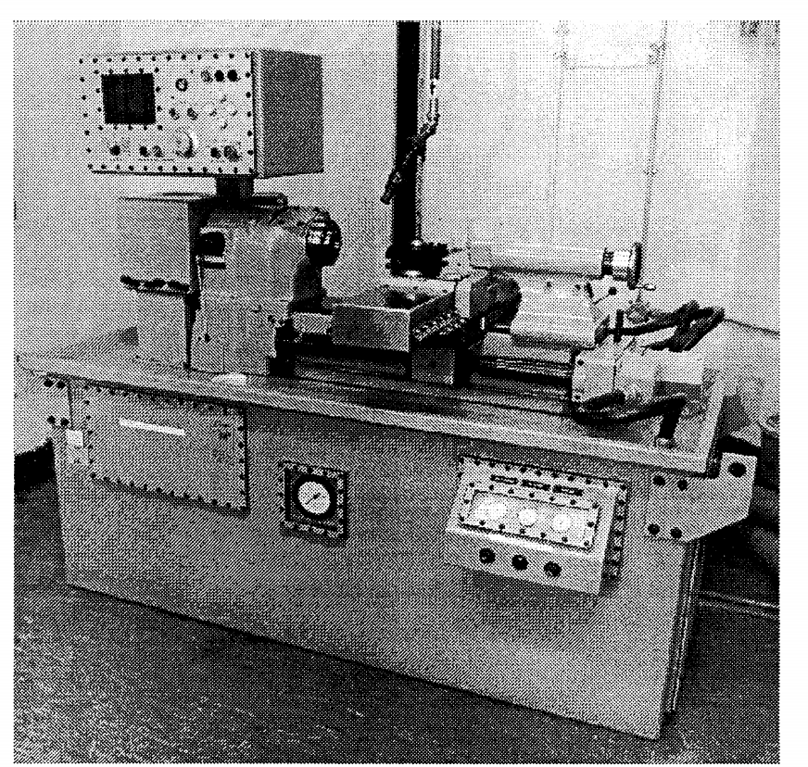
Figure 4 - Shows a lathe that has been modified for machining explosives [5]

Cutting forces

During machining, forces are applied on the workpiece and machine tool. These forces can be measured to help improve the conventional machining process. Data from machining components can be used to improve product accuracy and surface finish. For this report, the measurement of cutting forces will be used to ensure they stay within pre-determined parameters. Figure 5 shows the cutting forces applied during turning operations.

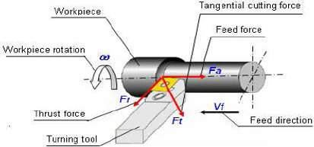
Figure 5 - Shows the cutting forces applied while turning.

Literature review

As explosive machining is very specialist area, there has been limited published reports that are available unclassified at a public level. However, a small number of reports have been written on explosive machining forces and several reports on the forces generated during conventional machining are available.

Woodrum [6] wrote about a similar study carried out in America in 2017. This paper describes the explosive used in the research and details the cutting forces applied during turning operations (known as lathing in America). In his research he changed three variables to improve machining time. These were depth of cut, incher per revolution and surface feet per minute. Inches per revolution is an American term used to define the amount of material being removed by the tool per revolution of the work piece. After numerous trials Woodrum concluded that the best way to reduce the time taken to machine a component while keeping the cutting forces and temperatures within specification was a shallow depth of cut and high SFM (surface feet per minute). This combination of faster feed rate with a lower depth of cut was deemed to give the best material removal rate and improve production and safety.

Tool temperature and workpiece temperature are key factors when trying to achieve a high standard of component. Davis et all [7] talks about how these factors can be measured to improve the quality of machined components and predict tool wear. They used a range of different temperature measuring devices to monitor the heat generated during machining including Thermocouples, Thermophysical processes, spectral radiation thermometry, and RTD (resistance thermography devices) among others. The report notes that it is very difficult to get experimental data to match the predicted data. The author discusses how difficult it can be to collect accurate data as there are numerous variables including the use of coolants, machine speeds and feeds and material type and grade.

Most conventional machining processes use coolant as a lubricant and cooling agent. A report by Leksycki et all [8] examines cutting forces and chip shape changes while cutting stainless steel using different speeds, feeds and amount of coolant used. The variable feed rates used were 0.05 to 0.4mm/rev and depth of cut 0.2 to 1.2mm. Results showed that the cutting force was reduced by up to 43% when using coolant or MQL (Minimal Quantity Lubrication) and the feed force reduced by up to 73%. FEA (Finite Element Analysis) was used to simulate the machining forces, a Johnson-Cook constitutive model was used to model the experiment. The percentage change between the experiment and FEA are displayed and the author notes that the cutting force is almost identical between the FEA and experimental value. However, differences of up to 35.6% were seen on the feed force.

One method of measuring tool and workpiece temperature is to use an infrared camera, this is a non-contact method of temperature measurement that measures the infrared energy emitted from a body. Masoudi et al [9] used a thermal imaging camera to measure the tool and workpiece temperature while turning a thin walled component. They concluded that using infrared cameras to measure cutting temperatures is an effective way however, IR does have limitations. One limitation is swarf accumulating around the cutting tip reflecting heat back onto the tool and workpiece thus giving high inaccurate temperatures. In this report the type of tool tip was changed to see if this produced lower temperatures, standard carbide tips and PCD (polycrystalline diamond) tips were used. The PCD tip produced temperatures 71% lower than a standard tip making this an ideal cutting tool.

Process optimisation is one of the main factors driving cutting force measurement, improving machined component quality, accuracy and machining time are all areas for improvement. Predicting machining forces can be a cost-effective way to collecting on machine data, due to the complex and expensive sensing equipment required. Simulations can also predict the forces of complex components that would be difficult to gather experimental data from. However, simulations often rely on data that has been collected previously. Another drawback of simulation is how long the simulation takes to run, intricate models can take many hours to run whereas data can be viewed live as a machine takes a cut. Sousa et al also conclude that the data completed from a simple machining operation is reliable data [10].

Research idea

An investigation into production and safety improvements while machining high explosives.

Machining explosives is an unavoidable task within the defense industry and improvements to safety will be welcomed within the industry. This project will aim to reduce the time spent machining explosive components and increase the quality of the component.

Research objectives

The overarching aim of this project is to improve safety and product quality while machining high explosives. This will be accomplished using these objectives:

- Measure and analyze the current cutting forces and cutting temperatures.
- Investigate methods to reduce the time spent machining components.
- Develop methods to reduce the time spent machining components while keeping the cutting forces and temperatures within safe parameters.
- Evaluate the results of experimental machining and implement this into the explosive production facility.

Research method

This is a practical project and will be completed by using CNC machines to trial different cutting speeds, feeds, and type of tool tip. From the literature review and previous research, it has been decided not to use computer simulation to calculate the cutting forces. This has been decided because the components to be machined are simple and reliable data can be obtained from live machining. Computer modelling can take hours to simulate and often relies on data collected from machining, whereas data from live cutting trails can be viewed and analyzed in real time. This means a cut can be taken, the data reviewed, and changes made to the parameters all in a fraction of the time one computer simulation would take.
Due to the nature of these cutting trials, they cannot be carried out within the AWE explosive production facility. Any explosive machining experiments will need to be conducted at an offsite location with safety measures in place. The CNC machine will need to be operated remotely from a safe distance with blast walls and an exclusion zone in place.
The data collected from the research will be cutting forces and temperatures produced from the machining trials. This data will be collected on a spreadsheet where it can be analyzed and put into graphs and tables so it can be viewed and understood easily.

Expected outcome

The expected outcome of this project is to evaluate the possibility to reduce the amount of time spent machining explosive components thus improving safety and the quality of the product. By reducing the machining time, the explosive will spend less time on the machine performing a dangerous operation. Quality and reliability improvements will also improve safety as the machinists will have more confidence in the machines and will carry out fewer quality operations therefore removing them from the explosive processing cell.

Resources

To complete this project the following resources detailed in Table 1 will be required, this is not an extensive list but gives an idea of what be required to carry out the explosive machining trials.

CNC machine designed or adapted for remote explosive processing | CNC tooling (chucks, vacuum fixtures)
Swarf and dust extract system | Different tool tips
Temperature measurement equipment | Force measurement equipment
Explosives for machining | Computers and software to record measurements.
Trained explosive machinist | Approximately £20,000 to use an offsite location.
Table 1 - Shows some of the resources required for this project.

Gannt chart

Figure 6 is an approximate timeline for the project. This is subject to change and could be for several reasons such as range availability, delivery of machinery or availability of competent persons.


Figure 6 - Shows the approximate timeline for the project.

References

[1] | G. v. research, “CNC Machines Market Growth & Trends,” Grand view research, 2 2020. [Online]. Available: https://www.grandviewresearch.com/press-release/global-computer-numerical-controls-cnc-machines-market. [Accessed 21 4 2021].
[2] | D. Mori, “CTX alpha 500,” DMG Mori, [Online]. Available: https://uk.dmgmori.com/products/machines/turning/universal-turning/ctx/ctx-alpha-500. [Accessed 23 4 2021].
[3] | Fanuc, “5- axis machining,” Fanuc, [Online]. Available: https://www.fanucamerica.com/solutions/applications/5-axis-cnc-machining. [Accessed 27 4 2021].
[4] | S. Xiang and Y. Altintas, “Modeling and compensation of volumetric errors for five-axis machine tools,” International Journal of Machine Tools & Manufacture, vol. 101, pp. 65-78, 2015.
[5] | M. G. AWE, “Machines for high explosive component manufacture - how to specify,” Transactions on Engineering Sciences , vol. 23, no. 135-144, 1999.
[6] | B. Randall Brock Woodrum, “Developing Lathing Parameters for PBX 9501,” Texas Tech University, 2017.
[7] | M. A. Davies, T. Ueda, R. M'Saoubi, B. Mullany and A. L. Cookea, “On The Measurement of Temperature in Material Removal Processes,” Manufacturing technology, vol. 56, no. 2, pp. 581-604, 2017.
[8] | K. Leksycki, E. Feldshtein, J. Lisowicz, R. Chudy and R. Mrugalski, “Cutting Forces and Chip Shaping When Finish Turning of 17-4 PH Stainless Steel under Dry, Wet, and MQL Machining Conditions,” Metals - Open Access Metallurgy Journal, vol. N/A, no. N/A, pp. 1-15, 2020.
[9] | Masoudi, Gholami, J. Iariche and Vafadar, “Infrared temperature measurement and increasing infrared measurement accuracy in the context of machining process,” Advances in Production Engineering & Management, vol. 12, no. 4, pp. 353-362, 2017.
[10] | Sousa, Silva, Fecheira, Lopes, Martinho, Casais and Ferreira, “Cutting Forces Assessment in CNC Machining Processes: A Critical Review,” MDPI sensors, vol. N/A, no. N/A, pp. 1-25, 2020.

Bibliography

- Barry Hill, “High explosives science and Pantex explosives mission”
- Department of energy “tool force evaluation of lathe machined explosive” 1980
- Perry, Stuart, Banks, Myers, Sefcik “Laser machining of explosives” patent
- Robert Petersen “Progress report on explosives machining study” 1980
- Skidmore, “Photographs related to the explosives machining accident in 1959”
- HSE, “Manufacturing explosives”
- Xu Chuangwen, Dou Jianming, Chai Yuzhen, Li Huaiyuan, Shi Zhicheng and Xu Jing “The relationships between cutting parameters, tool wear, cutting force and vibration”.
- Emre Altaş, Halil Çalışkan, “THE EFFECT OF CUTTING CONDITIONS ON CUTTING FORCES IN MILLING OF TI6AL4V ALLOY”.

