SUBMITTED TO: Dr: Ernest Wavel & Ben Chong
SUBMITTED BY: Ahmed Reza Helal
COURSE CCODE: BMIH6008
COURSE MODULE: Hotel Placement Research Project
DATE: 03/03/2025

"Appraising Customer Experience Management at Holiday Inn Sunderland: Aligning Global Brand Standards with Local Market Dynamics"
Placement Research Project

Acknowledgment
I have done a placement research report by myself. I didn’t use any type of AI tool for this report.

Contents
Executive Summary 3
1. Introduction 4
1.1 Background 4
1.2 Aim and Objectives 5
1.2.1 Evaluate Current Strategies 5
1.2.2 Alignment with Brand Standards 5
1.2.3 Impact of Local Context 5
1.2.4 Recommendations for Improvement 5
1.3 Research Question 5
1.4 Significance 6
2. Literature Review 6
2.1 Customer Satisfaction and Quality of Services 6
2.2 Customer-Oriented and Personalisation Approaches 7
2.3 Employee Engagement and Its Purpose in Customer Experience 7
2.4 Technology or Innovation in Consumer Engagement 7
2.5 Integration of Service Recovery in CEM 8
2.6 The Purpose of Artificial Intelligence and Analytics of Data in CEM 8
2.7 Gap Identification 8
3. Methodology 9
3.1 Methodology Approach of the Case Study 9
3.2 Method utilized in the Case Study Approach 9
3.3 Advantages 10
3.4 Limitations 10
3.5 Netnography: Evolution of the Experience of the Guest through Online 11
3.5.1 Application of Netnography 11
3.6 Reflective Writing: Researcher Observations in CEM 11
3.7 Importance of the Mixed Method Approach 11
4. Case Study of the Hotel Overview and Finding 12
4.2 Brand and Identity 12
4.3 Financial Performance and Turnover 12
4.4 Staffing and Operations 13
4.5 Branches and Locations 14
4.6 Geographical and Context of Cultural 15
4.7 Swot Analysis 15
4.8 PEST Analysis 17
4.9 Competitor Analysis (Price VS Quality) 18
4.10 Netnography Analysis 20
4.11 Impact on Brand Perception 20
4.12 Reflective Account 21
5. Discussion 21
5.2 Impact the Local Culture on Customer Satisfaction: 23
5.3 The Role of Workers' Engagement 24
5.4 Integration of the Technology in Customer Experience 25
5.5 The Recovery of the Service and Complaint Management 25
5.6 Limitations of the Research: 26
5.7 Valuable Areas Critical to Placement Hotel Operations 26
6. Conclusion 27
7. Recommendations and Practical Strategies 28
7.2 Investment in Technology Enhancement with a Human-Centric Focus 28
7.3 Increase Professional Development and Employee Engagement 29
7.4 Service of Optimization and Recovery Processes 29
7.5 Increased the Guest Feedback Mechanisms 30
References 30

Executive Summary:
This research project is concerned with investigating Holiday Inn Sunderland’s CEM practices relative to IHG’s global standards, culture, the role of engagement, and technology. The research question for the work was to assess how well the facility adheres to standard operating procedures as well as its clientele’s peculiar demands. The findings show that on one hand, the hotel is innovative with the effective use of such tools as self-service kiosks and artificial intelligence chatbots; however, the respondent part still enjoys calling on human persons when it comes to service delivery. Also, this research reveals that cultural factors and the economy of Sunderland influence the expectations of the guests; hence, guests expect more that involves cultural and economic aspects of Sunderland.
In that view, the study also emphasizes that keeping the employees engaged is important in providing excellent service since high turnover can be toxic to customer satisfaction. It is recommended to pursue a dual approach of integrating technological support into service delivery with the human touch, staff training, along with career development, and improvement of service recovery programs. It is also wise to seek collaborations with local merchants and other cultural-oriented companies, as this will enhance the experience of the guests. Altogether, these measures are made to enhance the operating efficiency and reach a competitive advantage in the experienced changes in the hospitality market.

- Introduction:
Holiday Inn Sunderland operates as an IHG flagship property that meets international standards through its delivery of service and experiences and upholds corporate brand character. The factors that have an impact on the hospitality industry include digital change, shifting attitudes of the customers, and changes in the market environment. This research investigates:
How well does Holiday Inn Sunderland align with IHG’s CEM strategies?
The effect of local culture on the visitor’s satisfaction with the hotel.
Staff members or human resources team engagement, service customization, and leveraging of information technology are important reform trends.
1.1 Background:
Holiday Inn Hotel is located in the city of Sunderland in the United Kingdom. This hotel is affiliated with IHG’s Holiday Inn brand, and operates as one of the flagship, offering guests quality services in line with the globally accepted brand reputation. Focused specifically on the theme of CEM (Customer Experience Management), the report will discuss how the hotel performs today in terms of meeting customers’ expectations as well as keeping up with the standards of the brands. Sunderland is different both culturally and geographically from many of the other Holiday Inn facilities and thus provides a sure challenge to deliver both culturally appropriate and brand consistent delivery of services, making it an ideal indicator of the customer. This report gives a detailed report of the Holiday Inn Sunderland and selected an aspect of hotel operations, observed during the placement, which requires analysis and potential enhancement. The rationale for undertaking the report is to critically examine how Holiday Inn Sunderland operates and serves customers within the volatile hotel industry environment.
1.2 Aim and Objectives:
The aim of this report is twofold: first, to review the methods that Holiday Inn Sunderland currently employs to focus on the customer experience, and second, to provide recommendations on how to enhance these opportunities. This analysis is structured around the following objectives:
1.2.1 Evaluate Current Strategies:
Analyse the present customer experience management system in the respective hotel and therefore pinpoint the opportunities and threats.
1.2.2 Alignment with Brand Standards:
Evaluate the extent of correspondence of these strategies to the general standards and objectives of the IHG brand.
    - Impact of Local Context:
Find out how the culture of the local market in Sunderland affects the expectations and satisfaction of their guests.
1.2.4 Recommendations for Improvement:
In light of placement information identify and give a list of recommendations on how customer services can be improved and productivity increased.
1.3 Research Question:
To what extent is the Holiday Inn Sunderland’s CEM strategy consistent with IHG strategies and company guidelines of other Holiday Inn sites, as well as addressing local market dynamics?
1.4 Significance:
The presented study adds theoretical as well as practical insights into hospitality by evaluating actual CEM applications in a mid-sized regional hotel. The research findings will enable hospitality managers and policymakers, together with business strategists, to comprehend client experiences in their specific regional setting. Also, it will include the implementation recommendations concerning the improvement of the service personalization, service digitalization, and employee engagement of the Holiday Inn Sunderland.
- Literature Review:
Customer experience management (CEM) in the hospitality industry includes several approaches that organizations use to achieve and nurture successful relationships with customers to enhance their experiences within hotels. The literature review identifies four key areas of CEM research that are relevant to the hospitality industry: being people through aspects such as service quality, customization, employees, and technology. Knowledge of these areas is crucial to the enhancement of how the delivery of services in a Holiday Inn Sunderland can be enhanced.
2.1 Customer Satisfaction and Quality of Services:
Customer satisfaction which is a function of service quality has been demonstrated to be a critical indicator of customer loyalty within hotels. Research within the current decade has used the model developed by Parasuraman et al, (1988) called SERVQUAL, to measure service quality based on distinguishing variables such as reliability, assurance, tangibles, empathy, and responsiveness. These dimensions are critical to delivering a distinct guest experience that covers the guest's needs beyond functional value proposition to emotional value proposition. In recent works, it has ensured that high-quality service increases customer satisfaction, loyalty behaviour, and word-of-mouth communication, which is why it is a key focus of CEM studies. (Mekonnen et al, 2018; Rather et al, 2019).
Several studies have extended to consider service recovery tools in digital environments, enabling the hotel to solve customer problems instantly. That is why service recovery staff training and rapid response solutions have been highlighted, indicating that guests who received effective service recovery are likely to regain high levels of loyalty and retention (Weber et al, 2017).
2.2 Customer-Oriented and Personalisation Approaches:
Due to exceptional consumer experience taking root in various industries, hotels have adopted personalized services as a way of creating distinct service delivery. Customers no longer want to purchase goods and services, as Pine and Gilmore (1998) pointed out in their work involving the ‘experience economy’. The study also reveals that elements of personalization including personalized room services, and crushed dining also play a key role in determining the levels of customer satisfaction and loyalty levels in the hospitality industries (Gupta and Ramachandran, 2019).
The use of technology in personalization which includes the application of AI and data analysis to provide personalized services that reflect customers' past experiences and preferences has been revealed to hold considerable promise. Research indicates that while such offerings improve customer satisfaction, they help build a competitive model for hotels (Nguyen et al, 2020; Kim et al, 2024).
2.3 Employee Engagement and Its Purpose in Customer Experience:
Engagement of employees is an important key driver of quality customer experience. Employees constitute the main interface that guests have with the organization, and satisfaction is likely to occur when human capital is committed (Lee and Kim, 2023). “Service-Profit Chain” model where an inverse relationship between employee satisfaction and customer retention was postulated and found to exist (Kumar and Kumar, 2020).
Training and employee engagement continue to be vital to get the most out of employees. International research has indicated that hospitality organizations that implement formal training and development programs, and endorse employee training and development receiving programmes record higher levels of employee motivation and productivity, thus enhancing organizational profitability as a result of increased guest satisfaction (Hollebeek, 2019). The use of employees can also reach decisions much quicker therefore enabling them to feed and excite the expectations of guests (Danis et al, 2021).
2.4 Technology or Innovation in Consumer Engagement:
Technologies in use in the last few years are revolutionising the management of customer experiences within the hospitality sector. The application of mobile check-ins, self-service kiosks, and smart room technology increases operational performance and unveils more guest control over their visit (Buhalis and Sinarta, 2019). Services leveraging technology decrease customer waiting time and enhance the organization’s efficiency thereby meeting guest demand for quick services (Prentice et al, 2020). Other trends include artificial intelligence for predictive analysis and chatbots for customer support that can be accessed at any time (Aydin et al, 2025). At the same time, it also revealed the problem of maintaining a personal approach due to the augmenting role of technologies that, if applied negatively, might negatively influence guests (Touni and Magdy, 2020).
2.5 Integration of Service Recovery in CEM:
One of the most discussed areas of CEM in the digital and traditional hospitality contexts is service recovery activities. Research done in the past has found that the provision of quality and timely solutions can greatly increase the satisfaction level of guests (Ali et al, 2021). Organizations that follow organizational procedures for the resolution of customer complaints and ensure members receive adequate training on how to handle such issues effectively improve staff retention rates and the reputation of the hotel brand (Singh et al, 2023). The hotel should adopt other evaluation and resolution mechanisms directly involving guests in real-time as a way of improving operations at Holiday Inn Sunderland.
2.6 The Purpose of Artificial Intelligence and Analytics of Data in CEM:
Customer experience strategies in hospitality have changed to the extent of artificial intelligence (AI) and data-driven decisions. The machine learning algorithms analyse customer behaviour, preferences, and feedback and provide tailored service (Nguyen et al, 2020). According to various studies, it is evident that guests can be engaged and satisfied through the use of artificial intelligence (Dev and Dutta, 2021). However, privacy issues, data security issues, and dependency on technologies are some of the following issues that affect hotels (Li et al, 2019). Data analytics could be of great use to Holiday Inn Sunderland in enhancing their guests’ engagements while keeping a close eye on possible insecure data handling situations.
2.7 Gap Identification:
However, there are still gaps in the knowledge available on customer experience management, even though research on the topic is vast. First of all, there is a lack of academic literature on how service quality and personalization strategies are managed and implemented for regional/localized markets like Sunderland. Meanwhile, global strategies are examined more vigorously than local guest expectations and culture-related aspects (Singh et al, 2023).
Secondly, most empirical research explores technology adoption in the aggregate, while relatively little attention is paid to medium-sized cities and smaller hotel markets. Previous studies focus mainly on large, central city locations, therefore, raising awareness of the research issue that looks at the effects of digital advancement in the less central or regional hotels such as Holiday Inn Sunderland (Acilar and Kamasa, 2024).
Thirdly, most previous research concerning the phenomenon of employee engagement in the hospitality industry targets upscale and urban contexts; there is a lack of concern with regional hotel settings. Since regional areas face distinct issues related to the labour market, research on methods that can help increase employee satisfaction and engagement in such settings remains limited (Chand and Gugloth, 2021).
Lastly, the previous literature on CEM in hospitality is highly concentrated on international hotel companies and big-city markets, while studies of regional hotels remain scarce (Ali et al, 2021). The environmental conditions that need to be addressed for hotels in Sunderland are different than in other major tourist destinations, including variability of demand, a high turnover rate of employees, and the consumers’ preferences (Chand and Gugloth, 2021). Further research should be carried out to understand how regional hotels can manage digital innovation and employee engagement strategies that will enhance their efforts in the delivery of services to customers while keeping costs down.
- Methodology:
3.1 Methodology Approach of the Case Study:
The case study method functions as a primary research technique throughout hospitality management because it helps examine business practices within genuine environmental settings (Yin, 2003). The natural environment of Holiday Inn Sunderland enables researchers to analyse Customer Experience Management (CEM) through this beneficial research approach (Stake, 1995). Case studies serve as an effective tool for studying complex business systems because they help investigators comprehend strategic measures together with operational difficulties that exist within the hospitality industry.
3.2 Method utilized in the Case Study Approach:
The research employs different data collection methods to obtain a thorough assessment of CEM.
3.2.1 Guest Surveys:
The hotel uses standardized forms to receive customer comments about their hotel stay experience.
3.2.2 Observations:
Staff-guest observations enable evaluators to measure how staff personalize their service and react to guests.
3.2.3 Document Analysis:
Independent reports and hotel policies together with guest feedback records allow the evaluation of strategic customer experience methods.
The research applies these approaches to achieve data reliability by allowing various sources to validate their findings through triangulation methods.

3.3 Advantages
3.3.1 Analysis of Context-Specific:
Enables a detailed evaluation of how CEM strategies are tailored to the unique business environment of Holiday Inn Sunderland.
3.3.2 Rich, detailed Insights:
The methodology enables researchers to collect complete qualitative data from employees and guests (Sutton and Austin, 2015).
3.3.3 Applications of the Practical Business:
Educational recommendations emerge from this method to assist operational choices in the industry (Greetham, 2014).
3.4 Limitations:
3.4.1 Generalizability Limitation:
Findings from one hotel may not be broadly applicable to all Holiday Inn locations or the wider hospitality industry (Yin, 2023).
3.4.2 Biased Researchers and Partiality:
Code evaluation through qualitative methods such as interviews and observations may produce results based on personal interpretations, according to Marshall (2015).
3.4.3 Limitation of the Time and Resources:
Reliable analysis and data collection for extensive case studies lead to demanding examination procedures that take considerable time.

3.5 Netnography: Evolution of the Experience of the Guest through Online
As the hospitality industry continues to be defined by digital engagement, netnography; the method of studying online guest behaviour in systematic ways, is extremely helpful in knowing how they perceive (Kozinets, 2015). Using the method, guest reviews, social media feedback, and ratings from an online booking platform are collected and interpreted to understand customer expectations and the hard brand reputation.

3.5.1 Application of Netnography
- Data Collection:
The research data was derived from TripAdvisor and Booking.com as well as social media networks where researchers systematically gather information (Minkwitz, 2018).
- Thematic Coding:
Guest comments receive thematic classification for service quality standards alongside cleanliness standards and staff behaviour evaluations (Singgalen, 2025).
- Sentiment Analysis:
Customer feedback analysis through sentiment tools detects both positive and neutral as well as negative emotional expressions (Matzain, et al, 2022).
- Ethical Considerations:
The researcher anonymizes all online data, which upholds privacy standards in research (Kozinets, 2015).

3.6 Reflective Writing: Researcher Observations in CEM
The research employs reflective writing as a qualitative method to document direct observations related to customer interactions combined with employee service quality and hotel operational evaluation. The technique immerses researchers in a better understanding of operational dynamics between staff members and customers as well as service efficiency standards (Schon, 1983).
3.7 Importance of the Mixed Method Approach:
A blend of quantitative and qualitative research method measures in the form of case studies, netnography, and reflective writing is used to evaluate the CEM strategies in Holiday Inn Sunderland. It thereby ensures a good analysis of the CXM programs under observation and interviews, guest reviews, as well as operational data and service metrics to point out the operational focus areas that need to be improved (Mousavi, 2024).
- Case Study of the Hotel Overview and Finding:
4.1 Overview:
A case study used for the assessment of CEM involves the Holiday Inn Sunderland, which is managed by the InterContinental Hotels Group (IHG). This important business hotel is situated in the area of Sunderland and offers accommodation services to all kinds of travellers, including business ones. Due to these factors, Sunderland is a very strategic market for the IHG in terms of economy, culture, and closeness to significant business locations InterContinental Hotels Group, 2023).
This section includes an evaluation of the hotel operations justifying its strategic fit to the IHG brand standards and how it responds to local market dynamics and several operational contingencies. It measures the simple financial ratio and the customer satisfaction index that specifies the outlook of the hotel in terms of responding to guests’ needs and its accomplishments of corporate goals in human resource management.
In addition, the study also employs strategic assessment tools such as SWOT analysis, PEST analysis, competitor analysis, and netnography to present a clear and detailed analysis of the strengths, weaknesses, possible opportunities, and threats to the completion in the hotel industry. It is through these facets that this report seeks to present recommendations that will assist the hotel to improve service delivery, increase its productivity and thus increase the level of satisfaction of guests, making us the preferred hotel in Sunderland.

4.2 Brand and Identity
IHG operates Holiday Inn as a worldwide brand that delivers comfortable and affordable accommodations under its management. The hospitality industry succeeded Holiday Inn from its 1952 establishment up to becoming a leading trusted brand. Consistency in customer satisfaction stands as the hallmark of Holiday Inn properties, which follow the core principles of IHG including innovation service excellence, and sustainability practices (IHG, 2022). The Sunderland property maintains its core principles through dedicated service that meets the requirements of business professionals and holiday visitors. People from all around the world choose Holiday Inn because of its strong reputation for dependable service and well-maintained facilities (Bowie et al, 2016).
4.3 Financial Performance and Turnover:
The hotel operations at Holiday Inn Sunderland create £5 million annually from guest accommodations together with dining sales and event bookings while showing a continuous increase in earnings each year. The yearly profitability of Holiday Inn Sunderland depends on how well the hotel performs during seasons and its relation to corporate alliances and local visitor numbers. The hotel takes advantage of IHG’s worldwide marketing efforts as well as loyalty programs, which help preserve customer loyalty (Kotler et al., 2017). The hotel maintains its profitability through both cost-saving measures that optimize energy efficiency and supply chain operations. The Holiday Inn business achieves worldwide financial triumph through its reported gross revenue of $6 billion in 2023, which reinforces the Sunderland property through IHG brand strength and diverse business approaches to promote ongoing success in the local hospitality sector (Statista, 2024).
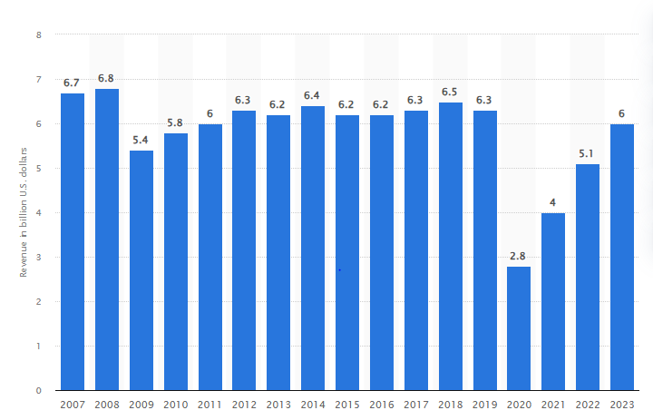
Source: (Statista, 2024).
4.4 Staffing and Operations:
The hotel maintains a workforce of approximately 150 employees who work in the front office, housekeeping food and beverage services, as well as maintenance and administration departments. The hotel organizational framework features general management at its peak, followed by department heads and supervisors beneath them, together with operational staff at the base of the chain (Baum, 2021).
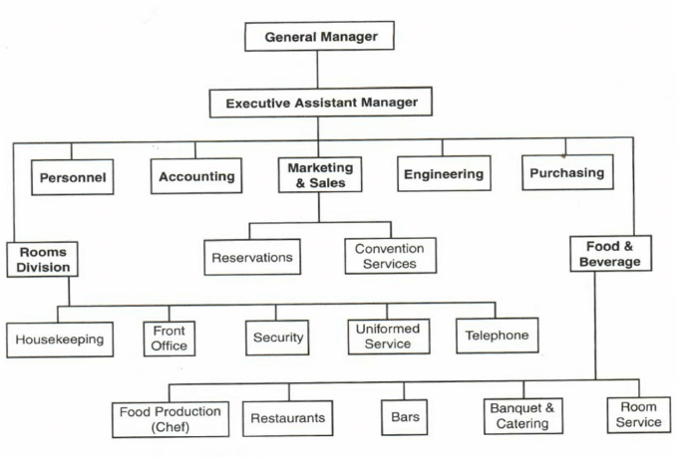
Source: Blashberg, (2024).
Employee training and professional development maintain top priority at the hotel because it enables service standards to harmonize with IHG standards. The hotel operates under a structured operational workflow that increases both service delivery and operational efficiency. The hotel uses flexible workforce approaches, including seasonal staff recruitment as well as staff skill transfers for efficient management of busy times (Nickson, 2019).
4.5 Branches and Locations:
The Holiday Inn hotel chain maintains 1202 branches worldwide, which are spread across both metropolitan and rural locations. The growing presence of Holiday Inn shows through its eight additional hotels during the last year (Statista, 2023). The Holiday Inn in Sunderland remains a part of this large network that delivers regular services next to unique facilities aimed at elevating guest satisfaction. The hotel serves as a significant asset for IHG because of its regional market importance, which supports the company's expansion across the UK region (IHG, 2023).
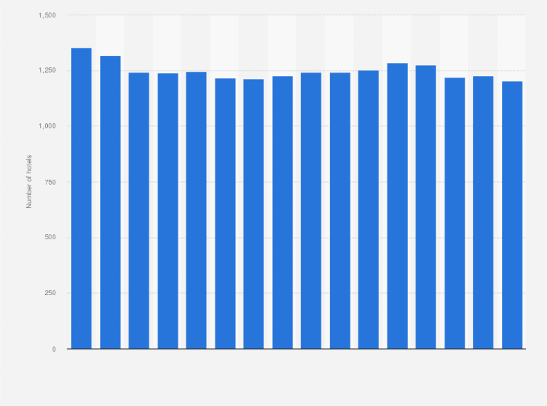
Source: (Statista, 2023).
The company aims to enhance its facilities as well as introduce new services to fulfil the changing needs of its customers in upcoming expansion phases. The hotel extends its competitive position through its involvement in IHG’s worldwide initiatives for sustainability and digital transformation projects (Chen and Dimou, 2022).

4.6 Geographical and Context of Cultural
The district of Sunderland maintains its historic industrial nature while its tourism industry expands. The hotel maintains a strategic position in the town centre, so it serves business customers, event participants, and visiting tourists who want to experience the Sunderland Empire Theatre, the Stadium of Light, and the National Glass Centre (VisitBritain, 2023).
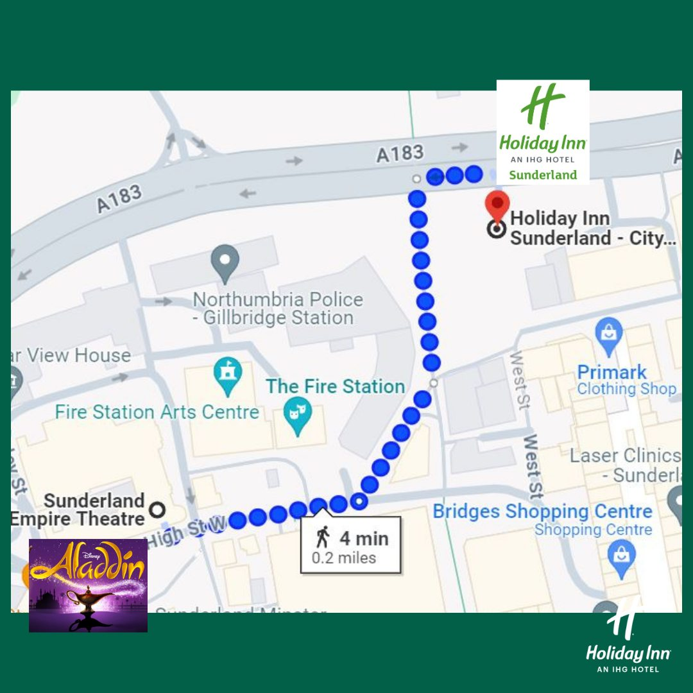
The hotel presents service options that mirror Sunderland's multicultural character through authentic local food and multi-purpose event areas suitable for cultural festivities.
4.7 Swot Analysis:
A SWOT analysis provides a strategic evaluation of Holiday Inn Sunderland by identifying its internal strengths and weaknesses alongside external opportunities and threats. This structure assists in analysing how the hotel stands versus competitors and determines its strategic growth path (Gürel and Tat, 2017).

Strength:
Holiday Inn Sunderland benefits from a strong brand reputation as part of the globally recognized InterContinental Hotels Group (IHG). Through its IHG Rewards loyalty program, the hotel builds guest loyalty, which results in higher satisfaction levels (InterContinental Hotels Group, 2023). Tourists from both business and leisure backgrounds find this hotel attractive because it provides high-quality services in a prime location along with contemporary amenities and excellent city access. The hotel advances IHG's sustainability goals, which increases its brand reputation while providing operational benefits (IHG, 2023).
Weaknesses:
The hotel operates successfully but continues to struggle with its high expenses for providing premium service options (Jones and Lockwood, 2020). The hotel experiences changing occupancy rates due to seasonal customer demand which disrupts its revenue consistency. Hotel services face difficulties in attracting cost-conscious customers because of opposing competition from local boutique hotels as well as short-term rental platforms (Brotherton, 2018). Staff member departures throughout the hospitality sector continue to be a problem that affects the consistency of service quality (Baum, 2019).
Opportunities:
The hotel has significant growth potential through market expansion and technological advancements. Adopting AI-enabled customer services like chatbot services and recommendations becomes a source of adding value for guests (Ivanov and Webster, 2019). Through green practices, the hotel can lure environmentally oriented travellers who are growing in number (Fransi et al, 2020). Local partnerships between Market House Hotel and businesses and tourism organizations will enhance its market standing while delivering multiple income sources (Morrison, 2019).
Threats:
The adverse effects of economic fluctuation, such as economic downturns and inflation, may slow down spending on travel and, hence, lower occupancy rates (WTTC, 2022). Environmental factors are those that affect the operation costs, such as new taxes, legal acts, judicial decisions, and labour relations rules (Cole, 2021). Healthy competition from international hotel brands and emerging online players is currently affecting market positions and market share (Guttentag, 2019).
4.8 PEST Analysis:
A PEST analysis evaluates the macro-environmental factors affecting Holiday Inn Sunderland by analysing political, economic, social, and technological influences. This framework enables evaluating factors outside its immediate domain that have impacts on business operations and strategy.

Political Factors:
Currently, government regulation is one of the most important aspects affecting hotels. Holiday Inn Sunderland is bound by laws governing the hospitality industry in the UK, consumer protection laws, and laws on health, employment, and safety issues, as well as environmental issues. VAT rates on accommodation and all food services fall under taxation policies that affect price and profit. Also, the Brexit deals determine the cost of imports and availability of products and services in the hotel, including human resource services. (Guardian, 2024).
Economic Factors:
The market trends, exchange rates, and overall economic stability on a regional level influence hotel performance. These macro-factors affect the formulation of an organisation’s price as well as the demand for international tourism. This could be because during a recession, individuals and businesses may spend less on traveling for business while growth brings in more domestic and international guests. Due to the current redevelopment status of Sunderland, the hotel profits from business-purpose travellers and those attending events (Times, 2024).
Social Factors:
Hospitality culture and trends are majorly influenced by consumers’ buying behaviour and culture. Currently, people look for unique experiences while traveling as well as top-quality accommodations that will suit their health standards. Thus, it can be seen that the advent of eco-tourism is a chance for Holiday Inn Sunderland to go green-oriented. Also, with the influx of millennial and Gen Z travellers, they require a user-friendly online experience, flexible purchasing approaches, and an account of their input on social media platforms (Nasha, 2024).
Technological Factors:
The use of technology to manage accommodation has been rapidly developing over the years and benefiting hotel guests. The decor, online booking apps, mobile apps, and self-serve kiosks also bring operational economies and guest satisfaction. The application of smart room technology and automatic services improves comfort and individualization in the framework of digital transformation (Max, 2024).
4.9 Competitor Analysis (Price VS Quality):
Holiday Inn Sunderland stands for evaluation against competing hotels based on price points and service delivery quality. By conducting market positioning analysis and competitor benchmarking, the hotel can improve its strategies while maintaining competitiveness against rivals (IHG, 2024).
Market Positioning:
Holiday Inn Sunderland competes with mid-range and premium hotels, as well as budget accommodations. The hotel supports competitive rates along with premium-quality service, which makes it appealing to both business customers and leisure tourists. Customers receive budget hotels at reduced rates yet receive minimal amenities and customer support. Luxury experiences in premium hotels exist as a substantially expensive option. The service package combined with affordable rates at Holiday Inn Sunderland establishes an effective customer satisfaction model (IHG, 2024).
Competitor Benchmarking:
Room rates, customer reviews, and service comparisons provide insight into competitive advantages and help find ways to improve performance. Customers have noted that Holiday Inn Sunderland triumphs in its loyal guest rewards along with contemporary accommodations and ideal positioning.

Hotel | Price (Measuring by per night) | Rate of visitors (Using 5 Likert scale) | Features
Holiday Inn Sunderland | 90 | 4.2 | Incentives Schemes, Modern Technology, Situated in City Centre
Premier Inn Sunderland | 75 | 4.1 | Cost-friendly, inadequate comforts
Hilton Newcastle | 130 | 4.4 | Luxury restaurant services.
Local Boutique Hotel | 85 | 4 | Hotel utilize modern design and customized assistance
The analysis of rivals demonstrates Holiday Inn Sunderland holds a good position in the market by providing guests with a cost-effective yet high-standard experience.
4.10 Netnography Analysis:
Netnography is a research technique that identifies the actions and attitudes of consumers through social interactions detected on the Internet (Kozinets, 2020). This analysis examines the aspect of the pro-active web presence of Holiday Inn Sunderland, the perception accorded to the brand by customers, and the influence of the discussions that are occasioned by the social media presence of the brand.
Online Presence:
Holiday Inn Sunderland operates on an official website and has a presence on social media and travel sites like TripAdvisor and Booking.com for instance, for promotional campaigns, customer inquiries and replies, etc. Website promotion and advertisement through digital media increase prospective clientele visibility (Chaffey et al, 2019).
Customer Sentiment:
Guest feedback patterns become apparent through proper analysis of online reviews. Guest comments that praise the hotel's cleanliness and friendly staff, together with its convenient area, routinely appear alongside complaints regarding intermittently slow services and the hotel's price structure (Xiang et al, 2017).
4.11 Impact on Brand Perception:
The brand image of the hotel is affected by the customer talk on digital media. An established and positive web presence is an advantage towards business popularity among customers with better chances of booking. Most customers who expressed dissatisfaction present this in their comments about a particular service or product, and by responding to them and addressing them, the overall impression given to the user can be changed for the better (Kim and Hardin, 2010).
Platform | Positive Feedback | Negative feedback | Comments
TripAdvisor | 82 | 18 | Excellent service, cleanliness, and pricing concerns
 | 85 | 15 | Comfortable stay, check-in process services are very slow
  Booking.com
Social Media | 78 | 22 | Usability, long time taken to attend to customer’s correspondence

4.12 Reflective Account
This report is a reflection on the observations made for the practical placement at Holiday Inn Sunderland. This section presents observations from the professional experience, advantages, and disadvantages, as well as main lessons learned.
Professional Observations:
Joining Holiday Inn Sunderland allowed me to experience the subsystem operations of a hotel that entail guest relations performance, teamwork, and delivery of services. Front desk, housekeeping, and food and beverage service tasks offered an appropriate view into the expectations placed on the hospitality industry. Customer relations brought out significant lessons in the need to ask questions and solve issues for the customers.
Strengths and Weaknesses:
One of the managerial competencies noted was the owner’s dedicated attention to the hotel’s cabin crew, offering a professional and polite attitude toward guests. As a result, the procedural management system adopted rendered daily operations efficient. However, there were some weaknesses, such as time delays during the busy hours of the operation and a lack of coordination between the units.
Lessons Learned:
The placement helped to unlock the importance of adequate teamwork, flexibility, and good communication, especially within the hospitality industry. The practical experience of working with the guest requests, the complaints, and the standards that are required by the company helped in my personal and professional growth. This placement has developed an understanding of the current and future scenarios needed for managing a hospitality business and the skills required for succeeding in my career.
- Discussion:
This section evaluates and synthesises the research data on the analysis of how Holiday Inn Sunderland has been managing CEM in light of earlier literature. The study also sought to assess the hotel’s conformity to IHG brand requirements, the impact that culture has on the clients’ perception of the services, and critical areas of development. This section analyses the theory touched upon, discusses the possible implications, considers the limitations, and points out the essential issues affecting hotels.
5.1 Alignment with IHG’s CEM Strategies
Findings from the Research
Research indicates Holiday Inn Sunderland follows IHG’s main customer experience management strategies through consistent branding digital services and satisfaction tracking methods. Standardized service procedures combined with the IHG Rewards loyalty program enable the hotel to improve customer retention. The strategies enable continuous guest experiences throughout all IHG hotels which leads to more loyal customers and additional reservations. The research also shows that self-service kiosks and digital concierge services have brought about check-in and check-out processes that are easy and smooth for a customer, attracting fewer lines and a shorter waiting time.
Comparison with Literature:
According to existing literature like Buhalis and Sinarta (2019), digital transformation, loyalty programs, and service consistency are the key integral components of good CEM. Providing Check-in and personalized services is also Holiday Inn Sunderland’s approach and aligns with the principles. Studies by Kim et al, (2024) also underscore that hotels that employ data-driven personalization in their services are better at engaging customers and immensely satisfied. Holiday Inn Sunderland is no different from industry trends of more automation but still gives customers a central focus. This fits in with the rest of the hospitality industry’s inclination towards digital-first solutions, which enable better operational efficiency and real-time service change in terms of customer choices.
Implications:
Branding is aligned with IHG’s CEM framework but requires continuous investment in technology and training of the staff for service quality. Standardization should produce a significantly recognizable brand experience; however, it may be impossible to train the specific requirements of local guests (Okeke et al, 2024). For Holiday Inn Sunderland, the challenge is the adoption of this global CEM policy to meet individual service enhancements that are tailored to the needs of the locality of Sunderland. According to the literature, one of the successful CEM strategies is that it should include regional preferences so that it could facilitate a closer customer connection (Gupta and Ramachandran, 2019). Staff training programs should also be redesigned to make sure employees can equally perform digital as well as traditional customer services. The ability to incorporate technological advancements yet with a personalised service is what Holiday Inn Sunderland can do to have high customer satisfaction levels while keeping a competitive advantage in the regional market.

5.2 Impact the Local Culture on Customer Satisfaction:
Findings from the Research:
The research therefore proved that various cultural and economic factors unique to Sunderland are influential in determining the guests’ expectations and level of satisfaction. It is evident that business people who are mainly concerned with productivity and order prefer organizations and therefore are content with the nature of the hotel’s organizational structure. Nevertheless, there are significant differences regarding the most appealing service types among the local tourists and leisure visitors in terms of regional identity. It will be important for these guests to be able to draw something remotely characteristic of Sunderland: furniture portraying local artwork, local cuisine, and a personalized approach that recognizes local culture (Solomon et al, 2022). This came out very clearly when it highlighted this change in expectation as having two expectations: while some of the guests look for the standardization and reliability of an IHG brand they also seek a more personal affiliation with the place.
Comparison with Literature:
These findings are supported by the literature, especially by Kim et al. (2024), who noted that customer satisfaction highly depends on the cultural factors and personalization of the services in the hospitality industry. Several academics made some recommendations regarding focusing on localisation through offering local products such as foods and localized artwork or telling local stories to let guests more engage with their feelings. This gives the visitor a value-added feel as well as helps to create a unique niche within the service delivery. Thus, it is for this reason that Pine and Gilmore (1998) have coined a theory called ‘The Experience Economy’, in which consumers rather focus on the experiences that they are offered instead of the mere services they are given. Hence, the incorporation of cultural aspects that recur in the facilities can take hotels from being a product that clients just purchase to one that transforms the customers’ lives through the experiences they offer them.
Implications:
Based on these observations, Holiday Inn Sunderland must try to balance the international image of the IHG brand and adopt the services that are acceptable in this culture. Developing a distinct service model with an accent to the specifics of the region, for instance, using local paintings and crafts, organizing local cuisine, and other local events, people can increase the gap between standardization and cultural deviations (Naudin et al, 2022). For example, the hotel could seek to host some culinary events like food fairs or source services from local craftsmen to improve the experience. The third strategy that can be incorporated is to educate the staff on cultural differences to enhance their understanding of the region and the delivery of services. These strategic adaptations would not only make the guests happy and loyal but also improve the hotel’s position in the local market. In conclusion, because brand recognition and variations related to cultural differences must always be taken seriously so that they correspond to the further needs of consumers in the selected hotel, Holiday Inn Sunderland can increase its competitive advantage in the context of the ever-developing multifaceted environment of the hospitality industry.
5.3 The Role of Workers' Engagement:
Findings from the Research:
This has been affirmed by the results of the study, which showed that employee engagement poses a significant correlation with service quality and customer satisfaction in Holiday Inn Sunderland. The research concluded that guest satisfaction increases where employees’ levels of engagement are high because employees give their best in meeting the guests’ needs. However, the organization has continued to face some challenges, some of which are high employee turnover that has a negative impact on its service delivery. The problem of employee turnover is well-known in the hospitality industry which leads to inconsistency and decline in service standards.
Comparison with Literature
This paper has been informed by the study conducted by Holllebeek, (2019) and Lee and Kim (2023) with their findings suggesting that the involvement of the employees can have a positive impact in regards to customer satisfaction. This improves productivity and services delivered because employees are active employees and committed to enhancing the entity’s goals. The role of this relationship is supported by the service-profit chain model developed by Heskett et al, (1994). When the people working in an organization are happy and involved on the job, then this normally results in the delivery of quality service to the clients.
Implementation:
To counter these problems, there is a need for greater investment in employee training, cross-utilization of employees, and major incentive programs, which could help boost the morale of the workers at Holiday Inn Sunderland. Positive employee engagement can result in improved service delivery, hence improved guest satisfaction, less turnover, and improved service delivery. The strategy of management can engage the employees of the hotel to align their visions and missions to those of the facility to ensure that a motivated team offers top-notch and quality services, hence improving customer loyalty.
5.4 Integration of the Technology in Customer Experience:
Findings from the Research:
Currently, the hotel has included touchless check-in kiosks and virtual chatbots as a way of improving guest satisfaction. There is always a section of consumers who have a problem with automation, saying that they would rather deal with a human agent.
Comparison with Literature:
According to research conducted by Aydin et al, (2025), it was revealed that if human touch is eliminated by efficiency, therefore improving the effectiveness of the system, there is a reduction in customer satisfaction. The working challenge for the Holiday Inn Sunderland is the lack of the application of technology, yet at the same time, it maintains its personalized service.
Implications
This means that there is a need to achieve a balance between the use of technology and face-to-face contact with the clients. To reduce the negative implications that arise from high automation, one can train people to work hand in hand with the tools rather than completely replace their interaction with technologies.

5.5 The Recovery of the Service and Complaint Management
Findings from the Research:
There is also a structured complaint-handling process in the hotel; however, the time taken to respond to complaints and the consistency in handling the complaints are lacking.
Comparison with Literature:
The works of Ali et al, (2021) consider service recovery efficiency to be a critical factor in increasing the guest retention rate. Singh et al, (2023) have stated that if a complaint is not handled properly, then it can harm the image of the brand.
Implications:
Better staff training, awareness, and increasing the response time for customers will prove beneficial to retain more customers. It can also make use of decisions in handling guest issues that may crop up since it entails real-time processing of results obtained from the sentiment analysis.

5.6 Limitations of the Research:
Generalizability:
The conclusions are drawn based on the case of Holiday Inn Sunderland and thus they cannot be generalized to any other IHG hotel. Leading the results or variations in this market environment might have different demographics or competitive grounds.
Constraints of the Research Methodology:
The use of a qualitative approach such as surveys from the guests and observations may also pose certain biases. Combining the study findings with more extensive research materials or follow-up research studies would improve the validity.
Data Availability:
However, since the organization is sensitive concerning operations, some vital data was off-limits to gather. Unfortunately, more elaborate data related to the company’s financial results and its customers’ classification were lacking.
5.7 Valuable Areas Critical to Placement Hotel Operations:
Personalized Service Enhancements:
This is an aspect that the hotel should incorporate because using data analytics will help enhance intrinsic customer experiences.
Strategies for the Employee Retention:
Promoting the health and care of the employees, fair remuneration policies, and career development are some strategies for staff retention and service improvement.
Adoption of the Strategic Technology:
Integration of human service and automation should therefore be optimally achieved to increase efficiency without compromising on the guests.
The framework of the Service Recovery:
The integration of the advanced complaint resolution mechanisms that will be supported by customer feedback systems that are embedded in AI will lead to better guest satisfaction and loyalty.

- Conclusion:
In conclusion, this research study delivers an in-depth exploration that reveals Holiday Inn Sunderland’s Customer Experience Management (CEM) operational success factors. Guest retention and operational efficiency improve substantially for the hotel when it thoroughly implements standardized IHG CEM framework elements such as the IHG Rewards loyalty program and self-service kiosks with AI-powered chatbots. The research shows that process optimization through technology implementation should not eliminate the personal touch that guests prefer for individualized service.
In addition, the study reveals that two important factors, local culture and economy, have a direct impact on the guests’ expectations and satisfaction. The hotel provides business travellers with professional services yet local tourists want experiences that connect them to local cultural elements, including local cuisine and cultural design alongside community involvement. A service model requiring customization should unite global brand principles with genuine local identity because these factors matter most to guests.
Another key element is introduced and termed employee engagement as a crucial determinant for service delivery. From the evidence presented, increased turnover and lack of staff motivation may result in inconsistency in service delivery while a motivated staff, well trained, with prospects of growth and associated incentives, will lead to more satisfied and loyal customers.
Key findings indicate that incorporating the major findings of this research, it is possible to conclude that the best approach for companies without compromising closer customer relationships is to use digital tools where those are valuable but keep all those aspects of business interactions that bring people closer. By competing such global standards with local variations and developing its human resources, there lies much scope and scope and business prospects in a competitive business environment for Holiday Inn Sunderland. This is important since sustainable improvement in its service delivery can only be attained when both aspects are effectively integrated with medium-term and long-run objectives being equally prioritized.
- Recommendations and Practical Strategies:
Based on the findings, insights, and experiences acquired during the placement at Holiday Inn Sunderland, a number of recommendations emerge to optimize the hotel’s operations and improve overall performance. These recommendations have been developed to resolve the essential research findings involving alignment with IHG's CEM strategies, local cultural integration, employee engagement, technological integration, and service recovery.
7.1 Enhance Integration of Global and Local Service Models:
In the local context, Holiday Inn Sunderland has completed adherence to IHG’s global CEM framework; however, the fact that a one-size-fits-all approach does not take into account local market nuances (Kim and Knuston, 2015). The hotel should bridge this gap by using a hybrid service model in which elements from global standards are combined with elements from localized standards. One idea could be to incorporate the regional dramatic aesthetic of cultural expressions into the interiors, engage with regional cuisine in eating places, and arrange events highlighting local heritage (Pina and Gilmore, 1999). These adaptations would set the property apart from the competition and be authentic to the local tourist who wishes to have an authentic experience. In addition, the hotel can improve guests’ emotional engagement and reduce repeat visitation by tailoring the guest experience (Zhang et al, 2020).
7.2 Investment in Technology Enhancement with a Human-Centric Focus:
Some of the innovations available in this category are self-serve kiosks and chatbots, all of which have boosted operational efficiency at Holiday Inn Sunderland. The research data shows that several guests continue to prefer engaging with human staff members. The hotel needs to achieve an appropriate mix of automated systems with traditional service practices (Bowen and Morosan, 2018). The hotel needs to combine technological spending with training initiatives that allow staff to function properly with digital systems. Frontline employees need training to decode and execute AI system data, which helps them provide palatable technical assistance alongside human service capabilities. Indeed, incorporating efficient statistics may help the hotel company to anticipate the desires of the guests so that proactive measures can be taken into account where necessary (Tussyadiah, 2020).
7.3 Increase Professional Development and Employee Engagement:
Employee engagement is key to good service quality. One of these challenges is high turnover coupled with a related problem of inconsistency in service delivery. The hotel should provide substantial training programs that educate staff not only on digital passports but also focus on customer service skills (Baum, 2020). Setting up planned career development programs can engage employees by letting them know what career paths are open to them (Lashley, 2018). As well as regular performance feedback, with resultant reward and recognition, can serve to improve morale. To motivate the employees, it is suggested that organizations implement incentive schemes at organizational, individual, and team levels, thereby ensuring that the workforce is prepared to foster the success of the hotel. These efforts will minimize turnover, provide better service consistency, and ultimately result in better customer satisfaction (Nazarian, 2021).
7.4 Service of Optimization and Recovery Processes:
This is the reason it is important to follow up on the mistakes made during the provision of services to the guest. The research done currently reveals that Holiday Inn Sunderland has a set procedure for handling complaints but the time taken to respond as well as the adherence to the company’s methods can still be improved upon. It is suggested that the hotel establish a strong and detailed service recovery system that is based on the real-time analysis of customers’ responses (Michel et al, 2004). The main use of AI-based sentiment analysis tools is to get first-hand information on the feelings of guests, allowing for quick action. In addition, increasing the educational level of staff by constantly holding training on conflict resolution and proactive communication lets them solve complaints more efficiently. These are areas where the hotel has the potential to turn around a negative situation and turn it into a positive aspect as a way of building trust (Khamiotiv, 2020).
7.5 Increased the Guest Feedback Mechanisms:
However, Holiday Inn Sunderland should develop even better ways of capturing and analysing guest feedback to enable positive growth and positive changes. It is key to have not only electronic feedback forms but also face-to-face communication to get a bigger picture of the guests’ experience (Oliver, 2014). Such data should be analysed with the aim of realizing the tendencies that would lead to improvements. The benefit of having a team that will review this feedback often is that it will prompt corrective action on those things that have been noted to be problematic in the operation to meet guest expectations. In addition, there is also the want to communicate to the guests how they have contributed to the improvement of the hotel services, the success of which will make them believe more in the hotel’s good intentions towards offering quality services (Dabholkar and Sheng, 2012).

References

- Acilar , K., Karamasa, C. (2024). Factors Affecting E-Commerce Adoption by Small Businesses in a Developing Country: A Case Study of a Small Hotel, International. Journal of Information Communication Technologies and Human Development, 3(3), pp; 31-41.
- Aydin, K. (2025). Chatbots to Predictive Insights: Examples of AI in Customer Service. Available at: https://www.novusasi.com/blog/chatbots-to-predictive-insights-examples-of-ai-in-customer-service. Accessed: (18 Feb 2025).
- Ali, B., Gardi, B., Othman, B.J. and Ahmed, S.A. (2021) ‘Hotel service quality: The impact of service quality on customer satisfaction in hospitality’, International Journal of Engineering Business and Management, 5(3), pp.117-132.
- Buhalis, D. and Sinarta, Y. (2019). Real-time co-creation and newness service: Lessons from tourism and hospitality. Journal of Travel & Tourism Marketing, 36(5), pp.563-582.
- Blashberg,T. (2024). Understanding Hotel Organizational Structures: Hierarchy and Roles. Available at: https://www.mara-solutions.com/post/hotel-organization. Accessed: (18 Feb 2025).
- Baum, T. (2021). Human Resource Management for Tourism, Hospitality and Leisure: An International Perspective. Cengage Learning.
- Bowie, D., Buttle, F., Brookes, M. and Mariussen, A. (2016). Hospitality Marketing. Routledge.
- Brotherton, B. (2018). Hospitality management: An introduction. 3rd edn. Sage.
- Booking.com, (2024). Holiday Inn Sunderland – An IHG Hotel. Booking.com/hotel/gb/holiday-inn-sunderland-an-ihg.html?utm_source. Accessed: (18 Feb 2025).
- Booking.com, (2024). Accommodation in Sunderland. Available at: https://www.booking.com/accommodation/city/gb/sunderland.html?utm_source=. Accessed: (18 Feb 2025). Accessed: (18 Feb 2025).
- Baum, T., Mooney, S. Robinson, R. (2020). 'COVID-19’s impact on hospitality workforce planning'. International Journal of Contemporary Hospitality Management, 32(9), pp. 2813-2829.
- Chaffey, D., Chadwick, F. (2019) Digital Marketing: Strategy, Implementation and Practice. 7th edn. Harlow: Pearson Education.
- Chen, R. Dimou, I. (2022). Sustainability and Digitalization in Hospitality: Trends and Innovations. Palgrave Macmillan.
- Cole, T. (2021). Tourism, Brexit and the climate crisis: on intersecting crises and their effects. Journal of sustainable tourism, 13(2), pp: 28-45.
- Chand, M. Gugloth, S. (2021). Employee engagement in the hospitality industry: The role of leadership and organizational culture. Journal of Hospitality and Tourism Management, 48, pp.112-123.
- Dev, C.S. Dutta, K., 2021. Artificial intelligence and the future of hotel service innovation. Cornell Hospitality Quarterly, 62(4), pp.424-438.
- Dabholkar, P.A. Sheng, X. (2012) 'The role of perceived control and customer participation in service interactions', Journal of Consumer Research, 39(5), pp. 936-949.
- Danis, L. (2021). How operators exceed guest expectations. Available: https://www.restaurantowner.com/public/How-Operators-Exceed-Guest-Expectations.cfm. Accessed: (18 Feb 2025).
- Fransi, E., Daries, N., Rosell, B., Roing, E., Fuentes, M., E. (2020). Sustainable tourism marketing. MDPI, 12(5), pp. 18-65
- Gupta, S. Ramachandran, K. (2019). Experience economy and personalization in hospitality: The role of artificial intelligence. Tourism Management Perspectives, 31, pp.43-53.
- Gürel, E., Tat, M. (2017). ‘SWOT analysis: A theoretical review’, Journal of International Social Research, 10(51), pp. 994-1006.
- Gretzel, U., Yoo, K.H. (2008) ‘Use and impact of online travel reviews’, Information and Communication. Technologies in Tourism. pp. 35-46.
- Guttentag, D. (2019). ‘Progress on Airbnb: A literature review’, Annals of Tourism Research, 75, pp. 165-184.
- Heskett, J.L., Sasser, W.E., Schlesinger, L.A. (1994). The Service Profit Chain. Harvard Business Review, 72(2), pp.164-174.
- Hollebeek, L.D. (2019). Developing effective customer engagement strategies: The role of employee training and development. Journal of Service Management, 30(5), pp.723-740.
- IHG (2022). InterContinental Hotels Group Annual Report 2022. Available at: www.ihgplc.com. Accessed: (19 Feb 2025).
- IHG (2023). InterContinental Hotels Group Annual Report 2023. Available at: www.ihgplc.com. Accessed: (19 Feb 2025).
- Ivanov, S., Webster, C. (2019) Robots, artificial intelligence, and service automation in travel, tourism and hospitality. Emerald Publishing.
- Jones, P., Lockwood, A. (2021). The Management of Hotel Operations. Cengage Learning.
- Kotler, P., Bowen, J. and Makens, J. (2017). Marketing for Hospitality and Tourism. Pearson.
- Kim, H., Hardin, A. (2010). ‘The impact of virtual experience on customer satisfaction’, Journal of Hospitality & Tourism Research, 34(3), pp. 310-328.
- Kozinets, R.V. (2020) Netnography: The Essential Guide to Qualitative Social Media Research. 3rd edn. London: SAGE Publications.
- Khamitov, M., Grégoire, Y. Suri, A. (2020) 'A meta-analysis of service failure recovery strategies', Journal of Marketing, 84(3), pp. 64-86
- Kumar, N., Kumar, R. (2020). Employee satisfaction and service-profit chain in hospitality industry: A study of Indian hotels. Journal of Hospitality Management and Tourism, 11(2), pp.1-12.
- Kim, H., So. F., and Li, J. (2024). Artificial Intelligence in Hospitality and Tourism: Insights from Industry Practices, Research Literature, and Expert Opinions. Sage journals, 49(2), pp. 115-126.
- Li, J., Bonn, M.A. and Ye, B.H. (2019). Hotel guest experience and artificial intelligence: A case study of chatbots in hospitality. International Journal of Hospitality Management, 83, pp.169-178.
- Lee, M., Kim, B. (2023). Effect of Employee Experience on Organizational Commitment: Case of South Korea. Behavioral Science, 13(7), pp: 521-584.
- Lashley, C. (2018) Hospitality management: Critical perspectives. Routledge.
- Mekonnen, A., O’Mahony, B., Ryan, B., 2018. The influence of service quality dimensions on customer satisfaction in the hospitality sector. Journal of Hospitality and Tourism Research, 42(7), pp.1003-1021.
- Max, E. (2024). Detailed PESTEL Analysis of Hotel Industry. Available at: https://www.edrawmax.com/article/hotel-industry-pestel-analysis.html. Accessed: (19 Feb 2025).
- Mat Zain, S.N.S., Ramli, N.A. and Adnan, R.A. (2022) 'Customer sentiment analysis through social media feedback: A case study on telecommunication company', International Journal of Humanities Technology and Civilization, 7(2), pp. 54–61.
- Minkwitz, A. (2018) 'Tripadvisor as a source of data in the planning process of tourism development on a local scale', Turyzm/Tourism, 28(2), pp. 49–55.
- Morrison, A.M. (2019) Marketing and managing tourism destinations. 2nd edn. Routledge.
- Nguyen, N., Lee, K. and Sirgy, M.J. (2020). The impact of AI-driven personalization on guest satisfaction in hotels. Journal of Consumer Marketing, 37(5), pp.637-650.
- Michel, S., Bowen, D.E. Johnston, R. (2009). 'Why service recovery fails: Tensions among customer, employee, and process perspectives', Journal of Service Management, 20(3), pp. 253-273.
- Mousavi, P., Shamizanjani, M., Rahimnia, F. Mehraeen, M. (2024) 'A metrics-driven approach for customer experience management evaluation: The case of commercial banks in developing countries', The TQM Journal, 37, British University in Dubai.
- Nahas, N., Mendiolea, J., Sinh, Y., Cattouf, N. (2024) The rise of luxury hospitality: Trends & differentiators for luxury hotel operators. Available at: https://www.adlittle.com/en/insights/viewpoints/rise-luxury-hospitality. Accessed: (19 Feb 2025).
- Nazarian, A., Atkinson, P. Foroudi, P. (2021) 'Employee engagement and service quality in hospitality: The mediating role of organizational culture', International Journal of Hospitality Management, 94, 102849.
- Nickson, D. (2019). Human Resource Management for the Hospitality and Tourism Industries. Routledge.
- Naudin, A., Zemīte, I., Hermane, A. (2022) 'A framework for exploring cultural and creative industries in regional contexts: The role of cultural intermediaries', Letonica, (46), pp. 36-51.
- Parasuraman, A., Zeithaml, V.A. and Berry, L.L. (1988). SERVQUAL: A multiple-item scale for measuring consumer perceptions of service quality. Journal of Retailing, 64(1), pp.12-40.
- Okeke, N. I., Alabi, O., Igwe, A. N., Ofodile, O. C. (2024). 'Customer-Centric quality management: A framework for organizational excellence in SMEs', International Journal of Management & Entrepreneurship Research, 6(10), pp. 3517-3540.
- Oliver, R.L. (2014) Satisfaction: A behavioral perspective on the consumer. Routledge.
- Pine, J., Gilmore, J.H. (1998). Welcome to the experience economy. Harvard Business Review, 76(4), pp.97-105.
- Prentice, C., Wang, X., Loureiro, S., M., C. (2020). The influence of digital service quality on customer experience and engagement. Journal of Hospitality Marketing & Management, 29(7), pp.836-853.
- Pine, B.J. Gilmore, J.H. (1999). The experience economy: Work is theatre & every business a stage. Harvard Business Press.
- Rather, R.A., Hollebeek, L.D. and Bhagat, S. (2019). Customer experience and engagement in the hotel industry: Examining the mediating role of satisfaction. International Journal of Hospitality Management, 81, pp.30-40.
- Singh, V., Sharma, M.P., Jayapriya, K., Bonda, K.K. (2023). ‘Service quality, customer satisfaction and customer loyalty: A comprehensive literature review’, Journal of survey in fisheries Science, 10(4S), pp, 3457-3464.
- Statista, (2024). Gross revenue of Holiday Inn hotels worldwide from 2007 to 2023. Available at: https://www.statista.com/statistics/223345/holiday-inn-hotels-revenue/. Accessed: (19 Feb 2025).
- Sparks, B.,A., Browning, V. (2011) 'The impact of online reviews on hotel booking intentions and perception', Tourism Management, 32(6), pp. 1310-1323.
- Statista, (2023). Number of Holiday Inn hotels worldwide from 2008 to 2023. Available at: https://www.statista.com/statistics/223362/number-of-holiday-inn-hotels/. Accessed: (19 Feb 2025).
- Sunderland City Council, (2023). Sunderland Tourism Report 2023. Available at: www.sunderland.gov.uk. Accessed: (19 Feb 2025).
- Sutton, J. Austin, Z. (2015) 'Qualitative research: Data collection, analysis, and management', The Canadian Journal of Hospital Pharmacy, 68(3), pp. 226–231.
- Singgalen, Y.A. (2025). 'Uncovering service gaps in hospitality: A thematic analysis of guest reviews for service quality improvement', Journal of Business and Economics Research (JBE), 6(1), pp. 105–117.
- Solomon, E. N.-A., Adu-Debrah, L., Braimah, M. (2022). 'Promoting tourism destinations through storytelling', in Global perspectives on strategic storytelling in destination marketing. Hershey, PA: IGI Global, pp. 117-135
- The Guardian, (2024) NICs rise will force businesses to close, warn hospitality bosses. Available at: https://www.theguardian.com/business/2024/nov/10/nics-rise-will-force-businesses-to-close-warn-hospitality-bosses. Accessed: (19 Feb 2025).
- The Times, (2024). £250 a night? How tax rises will hit staycation plans this year. Available at: https://www.thetimes.com/uk. Accessed: (19 Feb 2025).
- Touni, R. and Magdy, A. (2020). ‘The application of robots, artificial intelligence, and service automation in the Egyptian tourism and hospitality sector (possibilities, obstacles, pros, and cons)’, Journal of Association of Arab Universities for Tourism and Hospitality, 19(3), pp. 267–288.
- Tussyadiah, I. (2020) 'A review of research into automation in hospitality services', International Journal of Hospitality Management, 89, 102526.
- VisitBritain, (2023). UK Travel and Tourism Report 2023. Available at: www.visitbritain.com. Accessed: (19 Feb 2025).
- Verhoef, P.C., Kannan, P.K. Inman, J.J. (2015) ‘From multi-channel retailing to omni-channel retailing: Introduction to the special issue on multi-channel retailing’, Journal of Retailing, 91(2), pp. 174-181.
- World Travel & Tourism Council (WTTC) (2022) Economic impact report 2022. Available at: www.wttc.org. Accessed: (19 Feb 2025).
- Wirtz, J. & Mattila, A. (2004) 'Consumer responses to compensation, speed of recovery and apology after a service failure', International Journal of Service Industry Management, 15(2), pp. 150-166.
- Xiang, Z., Schwartz, Z., Gerdes, J.H. Uysal, M. (2017) ‘What can big data and text analytics tell us about hotel guest experience and satisfaction?’, International Journal of Hospitality Management, 68, pp. 102-117.
- Zhang, H., Zhang, J. Law, R. (2020) 'Local cultural integration in hotel experiences: Impact on customer engagement and loyalty', Tourism Management, 81, pp. 104 -134.

