

Problem Solving and Decision Making
Carl Mitchell 1806399

March 29, 2019
University of Wales Trinity Saint David

BMSK 4004

Executive Summary
The purpose of this report is to provide an overview of the Tesco case study which will discuss the development and description of its current portfolio. This will also discuss how Tesco has planned and actioned any previous attempts to solve its problems. This will further cover any impacts facing the company as well as methods that can be put into use to analyse the causes of problems using SWOT and PESTLE analysis. The stakeholders will be listed as well as analysed, this will all then be followed by a conclusion identifying the main issues that Tesco face. Once all the problems have been identified, possible business option can then be suggested to Tesco decision makers.
These methods will identify problems like Brexit, the Sainsbury’s and ASDA merger, how to cope with the threat of losing its top position as the number one supermarket due to the shift of customers shopping at discounted stores Aldi and Lidl, the possibility of having to cut costs and certain departments.
This will also identify Stakeholders, who is affected, who is interested and what level of power these Stakeholders have that may affect the business.
Once displaying these methods used to plan and identify the impact of the business, several suggestions will be put forward to TESCO’S decision makers.

Contents
Problem Solving and Decision Making 0
BMSK 4004 0
Executive Summary 1
Terms of Reference 3
Introduction 4
Findings 5
Overview Of TESCO 5
Previous plans and uses of TESCO to resolve problems 6
Nature, Scope and Impacts of problems TESCO currently faces. 7
PESTLE analysis 9
PESTLE ANALYSIS OF TESCO 10
SWOT ANALYSIS OF TESCO 11
STAKEHOLDER ANALYSIS 13
Fishbone Analysis 15
Conclusion. 16
References. 17

Terms of Reference
This report was requested by Tahir Mushtaq on January 2019. The purpose of the report is to recognise problems, identify causes using certain methods. This will also show use of such methods to identify Shareholders, Stakeholders, possible problems and offer ways to suggest solving the problems identified. This report was compiled by Carl Mitchell. Submission date 29th March 2019.

Introduction
This report will make use of the TESCO case study to identify problems and causes and how the company has dealt with its problems in the past. The report will use several methods that can identify the problems, causes and possible solutions based on the case study. It will also foresee possible impacts of the problems identified. Further analysis will then identify ways to solve the problems that can then be suggested to TESCO’S problem solvers.

Findings

Overview Of TESCO

TESCO is a well recognised brand that has grown in profit and floor space over the years. The main strategy was to make affordable food available to everyone as well as expanding and introducing new sales tactics like self-service stores and supermarkets offering its customers a wider product range within the economy. When faced with competitors trying to offer the same service of selling goods at lower prices, TESCO introduced GREEN SHIELD stamps enabling loyalty and customers to trade stamps for products. Once superstores were starting to develop, TESCO began opening their own petrol stations in the 70s with lower priced fuel. Once the price wars began in the 80s The Checkout 82 was introduced to reduce 1500 food item prices by between 3% and 26% also encouraging customers to eat healthily. TESCO further links with the social environment with the Computers of Schools scheme.
In the 90s they go on to develop small local stores forcing smaller shops out of the market due to the inability to compete with the low prices TESCO offers as well as entering the electric goods market. 1.3 million more customers were gained due to the ‘Every Little Helps’ line as well as the One in front initiative cutting queues by 45%. Later TESCO announces major expansion into Europe. In the 95 the Clubcard was launched, attracting 5 million customers in the first year, overtaking Sainsbury’s.
In the late 90’s TESCO began offering savings accounts, finest range. In the 2000s TESCO launches their online shopping site including the re-launch of Clubcard with Double up vouchers followed by 2010 initiatives like TESCO VALUE, Mortgages, Bag charges, free fruit instore for children. 2018 sees the merge with Booker Group to launch JACK’S aiming with the message to bring great tasting foods at lowest possible prices.
TESCO is now under threat due to a proposed merger with Sainsbury’s and Asda as well as Brexit bringing the CEO under pressure to cut cost with middle management, fresh product lines risking losing loyal customers who spend more as well as its leadership position due to customers shopping at Aldi and Lidl.

Previous plans and uses of TESCO to resolve problems
On the Hubspot website, Clifford, C (2019) explains rational decision making uses objective data analysis and logic as opposed to intuition and subjectivity to solve problems and reach a goal making use of a step-by-step model to help identify problems and find multiple solutions or alternatives to find the answer. It is an important skill to have, people are inherently emotional meaning beliefs and biases can cloud our judgment. Using data can sharpen our view, showing how the customers or audience interacts or uses a brand, liberating us from relying on assumptions of what the consumers like.
Clifford, C (2019) shows us 7 easy steps of a Rational Decision-Making Model.
1 Verify and define your problem.
2 Research and brainstorm possible solutions for a problem.
3 Set standards of success and failure for possible solutions.
4 Flesh out possible results of each solution.
5 Chose best solution and test it.
6 Track and analyse the results of your test.
7 Implement the solution if it solves the problem, if not then test a new one.

Reviewing the TESCO case study as well as using the 7 steps Decision Making Model above its clear that the best data to use to solve the problems were from the consumer and TESCO’s competitors, analysing data from trends in the market, prices, the economy at the time even the simplest way of gathering data can range from customer feedback forms, questionnaires to reviewing complaints and concerns to basically focus on the consumer’s needs.
Solutions seem to focus on bringing in the widest range of consumer possible by means of expansion, affordable prices, wider range of products, healthy range of foods, loyalty schemes, less queues, opening petrol stations with cheap petrol to gain even more consumers who can then use the supermarkets to spend more, developing TESCO extra, entering the electrical goods market, a clothing range, offering savings accounts as well as building a good social reputation with schemes such as ‘Computers of schools’. Another solution TESCO implements, monitors and reviews, that seems to work well is renaming or re-branding their loyalty scheme as well as customer initiatives from ‘every little helps’, ‘one in front’ to ‘Jack’s’.

Nature, Scope and Impacts of problems TESCO currently faces.

The Australian Transport website (2016), explains Problem assessment, which is assessing the scale and extent of a problem as well as understanding the cause and effect of the problems. Failure to do so can result in a mismatch of problems and solutions which won’t adequately solve the problem in the long term. There are 3 key steps in assessing a problem.

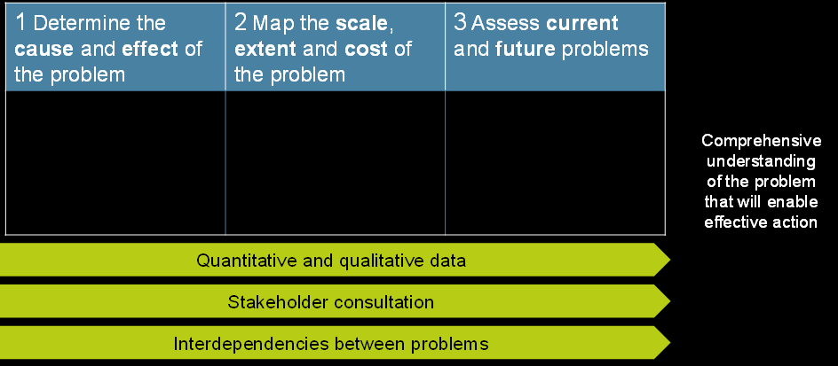
https://atap.gov.au/framework/problem-identification-assessment/3-stage-2-assessment.aspx
Cause and effect of the problem: To understand the cause and effect of a problem is to probe the explanations or fundamental causes rather than the symptoms.
Scale, extent and cost of the problem: Once cause and effect is identified, systematic mapping is needed to understand the scale and extent of the problem and the costs by using the best quality data.
Current and future problems: Accurately describe the content the current problem has, this shouldn’t be limited to just problems but examine constraints on opportunities.
So just by the looking at the TESCO case study, these are the problems that TESCO face.
Their position of the number one supermarket is under threat by the merger of Sainsbury’s and ASDA. The CEO and board of TESCO are under pressure due to the Brexit issue bringing uncertainty with food supplies from Europe. Reports form the Guardian suggesting a cost cutting strategy involving staff and fresh product lines. Removing middle management and departments that limited in opening hours of stores. Customer loyalty and sales may be affected form the loss of certain departments. Tesco may lose leadership position due to customers shopping at discount stores like Aldi and Lidl.
So even though the main problems are identified, use of a Decision making model and other methods can give the most effective solutions but use of a problem assessment can give insight into the following factors for TESCO’S problems.
How big a problem is: ranging from Sales, profit, image, position in the market and accessibility of product.
Who it affects: Customers, Staff, Stakeholders, Shareholders, people in the community, Suppliers, Local businesses as well as competitors.

Further models can be used to identify causes of problems TESCO currently face as well as persons or parties that may be affected by TESCO’S problems including cause and effect when possible solutions are considered.

PESTLE analysis
Marmol (2105) informs us in his book PESTLE ANALYSIS the definition uses 6 Variables, that uses the acronym formed by the initials of the 6 categories that are included in the model allowing managers to identify macroeconomic variables which can be considered when developing opportunities against risks. Some authors agree that the first origins of the appearance of pestle were found in the book Scanning the Business Environment published in 1967 by Francis j. Aguilar it was later developed in the 70’s and 80’s by notable authors like Liam Fahey, Vadake K. Narayannan and Arnold Brown. Marmol (2015) explains the 6 variables below.
Political variables: This refers to the political trends in a government, country, monetary policy etc.
Economic variables: Even though a company has no power to change the situation in the economy, it can prepare itself to deal with future changes by observing the country’s evolution.
Socio-cultural variables: To conquer a market it is essential to know the trends and characteristics of the population, this can include history, roots, traditions as well as media.
Technological variables: Experts in technology worldwide are working to improve processes that are already in use. The key to successful observation using technology is to question the product continuously and processes that are involved.
Legal variables: It is essential to stay informed of regulations. These can be labour and trade laws.
Environmental variables: The position and development are increasingly at the heart of most debates with Issues like waste, increasing population, climate change and pollution.

PESTLE ANALYSIS OF TESCO
Below using the information provided by the PESTLE analysis 3 Variables will be used with the TESCO case study to identify key issues or problems.
The 3 variables are:
Economical factor: Constantly observing where and when it is a good investment overall to establish itself in a certain area or country by gathering data from the growth of the country so for example if the there is an increase of car drivers in an area that has been looked into then a strategic way for TESCO to capitalize on this is to increase how many garages they can create with stores or superstores. They may also consider how the quality of food consumed in the area is and consider healthy, high quality or even discounted items. Also, with the threat of BREXIT it would be a good idea to practice these observations on other countries outside Europe to see if any opportunities arise that may be something to consider in the future.
Social factor: The better the means of communication to keep up to date with new trends, habits, history and traditions as well as media is essential to a company to control the market for EG: when referring to the TESCO case study the Guardian reported that TESCO is “likely” to embark on a new cost cutting strategy. Not definite and not maybe. So, the statement doesn’t necessarily mean a guarantee that TESCO will cut costs. This before it actually happens can cause shoppers to assume the information is true and shop elsewhere as well as potential job seekers being put off if prospects of not going higher up the career ladder due to management cuts. So other than observing what trends, needs of certain individuals etc, it is also essential to be self-aware of what the people in the social factor are saying about your company and how you present yourself to them.
Technological factor: Technology can be used to constantly improve as well as create more possibilities. For E.G. when green stamps were introduced so customers could spend the advantages were to buy stuff with them, however the main disadvantage was that it was possible for a person who had never used TESCO to spend them thus not ever having the TESCO experience, but now with the Clubcard it is more likely that the customer has shopped before to increase loyalty. As with the price wars, technology had to be used as efficiently as possible to calculate the 1500 food items as well compare with competitive brands. The key to using technology is to constantly review the product, scheme and process to find ways to improve them.

SWOT ANALYSIS OF TESCO
Morrison (2016) gives a brief history on the SWOT analysis and informs that it is credited by Albert Humphrey from his research project in the 60’s and 70’s, compiling data from several companies to identify key areas that the SWOT analysis tool could explore. The aim of a SWOT analysis is to reveal your competitive advantages. Analyse your prospect for sales, profit and product development. Prepare the company for problems and allow development for contingency plans.
The Healthcare Success website (2109) shows a simple diagram of the SWOT Analysis matrix including the 4 quadrants with examples.
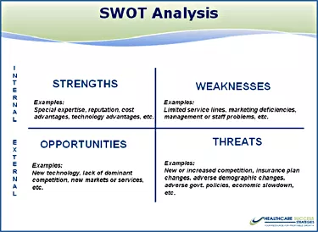
https://www.healthcaresuccess.com/blog/medical-advertising-agency/swot.html
Durosko, C. (2011) writes in his journal that a business can be only as good as its weakest link, focus on the strengths or minimize the weaknesses allowing better identification on what to work on. This can be used on any of a management team, company, service or product. It can provide lots of information before a strategic plan can be put into place using the steps below.
Strengths: Mostly within your control and may have a high rating with satisfaction and customer ratings.
Weaknesses: Also, within your control with area that can have the need for eliminating or improvement.
Opportunities: Can be long or short term that require brainstorming, usually the opposites of weaknesses but instead of focusing on how as to more of what can be done now.
Threats: Can be outside your control but also has an impact on the business but can also lead to new ideas.
So, using the example of the Swot Analysis matrix with the examples of the 4 quadrants as well as most effective ways for use, this can now be used with the information with the TESCO case study, resulting in the findings below.

TESCO SWOT ANALYSIS.

INTRENAL
STRENGTHS WEAKNESSES
Well recognised. Lots of stores. Price wars affect sales.
More product range. Loyalty schemes. Forced to reduce prices.
Openning up petrol garages. Reputation of forcing small businesses
Recognised as largest supermarket. closures.
Expanded in Europe. Online shopping. Relies on certain departments for certain
custom and sales.

OPPORTUNITIES THREATS
Encourage more healthy eating and Competitors and supermarkets.
other trends. Local stores and communities.
Other social and environmental projects. Sainsbury’s and ASDA merger.
Re-brand loyalty schemes and other BREXIT threatens supplies of fresh product.
customer incentives. Cost cutting strategy could lose clients to
Further rewards with savings accounts for E.G. rival companies.
Life insurance, motor insurance. Less incentive for staff progression if middle
Could introduce discounted department or stores. management are cut due to costs.
Shift in customers shopping at discounted
stores Aldi and Lidl.
EXTERNAL

As the SWOT Analysis shows, several elements have been identified in each of the 4 quadrants.

STAKEHOLDER ANALYSIS
TESCO has many stakeholders some are know as internal stakeholders and some are external stakeholders.
On the ebooklibrary.org, the world heritage Encyclopedia explains that stakeholder analysis is the process of identifying individuals who are likely to be affected or can affect an action the company may propose to take and sorted into sections according to the impact of the action and impact the action will have on each of them. A project plan is needed to address the stakeholders with the analysis of an issue to ensure that all affected are considered but varies between demand and balancing the information given.
On the Stakeholdermap website, Morphy, T (2008), tells us that in the book, Strategic Management: A Stakeholder Approach published in 1984, R. Edward Freeman set the agenda which has now become known as Stakeholder Theory which R. Edward Feeman, explains in his video on the site that the theory gives the idea of how business really works. A successful business needs to create value for supplier, customers, employees, financiers, communities, shareholders. Don’t look at a stakeholder as if they are isolated, meaning that their interest’s need to go together with the business and the company manager to work out how the stakeholder’s interest fits in.
Using this information, the TESCO stakeholders can be identified:
Internal: Employers. Employee’s. Shareholders. Owners.
External: Suppliers. Customers. Community. Governments. Banks. Pressure groups. Homeowners. Financiers. Social media. Newspapers.
Serra (2014) says that the most famous and widely used model to analyse your stakeholder’s power and interest is the Mendelow’s Matrix which divides your stakeholders into four groups recommending a specific type of treatment for each group. Below is and example of the matrix.

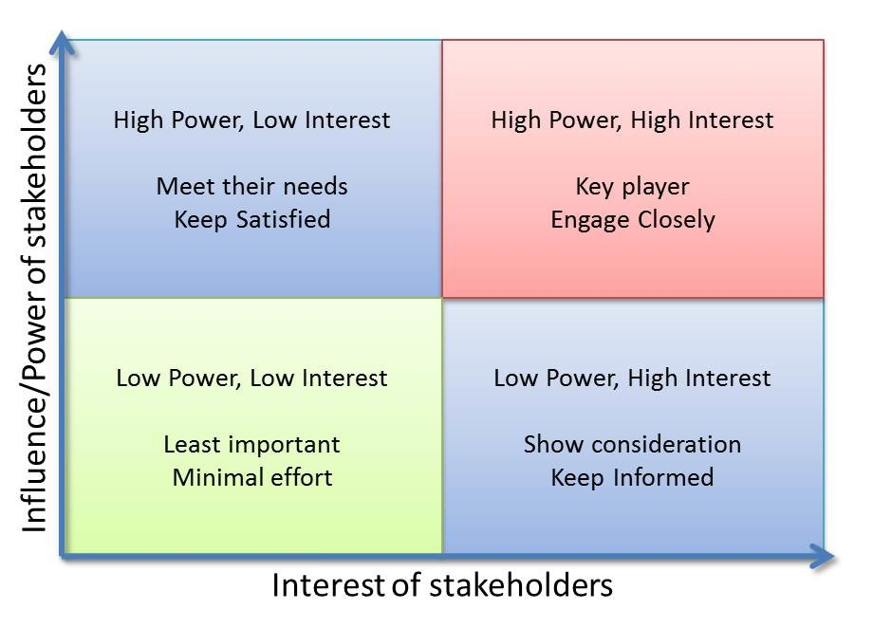
https://www.linkedin.com/pulse/20141209102103-26759263-stakeholders-analysis-power-influence-interest-matrix
Using all the information on Stakeholder analysis and combining the Stakeholder’s identified in TESCO’S case study, they can now be put into Mendelows Matrix as shown below.

Level of Interest
Low High
Minimal Effort Keep informed
Social media Employee’s
Low Newspapers Employers

Power
Keep Satisfied Key Players
Suppliers Shareholders
High Customers Owners
Banks and homeowners Government
Pressure groups Financiers
Communities

A SWOT Analysis can also be used on the Stakeholder’s identified, the results found are:
Strengths: Suppliers. Loyal customers. Employee’s and Employers. Financiers. Shareholders. Banks.
Weaknesses: Social Media. Newspapers.
Opportunities: Homeowners. Communities.
Threats: Pressure groups. Government.
Some Stakeholders in the Swot Analysis can change depending on a given situation for example: If TESCO were facing a crisis then social media and the newspapers would pose as a threat but if there was a new customer incentive, product or community involved scheme then this could then become an opportunity.

Fishbone Analysis
Desai, Desai and Ojode (2015) explains that the Fishbone or Ishikawa diagram which are used for cause and effect and appear as a fish skeleton, devised in the 60’s by professor Kaoru Ishikawa, these are represented in graphic diagrams of causes and effects of a problem that needs investigating. This breaks down the causes of a problem into elements and helps the problem solver to gather some ideas to causes of the problem. So, if you use a problem TESCO faces for example, cost cutting. The possible causes can be put into a Fishbone diagram as so.

Competitors Profit People

More discounts Loss in fresh food sales Loyalty not enough
Mergers Too many staff
In same area

Money spent in other area Price wars Cheaper options Cost cutting
Open wrong time Future limited supplies - Too much waste
Open too long From Brexit issue

Department Prices Product
So, a few causes can be identified with the Fishbone Analysis giving the effect of reverse engineering any given problem to the possible causes.

Conclusion.
After using all the methods, several problems, causes and possible solutions have been identified as well as Stakeholders that can affect the business or can be affected by the decisions that TESCO may undertake to solve these problems. The main issues that are clearly identified that TESCO faces are:
The possible threat of Brexit.
Cost cutting.
The Sainsbury’s and ASDA merger.
The shift in customers shopping at discounted stores like Aldi and Lidl.
How to keep customers spending.
How to keep their number one supermarket position.
How to satisfy as well as keep informed the identified Stakeholders.
Looking at all the information based on the report several business options can now be put forward to TESCO’S decision makers to resolve these problems.
The threat of Brexit can be monitored but TESCO could look for suppliers in other countries outside of Europe and make propositions to countries before competitors act first.
Cost cutting can be controlled but rather than do this on a large scale the best recommendation is to test the strategy to close departments and cutting middle management is to test a few stores as to monitor the situation to see if customers are lost due to going elsewhere. Identify what works for the store as well as low risk to the Stakeholders. Some areas may not need to cut costs depending on the location, competitors in the area or trends that the population have.
The Sainsbury’s and ASDA merger can be solved with the cost cutting strategy to a certain extent if the results are promising, if not then investigate the rival companies, even use SWOT analysis to see what they do well and what they do wrong to see if there are opportunities for TESCO to cater for customers that may shift to shop for them.
To keep customers spending there could be more loyalty options, review through transactions the most popular items are and strategically place these at the back of the store, so customers need to go through a good percentage of the store and possibly spend more before they get what they came for.
To satisfy the Stakeholders TESCO need to keep informed and satisfy them accordingly, so the test area or test store option can identify issues and opportunities that can be prevented or capitalised on with the lest impact and risk to the Stakeholders. This can then be used in the future when TESCO needs to solve the problem on a larger scale.
Even though TESCO’S number one position is under threat, if most or all of these problems were solved with the options put forward then TESCO should keep their position as well as their customers.

References.
50MINUTES.COM (2105) PESTLE Analysis: Understand and plan for your business environment. Management & Marketing. [Online]. Available at: https://books.google.co.uk/books/about/PESTLE_Analysis.html?id=h_uQCgAAQBAJ&redir_esc=y (Accessed: 24 March 2019).

Australian Transport (2016) Problem assessment https://atap.gov.au/framework/problem-identification-assessment/3-stage-2-assessment.aspx (Accessed: 22 March 2019).

Chi, C. Hubspot.com (2019) Rational Decision Making: The 7-Step Process for Making Logical Decisions https://blog.hubspot.com/marketing/rational-decision-making (Accessed: 22 March 2019).

Desai, K. Desai, M. Ojode, L. (2015) ‘Supply Chain Risk Management Framework: A Fishbone Analysis Approach’, 80 (3), (1, July), pp.35-36.

Durosko, C. (2011) ’Professional Remodeler; Arlington Heights’, Using a SWOT analysis to improve your remodelling business (June 2011), pp. n/a. https://search-proquest-com.ezproxy.uwtsd.ac.uk/docview/1277981509/41F2BBD54D4936PQ/5?accountid=130472

Healthcare Success (2019) SWOT: The High-Level Self-Exam that Boosts Your Bottom Line https://www.healthcaresuccess.com/blog/medical-advertising-agency/swot.html (Accessed 24 March 2019).

Marmol, D. (2105) PESTLE Analysis: Understand and plan for your business environment. Lemaitre Publishing.

Morphy, T. (2008) Stakeholder theory https://www.stakeholdermap.com/stakeholder-theory-freeman.html (Accessed: 28 March 2019).

Morrison, M. (2016) Swot analysis (TOWS matrix) Made simple https://rapidbi.com/swotanalysis/#comments (Accessed: 24 March 2019).

Serra, C. (2014) Stakeholder Analysis: Power/Influence-interest Matrix [Online] https://www.linkedin.com/pulse/20141209102103-26759263-stakeholders-analysis-power-influence-interest-matrix (Accessed: 28 March 2019).

World Heritage Encyclopedia. (2019) World eBOOK Library ‘Stakeholder Analysis’ [e-book]. Available at: http://www.ebooklibrary.org/articles/stakeholder_analysis (Accessed 25 March 2019).

