

ECPS6001: Psychology Empirical Project
Research Proposal

Student Name and University ID number: | Zach Evans 2205439
Proposed Supervisor’s name: | Dr Judith Marshall

Psychology Research Area (tick all that apply)

Social Psychology  ✓ | Developmental Psychology | Biological Psychology | Forensic Psychology
Health Psychology | Individual Differences | Educational Psychology | Political Psychology
Cognitive Psychology | Clinical Psychology | Counselling Psychology | Occupational Psychology
Other: indicate briefly

Proposed Study Design (tick all that apply)

Quantitative | Experimental | Applied (with UWTSD students | Online Questionnaire Survey
Qualitative ✓ | Quasi Experimental | Focus Groups ✓ | Online
Mixed Methods | Applied (with external organisation) | Interviews | Lab-based study
If Applied, and involving an external organisation, please indicate your plans for gaining appropriate approvals from the organisation: (not included in the word count) |  | Other study design: indicate briefly (not included in word count)

Undergraduate perceptions of the threat of environmental change and their sense of wellbeing: a qualitative study using focus groups.

Background
Research using social representation theory regarding the general perceptions of climate change and how that affects an individuals sense of well-being is crucial, in understanding a person’s drive to support or ignore the fight against environmental change. The reasoning to why social representation theory has been chosen is due to its long history of being a proven and successful way to analyse the ways in which people think: “Social representations theory provides many valuable tools with
which to prise open the dialectic of psychological processes and social practices and so
examine the legitimization of different knowledge systems” (Howarth, 2006). It is important to understand how an individual forms their own perceptions of the climate emergency so that scientists and governments can properly get the message across: “The way climate change information is created and disseminated … impacts on how we engage different segments of the general public in the climate change debate” (Crona, Wutich, Brewis, & Gartin, 2013). The ways in which individuals interact and their exposure to the climate emergency all effect their perceptions on their ability to “anchor” (Moscovici, 1988) information to develop a full sense of the climate emergency. Many studies highlight the differences between anchoring the threat of climate change and their overall objectification of the threat: (Atzori, Fyall, Tasci, & Fjelstul, 2019), (Moloney, et al., 2014), (Hoeijer, 2010), (Chen, 2019). Therefore, following these studies there is a clear real world link between the ability to anchor and objectify key information about climate change and a person’s overall perception; whether or not they perceive climate change as a serious threat. To further expand upon these studies the rationale of this study is to further understand people’s perceptions of climate change and how then that relates to their sense of well-being using social representation theory to support the analysis of participants.

Please state the main research question(s) or hypotheses(s):
- Do those who have a high understanding of climate change feel more emotional effects because of it?
- What are the reasons to why they feel these positive/negative emotional effects?

Undergraduate students who have very little knowledge of the threat of climate change will have a higher sense of wellbeing when discussing climate issues.

Methodological Details

Participants
The participants will be undergraduate students who are all over the age of 18 and are currently studying psychology or psychology and counselling at UWTSD. All students will be taken from levels 4 and 5 and will be sign up using the Experimental Management System (EMS). The participants will sign up of their own free will and will be placed in one of two focus groups ranging from sizes of 4-10 participants depending on how many sign up for the two focus groups.

Design
Using qualitative research methods and social representation analysis. The independent variable will be the different articles/images that will be presented to participants depicting different examples of climate emergencies or opinions about them. The dependant variable will be the participants views and opinions and how that relates to their sense of well-being.

Participants responses to the stimulus/ questions will all be recorded and a transcript shall be created with each participant being coded as a number e.g. participant 1, participant 2, participant 3. The transcript will allow a clear route to analysing participants qualitative data using the appropriate method of social representation analysis to search for patterns and links e.g. their sense of “anchoring” and “objectification” of their responses to the stimuli. Participants will all be allowed access to the stimuli (Articles/images) in order to gather the desired effect of a discussion/debate to collect the qualitative data needed to analyse. The articles/images will be used to start a debate between participants and through different prompts e.g. What actions do you think local communities or governments are taking to combat climate change? It will aim to answer the first research question by gaining an understanding of how aware they are of the climate emergency and what steps are being taken to combat it and then how they feel about this. Other prompts will be used to answer the second research question e.g. What can be the reason to why people feel so passionately about climate change?. This will allow for a deeper understanding into the rationale of the different participants and why they have certain beliefs on climate change.

Materials
The materials that shall be used are a series of images/articles used to support debate and discussion amongst the focus group (See Appendices 1). Other materials that shall be used include a consent and demographics form. A recording device shall also be used in order gather the needed data and shall be analysed using the social representation analysis (Moscovici, 1988).

Procedure
Participants will be required to complete the study in person in a pre-determined room. Following the completion of a consent form participants will then be shown the stimuli (Articles/Images relating to climate change). After this the participants will be asked a series of questions following the different prompts e.g. What particular article did you find stood out most? Participants will be prompted to take part in open debated with the different prompts there to help guide the discussion to remain on topic. Once all prompts and questions have been asked and the focus group concluded after 45 minutes participants will be given a debrief form and asked if they have any questions.

Key Ethical considerations

Participants will be subjected to potentially distressing and upsetting Images or discussions due to the topic of the study therefore, it is paramount that a full debrief process is followed in order to prevent any risk of harm to the participants with participants all having the opportunity to ask any questions that they wish. Participants data and answers in the transcript will be made and remain confidential through ensuring that the different participants are correctly coded as participant 1, participant 2 etc. this will ensure that no identifiable parts remain except the voice which, will be securely locked in a safe on campus on the recording device which only the researcher and supervisor shall have access too. It is also important that I as the researcher remain impartial to the participants which will be ensured by sticking to the prompts and discussing techniques with my supervisor beforehand to ensure that I as the researcher does not influence participants in any way.

References
Atzori, R., Fyall, A., Tasci, A. D., & Fjelstul, J. (2019). The Role of Social Representations in Shaping Tourist Responses to Potential Climate Change Impacts: An Analysis of Florida’s Coastal Destinations. Journal of travel research, p.1373-1388.
Chen, M.-F. (2019). Social representations of climate change and pro-environmental behavior intentions in Taiwan. International sociology, p.327-346.
Crona, B., Wutich, A., Brewis, A., & Gartin, M. (2013). Perceptions of climate change: Linking local and global perceptions through a cultural knowledge approach. Climatic change, p.519-531.
Fischer, A., Peters, V., Neebe, M., Vávra, J., Kriel, A., Lapka, M., & Megyesi, B. (2012). Climate Change? No, Wise Resource Use is the Issue: Social Representations of Energy, Climate Change and the Future. Environmental policy and governance, p.161-176.
Hoeijer, B. (2010). Emotional anchoring and objectification in the media reporting on climate change. Public understanding of science, p.717-731.
Howarth, C. (2006). A social representation is not a quiet thing: Exploring the critical potential of social representations theory. British journal of social psychology, p.65-86.
Mambet Doue, C., Navarro Carrascal, O., Restrepo, D., Krien, N., Rommel, D., & Lemee. (2020). The social representations of climate change: comparison of two territories exposed to the coastal flooding risk. International journal of climate change strategies and management, p.389-406.
Moloney, G., Leviston, Z., Lynam, T., Price, J., Stone-Jovicich, S., & Blair, D. (2014). Using social representations theory to make sense of climate change: what scientists and nonscientists in Australia think. Ecology and society, p.1.
Moscovici, S. (1988). Notes towards a description of Social Representations. European journal of social psychology, p.211-250.
Rice, D. (2024). USA Today Weather . Retrieved from https://eu.usatoday.com/story/weather/2013/12/03/abrupt-climate-change-report/3851501/

Appendices

Appendices 1
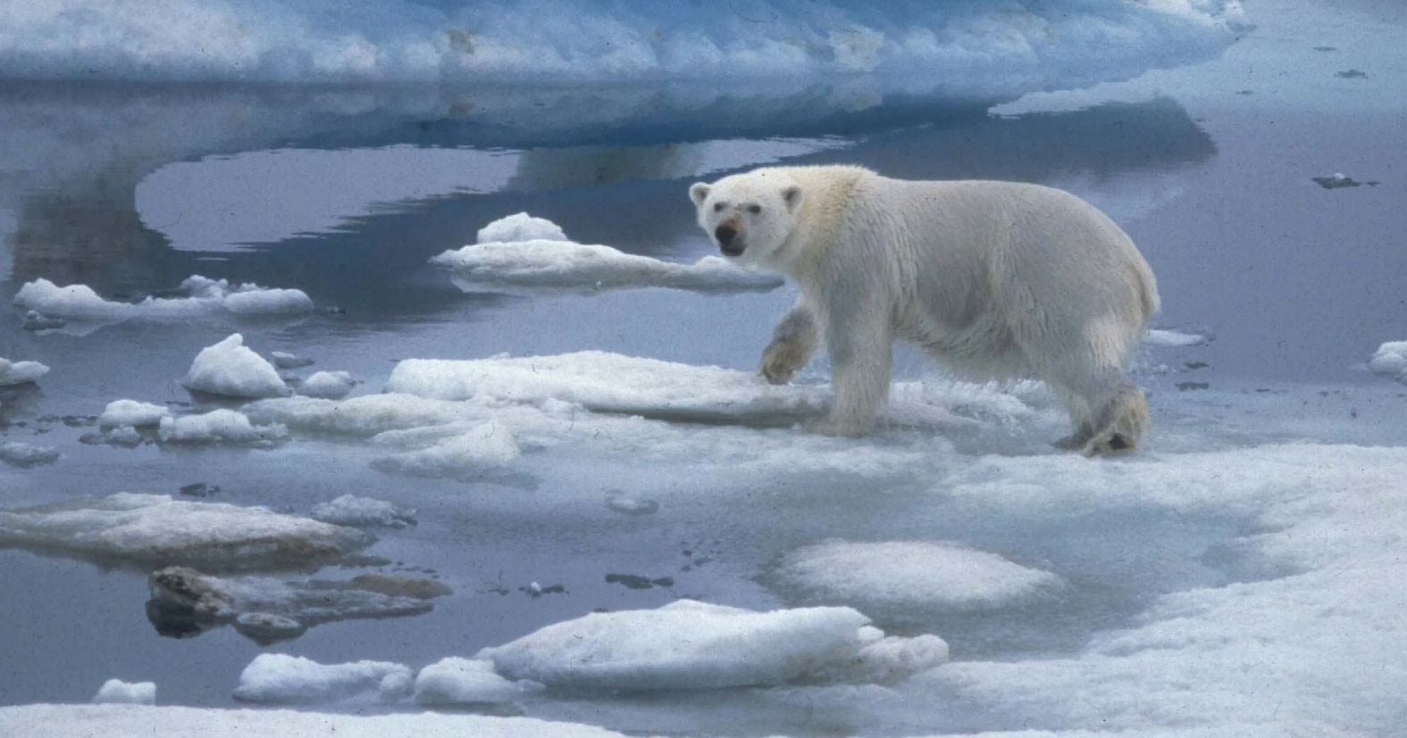
An example of one of the potential pictures that shall be shown to participants. (Rice, 2024)

