Name: Collette Owen
Student Number: 2517697
Course: Computing (Data & Information) Bsc
Module: L4 - Introduction to Web and Database Concepts - ACCA4023
Date: 29/06/206
Word Count: 1994

Contents

1. Title
2. Contents
3. Introduction & Requirements
4-6. Website
7-9 HTML Validation
10 CSS Validation
11-12 Evaluation (a)
13-16 Evaluation (b)
17-20 Website Comparison
21 References
22-29 Appendices

Introduction
This report details the design and implementation of a responsive, multi-page website for the Gwledd Fusion Food Festival. Built with standard-compliant HTML5 and embedded CSS using relative units, the platform provides a sustainable, and accessible way to advertise the event. In addition to promoting digital sustainability through optimised code practices, the project prioritises cross-device compatibility to ensure seamless navigation for a diverse user base. By using fluid layouts and scalability, the interface adapts to varying screen dimensions, maximising user engagement. Furthermore, this document outlines the complete developmental lifecycle, from planning to implementation. Ultimately, the report demonstrates how modern frontend principles can create an inclusive digital presence that reflects the vibrant, multicultural identity of the festival.

Requirements

Website Structure & Purpose
- index.html (Home): Establishes brand identity, highlights event dates, and introduces family activities via cultural imagery.
- about.html (About Us): Spotlights the company’s heritage (est. 1952) and details the live music lineup.
- tickets.html (Tickets): Drives conversions using tables and clear Call-to-Action buttons.

Target Audience
- Families
- Food Enthusiasts & Cultural Tourist
- Music Fans
This report analyses the specific design ideas, accessibility choices, and technical implementations used to build the festival's digital presence.

Website
Index.html -
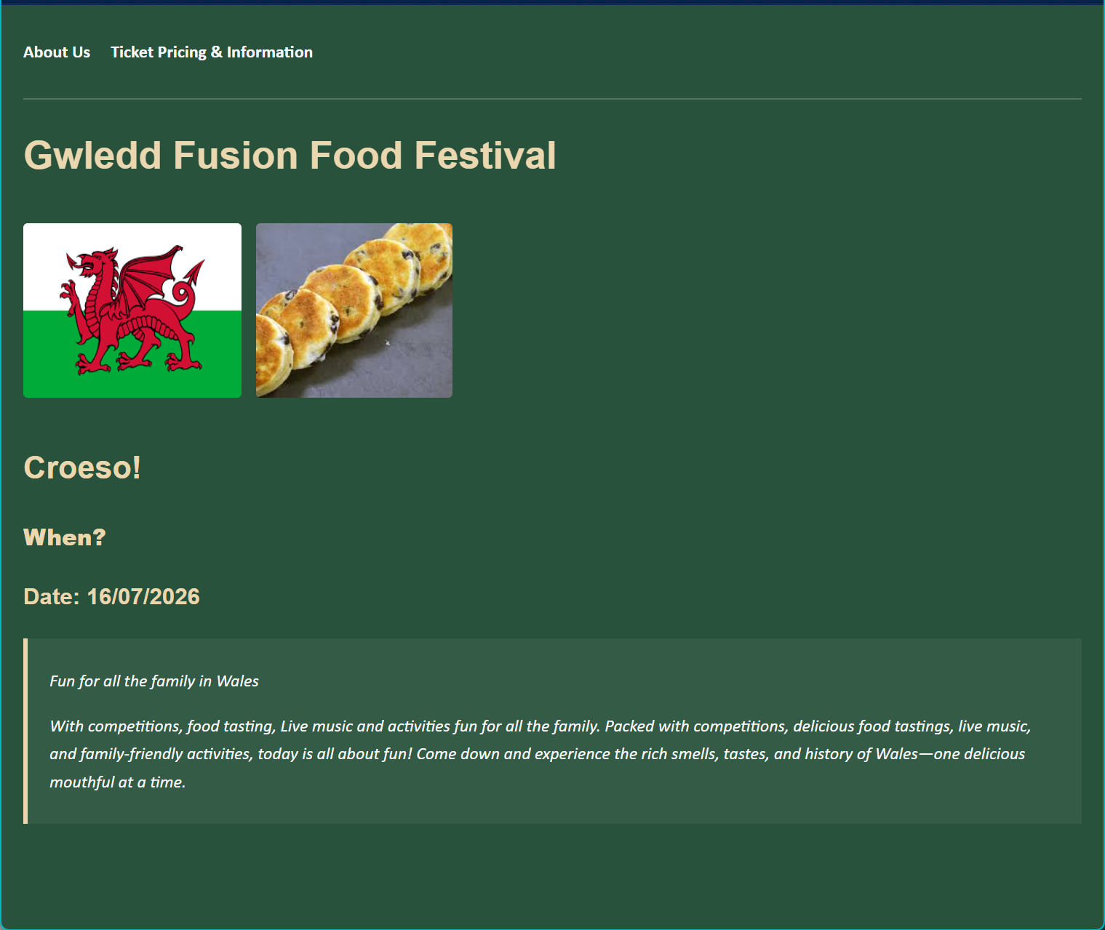

About.html
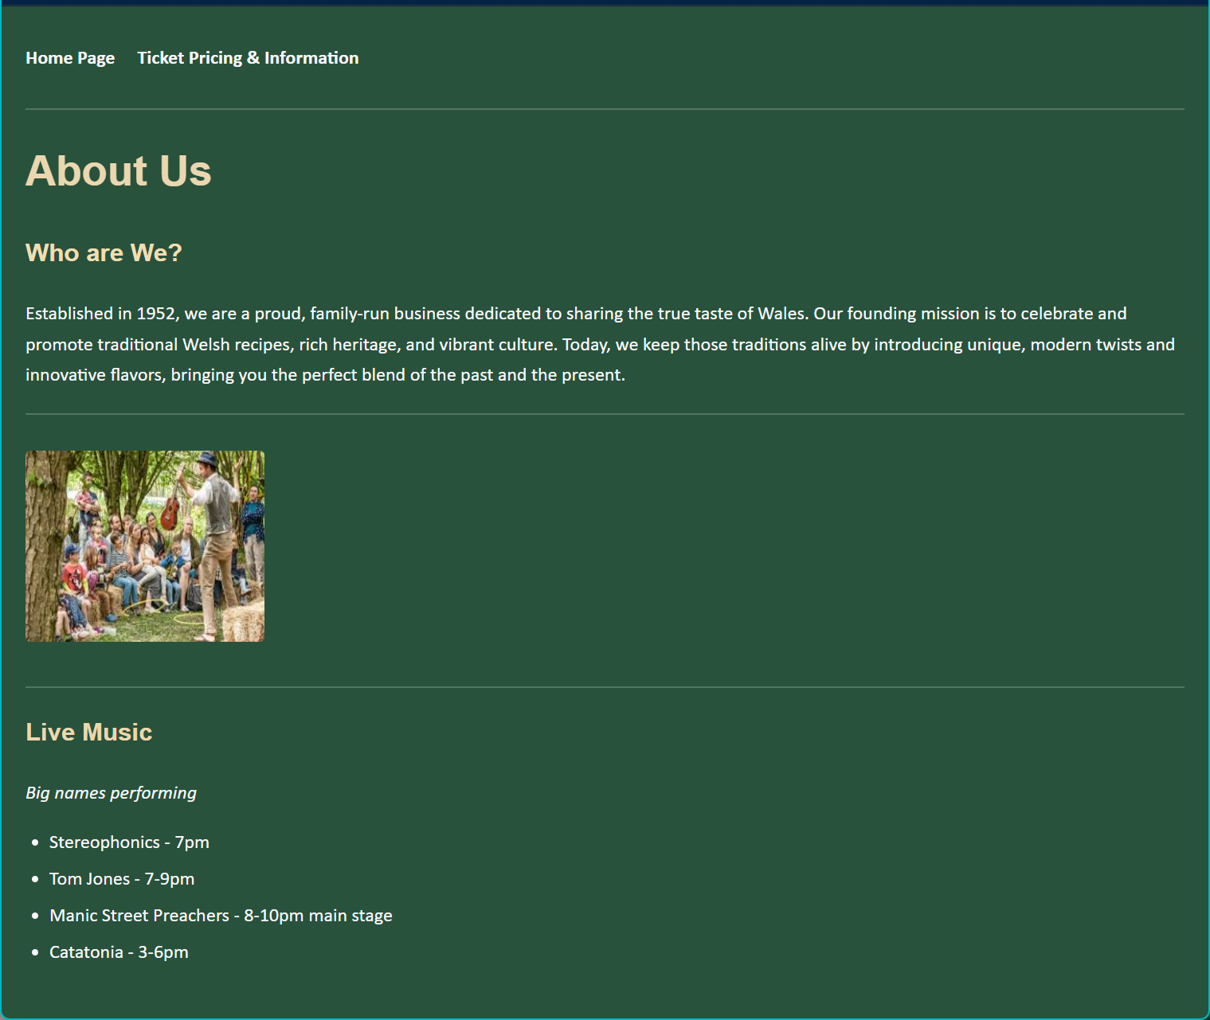

Tickets.html
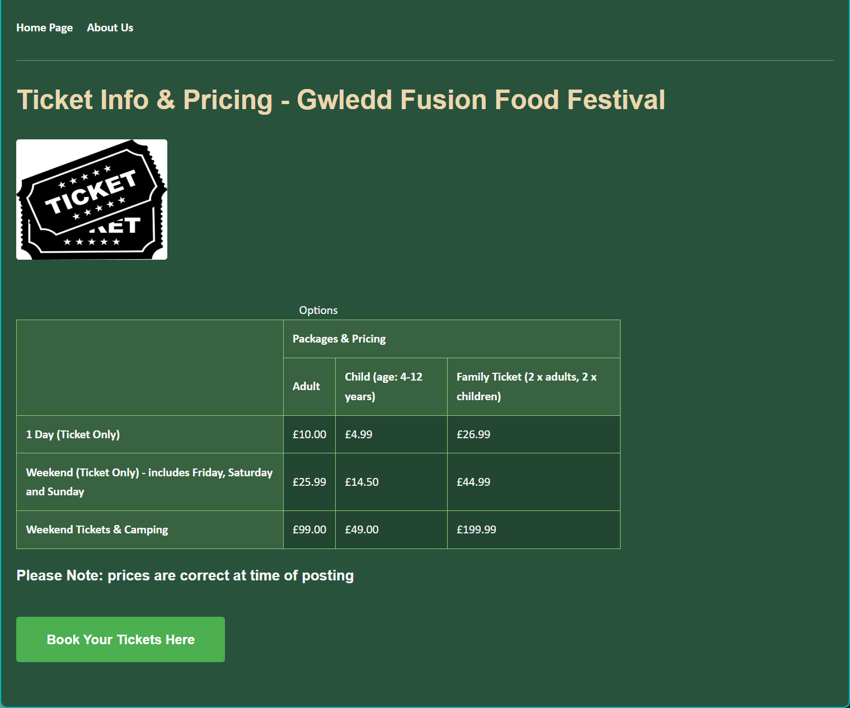

HTML Validation
My first validation review threw up 6 errors. I used the code form all 3 pages together. The errors are as follows:
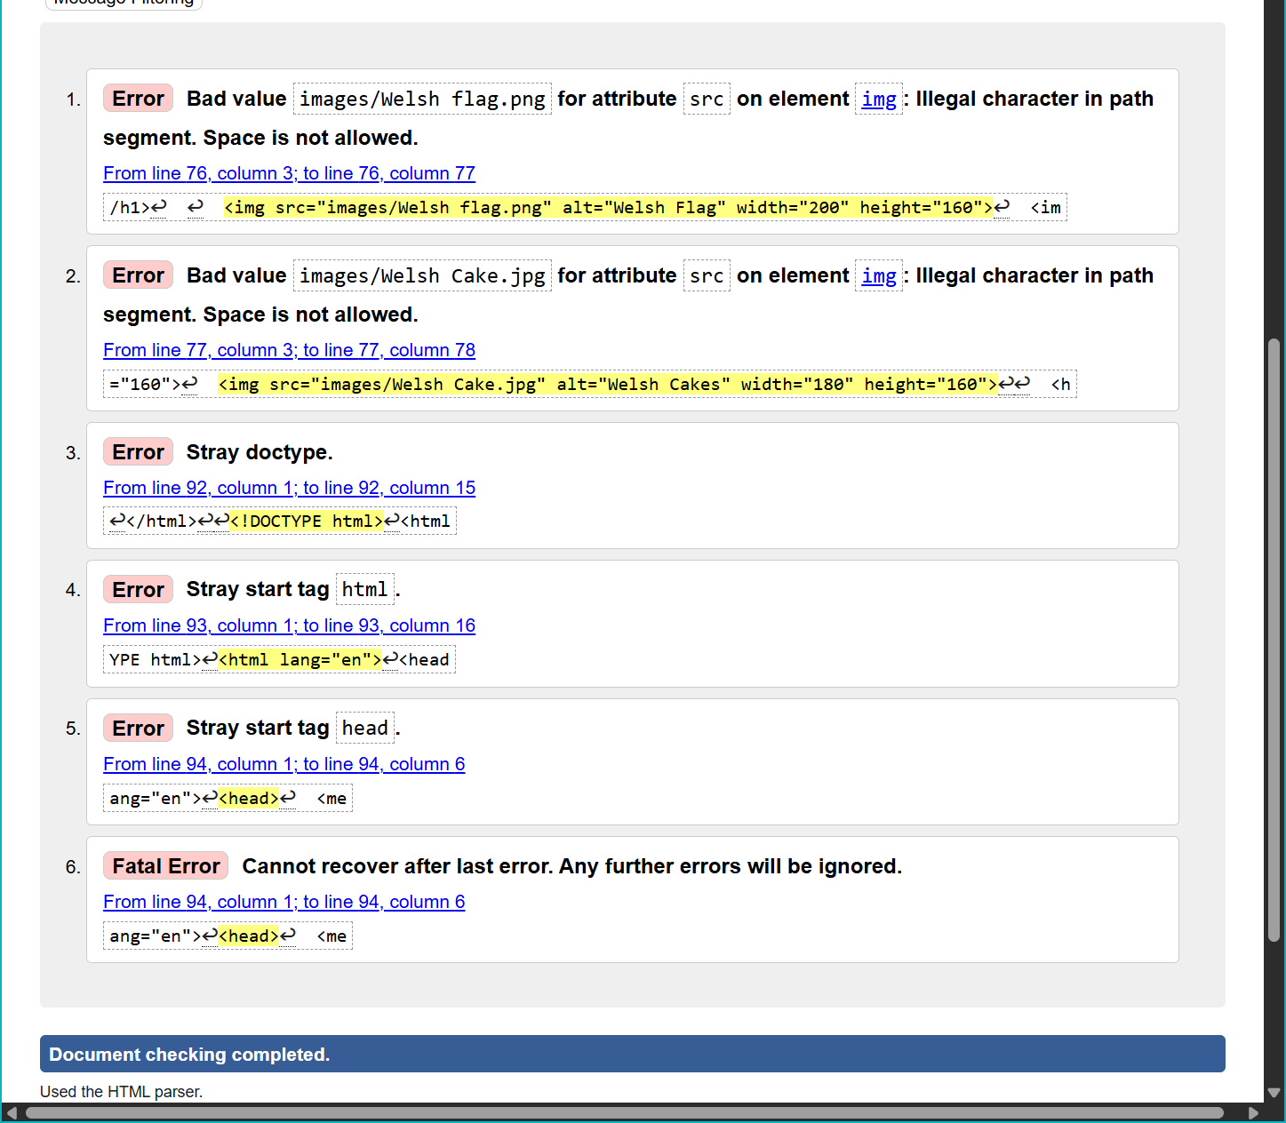
https://validator.w3.org/nu/#textarea

After reviewing my HTML code used for my website, 6 errors were highlighted.
1 and 2 highlighted a gap in the file name.
I fixed this be re-naming the images file names with an underscore in the space. Then proceeded to amend the file name in the code.

images/Welsh _flag.png"
images/Welsh_Cake.jpg"

3, 4, 5 & 6 There was a missing element for this error:
↩</html>↩↩<!DOCTYPE html>↩<html
I had missed a </html> which caused this error. By adding this at the end of my code this eliminated the error.

Once the code was corrected, I review each page individually this time. Page 1 gave a positive result:
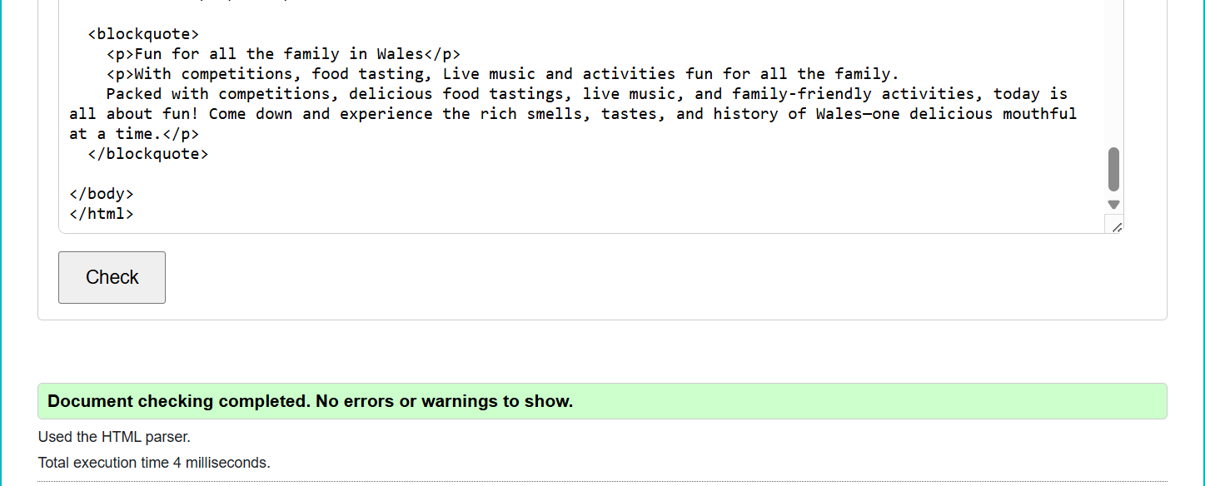

Page 2 of the website:
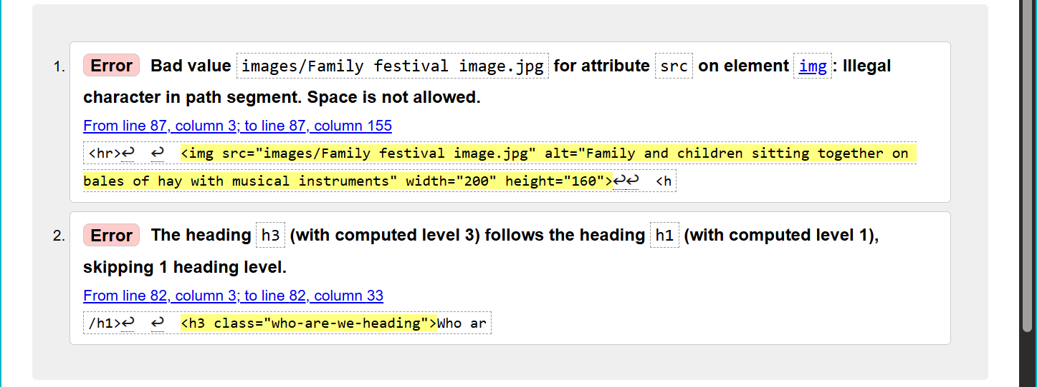

To fix error number 1, I renamed the images in the files and updated the file name in the HTML code.
To fix error number 2, I amended the heading size from h3 to h2.

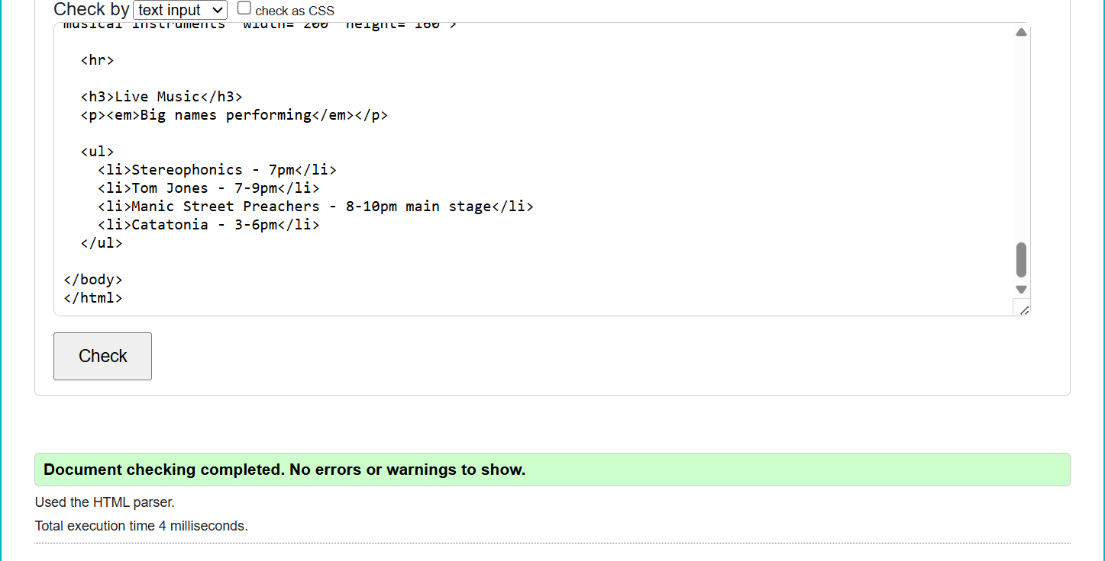

Page 3:
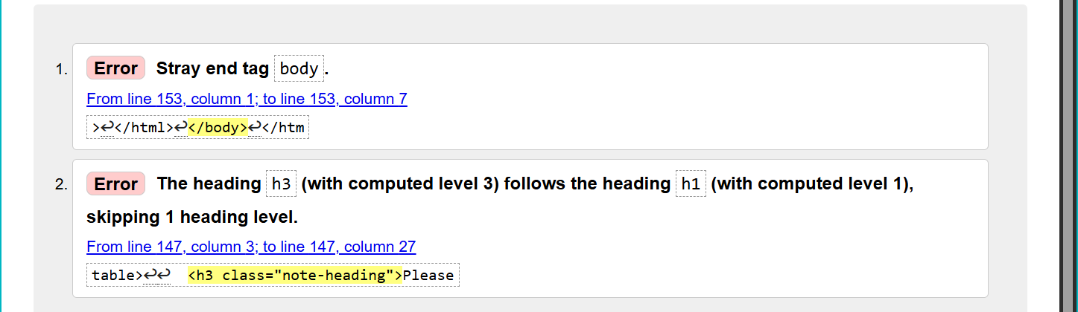

These errors were fixed by I removed the duplicated:
</body>
</html>

that were present at the end of the code.
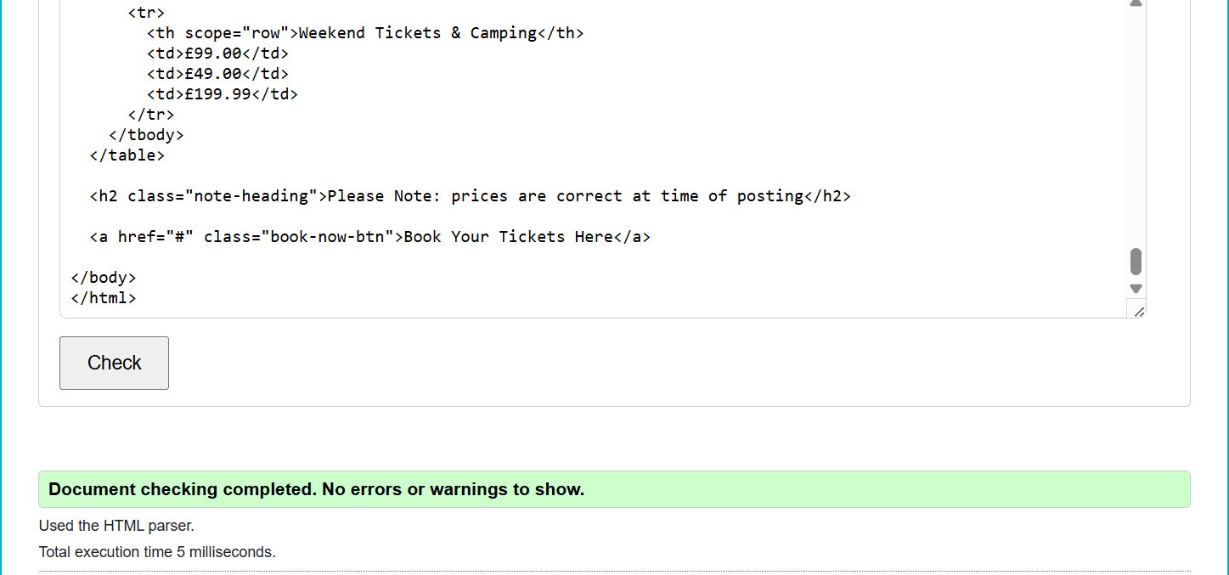
CSS Validation
http://jigsaw.w3.org/css-validator/
During the early stages of website development, I wrote custom CSS to improve the layout and appearance. I ran the code for all three pages through the CSS validator, and each passed with no errors. However, I realised I had updated the HTML header tags earlier from <h3> to <h2> on pages 2 and 3 but forgot to sync this change in the stylesheet. After updating the CSS selectors accordingly, I re-validated the code, and it passed with zero errors.
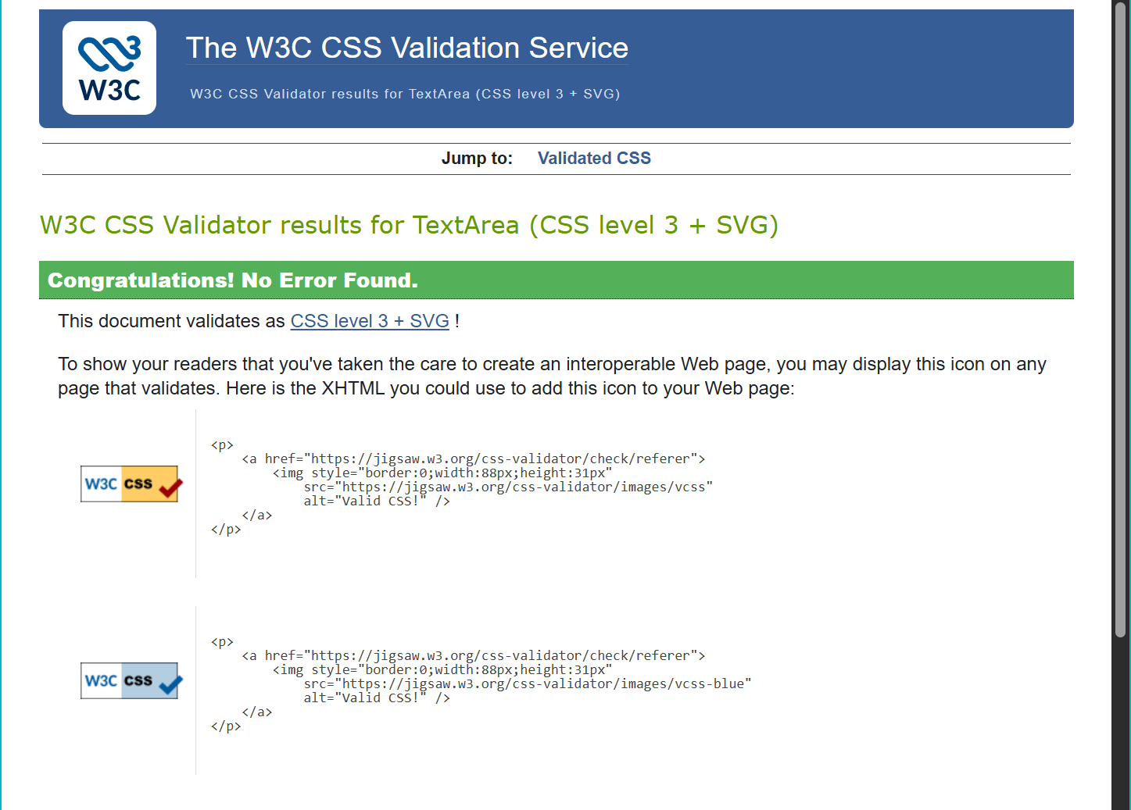

Validating the code has been highly effective for identifying overlooked errors and providing an immediate opportunity to fix them. Moving forward, I believe code validation should be integrated into the standard development process to guarantee code correctness and ensure the website operates smoothly
“It is strongly recommended that you validate your documents, especially for professional sites. Valid documents are more consistent on a variety of browsers, they display more quickly, and they are more accessible.” 1 - Niederst Robbins, J. (2018). Learning Web design : a beginner’s guide to HTML, CSS, Javascript, and web graphics
Evaluation - a
Usability –
Website usability relies on intuitive navigation, clean presentation, and a logical layout. To evaluate ease of use, thorough testing is required to see where users look first and how easily they find key information. Because a site's main purpose is to deliver information and drive actions (like purchases or bookings), a clear, readable content hierarchy is essential. Additionally, using clickable images can streamline navigation and reduce user steps. Ultimately, understanding user needs is the key to building a professional, functional website.
“A usable website is easy to navigate, intuitive, and efficient. It's essential to create user-centred experiences that prioritise usability. This increases engagement and enhances user satisfaction.” 2. MyUXAcademy, “Usability in web design: Creating user-centred experiences,”

Accessibility –
Website accessibility is essential for inclusivity. To broaden the audience a website receives it’s important to add elements that allow a website to be interpreted in different ways. For example, screen readers are used by many who have visual impairments or difficulty interpreting the text.
“Web accessibility means that websites, tools, and technologies are designed and developed so that people with disabilities can use them.” 3. Government Digital Service, “Understanding WCAG 2.2,”

Additionally, allowing the website to be interreacted with without the use of a mouse is essential for those whose physical disabilities means they can’t use common peripheral devices.
Tools and processes such as, Web Content Accessibility Guidelines (WCAG) ensures that all audiences have access to the information and resources that said website can support them with.
“The Web Content Accessibility Guidelines (known as WCAG) are an internationally recognised set of recommendations for improving web accessibility.” 4. Google. "SEO starter guide: The basics."

Search Engine Optimisation -
SEO is fundamentally about helping search engines understand a website's content, while simultaneously making it easier for users to discover that site and determine whether they should visit it. Ensuring the content is relevant and useful could increase a website’s discoverability.
By prioritising high quality information that directly answers user queries, a site naturally earns the trust of both visitors and search algorithms. This creates a sustainable loop were genuine utility drives higher search rankings and, consequently, more organic traffic.

“SEO stands for ‘search engine optimisation’. In short, it's a service that improves your website visibility and trust online. The better the visibility of your pages in search results, for relevant keywords to your industry and business, the more traffic you will receive to your website, attracting either new or repeat customers.” 5. A. Golpys, “What is SEO (search engine optimisation)?,”

Evaluation - b
Usefulness -
I chose a natural colour palette to reflect the event's outdoor, family-friendly theme, pairing a dark green background (#29523C) with warm cream text (#EBD7AF). This directly mirrors the theme, as design theory notes that green "is most commonly associated with nature... [symbolizing] growth, freshness, and hope." 6. Beaird, Jason, et al. The Principles of Beautiful Web Design,
To ensure maximum readability, I verified these colours via the WebAIM Contrast Checker; the combination yielded an excellent 6.28:1 contrast ratio, achieving full WCAG compliance for optimal accessibility and legibility.
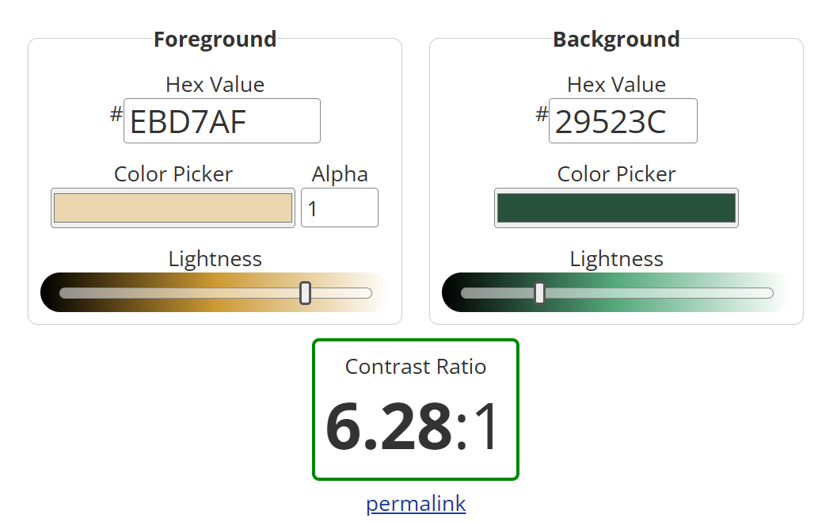
Functionality: I placed a clear navigation menu at the top of each page using intuitive page titles for maximum visibility. To structure the content professionally and draw the user's eye to key information, I used highlighted text boxes to segment data. To optimise usability, all three pages are fully populated and include cross-navigation links for seamless navigation, I integrated a structured table to display ticket pricing, creating a clean, effective layout for financial data.
As my first website, this project involved a steep learning curve in a short timeframe. I gained foundational skills in HTML and CSS, and I am eager to explore more advanced website building and development techniques in the future.
What would I do in the future differently?
- I would explore adding the CSS stylings in a separate file rather than integrate it into the text as I have done on this occasion. This would allow me to better focus on the HTML code ensuring the accuracy and layout.
- I would plan better the layout of the website both text and images.
- Improve on accessibility in terms of viewability across multiple device types.
- Do more research on colour schemes.
Search Engine Optimisation –
Example 1:
<title>Gwledd Fusion Food Festival</title>

The <title> tag is the most critical on-page SEO element. It tells search engines exactly what the page is about and appears as the clickable headline in Search Engine Result Pages.

Example 2:
<h2>Croeso!</h2>
<h3><strong>When?</strong></h3>
<h3>Date: 16/07/2026</h3>

Search engine web crawlers use heading tags to understand the structure, architecture, and core topics of your content. A logical, descending order helps search engines index your page accurately.
“Use words that people would use to look for your content, and place those words in prominent locations on the page, such as the title and main heading of a page, and other descriptive locations such as alt text and link text.” 7. Google. (2024). Search Engine Optimization (SEO) Starter Guide. Google for Developers

Example 3:
<img src="images/Welsh_flag.png" alt="Welsh Flag" width="200" height="160">
<img src="images/Welsh_Cake.jpg" alt="Welsh Cakes" width="180" height="160">

By adding ‘alt text to the images, it’s not only added to its accessibility, but it has also made it easier to be understood in searches of the website. This will improve rankings in its discoverability.

Example 4:
<html lang="en">

The ‘lang’ attribute inside the ‘html’ tag signals to search engines which language the content is written in. This prevents search engines from serving the page to users searching in languages they don't understand.

Example 5:
html, body {
font-size: 100%;

Search engines prioritise websites that load correctly on mobile devices (Mobile-First Indexing).

Accessibility –
Perceivable –
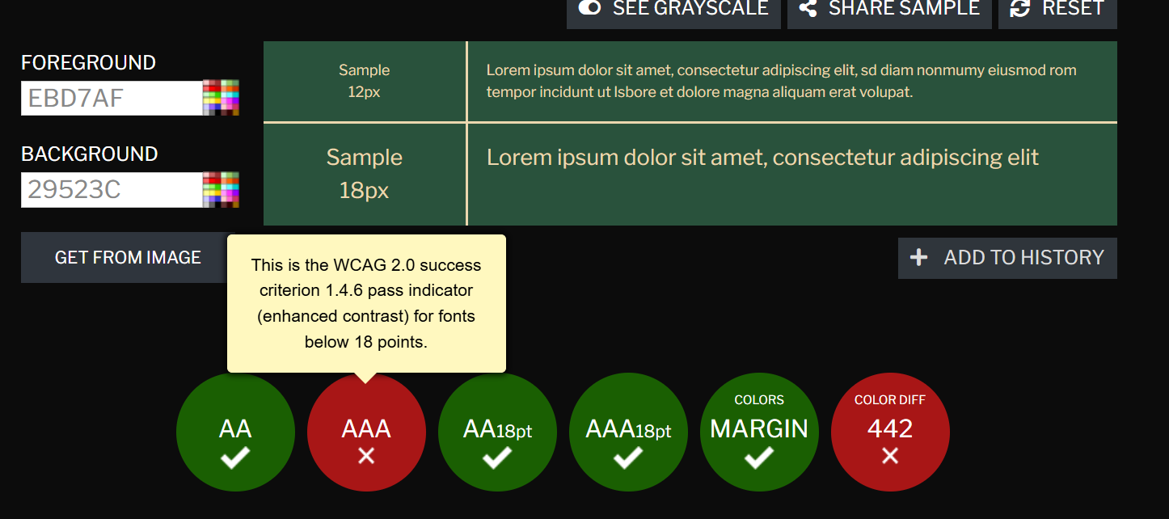
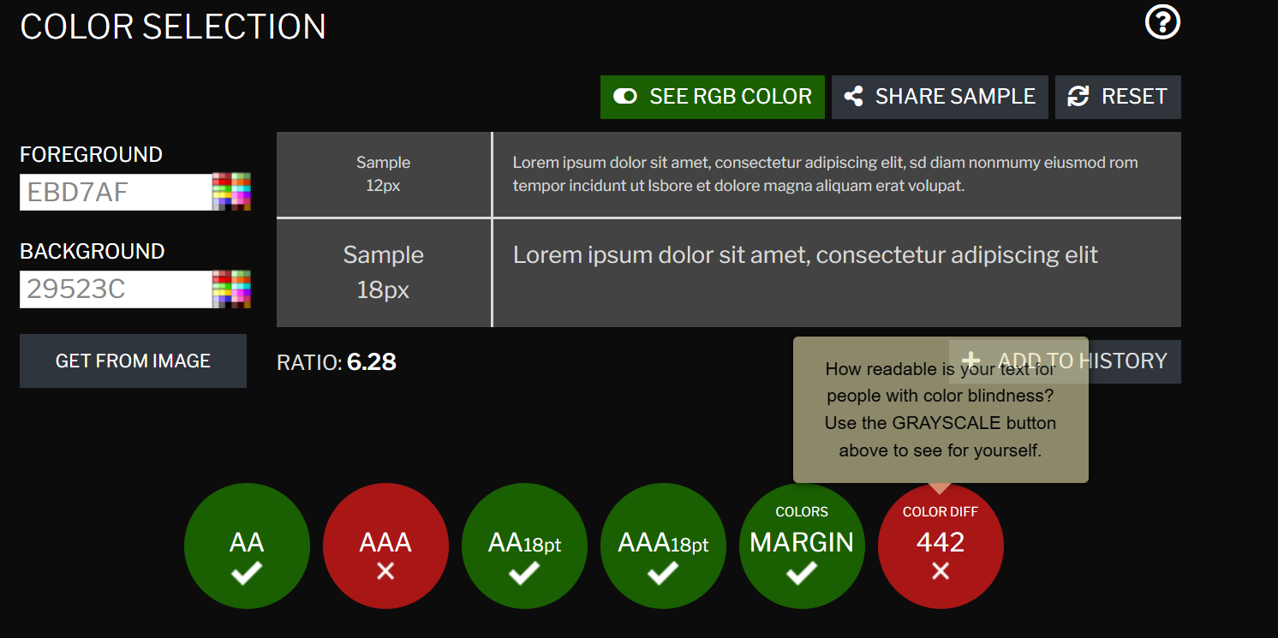
WCAG - Contrast Checker
Strength - Text Alts: All <img> tags use descriptive alt attributes (e.g., alt="Welsh Flags", alt="Tickets image"), enabling screen readers to describe visual content.
Strength - Language Attribute: Every page <html lang="en"> ensuring screen readers apply the correct language and accent aloud.
Area for Improvement - Colour Contrast Risk: The deep green background (#29523c) and pastel beige text (#EBD7AF) fall short of the required 4.5:1 contrast ratio, risking low readability for visually impaired users.
Operable -
Strength - Table Semantics: The Ticket Info table uses <caption>, <thead>, <tbody>, and <th scope="row">, allowing keyboard and screen reader users to easily map pricing data.
Area for Improvement - Functional Issue: The primary "Book Your Tickets Here" button is non-functional. On a live site, this broken call-to-action would severely degrade operability.
Understandable -
Strength – Predictable Navigation: Consistently placed navigation links at the top of every webpage to fulfil the principle of predictability.
Strength - Relative Font Sizing: Using a 100% base font size and relative units for headers and buttons ensures the layout scales cleanly when users increase browser text size.
Robust -
Strength - Modern Document Type: Every page utilises the <!DOCTYPE html> declaration, forcing modern browser rendering.
Strength - Standardised Tags: Native semantic tags like <ul>, <li>, <table>, and <blockquote> ensure built-in compatibility with assistive technologies.

Website Comparison
Tesco.com – Home Page
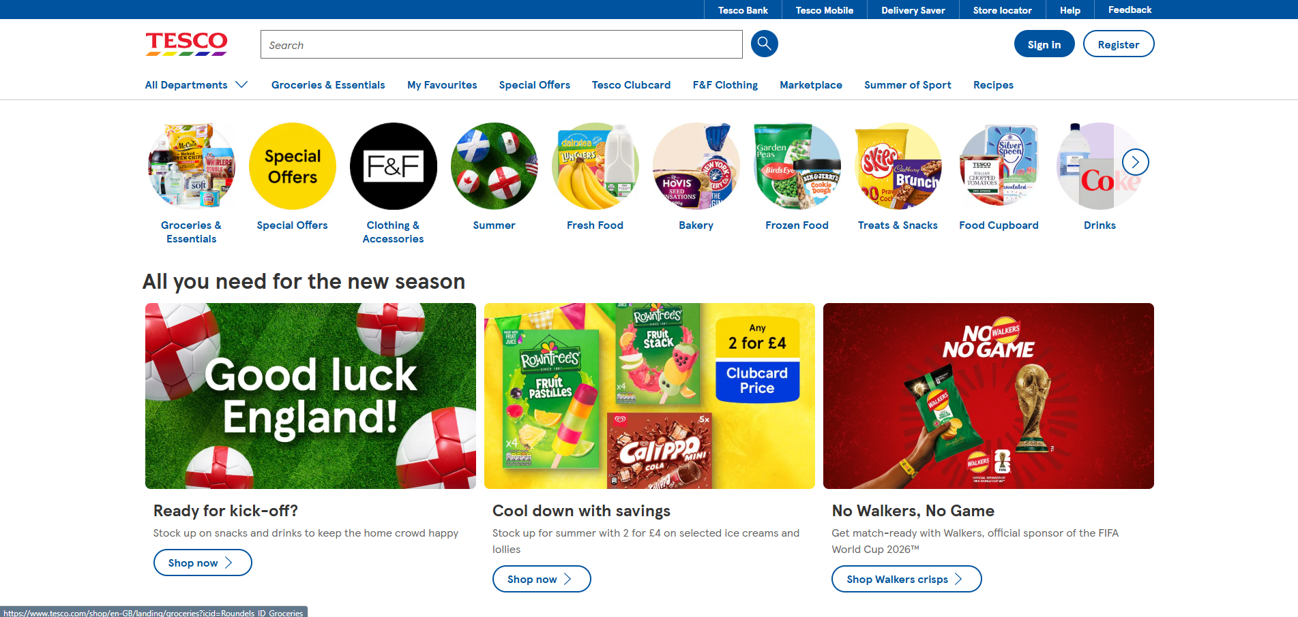
Asda.com – Home Page
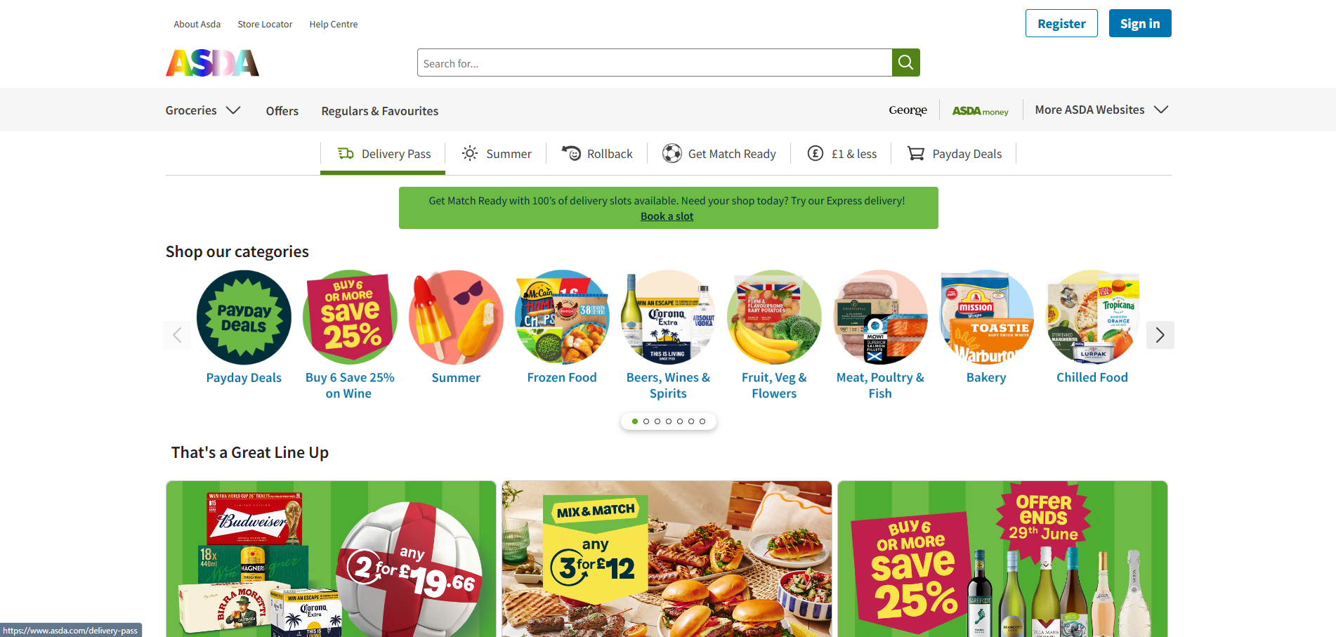

Tesco.com – WAVE addon analysis
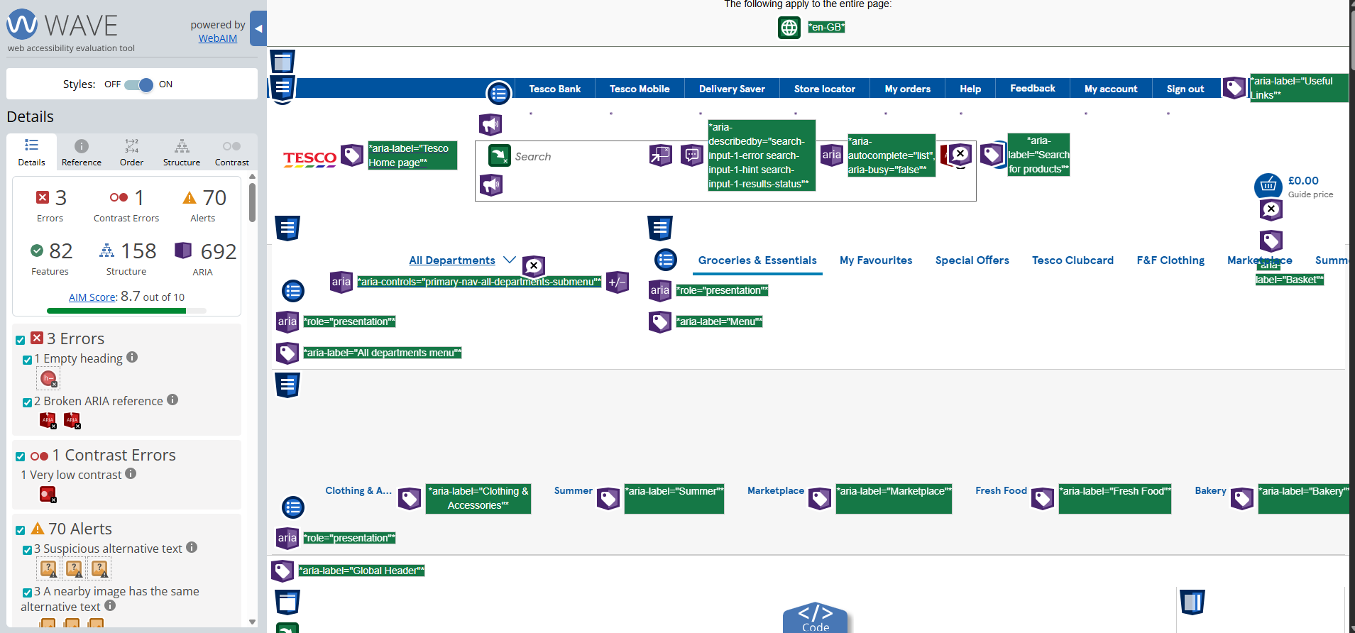

Asda.com – WAVE addon analysis
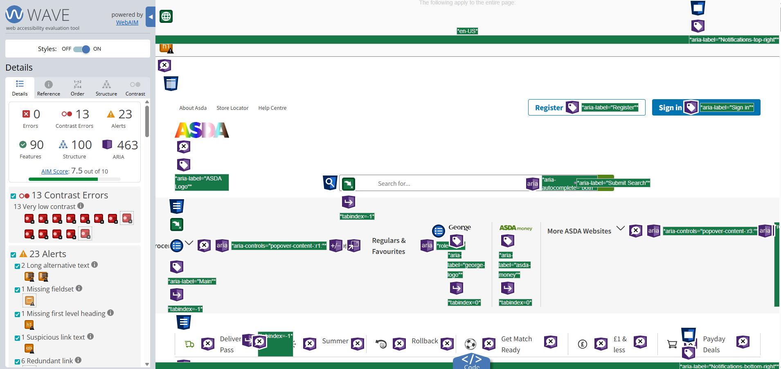

Tesco Mobile:
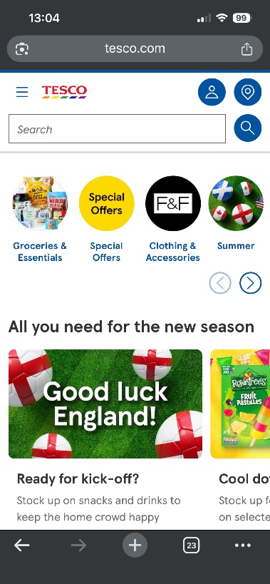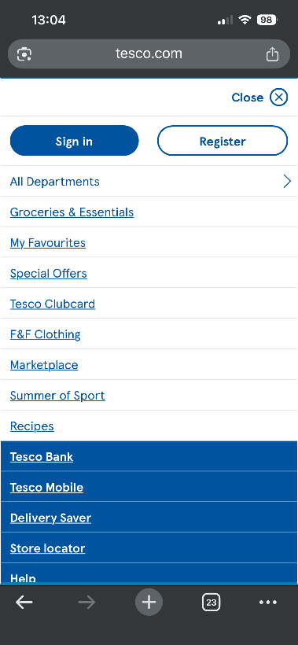
Asda.com Mobile:

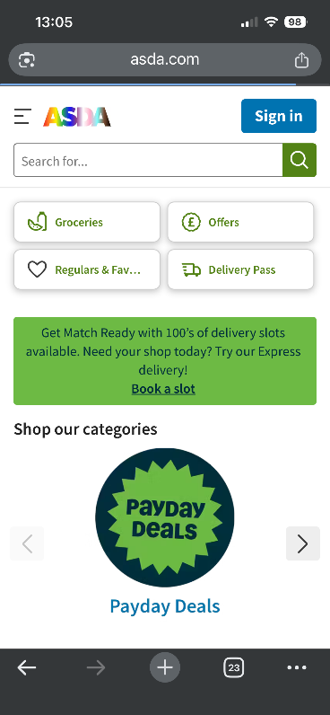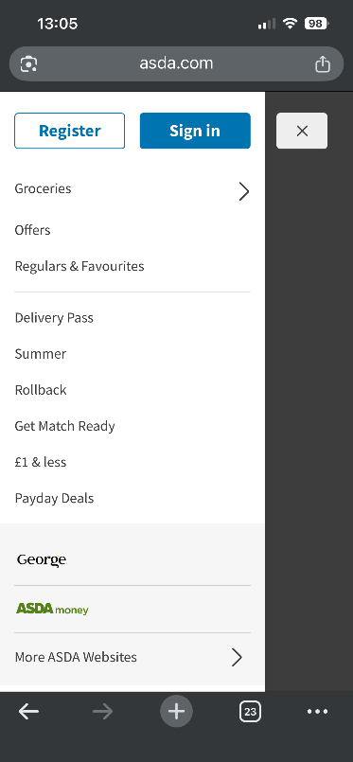

Category | Website A Notes - tesco.com | Website B Notes - asda.com
Usability | Layout & Navigation: Categorised imagery allows users to easily locate specific topics of interest. Primary navigation links are highly visible at the top of the page, positioned clearly alongside the "Sign In" and "Register" buttons.  Readability & User Experience: Content is well structured, making it easy to scan, sort, and find specific search items. Because these design elements are so intuitive and visible, it creates a seamless experience that allows potential customers to effortlessly find the products or services they need. | Layout & Navigation: High-impact promotional banners and clear category imagery allow users to easily locate specific deals and departments of interest. Primary grocery and "George" clothing navigation links are highly visible via a consolidated left-hand menu, positioned clearly alongside the search bar and utility links.  Readability & User Experience: Product grids with bold pricing and 'RollBack' tags allow efficient filtering directly to the basket.
Accessibility | Empty Heading Error: This has occurred when structural header tags (H1- H6) are technically written into the code but contain absolutely no text or verbal content inside them. <h2 class="ddsweb-heading ddsweb-carousel__title Khviia_heading Khviia_headlineXxl" id="ddsweb-6"></h2> Screen-reader users frequently navigate a webpage by jumping from heading to heading; an empty heading creates a "blank stop" that disrupts their understanding of how the page content is laid out. | Missing First-Level Heading Alert: This alert occurred when a webpage failed to include a top-level <h1> tag to serve as the main title of the page, which is flagged by the orange "h1" indicator in image_18a97d.png.
SEO | Strong performance with optimised meta descriptions and header tags, though missing image alt attributes hinder indexing. | Solid technical foundation featuring optimised page titles and clear tags that prevent duplicate content.
Mobile Responsiveness | Condenses the desktop layout into a mobile side menu (hamburger menu), maintaining excellent navigation and visibility across devices. | Condenses navigation into a mobile side menu (hamburger menu), maintaining excellent layout visibility across all devices.

References:

- pg: 86 - Niederst Robbins, J. (2018). Learning Web design: a beginner’s guide to HTML, CSS, Javascript, and web graphics (Fifth edition.). O’Reilly
- MyUXAcademy, “Usability in web design: Creating user-centred experiences,” LinkedIn, Oct. 25, 2023. [Online]. Available: https://www.linkedin.com/pulse/usability-web-design-creating-user-centred-experiences-myuxacademy-eggte/. [Accessed: Jun. 27, 2026].
- Government Digital Service, “Understanding WCAG 2.2,” GOV.UK, Oct. 29, 2024. Accessed: Jun. 27, 2026. [Online]. Available: https://www.gov.uk/service-manual/helping-people-to-use-your-service/understanding-wcag
- Google. (2024). Search Engine Optimization (SEO) Starter Guide. Google for Developers. https://developers.google.com/search/docs/fundamentals/seo-starter-guide
- A. Golpys, “What is SEO (search engine optimisation)?,” MadeByShape, Apr. 2022. [Online]. Available: https://madebyshape.co.uk/web-design-blog/what-is-seo-search-engine-optimisation/. [Accessed: Jun. 27, 2026].
- Beaird, J., George, J., & Walker, A. (2020). The principles of beautiful Web design (Fourth edition.). SitePoint Pty. Ltd.
- Google. (2024). Search Engine Optimization (SEO) Starter Guide. Google for Developers. https://developers.google.com/search/docs/fundamentals/seo-starter-guide

Appendices
Page 1: Index.html

<!DOCTYPE html>
<html lang="en">
<head>
<meta charset="utf-8">
<title>Gwledd Fusion Food Festival</title>
<style>

html, body {
font-size: 100%;
}
body {
font-family: Calibri, Candara, Segoe, sans-serif;
background-color: #29523c;
color: rgb(248, 249, 250);
line-height: 1.6;
padding: 20px;
margin: 0;
}

nav {
padding: 10px 0;
}
nav a {
color: rgb(248, 249, 250);
text-decoration: none;
margin-right: 15px;
font-weight: bold;
}
nav a:hover {
color: rgb(235, 215, 175);
text-decoration: underline;
}

h1, h2, h3 {
color: rgb(235, 215, 175);
font-family: sans-serif;
}
h1 { font-size: 2.2em; }
h2 { font-size: 1.8em; }
h3 { font-size: 1.3em; }

hr {
border: 0;
height: 1px;
background: rgba(248, 249, 250, 0.2);
margin: 20px 0;
}
blockquote {
margin: 20px 0;
padding: 10px 20px;
border-left: 4px solid rgb(235, 215, 175);
background-color: rgba(255, 255, 255, 0.05);
font-style: italic;
}
img {
border-radius: 4px;
margin: 10px 10px 10px 0;
}
</style>
</head>

<body>

<nav>
<a href="about.html">About Us</a>
<a href="tickets.html">Ticket Pricing & Information</a>
</nav>

<hr>

<h1>Gwledd Fusion Food Festival</h1>

<img src="images/Welsh_flag.png" alt="Welsh Flag" width="200" height="160">
<img src="images/Welsh_Cake.jpg" alt="Welsh Cakes" width="180" height="160">

<h2>Croeso!</h2>
<h3><strong>When?</strong></h3>
<h3>Date: 16/07/2026</h3>

<blockquote>
<p>Fun for all the family in Wales</p>
<p>With competitions, food tasting, Live music and activities fun for all the family.
Packed with competitions, delicious food tastings, live music, and family-friendly activities, today is all about fun! Come down and experience the rich smells, tastes, and history of Wales—one delicious mouthful at a time.</p>
</blockquote>

</body>
</html>

Page 2: About.html

<!DOCTYPE html>
<html lang="en">
<head>
<meta charset="utf-8">
<title>About Us - Gwledd Fusion Food Festival</title>
<style>

html, body {
font-size: 100%;
}
body {
font-family: Calibri, Candara, Segoe, sans-serif;
background-color: #29523c;
color: rgb(248, 249, 250);
line-height: 1.6;
padding: 20px;
margin: 0;
}

nav {
padding: 10px 0;
}
nav a {
color: rgb(248, 249, 250);
text-decoration: none;
margin-right: 15px;
font-weight: bold;
}
nav a:hover {
color: rgb(235, 215, 175);
text-decoration: underline;
}

h1, h2 {
color: rgb(235, 215, 175);
font-family: sans-serif;
}
h1 { font-size: 2.2em; }
h2 { font-size: 1.3em; }

.who-are-we-heading {
color: rgb(240, 222, 179);
}
p em {
color: rgb(248, 249, 250);
}

hr {
border: 0;
height: 1px;
background: rgba(248, 249, 250, 0.2);
margin: 20px 0;
}
img {
border-radius: 4px;
margin: 10px 10px 10px 0;
}
ul {
padding-left: 20px;
}
li {
margin-bottom: 5px;
}
</style>
</head>

<body>

<nav>
<a href="index.html">Home Page</a>
<a href="tickets.html">Ticket Pricing & Information</a>
</nav>

<hr>

<h1>About Us</h1>

<h2 class="who-are-we-heading">Who are We?</h2>
<p>Established in 1952, we are a proud, family-run business dedicated to sharing the true taste of Wales. Our founding mission is to celebrate and promote traditional Welsh recipes, rich heritage, and vibrant culture. Today, we keep those traditions alive by introducing unique, modern twists and innovative flavors, bringing you the perfect blend of the past and the present.</p>

<hr>

<img src="images/Family_festival_image.jpg" alt="Family and children sitting together on bales of hay with musical instruments" width="200" height="160">

<hr>

<h3>Live Music</h3>
<p><em>Big names performing</em></p>

<ul>
<li>Stereophonics - 7pm</li>
<li>Tom Jones - 7-9pm</li>
<li>Manic Street Preachers - 8-10pm main stage</li>
<li>Catatonia - 3-6pm</li>
</ul>

</body>
</html>

Page 3: Tickets.html

<!DOCTYPE html>
<html lang="en">
<head>
<meta charset="utf-8">
<title>Ticket Info & Pricing</title>
<style>

html, body {
font-size: 100%;
}
body {
font-family: Calibri, Candara, Segoe, sans-serif;
background-color: #29523c;
color: rgb(248, 249, 250);
line-height: 1.6;
padding: 20px;
margin: 0;
}

nav {
padding: 10px 0;
}
nav a {
color: rgb(248, 249, 250);
text-decoration: none;
margin-right: 15px;
font-weight: bold;
}
nav a:hover {
color: rgb(235, 215, 175);
text-decoration: underline;
}

h1, h2 {
font-family: sans-serif;
}
h1 {
color: rgb(235, 215, 175);
font-size: 2.2em;
}
.note-heading {
color: rgb(243, 246, 247);
font-size: 1.2em;
}

hr {
border: 0;
height: 1px;
background: rgba(248, 249, 250, 0.2);
margin: 20px 0;
}
img {
border-radius: 4px;
}

table {
border-collapse: collapse;
width: 100%;
max-width: 800px;
margin: 20px 0;
background-color: rgba(0, 0, 0, 0.15);
}
table, td, th {
border: 1px solid rgb(139, 209, 117);
padding: 12px; /* Expanded for breathing space */
text-align: left;
}
th {
background-color: rgba(139, 209, 117, 0.2);
}

.book-now-btn {
display: inline-block;
padding: 16px 40px;
background-color: #4CAF50;
color: #ffffff;
font-size: 1.1em; /* Converted from 18px to relative em unit */
font-weight: 700;
font-family: sans-serif;
text-decoration: none;
margin-top: 20px;
border-radius: 4px;
transition: all 0.2s ease;
}
.book-now-btn:hover {
background-color: #3e8e41;
box-shadow: 0 6px 12px rgba(0, 0, 0, 0.2);
transform: translateY(-2px);
}
</style>
</head>

<body>

<nav>
<a href="index.html">Home Page</a>
<a href="about.html">About Us</a>
</nav>

<hr>

<h1>Ticket Info & Pricing - Gwledd Fusion Food Festival</h1>

<img src="images/Tickets.jpg" alt="Tickets image" width="200" height="160">
<br><br>

<table>
<caption>Options</caption>
<thead>
<tr>
<th rowspan="2">&nbsp;</th>
<th colspan="3">Packages & Pricing</th>
</tr>
<tr>
<th>Adult</th>
<th>Child (age: 4-12 years)</th>
<th>Family Ticket (2 x adults, 2 x children)</th>
</tr>
</thead>
<tbody>
<tr>
<th scope="row">1 Day (Ticket Only)</th>
<td>£10.00</td>
<td>£4.99</td>
<td>£26.99</td>
</tr>
<tr>
<th scope="row">Weekend (Ticket Only) - includes Friday, Saturday and Sunday</th>
<td>£25.99</td>
<td>£14.50</td>
<td>£44.99</td>
</tr>
<tr>
<th scope="row">Weekend Tickets & Camping</th>
<td>£99.00</td>
<td>£49.00</td>
<td>£199.99</td>
</tr>
</tbody>
</table>

<h2 class="note-heading">Please Note: prices are correct at time of posting</h2>

<a href="#" class="book-now-btn">Book Your Tickets Here</a>

</body>
</html>

