Knowledge and Information Management Report: Amazon

Name: Khadjha Wilson (2020812)
Module: Knowledge and information management for the Workplace
Module code: BMSW5106
Lecturer: Dr Sujeewa Herath
Dr. Sampath Liyanage

Taks one: Introduction to Amazon
Jeff Bezos started Amazon, a multinational technology company based in the United States, in 1994. The business began as an online bookstore, but it has since grown to rank among the biggest e-commerce companies worldwide. The success of Amazon can be attributed to its focus on customer experience, providing e-commerce, cloud computing, digital streaming, and artificial intelligence services. (Yasar and Wigmore,2022)

The organisational structure of Amazon can be categorised as hierarchical. The senior management team consists of three CEOs and three senior vice presidents who oversee several critical parts of the business and report directly to CEO Andy Jassy. (Dudovskiy, 2022)

The four essential elements of the Amazon organisational system are:
1.Corporate hierarchy, to start. Because of Amazon's enormous scale, a hierarchical structure has emerged. More than 1.3 million people are employed globally by the largest online retailer in the world by revenue. (Dudovskiy, 2022)
2.Hybrid project groups: The corporate structure of Amazon incorporates hybrid project teams while creating new goods and services. According to the abilities and competencies needed for the project, specialists from different departments are drawn to the project. These workers may be hired on a part-time basis and report to the project manager as well as the head of their departments, or they may work on the project full-time and solely report to the project manager for the duration of the project. (Dudovskiy, 2022)
3.Flexibility of the company: As the company is very large, unlike many companies with a hierarchy organisational structure, Amazon remains flexible to adapt to constant changes in the external market. Successful organisation of hybrid project groups plays a huge role in maintaining flexibility of the business. (Dudovskiy, 2022)
4.One of the main characteristics of Amazon is stability. one of biggest online business, has "very little turnover among its most important power players, with many of them having been at the company for years, if not decades." (Kim, 2019). For modern businesses, when senior management team changes are a common occurrence, this is relatively unusual. (Dudovskiy, 2022)

Amazon’s value chain
Amazon's value chain is the collection of activities and processes that the corporation utilises to provide value to its customers while achieving operational excellence. Amazon has created a full value chain that separates it in the e-commerce business by relentlessly focusing on innovation and customer-centricity. (Edrawsoft, no date)
Inbound Logistics: Inbound logistics mainly refers to acquiring of raw materials. However, because Amazon does not often manufacture its items, its Fulfilment by Amazon service is its inbound logistics, and it provides these services to suppliers (Edrawsoft, no date). The inbound logistics operations at Amazon are incredibly effective and organised. The business runs a massive network of warehouses and distribution centres that are carefully positioned to optimise inventory control, shorten delivery times, and lower the cost of incoming logistics.
Operations: Amazon's advanced order fulfilment and inventory management technologies demonstrate its operational excellence. To streamline operations, improve productivity, and assure quick and accurate order processing, the company incorporates cutting-edge technologies such as robots and automation.
Marketing and sales: The reach of marketing and advertising spans a variety of media platforms and has a global impact. Campaigns for sales promotions, events, public relations, and focused customer marketing are all included. Amazon uses a variety of other methods than direct and traditional marketing to draw customers to its brand. It markets itself as a popular company by offering affordable rates, quick deliveries, and Amazon prime service. (Edrawsoft, no date). To provide relevant product recommendations, promotions, and a smooth shopping experience across a variety of channels, the company makes use of its extensive consumer data and analytics capabilities.
Outbound Logistics: Amazon is well known for the efficiency and dependability of its outbound logistics operations. Due to the company's vast network of fulfilment centres, orders may be processed quickly, packaged well, and delivered consistently, resulting in happy and devoted customers. (Edrawsoft, no date)
Service: Customer service is a top priority for Amazon, which provides a variety of help options including live chat, email, and an extensive self-service knowledge library. The business's customer-centric strategy guarantees quick and effective issue resolution, building trust and loyalty among its customers.

These additional components are essential to running smoothly:
- Procurement: The sales and operations process handle the company's purchases. This system manages inventory through the use of forecasting and just time inventory principles.
- Human resources: Without Amazon's HR management department, the value chain analysis wouldn't be completed. Amazon has internal staff, international employees, contractors, and a temporary workforce (Edrawsoft, no date). Amazon understands the value of its human capital. The organisation makes significant investments in attracting, developing, and retaining elite employees. Its workforce is noted for its customer-centric approach, agility, and commitment to excellence, all of which contribute to the value chain's overall success. Its awards programme and acknowledgement of good work have resulted in loyal employees and low turnover.
- Technology and Infrastructure: A significant factor in the value chain of Amazon is its ability to innovate. The business makes significant investments in cutting-edge technologies, cloud infrastructure, and data analytics. This provides smooth online interactions, effective supply chain management, and ongoing operation and service improvement.

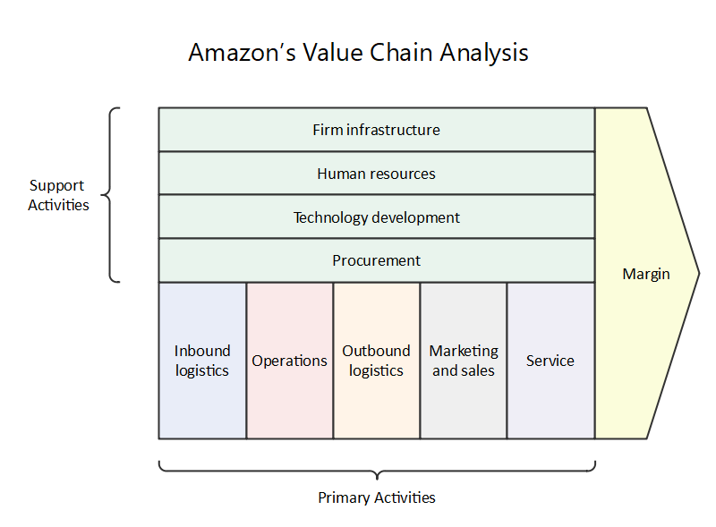
Figure 1: showing Amazon’s value chain.

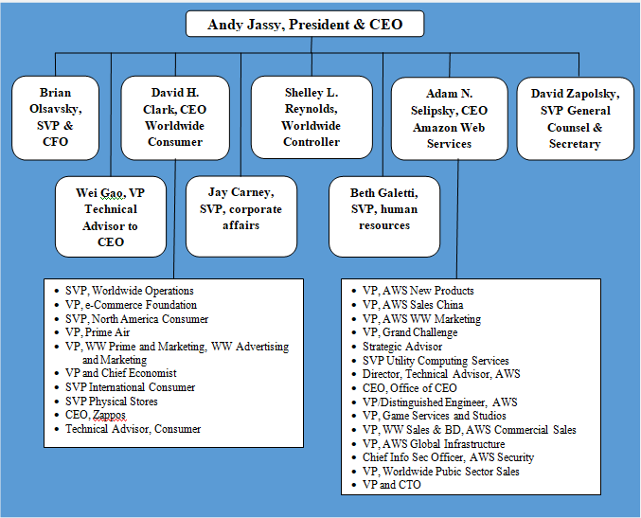
Figure 2-showing Amazon organisational structure.

Task two: Explaining the knowledge requirement of Amazon and how it facilitates them to make three types of decisions.

Across its operational, tactical, and strategic levels, Amazon relies on a wide variety of knowledge requirements, including both explicit and tacit knowledge.
Explicit knowledge
Khosrow-Pour & Kone, 2021 states 'Explicit knowledge is knowledge that can be verbalized, stored, accessed, and shared with others. Explicit knowledge is often seen as complementary to tacit knowledge in that you need both to draw a complete picture of organizational knowledge. ‘
The explicit knowledge needs of Amazon include:
Product details and specifications: Accurate cataloguing, efficient search engines, and detailed information delivery to customers all depend on explicit knowledge of the features, descriptions, and specifications of a product.
Pricing and inventory information: Amazon can make wise judgements about pricing, promotions, and stock management thanks to explicit knowledge of pricing strategies, competitive pricing analyses, and real-time inventory levels.
Customer preferences and behaviour: Amazon is able to personalise suggestions, focus marketing efforts, and improve customer experiences thanks to explicit knowledge of user data, purchase histories, and browsing behaviours.
Tacit knowledge
Tacit knowledge is gained by personal experiences and observations. It is the knowledge, intuition, and insights gained from actual experience with something in particular.
Amazon's tacit knowledge requirements include the following:
Market trends and insights: Amazon's strategic decision-making requires tacit knowledge of developing market trends, customer preferences, and industry dynamics. This information is frequently gained by experience, regular monitoring, and remaining alert to shifting market situations.
Intuition: Tacit information, especially at the strategic level, plays a crucial role in Amazon's decision-making processes. Leaders and decision-makers use tacit knowledge to identify risks, predict future market movements, and make informed choices.
Collaboration: Tacit knowledge is shared through team collaboration, promoting a culture of knowledge sharing and learning. Amazon promotes cross-functional collaboration in order to maximise on the expertise and tacit knowledge of its broad workforce.
Decision-making
Amazon uses these points to make three types of decisions, operational, tactical, and strategic which we analyse into further detail as shown here:
Operational Decisions: Explicit information is critical for day-to-day decision-making at the operational level. Amazon's knowledge management system aids operational decision-making by giving real-time data on inventory levels, order processing, and delivery logistics. This allows for efficient order fulfilment, inventory management, and timely client satisfaction.
Tactical Decisions: Tactical decision-making is aided by explicit knowledge of market trends, competition analyses, and customer behaviour. Amazon's knowledge management system makes this explicit knowledge more accessible, assisting in the development of pricing strategies, promotional campaigns, and inventory predictions.
Strategic decisions are long-term, high-level decisions that determine the company's direction and growth. At this level, tacit knowledge is crucial, with leaders making strategic decisions based on their experience, intuition, and industry insights. Amazon's knowledge management system aids strategic decision-making by facilitating cross-functional cooperation, documenting, and sharing best practises, and providing access to important market intelligence.

Task three: Explaining customer relationship management system (CRM) and Transactional processing systems purpose and importance to meet knowledge requirements.

Customer Relationship Management (CRM) System:

A Customer Relationship Management (CRM) system is a technology-driven tool that focuses on managing interactions and relationships with customers. Its purpose is to collect, organize, and analyse customer data to enhance customer satisfaction, retention, and overall business performance (Salesforce, no date).
Figure 3- CRM system

A CRM system helps meet knowledge requirements by:
- Customer Data Centralisation: A CRM system collects and combines customer data from multiple touchpoints, such as sales, marketing, and service. It acts as a central store for client information, such as contact information, purchase history, preferences, and communication history. This centralised data enables an in-depth understanding of customers and their interactions, therefore meeting knowledge requirements related to customer behaviour and preferences.
- Tracking Customer Interactions: CRM systems monitor and log customer interactions through a variety of channels, including social media, email, and phone conversations. Employees have access to a complete history of consumer interactions due to the logging of these exchanges. Personalised communication, greater customer service, and an improved understanding of consumer wants and expectations are all made possible by this knowledge.
- Analysing Customer Insights: The primary goal of analytical CRM is to analyse customer data so that management can better understand market trends as well as the wants and needs of customers. Client satisfaction is the goal of analytical CRM. Data mining and pattern recognition are routinely used in analytical CRM. (Kulpa, 2022)
- Customer service: CRM systems offer efficient customer service by providing a full view of customer information and interactions. When customer service employees have access to current and relevant information, they can respond to client questions efficiently, fix issues quickly, and give personalised support. This increases consumer pleasure while also strengthening customer ties.
Transactional Processing Systems:
Computer-based systems called transactional processing systems (TPS) automate and streamline the processing of a significant amount of normal business transactions within an organisation. They are there to make sure that transactions like sales orders, inventory control, and financial transactions are processed accurately and quickly.
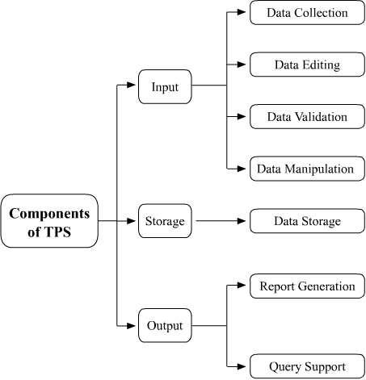
Figure 4- Transactional processing system
TPS plays an important role in meeting knowledge requirements by:
- Data Capture and Storage: Transactional data is captured and stored in real time via TPS. This information covers sales, purchases, inventory levels, and financial activities. TPS meets knowledge requirements for operational decision-making, inventory management, and financial reporting by properly and efficiently gathering and storing this data.
- Transactions: One of the most important features of a TPS is its ability to execute several transactions at the same time. A modern transaction processing system can manage and coordinate thousands of consumer orders at the same time. This enables the company to improve the selling process for customers while also providing an online option. (Contributors, 2023)
- Integration with CRM and Knowledge Management Systems: To ensure accuracy of data and accessibility, TPS interfaces effortlessly with CRM and knowledge management systems. This connection allows transactional data to flow in order to meet customer-related knowledge requirements such as order history, payment information, and customer preferences. It also makes transactional data more accessible for analysis and decision-making.
- Analysis and Reporting: TPS gives firms the ability to create transactional reports including sales reports, inventory reports, and financial statements. These reports assist in meeting the knowledge requirements for making decisions, analysing trends, and monitoring performance. TPS data analysis can also be used to spot trends, patterns, and anomalies, offering useful information for tactical and strategic decision-making.

Task 4: Critically evaluate the strengths and weaknesses of CRM and TPS and how they assist to make effective decisions on different functions at amazon.
Strengths of CRM:
- Improved Customer relationships: CRM systems give Amazon a thorough understanding of customer interactions, preferences, and needs, enabling the company to build and sustain strong relationships with consumers. This enables Amazon to personalise communications, customise marketing initiatives, and deliver excellent customer support (Thakral, 2021). A business can develop a more complete understanding of its consumers by having access to vast amounts of data on interactions with customers. It enables in-depth insights to pinpoint the company's strong points and weaknesses in terms of handling customers. The most profitable clients can be found via a CRM system, allowing for more focus on them. The CRM software also enables a company to customise its marketing messages for better outcomes and, consequently, a higher return on investment in sales and marketing.
- Increased Customer Satisfaction: CRM systems promote effective customer service by providing customer service employees with the knowledge necessary to answer questions, fix problems, and offer tailored assistance. This improves client loyalty and satisfaction. A CRM system speeds up operations, allowing staff to handle more inquiries and offering a better overall customer experience. An investment in a CRM system is an investment in customer loyalty, with the return coming in the form of increased customer lifetime value and word-of-mouth referrals (Thakral, 2021).
- Data-Driven Decision Making: Through data analysis, division, and trend analysis, CRM systems deliver important consumer data. Amazon may use this data-driven decision-making strategy to create focused marketing initiatives, optimise product offerings, and improve the entire consumer experience.

Weaknesses of CRM:

- Data Accuracy: CRM systems largely rely on accurate and current data. Incomplete or inaccurate data might produce incorrect interpretations and decisions. Regular data cleansing, validation procedures, and user training are necessary to ensure data quality and integrity. When employees become overly dependent on CRM software, it limits their flexibility in responding to customer inquiries. They frequently feel helpless in the face of customer inquiries involving information that isn't stored in the system. Customers may grow dissatisfied and turn to a competitor as a result, which has obvious consequences for the customer experience (Thakral, 2021).
- Challenges of Implementation and Integration: Implementing a CRM system across an organisation can be a complicated and time-consuming procedure. Integration with current systems and data sources may present difficulties and necessitate careful planning and cooperation. Employees will need some time to become used to the CRM system. It is the responsibility of the management team to guarantee proper participation and encouragement during the transition process. This can be costly because it diverts attention away from vital duties. However, the benefits of having a CRM system in place will far outweigh the initial time and productivity expenses. (Thakral, 2021)
- User Adoption: A CRM system's success is dependent on user adoption and active engagement. The system's effectiveness can be limited by resistance to change, a lack of training, or insufficient support for users. It is critical to encourage user adoption and to provide continuing training and assistance.

Strength of TPS

- Efficient Transaction Processing: Organisations that handle online transactions frequently utilise transaction processing systems. Through the coordination of banking and personal information as well as the processing and shipping of goods to the right customers, the systems enable them to handle thousands of purchases (Techslang, 2022). The Transaction Processing System (TPS) simplifies common transaction processing, including sales orders, inventory control, and financial transactions. This effectiveness guarantees quick and correct processing, lowering errors and enhancing operational effectiveness.
- Capabilities for Reporting and Analysis: TPS includes reporting and analysis features that allow Amazon to generate transactional reports and do data analysis. This helps with performance monitoring, trend analysis, and making educated decisions.
- Real-time Data Availability: TPS offers data on transactional operations in real-time, giving Amazon access to the most recent figures on sales, inventory levels, and financial performance. With real-time data readily available, decisions may be made quickly and proactively in response to shifting market conditions.

Weaknesses of TPS:
- Limited Range: TPS is largely focused on completing routine transactions and may have few capabilities beyond that.
- Challenges with Scalability: As Amazon expands, it may be difficult to scale TPS. Strong infrastructure and ongoing optimisation efforts are needed to efficiently handle a high volume of transactions.
- Individual business requirements: Every organisation has unique requirements that must be addressed individually. This requires developing a unique solution for each organisation that has needs. (Naini, 2021)

Task 5: Discuss the challenges in deploying CRM and TPS and provide recommendations to overcome these challenges and improve the knowledge development within Amazon.
Challenges in Deploying CRM:
- Data Integrity and integration: Ensuring the accuracy and integrity of consumer data is one of the major difficulties. The CRM system can suffer from insufficient or inconsistent data. Amazon has to implement data governance procedures, such as data cleaning, validation, and continuing maintenance, to address this issue. In order to guarantee data consistency across several platforms, integration with other systems should also be properly managed. confirming that migration from the existing systems is advantageous and possible, or that the platform you select allows integration with the solutions your business is using. (Sciandra, 2023)
- User Adoption and Training: The success of a CRM system depends on user adoption. The efficiency of the system may be limited by user resistance to change, a lack of training, or insufficient user support. Amazon should make significant investments in thorough user training programmes, offer continuous support, and create a culture that values using the CRM system.
- System adaptation: CRM systems frequently require adaptation to comply with unique business procedures and requirements. Excessive customization, on the other hand, might complicate the installation process and raise maintenance expenses.

Recommendations for Dealing with CRM Challenges:

- Executive Support: A CRM system's successful implementation requires strong executive support. Senior executives should support the CRM programme, convey its significance, and actively engage in its implementation, according to Amazon.
- Pilot Testing: Before adopting the CRM system throughout the entire organisation, Amazon should carry out pilot testing with a smaller group to discover any potential concerns and obtain feedback.
- User Feedback and Continuous Improvement: Amazon should set up systems to collect user feedback and continuously enhance the CRM system. User experience insights can be gained from regular assessments, user surveys, and feedback forums, which can also help to pinpoint problem areas and encourage system improvements.
Challenges in Deploying TPS:

- Data Security and Privacy: Because TPS handles sensitive transactional data, data security and privacy are critical issues. To safeguard transactional data from security and fraud concerns, Amazon should incorporate strong safety features such as encryption, access controls, and frequent security inspections. Transaction processing systems must also be able to handle huge volumes of data rapidly and reliably. This requires solid hardware and software solutions that can scale to meet the business's needs. (Casual, no date)
- System Scalability: As Amazon expands, achieving TPS scalability can be difficult. Handling a high volume of transactions efficiently requires a solid infrastructure and ongoing optimisation efforts.
- Integration Difficulty: TPS integration with other systems, like as CRM and financial systems, can be difficult. Integration attempts might be limited by incompatible data formats, old systems, and different databases. To give a complete view of the business, transaction processing systems must be able to connect with other systems such as accounting and customer relationship management.

Recommendations for Overcoming TPS Challenges:

- Scalable Infrastructure: Using cloud-based services and other technologies that can manage rising numbers of transactions, Amazon should invest in flexible infrastructure. To guarantee ideal system performance, regular capacity planning and performance monitoring should be carried out.
- Integration plan: Amazon must create a thorough integration plan that takes into account the connectivity of various systems, data formats, and the requirement for data synchronisation.
- Data Security Measures: Amazon should put in place a strong security structure that includes encryption, access limits, and regular security inspections to address data security and privacy issues. To keep customers' trust, compliance with relevant data protection laws must be enforced.

Task 6: Conclusion
In conclusion, Amazon’s knowledge requirements include both explicit and implicit information. The knowledge management system of the organisation is critical in providing access to explicit knowledge for operational and tactical decision-making. Meanwhile, Amazon's strategic decision-making is guided by tacit knowledge gained through experience, collaboration, and industry expertise.
Furthermore, CRM and TPS systems play unique but complimentary roles in addressing knowledge requirements. CRM systems are primarily concerned with customer relationship management and offering insights into customer behaviour, preferences, and interactions. TPS, on the other hand, assures precise and efficient transaction processing, as well as the provision of transactional data for analysis and decision-making. They work together to meet knowledge requirements for customer connections, operational efficiency, and informed decision-making. CRM and TPS have significant advantages in aiding decision-making across Amazon's various divisions. CRM systems improve relationships with customers, increase satisfaction, and deliver useful customer insights. TPS ensures efficient transaction processing, real-time data availability, and system integration. To maximise the efficiency of these systems in decision-making processes, however, difficulties relating to data accuracy, implementation, user acceptance, and sustainability must be solved. Lastly, by addressing these challenges and implementing the recommended strategies, Amazon can improve knowledge development within the company, enhance customer relationships, and make informed decisions across various functions.

Reference list
- Amazon Value Chain Analysis: EdrawMax Online (no date) Edrawsoft. Available at: https://www.edrawmax.com/article/amazon-value-chain-analysis.html (Accessed: 04 August 2023).
- Casual (no date) Transaction processing, Explained. Available at: https://www.causal.app/define/transaction-processing#:~:text=Challenges%20with%20Transaction%20Processing&amp;text=In%20addition%20to%20the%20security,the%20demands%20of%20the%20business. (Accessed: 04 August 2023).
- Contributors, T. (2023) Pros and cons of Transaction Processing System, Techfunnel. Available at: https://www.techfunnel.com/fintech/benefits-of-a-transaction-processing-system-in-business/ (Accessed: 04 August 2023).
- Dudovskiy, J. (2022) Amazon organizational structure: A brief overview - research-methodology, Research. Available at: https://research-methodology.net/amazon-organizational-structure-2-2/#_ftn2 (Accessed: 03 August 2023).
- Khosrow-Pour, M. and Kone , M. (2021) ‘State of the Art in Semantic Organizational Knowledge’, in Encyclopedia of organizational knowledge, administration, and Technology. Hershey: IGI Global, Business Science Reference, pp. 12–12.
- Kulpa, J. (2022) Council post: Why is customer relationship management so important?, Forbes. Available at: https://www.forbes.com/sites/forbesagencycouncil/2017/10/24/why-is-customer-relationship-management-so-important/ (Accessed: 04 August 2023).
- Naini, A. (2021) What is Transaction Processing System - A definitive guide in 2023, Mindmajix. Available at: https://mindmajix.com/what-is-transaction-processing-system#advantages-&amp;-disadvantages (Accessed: 04 August 2023).
- Saleforce (no date) What is CRM?, Salesforce. Available at: https://www.salesforce.com/uk/learning-centre/crm/what-is-crm/#:~:text=CRM%20stands%20for%20Customer%20Relationship,customer%20service%2C%20and%20increase%20profitability. (Accessed: 04 August 2023).
- Sciandra, P. (2023) Top challenges of CRM implementation, OMI. Available at: https://www.omi.co/crm-configuration/top-challenges-of-crm-implementation/ (Accessed: 04 August 2023).
- Thakral, R. (2021) Advantages and disadvantages of CRM, Target Intergration. Available at: https://targetintegration.com/advantages-and-disadvantages-of-crm/ (Accessed: 04 August 2023).
- Techslang (2022) What is a transaction processing system (TPS)? - definition by Techslang, Techslang. Available at: https://www.techslang.com/definition/what-is-a-transaction-processing-system/ (Accessed: 04 August 2023).
- Yasar, K. and Wigmore, I. (2022) Amazon. Available at: https://www.techtarget.com/whatis/definition/Amazon.

