Individual Development Assignment Blogs
Physical development blog
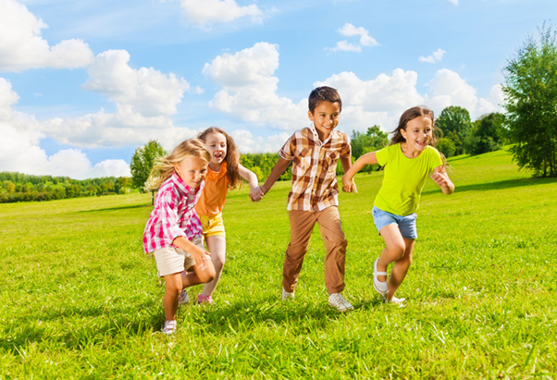
What is physical development?
'Physical development is the way in which children master the control of their bodies' (Johnson and Nahmad-Williams,2009,p77)
Thomas gives a great understanding of what physical development is:
Physical development is the process that starts in human infancy and continues into late adolescent concentrating on gross and fine motor skills as well as puberty. Physical development involves developing control over the body, particularly muscles and physical coordination. (Thomas,2017,hellomotherhood.com)

Physical Development is split into two groups gross motor skills and fine motor skills.
Gross motor skills are the large movements using the bigger muscles of the body, whole limb movements, movement of arms, legs, head and upper body. Gross motor skills require the coordination of muscles and the brain.
Gross motor skills are linked to balance, body awareness, coordination, reaction time and physical strength.
Children develop their gross motor skills at different times of their lives to their peers. Children develop skills at different paces with lots of factors attributing to development.
These Gross motor skills get monitored and observed through milestone targets assessed by a Health Visitor. If a child does not reach a target then it would be monitored further and flagged up, a plan would then be put in place to find out if there are any underlying issues, the child can then be helped if required.
Fine motor skills are the finer movements using the hands, wrists and fingers. Holding a crayon, eating finger foods, using scissors, stacking blocks, threading beads, drawing pictures or brushing teeth.
Fine motor skills also get monitored and observed by a health visitor during the early stages of a childs life. The Health Visitor would ask a child to complete different tasks such as build blocks on top of each other, draw a picture with a pencil or crayon or turn pages of a book. Lots of information gathered from www.understood.org (2021) and www.verywellfamily.com (2019) about fine and gross motor skills.
Fine motor skills develop with practice, patience and perseverance.
Remember each child develops at a different pace, it is not a race!
Neurological problems , developmental delays or disabilities can affect children reaching required targets. There is help out there to enable them to develop their skills to the best of their ability from simple modifications - pencil grips or Occupational Therapy assistance dependent on required needs of the child. Problems with motor skills could be because of a developmental coordination disorder (DCD) Dyspraxia.
Case study - Child who suffered with Dyspraxia, quite clumsy, had trouble coordinating his body, gross motor skills lacking - referred to an Occupational therapist and received trampolining therapy. He was placed into a large Lycra sack and told to jump on the trampoline then told to move right arm then left arm, the occupational therapist explained because his movements were being done with more force than usual with repetition the brain will begin to recognise the movements. The child completed the therapy and it enhanced his movement through his everyday life immensely.
Nutrition is a major factor in developing physically it is not just through movement and exercise.
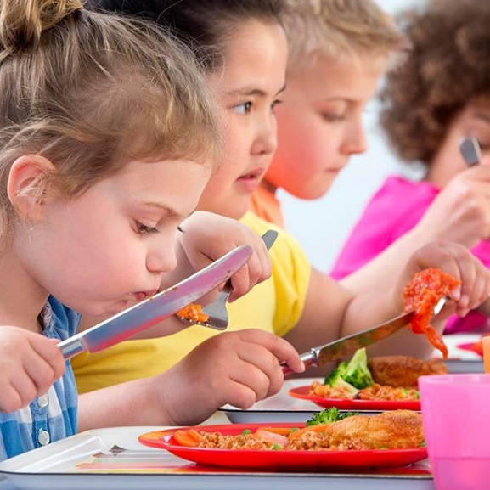
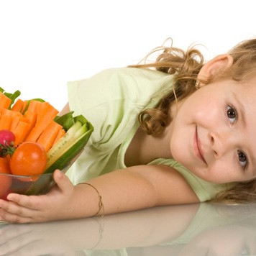

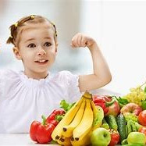
Welsh Network of Healthy School Schemes (WNHSS) was rolled out in Wales since 2000. It was rolled out to target the issues surrounding children's physical development in schools.
Welsh Network of Healthy School Schemes describes it as
'Actively promotes, protects and embeds the physical, mental and social health of its community through positive action'
Factors that effect Physical Development are : Hereditary - Asthma, Diabetes, Sickle cell anemia or cystic fibrosis. Maturation - the rate we develop physically. Poverty - poor nutrition, poor housing causing damp then causing asthma. Nutrition - Malnutrition - severe malnutrition in first four years of life child will struggle to catch up to correct development age. Obesity - less exercising less active, sedentary, rise in processed foods, poor diets.
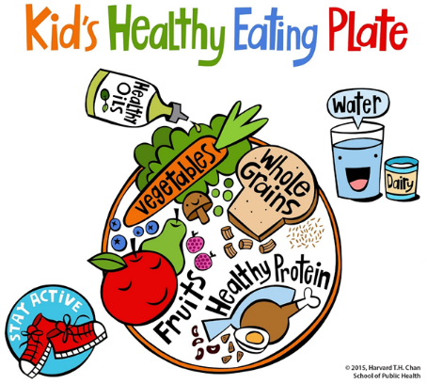
Healthy schools rating scheme is a voluntary rate scheme that allows schools to recognise they have a part to play in developing childrens physical development. It is a self-assessment tool to improve the health and wellbeing of their pupils. Once they have completed the assessment they get an award based on the findings. gov.uk (2019) was a good source for research.
Promoting physical development in the foundation phase framework is at the forefront of the design. Helping Wales ambition to be world leading in physical activity. Physical Education has become a core subject in the curriculum with a National physical literacy framework being developed. Reasoning behind these actions are to reduce obesity in children, reducing risk of inactivity in adulthood therefore reducing Diabetes type 2 and heart disease. Changing the thinking and paving the way for a healthier next generation. gov.wales (2013) was a great source of information.
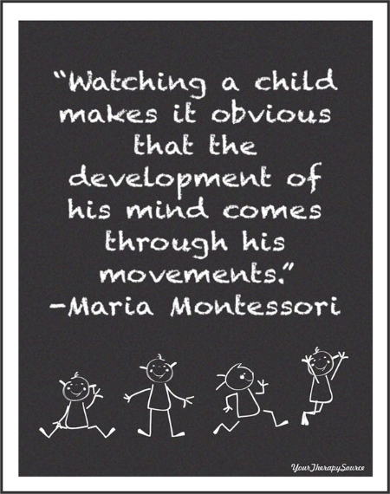
Social Development blog
Social development is the process of learning to live with others in a social learning environment (Johnson and Nahmad-Williams, 2009,p449)
Social development in early years is an important structure for a childs well-being and life happiness. It is linked closely to other developmental behaviours such as cognitive development and emotional development.
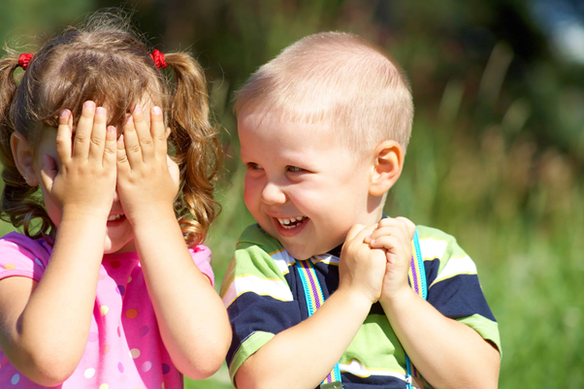
Social development is the foundation for building relationships and the ability to manage stressful situations. Good social development is essential for a child entering school age. Having the ability to interact with other peers, people and recognise how to manage and regulate own behaviour at that age.
Milestones to recognise Social development are:- sharing, pretend play, follow simple rules, shows more independence, develops friendships, understand peoples thoughts, show an understanding of right and wrong. reflectionsciences.com website had a good insight for researching this subject.
There are six stages of play development. Pathways.org explains each stage of play clearly:
• Unoccupied play (birth - 3months old)
- Solitary play (birth - 2 years old)
- Spectator/onlooker behaviour (2 years old)
- Parallel play (2+ years old)
- Associate play (3 - 4 years old)
- Cooperative play (4+ years old)
Social Development really starts from stage 5 Associate play. Stage 4 parallel play is when a child plays alongside another child with no conversing or communication between them.
Through play children learn and develop many skills such as confidence, self-esteem, resilience, interaction, social skills, independence, curiosity and the ability to cope with challenging situations. Children develop social skills through listening and sharing play.
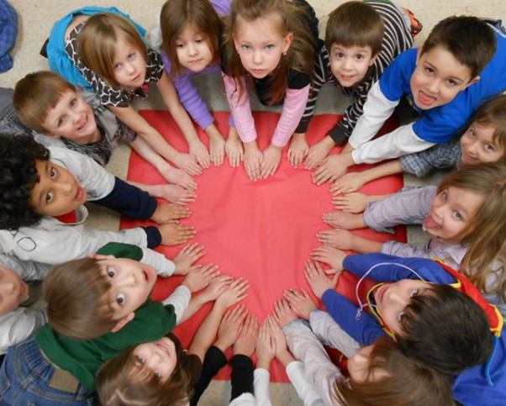
Lack of Social development skills can lead to speech problems or not knowing how to interact with other people in a civilised manner. Things that can hinder the development of social skills are: Improper speech and Language development, parental interaction or lack of it, learning environment, social interaction and health. Parents and Care givers have a huge influence over the way children develop their social skills and development, a lack of it will hinder a childs life in all aspects of the development stages.
Erik Erikson had a theory that there were 8 stages of psychosocial development. healthline.com states, Erik Erikson believed that a person passes through eight developmental stages and that these stages develop and build on each other.
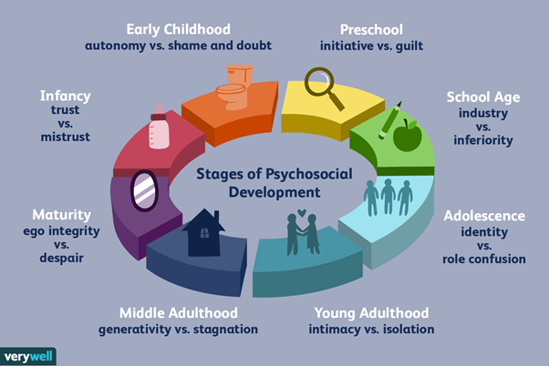
Stage 1 Trust V Mistrust - Birth to 12-18 months old, providing for your childs needs they are dependent on you. If a childs needs are not met fear, anxiety and mistrust can develop or appear.
Stage 2 Autonomy V Shame and Doubt - 18 months - 3 years old, Toddlers learn to gain their own independence - toilet training, beginning to be assertive to their needs and requirements. Children who do not have the opportunity to be assertive and independent may feel inadequate and self-doubting.
Stage 3 Initiative V Guilt - 3 - 5 years old, Child has the ability to achieve goals and interact socially, if a child is not supported in their goals they may lack ambition and have feelings of guilt.
Stage 4 Industry V Inferiority - 5 - 12 years old, child may succeed in different areas of interest and set goals whereas a child not supported could feel inferiority.
Stage 5 Identity V Confusion - 12 - 18 years old, developing a sense of who you are, beliefs, values and goals. If a teenager does not search for their own identity they may not develop skills: strong sense of self and cannot see a future for themselves.
Stage 6 Intimacy V Isolation - 18 - 40 years old, by this age you should know who you are and recognise yourself. You have good committed, loving relationships. People who are not able to reach this stage of development lack security of a happy loving relationship and struggle with their identity.
Stage 7 Generativity V Stagnation - 40 - 65 years old, At this time of life there is a feeling of needing to give to others and a feeling of knowing your needed. Others may feel they are unable to succeed at life, work, family or society and have a lack of motivation.
Stage 8 Integrity V Despair - over 65 years old, Reflection, ability to reflect on lifes achievements and be proud. Some who were not able to reach each stage of the development process may feel regret.

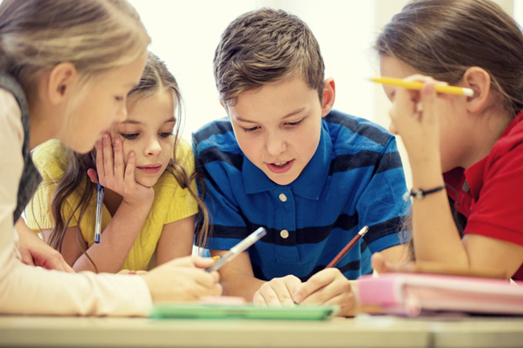
Covid 19 Impact
Three theories were looked at on conversation.com website about the effects of Covid 19 and social development impact on children. Attachment theory - supporting the individual child, Family systems theory - supporting the child in the family and Sociocultural theory -supporting a child in the community. Even though Covid 19 has stopped many interactions it is believed that it has enabled other interactions to develop being at home with family (nurturing). Giving opportunities to learn different skills of everyday life and learning the children may not have normally seen or done. Experts are not really sure if Covid 19 has had an influence on childrens social development because not enough time has passed to acknowledge any differences from previous years.
We just have to remember children are always learning and developing.
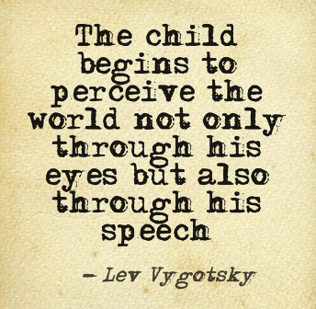

Emotional Development blog
A childs emotional development comes from understanding the world around them and making sense of their feelings and thoughts. Building on this with experiences and maturity.
Empoweredparents website explains emotional development is a child showing affection for others, expressing themselves and the feelings of others, self control and management of feelings and emotions, being observant to others and concentrating - paying attention, form healthy friendships with peers and adults, talk about feelings, show pride in achievement, being independent but able to ask for help if required, positive self image, ability to learn from mistakes.
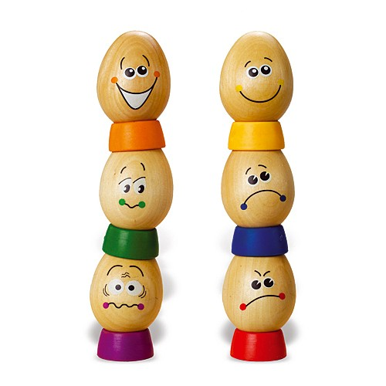
exploringyourmind website says there are three aspects to developing your emotions. These are Emotional understanding, Emotional Regulation and Empathy. The website goes on to explain that the strategies will only work if the childs family and social environment allow them to develop the skills.
Emotional development researchers agree that a child has emotions from a few weeks old. These emotions are: disgust, happiness, fear, anger, sadness, interest and surprise. Most researchers agree that a child will have shown these emotions by the age of 6 months old.

To develop their emotional skills children have emotional expressions first, up to the age of approximately 3 years old then their knowledge and understanding changes to emotional understanding. Children become more aware of their surroundings and inner feelings (Keenan and Evans,2009,p240)

Some of the stages of development are:
Birth - 6 months
- shows signs of most emotions from birth
- smiles and laughs
- facial expressions when happy towards familiar people
7 - 12 months
- anger and fear around strangers
- avoid uncomfortable situations
- secure base needed
1 -2 years
- self awareness
- dependent on adults
- feelings and emotions guided by their care givers
3 - 6 years
- become more self conscious
- able to express emotions
- able to begin to manage emotions
Children whose emotional development strategies have not been implemented or used because of outside factors such as maternal depression, poor parenting, family difficulties, home difficulties - divorce, bereavement, illness, abuse or poverty are possibly going to experience emotional difficulties through their childhood and into adulthood. (Johnson and Nahmad-Williams,2009,p189)
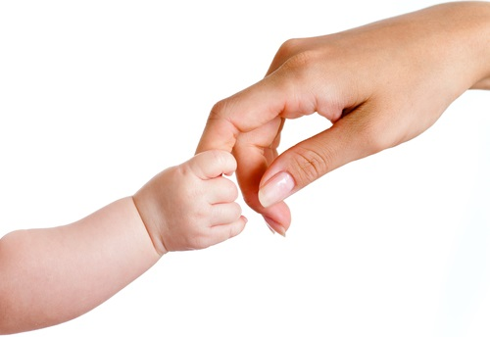
John Bowlby believed in his theory of attachment that the child would seek a level of proximity to their care giver. Staying close to the care giver so they can protect them from dangers. He believed the behaviours are instinctive and unlearnt - part of our biological making. Forming an emotional bond that develops and evolves through the childs development.
Phases of emotional development according to John Bowlby:
- Pre attachment phase - 0 - 6 weeks old
- The attachment phase - 6 weeks - 6 months old approximately
- The clear-cut attachment phase - 6 months - 1 year old approximately
- The formations of reciprocal relationships phase - from 24 months onwards
Sigmund Freud's theory was that the tie between a child and a care giver was simply because they were being fed by them. Three basic ideas:
- Emotional bond goes its own course from care givers to rest of the family in later development
- Relationship and bond will develop childs personality
- Characteristics with the care giver will define or influence.
Henri Wallon had different theories he believed that many aspects need to come together for a childs development - motor, cognitive, emotional and psychomotor.
Stages of emotional development according to Henri Wallon:
- Impulsive motor stage - 0 - 6 months old
- Emotional stage - 6 - 12 months old
- Sensorimotor stage - 1 - 3 years old
- Personality stage - 3 - 6 years old
- The Catergorial stage - 6 - 11 years old
- The Adolescence stage - from 12 years old and on
youaremom.com had great insight into the many theories of John Bowlby, Sigmund Freud and Henri Wallon. All the theorists have valid ideas and structures within their theories. There is no clear way of determining how emotional development gets established in children. What is known though is that if emotional development is lacking a child would struggle greatly.
Childhood emotional neglect can cause long term or short term consequences. Damage from neglect can be silent at first but could develop into depression, anxiety, failure to thrive, developmental delays or low self esteem. A therapist or psychologist can help a child overcome symptoms and cope with their emotions in a clearer and healthier way. Parents can also take parenting classes to help understand the skills needed to respond and help their child and the childs needs.
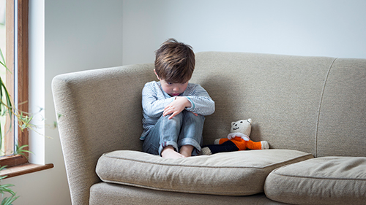
Covid 19 may have a long term affect on a childs emotional development. Centers for disease control and prevention website offers good understanding and ideas to help alleviate some of the worries it says: to maintain a normal routine where possible, talk, listen and encourage children to use expression, give honest, up to date and accurate information at the childs level of understanding, reassure children about their safety and well being and explain the importance of staying healthy, well rested, healthy eating, plenty of fluids and staying physically active when possible. We are all in this together and we will ride out this storm.
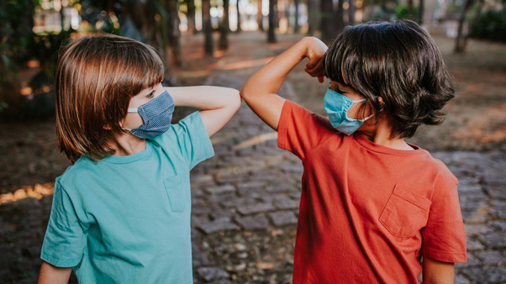
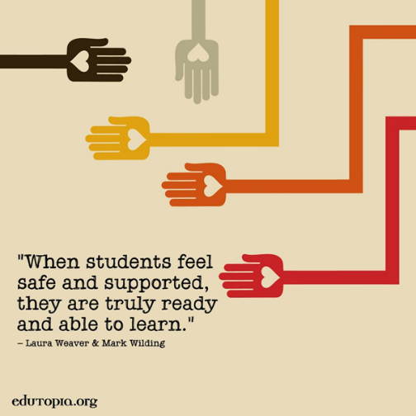

Cognitive Development Blog
What is Cognitive Development?
Cognitive development involves the areas of thought processes or mental activity and the way we sort and deal with knowledge to make sense of it, remembering, problem solving and decision making from childhood though to adulthood. “Cognitive development is the development of cognition or conceptual knowledge and understanding” (Johnson and Nahmad-Williams, 2009, p108)
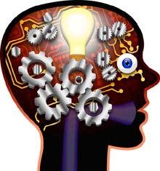
The benefits of cognitive development that the website wehavekids.com write about are: it promotes long term learning, develops problem solving skills, improves comprehension, improves confidence, improves memory, instils a love of learning and emphasises innovation.
Early focus is important when developing cognitive skills through observations developmental delays can be identified and early intervention in addressing the issue or problem. There are things called milestones that get observed throughout the childs life to ensure that they are developing their skills.
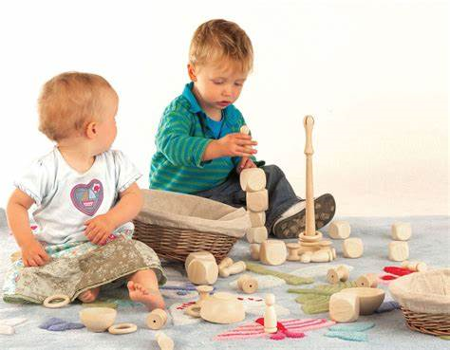
Johnson and Nahmad-Williams (2009) notes there are a few aspects of cognition: memory, abstraction, logic, problem solving, intelligence, reasoning, thinking, knowledge, understanding and metacognition- awareness of the process of cognition.
John Piaget’s theory understood there are several stages of cognitive development: Sensori-motor aged 0-2 developing object permanence, Pre-operational aged 2-7 developing egocentrism, Symbolic aged 2-4, Intuitive aged 4-7, Concrete operational aged 7-11 developing mental operations and Formal operational 11- 16 developing hypothetico-deductive reasoning. (Johnson and Nahmad-Williams, 2009, p115) He believed that each child moved through the stages in order – however each child would have varying experiences through their learning so their cognition will be individual to each child.
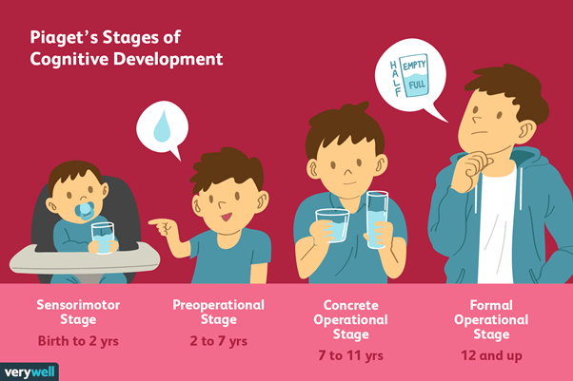
Lev Vygotsky’s theory was built on from John Piaget’s theory – realising that language and thought are sections that support each other but build their understanding separately. He believed in the Zone of Proximal development - where the distance between a young child operating alone and ability to have guidance from another person (Dowling, 2014, p35) in a scaffolding strategy, the level of support to meet ability of child – language appropriate to their attention and memory.
Jerome Bruner took Lev Vygotsky’s theory further building on them with his spiral curriculum – Where challenging topics are tackled in a learning age-appropriate way and revisiting year on year expanding their prior knowledge. He takes into consideration environment and experiential factors. Learning through three category headings – Enactive representation – action-based, Iconic representation – image-based and Symbolic representation – language-based. Jerome Bruner believed that when we observe something we are always sorting and organising it in order in our brains. (Johnson and Nahmad-Williams,2014, pp116-118)

How can I develop a childs Cognitive Development? By talking, singing and reading to them, let the child explore and observe, teach the child object names, answer the childs endless questions, lots of creative play, books and puzzles, story telling, child story telling their own stories form their imagination, educational toys and games and outdoor play. Ensure good health and wellbeing healthy food and sleep - makes a healthy body and mind.
'Build a strong foundation for future success' – wehavekids.com
One way to develop cognitive skills is by heuristic play. Heuristic play is providing a wide range of materials to play with in different ways, moving freely around with them exploring and experimenting different movements, theories and thoughts. Heuristic play was the theory of Elinor Goldschmeid developed in 1980’s. Child led form of play that can be done individually or with peers. It would look different in different parts of the world due to using common items found around the home. earlyimpactlearning.com was a great source for information.
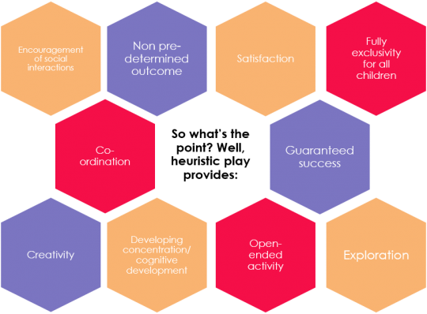
Heuristic play is usually for children aged one to two years old based from curiosity and finding out for themselves. Playing with a wide range of materials – thinking about natural, texture, noisy, shape, obscure, soft materials ensuring all are safe to use whilst they are playing with them and moving around with them. Perfect examples of materials are: empty boxes, egg boxes, pots and pans, teapots or laundry baskets with material in. The most important thing is the child can move freely with the items and that they are safe.
According to the website Earlyimpactlearning.com the different skills they can learn are: to stack, handle, transport, roll, post, gather, select, fill, manipulate, dump them and cover. So many skills that can be learned through one session of play learning.
Heuristic play develops Independence the children are able to choose what they play and use and how to use it, constructing and building and share if they want too. Problem solving if things go wrong the ability to how to solve it independently in their own way using their own thought processes. Concentration curiosity enables the child to be inquisitive and holds their attention span for longer periods of time. Creativity it helps to develop their own ideas and imaginations. Critical thinking getting them to choose the ideas and choices developing their own strategies. Gross motor skills lots of movement lifting objects, crawling, walking, rolling, bending and stretching.
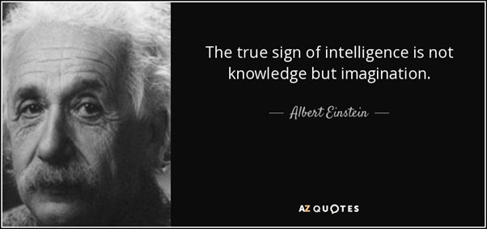

Blog links
Physical Development
https://academicblogs699637396.wordpress.com/2021/03/26/physical-development/
Social Development
https://academicblogs699637396.wordpress.com/2021/03/26/social-development/
Emotional Development
https://academicblogs699637396.wordpress.com/2021/03/26/emotional-development/
Cognitive Development
https://academicblogs699637396.wordpress.com/2021/03/26/cognitive-development/

Reference list
Physical Development Blog References
Thomas,K and Evans,S.(2009)An introduction to child development.2nd edn.London:Sage.
Dowling,M.(2014)Young childrens personal, social and emotional development.4th edn.London:Sage.
Johnson,J and Nahmad-Williams,L.(2009) Early childhood studies.Harlow:Pearson
Gov.wales,2018,Physical Literacy- an all-Wales approach to increasing levels of physical activity for children and young people. Available at: SECTION 1: Background to the Group and its purpose (gov.wales) (accessed 25th March 2021)
Early years matters,2021, Physical Development. Available at: Physical Development - Early Years Matters (accessed 25th March 2021)
Senedd Wales,2019, Physical Activity of Children and Young People. Available at: cr-ld12369-e.pdf (senedd.wales) (accessed 25th March 2021)
Thomas.k,2017,Define physical development. Available at: Define Physical Development (hellomotherhood.com) (accessed 25th March 2021)
Understood,2021,Gross motor skills: What you need to know. Available at: What Are Gross Motor Skills | Understood - For learning and thinking differences (accessed 25th March 2021)
Understood,2021,Fine motor skills: What you need to know. Available at: What Are Fine Motor Skills | Understood - For learning and thinking differences (accessed 25th March 2021)
Mauro.T,2019, Fine and gross motor skills in children. Available at: Fine and Gross Motor Skills in Children (verywellfamily.com) (accessed 25th March 2021)
Gov.uk,2019,Healthy schools rating Scheme Available at: Healthy schools rating scheme - GOV.UK (www.gov.uk) (accessed 25th March 2021)
Public Health network Cymru,2021,Welsh network of healthy school schemes (WNHSS) Available at: Welsh Network of Healthy School Schemes (WNHSS) | Public Health Network Cymru (accessed 25th March 2021)
Images
Children running on grass. Available at: https://cdn.cdnparenting.com/articles/2018/01/159883541-H.jpg (accessed 25th March 2021)
Stages of growing baby. Available at: https://cdn2.momjunction.com/wp-content/uploads/2018/09/Physical-Development-In-Infants-Toddlers-Chart-And-Tips.jpg (accessed 25th March 2021)
Child eating healthy food. Available at: https://www.agri-pulse.com/ext/resources/opinion/Matz/CR-Health-Inlinehero-healthy-choices-school-cafeteria-0818.jpg?1553189751 (accessed 25th March 2021)

Child with fruit bowl. Available at: https://th.bing.com/th/id/Rf60b3bc499d221aca96a94dfb5dc943d?rik=59UAkse4BEe45Q&riu=http%3a%2f%2fwww.childteaching.com%2fwp-content%2fuploads%2f2015%2f09%2fchild-nutrition.jpg&ehk=X6aKL5fp0fEZIJS7O%2bcetfYqVguXzaRSyNws3WRObLs%3d&risl=&pid=ImgRaw (accessed 25th March 2021)
Child with fruit. Available at: https://th.bing.com/th/id/OIP.6Sp2a4D9NviQ7tQzVlhvtgHaEx?w=291&h=187&c=7&o=5&pid=1.7 (accessed 25th March 2021)
Healthy eating plate. Available at: https://cdn1.sph.harvard.edu/wp-content/uploads/sites/30/2016/01/KidsHealthyEatingPlate_Jan2016.jpg (accessed 25th March 2021)
Maria Montessori quote image. Available at: https://i.pinimg.com/originals/d2/08/59/d208592064d0dce35ecf7c58b3a17cbc.jpg (accessed 25th March 2021)

Social Development Blog References
Thomas,K and Evans,S.(2009)An introduction to child development.2nd edn.London:Sage.
Dowling,M.(2014)Young childrens personal, social and emotional development.4th edn.London:Sage.
Johnson,J and Nahmad-Williams,L.(2009) Early childhood studies.Harlow:Pearson
Reflection Sciences,2017, What is social development in early childhood. Available at: Social Development in Early Childhood | Reflection Sciences(accessed 25th March 2021)
Pathways,2020,How kids learn to play: 6 stages of play development. Available at: The 6 Stages of How Kids Learn to Play | Child Development (pathways.org) (accessed 25th March 2021)
Ni direct,2021, How play helps childrens development. Available at: How play helps children's development | nidirect(accessed 25th March 2021)
Eitel.J,2017, Factors affecting early childhood development. Available at: Factors Affecting Early Childhood Development (hellomotherhood.com) (accessed 25th March 2021)
Beane.L and Shearer.A,2020,Will COVID lockdowns hurt your child's social development? 3 different theories suggest they'll probably be OK. Available at: Will COVID lockdowns hurt your child's social development? 3 different theories suggest they'll probably be OK (theconversation.com) (accessed 25th March 2021)
Lewis.R,2020,Erikson’s 8 stages of psychosocial development, explained for parents. Available at: Erikson Stages of Psychosocial Development in Plain Language (healthline.com) (accessed 25th March 2021)

Images
Stages of development image. Available at : https://www.verywellmind.com/thmb/zptm71LhMdLXmaxkDRIsX5TzSA4=/1500x1001/filters:no_up scale():max_bytes(150000):strip_icc()/2795740-article-erik-eriksons-stages-of-psychosocial-development-5ac3df9e875db90037ffa803.png (accessed 25th March 2021)
Childrens hands in heart shape. Available at: https://nsadvocate.org/wp-content/uploads/2017/05/earlychidhoodFeat-685x550.jpg (accessed 25th March 2021)
Two children image. Available at: https://www.parentingexperttomom.com/wp-content/uploads/2017/03/Social-and-Emotional-Development-in-Toddlers.jpg (Accessed 25th March 2021)
Four children doing school work. Available at: https://mommabe.com/wp-content/uploads/2018/11/education-elementary-school-learning-people-Emotional-Development-ss.jpg (Accessed 25th March 2021)
Lev Vygotsky quote image. Available at: https://i.pinimg.com/originals/2b/7b/d6/2b7bd62127f32fb703ae6e8c4c6df3f6.jpg (Accessed 25th March)

Emotional Development blog References
Thomas,K and Evans,S.(2009)An introduction to child development.2nd edn.London:Sage.
Dowling,M.(2014)Young childrens personal, social and emotional development.4th edn.London:Sage.
Johnson,J and Nahmad-Williams,L.(2009) Early childhood studies.Harlow:Pearson
Grace.E,2018,Emotional development in children. Available at: Emotional Development in Children (kidsdevelopment.co.uk)(Accessed 24th March 2020)
Mcilroy.T,2021,The stages of emotional development in early childhood. Available at: The Stages of Emotional Development in Early Childhood - Empowered Parents(Accessed 24th March 2020)
Exploring your mind,2020,The process of a child’s Emotional development. Available at: The Process of a Child's Emotional Development - Exploring your mind(Accessed 24th March 2020)
Ford.V and Dorries.N,2020, Effect of pandemic on childrens well being revealed in new report Available at: Effect of pandemic on children's wellbeing revealed in new report - GOV.UK (www.gov.uk) (Accessed 24th March 2020)
Centers for disease control and prevention,2020,Covid-19 Parental resources kit – childhood. Available at: Children's Wellbeing During COVID-19: Parental Resources |CDC(Accessed 24th March 2020)
Meinke.H,2019, Understanding the stages of emotional development in children. Available at: Understanding the Stages of Emotional Development in Children | Rasmussen University(Accessed 24th March 2020)
Legg.T,2019,Childhood emotional neglect: how it can impact you now and later. Available at: Childhood Emotional Neglect: What It Is, and How It Can Affect You (healthline.com) (Accessed 24th March 2020)
Youaremom,2020,Theories that explain emotional development. Available at: Theories that Explain Emotional Development - You are Mom(Accessed 24th March 2020)

Images
Egg emotions image. Available at: https://d39qw52yhr4bcj.cloudfront.net/catalog/product/cache/9/image/9df78eab33525d08d6e5fb8d27136e95/e/g/eggspressionscomp.jpg (Accessed 24th March 2021)
Baby crying with other child looking image. Available at: https://www.trendingus.com/wp-content/uploads/2016/05/Tips-to-Overcome-sadness.jpg (Accessed 24th March 2021)
Baby and mother holding fingerimage. Availbale at: https://babyhintsandtips.com/wp-content/uploads/2016/07/attachment.jpg (Accessed 24th March 2021)
Child huddled in corner of sofa. Available at: https://www.cdc.gov/coronavirus/2019-ncov/images/daily-life-coping/parental-resource-kit/young-man-500px.jpg (Accessed 24th March 2021)
Children elbow tapping. Available at: https://dmn-dallas-news-prod.cdn.arcpublishing.com/resizer/SMi14D0X2zzky5EX-L6DN1az0vc=/1660x934/smart/filters:no_upscale()/cloudfront-us-east-1.images.arcpublishing.com/dmn/MD52QYVXWRC5PN3UE3UN7IHMVU.jpg (Accessed 24th March 2021)
Laura Weaver and Mark Wilding quote. Available at: https://i.pinimg.com/originals/a7/ec/0b/a7ec0b978c0d891ca3a669372b413c35.jpg (Accessed 24th March 2021)

Cognitive Development Blog References
Thomas,K and Evans,S.(2009)An introduction to child development.2nd edn.London:Sage.
Dowling,M.(2014)Young childrens personal, social and emotional development.4th edn.London:Sage.
Johnson,J and Nahmad-Williams,L.(2009) Early childhood studies.Harlow:Pearson
Help me grow,2021,What is cognitive development. Available at:What is Cognitive Development | Help Me Grow MN (Accessed 23rd March)
Help me grow,2021,Cognitive milestones. Available at: Cognitive Milestones | Help Me Grow MN(Accessed 23rd March)
Encyclopaedia of childrens health,2021,Cognitive Development. Available at: Cognitive Development - stages, meaning, average, Definition, Description, Common problems (healthofchildren.com) (Accessed 23rd March)
Cherry.K,2020,The 4 stages of cognitive development. Available at: Piaget's 4 Stages of Cognitive Development Explained (verywellmind.com) (Accessed 23rd March)
Sagar.v,2019,The importance of building cognitive skills in children. Available at: The Importance of Building Cognitive Skills in Children - WeHaveKids - Family(Accessed 23rd March)
Williams.M,2021,18 benefits of heuristic play. Available at: 18 Benefits Of Heuristic Play – Early Impact Learning(Accessed 23rd March)
Williams.M,2021,What is Heuristic play? The essential guide. Available at: What Is Heuristic Play? The Essential Guide – Early Impact Learning(Accessed 23rd March)
Exploring your mind,2020,Lev Vygotsky- the theory of cognitive development. Available at: Lev Vygotsky - Theory of Cognitive Development - Exploring your mind(Accessed 23rd March)
Images
Children playing blocks. Available at: https://th.bing.com/th/id/OIP.QCspgjOSU0TU72O66SHv7AHaFx?pid=ImgDet&rs=1 (Accessed 24th March 2021)
Heuristic play hexagon graph. Available at: https://tiddlywinksnurseryschool.com/wp-content/uploads/2017/03/download-540x398.png (Accessed 24th March 2021)
Piaget’s stages of cognitive development image. Available at: https://www.verywellmind.com/thmb/2bSG-Cnbew4SIjO7WPrkDT5vBcY=/1500x1000/filters:fill(ABEAC3,1)/2795457-article-piagets-stages-of-cognitive-development-5a95c43aa9d4f900370bf112.png (Accessed 24th March 2021)
Head with cogs. Available at: https://th.bing.com/th/id/R0ebf45dedfed2afb9a0f77e74a013f97?rik=VTyfjARUhr2XcA&riu=http%3a%2f%2fwww.learninginfo.org%2fimages%2fcognitive-development.jpg&ehk=p8mMkJGWhIKoX5oT%2bnAADk1HfQFSYiQvXZMjbxDriLk%3d&risl=&pid=ImgRaw (Accessed 24th March 2021)
Child with imagine clouds. Available at: https://exploringyourmind.com/wp-content/uploads/2020/04/Vygotskys-Sociocultural-Theory-of-Cognitive-Development..jpg (Accessed 24th March 2021)
Einstein Quote image. Available at: https://www.azquotes.com/picture-quotes/quote-the-true-sign-of-intelligence-is-not-knowledge-but-imagination-albert-einstein-8-72-91.jpg (Accessed 24th March 2021)

