
Applied Leadership and Management in the Workplace
Module Assignment Submission
Student Name: | Leanne Thomas
Student Number: | 2318789
Module No: | BMSK4012
Module Title: | Business Plan

Statement of Confirmation of Authenticity
By the act of making this submission, the student declares that this is the work of the student named above. The work has not, in whole or in part, been knowingly presented elsewhere for assessment, or where assessment has been built on a previous assessment, this has been identified. Where materials have been used from other sources it has been properly acknowledged. If this statement is untrue, the student acknowledges that an assessment offence has been committed.
Attention is drawn to the plagiarism and unfair practice policies of both the University and of ILM.

Table of Content
Section 1 Executive Summary
1.1 Introduction
Section 2 Bara Cymraeg Introduction
2.1 Business Background
2.2 Business Details
2.3 Legal Status
2.4 Owner – Manager – Team Details
2.5 Product – Service details
Section 3 Market and Competitors
3.1 Market size and Trend Insights
3.2 PEST Analysis Competitor Analysis
3.3 SWOT Analysis
3.4 Customer Target market
3.5 Competitor Analysis
Section 4 Sales and marketing strategies
4.1 Marketing Objectives
4.2 Marketing strategies
4.3 Pricing Strategies
4.4 Sales Forecast
4.5 Budget and timescale
Section 5 Operations
5.1 Location – Premises – Equipment
5.2 Production and distribution processes
5.3 People – Staff - Suppliers
5.4 Systems and Procedures
5.5 Health and Safety – Quality Control – Legal Compliance
Section 6 Financial Information
6.1 Cashflow Forecast, Profits and balance sheet
6.2 Set-up and Operations Costs
6.3 Sources of Finances/Funding Requirements
Section 7 Appendices
7.1 Evidence of Market Research
7.2 Letters from Potential Customers / Firm Orders
7.3 Price List
7.4 Sample Promotion Material
Section 8 References
8.1 References
Section 9 Ciriculam Vitae
9.1 CV
Section 1 Executive Summary
Bara Cymraeg is a start-up business dedicated to showcasing the authentic flavours of Wales through a premium sandwich shop and mobile catering trailer. Launching on March 1st, 2027 (St David’s Day), Bara Cymraeg will celebrate local produce, sustainability, and cultural pride. Our mission is to serve high-quality, handcrafted Welsh food made from 100% locally sourced ingredients, promoting zero waste, low carbon operations, and community support. The short-term goal is to establish a thriving trailer-based food business, with mid-term expansion into events and long-term plans to open a permanent shop.
Section 2 Bara Cymraeg Introduction
2.1 Business Background Plan
- Business and Trading Name: Bara Cymraeg (Welsh Bread) – Business Brand Taste of Wales. The business name has had no previous owners - Companies House 2012 - Companies House 2016 Government UK - Write a Business Plan 2012 – Kings Trust Business Plans 2024
- Business Description: A Pre- launched sandwich shop featuring exclusively Welsh ingredients and produce, sourced produced and made entirely in Wales.
- Our Mission is to showcase the rich heritage and quality of Welsh produce by creating tasty sandwiches pastry and cakes using seasonal ingredients farmed and produced in Wales. We are dedicated to helping local farmers, bakers, and artisans while reducing our carbon footprint through local sourcing and environmentally friendly procedures. Every bite embodies the true taste of Wales, encouraging communal pride and environmental responsibility.

- Date You Will Start Trading: March 1st 2027 – launching on St David’s Day, the perfect date to celebrate and showcase authentic Welsh produce.
- • Short-Term Goals (Next 12 Months): To establish a thriving sandwich and cake trailer on a long term pitch that celebrates the rich heritage and exceptional quality of Welsh ingredients. We will craft delicious, seasonal sandwiches and cakes made exclusively from fresh, locally sourced produce grown and produced across Wales.

- Medium-term Goals 12 months – 3 Years to expand the use of the trailer to work at special events such as birthdays, weddings, anniversaries, food festivals, and craft fairs. We aim to expand our menu to offer a wider range of traditional Welsh products, including ,Welsh rarebit, crempogau and premium Welsh charcuterie boards.

- • Long-Term Goals (3–5 Years): To open a permanent shop. Calibrating with other Welsh traders selling honey, chutneys and other Welsh delicacy ‘s to sell in the shop at a profit.
2.2 Business Details
- Owner: Leanne Thomas
- Business Address: 27 Ffynnon Wen, Clydach, Swansea SA65EQ
2.3 Legal Status
- Business Status Solo Trader Registration. The business will be registering as a sole trader. One owner who will solely be responsible for decision making and liable for the business. Sole Trader Government UK 2024
2.4 Entrepreneur – Manager – Team Details
- Entrepreneur: Leanne Thomas (£30,784/year | £16/hour)
- Manager: Kieran Mayne (16 Hours/Week | £11,648/year | £14/hour)
2.5 Product – Service details
- Unique Selling Proposition (USP): Bara Cymraeg is the only sandwich shop in South Wales dedicated entirely to Welsh produce, with a strong focus on sustainability and a low carbon footprint.
Key Objectives:
- Source 100% of Ingredients Locally
- Partner with Welsh farmers, bakers, and suppliers to ensure all products are grown or made in Wales.
- Promote Sustainability and Low Carbon Footprint
- Implement eco-friendly packaging and minimise food miles by sourcing within Wales.
- Achieve Profitability Within Year One
- Target a monthly revenue of £6,690 to steadily increase by the end of the 12 months.
- Build a Strong Local Customer Base
- Establish repeat business through loyalty schemes and exceptional customer service.
- Create a Recognisable Welsh Brand
- Work with Apps Too Good To Go and calibrating with The Homeless charity Goleudy to eradicate any food waste.
Section 3 Market and Competitors
3.1 Market size and Trend Insights
- Growing demand for sustainable, local, and culturally rich food.
- This analysis underscores a growing consumer appetite for sustainable, locally sourced, and culturally rich food. Bara Cymraeg is well-positioned to ride this wave by leveraging its Welsh-centric brand, festival presence, and ethical ethos. Long-term success will hinge on balancing premium positioning with smart cost management, and scaling brand awareness through community partnerships and event-driven visibility.
- Artisan bakery tourism: The rise of "bakery pilgrimages" shows growing consumer interest in artisanal, sustainable baked goods—aligned with our proposed sandwich and cake offerings Mashall, C. 2025 The Guardian
Trend Insights
- A 2024 Welsh Government report cites that Welsh customers increasingly seek authentic, sustainable food experiences and are willing to pay more for Welsh products Grown Together 2024 - Business Wales
- Wales is gaining international acclaim: Michelin-starred chefs and Geographical Indication (GI) certifications recognize 20 iconic Welsh food/drink products, boosting the profile of local cuisine. Cooke, L.H. 2023 Wales
Target Market & Customer Profile
Our ideal customers include health-conscious professionals (aged 25–55), families seeking wholesome, culturally rich meals, and tourists keen to experience authentic Welsh cuisine. They appreciate high-quality, locally sourced ingredients, value sustainability, and are willing to pay a premium for ethically produced food.
Market Size & Trends
- Tourism's economic role in Wales: Pre-pandemic, tourism contributed around £2.4 billion directly to the Welsh GDP (5% of total) and supported approximately 161,000 jobs (12.1% of employment) Starkey, j. 2024 Business Wales GOV.WALES
- Food & Drink Sector in Wales: The broader Welsh food and drink supply chain grew 10% in 2023, employing 228,500 people (representing 17% of Wales’s workforce) and generating a turnover of around £24.6 billion Welsh Business 2024 GOV.WALES
- UK Hospitality Market Growth: The UK hospitality sector was valued at approximately USD 57.5 Billion in 2024, and is projected to grow to USD 85.6 billion by 2033 at a CAGR of 4.5%. By another estimate, the sector is reaching USD 69.5 billion in 2024, with projections up to USD 99.4 billion by 2032 at a 4.5% CAGR. Imarc Group 2024
- Food & beverage enterprises in Wales: About 7.3% of Welsh businesses (7,840 companies) operate in food and beverage services; tourism (11.8% of enterprises) grew since 2019, reflecting the rising demand for local hospitality J. Starkey, J. 2024 Business Wales GOV.WALES.
- Artisan bakery tourism: The rise of "bakery pilgrimages" shows growing consumer interest in artisanal, sustainable baked goods—aligned with our proposed sandwich and cake offerings. Mashall, C. 2025 The Guardian
- • Food Tourism Movement
– Cardiff International Food & Drink Festival attracts around 50,000 attendees over its three-day run in Cardiff Bay. Parker, D. 2014 Welsh Government
– Abergavenny Food Festival draws approximately 25,000 visitors across two days, with many returning year after year. Parkin, L. 2025 Abergavenny Food Festival
The above links have been CRAAP Tested to ensure the information is current, relevant, authentic, accurate, and purposeful. George, T. 2021 CRAAP Test
3.2 PEST Analysis Competitor Analysis
PEST Analysis
Political:  - Food Safety & Hygiene Regulations: Strict UK and Welsh Government rules for food hygiene require full compliance, including regular inspections.  - Support for Local Food Businesses: Welsh Government initiatives like Food & Drink Wales and grants for local produce businesses can offer funding or marketing support.  - Tourism Policies: Ongoing investment in Welsh tourism benefits local food businesses, as food and cultural experiences are key attractions for visitors.  - Trade Policies & Brexit: Potential fluctuations in ingredient prices due to post-Brexit trade agreements and import tariffs. | Economic:  - Tourism Revenue: Wales generates billions annually from tourism (e.g., £3.8 billion GVA in 2022), with food and drink spending being a major driver.  - Economic Uncertainty: Rising costs of ingredients and utilities may impact pricing strategies and profit margins.  - Growing “Premium Local” Market: Consumers are increasingly willing to pay more for quality, authentic, and locally sourced foods.  - Employment & Wage Trends: Wage increases could affect staffing costs, but also increase consumer spending power locally.
Social:  - Cultural Pride: Increasing demand for authentic Welsh products that showcase heritage (e.g., Welsh lamb, bara brith, and cawl).  - Health-Conscious Consumers: A growing interest in fresh, low-processed, and sustainable food options.  - Community Focus: Preference for businesses that support local farmers and reduce their carbon footprint.  - Food Tourism: Events such as the Cardiff International Food & Drink Festival and Abergavenny Food Festival attract thousands of visitors eager to try Welsh specialties. | Technological:  - Online Marketing & Social Media: Platforms like TikTok, Instagram, and Facebook play a crucial role in building brand awareness and showcasing Welsh produce.  - E-commerce & Pre-Orders: Online ordering systems and “click & collect” options can help increase sales.  - Mobile Payments & Contactless Tech: Consumers expect easy, cashless payment solutions at events and markets.  - Sustainability Technology: Tools for tracking food waste and implementing zero-waste strategies are becoming more accessible.
Johnson, G., Scholes, K., & Whittington, R. (2008). PEST Analysis
3.3 SWOT Analysis
Strengths  - Unique position as South Wales’s only sandwich shop dedicated to Welsh-produce.  - Strong emphasis on sustainability and a low carbon footprint.  - Direct partnerships with local farms ensuring quality and authenticity.  - Agile vanish-based model allows presence at high-profile events and festivals.  - Seasonal menus keep offerings fresh and rooted in local culture. | Weaknesses  - Higher input costs due to exclusive use of premium Welsh ingredients.  - Lower initial brand awareness compared to major competitors.  - Menu dependent on seasonal availability, requiring adaptability.  - Limited marketing resources in competition with larger chains.  - Heavy reliance on building loyalty and community engagement from the ground up.
Opportunities  - Local food surge: Strong trend toward supporting Welsh heritage and local farming.  - Festivals & events: High footfall at annual food gatherings presents mobile-van catering opportunities.  - Partnership potential: Collaborations with farms, food festivals, tourism bodies, and sustainability initiatives.  - Menu expansion: Growing interest in traditional Welsh dishes such as cawl, pasties, and charcuterie supports future diversification. | Threats  - Ingredient costs: Premium sourcing increases food costs and squeezes margins.  - Competitive landscape: Major chains enjoy strong brand loyalty and marketing budgets.  - Supply variability: Seasonal limitations may disrupt menu consistency if not managed well.  - Economic sensitivity: Premium dining is vulnerable to downturns impacting discretionary income.
Kenton, W. 2025 SWOT Analysis

3.4 Customer Target market
- Health-conscious locals and professionals, tourists, families, and cultural enthusiasts 18 years upwards.
3.5 Competitor Analysis
Competitor | Overview | Our Advantage
Gower Heritage Centre | A Welsh café and cake shop. This would be our closest competitor with cake sales and Welsh produce. They do not offer sandwiches. | We offer freshly made seasonal Welsh sandwiches. Based in a more central location.
Greggs | UK-wide chain, low-cost bakery & sandwiches | We offer high-quality, Welsh-exclusive ingredients with a strong regional identity.
Subway | Global fast-food sandwich brand | We prioritise freshness, seasonal produce, and flavour authenticity over processed fillings.
Local cafés/delis | Independent outlets offering food/drinks | Unlike them, we exclusively source Welsh produce and promote a low-carbon, sustainable model.
Porter, M. 2017 System and Software
Section 4 Sales and marketing strategies
4.1 Marketing Objectives
- Build brand recognition and online presence before launch
- Hit £10,737.17 in first month (March 2027)
- Achieve £90,323.61 revenue in Year 1

4.2 Marketing strategies
- Social media (TikTok, Instagram, Facebook)
- Professional website (Shopify or Squarespace)
- Print campaigns, community engagement
- Teaser campaigns, influencer marketing, event-based promotions

4.3 Pricing Strategies
- Value-based pricing reflecting premium local sourcing
- Introductory offers, loyalty programme, festival deals
4.4 Sales Forecast
- Year 1: £90,323.61 profit
- Year 2–3: + 50% growth £140,324
- Year 5: £250,000–£300,000
4.5 Budget and timescale
- Social media: Launch Jan 2027
- Website: Launch Feb 2027
- Sales Start: March 2027
Section 5 Operations
5.1 Location – Premises – Equipment
- Business Location:
Bara Cymraeg will initially operate from a custom-designed catering trailer, strategically positioned at high-footfall locations in Swansea as well as local markets, festivals, and tourist spots around Wales . The mobile model allows us to build brand awareness and test different trading locations before establishing a permanent shop in South Wales within 2–3 years.
- Branded packaging & display Eco Friendly.
Equipment & Tools Needed:
- Catering Trailer Setup: Fully fitted trailer with refrigeration, salad bar, sandwich prep station, Bread oven, hobs, soup maker and handwashing facilities (compliant with food safety standards).
- Food Preparation Equipment: Mixers, chopping stations, food thermometers, and eco-friendly food storage solutions.
- Serving & Display: Compact counter displays, cake stands, and branded eco-friendly takeaway packaging.
- Future Shop Requirements: Commercial-grade kitchen appliances (larger ovens, refrigeration units, and storage space) to handle increased production capacity.

5.2 Production and distribution processes
- The main Supplier for Bara Cymraeg will be Castle Howell. I have completed intensive research regarding this and smaller Welsh companies and they are the main disputer for the following ingredients and are based in Swansea. This will help us to keep our carbon footprint down and lower delivery costs by having one large supplier.
- Local Farms & Welsh Producers: Seasonal fruit, vegetables, meat, and dairy sourced directly from local farmers and growers.
- Artisan Bakers & Mills: Specialty bread pasties, sausage rolls, quiche and flour sourced from Welsh mills, meat and cheders from local farms and cheese mongers.
- Welsh Artisan Brands: Charcuterie, cheeses, meats, chutneys and honey producers for premium fillings and add-ons.

5.3 Staffing Plan
- Leanne Thomas: Owner/operator (full-time)
- Kieran Mayne: Assistant Manager (16 hours/week)
- Casual/festival staff (as needed): 2–3 trained part-time staff - Minimum wage.
Training:
- Level 2 Food Hygiene Certification
- Welsh cultural food induction
- Eco/sustainability handling and waste reduction
Logistics:
- 5-day trading week initially (Wed–Sun)
- 7am–3pm prep and sales routine
- Weekly ingredient ordering
- Fuel-efficient towing van
- Waste managed via local composting and zero-waste partners
5.4 Systems and Procedures
Business Systems
These are the key operational structures that help Bara Cymru run smoothly:
System | Purpose
Point of Sale (POS) System | Records sales, prints receipts, tracks stock of pasties, drinks, and sandwiches.
Inventory System | Monitors ingredients, baked goods, and packaging supplies to avoid shortages.
Cash Handling System | Ensures accurate till operations, float management, and daily reconciliation.
Food Preparation System | Standardises how sandwiches, quiches, and pasties are prepared and presented.
Health & Safety System | Ensures food hygiene, temperature checks, and allergen compliance are followed.
Customer Service System | Outlines how staff greet, serve, and handle customer feedback or complaints.
Staff Rota & Payroll System | Tracks staff hours, breaks, wages, and scheduling.

Business Procedures
These are the step-by-step instructions used daily by all staff:
Opening the Shop Procedure
- Owner or Manager to arrive 1 hour before opening.
- Turn on lights, ovens (if needed), and equipment.
- Check food safety (fridge/freezer temps, clean surfaces).
- Prepare and display fresh items (e.g. sandwiches, pasties).
- Count float and log it in the cash book.
- Unlock doors and turn the “Open” sign.
Food Preparation Procedure
- Wash hands thoroughly and wear gloves/apron.
- Follow recipe when making sandwiches etc
- Use fresh ingredients only.
- Label and store any pre-prepped items with date/time.
- Rotate stock: use FIFO (first in, first out).
Customer Service Procedure
- Greet each customer with “Bore da!” or a friendly hello.
- Take order clearly, upsell politely if appropriate (e.g. “Would you like a drink with that?”).
- Confirm order and price.
- Take payment (cash or card), issue receipt.
- Thank the customer, offer loyalty stamp (if you use one).
Cashing Up Procedure
- Close till and count remaining cash.
- Record totals (cash vs card) on daily takings sheet.
- Log discrepancies (if any).
- Store float safely for the next day.
- Lock up shop and check alarms/lights.
Cleaning Procedure (Daily)
- Wipe all counters and prep surfaces with sanitiser.
- Empty bins and replace liners.
- Sweep and mop floors.
- Wash all utensils and store properly.
- Check fridge/freezer cleanliness and close securely.
5.5 Health and Safety – Quality Control – Legal Compliance
Electrical PAT Testing 3 years £150.00 www.hawkesworth.co.uk
First aid box £37.14 www.thesafetysupplycompany.co.uk
Fire Risk Assessment and equipment £31.46 power extinguisher £8.78 fire blanket www.fireprotectiononline.co.uk
Licences
Register a new food business with the council www.swansea.gov.uk/howtoregisterfoodbusiness £0.00
Public Liability Trailer and Stock, Insurance www.protectivity.com/product/catering-van-insurance £70.00 year - 5 million This covers Customers onsite and at events. This insurance also covers the trailer and stock against theft, damage and breakdown.
Product Liability insurance £70.00 www.protectivity.com/product/catering-van-insurance This covers food poisoning or food claims regarding food.
Employers Liability Insurance £70.00 www.protectivity.com/product/catering-van-insurance This covers employee’s accidents or injuries.
Business Interruption Insurance £100.00 www.protectivity.com/product/catering-van-insurance This is financial protection for cancellations or unforeseen closures Swansea City Council Street Trading Licence - Inner Swansea £5,279.40 City centre street trading fees - Swansea
Best till and payment£228.00 system Picture from add on Face Book below
Enhanced DBS £50.00 This is a police check to ensure you are not a danger to the public or have a committed a serious offence. www.dbscheckonline.org.uk
Food Training and COSHH training £200 x 2 staff www.foodsafetyatwork.co.uk
Item | Monthly Cost
Generator (diesel + maintenance) | £425.00
PAT Testing (electrical) | £12.50
Public Liability, Trailer, Stock Ins. | £5.83
Product Liability Insurance | £5.83
Employers Liability Insurance | £5.83
Business Interruption Insurance | £8.33
Swansea City Centre Trading Licence | £439.95
Enhanced DBS Check | £8.34 x 2
Till & Payment System (POS) | £19.00
Training | £16.66
Total Fixed Monthly Overheads | £955.61

Section 6 Financial Information
6.1 Cashflow Forecast
Month | Opening Balance | Income | Expenses | Closing Balance
Month 0 | £0.00 | £50,000.00 | £41,000.00 | £9,000.00
Month 1 | £9,000.00 | £10,847.50 | £4,636.07 | £15,211.43
Month 2 | £15,211.43 | £10,847.50 | £4,019.12 | £22,039.81
Month 3 | £22,039.81 | £10,847.50 | £4,019.12 | £28,868.19
Month 4 | £28,868.19 | £10,847.50 | £4,019.12 | £35,696.57
Month 5 | £35,696.57 | £10,847.50 | £4,019.12 | £42,524.95
Month 6 | £42,524.95 | £10,847.50 | £4,019.12 | £49,353.33
Month 7 | £49,353.33 | £10,847.50 | £4,019.12 | £56,181.71
Month 8 | £56,181.71 | £10,847.50 | £4,019.12 | £63,010.09
Month 9 | £63,010.09 | £10,847.50 | £4,019.12 | £69,838.47
Month 10 | £69,838.47 | £10,847.50 | £4,019.12 | £76,666.85
Month 11 | £76,666.85 | £10,847.50 | £4,019.12 | £83,495.23
Month 12 | £83,495.23 | £10,847.50 | £4,019.12 | £90,323.61

Product | Price | Monthly Units | Monthly Revenue
Cheese & Leek Pastie | £3.50 | 400 | £1,400.00
Minted Lamb Pastie | £3.50 | 350 | £1,225.00
Sausage Roll | £3.50 | 300 | £1,050.00
Cheese & Ham Quiche | £5.50 | 150 | £825.00
Welsh Onion Quiche | £4.70 | 150 | £705.00
Cheese & Tomato Quiche | £4.70 | 150 | £705.00
Ham, Cheese & Salad Sandwich | £3.50 | 200 | £700.00
Cheese Salad Sandwich | £2.50 | 200 | £500.00
Ham Salad Sandwich | £2.50 | 200 | £500.00
Cheese Sandwich | £2.00 | 200 | £400.00
Ham Sandwich | £2.50 | 150 | £375.00
Coke (can) | £1.50 | 400 | £600.00
Bara Brith (avg £2.25) | £2.25 | 250 | £562.50
Monthly Total Revenue |  |  | £10,847.50

6.2 Set-up and Operations Costs
Item | Cost (£)
Catering trailer (custom) | £20,000
Equipment (kitchen, prep, POS) | £7,500
Initial ingredient stock | £2,000
Licences, insurance, branding | £1,500
Website and marketing | £1,000
Vehicle (used van) | £8,000
Misc (uniforms, cleaning, etc.) | £1,000
Total | £41,000

Different Costs within a Business
1. Direct Costs
Direct costs are expenses that can be directly traced to making each sandwich. These vary with the number of sandwiches produced.
2. Indirect Costs
Indirect costs are expenses that support the business but cannot be directly linked to a single sandwich. They are often shared across many products.
3. Fixed Costs
Fixed costs remain constant regardless of how many sandwiches are sold. These costs are incurred even if no sandwiches are made.
4. Variable Costs
Variable costs fluctuate with the number of sandwiches produced and sold. The more sandwiches made, the higher the variable costs.
6.3 Sources of Finances/Funding Requirements
- £25.000 House Sale
- 10,000 Loan Family
- 15,000 Wales Business Grant Business Wales 2019.
Total Start Up Funds = £50,000
Section 7 Appendices
7.1 Evidence of Market Research
- Basic Kitchen Equipment
- Trailer – £8,000
- Bread Oven – For making bread. £1,305.60 www.adexa.co.uk Product Code: HEO36Q
- Double Hob – Double counter top £99.60 cooking fillings with under counter storage. www.adexa.co.uk Product Code: CIC2800
- Soup Kettle / Warmer – £48.00 Keeps soups hot and ready to serve - under counter storage. www.adexa.co.uk Product Code: ESW02 10 litres
- Soup cups 12oz cups = 28 cups per 10 litre 500pcs £36.00 www.adexa.co.uk Product Code: WSB12OZ
- Drinks Refrigerator – £0.00 Small fridge glass front already on the trailer with cold drinks being replenished from large fridge.
- Tall Closed Fridge – £1,018.80 For storing sandwich fillings, dairy, and perishable items and drinks. 1200lt Commercial Refrigerator Stainless steel Upright cabinet Twin door. www.adexa.co.uk Product Code: R1200S
- Cutting Boards & Knives – £113.20 For slicing bread, vegetables, and meats. www.diamonddcs.co.uk Manufacturer Code: S122 - SKU: RBS122
- Food Processor / Mixer – For mixing cake batter or preparing fillings. £562.80 www.adexa.co.uk Product Code: DH20
- Salad Prep Station – £126.00 Refrigerated prep table with ingredient bins for easy sandwich assembly. www.adexa.co.uk Product Code: CHE06A
- Sandwich - Cake Display Case – Refrigerated or ambient display case for cakes/pastries. £914.40 www.adexa.co.uk Product Code: CW200BLACK
7.2 Letters from Potential Customers / Firm Orders
I Emailed a few different distributers but unfortunately this was my only response.
From: Graham Byrne <graham@rewardcatering.ie>
Date: Thu, 24 Jul 2025, 15:16
Subject: Reward Catering Trailers Inquiry.
To: leannethomas1983@hotmail.com

Hi,

I hope you're keeping well!

Thank you so much for your recent inquiry through our website : 👉

I understand you're interested in learning more about our catering trailers and units.

Would you be available for a quick chat today or tomorrow? I’d be happy to discuss your requirements and explain how we can help. If you’d prefer, I can also send you more information via email, just let me know what works best for you.

Looking forward to hearing from you!

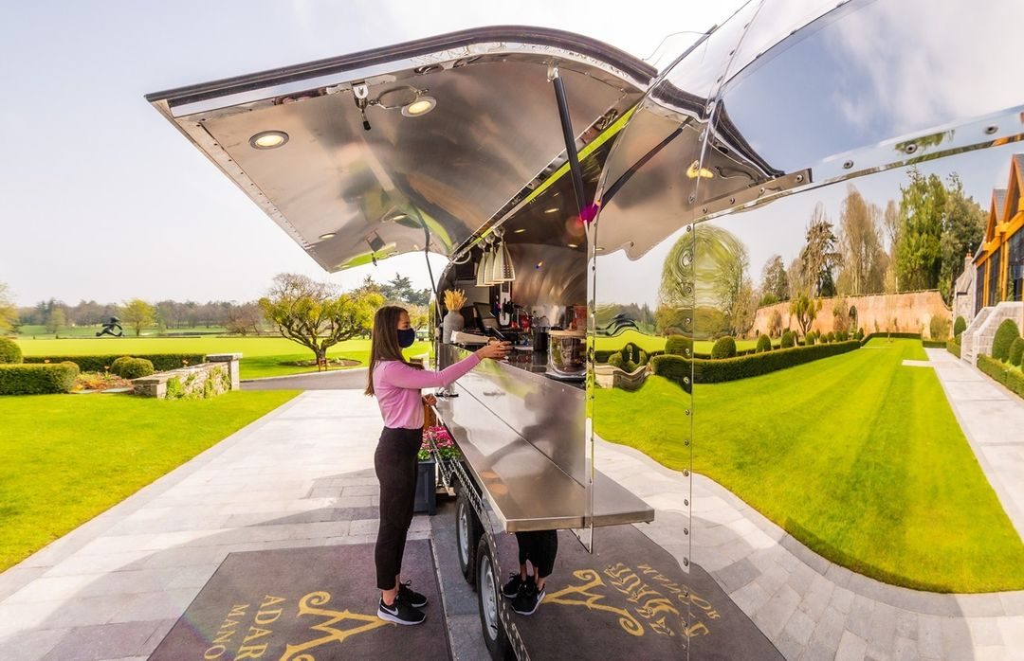

Best regards,

Graham Byrne  Sales Director  Sales | Reward Catering Limited  
   | +35319012644 / +353(0)868361559
    
   | Graham@rewardcatering.ie
   | https://www.rewardcatering.ie/
    
   | Unit 13, Cookstown Business Centre, First Avenue, Cookstown Ind Est. Dublin 24. D24 FC97
    

7.3 Price List
Food Price and suppliers
- 20 Slices of Cheese £4.50 2 slices per sandwich www.Tesco.com
- 20 Slices of Ham £4.78 2 slices per sandwich www.Tesco.com
- Tiger Bread 800g £1.80 www.Tesco.com
- Ice burg lettuce £0.89 www.Tesco.com
- Cucumber £0.89 www.Tesco.com
- Tomato £0.99 www.Tesco.com
- Welsh butter 200g £2.60 www.Tesco.com
- Bara Brith £3.75 for 5 slices www.Tesco.com
- Coke 24 Cans £12.00 www.Tesco.com
- Welsh Cheese and Leek Pastie £16.00 for 8 Castell Howell - Price given by Welsh Heritage staff
- Welsh Minted Lamb Pasties £16.00 for 8 Castell Howell - Price given by Welsh Heritage staff
- Welsh Sausage Rolls £16 for 8 Castell Howell – Price given by Welsh Heritage Staff
- Welsh Quiche £3.75 cheese and ham Blas ar Fwyd Website - BAF, Cheese & Ham Quiche,10cm
- Welsh Quiche Welsh Onion £3.25 Blas ar Fwyd Website - BAF, Cheese & Ham Quiche,10cm
- Welsh Quiche Cheese and Sundried Tomato £3.25 Blas ar Fwyd Website - BAF, Cheese & Ham Quiche,10cm

Item | Cost Price | 30% Markup Price | + Fixed Cost | Final Price (£)
Welsh Cheese and Leek Pastie | £2.00 | £3.00 | + £0.44 | £3.44 RU £3.50
Welsh Minted Lamb Pastie | £2.00 | £3.00 | + £0.44 | £3.44 RU £3.50
Welsh Sausage Roll | £2.00 | £3.00 | + £0.44 | £3.44 RU £3.50
Cheese & Ham Quiche | £3.75 | £4.88 | + £0.44 | £5.32 RU £5.50
Welsh Onion Quiche | £3.25 | £4.22 | + £0.44 | £4.67 RU £4.70
Cheese & Sundried Tomato Quiche | £3.25 | £4.22 | + £0.44 | £4.67 RU £4.70
Item | Cost Price | 100% Markup Price | + Fixed Cost | Final Price (£)
Ham, Cheese & Salad Sandwich | £1.49 | £2.98 | + £0.44 | £3.42 – RU £3.50
Cheese Salad Sandwich | £0.97 | £1.94 | + £0.44 | £2.38 - RU £2.50
Ham Salad Sandwich | £1.01 | £2.02 | + £0.44 | £2.46 RU £2.50
Cheese Sandwich | £0.74 | £1.48 | + £0.44 | £1.92 RU £2.00
Coke (can) | £0.50 | £1.00 | + £0.44 | £1.44 RU £1.50
Ham Sandwich | £0.75 | £1.50 | + £0.44 | £1.94 RU  £2.00
Item | Cost Price | 150% Markup Price | + Fixed Cost | Final Price (£)
Bara Brith (per slice) | £0.75 | £1.88 | + £0.44 | £2.32 RU £2.50

Cost Break Down of Sandwiches
Ingredient | Cost Calculation | Cost
Cheese (2 slices) | £4.50/20 × 2 = £0.45 | £0.45
Tiger Bread (2 slices) | £0.20 | £0.20
Salad (lettuce + cucumber + half tomato) | £0.09 + £0.09 + £0.08 = £0.26 | £0.26
Butter (5g) | 5g × £0.013 = £0.065 | £0.065
Total Base Cost |  | £0.98
Ingredient | Cost Calculation | Cost
Ham (2 slices) | £4.78/20 × 2 = £0.48 | £0.48
Tiger Bread (2 slices) | £0.20 | £0.20
Salad (lettuce + cucumber + half tomato) | £0.09 + £0.09 + £0.08 = £0.26 | £0.26
Butter (5g) | 5g × £0.013 = £0.065 | £0.065
Total Base Cost |  | £1.01

The Sandwich prices have all been added up, I have just deducted the salad price or added ham rice etc to make all the different combinations and prices. RU stands for round up the price to help increase profits.
7.4 Sample Promotion Material
Logo
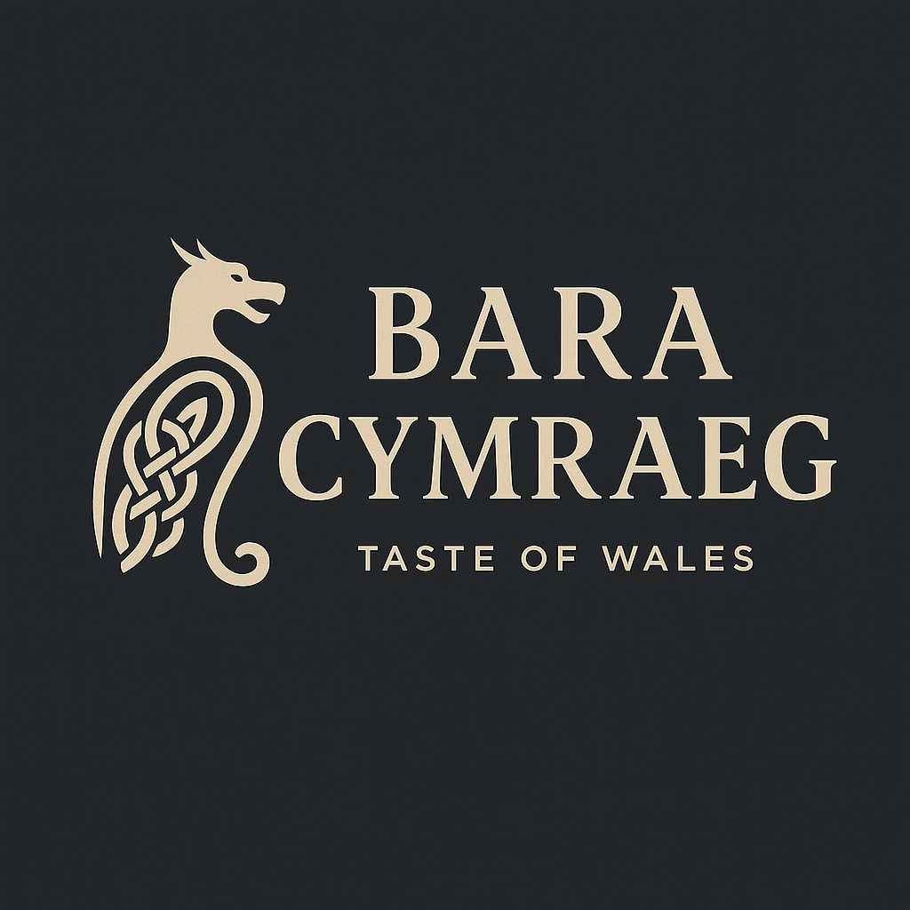
Menu
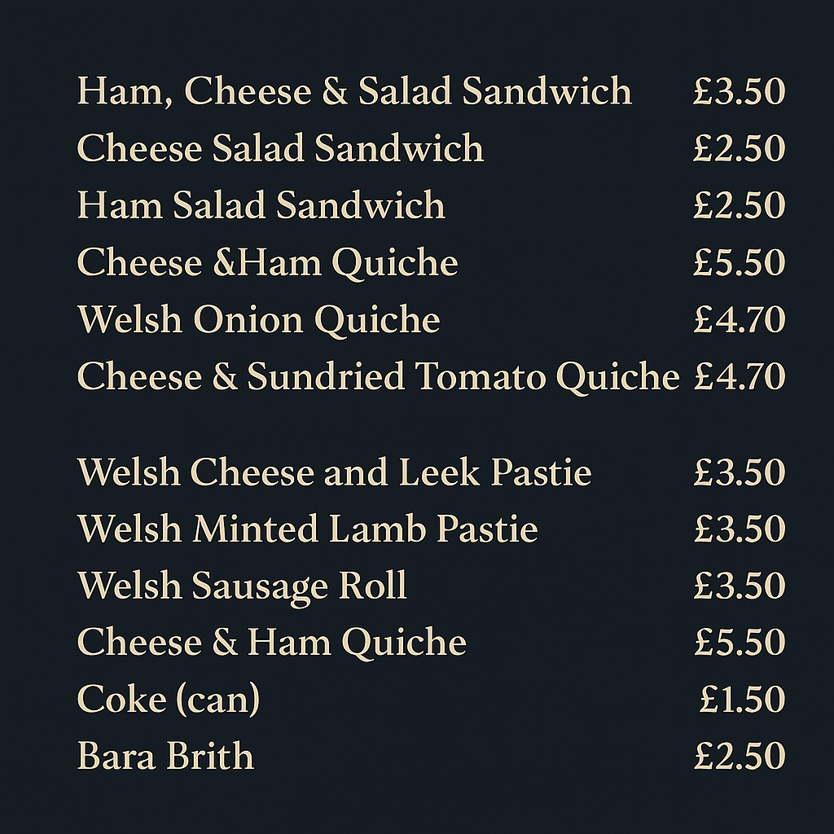

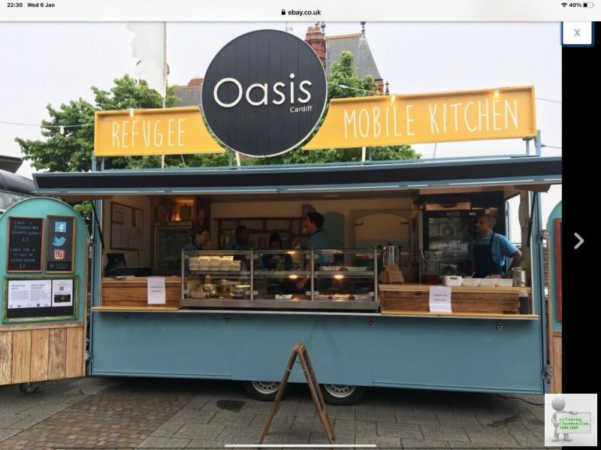
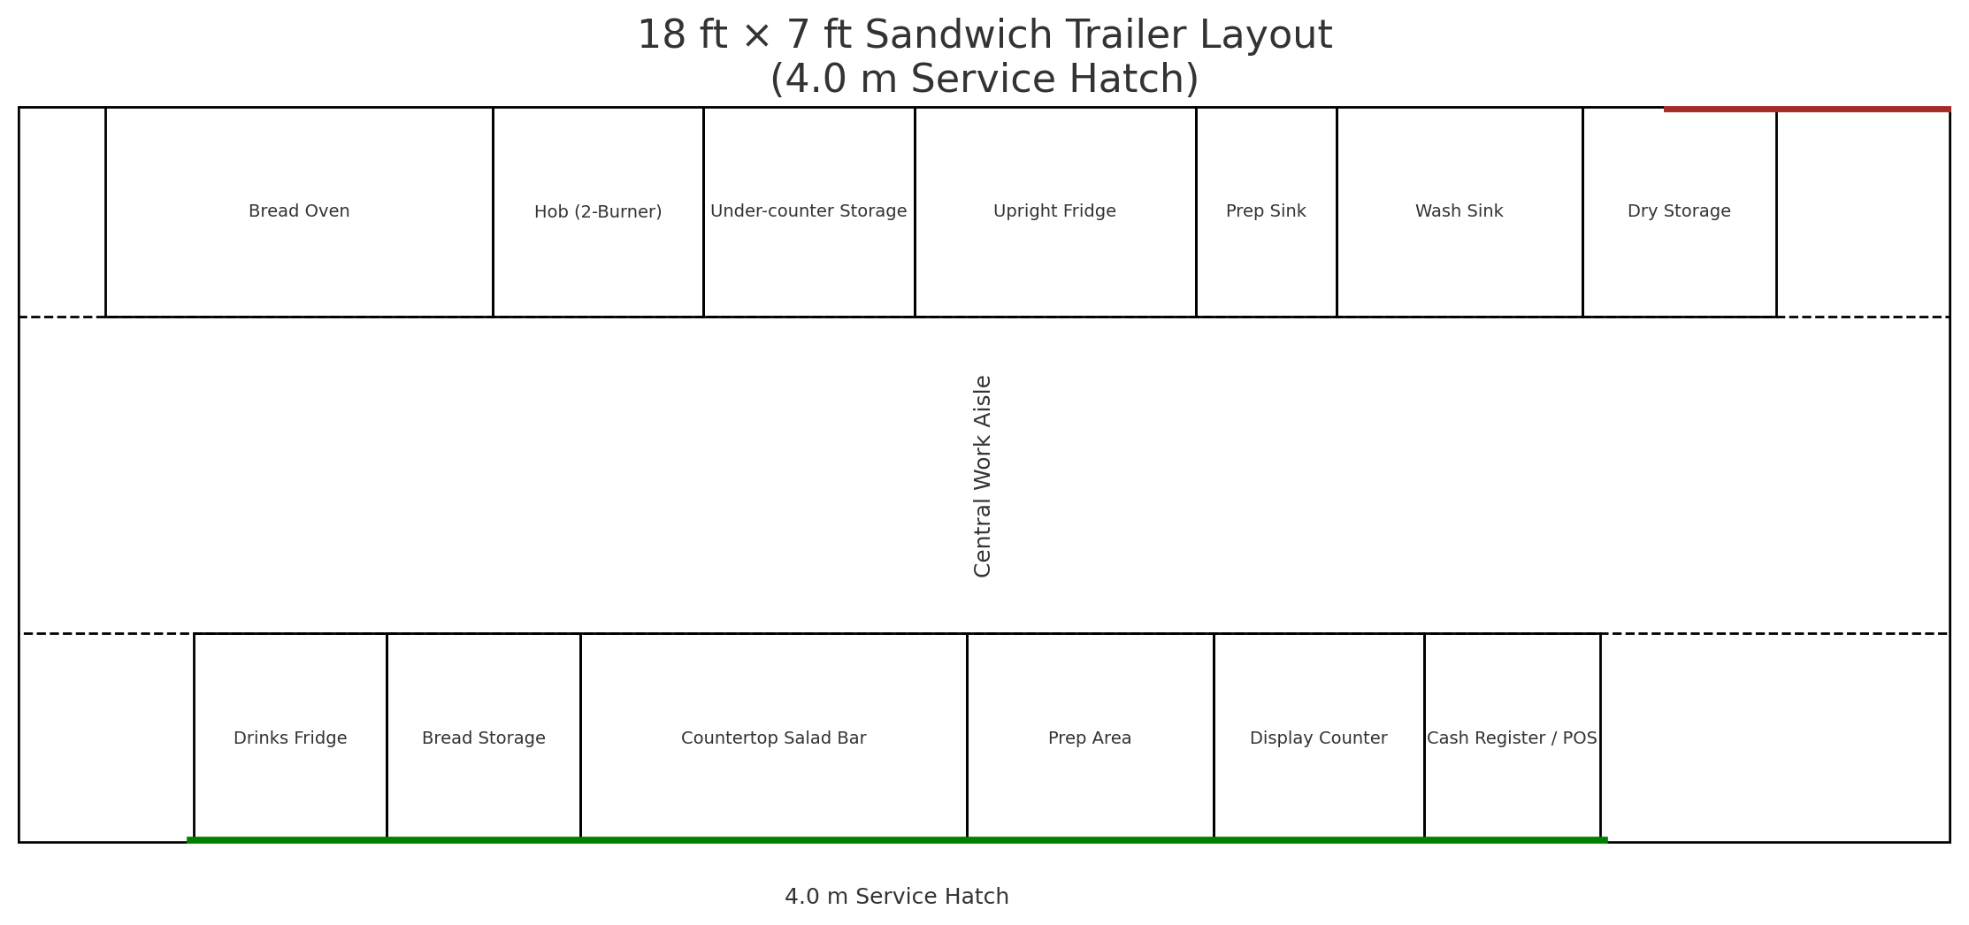
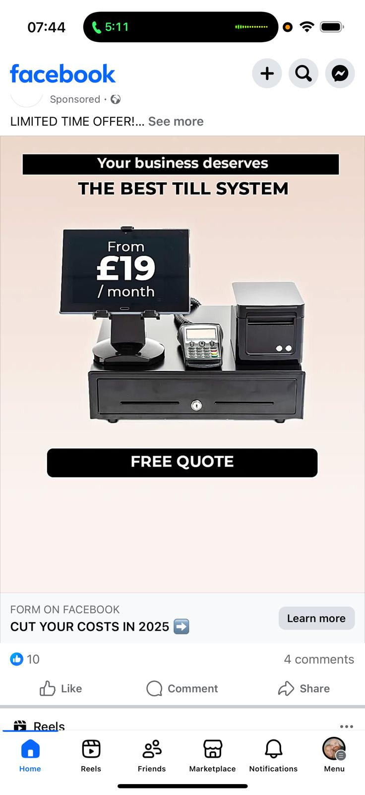

End of Business Plan – Bara Cymraeg | Leanne Thomas, 2025
Section 8 References
- Chris Marshall. “The Extraordinary Rise of Bakery Tourism: “People Travel from All over the World. It’s Mind-Blowing!”” The Guardian, The Guardian, 22 Apr. 2025, www.theguardian.com/food/2025/apr/22/the-extraordinary-rise-of-bakery-tourism.
- Cooke, Lowri Haf . “Michelin Star Restaurants in Wales Serving World-Class Food and Drink.” Wales, Jan. 2023, www.wales.com/visit/food-and-drink/michelin-star-restaurants-wales-serving-world-class-food-and-drink. Accessed 27 July 2025.
- Food and Drink Wales. “How Wales Became an Unexpected Leader in the Food and Drink Industry.” Ft.com, 2017, www.ft.com/partnercontent/food-and-drink-wales/how-wales-became-an-unexpected-leader-in-the-food-and-drink-industry.html.
- George, Tegan. “Evaluating Sources with the CRAAP Test.” Scribbr, 27 Aug. 2021, www.scribbr.com/working-with-sources/craap-test/. Accessed 18 July 2025.
- Revised on May 31, 2023.
- Gov.uk. “Write a Business Plan.” GOV.UK, 15 Oct. 2012, www.gov.uk/write-business-plan.
- GOV.UK, UK Government. “Become a Sole Trader.” GOV.UK, 2024, www.gov.uk/become-sole-trader/register-sole-trader. Accessed 18 July 2025.
- Government, Welsh. “Grants.” Business Wales, Grants | Business Wales, 2019, businesswales.gov.wales/businessfinance/types-finance-and-how-apply/grants.
- Government, Welsh . “Welsh Food and Drink Industry Grows by 10% | GOV.WALES.” GOV.WALES, 22 July 2024, www.gov.wales/welsh-food-and-drink-industry-grows-10.
- Government Digital Service. “Get Information about a Company.” GOV.UK, 3 July 2012, www.gov.uk/get-information-about-a-company.
- Government, UK. “Bara Cymraeg - Find and Update Company Information - GOV.UK.” Service.gov.uk, 2016, find-and-update.company-information.service.gov.uk/search?q=Bara+Cymraeg. Accessed 18 July 2025.
- Group, Imarc. “United Kingdom Hospitality Market Statistics | Forecast 2032.” Imarcgroup.com, 2024, www.imarcgroup.com/united-kingdom-hospitality-market.
- Johnson, Gerry, et al. Exploring Corporate Strategy. 8th ed., Harlow, Prentice Hall, 2020.
- Johnson, G., Scholes, K., & Whittington, R. (2008).
- Kenton, Will. “How to Perform a SWOT Analysis.” Investopedia, Investopedia, 28 May 2025, www.investopedia.com/terms/s/swot.asp . Accessed 18 July 2025.
- King's Trust. “Business Plans and Templates | Enterprise | How We Can Help.” Kingstrust.org.uk, 2024, www.kingstrust.org.uk/how-we-can-help/tools-resources/business-tools/business-plans.
- Parker , Dilys. Evaluation of Food Festivals Supported by the Welsh Government for the Financial Period of Front Cover Image from Narberth Food Festival. 2014.
- Parkin, Lucie. “Reach Your Target Audience through Us - Abergavenny Food Festival.” Abergavenny Food Festival, 17 Feb. 2025, www.abergavennyfoodfestival.com/reach-your-target-audience-with-the-abergavenny-food-festival. Accessed 19 July 2025.
- Porter, Michael. IEEE/ISO/IEC Draft Standard for Systems and Software Engineering - Architecture Evaluation. New York, Usa Ieee, 2017.
- Starkey, Joanne . “Wales Visitor Economy Profile: 2024 | GOV.WALES.” GOV.WALES, 15 July 2024, www.gov.wales/wales-visitor-economy-profile-2024. Accessed 19 July 2025.
- Wales, Business. “Food and Drink Wales - Growing Together.” Business Wales - Food and Drink, Food and Drink Wales - Growing together | Business Wales - Food and drink, 2024, businesswales.gov.wales/foodanddrink. Accessed 6 Jan. 2025.
Section 9 Curriculum Vitae
Leanne Thomas
Owner, Bara Cymru – Authentic Welsh Ingredient Sandwich Shop
27 Ffynnon Wen, Clydach, Swansea SA6 5EQ
📞 07475 389726 | ✉️ leanne_thomas1983@hotmail.com
Full UK Driving Licence | DBS on Update Service

Professional Profile
As the founder of Bara Cymru, I am proud to be launching a new start-up rooted in my passion for Welsh culture, local produce, and community connection. Bara Cymru (Welsh Bread) is an authentic Welsh sandwich shop bringing together traditional ingredients, locally sourced produce, and a modern approach to food retail—all with a distinctly Welsh identity.

This venture builds on over 20 years of leadership experience in the health and social care sector, where I developed key transferable skills including operational management, quality assurance, safeguarding, compliance, budgeting, and team development. These skills now form the backbone of my approach to running a business—ensuring that customer experience, food safety, and community engagement are at the heart of every decision.

Currently studying Business and Management at university, I am combining academic knowledge with practical insight to grow a sustainable, culturally driven start-up that offers something unique in the local food scene. My mission is to create a welcoming space where customers can enjoy traditional Welsh flavours while supporting local suppliers and celebrating our heritage.

Key Skills
- Small Business Management Set-up
- Welsh Food & Ingredient Sourcing
- Customer Service Excellence
- Health & Safety / Food Hygiene Compliance
- Menu Development & Local Branding
- Operations & Staff Training
- Community Engagement
- Budgeting & Inventory Management
- Strategic Business Planning

Business Experience

Founder
Bara Cymru – Clydach, Swansea | Opening 2025
Currently preparing to launch Bara Cymru, a start-up sandwich shop celebrating traditional Welsh ingredients and culinary heritage through locally sourced, high-quality food offerings.

Developed the business concept, brand identity, and menu rooted in authentic Welsh flavours and sustainable sourcing.

Applying leadership, compliance, and quality assurance experience from the health and social care sector to food retail operations.

Building partnerships with Welsh farmers and producers to ensure ethical, local supply chains.

Leading all aspects of start-up development, including budgeting, health and safety compliance, staffing plans, and marketing strategy.

Creating a warm, community-focused environment that promotes the Welsh language and culture through food, storytelling, and customer engagement.

Integrating knowledge from an ongoing Business and Management degree to guide strategic planning, operations, and long-term growth.

Previous Experience
Over 20 years of senior-level experience in regulated social care environments, including service management, staff training, and quality assurance across health and social care organisations. Known for proactive leadership, regulatory compliance, and a strong sense of community service.

Education & Training
Business & Management Degree (Ongoing) – University Study – Workplace Based | 2024–Present
- CAVA Level 3 Assessor Award
- QCF Level 3 Health & Social Care
- Train the Trainer: Food Hygiene, Medication, Manual Handling
- Level 2 Food Hygiene & Safety
- Safeguarding Adults & Children
- GDPR & Infection Control

Certifications & Compliance
- Full Enhanced DBS (on update service)
- Full UK Driving Licence – Clean Record

Employment History
Support Worker
Dimensions, Swansea | May 2024 – Present
Supporting individuals with daily living tasks, personal care, meal preparation, and community activities.

Key Account Recruitment Consultant
Vertro Recruitment, Swansea | Nov 2023 – Feb 2024
Staff recruitment, client liaison, interview coordination, shift allocation, supervision, and disciplinary processes.

Support Worker (Community Services)
Goleudy, Swansea | Jun 2023 – Dec 2023
Provided support to individuals in community housing services.

Operations Manager
Newcross Healthcare Solutions, Swansea | Dec 2021 – Jun 2023
Managed multiple supported living services including rehabilitation and homelessness support. Oversaw 60+ staff across several teams, monitored service outcomes, managed budgets, chaired meetings, and ensured regulatory compliance.

Associate Trainer / Trainee Assessor
Newcross Healthcare Solutions, Devon | Jan 2021 – Dec 2021
Delivered training in medication, manual handling, and basic life support. Developed lesson plans, completed quality assurance documentation, and conducted assessments (CAVA qualified).

Senior Care & Support Worker
Newcross Healthcare Solutions, Swansea | Jan 2021 – Nov 2022
Administered medication, completed handovers, updated care plans, and managed risk assessments.

Smart Customer Services Adviser
British Gas, Cardiff | Nov 2015 – Jul 2017
Managed high volumes of customer service calls and complaints. Supported new staff and tracked team KPIs.

Senior Community Care Manager
Swansea Council | Oct 2013 – Nov 2015
Coordinated rotas, managed care workers, liaised with healthcare professionals, conducted assessments, and quality monitoring.

Rehabilitation Community Care Worker
Swansea Council | Apr 2003 – Jul 2005
Delivered in-home care and support for hospital-discharged patients to reduce bed-blocking and promote independence.

Deputy Care Manager
Ivy House Supported Living, Swansea | Jan 2000 – Apr 2003
Supported 4 residents, managed medication, care planning, and organised daily operations.

Oncology Generic Worker
Singleton Hospital, Swansea | 1999
Assisted oncology consultants, managed patient files, coordinated emergency appointments.

Education & Qualifications
Business & Management Degree (Ongoing)
University Study – Workplace Based | 2024–Present
Professional Qualifications:
- CAVA Level 3 Assessor Award
- QCF Level 3 Health & Social Care
- NVQ Level 2 Health & Social Care
- English & Maths Level 2
- Train the Trainer: Medication, Manual Handling, Basic Life Support
- GDPR, Safeguarding (Adults & Children), Infection Control
- PBM, Food Hygiene Level 2

Certifications & Compliance
- Full Enhanced DBS (on update service)
- SCW Registered
- Full UK Driving Licence – Clean Record

References
Joanne Dewsberry-Evans – Support Worker
Dimensions, 130 Loughor Road, Swansea, SA4 6QY
📞 01792 417293 | ✉️ joanne.dewsberryevan@dimensions-uk.org
Permission to Contact Prior to Interview: No

Helen Williams – Key Accounts / Support Worker
Vertro Recruitment, Unit 10 iTec, 250 Carmarthen Road, Swansea, SA1 1HG
📞 02921 660880 | ✉️ helen@vrecruitment.co.uk
Permission to Contact Prior to Interview: Yes

