Dissertation Research Proposal

The Relevance Of The Change In The Tesco Clubcard Loyalty Scheme



Student name: Jessica Hopkins
Student Number : P145402

Contents Page

  - introduction to Tesco
  - rationale
  - Tesco
  - Introduction to the Tesco Clubard Loyalty scheme
  - The change to the Tesco Clubcard
  - Research Aims And Objectives
  - Literature review
  - Methodology
  - Research constraints
2.0 resources and planning
2.1 Gantt Chart
2.2 ethical considerations
2.3 conclusions
2.4 References

1.1 Introduction
Tesco PLC is one of the largest food and grocery retailers in the UK. It also retails non-food products. The company operates in Europe and Asia. It is headquartered in Hertfordshire, the UK. (Market Line 2017)
To maintain their competitive advantage it has been innovative in the marketing strategies it has used – one being the introduction of a loyalty Clubcard scheme. This dissertation looks at how this has evolved and assess how successful this evolution has been.
1.2 Rationale
The reasoning behind this research is to identify whether the change in the Tesco Clubcard is relevant in the current business environment and, whether consumer buying behaviour habits have changed, and if consumers like to keep their weekly shop to one company, or if they like to shop around for better deals, regardless if they have a loyalty card or not.
The topic has been chosen because of personal interest with the Tesco Clubcard loyalty scheme. This interest stems from being employed by Tesco, and seeing customer perceptions of the Clubcard scheme. Through the study of marketing modules in first year of university which focused on Tesco as on organisation, this has helped maintain personal interest within Tesco.

1.3 Tesco
Tesco was founded in 1919 by Jack Cohen when he began selling surplus groceries from a stall in the East End of London. At the end of the first day he made a profit of £1 on sales of £4. Tesco operates in 12 countries around the world, and employs over 530,000 people (Tesco, 2015). In the UK, Tesco has over 3500 stores and employs around 310,000 members of staff, making Tesco’s UK operation the largest within the group (Tesco 2015).

  - Introduction to the Tesco Clubcard scheme
The Tesco Clubcard was launched in 1995 and attracted nearly 5 million customers in the first year. With the introduction of the Tesco Clubcard, Tesco overtook Sainsbury’s market share. The scheme was a major investment for Tesco, costing the company around £10 million to set-up with the vouchers and discounts offered to Clubcard members accounting for 1% of Tesco’s income. (Palmer, et al., 2006).
A study by Empathy Research has found that Tesco's Clubcard is the most popular supermarket loyalty programme, with more than eight out of ten (87%) respondents. (Tesco's Clubcard Leads The Way In Loyalty Race' 2015)

There are many ways for customers to collect Clubcard points, for example either through the use of Tesco mobile, the use of the Tesco credit card, and each time customers use their Clubcard in store. In 2012 Tesco Bank extended its range of services to cover mortgage. Tesco clubcard holders can gain extra rewards when they take out a mortgage with the offer of Clubcard points following each repayment they make. In 2010 a new Clubcard was launched in the UK, which gave customers a new way to swipe their card in store. (Tesco plc, 2017). There are currently around 38 million Clubcard members globally (Tesco, 2015) with around 16.5 million of them being UK members (Christie, 2013).

1.5 The change within the Tesco Clubcard
One of the biggest changes is to the card it-self, which has now become contactless. Tesco have now also launched a smart phone app, making it easy for customers to sign up though the app, and show available vouchers in store rather than having to use the old fashioned way, which used to be having the vouchers sent through the post.
Another change the Clubcard has seen, is being partners with major restaurants, hotels and Uber. This is a major change to all customers as they can swap their points to vouchers worth up to four times the value to spend at largest chains.
Last week, the UK's biggest supermarket started rolling out an updated version of its Clubcard, which now includes a contactless button so shoppers just tap at the checkout to add their points. It has also inked new partnerships with the likes of Uber. This means for every 50 Clubcard points - equivalent to a £50 shop - accumulated, shoppers can now opt to exchange them for £1.50 of Uber credit (T, Hobbs, 2017)
With hotels it’s possible to get three times the value of customer’s points – leaving the customer to pay the remainder of the balance at the same rate as every other customer would. The same goes for Uber, as it’s possible to get three times the value of points towards a taxi journey.
Another change that the Clubcard has seen, is being able to exchange points with partners in denominations of 50p rather than only £2.50. This being very handy to all customers, as it stops any remainders of any vouchers going to waste.
Recently, customers have also seen a change within the Clubcard as the ‘double up’ known as the Clubcard boost system has stopped. This stopped back in May 2016. This was an opportunity for customers to exchange vouchers in denominations of £2.50. Only certain departments were available on the Tesco Boost, the majority covering the non-food and electrical departments. As this came to a stop in 2016, customers have been receiving more ‘double points’ and ‘triple points’ vouchers which are available to spend in store, in replacement of the boost system.

1.6 Research Aims and objectives
AIM -
The aim of this research is to critically evaluate the reason for the change in the Tesco Clubcard loyalty scheme within the current business environment. The main aim is to identify customer’s opinion on the change within Tesco Clubcard scheme. A critical part will be to get feedback from customers. This will be done by carrying out primary research, as well as secondary research through the use of the organisation.

Research objectives
The objectives can be summarized as follows:
- To evaluate the reasons for of the change within the Tesco Clubcard loyalty scheme
- To examine the existing secondary research that is available based on loyalty programmes, focusing mainly on the Tesco Clubcard.
- Using primary research critically evaluate customers and managers views with regards to the Tesco Clubcard loyalty programme
- Synthesise Secondary and primary research to provide conclusions and recommendations for the future of the loyalty card and future research based on the topic.

  - Literature review
Krafft & Mantra (2006, p. 361) define loyalty schemes as: ‘A marketing process that generates rewards for customers on the basis of their repeat purchase’.
This study will look at how supermarkets use marketing strategies and in particular the 5P’s to improve their competitive business advantage.
The concept of marketing –
CIM (The Chartered Institute of Marketing) offers the following definition for marketing: “ The management process responsible for identifying, anticipating and satisfying customer requirements profitably.”(The Chartered institute Of Marketing 2016).
The CIM also describes what a company is going to produce, how much they’re going to charge, how it’s going to deliver products or services to customers, and how it’s going to tell its customers about its products and services. Traditionally, these considerations were known as the 4P’s. Price, product, place and promotions. As marketing become more sophisticated, a fifth p was added – known as people.
Product – there is no point developing a product or service which no one wants to buy, many businesses decide what to offer first, then hope to find a market for it afterwards.
Price - A product is only worth what customers are prepared to pay for it. The price needs to be competitive, but this doesn’t mean you have to be the cheapest in your market – small businesses can compete with larger rivals by offering a more personal service, value-add’s or better value for money. Cim.co.uk, 2017)
Place - The product must be available in the right place, at the right time and in the right quantity, while keeping storage, inventory and distribution costs to an acceptable level. Cim.co.uk, 2017)
Promotion - Promotion is the way a company communicates what it does and what it can offer customers. It includes branding, advertising, PR, corporate identity, social media outreach, sales management, special offers and exhibitions. Promotion must gain attention, be appealing, send a consistent message and - above all - give the customer a reason to choose your product rather than someone else’s. (Cim.co.uk, 2017)

People – CIM describes people as - Everyone who comes into contact with your customers will make an impression. Many customers cannot separate the product or service from the staff member who provides it, so your people will have a profound effect — positive or negative — on customer satisfaction. Cim.co.uk, 2017)

1.8 Methodology
Research design – the purpose of this study is to gain customer insights of the change within the Tesco Clubcard loyalty scheme.
Research approach – the respondents will be the users and non-users of Tesco and managers within Tesco.
Sampling method – the in-depth interviews of this study will be limited to Tesco only. The researcher will have to WORK out whether the respondents fall under the category or not. If they do fall, then they will be interviewed for 10 minutes. The sample size will be 100 for this study.
Data collection method - The primary data will be collected from the users and non- users of the Tesco Clubcard loyalty scheme. Moreover, this data will be gathered from the respondents through and in depth interviews, and in depth interviews with managers.
Data analysis method – the data analysis of this research will be qualitative and quantitative .As mentioned previously, the data will be gathered from questionnaires an in depth interviews

Figure 1 – The Research Onion – Saunders, et al., 2009 p.138
The Important objective of this section is to convey research methods that will be utilised during the study, in order for the researcher to achieve the aims and objectives that were mentioned previously.
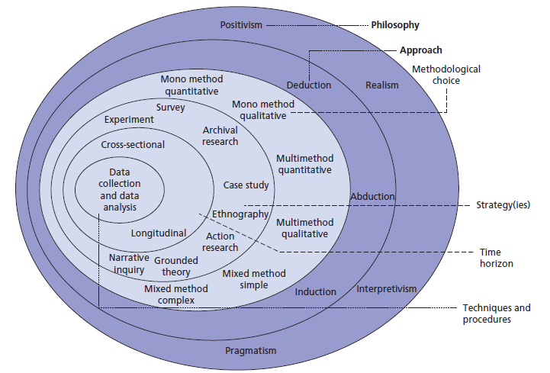

This research onion provided by Saunders et al demonstrates the various research structures a researcher can use (Saunders, Lewis, & Thornhill, 2009). It’s crucial to conduct research using the most effective methods to collect, analyse, and present data to successfully achieve a desired outcome. (Collis & Hussey, 2009).
The researcher will be addressing data collection and data analysis, the core of the onion. Cross- sectional design will also be implemented through the qualitative research and a structured interview with the assigned participants. Also, there will be use of mixed methods, as questionaries’ will be distributed. By doing this, the researcher will gain information about patterns and previous behaviours regarding the Tesco Clubcard loyalty scheme.
The following layer of the onion identifies both grounded theory and survey, both of these methods will be used during research in order to help the researcher have a greater understanding of the data collected. Therefore, the main focus of this study will be inductive whilst using the philosophical view, known as interpretivism.

  - Research constraints
The study is being conducted in the Tesco Store based in Llanelli due to time constraints. This study is meant to be for entire view of customers of Tesco but since geographical constraint may arise, the research is limited to one region only. Therefore, the research will not be able to reach THE ENTIRE customer base. The research will be restricted to 100 customers who are currently clubcard/non clubcard holders.
The willingness and capacity of staff to answer questions with relation to the Clubcard loyalty scheme is also impeded. Some staff may not be willing to discuss anything related to the clubcard such as their views, some may be unwilling to discuss anything to an external researcher like myself. Therefor the list of participants will be limited which is no way represents a probability sample of the organisation.

2.0 Resources and planning
Resources and planning is a vital part of any research project. The resources used throughout the dissertation consists of journals, articles, books, reports, handbooks, and professional websites. These will be obtained through online research, databases provided by the university, online databases, and libraries, via search engines. All the resources provided, will contribute to the final literature review and will be the making of the secondary data. Primary data will be collected though practical sources, such as the Clubcard manager who will provide information such as the company and its history, and will allow the research to conduct interviews with employees and the store manager. Secondary data will be collected through books in the library, academic journals and the internet.

2.1 Gantt Chart
A Gantt chart is a tool which maps out specific tasks that need to be completed and sets a date in which the tasks should be completed by. (Kumar, 2015, p.15). the attached Gantt chart will be a part of the planning process, outlining the proposed actions. The Gantt chart will be used as a useful aid to the researcher, as its important to manage the work load in a timely matter.

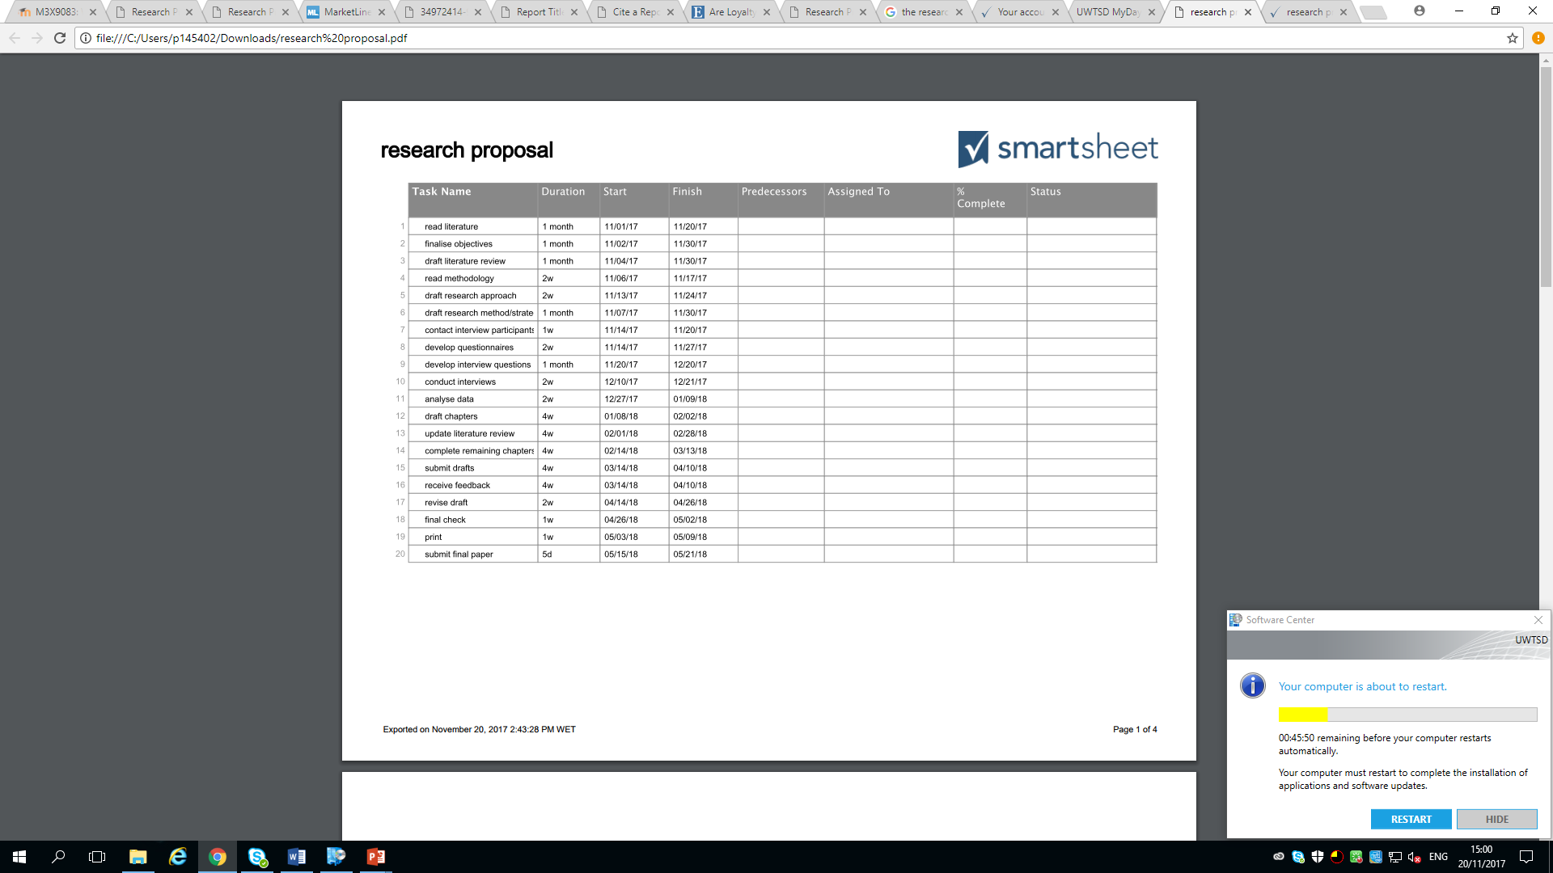
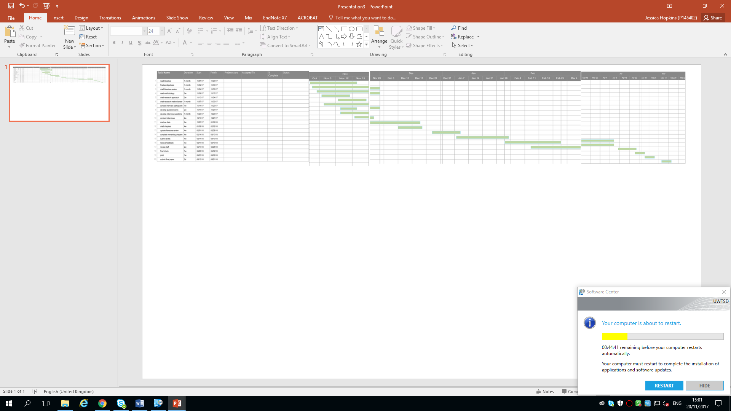

A breakdown of each month can be seen below: -


2.2 Ethical considerations
The research will be conducted with all persons over the age of 18. The nature of this topic is intended from a marketing concept, and exploration views only. This research is not to be used as a probe in to any ethical considerations, whilst this research is highly unlikely to cause any psychological harm. All employees who will be participating in the interviews will receive consent forms in advance explaining the topics that will be explored, thus giving the participants a chance to finish the survey at any chosen time, in order to avoid physiological implications.

2.3 Reliability and Validity
It is important that the results gathered have high validity and reliability. This can be executed by ensuring that the outcome of the research will be done in a consistent manner, therefor limiting the impact of variables. The research will be conducted in a fair and open way, making it consistent with every participants.

2.4 Conclusions
It’s clear to see that Tesco have revolutionized the Tesco Clubcard, which has attracted millions of customers, enabling them to gain a competitive advantage over their main rivals.

Reference list
Tesco plc. (2017). History. [online] Available at: https://www.tescoplc.com/about-us/history/ [Accessed 1 Nov. 2017].
Palmer, R., Meek, R., Parkinson, L. & Meek, H., 2006. Managing Marketing Performance 1sr ed. Oxford: Elsevier Ltd..
Tesco, 2015. History. [online]. Available at: http://www.tescoplc.com/index.asp?pageid=11 [accessed November 2 2017).
Christie, S,. 2013. Tesco Clubcard vs Nectar: Best loyalty schemes, [online] Available at: http//www.telegraph.co.uk/finance/personalfinance/household-bills/10273842/Tesco-Clubcard-vs-Nectar-Best-Loyalty-Schemes.html [Accessed November 1 2017].
Kumar, P.P. (2005). Executive Use Of A Gantt Chart For Managing Large Scale Projects. Cost Engineering. [online]. 47(7). P.14 – p.21. available from: http://web.a.ebscohost.com.exproxy.uwtsd.ac.uk.ehost/pdfviewer/pdfviewer?sid=3a689969-78f4-4c79 [Accessed November 1st 2017).
(Cim.co.uk, 2017)
Cim.co.uk. (2017). - [online] Available at: https://www.cim.co.uk/media/4772/7ps.pdf [Accessed 10 Nov. 2017].

MarketLine, 2017. Company profile – Tesco PLC, London: MarketLine.

Collis,J., & Hussey, R. (2009). Business Research: A Practical Guide for Undergraduate and Postgraduate Students. Basingstoke: Palgrave Macmillan.

Saunders, M., Lewis, P., & Thornhill, A. (2009). Research Methods for business students. Essex: Pearson Education Limited.

Hobbs, T 2017, ‘What happened to Tesco’s big plans for a digital Clubcard?’ Marketing week (Online Edition), p. 5, Business Source Complete. EBSCOhost. [Accessed November 1st, 2017).

'Tesco's Clubcard Leads The Way In Loyalty Race' 2015, Checkout, 41, 11, p. 6, Business Source Complete, EBSCOhost, viewed 20 November 2017.

Krafft, M. & Mantra, M. K., 2006. Retailing in the 21st century: Current And Future Trends. Heidelberg: Springer.

