

BA Leadership and Management
LEVEL 5

Principles and Concepts of Finance
(BMSW5012_CARD)

Assignment Title: Budgeting Principles and Approaches

Module Lead: Christine Joy

Name: Constantin Tanasa

Student Number:2332158

Total word count: 3580 Submission Deadline:20.03.2026

Contents
Executive summary 3
1. Introduction 4
2. Stock budget 6
2.1 Cash budget 7
2.2 Budgeted profit and loss 8
3. Management actions 10
4. Budgeting and budgetary control 12
4.1 Key design conditions 12
4.2 Behavioural risks and how to reduce them 13
4.3 Control tools 14
4.4 The information for effective control 14
4.5 Budget culture 14
4.6 Incremental budgeting 15
4.7 Practical budgetary control cycle for Silver Stitch 16
5. Evaluating traditional budgeting and alternatives in a fast-changing environment 17
5.1 Why annual budgets struggle with volatility 17
5.2 Practical alternatives that fit Silver Stitch constraints 18
5.3 CVP 18
5.4 Risk management 19
5.5 Sustainability 19
5.6 Research evidence on budgeting change 20
5.7 The role of internal controls and documentation 20
5.8 What success should look like by December 20
6. Recommendations 21
References 22
7. Conclusion 25

Executive summary

This report uses budgeting and cash control techniques to assess whether Silver Stitch Ltd can remove its opening £30,000 overdraft by the end of December and to identify the management actions needed to make that outcome reliable.
The budgets indicate that the overdraft can be cleared, but only if directors stop the inventory from expanding beyond what sales require and manage timing shocks (refurbishment and the September tax payment). The biggest threat is working capital, not profitability.
Silver Stitch should adopt a rolling forecast and a formal stock policy, supported by flexible budgeting and a small dashboard of liquidity-focused KPIs. They should
Move away from a static annual budget towards an adaptive budgeting cycle consistent with beyond budgeting principles, while retaining clear spending guardrails demanded by leaders.

1. Introduction

Silver Stitch Ltd sells casual clothing and begins June with a bank overdraft of £30,000. The bank expects the overdraft to be eliminated by the end of December.
Directors have provided monthly plans for sales income, stock purchases, operating expenses, taxation payments, interest, and refurbishment expenditure for June to December. This business receives customer cash in the month of sale, including credit card receipts, and pays a card handling fee. Suppliers allow one month’s credit on purchases, and selling expenses are paid one month in arrears.
Budgeting matters here because the bank’s requirement is a cash outcome, not an accounting profit outcome. A firm can show profit and still fail on cash if stock grows, if payments cluster, or if management reacts too late (Drury,2021; Atrill and McLaney,2021).
This report, therefore, focuses on the stock budget and what it implies for working capital, the cash budget, and whether the overdraft target is robust, and the budget profit and loss statement for June to December to contextualize performance. Then will discuss what conditions make budgeting work in practice and critically evaluate traditional annual budgeting and more adaptive alternatives in fast-changing environments (Hope and Fraser, 2003; Bogsnes,2016).
Three budgets were prepared using standard management accounting logic.
First, the monthly cost of sales from a given gross profit margin of 40%, meaning the cost of sales equals 60% of sales.
Second, built a stock budget by linking opening stock, purchases, and cost of sales to closing stock.
Third, construct a cash budget by applying the timing rules given, cash receipts in the month of sale net of card fees, stock payments one month after purchase, selling expenses paid one month in arrears, and non-cash depreciation removed from cash payment.
A budgeted profit and loss statement was prepared on an accrual basis for July to December, including depreciation and recognising expenses in the period they relate to (Seal, Garrison and Noreen, 2018; Dyson,2020).
Where the case does not provide the prior month’s purchases for the first stock payment month, it will be an assumption for the June stock payment. May purchases are approximated as equal to June purchases. This keeps the cash model internally consistent with the one-month credit term and can be replaced if the actual May figure is known (Drury,2021).

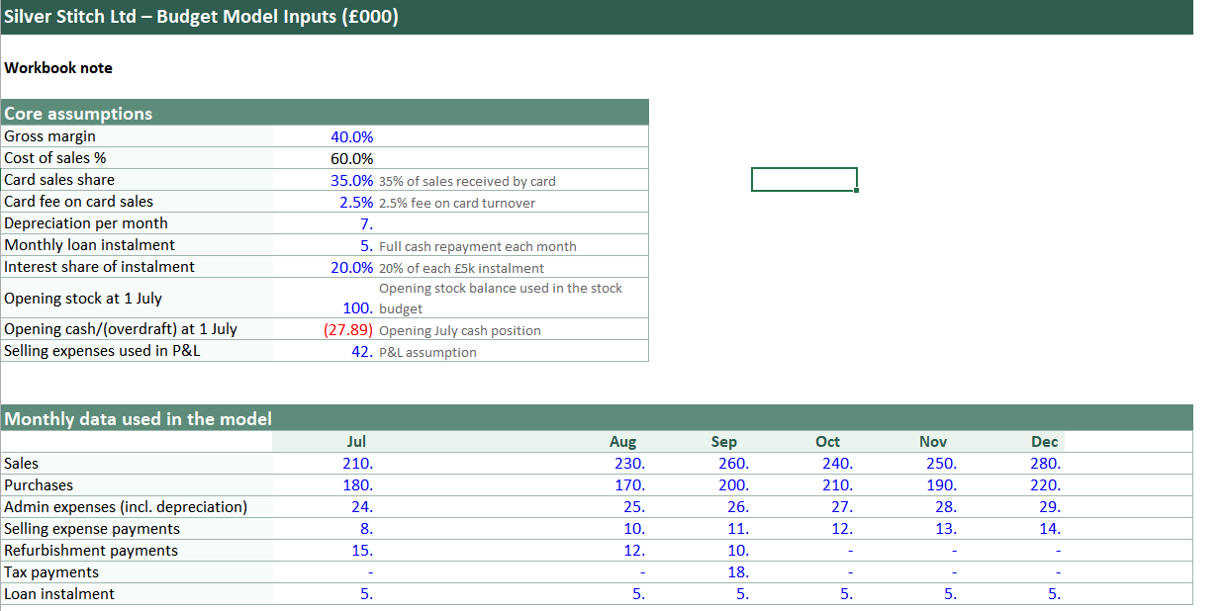

2. Stock budget
The stock budget is the clearest signal of a control problem. Closing stock rises month after month and reaches £388,000 by December. This is far above the stated minimum stock level of £50,000 and indicates that the planned purchasing volumes are not aligned with the sales plan.
In a clothing business, excess inventory is not a neutral buffer. It creates cash absorption, higher holding costs, risk of markdowns, and obsolescence as styles change (Atrill and McLaney,2018; Drury,2021).
Directors should treat this as a strategic issue because inventory policy shapes liquidity and competitiveness. Excess stock can affect the business into discounting, which weakens the margin and brand position. It can also create “busy work” in warehouses and stores and hide inefficiency because the firm can keep selling without noticing demand shifts until the cash runs out (Bhimani, 2006; Porter, 1985). The core problem is a weak link between budgeting and operational decisions: the budget records purchases, but it does not appear to constrain them.
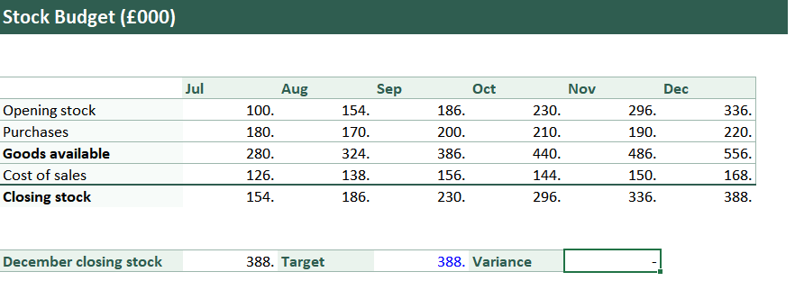

2.1 Cash budget

The cash budget shows the month-by-month movement from overdraft to positive cash. Under the assumption used, the business remains in overdraft during July and August, becomes positive by the end of September, and ends in December at roughly £59,250. This outcome is mainly driven by strong sales receipts and the timing benefit of supplier credit. It is not driven by a deliberate working capital strategy.
The timing profile matters. July to September are the most exposed months because stock payments ramp up, refurbishment outflows occur, and September includes a large tax payment.
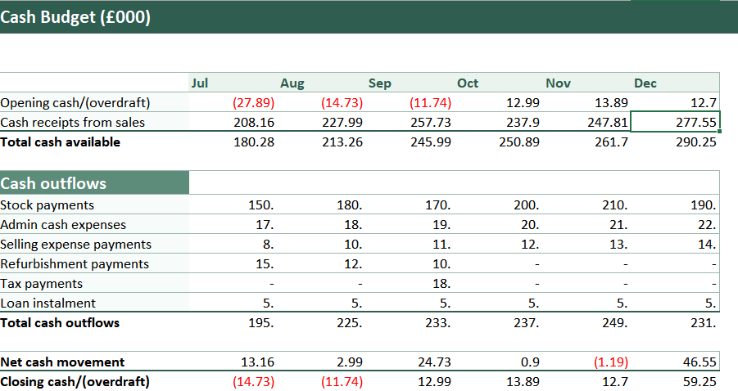
This means that a modest negative surprise (lower sales, higher costs, or delayed receipts) could keep the firm in overdraft longer than planned. In practice, banks are often less worried about a temporary overdraft than about management control signals. The build-up of stock may raise questions about whether directors understand cash drivers and whether the forecast is credible (Walsh, 2008; ICAEW, 2022).

2.2 Budgeted profit and loss

The budgeted profit and loss statement for July to December shows a healthy net profit of around £313,140. Gross margin delivers substantial gross profit, and operating expenses look controlled relative to sales. This is a classic illustration of why profit does not equal cash. Working capital growth can absorb cash even when profit is strong, and cash timing can create short-term stress even when the long-run model is profitable (Atrill and McLaney,2021).

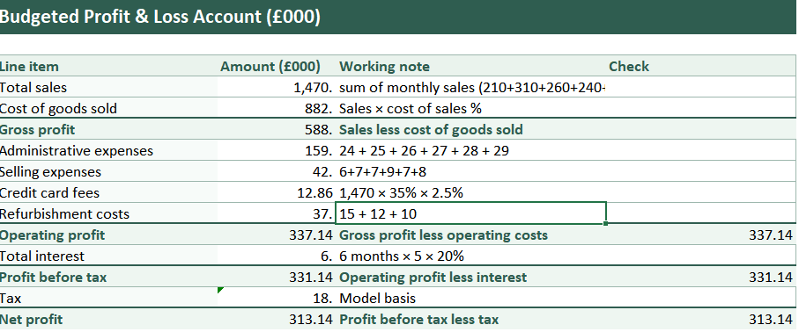
In Silver Stitch, the profit figure should not create complacency. A high profit forecast alongside a rising stock profile may signal that the budget is optimistic or that managers are measuring success in the wrong way. If the stock must later be marked down, profit will weaken in later periods.
Directors should therefore focus on profit quality: sustainable margin and controlled cash conversion cycle, not just accounting earnings (Marr,2013; Walsh,2008).

One limitation of the plan is that it treats sales, costs, and purchases as if they will unfold smoothly. In practice, retail demand varies week to week, and clothing sales often peak around promotions, paydays, and seasonal events.
Directors should not assume that a positive month-end balance means the business was liquid every day in that month. A simple remedy is to add a weekly cash calendar for high-risk months and align payments (stock settlements, refurbishment instalment, and loan payments) to expected sales peaks where possible (ICAEW,2020; FEE, 2019).
This also improves credibility with the bank because it shows directors understand liquidity as a daily constraint rather than a spreadsheet outcome.
Directors should also check whether the 40% gross margin is stable across products. Clothing margins often vary by category, and discounting can shift the mix. A single gross margin assumption can therefore overstate profit if sales rely on discounted lines. Segment reporting and contribution analysis by category would provide better decision support (Datar and Rajan, 2017).

3. Management actions
The fastest route to making the bank target reliable is to control inventory. Directors should create a formal stock policy that sets a target for closing stock and stock turns, with clear authorization rules.
A practical approach is to set closing stock as a defined number of weeks, of cost, of sales, adjusted for seasonality and supplier lead times. If projected stock exceeds the ceiling, purchases must stop except for proven fast-moving lines. This turns the stock budget from a reporting document into a decision rule (Drury, 2021; Seal, Garrison, and Noreen,2018).
In clothing, ageing stock becomes less valuable over time, creating a direct link between working capital and profitability. A monthly aged-stock report, plus a pre-planned markdown strategy, reduces the risk of a sudden end-of-season cash and margin collapse (Atrill and McLaney,2018).

The cash budget highlights vulnerable months, so directors should treat July-September as a liquidity management window. Actions include:
- Phase refurbishment spending so that non-essential work pauses until the overdraft is cleared. This is consistent with cash preservation guidance and avoids using expensive short-term finance for discretionary projects (Horner, 2020; ICAEW, 2022).

- Negotiate payment timing for refurbishment where possible (for example, staged payments) while maintaining supplier relationships.

- Increase the frequency of cash forecasting during this period. A monthly forecast is too slow. A weekly cash views allows management to act before a problem becomes visible in bank statements (Drury, 2011).

The business pays card fees on 35% of sales at 2,5%. The cost is predictable and should be treated as a variable selling cost in contribution analysis. Directors should ensure pricing and promotion decisions reflect payment costs and do not erode margin unintentionally. They can also review whether any discounts or promotions are justified by contribution, not by revenue alone (Datar and Rajan, 2017).

Loan instalments and interest payments reduce flexibility. Even if the forecast shows cash improvement, directors should track interest cover and forecast headroom against bank expectations. If headroom becomes tight, directors should prioritise actions to improve cash conversion (e.g., stock reduction, delayed discretionary spending) rather than cutting costs that damage demand (Walsh, 2008; Atrill and McLaney, 2021).
Although stock is the main driver in this case, directors should consider all working capital levers: inventory, receivables, and payables. Customers pay in the month of sale, so receivable risk is limited.
Payables are more relevant because suppliers offer one-month credit. They should maintain that credit discipline by paying on time and avoiding early payment, which unnecessarily sacrifices working capital.
At the same time, directors should avoid stretching payables in ways that damage supplier relationships or delivery reliability. Cash management guidance emphasises optimising timing while maintaining trust, not simply delaying payments (Horner, 2020).
They can also reduce working capital by accelerating the sell-through of slow-moving items and by narrowing the number of lines held where demand is uncertain. This is not a “cost-cut” strategy; it is a risk-reduction strategy. In management control terms, it requires clear policies and transparent decision rights so that buyers understand when they can commit cash and when they must pause (Simons, 1995).

4. Budgeting and budgetary control

A good budgeting system supports planning, coordination, and learning. It fails when it becomes a blame tool or locks in assumptions that age quickly. For Silver Stitch, the system connects sales, purchasing, and cash management and gives managers feedback on working capital drivers (Hansen, Otley, and Van der Stede, 2003; IFAC, 2018; IMA, 2020).

4.1 Key design conditions

- Clear responsibility: assign ownership for stock purchases and operating expenses within responsibility centres, and define which costs are controllable at that level (Drury, 2011).

- Timely feedback: produce variance analysis linking operational causes (pricing, volume, mix, purchasing) and corrective action (Dyson, 2020; Anthony and Govindarajan, 2007).

- Joined-up planning: finance, buying, and sales must share one forecast. If departments optimise their own targets, the firm can accumulate stock while believing it is “protecting sales” (Seal, Garrison and Noreen, 2018).

- Appropriate incentives: if managers are rewarded for meeting sales targets, they may push discounting or over-ordering. Control systems need balanced measures, so managers do not "win” by damaging cash (Merchant and Van der Stede, 2017; Marr, 2013).

4.2 Behavioural risks and how to reduce them

Budgeting has behavioural side effects. Common issues include budgetary slack, gaming, and short-termism. Managers can also manipulate forecasts if the forecast doubles as a target. One critique of traditional budgeting is that it encourages people to “negotiate” numbers rather than to describe reality (Jensen, 2003).
Directors can reduce these behaviours by separating forecasting from performance evaluation. Forecasts should be updated to reflect the best available information, while targets can be set separately. This aligns with beyond thinking and makes it harder for managers to deliberately understate forecasts to create easier targets (Hope and Fraser, 2003; Bogsnes, 2016).
Participation can improve commitment, but directors must combine participation with independent challenge, especially for working capital decisions where managers may be overly risk-averse about stock-outs (Drury, 2021).

4.3 Control tools

A static budget can mislead managers when activity levels change. Flexible budgeting adjusts cost expectations to the actual level of activity, improving fairness and insight.
It helps directors separate “volume effects” (sales higher or lower that plan) from “efficiency effects” (cost control and purchasing discipline) (Seal, Garrison and Noreen, 2018).
A KPI dashboard should be small and linked to cash drivers. For Silver Stitch, suitable measures include gross margin, markdown rate, stock turns, aged stock percentage, operating expenses ratio, and liquidity buffer indicator. The point is to measure what predicts cash, not to create a long list of metrics (Marr, 2013). Balanced scorecard thinking is useful here because it prevents single-metric failure and reminds directors to protect customer value while improving finances (Kaplan and Norton, 1996).

4.4 The information for effective control

Budgeting relies on timely, accurate information. If sales data arrives late, stock records are inaccurate, or managers cannot see the age and location of inventory, budgetary control becomes guesswork. Directors should ensure that the accounting information system supports daily sales reporting, stock reconciliation, purchase order tracking, and exception reporting (Bodnar and Hopwood, 2019; IASB, 2018).
For example, an exception report that flags items where stock days exceed a threshold is more useful than a long stock list. Similarly, a simple dashboard that shows daily takings versus forecast can detect a downturn earlier than waiting for the month-end accounts.

4.5 Budget culture

Budgets can unintentionally create a compliance mindset: managers focus on hitting numbers rather than improving decisions. This is especially problematic where the key driver is working capital, because purchasing decisions can look “successful” (high availability, full shelves) while damaging cash.
Control system research warns against relying on one control lever and instead recommends combining diagnostic controls (budgets, variance reports) with interactive controls (regular discussion of risk and assumptions), so managers pay attention to uncertainty rather than treating the budget as fixed truth (Simons, 1995).
In Silver Stitch, the directors should use the cash forecast interactively: each month, they should review the assumptions behind sales, margin, and purchasing, and ask what has changed in the market.
Behavioural economics also helps explain why inventory can grow despite clear financial risk.
Decision-makers often overweight the fear of stock-outs and the regret of missed sales, leading to “insurance buying. They may also anchor on previous purchasing volumes and adjust slowly, even when sales patterns shift.
In a budgeting context, these biases can appear as incremental buying patterns that continue because “that’s what we always do, not because the data support it. Directors can reduce bias by setting pre-commitment rules (inventory ceilings) and by requiring buyers to document the evidence for large purchases (Drury, 2021).

4.6 Incremental budgeting

Incremental budgeting takes last year’s numbers as the baseline and adjusts. It is simple and can feel fair because it preserves departmental expectations. However, it can also lock inefficiency into the system and prevent strategic change.
In Silver Stitch, an incremental approach to purchasing could explain the stock build-up, as purchases rise month by month without a clear link to the cost of sales. The danger is that the budget becomes a justification for action rather than a constraint. Directors should therefore apply “zero-based challenge” to working capital decisions, meaning buyers must justify required stock levels from demand forecasts and lead times rather than from historical spend (Bhimani, 2006).

4.7 Practical budgetary control cycle for Silver Stitch
A workable cycle is plan, execute, measure, learn, and replan. Each month, directors can use the comparison of actuals to the flexible budget, identify the biggest variance, and assign actions. They should also track a weekly cash forecast in the vulnerable months to prevent surprises.
Importantly, they should not punish managers for every variance. Instead, they can focus on material variances and those that reveal decision problems (for example, purchases exceeding policy, or markdown rates rising). This approach supports learning and avoids creating a blame culture that encourages data manipulation (Merchant and Van der Stede, 2017; Bragg, 2020).

5. Evaluating traditional budgeting and alternatives in a fast-changing environment

5.1 Why annual budgets struggle with volatility
Traditional annual budgets fix assumptions for too long, particularly in markets with changing demand, supply costs, and competition. When a condition shifts, managers spend time explaining variances instead of adapting.
Annual budgeting can also encourage behaviours like sandbagging and end-of-year spending (Merchant and Van der Stede, 2017).
Empirical work shows that many organisations keep budgets but continually adapt them because static budgets are too inflexible for modern environments (Libby and Lindsay, 2010; Robertson, 2018; ACCA, 2003).
In this case, the stock build-up suggests that an annual purchase plan could become self-fulfilling, buying continues because it is “in the plan” even when inventory is already excessive. That is a direct example of a budget acting as a barrier to strategic change rather than enabling it.

5.2 Practical alternatives that fit Silver Stitch constraints

A realistic approach for Silver Stitch is hybrid, not extreme. Directors still need clear spending limits to satisfy the bank. However, they can enhance flexibility by using:
- Rolling forecasts; update the cash view and adjust purchasing to demand signals (Hope and Fraser, 2003; Bunce et al., 1995).
- Continuous budgeting: maintain control while allowing adjustment as conditions change (Frow, Marginson and Ogden, 2010).
- Scenario analysis: test downside sales and margin cases to identify when cash becomes fragile, then pre-agree responses (Horner, 2020; Bragg, 2020).
- Beyond budgeting principles: decentralise decisions within clear boundaries, increase transparency, and replace fixed targets with relative and directional goals where appropriate (Bogsnes, 2016; Neely, Bourne and Adams, 2003).

5.3 CVP

Directors should use CVP and contribution analysis to understand sensitivity to volume and margin. Contribution shows how much each sales covers fixed costs and finance charges, so it supports quick decisions on pricing, promotions, and cost control.
CVP has limitations (for example, it assumes linear cost behaviour and stable sales mix), but it remains useful for short-horizon planning and for challenging optimistic revenue assumptions (Drury,2021; Atrill and McLaney, 2021; Horngren et al., 2015). It also makes card fees visible as a variable selling cost, supporting better pricing discipline (Datar and Rajan, 2017).

5.4 Risk management

The banks' request to remove the overdraft is a governance signal. Lenders want evidence of control, a clear forecast, sensible assumptions, and credible mitigation plans.
Directors should therefore treat risk management as part of budgeting, not as a separate exercise. A practical method is to identify the top five cash risks (sales shortfall, margin erosion, inventory build, refurbishment timing, and supplier disruption) and assign an owner and mitigation plan to each (CIMA, 2020; FRC, 2024). This approach also helps directors avoid “single forecast bias”, where they believe the base case is more certain than it is.

5.5 Sustainability
Although the case is framed around cash and budgeting, directors should avoid actions that boost short-term cash at the expense of long-term value.
For example, aggressive discounting may convert stock to cash quickly but can damage brand perception and future pricing power.
At the same time, deferring essential maintenance or staff training may reduce cash outflow but can harm operational capability.
The sustainability literature emphasises balancing short-term financial performance with longer-term resilience and stakeholder value (European Commission, 2019; World Economic Forum, 2020). In practical budgeting terms, directors can separate “essential” and “deferrable” spending categories and protect essential spending even while they phase out discretionary projects.

5.6 Research evidence on budgeting change
The beyond budgeting movement argues that rigid budgets create dysfunction and reduce adaptability, but research also shows that many organisations retain budgets because they serve coordination and planning purposes.
Surveys indicate that firms often modify rather than abandon budgets, adopting rolling forecasts and reforecasting while still using budgets for accountability (Libby and Lindsay, 2010).
Other studies highlight continuous budgeting approaches that reconcile flexibility with control (Frow, Marginson, and Ogden, 2021).
For Silver Stitch, this supports the recommendation for a hybris model: a stable set of guardrails to satisfy the bank, combined with rolling forecasts and adaptive decision rules to manage volatility (UK Government, 2021).

5.7 The role of internal controls and documentation

Because the bank is monitoring the overdraft, directors can maintain a clear audit trail of decisions. That includes approved purchasing limits, refurbishment phase approvals, and documented assumptions in the rolling forecast.
Internal control does not need to be bureaucratic; it can be a short one-page control log. The point is to ensure consistency and to reduce the chance that informal decisions quickly erode cash discipline. Good documentation also supports continuity if roles change and strengthens governance credibility (Otley, 2016).

5.8 What success should look like by December

By December, success is not only a zero overdraft, but the business also has control over its cash flow. Directors should therefore aim to show:
- The overdraft has been eliminated
- Inventory stabilised within an explicit policy
- An operating rhythm of rolling forecasts and variance reviews
- A KPI dashboard that links profit quality and liquidity
If Silver Stitch achieves those outcomes, it improves both short-term lender confidence and long-term resilience in a market where demand and costs can change quickly (Hope and Fraser, 2003; Libby and Lindsay, 2010).

6. Recommendations

To make the recommendations implementable, directors should sequence them.
In month one, they should set the inventory ceiling, freeze non-essential refurbishments, and implement a weekly cash forecast for July-September.
In months two and three, they should introduce flexible budgeting for controllable costs and establish variance review meetings with clear action owners.
In months four to six, they should embed a KPI dashboard and integrate scenario analysis into decision-making.
This staged approach reduces change overload and makes budgetary control part of routine management rather than a one-off project.

7. Conclusion

Silver Stitch's forecast suggests that the overdraft can be removed by the end of September and that the business can finish December with a positive cash balance.
However, the same budget reveals a serious working capital risk: inventory grows sharply and reaches £388,000 by December.
The bank target is therefore achievable but not secure unless directors control stock and manage the timing of cash outflows in the vulnerable months. The priority actions are to introduce a formal stock policy, phase out discretionary refurbishment spending until liquidity improves, and run a rolling cash forecast supported by flexible budgeting, variance analysis, and a small KPI dashboard focused on cash drivers.
Finally, Silver Stitch should reduce reliance on a static annual budget and adopt a hybrid approach that combines guardrails with adaptive forecasting, consistent with beyond budgeting thinking.

References
ACCA Advanced budgeting, planning, and forecasting. Available at: https://www.accaglobal.com/learning-and-events/financial-management/advanced-budgeting-planning-forecasting.html (Accessed: 12 March 2026).
Anthony, R.N. and Govindarajan, V. (2007) Management Control Systems. 12th edn. Boston, MA: McGraw-Hill.
Atrill, P. and McLaney, E. (2018) Accounting and Finance for Non-Specialists. 11th edn. Harlow: Pearson.
Atrill, P. and McLaney, E. (2021) Management Accounting for Decision Makers. 10th edn. Harlow: Pearson.
Bhimani, A. (2006). Contemporary Issues in Management Accounting. Oxford: Oxford University Press.
Bodnar, G.H. and Hopwood, W.S. (2019). Accounting Information Systems. 12th edn. Harlow: Pearson.
Bogsnes, B. (2016). Implementing Beyond Budgeting: Unlocking the Performance Potential. 2nd edn. Hoboken, NJ: Wiley.
Bragg, S.M. (2020). Budgeting: A Comprehensive Guide. 4th edn. Boston, MA: AccountingTools.
Bunce, P., Fraser, R. and Woodcock, L. (1995) ‘Advanced budgeting: a journey to advanced management systems’, Management Accounting Research, 6(3), pp. 253–265.
Chartered Institute of Management Accountants (CIMA) (2020) ‘Risk management and the role of management accounting’. London: CIMA.
Datar, S.M. and Rajan, M.V. (2017). Horngren’s Cost Accounting: A Managerial Emphasis. Global edn. Harlow: Pearson.
Drury, C. (2021). Management and Cost Accounting. 11th edn. Harlow: Pearson.
Dyson, J.R. (2020). Accounting for Non-Accounting Students. 7th edn. Harlow: Pearson.
European Commission (2019) Guidelines on non-financial reporting: Supplement on reporting climate-related information. Available at: https://ec.europa.eu/finance/docs/policy/190618-climate-related-information-reporting-guidelines_en.pdf (Accessed: 09 March 2026).
Financial Reporting Council (2014) Guidance on Risk Management, Internal Control and Related Financial and Business Reporting. Available at: https://www.frc.org.uk/library/standards-codes-policy/corporate-governance/corporate-governance-overview/ (Accessed: 17 March 2026).
Frow, N., Marginson, D. and Ogden, S. (2010) ‘Continuous budgeting: reconciling budget flexibility with budgetary control’, Accounting, Organizations and Society, 35(4), pp. 444–461.
Hansen, S.C., Otley, D.T. and Van der Stede, W.A. (2003) ‘Practice developments in budgeting: an overview and research perspective’, Journal of Management Accounting Research, 15(1), pp. 95–116.
Hope, J. and Fraser, R. (2003) Beyond Budgeting: How Managers Can Break Free from the Annual Performance Trap. Boston, MA: Harvard Business School Press.
Horner, D. (2020). Accounting for Non-Accountants. 12th edn. London: Kogan Page.
Horngren, C.T., Datar, S.M., and Rajan, M.V. (2015). Cost Accounting: A Managerial Emphasis. 15th edn. Harlow: Pearson.
ICAEW (no date) Managing your cash flow. Available at: https://www.icaew.com/technical/corporate-finance/business-finance-guide/more-information/managing-your-cashflow (Accessed: 10 March 2026).
Institute of Management Accountants (IMA) (2019) Key Principles of Effective Financial Planning and Analysis. Available at: https://www.imanet.org/-/media/c91d297df90e4ad090ac72289b26099c.ashx (Accessed: 12 March 2026).
Institute of Management Accountants (IMA) (2019) Key Principles of Effective Financial Planning and Analysis. Available at: https://www.imanet.org/-/media/c91d297df90e4ad090ac72289b26099c.ashx (Accessed: 13 March 2026).
Institute of Management Accountants (IMA) (2020) ‘Statement on management accounting: planning, budgeting and forecasting’. Montvale, NJ: IMA.
International Accounting Standards Board (IASB) (2018) Conceptual Framework for Financial Reporting. Available at: https://www.ifrs.org/issued-standards/list-of-standards/conceptual-framework/ (Accessed: 12 March 2026).
International Federation of Accountants (IFAC) (2018) International Good Practice Guidance: Evaluating and Improving Budgeting. New York: IFAC.
Jensen, M.C. (2003) ‘Paying people to lie: the truth about the budgeting process’, European Financial Management, 9(3), pp. 379–406.
Kaplan, R.S. and Norton, D.P. (1996). The Balanced Scorecard: Translating Strategy into Action. Boston, MA: Harvard Business School Press.
Libby, T. and Lindsay, R.M. (2010). Beyond budgeting or budgeting reconsidered? A survey of North-American budgeting practice, Management Accounting Research, 21(1), pp. 56–75.
Marr, B. (2013). Key Performance Indicators (KPI): The 75 Measures Every Manager Needs to Know. Harlow: Pearson.
Merchant, K.A. and Van der Stede, W.A. (2017). Management Control Systems: Performance Measurement, Evaluation and Incentives. 4th edn. Harlow: Pearson.
Neely, A., Bourne, M. and Adams, C. (2003) ‘Better budgeting or beyond budgeting?’, Measuring Business Excellence, 7(3), pp. 22–28.
Otley, D. (1999) ‘Performance management: a framework for management control systems research’, Management Accounting Research, 10(4), pp. 363–382.
Otley, D. (2016) ‘The contingency theory of management accounting and control: 1980–2014’, Management Accounting Research, 31, pp. 45–62.
Porter, M.E. (1985) Competitive Advantage: Creating and Sustaining Superior Performance. New York: Free Press.
Robertson, D. and Williams, J. (2018) ‘Beyond budgeting: a critical review’, Journal of Applied Accounting Research, 19(2), pp. 211–229.
Seal, W., Garrison, R.H., and Noreen, E.W. (2018). Management Accounting. 6th edn. Maidenhead: McGraw-Hill Education.
Simons, R. (1995) Levers of Control: How Managers Use Innovative Control Systems to Drive Strategic Renewal. Boston, MA: Harvard Business School Press.
UK Government (2021) ‘Business statistics and cost pressures: retail and manufacturing’. London: GOV.UK.
Walsh, C. (2008). Key Management Ratios: The 100+ Ratios Every Manager Needs to Know. 4th edn. Harlow: Prentice Hall.
World Economic Forum (2020) Measuring Stakeholder Capitalism: Towards Common Metrics and Consistent Reporting of Sustainable Value Creation. Available at: https://www.weforum.org/publications/measuring-stakeholder-capitalism-towards-common-metrics-and-consistent-reporting-of-sustainable-value-creation/ (Accessed: 12 March 2026).

