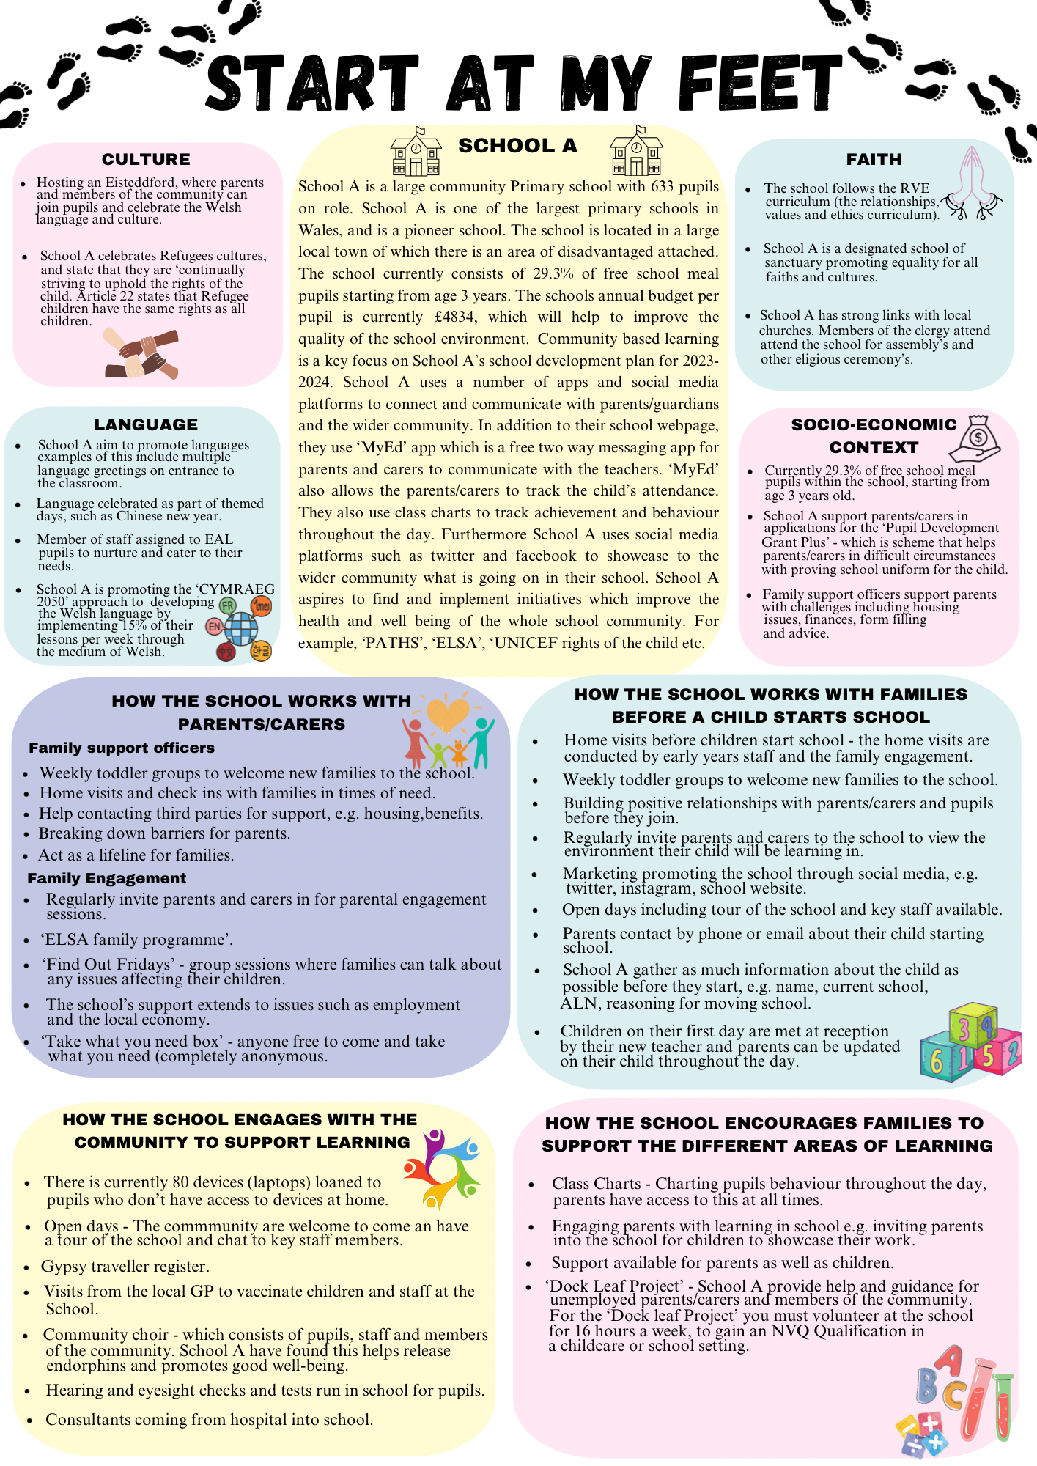
Start at my feet poster submission through turn it in – error uploading so have uploaded my poster through a word document in order for turn it in to accept

