Student Name: Rena Begum
Student Number: 1712108
Module Name: Managing Projects in the Organization
Module Code: BMSK5004
Assessment Title: Project Planning and Management in Workplace.
Assessment Component: 1
Tutor: Paul Ranson

Content
Introduction
……………………………………………………...……………………………………………………. 3
The Vintages Move
……………………………………………………………………………………………………………. 4
Manager
……………………………………………………………………………………………………………. 5
5 Tools
……………………………………………………………………………………………………………. 6
…………………………………………………………………………………………………………… 8
Reflection
…………………………………………………………………………………………………………… 9
Conclusion
…………………………………………………………………………………………………….…….. 10
Reference
…………………………………………………………………………………………………….…….. 11

Introduction
In this report I will explain how the project Vintage move and its stakeholders use different tools and resources to improve and assist the working progress for the Vintage move. Firstly, I will describe Vintage and how its stakeholders thought of moving the business to Sparkhill I also will clarify the reason for the stakeholders of Vintage suddenly deciding their move and what inspired them to. Then I will explain how the project manager keeps all the employees working together as one team and on track. After that I discuss about the five tools called brown paper planning, user stories, the chevron, the ion triangle and the Gantt chart and how Vintage can use these tools to help improve the working progress of the Vintage move. I also summarize in full detail what the Gantt chart is and how it works and finally I will explain about my perspective as a project manager and what I can do to help Vintage.

The Vintages Move
The vintage Antique shop is a traditional shop which is running successfully and has reached its 3rd generation, it is located in high street, Shirley. Although the family’s traditional shop has been having positive working progress throughout the three generations, Denis and Doreen (stakeholders of the shop) are thinking of moving the business to a warehouse in Spark hill, and want to use their knowledge and experience in the business and develop the business to increase more profits for the organisation, Denis and Doreen got inspired by watching Salvage Hunters ( tv show), where they got the idea of making profits by shifting the shop to Spark hill. Furthermore, the high level of competition between all shops and businesses linked with vintage and others in high street have created an increasing chance for vintage to continuously improve their shop to be number one in the market, the improvement of the shop will help them gain plenty of benefits.

Manager
A manager’s job is to discuss with the owner and employees about all tasks needed to be completed, the manager helps keep the staff members on schedule and ensuring that they stick to their job role. This would help decrease the chances of risks in vintage as for a successful future, cooperation between all members of the hierarchy in the business is needed. (W. Jason 2017).
Linking back to what Jason Westland had said, managers need to keep their employees on track and allow them to understand their job role as this is beneficial to the business (vintage). Managers do this by constantly interacting with staff members, giving recognition and compliments, supplying feedback, leadership and training, constructing work culture by design, creating a improvement gap for any disasters in the business, giving strong leadership and a good focus of the tasks for each employee, keeping themselves and others accountable and displaying good problem solving.(M. Bernard 2017).
If the manager appoints an employee to do a task then the employee’s responsibility is to complete the task given to them without lazing around because this would affect the business as you would be wasting precious time that you could’ve used for good quality of work. Furthermore, if an employee doesn’t complete their task in time then there is a chance for other workers to be on hold as well as the other jobs needed to be completed, which will affect the working time and progress of the business. An example of this would be the shop “Vintage” as if the working progress of the warehouse, Dennis and Doreen were going to shift to had become slow then it would be a loss of time and profit for the antique shop and all tasks needed for the move would be delayed. (M. Ryan 2020).
A Gantt chart is used for planning businesses of all types and they are useful because this is a way of showing scheduled to be done on a particular day. The manager of Vintage can use the Gantt chart to keep all the employees on task and if any of the staff forget their task then they can simply just refer back to the Gantt chart which would make the manager’s job easy as well as all tasks will be completed on time. (Project Manager 2020).

5 Tools
I have used five tools for the Vintage project move called: brown paper planning, user stories, the chevron, the iron triangle and the Gantt chart. I will explain these five tools and how they are connected to each other and how it is useful for Vintage.
Brown paper planning is a project plan template which increases the chance of success. It is a process that uses effort and teamwork to plan a changed completion and as well as that it encourages great team leadership. It also emphasizes all obstacles, events, interfaces, decision points and deliverables. This will help starting the Vintage move of what they need and the reason why and also the time scale of how long it will take for all tasks to be completed. This is good opportunity for Vintage move because if they already have an idea of what they need and how long it will take then there wouldn’t be a delay in the move. (WorkshopBank 2009).
User stories are tools used in Agile software development to get a description of a software feature. This portrays the type of user and what they require and why, a user story helps simplify the description of what a user needs and why. User stories can help Vintage move by creating a description of what’s needed during particular times and why, also this would be useful for the business because if they note the reason of their certain requirement then their needs will be completed exactly how they want it to be done. (R. Margaret 2006).
The chevron is a diagram shaped like a V, this diagram is structured to help plan out; what must be in the project, what is wanted to be in the project and what is nice to have in the project. (Heagney 2016). By creating a chevron diagram it will help Vintage stakeholder’s because due to this the stakeholders will not get confused about what must, what is wanted and what is nice to have in the project but instead can be put in a chevron diagram, which will help understand the business layout and there would be no mistakes in the future of the business. The chevron diagram helps the Vintage Stakeholders understand the main needs of the warehouse and how the organisation will be and if it is best for all the Vintage Stakeholders. This diagram is just to summarise the users story, this is because the users story has a lot of information about how the warehouse must be done but after using the chevron diagram, this will help us to know what is the key factors and what we must work on and what extras are there that will make the warehouse look good.
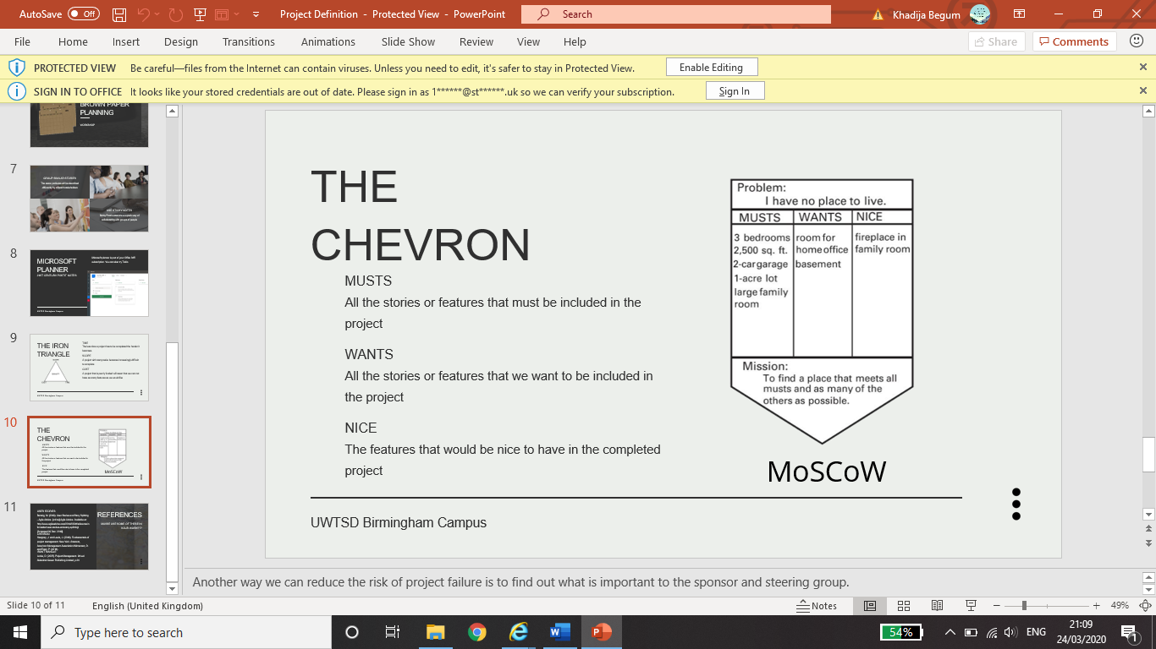

In mid-1980s Dr Martin Barnes created the Ion triangle whilst thinking about a solution for demonstrating quality, cost and time that are consistent on focusing on fixing one point of the project that will impact the other two. The Ion triangle is also known as the project triangle, this shows the triple constraint of time, cost, quality or scope that must be handled in project delivery. Each constraint is linked and shifting one point of the triangle will affect the other two points. This will help the Vintage move because if they structure their project by using the Ion triangle but do tamper with any one of the points needed for their project then all other necessary tasks will be affected, and they will have to fix the other points, which then could impact on the pace and quality of their business and their move to Spark hill. (T. Morphy 2008).
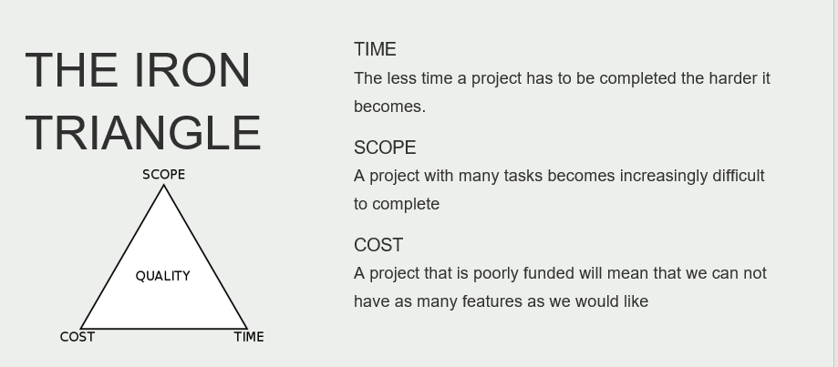

The Gantt chart is a project management tool that helps plan and calendar projects of all types of sizes, even though they are especially useful in making more complex projects simple. The Gantt chart is a horizontal bar chart involving start and finish dates, also deadlines, bookings and dependencies – this contains the quantity of work per task completed at each step and who is the manager of all tasks. The Gantt chart can help Vintage move because if the business has trouble sorting out each task and what time it should be completed by then the Gantt chart can plan out and program each step needed for the business move, which would help complete the work progress within its given time. (apm 2020).

How a Gannt Chart Works
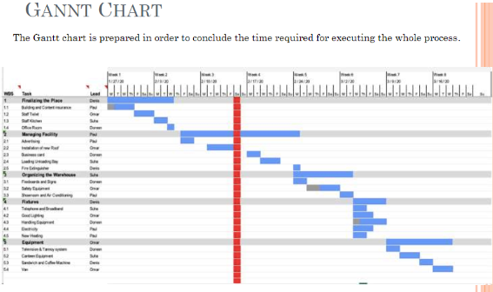

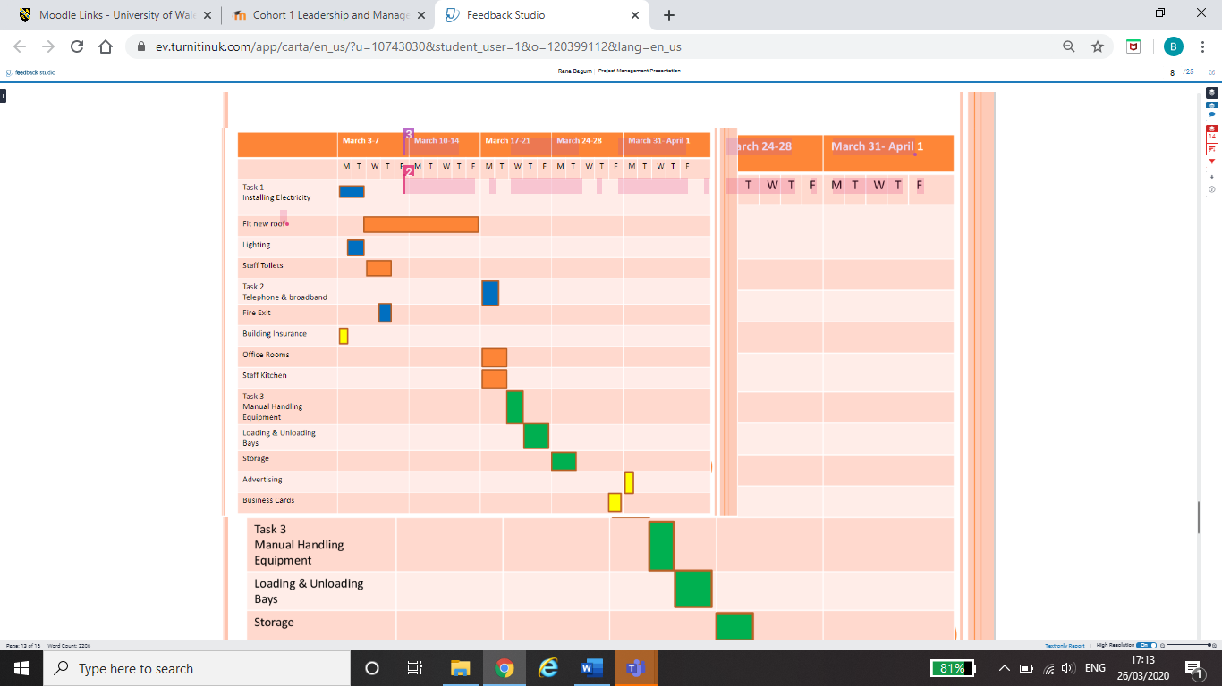

A Gantt chart is a horizontal bar chat that portrays the project timetable, this tool is named after its creator called Henry Gantt who designed the Gantt chart (tool) within the years 1910 and 1915. Gantt charts in this generation also portray the dependency relationships between events and recent program position. The Gantt chart lists all tasks needed for the project and plans out the start and end dates of the working progress of the project. Furthermore, there are a few benefits of a Gantt chart such as you visualize your entire project, you can witness the connection of tasks, you can keep everyone on task and you will be able to recognize the working effort of each staff member. This will help Vintage and its stakeholders communicate with each other because if they need to decide on what goes on the Gantt chart then they need to have some interaction also when stakeholders refer back to the Gantt chart then they need to socialize with each other to understand the task, this is beneficial to vintage as then there wouldn’t be conflict between stakeholders. (TeamGantt 2020).
Reflection
I can reflect from my own ability as project manager that being a project manager isn’t easy and that your business can be assisted using the five project management tools called brown paper planning, user stories, the Chevron, the Ion triangle and the Gantt chart. In addition to my point, I realised that as a project manager you must first of all visualise what’s beneficial to the business and all tools and resources you can use to help assist the business and its working progress. Furthermore, from my perspective I think that the most important and useful tool out of the five tools is the chevron as this tool can help Vintage a lot because it schedules all tasks and the time needed for it, also as well as that it picks out what must be in the project, what is wanted to be in the project and what is nice to have in the project and also picks out any extra needs that could be beneficial to the project so this means that most of the managers job is simplified and made easy as then all that’s left to complete is the cost for all requirements needed for the Vintage move. However, although the Chevron is the most useful tool, the brown paper planning is also quite useful as this tool arranges all needs and requirements for the project and not only that it encourages the teamwork within the business as for this tool everyone needs to work together as a team, this means that there will be a less chance of having any trouble with the staff in the future, which is also a benefit to the Vintage project. The least useful tool out of the five tools is the user stories because even though it tells you who the user is what their needs are, it is not completely beneficial to Vintage as a business, because it doesn’t show how long it would take to complete the needs and requirements for the project as then there may be a high chance for the working progress of the project to be delayed. Overall I think that the main job for a Vintage project move is to pick out the most appropriate and useful tools and resources that would benefit the project as well as the business, so that in the future there are no disappointments or delay in the business.

Conclusion
I have learnt that following the five tools can be an appropriate and useful reference for Vintage to refer back to in case of any let downs during the Vintage move and being a stakeholder you must think of what is beneficial to the project and business also each stakeholder must participate in giving ideas for the sustainable future of the business and to gain benefits for the Vintage move.

References
- Apm (2020). What is a Gantt chart?. Available: https://www.apm.org.uk/resources/find-a-resource/gantt-chart/. [Last accessed 26th March 2020].
- Heagney, J. (2016). Fundamentals of project management. Available: https://vuthedudotorg.files.wordpress.com/2015/10/fundamentals-of-project-management-0814437362.pdf. [Last accessed 25th March 2020].
- Marr, B. (2017). 14 Simple Expectations Great Employees Have of Their Boss. Available: https://finance.yahoo.com/news/14-simple-expectations-great-employees-112522691.html. [Last accessed 21st March 2020].
- McVay, R. (2020). Rights and Responsibilities of Employers and Employees. Available: https://www.educaloi.qc.ca/en/capsules/rights-and-responsibilities-employers-and-employees. [Last accessed 21st March 2020].
- Morphy, T. (2008). Project Management, project planning, templates and advice. Available: https://www.stakeholdermap.com/project-management/project-triangle.html. [Last accessed 25th March 2020].
- Project Manager (2020). The Ultimate Guide to Gantt Charts. Available: https://www.projectmanager.com/gantt-chart. [Last accessed 24th March 2020].
- Rouse, M. (2006). user story . Available: https://searchsoftwarequality.techtarget.com/definition/user-story. [Last accessed 24th March 2020].
- TeamGantt (2020). WHAT IS A GANTT CHART?. Available: https://www.teamgantt.com/what-is-a-gantt-chart. [Last accessed 26th March 2020].
- Westland, J. (2017). Project Manager Job Description (with free copy+paste examples!). Available: https://www.projectmanager.com/blog/project-manager-job-description. [Last accessed 21st March 2020].
- WorkshopBank (2009). Brown Paper Planning (Project Plan Template). Available: https://workshopbank.com/project-plan-template. [Last accessed 24th March 2020].

