Yasmin Vaughan
2004113
Date of submission: 7th November 2022
Title: Supporting your discussion with theory, practice and evidence from literature, critically reflect on how you would support an individual learner whose progress is being affected by specific barriers to his/ her learning during one particular transition period (horizontal or vertical). The response should include: 1.A written reflection. (3,500 words) 2.A one page profile of the pupil and a support plan that outlines the provision, the role of key stakeholders in the transition process and any evaluation strategies. (1,500 words)
Word count: 5000

Target | Page found
To be more critically reflective | 14
To synthesise references into my writing | 10
Using different writing techniques. | Throughout

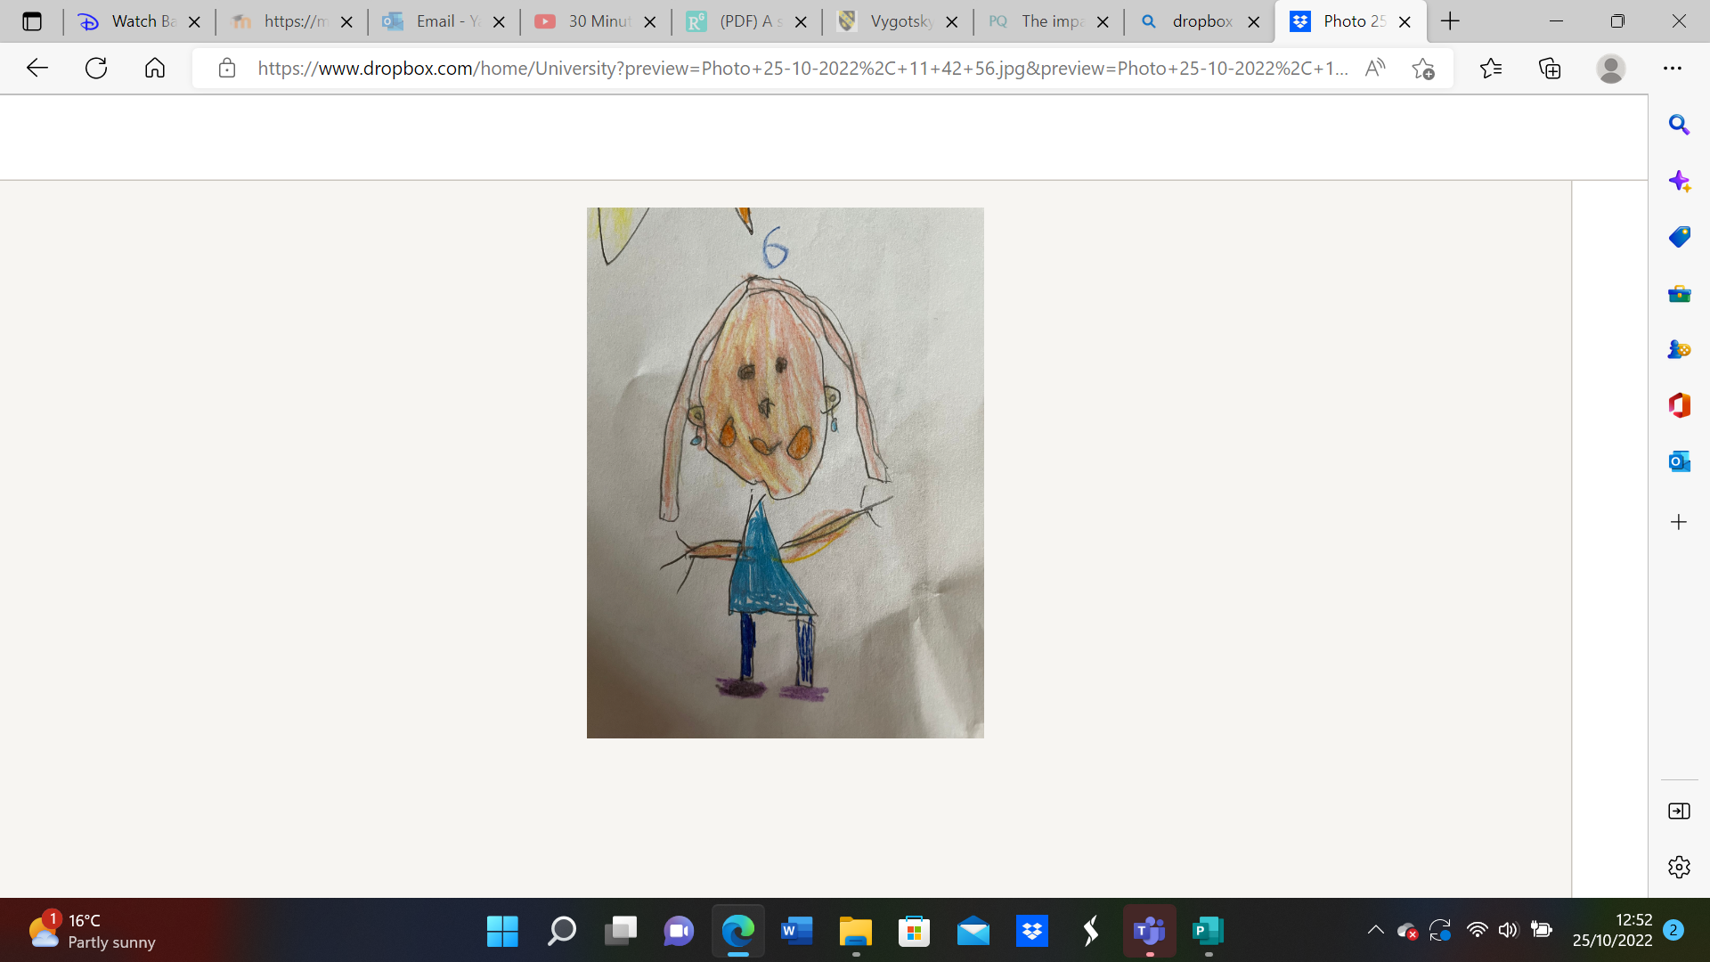
Part 1
One page profile
About Maggie (teacher’s notes)
Maggie is a three year old girl who suffers with selective mutism. She is a shy little girl who does not insert herself into social interactions with her peers or her teachers. Maggie often plays alone and will move away if approached by a peer.
Maggie comes from a household with little support, the family does not have a strong or easy relationship which can affect Maggie in school.
Relationships between home and school is difficult so approaching the parents about support and learning opportunities for Maggie is a difficult task.
What is important to Maggie?
• Her stuffed bear, Glowy, she makes her feel safe and comforted in school.
• Playing with Play Doh, she likes to use the Doh to make shapes using the tools.
• Wearing the princess dresses in the role play area, although she does not like to share them with her peers.
• Having her own personal space without being interrupted by peers or teachers. She enjoys spending time in the quiet corner to be alone.
What do others like about Maggie?
• She is quiet
• She is creative with her drawings, Play Doh and dress up.
• She is very courageous as she is able to spend time by herself.
• She is very patient and does not argue with peers.
What does Maggie need to support her social development?
• Maggie needs support from the Speech and Language Therapist to support her speech and language development.
• A play therapist comes into school to help her express her feelings using toys and allows her to begin to gai confidence in her speech.
• Maggie will have one to one support during activities in class where speech and group work in needed.
• Maggie needs encouragement to interact with her peers in class. Encouraging her engage in group activities.
• Having her teddy in class with her if she is feeling overwhelmed or anxious, although encouraging her to leave her teddy in her bag to build her confidence.
• Maggie needs time to be alone in the classroom using the quiet area.

Support plan

This support plan was created for Maggie to support her social development and her language development. This support plan will support Maggie through her play therapy for half a term. (six weeks) Throughout these six weeks, Maggie will begin to understand her emotions and understand how to express them. She will be encouraged to socialise with her peers. These experiences can allow Maggie to gain confidence allowing her to feel more comfortable in her classroom. It is hopeful that this will encourage Maggie to speak and to interact with her peers more. Key stakeholders were considered, such as local authority grants for a registered play therapist, the parents and the class teacher. This was agreed following the conversation with the ALNco.

 | Activity (30 minutes) | Progression step(s) | Next steps/ parental engagement.
Week 1 | Session 1: introduction session.  Maggie will be encouraged to bring a stuffed animal or toy of her choice to the session to show the comfort and safety of play therapy sessions.  Maggie and her parents will be joined by the play therapist. Her parents will be the observers to the session, understanding the play therapy routine and their child.  The play therapist will introduce themselves and play therapy. They will get to know the family before the session begins.  Maggie will be given costumes to try on (princesses and queens). Maggie must wear the costume and try to describe what she would do as queen/princess. Maggie can use cards to describe her castle, if she is not confident enough to communicate.  This allows the therapist to get to know Maggie through her likes. | Progression step: I can make decisions based on what I like and dislike. | Maggie’s parents should be encouraged to watch the video:  “My Child Won't Speak (2009)” By David Lunch. (YouTube, 2009)  Maggie should be encouraged to communicate her feelings with her family every morning and night.
Week 2 | Session 2: understanding emotions/feelings.  The play therapist will begin to talk to Maggie about emotions/feelings and how everybody has emotions/feelings.  Maggie will be provided with coloured paints and pieces of paper. The therapist will call out a feeling to Maggie and she must draw and colour the paper with how that feeling looks and feels to her.  For example: happiness could be yellow, pink, purple or a picture of a beach.  Emotions thermometer (Extension if showing progress in the session)  Maggie is encouraged to use the emotion thermometer (0= smiley face, 10= frowning face). She will be allowed to hold her stuffed animal for comfort.  Maggie is asked to explain something that makes them happy and something that makes them sad, the therapist will write them down for her. Maggie will place them next to the numbers. This activity will encourage Maggie to use her voice. | I can communicate my needs and feelings in my relationships | Maggie will be given her pictures to take home and show her parents. Maggie will be encouraged to link colours to feelings at home to help her find her safe space.
Week 3 | Week 3: Lego play  This session allows Maggie to express her home life using Lego. Maggie will be asked to use the Lego to build her home. The colours of blocks and objects she chooses will express how she feels at home.  This activity can then be repeated with the classroom being the focus. Maggie can express her feelings at school.  These activities will allow the therapist to understand how Maggie feels in her environments and where the anxiety could be built.  Maggie will be encouraged to communicate her feelings in home and at school to the therapist. | I can identify who looks after me and who my family and friends are. | Maggie can be given a set of Lego to take home to build her dream house with her parents. They can decide on the colours, the objects, the design and the size of the house together.  This can lead to the family creating rules of the house to encourage them to create a more positive relationship.
Week 4 | Week 4: Friendship builder- Bubble play.  Maggie will bring three peers with her to this session. The therapist will blow bubbles into the area. The children will be encouraged to express a worry that they have. For example, not having anyone to play with. The children will then move around the area to pop the bubbles and remove the worry. Each child will be given the opportunity to express a worry.  The session will close with the children sat in a circle. They will sing a song together, following the worry wizard.  The song will be:  “We all have worries, we are not alone” | I have an awareness of the feelings of others.  I am aware of when others are kind to me and when I am kind to others. | Maggie will be encouraged to interact and play with the children from this session.  Maggie can sing the song at home with her family and within the classroom. The song was created following the worry wizard.  A worry monster can be added to the classroom for Maggie and her peers to express and remove their worries within the classroom.
Week 5 | Session 5: Doh disco will be the focus of this session.  Children will be joining the session with Maggie. Each child will be given play doh to use. A song and video will be shown to the children for them to copy. Pocking, rolling, shaping the doh will be encouraged. The children will be prompted to sing the song. | I can recognise and follow rules and norms in the groups and situations in which I take part.  I can show care and respect for others. | Maggie will participate in Doh Disco as a classroom routine activity.  Maggie will be encouraged to use her doh to support her gross motor skills. She will be encouraged to engage with the songs alongside her classroom peers.
Week 6 | Session 6: reflection session.  Maggie will be joined with her parents.  The play therapist will ask Maggie how she feels since starting the sessions using the emotion chart. She will be encouraged to use her voice and give examples of where she has progressed.  The parents will also be asked how Maggie has progressed since the sessions began.  The therapist will bring in the class teacher to express Maggie’s progression in the classroom.  The session will end with any questions from the parents, Maggie or the therapist. | I am beginning to have an awareness that thoughts and feelings change, and I am starting to notice when change happens. | The parents will be asked to complete more tasks at home together such as photographs, family meals, movie nights or family walks.  The class teacher will create fortnightly meetings with the parents to support Maggie further in the classroom.

Part 2
Introduction
This assignment will consist of a support plan which will be created to aid the development of a child who is experiencing the transition into nursery. This support plan will be created using the ‘one page profile’ of the child, providing them with sessions of play therapy to aid their social development. The child will be referred to by the pseudonym ‘Maggie’ for confidentiality purposes. This is to ensure that the identity and personal details of the child will be private for the child’s best interests (BERA, 2018). Maggie is struggling with selective mutism, this is an anxiety disorder which is more commonly seen within children although the disorder itself is quite rare (Longobardi, et al., 2018). It has been seen that in recent years selective mutism has begun to increase as more factors have infiltrated children’s lives increasing the anxiety that children hold. According to CDC, 9.4% or 5.8 million 3-17 year old children were diagnosed with anxiety in 2019 (Centers for Disease Control and Prevention, 2022). Although this is not a statistic for the year 2022, it was stated that anxiety in children has increased and is continuing to increase rapidly. Maggie is experiencing a vertical transition as she enters nursery.
Johnson (2013) states that there are two types of transitions, vertical and horizontal. A vertical transition refers to major life transitions such as moving schools, a new baby in the family or a bereavement. A horizontal transition refers to a less distinctive transition such as everyday transitions (Johnson, 2013). An example of this is a transition from the classroom to the dinner hall or a supply teacher covering a school day. A vertical transition can impact an individual greatly as it is something that cannot be reversed. Once a baby has been born, it cannot be unborn, or a child cannot become younger (Aubrey-Smith, 2016). This type of transition can be very distressing and can often lead individuals to behave in different ways, some can become disruptive and aggressive, or some could become mute. This vertical transition into a nursery can appear distressing to Maggie and therefore increased her anxiety, which she filtered through her selective mutism. Maggie comes from a household with family issues which can affect her emotionally. Maggie often comes into school with unwashed and damaged clothing and an obvious lack of hygiene. This means that she is not receiving the support at home academically or to accommodate her basic needs.
Social development
Social development is the process where children begin to interact and socialise with their environment and those around them. Social development begins from birth as children will begin to communicate with parents or siblings through facial expressions, small sounds or crying (Littleton, 2005, pp. 1-20). As children grow, their social abilities will improve as they begin to transition into new periods in their life. Social development is a detrimental stage to the holistic development of children as it supports the language development, the wellbeing of children and their ability to create positive relationships (Barnes, 1995, pp. 3-10). Social skills can be seen as the most essential skills to develop for a child as it prepares them for the social world around them such as workplaces, society rules and growing a family (Huitt, 2011).
Bowlby’s attachment theory states that children form attachments from birth. The parents become the first attachment based on basic care and needs of the baby. As the child grows, they will begin to form attachments with others such as extended family, other caregivers and their peers. These attachments are essential for children during their social development as the children can begin to gain confidence, language skills and increase their self-esteem (Cherry, 2022). It is important to understand how essential attachments are for young children as it is the beginning of an ongoing development journey. As teachers, building the bond and positive relationships with the children allows them to feel comfortable in their surroundings and allows them to flourish in their progression (Bowlby, 1997). Maggie needs support in her social development as she is not able to communicate or interact with her peers or class teachers due to her selective mutism. This means that she is not gaining the positive relationships, the confidence or the language skills that is detrimental to her holistic development. Early support and intervention within this large transition will support her social development greatly.
Transitions
Transitions occur in every young person’s life whether this is a large transition or smaller, manageable transitions. A transition is essential for individuals to experience at a young age as it allows them to develop the skills and the independence that they can take with them through their lives. Although a transition is important for children, it can be a very difficult and confusing stage for them in their development (Symonds, 2015, pp. 1-50). For children, each new experience in life is detrimental as it is the start to the child building their identity. The smaller transitions and experiences in life allows a child’s brain to make healthy connections which allows the brain to grow. These early connections make it easier for the children to develop in many other aspects as the brain is able to retain and use previously obtained information (CDC, 2022). These early transitions can provide children with a basis to begin their journey of life. For a child who is new to school, it is important to provide them with first impressions which will be impactful and positive. As a child begins nursery, they are beginning their journey to education, so it is important to provide a safe and exciting first impression for them (Aubrey-Smith, 2016). Traumatic and stressful transitions can impact motivation and academic achievement (Educational Transitions and Change Research Group, 2011). As a key stakeholder, is it important that opportunities are provided for Maggie to create positive relationships with peers and staff to support her transition into nursery. This has a potential to alleviate some anxiety for her.
Bronfenbrenner’s theory describes how additional factors influence the holistic development of children. His ‘ecological model’ (see appendix) shows how factors such as extended family, living environments and social conditions can affect how a child develops. From experiences in two teaching experiences, I agree with this statement as both schools have been different. Both schools were placed in areas of complete contrast and both schools showed difference in attainment levels, ability and child development milestones due to the additional factors which influenced them (Hayes, et al., 2017, pp. 1-64). Maggie comes from a family with little support, this means that her development level is significantly lower than some in her class. The support she obtains from school interventions can aid in her progression in her development. Bronfenbrenner’s ecological theory can be difficult to implement in practice as each stage is hard to meet. The practitioners have no control over family culture or beliefs nor over the living areas. This shows how the model can be irrelevant to everyday practice (A Critique of Bronfenbrenner’s Ecological Systems Theory, 2022). Home- school links are a positive step to supporting the development of children as this is achievable for schools.

Selective mutism
According to the NHS, selective mutism is a severe anxiety disorder which results in the inability to speak in situations which are uncomfortable for the individual (NHS, 2019). In most cases of selective mutism, the child can communicate with certain individuals if they are in a comfortable atmosphere or if the individual makes the child comfortable (NHS, 2019). A study from 2013, consisting of 21 participants, shows the average age of children with selective mutism is 3.38 years old (Bergman, 2013). This might not be reliable in today’s date as it could have greatly changed in those years. However, this fits with the age of Maggie and shows that selective mutism should not be overlooked. Historically, selective mutism was known as ‘elective mutism’ as it was believed that children were deliberately not speaking as a behavioural issue. Further research has proven that selective mutism is very strongly linked with anxiety (Beate Oerbeck, 2020). Anxiety can change the way in which people behave as it can remove the individual’s control if they are experiencing discomforting or fearful situations. Nabors (2020) states how children experiencing anxiety tend to avoid situations which increase their anxiety and will often become withdrawn from their surroundings. Some will begin to ease once the situation has deflated however some children will not be able to change the behaviour (Nabors, 2020, pp. 1-5). A study conducted by The American Psychiatric Association (APA), to disprove elective mutism, used a small group of children and a questionnaire to understand where the anxiety is built from home and school environments. This showed that the children were not deliberately refraining from speaking but being overpowered from the anxiety and in certain situations has led to mutism (Koskela, et al., 2020).
According to clinically referred studies, such as Cunningham (2004) selective mutism is most common in girls. Kawai (2020) believes, within his study into psychological symptoms in Japanese children, that selective mutism in girls is most common where there are specific number of boys to girls in a ratio, this ratio being one boy to every 0.4-2.6 girls (Kawai, et al., 2020). Children encounter many factors which could influence their anxieties, such as family issues, overstimulation in a social experience or ability levels. Maggie is in a nursery class which is primarily girl based, this implies that the influence of the boys in the class might not be seen as the primary issue. Black and Uhde (1995) believe that selective mutism results from social phobia, which is the fear of social interactions due to the build-up of social anxiety. Social phobia can be caused from social anxieties in the family or because of the family itself (Black, 1995, pp. 1-20). By this it is meant that having an unsupportive or difficult family relationship can make social interactions difficult for children as they do not have the skills to act upon. Maggie comes from a household where support is not provided, this means that it can be difficult for her to put herself in social occurrences where she must be vulnerable and open. This can be very difficult for a child who is not used to having positive social interactions daily.

Support Plan
The support plan contains six weekly sessions of play therapy to support Maggie’s social development. This support plan can make Maggie’s transition into education easier as it can allow her to feel comfortable in her surroundings. Froebel (1837) expresses how play is full of meaning. Play is more than just use of toys, it is detrimental to the holistic development of children as it provides skills for each area of development. Children experience the world around them through play. Play brings new textures, materials, smells and even use of the objects which they would recognise. It teaches children about society’s rules such as time, social behaviours and friendship (NI Direct Government Services, 2022). It is important to understand play as a non-taught essential in a child’s life as it is a spontaneous and enjoyable experience for children with no additional goals or targets to meet (Landreth, 2012, pp. 7-27).
Estyn encourages play within schools to create a richer education for the children where they are able to explore their environments and are encouraged to use their imagination. Play enables mistakes to be made which supports the holistic development of children as children learn through trial and error. Without mistakes, children will not develop the skill of problem solving and will not gain motivation to improve their abilities (Learning through play in a real-life context, 2018). Schools should encourage the use of trial and error within classrooms to allow children to become ‘ambitious and capable learners’ following the four purposes in the new Curriculum for Wales 2022 (Welsh Government, 2018).
Theorists, such as Frank (1995) disagree with play as it is a waste of time as there is no observable learning. Some theorists only see play as acceptable if it suits their important views and not as a form of development. Teachers discourage this way of thinking as children have a right to play following the United Nations Convention on the Rights of the Child (UNCRC) (UNICEF, 2016, p. 10). These rights are celebrated within a school setting with assemblies, displays and activities. Many do not view children as their own person with their own beliefs and opinions often leaving children being overlooked and unnoticed (Landreth, 2012, pp. 7-27). Papalia and Olds(1986) disagrees with this as play allows children to find their identity and their meaning in life. It allows them to develop their imagination and skills in a way which encourages them to make their own choices, their own voices and their own personality (Papalia & Olds, 1986).
Froebel’s theory of play has changed education since 1836 when he opened the first kindergarten to allow young children to begin their educational journey. Many teachers use Froebel’s theory as guidance for practice as the theory encourages the use of play for children to take risks, have new experiences and develop new skills. Many parents in today’s day are overprotective of children and are afraid to let them explore the world, this shows that school is important for children to have the freedom to explore (Bruce, 2012, pp. 1-10) (Powell, 2022). Froebel has influenced Welsh education through the Curriculum for Wales 2022 which allows children to play and use their environment to develop holistically whilst also supporting their wellbeing. The curriculum for Wales will support children throughout their education by supporting children unlike years before (Government, 2022). The wellbeing of children, like Maggie, is the drive and focus of education to provide unique support for each child. Steiner (1919) created Waldorf schools which differ from mainstream schools as the education system focuses on the spiritual and creative side to development over the academic side. It is however similar to mainstream schools as Steiner focuses on the development of the holistic child to support their learning from nursery to 18 years (EarlyChildhoodEducation, 2021). This viewpoint on education can be adapted into Welsh education by supporting the creative, moral and spiritual development of children as this is just as important as academics and skills development. Although, due to recent findings, Waldorf schools are seeming to be less trustworthy as Ofsted warned concerns for safeguarding, bullying and poor support for special educational needs (Williams, 2019).
Froebel’s theory, however, does not take into consideration the time and resources which schools possess. The daily timetable within a class is full and busy to ensure children are learning and developing skills for progression, this means that setting time aside for play is difficult. To ensure that children’s play experiences are valuable, a significant period of time should be devoted to it. Many schools in Wales have little funding for resources such as suitable toys or play equipment, this insinuates that many children do not have access to the rich play experiences which Froebel encourages. This showing how Froebel’s theory is not always beneficial within education.
In this instance, play and play therapy is beneficial for Maggie’s social development as it can allow her to feel comfortable and confident in her environment which could encourage her to communicate with her peers. Play can allow her to develop the skills necessary to express her feelings and understand her anxieties. It can be hard for children to understand their anxieties so creating a safe space for her to understand them can help her to overcome her anxiety. Maggie can work with the therapist weekly, using new techniques and skills that can be implemented into the classroom. Vygotsky’s (1978) Zone of Proximal Development persuades teachers to provide activities for children to challenge their abilities and aid progression (Hausfather, 1996). Providing children with a more knowledgeable other (MKO) so children can tackle the more challenging tasks allowing them to develop independently and with support if needed (Miller, 2011, pp. 1-30). Play therapy incorporates this theory by allowing children to freely explore play opportunities alongside the therapist to support and direct the play if necessary. This MKO can encourage Maggie to express and understand her feelings through play rather than through speech.
Maggie’s play therapy can be adapted into the classroom to make her feel more comfortable and safer in her learning environment. Activities such as Doh Disco can be added into the daily routine to support Maggie through her 6-week journey. Doh Disco is an activity supporting the social and physical development of children. Children will stand in front of a screen where a song and a movement pattern will be shown for them to copy the actions with the Play Doh. These actions will support the children’s fine motor skills as well as their confidence in the classroom. The song will support their social development as the children will interact with their peers and their classroom mentors to participate (Spread the Happiness, 2022). This method of play can support Maggie in the classroom by encouraging her to engage with her classmates and gain confidence around her peers. In trust that this repetition and routine will decrease her anxiety in the classroom and encourage her to become more social. Children in younger years look forward to their Doh Disco period as it is an enjoyable way for them to develop and socialise in a way that isn’t complicated. This activity will be a positive and beneficial addition to their routine. After extensive research into Doh Disco, negative comments are unseen proving the benefits and success the activity has.

Although play therapy is highly beneficial for a child with social or language struggles, it can be difficult for schools to incorporate it into their environment. Play therapy must have training and expertise for it to be beneficial for the children which is often difficult within a school due to funding and time. Staff members within school settings often have multiple roles such as safeguarding officers or deputy headteachers, however a play therapist within a school is very unlikely. This implies that a play therapy specialist must be brought into the school to work with these children. Funding is an issue as schools do not have excess funding for outside agencies to visit, which is why many teachers have training for any additional roles which are needed in that school (Spielman, 2020). The schools can often struggle to provide the necessary resources for a play therapy session as many schools have limited rooms, equipment and additional staff to support it. These factors show how play therapy isn’t always practical for children. Drew (2022) believes that it can be unfair on the child and their peers to provide children with play therapy sessions as the child is completing the same tasks from the classroom and is continuing to play without structure. He instead suggests that structured and guided play can be more beneficial for the social development of a child (Drew, 2022).

Conclusion
After thorough research into transitions and selective mutism, it is clear that the support plan, consisting of play therapy sessions, will greatly support Maggie’s social and language development. These sessions aspire to support Maggie through her anxious interactions with her transition, encouraging her to socialise with her peers and work together with those around her. The one-page profile, used by all members of staff associated with the classroom, will provide further sustenance to Maggie’s learning and development within the classroom.
I believe that this assignment has supported my ability to learn about additional learning needs and barriers to education that I am unfamiliar with. Selective mutism is not a common occurrence within a school, so it is often left unrecognised or misdiagnosed. I have been able to develop a support plan for this barrier in order to support future children in my care who share these same struggles. I have enjoyed my experience with research in this assignment and I would like to improve my knowledge into interventions regarding play.
This has supported my personal professional development, more specifically ‘Pedagogy: refining teaching towards sustained highly effective practice’. This is because I have been able to manage the learning environment, supporting every learner regardless of their additional needs or unique circumstances. This standard has led me to provide positive learning behaviours within my practice. I have also developed my professional practice by ‘involving partners in learning’ such as the parents and play therapist. The importance to working with a variety of partners within education is high and also difficult to manage. I aim to further work on this target for future practice to ensure that the children are receiving the best possible care and attention (Education Workforce Council, 2022).
I believe this assignment has shown me that the ‘leading colleagues, projects and programmes’ is a standard I wish to focus on for future practice. Not all schools have access to funding, resources and training to provide additional support methods for children like Maggie, I would like to take control of these situations to create my own methods of intervention (Education Workforce Council, 2022).

References
A Critique of Bronfenbrenner’s Ecological Systems Theory (2022) Nicky Taylor.
Aubrey-Smith, F., 2016. A smooth transition into the early years. Researchgate, 1(1), pp. 1-5.
Barnes, P., 1995. Personal, social and emotional development of children. 1 ed. London: Blackwell Publishers Ltd.
Beate Oerbeck, K. R. O. H. K., 2020. The Selective Mutism Questionnaire: Data from typically developing children and children with selective mutism. Sage Journals, 25(4).
BERA, 2018. Ethical Guidelines for Educational Research, fourth edition. 1st ed. London: BERA.
Bergman, R. L., 2013. Treatment for children with selective mutism:. 1st ed. New York: Oxford University Press.
Black, U., 1995. Psychiatric characteristics of children with selective mutism: A pilot study.. 1st ed. London: Journal of the American Academy of Child and Adolescent Psychiatry.
Bowlby, J., 1997. Attachment and loss. Pimlico, Volume 1(1), pp. 1-30.
Bruce, T., 2012. Early childhood practice: Froebel today. 1 ed. London: Sage.
CDC, 2022. Early Brain Development and Health. [Online]
Available at: https://www.cdc.gov/ncbddd/childdevelopment/early-brain-development.html
[Accessed 25 October 2022].
Centers for Disease Control and Prevention, 2022. Anxiety and depression in children: Get the facts. [Online]
Available at: https://www.cdc.gov/childrensmentalhealth/features/anxiety-depression-children.html
[Accessed 17 October 2022].
Cherry, K., 2022. What Is Attachment Theory?. [Online]
Available at: https://www.verywellmind.com/what-is-attachment-theory-2795337
[Accessed 2 November 2022].
Cunningham, C. M. A. B. M. &. P., 2004. Behavioral and emotional adjustment,. 1st ed. London: Journal of Child Psychology and Psychiatry.
Drew, C., 2022. Unstructured Play: 13 Pros & Cons For Learning. [Online]
Available at: https://helpfulprofessor.com/unstructured-play-based-learning/
[Accessed 28 October 2022].
EarlyChildhoodEducation, 2021. The Steiner Education Approach. [Online]
Available at: https://earlychildhoodeducation.co.uk/steiner-education-approach/
[Accessed 1 November 2022].
Education Workforce Council, 2022. Professional Learning Passport (PLP). [Online]
Available at: https://www.ewc.wales/site/index.php/en/professional-development/professional-learning-passport
[Accessed 1 November 2022].
Educational Transitions and Change Research Group, 2011. Transition to School: Position Statement. 1 ed. London: Charles Sturt University..
Frank, L., 1955. Play in personality development. American journal of orthopsychiatry, 25(3), pp. 576-590.
Government, W., 2022. Curriculum for Wales. [Online]
Available at: https://hwb.gov.wales/curriculum-for-wales
[Accessed 26 October 2022].
Hausfather, S. J., 1996. Vygotsky and Schooling: Creating a Social Contest for learning.. Action in Teacher Education, 1(10), pp. 1-18.
Hayes, N., O'Toole, L. & Halpenny, A. M., 2017. Introducing Bronfenbrenner : A Guide for Practitioners and Students in Early Years Education. 1 ed. London: Taylor & Francis Group.
Huitt, W. G., 2011. Social Development: Why It Is Important and How To Impact It, Valdosta: Educational Psychology Interactive..
Johnson, S., 2013. Early Years Transitions Action Research Project. [Online]
Available at: https://tactyc.org.uk/pdfs/2013-conf-Johnson.pdf
[Accessed 14 October 2022].
Kawai, T. et al., 2020. Gender Differences in Psychological Symptoms and Psychotherapeutic Processes in Japanese Children. Pubmed, 1(1).
Koskela, M. et al., 2020. The impact of parental psychopathology and sociodemographic factors in selective mutism - a nationwide population-based study. Proquest, 20(1).
Landreth, G., 2012. Play Therapy : The Art of the Relationship. 3 ed. New York: Routledge.
Learning through play in a real-life context (2018) Estyn.
Littleton, K., 2005. Children's personal and social development. 1 ed. London: Blackwell.
Longobardi, C., Badenes-Ribera, L., Gastaldi, F. G. M. & Prino, L. E., 2018. The student–teacher relationship quality. Wiley, 1(1), pp. 32-33.
MapoolCampus, 2019. Bronfenbrenners ecological model. Ecological Systems Theory By Bronfenbrenner. [Online]
Available at: http://mapoolcampus.com/bronfenbrenners-ecological-model.html
[Accessed 29 October 2022].
Miller, R., 2011. Vygotsky in perspective. 1st ed. London: Cambridge University Press.
My Child Won't Speak (2009). 2009. [Film] Directed by David Lunch. England: YouTube.
Nabors, L., 2020. Anxiety Management in Children with Mental and Physical Health Problems. 1 ed. London: Springer International Publishing AG.
NHS, 2019. Selective mutism. [Online]
Available at: https://www.nhs.uk/mental-health/conditions/selective-mutism/
[Accessed 14 October 2022].
NI Direct Government Services, 2022. How play helps children's development. [Online]
Available at: https://www.nidirect.gov.uk/articles/how-play-helps-childrens-development
[Accessed 03 November 2022].
Papalia & Olds, 1986. Human development. 1st ed. New York: Mcgraw-Hill.
Powell, S., 2022. The power of play. [Online]
Available at: https://www.froebel.org.uk/about-us/the-power-of-play
[Accessed 26 October 2022].
Spielman, A., 2020. HMCI commentary on school funding. [Online]
Available at: https://www.gov.uk/government/speeches/commentary-on-school-funding
[Accessed 28 October 2022].
Spread the Happiness, 2022. Dough Disco ™. [Online]
Available at: https://www.spreadthehappiness.co.uk/dough-disco/
[Accessed 29 October 2022].
Symonds, J., 2015. Understanding school transition: what happens to children and how to help them. 1 ed. London: Taylor & Francis Group.
UNICEF, 2016. The United Nations Convention on the Rights of the Child. [Online]
Available at: https://www.unicef.org.uk/wp-content/uploads/2016/08/unicef-convention-rights-child-uncrc.pdf
[Accessed 29 October 2022].
Welsh Government, 2018. The four purposes of the curriculum for Wales. [Online]
Available at: https://gov.wales/sites/default/files/publications/2018-03/the-four-purposes-of-the-curriculum-for-wales.pdf
[Accessed 2 November 2022].
Williams, Z., 2019. These Steiner ‘failures’ are really a failure of the free school agenda, Wales: The Guardian.

Appendix
Appendix 1: Bronfenbrenner’s ecological model.
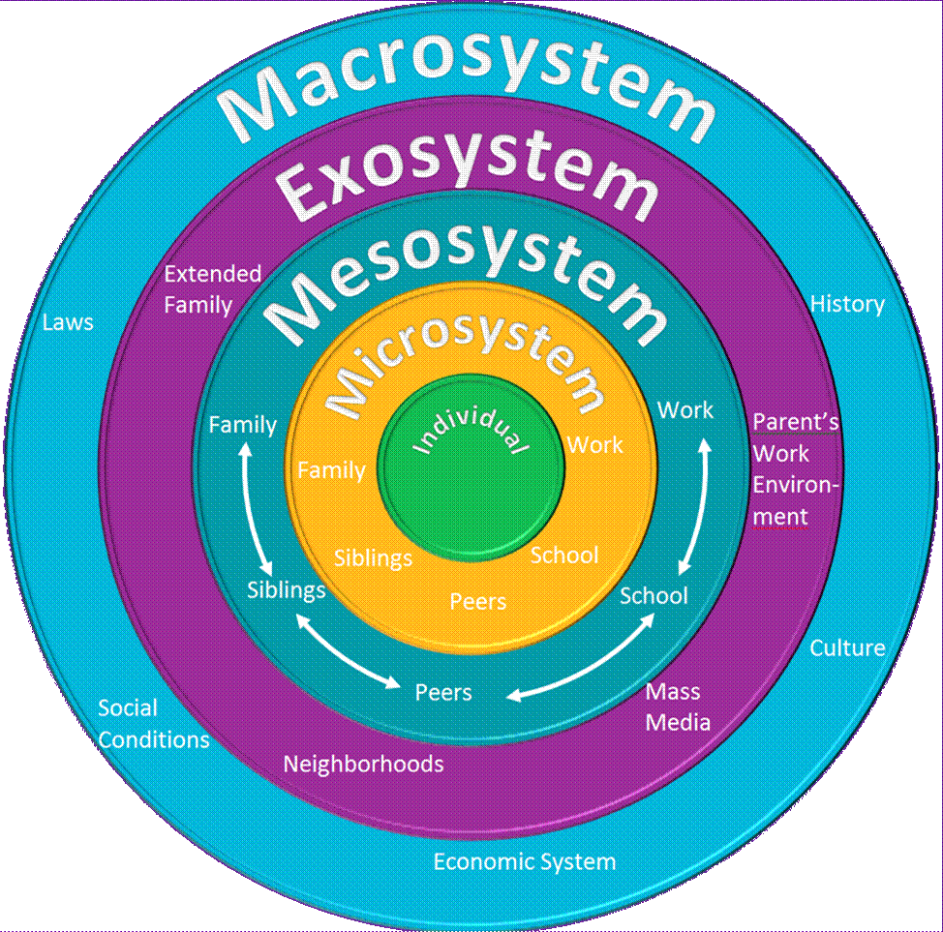

(MapoolCampus, 2019)

