Comparison of Machine Learning Algorithms for Fashion-MNIST Dataset

Summary
In recent years, more and more machine learning researches began to use Fashion-MNIST Dataset to evaluate the performance of algorithms. In this paper, split the dataset into train, test and evaluation subsets, and then use KNN classifier and decision tree classifier respectively to study and test. By adjusting k value of KNN algorithm and maximum tree depth value of decision tree algorithm, KNN algorithm and decision tree algorithm with the best performance can be obtained respectively. Finally, the performance of the two algorithms is compared by comparing their confusion matrices, recall, precision, f1 score and classification accuracy. The results showed that when k value was 4, the performance of the KNN classifier was the best. When the maximum tree depth was 10, the performance of the decision tree classifier was the best. In this case, the accuracy rates of the two were 0.8876 and 0.794, respectively.

Introduction
For Amazon, Alibaba and other online commodity sellers, category identification is very important, which can help buyers to quickly find the corresponding commodities in the online mall by taking photos instead of using text descriptions, thus improving the transaction rate. Among them, the classification and identification of clothing products is very important. Fashion-MNIST Dataset contains 70,000 positive photos of different clothes. Machine learning algorithm is used to study and test the data set, which can realize the classification of clothing items.
Matthew Y. W. Teow used the combination of simple two-dimensional piecewise linear functions to form a multilayer continuous cascade projection function, and used the formalized framework to model the learning of convolutional visual features in the convolutional neural network. The final results showed that the accuracy of the model reached 90.19%[1]. Shobhit Bhatnagar proposed three different convolutional neural network architectures and used batch normalization and residual skip connections to simplify and accelerate the learning process. The final results showed that the accuracy of the model reached 92.54%[2]. Edmira Xhaferra integrates deep learning into the convolutional neural network CNN, and uses two different convolutional neural networks CNN-C1 and CNN-C2 architectures for comparison. The final results show that the two architectures are superior to the traditional CNN model, reaching 93.11%[3]. Mohammed Kayed used LeNet-5 architecture of convolutional neural network CNN to train and learn Fashion-MNIST, and test results showed that the accuracy of the model was more than 98%[4].
In addition to using convolutional neural network to test Fashion-MNIST in many studies, KNN classifier and decision tree classifier are also competent for classifying this dataset. In this paper, these two classifier algorithms will be used and their performance will be tested.

Fashion-Mnist Dataset
The classic MNIST dataset, which contains 70,000 handwritten digits, has been tested and studied by countless researchers for more than a decade as a benchmark for measuring algorithm performance. However, the shortcomings of this data set are becoming more and more obvious[5]. Regardless of whether the algorithm is good or bad, it can easily achieve an accuracy rate of more than 95 %, and it cannot show the difference in algorithm performance. If it doesn't work, it won't work at all, and if an algorithm works successfully in MNIST, it might not work in other datasets".
In this regard, some researchers made Fashion-MNIST based on photos of fashion products provided by the research department of Zalando (a German fashion technology company), which contains 70,000 frontal photos of fashion products, all of which are 28x28 in grayscale Photos, including 60000 training sets and 10000 test sets, are divided into 10 categories, including T-shirt , trouser, pullover, dress, coat, sandal, shirt, sneaker, bag, ankle boot , and are divided into 0 to 9 as labels for each category[6]. In order to be compatible with MNIST, Fashion-MNIST is exactly the same as MNIST in format, category, data volume, train and test division. Compared with the handwritten digit data set, the details and complexity of the clothes contained in Fashion-MNIST are much more difficult than the handwritten digits, which brings challenges to various classifiers and can also demonstrate the performance of each classifier well.
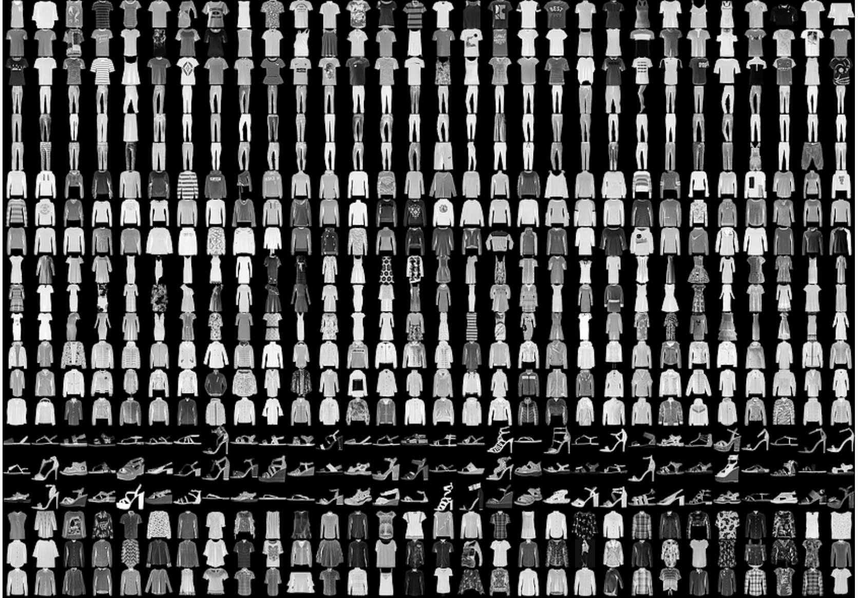
Figure 1 Fashion-MNIST Dataset example

Classification Algorithms
KNN classifier
KNN is a kind of instance-based learning algorithm, which has been used in different classification fields. It is a relatively mature algorithm and one of the simplest machine learning algorithms[7]. Its working principle is to first read a large number of training samples for training, and then input test samples into it. When judging the category of test samples, it mainly depends on the category of samples near the test samples. When most of the adjacent samples belong to a certain category, Then the sample is considered to belong to this category.
The specific algorithm steps are to calculate the distance between the test sample and each training sample, and then sort according to the distance, select the K points with the smallest distance and check their categories, and the category with the highest frequency is used as the predicted classification of the test data. According to the logic of the algorithm, the calculation of the distance and the selection of the K value have a great influence on the performance of the algorithm.
Commonly used distance calculation methods include Manhattan distance, Euclidean distance and Minkowski distance, among which Euclidean distance is the longest used, and its calculation method is as follows: For two n-dimensional vectors x and y, Euclidean distance is:
$d\left(p,q\right)=d\left(q,p\right)=\sqrt{{{(q}_{1}-p_{1})}^{2}+{{(q}_{2}-p_{2})}^{2}++{{(q}_{n}-p_{n})}^{2}}=\sqrt{\sum_{i=1}^{n}{{{(q}_{i}-p_{i})}^{2}}}$(1)
As for the selection of the K value, when a smaller k value is selected, it is equivalent to predicting the sample in a smaller area. At this time, although the approximation error will be small, the predicted value of the sample will not be disturbed by the distant sample, but at the same time, the estimation error of learning will increase. When there is more noise in the training set, the small K value will cause the accuracy of the algorithm to decrease, and it will also make the model more complex. When a larger K value is selected, although the resistance to noise interference increases, samples that are far away from the test sample or have a low similarity will also interfere, resulting in an increase in the approximation error. In practice, you can select a smaller value for the K value, divide the training samples into a training set and a verification set, and test the accuracy of the model separately, so as to obtain the mean value of the accuracy as the result of cross-validation. By continuously increasing the K value, the corresponding accuracy is obtained, so as to determine the best K value.
Decision tree classifier
Decision tree algorithm is a basic classification and regression algorithm. It uses top-down recursive method to divide from the root, selects an optimal attribute as the root node, then determines the branch of the internal node step by step, and finally goes to the leaf node[8]. Since all data will be completely classified from the root node to the leaf node, the decision tree algorithm can be used for data prediction and classification.
According to the principle of decision tree algorithm, the performance of the algorithm is mainly affected by the depth of the maximum tree, the number of leaf nodes and the number of leaf node samples. When the number of samples is large enough, it is easy to have the phenomenon that the depth of the tree is too large, extending down the nodes of more than several layers. The number of leaf nodes also needs to be limited. When the number of leaf nodes is too large, that is, there are too many branches in the decision tree, the algorithm is prone to overfitting phenomenon, and the minimum number of samples in leaf nodes also needs to be limited, otherwise the algorithm overfitting phenomenon will also occur[9]. The above three features all change with the growth of the tree, and limiting these three features is to limit the growth of the tree, because when the tree grows too much, although the accuracy of the training sample is constantly improved, the accuracy will first increase and then decrease when applied to the test sample.

Simulations
Database preparation
For 70,000 images in Fashion-MNIST, due to the large number of 60,000 images in the original training set, it will take a lot of time to verify the algorithm. In this paper, 40% (24,000) images are randomly selected as training images, and 10% (2400) images are selected as verification set for cross-verification. Moreover, all the images are 28×28 gray scale images, that is, the training matrix size adopted by this algorithm is 21600×784, the verification matrix size is 2400×784, and the test matrix size is 10000×784.
Before the algorithm test, the data need to be standardized, that is, normalized, because different features in the feature vector often have different dimensions and units. After the normalization, all data is restricted within the range of [0,1], and all indicators are at the same order of magnitude, so that comprehensive evaluation and comparison can be carried out.
Determination of the best K value
As mentioned in Section 2.1, K value has a great impact on the performance of KNN classifier, because there are 10 categories in the database, and K value is usually selected as odd. Therefore, the minimum value of K value is 1, the maximum value is 11, and the training set and verification set are used to test the accuracy of the model, so as to obtain the average value of accuracy as the result of cross-validation. The accuracy values corresponding to different K values are collected, and finally get the most suitable one for this database.
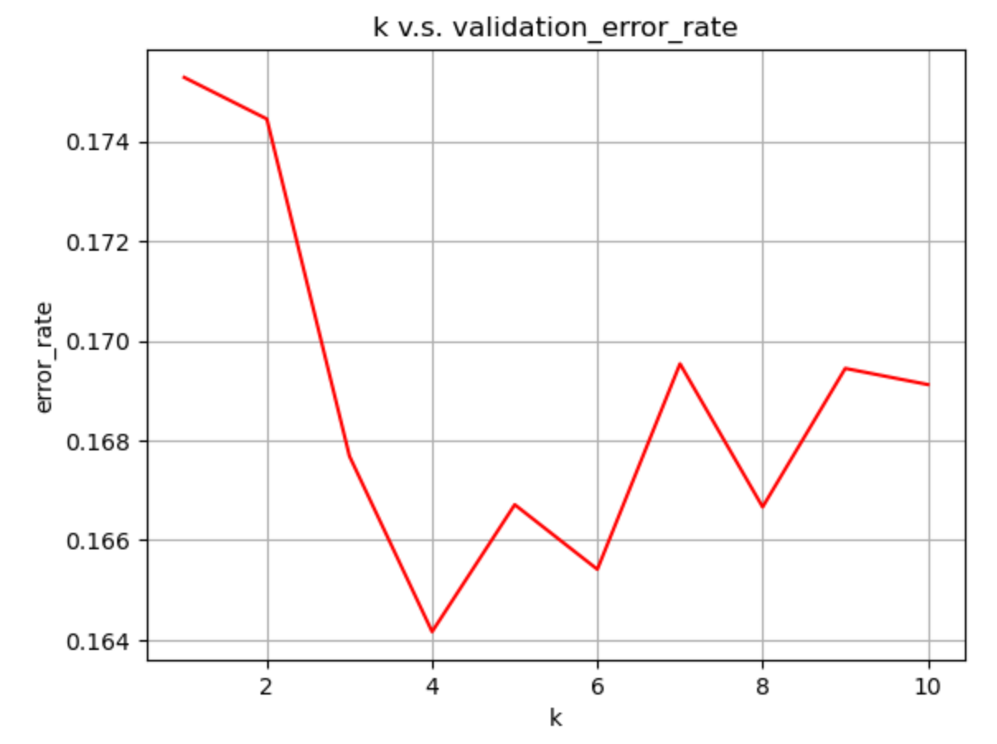
Figure 2 k vs. validation_error_rate
As shown in Figure 2, when the value of K is 4, the error rate of the verification set is the lowest, so this value is applied to the test set.
Determination of maximum tree depth
For decision tree classifiers, if the maximum tree depth is too large, the algorithm is prone to overfitting, so the maximum tree depth should be limited. The range of maximum tree depth was selected as [1,50], and the training set and verification set were tested to obtain the relationship between the maximum tree depth and the accuracy.
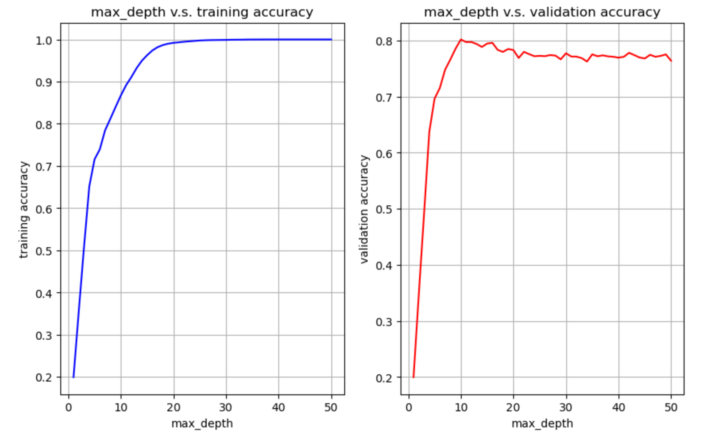
Figure 3 max_depth vs . training /validation accuracy
As can be seen from Figure 3, with the increase of the maximum tree depth, although the accuracy rate of the training set keeps rising, the accuracy rate of the verification set shows a trend of first rising and then declining, that is, showing the phenomenon of over-fitting. By selecting the point corresponding to the maximum correct rate in the verification set, the maximum tree depth should be selected as 10.
Comparison of the effect of two classifiers
Classifier performance judgment index
The performance evaluation of classifier usually includes confusion matrices, recall, precision, f1 score and classification accuracy[10].
Classification accuracy is the most commonly used to evaluate the performance of a classifier, that is, the ratio of the correct number of predictions to the total number of predictions. When a classifier has a high accuracy, it means that the model has made correct predictions in most cases.
$Accuracy=\frac{CorrectionPrediction}{CorrectionPrediction+InorrectionPrediction}$ (2)
$Accuracy=\frac{TruePositive+TrueNegative}{TruePositive+FalsePositive+TrueNegative+FalseNegative}$ (3)
However, sometimes the accuracy will lead to misdirection. Classifier with high accuracy may not produce good results in reality. For example, when detecting bad fruit in fruit, due to the small number of bad fruits, it may occur that although classifier has high accuracy, it cannot identify bad fruit, so recall rate is needed as auxiliary evaluation standard. The calculation principle is the ratio between the number of positive cases and the total number of positive case labels, namely:
$Recall=\frac{TruePositive}{TruePositive+FalseNegative}$ (4)
In the above case, there will be a situation where the accuracy rate of the algorithm is high but the recall rate is very low, which means that the algorithm is not effective in identifying bad fruits .
However, when the algorithm identifies all good fruits as bad fruits, the recall rate will be very high, but obviously the algorithm performance is not good at this time, so the concept of precision is introduced. Precision is the ratio between the number of positive cases predicted correctly and the total number of positive predictions, that is:
$Precision=\frac{TruePositive}{TruePositive+FalsePositive}$ (5)
When the algorithm identifies good fruits as bad fruits, although the recall rate is high, the calculation accuracy is very low. Thus, it can be judged that the algorithm has excellent performance in the identification of bad fruits, but poor performance in the judgment of good fruits.
In most cases, the performance evaluation of algorithms should not focus only on accuracy or recall rate, but on a balance between them, that is, both accuracy and recall rate. Therefore, the concept of f1 score, which combines recall and precision, is the harmonic average of these two values. When there is a low recall rate and accuracy, both result in a lower f1 score. The specific formula is as follows:
$F1Score=2*\frac{Recall*Precision}{Recall+Precision}$ (6)
When the recall rate is 20% and the accuracy is 100%, if the arithmetic average is calculated, it can be 60%, while f1 score is 33.33%. Obviously, f1 score is lower, which can show the poor algorithm performance. Therefore, f1 score is an important indicator to evaluate the algorithm performance.
The confusion matrix can display various results predicted by the algorithm, and show the real data category and the data category predicted by the algorithm in the form of a matrix, which is clear. Through the confusion matrix, reader can quickly find the various parameters needed to calculate recall, precision, f1 score and classification accuracy.
Effect comparison and analysis
After k is set to 4 for KNN classifier and the maximum tree depth is set to 10 for decision tree classifier, the test set containing 10000 pictures is tested. The results are as follows.
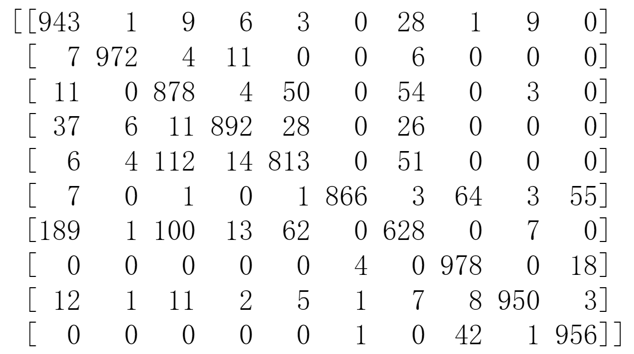
Figure 4 confusion matrices o f KNN classifier

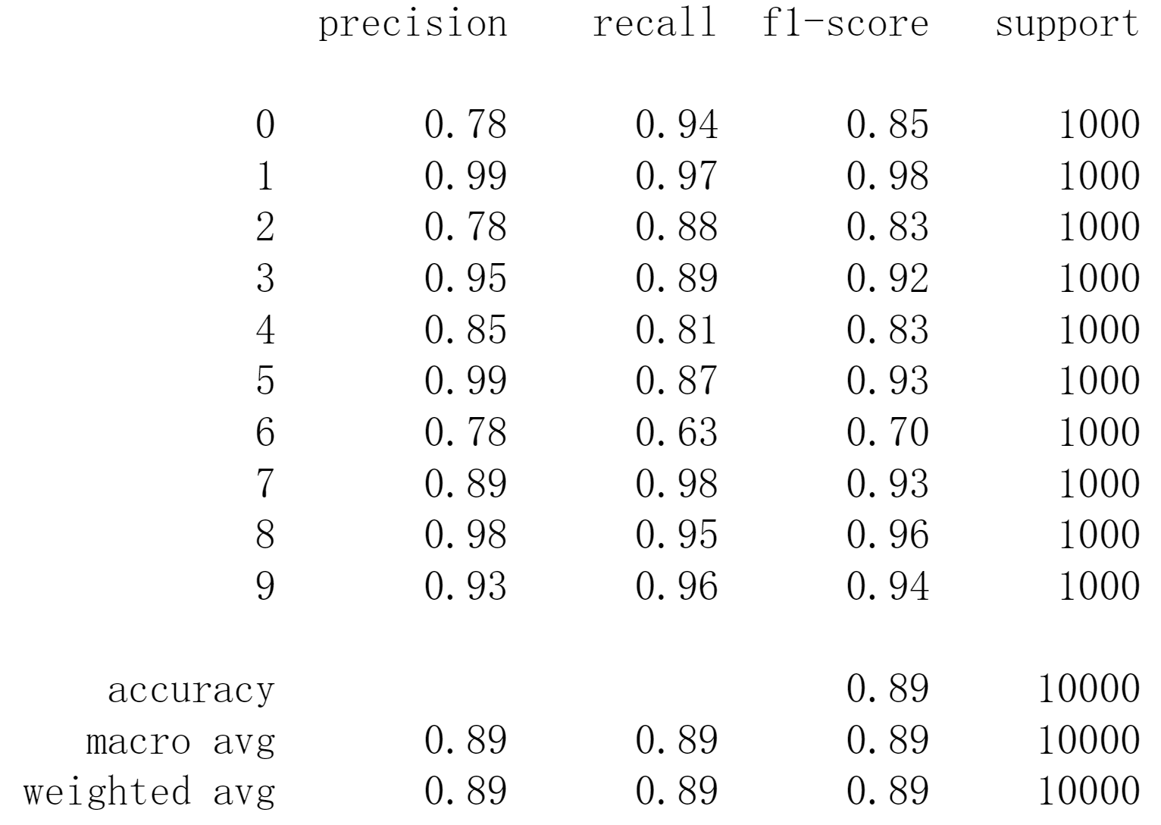
Figure 5 recall, precision, f 1 score and classification accuracy o f KNN classifier
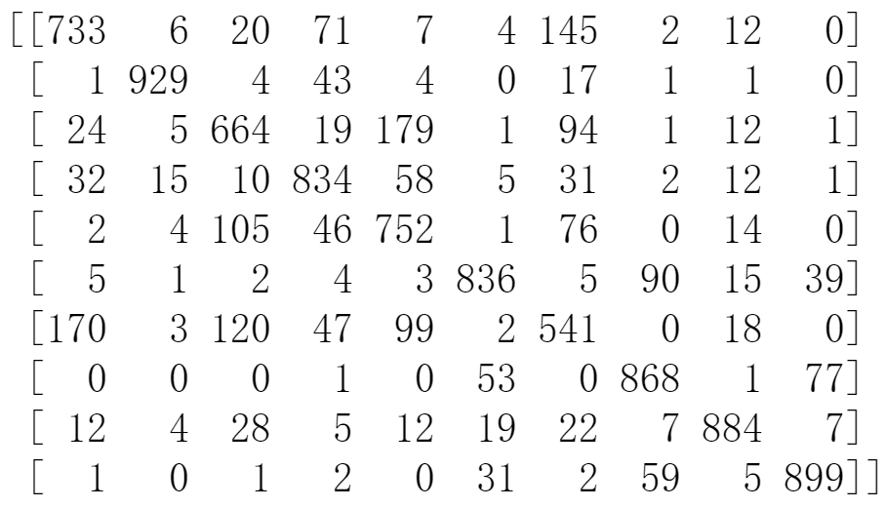
Figure 6 confusion matrices of decision tree classifier
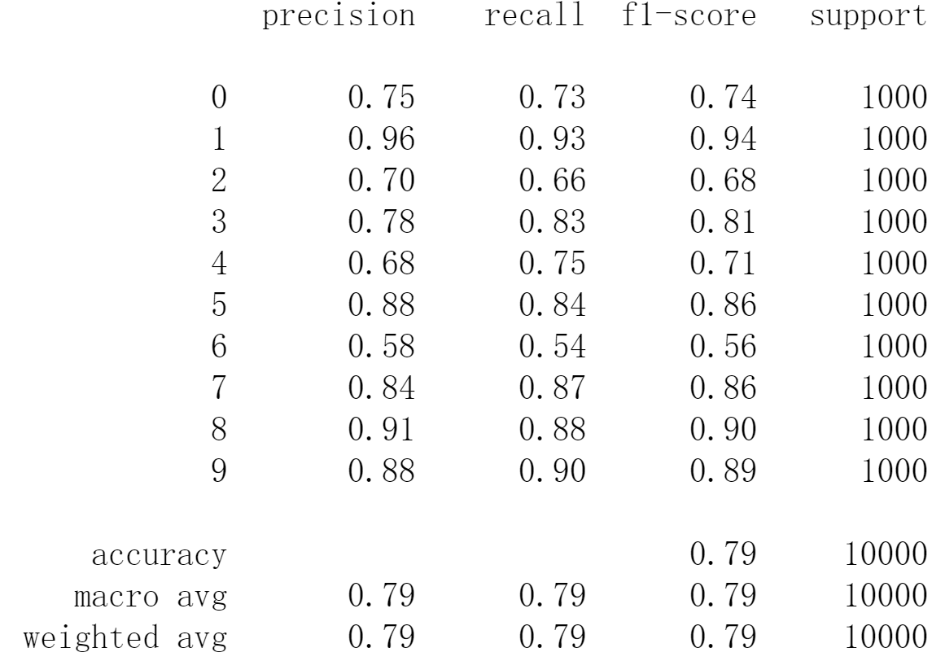
Figure 7 recall, precision, f1 score and classification accuracy o f decision tree classifier
It can be seen from Figure 4 that the KNN classifier has the lowest correct rate for category 6 shirts , only 62.8% . The same situation also appears on the decision tree classifier , its correct rate for category 6 shirts is also the lowest, only 54.1% . Through the confusion matrix, it can be found that the misjudgment of category 6 shirt by the two classifiers is mainly misjudged as category 0 T - shirt, and the ratios in this case are 1 8.9% and 17.0% respectively. The reason may be that the similarity between shirt and T-shirt is relatively high. In this regard, this paper believes that in the future, the proportion of category 0 and category 6 in the training set should be increased or the total number of training sets should be increased to improve the accuracy rate.
From the confusion matrix in Figure 4 and Figure 6, it could also be seen that KNN classifier had the highest accuracy on categories 1 T-shirt, 7 sneaker and 9 ankle boot, which were 97.2%, 97.8% and 95.6%, respectively. The accuracy of decision tree classifier was the highest for categories 1 T-shirt, 8 bag and 9 ankle boot, which were 92.9%, 88.4% and 89.9%, respectively.
As can be seen from Figure 5, the f1 score of KNN classifier on category 1 trouser, 8 bag and 9 ankle boot was the highest, which were 0.98, 0.96 and 0.94, respectively, while the f1 score of sneaker category 7 was also relatively high, which was 0.93. And the correct rate is basically corresponding. However, category 6shirt still has the lowest f1 score (0.70), and the corresponding precision and recall are 0.78 and 0.63, which are mainly pulled down by the value of recall.
As can be seen from Figure 7, the f1 score of the decision tree classifier for 1 trouser, 8 bag and 9 ankle boot was the highest, which were 0.94, 0.90 and 0.89, respectively, corresponding to the accuracy. The category with the lowest f1 score is also category 6 shirt (0.56), and the corresponding precision and recall are 0.58 and 0.54, both of which are relatively low.
Finally, the total correct rate of the KNN classifier for the test set is calculated to be 0.8876, and the overall accuracy of the decision tree classifier on the test set is 0.794. As can be seen from the above analysis, The accuracy values of different categories correspond to recall, precision and f1 score, indicating that the accuracy can reflect the performance of the classifier in this classifier test, and that the performance of the KNN classifier is better than that of the decision tree classifier[11].

Conclusion
For the fact that MNIST is increasingly difficult to distinguish the performance of classifiers, this paper selects Fashion-MNIST generated based on fashion items, and uses KNN classifier and decision tree classifier for training and testing. By adjusting the parameters, K is obtained as 4 and the maximum tree depth is 10 , the performance of the two classifiers is the best.
After testing the test set, the accuracy of KNN classifier is 0.8876 and the accuracy of decision tree classifier is 0.794. recall, precision and f1 score are basically consistent with the accuracy. The performance of the decision-maker can be reflected with accuracy.
At the same time, it can be seen from the parameters that the two classifiers have the worst prediction effect on the category 6shirt, which is mainly wrong prediction into the category 0 T-shirt. The possible reason is that shirt and T-shirt are too similar, and a considerable number of shirts are also short-sleeved, so the algorithm cannot distinguish. Therefore, it is suggested that the ratio of shirt to T-shirt can be increased in training set and verification set.
Finally, for the fact that the correct rate of the decision tree classifier is 0.0936 lower than that of the KNN classifier, the performance of the KNN classifier is better. This paper also believes that the random forest method can be used to replace the decision tree in the future, a large number of decision trees can be gathered into a forest, and then the Fashion-MNIST can be trained and tested to improve the performance of the classifier.

References
[1]. M., Y.W.T. Experimenting Deep Convolutional Visual Feature Learning using Compositional Subspace Representation and Fashion-MNIST. in 2020 IEEE 2nd International Conference on Artificial Intelligence in Engineering and Technology (IICAIET). 2020.
[2]. S., B., G. D. and H.K. M. Classification of fashion article images using convolutional neural networks. in 2017 Fourth International Conference on Image Information Processing (ICIIP). 2017.
[3]. E., X., C. E. and T. L. Classification of Standard FASHION MNIST Dataset Using Deep Learning Based CNN Algorithms. in 2022 International Symposium on Multidisciplinary Studies and Innovative Technologies (ISMSIT). 2022.
[4]. M., K., A. A. and M. H. Classification of Garments from Fashion MNIST Dataset Using CNN LeNet-5 Architecture. in 2020 International Conference on Innovative Trends in Communication and Computer Engineering (ITCE). 2020.
[5]. S., S., K. P. and S. S. Clothing Image Recognition Based on Multiple Features Using Deep Neural Networks. in 2020 International Conference on Electronics and Sustainable Communication Systems (ICESC). 2020.
[6]. P., D. and U. A. A Novel Deep Learning Model for Accurate Prediction of Image Captions in Fashion Industry. in 2022 12th International Conference on Cloud Computing, Data Science & Engineering (Confluence). 2022.
[7]. T., M., et al. Analogizing time complexity of KNN and CNN in recognizing handwritten digits. in 2017 Fourth International Conference on Image Information Processing (ICIIP). 2017.
[8]. W., Y. Student Information Management Decision System Based on Decision Tree Classification Algorithm. in 2022 IEEE 5th International Conference on Information Systems and Computer Aided Education (ICISCAE). 2022.
[9]. E., P., S. C. and G. P. A Combined Fuzzy Cognitive Map and Decision Trees Model for Medical Decision Making. in 2006 International Conference of the IEEE Engineering in Medicine and Biology Society. 2006.
[10]. M., B., A. A. and D. M. Comparison of Machine Learning Algorithms for Raw Handwritten Digits Recognition. in 2018 52nd Asilomar Conference on Signals, Systems, and Computers. 2018.
[11]. S., H., et al. Performance Evaluation of Machine Learning Algorithms in Handwritten Digits Recognition. in 2019 1st International Conference on Smart Systems and Data Science (ICSSD). 2019.

Appendix
- Importing libraries

- import numpy as np
- import pandas as pd
- import matplotlib.pyplot as plt
- import seaborn as sns
- import warnings
- warnings.filterwarnings('ignore')
- from sklearn.pipeline import Pipeline
- from sklearn.preprocessing import MinMaxScaler
- from sklearn.model_selection import cross_validate
- from sklearn.neighbors import KNeighborsClassifier
- from sklearn import tree, model_selection
- from sklearn.model_selection import train_test_split
- from sklearn.metrics import confusion_matrix, classification_report, accuracy_score

- Loading dataset

- df=pd.read_csv('./fashion-mnist_train.csv')
- df.head()
- df.info()
- df_test=pd.read_csv('./fashion-mnist_test.csv')
- df_test.head()

- Defining x and y

- x=df.drop('label',axis=1)
- y=df.label

- Splitting the data into training, validation, and test

- x_test=df_test.drop('label',axis=1)
- y_test=df_test.label
- x_test.shape
- x, x_train, y, y_train = train_test_split(x, y, test_size=0.4, random_state=0)
- x_train, x_val, y_train, y_val = train_test_split(x_train, y_train, test_size=0.1, random_state=0)
- x_train.shape
- x_val.shape

- Normalize the data

- normalize=MinMaxScaler()
- x_test_norm=normalize.fit_transform(x_test)
- x_train_norm=normalize.fit_transform(x_train)
- x_val_norm=normalize.fit_transform(x_val)

- Model Bulding and evaluation
- KNeighbors

- test_error_rate=[]
- train_error_rate=[]
- for k in range(1,11):
- knn=KNeighborsClassifier(k)
- operations=[('normalize',normalize),('knn',knn)]
- pipe=Pipeline(steps=operations)
- cross_dict=cross_validate(pipe,x_train,y_train,cv=5,scoring='accuracy', return_train_score=True)
- test_error_rate.append(cross_dict['test_score'].mean())
- train_error_rate.append(cross_dict['train_score'].mean())
- train_error_rate=[1-acc for acc in train_error_rate]
- validation_error_rate=[1-acc for acc in test_error_rate]

- Finding the best k

- plt.title('k v.s. validation_error_rate')
- plt.xlabel('k')
- plt.ylabel('error_rate')
- sns.lineplot(x=range(1,11),y=validation_error_rate, color='red');
- plt.grid(True)

- Calculate the accurancy on test set-the best k

- knn=KNeighborsClassifier(n_neighbors=4)
- knn.fit(x_test_norm,y_test)
- KNeighborsClassifier(n_neighbors=4)
- y_test_pred=knn.predict(x_test_norm)
- print(type(knn).__name__)
- print(accuracy_score(y_test, y_test_pred))
- print(confusion_matrix(y_test, y_test_pred))
- print(classification_report(y_test,y_test_pred))

- Decision Tree

- max_depth=50
- max_depth_list=np.arange(1,max_depth+1)
- max_depth_list

- Defind weighted_accuracy

- def weighted_accuracy(confusion):
- M=confusion.copy().astype('float32')
- for k in range(0, M.shape[0]):
- M[k]/=M[k].sum()+1e-8
- acc = M.diagonal().sum()/M.sum()
- return acc
- acc_train_list=[]
- acc_val_list=[]
- for j in max_depth_list:
- DecisionT= tree.DecisionTreeClassifier(max_depth=j)
- DecisionT.fit(x_train_norm, y_train)
- y_val_pred=DecisionT.predict(x_val_norm)
- confusion_val=confusion_matrix(y_val, y_val_pred)
- acc_val=weighted_accuracy(confusion_val)
- y_train_pred=DecisionT.predict(x_train_norm)
- confusion_train=confusion_matrix(y_train, y_train_pred)
- acc_train=weighted_accuracy(confusion_train)
- acc_train_list.append(acc_train)
- acc_val_list.append(acc_val)

- Finding the max_depth_best

- fig, ax = plt.subplots(1,2, figsize=(10,6))
- ax[0].plot(max_depth_list, acc_train_list, 'b')
- ax[0].set_title('max_depth v.s. training accuracy')
- ax[0].set_xlabel('max_depth')
- ax[0].set_ylabel('training accuracy')
- ax[0].grid(True)
- ax[1].plot(max_depth_list, acc_val_list, 'r')
- ax[1].set_title('max_depth v.s. validation accuracy')
- ax[1].set_xlabel('max_depth')
- ax[1].set_ylabel('validation accuracy')
- ax[1].grid(True)
- Temp1 = np.argmax(acc_val_list,axis=0)
- max_depth_best =(max_depth_list[Temp1])
- max_depth_best

- Calculate the accurancy on test set-the best depth

- DecisionT= tree.DecisionTreeClassifier(max_depth=10)
- DecisionT.fit(x_train_norm, y_train)
- prediction = DecisionT.predict(x_test_norm)
- print(type(DecisionT).__name__)
- print(accuracy_score(y_test, prediction))
- print(confusion_matrix(y_test, prediction))
- print(classification_report(y_test, prediction))

