BA International Hotel Management
Module Title: Hotel Placement Research Project
Module code: BMIH6008
Module lead: Ernest Wavei
Topic: Role of Better Customer Experience and Effective Operational Activities in Budget Hotels: A Case Study of Ibis Hotel Nottingham
Student name: Cecilia-Maria Cojocaru (181288)
Word count:7490

ACKNOWLEDGEMENT OF AI TOOLS USE
I acknowledge the use of Grammarly (https://grammarly.com/) bettween 24.05.2025-05.06.2025 to check my work using the prompt: check the text for readability, grammar and syntax,
I confirm that I have not presented any AI generated text as my own work. I confirm I have copies of my drafts, notes and other resources I used before and after the use of AI tools which I may be asked to provide in evidence.

Executive Summary
This research evaluates both customer experience quality and operational efficiency in budget hotels through an examination of Ibis Hotel Nottingham. The research analyzes how optimized service organization combined with effective personnel leadership together with technological advancements improves guest satisfaction. This investigation demonstrates vital operational barriers and suggests solutions to improve service quality and operational effectiveness and business competition.
Different scholarly perspectives on customer satisfaction and service quality is outlined in the literature review section of the study. In this portion of the study, the researcher identified that most scholarly researchers discussed and analysed about advanced customer management activities to enhance service qualities and service rates in the operational areas. Moreover, in this analysis, it is identified that companies in budget hotels also face competitive challenges to satisfy customers with the best services due to resource constraints.
The methodology portion of the study designed the fittest techniques to complete the project to meet research objectives. In this portion, the researcher showed that identifying roles of operational standards to enhance customer satisfaction, the use of secondary datasets are ideal and effective.
Ibis Hotel Nottingham is a budget-friendly hotel located in the Lace Market area. It provides a vital set of amenities such as reception for 24 hours and free Wi-Fi. However, it confronts competition from Premier Inn and Travelodge. The hotel offers a moderate range of rooms with good quality. A few guests appreciate the cleanliness and service along with reporting a number of issues with cleanliness, noise, and behaviour of staff. The hotel can introduce improvements in the satisfaction of customers through the enhancement of quality of service, the upgrades of rooms, and paying attention to concerns related to guests.
Budget hotel achievement requires both outstanding guest experiences with excellent operational performance according to the study findings. Research outcomes demonstrate how service quality combined with proper workforce management and digital integrations achieves their desired effects. Implemented recommendations should improve the operations and guest satisfaction performance at Ibis Hotel Nottingham through workforce development programs and technological implementations along with eating venue upgrades and employee planning initiatives and green initiatives.

Table of Contents
Executive Summary 2
Introduction 6
Background and Context 6
Case Study Overview: Ibis Hotel Nottingham 6
Aim and Objectives 7
Significance of the Study 8
Literature Review 8
Effectiveness of Operational Activities in Enhancing Hotel Efficiency 9
Challenges Faced by Budget Hotels in Balancing Cost-Effectiveness with High Service Standards 11
Potential Strategies to Improve Customer Experience and Operational Efficiency in Budget Hotels 12
Literature Gap 13
Methods 13
Case Study Hotel Overview and Findings 14
Ibis Hotel Nottingham Overview 14
SWOT Analysis for Ibis Hotel Nottingham 16
Strengths 17
Weaknesses 17
Opportunities 18
Threats 18
PESTLE Analysis for Ibis Hotel Nottingham 18
Political 18
Economic 19
Social 19
Technological 19
Legal 19
Environmental 20
Comparison with Competitor Hotels Based on Price and Quality Utilising Strategic Group Analysis 20
Netnography of Ibis Nottingham Centre Based on Customer Experience and Operational Activities 24
Discussion 25
Conclusion and Recommendations 30
Recommendations and Practical Strategies 31
Enhancing Staff Training and Multitasking Efficiency 31
Leveraging Technology for Operational Efficiency 32
Improving Food and Beverage Service Quality 32
Implementing a Customer Feedback and Engagement System 32
Strengthening Workforce Planning and Employee Well-being 33
Enhancing Sustainable and Cost-effective Practices 33
Reference list 34

Introduction

Background and Context
The global economy depends heavily on the hospitality industry because it provides accommodations together with various services to satisfy customers from different backgrounds. Budget hotels within this industry have become increasingly popular because they offer affordable stays accompanied by essential service quality (Rahimi and Kozak, 2017). In this intensely competitive industry, the factors of customer experience with efficient operation determine overall success.
Budget hotels need to maintain effective price strategies together with superior service delivery to provide advantageous experiences for their clients. The way hotel staff manage check-in and check-out services in addition to food service and front desk functions directly affects guest satisfaction levels which determines client loyalty (Truong et al., 2020). Modern society requires budget hotels more because travellers need affordable accommodations as business professionals and tourists stay for limited periods of time. The successful delivery of stable services together with operational excellence combined with focused customer engagement stands as a necessity. The study examines customer experience improvements along with operational efficiency measures which lead to extended budget hotel success by studying Ibis Hotel Nottingham.

Case Study Overview: Ibis Hotel Nottingham
The Ibis Hotel Nottingham operation belongs to Ibis Hotels which operates under Accor as their globally recognised budget hotel brand. The hotel positions itself in Nottingham's central area to provide rooms to corporate travellers alongside tourists who need economical yet comfortable accommodation (Ibis, 2025). The hotel maintains a 24-hour reception with check-in/check-out support as well as bar service and food preparation capabilities from snacks to breakfast meals. The hotel's operational elements contribute fundamentally to guest happiness and effective facility administration. The case of Ibis Hotel Nottingham demonstrates its perfect position as a research subject because it masterfully combines operational effectiveness with guest satisfaction thereby illustrating affordable hotel management practices.
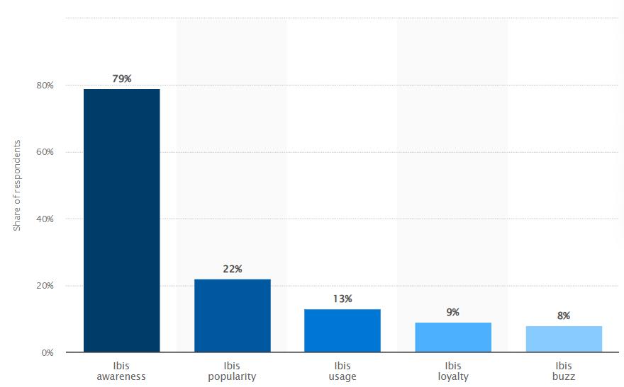
Figure: Ibis brand awareness, usage, popularity, loyalty, and buzz among hotel customers in the UK in 2022
(Source: Statista, 2022)

Aim and Objectives
Aim:
To examine how better customer experience and effective operational activities contribute to the success of budget hotels, with a specific focus on Ibis Hotel Nottingham.
Objectives:
- To evaluate the impact of customer service quality on guest satisfaction and retention in budget hotels.
- To analyse the effectiveness of operational activities such as front desk management, food and beverage services, and housekeeping in enhancing hotel efficiency.
- To identify the key challenges faced by budget hotels in balancing cost-effectiveness with high service standards.
- To recommend strategies for improving customer experience and operational efficiency in budget hotels like Ibis Hotel Nottingham.

Significance of the Study
This research serves practical applications in addition to academic fields because it evaluates budget hotel operational approaches to increase satisfaction and operational performance together with market competitiveness. An analysis of Ibis Hotel Nottingham seeks to detect established budget hotel leadership strategies while identifying their encountered challenges. Hotel managers along with industry professionals may use the research findings to develop methods that enhance service quality and boost staff efficiency and operational workflow (Bharwani and Jauhari, 2017). This investigation enriches academic knowledge within hospitality management by supporting upcoming studies regarding budget hotel service quality enhancement and operational effectiveness. Hoteliers along with policymakers and researchers in hospitality should utilise these recommendations to enhance budget accommodation service standards.

Literature Review
Impact of Customer Service Quality on Guest Satisfaction and Retention in Budget Hotels
Customer service quality is vital for enhancing customer satisfaction as well as retention in the environment of budget hotels because it directly influences customers’ experiences, perceptions and loyalty. According to the perspective of Ali et al. (2021), it can be mentioned that budget hotels mainly compete with luxury hotels on the grounds of service effectiveness and cost structures. It is also identified from the same study that good customer service can increase guest satisfaction and encourage return business along with a positive reputation through word-of-mouth. The same thing is identified in the study of Abdullah et al. (2023), where the researchers mentioned that maintaining a high standard of customer service quality helps companies to get competitive advantages in the market because satisfied customers feel interested in revisiting the hotel. For example, it can be included that prompt check-in and check-out procedures, courteous and accommodating staff, efficient problem-solving approaches and cleanliness are coined as effective customer services that increase guest satisfaction rates in budget hotels.
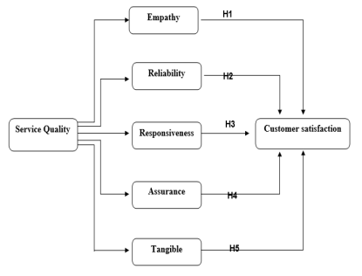
Customer Satisfaction Approaches
(Source: Ali et al. 2021)
On the other hand, based on the perspective of Radwan (2022), it can be argued that despite the lack of luxuries, great service loyalty and trust. In this technologically advanced era, guests' pleasure is further reinforced by digital involvement, which includes rapid responses through online channels. For themselves, service quality or service standards are not considered as encouraging items. With the proper implementation of the GAP Model, companies in the hotel and hospitality sector identify the gap between customer expectations and management practices, service quality specifications, external communication and expected services (Esmalian et al. 2021). With the help of this model, companies try to identify internal gaps between customers’ expectations and organisational offerings to enhance their standards. So, it can be said that service quality impacts customers’ satisfaction levels inside the firm and guides companies to innovate different strategies.

Effectiveness of Operational Activities in Enhancing Hotel Efficiency
According to the research work of Khalil et al. (2024), it has been identified that effective operational efficiency plays an important role in enhancing hotel performance and customer satisfaction. The operational effectiveness of a budget hotel depends upon seamless service delivery, guest satisfaction and cost optimisation. Additionally, as per the perspective of Ali et al. (2021), it is also identified that to deliver an exceptional guest experience, efficient hotel management operations require well-organised front-desk management, proper housekeeping approaches, good quality of food and beverage and overall maintenance. From the same study, it has also been identified that the use of technology, such as automated booking platforms as well as property management systems or PMS, simplifies check-ins and reservations, reducing waiting times and improving convenience. Workforce management, which includes scheduling and staff training, ensures that workers are prepared to satisfy guests’ demands while keeping low-cost structures. As opined by Prakash et al. (2023), it can be mentioned that profitability increases and the waste generation process is avoided in the food and beverage departments of a budget hotel through proper inventory control. Moreover, sustainability initiatives like energy-efficient lighting and water conservation not only lower operational expenses but also attract eco-friendly customers from the market.
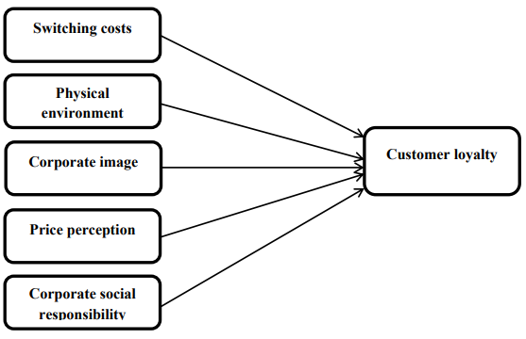
Customer Loyalty Approaches in Budget Hotels
(Source: Radwan, 2022)
Based on the findings of Khalil et al. (2024), it can be said that service interruptions are reduced when departments communicate effectively, which promotes teamwork and prompt problem-solving approaches. From the perspective of the Total Quality Model, organisations can investigate and evaluate their operational excellence in the competitive marketplace. Through different standards like customer focus, data-driven decision-making, employee involvement and continuous improvement, organisations can define their lacks and identify areas for improvement to obtain competitive success (Souza et al. 2022). As per this market situation, it can be said that the initiation of data-driven techniques in customer service management can innovate strategies to attract more customers to enhance the profit generation rates. It is true that upholding hygiene and cleanliness improves hotels’ reputation in the market, but based on the perspective of Kim and Chung (2022), it can be argued that in this digitally advanced time, companies give more focus on digitisation which includes predictive analysis through automation, IoT utilisation to supervise service qualities and analyse customers’ feedback and others. However, it can be deduced that to obtain enhanced hotel efficiency, effective operational efficiency is important in a highly competitive environment.

Challenges Faced by Budget Hotels in Balancing Cost-Effectiveness with High Service Standards
According to the research work of Wang et al. (2024), it can be said that maintaining cost effectiveness while ensuring high service standards is considered as a major issue for budget hotels. These hotels frequently have to reduce their operation expenses because of limited resources, which can affect their employee training programs, service quality enhancement and offering innovative services for enhanced visitor expenses. According to the research work of Kuyken et al. (2022), it can be mentioned that it is challenging for companies to hire and keep qualified employees under stringent wage restrictions, which could result in uneven service delivery. Furthermore, it has also been identified that a careful cost management approach is needed to maintain modern facilities, security and sanitation within a limited operational budget. As opined by Wang et al. (2024), profit margins are further strained by enhancing operating costs, such as utility expenditure and supply costs.in operational areas of the hotel industry, it is identified that in competition with luxury hotels, budget hotels face challenges in maintaining service quality within affordable rates due to the cost rise of associated products. Another vital challenge faced by budget hotels in balancing cost-effectiveness and service standards is the cost-based challenges of implementing high-tech activities in their regular activities like online booking systems, online customer feedback channels and others. Moreover, implementing data-driven approaches and automation in customer services requires a high cost range.

Potential Strategies to Improve Customer Experience and Operational Efficiency in Budget Hotels
To enhance opportunities for companies to get a competitive advantage and enhance customer experience, companies in the hotel and hospitality sector need to focus on innovative strategies by considering different development models. For a better understanding, it can be said that as per Lalmi et al. (2022), the Lean Management Model might be a useful tool for companies to enhance better customer experience and operational effectiveness. The main objective of this theory is to reduce waste with project optimisation and service delivery improvement. Budget hotels can reduce wasteful expenses without sacrificing quality by implementing standardisation approaches compared to their existing competitors. Based on the research work of Bharwani and Mathews (2021), it can also be mentioned that the sector can opt for mobile-based service-providing systems to increase the accessibility of booking data and connectivity with organisations. On the other side, as per the perspective of Hilverda et al. (2023), it can also be mentioned that the implementation of the Continious Improvement Model can bring opportunities for companies in this field because this model helps firms to identify customers’ demands and customise offers as per requirements. As a result, the rate of employee satisfaction increases and making a balance between demands and offers becomes easier. Additionally, with data-driven decision-making, innovative automation for the overall operation and predictive analysis, companies in the hostel and hospitality sector can enhance their customer satisfaction rates accordingly.

Literature Gap
Most researchers focused on the link between customer satisfaction approaches of companies and operational activities through accommodations, sustainability and amenity-based perspectives. As a result, the discussion on technological upgradation and resource-based strategies is neglected. Moreover, most studies identified already happened incidents of existing companies. For critical analysis, it is also important to discuss potential strategies for developing companies, considering their operational challenges. The unavailability of an argument between the positive and negative impacts of effective customer service approaches on organisational performance also limited the study’s effectiveness from the perspective of critical discussion.

Methods
According to the research work of Mishra and Alok (2022), it has been identified that the term Methodology refers to the process of conducting research work by considering several standards and techniques. To understand the role of better customer experience and effective organisational behaviour in a budget hotel, this study used the ‘Case Study’ analysis method here. As per the perspective of Deng et al. (2023), it can be said that Case study refers to the process of analysis and evaluating a specific study by considering case examples and real-life incidents. Moreover, it can be also mentioned that case study analysis refers to the process of analysing specific events and generating themes upon these events to conduct in-depth analysis by comparing and contrasting different perspectives as well as scholarly opinions with real-life incidents. To make the study case-specific, the real-life analysis of Ibis Hotel Nottingham has been considered here.
For in-depth analysis, this study has used different relevant datasets from multiple resources. In the research method, mainly three types of data-gathering processes are followed by researchers, including primary research, secondary research and mixed research. Based on the perspective of Dzwigol (2022), it is found that primary research refers to the process of collecting raw data from fields and analysing them as per research questions. On the other side, the secondary data collection method refers to the process of already analysed and existing datasets from papers of different scholars. By reading and analysing different existing documents like journals, articles, books, online resources, government websites and others, researchers usually collect the secondary data. In this study, the researcher used the secondary data collection technique to gather data. The benefit of using primary research is the availability of unbiased datasets and options for customisations to reach research objectives. For this purpose, the researcher used online libraries, governmental websites, peer-reviewed articles, papers and others. The benefit of using secondary datasets is the reliability of information because these datasets are already examined and analysed by scholars. Moreover, the cost structures of utilising secondary datasets are comparatively lower than primary data analysis. This study also used a thematic data analysis method to identify the role of better customer experience and effective operational activities in a budget hotel. In the thematic data analysis method, researchers develop themes as per research objectives and research questions (Mishra and Alok, 2022). The benefit of using this data analysis method is opportunities to conduct critical analysis and comparative discussion on the selected topic.
Throughout the study, the researcher maintained ethical standards to ensure the academic integrity of the study. The researcher acknowledged former scholars whose papers and works are used in the study. Moreover, to enhance the standard of the study, the researcher avoided plagiarism as well as the use of generative AI in this study. Finally, it can be mentioned that the researcher-maintained data protection norms as per the GDPR guidelines.

Case Study Hotel Overview and Findings

Ibis Hotel Nottingham Overview
Ibis Hotel Nottingham is a member of the Ibis brand owned by Accor Group. The hotel is located in Nottingham, a city in the East Midlands of England. The Ibis brand has more than 1200 hotels around the globe. Ibis Hotel in Nottingham is supported by Nottingham’s enriched history. However, Ibis Nottingham is a smaller branch with around 150 rooms. It focuses on the provision of accommodation with budget-friendly aspects. This can target a number of travellers seeking comfort at an affordable price. The hotel runs a lean operation with a small and efficient team (Accor, 2025).
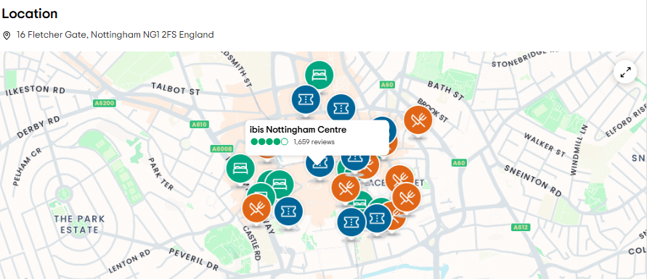
Figure: Ibis Nottingham Centre location
(Source: Tripadvisor, 2025)
The hotel offers a number of services related to housekeeping and dining. The staff handles a set of roles to keep costs at a low level. The model is helpful for the hotel to operate in an efficient way without compromising the quality of service. Turnover for Ibis hotels around the globe is considered a component of the larger Accor group’s earnings. Accor reported an annual revenue of around €4 billion in 2022. Ibis Nottingham utilises Accor’s digital systems including the Accor ALL application. This is helpful for guests to check in online, unlock their room with a mobile-based key, and earn loyalty points.
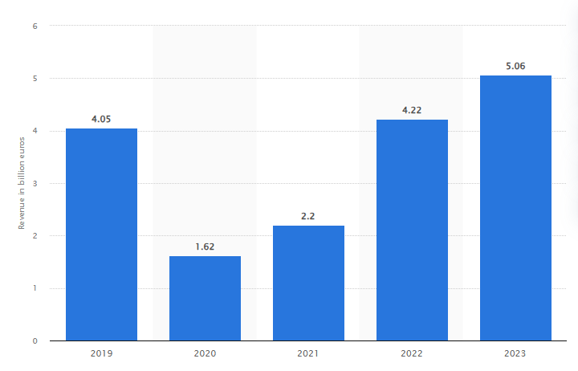
Figure: Revenue of Accor (Parent Company of Ibis Nottingham)
(Source: Statista, 2025)

SWOT Analysis for Ibis Hotel Nottingham
Strengths | Weaknesses
- Situated in the Lace Market area being close to basic requirements  - Within walking distance of the train station and tram shop  - Budget-friendly pricing  - Free Wi-Fi, and discounted and secure parking-related facilities (Tripadvisor, 2025)  - Trustworthy due to falling under Accor | - Limited range of amenities  - Expensive parking  - Unacceptable behaviour of staff reported
Opportunities | Threats
- Benefits from the growth of visitors by more than 4% in Nottingham and Nottinghamshire (Council, 2025)  - Expansion of services by Accor ALL application’s seamless features | - Competition from existing hotel chains in Nottingham  - Influence of economic uncertainty on the demand  - Around 35% fall in demand for hotels in 2020 (RSM, 2025)
Table: SWOT Analysis
(Source: by the learner)
Analysis

Strengths
The hotel is situated in the Lace Market area being close to a number of shops, restaurants, and attractions. The hotel is considered within walking distance of the Nottingham train station and Lace Market tram stop. Ibis is generally popular for offering a number of accommodations with a budget-friendly range of pricing. This attracts a number of travellers sensitive to high prices, students, tourists, and individuals associated with business-related tours. The hotel offers free Wi-Fi in the complete range of rooms along with discounted and secure parking-related facilities for overnight at Lace Market Car Park. The hotel being a part of Accor is helpful in building trust along with encouraging bookings from a set of loyal customers.

Weaknesses
Ibis Nottingham has a limited range of amenities compared to hotels existing in the city due to its focus on budget-based aspects for travellers. Apart from these, the cost of parking has been considered expensive even with validation. Staff’s attitude and behaviours have been criticised by a number of customers. This may take place due to a small range of staff even during peak periods.

Opportunities
Nottingham and Nottinghamshire witnessed around 35 million visitors in 2023 with an increase of more than 4% compared to 2022. Hence, Ibis Nottingham can capitalise on this growth in a seamless way. Ibis’ utilisation of the Accor ALL application is providing opportunities for the hotel to enhance rates of occupancy. The expansion of the services can introduce improvements in the experiences of guests along with reducing operation-related costs.

Threats
The hotel confronts major competition from a number of leisure-focused and budget-focused brands such as Premier Inn and Travelodge respectively. A range of uncertainties in the economy can influence the demand for hotels in a negative way along with tending toward a low level of bookings. For instance, the rates of occupancy in hotels in the UK fell to around 35% in 2020 during COVID-19.

PESTLE Analysis for Ibis Hotel Nottingham

Political
An objective of the UK government to witness around 50 million visitors coming from other nations every year by the end of 2030 has been announced (Department for Culture, 2024). This is a component of its plans to stay as one of the most visited nations around the globe to boost economic growth eventually. Hence, Ibis can obtain benefits from such approaches through the promotion of domestic tourism. The goal is to enhance the rates of occupancy. Modifications in the policies regarding taxation can influence Ibis. For instance, the ‘transient visitor levy’ is applicable to the occupation of accommodation for a shorter period of time in a local authority-based area. A visitor-based levy can help in providing a range of localised costs. The range commences from hosting visitors to assisting additional investment in tourism-related infrastructure.

Economic
Rising inflation in the UK has majorly reduced a disposable form of income for a sizeable number of tourists and travellers. The rate measured by the CPI witnessed a growth of more than 11% in October 2022. The disposable income per household in the UK fell by more than 2% in the FY 2022-23 (Statista, 2025). However, such economic pressure may force a number of individuals toward budget-based accommodations such as Ibis instead of leisure-focused hotels. Ibis can capitalise on this trend by maintaining a competitive range of pricing while offering vital services. Accor’s financial strength is helpful for Ibis Nottingham by being backed during difficult economic circumstances. Operating under a large parent company ensures access to a set of resources such as technology and loyalty-based programs for its served customers.

Social
Trends based on travel afterwards the pandemic witnessed a growth in domestic tourism in a major way. Visits of national tourists in the UK revolved around 38 million. This was more than 20% higher compared to 2022 (Statista, 2025). Ibis can be benefitted due to this along with the individual increment of visitors in Nottingham. Nottingham is considered a potential destination for a number of cultural and sporting-focused events. Events such as the Nottingham Tennis Open and the Robin Hood Festival attract a sizeable number of visitors.

Technological
Ibis utilises Accor’s advanced form of digital tools to be helpful for its guests to book the hotel online along with managing the bookings. Accor's complete range of applications caused around 20% of its booking-related revenues in a direct way (O’Neill, 2024). Ibis hotels have adopted a range of systems based on an efficient approach to utilising energy. Hence, Ibis Nottingham can save potential energy through lighting and heating in an automated way in case implemented.

Legal
The UK government introduced an excessively strict form of protocol regarding health and safety afterwards the outbreak of the pandemic. Ibis Nottingham aligns with these regulations by including cleaning on a regular basis, enhanced ventilation of the room, and a set of hygiene-based stations. The compliance can ensure the safety of guests along with preventing a number of legal issues in the future. Ibis Nottingham follows the UK’s National Minimum Wage (NMW) and a fair circumstance of working for its staff. The minimum wage for staff at the Ibis Nottingham Centre is around £12.49 per hour. This is more than mentioned in the regulations of the NMW (GOV.UK, 2025).

Environmental
Accor Group implemented ALLSAFE in Ibis Nottingham. The goal is to provide a label related to hygiene and cleanliness to guarantee guests’ satisfaction. Ibis is included in Accor’s 93% of hotels to reduce the consumption of water and energy associated with “Planet 21”. Accor has committed to achieving net carbon zero by the end of 2050. Ibis Nottingham can benefit from this strategic approach in the long term through the implementation of a number of technologies with a low level of carbon-related emissions and eco-friendly materials. More than 70% of tourists around the globe are prone to choose hotels with a prioritisation of sustainability (Roiback, 2025).

Comparison with Competitor Hotels Based on Price and Quality Utilising Strategic Group Analysis
Hotel | Price | Quality | Amenities
Ibis Hotel Nottingham | Medium - £50 to £90 | Moderate - Standard and budge-friendly rooms with a modern and basic approach | - Free Wi-Fi  - Reception available for 24 hours  - On-site bar  and breakfast and 24h fast food available(pizza, macaroni and toast);
Premier Inn Nottingham City Centre (Chapel Bar) | Higher - £65 to £200 (KAYAK, 2025) | High - Comparatively large rooms with comfortable beds and slightly enhanced design | - Free Wi-Fi  - On-site restaurant  - Reception available for 24 hours (KAYAK, 2025)
Travelodge Nottingham Central | Lower - £30 to £80 (KAYAK, 2025) | Low to moderate - Basic budget-friendly rooms with a slightly older approach to existing decors | - Free Wi-Fi with a limit of 30 minutes and unlimited with a fee  - On-site restaurant
Table: Comparison with other hotels
(Source: by the learner)
Analysis
Ibis Hotel Nottingham is situated in the midrange as a budget-focused entity. This offers a balance between affordability and a modern set of vital amenities. These include free WiFi, a reception available for 24 hours, and an on-site bar with breakfast. In comparison, Premier Inn Nottingham City Centre (Chapel Bar) charges an excessively high price. However, this justifies a number of larger rooms, comfortable beds, and an on-site restaurant.
Travelodge Nottingham Central is the most budget-friendly option. This caters to travellers with a basic set of rooms, an older style of décor, and a limited time of free Wi-Fi. This is executed with attention to a number of budget-focused travellers associated with spending-related expenses at a minimum. Ibis is on the verge of dominating the existing market by offering a modern and budget-friendly set of stays with a reception for 24 hours and a convenient form of options for dining. However, it lacks rooms with a larger size and premium bedding such as the ones in Premier Inn. Travelodge is considered cheaper among those all. However, free Wi-Fi for a limited time and outdated rooms may not appeal to individuals seeking a consistent form of connectivity and a set of modern comforts.
Netnography
This is considered a research-based method of studying communities and conversations available online related to a specific business entity. Analysis of datasets from social media, forums, and blogs is executed to grasp perceptions, opinions, and behaviours of consumers towards that company (Kozinets and Gretzel, 2023).
Reflective Account
Observing as well as analyzing various operations of budget hotels, particularly Ibis Hotel Nottingham, has mainly provided me with a high level of deep understanding of how these establishments balance cost and the level of efficiency with guest satisfaction. Budget hotels operate in a highly competitive environment where there is operational efficiency as well as a customer experience determining success. During my professional revel in the hospitality quarter, I actually observed that at the same time as price variety inns like Ibis Nottingham's awareness of affordability, they should additionally make certain that visitors feel cushy, welcomed, and valued. One of the most important elements of my declaration was the emphasis on streamlined operations—from virtual take-a-look-in kiosks reducing wait instances on the front table to the housekeeping body of workers retaining excessive cleanliness standards regardless of getting limited property. The integration of technology in visitor interactions has considerably advanced performance, however, it additionally offers a project: the decreased human detail in customer support. While self-provider kiosks permit visitors to check in inside minutes, some website site visitors, in particular individuals who feel private interaction, might experience the experience lack of warmth. Additionally, within the route of my visits and expert observations, I found that the small room sizes and confined in-residence offerings are common exchange-offs for affordability. This turned into specifically evident even as compared to competition like Premier Inn and Holiday Inn Express, which offer barely huge rooms and more potent centres however at a better rate. Another key commentary is that while the house obligations and meals & beverage services are optimized for efficiency, there are occasional provider delays for the duration of height hours due to the motel's lean staffing model. However, Ibis Nottingham's strategic location and determination to cleanliness and standardization assist offset those boundaries. In phrases of competitive positioning, price vs. Fine is a prime issue in vacationer choice-making, and Ibis balances this well with the aid of imparting ordinary services at reasonable charges.
Throughout my professional journey, I have gained some of the valuable skills as well as experiences that have shaped my growth and development. One of the most significant skills actually which gained powerful time management, which has been important in balancing multiple tasks and meeting time limits. In unique, running on initiatives inclusive of growing strategic advertising plans for Ryvita and conducting studies on leadership patterns for Coca-Cola has stronger my ability to prioritize responsibilities and allocate assets successfully. Additionally, I actually have improved my interpersonal skills by taking part with diverse teams, especially even as running on community engagement projects in regions just like the Northern Quarter in Manchester. These experiences have helped me broaden better communication and teamwork competencies, permitting me to navigate special personalities and work patterns to achieve shared dreams. Furthermore, I have learned the importance of critical thinking and flexibility, especially in dynamic environments like the startup assignment for Digi Bottles and the studies paper on microneedling with PRP.

Netnography of Ibis Nottingham Centre Based on Customer Experience and Operational Activities
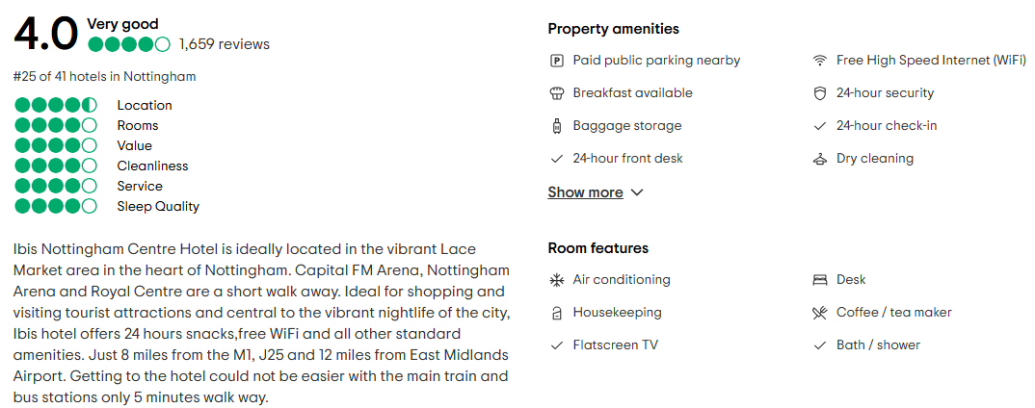
Figure: Overall Review of Ibis Hotel Nottingham
(Source: Tripadvisor, 2025)
Ibis Nottingham Centre has a 4.0/5 rating from 1659 individuals. However, it ranks 25 out of 41 hotels in Nottingham. The hotel offers free WiFi, reception available for 24 hours, snacks, and parking in public. A set of small upgrades could enhance the level of comfort. Additionally, options for parking could be improved. Focusing on cleanliness and quality of service by highlighting its central location and services could be helpful in boosting the satisfaction of guests and rankings eventually.
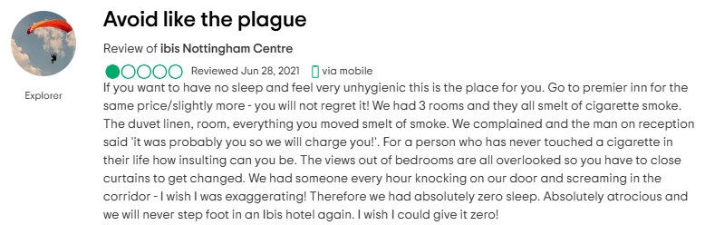
Figure: Negative Customer Experience
(Source: Tripadvisor, 2025)
The review highlights a number of major issues with Ibis Nottingham Centre. The guest complained about smoke from cigarettes in the room and a disruption of noise throughout the night. Hence, the customer-related service can be considered poor. Apart from these, the dismissive form of response of the staff at reception to the complaint worsened the experience. A range of concerns regarding privacy were raised. Hence, Ibis must strengthen its existing protocols regarding cleaning, services for customers, and improvements in controlling noise.
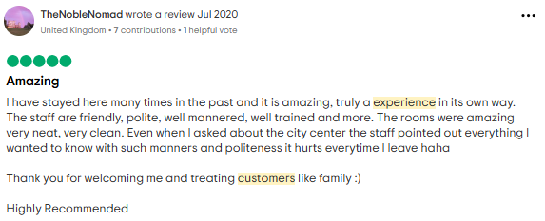
Figure: Positive Customer Experience and Effective Operational Activities
(Source: Tripadvisor, 2025)
The review showcases a positive experience at the hotel by the guest. The individual commented on the friendly, polite, and trained staff. Helpfulness with the information regarding the city centre was noted. The clean rooms were additionally appreciated. Expressing the feeling of being valued and welcomed in a proper form was highlighted. These, as a whole, enhanced the stay of the individual at the hotel.

Discussion
As per the literature review of this study, it has been identified that maintaining effective customer service quality is essential for budget hotels to gain competitive advantages in the marketplace. For this purpose, companies in this detector offer several benefits, including standardised accommodations with budget-friendly cost structures, which can enhance customer satisfaction rates. As a result, customers' interest in revisiting these hotels increased significantly. The same thing is identified in the operation of Ibis Hotel because it provides good accommodations, free Wi-Fi facilities, car parking benefits, attractive amenities and others to attract customers. Moreover, the company tries to provide its offers and services in cheaper price ranges (Tripadvisor, 2025). So, based on these identifications, it can be discussed that effective customer engagement strategies with updated services might increase the reputation of a firm in the budget hotel sector. It has also been identified that due to the rapid growth of competition in the hospitality sector, sustaining becomes difficult for companies. The same voice is identified in the case study of Ibis Hotel. The presence of Accord Hotel, Premier Inn and other luxury hotels providing advanced amenities to customers within a cheaper budget becomes challenging for the company (RSM, 2025). So, it can be discussed that after having opportunities to attract all kinds of customers by providing cost-friendly approaches, budget hotels face issues in the market to compete with others.
The analysis of Ibis Hotel Nottingham’s operational model and also its competitive position within the budget hotel market has mainly yielded some crucial insights into the hotel’s performance. The particular findings from the SWOT and PESTLE frameworks, coupled with unique research, offer an in-intensity view of the internal and outside elements that shape the inn’s operations (Tan et al., 2021). Situated in the Lace Market vicinity of Nottingham, a part of the global Ibis logo under Accor, the lodge has located itself as a cheap and accessible alternative for quite some guests. This talk significantly translates the study’s findings, addressing the number one research goals, exploring the results of those findings, acknowledging obstacles, and declaring regions essential to the resort's operational enhancement.
The main objective of this particular research was to mainly understand some of the operational dynamics of Ibis-specific Hotel Nottingham and also its position within that the highly competitive price range hospitality zone. The research aimed to have a look at the motel's inner strengths and weaknesses, discover outside possibilities and threats, and evaluate how those factors affect its marketplace status. The research questions riding this look at have been targeted at identifying the resort's competitive advantages, recognizing areas that have an effect on guest pleasure, data opportunities for boom, and figuring out out-of-door threats that would in all likelihood disrupt its operations. These questions guided the research process, with the aim of presenting actionable insights that would assist in refining the motel's techniques.
The evaluation highlighted numerous key strengths of Ibis Hotel Nottingham that contribute appreciably to its marketplace positioning. One of the maximum critical strengths of the inn is its place within the Lace Market location, which is a high spot inside Nottingham. This important vicinity offers easy right of entry to several factors of hobbies, at the side of cultural landmarks and transport hubs including the teach station and tram stops (Izadi et al., 2021). The accessibility and comfort supplied with the aid of the resort's location make it an appealing choice for both business employers and leisure tourists. The inn's strategic placement in a bustling area lets it cater to a big kind of traffic, as a consequence enhancing its attraction. Additionally, the lodge's pricing approach, which makes a speciality of offering lower-priced accommodation, performs a vital feature in attracting a substantial customer base, particularly university students, tourists, and enterprise tourists who're searching out charge-effective answers.
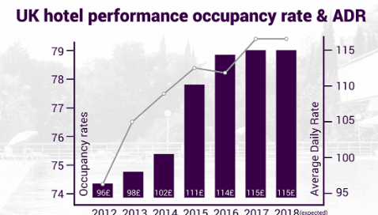
Figure 1: Hotel industry growth in the UK
(Source: plan radar, 2021)
The Ibis Hotel’s value proposition is also very much further strengthened by its various affiliations with Accor, which is a globally recognized brand within the hospitality industry. Being part of the Accor employer lends credibility to Ibis Nottingham, which instils recall and self-assurance in clients. The hotel benefits from the installation brand reputation, which helps in driving bookings and attracting new clients. Moreover, the loyalty program provided through the Accor ALL app performs a huge feature in patron retention. By supplying rewards and customized benefits, the app encourages repeat bookings, developing a robust courting among the hotel and its visitors (Arbelo et al., 2021). The digital infrastructure provided through Accor enhances overall customer enjoyment, bearing in mind streamlined check-ins, keyless room access, and unique technological advantages that meet the desires of modern-day vacationers.
Despite the one’s strengths, the research additionally identified several weaknesses that save the resort's ordinary performance. One top-notch difficulty is the restrained variety of centres available to traffic. While the motel keeps a focal point on providing essential offerings, such as free Wi-Fi and discounted parking, it lacks additional facilities that many visitors assume, which include a fitness centre, spa, or a greater numerous ingesting experience. The absence of those offerings should probably deter clients who are looking for a more complete variety of offerings whilst reserving a life. Guests’ privy to a greater variety of offerings at competing lodges may also additionally view the shortage of these amenities as a disadvantage, in particular, if they're searching out more high-priced or numerous stays.
Another significant weakness identified within Thai particular research is the high cost of parking at the Lace Market Car Par, regardless of validation. Nottingham's town centre is known for its limited parking alternatives, which may make it tough for visitors to discover alternative answers. The value of parking is considered a key element within the selection-making method for capability clients, and plenty expressed worries about the extra prices (Franzoni et al., 2021). This might also need to cause a notion of terrible fees for coins, specifically for site visitors who anticipate getting hold greater for the charge they will be paying. Given the resort's recognition of providing less expensive motels, the immoderate parking fees may additionally negatively impact the lodge's recognition and tourist satisfaction.
Additionally, the research exposed concerns concerning staff conduct, with a few visitors reporting unacceptable interactions with motel personnel. These terrible encounters may harm the lodge's popularity and purchaser loyalty, as traveller satisfaction is regularly carefully tied to the awesomeness of the provider obtained. It is plain that there is a need for better training and improved management practices to make certain that each one of the visitors has a nice time. Issues associated with customer support are especially vital in the hospitality place, wherein personal interactions with personnel can notably affect the overall guest enjoyment. Failing to address the one's issues may result in the inn losing clients to the opposition who offer greater regular and professional service.
In terms of the various opportunities, the research reveals some of the several areas in which Ibis particularly Hotel Nottingham should increase its services and enhance its market status. One of the most significant opportunities is the growing quantity of site visitors to Nottingham. The metropolis has seen a four% increase in tourism in 2023, which gives a clear possibility for the resort to grow its occupancy charges (Prakash et al., 2021). Nottingham's appeal as a cultural and sporting excursion spot, with occasions like the Nottingham Tennis Open and the Robin Hood Festival attracting domestic and international visitors, manner that the hotel can tap properly into a developing market of travellers. With an increase in each amusement and business tour, the inn can benefit from this upward push in call for through in addition to advertising itself as a low-cost, available, and nicely-positioned alternative for site visitors.
In addition, the increasing adoption of digital tools in the hospitality industry presents various opportunities for Ibis Nottingham to mainly enhance its service offerings. The inn's use of the Accor ALL app for test-ins and loyalty application management is already a step within the proper path. However, there's a similar development of the app's capability to decorate. For instance, the app may be prolonged to offer precise deals or customized services, together with restaurant reservations or guidelines for local sights. These kinds of services ought to make the hotel greater attractive to tech-savvy customers who rate comfort and personalization. Additionally, leveraging virtual equipment to streamline operations and beautify performance can assist reduce operational expenses and boom profitability, which is particularly crucial in a price-range motel setting.
Despite these possibilities, the studies also highlight several outside threats that might affect the resort's long-term sustainability. One of the maximum good-sized threats is the growing opposition from different finance motel chains, which encompass Premier Inn and Travelodge. These competitions provide similar pricing strategies however often offer a broader variety of services, in conjunction with breakfast alternatives and huge on-net site centres (Sarwar et al., 2021). This opposition intensifies the pressure on Ibis Nottingham to differentiate itself in a crowded market. While the motel’s region and pricing provide some gain, the presence of sturdy competition means that the hotel needs to continuously innovate and improve its services to live in advance of the opposition.
In addition to that of the various competitions, economic uncertainties pose some of the significant threats to the actual hotel’s profitability. The UK monetary machine has been experiencing inflationary pressures, which has triggered a decrease in disposable income for plenty of consumers. These financial surroundings make charge-touchy customers more careful in their spending, most importantly to enable discounts in name for resort bookings (Pereira et al., 2021). During times of monetary downturn or financial instability, discretionary spending on enjoyment excursions tends to say no, and budget motels like Ibis may be impacted with the aid of those shifts in consumer behaviour. While lower-priced lodging remains in name, the fluctuating economic device could result in a decline in bookings, in particular during intervals of low client self-perception.
Acknowledging the regulations of the studies is vital in informing the scope and applicability of the findings. While the evaluation of Ibis Hotel Nottingham offers valuable insights, the studies are based on secondary records sources, inclusive of publicly available statistics and purchaser opinions. These facts may not fully capture the complexities of the hotel's inner operations or the general variety of guest reports. Furthermore, external elements collectively with changes in neighbourhood policies or unexpected economic shifts have been now not accounted for in the studies (Al-Sabi et al., 2021). To gain an extra comprehensive expertise of the resort's performance, future studies should contain direct interviews with hotel personnel, manipulation, and a larger sample of guests to provide deeper insights into the inner workings of the hotel.

Conclusion and Recommendations
The research identifies operational efficiency together with exceptional customer experience as vital elements for budget hotel success through the example of Ibis Hotel Nottingham. Budget hotels must balance excellent service quality against cost efficiency to meet their operational demands. The factors which shape customer satisfaction mainly involve effective processes during check-in and check-out and staff behaviour alongside meal services and digital connectivity. Operational drive originates from well-organised workforce management alongside technology utilisation and sustainable operational practices.
Guest retention rates heavily depend on hotel service quality according to research findings which provide competitive advantages to establishments that merge operational excellence with personalised guest experiences. The efficiency of budget hotels faces challenges stemming from cost limitations together with employee shortages and various consistency issues in service delivery.
Hotels need to apply strategic workforce planning and technology integration with improved service training together with sustainable practices as solutions for these challenges. Ibis Hotel Nottingham can establish superior communication with guests combined with better operational performance and a steadfast market position through the implementation of these suggestions. Through this study academic institutions and the hotel industry connect better to optimise budget hotel operations by demonstrating the requirement for continuous advancement and innovative service approaches.

Recommendations and Practical Strategies

Enhancing Staff Training and Multitasking Efficiency
The main research conclusion reveals that properly trained workers establish both higher operational performance and superior customer satisfaction. Ibis Hotel Nottingham should establish concrete training curricula which develop capabilities for customer interaction while addressing problem situations and handling multiple tasks simultaneously. The staff should receive training that prepares them to perform tasks from front desk operations to bar service and food preparation to maintain peak operation flow (Dalkhjav et al., 2024). Staff members should cycle through different operational areas under a training system which enhances their expertise across various roles. By implementing such a system the staff becomes more flexible which leads to decreased dependence on one workforce sector while enhancing overall productivity. A comprehensive training program should include training to enhance employee abilities in interacting with guests because this will create a welcoming and more hospitable environment.

Leveraging Technology for Operational Efficiency
The digital transformation works as a primary driver for operational efficiency enhancement. Each operational process of Ibis Hotel Nottingham can achieve greater efficiency through expanded self-service technology implementation. Implementing mobile check-ins and automated payment systems together with AI-derived chatbots for customer service lowers front desk staff duties so they can assist with challenging guest requirements (Hussein et al., 2024). The hotel should leverage Property Management Systems (PMS) at maximum capability for achieving smooth operational connections between front desk services and housekeeping and reservations tasks. Property Management Systems enabled real-time monitoring of rooms and automated inventory management as well as predictive alerts for maintenance incidents which ensure hotel services remain uninterrupted.

Improving Food and Beverage Service Quality
Food and beverages maintain essential functions in maintaining budget hotel guest satisfaction levels. Ibis Hotel Nottingham should widen the variety of its breakfast options while improving snacks to serve different dietary needs. To enhance guest satisfaction the hotel should offer pre-made food items during busy times and let guests serve themselves using multiple methods for faster service delivery (Mahafzah et al., 2020). Onyx City should spend their money on environmentally responsible packaging together with sustainable ingredient acquisition because these measures will strengthen its brand and meet its guests' requirements for green hospitality services.

Implementing a Customer Feedback and Engagement System
Ibis Hotels needs customer feedback to enhance their ongoing improvement processes. Ibis Hotel Nottingham should introduce a live feedback technology which enables guests to provide ratings directly following their arrival and during their stay including their departure process. The collected data needs to be examined on a regular basis to discover which operational areas require enhancements (Rather and Sharma, 2017). All staff require training to interact with hotel guests as well as immediate resolution of their concerns. The hotel’s status and guest loyalty will improve because of professional online review responses and guest feedback encouragement.

Strengthening Workforce Planning and Employee Well-being
The delivery of high-quality services requires workforce motivation alongside employee satisfaction as a fundamental element. Budget hotels constantly confront employee retention difficulties because their workers experience elevated workload demands and insufficient pay (He et al., 2019). Flexible shift arrangements at Ibis Hotel Nottingham should be implemented to help prevent work-related burnout among their personnel. The Accor Group should develop employee recognition systems that facilitate career advancement because they both build staff dedication and minimise staff turnover. Training staff in mental health support and introducing stress management programs will enable employees to handle intense workplace conditions which results in better service delivery and staff contentment.

Enhancing Sustainable and Cost-effective Practices
The hospitality sector identifies sustainability as a fundamental priority that continues to rise in significance. To achieve better energy efficiency Ibis Hotel Nottingham must adopt smart lighting technology along with automated temperature systems and water-saving programs. The combination of cost-saving operational methods with eco-friendly features attracts environmentally mindful guests (Prakash et al., 2023). The hotel should enhance waste management through improved efficiency in food waste reduction and by increasing the use of recyclables. Cooperating with sustainability-oriented suppliers in the hotel’s local area helps the hotel develop its corporate social responsibility (CSR) profile.

Reference list
Tan, Y. and Despotism, D., 2021. Investigation of efficiency in the UK hotel industry: A network data envelopment analysis approach. International Journal of Contemporary Hospitality Management, 33(3), pp.1080-1104. (Accessed: 24.05. 2025).
Izadi, J., Froude, P. and Nazarian, A., 2021. Into the unknown: Impact of Coronavirus on UK hotel stock performance. European Journal of International Management. (Accessed:24.052025).
Arbelo, A., Arbelo-Pérez, M. and Pérez-Gómez, P., 2021. Heterogeneity of resources and performance in the hotel industry. Journal of Hospitality & Tourism Research, 45(1), pp.68-89. (Accessed: 24.05.2025).
Franzoni, S., Sarwar, H. and Ishaq, M.I., 2021. The Mediating Role of HRM in the Relationship between CSR and Performance in the Hospitality Industry. Sustainability, 13(24), p.13699. (Accessed: 24.05.2025).
Prakash, S., Sharma, V.P., Singh, R. and Vijayvargiya, L., 2023. Adopting green and sustainable practices in the hotel industry operations-an analysis of critical performance indicators for improved environmental quality. Management of Environmental Quality: An International Journal, 34(4), pp.1057-1076. (Accessed: 24.05.2025).
Sarwar, H., Ishaq, M.I. and Franzoni, S., 2024. Influence of HRM on CSR and performance of upscale hotels in developed and developing countries. Environment, Development and Sustainability, 26(1), pp.335-357. (Accessed: 24.05.2025).
Al-Sabi, S.M., Al-Ababneh, M.M., Masada, M.A. and Elshaer, I.A., 2023. Enhancing innovation performance in the hotel industry: the role of employee empowerment and quality management practices. Administrative Sciences, 13(3), p.66. (Accessed: 24.05.2025).
Pereira-Moliner, J., López-Gamero, M.D., Molina-Azurin, J.F., Tari, J.J. and Petrosa-Ortega, E.M., 2021. Sustainability, competitive advantages and performance in the hotel industry: A synergistic relationship. (Accessed: 24.05.2025).
Marfo, M., ARMAH, A.A., Ofri, E.F., Ofri, E.B., Adadevoh, L. and Asante, C.R., 2024. The Influence of Green Innovations on the Environmental Performance of the Hotel Industry in Ghana: Does the Moderating Role of Green Transformational Leadership Matter? International Journal, 5(11), pp.1562-1578. (Accessed: 24.05.2025).
Environmental performance in the hotel industry. Frontiers in Environmental Science, 10, p.841205. (Accessed: 24.05.2025).
Planradar (2021) https://www.planradar.com/uk-hospitality-industry-growth/ (Accessed: 24.05.2025).
Bharwani, S. and Jauhari, V., 2017. An exploratory study of competencies required to cocreate memorable customer experiences in the hospitality industry. In Hospitality marketing and consumer behavior, pp. 159-185. (Accessed: 25.05.2025).
Accor, 2025. Ibis Nottingham Centre. Available at https://all.accor.com/hotel/6160/index.en.html:
Council, N. C., 2025. Tourism in Nottingham & Nottinghamshire demonstrates impressive growth at £2.36 billion, Nottinghamshire County Council Newsroom. Available at: https://www.nottinghamshire.gov.uk/newsroom/news/tourism-in-nottingham-nottinghamshire-demonstrates-impressive-growth-at-236-billion#:~:text=In%202023%2C%20Nottingham%20and%20Nottinghamshire,68.94%20economic%20impact%20per%20trip (Accessed: 25.05.2025).
Dalkhjav, B., Munkhuu, B. and Sukhragchaa, A.S., 2024. Enhancing job performance in the hospitality sector: exploring the role of employee engagement, multitasking, organizational culture, and recruiting practices. Journal of Tourism, Sustainability and Well-being, 12(2), pp.188-205. (Accessed: 25.05.2025).
Department for Culture, 2024. New ambition for 50 million annual visits to UK announced by Tourism Minister, GOV.UK. GOV.UK. Available at: https://www.gov.uk/government/news/new-ambition-for-50-million-annual-visits-to-uk-announced-by-tourism-minister#:~:text=A%20new%20ambition%20for%20the,visited%20worldwide%2C%20driving%20economic%20growth (Accessed: 25.05.2025).
GOV.UK, 2025. National Living Wage to increase to £12.21 in April 2025. Available at: https://www.gov.uk/government/news/national-living-wage-to-increase-to-1221-in-april-2025 (Accessed: 25.05.2025).
He, J., Morrison, A.M. and Zhang, H., 2019. Improving millennial employee well-being and task performance in the hospitality industry: The interactive effects of HRM and responsible leadership. Sustainability, 11(16), p.4410. (Accessed: 25.05.2025).
Hussein, H., Albadry, O.M., Mathew, V., Al-Romeedy, B.S., Alsetoohy, O., Abou Kamar, M. and Khairy, H.A., 2024. Digital leadership and sustainable competitive advantage: leveraging green absorptive capability and eco-innovation in tourism and hospitality businesses. Sustainability, 16(13), p.5371. (Accessed: 25.05.2025).
Ibis, 2025. World Cheap Hotels in Nottingham_ibis Hotels. Available at: https://ibis.accor.com/en/destination/city/hotels-nottingham-v2858.html (Accessed: 25.05.2025).
KAYAK, 2025. Premier Inn Nottingham City (Chapel Bar) from $64. Available at: https://www.kayak.com/Nottingham-Hotels-Premier-Inn-Nottingham-City-Chapel-Bar-.2385145.ksp (Accessed: 25.05.2025).
KAYAK, 2025. Travelodge Nottingham Central from $31. Available at: https://www.kayak.com/Nottingham-Hotels-Travelodge-Nottingham-Central.137184.ksp (Accessed: 25.05.2025).
Kozinets, R.V. and Gretzel, U., 2023. Qualitative social media methods: Netnography in the age of technocultures. The Sage handbook of qualitative research, pp.403-420. (Accessed: 25.05.2025).
Mahafzah, A.G., Aljawarneh, N.M., Alomari, K.A.K., Altahat, S. and Alomari, Z.S., 2020. Impact of customer relationship management on food and beverage service quality: The mediating role of employees satisfaction. Humanities & Social Sciences Reviews, 8(2), pp.222-230. (Accessed: 25.05.2025).
O’Neill, S., 2024. Accor’s Top Digital Exec Reveals Data on Its Hotel Tech Game, Skift. Available at: https://skift.com/2023/07/10/accors-top-digital-exec-reveals-data-on-its-hotel-tech-game/ (Accessed: 5 February 2025). (Accessed: 25.05.2025).
Prakash, S., Sharma, V.P., Singh, R. and Vijayvargy, L., 2023. Adopting green and sustainable practices in the hotel industry operations-an analysis of critical performance indicators for improved environmental quality. Management of Environmental Quality: An International Journal, 34(4), pp.1057-1076. (Accessed: 25.05.2025).
Rahimi, R. and Kozak, M., 2017. Impact of customer relationship management on customer satisfaction: The case of a budget hotel chain. Journal of travel & tourism marketing, 34(1), pp.40-51. (Accessed: 26.05.2025).
Rather, R.A. and Sharma, J., 2017. Customer engagement for evaluating customer relationships in hotel industry. European Journal of Tourism, Hospitality and Recreation, 8(1), pp.1-13. (Accessed: 26.05.2025).
Roiback. 2025. The growth of sustainability in hotels: An industry in transformation. Discover your potential. Available at: https://en.roiback.com/rb-academy/the-growth-of-sustainability-in-hotels#:~:text=According%20to%20the%20World%20Tourism,transformation%20in%20the%20hotel%20industry. (Accessed: 26.05.2025).
RSM, 2025. Hotel sector makes astonishing recovery four years on from first Covid lockdown. Available at: https://www.rsmuk.com/insights/hotels-tracker/hotel-sector-makes-astonishing-recovery-four-years-on-from-first-covid-lockdown (Accessed: 26.05.2025).
Statista, 2022. Ibis brand awareness, usage, popularity, loyalty, and buzz among hotel customers in the UK in 2022. Available at: https://www.statista.com/forecasts/1335566/ibis-hotels-brand-profile-in-the-uk (Accessed: 26.05.2025).
Statista, 2025. Cost of living crisis in the UK - Statistics & Facts. Available at: https://www.statista.com/topics/9121/cost-of-living-crisis-uk/
Statista, 2025. Revenue of Accor worldwide from 2019 to 2023. Available at: https://www.statista.com/statistics/266261/revenue-of-the-accor-group/#:~:text=French%20hotel%20company%20Accor%20generated,year%20ends%20on%20December%2031st (Accessed: 27.05.2025).
Statista, 2025. Travel and tourism in the United Kingdom - statistics & facts. Available at: https://www.statista.com/topics/3269/travel-and-tourism-in-the-united-kingdom-uk/(Accessed: 27.05.2025).
Tripadvisor, 2025. Amazing. Available at: https://www.tripadvisor.co.uk/ShowUserReviews-g186356-d729350-r761441507-Ibis_Nottingham_Centre-Nottingham_Nottinghamshire_England.html (Accessed: 27.05.2025).
Tripadvisor, 2025. Avoid like the plague. Available at: https://www.tripadvisor.com/ShowUserReviews-g186356-d729350-r794612838-Ibis_Nottingham_Centre-Nottingham_Nottinghamshire_England.html(Accessed: 27.05.2025).
Tripadvisor, 2025. Ibis Nottingham Centre. Available at: https://www.tripadvisor.co.uk/Hotel_Review-g186356-d729350-Reviews-Ibis_Nottingham_Centre-Nottingham_Nottinghamshire_England.html#REVIEWS (Accessed: 27.05.2025).
Truong, N., Dang-Pham, D., McClelland, R. and Nkhoma, M., 2020. Exploring the impact of innovativeness of hospitality service operation on customer satisfaction. Operations and Supply Chain Management: An International Journal, 13(3), pp.307-319. (Accessed: 27.05.2025).
Ali, B.J., Gardi, B., Othman, B.J., Ahmed, S.A., Ismael, N.B., Hamza, P.A., Aziz, H.M., Sabir, B.Y., Sorguli, S. and Anwar, G., 2021. Hotel service quality: The impact of service quality on customer satisfaction in hospitality. International Journal of Engineering, Business and Management, 5(3), pp.14-28. (Accessed: 27.05.2025).
Abdullah, O., Sufi, T. and Kumar, S., 2023. Impact of Food and Beverage Quality and Service Quality Towards Customer Satisfaction and Customer Retention, A Study of Five-Star Hotels. International Journal of Professional Business Review: Int. J. Prof. Bus. Rev., 8(5), p.98. (Accessed: 27.05.2025).
Radwan, H.R.I., 2022. A Study on the Factors Contributing to Customer Loyalty in Budget Hotels in Cairo and Alexandria, Egypt. African Journal of Hospitality, Tourism and Leisure, 11(1), pp.26-45. (Accessed: 27.05.2025).
Esmalian, A., Dong, S., Coleman, N. and Mostafavi, A., 2021. Determinants of risk disparity due to infrastructure service losses in disasters: a household service gap model. Risk analysis, 41(12), pp.2336-2355. (Accessed: 27.05.2025).
Khalil, N., Che Abdullah, S.N., Haron, S.N. and Hamid, M.Y., 2024. A review of green practices and initiatives from stakeholder’s perspectives towards sustainable hotel operations and performance impact. Journal of Facilities Management, 22(4), pp.653-682. (Accessed: 27.05.2025).
Prakash, S., Sharma, V.P., Singh, R. and Vijayvargy, L., 2023. Adopting green and sustainable practices in the hotel industry operations-an analysis of critical performance indicators for improved environmental quality. Management of Environmental Quality: An International Journal, 34(4), pp.1057-1076. (Accessed: 27.05.2025).
Souza, F.F.D., Corsi, A., Pagani, R.N., Balbinotti, G. and Kovaleski, J.L., 2022. Total quality management 4.0: adapting quality management to Industry 4.0. The TQM journal, 34(4), pp.749-769. (Accessed: 27.05.2025).
Kim, C. and Chung, K., 2022. Measuring customer satisfaction and hotel efficiency analysis: An approach based on data envelopment analysis. Cornell Hospitality Quarterly, 63(2), pp.257-266. (Accessed: 27.05.2025).
Wang, Z., Chen, H., Luo, J., Wang, C., Xu, X. and Zhou, Y., 2024. Sharing service in healthcare systems: A recent survey. Omega, 129, p.103158. (Accessed: 27.05.2025).
Kuyken, W., Ball, S., Crane, C., Ganguli, P., Jones, B., Montero-Marin, J., Nuthall, E., Raja, A., Taylor, L., Tudor, K. and Viner, R.M., 2022. Effectiveness and cost-effectiveness of universal school-based mindfulness training compared with normal school provision in reducing risk of mental health problems and promoting well-being in adolescence: the MYRIAD cluster randomised controlled trial. BMJ Ment Health, 25(3), pp.99-109. (Accessed: 27.05.2025).
Lalmi, A., Fernandes, G. and Boudemagh, S.S., 2022. Synergy between Traditional, Agile and Lean management approaches in construction projects: bibliometric analysis. Procedia Computer Science, 196, pp.732-739. (Accessed: 27.05.2025).
Bharwani, S. and Mathews, D., 2021. Techno-business strategies for enhancing guest experience in luxury hotels: a managerial perspective. Worldwide Hospitality and Tourism Themes, 13(2), pp.168-185. (Accessed: 27.05.2025).
Hilverda, J.J., Roemeling, O., Smailhodzic, E., Aij, K.H., Hage, E. and Fakha, A., 2023. Unveiling the Impact of Lean Leadership on Continuous Improvement Maturity: A Scoping Review. Journal of healthcare leadership, pp.241-257. (Accessed: 28.05.2025).
Mishra, S.B. and Alok, S., 2022. Handbook of research methodology. (Accessed: 27.05.2025).
Dzwigol, H., 2022. Research methodology in management science: Triangulation. Virtual Economics, 5(1), pp.78-93. (Accessed: 28.05.2025).
Deng, X., Bashlovkina, V., Han, F., Baumgartner, S. and Bendersky, M., 2023, April. What do llms know about financial markets? a case study on reddit market sentiment analysis. In Companion Proceedings of the ACM Web Conference 2023 (pp. 107-110). (Accessed: 28.05.2025).
Radwan, H.R.I., 2022. A Study on the Factors Contributing to Customer Loyalty in Budget Hotels in Cairo and Alexandria, Egypt. African Journal of Hospitality, Tourism and Leisure, 11(1), pp.26-45. (Accessed: 28.05.2025).

Appendix
Figure: Ibis Nottingham Centre location
Figure: Revenue of Accor (Parent Company of Ibis Nottingham)
Figure: Overall Review of Ibis Hotel Nottingham
Figure: Negative Customer Experience
Figure: Positive Customer Experience and Effective Operational Activities

