Cover sheet

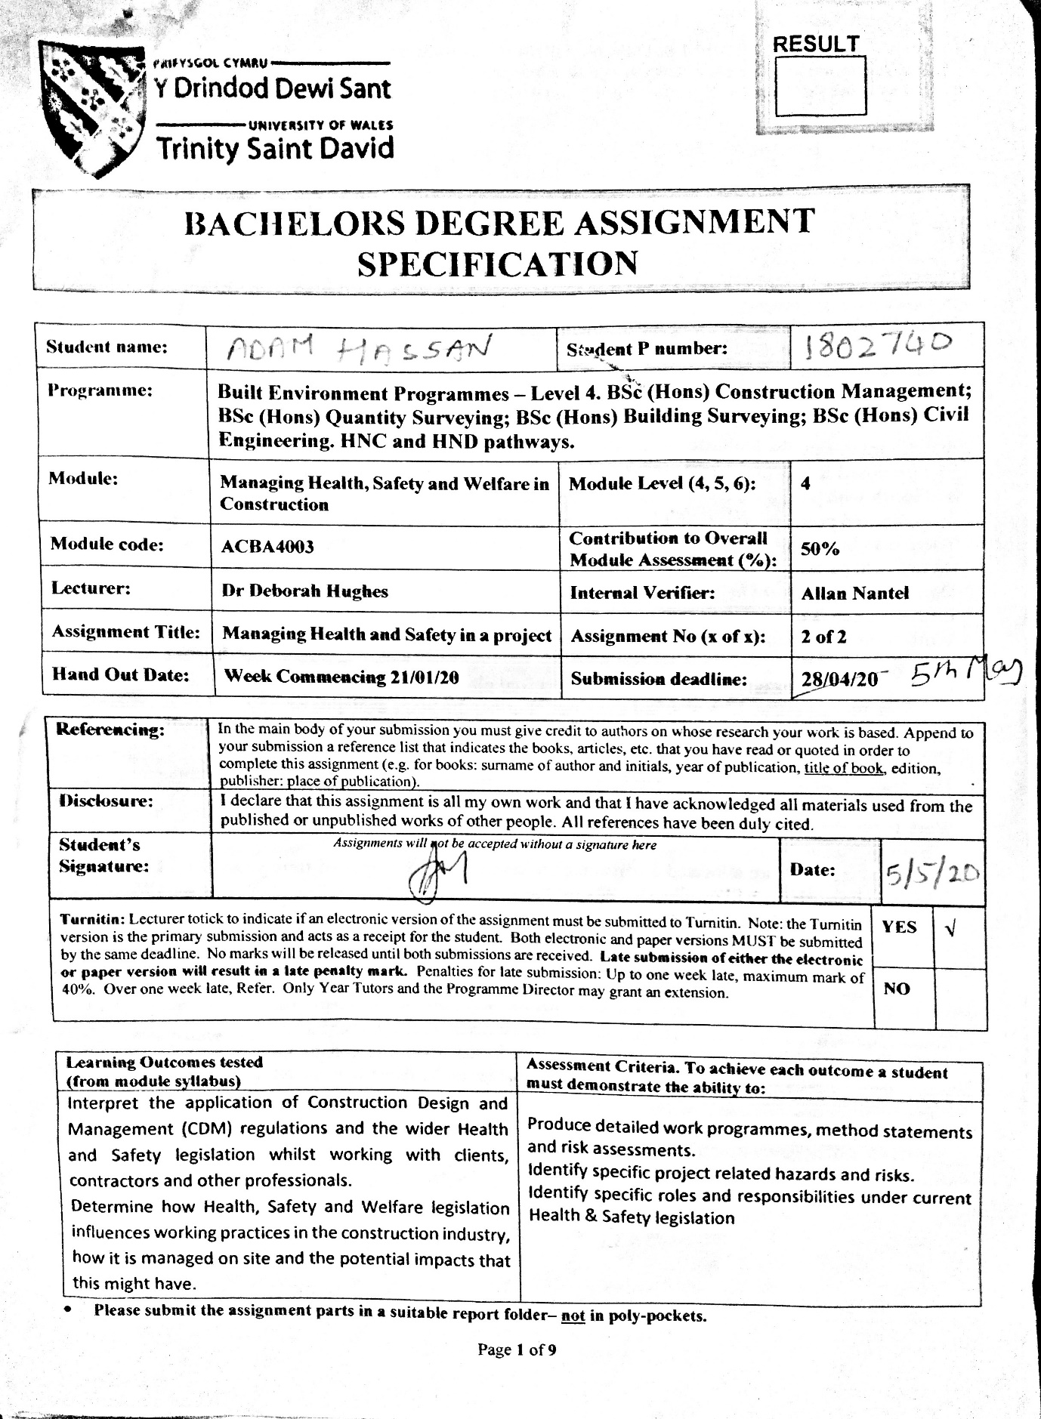

Construction Phase Plan

Contents

PROJECT DETAILS 3
RESPONSIBILITIES 4
PRINCIPAL CONTRACTOR DUTIES 4
SITE MANAGER DUTIES 5
SITE SUPERVISOR 5
SITE ACCESS AND PARKING 5
SITE SECURITY 5
SITE RULES 6
TRAFFIC MANAGEMENT 6
RISK & METHOD STATEMENTS – RAMs 6
HEALTH AND SAFETY HAZARDS 6
Vehicle and Traffic Management 6
Underground services 7
Working at height 7
Protection against falling objects 7
Noise 7
Manual handling 7
Use of work equipment 7
Lifting equipment 8
RISK ASSESSMENT AND CONTROL MEASURES 8
Vehicle and traffic management 8
Underground services 9
Working at height 9
Protection against falling objects 10
Noise 10
Manual handling 11
Use of work equipment 11
Lifting equipment 11
CONSULTATIONS WITH WORKFORCE 12
SITE INDUCTION/TOOLBOX TALKS 12
EMERGENCY & FIRE ARRANGEMENTS 12
REPORTING OF ACCIDENTS AND RIDDOR 13
PERSONAL PROTECTIVE EQUIPMENT (PPE) 13
WELFARE FACILITIES 14
MATERIAL STORAGE 14
WASTE MANAGEMENT 15

PROJECT DETAILS
Principal Contractor: Sam Smith – 07xxxxxxxxx
Client: UWTSD
Project Description: The construction of a two storey detached domestic building with a loft room.
Project Location: Swansea, SA1 8PP
Project Start Date: 6th May 2020
Project End Date: 8th November 2020
Site Hours: 8.00am – 6.00pm Mon to Fri & 8.00am – 1.00pm Sat
Principal Designer Name and Contact Number: Steven Stevens – 07xxxxxxxxx
Site Manager Name and contact Number: John Jones – 07xxxxxxxxx
Site Supervisor Name and contact number: Adam Adams – 07xxxxxxxxx

RESPONSIBILITIES
The Principal Contractor is responsible for the overall works on the site.
The Project Manager is responsible for the overall control of the project activities and will organise meetings with the contractors when necessary.
The Site Supervisor is responsible for the daily safe working environment on the site and to ensure activities are co-ordinated to avoid the possibility of conflicts between work activities.

PRINCIPAL CONTRACTOR DUTIES
The principal contractor has the responsibility to ensure the following:
- Coordinates and liaises the project works with the client (UWTSD), Principal Designer and Site Manager.
- Collates relevant information and maintains it as work proceeds.
- Site is properly secured to prevent any unauthorised access.
- Proper hoarding of site and hazard warning signs are in place.
- Draw up site rules and provide induction to employees and all visitors.
- Gives site inductions and toolbox talks.
- Ensures appropriate welfare facilities are in place.
- Assesses and addresses health and safety issues and risks with the workforce.
- Ensures the health and safety file is reviewed and updated.
- Draws up a construction phase plan (CPP) prior to setting up the construction site, which will be revised and updated throughout construction.
- Ensures the CPP is implemented throughout the construction work, without risks to health and safety.
- Fire and emergency risk assessment and safety plan for the site.
- The site traffic management.
- Waste management arrangements.

SITE MANAGER DUTIES
- Oversee operations of the site on a day-to-day basis.
- Liaise with the client (UWTSD) and Principal contractor.
- Pre-plan safe methods of construction.
- Supervise construction workers.
- Monitor and ensure the project is within the timescale and budget.
- Select the appropriate tools and materials for the project.
- Manage any delays or problems encountered on site during a construction project.
- Manage quality control, health and safety checks and the inspection of work carried out.
- Assess and minimise risk.

SITE SUPERVISOR
- Supervise the workforce on site.
- Maintain a record of workforce attendance.
- Inspect construction site regularly to identify and eliminate potential safety hazards.
- Ensure site safety rules are implemented to minimise accidents and injuries.

SITE ACCESS AND PARKING
• Gated controlled access to site.
• Public parking is available at the UWTSD SA1 campus car park, Parc Tawe Retail Parc and Sainsburys Supermarket car park.

SITE SECURITY
• Locked and gated entrance.
• All employees working on site must sign in and out when entering and leaving the site.

SITE RULES
- Keep records of all arrivals and departures to/from their site.
- Appropriate PPE must be worn at all times when on site, including any visitors to the site.
- All personnel must undergo safety induction training.
- Every incident and accident must be reported to the Site Manager.
- Keep the site tidy and free from obstruction to prevent slips and falls, particularly access and escape routes.
- No smoking, except at designated areas on site.
- Mobile phones must be switched off.
- No earphones or radios.
- Alcohol on site is not permitted.

TRAFFIC MANAGEMENT
Safety arrangements will be made as the site has access directly on to a public highway. The Principal Contractor will monitor all deliveries and all unloading. A plan will be set up for deliveries and the use of vehicles on site to ensure minimal risk and safety of all employees on site.

RISK & METHOD STATEMENTS – RAMs
Prior to the start of the works, the Principal Contractor is required to submit method statements for any works carried out which have significant risks, which will be reviewed by the Site Management.

HEALTH AND SAFETY HAZARDS
The following health hazards have been identified:

Vehicle and Traffic Management
Some of the hazards associated with vehicle and traffic routes include collisions with pedestrians, workers on site, other vehicles or structures like scaffolding etc. Some obstacles like bends, gates and barriers or uneven surfaces and slopes are hazards to be considered.

Underground services
Underground services are a great hazard as while excavating to lay foundation, cables and pipes can be damaged. This can lead to accidents, like electrocution, fires, electrical ark, gas release, explosions, contamination and flooding, which can lead to employee injuries, burns or deaths. Even cables that have been previously damaged but left unreported and unrepaired can be very hazardous and cause harm.

Working at height
Activities involving working at height, like work from ladders, scaffolds and platforms as well as roof work, particularly work on pitched roofs, are all hazardous. The danger of falling through a surface or off a height like a roof or scaffolding or items falling can occur as a result of poor edge protection and/or scaffolding without guardrails or covers and unguarded openings.

Protection against falling objects
Construction workers and members of the public need to be protected from the hazards related to falling objects. Accidental dropping or tipping of materials/objects or tools from height can cause serious harm to persons below.

Noise
Exposure to workplace noise can cause permanent hearing loss and tinnitus (disabling ringing in the ears or head). It can make it more difficult to hear sounds that are necessary to work safely, such as verbal instructions and failure to hear warning signals or alarms risks.

Manual handling
Manual handling involves transporting or supporting of a load by one or more employees, and includes lifting, putting down, pushing, pulling, carrying or moving a load. Manual handling can result in simple injuries like cuts, bruises, fractures etc, to more serious and debilitating damage to the musculoskeletal system of the body.

Use of work equipment
- Health hazards involved in handling work equipment include:
- Puncture wounds and cuts caused by sharp equipment
- Equipment that transmits vibrations into the hand or arm could cause long-term illness or disability.
- Workers can be crushed by moving parts or hit and injured by moving parts of machinery or ejected material.
- Electrical faults in equipment can lead to electrocution.

Lifting equipment
This involves lifting operation involving the lifting or lowering of a load using lifting equipment and includes attachments used for anchoring, fixing or supporting it. Working with any machinery can be dangerous. Lifting equipment can cause injuries if they fail or loads fall. Workers are at risk of being crushed by a moving load or lifting equipment if loads exceed lifting load limits.

RISK ASSESSMENT AND CONTROL MEASURES
Prior to work starting, a risk assessment of all activities will be carried out and all hazards and risks as well as control measures will be discussed prior to start of works and throughout construction via toolbox talks. Risk assessments include:

Vehicle and traffic management
A major risk in this project will be construction traffic management to ensure the safety of members of public and avoidance of traffic congestion in the area.
Control measures:
- Have a plan and scheduling of traffic including appropriate times for deliveries.
- Provide clear signed warning of any height or width restriction.
- Good visibility for drivers is needed to stop or change direction safely.
- Reduce vehicle speed into and around the site.
- Only trained, competent and supervised drivers are to operate vehicles.
- All personnel to wear high visibility jackets when there are vehicles operating in the vicinity.
- Only trained drivers will be allowed to drive relevant vehicles on site. Vehicles should be fitted with reversing warning systems.

Underground services
When excavating the ground to lay the foundation, cables and pipes can easily be cut or crushed with heavy machinery and cause serious damage to services below ground. Therefore, appropriate planning with underground services in mind can prevent or greatly reduce the risk of problems during the project.
Possible control measures include:
- Possibility of laying the foundation in a different position to avoid any underground services that may be already present.
- Obtaining service drawings from utilities companies and other organisations with the relevant information about the site.
- Using cable locating devices to pinpoint the locations of underground services. A locator for example a CAT scan used to trace the line of pipes or cables and to confirm the location and depth. Only thoroughly trained persons will be allowed to use locators to calibrate them correctly and recognise locator’s limitations.
- Identifying, marking and recording positions of the services and other underground structures

Working at height
Working at height is a major risk and health hazard. During initial stages of construction, measures will be taken, as much as possible, to avoid working from height. During later stages and roof building, scaffolding will be required, and the correct safety equipment and guards will be used to prevent any injuries.
Control measures:
- Avoid working at height unless necessary and no other choice.
- Proper training
- Workers need to be provided with safe access to and from the ground.
- The proper protection equipment must be used.
- All equipment must be fully checked.
- All scaffolding will be installed by a certified scaffolding provider who hold all appropriate scaffolding accreditation.
- Carry out daily scaffolding checks.

Protection against falling objects
Appropriate safety precautions will be assessed and used to prevent accidents and injuries from falling objects.
Control measures:
- Use hoists, rubbish chutes or netting.
- Cordon off hazard areas and post warning signs.
- Always wear hard hats when work is being performed overhead.
- Stack materials securely to prevent them from sliding or falling and store heavier items on or near the ground and lighter items higher up.
- Secure all tools to prevent them from falling on people below.
- Use toe boards or guardrails on scaffolds to prevent objects from falling.
- Use debris nets or catch platforms to grab falling objects.

Noise
The control of noise levels on site will be assessed and where appropriate different tasks will be carried out at different times.
Management duties:
- Monitoring of noise levels will be carried out on site.
- Inspection and maintenance of equipment and tools prior and during construction will ensure safety and compliance with regulations.
- Training and toolbox talks will be provided.
- Regular re-assessment will take place throughout the construction and means of eliminating/controlling noise.
- Health surveillance to monitor workers’ hearing ability will also be carried out.

Control of noise measures can include:
- The use of low noise machines and tools.
- The use of mufflers / silencers.
- The use of vibration stabilising pads
- Wearing hearing protection.
- The use of a quieter method/process on site.

Manual handling
It is important to manage the hazards of manual handling in the workplace to avoid a risk of back injury or other musculoskeletal injuries. This can lead to gradual wear and tear of the spine and damage to spine discs caused by frequent manual handling activity, repetitive back bending, pulling and lifting, bending and twisting.
Management duties:
- Assess the type of manual handling tasks that will be carried out.
- Lifting equipment needs to be thoroughly examined and other equipment properly maintained.
Control measures:
Use lifting aids like barrows, trolleys, conveyors, hoists, and cranes.
Deliver materials directly to their point of use if possible.
Reduce the need to bend, twist, stoop or stretch for materials by allowing enough room for the work.

Use of work equipment
The appropriate work equipment for each task on site will be assessed and discussed with workers to ensure safe use.
Control measures:
- Ensure that equipment is suitable for use.
- Properly install any equipment and ensure that any safeguards are in place.
- Ensure that equipment is regularly inspected by a suitably competent person.
- Ensure equipment is used for its intended purposes only.
- Maintain equipment in good condition.
- Ensure training is provided.

Lifting equipment
The person using lifting equipment needs to be trained to handle such equipment, otherwise consequences may be fatal. Injuries and even death can be avoided with proper handling, training and supervision.
Control measures:
- Lifting operations are to be properly planned and supervised.
- Ensure lifting equipment undergo regular examination and maintenance by a qualified person.
- Provide proper training and supervision during load lifting using lifting equipment.

CONSULTATIONS WITH WORKFORCE
The Principal Contractor must arrange for consultations with the workforce on all health and safety matters and the delivery of suitable site health and safety inductions and training. The Principal Contractor involves the workforce on the site to get their views and implement an effective health and safety management system.

SITE INDUCTION/TOOLBOX TALKS
Prior to the start of works on site, all personnel must attend a safety induction briefing and regular on-site toolbox training sessions will be given by the Site Manager, which includes:
- Site rules.
- Site welfare facilities and their cleanliness.
- Fire and evacuation procedures.
- Personal protective equipment rules.
- Accident and first aid procedures.
- Health and safety rules.
- Site risks and hazards.
- Working at height procedure and safety.
- Restrictions on the handling of equipment and machinery on site and to examine them before use.
- Waste and debris clearing as work progresses.

EMERGENCY & FIRE ARRANGEMENTS
The Principal Contractor will carry out a risk assessment to identify probable major issues for which emergency procedures would be required.
An emergency plan will be prepared for any emergency event and/or any likely incidents. Nominated personnel will be responsible for specific emergency actions and will be trained to deal with these responsibilities; raising the alarm; calling the emergency services; emergency exits; assembly points; re-assessment of the emergency plan at regular intervals.
Training, as well as a written version of the plans, will be given to all personnel on site, on the procedures for dealing with any emergency situations that may arise.
All access routes for emergency services and all escape routes will be kept clear at all times.
The nearest A&E department is at Morriston Hospital.

REPORTING OF ACCIDENTS AND RIDDOR
The Principal Contractor must report, and consequently, the Site Manager must also be informed of all accidents and near misses, regardless of severity of incident or injury, specific injuries lasting more than seven days, injuries to members of the public, any illnesses, dangerous occurrences and work-related deaths. A record of all accidents and near misses must be filled in the accident book and RIDDOR reporting is done through an online reporting system.

PERSONAL PROTECTIVE EQUIPMENT (PPE)
All PPE are provided by the principal Contractor:
- Steel toe cap boots
- Hard hat and
- High-vis vest
- Protective glasses/goggles.
- Ear protection.
- Harness, lanyard and karabiners

WELFARE FACILITIES
Welfare facilities will be provided as per the Workplace (Health, Safety and Welfare) Regulations 1992 and as per Schedule 2 of the 2015 CDM Regulations, i.e. the number of toilets and washbasins will be provided as per Table 1:
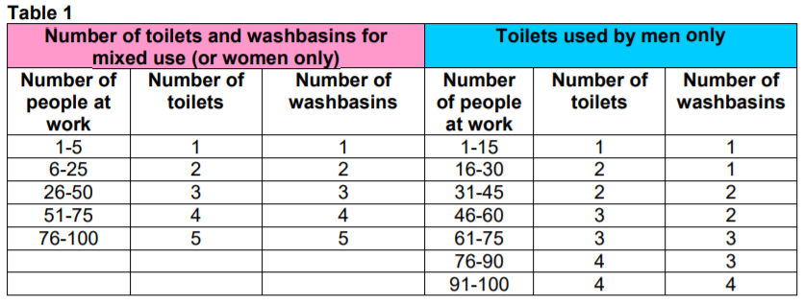
Site welfare facilities, such as toilets, washing facilities, changing rooms, suitable seating area for workers to use during breaks, and drinking water will be available throughout the construction period. The facilities must be kept clean and in good condition, and ensure there is always an adequate supply of toilet paper, soap etc.
The site is near the Technium building and permission is granted to use the toilet facilities there.
Smoking rules: No smoking inside any welfare facilities. No smoking in any enclosed area on site.

MATERIAL STORAGE

The arrangements for materials storage should be discussed and agreed between the Principal contractor and the project client (UWTSD).
- Deliveries must be planned well to keep the amount of materials on site to a minimum.
- Storage areas must be designated for tools and equipment, materials, waste, flammable substances and hazardous substances.
- Materials must be stored away from access and emergency escape routes.
- Weather conditions must be taken into account for the storage of materials.
- Flammable materials will need to be stored away from other materials and protected from accidental ignition.
- Storage areas must be kept tidy.

WASTE MANAGEMENT
A site waste management plan (SWMP) will be prepared (although not a legal requirement), describing how materials will be managed efficiently and disposed of legally during the construction of the works.
The Principal contractor must arrange suitable site induction and training of personnel to ensure that the plan is applied. He must also update the plan as the works progress to reflect the actual handling of waste.

Construction Method Statement

Contents

1 INTRODUCTION 2
2 DESCRIPTION OF PROJECT 3
3 ACTIVITY AND DESCRIPTION OF WORK 3
4 LOCATION 3
5 DATE AND DURATION OF WORK 4
6 RESPONSIBILITIES 4
7 HOURS OF WORK 4
8 SECURITY 4
9 SITE ENCLOSURE 4
10 SITE RULES 5
11 SITE ACCESS AND PARKING 5
12 SITE INDUCTION/TOOLBOX TALKS 5
13 PPE REQUIREMENTS 6
14 WORK PROCEDURE AND CONTROL MEASURES INCLUDING THE SEQUENCE OF WORK 6
15 MONITORING ARRANGEMENTS 7
16 ACTIVITIES WITH RISKS TO HEALTH AND SAFETY 7
Use of and Contact with Power Tools 7
Working at height 8
Noise 9
17 WELFARE FACILITIES 10
18 FIRST AID PROVISIONS 10
19 EMERGENCY & FIRE PROCEDURES 10
20 REPORTING OF ACCIDENTS & RIDDOR 11
21 WASTE MANAGEMENT 11
APPENDIX: SITE SET UP PLAN AND SECTION 12

INTRODUCTION
This Method Statement outlines the management procedure of the construction works for this project. It provides details of how the work will be carried out and the health and safety issues involved. The content of this Method Statement is an assessment based on current information and the findings of the relevant Risk Assessment(s) and is subject to amendments as the project progresses.

DESCRIPTION OF PROJECT
Planning consent has been granted for the UWTSD to build a single, two storey detached domestic building with a loft room. [See Appendix 1 for floor plans and elevations]. This will be an accommodation for a full-time caretaker and their family.

ACTIVITY AND DESCRIPTION OF WORK
- Site set-up which includes site clearance, fencing, setting up a temporary office and welfare facilities.
- Ground works - excavation
- Construction of foundations and structural works
- Construction of the outside of the building
- Roof and eaves
- External facings, cladding and the fixing of windows and doors
- Internal works - joinery, painting and plastering etc.

LOCATION
The accommodation will be built adjacent to the new student accommodation on the SA1 site with access directly on to a public highway.

DATE AND DURATION OF WORK
The work is to start on the 6th May 2020 and will be completed on 8th November 2020. Project is estimated to be completed in about 6 months.

RESPONSIBILITIES
Principal Contractor: Sam Smith – 07xxxxxxxxx
Sub-contractors: ABC Ltd – 07xxxxxxxxx
Site Manager: John Jones – 07xxxxxxxxx
Site Supervisor: Adam Adams – 07xxxxxxxxx
The Principal Contractor is responsible for overall works on the site.
The Project Manager is responsible for overall control of the project activities and will organise meetings with the contractors, when necessary.
The Site Supervisor is responsible for the daily safe working environment on the site and to ensure avoidance of possible conflicts between work activities.

HOURS OF WORK
8.00am – 6.00pm Mon to Fri
8.00am – 1.00pm Sat

SECURITY
All employees working on site must sign in and out when entering and leaving the site. The site will be made appropriately secure to prevent entrance to the site by unauthorised persons and to prevent removal of materials or goods from the site.
It can also act as a deterrent to would-be trespassers.

SITE ENCLOSURE
Hoarding and fencing must be erected to prevent unauthorised access to a site and protect the public. The hoarding around a construction site is the responsibility of the principal contractor.
- 2.4 metres hoarding and fencing will be erected around the boundary of the site for protection with a personnel site entrance gate at the front.
- There will be Caution and Safety signs, and signals placed in and around the hoarding to enable the site to be more visible and members of the public will be aware of any potential hazards surrounding the site. as required by The Health and Safety Regulations 1996.
- Under the Health and Safety at Work Act of 1974, efficient lightings in and around the site will enable workers to continue during hours of inadequate daylight.

SITE RULES
Site rules are a requirement under CDM (Construction Design & Management Regulations 2015).
- All personnel shall undergo safety induction training.
- Keep records of all arrivals and departures to/from their site.
- All personnel and visitors must always wear appropriate PPE when on site.
- Every accident and incident must be reported to the Site Manager.
- Keep the site tidy and free from obstruction to prevent slips and falls, particularly access and escape routes.
- No smoking, except at designated areas on site.
- Mobile phones must be switched off.
- No earphones or radios.
- Alcohol on site is not permitted.

SITE ACCESS AND PARKING
Gated controlled access to site with access directly on to a public highway.
There is no parking on site so the UWTSD student car park on the SA1 campus is available for those who will be on site for longer than 4 hours and is only a 5-minute walk from the construction site. Also, public parking is available at Parc Tawe Retail Park and Sainsburys Supermarket, which are about 10-15minutes walk from the site where free parking is available for 2-4 hours.

SITE INDUCTION/TOOLBOX TALKS
The principal contractor's duty under Construction Design & Management Regulations 2015 (CDM) to ensure that a suitable site induction is provided to anyone on coming on site, including visitors. Induction includes information on the following key points:
- Who is in charge and responsibilities of each person on site.
- The layout of the workplace including entries and exits, location of facilities, first aid and security requirements.
- Site rules.
- Hazards, risks and control measures involved in carrying out tasks.
- Safety documents, policies and plans specific to the workplace.
- Consultation of the workforce on health and safety matters, as well as individual worker's responsibility for health and safety.
- Reporting of incidents and hazards.
- Emergency and fire procedures.

PPE REQUIREMENTS
This is in accordance with The Personal Protective Equipment Regulations 2002.
Workers on site must ensure that PPE is worn and used in accordance with the instructions provided to them. Any visitors must wear the appropriate PPE while on site.
● Hard hats
● Safety boots
● High visibility clothing
● Ear protection
● Safety gloves
● Safety glasses
● Safety harness, lanyard and karabiners

MONITORING ARRANGEMENTS
Under The Construction (Design & Management) Regulations 2015, safety standards will be monitored periodically by the Principal Contractor and Site Manager through:
- An inspection and checklist will be included with the site safety records.
- An inspection of attendance registers, fire equipment, first aid equipment and working equipment used on site.
- A review and update (if necessary) of the Construction Phase Plan.
- Weekly safety review meetings to ensure method statements and risk assessments have been followed and make changes if necessary.
- Health and Safety inspections and reviews.
- Tool box talks will be regularly provided.

ACTIVITIES WITH RISKS TO HEALTH AND SAFETY
The Principal Contractor and Site Manager must access the risks to the health and safety of the employees on site to identify the measures he needs to take to comply with the requirements of The Management of Health and Safety at Work Regulations 1999.

Use of and Contact with Power Tools
The Provision and Use of Work Equipment Regulations 1998 (PUWER) place a duty on employers to ensure the work equipment employees use and operate is always safe to use. Work equipment includes tools like hand tools, portable power tools, drilling machines, circular saws, lifting equipment and lifts including forklift trucks, vehicle hoists and lifting slings, as well as all working at heights equipment, such as ladders, mobile elevated work platforms (MEWPs), folding access platforms and fall protection equipment, etc.
The Principal Contractor duties include:
- Ensuring equipment is suitable for the intended use.
- Ensuring equipment is safe for use via regular maintenance and safety inspections.
- Providing training and information about the equipment’s operation.
- Ensuring equipment is fitted with appropriate warning signs, marks, safety bars or guards.

The employees also have duties which include:
- Following instructions and regulations.
- Reporting any hazards or faults.
- Attending any required training.
- Operating machinery or equipment properly in accordance with the manufacturer's instructions for the safe use of equipment.
- Performing safety checks before use.
- Wearing appropriate PPE.

Working at height
In this project, some of the trained workforce will need to use ladders, elevating platforms and/or tower scaffolds to build the two-storey house.
The Work at Height Regulations 2005 involves “any work activities where there is a need to control a risk of falling a distance which can cause an injury, which include falls from ladders, rooftops and fragile surfaces”. Therefore, the employers and employees have duties to ensure that risk and hazards are kept to a minimum.
The Principal contractor must:
- Inspect all protection equipment before use.
- Ensure that a suitable and sufficient platform or covering is provided for danger areas like fragile surfaces.
- Ensure that the distances from fragile surfaces to the ground are restricted to minimise the consequences of a fall.
- Assess the risks involved to prevent any injuries or falls.
- Provide training prior to the use of equipment.
- Take weather conditions into account that can endanger safety.
It is the duty of the employees to:
- Select and use the appropriate work equipment to be used.
- Be properly supervised and works at height carried out by competent persons.
- Have access to Work at Height equipment, including the appropriate PPE.
- Have training in the use of equipment.
- All scaffolding will be installed by a certified scaffolding provider who hold all appropriate scaffolding accreditation and will follow safety regulations.
- Carry out daily scaffolding checks.

For construction work, the Regulations require that “handrails have a minimum height of 950 mm, and that any gap between the top rail and any intermediate rail should not exceed 470 mm”. The Regulations also require “toe boards to be suitable and sufficient (eg a toe board of a minimum 100 mm height would be acceptable)”.

Noise
The Control of Noise at Work Regulations 2005 states that “the level at which employers must provide hearing protection and hearing protection zones is 85 decibels (daily or weekly average exposure) and the level at which employers must assess the risk to workers' health and provide them with information and training is 80 decibels”.
The Principal Contractor duties include:
• Estimate employees’ exposures to noise for example the level of noise, type and duration exposed.
• Identify what noise-control measures and/or personal hearing protection are needed, or whether working practices are safe; and
• Identify any employees who need to be provided with health surveillance and whether they are at risk.
Employees have a duty to:
- Use noise-control measures, such as exhaust silencers and machine enclosures.
- Wear hearing protection
- Maintain the hearing protectors and noise-control equipment they use.
- Report defects found in the hearing protectors.

WELFARE FACILITIES
Welfare facilities will be provided as per the Workplace (Health, Safety and Welfare) Regulations 1992.
Site welfare facilities, such as toilets, washing facilities, changing rooms, suitable seating area for workers to use during breaks, and drinking water will be available throughout the construction period. The facilities must be kept clean and in good condition while ensuring there is always an adequate supply of toilet paper, soap etc.
The site is near the UWTSD Technium building and permission is granted to use the toilet facilities there.
Smoking rules: No smoking inside any welfare facilities. No smoking in any enclosed area on site and smoking is only permitted at designated areas on site.

FIRST AID PROVISIONS
First aid facilities will be assessed and provided as per the Health and Safety (First Aid) Regulations 1981.
- A First Aid Box, with eye washing solutions, will be provided on site.
- A trained First Aid appointed person will always be available on site.
- Employees will be informed about first-aid arrangements.

EMERGENCY & FIRE PROCEDURES
The provision of an emergency plan is in accordance with the Management of Health and Safety at Work Regulations 1999.
The Principal Contractor will carry out a risk assessment to identify probable major issues in which emergency procedures would be required.
An emergency plan will be prepared for any emergency event and/or foreseeable incidents. Nominated personnel will be responsible for specific emergency actions and will be trained to deal with these responsibilities; raising the alarm; emergency exits and means of escape; assembly points; calling the emergency services; re-assessment of the emergency plan at regular intervals.
Training, as well as a written version of the procedures, will be given to all personnel on site, on the procedures for dealing with any emergency situations that may arise.
All access routes for emergency services and all escape routes will always be kept clear to provide a safe path.

REPORTING OF ACCIDENTS & RIDDOR
It is the duty of The Principal Contractor to report workplace injuries and accidents, occupational diseases and specified dangerous occurrences (near misses) under the Reporting of Injuries, Diseases and Dangerous Occurrences Regulations 2013 (RIDDOR). Accidents or near misses must be reported in the accident book and a record of any injury or over a seven-day injury, disease or a dangerous occurrence must be reported online.

WASTE MANAGEMENT
A Site Waste Management Plan (SWMP) will be prepared that covers the requirements of the Site Waste Management Regulations 2008.
The Contractor(s) will be responsible for ensuring that the site is kept tidy at all times and that all waste is removed during or at the end of each working period, in order to maintain a safe working environment.
Within three months of the work being completed, the principal contractor should add to the plan a confirmation that the plan has been monitored on a regular basis to ensure that work has progressed according to the plan, and that the plan had been updated with an explanation of any deviation from it.
==============================================================
All legislations and regulations were obtained from:
https://www.hse.gov.uk/

The Health and Safety at Work Etc Act
http://www.legislation.gov.uk/ukpga/1974/37

The Management of Health & Safety at Work Regulations http://www.legislation.gov.uk/uksi/1999/3242/contents/made

The Construction (Design and Management) Regulations 2015
http://www.legislation.gov.uk/uksi/2015/51/contents/made

Working at height regulation 2005
http://www.legislation.gov.uk/uksi/2005/735/contents/made

The Provision and Use of Work Equipment Regulations 1998 (PUWER) http://www.legislation.gov.uk/uksi/1998/2306/contents/made
The Manual Handling Operations Regulations 1992http://www.legislation.gov.uk/uksi/1992/2793/contents/made
The Personal Protective Equipment Regulations 2002 http://www.legislation.gov.uk/uksi/2002/1144/contents/made

APPENDIX: SITE SET UP PLAN AND SECTION

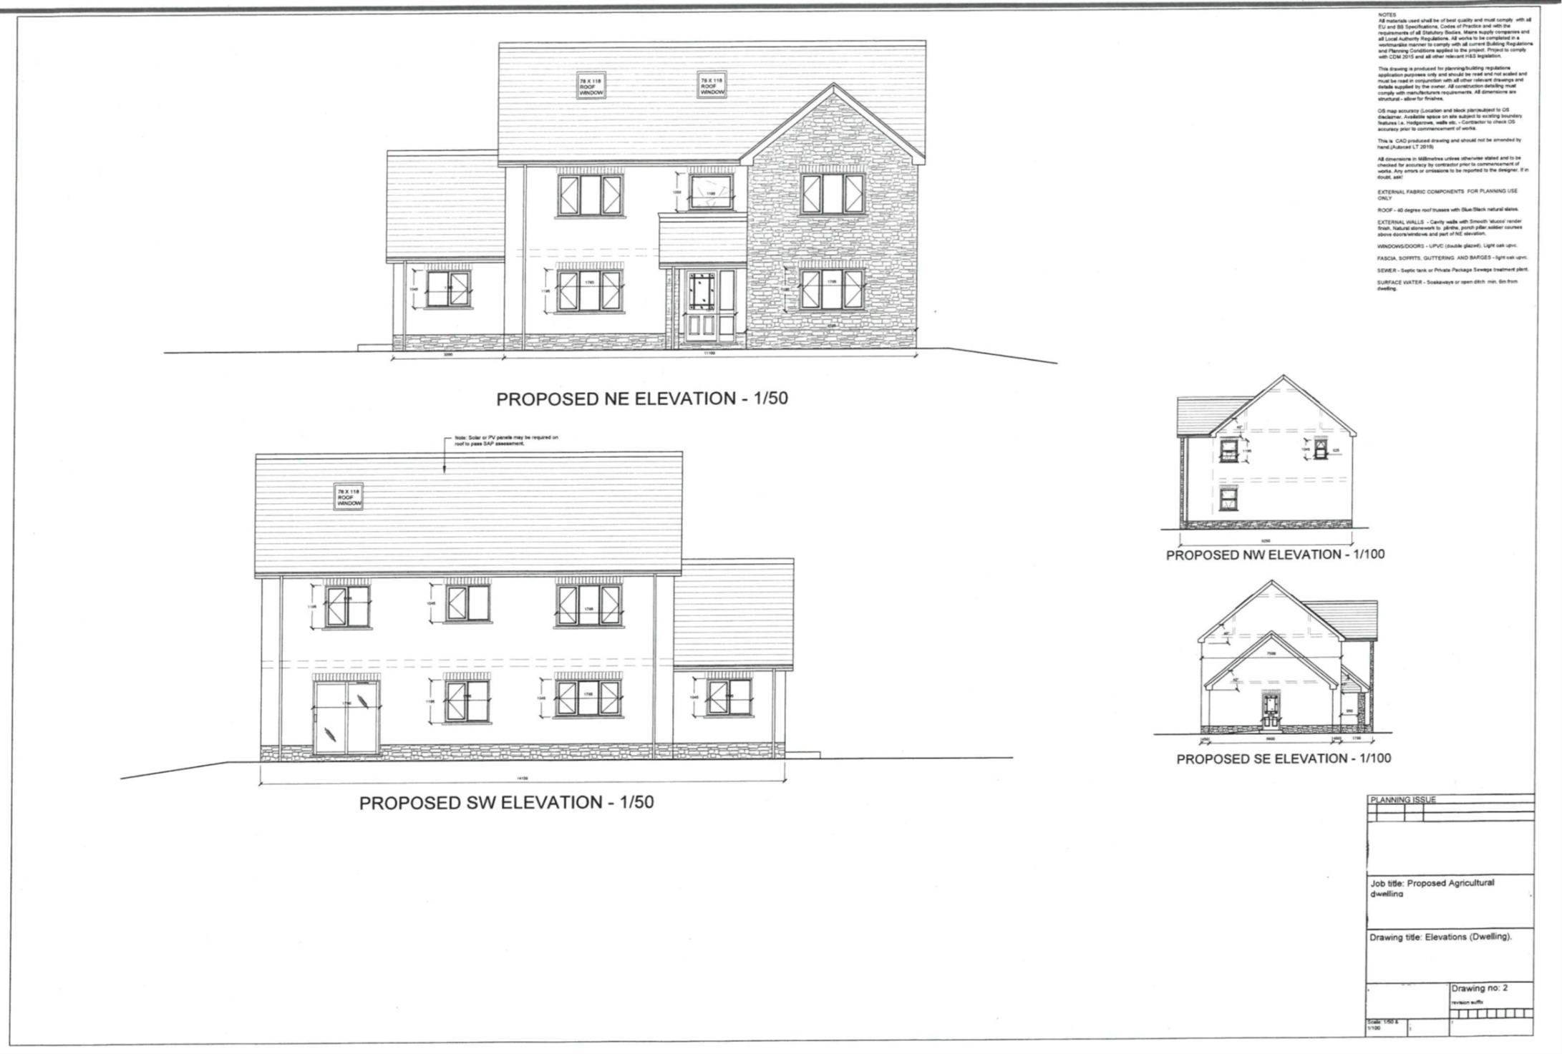
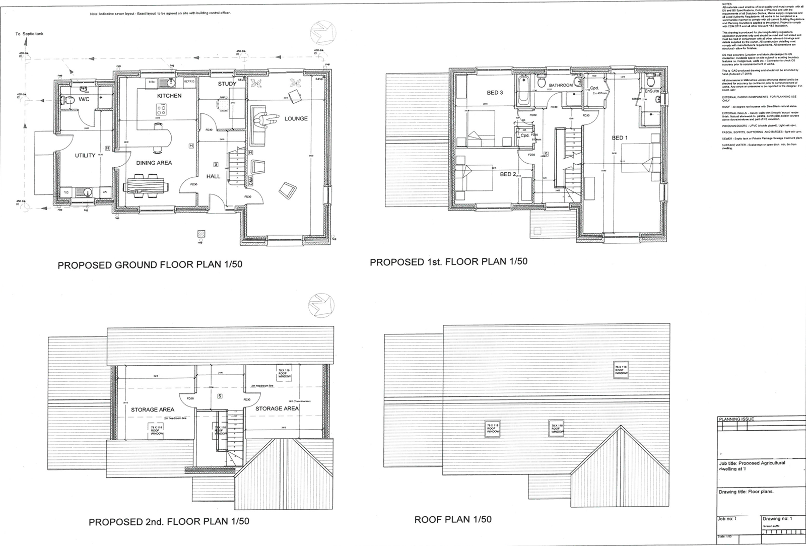

Risk Assessment Sheets

Activity to be Assessed |  |  |  |  |  |  |  |  |  |  |  |  |  |  |  |  |  |  |  |  |  |  |  |  |  |  |  |  |  |  | Assessment Number
Working at Height |  |  |  |  |  |  |  |  |  |  |  |  |  |  |  |  |  |  |  |  |  |  |  |  |  |  |  |  |  |  | 1802740
Persons undertaking or affected by the activity
 |  | x | Employees |  |  |  | x |  | Contractor |  |  |  |  |  |  |  | Public |  |  |  |  |  |  |  |  |  | Service User
 |  |  | Other …………………………………………………………………………………………….
Identified Hazards and Associated Risks |  |  |  |  |  |  |  |  |  |  |  |  |  |  |  |  |  |  | Likelihood |  |  |  |  |  |  |  |  |  |  |  | Severity |  |  |  |  |  |  |  |  |  |  | Risk Level
1 | Working on scaffolding may cause a fall from height. |  |  |  |  |  |  |  |  |  |  |  |  |  |  |  |  |  | 3 |  |  |  |  |  |  |  |  |  |  |  | 5 |  |  |  |  |  |  |  |  |  |  | 15
2 | Falls from mobile elevation platforms. |  |  |  |  |  |  |  |  |  |  |  |  |  |  |  |  |  | 2 |  |  |  |  |  |  |  |  |  |  |  | 4 |  |  |  |  |  |  |  |  |  |  | 8
3 | Falls from ladders. |  |  |  |  |  |  |  |  |  |  |  |  |  |  |  |  |  | 4 |  |  |  |  |  |  |  |  |  |  |  | 3 |  |  |  |  |  |  |  |  |  |  | 12
4 | Material/tools falling from scaffolding or MEWPS. |  |  |  |  |  |  |  |  |  |  |  |  |  |  |  |  |  | 2 |  |  |  |  |  |  |  |  |  |  |  | 3 |  |  |  |  |  |  |  |  |  |  | 6
5 | A collapse or fire in the structure. |  |  |  |  |  |  |  |  |  |  |  |  |  |  |  |  |  | 1 |  |  |  |  |  |  |  |  |  |  |  | 4 |  |  |  |  |  |  |  |  |  |  | 4
Existing Control Measures / Additional Control Measures Required
1 | - Inspect scaffolding before use.  - Ensure handrails are secure.  - Talks with workers on not misusing or interfering with the scaffolding will be provided.  - Safety harnesses and connecting it to an energy absorbing lanyard to a suitable anchor point are provided.
2 | - Fall arrest system are in place.  - Workers trained not to overreach.
3 | - Ladders are used as a last resort and to be used for a limited time.  - Only the correct ladders are to be used at all times and checks on the ladders before and after use.
4 | - Toe boards will be installed on scaffolding.  - Tool tethers will be used to avoid tools dropping accidentally.  - Maintaining a tidy work area to allow paths to be clear.  - Mesh on scaffolding to stop bricks or loose material falling.  - Exclusion zones to stop people entering the work area if unnecessary.
5 | - Emergencies and rescue plan by having an agreed evacuation plan.
Reassessment of Activity Hazards |  |  |  |  |  |  |  |  |  |  |  |  |  |  |  |  |  |  | Likelihood |  |  |  |  |  |  |  |  |  |  |  | Severity |  |  |  |  |  |  |  |  |  |  | Risk Level
1 | - Airbags and netting may be provided where applicable in case of falls from height. |  |  |  |  |  |  |  |  |  |  |  |  |  |  |  |  |  | 3 |  |  |  |  |  |  |  |  |  |  |  | 5 |  |  |  |  |  |  |  |  |  |  | 15
2
3
4
Name: John Jones  Position: Site Manager |  |  |  |  |  |  |  |  |  |  | Signed: JJ |  |  |  |  |  |  |  |  |  |  |  |  |  |  |  |  |  |  |  | Date of Completion:  November 8th 2020
Reviews |  |  |  |  | Key
Review Date:  June 15th |  |  |  |  | Likelihood |  |  |  |  |  |  |  | Severity |  |  |  |  |  | Severity of Injury |  |  |  | 5 |  | 5Y |  |  |  |  |  |  |  | 10R |  |  |  |  | 15 |  |  |  |  | 20 |  |  |  | 25
Reviewed by: JJ |  |  |  |  | 1 very unlikely  2 unlikely  3 likely  4 very likely  5 certainty |  |  |  |  |  |  |  | 1 nuisance  2 minor  3 medical treatment  4 major  5 fatal |  |  |  |  |  |  |  |  |  | 4 |  | 4 |  |  |  |  |  |  |  | 8 |  |  |  |  | 12 |  |  |  |  | 16 |  |  |  | 20
Review Date :  August 10th |  |  |  |  |  |  |  |  |  |  |  |  |  |  |  |  |  |  |  |  |  |  | 3 |  | 3 |  |  |  |  |  |  |  | 6G |  |  |  |  | 9 |  |  |  |  | 12 |  |  |  | 15
Reviewed by: JJ |  |  |  |  |  |  |  |  |  |  |  |  |  |  |  |  |  |  |  |  |  |  | 2 |  | 2 |  |  |  |  |  |  |  | 4 |  |  |  |  | 6Y |  |  |  |  | 8 |  |  |  | 10Y
Review Date :  September 10th |  |  |  |  |  |  |  |  |  |  |  |  |  |  |  |  |  |  |  |  |  |  | 1 |  | 1 |  |  |  |  |  |  |  | 2 |  |  |  |  | 3 |  |  |  |  | 4 |  |  |  | 5G
Reviewed by: JJ |  |  |  |  |  |  |  |  |  |  |  |  |  |  |  |  |  |  |  |  |  |  | 0 |  | 1 |  |  |  |  |  |  |  | 2 |  |  |  |  | 3 |  |  |  |  | 4 |  |  |  | 5
Review Date :  October 8th |  |  |  |  |  |  |  |  |  |  |  |  |  |  |  |  |  |  |  |  |  |  |  |  | Likelihood of Injury
Reviewed by: JJ |  |  |  |  |  |  |  |  |  |  |  |  |  |  |  |  |  |  |  |  | Low Risk |  |  |  |  |  |  |  |  |  |  |  |  |  | Medium Risk |  |  |  |  |  |  |  |  |  | High Risk
Activity to be Assessed |  |  |  |  |  |  |  |  |  |  |  |  |  |  |  |  |  |  |  |  |  |  |  |  |  |  |  |  |  | Assessment Number
Noise Pollution |  |  |  |  |  |  |  |  |  |  |  |  |  |  |  |  |  |  |  |  |  |  |  |  |  |  |  |  |  | 1802740
Persons undertaking or affected by the activity
 |  | x | Employees |  |  | x |  | Contractor |  |  |  |  |  | x |  | Public |  |  |  |  |  |  |  |  |  | Service User
 |  |  | Other …………………………………………………………………………………………….
Identified Hazards and Associated Risks |  |  |  |  |  |  |  |  |  |  |  |  |  |  |  |  |  | Likelihood |  |  |  |  |  |  |  |  |  |  |  | Severity |  |  |  |  |  |  |  |  |  | Risk Level
1 | Loud machinery can cause hearing damage over time. |  |  |  |  |  |  |  |  |  |  |  |  |  |  |  |  | 3 |  |  |  |  |  |  |  |  |  |  |  | 3 |  |  |  |  |  |  |  |  |  | 9
2 | Interfere with communication on site so less likely to hear warnings of danger. |  |  |  |  |  |  |  |  |  |  |  |  |  |  |  |  | 3 |  |  |  |  |  |  |  |  |  |  |  | 3 |  |  |  |  |  |  |  |  |  | 9
3 | Sudden loud noises can cause permanent hearing damage. |  |  |  |  |  |  |  |  |  |  |  |  |  |  |  |  | 1 |  |  |  |  |  |  |  |  |  |  |  | 4 |  |  |  |  |  |  |  |  |  | 4
Existing Control Measures / Additional Control Measures Required
1 | - Wear hearing protection when operating loud machinery.  - Use mufflers / silencers on loud machinery.  - Workers are time limited when using loud machinery.  - Regular health surveillance checks provided.
2 | - The use of low noise machinery.  - A plan is provided for different works to be carried out at different times so high noise is not overlapped.
3 | - Wear hearing protection when operating loud machinery.  - Regularly check noisy equipment for maintenance issues that may cause sudden higher noise levels.
Reassessment of Activity Hazards |  |  |  |  |  |  |  |  |  |  |  |  |  |  |  |  |  | Likelihood |  |  |  |  |  |  |  |  |  |  |  | Severity |  |  |  |  |  |  |  |  |  | Risk Level
1 | - Enclosed areas with screens of absorbed material that act as a sound barrier may be provided to further enclose sound. |  |  |  |  |  |  |  |  |  |  |  |  |  |  |  |  | 3 |  |  |  |  |  |  |  |  |  |  |  | 3 |  |  |  |  |  |  |  |  |  | 9
2
3
Name: John Jones  Position: Site Manager |  |  |  |  |  |  |  |  |  | Signed: JJ |  |  |  |  |  |  |  |  |  |  |  |  |  |  |  |  |  |  |  | Date of Completion:  November 8th 2020
Reviews |  |  |  | Key
Review Date:  June 15th |  |  |  | Likelihood |  |  |  |  |  |  |  | Severity |  |  |  |  |  | Severity of Injury |  |  |  | 5 |  | 5Y |  |  |  |  |  |  |  | 10R |  |  |  | 15 |  |  |  |  | 20 |  |  |  |  | 25
Reviewed by: JJ |  |  |  | 1 very unlikely  2 unlikely  3 likely  4 very likely  5 certainty |  |  |  |  |  |  |  | 1 nuisance  2 minor  3 medical treatment  4 major  5 fatal |  |  |  |  |  |  |  |  |  | 4 |  | 4 |  |  |  |  |  |  |  | 8 |  |  |  | 12 |  |  |  |  | 16 |  |  |  |  | 20
Review Date :  August 10th |  |  |  |  |  |  |  |  |  |  |  |  |  |  |  |  |  |  |  |  |  | 3 |  | 3 |  |  |  |  |  |  |  | 6G |  |  |  | 9 |  |  |  |  | 12 |  |  |  |  | 15
Reviewed by: JJ |  |  |  |  |  |  |  |  |  |  |  |  |  |  |  |  |  |  |  |  |  | 2 |  | 2 |  |  |  |  |  |  |  | 4 |  |  |  | 6Y |  |  |  |  | 8 |  |  |  |  | 10Y
Review Date :  September 10th |  |  |  |  |  |  |  |  |  |  |  |  |  |  |  |  |  |  |  |  |  | 1 |  | 1 |  |  |  |  |  |  |  | 2 |  |  |  | 3 |  |  |  |  | 4 |  |  |  |  | 5G
Reviewed by: JJ |  |  |  |  |  |  |  |  |  |  |  |  |  |  |  |  |  |  |  |  |  | 0 |  | 1 |  |  |  |  |  |  |  | 2 |  |  |  | 3 |  |  |  |  | 4 |  |  |  |  | 5
Review Date :  October 8th |  |  |  |  |  |  |  |  |  |  |  |  |  |  |  |  |  |  |  |  |  |  |  | Likelihood of Injury
Reviewed by: JJ |  |  |  |  |  |  |  |  |  |  |  |  |  |  |  |  |  |  |  | Low Risk |  |  |  |  |  |  |  |  |  |  |  |  |  | Medium Risk |  |  |  |  |  |  |  |  |  | High Risk

Activity to be Assessed |  |  |  |  |  |  |  |  |  |  |  |  |  |  | Assessment Number
Manual Handling |  |  |  |  |  |  |  |  |  |  |  |  |  |  | 1802740
Persons undertaking or affected by the activity
 |  | x | Employees |  | x | Contractor |  |  |  | Public |  |  |  | Service User
 |  |  | Other …………………………………………………………………………………………….
Identified Hazards and Associated Risks |  |  |  |  |  |  |  |  |  |  | Likelihood |  |  |  | Severity |  |  |  | Risk Level
1 | Repeated high force movements can cause strains or sprains. |  |  |  |  |  |  |  |  |  | 3 |  |  |  | 2 |  |  |  | 6
2 | Repetitive movements can cause soft tissue injury. |  |  |  |  |  |  |  |  |  | 4 |  |  |  | 3 |  |  |  | 12
3 | Sustained awkward posture can cause back injury. |  |  |  |  |  |  |  |  |  | 4 |  |  |  | 4 |  |  |  | 16
4 | Loads that are too heavy can cause chronic pain. |  |  |  |  |  |  |  |  |  | 3 |  |  |  | 5 |  |  |  | 15
5 | Carrying loads for extended time can cause strains and sprains. |  |  |  |  |  |  |  |  |  | 3 |  |  |  | 2 |  |  |  | 6
Existing Control Measures / Additional Control Measures Required
1 | - A schedule is in place where workers take turns on jobs that require heavy lifting to stop them working extended periods of time.
2 | - A schedule is in place where workers take turns on the job to stop them working extended periods of time. Reduced carrying distance.
3 | - Training the work force on how to lift and carry heavy items. Use a forklift truck if loads are too heavy.
4 | - Do not lift anything over the specified weight limit.  - Use lifting equipment.
5 | - Remove any obstructions from paths to allow for safer movement.  - The storage area is close enough to the main road to reduce the offload carrying distance.
Reassessment of Activity Hazards |  |  |  |  |  |  |  |  |  |  | Likelihood |  |  |  | Severity |  |  |  | Risk Level
1 | Adjusting storage facilities to be higher than ground level and not above the shoulders may be provided to allow for safer lifting and less reaching. |  |  |  |  |  |  |  |  |  | 3 |  |  |  | 5 |  |  |  | 15
2
3
4
Name: John Jones  Position: Site Manager |  |  |  |  |  |  | Signed: JJ |  |  |  |  |  |  |  | Date of Completion:  November 8th 2020
Reviews |  |  |  | Key
Review Date:  June 15th |  |  |  | Likelihood |  |  |  | Severity |  |  | Severity of Injury | 5 | 5Y |  |  | 10R | 15 |  |  | 20 | 25
Reviewed by: JJ |  |  |  | 1 very unlikely  2 unlikely  3 likely  4 very likely  5 certainty |  |  |  | 1 nuisance  2 minor  3 medical treatment  4 major  5 fatal |  |  | Severity of Injury | 4 | 4 |  |  | 8 | 12 |  |  | 16 | 20
Review Date :  August 10th |  |  |  |  |  |  |  |  |  |  | Severity of Injury | 3 | 3 |  |  | 6G | 9 |  |  | 12 | 15
Reviewed by: JJ |  |  |  |  |  |  |  |  |  |  | Severity of Injury | 2 | 2 |  |  | 4 | 6Y |  |  | 8 | 10Y
Review Date :  September 10th |  |  |  |  |  |  |  |  |  |  | Severity of Injury | 1 | 1 |  |  | 2 | 3 |  |  | 4 | 5G
Reviewed by: JJ |  |  |  |  |  |  |  |  |  |  | Severity of Injury | 0 | 1 |  |  | 2 | 3 |  |  | 4 | 5
Review Date :  October 8th |  |  |  |  |  |  |  |  |  |  |  |  | Likelihood of Injury

Legislations and Regulations relevant to the project

The Health and Safety at Work Etc Act
is the main legislation governing the workplace health and safety. Employers must protect the 'health, safety and welfare' of all their employees at work, as well as any persons on their premises, including temps, casual workers, clients, visitors and the general public.
There are also regulations which are vital to managing health and safety at work. The regulations identified for this project include:

The Management of Health & Safety at Work Regulations
require that an employer must suitably assess work-based activities and implement any appropriate controls to manage potential risks to the health, safety and welfare of employees (and others).
Employers have a duty to:
- Appoint competent person(s) to manage workplace health and safety
- Provide adequate health and safety training for employees
- Provide preventive and protective measures
- Ensure that there are suitable procedures in place in case of emergency
- Ensure provision of health surveillance to employees exposed to noise, vibration, chemicals etc
- Carry out a suitable and sufficient assessment of risks presented to the health, safety and welfare of anyone on site

The Construction (Design & Management) Regulations
The Principal contractor appointed by UWTSD (the client) is to coordinate the construction phase of a project. Duties include:
- Plan, manage, monitor and coordinate construction phase of a project.
- Take account of the health and safety risks to everyone on site and members of the public and managing the measures needed to control them
- Liaise with the client and principal designer
- Prepare the construction phase plan
- Organise cooperation between contractors and coordinating their work
- Ensure suitable site inductions are provided
- Ensure steps are taken to prevent unauthorised access by using fencing and other controls
- Ensure workers are consulted and engaged in securing their health and safety
- Ensure welfare facilities are provided
Relevant regulations include:
The Management of Health and Safety at Work Regulations 1999
The Health & Safety Signs and Signals Regulations 1996
The Personal Protective Equipment Regulations 2002
The Working at Height Regulations 2005
The Control of Noise at Work Regulations 2005
The Manual Handling Operations Regulations 1992
The Provision and Use of Work Equipment Regulations 1998 (PUWER)
The Lifting Operations and Lifting Equipment Regulations 1998 (LOLER)
The Workplace (Health, Safety and Welfare) Regulations 1992
The Health & Safety (First Aid) Regulations 1981
The Regulatory Reform (Fire Safety) Order
The Reporting of Injuries, Diseases and Dangerous Occurrences Regulations 2013 (RIDDOR)

