Organizational Culture at British Airways




Student: Edis Mjekra
Student Number: 2336012
Module: Organizational Culture
Lecturer’s Name: Rameses Manalang

Table of Contents

- Introduction
- Organizational Culture of BA
- How organizational Culture Helps Shape BA Structure and Decision-Making
- Frameworks, Models or Theories
- Organizational structure Chart of BA
- Adaptation to the External Environment
- Effective Functioning of the organization
- The Influence of Organizational Culture on Performance
- Conclusion
- References

Introduction

Organizational culture plays a critical role in shaping how organizations function, making decisions and achieving their goals. Culture refers to the shared values, beliefs, behaviors and norms that influence how employees interact with one another and how work is carried out within an organization. These shared practices often develop over time and become deeply embedded in everyday organizational activities.
In large organizations, culture becomes particularly important because it helps coordinate behavior across different departments, teams and geographic locations. When employees share similar expectations about how work should be performed, organizations can operate more efficiently and maintain consistent standards. Culture also influences how leaders make decisions, how employees respond to change and how organizations adapt to external pressures.
British Airways (BA) represents an excellent case for examining the impact of organizational culture. As one of the largest airlines in the United Kingdom and a major global carrier, BA operates in a highly complex and regulated environment. The aviation industry requires extremely high levels of safety, reliability and operational discipline. At the same time, airlines must also compete with customer service, innovation and operational efficiency.
British Airways is also part of the International Airlines Group (IAG), a large airline group that includes several major carriers. This means that BA must balance its own organizational culture with the strategic and financial priorities of the wider group. As a result, culture plays a significant role in shaping the organization’s structure, governance processes and decision-making systems.
This report analyses the organizational culture of British Airways and evaluates how culture influences the company’s structure, decision-making processes and overall performance. The report also applies relevant organizational culture theories to better understand the dominant cultural characteristics within BA. Finally, the report evaluates how culture affects the organization’s ability to adapt to external challenges and maintain effective operations in a highly competitive industry.

Organizational Culture of BA

The organizational culture at British Airways is strongly influenced by the nature of the aviation industry. Airlines operate in an environment where safety, reliability and operational discipline are essential. As a result, BA has developed a culture that emphasizes compliance with procedures, clear communication and strong professional responsibility.
One of the most crucial elements of BA’s culture is its focus on safety. In aviation, safety is always the highest priority and must never be compromised. Employees are trained to follow strict operational procedures, complete safety checks and report any issues that may affect aircraft operations or passenger wellbeing. This creates a working environment where employees understand the importance of following established procedures and maintaining ambitious standards of performance.
Another key feature of BA’s organizational culture is its commitment to customer service. British Airways positions itself as a premium airline that provides a high-quality travel experience. Employees are expected to behave professionally, provide assistance to passengers and ensure that customers receive a consistent level of service throughout their journey. These expectations help reinforce a culture that values professionalism and customer satisfaction.
However, the organization also contains strong professional subcultures. Distinct groups within the airline such as pilots, cabin crew, engineers and ground operations staff often develop their own working practices and professional identities. These subcultures are shaped by training, experience and regulatory requirements. While these groups contribute valuable expertise to the organization, they can also create communication barriers if departments operate too independently.
British Airways’ culture is also influenced by its membership in International Airlines Group. As part of a larger airline group, BA must align with group-level financial goals and governance structures. IAG’s annual reports highlight strong financial discipline and performance monitoring, which reinforces a culture focused on accountability and efficiency (IAG, 2024; IAG, 2026).
Overall, the organizational culture at British Airways combines strong operational discipline with customer service values and financial accountability. This combination reflects the demands of the aviation industry and the organization’s strategic priorities.

How organizational Culture Helps Shape BA Structure and Decision-Making

Organizational culture has a considerable influence on how British Airways structures its operations and makes decisions. In aviation, organizational structures must support safety, coordination and efficiency. As a result, BA operates using a structured and hierarchical organizational model.
The company is divided into specialized departments including flight operations, engineering and maintenance, cabin services, safety management, customer service and commercial operations. Each department has clearly defined roles and responsibilities. This structure helps ensure that operational processes remain consistent and that regulatory requirements are met.
Culture reinforces this structure by encouraging employees to follow established procedures and respect professional authority. For example, pilots and engineers must follow strict operational protocols when performing their duties. These procedures reduce the likelihood of operational errors and improve coordination across departments.
Decision-making at BA is also influenced by its safety-focused culture. In safety-critical industries, decisions are typically based on data analysis, risk assessments and regulatory requirements. Managers must carefully evaluate potential risks before implementing operational changes. This approach ensures that safety and reliability remain the organization’s top priorities.
However, the hierarchical structure can sometimes slow decision-making processes. Major operational or strategic decisions often require approval from multiple management levels. While this ensures accountability and reduces risk, it may reduce the organization’s ability to respond quickly to unexpected challenges.
Professional subcultures within the airline can also influence decision-making. Each department may approach problems differently based on its technical expertise and operational priorities. While this diversity of perspectives can improve decision quality, it may also create delays when departments need to coordinate their responses.
Additionally, BA’s position within International Airlines Group means that some strategic decisions are made at the group level. This provides strong financial oversight and ensures alignment with the wider corporate strategy, but it may also introduce additional governance processes (IAG, 2024; IAG, 2026).

Frameworks, Models or Theories

To better understand the organisational culture of British Airways, it is useful to apply recognised academic approaches. Two of the most relevant for this analysis are Schein’s Organisational Culture Framework and Handy’s Cultural Types Model. These help explain both the depth of culture and the type of culture present within the organisation.

Schein’s Organisational Culture Framework
Schein’s framework is one of the most widely used approaches for analysing organisational culture. It explains culture through three levels: artefacts, espoused values and assumptions (Schein and Schein, 2022). These levels show how culture exists both visibly and deeply within an organisation.
The first level, artefacts, includes the visible and observable elements of culture. At British Airways, artefacts can be seen in uniforms, safety procedures, structured briefings and operational manuals. These elements reflect a strong emphasis on professionalism, consistency and safety. For example, the use of checklists and formal communication processes highlights the organisation’s focus on reducing risk and maintaining operational control.
The second level is espoused values, which represent the official values and principles promoted by the organisation. British Airways emphasises values such as safety, customer service, responsibility and sustainability. These values are communicated through company strategies and initiatives, such as the “BA Better World” programme, which demonstrates the airline’s commitment to environmental responsibility (British Airways, 2024a).
The third level, underlying assumptions, consists of deeply embedded beliefs that employees accept as normal and rarely question. At British Airways, a key underlying assumption is that safety must always come first. Employees understand that strict procedures and operational discipline are essential for maintaining passenger trust and ensuring safe operations.
Schein’s framework helps explain how British Airways’ culture is not only visible in its practices but also deeply rooted in its core beliefs.

Handy’s Cultural Types Model
Handy’s Cultural Types Model provides another useful way of analysing organisational culture. The model identifies four types of culture: power culture, role culture, task culture and person culture.
British Airways is primarily characterised by a role culture. In this type of culture, roles and responsibilities are clearly defined, and authority is based on position within the organisation. Procedures and rules are strongly emphasised, which ensures stability and consistency. This is particularly important in the aviation industry, where safety and compliance are critical.
However, British Airways also demonstrates elements of task culture, especially in areas such as innovation, sustainability and customer experience improvements. Task culture focuses on teamwork and collaboration, where employees from different departments work together to achieve specific goals. For example, digital transformation projects within the airline require cross-functional collaboration between IT, operations and customer service teams.
The combination of role culture and task culture allows British Airways to maintain operational control while also adapting to changes in the external environment. While role culture ensures safety and reliability, task culture supports innovation and continuous improvement.
In summary, Schein’s framework explains how culture operates at different levels within British Airways, while Handy’s model identifies the dominant type of culture within the organisation. Together, they show that British Airways operates with a strong role-based culture supported by elements of task culture, allowing the organisation to balance stability with adaptability.

5. Organizational structure Chart (British-airways)
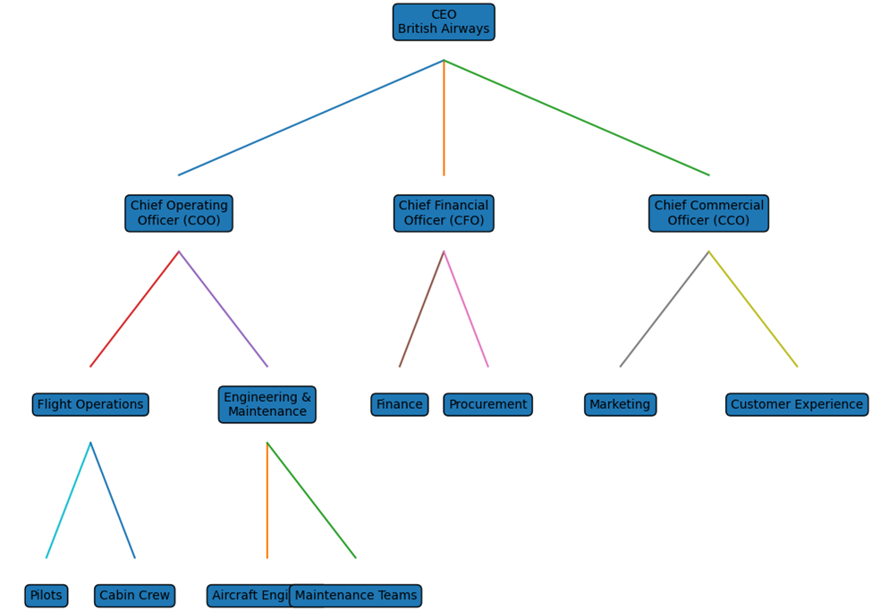

Description of the Organizational Chart

The organizational chart above presents representation of the structure
commonly found in large airline organizations such as British Airways. At the top of the
structure is the Chief Executive Officer (CEO), who is responsible for the overall leadership,
strategy and performance of the airline.
Reporting directly to the CEO are several senior executives including the Chief Operating Officer (COO),
Chief Financial Officer (CFO) and Chief Commercial Officer (CCO). The COO is responsible for the day-to-day
operations of the airline, including flight operations and engineering maintenance. The CFO manages financial
planning, budgeting and procurement processes, ensuring that the airline remains financially sustainable.
The CCO oversees commercial activities such as marketing, sales and customer experience.
Under the operational divisions there are specialized teams responsible for key activities. For example,
Flight Operations supervises pilots and cabin crew, ensuring safe and efficient flights. Engineering and
Maintenance manages aircraft engineers and maintenance teams who maintain aircraft safety and technical
reliability.
This layered structure reflects the hierarchical and role-based culture typical in aviation organizations.
Clear reporting lines and specialized departments allow the airline to coordinate complex operations while
maintaining strict safety and regulatory compliance.

Adaptation to the External Environment

Organisational culture plays a crucial role in determining how effectively British Airways operates on a day-to-day basis. In a complex and safety-critical industry such as aviation, culture is not only a support mechanism but a fundamental requirement for ensuring coordination, reliability and performance.
One of the keyways in which culture supports effective functioning at British Airways is through its strong emphasis on safety and compliance. Employees are trained to follow strict operational procedures, safety protocols and reporting systems. This shared understanding reduces uncertainty and ensures that all staff operate within clearly defined guidelines. As highlighted by aviation research, organisations with strong safety cultures tend to experience fewer operational incidents and higher levels of reliability (FAA, 2026). In this context, BA’s culture directly contributes to safe and stable operations.
Another important benefit of BA’s culture is consistency across operations. Airlines operate across multiple locations, time zones and teams, which requires a high level of coordination. The role-based culture at BA ensures that employees follow standardised procedures regardless of location. This consistency improves efficiency, reduces errors and allows the organisation to maintain a reliable service for passengers.
Furthermore, organisational culture supports clear communication and accountability. In aviation, effective communication is essential for safety and operational performance. British Airways promotes structured communication systems, such as briefings, reporting channels and formal decision-making processes. These systems ensure that information is shared accurately and that responsibilities are clearly understood by all employees.
However, while BA’s culture supports operational effectiveness, it can also create certain challenges. The organisation’s strong focus on procedures and hierarchy can sometimes lead to limited flexibility. Employees may feel constrained by strict rules and may be less likely to take initiative or propose new ideas. In rapidly changing situations, such as operational disruptions or customer service issues, this lack of flexibility can slow response times.
Additionally, the presence of strong professional subcultures within British Airways can affect collaboration. Different departments, such as flight operations, engineering and customer service, may prioritise their own objectives rather than focusing on overall organisational performance. This can lead to communication gaps and delays in decision-making, particularly when cross-functional coordination is required.
Another potential limitation is bureaucracy, which can arise from hierarchical structures and multiple levels of approval. While these processes ensure accountability and risk management, they can also reduce organisational agility. In a competitive and fast-changing industry, organisations must be able to respond quickly to customer needs and external challenges.
Despite these challenges, British Airways’ organisational culture remains largely an enabler of effective functioning. The benefits of safety, reliability and consistency outweigh the limitations, particularly in an industry where mistakes can have serious consequences. However, to improve overall effectiveness, BA must continue to balance its structured culture with greater flexibility, innovation and collaboration.
In conclusion, organisational culture at British Airways plays a central role in supporting effective operations. While it provides strong foundations for safety and coordination, ongoing improvements in flexibility and cross-functional collaboration will be essential for maintaining long-term organisational success.

Effective Functioning of the Organization

Organizational culture has a direct impact on how effectively an organization functions. At British Airways, culture generally supports reliable operations and coordinated teamwork across departments.
One major advantage of BA’s culture is its emphasis on safety and compliance. Employees are trained to follow strict procedures and maintain high operational standards. This discipline reduces the likelihood of accidents and supports regulatory compliance.
Another advantage is organizational consistency. Standardized procedures help ensure that employees from separate locations and departments perform tasks in an equivalent way. This consistency is essential for airlines that operate large networks and manage complex logistics.
However, cultural characteristics that support stability can also create challenges. Highly structured organizations may struggle to respond quickly to unexpected changes or operational disruptions. Employees may feel reluctant to challenge established procedures or propose innovative solutions.
Strong departmental subcultures may also reduce communication between teams. When departments operate independently, collaboration may become more difficult and organizational learning may slow down.
Despite these potential challenges, BA’s organizational culture generally acts as an enabler of effective functioning by providing clear expectations, professional standards and operational discipline.

The Influence of Organizational Culture on Performance

Organizational culture has a significant impact on organizational performance at British Airways. Culture influences several key performance areas including safety outcomes, operational efficiency, customer satisfaction and financial performance.
A strong safety culture improves operational reliability and reduces the likelihood of accidents. Research suggests that effective safety reporting systems and learning cultures contribute to improved safety performance within aviation organizations (FAA, 2026).
Customer experience is another area where culture affects performance. Employees who share service values and communication standards are more likely to deliver positive customer experiences. Research in the aviation sector shows that cultural factors and service interactions influence passenger satisfaction and airline reputation (Mansouri, 2026).
Financial performance can also be linked to organizational culture. IAG reports indicate strong financial results supported by disciplined operational practices and strategic investments in fleet and technology (IAG, 2024; IAG, 2026).
However, culture may also negatively affect performance if organizations become too resistant to change. Excessive bureaucracy or rigid procedures may limit innovation and slow organizational adaptation. For airlines operating in a rapidly changing industry, maintaining a balance between operational discipline and flexibility is essential.
Overall, the culture at British Airways plays a significant role in supporting safety, service quality and financial stability.

Conclusion

Organizational culture plays a fundamental role in shaping the structure, decision-making processes and performance of British Airways. The airline operates in a highly regulated environment where safety, reliability and service quality are essential.
The analysis shows that BA’s organizational culture is primarily characterized by role culture supported by elements of task culture. This combination allows the organization to maintain strong operational discipline while also encouraging innovation in areas such as digital transformation and sustainability.
Although BA’s culture provides stability and reliability, it can also create challenges when bureaucratic procedures slow decision-making or when departmental divisions reduce collaboration. Leaders must therefore ensure that organizational structures remain flexible enough to support innovation and adaptation.
In conclusion, the organizational culture of British Airways acts as both a stabilizing force and a strategic asset that supports long-term organizational performance in a competitive global industry.

References
British Airways (2024a) BA Better World 2024 Report. https://basustainabilityreport.co.uk/ (Accessed: 28 February 2026).
British Airways (2024b) BA Better World: Planet. https://www.britishairways.com/content/information/about-ba/ba-better-world/planet (Accessed: 28 February 2026).
Civil Aviation Authority (CAA) (2022) The UK National Aviation Safety Plan 2022–2024. https://www.caa.co.uk/publication/download/19861 (Accessed: 28 February 2026).
CIPD (2023) Organizational culture and behavior. https://www.cipd.org/uk/knowledge/factsheets/organisational-culture-and-behaviour-factsheet/ (Accessed: 28 February 2026).
Deloitte (2025) Aerospace and Defense Industry Outlook. https://www.deloitte.com/us/en/insights/industry/aerospace-defense/aerospace-and-defense-industry-outlook.html (Accessed: 7 March 2026).
FAA (2026) Targeted Review of Safety Culture Interventions. https://www.faa.gov/data_research/research/med_humanfacs/oamtechreports/media/202605.pdf (Accessed: 7 March 2026).
Hofstede Insights (2023) Country comparison tool. https://www.hofstede-insights.com/country-comparison/ (Accessed: 14 March 2026).
IAG (2024) Annual Report and Accounts 2024. https://www.iairgroup.com/media/4qxgaavc/iag-annual-report-and-accounts-2024.pdf (Accessed: 14 March 2026).
IAG (2026) Full year results 2025. https://www.rns-pdf.londonstockexchange.com/rns/6078U_1-2026-2-26.pdf (Accessed: 21 March 2026).
Kabashkin, I. (2025) Decision-Making Framework for Aviation Safety. https://www.mdpi.com/2076-3417/15/3/1626 (Accessed: 21 March 2026).
Mansouri, S. (2026) Airline customers and cultural differences. https://www.sciencedirect.com/science/article/pii/S0969699725002236 (Accessed: 28 March 2026).
Pratama, G.B. (2025) National culture and aviation safety. https://www.sciencedirect.com/science/article/pii/S0022437524002019 (Accessed: 28 March 2026).
Schein, E.H. and Schein, P. (2022) Organizational Culture and Leadership. 6th edn. Hoboken, NJ: Wiley. Available at: https://www.wiley.com/en-gb/Organizational+Culture+and+Leadership%2C+6th+Edition-p-9781119212041 (Accessed: 28 March 2026).

