STUDENT FEEDBACK FORM

Generic Assessment Criteria |  | Marks available | Marks  awarded
1. Engagement with Literature Skills
.
 |  | 20
2. Knowledge and Understanding Skills

 |  | 10
3. Cognitive and Intellectual Skills

 |  | 30
4. Practical Application Skills

 |  | 30
5. Transferable Skills for Life and Professional Practice

 |  | 10
Assessment Mark (Assessment marks are subject to ratification at the Exam Board. These comments and marks are to give feedback on module work and are for guidance only until they are confirmed. ) | Late Submission Penalties (tick if appropriate) |  |  | %
 | Up to 1 week late (40% Max) |  |  | %
 | Over 1 week late (0%) |  |  | %

Effectiveness of exercise as a treatment modality for rotator cuff repair: A Systematic Review

Abstract
A literature review of studies investigating rotator cuff activation during the early rehabilitation stages of healing post-surgical rotator cuff repair. During rehabilitation it is essential to appropriately load the targeted tissue to promote healing and prevent capsular adhesions without damaging the repair. The rehabilitator must be knowledgeable of the anatomy and physiology of the healing of a rotator cuff repair, understand the planes of movement, speed and type of resistance used. Electromyography (EMG) delivers a useful means to establish muscle activation level during specific rehabilitation exercises. Undergraduate sport therapists/ clinicians can benefit massively from this data since clinicians can see the demanding exercises from least to most during a selected number of therapeutic exercises which can be integrated into a rehabilitation protocol during the first 6 weeks during this maximum protection phase post-surgery.

Introduction
The rotator cuff contains 4 muscle tendon units that stabilise the humeral head within the shoulder joint and aid in moving the shoulder joint (Hudak et al., 2017). “Rotator cuff tear” refers to partial or full discontinuation of 1 or more of these units due to traumatic injury or degeneration (age related). Approximately 54% of adults older than 60 years have a partial or complete rotator cuff tear, compared with only 4% of those aged 40 to 60 years. Symptoms include pain, weakness, and limitation of motion (Ribiero et al., 2020). An MRI based study found asymptomatic partial and full-thickness rotator cuff tears to occur in 50% of individuals >60 years of age (Russell et al., 2014). The supraspinatus tendon is the most injured due to its anatomical position, as it is easily stressed with tensile and compressive overload (Bunker, 2002). Although this condition may be related to social life and can be associated with chronic pain, weakness and dysfunction (Kolber and Hanney, 2012). A recent systematic review with meta-analysis investigated the different approaches to a rotator cuff repair with the outcome of conservative treatment the most effective (Piper et al., 2018).
Rotator cuff repair surgery is effective in the reduction of pain and to restore normal joint function and strength (Gaunt et al., 2015). This is combined with exercise therapy where continuous range of movement assessments will be carried out, assessing manual passive range of motion (ROM) and active and assisted ROM. While all therapists follow a procedure with rehabilitation stages in order to return to full function or return to play. Michener et al., (2004) investigated the effectiveness of rehabilitation for patients with subacromial impingement syndrome. Whereas, joint mobilisation and exercise demonstrated beneficial outcomes in function, pain and disability, but it was concluded that the results were unclear due to the lack of information regarding frequency, intensity, level and supervision for the interventions, so even though the study found benefits it may not always be a true positive finding. Furthermore, the success of non-operative treatment within chronic patients is not currently known, with no gold standard protocol to guide treatment (Marta et al., 2013). Although, the modern advancement of surgical repair equipment and techniques, many rotator cuff repairs do not clinically heal (Gaunt, 2015). Recent literature has produced rates of retear ranging from 10% in small tears (<2 mm) to 57% in large tears (>6mm) (Choi et al., 2014). There are numerous factors that play a role in the success or failure of repairs that include patient related factors, rehabilitation variables or surgery related variables (Gaunt et al., 2015). There is a lot of controversy within the literature to show which rehabilitation exercises are suitable for the rotator cuff repair in the first 6 weeks in relation to the type, volume and intensity to facilitate optimal healing of the repair and preventions of adhesions (Gaunt et al., 2015). As this tendon-complex must be managed appropriately with the correct amount of load in order to promote healing without damaging the repair (Gaunt et al., 2015). Electromyography (EMG) is a popular method for evaluating skeletal muscle activity and function through the capture electrical activity by collecting a signal via electrodes placed on the skin over the intended muscle or another method by fine-wire electrodes placed directly into the muscle which is known as intramuscular EMG (Waite et al., 2010), EMG can provide information when, how, how much and how often a muscle is active throughout its ROM (Escamilla et al., 2019).
This systematic review investigates the effectiveness of exercise as a treatment modality for a chronic rotator cuff repair, selected articles were reviewed to determine their level of evidence and potential sources of bias. Utilising primary studies conducted using electronic databases Medline via PubMed, the Cochrane database, and physiotherapy evidence database (PEDro). Moreover, a manual search was conducted including general internet search, screening of the literature references listed in the collected articles. A manual search for the relevant studies in relation to the topics of tendon healing and length of immobilisation. The literature reviewed is based on the PICO concept of Cochrane Institute. The levels of evidence were classified based on the oxford centre for evidence-based medicine 2009. The PEDro scale was used to analyse the individual studies and the systematic reviews were recorded using AMSTAR. Studies that showed the highest level of evidence was included, for example if there was two level I articles found, level II articles wouldn’t need to be included. This review was focused predominantly on chronic pathologies (mixed gender aged 40+) with exercise therapy as the intervention, patients who do not take part in high intensity physical activity or subjects who do not take part in resistance training. The main outcome is to determine the effectiveness of exercise on pain and dysfunction of patients with chronic rotator cuff tears/ repairs.
Methods
Eligibility criteria
Studies were selected according to the following criteria: population, outcome of interest and study design. The inclusion criteria were patients aged 40+, rotator cuff pathology, non-athletic background which means they take part in low-intensity or no physical activity a week, and post-surgery patients. Studies that investigated EMG activity for the supraspinatus, teres minor, infraspinatus or subscapularis. Studies which were published in English, randomised trials, case studies or cohort studies. The exclusion criteria states that patients without a rotator cuff tear, no EMG activity stated, presence of a physical health/ disease condition which could affect the intervention, for example a coronary heart disease patient would be not liable to take part in the study. In order to have optimal homogeneity of studies, studies/ exercises that did not normalise EMG activity, exercises that lacked detailed information, exercises that are not practical to use as rehabilitation exercises and exercises that used exercise machines with variable resistance were excluded from the review. There are no restrictions on dates of publication. Due to the resources attributed to the project, only articles in English are included and searches are restricted to 3 databases (Sports discuss, Pub Med and Cochrane library).
Population
Studies involving adults 40+ years was included. Patients who are in the rehabilitation phase post-surgery who are tailored for this specific population based on their specific injury (partial or complete rotator cuff tear). If patients who are under this age category, presence of a health/disease condition (e.g. cancer) or has no injury within the rotator cuff region will be excluded from the study.
Intervention
The review includes studies involving patients with rotator cuff repairs with exercise as a treatment modality post-surgery in order to gain full function and for the patients to be pain-free. Interventions are not included if articles do not state rotator cuff repairs or exercise therapy as a treatment modality or rehabilitation of the rotator cuff, or if it doesn't state exercise or rehabilitation of the rotator cuff repair.
Control/Comparator
The effectiveness of exercise as a treatment modality was reported to allow for comparison between studies any factors associated with successful outcome (full ROM and pain free).
Outcomes
The primary outcomes were the effectiveness of exercise to regain full function post-surgery, investigating EMG synthesis. These will be modifiable factors which the participants experience during participation in the programme. During the rehabilitation phase, pain was the main objective marker within the early stages, once pain subsides full ROM can be obtained via passive ROM, soft tissue release/stretching and through exercises that will further strengthen the shoulder girdle in order to cope with the high ROM joint. Studies aiming to identify effective interventions as an alternative to exercise will not be included as the focus of the review was to look how exercise was effective to pain and dysfunction looking at various types of exercise.

Search Strategies and sources
To retrieve studies, evidence-based medicine reviews and Cochrane databases of systematic reviews was utilised. The following terms were used together and in isolation: chronic rotator cuff repair, randomised controlled trial(s); cohort studies; physical therapy; passive movements; shoulder outcomes; rotator cuff surgery; current EMG research; rankings of exercise; rehabilitation and therapeutic exercise. Additionally, other systematic reviews and keywords in papers within the domains of exercise as a treatment post-surgery were used to develop a thorough strategy. All results were downloaded and stored on One drive (https://onedrive.com). One drive was used to remove duplicates, and the remaining were uploaded to Covidence (https://www.covidence.org/home) for screening and data extraction. Any more relevant studies were found through the following methods:
- Screening for reference lists
A systematic review found in the search was assessed to see if its relevant to the research question using phase 1 of the risk of bias in systematic review’s tool. The ones that are relevant will have the citations for the studies included in their reviews downloaded into Onedrive, which will then be recorded in the PRISMA diagram. If there are any copies/duplicates from the previous search results, they will be removed, and the remaining papers will be uploaded into Covidence for screening.
- Contacting experts in this field
Experts of exercise therapy post-surgery rehabilitation were reached out. These elite level individuals were identified through the screening process. Correlating authors for any protocol papers or conference abstracts for studies were approached via email and asked if there are any full texts of work or preliminary data that is theirs.
Study designs
This review includes experimental, randomised-controlled trials and narrative reviews. Only studies which are set in Western high and middle-income countries were included. This might allow comparison between exercise therapy post-surgery vs no exercise post-surgery due to higher levels of homogeneity between these two.
Screening and data collection
All screening and data extraction was conducted in Covidence. Initial screening of studies is based on information contained in the titles and abstracts. All screening was conducted by MT with a random selection of 50% being screened independently by a second reviewer. A data extraction form was developed and piloted, which is used to extract data from the included studies on exercise rehabilitation treatment outcomes, in relation to pain and dysfunction with rotator cuff repairs. Data on the format, duration and location of each programme is extracted and compared on success rates, adherence and attrition.
Risk of bias assessment
Risk of bias assessment was conducted by MT. This will be checked between the research team who will check these assessments for all included studies. The following appraisal tools from the critical appraisal skills programme will be used to assess the included studies: CASP qualitative checklist, CASP randomised controlled trial checklist and CASP Cohort study checklist (CASP, 2010).
Data synthesis
The data from the studies will be synthesised narratively. The synthesis combines both qualitative and quantitative data. Anticipating that most of the extracted data is qualitative, where quantitative data is available there will be variability in what factors are assessed leaving limited scope for meta-analysis. Exercise variety varies between studies and to synthesise this evidence, a narrative approach was utilised.
Results
The search found 6 studies met the inclusion criteria for the infraspinatus (Gurney et al., 2016; Herrington et al., 2015; Anderson et al., 2010; Gaunt and McCluskey, 2010; Long et al., 2010; Uhl et al., 2010), 5 for the supraspinatus (Gurney et al., 2016; Jung et al., 2015; Gaunt et al., 2010; Long et al., 2010; Myers et al., 2005), 3 for the subscapularis (Gurney et al., 2016; Jung et al., 2015; Wickham et al., 2010) and 2 for the teres minor (Gurney et al., 2016; Marta et al., 2013). Muscle activation at 0- 20% MVIC is considered low-level as these studies only focused on an EMG activity between this range as this is appropriate level of activation performed during the first 6 weeks of rotator cuff rehabilitation post-surgery (Gaunt et al., 2015). For all four rotator cuff muscles, the EMG activity was ranked and summarised from lowest to highest to allow meaningful comparison of activities. This can be shown in figures 1-6.
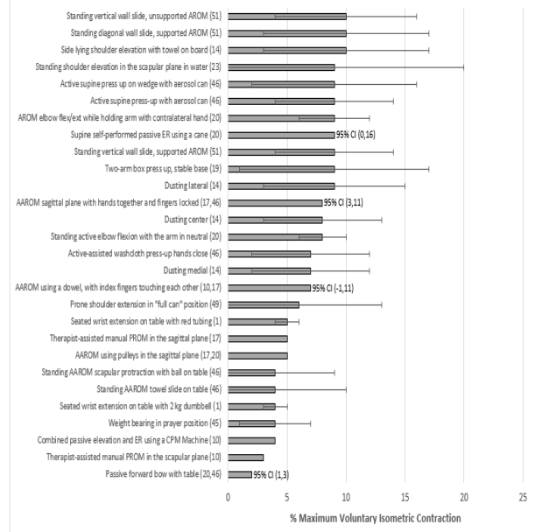
Figure 1: Shows infraspinatus percentage maximum voluntary isometric contraction ranking of exercises (0-10%) (Wills et al., 2016).
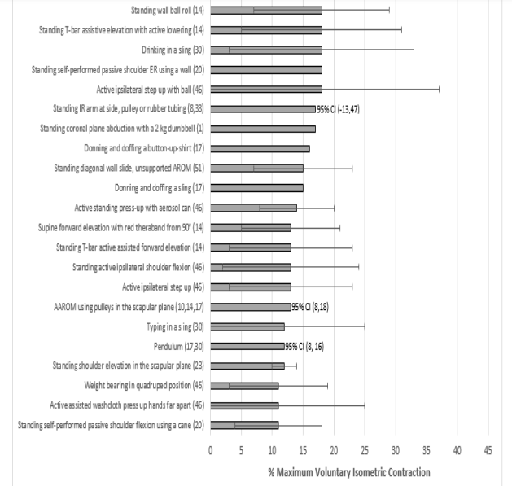
Figure 2: Shows infraspinatus percentage maximum voluntary isometric contraction ranking of exercises (11-20%) (Wills et al., 2016).
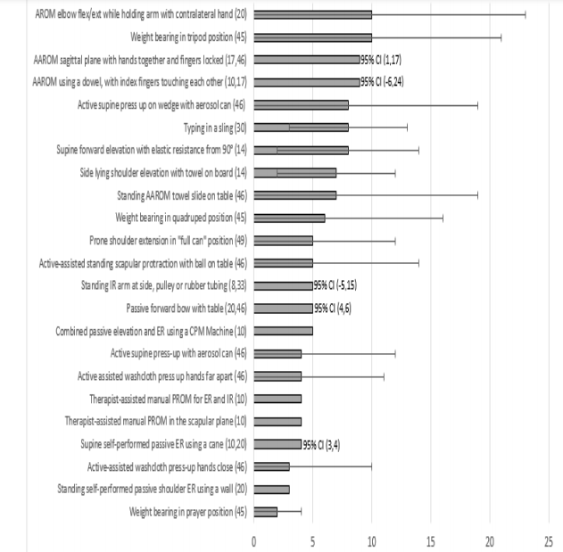
Figure 3: Shows supraspinatus percentage maximum voluntary isometric contraction ranking of exercises (1-10%) (Wills et al., 2016).
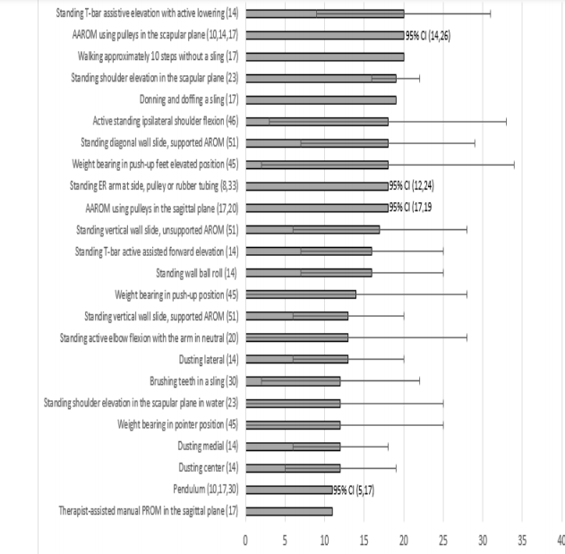
Figure 4: Shows supraspinatus percentage maximum voluntary isometric contraction ranking of exercises (11-20%) (Wills et al., 2016).

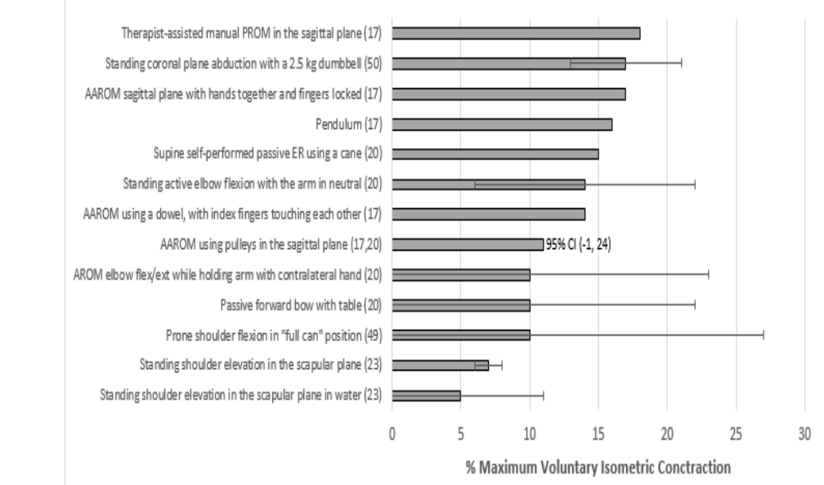

Figure 5: Shows Subscapularis percentage maximum voluntary isometric contraction ranking of exercises (0-10%) (Wills et al., 2016).
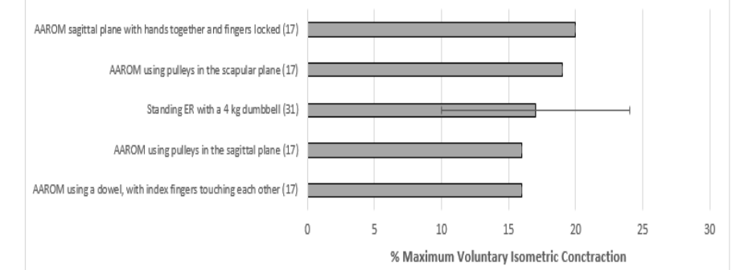
Figure 6: Shows teres minor percentage maximum voluntary isometric contraction ranking of exercises (0-10%) (Wills et al., 2016).

Discussion
The main outcome of post-surgical rehabilitation for rotator cuff tears is to allow time for the healing to take place around the repaired rotator cuff tendon while reducing the risk of atrophy to the muscles and stiffness (Gaunt et al., 2015; Van der Meijden et al., 2012). There are different phases during the rehabilitation process which all have the standard of care, that starts with maximum protection to the affected joint/ structure to progress into minimum protection (Gaunt et al., 2015). With rotator cuff rehabilitation it is vital that these structures do not get overloaded too quickly as this will result in further problems as the tendon could potentially retear, following Magnussons model where cyclic loading is applied giving the tendon time to heal (Magnusson et al., 2009). EMG studies investigate the rotator cuff during specific activities, which has been an essential part of establishing these protocols (Gaunt et al., 2015, Van der Meijden et al., 2012). Within these early stages heavy and long-winded sessions are avoided like previously mentioned it could result in retear of the tendon, making sure tendon integrity and reducing the risk of gapping. EMG activity is beneficial within these early stages since it is visible to how much an individual muscle is contracting during an exercise to ensure the tendon is not overloaded. Isometrics are used as these types of exercises are categorised and utilised a lot within the early stages as the muscle contracts but does not lengthen or shorten, it just contracts at the same length, with muscle activation levels <20% which can be seen in figures 1-6 (Raschhofer, 2017). Strengthening exercises are classified that produce >40% EMG activity, these types of exercises are introduced in the later stages once the tendon has support from the surrounding muscles and pain has completely subsided (Sgroi and Cilenti, 2018).

This review discovered 50 low-level exercises for infraspinatus, 47 low-level exercises for supraspinatus, 13 low-level exercises for subscapularis and 5 low-level exercises for teres minor. These results exceed the amount of exercises any rehabilitation protocol would include but it is to show the most common/ theorised exercises within this early maximum protection stage of healing. (Van der Meijden et al., 2012). There are many passive ROM exercises which is categorised as low-level activation, this outcome is reliable within the early stages within this maximum protection phase as the results from these studies (Kropf and Sewards; Massachusetts, 2007) explains and shows how much the rotator cuff is activated during these types of exercises. Active assisted ROM exercises are most introduced in the moderate stages of healing just after the 6-week marker normally, although EMG activity for a variety of shoulder exercises were analysed in this study and shown levels of activation <20%. By utilising the aid of a dowel, T-bar, pulleys or a towel this exercise promoted assistive elevation of the upper extremity with supraspinatus and infraspinatus activity was closer to 10% which is like pendulum levels of activation, for a sports therapist deciding on including these within the early stages, it is advised not to but if carried out with the correct equipment and intensity it can be introduced in the later stages of the maximum protection phase (Raschhofer et al., 2017). Data collected from the pendulum exercise (a very popular prescribed exercise for rotator cuff muscles) was ranked 25th (11%) out of the 47 supraspinatus activation levels. This makes it the highest activation level in relation to all the other passive interventions for the rotator cuffs. EMG activity for the infraspinatus and subscapularis were also >10% during the pendulum, this could be due to the patient’s difficulty maintaining true passive movement throughout the arm swinging included in this exercise. As a common mistake made by patients is for them to actively move the shoulder which results in unwanted activation from the rotator cuff muscles, where the shoulder is meant to move via the trunk (Long et al., 2010). When prescribing this exercise to a patient it is important to educate the patient in this to ensure the correct form is carried out to gain the maximum benefits the exercise can produce (Long et al., 2010).
The activation level of common activities of daily living were also investigated in this study. Even though these activities were not prescribed to the patient, the patient will still carry out these activities daily, this is included to promote awareness of the activation level during these daily activities. Again, it would benefit the patient to educate them about this as these types of activities can impact rotator cuff healing. Only a selected number of daily activities were included some with a sling worn and some without just to put this into perspective as patients will be wearing the sling carrying out activities as well as not wearing a sling carrying out activities. Drinking a bottle while wearing a sling produced 19% activating for the infraspinatus and 20% activity for the supraspinatus. EMG activity for buttoning and unbuttoning a shirt produced activity >20% for the supraspinatus. Brushing teeth and typing while wearing a sling, supraspinatus remained near 10% for both and infraspinatus ranged from 12% to 20% (Jung et al., 2015). Also, when walking at high frequency, this can create a substantial threat to rotator cuff repair integrity, while educating the patient of the proper use of a sling can reduce these risks and create unnecessary stress to the repair, to further continue healing within this maximum protection phase.
Conclusion
The main purpose of this review was to examine the EMG activity around the current research on rotator cuff muscles and then rank the most demanding exercises from least to most for patients to apply during the first 6 weeks post-surgical repair to maximise healing and prevent further damage to the tissue or even retearing. Throughout this review the results show that many therapeutic interventions not commonly prescribed in the rehabilitation process may be more beneficial during this early stage after a repair. The muscle activation of the involved rotator cuff muscles ranged from 2-20%, which categorised them all in the low-level activation region as has been described to be clinically meaningful in the literature. The results shown the pendulum, which is most included in this early phase, by indicating that it produced a high activation level that was seen to surpass the other passive activities. Also, the results indicated the risks and dangers presented by the sling non-compliance and activities of daily living on repair integrity. Additionally, by adhering to a gradual progression based on the EMG activity, rehabilitation exercises can be advanced in a systematic fashion that considers the plane of the movement, position of extremity and speed of the movement. Based on these results a clinician can create a standardised protocol to utilise in order to make sure this gradual progression occurs, combined with the expertise knowledge of the rotator cuff activation levels. Utilising this method and the increased knowledge of the clinician and patient, rotator cuff repairs can be better protected during these early stages during the inflammation and proliferative phases to maximise protection and to prevent re-tear to this structure.

Word count : 3921

References
Andersen, L., L., Andersen, C., H., Mortensen, O., S., Poulsen, O., M., Bjornlund IBT, Zebis, M., K. (2010) ‘Muscle activation and perceived loading during rehabilitation exercises: Comparison of dumbbells and elastic resistance’, Physical Therapy, 90(4), pp. 538-549.
Bunker, T. (2002) ‘Rotator cuff disease’, Current Orthopaedics, 16(3), pp. 223–233.
Choi, S., Kim, M., K., Kim, G., M., Roh, Y-H., Hwang, I., K., Kang, H. (2014) ‘Factors associated with clinical and structural outcomes after arthroscopic rotator cuff repair with a suture bridge technique in medium, large, and massive tears’, Journal of Shoulder Elbow Surgery, 23 (11), pp.1675-1681.
Gaunt, B.,W., Uhl, T., L. (2015) ‘The challenge of rotator cuff repair rehabilitation - progressing exercises safely: Understanding healing and using EMG evidence as a guide’, APTA Combined Sections Meeting.
Gurney, B., Mermier, C., LaPlante, M., Majumdar, A., O’Neil, K. (2016) ‘Shoulder electromyography measurements during activities of daily living and routine rehabilitation exercises’, Journal of Orthopaedic Sports Physical Therapy.
Herrington, L., Waterman, R., Smith, L.(2015) ‘Electromyographic analysis of shoulder muscles during press-up variations and progressions’, Journal of Electromyography Kinesiology, 25(1), pp. 100-106.
Hudak, P., L., Amadio, P., C., Bombardier, C. (2017) ‘Development of an upper extremity outcome measure: the DASH (disabilities of the arm, shoulder, and head)’, American Journal of Indian Medicine, 60(8), pp.527–546.
Jung M-C, Kim S-J, Rhee J-J, Lee D-H (2015) ‘Electromyographic activities of the subscapularis, supraspinatus, and infraspinatus muscles during passive shoulder and active elbow exercises’, Knee Surgical Sports Traumatology Arthroscopy, pp. 1-6.
Keener, J., D., Galatz, L., M., Stobbs-Cucchi, G., Patton, R., Yamaguchi, K. (2014) ‘Rehabilitation following arthroscopic rotator cuff repair: A prospective randomized trial of immobilization compared with early motion’, Journal Bone Joint Surgery America, 96(1), pp.11- 19.
Kjær, M., Langberg, H., Heinemeier, K., Bayer, M.L., Hansen, M., Holm, L., Doessing, S., Kongsgaard, M., Krogsgaard, M.R. and Magnusson, S.P. (2009) ‘From mechanical loading to collagen synthesis, structural changes and function in human tendon’, Scandinavian Journal of Medicine & Science in Sports, 19(4), pp.500-510.
Kolber, M., J., Hanney, W., J. (2012) ‘The reliability and concurrent validity of shoulder mobility measurements using a digital inclinometer and goniometer: a technical report’, International Journal of Sports Physical Therapy, 20(7), pp.306–313.
Kropf EJ, Sewards MJ, ‘Temple Orthopaedics and Sports Medicine. Arthroscopic rotator cuff repair: Physical therapy protocol’ Temple Orthopaedics and Sports Medicine, http://ortho.templehealth.org/content/default.htm
Long, J., L., Ruberte, T., R., A., Skendzel, J., G., Jeon, J., Hughes, R., E. (2010) ‘Activation of the shoulder musculature during pendulum exercises and light activities’, Journal of Orthopaedic Sports Physical Therapy, 40(4), pp. 230-237.
Marta, S., Pezarat-Correia, P., Fernandes, O., Carita, A., Cabri, J., De Moraes. A. (2013) ‘Electromyographic analysis of posterior deltoid, posterior rotator cuff and trapezius musculature in different shoulder exercises’, International Sports Medicine Journal, 14(1), pp. 1-15.
Massachusetts General Hospital Orthopaedics. ‘Rotator cuff repair rehabilitation protocol’, Massachusetts General Hospital. http://www.massgeneral.org/ortho/
Myers J., B., Pasquale M., R., Laudner K., G., Sell T., C/, Bradley J., P., Lephart S., M. (2005) ‘On-the-field resistance-tubing exercises for throwers: An electromyographic analysis’, Journal of Athletic Training, 40(1), pp. 15-22.
Piper, C., C., Hughes, A., J., Ma, Y. (2018) ‘Operative versus nonoperative treatment for the management of full-thickness rotator cuff tears: a systematic review and meta-analysis', Journal of Shoulder Elbow Surgery, 27(4), pp.572–576.
Raschhofer, R., Poulios, N., Schimetta, W., Kisling, R. and Mittermaier, C. (2017) ‘Early active rehabilitation after arthroscopic rotator cuff repair: a prospective randomized pilot study’, Clinical Rehabilitation, 31(10), pp.1332-1339.

Ribeiro, L.; Cools, A., Paula, C. (2020) ‘Rotator cuff unloading versus loading exercise program in the conservative treatment of patients with rotator cuff tear: protocol of a randomised controlled trial’, British Medicine Journal, 10,(12), pp. 123-129.
Russell, R., D., Knight, J., R., Mulligan, E., Khazzam, M., S. (2014) ‘Structural integrity after rotator cuff repair does not correlate with patient function and pain: A meta-analysis’, Journal of Bone Joint Surgery America, 96(4)pp. 265-271.
Sgroi, T.A. and Cilenti, M. (2018) ‘Rotator cuff repair: post-operative rehabilitation concepts’, Current reviews in Musculoskeletal Medicine, 11(1), pp.86-91.
Van der Meijden OA, Westgard P, Chandler Z, Gaskill TR, Kokmeyer D, Millett PJ. (2012) ‘Rehabilitation after arthroscopic rotator cuff repair: Current concepts review and evidence based guidelines’, International Journal of Sports Physical Therapy, 7(2), pp.197-218.
Wells, S.N., Schilz, J.R., Uhl, T.L. and Gurney, A.B. (2016) ‘A literature review of studies evaluating rotator cuff activation during early rehabilitation exercises for post-op rotator cuff repair’, Journal of Exercise Physiology, 19(3), p.70.
Wickham J, Pizzari T, Stansfeld K, Burnside A, Watson L. (2010) ‘Quantifying “normal” shoulder muscle activity during abduction’, Journal of Electromyography Kinesiology, 20(2), pp. 212- 222.

