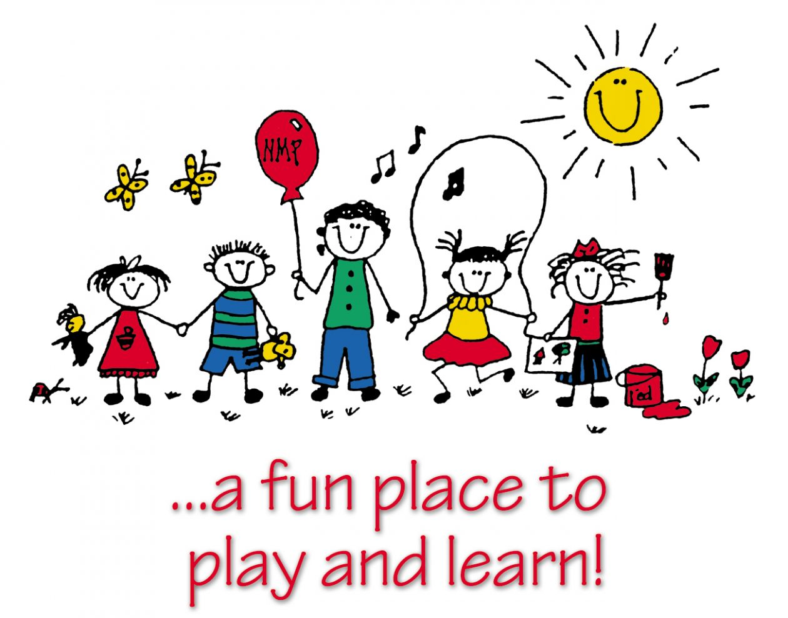

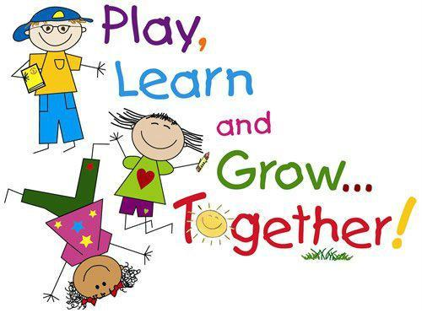
(Source: Greenmill Primary School and Early Childhood Centre, 2019)

Children’s Play, Principles and Practice

(Source: Pinterest, no date)

Part 1 – Play types and the importance of self-directed and holistic play.

Play should be self- directed allowing the children to freely choose the activities they take part in, the play therefore will be natural, intrinsically motivated and child led. Play is difficult to define as there various different types of play, however on behalf of Play Wales, Hutt (2002) states within their play policy that children should have access to stimulating play experiences that are full of challenges and enrichment allowing the children to explore the world around them, through freely chosen play. This self- directed play will benefit the child’s learning, overall development and wellbeing. Similarly, the UNCRC recognises that every child has the right to play, regarding article 31 as a fundamental right that is vital to the child’s health and happiness (Children and Young Peoples Commissioner Scotland, 2020). Powell and Wellard (2008, cited in Howard and McInnes, 2012) recognised play as a beneficial factor in child development, therefore specific play policies have been introduced ensure children have access to play opportunities that will aid their health, social interaction and education. Play is essential to key areas development such as the cognitive, physical, social, and emotional well-being of children (Ginsburg, 2007).

How can self-directed play benefit children?
- Builds self-confidence. Children learn there is a lot they can do for themselves. They are able to explore on their own, making their own games and rules which results in them feeling success from what they have achieved.
- Encourages independence. Children learn independence through self-directed play from a young age.
- Stimulates imagination. Children are able to explore their creativity during self-directed play. They are able to invent and explore their own story lines as they play freely.
- Enhances problem-solving. During self-directed play, the child can make up their own rules that they will have to figure out how to make work the way they intended.
- Allows children to learn at their own pace. There is no timeline or academic targets to meet during self-directed play. Therefore, the children have opportunities to build on their own knowledge and understanding of the world around them.
- Encourages internal motivation. Children are able to define their own successes through self-directed play. This will build upon their innate personal emotions including happiness and joy as children will challenge themselves to try new activities (Hollis Montessori, 2018).

Margaret and Rachel McMillan’s theory was based on the health and wellbeing of the children. The sisters believed that learning through play and imagination enables them to engage with their surroundings and build upon their existing knowledge (Daly, Byers, Taylor, 2004).

Maria Montessori, believes in a self- directed approach that encourages independent learning and collaborative play. The children are therefore able to make creative choices about their play in groups or independently (Montessori Northwest, 2017).

How can adults support self directed play?

It is the role of the adult to facilitate play and ensure there are opportunities and stations set up for each child to play. The adult should only intervene if necessary to enrich play or is invited by the child.

Friedrich Froebel (1782-1852, cited by Steven Bonnay, 2017) suggested that children learn best through play. Froebel believed that adults should follow the children’s natural growth through play, he established the first pre-school where he discovered that at that age children’s development should be enhanced through exploration, individual interests and the outdoors.

The adult should act as the facilitator in order to support the children’s learning and enhance their educational experiences. This is reinforced by Dewey (1859-1952 cited by Steven Bonnay, 2017), as he believed that children should explore through play and activities should be based on the child’s interests and individual stage rather than setting targets or next steps.

According to Michigan State University (2015) adults support play across three stages.
- Planning for play- ensuring the environment is structured around the child’s strengths, abilities and needs which will encourage them to be successful and independent as well as giving the children choices to empower their own learning through play.

Supporting play – praising and validating the child’s efforts will show them that what they are doing is valued. Adults could engage and model positive behaviours through interacting with the child if invited showing they respect their play choices. Adults are also there to prevent conflict, by only intervening if there is a safety concern otherwise conflict resolution should be practiced by the children.

Reviewing play - checking in is a valuable way of learning about the children’s play preferences in order to keep them engaged in the future. Listening to the children’s views about their play space and how it could be made better so they can learn and grow from previous experiences.

Role Play
The list of play types are exhaustive, however role play can be linked with self-directed play as it can be freely chosen and child led. Through role play children are learning about everyday life, routines, rules/ boundaries and how the world around them functions for example playing ‘shops’ and dealing with money or playing ‘house’ and partaking in daily chores or looking after a baby. Children will act out familiar and unfamiliar which allows them to:
- Develop decision making skills
- Develop confidence and self-esteem
- Express their personality
- Develop communication and language skills
- Cultivate friendships
- Use their imagination
- Show initiative
- Investigate real life situations
- Learn cooperation and develop teamwork skills
- Express themselves freely (Early Years Resources, 2016).

Holistic approach to play

Adults work holistically, ensuring the children feel valued and supported. The holistic approach focuses on creating an environment that is both engaging and natural, it encourages social, emotional and psychological growth for the children and influenced Maria Montessori’s development of the ‘Montessori Method’ that favours holistic learning (American Montessori Consultants, 2017).

Similarly, Bruce (2012) based her play centred theories on working holistically. Bruce suggested that children should be able to make more choices about their learning as both biological and social aspects are important when developing through play. Therefore, creating an environment that is calm welcoming and warm will allow children to play freely and happily so they get the most out of their play experiences.

Te Whariki (2017) has adapted an holistic view of their nurseries, they believe in a child centred approach to ensure they are engaged in learning and play activities. Te Whariki’s vision is for all children to be confident, competent communicators and members of society who feel valued and are ready to learn. Through play they encourage a healthy mind, body and soul, secure in their sense of belonging and respectful of cultural values and diversity.

Part 2 – Risk and the benefits

What is ‘risky play?’
Risky play can be defined as:
“A thrilling and exciting activity that involves a risk of physical injury, and play that provides opportunities for challenge, testing limits, exploring boundaries and learning about injury risk” (Sandseter, 2007; Little & Wyver, 2008).

‘Creating opportunities for children to explore and test their own capabilities, to manage risk and to grow as capable, resourceful and resilient children into adulthood.’ (Ouvry, 2014).

Benefits of risky play
Important life skills can be learnt through risky play, such as:
- Building resilience and persistence, emotionally and physically
- Balance and coordination
- Knowledge of own strengths and weaknesses
- Knowledge of own limits and capabilities
- The ability to assess and make judgement about risk
- Handling tools purposefully and safely
- Understanding that actions have consequences
- Develop own confidence and independence
- Resourcefulness
- Creativity and inventiveness
- Curiosity and wonder
- Problem solving
- Develops own self esteem
- Increase academic performance
- Social development and making friends
Risk and challenge can arise anytime in day to day life, therefore allowing children to participate in risky play will aid the development of vital life skills they may need throughout their lives allowing them to mange risk appropriately. (Early Learning Services, 2016).

Good Practice of Risky Play

Risky play should be included in a child’s daily life. This is shown evidently throughout Scotland’s Fort William Schools. These schools are pioneers for outdoor and adventurous risky play to challenge their children. Their schools primary focus is on child-led learning, play, development and resilience outdoors where they are connected to nature allowing them to take risks and improve their health and wellbeing (Stramash Social Enterprise, no date).

Fjortoft (2004) believes that:
“Children who experience wild, rough ground with lots of uneven surfaces, boulders, trees and bushes are more developed physically than children who play in conventional ‘flat’ playgrounds…the more varied the terrain the greater the variety of play opportunities and movements.”

This is shown in many Danish schools as children have free access to the outdoor environment and are exposed to risks such as rivers, climbing trees, sharp objects, steep terrain and wildlife. Studies show that woodland areas, and the use of natural materials such as sticks, inspire children and lead to more enthusiastic and active play among children where they are excited and open to challenge. Natural environments provide children with a variety of risks that they must learn to cope with such as uneven surface and steep slopes (Social Education Gateway, 2019). Amongst the many risks are also life lessons to be learnt that the children are unconsciously learning while managing their own risks. The pedagogue takes a step back from intervention and allows the children’s curiosity to take over as they explore and become familiar with their own strengths and limitations. This is because the pedagogue feels comfortable that the children will not climb higher than they are comfortable, and the children understand the boundaries as in where they are and are not allowed to go. The children experience real life situations and discover what is safe and what isn’t.
As a result of this approach, holistically these opportunities will benefit the children as they are enjoying the experiences and choosing to take part in the activities (SBS Dateline, 2016).

Role of the adult

Risk taking is an essential part of play and being exposed to some risk within a
controlled environment is said to be a benefit as it provides a great learning experience for the children. However, it is the role of the adult to ensure that they set and maintain an acceptable level of risk, so children are able to push themselves and develop skills but not expose them to unacceptable risk. For example, if a child does ride too fast on a bike/scooter out on the yard, fall off and graze their knee- this can be a positive learning experience as they now know the consequences of their actions. However, children need protection from greater injuries, the adults have a duty of care to ensure the safety of the child, for example providing the children with a paddling pool can allow for lots of fun and learning but also has a rick of drowning if not supervised by an adult. Therefore, it is important that the children are monitored but also readily able to enjoy the activity to their own satisfaction as some children may be able to swim or go under water, but some may need encouragement to do this. The appropriate adult should plan exciting activities and risk assess areas daily ensuring equipment is safe and in line with all health and safety policies. The adults should ensure all children are included and then reflect on what went well and what could be improved (Early Years Resources, 2018).

Furthermore, Moyles (1989, cited by Sarah Ivison, 2014) suggested that children should have the freedom to explore without adult intervention then once the child is familiar with a toy or activity, they may need help from an adult on how to use it. Similarly, both Vygotsky (1896-1934 cited by Bonnay, 2017) and Bruner (1978, cited by Mcleod, 2019)
believed that the zone of proximal development is a set of skills or knowledge that the children cannot access independently but with the support of an adult the children could learn through ‘scaffolding’ their skills through play. This meaning that with the help and guidance from a more capable adult during risky play the child could achieve a specific goal that initially was above their own capability.

Part 3 – Observation method

Foundation Phase Profile
According to Welsh Government (2015) the Foundation Phase Profile is a tool used to support assessment of children throughout Foundation Phase that is based on observation. The profile was developed holistically to get an accurate insight of children’s development and their abilities across key areas of learning.
Leech (2008) stated that observations form a vital and fundamental part of the foundation phase profile, underpins practice and is the key to quality provision.
Observation
Each child is unique and have different abilities, therefore, observations are carried out and are best when taken from child -led activities. Observing children when they have chosen what they want to do, who they want to play with and what resources they need, in line with their interests will provide reliable information about the children as individuals (Early Years Matters, 2020).
The Foundation Phase Profile Handbook (2017) argues that observation plays a key role throughout daily life within foundation phase. Observations create an opportunity to record information to determine where the child is on the learning continuum and highlighting any difficulties or exceptional abilities they may have. Observing the children can also help to gage progress made and their individual strengths and weaknesses. The information gathered will then have a positive impact on children’s learning as practitioners can create further opportunities to validate their learning. It has been documented that children may learn and behave differently in different environments, therefore, the observations should take place indoors and outdoors to get an accurate picture of the child. The Foundation Phase Profile is based on both child and practitioner- led activities across an enhanced and continuous provision. This allows for an easier method of observation because specific areas do not need to be set up as the skill ladders have been designed to run across all areas.
The children should be encouraged to show understanding and appreciation of their developed skills by sharing their thoughts and opinions about their progression across the activities they are engaged in. This discussion will help children reflect on their own capabilities and acknowledge any areas where they may need support.
The Profile has been designed to run alongside health assessments in order to identify any developmental delays, special or additional learning needs, ensuring that children receive the support they need.

Without such observations it would be an impossible task to ensure that the planned activities of the setting and the methods used by the appropriate adults are meeting the individual needs of each child.

In addition to this Froebel (1782-1852 cited by Steven Bonnay, 2017) believed that children learn best through play. Therefore, the adults role would be to facilitate opportunities for the child to play during the transition process and to then observe the children and develop and plan activities that would appeal to the child’s interests, their skills and overall readiness to learn.

What does the Foundation Phase Profile not tell us?
There can be some critique of the Foundation Phase Profile including:
- Observations may not show a true reflection of the child- this is because on observation is taken on a small part of the child’s day, where the child may be feeling unwell, it could be completed at a time of day where the child is tired, or generally not interested in the activity because they did not freely chose it.
- ALN – although the profile is designed to be inclusive of all children, the profile does not have sufficient details to fully assess ALN or SEN children. Practitioners would have to use additional assessments designed specifically for children with additional learning needs.
- Environmental factors- an observation may have taken place indoors and the child’s preference would be to play outdoors. This therefore is not self -directed and cannot give a reliable reflection of the child.
- Adult role- an adult could have intervened in the child’s play, voicing a different perspective this can stop play and the children’s engagement and focus may be lost.
- Developmental factors- resources available to the children may be above or below their developmental age, therefore they may show little to no interest in activities because the resources are not suitable.
(The Foundation Phase Profile Handbook,2017)

Part 4– Role of play when undertaking observations and assessments
Paley (1991) a keen observer of children also believes that recognition of the children’s different interests, learning needs, learning styles and responses to the same situations is one of the best ways of teaching children. Writing in the boy who could be a helicopter Paley states: “Without the uniqueness of each child teaching would be a dull, repetitive exercise.”
Observation and assessments therefore are a vital part of children’s education.
The role of play when undertaking observations and assessment is to ensure that children are engaged in self- directed, child- led activities that they are enjoying which is filtered into the necessary areas of learning. This will provide a reliable outlook on the child as they are engaged with their learning through play rather than being set a focused task that they may not enjoy or be able to achieve.
According to Essex County Council (no date) play based assessment is beneficial because skills identification, goals and targets for the children evolve during child- led, self-directed activity. Additionally, observations and assessments done through play will be beneficial as play is a natural expression for most children where they are able to develop new concepts and explore their own feelings and emotions. Therefore, providing practitioners with a reliable insight and understanding of the child’s individual needs and identification of any possible strengths or weaknesses (hsr Psychology, 2020).
General observations of the child’s likes and dislikes, play preferences and appropriate liaison with outside agencies should be undertaken before a play based assessment can be performed.
Observations and assessments of a high standard will be child centred, following their own interests and extending what they are able to excel at. The observations and assessments should be encouraging and aim to further the child’s development across all areas of learning, including areas where the child may struggle or show little interest in. This therefore enables the practitioners to create and plan individual and specific steps to ensure the children reach their full potential and master skills across the curriculum (Foundation Phase Profile Handbook, 2017).

Reference List
American Montessori Consultants (2017) Maria Montessori’s Holistic Approach To Education. Available at: https://www.amonco.org/maria-montessori-holistic-approach/ (Accessed 27.11.19).

Bonnay, S. (2017) ‘Early Childhood Education: Then and Now’, The Spoke [blog]. 25 May. Available at: http://thespoke.earlychildhoodaustralia.org.au/early-childhood-education-now/
(Accessed 21.11.19).

Bruce, T. (2012) Early Childhood Practice. London: SAGE Publications Limited.

Children and Young peoples commissioner Scotland (2020) Article 31. Available at:
https://www.cypcs.org.uk/rights/uncrcarticles/article-31 (Accessed 14.01.20).

Daly, M. and Byers, E. and Taylor,W. (2004) Early years management in practice. Oxford: Heinmann, Educational Publishers.

Early Learning Services (2016) Challenge and risk in children’s play – Is it worth the Risk?
Available at: https://www.earlylearningservices.com.au/2016/10/26/challenge-risk-childrens play/ (Accessed 16.01.20).

Early Years Matters (2020) Observation, Assessment and Planning. Available at: http://www.earlyyearsmatters.co.uk/eyfs/a-unique-child/planning/ (Accessed: 18.01.20).

Early Years Resources (2016) The Importance of Imaginative Play in Child Development. Available at: http://www.earlyyearsresources.co.uk/blog/2016/04/the-importance-of-imaginative-play-in-child-development/ (Accessed 16.01.20).

Early Years Resources (2018) The Importance of Risky Play in Childhood. Available at: http://www.earlyyearsresources.co.uk/blog/2018/10/risky-play-importance/ (Accessed 16.01.20).

Essex County Council (no date) Play-based Assessment in the early years’ setting. Available at: https://www.essexlocaloffer.org.uk/wp-content/uploads/2015/03/Play-based-Assessment.pdf (Accessed: 17.01.20).

Ginsburg, K.R. (2007) The Importance of Play in Promoting Healthy Child Development and Maintaining Strong Parent-Child Bonds. America: Committee on Communications and the Committee on Psychosocial Aspects of Child and Family Health.
Greenmill Primary School and Early Childhood Centre (2019) [image]
Available at: https://blogs.glowscotland.org.uk/ea/greenmillprimaryandeccmain2017/pupil-groups/dyslexia-friendly-schools/6f5d14e1541d128a450e310198a66dd6_clip-art-preschool-clipart-kid-4-clipartingcom-preschool-kids-playing-clipart_1305-1024-2/
(Accessed: 07.01.20).

Hollis Montessori School (2018) Why Encourage Self-Directed Play? Available at: https://hollismontessori.org/blog/2018/2/19/why-encourage-self-directed-play (Accessed 14.01.20).
Howard, J and McInnes, K. (2012) The impact of children’s perception of an activity as play rather than not play on emotional well-being. United Kingdom: Centre for Children and Young Peoples Emotional Health and Wellbeing.
hrs psychology (2020) Play-based assessments. Available at: https://www.hsrpsychology.co.uk/services/specific-assessments/other-assessments/play-based-assessment/ (Accessed 17.01.20).
Hutt, J. (2002) Welsh Government Play Policy. Wales: Welsh Assembly Government.

Ivison, S. (2014) Spiral of Learning- Janet Moyles. Available at: https://prezi.com/9th2z1hcsemc/spiral-of-learning-/ (Accessed 17.01.20).

Leech, S. (2008) How to Observe Children. (2nd Edition) Oxford: Heinemann.

Mcleod, S. (2019) Bruner - Learning Theory in Education. Available at: https://www.simplypsychology.org/bruner.html (Accessed: 16.01.20).

Michigan State University (2015) The power of play – Part 5: Adult roles in child’s play. Available at: https://www.canr.msu.edu/news/the_power_of_play_part_5_adult_roles_in_childs_play (Accessed 15.01.19).

Montessori Northwest (2017) What is Montessori Education? Available at: https://montessori-nw.org/what-is-montessori-education (Accessed: 24.11.19).

Ouvry, M (2014) The benefits of outdoor play. Available at: https://www.kccc.ie/Resources/The-Benefits-of-Outdoor-Play (Accessed: 15.01.20).

Paley, V.G. (1991) The boy who could be a helicopter. United States of America: Harvard University.

Play to learn [image] Available at: https://www.pinterest.co.uk/pin/788200372259682595/
(Accessed: 07.01.20).

Sandseter, E. B. H. (2007). Categorizing risky play – How can we identify risk-taking in children’s play? European Early Child Education Research Journal, 15(2), 237-252. Available at: http://www.tandfonline.com/doi/full/10.1080/13502930701321733#.UygSNM6YcRA.
(Accessed 16.01.20).

SBS Dateline (2016) Denmark's Forest Kindergartens [video] Available at: https://www.youtube.com/watch?v=Jkiij9dJfcw (Accessed 17.01.20).

Social Education Gateway (2019) Spaces for risky play and learning risk management. Available at: https://www.schooleducationgateway.eu/en/pub/viewpoints/experts/spaces-for-risky-play.htm (Accessed 17.01.20).

Stramash Social Enterprise (no date) Complete Early Years Education In Nature. Available at: https://stramash.org.uk/home/vision-mission-values/ (Accessed: 16.01.20).

Te Whāriki (2017) Early Childhood Education Curriculum – New Zealand. Available at: https://www.geteduca.com/frameworks/te-whariki-ece-curriculum-new-zealand/
(Accessed 17.01.20).

Welsh Government (2017) Foundation Phase Profile Handbook. Available at: https://hwb.gov.wales/storage/f9d85dba-85a4-4e87-bb58-a24730ad7e57/foundation-phase-profile-handbook-revised-september-2017.pdf (Accessed 17.01.20).

Observations of children’s play gives the observer a collection of important information. It provides information about the learner in respect of them as individual. Observations form a part of the EYFS assessment and planning cycle. They are a great tool to use as a basis for reflection.
When working in a childcare setting observing children’s play becomes part of the practitioner’s responsibility. It is down to leaders and managers to ensure practitioners are confident in carrying out observations and understand the purpose of them.
Observing children’s play is about sitting back and watching what is happening, depending on the type of observation you are using will determine the purpose of the observation. Many settings follow the simple rule LOOK, LISTEN AND NOTE. By remembering this will help provide you with the answers you are looking for in your observation.
There are many reasons why we observe children’s play these may be influenced by certain factors however the general purpose will be to;
- Find out more about the child or group of children
- Evaluate the provision
- Observe and monitor practitioners practice
- Find out how children respond to certain activities
- Find out how children’s skills are developing
- Observe the interactions between adult and children
- Observe child’s language development
- Evaluate the effectiveness of the rooms routine
- Observe children’s patterns of behaviours
- Find out children’s patterns of friendships early years careers

In line with Article 28 which outlines that every child has the right to an education that fits their needs.

